The Role of Digital Storytelling in Building Brand Loyalty: A Case Study of ASOS (UK E-commerce Brand)

Table of Contents
1. Introduction 3
1.1 Research Background 3
1.2 Research rationale 3
1.3 Problem statement 5
1.4 Research aim and objectives 5
1.5 Research questions 6
1.6 Justification of the study 6
1.7 Limitation 6
2. Literature Review 7
2.1 Identification of key literature to establish gaps 7
2.2 Theoretical underpinnings 9
3. Methodology 9
3.1 Methods of data collection 9
3.2 Methods of data analysis 10
3.3 Ethical considerations 10
3.4 Limitations 10
4. Expected findings 10
4.1 Key expected findings based on theory, literature, and methods 10
4.2 Potential implications of the findings 11
5. Timeframe 11
6. Conclusion 11
7. References 13

1. Introduction

1.1 Research Background
In the contemporary digital landscape, customers are progressively drawn to brands that connect with them on a deeper emotional level. Storytelling strategy shifts the focus from transactional interactions to meaningful relationships, where customers feel a personal connection with brands. According to Tiiri (2024 p.6), “storytelling has the potential to enrich these touchpoints by creating memorable and emotionally engaging experiences”. Brands boost emotional engagement and loyalty by aligning narratives with customers' aspirations and values through storytelling strategy.
ASOS is a leading UK-based e-commerce brand that sells over 36,000 labelled and own beauty and fashion products like clothing, perfume, accessories, footwear, and beauty products. This brand invested £106.7 million in its marketing campaigns (Ziginov, 2021). ASOS invested money and time in making quality content to make strong relationships with customers. ASOS builds stories around inclusivity, diversity, and self-expression (ASOS, 2025). The hashtag “#AsSeenOnMe” encourages customers to share their photos with ASOS products on social media (Twirl, 2024). This user-generated content helps this fast fashion brand to build trust and authenticity among customers.

1.2 Research rationale
Research related to the role of storytelling on brand loyalty of ASOS is significant because brand loyalty in today’s competitive environment is increased by emotional engagement rather than product quality and price. ASOS has 2.9 billion GBP and 19.5 million active customers worldwide (Statista Research Department, 2025). This is one of the leading e-commerce companies of the UK and this is selected as the UK e-commerce market is expected to increase from $363.0 million in 2023 to $927.9 million by 2030 (Grand View Research, 2025).
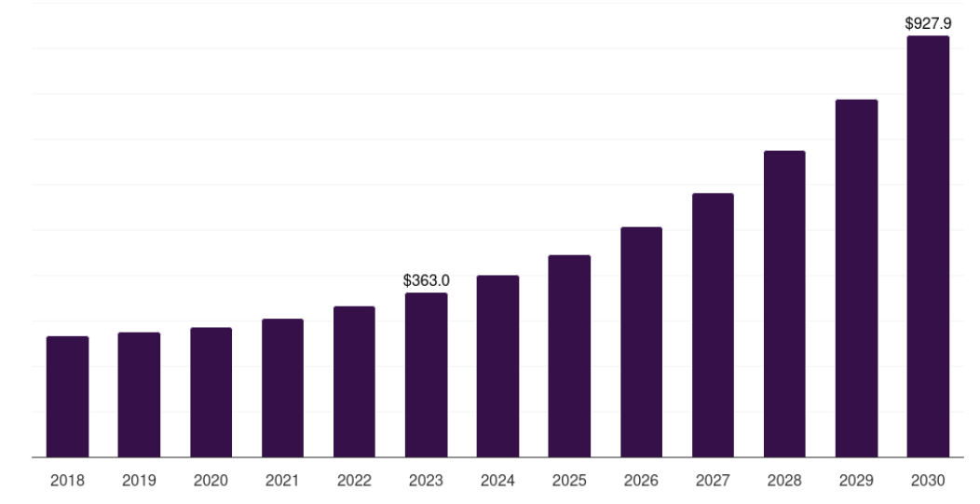
Figure 1.2.1: The UK e-commerce market
(Source: Grand View Research, 2025)
In recent years, customers have been constantly looking for multiple brands through social media platforms like Facebook, Instagram, YouTube, and many others. These social media platforms are used for storytelling by the E-commerce company ASOS. It has been reported that 55% of e-shoppers buy fashion or accessories through Facebook, 44% by TikTok and 47% by Instagram in the UK (Searles, 2024). So, it expects that this selected UK based e-commerce company will get success in building customer engagement by storytelling through social media platforms.
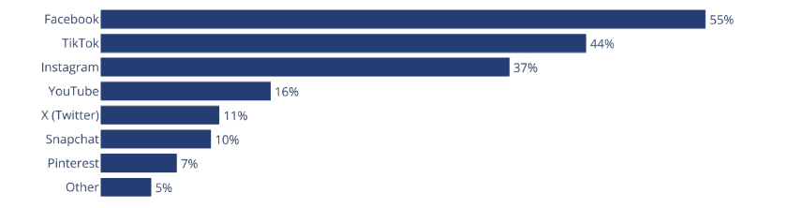
Figure 1.2.2: Social media platforms shopped by e-shoppers for their accessories in the UK
(Source: Searles, 2024)
E-commerce sales is strongly related to storytelling strategies as this makes emotional connections with customers by building trust and driving purchases (Kemp et al. 2021). Retail e-commerce sales worldwide increased from 4206 billion U.S. dollars in 2020 to 6542 billion U.S. dollars in 2023 (Statista Research Department, 2025). So, it states that this topic related to retail e-commerce market and online marketing is fruitful to find out relevant information about the impacts of storytelling strategy on brand loyalty.
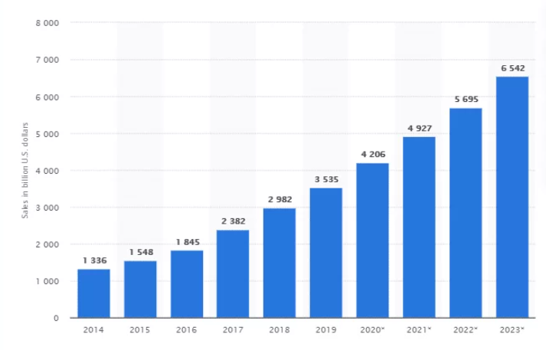
Figure 1.2.3: Retail-ecommerce sales in worldwide
(Source: Statista Research Department, 2025)

1.3 Problem statement
Lack of authenticity in storytelling leads to damage to brand reputation (Singh, Kumar, and Lal, 2025). Oversaturation of content, difficulty in measuring impacts and ethical sensitivity are the key problems in maintaining storytelling strategy.
Despite the growing significance of storytelling within digital marketing, there is limited academic understanding of how storytelling basically encourages brand loyalty in the e-commerce sector. Although ASOS invests in digital narratives, it is unclear which aspects of its storytelling mostly drive emotional connection and repeat customer behaviour.

1.4 Research aim and objectives
Aim: To analyse how ASOS uses digital storytelling through its social media and online platforms to strengthen customer loyalty and engagement.
Objectives:
- To evaluate how ASOS applies digital storytelling strategies across its online and social media platforms to connect with consumers and communicate brand values.
- To examine the effectiveness of ASOS’s digital storytelling in influencing customer emotional connection, perception, and brand trust for the identification of opportunities and challenges faced by the firm in the UK e-commerce sector.
- To explore the relationship between storytelling techniques of ASOS and the development of its brand loyalty among the target audience.

1.5 Research questions
- How are digital storytelling strategies of ASOS across its social media and online platforms to connect with consumers and communicate brand values?
- What are the impacts of ASOS’s digital storytelling on customer emotional connection, perception, brand trust etc and what opportunities and challenges faced by the firm in developing customer loyalty in the UK e-commerce sector?
- What is the relationship between ASOS’s storytelling techniques and the development of its brand loyalty among the target audience?

1.6 Justification of the study
This research is justified because it examines the importance of digital storytelling in strengthening brand loyalty in the competitive e-commerce fashion industry. ASOS is a perfect case study as it is a global online fast-fashion and beauty retailer which is known for its inclusive and creative storytelling (ASOS, 2025). This brand uses storytelling strategy to make an emotional connection with its customers and balance between performance metrics and brand loyalty. Understanding how storytelling encourages consumer loyalty gives valuable insights for marketers seeking to build brand-consumer relationships. This research study contributes to academic literature by combining perspectives from consumer behaviour, digital marketing, and brand communication, offering a deep knowledge of modern branding strategies in digital contexts.

1.7 Limitation
The primary limitation of this research is the following secondary qualitative data that depends on pre-existing data like online campaigns, reports, and existing articles. Lack of first-hand consumer perspectives make a limit in this research. Moreover, results based on a single case study may not be completely generalisable to other brands, though they give a strong foundation for further comparative research.

2. Literature Review

2.1 Identification of key literature to establish gaps
According to Abdelhady (2023), digital storytelling is a fruitful digital marketing strategy that endures customer relationships. Mandung (2025), noted that storytelling is an effective marketing tool that not only presents product information but also creates relatable and immersive narratives that resonate with customers' emotions, values, and aspirations. Storytelling advertising makes a potential impact on shaping a positive perception of service quality and products compared to physical advertising. According to the view of Tiiri (2024 p.20), “storytelling enables brands to go beyond product features and connect with consumers on a personal and emotional level, addressing their aspirations, beliefs, and identities”. Storytelling fosters a sense of engagement, connection, and loyalty of customers. Case study strategies are widely used in many marketing and consumer-behaviour studies to explore the brand communication comprehensively within the real world contexts. Case study designs can also help the researcher to examine the practices of storytelling in a brand setting, giving them a deeper understanding of the patterns of emotional engagement (Ahmed et al, 2024). This plan enhances the knowledge on formation of brand loyalty.
Brand storytelling is an effective approach that attracts customers' attention. Rachman et al. (2024, p.356) “brands are now expected to not only tell their own stories but also to facilitate contributions from consumers, creating a more authentic and relevant collaborative narrative”. Technologies like Big Data analysis and artificial intelligence (AI) are the key foundations of brand storytelling. Although storytelling provides several opportunities, changing digital trends, fierce competition and online reputation risks are some risks of storytelling strategy. Social media platforms play an important role in spreading brand stories. In the digital age, brand loyalty is identified as a valuable asset as loyal customers are engaged with repeat purchases, give constitutive feedback and recommend brands to others (Mandung, 2025). The research on digital stories tends to use the secondary qualitative data, including social media posts, campaign reports, and communication with the consumer, to compare them based on the theme and determines recurring themes (Jacub 2025). This methodology practice focuses on the role of pattern story telling in influencing brand loyalty in digital environments.
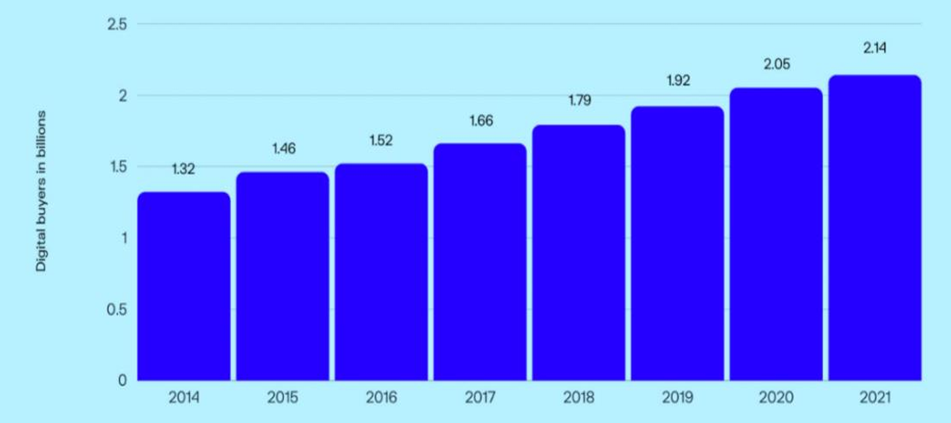
Figure 2.1.1: Growing number of online shoppers
(Source: Huang, YOU, and Zhou, 2022)
ASOS highlights influencers and real customers, telling stories that celebrate individuality. This strategy creates an emotional bond between this fast fashion brand and its customers. This encourages consumers to see themselves represented in the brand. ASOS uses social media platforms to present their stories and attracts customers, mostly the younger customers. It has been found that online shoppers increased from 2.06 billion in 2020 to 2.14 billion in 2021 (Huang, YOU, and Zhou, 2022). ASOS sells over 850 brands and ships to 196 countries. As per the Brandz ranking of 2021, ASOS ranked 10th in apparel (Huang, YOU, and Zhou, 2022). This e-commerce brand also use online marketing strategy like storytelling to engage with larger range of customers.
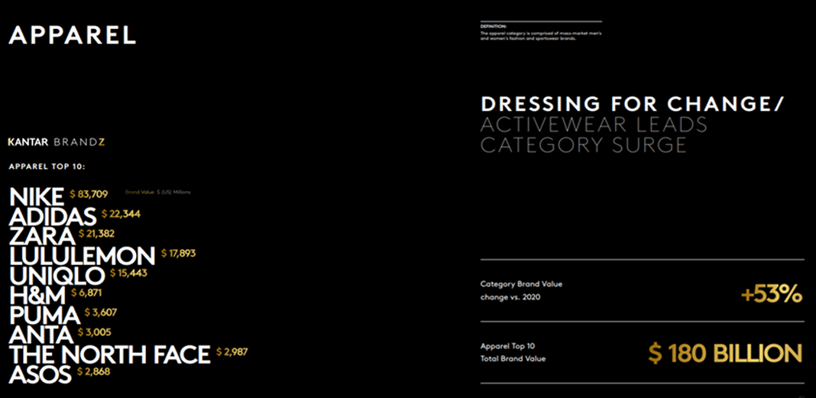
Figure 2.1.2: ASOS ranked under top ten apparel brands
(Source: Huang, YOU, and Zhou, 2022)
Idrees, Vignali and Gill, S., 2020) noted that via #AsSeenOnMe seen on hashtags, customers actively share their photos and styling ideas on social media. This hashtag presents the individual image of brands. Retailers also observe traffic and engage with customers through their social media. A range of digital stories researchers use interpretivist philosophy to interpret consumer perceptions by making sense subjectively, focusing on experiences instead of numerical generalisation. Interpretivism favours the interpretation of stories, feelings, and brand connotations of e-commerce (Limna et al., 2025). This philosophical premise illustrates a methodological loophole in the way emotional engagement is investigated in online brand storytelling.

2.2 Theoretical underpinnings
Narrative transportation theory:
According to Mandung (2025), narrative transportation theory states that when customers become engaged in a story, they experience suspension of disbelief, which enables them to relate to the brand on a deeper level. Emotional engagement through story is effectively recognised as a key driver of loyalty because customers feel a personal connection and trust with brands. Based on this theory concept, customers are likely to advocate for brands which give emotionally satisfying experiences. So, it understands that emotional connections create a strong and positive brand perception among customers.
Consumer-brand relationship theory:
As per the consumer-brand relationship theory, positive relationships with brands cause brand acceptance and Word-of-mouth (WOM) (Wallace et al. 2022). Storytelling strategy creates a strong emotional connection between customers and brands, and this strong bond contributes to an increasing rate of brand loyalty and customers. ASOS uses storytelling strategy to create stronger emotional bonds with its customers that strengthen its brand loyalty and customer engagement. The available sources on the topic of digital storytelling often use the inductive research methodology in which patterns can be formed based on consumer-created stories and brand narratives rather than a predefined hypothesis (West et al, 2022). Such strategy is in line with qualitative analysis and emphasizes the development of emotional themes in the context of storytelling based marketing environments.

3. Methodology

3.1 Methods of data collection
Data are collected from mostly two basic methods, such as primary and secondary methods. Primary data collection occurs through surveys, interviews, observations, and other (Mazhar et al. 2021). On the other hand, secondary method data are collected from articles, journeys, and relevant online sources. In this research, the secondary data collection method will be followed to present the impacts of the digital storytelling strategy of ASOS on its brand loyalty and customer engagement. Already published articles, journals, and books that are available in Google Scholar will be used as secondary sources in this research. Company reports of ASOS, newspapers, and other authentic online sources will also be used to gather relevant information about the research. The secondary data collection method is a more cost-saving, time-efficient, and bias-free method compared to the primary data collection method.
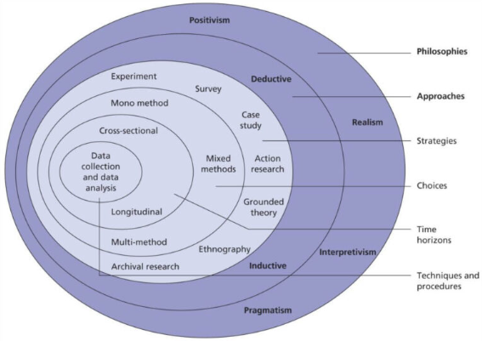
Figure 3.1.1: Research Onion
(Source: Abdelhakim, 2021)

3.2 Methods of data analysis
Data are analysed through two key methods, such as quantitative and qualitative methods. The quantitative method presents numerical data by including statistics and graphs (Alturki, 2021). On the other hand, qualitative methods showcase non-numerical data based on secondary sources. In this research study, the qualitative method will be applied in this research to analyse the collected data related to ASOS storytelling strategies. Thematic analysis will be followed as a secondary qualitative method to present detailed information about the role of storytelling strategy on brand loyalty based on ASOS case study.
A secondary qualitative research method is selected as this permits in-depth analysis of existing data, such as social media content, interviews, and brand reports of ASOS. This method saves time, cost, and resources during data collection and data analysis compared to the primary quantitative analysis method (Cheong et al. 2023). A secondary qualitative method will help to identify themes, patterns, and meanings behind ASOS’s storytelling strategies and their impact on brand loyalty.

3.3 Ethical considerations
In the case of secondary qualitative research, all secondary sources should be credible and properly cited. Data will be drawn from ethically approved and publicly available sources during this research. Protecting the privacy and confidentiality of original participants is an effective way to maintain research ethics (HWANG, 2023). Misinterpretation of qualitative data must be avoided to control accuracy and integrity in this research.

3.4 Limitations
Lack of primary quantitative data collection and representation is one of the limitations in this research. Only qualitative research analysis is selected, so the lack of numerical data and statistical presentation creates a gap in this research.

4. Expected findings

4.1 Key expected findings based on theory, literature, and methods
As per the narrative transportation theory, brand relationship theory, and relevant literature, it is understood that ASOS’s digital storytelling effectively enhances emotional engagement and brand loyalty. The research findings will reveal that inclusive and authentic storytelling like ASOS’s focus on sustainability, diversity, and real customer experiences, makes a sense of belonging and trust among consumers. ASOS potentially builds emotional connections which move beyond simple product promotion to make a meaningful brand–consumer relationships. As per literature review, it pointed out that although storytelling creates many opportunities, fierce competition, changing digital trends, online reputation risks are some challenges of storytelling strategy. It expects that the opportunities and challenges of storytelling strategy on brand loyalty will be effectively analysed in detail through a secondary qualitative method.

4.2 Potential implications of the findings
The research study could give valuable insights for both marketers and academics. These research findings will strengthen the link between emotional transportation, brand loyalty, and storytelling by offering a deeper understanding of digital consumer psychology. The findings help brands to design “story-driven marketing strategies” that foster loyalty via emotional resonance rather than price competition. This research may influence ASOS and similar e-commerce brands to invest in inclusive, sustainable, and consumer-led storytelling while controlling authenticity across digital platforms.

5. Timeframe
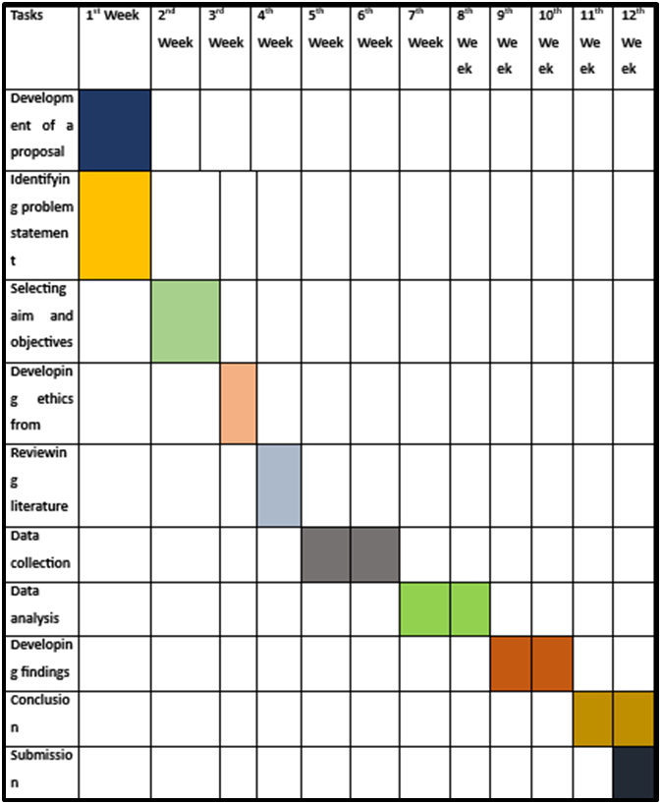
Figure 5.1: Timeframe for research
(Source: Self-developed)

6. Conclusion
As per the above discussion, it is concluded that digital storytelling takes a key role in increasing brand loyalty through building emotional connections between consumers and brands. ASOS strengthens its customer engagement by sharing stories related to inclusivity and authenticity. This fast fashion retailer brand uses a storytelling strategy on social media platforms. This brand promotes #AsSeenOnMe to foster their customer engagement and brand loyalty. Based on narrative transportation theory and consumer–brand relationship theory, when consumers become emotionally connected to a brand’s story, they develop a sense of advocacy that extends beyond transactional interactions.
Secondary thematic analysis will be followed to showcase data related to the impacts of ASOS storytelling on their brand loyalty. ASOS can strengthen its competitiveness by crafting genuine, relatable narratives related to customer values such as sustainability, diversity, and individuality. It concludes that digital storytelling is a significant marketing tactic to build an enduring brand–consumer relationship.

7. References
Abdelhady, M.H., (2023). The Impact of Digital Storytelling on Tourist Loyalty: The Mediating Role of Consumer Purchase Decision. Journal of the Faculty of Tourism and Hotels-University of Sadat City, 7(2/1).https://mfth.journals.ekb.eg/article_326119_e264e522e43a6227006e3cc90689442e.pdf?lang=en
Abdelhakim, A.S., 2021. Adopted Research Designs by Tourism and Hospitality Postgraduates in The Light‎ of Research Onion. International Journal of Tourism and Hospitality Management, 4(2), pp.98-124. https://ijthm.journals.ekb.eg/article_206774_39a512b92a6470df762792c8d0c60a12.pdf
Ahmed, S., Sharif, T., Ting, D.H. and Sharif, S.J., 2024. Crafting emotional engagement and immersive experiences: Comprehensive scale development for and validation of hospitality marketing storytelling involvement. Psychology & Marketing, 41(7), pp.1514-1529. https://onlinelibrary.wiley.com/doi/pdfdirect/10.1002/mar.21994
Alturki, R., (2021). Research Onion for Smart IoT‐Enabled Mobile Applications. Scientific programming, 2021(1), p.4270998.https://onlinelibrary.wiley.com/doi/abs/10.1155/2021/4270998
ASOS, (2025). About Us. [online]. Available at: https://www.asos.com/about/who-we-are/?ctaref=aboutus|whoweare [Accessed on: 6th November 2025]
Cheong, H.I., Lyons, A., Houghton, R. and Majumdar, A., (2023). Secondary qualitative research methodology using online data within the context of social sciences. International Journal of Qualitative Methods, 22, p.16094069231180160.https://journals.sagepub.com/doi/abs/10.1177/16094069231180160
financial-news.co.uk, (2024). Asos Unveils Ambitious ‘Inspired By’ Campaign. Financial News. [online]. Available at: https://www.financial-news.co.uk/asos-unveils-ambitious-inspired-by-campaign/[Accessed on: 6th November 2025]
Grand View Research, (2025). UK e-commerce market, 2018-2030 (US$M). [online]. Available at: https://www.grandviewresearch.com/horizon/outlook/e-commerce-market/uk[Accessed on: 6th November 2025]
Huang, X., YOU, A.T. and Zhou, X., (2022). Research on the Online Marketing Strategy of ASOS’s Young Customer Market.https://pdfs.semanticscholar.org/296e/58a7190ee8843217d1e9c642e010ee8763a8.pdf
HWANG, H.J., (2023). The importance of anonymity and confidentiality for conducting survey research. Journal of Research and Publication Ethics, 4(1), pp.1-7. https://www.researchgate.net/profile/Eungoo-Kang/publication/370048267_The_Importance_of_Anonymity_and_Confidentiality_for_Conducting_Survey_Research/links/643aecc92eca706c8b5f9dc9/The-Importance-of-Anonymity-and-Confidentiality-for-Conducting-Survey-Research.pdf
Idrees, S., Vignali, G. and Gill, S., (2020). Technological advancement in fashion online retailing: a comparative study of Pakistan and UK fashion e-commerce. International Journal of Economics and Management Engineering, 14(4), pp.313-328.https://www.academia.edu/download/95458810/Technological_Advancement_in_Fashion_Online_Retailing_A_Comparative_Study_of_Pakistan_and_UK_Fashion_E_Commerce1_1_.pdf
Jacub, E.T.D., 2025. A Thematic Analysis of Beauty Influencers Narrative Strategies on Instagram From the Audience's Perspective. Ganaya: Jurnal Ilmu Sosial dan Humaniora, 8(2), pp.365-374. https://jayapanguspress.penerbit.org/index.php/ganaya/article/download/4221/2009
Kemp, E., Porter III, M., Anaza, N.A. and Min, D.J., (2021). The impact of storytelling in creating firm and customer connections in online environments. Journal of Research in Interactive Marketing, 15(1), pp.104-124.https://www.emerald.com/insight/content/doi/10.1108/jrim-06-2020-0136/full/html
Limna, P., Shangchart, Y., Kraiwanit, T., Asanprakit, S. and Nivornusit, R., 2025. Muketing: The Fusion of Mutelu and Marketing in E-Commerce—Trends in Thailand's Faith Economy. Frontiers in Communication, 10, p.1662524. https://www.frontiersin.org/journals/communication/articles/10.3389/fcomm.2025.1662524/pdf
Mandung, F., (2025). The Influence of storytelling techniques in digital marketing on brand loyalty: A Consumer Psychology Perspective. Golden Ratio of Marketing and Applied Psychology of Business, 5(1), pp.66-78.https://goldenratio.id/index.php/grmapb/article/view/782
Mazhar, S.A., Anjum, R., Anwar, A.I. and Khan, A.A., (2021). Methods of data collection: A fundamental tool of research. Journal of Integrated Community Health, 10(1), pp.6-10.https://www.researchgate.net/profile/Syeda-Ayeman-Mazhar/publication/356269289_Methods_of_Data_Collection_A_Fundamental_Tool_of_Research/links/61fe7e23870587329e943cd1/Methods-of-Data-Collection-A-Fundamental-Tool-of-Research.pdf
Rachman, R., Hamid, M.A., Wijaya, B.K., Wibowo, S.E. and Intan, D.N., (2024). Brand storytelling in the digital age: challenges and opportunities in online marketing. Jurnal Ekonomi, 13(01), pp.355-364.https://ejournal.seaninstitute.or.id/index.php/Ekonomi/article/view/3748
Searles, K., (2024). UK fashion shoppers relying heavily on social media. Internet Market. [online]. Available at: https://internetretailing.net/uk-fashion-shoppers-relying-heavily-on-social-media-2/[Accessed on: 6th November 2025]
Singh, M., Kumar, D. and Lal, R., (2025). Digital Storytelling and Brand Positioning in the Media Age: Building Consumer Trust through Narrative Authenticity.https://www.researchgate.net/profile/Mansi-Singh-66/publication/393149580_Digital_Storytelling_and_Brand_Positioning_in_the_Media_Age_Building_Consumer_Trust_through_Narrative_Authenticity/links/68622089e4632b045dc87e7a/Digital-Storytelling-and-Brand-Positioning-in-the-Media-Age-Building-Consumer-Trust-through-Narrative-Authenticity.pdf
Statista Research Department, (2025). ASOS - statistics & facts. Statista. [online]. Available at: https://www.statista.com/topics/6330/asos/?srsltid=AfmBOorU0W-GP7ZXu_yaCoqS4rXHM5yyxTDMKsv6PmY_nRyuvJAaoUN0#topicOverview[Accessed on: 6th November 2025]
Statista Research Department, (2025). Retail e-commerce sales worldwide from 2022 to 2028. Statista. [online]. Available at: https://www.statista.com/statistics/379046/worldwide-retail-e-commerce-sales/[Accessed on: 6th November 2025]
Tiiri, E., (2024). Emotional Marketing through Storytelling: Building Brand Loyalty Across the Customer Journey. https://aaltodoc.aalto.fi/items/3c1d3ad6-79c8-41ac-859e-97ccc606a62b
Twirl, (2024). Inside ASOS’s #AsSeenOnMe: UGC in E-Commerce. Twirl. [online]. Available at: https://www.usetwirl.com/post/inside-asos-s-asseenonme-ugc-s-role-in-modern-marketing [Accessed on: 6th November 2025]
Wallace, E., Torres, P., Augusto, M. and Stefuryn, M., (2022). Do brand relationships on social media motivate young consumers’ value co-creation and willingness to pay? The role of brand love. Journal of Product & Brand Management, 31(2), pp.189-205. https://www.emerald.com/insight/content/doi/10.1108/jpbm-06-2020-2937/full/html
West, C.H., Rieger, K.L., Kenny, A., Chooniedass, R., Mitchell, K.M., Winther Klippenstein, A., Zaborniak, A.R., Demczuk, L. and Scott, S.D., 2022. Digital storytelling as a method in health research: A systematic review. International Journal of Qualitative Methods, 21, p.16094069221111118. https://journals.sagepub.com/doi/pdf/10.1177/16094069221111118
Ziginov, S., (2021). CUSTOMER ENGAGEMENT VIA SOCIAL MEDIA. HOW DOES SOCIAL MEDIA MARKETING AFFECT CONSUMER DECISION-MAKING PROCESS AND SALES? CASE: ASOS.https://www.theseus.fi/handle/10024/502594

