

Certificate of Higher Education Skills for the Workplace
Module: Effective Team Work and Communication
(BMSW4002-LON)
Assignment Title: Effective Team Work and
Communication Assignment1 (Report)
Lecturer name: Saqib Shamim
Student name and ID: Natalia Bejenari (2125544)

Table of Content
Introduction: 2
Communication Models 3
Shannon-Weaver's model 3
Schramm's model 5
Berlo's model 6
Communication Skills 7
Skills of Verbal Communication 8
Skills of Non-Verbal Communication 8
Listening 8
Active Listening 8
Empathetic Listening 9
The Benefits and Drawbacks of Communication Technology 9
Advantages 9
Disadvantages 9
Conclusion 10
References 10

Introduction:
The term 'communication' originates from the Latin ‘communis’, which means ‘common wisdom'. It is a two-way communication process by which information or messages can be delegated to group or individual, one to another. This process will continue with at least one sender and recipient passing on the messages. Its significance cannot be overstated. Above all, society, culture, and humanity do not exist apart from mutual dependence. Effective communication not only enhance trust but also sometimes reduces the chance of misperception and wars. It aids in the formation of the general societal framework, assists individuals in finding employment, provides guidance, and transmits traditions, morals, and conventions.
The bar of efficient communication may occur misunderstanding, which may lead to the transmission of false facts or misinterpretation. Semantic hindrances are happened by a malfunction in the conversation between the recipient and the sender. Psychological hindrances are vital in mutual communication because it is very hard to interpret in anyone’s mind and in which sense the information is delivered, this frequently causes misunderstanding. Cultural obstacles are the ones that happen as a result of dissimilarities between various civilizations throughout the world.
To make a better understanding of communication, this report contains three models of effective communication, various communication skills and the effect of communication technologies.

Model of Communication
The communication models are designed to be fundamental, to emphasise the main communication elements and the relationship between them, and to include all possible types of meaning transmission (Elleström, 2018). A few models represent communication in greater detail than others.

Shannon-Weaver model of communication
This model (1948/49) extensively examines the process of transmitting data from one source to a receiver through one-way communication. It mainly emphasises the significance of decreasing noise and proposes the idea of a channel that mediates the information (Kubota, 2019). This model is described using the following stages:
The sender or the source
The information was initially handled by a person, an object, or an item. This process begins with the transmitter selecting a message to transmit to a receiver via a channel.
Encoder
Encoding is the entity or system that converts a notion into signals that may be communicated from one end to the other.
Channel
It is a structure that moves data from the transmitter end to the receiver end. This is referred to as ‘medium'.
Noise
Noise interferes with communication because it passes from the transmitter to the receiver. When a transmitter makes an error while encoding or a receiver creates an error while decoding a message, internal noise occurs but external noise occurs when anything external to the system interferes with communication (CT, 2022).
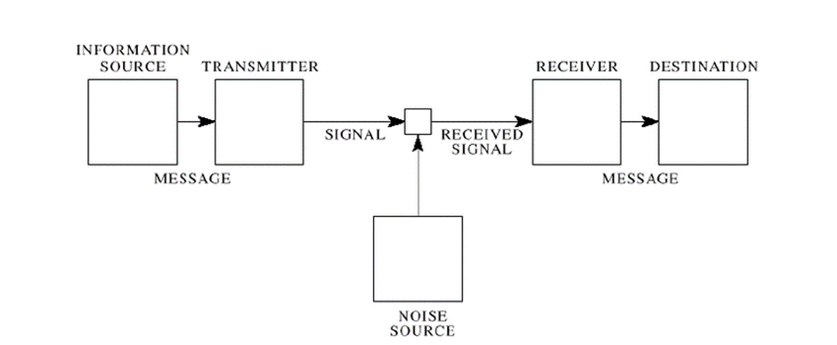
Figure: Shannon- Weaver Mathematical Model of Communication
(Source: CT, 2022)
Case Study
The "Maria and Pedro" case study is ideal for grasping this notion. Maria and Pedro are a couple in this case study. Pedro is a construction worker. Maria calls Pedro one day and requests that he carry chicken house during his working hours. Unfortunately, Pedro is listening to the kitchen rather than the chicken.
It is evident from this case study that Pedro misunderstands due to the excessive noise on the building site. Shannon and Weaver's communication model explicitly elaborates on this mistake, as the role of noise during message transmission is indicated here. Maria should inquire again to avoid this situation, which is known as feedback. Schramm's communication model outlines how to avoid this kind of misunderstanding.
By using this approach, any misunderstandings may be prevented since it describes the hurdles to successful communication extremely effectively by identifying technology concerns, linguistic issues, and efficiency issues. It also separates communication into manageable portions and has been used to explain almost any sort of contact that anybody can think of.
The Shannon-Weaver communication paradigm in action at the workplace
My colleague Jonson called his friend to arrange a meeting. The noise occurred throughout his call (transmission error), and his acquaintance is unable to hear clearly. So his pal inquired once more. Jonson is the transmitter, the cell (Jonson) is the encoder, and also the channel is Cable. The voice is distracted by noise, his buddy's phone is the recipient, and his friend is the recipient. This is because of a transmission problem, and his acquaintance is unable to adequately hear Jonson's message.

Schramm's model
According to Schramm's model (1954), encoding and decoding appear to be the two essential phases of efficient communication. Encoding is heavily criticised since it begins the transmission process by converting thoughts into the material. Information is pointless if it isn't properly stated and discussed with others (Kalogiannidis, and Papaevangelou, 2020). And also communication is useless as long as the recipient recognizes or decodes the information that the sender is attempting to communicate.
The source, recipient, message, noise and feedback are the components of Schramm's communication paradigm.
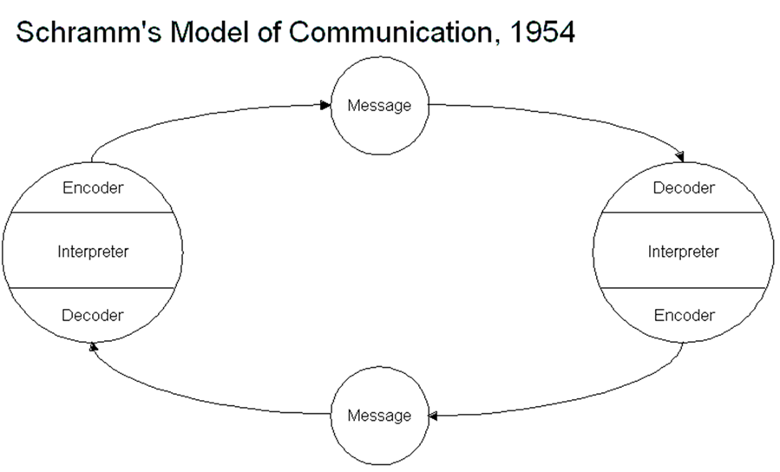
Figure: Schramm’s model of communication
(Source: SL, 2022)

The main dissimilarity between this model with the other model of communication as this sort of communication incorporates a feedback mechanism. The transmitter may more easily identify the extent to which the message was received, comprehended and accepted by the recipient (SL, 2022). This is the initial nonlinear communication model. This model assumes that dialogue is a bidirectional process rather than a unilateral one, culminating in a circular system. This framework enables both the sender and the receiver to compose and transfer messages.
Case Study
In the context of the "Maria and Pedro" case study, this communication model suggests the importance of feedback in communication. The uncertainty will be clarified if Maria questions Pedro again.
Schramm's communication model in use in the workplace
I requested a ride from a buddy, but he stayed mute. The chat ended because my companion stayed mute. According to this concept, whenever my buddy receives a message, he or she must offer input. If he is unsure about the message, he must consult with me.

Berlo's model of communication
The communication model of Berlo (1960) believes that successful communication occurs whenever the sender and recipient of information are similar or approximately equivalent. The sender, information, channel, and receiver are the primary components of this concept (Narula,2006).
This approach focuses on the factors that influence the primary components, such as the sender's presenting abilities, point of view, expertise, social aspects, and culture. The message is overburdened by the topic, component, treatment, construction, and coding. The channel is determined by listening. Observing, touching, smelling, and distinguishing The receiver is immediately impacted by the same components as the sender.
In comparison to modern communication representation, this approach is straightforward. The basic variables that are an element of every communication process, as well as the elements that influence them, are considered. As a result, it differs from Schramm's model and Shannon and Weaver's paradigm.
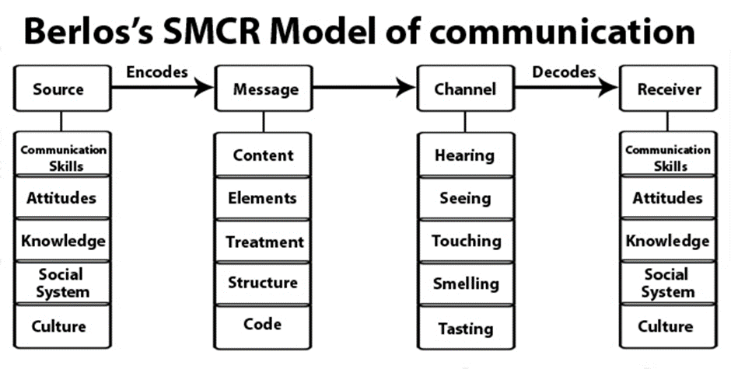

Figure: Berlo’s Model of communication
(Source: Narula,2006)
Case Study
"Professor Case" is a nice illustration of how to explain this paradigm. In the story professor, the professor was highly educated and he never met the people of the village near his house as there are no similarities between them and the professor. One day, the teacher's house was aflame, and he went to get some help. But the villagers did not understand his language and did not come to help. His house burnt totally. The day after that, after discussion it is found out that the villagers could not understand his language as they are not as educated as him. From this case study, it is clear that the receiver and the sender must be in the same position.
Berlo's model of communication in use in the workplace
For example, in one class, I couldn't comprehend what the lecturer was saying. To have good communication, the source and receiver must be in the same position, according to this concept.

Communication Skills
Without saying anything, an observer can discover another person's looks, emotional state, personality, or ambitions by seeing their posture, facial expression, and attire (Kurniadi, and Mahaputra, 2021).

Skills of Verbal Communication
The sharing of information with another person through speech is referred to as verbal communication.
The most important conversational rule is that neither the other person nor oneself should dominate the conversation (Paranduk, and Karisi, 2020). Always be courteous and welcoming. It is critical to understand the other person's point of view and try to assist them. Attempt to establish an emotional connection during the talk.

Skills of Non-Verbal Communication
People communicate in a variety of ways, one of the most essential being Non-verbal communication.
Nonverbal communication may be classified into several forms. For example, body movement is the most basic kind of nonverbal communication. Maintaining a conscious facial expression is really difficult. Eye contact typically influences dependability and trustworthiness (Smith, 2021).
Case Study
"A day with the chief" is one of the greatest possibilities for defining the importance of interpersonal skills. Mark is among the top salespeople in this case scenario. For this, he is given the opportunity to visit their headquarters and speak with the CEO of his firm. When he arrives, he becomes anxious. Something went awry during the discussion with the CEO, and his CEO dismissed him.
It is obvious from this case scenario that Mark does not accurately interpret the context during the dialogue. Mark's deficiency of verbal and nonverbal communication skills is to blame for the shift in the CEO's attitude, as Mark becomes dominant, ignoring the CEO's inquiries, which is a kind of verbal communication, and his body language, which is a form of nonverbal communication.

Listening
There are two kinds of listening:

Active Listening
The majority of the instincts are activated in order to actively listen and pay full attention to the speaker. Maintaining eye contact, head shaking, smiling and reacting in the agreement is also an indicator to encourage them to continue (USIP, 2022).

Empathetic Listening
Empathic listening requires the listener to lay aside their own views and viewpoints in order to focus exclusively on the speaker. Importantly, it must show that the person clearly embraces the message, even if they disagree with it. Empathic listening appears to be a way for connecting emotionally with someone who is speaking. When two people have opposite viewpoints, it might be challenging to absorb the message effectively (Kapur, 2018).
Case Study
"Max the multitasker" is an ideal metaphor for understanding empathic listening. In this scenario, the main character, Max, is an event organiser who did not have enough funds to hire staff to help with the planning. But he works really hard and always strives to provide his best. He receives an assignment from an old customer one day, and the date of the occasion is mentioned. Meanwhile, his customer modifies the schedule over the phone while he is with some other client, but he forgets to write it down. On the event day, his client discovers that a different event taking place at the same location. As a result, his customer misbehaves with him.
According to this case study, the key explanation is Max's listening abilities, which are one of the most important aspects of his communication. This might be avoided by practising empathic listening, which requires attention from the speaker. His customer, on the contrary hand, should not act in this manner since she, too, lacks sympathetic listing abilities.

The Benefits and Drawbacks of Communication Technology
The advantages and disadvantages are listed below.

Advantages
- It improves communication efficiency.
- Communication is more efficient in emergency situations (Rohini et al., 2022).
- It is possible to communicate from any location.
- Long-distance communication is significantly more convenient (Irani, 2019).

Disadvantages
- It is more difficult for the older generation (MJ, 2022).
- Cybercrime is a real possibility (Monteith, 2021).
- The discussion is less emotional.

Conclusion
Almost everything in daily life may be considered a means of communication. Anyone may improve their possibility to connect and interact with people by identifying their skills and weaknesses and practising good behaviours on a daily basis. It is also important to remember that without these brilliant ideas, our lifestyles would be remarkably separate, and society would not be as prosperous as it is now. It is also anticipated that the future would offer more new technologies, particularly wireless technology.

References
- Narula, U. (2006). Communication models. Atlantic Publishers & Dist.
- Elleström, Lars. "A medium-centered model of communication." Semiotica 2018.224 (2018): 269-293.
- Irani, E., 2019. The use of videoconferencing for qualitative interviewing: Opportunities, challenges, and considerations. Clinical Nursing Research, 28(1), pp.3-8.
- Kalogiannidis, S. and Papaevangelou, O., 2020. Impact of Business Communication on the Performance of Adult Trainees. International Journal of Academic Research in Progressive Education and Development, 9(3), pp.213-222.
- Kapur, R., 2018. Barriers to effective communication. Delhi University.
- Kubota, M., 2019. What is “Communication”?―Beyond the Shannon & Weaver’s Model―. International Journal, 13(1), pp.54-65.
- Kurniadi, W. and Mahaputra, M.R., 2021. Determination of Communication in the Organization: Non Verbal, Oral and Written (Literature Review). Journal of Law, Politic and Humanities, 1(4), pp.164-172.
- MJ, 2022, “Communication of Technology: Advantages and Disadvantages” available at http://mackenziejones212.blogspot.com/2012/02/google-chrome-advantages-and.html [Acessed on 10th December 2022]
- Monteith, S., Bauer, M., Alda, M., Geddes, J., Whybrow, P.C. and Glenn, T., 2021. Increasing cybercrime since the pandemic: Concerns for psychiatry. Current psychiatry reports, 23(4), pp.1-9.
- Paranduk, R. and Karisi, Y., 2020. The effectiveness of non-verbal communication in teaching and learning english: a systematic review. Journal of English Culture, Language, Literature and Education, 8(2), pp.140-154.
- Rohini, P., Tripathi, S., Preeti, C.M., Renuka, A., Gonzales, J.L.A. and Gangodkar, D., 2022, April. A study on the adoption of Wireless Communication in Big Data Analytics Using Neural Networks and Deep Learning. In 2022 2nd International Conference on Advance Computing and Innovative Technologies in Engineering (ICACITE) (pp. 1071-1076). IEEE.
- SL, 2022, “Models of Interpersonal Communication” Available at https://socialsci.libretexts.org/Bookshelves/Communication/Interpersonal_Communication/Book%3A_Interpersonal_Communication_-_A_Mindful_Approach_to_Relationships_(Wrench_et_al.)/02%3A_Overview_of_Interpersonal_Communication/2.04%3A_Models_of_Interpersonal_Communication [Acessed on 10th December 2022]
- Smith, J., 2021. 1.4 Non-verbal Communication. Communication: Fundamentals for the Workplace.
- USIP, 2022, “What is Active Listening?” Available at https://www.usip.org/public-education-new/what-active-listening [Acessed on 10th December 2022]

