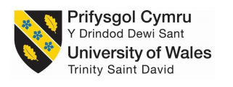
Effective Team Work and Communication

Table of Contents
Introduction 3
Teamwork and the roles of teamwork in the workplace 3
Elements of Effective Teamwork 5
Theories of Team Development 6
Communication and Effective Teamwork 8
Conclusion 10
References 11

Introduction
Teamwork and communication are the key to increase organisational efficiency by maintaining the balance of work productivity among the workforce and providing necessary information throughout every organisational hierarchy to run the operations of the organisation without any interruption. Teamwork increases effectiveness in work productivity by exchanging skills and knowledge of one employee with the others. Teamwork increases motivation and belongingness in the organisation by satisfying the social needs of the employees. Communication is not only important for developing a strong relationship between the workforce and the management but also to exchange important information to enable every employee and professionals to perform their activities with full efficiency. This report is prepared as an consultant that provides consultancy on teamwork in workplaces. This report is prepared to suggest implementation of team work in O2, the most renowned mobile operating company of UK. This report is designed to highlight the importance of effective teamwork for increasing organisational productivity and performance. This report also describe the importance of communication skills for creating effective teamwork. This report elaborates various theories and approaches has been represented to support the argument of effective teamwork and communication skills for increasing organisational performance.

Teamwork and the roles of teamwork in the workplace
Teamwork is the work effort and work productivity of a specific team that is collaboratively given by all the team members for achieving their common goals. Teamwork helps to complete a task with efficiency and effective activities taken by all team members who equally contribute in the attainment of team goals. Individual employees work for their own personal or professional goals depending on individual strengths and skills. Teamwork increases employee strengths and skills by collaborating all team members inherent talents and competencies together to develop new skills and knowledge for performing task with more productivity and efficiency to achieve their common goal in a better way (Anderson and West, 2017). The employees of O2 need to practice teamwork in the operational activities to increase their productivity and quality of work performance. Teamwork not only reduces the workload but also creates a friendly environment where the employees feel enthusiastic to enjoy their work. The roles of teamwork in the workplace of O2 is described below:
Introducing Unity: Teamwork increases the diversity in talents and communication skills of the employees and motivate them to accept challenging work to collaboratively dedicate themselves for achieving organisational goals (Choi and Yoo, 2010). To increase team unity of O2, the team members can share their opinions and experience to strengthen the skills and competency of other team members. The team members collaboratively participate to solve organisational problems with unity.
Improved Efficiency and Productivity: Teamwork makes the team members more efficient and productive by reducing the pressure on individuals and distribute workload collaboratively on teams (Baumeister, 2015). The team members of O2 can participate together for performing the work. When the individuals work together they have more efficient work output and high job satisfaction. the productivity of the team members increases to complete their task more quickly by optimisation of their team performance.
Providing Learning Opportunities: Teamwork increases the opportunities of new learning as team members share their experience and opinions to increase their collaborative knowledge and skills (Choi and Yoo, 2010). The team members of O2 can learn from other members mistakes and develop new concepts from experienced coworkers. Exchange of perceptions, skills, and knowledge helps to discover inherent talents of the team members by encouraging their innovative capacities.
Promoting Workplace Synergy: Teamwork brings unity in the workplace by creating a team work environment with a friendly atmosphere and loyalty that strengthens the relationship between the employees and encourage a cooperative and supportive behaviour in the workplace (Baumeister, 2015). The team members of O2 are equally responsible for achieving their own goals which encourage them to keep their best work effort for accomplishing the team values and goals. The team encouragement increases the team output at higher levels.

Elements of Effective Teamwork
Effective teamwork increases employee engagement and job satisfaction to bring loyalty among the workforce. Effective teamwork focus on employee well being to retain the talented employees for adjusting with highly competitive global competition (Robinson and Smith, 2016). O2 has to develop effective teamwork by bringing appropriate elements in the team. Good teamwork represents synergistic team performance where every team member is committed to achieve the shared team goals by maximization of individual strengths for increasing team output with high efficient team performance. O2 can increase efficiency in the teamwork by introducing the following elements in the teams:
Communication: Effective communication increases consistency in the team performance by providing necessary information to every team member to balance between their work progress. A friendly communication process in the workplace of O2 encourages cooperative and supportive team environment and the team members feel enthusiastic for achieving their shared goals (DeChurch, 2010). A good team leader is a good listener for the team members to listen to their problems and provide effective solutions. Proper communication also enhances encouragement by collaborating the new ideas of the team members and create a harmonious environment in the team.
Delegation: An effective teamwork is dependent on the understanding of individual team member's strengths and weaknesses that impact on the team performance. The team members of O2 can learn from other members mistakes and develop new concepts from experienced coworkers. Exchange of perceptions, skills, and knowledge helps to discover inherent talents of the team members by encouraging their innovative capacities.
Efficiency: To develop effective teamwork, a strong and cohesive collaboration of team tasks in a timely manner is important for increasing team efficiency (Gayeski, 2014). The team members have to acknowledge their capabilities nad match them with their responsibilities in the team (DeChurch, 2010). The team members of O2 can participate together for performing the work. When the individuals work together they have more efficient work output and high job satisfaction. the productivity of the team members increases to complete their task more quickly by optimisation of their team performance.
Ideas: The team members should encourage exchange of ideas and suggestions for creating new ideas to increase team performance and productivity through collaborative brainstorming sessions in the team. Exchange of ideas among the team members builds a trustworthy team environment and strengthens the loyalty of team members.
Support: Teamwork brings unity in the workplace by creating a team work environment with a friendly atmosphere and loyalty that strengthens the relationship between the employees and encourage a cooperative and supportive behaviour in the workplace (Gayeski, 2014). The supportive nature of the team members increases their confidence to handle difficult challenges and motivates them for increasing productivity by creating team belongingness among the team members.

Theories of Team Development
Effective team is developed with implementation of proper theories of team development. The most effective theory of developing effective team in the workplace is the team development theory given by Bruce Tuckman. Tuckman's team development theory is a five stage development process where a team has to go through definitive stages to become a successful team (Butchibabu and Shah, 2016). O2 can follow Tuckman's team development theory to build up effective team in different operational levels. The five stages to develop effective team by the employees of O2 are described below:
Stage-1: Forming
In the forming stage the team members receive orientation and acquainted with other team members. the team members get leadership and authority from the team and gets knowledge of the team members (Pfrimmer, 2009). The team members try to get to know each other for developing an effective team and want to discover how they can benefit themselves by working as a team.
Stage-2: Storming
In the storming stage, the team members faces some difficulties and critical issues to work as a team and conflict may arise between team members due to their differences and diversity. Individual personalities conflict with one another and arguments take place which make the team and productive for a certain time (Deering and Colacchio, 2011). Team members may disagree to accept their common team goes and subgroups may form based on the agreement. the team leader come forward to remove the obstacles of individual differences and motivate in encourage the team members by developing a friendly environment to reduce conflict.
Stage-3: Norming
In the norming stage, the conflicts and disagreements between the team members starts to get resolved and team unity starts to get formed. The team members gets it about their roles and responsibilities in the team and a sense of cohesion and unity take place to resolve the interpersonal differences (Pfrimmer, 2009). The cooperative and supportive behaviour of team members help them to focus on team effort for achieving the team goals by increasing team productivity and team performance.
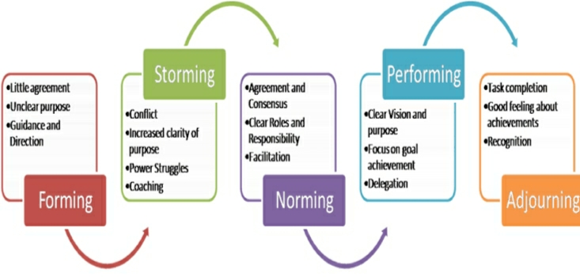

Figure: Tuckman’s Team Development Theory
(Butchibabu and Shah, 2016)

Stage-4: Performing
In the performing stage, the team members becomes well-established to fit in the team and their well-functioning behaviour provides a clear structure of team and a strong commitment for achieving teams mission and goals (Deering and Colacchio, 2011). They start to handle their problems and conflicts in a mature way by identifying constructive solutions for team problems. The team members give their main focus on solving work problems and their supportive behaviour meets the team goals.
Stage-5: Adjourning
In the adjourning stage, the team goals are achieved by the team members and they wrap up the final workload for diminishing the team. The team may get reassigned to a new workload with the existing team members or new team members. Existing members continue performing their words with ongoing responsibilities and the team members start to fit themselves in the team with the first stage of forming.

Communication and Effective Teamwork
Communication creates effective teamwork by building supportive team atmosphere and encouraging good communication between the team members to strengthen their relationship and providing information that are necessary for maintaining their work progress. Communication removes the gap between team relationship that may cause conflict and interpersonal differences creating team arguments (Nancarrow and Roots, 2013). A good team communication encourages the key members for achieving their shared team values and goals. O2 has to maintain the lines of communication between different work teams to creating synergistic team environment to foster team member engagement with high job satisfaction and job motivation. Communication increases the efficiency in the teamwork by the following ways:
Strengthening Team Relationship: Good communication strengthens the relationship between the employees. A friendly communication process in the workplace of O2 encourages cooperative and supportive team environment and the team members feel enthusiastic for achieving their shared goals. Communication creates a friendly atmosphere and loyalty that strengthens the relationship between the employees and encourage a cooperative and supportive behaviour in the workplace.
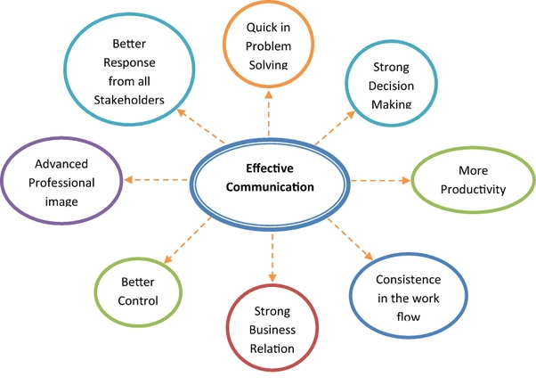

Figure: Role of Communication in Building Effective Teamwork
(Nancarrow and Roots, 2013)

Providing Work Information: Communication is the channel to exchange information regarding work that is necessary for achieving the team goals. Effective communication increases consistency in the team performance by providing necessary information to every team member to balance between their work progress (Gayeski, 2016).
Resolving Conflict: Due to lack of communication, team conflict may arise between the team members for their interpersonal differences and diversity. Effective communication resolves team conflict by strengthening their team bonding and creating team commitment between the members.
Creating New Ideas: Communication exchanges knowledge and suggestions for creating new ideas to increase team performance and productivity through collaborative interaction in the team (Gayeski, 2016). Exchange of ideas among the team members builds a trustworthy team environment and strengthens the loyalty of team members.

Conclusion
Teamwork increases effectiveness and productivity by exchanging skills and knowledge of one employee with the others. Teamwork increases motivation and belongingness in the organisation by satisfying the social needs of the employees. The employees of O2 need to practice teamwork in the operational activities to increase their productivity and quality of work performance. Teamwork not only reduces the workload but also creates a friendly environment where the employees feel enthusiastic to enjoy their work. The most effective theory of developing effective team in the workplace is the team development theory given by Bruce Tuckman. Effective teamwork is dependent on effective communication. Communication is not only important for developing a strong relationship between the workforce and the management but also to exchange important information to enable every employee and professionals to perform their activities with full efficiency.

References
Anderson, N. & West, M.A. (2017) Measuring climate for work group innovation: development and validation of the team climate inventory: Vol 19, 235 – 258.
Baumeister, R.F,(2015) The need to belong desire for interpersonal attachments as a fundemental motivator, 117, 497-529.
Butchibabu, A., Sparano-Huiban, C., Sonenberg, L. and Shah, J., 2016. Implicit coordination strategies for effective team communication. Human factors, 58(4), pp.595-610.
Choi, SY., Lee, H., Yoo, Y. – MIS quarterly, (2010) – JSTOR: The Impact of information technology and transactive memory systems on knowledge sharing, application and team performance: a field study.
Deering, S., Johnston, L.C. and Colacchio, K., 2011, April. Multidisciplinary teamwork and communication training. In Seminars in perinatology (Vol. 35, No. 2, pp. 89-96). WB Saunders.
DeChurch, L.A. and Mesmer-Magnus, J.R., 2010. The cognitive underpinnings of effective teamwork: a meta-analysis. Journal of applied psychology, 95(1), p.32.
Gayeski, D. (2014). “Professional communication: Will it emerge or evaporate?” Communication World. P. 48-90.
Gayeski, D. (2016). “Integrated communication systems”
Nancarrow, S.A., Booth, A., Ariss, S., Smith, T., Enderby, P. and Roots, A., 2013. Ten principles of good interdisciplinary team work. Human resources for Health, 11(1), p.19.
Pfrimmer, D., 2009. Teamwork and communication. The Journal of Continuing Education in Nursing, 40(7), pp.294-295.
Robinson, L., Segal, J., Smith, M. (2016). Effective Communication Skills.

