Evans Quartey-Tackie (2318850)
2318850@student.uwtsd.ac.uk
Data warehousing
Component 1
10th July 2026
Module Code: ACCA5026
Lecturer: MD Abrar Jahin Almazi Bipon

Contents
Introduction 5
TASK 1 6
1.1 OLTP vs Data Warehouse 6
1.2 Data Warehouse Architecture and ETL 7
1.3 Data Marts for Management Decision-Making 8
1.4 OLTP Normalisation vs. Data Warehouse Dimensional Modelling 9
TASK 2 10
2.1 Source System Identification 10
2.2 Star Schema Design 10
2.3 Data Marts and Schema 13
2.4 ETL Plan 14
2.5 Data Quality and Governance 14
Conclusion 15
Bibliography 16

Figure 1 - Comparison Between OLTP Systems and Data Warehouse in NHS England 6
Figure 2 - NHS Data Warehouse Architecture 7
Figure 3- Simplified ETL Process 8
Figure 4- Proposed NHS England Data Marts for Senior Management Decision-Making 9
Figure 5- Star Schema for NHS Patient Activity 10
Figure 6 - Shared Dimension Table 11
Figure 7- Patient Attendance Star Schema 12
Figure 8 - Monthly Performance Star Schema 12

Introduction

NHS England manages large volumes of patient, clinical, operational, workforce and financial data across hospitals, community providers, specialist services and Integrated Care Systems. However, much of this data is held in separate systems such as EPR, PAS, workforce and finance platforms, which limits national visibility of performance, capacity, cost and quality. This report proposes a data warehousing solution to integrate these fragmented sources into a trusted analytical platform. It explains the difference between OLTP systems and data warehouses, outlines a suitable architecture and ETL process, designs management data marts and star schemas, and considers data quality and governance. The aim is to support evidence-based decisions, improve patient flow, strengthen workforce and financial planning, and improve care quality.

TASK 1

1.1 OLTP vs Data Warehouse

In NHS England, OLTP systems run daily care, while a data warehouse turns system-wide data into insight. Electronic Patient Records (EPR), Patient Administration Systems (PAS), workforce systems and finance systems are examples of OLTP platforms. They capture and update transactions such as admissions, appointments, clinical procedures, staff shifts and payments. Their priority is speed, accuracy and reliability, because frontline staff need current records to deliver safe care [1] [1].
A data warehouse has a different purpose. It is not used to record live clinical transactions. Instead, it extracts copies of data from operational systems, cleans and combines them, stores historical data and structures it for reporting, analysis and decision support [1]. OLTP systems answer immediate operational questions, such as whether a patient has been admitted or which staff member is on duty. A data warehouse answers board-level questions, such as which regions have the longest waiting lists, where bed occupancy is highest, how performance changes over time, and how staffing levels affect cost, quality and patient outcomes.
This distinction matters because NHS data is often spread across separate local systems. These systems are effective for recording individual events, but they are less suitable for complex national analysis, historical trend reporting and cross-regional comparison [3] [2], [4]. A healthcare data warehouse would consolidate patient, clinical, workforce and financial data into a single trusted analytical platform. This would help the CEO and board monitor performance, identify pressure points, compare regions consistently, support resource planning, improve quality of care and make evidence-based decisions without overloading frontline OLTP systems [4], [5] [3].
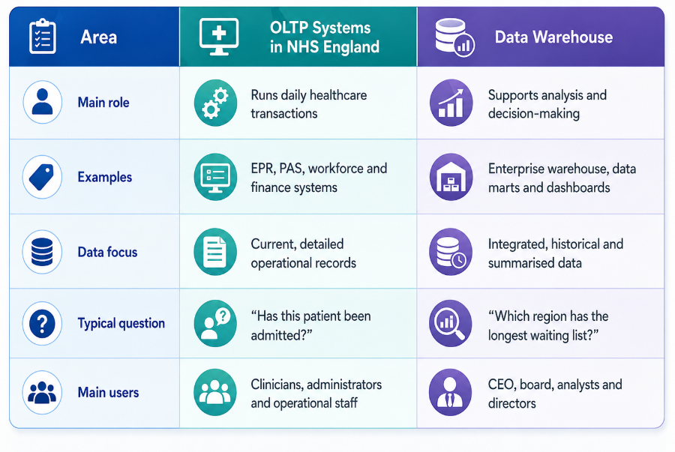
Figure 1 - Comparison Between OLTP Systems and Data Warehouse in NHS England

1.2 Data Warehouse Architecture and ETL

For NHS England, the data warehouse should sit above existing operational systems rather than replace them. Hospitals, community providers and national teams would continue using Electronic Patient Records, Patient Administration Systems, workforce systems and finance platforms for daily work. The warehouse would receive controlled copies of data from these systems and combine them into one structured environment for analysis [1] [4], [2].

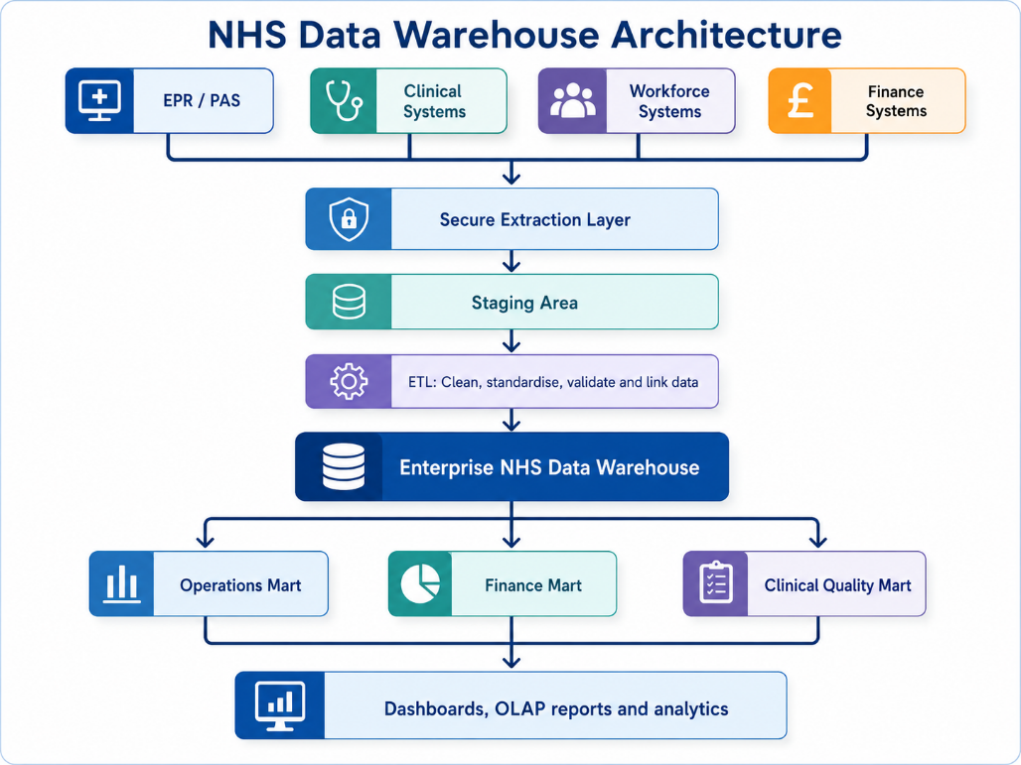
Figure 2 - NHS Data Warehouse Architecture

The source systems would provide different types of NHS data. EPR and PAS systems would supply patient activity data such as NHS number, admissions, discharges, diagnoses, procedures and referral-to-treatment times. Clinical systems would add information on diagnostic tests, theatre activity, prescribing and outcomes. Workforce systems would provide rosters, sickness absence, overtime, vacancies and agency usage. Finance systems would provide budgets, tariffs, expenditure and cost per patient episode. Once integrated, NHS England could examine issues that are difficult to see in separate systems, such as whether delayed discharges are linked to bed pressure, staffing shortages or higher treatment costs [5].

The ETL process stands for Extract, Transform and Load. First, data is extracted from source systems using secure read-only connections. Second, it is transformed by removing duplicates, correcting errors, standardising dates, mapping clinical codes such as ICD-10 or SNOMED CT, and linking records to common patient, provider, specialty and time dimensions . Third, the cleaned data is loaded into the enterprise warehouse and then made available through subject-specific data marts [5].
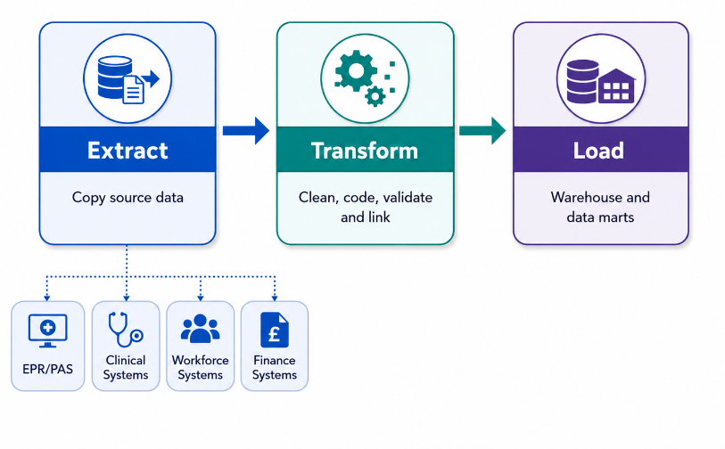
Figure 3- Simplified ETL Process

This design should reassure the CEO and board because live systems remain the official systems of record. Doctors, nurses, administrators and finance staff would continue using EPR, PAS and other systems as normal. The warehouse would use scheduled or incremental data loads, often outside peak hours, so analytical reporting does not slow frontline systems. This allows NHS England to gain national insight into patient flow, workforce capacity, financial performance and quality of care without disrupting daily healthcare operations [6].

1.3 Data Marts for Management Decision-Making

A data mart is a focused part of the wider data warehouse designed for a specific group of users. For NHS England, the enterprise warehouse would hold integrated patient, clinical, workforce and financial data, while data marts would provide tailored views for senior leaders. This allows each director to receive relevant information without losing consistency across the organisation.
The Chief Executive’s data mart should provide a strategic, system-wide view of NHS performance. It would combine data from EPR, PAS, bed management, workforce, finance and quality systems. Key measures would include bed occupancy, emergency admissions, discharge delays, elective waiting lists, referral-to-treatment times, workforce pressure, readmissions and mortality indicators. These measures should be analysed by time, NHS region, Integrated Care System, provider, specialty and care pathway. This would help the Chief Executive identify national pressure points, compare regional performance and prioritise support for areas experiencing capacity problems [7].
The Finance Director’s data mart should focus on cost, budget control and efficiency. It would use finance, costing, PAS, theatre and workforce data. Key measures would include treatment cost, cost per patient episode, budget variance, tariff income, agency staffing cost, theatre utilisation and expenditure by specialty [8]. This mart would allow the Finance Director to compare financial performance across providers, identify high-cost pathways and assess whether operational pressures, such as delayed discharges or agency staffing, are increasing costs.
The Medical Director’s data mart should focus on clinical quality, safety and outcomes. It would use EPR, PAS, incident-reporting, infection-control, complaints and patient feedback data. Key measures would include readmission rates, mortality indicators, infection rates, complications, patient safety incidents, length of stay and patient satisfaction [9]. These measures should be analysed by diagnosis, procedure, specialty, provider, patient group and time period. This would help the Medical Director identify clinical variation, monitor patient safety and target quality improvement programmes .
All three data marts should share common dimensions, such as Date, Provider, Specialty, Patient Group and Region. This ensures that the CEO, Finance Director and Medical Director receive tailored insights while relying on the same trusted data definitions.
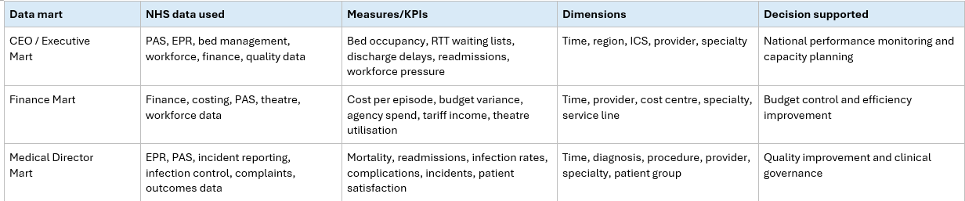
Figure 4- Proposed NHS England Data Marts for Senior Management Decision-Making

1.4 OLTP Normalisation vs. Data Warehouse Dimensional Modelling

Normalised OLTP structures and dimensional warehouse models are designed for different purposes. In NHS operational systems such as EPR and PAS, data is usually normalised into many related tables, for example separate patient, admission, ward, consultant, treatment and invoice tables. This reduces duplication, improves data integrity and supports fast updates to individual records. It is suitable for live care because staff need accurate current records when registering patients, recording treatments or updating discharge details [10].
However, the same structure is less suitable for strategic analysis. Board-level questions, such as average length of stay by region, specialty and month, may require many joins across large operational tables. This can make reporting complex if run directly against live systems. A data warehouse therefore uses dimensional modelling. In a star schema, a central fact table stores measurable events, while surrounding dimension tables describe the context [11]. For NHS England, Fact_Patient_Activity could store measures such as length of stay, waiting time, bed days, treatment cost and readmission flag. It would link to dimensions such as Dim_Patient , Dim_Treatment , Dim_Location and Dim_Time . This design is easier for managers and analysts to understand because they can analyse facts by patient group, treatment type, hospital, ICS region and reporting period.
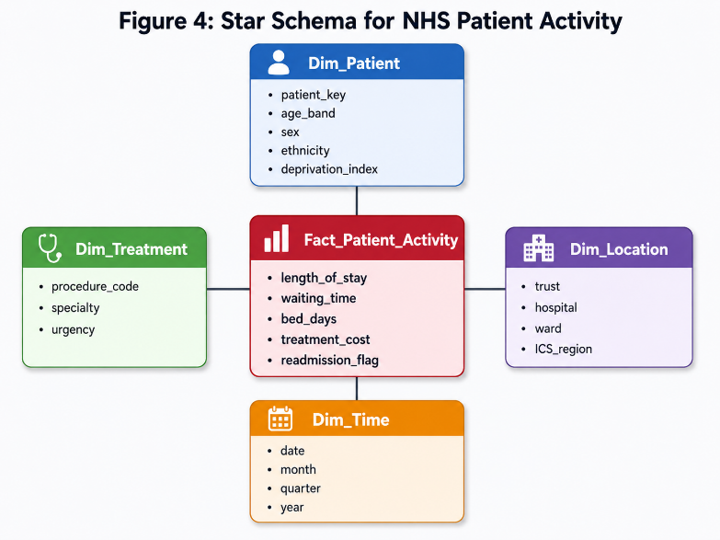
Figure 5- Star Schema for NHS Patient Activity

The key difference is that OLTP normalisation is update-focused, while dimensional modelling is analysis focused. The warehouse does not replace normalised EPR or PAS databases; it restructures copied data into a simpler model for faster reporting, trend analysis and cross-regional comparison.

TASK 2

2.1 Source System Identification

NHS England’s data warehouse should be fed by both internal and external data sources. Internal sources should include Electronic Patient Records and Patient Administration Systems for patient demographics, admissions, discharges, diagnoses, procedures and waiting times. Clinical systems such as pathology, radiology, pharmacy, theatre and emergency department systems would provide tests, treatments and outcomes. Workforce and rostering systems would supply staffing levels, sickness, vacancies, overtime and agency usage, while finance and costing systems would provide budgets, tariffs, expenditure and cost per patient episode. Other internal feeds should include bed management, incident-reporting and patient-feedback systems.
External sources could include Office for National Statistics demographic data, public health datasets, deprivation indices, CQC ratings, national tariffs and benchmarking datasets to support wider performance comparison [12].

2.2 Star Schema Design

An appropriate design for an NHS data warehouse is a star schema constellation, also called a bus architecture. This means that several star schemas are used, with each fact table representing a different NHS business process. Shared dimensions are conformed, meaning they have the same keys and definitions across the warehouse. This allows analysis across patient activity, staff resources and monthly performance indicators.
Shared Dimensions

The warehouse would include several master data and metadata dimensions. Dim_Patient stores patient master data, including patient_key as the surrogate primary key, pseudonymised NHS number, date of birth, gender, ethnicity, postcode area, registered GP practice, valid_from, valid_to and is_current. This should be a Type 2 slowly changing dimension so that historical changes, such as a patient moving GP practice, are preserved.
Dim_Staff stores staff master data such as staff_key, staff ID, role, grade, specialty, department and employment type. Dim_Organisation stores NHS organisational master data, including org_key, ODS code, trust name, site name, region and Integrated Care Board. Dim_Service_Type is a metadata dimension containing service code, service name, care setting and specialty group, such as A&E, outpatient, inpatient, diagnostic or community services. Dim_Date stores date metadata such as day, month, quarter, financial year, weekend flag and bank holiday flag. Dim_Diagnosis stores clinical metadata such as ICD-10 code, diagnosis description, chapter and body system.
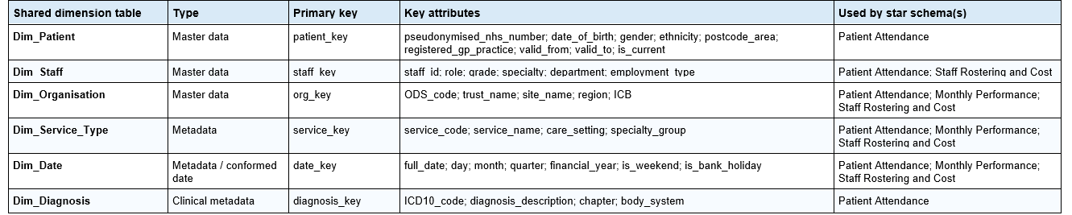
Figure 6 - Shared Dimension Table

Star Schema 1: Patient Attendance

The first star schema is centred on Fact_Attendance. Its grain is one row per patient encounter or appointment. It links to Dim_Patient, Dim_Staff, Dim_Service_Type, Dim_Organisation, Dim_Date and Dim_Diagnosis. The fact table contains foreign keys such as patient_key, staff_key, service_key, org_key, appointment_date_key, discharge_date_key and diagnosis_key. Dim_Date acts as a role-playing dimension because it is used for both appointment date and discharge date. Measures include wait_time_minutes, length_of_stay_days, did_not_attend_flag, was_seen_flag and treatment_cost.
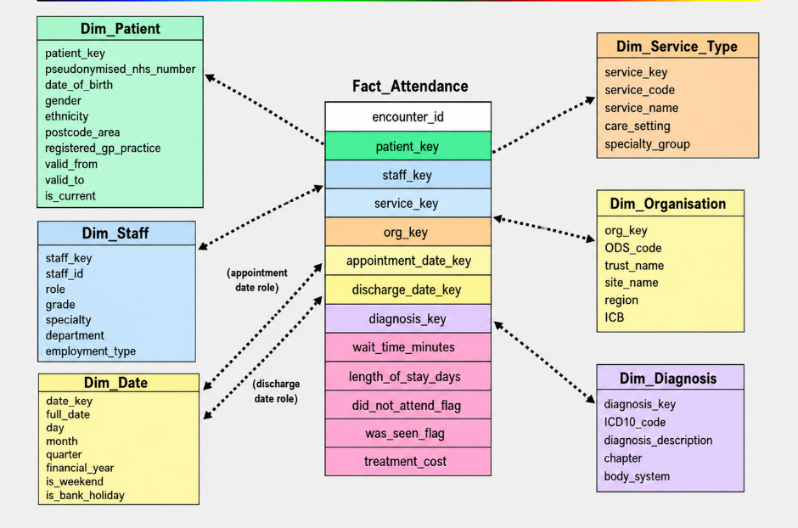
Figure 7- Patient Attendance Star Schema

Star Schema 2: Monthly Performance Indicators

The second star schema is centred on Fact_Monthly_Performance. Its grain is one row per organisation, service type and month. It links to Dim_Organisation, Dim_Service_Type and Dim_Date. This is an aggregate fact table used for performance dashboards. Measures include total_attendances, average_wait_time, percentage_seen_within_4_hours, 18_week_RTT_percentage, DNA_rate, bed_occupancy_rate and total_cost.

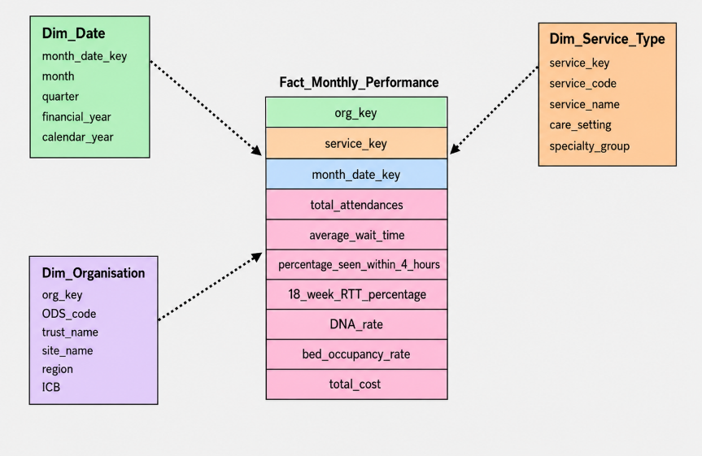
Figure 8 - Monthly Performance Star Schema

Star Schema 3: Staff Rostering and Cost

The third star schema is centred on Fact_Staff_Shift. Its grain is one row per staff member per shift. It links to Dim_Staff, Dim_Organisation, Dim_Service_Type and Dim_Date. Measures include hours_worked, overtime_hours, bank_or_agency_flag and shift_cost. This supports workforce planning and cost analysis.
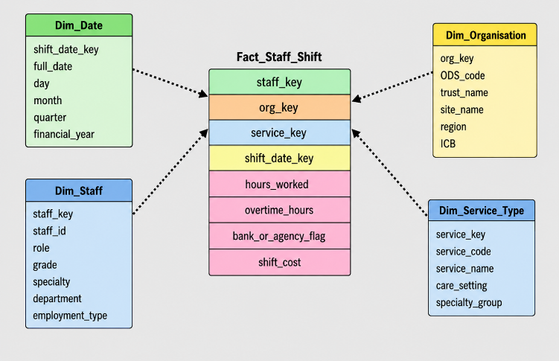
Figure 9 - Staff Rostering Star Schema

This design is suitable because each fact table has a clear grain and avoids mixing transactional and aggregate data. Conformed dimensions allow cross-schema analysis, such as comparing staff costs with attendance volumes or monthly waiting-time performance. Surrogate keys improve consistency, aggregate facts improve dashboard speed, and pseudonymised patient data supports confidentiality.

2.3 Data Marts and Schema

NHS data marts are departmental subsets of the wider data warehouse. They reuse conformed dimensions such as Date, Organisation, Service Type, Patient and Staff, but expose different fact tables and KPIs for departmental decision-making [13].

Data mart | Schema and data contained | Decision-making supported
Finance Mart | Uses a star schema with fact tables such as Fact_Financial_Performance, Fact_Attendance and Fact_Staff_Shift. Data includes treatment cost, staff cost, agency spend, procurement spend, claims, payments, budget variance and cost per episode. Dimensions include Date, Organisation, Department, Cost Centre, Service Type and Patient Class. | Supports budgeting, cost control, financial planning, service-line profitability and monitoring the cost impact of activity and quality.
Operations Mart | Uses Fact_Attendance, Fact_Monthly_Performance, bed-day facts or waiting-list facts. Data includes attendances, waiting times, length of stay, DNA rates, bed occupancy, patient turnover and service utilisation. Dimensions include Date, Organisation, Service Type, Location, Patient and Staff. | Supports capacity planning, waiting-list management, bed flow, demand forecasting and operational performance monitoring.
Clinical Quality Mart | Uses encounter, diagnosis, procedure, laboratory or quality-event fact tables. Data includes readmissions, mortality, infection rates, incidents, complications, diagnoses, procedures, prescribing and patient outcomes. Dimensions include Patient, Diagnosis, Procedure, Provider, Date, Organisation and Service Type. | Supports clinical governance, safety monitoring, pathway improvement, outcome reporting and quality assurance.
Workforce Mart | Uses Fact_Staff_Shift. Data includes hours worked, overtime, sickness, vacancy rates, bank/agency use, staff grade, role, department and shift cost. Dimensions include Staff, Date, Organisation and Service Type. | Supports rota planning, workforce efficiency, staffing-demand comparison and control of overtime or agency costs.

These marts link back to the earlier NHS star schema design because they share the same conformed dimensions while giving each department fast, focused and relevant analytics.

2.4 ETL Plan

A simplified ETL plan should extract data from fragmented NHS systems, transform it into a common dimensional schema using standard identifiers and clinical codes, and load validated dimension and fact tables on a scheduled, auditable basis [14].

Target table | Main source systems | Practical ETL transformations before loading
Dim_Patient | EPR, PAS, GP registration systems | Deduplicate patients; validate and pseudonymise NHS number; standardise gender, ethnicity, postcode and GP practice. Apply Type 2 history for address or GP changes.
Dim_Staff | HR, payroll, rostering systems | Standardise staff IDs, job roles, grades, departments, specialties and employment type.
Dim_Organisation | PAS, NHS ODS/reference data | Map trusts, hospital sites, regions and Integrated Care Boards to standard ODS organisation codes.
Dim_Service_Type | PAS, EPR, service catalogues | Standardise service names and codes such as A&E, inpatient, outpatient, diagnostic and community care.
Dim_Date | ETL-generated | Generate calendar dates, months, quarters, financial years, weekend flags and bank holiday flags.
Dim_Diagnosis | EPR, clinical coding systems | Validate and standardise ICD-10 diagnosis codes, descriptions, chapters and body systems.
Fact_Attendance | PAS, EPR, A&E, theatre systems | Match each encounter to patient, staff, service, organisation, date and diagnosis keys. Calculate waiting time, length of stay, DNA flag and treatment cost.
Fact_Staff_Shift | Rostering, HR, payroll systems | Link shifts to staff, organisation, service and date keys. Calculate hours worked, overtime, bank/agency flag and shift cost.
Fact_Monthly_Performance | Loaded warehouse facts, performance systems | Aggregate monthly attendance, waiting-time, RTT, DNA, bed occupancy and total cost KPIs by organisation and service type.

This plan is practical because it shows where each warehouse table is sourced from, what cleaning or standardisation is required, and how transactional NHS data is transformed into dimensions, detailed facts and monthly aggregate facts.

2.5 Data Quality and Governance

Data quality and governance are essential because NHS warehouse outputs affect patient care, finance and national performance decisions. During ETL, data should be profiled, deduplicated, validated and standardised using common NHS numbers, ODS codes, ICD-10/SNOMED CT codes and service definitions. Patient data should be pseudonymised, encrypted and protected through role-based access control. Ongoing governance should ensure UK GDPR and NHS information governance compliance, with audit logs, data lineage, ownership, access reviews and monitoring of accuracy, completeness, consistency and timeliness.

Conclusion

Overall, a data warehouse would allow NHS England to turn fragmented operational data into consistent, historical and decision-ready information. By integrating EPR, PAS, clinical, workforce and finance data, the warehouse would support national analysis without disrupting frontline systems. The proposed data marts, dimensional models and star schemas provide tailored insight for executives, finance teams, clinical leaders and operational managers. A controlled ETL process, supported by strong data quality checks, pseudonymisation, access control and governance, would ensure the warehouse remains accurate, secure and compliant. This solution would help NHS England monitor performance, identify pressure points, allocate resources more effectively and support long-term improvements in patient care and service sustainability.

Bibliography

[1] | E. A. Sheta. O, “The technology of using a data warehouse to support decision-making in health care,” ArXiv, 2013.
[2] | C. a. M. M. Ledbetter, “Toward best practice: leveraging the electronic patient record as a clinical data warehouse.,” Journal of healthcare information management : JHIM, vol. 15, no. 2, pp. 119-131, 2001.
[3] | D. e. a. Cheng-Zarate, “Creating a data warehouse to support monitoring of NSQHS blood management standard from EMR data.,” BMC Medical Informatics and Decision Making, vol. 24, 2024.
[4] | K. T. e. a. Ivanovski, “Building a healthcare data warehouse: considerations, opportunities, and challenges." Frontiers in Digital Health,” vol. 7, 2025.
[5] | S. e. a. Lyu, “The development and use of data warehousing in clinical settings: a scoping review,” Frontiers in Digital Health, vol. 7, 2025.
[6] | S. e. a. Priou, “Where have my patients gone?': A simulation study on real-world data processing in Clinical Data Warehouses.,” Health Policy and Technology, 2024.
[7] | J. O. B. O. C. R. O. A. W. &. O. C. A. Arowoogun, “A comprehensive review of data analytics in healthcare management: Leveraging big data for decision-making,” World Journal of Advanced Research and Reviews., 2024.
[8] | L. J. C. N. P. R. &. P. U. Basile, “Business intelligence in the healthcare industry: The utilization of a data-driven approach to support clinical decision making.,” Technovation, 2022.
[9] | N. K. M. S. W. W. &. C. E. Darach, “Data Analytics and Administrative Decision-Making in Nursing Management: A Systematic Review,” Journal of Nursing Management, 2025.
[10] | M. R. P. S. P. A. J. K. C. S. T. K. Y. &. N. F. Fischer, “BCNF* - From Normalized- to Star-Schemas and Back Again,” Companion of the 2023 International Conference on Management of Data., 2023.
[11] | H. F. G. A. M. B. &. L. N. Akid, “Performance of NoSQL graph implementations of star vs. snowflake schemas.,” IEEE Access, 2024.
[12] | L. A. N. G. J. E. M. G. C. L. J. R. R. D. D. M. M. F. R. &. R. R. Mcvey, “Hidden labour: the skilful work of clinical audit data collection and its implications for secondary use of data via integrated health IT.,” BMC Health Services Research, 2021.
[13] | N. &. A. J. Arfaoui, “A New Approach to Generate Hospital Data Warehouse Schema.,” Hospital Management and Emergency Medicine., 2016.
[14] | B. Z. F. O. N. &. F. S. S. Ozaydin, Healthcare Research and Analytics Data Infrastructure Solution: A Data Warehouse for Health Services Research., (2020).

