  LOCATION Swansea | LLEOLIAD abertawe
LEVEL 4 | LEFEL 4
EXAMINATION PERIOD | CYFNOD ARHOLIADAU
may 2016 | mai 2016

MODULE CODE: M4X01123
IP INTERNETWORKING
TIME: 2 HOURS
answer Three quESTION out of Four

Equipment or materials required – None
Adnoddau neu ddefnyddiau sydd eu hangen - Dim

ANSWER THREE QUESTION OUT OF FOUR

  - With reference to routing loops;
    - What are the conditions that can lead to routing loops?
    - How routing loops can impact network performance includes?
(8 marks)

  - Define Zinn’s three routing principles. (9 marks)

  - Define a Metric and list the metrics used in IP routing protocols. (8 marks)

  - Link state routing protocols:
    - What are the requirements for using a link state routing protocol? (6 marks)
    - What are the two link state routing protocols used in IP routing? (4 marks)

  - Explain OSPF packet types. (10 marks)

  - What is the purpose of TTL filed in an IP header and how it works? (5 marks)

  - A small network has been set up as shown in figure 2. You are asked to configure a suitable routing that gives you full control of path selection.
    - Which routing you would configure? (2 marks)
    - List advantages and disadvantages of your choice of routing. (6 marks)
    - Write the full commands to establish end-to-end connectivity. (4 marks)

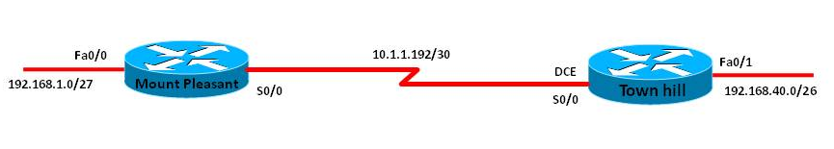
Figure 2

  - Compare classful and classless routing protocols (8 marks)
  - With examples explain interior and exterior gateway routing protocols. (5 marks)

  - Compare link state and distance vector routing protocols. (8 marks)

  - Refer to partial output shown in figure 3 answer the following:
    - Which routing protocol is configured on router R1? (1 mark)
    - What are the remote networks learned by R1 using the
protocol? (3 marks)
    - For each remote networks list the metric used by the protocol.
(3 marks)

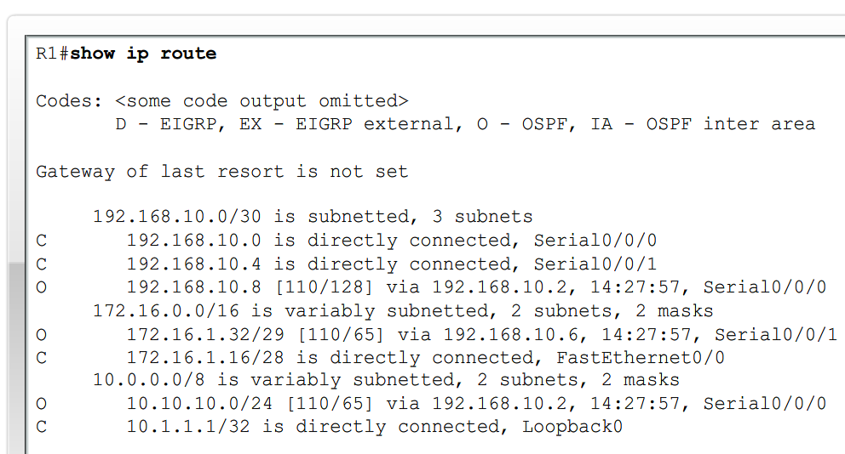
Figure 3

  - What is the purpose of Administrative Distance? Write the AD value for protocols listed below
    - Connected interface
    - Static
    - Default
    - EIGRP
    - OSPF
    - RIP
    - Unknown (10 marks)

