Situated Sustainability, Objects of Connection and Theories of Transitional Object Attachment
Michael Brown
1811768
BA part time design craft
Independent enquiry ADDA6006
Word count: 5197
Supervisor: Rhian Haf
How can makers use objects to promote probe and provoke an emotional response and sentimental connections through transference theory and does this develop an individual’s understanding of aesthetic design.

This assignment delves into the fascinating intersection of theories on subdued actions, creative inspiration, and the hyperreal, examining their potential applications in art and object interaction. As I explore these theories and their practical implications, I aim to uncover insights into how an object can provoke emotions, challenge perceptions, and improve our understanding of the world through objects and creative expression. Semiotics, ethics, and autonomy are additional concepts I would like to consider in this context. Emotional connections and sentimentality stem from emotional connections and aim to evoke sentiments and resonate with people personally.

The concept of "subdued actions" Lucy Suchman (2007, p.69) suggests, is that human behaviour is not always overt or explicit but can be subtle and indirect. How do these subdued actions manifest in the art world, and how can artists utilise them to communicate emotions, provoke thought, or engage with their audience (Suchman, 2007, p. 69).

There are various elements that bring an object’s aura to life. Benjamin (1935) describes this as the unique presence. These include Sentimentality, which is the quality of being excessively or overly emotional, especially in relation to objects, places, or memories. Authenticity is the quality of being genuine, original, or true, especially in relation to artistic expression, cultural identity, or personal values. The Welsh word hiraeth has no exact equivalent in English., but it refers to a deep longing or nostalgia for a home (Crossley-Baxter 2021); cultural appropriation is the act of taking or using elements from another culture, especially without proper respect, understanding, or consent. Semiotics is the study of signs, symbols, and meanings, especially in relation to communication, representation, and interpretation. Ethics is the branch of philosophy that deals with moral principles, values, and judgments, especially in relation to human actions and interactions.

Autonomy is the quality of being self-governing, independent, or free, particularly concerning individual rights, choices, and creativity. I experienced a sense of Hiraeth for my previous home; I missed the convenience of its location, the three bathrooms, and most notably, the roomy garage. Currently, I have three small 8 x 6 sheds, which, to a lesser extent, represent a loss. However, if I were to lose my sheds, I would feel nostalgia for those spaces which embody a remembrance of a place I once occupied.

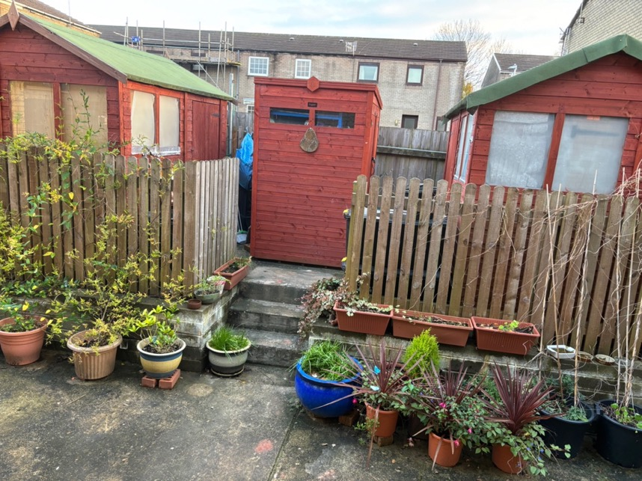
Fig.1 Sheds (2023)

In the ordinary course of life, I may not sense this longing, but with the passage of time and the effects of weather on my humble sheds, the day will come when they are gone. At that moment, nostalgia will envelop me, and a profound sense of sentimentality will usher in Hiraeth again.

These concepts are interrelated and can be applied to various aspects of art and design, such as the creation, appreciation, and criticism of artworks. This research will explore how sentimentality, authenticity, and hiraeth influence chosen materials, techniques, and themes in ceramic art, and how they affect the emotional response and connection of the viewer and the object’s Aura. Furthermore, this will examine how cultural appropriation can be a source of inspiration or controversy in art and how this can be avoided or addressed within the work. Additionally, this research will analyse how semiotics, ethics, and autonomy are involved in the use of technology in art, such as AI, VR, and 3D, and how they challenge or enhance the traditional notions of artistic expression, attraction, value, and identity.

Having a background in conservation, I have always been passionate about establishing a profound connection between objects and places through my work. I find myself drawn to the idea of using local, wild clay from an open-cast mine, as it allows me to tap into the rich emotional connection of human sentimentality and nostalgia. I believe that the concepts of sentiment, authenticity, and hiraeth may be universal and can be appreciated by people from diverse cultures and backgrounds. However, according to Anna LeMind (2021) In people with the hearts of old souls resides an unparalleled understanding of Hiraeth, a sentimentality that transcends time and space. These individuals, attuned to the whispers of nostalgia and veiled melancholy, navigate the intricate tapestry of their past with a tender, sentimental touch. According to the tenets of New Age spirituality Joy (2022) there’s no one true way to pursue spiritual enlightenment, old souls possess an innate intuition, a profound connection with their inner selves, and a recollection of past lives. For those who resonate with these beliefs, Hiraeth becomes a sentimental bridge to the echoes of previous reincarnations. In this realm, Hiraeth manifests as a poignant yearning for the cherished places that once cradled the essence of home or homeland, the faces that comprised a familial tapestry, and the cherished moments woven into the fabric of past lives. It stands as a testament to the sentimental depths of emotion, offering just one lens through which to view this complex emotional state (LeMind, 2021).

Delving further into the logic of this sentiment, an individual embodying the characteristic of an old soul emerges as a sentimental, deep-thinking introvert—a soul that contemplates with depth, dreams with sentimentality, and navigates the abstract realms of thought with a sentimental touch. These individuals are no strangers to the subtle dance of sentimentality, often finding themselves immersed in a sentimental pensiveness, a wistful reflection on past chapters, and an intimate retreat into the realms of sentimental fantasy (LeMind, 2021).

Unsurprisingly, within the sentimental core of old souls, an indescribable yearning for imaginary realms, sentimental landscapes, and sentimental faces blossoms. Their past, overanalysed and sentimentalised, becomes a source of sentimental nostalgia—a sentimental homage to the homes once inhabited and the experiences once cherished (LeMind, 2021). This emotional state, a sentimental pilgrimage through the recesses of memory, is a sentiment all share at some point in life. Yet, many still need to learn its name. The quintessential example of Hiraeth, a sentiment brimming with nostalgia, emerges when gazing into the starry sky—a celestial display that elicits an unexplainable sentimental longing. In the vast expanse of the night sky, the stars, though distant, evoke a sentimental calling. Is it the sentimental cry of a lost homeland reaching across galaxies, or perhaps the sentimental whispers of stardust rekindling a timeless connection with the universe. Thus, sentiment is familiar to all, though challenging to articulate.

Within my ceramic art, these notions play a central role, leading to contemplation on the intricate subject of cultural appropriation through inspirational influence from other cultures without first understanding their significance. How does sentiment, authenticity, and hiraeth manifest in my ceramics, and how do they enable a deep connection between objects and feelings? In watching a television show like "The Repair Shop," where people reconnect with something they have lost and found, whether it's a cherished item or a piece of their past. Each imbued with a treasure trove of memories, these items may represent a link, a tangible connection to someone who has departed and where individuals find solace and connection in items left behind by loved ones who have passed away. These objects represent a link to the past and often require restoration; such objects bear the scars of time and require restoration and renewal, much like human experiences.

This fascination with sentimentality has deep personal roots; my wife suggests that I'm not very sentimental about things; she may be right to an extent; however, I care about the environment, having a background in conservation and, by definition, of conservation to conserve habitat and natural surroundings. My son, who is autistic, has taught me about the profound attachment we can have to objects. As he's grown older and it's time to let go of certain things like toys and outgrown clothes, he has insisted on keeping them, explaining that they hold memories. This has led me to ponder the origin of such behaviours – whether learned or intrinsic to human nature – thus prompting a profound reflection on morality and the implications of human attachments. I also suspect there are cultural aspects in play.


Fig.2 Wild Clay (2023)

In my creative process, I explore techniques to imprint meaning and sustainability into my art, employing digital tools to breathe life into my creations. There is also a romantic dimension in sourcing my clay from nature, forging a close relationship with the Earth and immersing hues of the natural world, striving to infuse my work with a sense of authenticity by sourcing wild clay from past derelict former industrial locations such as the old Victorian brickwork, Bryncethin, and the Margam opencast mine.


Fig.3 Natural clay (2023)
Once abandoned and forgotten, these materials now find new life in my art, embodying the sentiment and history of the places they were unearthed from. These locations serve as poignant symbols of local and national connections; however, globally, and culturally, others may not acknowledge a significant connection.

"Hiraeth" relates to old souls and deep thinkers, who are portrayed as individuals more attuned to nostalgia and unexplained sadness. Thought to be intuitive and connected to their inner selves, potentially remembering past lives. Hiraeth, in this context, is described as a longing for the places, people, and experiences from previous incarnations. The characteristics of an old soul are equated with those of a deep-thinking introvert who is contemplative, dreamy, and inclined toward abstract thinking. These individuals often feel pensive or melancholic without a clear cause, frequently reflecting on their past and immersing themselves in fantasy worlds. The narrative portrays Hiraeth as a complex and profound sentiment tied to a deep connection with one's past, the universe, and the mysteries beyond familiar horizons.

In exploring Hiraeth, the profound sense of longing and connection to past experiences finds an unexpected counterpart in the tangible world, particularly within the confines of an abundant opencast coal mine nearby. The expansive landscape of the mine becomes a canvas for intertwining nostalgia with the physicality of clay extracted from its depths. Often immersed in contemplation and abstract thought, old souls might discover a unique resonance in working with the clay sourced from this industrial landscape. As individuals reflect on their past and feel an unexplainable yearning for places and experiences, the coal mine symbolises shared memories and the evolving present. Just as the stars in the sky evoke a longing, so does the raw material from the opencast coal mine, offering a connection to the history imprinted on its layers. Clay becomes a shared language in the communal space where people gather and connect. The clay, moulded by hands and shaped by shared experiences, bridges the gap between the ethereal realm of deep thinking and the tangible world of creative expression. The transforms of space where the emotions of Hiraeth are not only contemplated but also crafted into tangible forms.

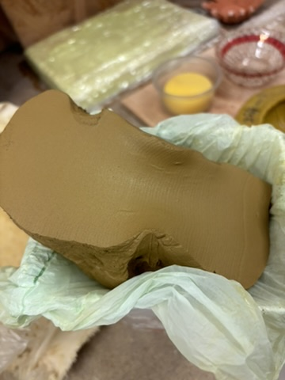
Fig.4 Natural clay body (2023)

The action of using wild clay from the opencast coal mine becomes a symbol of reclaiming and repurposing the past for present creativity. This dual connection — the emotional resonance of Hiraeth and the tangible use of clay from the industrial landscape — transforms the ordinary into a medium for expressing the intricate bonds between individuals and their surroundings. It invites us not only to reflect on our experiences but also to actively shape them, moulding the clay of the past from the depths of the mine into the artwork of the present.

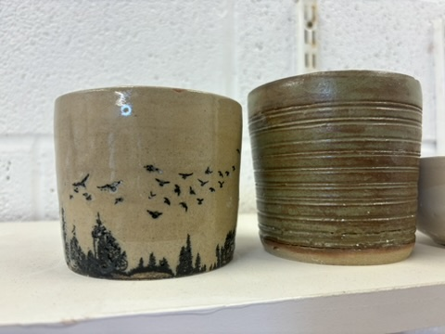
Fig.5 Pottery (2023)

Incorporating the colours of nature and working closely with the Earth and its elements enhances understanding of the materials. In a world where ecological concerns and social divisions loom large, these humble gestures of connecting with the Earth and its history are undeniably heartening. Through my work, strive to celebrate the qualities of sentiment, authenticity, and hiraeth, and in doing so, I hope to inspire a greater appreciation for the beauty of the natural world and the cultural significance of the objects that individuals or society may hold dear. At a time when environmental worries and societal conflicts are weighing heavily on human communities, these seemingly modest gestures resonate with a sense of hope and unity. For example: Matt Levy and Takuro Hitomi Shibata are ceramic artists and authors of the book Wild Clay: Creating ceramics and glazes from natural and found resources (Smith, 2023).

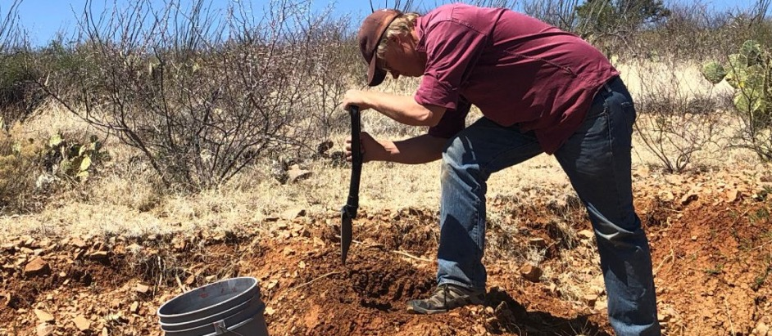Fig.6 Found clay (2023)

Although based in the US and Japan, these artists advocate for using local and natural materials to create unique and sustainable pottery and have extensive experience in the chemistry and technology of clay and glaze, as well as the art and craft of ceramics. Both artists have also collaborated with other international potters who share their vision of digging and processing their wild clay, and their work reflects individual, cultural and environmental influences.

Transference theory is rooted in psychoanalysis and delves into the unconscious redirection of emotions, desires, and expectations from one person to another, this also extends to objects. People often project their unresolved feelings onto objects, imbuing them with emotional signification. This emotional transference occurs due to past experiences or associations. For example, a particular chair may evoke feelings of comfort and security, reminiscent of a childhood home, while a piece of art resonates with personal values, becoming a canvas for self-expression (Bretherton, 1992, pp.759-775).

Objects, under the lens of Transference Theory, act as vessels for the projection of one's inner world. This is particularly relevant in today's context of environmental consciousness and sustainability, where objects crafted from eco-friendly, sustainable materials or those that remind people of the countryside landscape can trigger positive emotions and align with their desire for a greener lifestyle. Understanding environmentally conscious behaviour often involves examining the psychological factors that motivate individuals to act sustainably. One theory that might be relevant is the Value-Belief-Norm (VBN) Theory (Stern, 2000, p.407). This theory indicates that people's environmental behaviours are guided by their personal values, beliefs about the environmental impact of their actions, and their perceived ability to reduce that impact. This provides a desired connection to nature (Wilson, 1984, p.18) by understanding the emotional associations and symbolic meanings individuals may transfer onto objects on a deeper emotional level. In doing so, they enhance users' connection and engagement with these objects. Wilson (1984, p2) posits the Biophilia Hypothesis that humans have an innate desire to connect with nature. Transference theory highlights objects' profound role in reflecting and shaping our inner emotional landscape, including our commitment to values, thus being more likely to adopt environmentally friendly behaviours. Another related concept is Affordance Theory, which suggests that objects in our environment can invite or afford specific interactions based on perceptual qualities (Gibson, 1977, pp. 67-82).

In an article published on LinkedIn by Now Inks (2023), this group of academic alchemists explore the intersection of spirituality and environmental consciousness. The article discusses the emerging synergy between spirituality and ecological awareness against contemporary environmental challenges and a perceived disconnection from the natural world. It suggests that spiritual beliefs and practices can inspire a profound connection with the environment, fostering a sense of responsibility and stewardship toward the planet. The post highlights the spiritual transition between individuals and the environment and object. Many spiritual traditions emphasise the interconnectedness of all life forms, aligning with environmental consciousness by recognising that the well-being of individuals is intricately linked to the well-being of the Earth. This interconnected worldview motivates sustainable living.

Furthermore, the intersection of spirituality and environmental consciousness motivates individuals to treat the Earth respectfully. Spiritual practices, such as meditation, prayer, and rituals in nature, are presented as means to deepen the bond with the environment and increase awareness of the impact of personal actions and notes that spirituality infuses environmental activism with compassion and empathy. Rather than approaching environmental issues with anger or despair, spiritual individuals see themselves as opportunities for growth and transformation, leading to more constructive and peaceful efforts in preserving the planet.

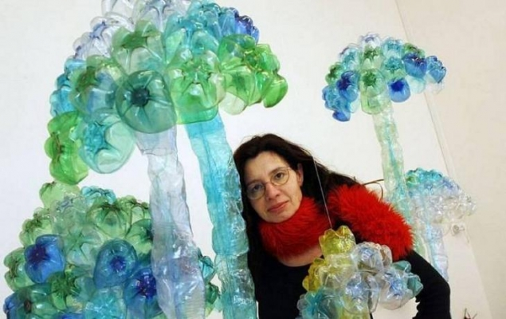
Veronika Ricthterova (2023) describes herself as a PET-art sculptor, and her work “Sacred Earth” aims to convey the intersection of spirituality and environmental consciousness. The artist uses sustainable materials and recycled elements, she crafts symbolic representations of spiritual motifs and elements from nature.
Fig.7 Sacred Earth (2023)

Ricthterova (2023) symbolism promotes “Interconnectedness” which uses Intricate designs that symbolise the influences between of all life, these are inspired by spiritual teachings emphasising oneness. Her work also focuses the use of reclaimed materials which represent renewal and transformation, which are aligned with spiritual beliefs in growth and change. Environmental Stewardship creates connections that subtly integrate elements, highlighting ecological consciousness, such as depictions of endangered species and representations of sustainable practices. The visitors to her work experience a transfer of emotions and ideas related to spirituality and environmental consciousness without explicit artist guidance. The aesthetic beauty encourages reverence for nature, while recycled materials prompt reflection on sustainability, fostering a connection between spiritual and ecological themes.

In "Harmony in Recycled Form," sculptor Tim Pugh (2019) creates sculptures integrating spiritual symbols, natural materials, landscapes, and mixed media., emphasising the unity of spiritual beliefs and environmental harmony. Symbolic design highlights unity with nature.

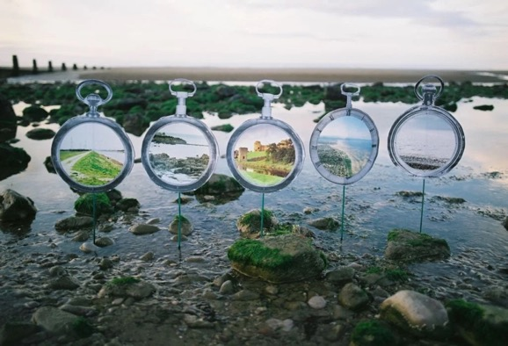
Fig.8 Harmony in Recycled Form (2019)

Each sculpture merges spiritual symbols with elements from the natural world, emphasising unity between spiritual beliefs and ecological harmony. Cycle of Life incorporates repurposed materials which represent the cyclical nature of life and the importance of sustainability in spiritual and ecological contexts. Pugh is also an activist through art and highlights environmental issues, encouraging viewers to contemplate their role in preserving the planet (Pugh, 2019). Through transference of meaning, art enthusiasts subconsciously transfer appreciation for spiritual harmony onto the sculptures. Recycled materials become a metaphor for responsible living and environmental stewardship, inspiring individuals to adopt eco-friendly practices. Richterova and Pugh are conduits for the intersection of spirituality and environmental consciousness. Their creations provide a visceral experience, fostering a deeper connection to themes of interconnectedness, stewardship, and harmony, transcending intellectual understanding.

In contrast, using digital tools in the creation of such objects raises questions about the objects’ authenticity. While AI has the potential to help create items that meet users' emotional and environmental expectations, there is a concern that the process may strip the object of human touch, potentially making it feel less authentic or genuine. The challenge for designers is to strike a balance between leveraging AI's capabilities for efficiency and customisation while preserving the authenticity and emotional resonance of the object.
This requires a thoughtful approach to design that integrates technology without compromising the emotional connection people have with the object. Transference Theory underscores the intricate relationship between individual objects and the impact of AI on their authenticity. Objects, viewed through the lens of Transference Theory, serve as conduits for projecting one's innermost sentiments and desires. This perspective gains particular significance in the contemporary era marked by heightened environmental consciousness and a growing emphasis on sustainability. Objects crafted from eco-friendly and sustainable materials evoke a positive emotional response, resonating with individuals' aspirations for a greener, more sustainable lifestyle (Smith, 2021). Furthermore, these objects may possess a unique ability to connect users with the natural world, fostering a sense of harmony and deepening their desired connection to nature (Brown, 2019). By delving into the emotional associations and symbolic meanings that individuals imbue into objects, designers can establish a profound and lasting connection with users, thereby enhancing their engagement and resonance with these items. Transference Theory offers a compelling framework to comprehend the influential role of objects in reflecting and moulding our inner emotional landscape, encompassing our commitment to values and principles (Johnson, 2020).

Sentimental beliefs play a significant role in developing attachment to objects in adulthood (Nordsletten et al., 2013 pp.229-237). Beliefs about memory also influence the presence of object attachment in older adults. If an older adult cannot find an object associated with a core memory, they may fear the loss of memory for a significant event or person. For instance, older adult concerned about forgetting aspects of their family life during their children's youth may feel compelled to retain their children's school artwork or maintain items associated with their military service to safeguard those memories (Gordon, 2013 pp.328-339). Depending on the content of the memory, these objects can provide a sense of comfort. Beliefs about beauty and concerns about wastefulness, which are commonly reported by adults with hoarding disorders (Dozier et al., 2014 pp.220-227), can also impact the normative attachment to objects in later life.

Butler et al. (1970) suggests the theory of moral sentiments, punishments, and rewards have an essential social function. Approval and reward acts benefit society; alternatively, disapproval and punishment acts to harm society. Nature has equipped cultures with appetites and aversions that promote our species' continued existence. It is almost as if an invisible hand were guiding what we do through moral guidance.

Social disease of nostalgia explores the cultural and significance of the miniature in various contexts and delves into how reduction, and fragmentation play a role in human perception of the world in art and everyday life. Susan Stewart (1993) discusses how the role of the object can evoke nostalgia, desire, and a sense of loss. She examines a wide range of subjects, from literature and art to collecting, museums, and architecture, to shed light on how people’s fascination with the small and the miniature reflects our relationship with the past, memory, and the construction of meaning. She offers an interdisciplinary exploration of the concept of longing and how it manifests in various aspects of culture and society through the lens of the miniature (Stewart, 1993).

Benjamin (1935) argued that the aura of an object is its unique presence in time and space, its authenticity and originality, and its historical and cultural significance. He claimed that the aura of an object is diminished or destroyed by the process of mechanical reproduction, such as photography, film, or printing, which creates copies that are detached from the original context and meaning of the object (Underwood, 2008, p.9). According to Benjamin, various elements bring an object’s aura to life. These include the distance between the object and the observer, which creates a sense of reverence and awe. For example, a painting in a museum or a religious icon in a temple has a more extraordinary aura than a reproduction in a book or a screen, as this is tangible (Underwood, 2008).

The duration of the object’s existence reflects its historical and cultural value. For example, an ancient artefact or a rare manuscript has a greater aura than a mass-produced item or a digital file (Benjamin p.7 1935). However, this paradigm seems to be in a period of transition. The rise of Non-Fungible Tokens (NFTs) has introduced a new perspective on the value of virtual assets in the digital realm (Kaczynski and Duke Kominers 2021), therefore providing provenance and authenticity to the tangible reality of value.

By drawing these parallels, this narrative underscores the common thread of human longing for authenticity and meaningful connections, whether in the digital realm or within the cultural and emotional dimensions of the human experience. The singularity of the object makes it irreplaceable and incomparable. For example, a handmade craft or a personal souvenir has a greater aura than a factory-made product or a generic gift (Benjamin, 1935, p.10). The trace of the object’s creator reveals the human skill and intention behind the object. For example, a painting with visible brushstrokes or a sculpture with fingerprints has a greater aura than a photograph or a 3D-printed model (Benjamin, 1935, p.5). These elements contribute to the object; however, the current position is changing. The distortion of reality in the context of advanced technologies, for example, AI, VR, and AR, uses Jean Baudrillard's (1984) concept of hyperreality and the precession of simulacra as a framework. It explores how these technologies impact our perception of reality, particularly through digital blurring the line between what is real and what is simulated, with the copy often appearing more 'real' than the original (Athes, 2019, p.176).

In the realm where digital technology blurs the boundaries between simulated reality and the tangible world, distinguishing between the two becomes a challenging endeavour. The pervasive influence of the digital realm leads to a distortion of reality, creating an environment where everything seems like a projection. This intricate illusion challenges our perception of what is genuine and what is simulated.

The perversion of reality as individuals increasingly seek refuge in virtual pleasure paradises and embrace artificial pleasures through their digital means. This trend leads to a disconnection from genuine human experiences (Athes, 2019, p.179). The convergence of AI, VR, and AR technologies intensifies this hyperreal condition, where digital avatars can mimic or surpass the depth of human relationships, challenging our traditional understanding of reality. In line with Baudrillard's (1981) theory, it explores how digital avatars contribute to the objectification and commodification of reality within digital spaces. It specifically looks at their role in eroding authentic human connections. It also considers the implications of digital invasion regarding issues like consent, exploitation, and the loss of authenticity, echoing Baudrillard's concerns about reality distortion in contemporary society (Baudrillard, 1981, pp.174-184).

However in the realm of Hiraeth, the term doesn't denote a tangible place that one can physically visit; rather, it represents a profound emotional state—a nuanced blend of longing, yearning, and nostalgia, in this sense, Hiraeth manifests in the dynamic landscape, residing in memories, desires, and the hearts of those touched by its pull. This concept of yearning for non-existent places finds resonance in the perversion of reality and the embrace of artificial pleasures through digital means. In the digital realm, individuals often seek solace in virtual realities or pleasure paradises that exist solely in the digital domain. Though intangible in the physical world, these spaces are crafted and experienced through digital mediums, akin to the essence of Hiraeth.

The holographic principle, proposed by theoretical physicist Juan Maldacena, posits that our 4D universe is a projection from information encoded on a 2D surface, suggesting a parallel with the creation of virtual spaces in the digital realm (Ananthaswamy 2022). The perversion of reality and the Hiraeth concept can be viewed as reflections of this holographic principle. The digital pursuit of virtual pleasures and the detachment from genuine human experiences also echo the yearning for authenticity, akin to the homesickness or grief associated with Hiraeth. This yearning can be interpreted as a desire for the "real" 3D universe, mirroring the holographic principle's proposition. Extending the holographic principle to object perception suggests that our perception of three-dimensional objects is a projection from information encoded on a two-dimensional surface (Ananthaswamy, 2023). In virtual realities, objects may lack physical tangibility but can be perceived and interacted with as if real, paralleling the illusion of three-dimensional objects existing in space. This dynamic deeply influences interactions with objects, particularly within virtual realities and the context of Hiraeth.

In my artistic endeavours, I also employ 3D software to envision and design sculptures, translating virtual concepts into physical reality through 3D printing. This fusion of virtual and tangible, coupled with modern tagging and exclusivity measures, allows for the creating of unique pieces that bridge the chasm between the digital and physical worlds, offering a tangible token of the virtual realm while preserving the authenticity sought in the concept of Hiraeth. The holographic principle suggests that our perception of objects as three-dimensional entities existing in space is a projection from a two-dimensional reality. This can profoundly affect how we perceive and interact with objects, especially in the context of virtual realities and the concept of Hiraeth.

This highlights the need for critical reflection on the transformative power of these technologies and calls for a nuanced understanding of the hyperreal condition. It emphasises the importance of ethical responsibility when engaging with technologies, particularly concerning using digital methods (Athes, 2019, p.179). By resisting the temptation of digital escapism and preserving genuine human connections, Athes suggests that we can navigate the distortion of reality and cultivate empathy, compassion, and meaningful interactions beyond the simulated experiences of technology. The article "The 'Scientific Simulacra': When AI and Hyperreality Collide" discusses the intersection of artificial intelligence (AI) and hyperreality, where reality and its representation become indistinguishable (Blades, pp.57-94. It highlights explicitly using AI language models, such as Chat GPT powered by GPT-3, create entirely artificial but convincingly realistic scientific articles, however this could also be applied to the creation of artwork.

AI language models, like ChatGPT, can now create convincingly realistic yet wholly artificial artwork. This phenomena extends the threshold of hyperreality beyond the visual and symbolic domains into cognitive dimensions, posing complicated philosophical question regarding truth and the role of technology. (Nosta 2023). While AI could potentially develop creativity processes, it also presents the risk of creating duplicate artwork. As human society delves deeper into this hyper realistic era, discerning reality from simulation becomes increasingly difficult. Therefore, staying vigilant and connected to underlying truths becomes more critical to navigate.

In the intricate tapestry of emotion, art, and design, explored through the lens of Transference Theory, this highlights a myriad of interconnected concepts. These theories offer a nuanced understanding of individuals’ emotional connections with objects, extending into broader discussions on sustainability, environmental consciousness, and ethical considerations in the creative process. Transference Theory, rooted in psychoanalysis, delves into the unconscious redirection of emotions and desires from one person to another, including objects. Objects become vessels for projecting feelings, notably relevant in the context of sustainability and environmental consciousness aligned with aspirations for a greener lifestyle. Complementing this, the Value-Belief-Norm (VBN) Theory examines how individuals' environmental behaviours are guided by personal values, beliefs, and perceived abilities, this highlights the emotional associations individuals transfer onto eco-friendly objects.

Furthermore, Affordance Theory suggests that objects can invite specific interactions based on their perceptual qualities, emphasising their active role in shaping behaviours and interactions, enriching discussions on emotional connections and engagements with the material world. Explored with varying perspectives, it intertwines with Transference Theory, particularly in the context of sentimentality and the aura of an object, where its acceptability hinges on a noticeable understanding of the content. As described by Benjamin, the Aura of an Object adds depth to discussions on sentimentality, authenticity, and Hiraeth—a deep longing or nostalgia for home or experiences from previous incarnations. Digital tools in design are helpful for manufacturing, improving productivity and quality, although they present challenges to the authenticity of objects. AI, VR, and 3D technologies may create an imbalance in efficiency whilst preserving emotional connections. Hyperreality explores the blurred boundaries in the digital age, intersecting with AI, and raises ethical considerations surrounding AI-generated content.

This weaves diverse concepts to explore how objects, art, and design provoke emotions and enhance our understanding of the world through Transference Theory. It encompasses psychological, cultural, and ethical dimensions, examining the intersection of emotion, art, and design. A common thread emerges—objects are not mere artefacts but vessels of emotion, carriers of sentimentality, and bridges to our past. Understanding these theories unravels the intricate web of emotions in art, design, and the human experience, challenging perceptions. The intersection of spirituality and environmental consciousness emerges as a powerful force for positive change, encouraging responsible environmental stewardship and harmonious coexistence with nature, contributing to a balanced and sustainable future.

References List

Websites

Ananthaswamy, A. (2022) Is Our Universe A Hologram? Physicists Debate Famous Idea On Its 25th Anniversary. Available at: https://www.scientificamerican.com/article/is-our-universe-a-hologram-physicists-debate-famous-idea-on-its-25th-anniversary/ [Accessed: 12 December 2023].

Ananthaswamy, A. (2023) Is Our Universe a Hologram? Physicists Debate Famous Idea on Its 25th Anniversary Available at: https://www.scientificamerican.com/article/is-our-universe-a-hologram-physicists-debate-famous-idea-on-its-25th-anniversary/ [Accessed: 12 December 2023].

Arewa, O. (2016). Cultural Appropriation: When ‘borrowing’ Becomes Exploitation. Available at: https://theconversation.com/cultural-appropriation-when-borrowing-becomes-exploitation-57411 [Accessed: 28 November 2023].
Butler, E. et al. (1970) The Theory of Moral Sentiments — Adam Smith Institute. Available at: https://www.adamsmith.org/the-theory-of-moral-sentiments [Accessed: 28 November 2023].

Crossley-Baxter, L. (2021) The Untranslatable Word That Connects Wales. Available at: https://www.bbc.com/travel/article/20210214-the-welsh-word-you-cant-translate [Accessed: 28 October 2023].

Joy, I. (2022) What Even Is New Age Spirituality. Available at: https://medium.com/change-your-mind/what-even-is-new-age-spirituality-dc382fbf7c06 [Accessed: 28 November 2023].

LeMind, A. (2021). Hiraeth: An Emotional State That Affects Old Souls And Deep Thinkers - Learning Mind. Article Available at: https://www.learning-mind.com/hiraeth-deep-thinkers/ [Accessed: 28 November 2023].

Now links, (2023) The Intersection of Spirituality and Environmental Consciousness Available at: https://www.linkedin.com/pulse/intersection-spirituality-environmental-consciousness-now-now1?trk=article-ssr-frontend-pulse_more-articles_related-content-card#:~:text=By%20recognizing%20the%20sacredness%20of,a%20harmonious%20coexistence%20with%20nature

Nosta, J. 2023. The ‘Scientific Simulacra’: When AI And Hyperreality Collide. Available at: https://www.bbntimes.com/science/the-scientific-simulacra-when-ai-and-hyperreality-collide [Accessed: 17 December 2023].

Pugh, T. (2019) Environmental Artist Available at: https://www.timpugh.co.uk/about [Accessed: 7 December 2023].

Richterova, V. 2023. My Works – Veronika Richterová. Available at: https://www.veronikarichterova.com/en/my-works/ [Accessed: 7 December 2023].

Kaczynski, S. and Duke Kominers, S. 2021. How NFTs Create Value. Available at: https://hbr.org/2021/11/how-nfts-create-value [Accessed: 12 December 2023].

Bibliography

Athes, H. (2019) Baudrillard, Sepultura and Steve Cutts' Animation. Dystopian Common Ground. Hermeneia, (22), pp. 173-180. Available at: https://theconversation.com/cultural-appropriation-when-borrowing-becomes-exploitation-57411 [Accessed: 28 November 2023].

Baudrillard, J (1984) Simulacra and Simulation, p.2, The University of Michigan Press, US

Baudrillard, J (1984) Hypermarket and Hypercommodity, pp75-79 The University of Michigan Press, US

Benjamin, W. (1935) The Work of Art in the Age of Mechanical Reproduction p7.

Blades, D. W. (2001) JOURNAL ARTICLE, Chapter Three: The Simulacra of Science Education pp. 57–94. Available at: https://www.jstor.org/stable/42976388 [Accessed: 28 October 2023].

Brown, E. 2019). Nature, Connection, and Design: A Holistic Approach. Sustainable Living Quarterly, 36(4), pp.187-203. [access date 07.11.2023]
Bretherton, I. (1992). The origins of attachment theory: John Bowlby and Mary Ainsworth. Developmental Psychology, 28(5), pp.759–775. Available at https://doi.org/10.1037/0012-1649.28.5.759 access date [01.10.2023]

Dozier, M.E. and Ayers, C.R., (2014). The predictive value of different reasons for saving and acquiring on hoarding disorder symptoms. Journal of Obsessive-Compulsive and Related Disorders, 3(3), pp.220-227. [access date 01.11.2023]

Gordon, O.M., Salkovskis, P.M. and Oldfield, V.B., (2013). Beliefs and experiences in hoarding. Journal of Anxiety Disorders, 27(3), pp.328-339. [access date 01.11.2023]

Nordsletten, A.E., de la Cruz, L.F., Billotti, D. and Mataix-Cols, D., (2013). Finders keepers: The features differentiating hoarding disorder from normative collecting. Comprehensive Psychiatry, 54(3), pp.229-237. [access date 07.11.2023]

Underwood (2008), Benjamin, W. (1935) The Work of Art in the Age of Mechanical Reproduction pp.1-12 penguin England.

Smith, A. (2021). Sustainable Design and Emotional Engagement. Environmental Journal, 45(2), 112-128. [access date 07.11.2023]

Smith, I. (2023) Crafts Council Stories Down to earth: Why more potters are making use of wild clay Craft magazine accessed date [01.10.2023]

Stern, P. C. (2000). Toward a coherent theory of environmentally significant behaviour. Journal of Social Issues, 56(3), 407-424. Available at https://www.researchgate.net/publication/236533664_Toward_a_Coherent_Theory_of_Environmentally_Significant_Behavior
Access date [05.10.2023]

Wilson, E. O. (1984). Biophilia. Cambridge, MA: Harvard University Press. E-book available at https://www.google.co.uk/books/edition/Biophilia/BapY4GLfMOAC?hl=en&gbpv=0 Access date [05.10.2023]

Gibson, J. J. (1977). The theory of affordances. In R. Shaw & J. Bransford (Eds.), Perceiving, acting, and knowing: Toward an ecological psychology (pp. 67-82).
Hillsdale, NJ: Lawrence Erlbaum Associates. Access date [05.10.2023]

Johnson, L. (2020). Transference Theory and its Application in Design Psychology. Psychological Design Review, 22(3), 245-260. [access date 07.11.2023]

Stewart, S. (1993). On Longing: Narratives of the Miniature, the Gigantic, the Souvenir, the Collection (pp. 1-212). Duke University Press,
Durham and London

Suchman, L. A. (2007). Human-Machine Reconfigurations: Plans and Situated Actions. (pp. 1-212). Cambridge University Press

Illustration

Fig.1. Brown, M. (2023) Sheds. [photograph] (owner’s collection)

Fig.2 Brown, M. (2023) Wild Clay. [photograph] (owner’s collection)

Fig.3 Brown, M. (2023) Natural clay. [photograph] (owner’s collection )

Fig.4 Brown, M. (2023) Natural clay body. [photograph] (owner’s collection)

Fig.5 Brown, M. (2023) Pottery. [photograph] (owner’s collection)

Fig.6 Ancientpottery.com (2023) found Clay [Online] Available at: https://ancientpottery.how/where-is-clay-found/

Fig.7 Richterova, V. (2023) Sacred Earth, [Online] Available at: https://www.riseart.com/guide/2282/art-world-news-tackling-the-plastics-crisis-3-artists-turning-trash-into-treasure#:~Can%20you%20change%20call%20S%20call%20S%20call%20S:text=2.-,Veronika%20Richterova,importance%20of%20recycling%20waste%20materials

Fig.8 Pugh, T. (2019). Harmony in recycled form, About | Current. [Online] Available at: https://www.timpugh.co.uk/about [Accessed: 7 December 2023].

Reading list
Bowlby, J. and Ainsworth, M., 1969. Nature of the emotional bonds. New York: Basic Books. [access date 01.10.2023]
Bowlby, J. and Ainsworth, M., 1988. Attachment theory. London: Routledge. [access date 01.10.2023]
Bowlby, J. and Ainsworth, M., 1993. The origins of attachment theory. Developmental Psychology, 28(5), pp.759-775. [access date 01.10.2023]

Kleon, A. (2012) Steal like an artist: 10 things nobody told you about being creative. New York: Workman Publishing. [access date 20.10.2023]

Hockney, D (2006) Secret Knowledge: Rediscovering the lost techniques of the Old Masters,
Thames and Huudson, London

Hockney, D. (2001) "David Hockney's Secret Knowledge." [Online] Available at: https://www.bbc.co.uk/programmes/b0074m8f (Accessed: 29 November 2023).

