I worked at HMPS Cardiff as a facilitator for 8 years, January 2017 I was promoted and secured a Teaching Role with the view of completing the PCGE (PCET) part time course. To date I have completed 703 hours of teaching and thoroughly enjoyed the teaching experience, having completed my first year of placement at HMPS Cardiff I am able to critically reflect on the overall Professional Teaching Experience which my portfolio applies to, I will do this using Gibbs Reflective Cycle (A5, K1, V3).
I gained experience observing Teachers, all using different methods of teaching. Using the lesson observation forms I reflected on each lesson, identifying what skills I would need to develop. Carrying out observations I identified different learning styles and different techniques used by the teacher to meet the needs of their learners. Each teacher had a lesson plan for their class and a class time table, this was useful for times when I covered lessons in the absence of teachers, understanding aims and objectives of the lesson. After many observations I became more confident to teach and was keen to put knowledge into practice, I began gaining experience with ‘supply teaching’, covering classes for staff leave and sickness. (A5, V3). Supply Teaching had its pros and cons for example, lesson plans and timetables were devised allowing a smooth transition, I was supplied with a rota allowing preparation, however this often changed at short notice due to unpredictable staff sickness, covering a class with very short notice was challenging as I felt unprepared and had little time to familiarise myself with the learners and the lesson plan. I believe this caused distraction to leaners as I had little knowledge of their needs, subject knowledge, learning styles and their abilities. Referring to the UK Professional Standards Framework (Annex 1) I was able to practice some ‘Areas of Activity’ A2, A3 A4 and Professional Values V1, V2 but with short notice and little time spent with the learners as ‘supply’, it was difficult to achieve ‘Core Knowledge’ standards K1, K2, K3, not knowing when I would next teach the leaners, however I remained professional and a good role model continuing to carry out the role of a teacher, facilitating learning, providing information, building a report and assessing. Again at the end of each lesson I would carry out critical reflection in order to develop my skills (A2,A3, A5, V3).
After gaining experience teaching at my placement my next task was to create a ‘Scheme of Work’ for a Parenting Class, embedding essential skills, literacy, numeracy and digital literacy, covering topics for Anger Management, Parenting Skills, Budgeting, Healthy Eating and Substance Awareness. At first the class time table was 4 weeks but as I became more confident with teaching and marking I extended the timetable another week adding more Units from the ‘Agored Cymru Criteria’, Essential skills. I created lesson plans using the Agored Cymru website (https://www.agored.cymru/) to identify appropriate and accredited units for the leaners, focusing mainly on Essential Skills. Currently I teach the following units:
- Contributions to Discussion
- Punctuation and Grammar
- Tobacco and Alcohol Awareness
- Budgeting
- Health Eating – Labels
- Working in a Team
- Food Hygiene
All Units can be achieved on Entry 1 Level to Level 1 as there is a great deal of differentiation with leaners in the classroom. To meet learner’s needs I created a ‘Portfolio’ for each Unit and Level which is used as summative assessment and evidence of the leaner achieving the Agored Cymru Assessment Criteria. (A1, K1, K2, K3, K4, K5, K6, V1, V4). I will continue to use the Agored Cymru website to develop the class timetable and include more units as I become more confident.
When creating lesson plans I set SMART objectives taking into consideration learner’s needs and goals, I selected suitable teaching methods Using Dales Cone of Experience which helped me understand learners retain more information with “experiential learning”:
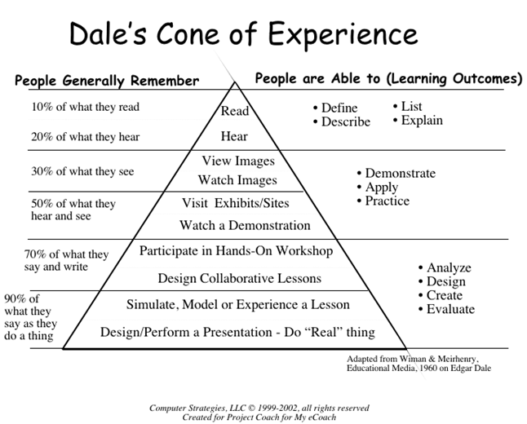

After carrying out research I considered Kolbs Learning Style Theory, using lots of Visual, Audio Kinesthetic resources and considering each learning style as this theory states ‘one prefers to learn through one of these sense channels.’ McLeod, S. A. (2017).
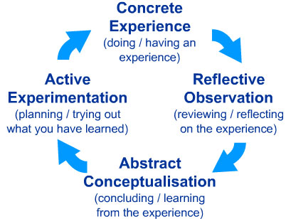

Kolbs Learning Style Theory

Also applying ‘Blooms Taxonomy’, focusing on the cognitive domain, allowing learners to progress through each stage as shown in diagram:
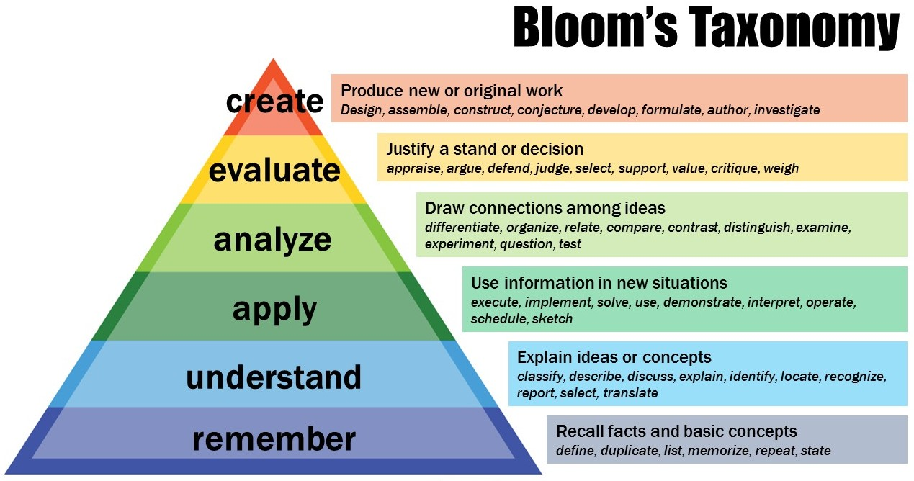

Patricia Armstrong, former Assistant Director, Center for Teaching 2017

Using all the above theories gave me a better understanding of designing a programme and how to meet the learner’s needs (A2, K2, K3, K4, K5 K6, V1, V2, V3). I would like to include a wider range of technology within the lesson such as YouTube Videos and visual aids for example a range of foods on the healthy eating lesson. In order to do this I need to gain authorisation with the establishments security team, although this may be a time consuming task I believe leaners will benefit immensely.
After devising a Scheme of Work, I was ready to put it into practice. Initial assessment took place in an ‘Induction Centre’, here they complete Literacy, Numeracy and Digital Literacy Assessments and are scored with levels varying from Pre-Entry to Level 2, they also complete the’ Do It Profiler’ which identifies leaner needs such as ADHD and any social or behavioural difficulties. This data is accessible via a database that all teachers have access to. I find this a very useful tool however it has been known that some leaners don’t complete the tests correctly for example, a learner could be scored at Entry 1 but using formative assessment he indicates a greater level, questions are often multipliable choice and the assessment is quite time consuming therefore some leaners will lack concentration and skip thorough the questions. I would like to introduce a brief initial assessment within the classroom, using relevant resources to receive more accurate learning levels (A3, K2, K3, K4, K5, V1).
Twelve leaners are allocated to the class, all leaners are males aged eighteen years and over, I have little knowledge of leaners before meeting them. I would like to get more involved in the allocation process of learners attending the class, achieving a more diverse group. Meeting learners before they are allocated to have a better understanding of their needs, goals and objectives. The learning is mainly Student-Centred, learners taking part in work related activities, tackling problems and completing Portfolios. The groups are small and I engage as the Teacher to build good relationships, encouraging independence. Although most lessons are student- centred I am a very hands on as a Teacher, facilitating the class exercises which can be very demanding and unpredictable. As the class is aimed at ‘Parenting Skills’ leaners who are referred to the class are also working with Social Services and Local Authorities to have access to their children, some leaners have mental health issues, substance misuse issues, and left school at an early age without any qualifications. Leaners are also in a prison environment which can also cause anxiety and depression, therefore as well as being their teacher I also be carrying out the role of a Mentor, making referrals to agencies for learners to receive professional support, helping them meet their needs as I strongly agree with Maslow’s Hierarchy Theory:
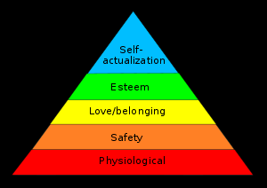

‘Maslow (1943, 1954) stated that people are motivated to achieve certain needs and that some needs take precedence over others. Our most basic need is for physical survival, and this will be the first thing that motivates our behaviour. Once that level is fulfilled the next level up is what motivates us, and so on.’ McLeod, S. A. (2017). (A4, K2, K3, K4, K5, K6, V1, V2, V3 V4).
Throughout the 5 week timetable I support leaners, developing their skills and encourage them to take responsibility of their own development. Leaners have access to toilet facilities and breaks offering a cup of tea or water, there is a computer in the classroom allowing leaners access to IT such as Microsoft and opportunities to job search and create CV’s. They have access to the ‘WEST Tool’ to develop their Literacy, Numeracy and Digital Literacy Skills, this tool is useful for those learners who complete work before others and helps them to keep motivated. Visits from various Agencies are included into the class time table for example, PACT who support learners with Social Services, The Job Centre, Substance Misuse Teams, Dental Hygienist and the Wellbeing Co-ordinator, once a week we attend the prison library where learners also have access to newspapers, policies and procedures. I would like to have a wider range of referral services, for example, a Social Worker to visit the class assisting learners with any questions and offering support with father rights/parental right. I attend weekly meetings with Teachers and Managers, engaging with professional development. I carry out reflection at the end of reach lesson updating lesson plans, welcoming advice from peers. I often work with a Teaching Assistant, I ensure the assistant has all the information to participate and is fully aware of lesson objectives, contributing to their development.. (A4, K3, K4, V1, V2, V3, V4).
Overall, I have thoroughly enjoyed my first-year work placement, gaining experience as a teacher from Peers and developing my skills. Although I am employed by my work placement I would like to gain experience outside the prison environment, this would allow me to use a wider range of resources as at present there are many restrictions and limited resources in the prison environment. I would also like to include females in my learner group for comparison. I will continue to observe teachers in their classrooms, reflecting on the lesson highlighting areas of improvement for myself and also be observed by Peers for future development. I will continue to attend conferences and keep up to date with policies and procedures that are continuously changing and work towards year 2 of the PCET/PGCE.

Annex 1

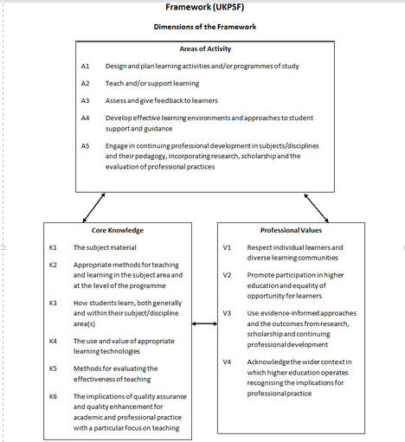

Bibliography
McLeod, S. A. (2017). Kolb - learning styles. Retrieved from www.simplypsychology.org/learning-kolb.html
McLeod, S. A. (2017). Maslow's hierarchy of needs. Retrieved from www.simplypsychology.org/maslow.html
Reece, I. & Walker, S. (2006). Teaching, Training & Learning sixth edition. Tyne and Wear, Business Education Publishers Limited
Petty, G. (2009) Teaching Today. Cheltenham. Nelson Thornes LTD
Gravells, A. (2011). Principles and Practice of Assessment in lifelong learning sector second edition. Exeter, Learning Matters Ltd.
Watkins, L. (2002). Teaching and Learning in Further and Adult Education second edition. Cheltenham. Nelson Thornes
Minton, M. (2005) Teaching Skills in Further Adult Education third edition. London, Thomson Learning.
Minton, M (2005) Teaching skills in Further & Adult Education second edition. London, Thomson Learning.
Gravells, A. (2010). Planning and Enabling Learning in the Lifelong Sector second edition. Exeter, Learning Matters Ltd.
Curzon, L. B. (2003). Teaching in Further Education sixth edition. London, Continuum.
Gould. J (2009). Learning Theory and Classroom Practice in the Lifelong Learning Sector. Exeter, Learning Matters
Ginnis, P (2002). The Teachers Toolkit. Bethel CT USA, Crown House Publishing Company LLC.
The Higher Education Academy 2014, Pedagogic theory file:///C:/Users/cez_c/Pictures/parenting%20resources/pedagogic_theory_0.pdf
Aregu, B. B (2013) Educational Research and Reviews. Article Number - 0C9999D41499. Creative Commons Attribution License 4.0
Koehler, M & Mishra, P & Cain, W (2013) Journal of Education What is TPACK? volume 193, number 3. Michigan state University.
‘Teaching Strategies; resource downloaded from Moodle – no reference
Care for the Family Facilitators Handbook, 2017.
https://my.cumbria.ac.uk/media/MyCumbria/Documents/ReflectiveCycleGibbs.pdf
HEA standards for lifelong learning sector (2011) - https://www.heacademy.ac.uk/individuals/fellowship
https://www.theguardian.com/education/2005/mar/15/furthereducation
https://www.sciencedirect.com/science/article/pii/S0360131505 001600
https://www.heacademy.ac.uk/system/files/downloads/what_is_the_uk_professional_standard_framework.pdf
https://www.gov.uk/government/uploads/system/uploads/attachment_data/file/329746/what-makes-great-pedagogy-nine-claims-from-research.pdf
https://www.heacademy.ac.uk/system/files/resources/pedagogic_theory_0.pdf

Patricia Armstrong, former Assistant Director, Center for Teaching 2017 https://cft.vanderbilt.edu/guides-sub-pages/blooms-taxonomy/#bg

