LCCB4005
The Global Business Environment
Assessment 2

A Case Study on Porter’s Five Forces Analysis of the Airline Industry

Student Name: Martina Martinova Karadzhova
Student ID: 2021296
University of Wales

Table of Contents
Introduction 3
Q1. The unlikelihood of the price war between low-cost providers in the airline industry 4
PESTLE Analysis 4
The Diamond Model of Porter 6
Q2. The effect on the industry of the proposed strategic alliance between British Airways, American Airlines and Iberia 7
Microeconomics and Macroeconomics 10
Key features of the world economy 10
Conclusion 12
References 13

Introduction
Porter's five forces model is widely known for identifying and evaluating five competitive forces that provide structure to every industry and helps in determining the strengths and weaknesses of these industries (Abdelghany and Abdelghany, 2016). These forces are specifically designed to assist enterprises in developing corporate strategies that will enable them to sustain and flourish in the competitive market.
The aim of this report is to discuss the impacts of Porter’s five forces in shaping the airline industry. This report primarily intends to discuss the likelihood of price war between low-cost providers in the airline industry and the strategic association between British Airways, American Airlines, Iberia.

Q1. The unlikelihood of the price war between low-cost providers in the airline industry
Price war refers to a situation where two or more contending organizations reduce prices of similar products or services to attract their competitors' customers or acquire a portion of the market share. Price wars can enable companies to obtain a substantial percentage of the market, which can lead to lucrative outcomes in the long term.
Initially, most of the customers of the airline industry were influenced by price. This influence was partially driven by the internet, where customers could easily compare prices of a different airline company and select the cheapest ones (Truxal, 2013). Using this as an advantage, low-cost carriers such as Ryanair and EasyJet joined the market and drove down prices exponentially. But with the changes in the dynamics of the market, price is no longer the only driving factor that induces travellers while they are booking a flight. Here is a list of reasons for which price war between low-cost providers in the airline industry is unlikely:
- Reaching bottom: Low-cost carriers (LCCs) have gradually reduced prices which enabled them to stimulate incredible growth rate over the past few years. However, this reduction in price led to a decline in the quality of service. Customers from mature markets are not satisfied with this model, which is why LCCs are forced to limit the descending spiral of ticket prices. This will enable them to satisfy their customers by fulfilling their demands at an affordable price range.
- Rising demands of the customers: Customers are now more drawn towards companies that provide better services than those that sell tickets at cheaper rates. So, the airline companies that provide superior customer service have the upper hand.
- Introduction of new technologies: Nowadays, most LCCs are adopting new technologies to stream a higher level of customer service. With the development of an advanced analytics tool, carriers can navigate customer preferences and buying behaviour to customise services that align with their demands.

PESTLE Analysis
Apart from the above-mentioned reasons, there are some factors that have been affecting the global business environment that led to an end in a price war in LCCs. Some of these are:
- Political: Most governments make investments to make their country a popular destination for tourists, which is why the number of passengers travelling has increased, especially in the EU, resulting in an increase in inter Europe travels.
- Economic: Economic stability has caused LCCs like Ryanair and EasyJet to witness rapid growth. However, the increased price of fuel has led to an increase in operational costs. Companies are now strategising to reduce this cost.
- Social: With the increase in income of middle-class people around the globe, travelling over the holidays have gained much popularity. Tourism is now becoming broader and more diverse.
- Technological: The advancement of technology has enabled customers to track flights and to get the latest information on airfare, flight schedule and a lot more (Ellis, 2018). It also allows customers to compare ticket prices between different airlines to secure the best deals.
- Legal: Airline companies have to comply with specific standards of certain countries. For example, in Europe, any qualified airline can fly anywhere in the EU without government agreement. This is what led to an increase in LCCs. But in some countries, it is difficult for new airlines to get a license.
- Ecological: As customers are increasingly becoming more environmentally aware, they are more drawn towards airlines that are eco-friendly and are working towards the reduction of carbon footprint.
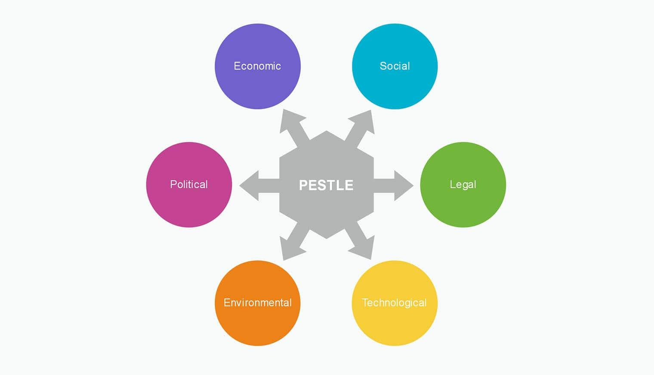
Figure-01: PESTLE Analysis (Ellis, 2018)
The above-mentioned factors can be further explained by the following business model:

The Diamond Model of Porter
This model has been designed to analyse the competitive advantages that countries have because of certain factors that are available to them and to discuss how the role of the government acts as a catalyst with the aim to grow a country's position in the aggressive global market.
This model is similar to Porter’s Five Forces model. Four of the primary factors that are discussed in this model include:
- Firm strategy, structure and rivalry: This refers to the situation where competition forces companies to step out of their comfort zone and adapt new techniques that will help them survive in the competitive market (Roy, 2009). For instance, previously, airline companies had been increasingly reducing their prices to attract more customers, but now they are transitioning to ensuring that the customers receive better services which they demand. This indicates that they are switching their strategies according to the demand of the market.
- Related supporting industries: This refers to the sectors that help in facilitating innovation and newness while promoting the utilisation of new technology. This factor corresponds to the suppliers and customers representing threats and opportunities in Porter's Five Forces Model.
- Demand conditions: This denotes the size and type of the customer base for products and services. This factor enables companies to drive innovation as well as to bring improvements to existing products.
- Factor conditions: This is the most significant determinant in this model. Factor conditions refer to components such as a country’s economy, its pool of skilled labour, technological innovations, infrastructure and capital (Lerrthaitrakul and Panjakajornsak, 2014). According to Porter, the components of actor condition play vital roles in determining the competitive advantages of a country. These elements are essentially far more critical than naturally inherent elements such as land and natural resources.
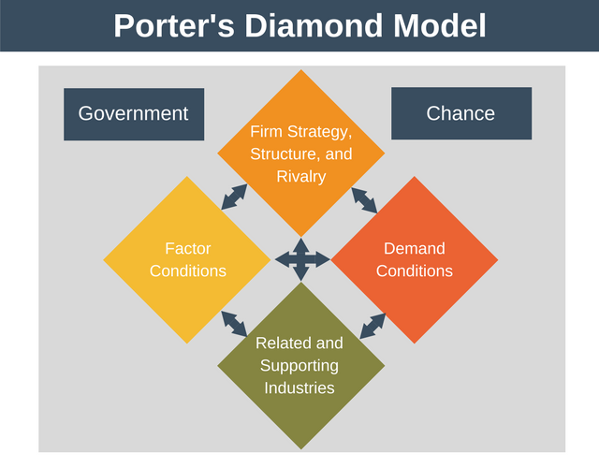
Figure-02: Porter’s Diamond Model (Roy, 2009)
Porter's Diamond Model helps to guide businesses in the global market. This model enables them to develop strategies and tactics to assist them in investing and operating in various markets across the globe.

Q2. The effect on the industry of the proposed strategic alliance between British Airways, American Airlines and Iberia
The airline industry is a business where paying customers and freight are transported through the air. It also includes programmed routes. The transportation though happens usually by airplanes can also include helicopters. The proposed strategic alliance between British Airways (BA), American Airlines (AA), and Iberia (IB) was a list of agreements that concluded that these companies would cooperate in the routes of Europe and North America (Gagnepain and Marín, 2010). The sectors they agreed to show cooperation on were prices, capacity, schedules, marketing, and sales. The companies also decided to share revenues. This alliance was formed on the competence of the companies and the availability of new profit opportunities. The effect on the airline industry of the proposed strategic alliance between British Airways, American Airlines, and Iberia:
- Increase in Regular Restraints: Companies working alone in the industry will face various constraints which will not occur for the companies involved in a strategic alliance. As AA, BA, and IB deals with their usual restraints faster and more efficiently, the rest of the industry will start to fall behind.
- Change in Customer Benefits: Customers will see a difference in scale effects that will depend on the geographic location and size of the network. There will also be different link effects that relate to service connectivity (Iatrou and Oretti, 2007). Customers will be prone to select airlines that offer them more benefits.
- The difference in Revenue: As the three companies chose to share revenues, their yearend revenue will amount to a huge number in comparison to others in the industry. This will create a clear gap between BA, AA, and IB and the rest of the companies.
- Reduction in level of Competition: The strategic alliance between BA, AA, and IB will reduce competition in the airline industry. BA and AA are two major airline companies in the industry, and IB has some influence as well. These three companies now cooperating for customers instead of competing against each other will decrease the overall competition in the industry.
- More opportunities for Small Companies: While the big companies are bringing in the majority of the revenue, there will be scope for the smaller companies to slowly develop their business and strike a claim in the industry.
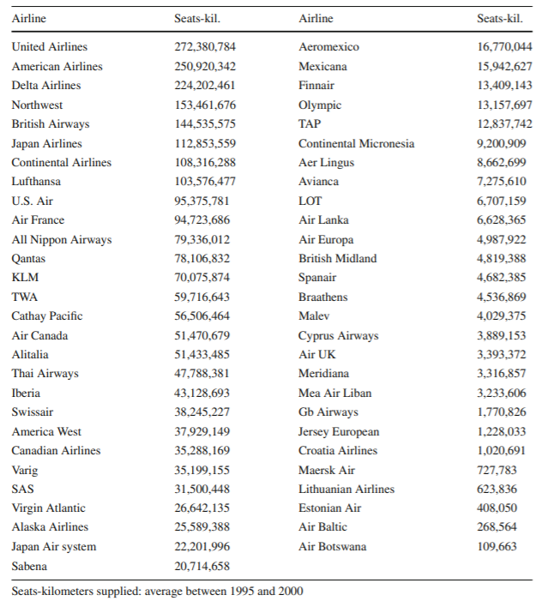
Figure-03: List of airlines and Seats-Kilometers supplied (Gagnepain and Marín, 2010).

The alliance between British Airways, American Airlines, and Iberia have been mentioned as one of the prime examples in the above case study. British Airways, American Airlines, and Iberia are all part of the OneWorld Alliance which is one of the three major airline alliances in the industry (Lu, 2003). Like all other industries, the airline industry has a few factors which can affect its overall condition: the buyers’ powers, the suppliers’ power, newcomers as threats, substitutes as threats, and the future.
To understand the effects of the above proposed strategic alliance, it is necessary to understand why organizations engage in international trade in the first place. Usually, the main reason for any company to get involved in international business is expansion or growth. Companies searching for a new market or diversifying their business often expand to international trade. The reasons why organizations engage in international trade are given below:
To expand sales or to grow: Often overseas expansion means an increase in growth for the company and the economy. An organization gets involved in international trade to earn profit from newer markets. There are attractive returns in new markets, it is the easiest way for companies to expand the name of their business.
Resource Collection: There are many countries in the world full of natural resources. These resources are often helpful for organizations to decrease the cost of their supplies which reduces dependence on the local market. It is an overall beneficial step for the companies.
Minimize Losses and Encourage Innovation: Many times organizations expand to a new market with fresh consumers to reduce the losses faced in their current market. Introducing a new product or service in a new market minimizes loss in the previous one. It is also stated by 53% of businesses that a new product or service evolves due to the abroad trade (Bende-Nabende, 2003).
For a company to expand internationally, it is necessary to understand the key features relevant to the international economy, the foundations of the micro and macro economy, and different market structures.

Microeconomics and Macroeconomics
Microeconomics and macroeconomics are the two leading parts of economics. Microeconomics views specific markets and their concepts for example elasticity, perfect combination, and market equilibrium. Whereas macroeconomics deals with the overall functions, activities, and total indicators of the economy which includes GDP, productivity, exchange rates, interest rates, inflation, etc. When working in a global market, an organization needs to mind a country’s macroeconomic policies with its microeconomic impact. As seen in history, the economic conditions of one country can hugely impact the entire international economy.

Key features of the world economy
The world economy is made up of some particular features which an organization or a firm needs to understand properly.
- Opportunities to build new markets
- Various possibilities for production
- An equal turf for small and big companies
- Importance of networking
- Chances of overcoming different barriers
Market structures and Economy: There are four types of market structures in economy which are monopolistic competition, monopoly, perfect competition, and oligopoly. Competitive firms do not make an economic profit. Often, in the long run, new entries reduce margins and push the least competent firms out of the market. Properly understanding a market structure ensures that the firms make the best choices in case of decision-making.
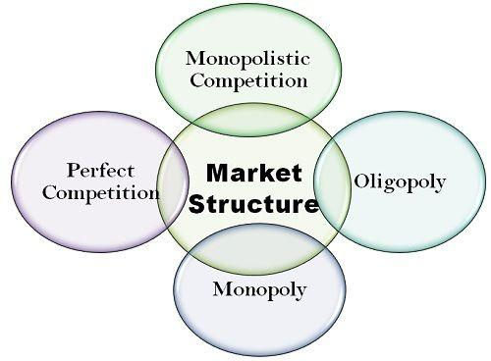
Figure-04: Types of Market Structure

Conclusion
This report is on the global business environment of the airline industry. It depicts a description and an understanding of the happenings in the changing global business environment. It further states the microeconomic and macroeconomic foundations of the market and its influences on different firms (Helpman and Krugman, 2002). The answers to the case questions are also given with relevant business models or theories. After thorough research, it is concluded that the airline industry, despite going through a structural change, has a bright future ahead.

References
Abdelghany, A. and Abdelghany, A., 2016. Modeling Applications in the Airline Industry. Farnham: Taylor and Francis.
Bende-Nabende, A., 2003. International trade, capital flows, and economic development in East Asia. 1st ed. Aldershot, Hampshire: Ashgate.
Ellis, D., 2018. The Global Airline Industry and International Relations: The Globalization Paradox. The Global Studies Journal, 10(4), pp.19-38.
Gagnepain, P. and Marín, P., 2010. The effects of airline alliances: what do the aggregate data say? [online] Parisschoolofeconomics.eu. Available at: <https://www.parisschoolofeconomics.eu/docs/gagnepain-philippe/alliances-series.pdf> [Accessed 17 April 2021].
Helpman, E. and Krugman, P., 2002. Market structure and foreign trade. 1st ed. Cambridge, Mass.: MIT Press.
Iatrou, K. and Oretti, M., 2007. Airline choices for the future. 1st ed. Aldershot, England: Ashgate.
Lerrthaitrakul, W. and Panjakajornsak, V., 2014. The Airline Service Quality Affecting Post Purchase Behavioral Intention: Empirical Evidence from the Low Cost Airline Industry. International Journal of Trade, Economics and Finance, 5(2), pp.155-158.
Lu, A., 2003. International airline alliances. 1st ed. The Hague: Kluwer Law International.
Roy, D., 2009. Strategic foresight and Porter's five forces. München: GRIN.
Truxal, S., n.d. Competition and regulation in the airline industry.

