Assignment 1 CONSTRUCTION Management

By Jennifer Autumn Sapphire Sargisson

Contents
1 Introduction 2
2 task 1 4
3 Task 2 5
3.1 Time 5
3.2 Costs 5
3.3 Resources 5
4 Task 3 6
5 Task 4 7
6 Task 5 8
7 Conclusion 9
8 Bibliography 9

Figure 1 location of site in Swansea/Abertawe 3
Figure 2- satellite view for site (add source) 4
Figure 3- 1st half of Gantt chart 5
Figure 4- 2nd half of Gantt chart 6
Figure 5-Herzberg 9
Figure 6- Site layout 10
Figure 7- Gantt chart with delay 12

Introduction
in this document I will cover the production and management of a site in Swansea waterfront area. The client of the project is University of Wales Trinity St David and Fig 1 shows the site location. In addition, Fig 2 shows the overview of the site.
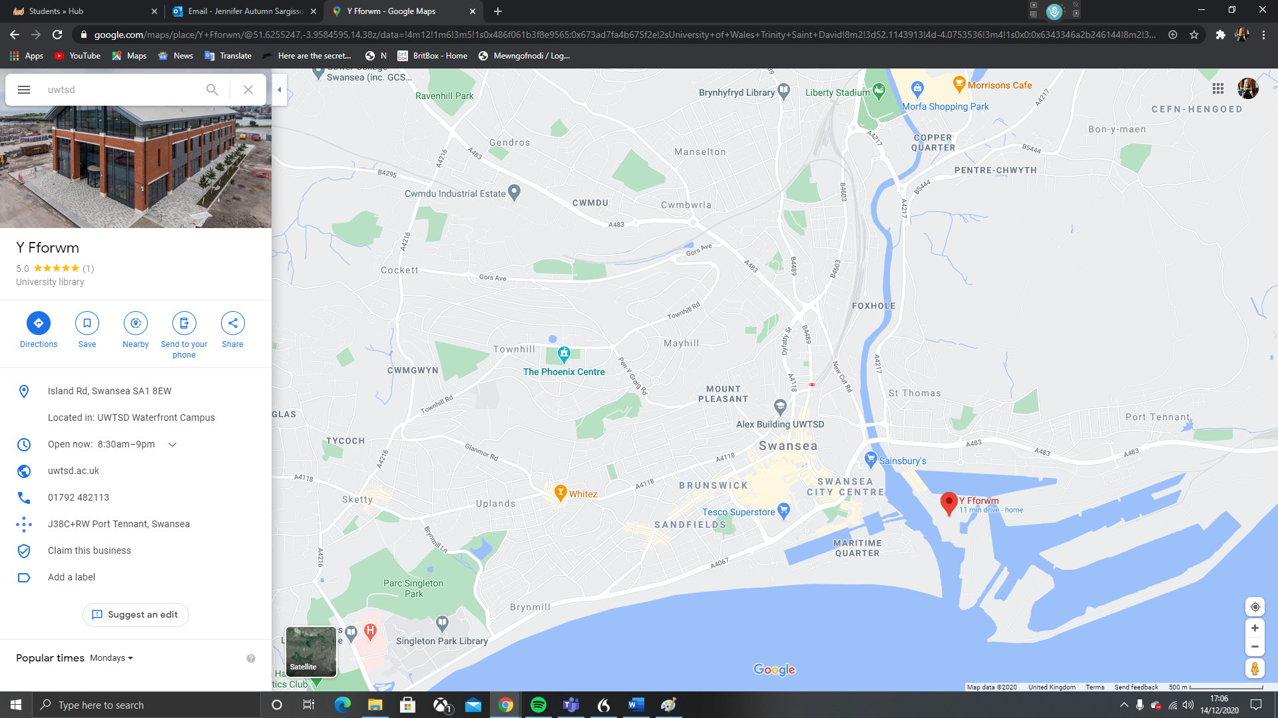
Figure 1 location of site in Swansea/Abertawe
Sourced from https://www.google.com/maps/@51.6225364,-3.9320669,14z
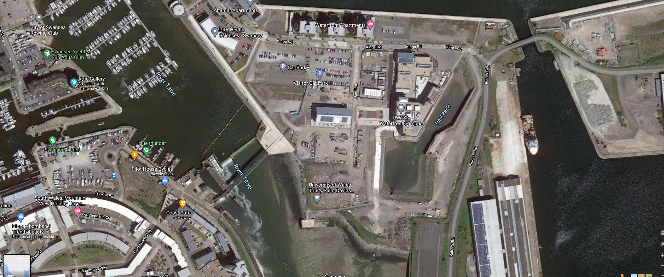
Figure 2- satellite view for site (add source)
Sourced from https://www.google.com/maps/@51.6167757,-3.9279963,245m/data=!3m1!1e3
over the next few tasks, I will be producing a Gantt chart and doing a report on it. Also, in task three I will explain the different theories and methods to improve production on site. In task four I will be producing and doing a general explanation of the site layout for the project. And task five using a Gantt chart from task one I will be showing what happens if a general strike at the local concrete plant happens while also showing the increase in costs, (note this will be attached as Gantt chart 2 on submission).

task 1
For this please see attach File (Gantt chart 1 in the submission) and red bars are the Critical path for the project
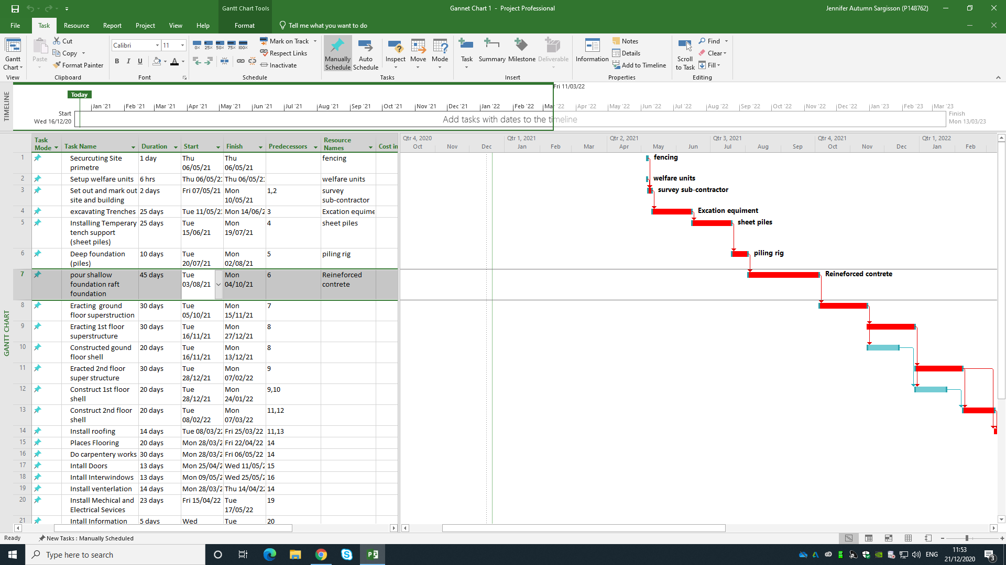
Figure 3- 1st half of Gantt chart
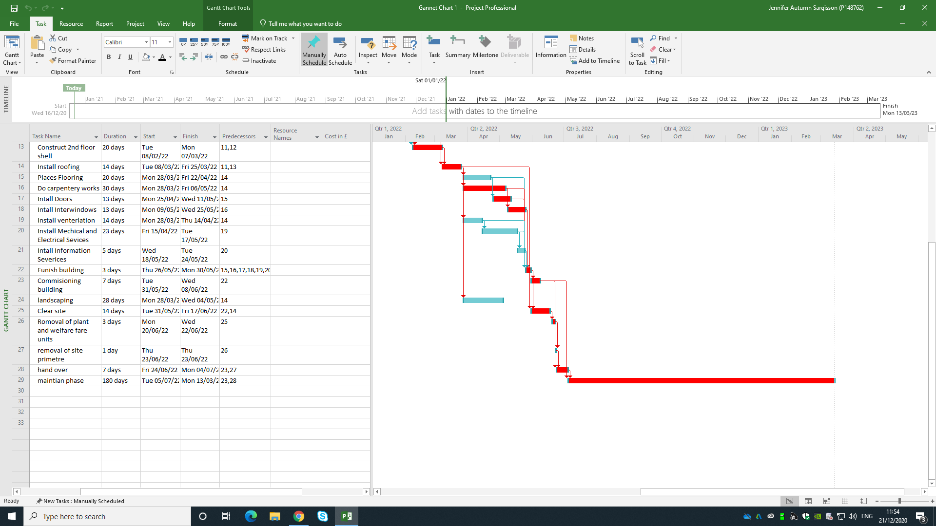
Figure 4- 2nd half of Gantt chart

Task 2
For this task, I will create a report under Gantt chart from task one, and cover its factors of time, costs and resources use on-site. Of the works on site

Time
regarding the time of the project, the main construction work will be done within around 13 months at minimum (if there is no delay in getting resources, plant and equipment to site). For the start until the mid-part of the project, mostly speaking is straightforward as is no more than two tasks going on at once however once the roof is constructed and the shell of the building is erected it allowed for the inside work to start which most of these can be done alongside each other. Towards the end the number of tasks start reducing as commissioning, handover and maintenance stages going on.

Costs
the cost of the project will be expensive for the contractor at the start even though setting up the site may not be too expensive, until we break open the topsoil the costs will be expensive especially when constructing the foundations mainly piling will be what most of the first instalment payments will cover. This means it may be beneficial at the start for the contractor to use or get some money for itself to cover costs at the start of the project with the intention to make back the money during the latter stages of the project if the procurement of capital is done in the traditional construction way. If the contractor must take out the loan it may be risky especially if the project goes over targeted time by the client as I would gather the University of Wales Trinity St David’s will have high Liquidated Ascertained Damages cost. However, I would predict that if all goes well and the payments of the client on time will make even when installing just after the mechanical and electrical installations.

Resources
throughout this project resources should be managed and monitored regularly to ensure that we keep within costs and do not have delays. One way we can do this is by buying for multiple suppliers or watching events going on locally. However, there may be shortages in the labor market that can cause delay on site, so planning and hiring would be good if we early however, this can be more costly if a delay happens on site.

Task 3
for this task, I will be explaining the different theories and methods to improve production on site and motivation of workers.
One of the easiest ways to improve quantity on site is to hire/contract more workers and laborers onto the site, this would help shorten time on project/task as if correctly managed the workers together will produce a higher output however this that the cost of capital resources mainly money. Also, the issues are that you may hire or need to hire too many people that the site cannot really support them as they may get in the way of each other and cause diminishing returns to come in to effect with also needing to increase the controls of health and safety on site. So, you may need to use the theories that I will discuss below to improve motivation which in turn should improve quantity and possibly quality on-site.
Where you can possibly get round, this is Hertzberg theory which is known by as two factor theory. Hertzberg propose that to incentivise employees you most provide things from the two factors one of which is motivating factors and the other is hygiene factors. Motivating factors are factors that can encourage an employee to work harder like achievements, recognition and personal growth, while hygiene factors is things that if not put in place will decrease productivity and motivation” for example salary and job security can would come under this (Alshmemri, Shahwan-Akl, and Maude, 2017). The image below on how this works
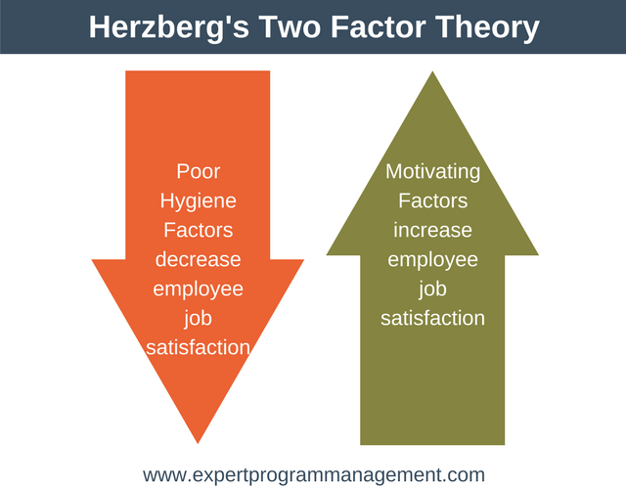
Figure 5-Herzberg
Sourced from https://expertprogrammanagement.com/2018/04/herzbergs-two-factor-theory/

Task 4

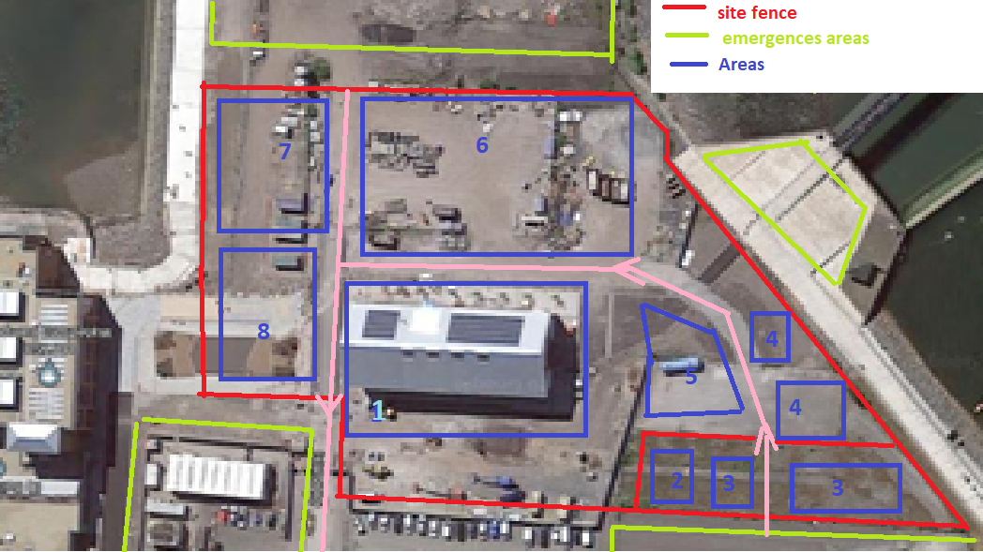
Figure 6- Site layout
Sceen shotted and then altered from
using Pictures above I will type out what each number response to.
- The Building/ structure footprint/ construction area
- Welfare units- to provide a place for works to sit, eat and go to toilet out for the elements as HASAWA 1974 2(2)e says, “the provision and maintenance of a working environment for his employees that is, so far as is reasonably practicable, safe, without risks to health, and adequate as regards facilities and arrangements for their welfare at work.” And it means that we do not have to ask the university to use their ones.
- Staff car parks- to allow staff to park and not use the university parking up
- Delivery drop off points- two unloading point one for low risk to mild risk articles and substances and another of high risk or higher (will have a way to storage in an airtight storage
- Plant parking/ Storage- place to storage plant and vehicle when not being used or inspected
- Material Storage- materials for the project are storage in this area unless they pose a high risk to employee health
- Stores & hazard articles and substances Storage-Stores for specialised equipment and specialised storage for materials and substance dangerous to health (including some waste
- Waste, bins and skips- to storage non-hazards amount of waste and to sort out in to general, recycling, reusable and specialised deposal
Pink is the road that vehicle must take around (one way apart from the section between 6 and 7)
above is my layout of the site plan for the project

Task 5

In the case of a strike by the local concrete company/supplier which could last two weeks and raise the price of concrete by 10p per meter cubed will affect the final cost and finishing time depending where it hits within the project. If happens along on the project or after the concrete structure is erected this may, still cost more but will not affect the final time as per concrete is used in the project is on the critical path for any delays here would extend the project time. We could after strike hire more people help with concrete works and form, of must be careful of not over hiring as this could cause the laws of diminishing return to start effecting the project. The laws of diminishing returns mean that once you hit a certain point managing and production will be severely reduced meaning that little work be done other because will be there. As shown in Fig 3, material costs are shown for shallow foundations where the total volume roughly of structure that needs concrete in is 1800 m³ however different safety if we say that quality reasons need a bit more will order between 5 to 10% more to avoid any problems, so that the total concrete is n now 1980 m³, so if the price of concrete is up by 10p per meter cubed this would mean the total extra cost would go up by £198, before the material, as with any delays depending on the contract with subcontractor we may have to pay more for the Labor and as well for rehiring equipment for that time period if we can't negotiate with the supplier which will probably a lot more cost the project. If during the design phase we spot this strike or it gets extended, it may be an idea to change the construction method from additional to modular/prefab construction, however this may need a bit more research and time to be sure as they might be affected as well, also this would mean that designs may have to be altered and submitted for approval again, which could waste time and money if the strikes are sorted out within time. Another thing we could do is to clear up some more space to store concrete in and tried to improved amount the amount we can store on site to try and order for multiple cement companies to get enough cement on-site to us through the strike, however this may need a higher capital investment regarding technology, to convert the cement into concrete, on top of a bit more time and Labor needed to do this. So, in general strike like this will affect the three aspects of site construction management as it will affect time which in turn will affect quantity, also because of increased time it will affect costs and lastly the pending when it hits and the support, we have ready for it may affect the quality of the work on the site. Also, we may ask for extension on the date/deadline of the project.
If it happens when the shallow foundation is being poured it will delay the hole project by around 2-week trough out as it a critical path task. As shown below
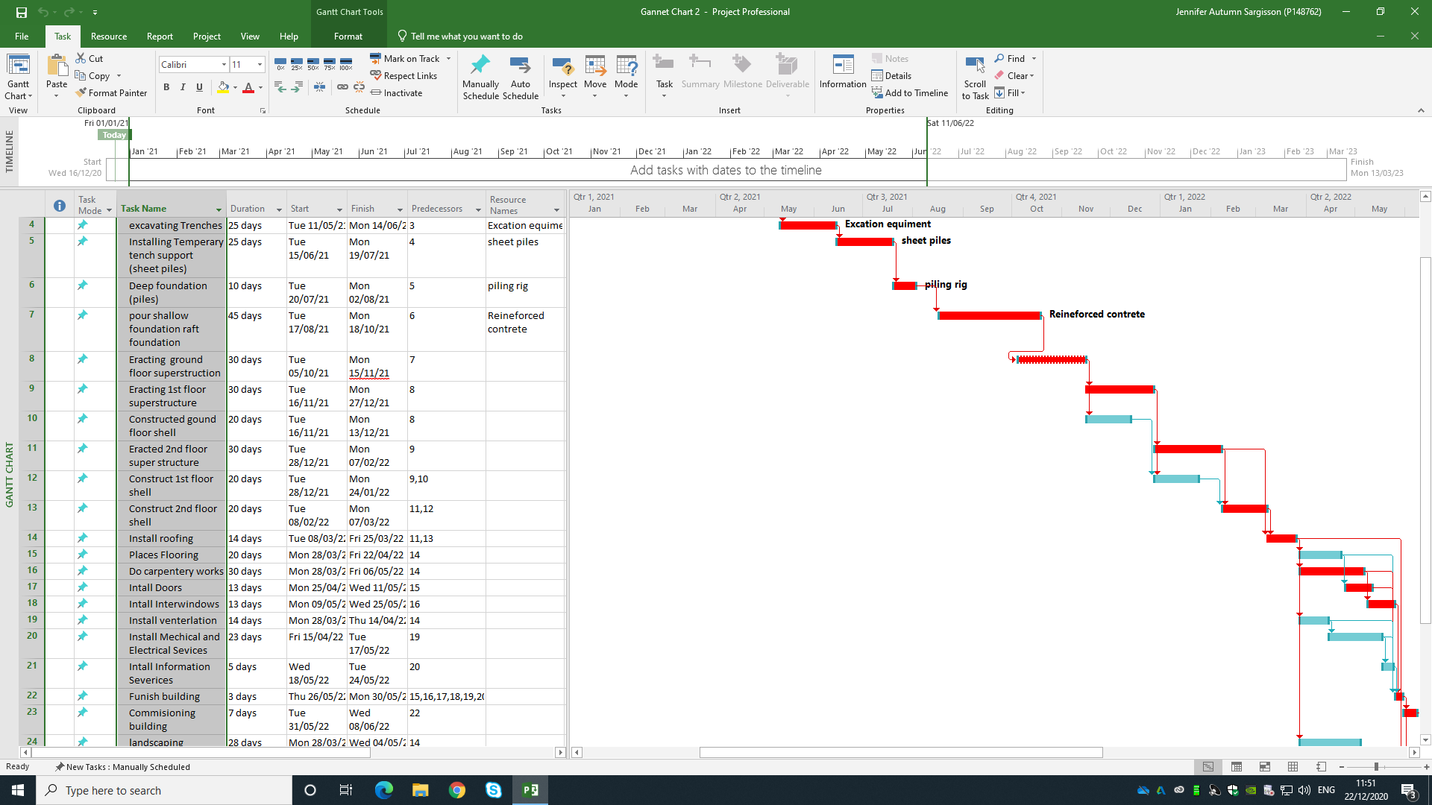
Figure 7- Gantt chart with delay

Conclusion
if we use a Gantt chart and a site layout production, quantity and time should be easier to manage with the project for University of Wales trinity St David’s. But this only would happen if both kept up-to-date and changed with the project construction. And, if we keep our eyes out for problems on the horizon, we be able to mitigate them earlier.

References
AECOM Ltd (2020) Spon's Architects' and Builders' Price Book 2020. [Online]. Available at: https://moodle.uwtsd.ac.uk/pluginfile.php/343237/mod_resource/content/0/Spons%20Architects%202020.pdf (Accessed: 19th December 2020).
Alshmemri, M., Shahwan-Akl, L. and Maude, P. (2017) 'Herzberg’s Two-Factor Theory', Life Science Journal 2017, 14(5), pp. 12-16 [Online]. Available at: https://www.lifesciencesite.com/lsj/life140517/03_32120lsj140517_12_16.pdf (Accessed: 20th December 2020).

