How can we improve children’s use of self assessment through the “What’s stuck with you post it note assessment for learning strategy?”
Black and Williams (1988) conducted research detailing the importance of AFL strategies in a modern-day teachers repertoire. However, Gadsby (2015) is critical of its useage stating that, “many well intentioned teachers are engaging with the letter of AFL rather than the spirit of it.” Gadbsy (2015) Suggesting that AFL strategies can be part of a routine, but the benefits may not be fully understood or utilised. If the class teacher is not fully engaging with AFL then it cannot be expected that the children are engaging with it or understanding its importance fully either.
During my placement experiences, both teachers I worked with used a wide variety of AFL strategies. However, the use of the strategies did not always seem to have the desired outcome of moving on the learner in their outcomes. In my study I will investigate and compare how children are encouraged to take responsibility for their learning and how they self-assess their work.
I will be focusing particularly on the use of the AFL strategy, “What stuck with you?” Where children write on a post it note something they have taken from the lesson, and place this post it note on a designated board in the class room. (See appendix one). Children will be encouraged to reflect on their own learning in the way they feel most appropriate. I will compare how children from a school who are not experienced in this strategy self-assess their work using this method, to children who are practised in the use of this strategy.
The aim of my research is to understand whether children are well enough informed on the importance of AFL and how it will help move their learning on. In school number one, children will be given structured post it notes, with a series of four questions to answer to reflect on their learning. In school number two, no structured questions will be given to answer, however suggestions will be made as to how children can self-assess appropriately.

Research context
The research was conducted in key stage two, with school one being a year 4 class in an inner city school in Cardiff, consisting of around 300 pupils. The school has identified an above average amount of children with special educational needs in the school, and an average amount of children eligible for FSM according to the Welsh government’s national average figure of 20.1%. (Welsh Government 2016).
School number two is a large school in Bridgend with around 550 pupils. In contrast to school number one, only 5% of children are entitled to free school meals which is significantly above the national and local average. Around 20% of children are identified as SEN. What lies in greater contrast is the EAL population in both schools, with 7% of children in school two coming from ethnic minorities and 1% receiving support for EAL whereas school one has around 30% of children coming from ethnic minority families.
Literature review.
Vygotsky stated that children learn best when they interact and cooperate with more competent people in their environment and in cooperation with their peers. (Vygotsky, 1978). The “What stuck with you?” post it note strategy combines the important features of self-assessment with peer assessment and peer learning. Children are given the freedom to write on their post it note whatever useful things they have taken from the lesson. The children then will display their post it note on a designated board, which is accessible to the children in the classroom to view at any time. Other children in the class can view their own self-assessment as well as their peers, encouraging a magpie effect where in which children can read their peers self-assessment and may take on board aspects of what their peers have learned.
Children choose to summarise their learning in numerous ways. Some children choose to use diagrams to explain their learning, which could appeal to learners in the classroom. Other children may summarise their learning in a way which their peers may understand more than their class teacher’s explanation.
Gadsby defines AFL as, “a part of everyday practice by students, teacher and peers that seeks, reflects upon and responds to information from dialogue, demonstration and observation in ways that enhance ongoing learning.” (Gadsby, 2015) It is widely agreed that AFL is beneficial in the classroom. It helps teachers identify strengths and weaknesses and gives children their own voice in assessing their learning. However, as cited by Gadsby, “many well intentioned teachers are engaging with the letter of AFL rather than the spirit of it.” Many teachers, although they are using AFL strategies regularly, it may not be having the desired effect of excelling children in their learning outcomes. The Assessment Reform Group (ARG, 1999) state how they feel that children make the best progress when they take ownership of the learning. They argue that more emphasis needs to be placed upon AFL as opposed to traditional teacher led assessment. Children work with their teacher in a collaborative way, and together they identify learner’s strengths and weaknesses, and how to best to support the child in progressing. To improve self-assessment techniques for the children, ownership over learning must be encouraged and facilitated by the class teacher. This skill cannot happen immediately, and it needs to become part of classroom culture.
Many studies support the benefits of using AFL as an assessment tool, however Wragg (2001) highlights that although self-assessment can work for some, it can also have negative effects on others. He supports the ARG in regard to AFL benefiting children who take ownership of their learning. He states how placing an emphasis on the learner is integral in terms of assessment as, “assessment should not merely be something that teachers do to their pupils.” He agrees that often self-assessment can be highly beneficial and revealing for teachers , and successful in making children party to their own learning. With that it can offer children a huge sense of pride in their work and their performance, giving them a sense of autonomy and independence over their learning. This is the desired effect of successful AFL, that children respond in a positive manner. However, with other children it may have the entirely opposite effect. Wragg states how for some it may be debilitating and invites a sense of failure. Some children may be hard on themselves and in response to this will have negative implications on their self-esteem.
To minimise negative implications of AFL, it is integral that in the classroom environment possesses a positive ethos, where children are praised for their contributions and feel valued, and receive detailed input on self - assessment. This is supported by Koller and Fischer (2010) who identify the requirement for a positive classroom ethos, in order for AFL to be successful. Children need to understand the importance of self-assessment and should be given the freedom to explore this within a secure, supportive and positive academic setting. This should be facilitated by a teacher who has sound knowledge of self-assessment, and how it helps children move forward in their learning outcomes.
The relevant literature I have read has helped me refine my research question as both schools differ in their experience of AFL usage and in particular, “The whats stuck with you?” post it note method.
School one had never used this form of AFL. However, the children in school two were well accustomed to self-assessing their work, and this form of AFL. I had chosen to use this method personally in my lessons where I taught in school two, and during the plenary activity would have children discuss their post it note with the class. This was always met with positive feedback from myself or the class teacher, and children were accustomed to and willing to share their learning with others in the class.
This led to the question being decided, to compare a class where children were not used to using AFL , to a class where they were experienced in doing so. We wanted to compare the children’s feedback, and their response to self-assessing their work, and how well both classes engaged with the concept.
Methodology
The research was conducted to ascertain how pupils respond to AFL, and to broaden subject knowledge in regard to this.
The study was of a qualitative nature and two different methods were used to see how children responded, and what could be altered from the first lesson and adapted into the second lesson to improve it.
We undertook two lesson studies in both classrooms. Hopkins (2008) advocates the use of lesson study in, “improving teachers practice and student experience as a way that can increase teacher’s responsibility for their actions and create a more energetic and dynamic environment in which teaching, and learning can occur.” (Hopkins, 2008). From conducting two lesson studies, we could gauge what was successful in school one, and integrate this into the lesson for school two.
As school one was less accustomed to using AFL of this nature, more structure was given to help children self -reflect on their work. A set of four questions were put on the white board for the class. (See appendix ) . The children were informed by my partner, to answer one question of their choice. We knew that this would result in potentially a narrower set of feedback as children were confined by a set of questions.
In each class, both myself and my partner observed the lesson. However, we were careful not to create a Hawthorne effect and cause the children to behave differently because they were being watched. We did not make notes or collect any data during the lesson and simply observed. Myself and my partner both conducted ourselves as teaching staff, working with small groups and assisting the children during the lesson. Although the post it note requirements for the children were different in each school, the interview questions we kept the same. (See appendix for the interview questions.) (See appendix for the interview notes from school one and school two)
My partner and I selected children based on their post it notes and how well they responded to the AFL task. In both schools we chose a child who responded in detail with their self-assessment, a child who had grasped the concept but would benefit from more input, and a child who had not engaged with the strategy or engaged to a minimum level. In school one, several children did not self-assess on their post it note, which did not occur in school two. This could be due to a lack of understanding of the task, according to Sundered et al (2010) who suggests this is often a reason as to why some children may abstain from the process. However, the child selected in school two had not been able to take anything from the lesson and therefore could not comment on what they had learned. Topping (2009) and Boon (2016) stress the need for reinforcing the process of AFL and continuous practice, to obtain the desired results. Children should ensure that they link their strengths and weaknesses to the success criteria. My partner and myself ensured that the questions in school one were directly linked to the success criteria, and I ensured that when discussing ideas for self-assessment in school two with the children, that the success criteria was mentioned.
My partner and I decided to interview three children on their AFL feedback. Interviews give an insight into, “dimensions of information not otherwise available, such as non-verbal cues or feelings.” (Greig, 2010) We felt interviewing the children rather than giving them a questionnaire would be more beneficial as children would be able to discuss their opinions with us and would not be constrained by rigid questioning and would allow more of a free flow of discussion.
We decided to use semi structured interviews as this format, although has set questions and certain set topics, still allows “ a lot of scope for the interviewees on ideas to develop.” (Greig, 2010) We felt this would enable new ideas to be brought up during the interview, allowing a more child led approach in regard to the data collection. My partner and I compiled a list of questions together before the interview, but discussed that we were happy for the interview to develop in whatever way the children led it. We felt that this fitted with our study in allowing children autonomy over their learning and what they wanted to discuss.
Many studies reveal that although the practice of AFL is extremely beneficial, this is only when it is executed correctly. Boon (2016) remarks on many short comings of the use of AFL strategies. Many AFL strategies including the use of peer assessment are ignored by learners.
Zubdert et al (2010) remarked that this could be due to learners not understanding the process of assessment for learning. We therefore wanted to ensure that the class would be informed about why they are assessing their work, and what to include. For children to be successful in AFL, this is a process that needs to be reinforced and become a regular feature that they use regularly. Children must be specifically instructed, to ensure that they identify their strengths and weaknesses in accordance with the success criteria. For children to gain more autonomy in their learning, they could decide as a class, their success criteria and whether they have met this. A cycle of this manner is integral in children taking ownership of their learning and ensuring they have met their learning objective. This will also benefit child engagement as they are not simply passive learners, but are active in their learning.
Vygotsky discusses the importance of peer learning, and how children learn better from their peers. (Topping 2009) (William 2011) support this theory, suggesting that children are more likely to ask for calcification of a topic from their peers as opposed to an adult in a position of authority. To create successful AFL feedback, children should therefore be encouraged to discuss their assessment in relation to the success criteria openly within the classroom, facilitated by the teacher in a positive environment. This benefits the child and their peers and helps the teacher to assess the learning using a feedback and discussion process.
In school two, this form of classroom ethos and culture was more prevalent than in school one. This also influenced the lesson input and AFL structured questioning as we felt children needed more training in regard to what was required from them in school one. Children in school two were used to assessing and feeding back to their peers and were therefore given more autonomy in self-assessing their learning.

Ethical considerations
Before beginning the lesson study and research project, I considered the ethical issues that may arise and how to keep them to a minimum.
Before beginning the project, I read the University guidelines on ethical research; UWTSD Research, Ethics and Integrity code of professional conduct and practice (2017) and BERA Ethical Guidelines for Educational Research (2011). In response to these two sets of guideless I ensured that the steps were adhered to, in order to ensure that there is no risk to the participants. I ensured that I adhered to both the school and university safeguarding policy, and children had the right to withdraw from the research at any point in time and were not treated any differently if they chose to do so, and I informed them of this. If any emotional distress was caused to any of the pupils, it was explained that they may leave at any point. The pupils were not under any instances different to normal school situations where they may be put under the risk of physical harm.
I obtained assent from the children involved and adult consent from the parents/legal guardians.
Myself and my research partner adhered to legal requirements in relation to working with children including the guidelines outlined in the schools safeguarding policy, which I read. I attempted to reduce any sense of intrusions to the norm and ensured pupils felt at ease for the duration of the research.

The risk to myself was that my partner and I were the only adults conducting the interview with the children. To reduce this risk, both interviews were conducted in an open area with the door left open.
To ensure minimal risk I ensured that throughout the research project, I adhered to the normal safe guarding policy in all aspects so as not to put my personal safety or professional name at risk. I ensured that the focus group interview were conducted in an open, accessible space. The school ELSA room has an open door into the school corridor, which is opposite the classroom in which I taught. I treated all the children equally in accordance with the schools safe guarding policy and showed no child any preferential treatment. My interview and teaching were conducted with another adult present at all times. I acknowledge that as I have been their teacher previously, they may have felt that they were obliged to take part in my focus group interview. However, I made sure that they were made aware that they were not obliged to do so and that there were no consequences if they chose not to do so. I informed them that they were able to ask me questions about the research and if they wish to refuse or withdraw at any point this is perfectly fine.
I will ensure compliance with legal requirements of storage and use of data. All data will be saved in a password protected online account and made confidential with all names removed.
I did not use any leading questions or pose questions that may put children at unease. I ensured wording of questions did not risk altering their viewpoints negatively or show bias toward any answer. Pupils were given the full opportunity and ability to answer questions honestly.

I am a student at the University and I am aware and appreciate the need to uphold professional standards always to ensure that the good name of the university is upheld. I therefore conducted myself and my research in a professional, ethical and appropriate manner. It is also important in upholding relations between the university and partner schools, and therefore I am aware of the need to conduct myself in the same ethical and professional manner in both schools in order to maintain good university/ school partnership relations. Consequently, I will not falsify any results or manipulate the research. I will not plagiarise others work. I arrived punctually and will submit my work punctually and in the appropriate format.
Lesson study
In school one, my research partner taught the lesson. It was a literacy lesson focusing on creating a poster to advertise a chosen area in Cardiff. Children were shown a slide show presentation with what they needed to include on their posters. This acted as the learning objective and was revisited again before the children started the lesson.
Five minutes before the end of the lesson the class were stopped and told to fill in the post it notes that were on their table. My partner displayed a list of four questions on the white board which the children could select from and answer. (See appendix 11) In hindsight, especially as children in this class had not done this AFL strategy before, more time given to complete the post it notes would have been useful for the children.
The majority of children engaged with the task, but not all completed the task in the way that we had predicted. As behaviour problems were minimal in this class, I feel that Zubdert et al (2010) theory was relevant as it appeared that children did not fully understand the task. I feel a lack of understanding was the most likely explanation as to why some of the children did not engage fully with their post it note assessment in school one.
When collecting the post it notes and analysing the feedback from the children, the majority of responses were simple and lacking in detail, which because of the structured nature of the four questions, was to be expected. We had hypothesised that the post it notes would be a clear representation of ability- that the higher ability children would be more reflective and expand on their answers, and the lower ability children would be less so. This would not the case and the answers the children had given were all on a similar level, which could be because of a lack of understanding of the task, and also the restrictive question style.
In reference to the interview transcript, the higher ability child was able to recognise the importance of self-evaluation. When asked “why do you think we asked you to fill in a post it note?” she responded, “it helps you think about what you’ve done. If you’ve done it right and if you can change it.” The other two children were less reflective and child two responded that his poster was perfect and didn’t need any improving.
When conducting the interview, I noted a downfall of the strategy being used. The children, when being questioned were asked in a consecutive order each time, beginning with the high ability child. (Child one) As can be seen from the transcript, the lower ability child (Child three) would mirror the higher ability child’s answer by saying he agreed and putting forward no opinion of his own. This could also be down to a lack of understanding or fear of judgment from two practitioners in the room. This questioning style was rectified for the second lesson to give all children a chance of putting forward their own opinions.
The outcome of this lesson supports the opinions of Topping (2009) and Boon (2016) who state the need for rigorous practice and training for the learners, and that to achieve the desired results of AFL, a deep level of reinforcement is required. Children engaged with the strategy on a basic level in school one, but in order for children to reflect and engage on a deeper level, this strategy must be engaged with regularly by the learners which would be adaptations we would make as teachers and ensure this is made a regular feature as a plenary activity in order to build the children understanding and confidence.

Lesson two consisted of a maths lesson on equivalent fractions. Similar to lesson one, the lesson objective was on the board for the children. It was discussed as the starting point of the lesson, and revisited prior to children completing their post it notes. Before the end of the lesson, the children were stopped as a class. As opposed to lesson one, children were given the autonomy to decide how to self assess in school two.
I facilitated the children’s thinking by discussing what they might like to include and gave examples. I told the children that they could imagine that they are writing the post it note to a friend who has never studied improper fractions before and to include information that may help this friend. I offered other examples such as including what they learned, what they found hard, what they found easy, and what advice they might give to help a friend who found the lesson hard. However, as the children had previously used this form of strategy, I gave them the autonomy to decide how to best reflect on their own learning and told the class I was simply giving them ideas which they did not need to use.
A high ability, middle ability and low ability child were chosen for the interview, and their post it notes are included in the appendix.
Child one has given a detailed answer including many of the examples I suggested. She included what she had learned, found easy and hard and what advice she would give. Her post it note shows a great deal of self-reflection and would be an extremely useful tool for not only her own learning, but for her peers and also the class teacher. It is clear to see she has understood not only the lesson, but the purpose of the AFL strategy and is able to explain her learning in her own way. Wragg (2001) describes this type of learner, saying how AFL is beneficial to this kind of learner as it allows them to be party to their own learning, offering them a sense of pride in their performance. This child had clearly understood the lesson and had been successful. Her AFL feedback demonstrated this and allowed her to receive praise for her work.
Child two has demonstrated she has understood the work and has explained her learning in a visual way stating how, “fractions are like cake” and this description was aided with two diagrams. She has been less eloquent in her description than child one, and her first statement may not be able to assist other child or allow her to recap her learning, however she responded to the AFL and included key points that were relevant to her own individual learning.
Child three`s post it note was less descriptive. It could be suggested from the post it note that the lack of detail was due to a lack of understanding of the lesson, or of the AFL strategy. As a teacher, this would be useful in helping identify that this child had struggled with the lesson, and that more assistance is needed to help push his learning on. A deeper explanation would also be useful for this child in regard to this particular AFL strategy and what he could include. More scaffolding may be beneficial to this child, so that it does not result in him feeling disengaged.
In reference to the post it notes included in the appendix from class two, it is clear that children have understood the AFL requirements due to the positive reinforcement from myself and the class teacher as part of the classroom ethos, and because the children understand and practice self-assessment on a regular basis. The children have responded well and have taken personal responsibility for their learning. Growth mindset terminology is also used in one of the post it notes by a child who states, “I found it a bit of a challenge, but I got there. I learned much more about finding what times tables they are from.” For a practitioner this is useful to see that this child has the ability not only to self assess, but has the confidence to state that they found it difficult at first. If the classroom environment was not one of a positive encouraging nature, such a response may not have existed. This would also assist a teacher from an assessment point of view and allow a decision to be made as to whether this child needed extra support to move the learning on, and to ensure a sound understanding of the topic.
Within the interview, I ensured that each child was asked questions in different orders so as not to allow children to rely on their peer’s answers. It was clear from the responses that two out of the three children engaged with the spirit of AFL, why it is important and who it assists. It was also clear to see that the low ability child required more structure and scaffolding with his self assessment, so a method of structured questions like school one may have been more appropriate.
Child one discusses in relation to question about why what stuck with you is useful. “You can go up and have a look to see what you’ve learned. If you found it easy you can have harder work next time and If you found it too hard you can have easier work next time. Child two discuses that, “ if you are stuck you can have a look at others work to help you. If you didn’t understand you can go to the board and have a look.” All children agreed that the what stuck with you is useful as it allows them to go and read other children’s answers to help them. This is supported by Vygotsky’s theory on children learning best from their peers. When observing the children placing their post it notes on the board, whilst they were doing so, they were also reading other children’s post it notes which demonstrates their understanding of this AFL and they were learning from their peers. In this sense, “What stuck with you?” evolves from simply a self-assessment to peer learning, as children are engaging with their peers learning from reading what others have written.
During the interview the children were asked if they liked being given freedom to write down whatever they wanted on their post it note. I ensured that I asked the low ability child this question first so that he was able to answer honestly. He stated that he would prefer structured questions whilst child one and two both said they liked the freedom to write what they wanted and expressed their reasons for this. Child one stated that she likes to write what she wants as it is sometimes hard to understand what the teacher means. Child two agreed stating that, “You can see what we’ve learned not what you want us too.” Which I feel reflections the true spirit of this AFL strategy. This comment reflects the independent learning of this child. She feels secure in the classroom environment to express her own learning without feeling at risk of embarrassment or humiliation from her peers or from the practitioner.
Findings
From reading the literature and using this to reflect upon my findings, Toppin g(2009) and Boon`s (2010) theory regarding the necessity of practising and reinforcing AFL to be extremely relevant and illuminating. From school one’s results, it was clear that many of the children were unsure of what was expected of them and how best to reflect on their learning. To improve this, it would be beneficial for this class to practice this AFL method after each lesson, so It becomes part of the classroom culture.
What was illuminated by my results in school two, was the personal nature of AFL. Children learn best when they are given their own autonomy over their learning, which was revealed by the children in school two and their personal feedback of results. Class two revealed a group of children who were comfortable with this strategy, however, it allowed me to identify the needs of children who may not feel as comfortable or confident reflecting on their work as they may not have understood the topic or performed well in the lesson.
Based on the interview, I will ensure that there are some questions on the board to help scaffold the less confident children if they so wish and give them the option to not place their post it note on the board. However, with a positive ethos in the classroom, I would ensure that all children feel confident to put their work on the wall without fear of ridicule or embarrassment. I would like to support the children who according to Wragg (2001) feel deliberated or a sense of failure when self-assessing their work and help create a positive experience for all children in the class in regard to assessing their learning.
In school one the limitations of the study were that children were not given the autonomy to write their own post it notes, they were all given a set of four questions to answer. From this we cannot be sure that some children would have expressed their learning in a similar way to children from school two, however because they had never used the “what`s stuck with you?” method before we decided to use our best judgment and give the class structured questions to support them.
This limits the result as the children’s feedback cannot then be directly compared because the strategy used was not the same in both schools. However, we felt that this needed to occur to avoid a vast number of children abstaining from the task due to lack of understanding, which is why we selected this method.
Conclusion
A short coming in my research project was the timing on the two lessons. When my partner and I discussed the research project, we hoped that the lesson would be taught firstly in school two, as my partner would be able to see and understand the AFL strategy and be able to mirror this in her lesson. However, due to both our class teacher’s schedules, this was not possible. I feel that better results may have been produced this had been possible as school two were experienced in the strategy and this could have helped my partner to see this before conducting her lesson.
However, I feel a strength of the research was evident in school two, where many of the children had a clear understanding of the AFL strategy and its importance. They were eloquent in discussing their learning, and willing to share their idea. It was a valuable insight for me as a teacher to hear them vocalise their learning in their own words.
From my research practice is integral in achieving reflective results in AFL. As a recommendation for myself as a class teacher, I will ensure that there is a positive classroom ethos, and children are active learners who assist in selecting the learning objective and are autonomous in reflecting on their learning and how they need to improve.

Black. P and Williams D.(1998) Assessment and classroom learning. Assessment in education. S 1 pp7-74
Boon, S. (2016) Increasing the uptake of peer feedback in primary school writing: findings from an action research enquiry. Pp. 212-227
Gadsby, C. and Beere, J. (2015). Perfect assessment for learning. Bancyfelin: Independent Thinking Press.
Greig, A., MacKay, T. and Taylor, J. (2010). Doing research with children. Los Angeles: SAGE.
Hopkins, D. (2009). A Teacher's Guide to Classroom Research. London.
Topping, K. (2009) . Theory into practice. Ohio State University. Pp.5-8
Vygotsky, L. (1978). Interaction between learning and development. Cambridge, MA. Harvard University Press. (pp79-91)
Wragg, E. (2001). Assessment and learning in the primary school. London: Routledge Falmer.

Appendix
Appendix 1.

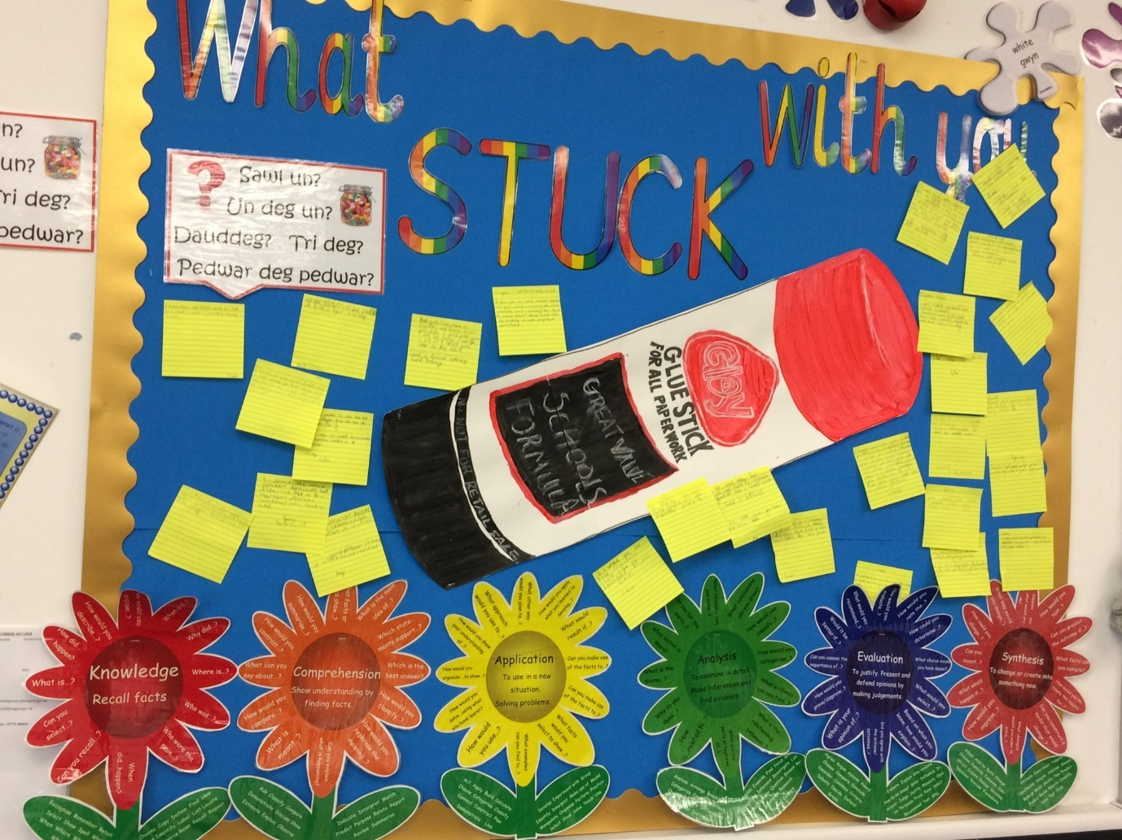

Appendix 2.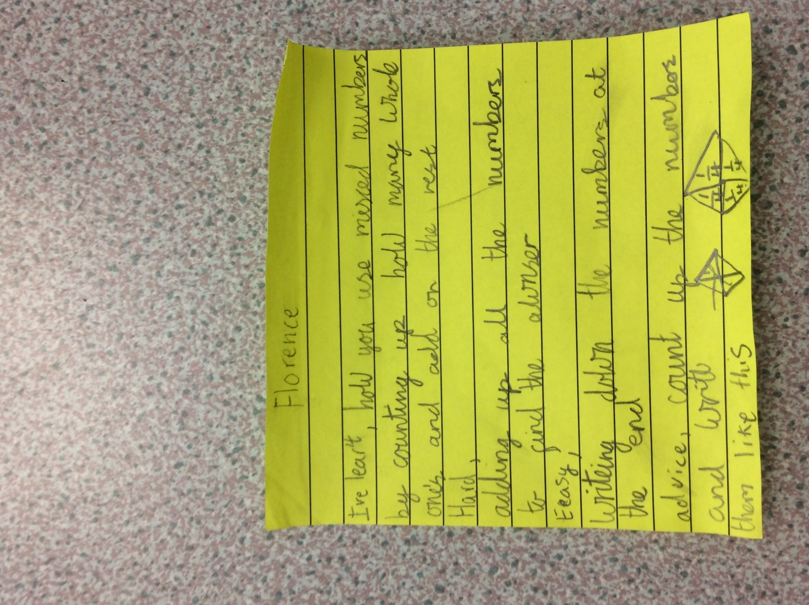

Appendix 3
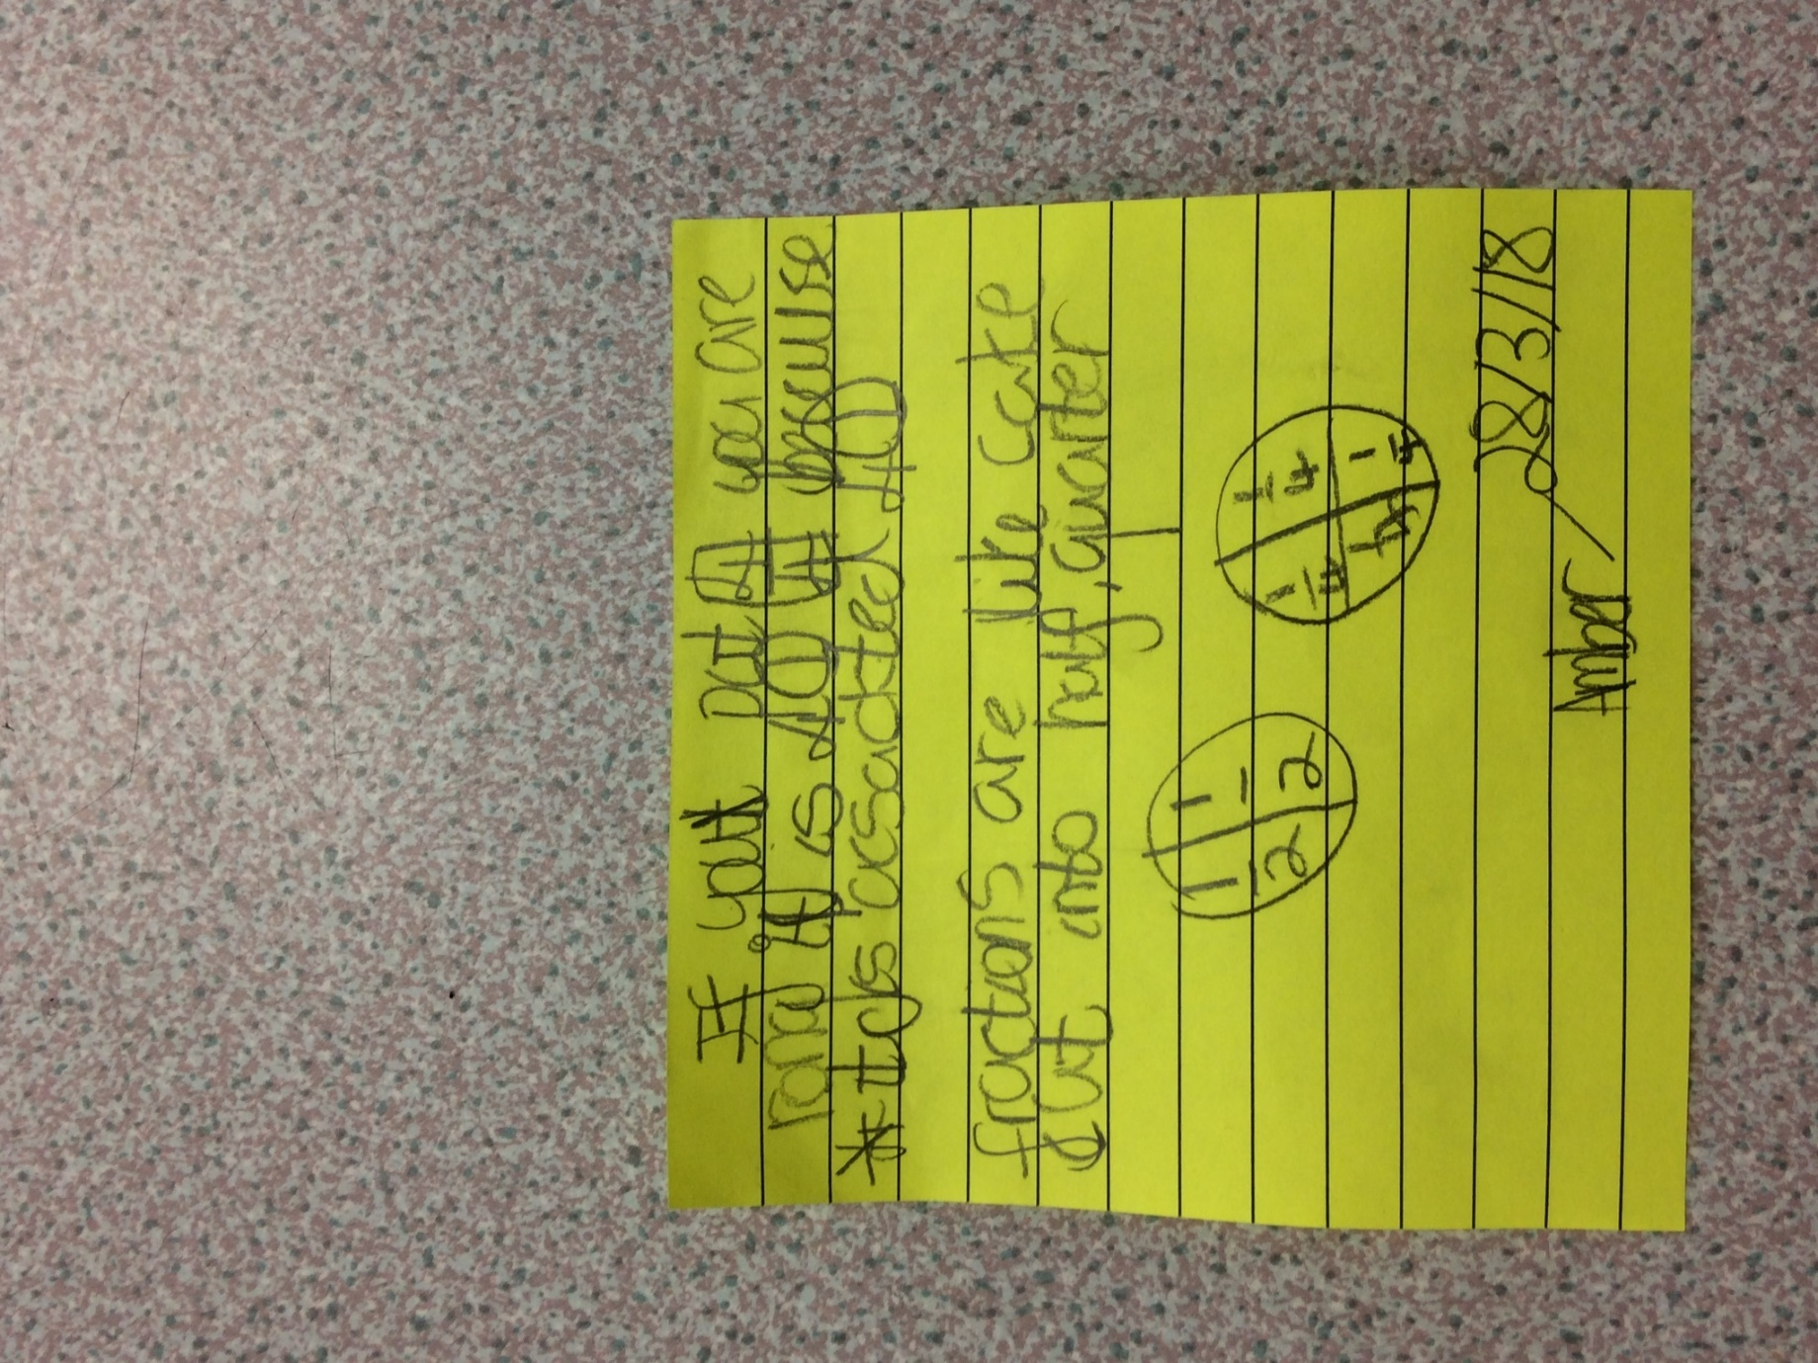

Appendix 4


Appendix 5
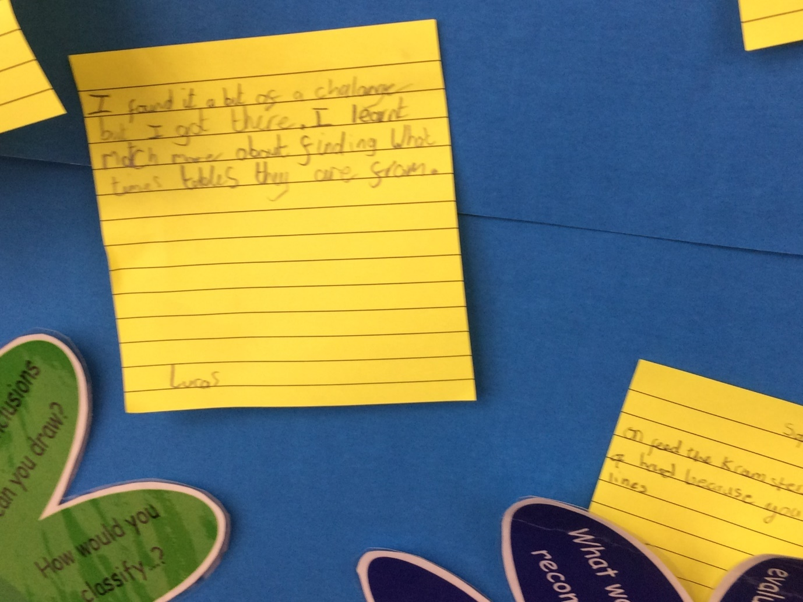

Appendix 6
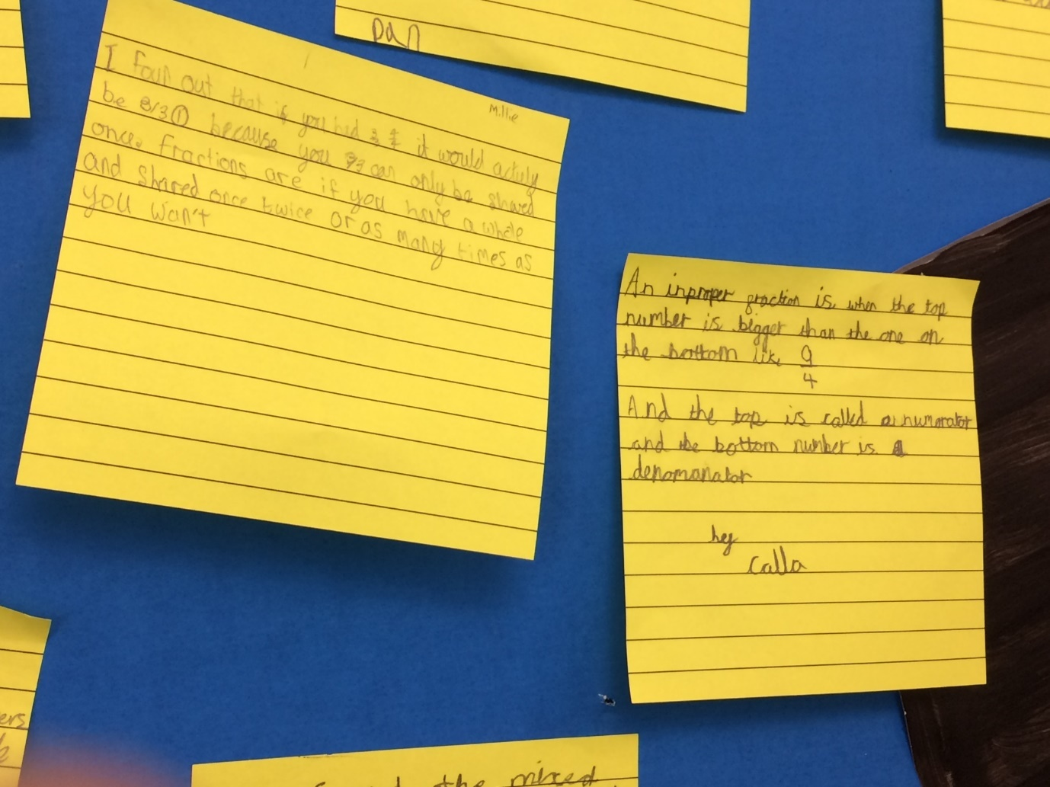

Appendix 8
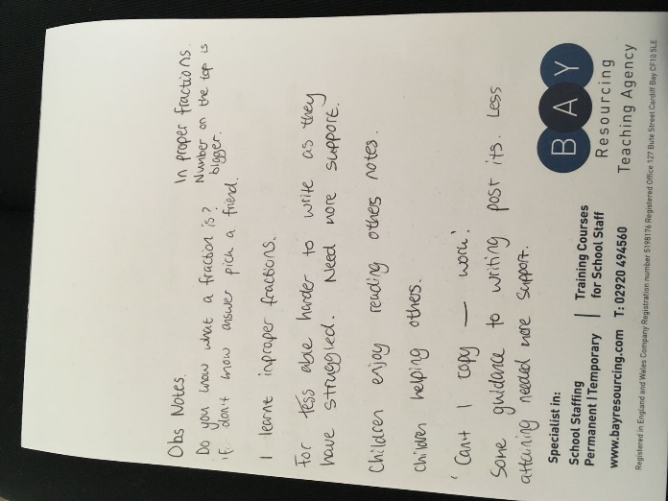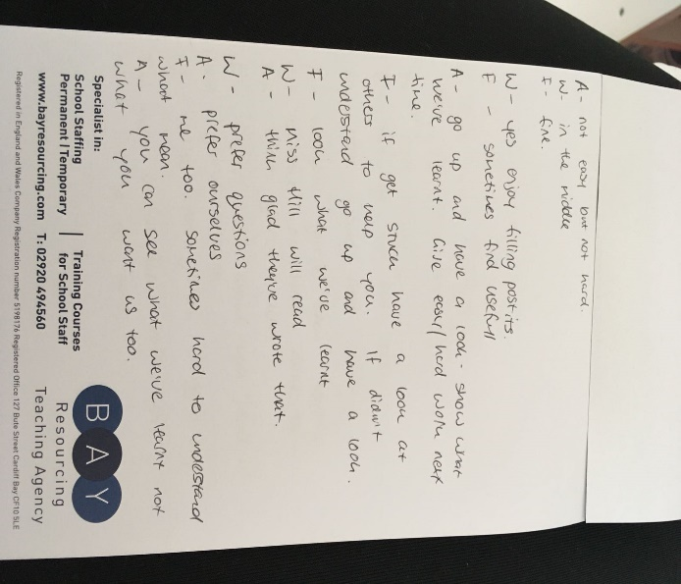
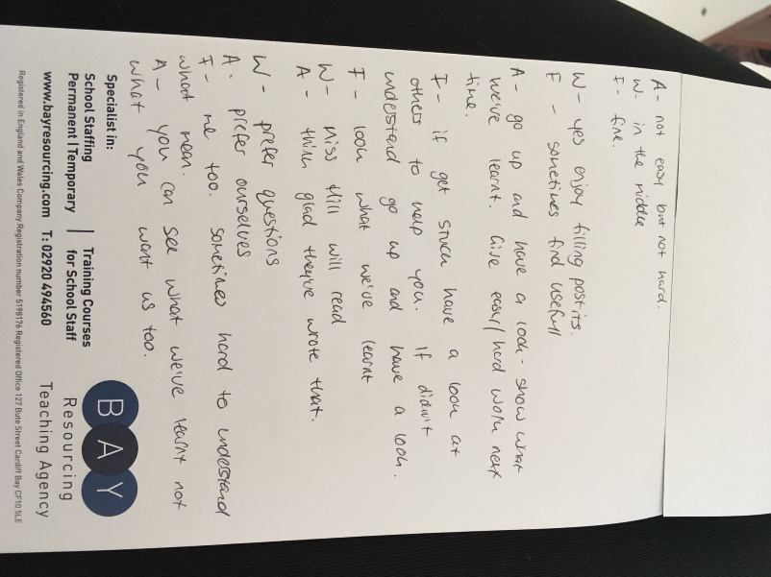

Appendix 9

Appendix 9
Observation notes school 1
Child one: Me K and L did all the work and A only coloured in the letters
Partners repsonse- Maybe if youd shared out the jobs do you think that would have improved the group work?
Child 2: We worked well as a group and our poster was perfect
Child 3: I agree, nothing to improve.
Question 2.
All children agreed that they enjoyed it.
Question 3
Child one: It helps you think about what you’ve done and if you’ve done it right. It helps you know if you need to change it.
Child 2: It helps us knownif we have met the success criteria.
Child 3: Yes same.

Question 4
Child one: There are different questions so you get different answers and everyone’s opinion.
Child two. Helps the teacher know what you thought about the lesson
Child 3. Same as what they said.
My partner- Yes, it helps the teachers with future planning.
We did not ask question 5.
Question 6.
All children agreed it was useful.
Question 7
Questioning deviated and child one expressed she liked post it notes as it allowed your answers to be private. Both children agreed with this.
Question 8
Child one: I would like both. I would like to be able to write my own thoughts too.
Child two: I would like to have written my own thoughts.
Child three. I found it hard to know what to write
Question 9
Child one: My teacher will read this and see if I have improved
All children agree with this.
Did not ask question 10
Question 11
Child one: I did not find the lesson hard
Child two: I enjoyed being creative and doing nice colouring
Child three: Everything was easy and I liked using the ipads.
Did not ask question 12 or 13
Question 14
Child one: It would be good to see what others have said
Child two: Yes I would like to see
Child three: Yes
Question 15
Child one : It doesn’t matter what anyone else thinks, just write down your own thoughts
Both children agree with this.
Question 4)

Appendix 10
Interview questions
1. How did you find the lesson?
2. Did you enjoy the ‘What’s stuck with you?’ activity at the end? (ask why)
3. What do you know about self-assessment? Can you tell me what it means?
4. Why do you think I asked you to fill in a post it note?
5. Did you realise it’s an opportunity for self-assessment?
6. Do you think that it is useful/ does it help you?/ Why do you think it is important to self-assess?
7. Did you think having the questions I gave you to answer helped you self-assess?/ Do you think you would have found it harder or easier without the questions?
8. Would you have liked to have written your own feelings/opinions on the lesson instead of following the questions?
9. Who do you think will read your post it note?
(If child says the teacher, ask why this will help a teacher/what will they use it for?)
10. Has your post it note shown that you have met the learning objective?
11. What did you find hard about the lesson?
12. What did you find easy?
13. Have you put this on your post it note?
(if not would you do this next time?)
14. If these were stuck on the classroom wall would you like to go and read what other children have written on their post it note?/ Would you like to read what other people have written on their post it note?
15. What advice would you give to help a friend who has never self-assessed their work using a post it note before?

Appendix 10
Questions for AFL post it note school one.
1)Explain a good feature of your poster
2)How well did your group work together?
3)How could you improve your poster?
4)What would you do differently next time?
5)What was difficult about the task?
6)What skills have you improved?

