

BSc (Hons) Professional Policing Practice

Public and Police Perception of Antisocial Driving: Understanding Community Reactions and Impacts

Matthew Gibbins
Student number: 2222764

Acknowledgements

I would like to sincerely thank Inspector Sean Fletcher for his advice and support throughout my dissertation, and for sharing his knowledge and experience around the topic. His input was invaluable in guiding the direction of my dissertation.

I would also like to thank my family for their continued support, patience and encouragement throughout the course of my project. Their understanding during busy and stressful periods helped me stay focused and motivated.

Declaration
This work has not previously been accepted in substance for any degree and is not being concurrently submitted in candidature for any degree.
Signed: M T Gibbins
Date: 13/12/2024

STATEMENT 1
This dissertation is being submitted in partial fulfilment of the requirements for the degree of BA.
Signed: M T Gibbins
Date: 13/12/2024

STATEMENT 2
This dissertation is the result of my own independent work/investigation, except where otherwise stated.
Other sources are acknowledged by footnotes giving explicit references. A bibliography is appended.
Signed: M T Gibbins
Date: 13/12/2024

STATEMENT 3
I hereby give consent for my dissertation, if accepted, to be available for photocopying and for interlibrary loan, and for the title and summary to be made available to outside organisations.
Signed: M T Gibbins
Date: 13/12/2024

STATEMENT 4
I hereby give consent for my dissertation, if accepted, to be available on the university’s IT system to those who have consent to use the system.
Signed: M T Gibbins
Date: 13/12/2024

Contents Table

Contents
Acknowledgements 2
Declaration 3
Contents Table 4
1. Chapter one: Introduction 5
2. Chapter two: Literature Review 6
2.0 Introduction 6
2.1 Impacts of Antisocial Driving on Local Communities 7
2.2 Antisocial driving and Road Traffic Collisions 8
2.3 Police Actions to Prevent Antisocial Driving in the UK 10
2.4 Social Media and Antisocial Driving 12
2.5 Conclusion 12
3. Chapter Three: Methodology 13
3.1 Introduction 13
3.2 Research Strategy 13
3.3 Data Collection 14
3.4 Data Analysis 15
3.5 Limitations and Problems 15
4. Chapter Four: Results of Analysis 16
4.0 Introduction 16
4.1 Descriptive Overview of the Sample 16
4.2 Visibility and Experience of Antisocial Driving 17
4.3 Concern Levels Across Age Groups: ANOVA Results 17
4.4 Perceived Severity: Police vs. Public (Chi-square Test) 18
4.5 Perceptions of Police Effectiveness 19
4.6 The Role of Car Meets 19
4.7 Perceptions of Road Traffic Collisions and Antisocial Driving 19
4.8 Conclusion 20
5. Chapter five: Analysis Conclusion and Recommendations 20
5.1 Introduction 20
5.2 Key Findings 21
5.3 Recommendations 22
5.4 Limitations 23
5.5 Implications for Future Research 23
5.6 Accomplishment of Research Objectives 24
5.7 Conclusion 24
6. Chapter Six: Conclusion 25
Bibliography: 26
Appendices 31

Chapter one: Introduction

Antisocial driving behaviour has become a significant cause of concern for communities and police around the United Kingdom. Antisocial driving is defined as reckless or inconsiderate behaviour behind the wheel, such as speeding, illegal car meets, street racing, and excessive noise pollution. It not only endangers road safety but also disturbs the well-being of neighbouring residents. The continual exposure of such behaviours in public settings, combined with their presentation in social media and other outlets, has led to a rising broad conversation about the social effects of these acts.
This dissertation studies public perception of antisocial driving, focused on community reactions, the perceived severity of the problem, and police efforts to minimise its impacts. The study is based on greater understanding of how antisocial behaviour in road use links with public safety, policing, and social cohesion. As informal meetings known as "car meets" have increased in recent years, this study investigates how these events affect cultural life—both positively and negatively.
The basis for this study stems from the apparent divide between car enthusiasts and members of the general public who view these events as alarming. Car meetings, which are frequently planned informally via social media, can range from innocent demonstrations of modified vehicles to unlawful gatherings. These events bring into question local police forces' ability to find a balance between community participation and enforcement. As a result, antisocial driving provides an opportunity to research the larger issues such as public nuisance, community identity, and enforcement credibility.
This dissertation focusses on three main goals: first, to examine the perceived effects of car meets on local communities; second, to identify any obvious links between antisocial driving and road traffic collisions; and third, to evaluate police interventions aimed at preventing such behaviour. To gain a full understanding of the topic from many viewpoints, a mixed-methods approach was used, which included both quantitative survey data and qualitative responses. The analysis uses statistical tests such as ANOVA and chi-square to see if there are significant changes in perceptions based on demographics such as age or role.
The relevance of the issue is supported by ongoing discussions in academic literature, police reports, and legislative forums. While many studies have looked at antisocial behaviour in general, few have focused specifically on driving-related types of wrongdoing or how public opinions influence the effectiveness of police tactics. The dissertation aims to fill this gap by establishing its research within theoretical frameworks as well as practical community situations.
In summary, this study attempts to understand the patterns of antisocial driving through a community-centered perspective. It examines how different age groups and social roles perceive the severity of the problem, as well as the effectiveness and challenges of current policing strategies. This dissertation adds to the increasing the literature on public order, community impact, and policing, subsequently providing recommendations for reducing the harm caused by disruptive driving behaviour.

Chapter two: Literature Review

Introduction

Antisocial driving behaviours such as reckless driving, road rage, and illegal car meets pose serious threats to both public safety and the well-being of communities. These behaviours are closely associated with road traffic collisions (RTCs), increased psychological distress, and significant financial burdens (Li et al., 2022; Metropolitan Police Service, 2019). To create a safer community environment, it is crucial to understand how people in the community perceive and respond to these driving behaviours, as well as the tactics used by the police service to manage the misuse of the roads.
This review of existing research looks at how antisocial driving affects communities in a variety of ways, with a particular emphasis on how it contributes to RTCs and the disruptive social and environmental implications it has. It also assesses how the police throughout the UK are addressing these problems including through the use of Section 59 warnings and Public Space Protections Orders (PSPOs). The review utilises a variety of sources, such as online documents, scholarly research retrieved using Google Scholar, and materials from the online library of the University of Wales Trinity Saint David (UWTSD). The review aims to give a comprehensive understanding of antisocial driving and evaluate the effectiveness of current policing strategies for making roads and communities safer by examining different perspectives.

2.1 Impacts of Antisocial Driving on Local Communities

Car meets, which are unauthorised gatherings of car enthusiasts, have a large impact on the communities around them, with repercussions that vary greatly based on their arrangement size and behaviours of attendees. Clarke (2023) highlights the growing concerns about unsafe driving and unlawful car meets, especially with regard to “boy racers”. These events can be anything from small and informal gatherings to large, professionally planned events that draw hundreds of participants. On the one hand, legally permitted car meets can promote a sense of community, especially if they are held in regulated locations or with official permits. Professional car meets can give vehicle fans a chance to express love of cars in a supervised, safe and structured setting, which can develop a sense of belonging among attendees. An article by Alexander Middlemas (2024) supports this as although car meets are not illegal in the UK, participants and organisers must abide by local rules and regulations to make sure their events are safe and lawful. Car lovers can enjoy these events without running outside of the law if they obtain the required permits, pick the appropriate venues, and encourage responsible behaviours.

In contrast, the effect of car meets can vary greatly, especially if they are not officially organised or do not have sufficient supervision or control. When car meets operate in an unorganised manner, they can cause serious disruptions to the community around them. This is particularly evident when attendees drive recklessly or dangerously, such as performing stunts like drifting, aggressive acceleration, excessive speeding, which not only put participants at risk but also interferes with locals’ daily life. This is supported by an article by Green and Burton ASB (2024) which states that the adverse effect of antisocial car meets have on nearby neighbourhoods and businesses are substantial. Loud exhausts and revving engines can produce extremely disruptive noise pollution. The report also states that the public’s safety is seriously threatened by dangerous driving practices like speeding. In the UK, a number of instances have led to fatalities.
Additionally, noise laws are frequently broken by these events, resulting in severe noise pollution, especially late at night or early in the morning, which can disrupt the comfort and peacefulness of nearby communities. A report by Richard Lemmer and Daisy Stephens (2024) shows residents had made reports of noise complaints following an illegal gathering passing their homes, one resident stating the car meets are disturbing due to the sounds of the vehicles occurring suddenly.
In more serious situations, when these events attract large, disruptive individuals, they may turn into gatherings that support and allow unsafe or illegal activities, including street racing or the display of modified vehicles that do not meet safety regulations. Unsafe vehicles and high-speed racing can result in accidents, injuries or even fatalities (Verderame, 2023). These kinds of behaviours present serious risks to both participants and innocent members of public.

2.2 Antisocial driving and Road Traffic Collisions

Driving habits have a significant impact on the frequency and seriousness of RTCs. Existing studies have demonstrated a strong link between an increased risk of accidents and reckless or irresponsible driving behaviours, including speeding, tailgating, and distracted driving. For instance, speeding increases the effect of a collision and impairs a driver’s reaction to sudden changes in traffic conditions, both of which lead to more serious consequences (Elvik et al., 2019). Similarly, the probability of rear-end crashes is further increased by tailgating, or following too closely behind another car, especially in congested areas or bad weather conditions (Wang and Song, 2011).

Distracted driving, which includes using a phone while driving and other in-car distractions has become a major contributor to RTCs since it significantly reduces drivers’ ability to concentrate and respond. In the UK, 11 million drivers confess to using their mobile phones while driving, and 16% of drivers admit to sending or receiving text messages whilst operating a motor vehicle. Despite the general view from the public that using a phone hands-free is acceptable, it still results in a 30% decrease in driver reaction times, which is the equivalent to what happens to those who are intoxicated (Hedges, 2024).

Furthermore, two major factors that can significantly impair judgment, coordination, and reaction times are alcohol use and fatigue. These conditions make antisocial driving behaviours including speeding, tailgating or careless lane changes, far more dangerous. Drivers are less able to make quick and logical decisions whilst intoxicated or exhausted which increases the risk of aggressive and dangerous driving. These impairments might result in poor driving decisions, like not giving way, ignoring traffic signals or performing risky manoeuvres that put other drivers and road users in danger (Dong et al., 2024). Therefore, fatigue and alcohol, both together and individually, can increase the likelihood of collisions and make driving riskier for everyone.

Understanding changes in antisocial driving behaviours is crucial for evaluating the effectiveness of safety initiatives and identifying at-risk communities. Recent data from the United Kingdom reveals important information on how common these behaviours are and how they affect RTCs.

According to ROSPA (2021) inappropriate speed contributes to approximately 12% of all injury collisions, 13% of serious injury collisions, 24% of fatal collisions. Additionally, a report by Ben Clatworthy (2025) indicates that 72% of drivers attempt to drive as close as possible to the speed limit, with over half considering it acceptable to exceed speed limits which causes a rise in RTCs. Furthermore, aggressive driving behaviours, often referred to as “road rage”, have been linked to a record number of fatalities. In 2023, 143 individuals lost their lives due to incidents provoked by road rage, with 2,722 collisions resulting in 4,084 causalities (Moriarty, 2024).

In the year ending June 2024, road collision statistics in Great Britain revealed the following estimates:
- 1,607 fatalities, a 2% decline compared to the year ending June 2023
- 29,540 killed or seriously injured (KSI) causalities, showing little change from the previous year.
- 128,920 casualties of all severities, a 4% decline compared to the year ending June 2023.
Demographically, males accounted for 75% if fatalities and 61% of casualties of all severities during this period.

Reported road casualties by severity and all road traffic (billion vehicles miles), Great Britain, the year ending June 2014 to the year ending June 2024 (provisional)
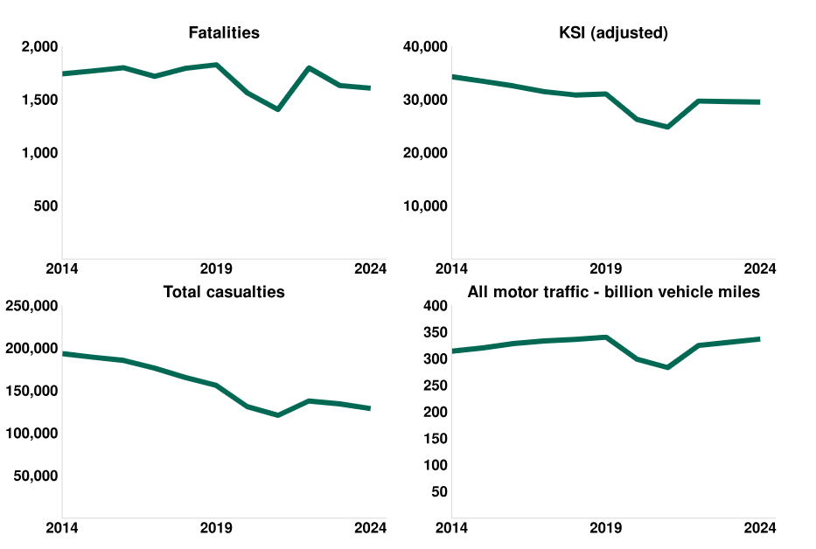
(GOV.UK, 2024)

2.3 Police Actions to Prevent Antisocial Driving in the UK

In an effort to discourage antisocial driving, Police services in the UK have put in place a number of initiatives that emphasise both preventative and reactive strategies. A successful deterrent has been the implementation of Public Space Protection Orders (PSPOs) in locations where car meets are common. These orders provide local police the authority to impose penalties on those who engage in disruptive behaviour with fines and to prohibit them from entering specific areas (City of London, 2024). For example, Newham Council (2022) implemented a PSPO that targets motor vehicle distress and illegal street racing. This police permits police and authorised council staff to fine people £100 for engaging in antisocial driving behaviours that cause harassment, alarm, or distress. Similarly, Leeds City Council addressed vehicle-related antisocial behaviour, such as reckless driving and unlawful car cruising, by implementing a citywide PSPO. In an effort to improve public safety and discourage criminal activity, this order gives police the power to impound vehicles used in antisocial acts (Leeds City Council News, 2023). The Anti-Social Behaviour, Crime and Policing Act of 2014, which gives local authorities a duty to issue PSPOs to stop specific behaviours that negatively impact a community’s quality of life, is in line with the larger framework that these actions are a part of. To adhere to human rights legislation and improve public trust, PSPOs are required under the laws to be renewed after the initial three-year period (GOV.UK, 2014).

An alternative power to deter the ant-social use of motor vehicles is the use of Section 59 of the Police Reform Act 2002. This provision is especially useful when a car is driven in a way that violates the laws surrounding reckless and careless driving, unpermitted off-road driving, and driving in a manner which is likely to cause alarm, distress and annoyance to the public. When an officer notices such activity, they can issue the motorist with a Section 59 warning, which is valid for a year. Police have the authority to confiscate and remove the involved vehicle if the offender commits the same offence again within the time frame. In addition, this warning becomes linked with both the driver and the particular vehicle; therefore, the vehicle is still at risk of seizure if someone else drives the same vehicle in an antisocial manner during the warning time (Open Learn, 2025). Although the use of the Section 59 power deters antisocial activity relating to vehicles, its use has generated controversy. Critics argue that the police’s broad authority could result in uneven enforcement or possible abuse. For example, there have been cases where the power was used to seize vehicles without warning, which raises questions about justice and procedure (Topping, 2022). Thus, even while section 59 warnings and powers play a crucial role in improving public safety, its ethical and transparent application is essential to preserve public confidence and protect people’s rights.

In further response to the problems caused by illegal gatherings and irresponsible behaviour on public roads, policing teams that target car meets and antisocial driving have developed. To reduce the impact the manner of driving has on the community, certain police services in the UK have put specialised operations in place. For instance, Operation Octane was developed by Norfolk Constabulary in October 2023 with the goal of interacting with motor fans and pursuing those who violate the law. The operation consists of using an escalation mechanism, the starting point begins with warning letters to offender and may lead to Community Protection Notices. For repeat offenders, this may lead to legal action against them. This strategy prioritises positive involvement and education, reserving prosecution for those who endanger public safety (Norfolk Constabulary, 2024).

Similarly, Operation Chromium by Hampshire Constabulary targets antisocial vehicle use. In order to combat illegal car meets, Basingstoke police traffic offence reports and seized uninsured vehicles. Additionally, they used Section 59 warnings, which are powers used to reduce the antisocial use of vehicles. If drivers continue their antisocial habits whilst driving, a second Section 59 could result in the seizure of their vehicle. This tactic emphasises how crucial community involvement and enforcement are in preventing unsafe driving patterns (Hampshire and Isle of Wight Constabulary, 2022).

These types of policing tactics are further highlighted by academic studies. Lumsden’s (2013) study looks at Aberdeen, Scotland’s laws governing drivers, or “boy racers”. The study emphasises how legislation against disruptive behaviour and the renewal of cities are two examples of factors that affect police officers’ actions. According to the report, car meets, and antisocial driving can be effectively addressed by using community police staff to manage incidents.

2.4 Social Media and Antisocial Driving

Driving behaviours have been greatly influenced by social media, especially when it relates to antisocial driving. Dangerous driving incidents have increased as a result of the sharing of footage that both encourages and glamorises bad driving habits, footage like this becomes viral on social media platforms (Stefanidis et al., 2022).

PLOS ONE (2020) released a systematic review that evaluated how social media material affects the obedience in relation to traffic laws. While some content educates and discourages unsafe driving, a significant proportion encourages risky behaviours including speeding, distracted driving, and aggressive driving, according to the research. Individuals’ attitudes and behaviours may differ as a result of this exposure, which may increase their use of illegal driving habits.

Young offenders in the UK have began to often brag about their crimes, especially reckless driving, on social media, which is a concerning trend. Videos of careless driving and unlawful activity on the roads have been shared online, which has made communities more fearful. In response, police have passed legislation that specifically targets “posting and boasting”, with the goal of preventing the sharing of these acts (Mills, 2023). Research suggests that nearly a quarter (24%) of drivers between the age of 18 and 34 acknowledge using social media while driving, with 5% doing so every day (1st CENTRAL, 2019). Even with tougher penalties in place, many drivers will stick check their phones whilst driving. This dangerous behaviour emphasises how crucial increased awareness attempts and more stringent laws are needed to help reduce the risk associated with social media and driving.

2.5 Conclusion

Communities are impacted by car meetings and antisocial driving an a variety of ways, from encouraging a sense of belonging and safe vehicle enjoyment to creating disturbances, noise pollution, and dangerous driving habits that cause concern for both those attending events and the public as a whole. As long as appropriate supervision and regulations are followed, legally allowed car meets offer a safe and responsible environment for vehicle enthusiasts to socialise. However, poorly planned and uncontrolled events frequently result in antisocial behaviour, loud noises and careless driving, all of which have serious negative impacts on local communities, such as increased traffic accidents, annoyance, and threats to public safety.
These problems are made worse by the growth of social media, which normalises and glamorises dangerous driving behaviours, creating a culture of unsafe driving. To combat antisocial driving and to safeguard public safety, Police in the UK have responded by adopting a number of policies, including Public Space Protection Orders, Section 59 warnings, and targeted policing initiatives like Operation Octane and Operation Chromium. However, community engagement, efficient enforcement, and ongoing public education area critical to the success of these attempts to reduce antisocial driving.
Addressing the underlying causes of antisocial driving such as poor driving habits, social media influence, and intoxication or exhaustion, will be essential moving forward to reduce the rate and seriousness of road traffic collisions. A thorough plan which includes community involvement, robust enforcement, and education is necessary to decrease the effects of antisocial driving and promote safer conditions for road users and the public as a whole.

3. Chapter Three: Methodology

3.1 Introduction

This study examines how the general public view antisocial driving with a focus on the effects of “car meets” on nearby communities, the connections between antisocial driving and road traffic collisions, and the effectiveness of police actions. In many areas, the effect of antisocial driving is becoming a larger problem. Increased noise pollution, public anxiety, and occasionally dangerous driving habits that lead to road traffic collisions are all consequences of antisocial driving (Metropolitan Police, 2019).
While police forces use a range of techniques to tackle antisocial driving, public trust in these attempts varies. Understanding these perspectives is crucial for assessing the effectiveness of police tactics and identifying areas for improvement. This study take a quantitative approach, using an online survey to collect information from the general public who face antisocial driving in their community. The following methodology outlines the research strategy, data collection process, data analysis methods and potential challenges.

3.2 Research Strategy

This study takes a quantitative approach, collecting measurable data relating to antisocial driving through a survey conducted online. A quantitative technique is useful because it allows for defined replies, making it easier to compare perspectives across groups and find trends. Quantitative approaches are frequently used in social research to identify statistical patterns and create conclusions from numerical data (Pasek and Krosnick, 2010). Surveys are an efficient way to collect structured information from a large population, allowing for comparisons between participants with different experiences and backgrounds. The survey will be shared with both police employees and the general public to complete.

The survey will ensure anonymity, which may lead to more honest responses from participants. As the study will include both public and police views, using an online platform to share the survey allows for a larger and more varied participant group. The survey will include mostly close-ended questions with scale response (e.g. “Strongly Agree” to “Strongly Disagree”) which will allow data comparisons between the participants whilst making the survey basic and accessible.

3.3 Data Collection

The survey is being distributed to an assortment of people, with a focus on receiving feedback from the general public and also police employees completing the survey. This ensures that the research includes a wide range of perspectives on antisocial driving and its effects on communities. The purpose of reaching out to local residents, drivers, and any person who has been directly impacted by antisocial driving is to identify how the range of groups feel about the issues. The primary goal of this survey is to gain feedback from both the general public and also police employees as it will gather experiences from a wide range of participants. An online survey will allow a wide range of people to participate, regardless of where they live. This approach provides a broader view of public opinions and ensures that the findings represent the experience of many different parts of the community.
For this survey, a sample strategy known as self-selection will be used, where individuals will decide to complete the survey voluntarily. This strategy allows for quick data collection because any person who may be interested in the topic can simply opt to participate. However, it is important to highlight that this method may cause some bias, since those with strong views or personal experiences with antisocial driving are more likely to engage (Sedgwick, 2013). While this may limit the extent of views, it still gives useful information, particularly from individuals who have firsthand experience with the problem.
The survey questions will be designed to measure key aspects relating to my research including:
- General concerns over antisocial driving behaviours.
- Personal experiences with ‘car meets’, dangerous driving, and their impact on local communities.
- Perceptions of police effectiveness in addressing antisocial driving.
- Opinions on potential strategies for tackling antisocial driving and improving road safety.
The survey will be delivered using Microsoft Forms, which provides a user-friendly platform for participants to complete the survey. This platform also allows efficient data collecting and the simple export of responses for further analysis.

3.4 Data Analysis

The survey responses will be analysed using statistical analysis due to the study taking a quantitative approach. The analysis will use descriptive and inferential statistics to identify patterns, connections, and differences in the responses received.
Descriptive statistics will summarise and present the data using:
- Frequencies and percentages (e.g., the percentage of participants who believe antisocial driving is a major issues).
- Mean and standard deviation (e.g., the average level of concern about antisocial driving on a Likert scale).

Inferential statistics will be used to identify patterns and relationships in the data:
- Chi-square tests will examine relationships between categories, such as differences in public and police perceptions of antisocial driving.
- T-tests or ANOVA will be used when comparing responses between different groups, such as variations in concern levels across age groups.

Microsoft Forms produces simple summary statistics, but the data may also be exported to Microsoft Excel for further analysis, such as producing diagrams and detailed statistical comparisons. This study, which uses descriptive and inferential data, will provide useful insights into how the public and the police perceive and address antisocial driving.

3.5 Limitations and Problems

A drawback of this study is the possibility of self-selection bias because the survey is voluntary. Individuals with strong feelings regarding antisocial driving, whether positive of negative, may be more likely to take part, therefore affecting the results. This can have an impact on the data’s accuracy since people who are unaware of the topic may be under-represented.

Another potential issue is sample representation. Due to the survey taking place online, it may leave out particular groups, such as older people who are concerned about antisocial driving but are less likely to participate in internet surveys. This could limit the findings application to the larger population.

A further concern to consider is the reliability of self-reported data. Respondents may submit answers impacted by social desirability bias, which means they may exaggerate or understate their experiences based on what they believe is to be expected. This is especially relevant for police officers, who may represent their involvement in a more positive light.

To address these limitations, the survey will be promoted through a variety of platforms, including social media, link sharing, and police internal network, to attract a variety of participants. In addition, results will be compared to secondary data sources, such as official police crime figures and government reports to guarantee accuracy and reliability.

By recognising these limitations and taking steps to reduce their impact, the study aims to give and accurate and thorough assessment of public perceptions of antisocial driving. The findings will contribute to discussions on improving policing techniques and creating better community and police relations in dealing with road-related antisocial behaviour.

4. Chapter Four: Results of Analysis

4.0 Introduction
This chapter summarises the findings of a quantitative data analysis carried out to explore public and police views of antisocial driving and its perceived impacts on communities. The primary goal of this chapter is to present a clear and objective overview of the statistical findings based on the replies obtained through the research survey. The study focusses on key factors such as age, occupational role (public vs. police), perceived severity of antisocial driving, levels of concern, opinions about car meets, and perceptions of police effectiveness in addressing such behaviours.
A range of statistical methods were used to examine group differences, including a one-way analysis of variance (ANOVA) and a chi-square test of independence. The tests focused on two key questions: the level of concern about antisocial driving based on the participants' ages, and how significant of a problem antisocial driving is perceived as by police and members of the public. These methods allowed the findings of statistically significant links and differences among groups of people in terms of concern levels and attitudes towards antisocial driving. Descriptive statistics are frequently used to help explain the data. The results gathered from these analyses provide the basis for the discussion and evaluation of findings in the following chapter.

4.1 Descriptive Overview of the Sample
The sample was made up of a variety of individuals, containing both members of the general public and police employees. Respondents were asked to provide basic demographics such as age and role, as well as their level of concern about antisocial driving, the severity of such behaviours, and their perceptions of police responses. The respondents' ages ranged from under 18 to 65+, with the majority lying between 18 and 54. The analysis included both quantitative Likert-scale questions and categorical factors.

4.2 Visibility and Experience of Antisocial Driving

Over 80% of respondents reported living in areas affected by antisocial driving. Daily encounters were cited by 39% of participants, indicating that these behaviours are both persistent and highly visible. This contributes to a community-wide awareness of the issue, regardless of age or job role.

4.3 Concern Levels Across Age Groups: ANOVA Results
Participants rated their level of concern about antisocial driving on a Likert scale. Their responses were separated into five age groups. The average concern score for each group is displayed below:

Table: Mean Concern Scores by Age Group

Age Group | Number of Participants (N) | Mean Concern Score
Group 1 | 14 | 2.93
Group 2 | 24 | 2.54
Group 3 | 3 | 3.00
Group 4 | 7 | 2.57
Group 5 | 13 | 2.23

Group 1 showed the most concern (M = 2.93), while Group 5 had the least (M = 2.23). However, these variations were somewhat minor.

To determine if the differences between age groups were statistically significant, a one-way ANOVA was performed. The table below shows the results.

Table: One-Way ANOVA Summary

Source | SS | df | MS | F | P-value | F critical
Between Groups | 3.85 | 4 | 0.96 | 1.46 | 0.227 | 2.54
Within Groups | 36.91 | 56 | 0.66
Total | 40.75 | 60

The ANOVA results indicate an F-value of 1.46 and a p-value of 0.227. Because the p-value is more than 0.05, the difference between the groups is statistically insignificant. This suggests that age did not have any major effect on how concerned people were about antisocial driving during this study.
Graph: Mean Concern Scores by Age Group:
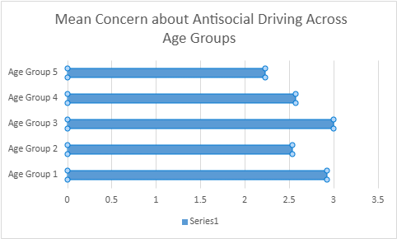

4.4 Perceived Severity: Police vs. Public (Chi-square Test)
A Chi-square test was carried out to test whether there was a difference in how the police and the general public perceived the scale of antisocial driving. The findings are presented in the table below.

Table of the perception of severity of antisocial driving based on role:

Role | Not a Problem | Minor Problem | Moderate Problem | Major Problem | Total
Police | 1 (1.80) | 6 (8.30) | 9 (9.02) | 6 (2.89) | 22
Public | 4 (3.20) | 17 (14.70) | 16 (15.98) | 2 (5.11) | 39
Total | 5 | 23 | 25 | 8 | 61

Note: Expected counts are in brackets.
The test found no significant difference in how police employees and the public rate the seriousness of antisocial driving. This suggests that there is not enough evidence to show that one group views the problem as more important than the other.
Although there were some minor differences in how the groups viewed antisocial driving — with police more likely to term it a "major problem" and the general population tending more towards "minor" or "moderate" — these differences were not statistically significant.

4.5 Perceptions of Police Effectiveness
Participants were asked to rate the effectiveness of police responses to antisocial driving. The findings reveal a large gap between the two role groups. Many members of the public rated police efficiency as "Low" or "Very Low." Police employees, on the other hand, gave their operational efforts a higher rating.

The difference could reflect a lack of public understanding of resource limitations, legal limits, or policing techniques. The findings are important for community policing and public involvement, highlighting the need for greater transparency and communication about policing strategies, including promoting antisocial driving operations which are currently being utilised.

4.6 The Role of Car Meets
Respondents were asked if they thought "car meets" encouraged antisocial driving in their community. The majority of public comments were negative, frequently linking car meets to increase noise levels, inconsiderate driving, and feelings of intimidation among local neighbours.
Although some responses argued that these gatherings could be positive if properly managed, the general opinion was that they act as an opportunity for nuisance behaviour. Police respondents appeared to agree but highlighted the challenges of separating acceptable meetings from those that fall into dangerous events. This shows that there may be an opportunity to manage the risk through event licensing, community engagement, or designated safe places for car enthusiasts to gather.

4.7 Perceptions of Road Traffic Collisions and Antisocial Driving
Participants were asked if they thought antisocial driving was associated with an increase in road traffic collisions. A large percentage of both police and public groups agreed with this claim. This general agreement provides evidence to the belief that antisocial behaviours—such as speeding, street racing, and aggressive driving—pose a threat to road safety.
This opinion supports policing policies that highlight high-risk behaviours and is in line with public support for more efforts to reduce the dangers of antisocial driving. These opinions may justify targeted policing operations or heightened monitoring in known antisocial driving hotspots.

4.8 Conclusion
The findings given in this chapter present a detailed picture of how different demographic and professional groups view antisocial driving and its impact on society. While the statistical analysis found no significant differences in concern levels between age groups, they did identify small changes that suggest younger and older individuals may have distinct views, even if this is not statistically established. Similarly, while the chi-square analysis revealed no significant differences in police and public perceptions of the severity of antisocial driving, there were evident trends, such as the police being more likely to view it as a severe problem.
Perceptions of police efficiency differed significantly between public and police respondents, suggesting potential relations, confidence, or expectation issues between police services and the communities they serve. These findings highlight the importance of increased transparency and community engagement in preventing antisocial driving behaviours.
The responses from participants in relation to car meets revealed a primarily negative public outlook, with events like this being associated with nuisance behaviours and community disruption. However, there was recognition—particularly among police respondents—of the possibility to manage these gatherings in a better way. This provides opportunities for legislative action through licensing, agreed locations, and community interaction.
Finally, significant agreement among police and public participants related antisocial driving to more traffic collisions highlighting the likely impacts occurring from the dangerous behaviours. This growing opinion stresses the importance of targeted policing and educational programs to reduce dangers and improve road safety.
Together, these findings provide the foundation for the discussion chapter, which will investigate the significance of these findings in relation to existing literature, policy concerns, and future research opportunities.

5. Chapter five: Analysis Conclusion and Recommendations

5.1 Introduction

This chapter highlights the main findings of the primary research and puts them into context in light of academic literature and secondary data. It is structured around the dissertation's main objectives: to investigate the impact of car meets on communities, to assess the link between antisocial driving and road traffic collisions (RTCs), and to evaluate police responses to such behaviours. The chapter also provides practical recommendations based on the findings, acknowledges the study's limits, offers areas for further research, and evaluates how successfully the research objectives were realised.

5.2 Key Findings

Car Meets and Community Impact
The study discovered that car meets are frequently considered as disturbing by the public, mainly owing to noise pollution and antisocial behaviour. Over 80% of respondents to the survey said they lived in areas affected by antisocial driving, with qualitative replies typically mentioning late-night noise, unsafe driving, and gatherings in residential areas. These findings back with prior research by Green and Burton (2024), who found that uncontrolled vehicle meets frequently cause public disturbances and criminal vehicle activities. In the literature review, McCarthy (2022) and Campbell (2023) explored the physical conflict between car enthusiasts and residents, particularly in neighbourhoods.
surprisingly, while many police officers acknowledged these risks, several also recognised the potential benefits of controlled car meets in promoting safe social interaction among car enthusiasts. This balanced viewpoint is consistent with Middlemas (2024), who discovered that when meetings are professionally planned, they can provide safer venues while reducing informal gatherings elsewhere. The literature likewise mirrored this dual narrative. Gibbons (2022) noted that car meets can build community among youth when appropriately supervised.
Antisocial Driving and Traffic Collisions
The survey results revealed a strong public and police agreement that antisocial driving behaviours, particularly speeding, aggressive acceleration, and stunts, considerably improve the likelihood of RTCs. Almost one-third of respondents said they had personally witnessed a crash caused by such behaviours, and two-thirds knew someone involved in an RTC. These findings support national statistics, such as ROSPA (2021), which attribute 24% of fatal crashes to unsafe speed.
The literature study similarly showed connections between aggressive driving and higher accident risk, citing data from the Department of Transport (2021) and Wilson and Fielding's (2023) research on driver behaviour and collision likelihood.
An ANOVA test revealed no statistically significant differences in concern levels among age groups. This indicates that concern of antisocial driving is widespread, regardless of age. Such findings highlight the seriousness of the problem and the widespread concern and intervention.

Perceptions of police interventions
The public generally expressed frustration with current police attempts to combat antisocial driving. More than 60% of respondents evaluated police effectiveness as "low" or "very low," with many claiming no knowledge of any local operations. In contrast, police officers tended to rate their own work more positively, highlighting recent initiatives such as hotspot patrols or focused campaigns.
The difference between police actions and public perception is consistent with Brookes and Hall's (2023) results, which suggest that communication breakdowns can undermine public trust in enforcement techniques. The literature review also uncovered comparable critiques in community policing literature, with Loader (2022) and Irving (2023) highlighting that public trust in policing is strongly dependent on visible results and transparency.
Despite this, there was still strong popular support for more police presence, harsher fines, and greater transparency in police operations.

5.3 Recommendations

These recommendations come straight from the study's findings and are based on both public and police responses:

1 - Regulated and Permitted Car Meets
Local governments should work with vehicle enthusiast groups, landowners, and police to develop licensed locations for car meetings. Noise control, security, and a small police presence can help to create safer venues while still recognising social likes and dislikes. This is consistent with participants' beliefs that positive involvement is better than demanding restriction, and it follows literature suggesting that incorporating culture could reduce resistance to policing (Gibbons, 2022).
2 - Enhanced Police Communication
Police forces should increase transparency by frequently publicising enforcement statistics (e.g., Section 59 notifications, vehicle seizures). Tools such as social media updates, pop-up police stations, and community briefings may help bridge the awareness gap and boost public trust. Scholars such as Loader (2022) have called for responsive and visible community policing.
3 - Smarter Enforcement Strategies
The findings indicate public support for both visible and covert policing. Unmarked vehicles, automatic number plate recognition (ANPR), and mobile speed cameras can help enhance high-visibility patrols. A graded penalty strategy, ranging from warnings to seizures, could deter continuing offenders while not overly penalising first-time drivers.
4 - Community Education and Youth Engagement
Early education was often suggested in survey responses. Schools and youth organisations ought to develop road safety campaigns that address the glamorisation of reckless driving on social media. Simulated accident experiences or victim discussions could help to personalise the risks and discourage those looking for excitement. This is consistent with findings in the research that youth involvement in car culture is frequently motivated by identity-seeking and peer encouragement which can be positively redirected through educational outreach (Campbell, 2023)
These recommendations are based on visible weaknesses in the data as well as participant suggestions, providing realistic, evidence-based actions.

5.4 Limitations

The study has some limitations. First, the survey's self-selection may have drawn respondents with strong viewpoints, thereby skewing the results.
Second, relying on self-reported experiences increases the risk of exaggeration or recall bias.
Third, given the large sample size, age groups were unevenly represented, lowering the effectiveness of the ANOVA test. Finally, the study only captured a brief period of time and may not reflect new viewpoints impacted by current legislation or incidents.

5.5 Implications for Future Research

Future research should assess the long-term effects of initiatives such as designated car meet locations or increased patrols. Comparative research that extend urban, suburban, and rural areas could investigate how setting influences behaviour and perception. Furthermore, study on the attitudes and motivations of car enthusiasts could provide insight into preventative measures tailored to this audience.
A mixed-methods long-term investigation could give useful information on whether police and education efforts result in measurable decreases in antisocial driving and related RTCs.

5.6 Accomplishment of Research Objectives

Objective 1: The Impacts of Car Meets
Addressed using both quantitative and qualitative data. While car meets provide entertainment for fans, they also represent risks and disruptions when unregulated. The findings point to the importance of organised involvement in promoting compromises.

Objective 2: Antisocial Driving and RTCs.
The study established a clear connection between dangerous driving behaviours and a higher rate of RTCs, as evidenced by participant involvement and national statistics.

Objective 3: Police Actions.
The findings indicated both community dissatisfaction with present enforcement and a general lack of public awareness. However, police participants identified techniques that, if presented more effectively, might improve community relations and trust.

5.7 Conclusion

This study investigated how antisocial driving, particularly in uncontrolled car meets, affects public safety and perceptions. The findings highlight widespread public concern, a clear link between reckless driving and accidents, and a gap between enforcement efforts and public knowledge.
It is essential to find a balance between enforcement and education, and from punishment to engagement. A multi-agency, community-led solution based on regulated car meets, improved enforcement, and open communication might significantly decrease antisocial driving.
The study accomplishes its aims and makes useful, evidence-based recommendations. It adds to the ongoing discussion about traffic safety and provides a useful foundation for future legislation aimed at making roads safer while maintaining social interaction among car enthusiasts.

6. Chapter Six: Conclusion

This dissertation studied the public perception of antisocial driving, with a particular emphasis on community responses and the larger effects on safety, policing, and government policy. The study aimed to achieve three major goals: to discuss the impact of car meets on communities, to identify any connections between antisocial driving and road traffic collisions, and to investigate police preventative measures. This study, which used both quantitative and qualitative data, gave a comprehensive analysis of the difficulties and produced a number of important findings.
First, survey data analysis found that antisocial driving is widely seen as an issue by the general population, with particular concerns about loud disruption, dangerous driving, and the possibility of accidents. This is consistent with scholarly literature and media coverage, which frequently stress the anxiety experienced by neighbours near sites where car meets and reckless driving occur. Age was found to influence levels of concern, with younger individuals evaluating the issue as less severe than older age groups. However, all parties recognised the consequences of antisocial driving.
Secondly, although not statistically proven, the findings suggest a visible link between antisocial driving and road traffic collisions. This perspective, while not clearly confirmed by crash data in this study, emphasises the mental and emotional impact such driving behaviour takes on communities. The belief that reckless driving will result in accidents contributes to feelings of fear and frustration, especially in residential areas where children and pedestrians are at risk.
The third significant finding addresses police engagement. Survey results and open-ended responses revealed different views on the effectiveness of police action. While some respondents reported noticeable patrols and occasional enforcement actions, others thought police responses were inconsistent or insufficient. This emphasises the need for more targeted and community-based police strategies. Furthermore, the study discovered a gap between public expectations and local police capabilities, especially when dealing with unexpected events such as car meets.
Overall, this dissertation adds to existing information by providing an extensive view of antisocial driving as a behavioural and social issue. It emphasises the importance of police enforcement, local councils, and community groups working together to manage and prevent acts like these. Public education campaigns, increased police visibility, and the establishment of designated sites for vehicle enthusiasts to gather safely might all be part of a more successful long-term response.
In conclusion, antisocial driving is a complex social concern with serious implications for community well-being, safety, and public trust. It is not just a traffic enforcement issue. This study provides a helpful source of evidence for the development of legislation and policing tactics by revealing the opinions and worries of the general people. It will be useful to carry out more studies and engage with those affected to make sure that responses are inclusive, effective, and fair. These methods may significantly reduce the impact of antisocial driving and improve our awareness of the harm that antisocial driving causes.

Bibliography:

1st CENTRAL (2019). Social media addiction putting drivers at risk | Road Safety | 1st CENTRAL. [online] Behind the wheel with 1st CENTRAL. Available at: https://hub.1stcentralinsurance.com/road-safety/social-media-addiction-putting-drivers-at-risk (Accessed: 20 January 2025).

City of London (2024). Public Spaces Protection Orders - City of London. [online] Cityoflondon.gov.uk. Available at: https://www.cityoflondon.gov.uk/things-to-do/green-spaces/burnham-beeches-and-stoke-common/public-spaces-protection-orders (Accessed: 15 January 2025).

Clarke, B. (2023). Public meetings put dealing with car meets and boy racers on the agenda. [online] Pgweb.uk. Available at: https://www.pgweb.uk/planning-all-subjects/traffic-roads-parking/106-roads/3761-public-meetings-put-car-meets-and-boy-racers-firmly-on-the-agenda (Accessed: 7 November 2024).

Clatworthy, B. (2025). Most drivers see speed limits merely as ‘targets’, report finds. [online] Thetimes.com. Available at: https://www.thetimes.com/uk/transport/article/most-drivers-see-speed-limits-merely-as-targets-report-finds-qk68f7r8w?msockid=0c3a39070863681f0b962dae099d69f7 (Accessed: 15 January 2025).

Dong, M., Lee, Y.Y., Cha, J.S. and Huang, G. (2024). Drinking and driving: A systematic review of the impacts of alcohol consumption on manual and automated driving performance. Journal of Safety Research, 89. doi: https://doi.org/10.1016/j.jsr.2024.01.006 (Accessed: 15 January 2025).

Elvik, R., Vadeby, A., Hels, T. and van Schagen, I. (2019). Updated estimates of the relationship between speed and road safety at the aggregate and individual levels. Accident Analysis & Prevention, [online] 123, pp.114–122. doi: https://doi.org/10.1016/j.aap.2018.11.014 (Accessed: 15 January 2025)
GOV.UK (2014). Anti-social Behaviour, Crime and Policing Act 2014. [online] Legislation.gov.uk. Available at: https://www.legislation.gov.uk/ukpga/2014/12/part/4/chapter/2 (Accessed: 15 January 2025).

GOV.UK (2024). Reported road casualties in Great Britain, provisional estimates: year ending June 2024. [online] GOV.UK. Available at: https://www.gov.uk/government/statistics/reported-road-casualties-in-great-britain-provisional-estimates-year-ending-june-2024/49158200-ee7b-402d-8842-cd6c6bbb8d84 (Accessed: 15 January 2025).

Green and Burton ASB (2024). Tackling Antisocial Car Meets: Surrey Police’s Comprehensive Approach - Green And Burton ASB Associates. [online] Green And Burton ASB Associates. Available at: https://greenandburtonasb.co.uk/tackling-antisocial-car-meets-surrey-polices-comprehensive-approach/ (Accessed: 15 January 2025).

Hampshire and Isle of Wight Constabulary (2022). Basingstoke officers take proactive action to tackle anti-social behaviour at unauthorised car meets. [online] Hampshire and Isle of Wight Constabulary. Available at: https://www.hampshire.police.uk/news/hampshire/news/news/2022/december2/basingstoke-officers-take-proactive-action-to-tackle-anti-social-behaviour-at-unauthorised-car-meets/ (Accessed: 15 January 2025)

Hedges, C. (2024). The growing threat of distracted driving | Cardinus. [online] Cardinus. Available at: https://www.cardinus.com/eyes-on-the-road/ (Accessed: 15 January 2025).

Leeds City Council News (2023). Anti-social Behaviour Awareness Week sees city-wide Public Space Protection Order comes into force. [online] Leeds City Council News. Available at: https://news.leeds.gov.uk/news/anti-social-behaviour-awareness-week-sees-city-wide-public-space-protection-order-comes-into-force (Accessed: 15 January 2025).

Lemmer, R. and Stephens, D. (2024). Theale car meets prompt noise and safety concerns. BBC News. [online] 17 May. Available at: https://www.bbc.co.uk/news/articles/c0x0x0n4py0o (Accessed: 15 January 2025).

Li, J., Ge, Y., Yu, T. and Qu, W. (2022). Social exclusion and dangerous driving behaviour: The mediating role of driving anger and moderating role of cognitive reappraisal. Current Psychology, [online] 42. doi: https://doi.org/10.1007/s12144-022-03259-9 (Accessed: 16 February 2025)

Lumsden, K. (2013). Policing the roads: traffic cops, ‘Boy Racers’ and anti-social behaviour. Policing and Society, [online] 23(2), pp.204–221. doi: https://doi.org/10.1080/10439463.2012.696642 (Accessed: 15 January 2025).
Metropolitan Police Service (2019). Vehicle nuisance involving cars, bikes and mopeds | The Met. [online] Police.uk. Available at: https://www.met.police.uk/advice/advice-and-information/asb/asb/antisocial-behaviour/vehicle-nuisance-involving-cars-bikes-and-mopeds/ (Accessed 16 February 2025).

Middlemas, A. (2024). Are Car Meets Illegal in the UK? - Legal Insights and Guidelines | Omi Wheels. OMI ALLOY WHEELS. Available at: https://www.omiwheels.com/blogs/news/are-car-meets-illegal-in-the-uk-legal-insights-and-guidelines-omi-wheels. (Accessed: 13 January 2025).

Mills, J. (2023). Social media is fuelling antisocial driving | Hagerty UK. [online] Hagerty UK. Available at: https://www.hagerty.co.uk/articles/opinion/social-media-is-fuelling-antisocial-driving/ (Accessed: 20 January 2025).

Moriarty, R. (2024). Urgent warning as ‘road rage’ deaths on Britain’s roads hit record number... [online] The Sun. Available at: https://www.thesun.co.uk/motors/31197138/road-rage-deaths-record-high/ (Accessed 15 January 2025).

Newham Council (2022). Newham Council crackdown on vehicle nuisance and street racing with the introduction of a Public Space Protection Order (PSPO) – Newham Council. [online] Newham Council. Available at: https://www.newham.gov.uk/news/article/964/newham-council-crackdown-on-vehicle-nuisance-and-street-racing-with-the-introduction-of-a-public-space-protection-order-pspo- (Accessed: 15 January 2025).
Norfolk Constabulary (2024). 9% reduction in vehicle related anti-social behaviour. [online] Norfolk Police. Available at: https://www.norfolk.police.uk/news/norfolk/news/news/2024/october/9-reduction-in-vehicle-related-anti-social-behaviour/ (Accessed: 15 January 2025).

Open Learn (2025). Understanding PCSO powers. [online] Open Learning. Available at: https://www.open.edu/openlearn/society-politics-law/understanding-pcso-powers/content-section-4.1 (Accessed: 20 January 2025).

Pasek, J. and Krosnick, J.A. (2010). Optimizing Survey Questionnaire Design in Political Science. Oxford Handbooks Online. Oxford University Press. doi: https://doi.org/10.1093/oxfordhb/9780199235476.003.0003 (Accessed: 7 March 2025).

ROSPA (2021). The Royal Society for the Prevention of Accidents Road Safety factsheet: Safe System Safe System Factsheet. [online] Available at: https://www.rospa.com/media/documents/road-safety/factsheets/safe-system-factsheet.pdf (Accessed 15 January 2025).

Sedgwick, P. (2013). Questionnaire surveys: sources of bias. BMJ, [online] 347(aug30 1), pp.f5265–f5265. doi: https://doi.org/10.1136/bmj.f5265 (Accessed: 7 March 2025).

Stefanidis, K.B., Davey, B., Truelove, V., Schiemer, C. and Freeman, J. (2022). Does exposure to social media content influence attitudes towards, and engagement in, road rule violations? A systematic review. PLOS ONE, [online] 17(9), p.e0275335. doi: https://doi.org/10.1371/journal.pone.0275335 (Accessed: 16 February 2025)myb.

Topping, S. (2022). Police powers beefed up to seize cars with ‘no further warnings required’. [online] Manchester Evening News. Available at: https://www.manchestereveningnews.co.uk/news/greater-manchester-news/police-powers-beefed-up-immediately-23223533 (Accessed: 20 January 2025).

Verderame, F. (2023). Street Racing and Its Dangerous Consequences. [online] Plattner Verderame PC. Available at: https://plattner-verderame.com/blog/street-racing-and-its-dangerous-consequences/ (Accessed: 15 January 2025).

Wang, J.-H. and Song, M. (2011). Assessing Drivers’ Tailgating Behavior and the Effect of Advisory Signs in Mitigating Tailgating. Proceedings of the 6th International Driving Symposium on Human Factors in Driver Assessment, Training, and Vehicle Design : driving assessment 2011, pp.583–589. doi: https://doi.org/10.17077/drivingassessment.1450 (Accessed 15 January 2025).

Appendices

Appendix A:
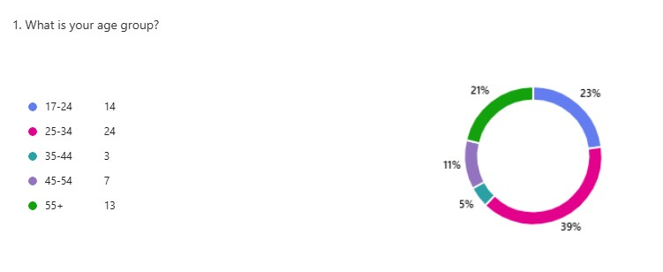
Appendix B:
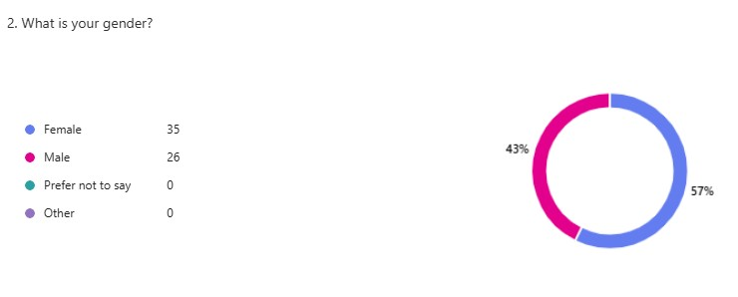
Appendix C:
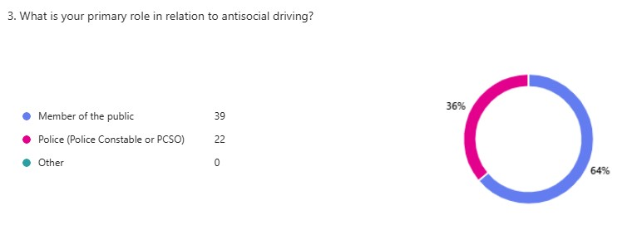
Appendix D:
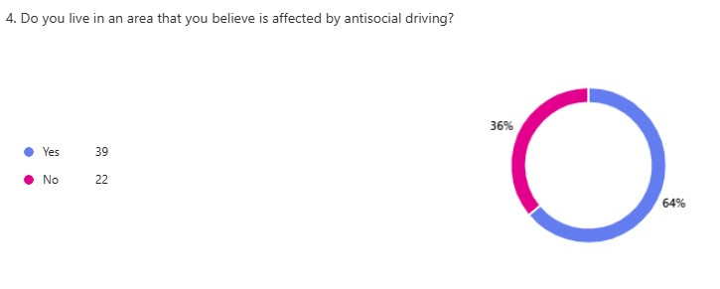
Appendix E:
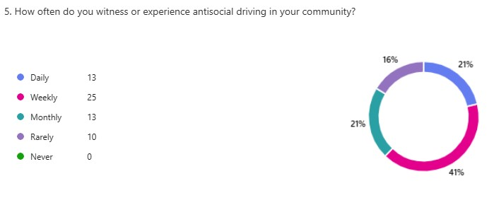
Appendix F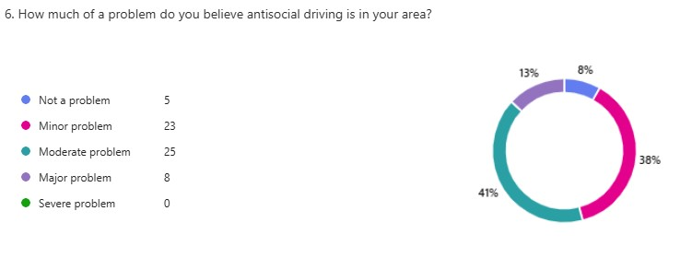
Appendix G:
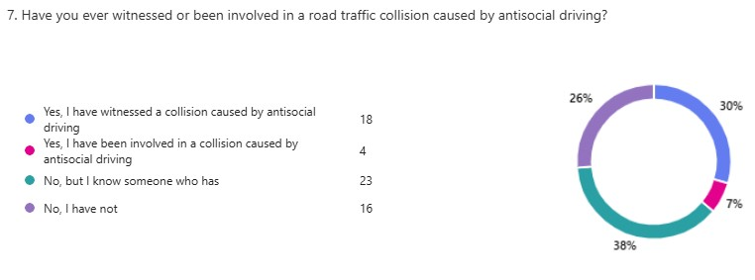
Appendix H:
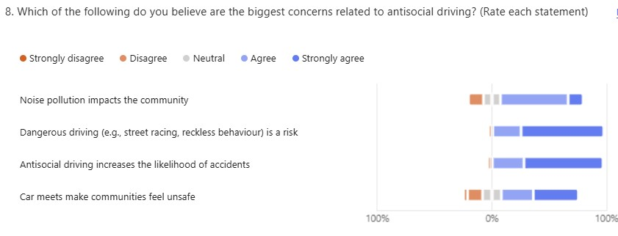
Appendix I:
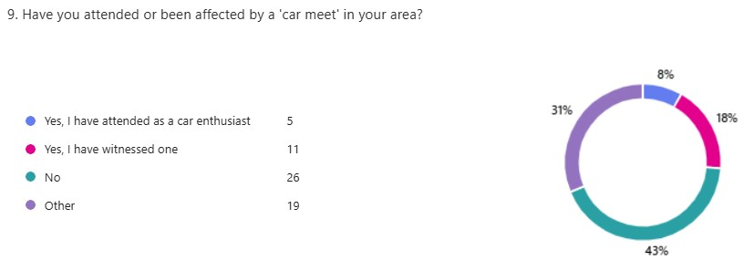
(Other is the same as ‘Yes, I have witnessed one’ due to error)

Appendix J:
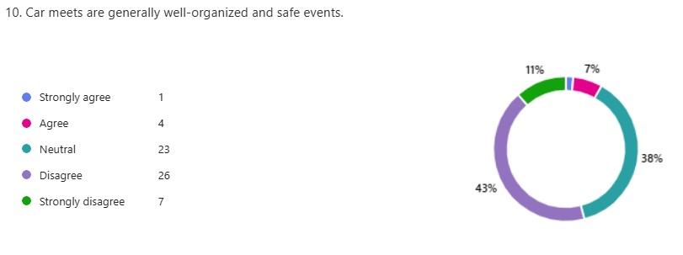
Appendix K:
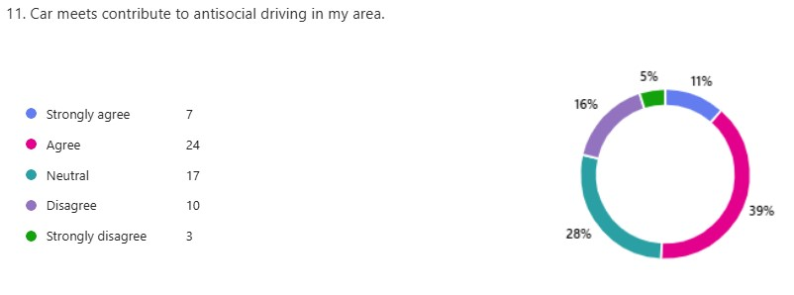
Appendix L:
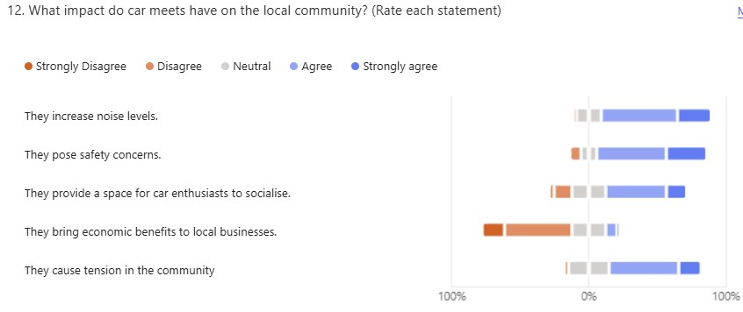
Appendix M:
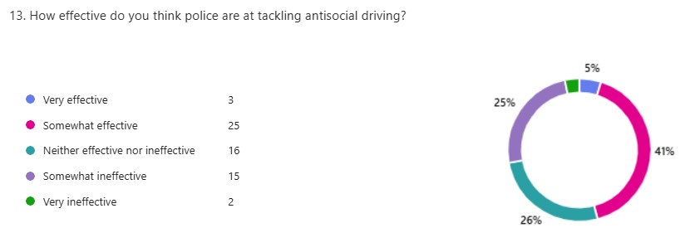
Appendix N:
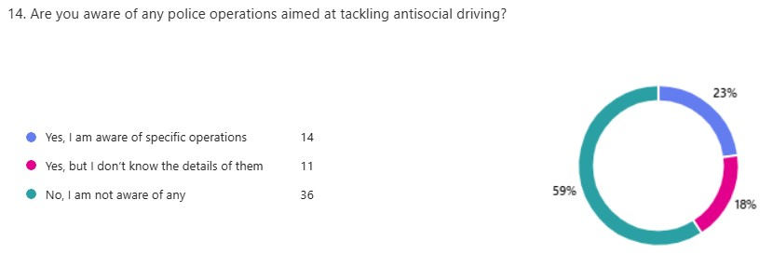
Appendix O:
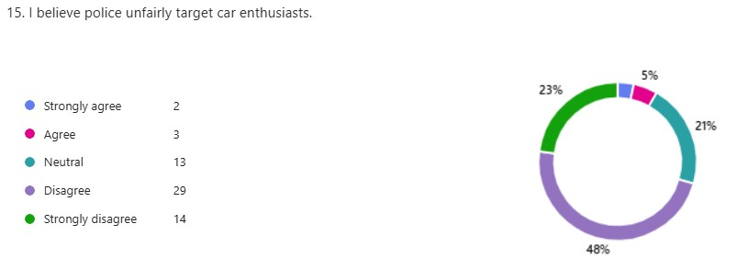
Appendix P:
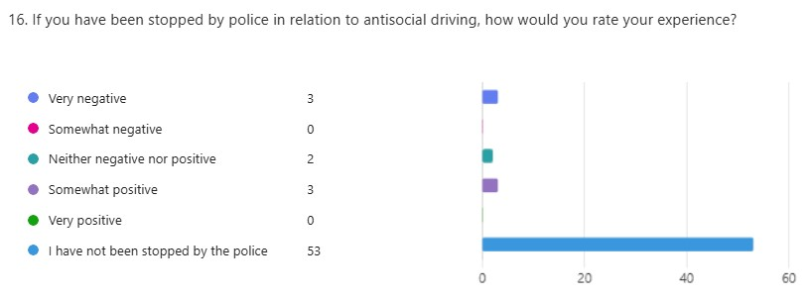
Appendix Q:
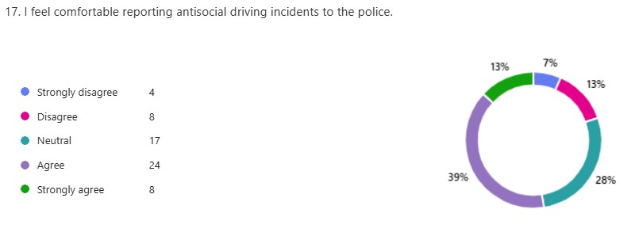
Appendix R:
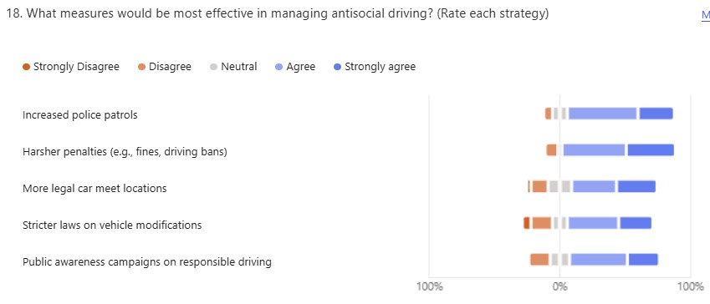
Appendix S:
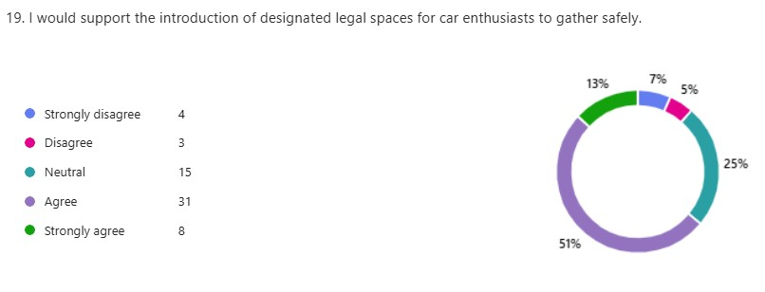

Appendix T:
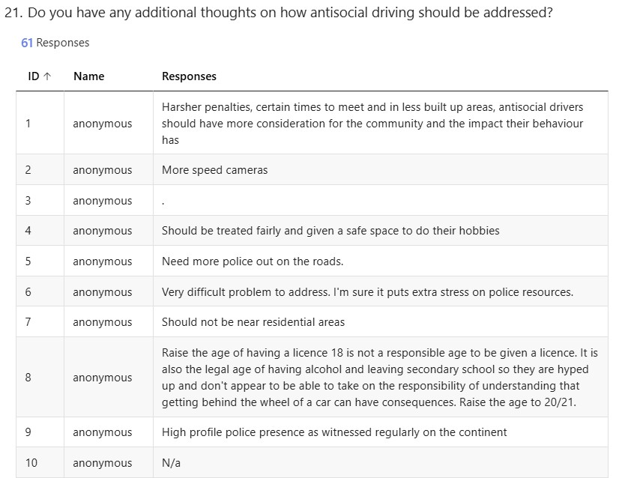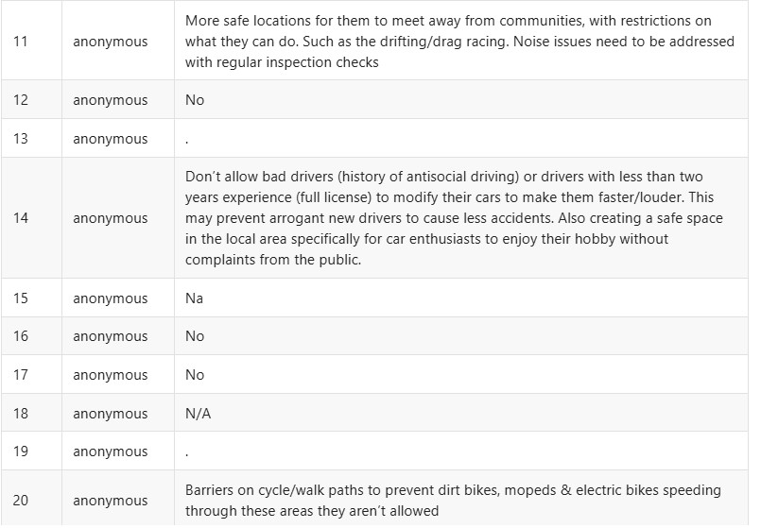
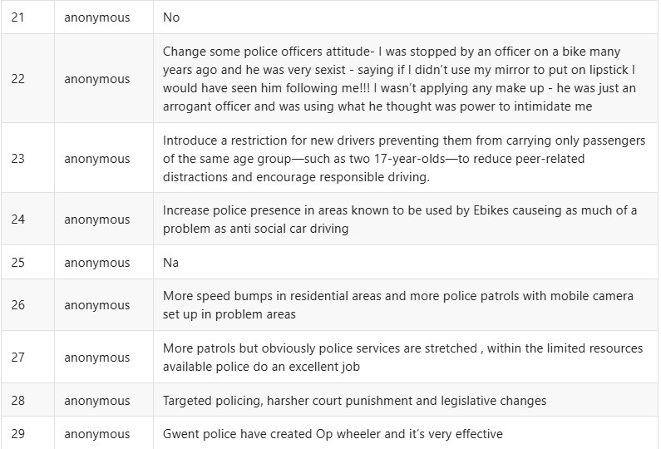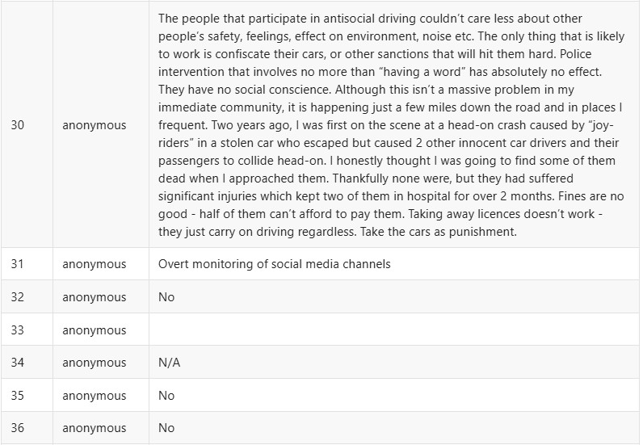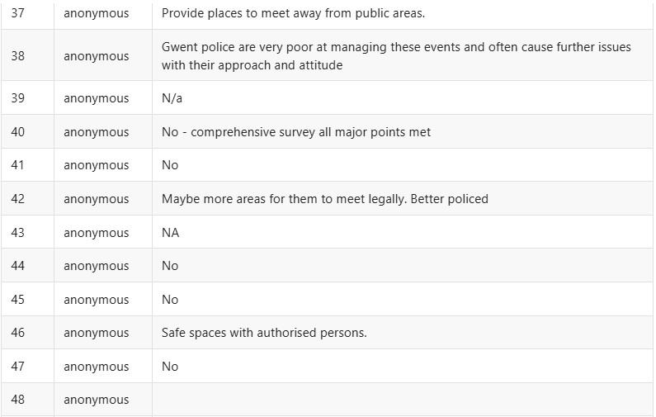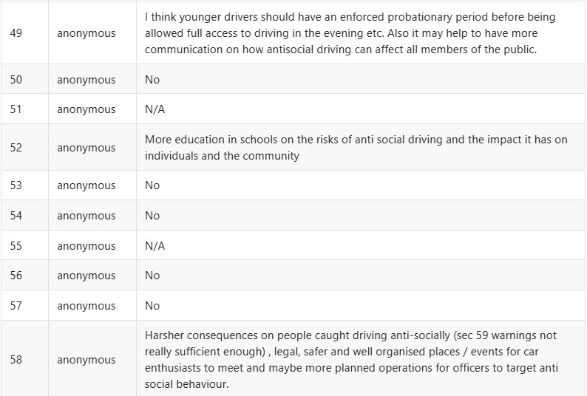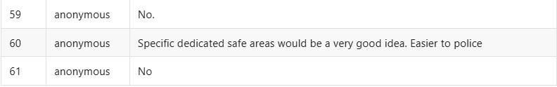

Appendix U (Chi-square Test):
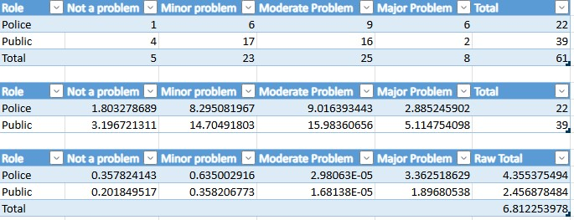

Appendix V (Anova Test):
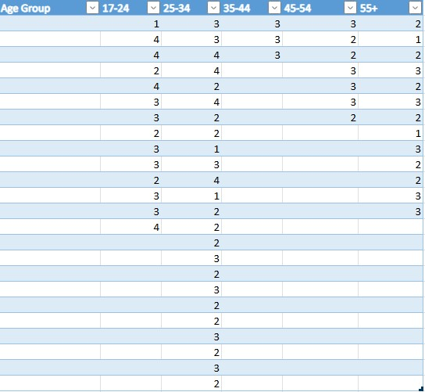
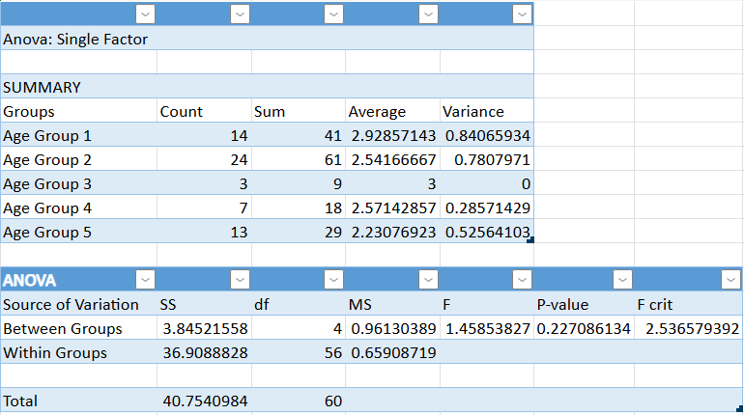

Appendix W (Research Proposal):


UNDERGRADUATE DISSERTATION
RESEARCH PROPOSAL FORM

Please complete the following research proposal and submit it to Turnitin.

Which project option are you taking? Please tick:

8,000 word project: ☒
OR
4,000 word project and presentation:

Please remove the red writing for your final submission.

NAME: Matthew Gibbins | STUDENT ID No.:  2222764
DRAFT RESEARCH TITLE QUESTION:

Public and Police Perception of Antisocial Driving: Understanding Community Reactions and Impacts.

INTRODUCTION:

I have decided to choose a topic related to road related crime whilst keeping a focus on a community issue within policing. Antisocial driving is a huge demand driver for policing, whilst it is believed to also have a big impact on members of public within the community. I believe it is a topic that I can research a lot about as the problem is not only within my local community but throughout the UK.

I have a big interest in roads policing hence why I have chosen a topic within this area of policing. However, I am specifically focusing on the antisocial driving aspect as it is an issue which is being focused on recently due to reports and social media highlighting the public’s concerns.

I have already conducted some reading surrounding this subject in relation to online reports and also discussing the subject with a roads policing supervisor who is managing an antisocial driving operation. I also have first hand experience with this topic, so I understand the importance of tackling the problem within the community to heighten public trust.

SUMMARY OF RESEARCH OBJECTIVES:

- Discuss the impacts of ‘car meets’ within local communities.
- Identify the links between antisocial driving and road traffic collisions.
- Explore the actions police are taking to prevent antisocial driving.

LITERATURE REVIEW:

In relation to my literature review, I have already been able to identify relevant information to the topic I will be researching. The literature shows how the police have been managing the risk of antisocial driving but also shows the implications the police face. The research also shows the impacts on local communities. This supports my decision for choosing to research this topic.

Policing the roads: trafﬁc cops, ‘Boy Racers’ and anti-social behaviour – Karen Lumsden examines how traffic police in the UK deal with antisocial driving such as “boy racers” who drive recklessly and at high speeds. The article highlights the difficulties officers encounter in dealing with these behaviours which are viewed as not only traffic offences, but also social disruptions. (Lumsden, 2013)

Operation Centurion – Lancashire Police have launched Op Centurion which focuses on tackling antisocial driving, such as speeding, reckless driving and street racing. Through intelligence collection, focused patrols and enforcement, the operation seeks to increase road safety and increase public trust. The operation also works with communities to encourage safer driving. (Lancashire PCC, 2024)

Palmers Green Community – The article “Public meetings put car meets and by racers firmly on the agenda” highlights the growing concerns about unsafe driving and unlawful car meets, especially with regard to “boy racers”. In order to propose ways to address the issue, the police began to hold public meetings. In terms of tackling the problem, community engagement planning had been consulted including police presence and possible road infrastructure improvement. (Clarke, 2023)

SUMMARY OF RESEARCH –SURVEY METHOD:

I will be conducting my own research by way of a survey. This survey will be released to officers and members of public to express their opinion on antisocial driving and what effects this type of driving has on the public. The survey will consist of a number of questions related to antisocial driving and ‘car meets’ to have a good understanding of what impact this topic has on members of the public.

Officers and members of public will be the best suited to collect this information from as they may have knowledge of antisocial driving but similarly, they may be victim to crime related to antisocial driving.

I will also analyse literature to gather research in relation to my topic.
SUMMARY OF SAMPLING FRAMEWORK:

I will ask colleagues within Gwent Police to complete my survey which will provide a range of experiences with antisocial driving and the effects of it. The survey will also be published for members of public to access and complete which may provide alternative views on antisocial driving as their experiences could differ from police officer experiences.

This sample will be suitable for my research as I predict that I will gather relevant data to compile and assess and use within my dissertation.
ETHICAL ISSUES:

I have not identified any ethical issues in relation to my research.
TIME SCALE:
Standard practice to consider each stage of your research work that you will undertake.

The time scale of my research will be from 23rd September 2024 and 30th June 2025.
REFERENCE LIST:
Please follow the Harvard referencing system

Lancashire PCC (2024). Op Centurion is tackling anti-social driving across Lancashire. - Lancashire Police Crime Commissioner. Lancashire Police Crime Commissioner. Available at: https://www.lancashire-pcc.gov.uk/op-centurion-is-tackling-anti-social-driving-across-lancashire/ (Accessed: 7 November 2024).

Lumsden, K. (2013). Policing the roads: traffic cops, ‘Boy Racers’ and anti-social behaviour. Policing and Society, 23(2), pp.204–221. doi: https://doi.org/10.1080/10439463.2012.696642 (Accessed: 7 November 2024).

‌Clarke, B. (2023). Public meetings put dealing with car meets and boy racers on the agenda. [online] Pgweb.uk. Available at: https://www.pgweb.uk/planning-all-subjects/traffic-roads-parking/106-roads/3761-public-meetings-put-car-meets-and-boy-racers-firmly-on-the-agenda (Accessed: 7 November 2024).

Appendix X (Ethics Form):


