Tesco UK
Salma Bibi (1711171)
Strategic Management for SMEs
BMSW6104
Modul Tutor: Dr Olu Adegbite

Learner Group: 3

Table of Contents
Introduction 2
1.Introduction to Tesco 3
2. Strategic Direction 4
VMOST Analysis 4
Porters Five Forces Model 7
3. Environmental Scanning 10
PESTLE Analysis 10
SWOT 13
4. Stakeholder Analysis 14
5. VRIO Analysis 18
6.Recommendation 21
Conclusion 24
References 25

Introduction

SME’s stands for small and medium-sized enterprises (Berisha & Pula, 2015). Statistics shows, at the beginning of 2019 there were 5.9 million private businesses in the UK, an increase from 5.6 million in 2018. More than 99% of which were small or medium sized businesses (SMEs) employing fewer than 250 people which means only 0.1% of the country’s entire business population employs more than 250 people (Merchant Savvy, 2020). Some of the worlds giant successful companies started out as an SME which were Amazon, Apple and Starbucks (RinggitPlus, 2018) this shows SME is a good place to start a career.

This report will critically analyse the strategic management of Tesco UK. In order to access major factors of the report, information will be obtained from various sources such as books, journals and the internet. It will analyse the company’s internal and external environment using theoretical tools such as PESTLE and SWOT. These tools will help identify the micro and macro-environmental factors which may impact the position of the business. VMOST Analysis, Porters 5 Forces and VRIO will be used to analyse different strategies of Tesco. Furthermore, the company’s stakeholder of all kinds will be identified though brainstorming and placing them to the correct category in the theoretical model developed by Edward Freeman in 1984 (Stakeholder Theory, 2020). Finally, from the findings, new strategies will be highlighted for Tesco’s sustainable growth and to remain a competitive advantage.

1.Introduction to Tesco

The purpose of Tesco is to supply a wide range of goods which sells both online and in store allowing customers to shop however, whenever and wherever they want. Tesco UK is the leading food retail industry who tries to understand customers, colleagues and communities and what matters to them. Trying to make things better and putting the customer at the heart of everything they do. In addition to providing a home delivery service it also offers financial services such as its own credit card, various types of insurances and personal loans. Tesco continue to invest in a strong UK business, already investing in many key areas, such as; service, staff, price, value, range, quality, brand, marketing and many more.

Tesco UK was founded in 1919 when Jack Cohen began selling surplus groceries from a small stall in London’s East End (Tesco PLC, 2020). The name TESCO was formed from the initials of TE Stockwell, who was a partner in the firm of tea suppliers, and CO from the first two letters of Jack's surname. The first Tesco store was opened in 1929 in Burnt Oak, Edgware, North London where they sold their first ever branded Tesco Tea and other great value dry products.

Jack Cohen’s new ideas for stock control brought greater savings for customers which enabled the continued success and helped him expand the business across stores; building the first modern food warehouse in the country after purchasing a plot of land in Edmonton, North London. Jack Cohen continued bringing new ideas and launched the first self-service store in the UK which changed the face of British shopping. Throughout the period, Tesco launched a number of other service areas such as introducing clothing, electrical products, household goods, telecom services as well as introducing petrol filling stations at major sites. Tesco were the first retailer to launch its own brand healthy eating products at affordable prices as well as developing their finest range for more affluent customers which was aimed to fill the gaps in the market. Tesco Clubcard attracted millions of customers which helped them evolve in the value chain. In 2000, Tesco.com was launched serving millions of customers daily. This continued success allowed Tesco to develop their brand and become the business we recognise today.

2. Strategic Direction

VMOST Analysis

The VMOST framework will be used to analyse Tesco’s ultimate vision. VMOST is an acronym that stands for vision, mission, objectives, strategies and tactics (Sondhi, 1999). Without these five elements an organization cannot exist. Any projects within an organization will be chaotic without a vision and mission to what they want to accomplish as a goal. This is necessary for any organizations as well as SME’s; the vision will get further apart and everyone in the company will have a different perception from each other if they do not have a technique to follow.
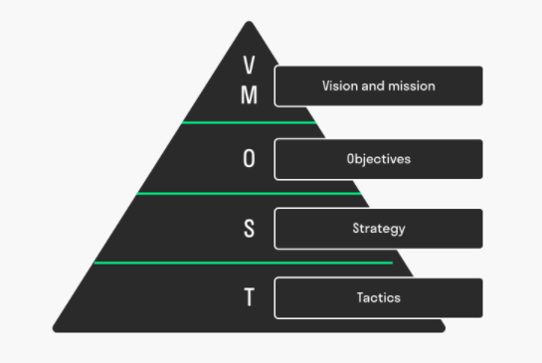
Figure 1: VMOST Analysis Model (Harnish, 2020)

Vision refers to the managements plan to create a firm’s future path including customer focus, future technology, culture and the structure of the company.
Tesco’s key enablers are its business strength. These help Tesco to sustain and improve its core activities.
- They are establishing a multi-channel leadership and building a seamless offer that will enable customers to shop wherever they want. Tesco UK are always looking at ways it can use technology to make consumer shopping experience easier. It has an option to choose from larger stores serving the big shopping purpose and stores which serve the convenience purpose. They also have an online food retailing operation system with a choice to click and collect or have the products delivered to the customers door. Additionally, Tesco has introduced their own mobile app for grocery shopping, ability to manage Tesco accounts easily and Clubcard for customers who are ‘on the go’ (Tesco App, 2020).
- Tesco has developed its staff and empowered them to deliver better customer service. Their core purpose is at the heart of everything that they do. The company offers opportunities for all colleagues to grow regardless of gender,
- Tesco UK hold many local community projects such as bags of help scheme (Tesco Community Grants, 2020). This helps a lot of community groups and organisations get funding to help community projects.
Tesco’s vision provides a simple expression of who they are and what they do which was created by the people who work there. “To create and maintain a market leading underwriting, technical pricing and claims handling organisation to support the Tesco Bank Growth Strategy” (Tesco Underwriting, 2020). The vision is supported by the companies Underwriting values which provides the foundation of everything they do. Below are the five value gems representing what is precious to Tesco Underwriting. The five value gems clarify direction, inspires organizational members and encourages commitment from them.

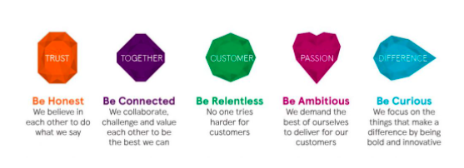
Figure 2: Five Value Gems, (Tesco Underwriting, 2020)

Moreover, mission refers to the firm’s current business activities. It summarises who the firm is and what its business is. This includes the current product and service offering, as well as the value and priorities of the organisation.
According to Tanwar, (2013). Strategy is “deciding where you want your business to go and deciding how you will get there”. Tesco’s four core activities include, using their insight to understand what customers want. They buy products and services from suppliers, move them through their distribution network and sell them to their customers.
Tesco is a British retailer built with a simple mission – “to be the champion for customers”. The core purpose is to help make life easier for customers and to help them enjoy a better-quality life (Our Tesco, 2020). Customers always want quality products at value prices and Tesco aim to deliver this the right way. According to Hooker (2018), Tesco have noticed the changing habits of consumers where they prefer to buy Tesco’s own-label products rather than products made from outside brands. Therefore, Tesco are now advertising and selling more of their own branded products such as baked beans, biscuits, tea bags, coffee, ketchup and many more (Vizard, 2018). Since Tesco are heavily promoting their own-label brands this will be a competitive challenge for the world’s leading consumer brands like Nestle, Uniliever.

Each day at Tesco, the management team are trying their best effort to understand colleagues, customers, communities and what matters to them. This is why “Serving shoppers a little better every day” is their core purpose. They aim to treat people how they want to be treated. A culture of trust and respect is essential to the success of Tesco no matter who they work with (Our Tesco, 2020) this also helps Tesco maximize value. Tesco have touched millions of peoples lives since their launch in 1919 (Tesco PLC, 2020), their scale gives them an opportunity to make a positive difference to some of the biggest challenges facing the world such as providing opportunities for young people (Tesco PLC, 2020), tackling food waste (Tesco PLC Sustainability, 2020) and improving health (Shelley, 2014). This shows they remain original, competitive and their uniqueness.

Tesco management shared a passion for helping young people find work. This shows they are working towards achieving their objectives. There are very good opportunities for young people through the marketing graduate scheme including great opportunities for training and development. Tesco colleagues take part in this volunteering programme which enables them to talk about the challenge’s that young people face and people’s experiences of getting jobs (Tesco PLC, 2020). It gives young people a great opportunity to meet new people and learn new skills as well as begin to have an impact on opportunities. Tesco already have a significant opportunity to make a difference to many young people. It Is believed that Tesco will achieve a significant and real change for young people. The benefit of Tesco’s mission is that they foster forward thinking and make a difference in the society by risk-taking and experimenting new directions.

Porters Five Forces Model

Porters five forces analysis tool identifies five competitive forces, threats of new entrant, bargaining power of buyers, bargaining power of suppliers, threat of substitute products, competitive rivalry within an industry.

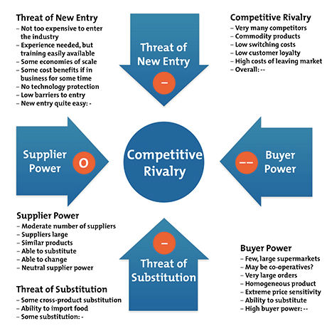
Figure 4: Porters Five Forces (Porter, 1980)

Competitive Rivalry within the Industry

The competitive rivalry for Tesco is based on the following external factor:

High number of firms. – Strong Force
Low switching costs – Strong Force

Since the outbreak of coronavirus in the UK, has caused the volume of consumer spending in grocery stores (Sabanoglu, 2020) with Lidl showing the highest increase in sales with 17.6%. and morrisons showing the smallest growth in sales with 4.6%. Out of the four major supermarkets (Asda, Tesco, Sainsbury’s and Morisons) Sainsburys saw the highest increase in sale number. This illustrates the industry having a strong force on low switching cost which allows customers to choose substitutes.

According to Statista Research Department (2020), the supermarket industry continues to rise in the UK as well as taking 6.9% of the global e-commerce market. There are companies competing at various levels such as the German discounters Lidl and Aldi; they have shown the greatest breakthrough as customers search for discounted brands and cheaper alternatives in grocery stores. However, Tesco have reacted to this by reducing their prices resulting in ongoing supermarket price wars.

Bargaining Power of Customers/Buyers

Large number of providers – Strong Force
High availability of substitutes – Strong Force
Switching costs are low – Strong Force

Statista (2019) shows the growth levels of grocery and food market in the UK was 90% in 2019 and predicted to reach 92.8% by 2024 (Sabanoglu, 2019). This affects the company’s external environment and makes the bargaining power of the customers a strong force. Additionally, the availability of substitutes such as (Aldi, Lidl, Poundland, B&M) also affects the bargaining power of buyers as similar products can be purchased at lower prices. Hence, Tesco have introduced two new bands (Eastman’s Deli and Stockwell & Co) to their own-label food ranges which offers customers quality products at great value prices; this continues to replace its ‘Everyday Value’ products. (Barrie, 2020). The online sales are predicted to increase from 11.6% to 16.7% in 2024 which is more than any other sector market.

Bargaining Power of Suppliers

Large number of suppliers – Weak Force

The wholesaling industry cater for multiple organisations one of which includes Tesco. The key supplies for Tesco include grocery, frozen food, dairy, egg, poultry, confectionary fish and seafood, beef, pork, fruit and vegetables. The greater integration between wholesale and retail operations has weakened sales and increased competition; this increases supply power.

Threats to Substitutes

High substitute availability – Strong Force

Tesco faces intensifying competition from alternative retailers (Sabanoglu, 2020). The competitors provide similar products including delivery services therefore consumers can choose to go to other supermarkets like Costco, Aldi or Lidl for cost saving and the convenience of a one-stop shop. According to Sabanoglu (2020) Tesco saw sales decreasing in 2015/2016 for multiple months but then managed to stabilise and entered the growth in 2019. However, as of February 2020 due to covid-19 sales were once again in decline. This external factor contributes to the strength of the threat of substitution in the supermarket industry.

Threats from New Entrants

Low switching costs – Strong Force

Establishing a small to medium business involves low capital costs which empowers new entrants to the industry. The threat of new entrants is relatively high as the supermarket industry is growing higher in numbers, and consumers are always looking for discounts and alternatives; a new competitor is likely to affect the competitive environment and profitability for Tesco; such as the German discounters Aldi and Lidl (Sabanoglu, 2020). Tesco’s are located in busy locations with many other attractions nearby; this allows an opportunity with more profitability for the business.
The threat of new entrants is strengthened as the low switching costs allows consumers to shop elsewhere.

3. Environmental Scanning

Various internal and external factors can affect the functioning of an organisation. PESTLE is a tool/framework used to analyse the external factors affecting the business. However, these factors cannot be controlled by the business, but can influence decision making.

PESTLE Analysis

The six categories of the PESTLE analysis tool will be used to analyse the external environment faced by Tesco.
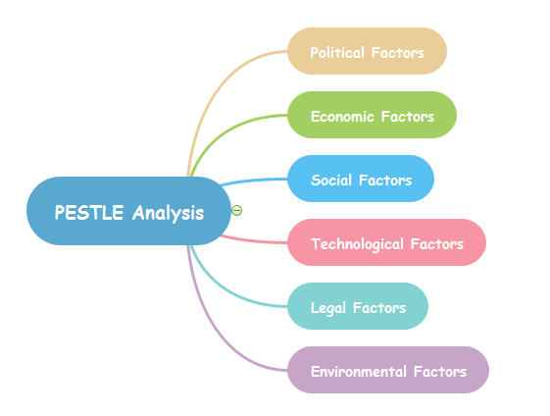

Figure 3: PESTLE. (Subrina, 2020)

Political Environment
Government regulations and legal factors greatly influence the performance of Tesco, these include tax rates, acts of legislation and the stability of the area it operates in. These are assessed in terms of their ability to affect the business environments and trade markets. The main issues addressed in this section include political stability, tax guideline, trade regulations, safety regulations and employment laws. Tesco is generally known for selling food and non-food products as well as providing finance, mobile, insurance, hardware services and much more. The increased VAT rate that the UK government adopted in 2011 had an effect on Tesco which went up from 17.5% to 20% (BBC News, 2020)

Economic Environment
Economic factors have a direct impact on the long-term development of a company.
Through this factor, businesses examine the economic issues that are bound to have an impact on the company. This includes factors like inflation, interest rates, economic growth, the unemployment rates and policies. Tesco has been facing a lot of challenges for its demand, products and supply. The demand for its products has dropped because of its competitors. As a result, Tesco has to negotiate now fair prices which other companies could not able to match. Tesco is aware of the changes in household incomes therefore, they have shifted most of its focus towards advertising its value brands rather than the more luxurious items (Vizard, 2018).

Social Environment
With this factor, the business can analyse the socio-economic environment of its market, via elements such as customer demographics, cultural limitations, lifestyle attitude and education. As the birth rate has increased over the years; Tesco have increased the number of non-food items offered such as children’s toys, educational material, school uniform (Public health England, 2020). People are more aware on healthy products With these Tesco understands how consumer needs are shaped and what brings them to the market for a purchase. Due to a variety of social changes, trends indicate that customers in the UK have moved towards bulk shopping as well as looking for better prices.

Technological Environment
Technology can either positively or negatively impact the introduction of a product or service into the marketplace. These factors include technological advancements, lifecycle of technologies, the role of the internet and the spending on technology research by the government. The advancements in technology have brought various new opportunities for Tesco. Two of the most district ones include, the development and introduction of online shopping with facilities for home delivery. Consumers can easily compare prices between supermarkets. Secondly, self-service checkout points of providing convenience and ease for customers. Tesco has effectively integrated mobile technologies in its products to reach out to the consumers. It has also made a substantial mark on other digital platforms according to various digital metrics, along with positioning correctly through social media.

Legal Environment
Legal factors are about the limits the law places on business activity whether that’s employment law or the law relating to the sale of goods. Due to covid-19 outbreak the UK government have advised supermarkets, one of which is Tesco to block off access in certain areas selling non-essential items in their stores (Baker, 2020). Shoppers have complained that they are unable to access baby clothing however Tesco have advised that staff could help people get what they require if they ask. Nevertheless, Tesco will still have to abide by the certain rules provided by the government even though if this affects the performance of the company.

Environmental
Environmental sustainability has always been a priority for Tesco. Increased consumer awareness regarding social responsibility has meant increased pressure to reduce their carbon emissions. According to Tesco Sustainability (2020) they aim to become zero-carbon business by 2050. The report also states in 2019/20 they have made good progress to meet their target which was 35% by 2020 but have already reduced 37% of carbon emissions from their operations.

Internal Environment

SWOT analysis is another management tool to understand the microenvironment such as strength’s weaknesses opportunities and threats corresponding to a business.

Strengths  - Tesco has a range of lines including, clothing, finance and Petrol filling stations  - Tesco is famous for the quality of its products. | Weakness  - Recalling for its products affected their reputation  - Shortage of product during covid-19  - Quality control
Opportunities  - Good job opportunities for students and beginners.  - Good career progression  - Rapid growth online means increased profitability in the future | Threats  - Tesco faces many competitors in the UK.  - The growth of online independent retailers is also a threat

Figure 5: SWOT Analysis

4. Stakeholder Analysis

A stakeholder is any individual, group or an organisation with an interest in the business. Stakeholder analysis is used to identify and understand the key stakeholders based on their attributes into relationships and interest related to an organisation; it aims to identify everyone with a concern or interest who is involved. This analysis will review the internal and external stakeholders of Tesco as well as their influence on the company. Tesco believe engaging and collaborating with stakeholders allows them to learn and share things with each other (Tesco Sustainability, 2020). Stakeholder positions are very likely to change over the lifetime of the business for example their interest may increase of the outcome of the business performance or because of their job role

Internal Stakeholders are the primary stakeholders and those that are directly affected by the business’s performance; they include investors, employees, volunteers, donators, managers, partners and owners. The employees and managers are the most powerful at Tesco, they define the business and are key to its continuous process.

External Stakeholders (also known as the secondary stake holders) deal with the company externally who are individuals, groups and organisations that are not directly affected by the business’s performance. They include, customers, suppliers, creditors the government and society etc. According to Tesco Sustainability, (2020) they are committed to build a trusted partnership with suppliers to help deliver quality and value products to their customers as well as to help their suppliers grow.

Stakeholder Mapping
Stakeholder mapping involves the mapping out the various individuals or organisations; how the business addresses the fact that stakeholders have different power. Tesco should spend more time responding to stakeholders who have firstly a high level of power but also a high level of interest. Tesco should engage regularly with these stakeholders keeping constant regular communication with them take notice of what the stakeholders saying.
Stakeholders have a stake in the outcomes to the organisation and thus an interest in shaping events according to their stake. Each will have something to gain or lose depending on the outcome which gives them a stake and also a desire to shape that outcome in a particular way. Mendelow’s matrix tool enables companies to look at the power and interests of stakeholder (Mendelow, 1991). Mapping out the flows of information is an important first step to understanding how the organisation works and at the same time what possibilities are there for changing those flows of information to change the structure of the system.

Power/Interest Grid is used to prioritize the stakeholders. This grid helps to classify the level of interest the different stakeholders have in the processor the organisation as well as their power to affect or be affected by it. Mendelow, (1991) suggests stakeholder groups are analysed based on power and interest. Someone’s position on the grid shows a company the actions they need to take with them. High power high interest stakeholders are the key players who should be fully engaged through full communication and consultation. Those with high power less interest are the people Tesco will need to keep informed and satisfied as they are powerful enough to cause problems. Stakeholders with low power and high interest can be useful supporters, so they can be involved in low-risk areas and can be consulted in their interest area. Low power less interest stake holder interest stakeholders are not very powerful, and they are not as interested in the organisation. Tesco engage with a range of stakeholders including Government and regulators, community groups, trade bodies, NGOs and the media (Tesco Sustainability, 2020).

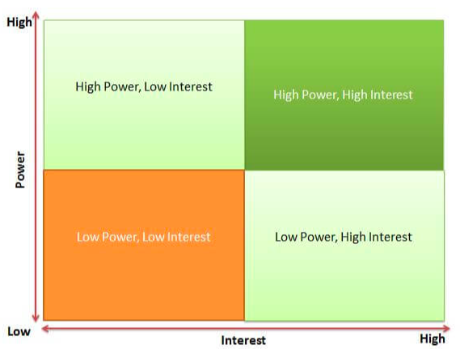
Figure 6: Mendelow Matrix (Mendelow, 1991)

High Power and High Interest (Manage Closely)

The management team, union and employees are believed to have a high power and high interest within Tesco. Owners at Tesco are responsible in the activities of the business in terms of how it performs financially, what profits it makes by consistently producing focusing on improving the business for greater results and performance. Employees are the core asset for Tesco who help manage the company’s daily operation efficiently and effectively. They are the first point of contact for customers which makes them the biggest impact of the success in Tesco. Hence, their expectations should be managed closely.

High Power and Low Interest (Keep Satisfied)

The government, suppliers, banks and other financial providers are believed to have a high power and low interest. These stakeholders need to be kept satisfied as they impact strategy and have power. Although these stakeholders are less interested, Tesco should deal with them cautiously, since they have a lot of power, they may use this negatively if they become unsatisfied. It was revealed that products were withdrawn from Tesco shelves due to containing 60% horsemeat being found in Tesco branded products (BBC News, 2013; BBC News UK, 2013). Therefore, it is necessary for Tesco to abide by the government policy and procedures and ensure their products are as promised.

Low Power and High Interest (Keep Informed)

The community and customers are believed to have an interest as a stakeholder in getting products value for money and a product of the right quality as well as receiving fair treatment and good quality customer service. These stakeholders are closely monitored by Tesco; the engagement with these services range from surveys and multi-stakeholder projects (Tesco Sustainability, 2020). Information gathered from these stakeholders will help improve and enhance the operation of Tesco. It will allow them to make better informed decisions. Therefore, it is recommended that they are kept informed of any new launch to their products or services through stakeholder marketing communication. They must feel they are heard

Low Power and Low Interest (Monitor)

Third party agencies and recruiting companies are believed to fit in to this category. It is irrelevant to communicate with stakeholders every day that have a low level of interest and a low power influence. The overall strategy is to ignore these stakeholders for the time being. However, if positions change throughout the course it will be wise to inform them occasionally of what’s going on. Tesco should focus more on stakeholders who have more interest in the business and high-power influence such as the government. They are the key players, who are both interested in the business and have the power to direct the work.

5. VRIO Analysis

VRIO is a powerful tool to analyse business strategy and sustainable competitive advantage. The tool was developed by Barney (1991) It is an internal analysis that will evaluate the resources of the company in a structured way so a better decision can be made. VRIO is an acronym that stands for four questions that ask if a resource is: Valuable, Rare? difficult to Imitate? and is it exploited by the Organisation? The four areas can help determine whether something is a source of a sustainable competitive advantage.

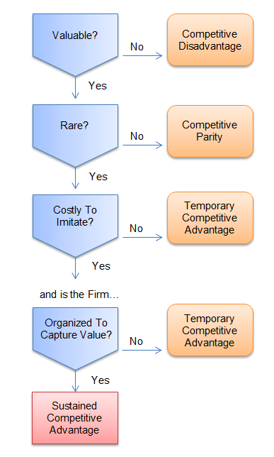
Figure 7: VRIO Framework - Retrieved from (Rothaermel, 2012)

Attributes | Valuable | Rare | Imitable | Organised
Own-label Food Brands | Yes | Yes | Yes | Yes
HR and Culture | Yes | Yes | No | Yes
Employees | Yes | Yes | Yes | No
Cost Efficiency | Yes | No | Yes | Yes
New Technology | Yes | No | Yes | Yes
Customer Loyalty | Yes | No | Yes | Yes

Figure 8: VRIO Analysis for Tesco
- Own-label food products: The VRIO analysis shows that the own-label food products are a valuable recourse and are rare to be found as Tesco may use special ingredients that other competitors are unable to reach. However, it has been identified through the analysis that it may easily be imitable by competitors with a substitute. Blake (2019) analysed retailers selling own branded products twice the price to their value range products; weighing the same and with the exact same ingredients, the only difference was the packaging. Therefore, competitors can trick consumers by using a different strategy such as preparing the packaging and reducing the price of items to become a competitive advantage. Therefore, Tesco need to always keep an eye out and examine the competitive marketing strategies regularly in order to continue to grow and stay competitive for the long run.

- HR and culture: According to the VRIO analysis, Tesco HR department and its culture is a valuable resource and is found to be rare according to the analysis. As identified in the above analysis, it is impossible to imitate the culture by any rivals or competitors as Tesco UK have been operating for over 100 years. Which means they have gradually over the years developed their working culture and their unique brand image is unchangeable.

- Employees: The VRIO analysis shows, employees are a valuable resource of Tesco and are a rare resource. They are highly skilled and trained which is always not the case in other organisations, however it is identified that they can be imitable. Employees remain the most important asset of Tesco because they drive the performance in the industry. However, according to BBC News (2017) Tesco revealed their hourly pay for staff will rise by 10.5%in three stages with overtime pay being cut on Sundays. Nonetheless, pay still remains lower than other supermarkets in the industry like Lidl and Aldi. If staff do not get paid enough, they will look for other opportunities where they are more valued and paid higher. Other organisations can train their employees to improve their service. These competitors can also offer better pay packages, work environment, benefits and growth opportunities. This makes employees at Tesco a resource that provides a competitive advantage.

- Cost efficiency: The cost efficiency is a valuable resource to Tesco but is not found to be a rare resource; cost efficiency can be imitable as identified by the analysis. Customers can easily find other alternatives at cheaper prices. Research shows Asda to have the least expensive grocery items to keep costs down for their consumers during covid-19 whereas Morrisons and Tesco were more expensive than Waitrose (Morgan, 2020). Tesco should work harder on showcasing their uniqueness and not just the products, they can give more attention on personalised gift vouchers or coupons on a regular basis; this can also be on special festive seasons and occasions such as birthdays.

- New technology: The VRIO analysis shows technology is a valuable resource to Tesco but is not found to be a rare resource; since technology has allowed Tesco grow tremendously in trade and commerce it is also be duplicatable and other businesses are doing the same thing competitors can easily duplicate what Tesco are doing and steal most or some of their customers. As identified by VRIO analysis, new technology can be imitable as it is a non-time consuming nor difficult for it to be imitated. Technology has accelerated significantly in the past 10 years and every company is a tech company who are trying to bring innovation into their culture. It’s also a competitive advantage as other organisations are competing in this field.

- Customer loyalty: According to the VRIO analysis customer loyalty is a valuable resource but is not found to be a rare resource and can be imitated. Although Tesco UK have been operating over 100 years and they have a strong customer relationship, this is difficult to imitate for another company. However, If Tesco lack maintaining effort into customer service, consumers will easily find other alternatives. Other companies can duplicate what Tesco are doing and gain competitive advantage.

6.Recommendation

The challenges most SMEs face today are:

Competitive job market for digital marketers (New Technology)
Many SMEs face challenges trying to promote their business and sell products online. They try to multitask and manage everything themselves. People may visit the site but not purchase anything and this can be frustrating. Small business owners are very stressed and it’s difficult to figure out what the right ways are in which they should be going to market with so many choices. This is something that is seen happening across SME’s; a stressed boss trying to manage and figure everything out at the same time. Another problem is marketers don’t have the knowledge about digital marketing. They may happen to know how to use technology, but they don’t have knowledge of how to develop a brand or how to grow a business using branding.

It is quite tough to find and attract good talent in digital marketing because there is a huge competitiveness for this particular talent. Often times in this small business environment, someone will come in and join the team for a short period of time, they will get some training, and take advantage of the fact that they can actually learn from that business and then they may go and find something else and use this skill for a competitive advantage. Unfortunately, this is not within the control of the organisation.

Small business owners who have limited budgets available and they want to know they’re using their marketing spending effectively; it is highly important to set up a strategy first and understand where exactly it is they want to reach. This will help them identify their position in the market as well as identifying their marketing objectives, where the skill gaps are in the business and what the right channels and right direction in which they should undertake. If there are skill gaps within the business, they may need to hire different types of capabilities, like an external resource; an agency partner to be able to fill in the gap. Feedback from consumers go a long way in supporting SMEs, therefore, it is very important that customer testimonials are loaded on to the site with feedback. The company would basically send a thankyou message to their buyers and let them respond to that nice message and then the company will get their testimonial. These small details are very important and can convert someone in a positive way.

Customer Loyalty

Keeping up to date with consumer needs and wants as well as how to maintain customer loyalty and keeping up with trend – Previously, small businesses who had a good store and a good website had a defence against new competitors. Today it is easy and cheap for competitors to enter the market industry and if they have a good product or a better product, they will take over the market industry.

Customer satisfaction and loyalty is very important and is a great goal for any organisation. Customers may not always know what a company is doing for them therefore, it is the duty of SME’s (in this case Tesco UK) to notify customers by keeping in touch. Customers need to know how Tesco are serving the community to build a reputation and that will bring people closer. This will allow the change of a customer’s perception and produce Tesco further growth in sales. This can be conducted via communication through various communication channels, such as, regular emails, newsletters, messages and advertising daily community work or new products and new offers listed on social media platforms. It’s also very important trying to understand the format customers would like to communicate and then communicate with them in that way. It’s also very important to keep them updated on products and services and this will build loyalty.

Remembering special occasions such as birthdays, milestones in a customer’s life or of their children are achieving, giving ideas/tips on that particular milestone and providing vouchers, money off coupons or offering extra points on Tesco’s loyal Clubcard holders. Sending them gift vouchers for couple of pounds off will let them know that you are thinking of them. These small gifts lead to earn more business in the future and differentiate a company from its competitors.

Employees

Tesco can partnership with other stores or distribution centres to go into local schools, colleges and job centres to prepare younger people for interviews, applications and what they need to expect when applying for jobs. Tesco need to train and inspire young people and let them know about the great opportunities at Tesco, which will give them the opportunity to achieve their potential. As a group of young people, are eager to learn and can absorb more information and knowledge; they can then foster their experience to help Tesco achieve their ultimate goal. According Fincher, (2018) as well as younger generation learn from their elders, many seniors also learn something new from the youth or younger generation such as open-mindedness and using technology to connect. The younger generation will be the future of Tesco.

Conclusion

SMEs contribution to the UK’s economy is increasing each year (Merchant Savvy, 2020). From the findings, it is believed Tesco UK has a competitive advantage which can be sustained. Therefore, gives them an edge over competitors who cannot replicate that advantage as their brand image remain original. Over the years Tesco has become well known for their products and services (Winterman, (2013) and are always trying to differentiate in what they do on a daily basis; from quality, style or service Tesco are not afraid of taking risks and experimenting new directions. This information was gathered through the help of the tool VRIO analysis

References

- Baker, (2020) Available at; https://news.sky.com/story/coronavirus-supermarkets-shut-off-parts-of-stores-following-government-advice-to-limit-access-to-non-essentials-12126532
- Barney, J, (1991) Firm Resources and Sustained Competitive Advantage. Available at; https://josephmahoney.web.illinois.edu/BA545_Fall%202019/Barney%20(1991).pdf Journal of Management, 1991, Vol. 17, pp. 99-117
- Barney, J. B. (1995) Looking Inside for Competitive Advantage. Academy of Management Executive, Vol. 9, Issue 4, pp. 49-61
- Barrie, J (2020). Available at; https://inews.co.uk/news/consumer/tesco-new-deli-food-161094
- BBC News (2013) Horsemeat scandal: Tesco reveals 60% content in dish. Available at; https://www.bbc.co.uk/news/uk-21418342
- BBC News (2017) Tesco is raising store staff pay by 10.5% over two years. Available at; https://www.bbc.co.uk/news/business-40386827
- BBC News UK (2013) Horsemeat scandal: Withdrawn products and test results Available at; https://www.bbc.co.uk/news/world-21412590
- BBC News, (2020) Available at; https://www.bbc.co.uk/news/explainers-53334098
- Berisha, G & Pula, J. S (2015) Defining Small and Medium Enterprises: a critical review. Academic Journal of Business, Administration, Law and Social Sciences. IIPCCL Publishing, Tirana-Albania. Vol 1, No 1. ISSN 2410-3918
- Blake, I (2019) Available at; https://www.thesun.co.uk/money/8843698/supermarkets-flog-same-food-twice-price-different-packaging/
- Fincher, (2018) Available at; https://www.optimalhomecare.com/five-things-older-generations-can-learn-from-youth/
- Harnish, V (2020) Available at; https://www.toolshero.com/strategy/vmost-analysis/
- Hooker, L (2018) How UK shoppers fell in love with own-label groceries. Available at; https://www.bbc.co.uk/news/business-44684306
- Mendelow, A. L. (1991) ‘Environmental Scanning: The Impact of the Stakeholder Concept’. Proceedings from the Second International Conference on Information Systems 407-418. Cambridge, MA.
- Merchant Savvy, (2020) UK SME Data, Stats & Charts. Available at; https://www.merchantsavvy.co.uk/uk-sme-data-stats-charts/
- Morgan, C (2020) Available at; https://www.dailymail.co.uk/femail/article-8819551/Asda-named-Britains-cheapest-supermarket.html
- Our Tesco (2020) Available at; https://www.ourtesco.com/working-at-tesco/our-company/our-values/
- Porter, M (1980) Competitive Strategy: Techniques for analysing industries and competitors. New York: Free Press
- Public health England (2020) Available at; https://fingertips.phe.org.uk/profile/child-health-profiles/data#page/1/gid/1938133228/pat/6/par/E12000005/ati/102/are/E08000025/cid/4
- RinggitPlus, (2018) Available at; https://ringgitplus.com/en/blog/Banking/5-Famous-Corporations-That-Started-as-SME-Businesses.html
- Rothaermel, F. T. (2012) Strategic Management: Concepts and Cases. McGraw-Hill/Irwin, p. 91
- Sabanoglu, (2019). Available at; https://www.statista.com/statistics/777710/uk-food-grocery-market-growth/
- Sabanoglu, T (2020) Available at; https://www.statista.com/statistics/1108853/grocery-sales-increase-in-the-united-kingdom-coronavirus/
- Sabanoglu, T (2020). Available at; https://www.statista.com/statistics/386598/tesco-sales-percentage-change-great-britain-uk/
- Shelley, R (2014) Using its scale to improve health. Available at; https://www.theconsumergoodsforum.com/blog/scale-for-good-how-tesco-is-using-its-scale-to-improve-health/
- Sondhi, R. (1999). Total Strategy. Lancashire: Airworthy Publications
- Stakeholder Theory (2020) Available at; http://stakeholdertheory.org/about/ No Date (Assessed: 20/11/2020)
- Statista Research Department (2020). Available at; https://www.statista.com/topics/1983/supermarkets-in-the-united-kingdom-uk/
- Subrina, (2020). Available at; http://www.mindmapsoft.com/pestle-analysis-mindmap/
- Tanwar, R (2013) Porters Generic Competitive Strategies. Available at; https://sswm.info/sites/default/files/reference_attachments/TANWAR%202013%20Porter%E2%80%99s%20Generic%20Competitive%20Strategies.pdf IOSR Journal of business AND management (IOSR-JBM) e-ISSN: 2278-487X, p-ISSN: 23197668. Volume 15, Issue 1 PP11-17.
- Tesco App (2020). Available at; https://www.tesco.com/zones/apps
- Tesco Community Grants, (2020). Available at; https://tescobagsofhelp.org.uk/tesco-community-enablers/
- Tesco PLC Sustainability, (2020) Available at; https://www.tescoplc.com/sustainability/product/food-waste/
- Tesco PLC, (2020) Available at; https://www.tescoplc.com/about/our-history/
- Tesco PLC, (2020). Available at; https://www.tescoplc.com/updates/2020/supporting-25-000-young-people-igd-and-the-prince-s-trust/
- Tesco Sustainability, (2020) Available at; https://www.tescoplc.com/sustainability/planet/climate-change/carbon-footprint/
- Tesco Sustainability, (2020) Stakeholder engagement. Available at; https://www.tescoplc.com/sustainability/overview/stakeholder-engagement/
- Tesco Underwriting (2020) Available at; https://www.tescounderwriting.com/about-us/our-vision-values/
- Vizard, S (2018). Available at; https://www.marketingweek.com/tesco-shifts-marketing-focus-to-value/
- Winterman, (2013) Available at; https://www.bbc.co.uk/news/magazine-23988795

