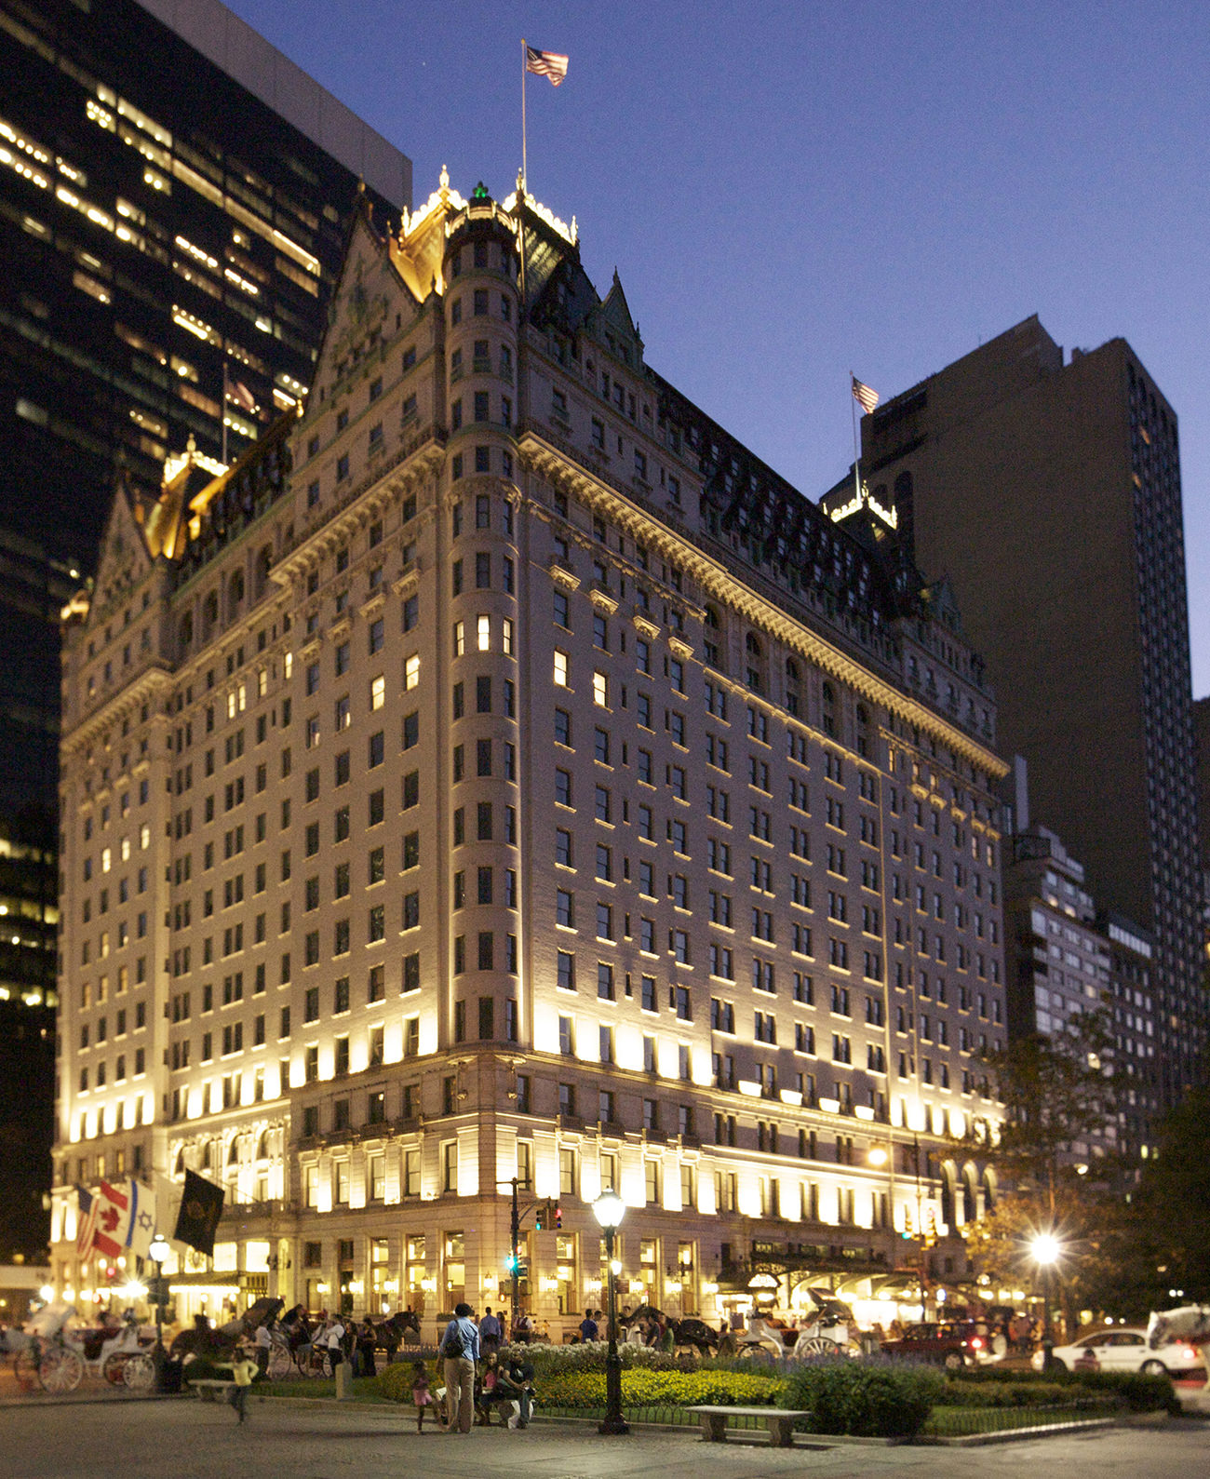

The Plaza New York
Consultancy Report 2023
Consultant: Roland Berger
Student Name: Md Taslim Olid
Student ID: 2027984
Lecturer name: Julia Ault
Date: 08/06/2023
Contents
Executive Summary 5
Introduction 9
Scope and Analysis 9
Background of The Plaza New York 10
Property Amenities of The Plaza New York 10
Room Categories and Features at The Plaza New York 10
COVID-19 Measures Taken by The Plaza New York 11
PESTLE Analysis of The Plaza New York 12
SWOT Analysis of The Plaza New York 14
Main Body 15
Analysis of the Issues 15
Tangible and Intangible Issues (Infrastructural, Interior, and Staff Related Issues) 16
Necessary Steps to be Taken by The Plaza New York 17
Interior Issue 18
Low Natural Lighting 19
Bathroom Fittings 19
Cleanliness 19
Old Broken Electricity Ports 19
Missing Complementary Personal Grooming and Hygiene Kits 19
Broken Refrigerator 20
Room Service Issue 20
Bellman Issue 20
Concierge Issue 20
Staff Shortage 20
Other Issues 20
Necessary Timeline for Taking Steps 21
SOSTAC Analysis of The Plaza New York 21
Findings and Results 23
Interior Issue 23
Lighting Issue 23
Bathroom Fitting Issue 24
Cleanliness Issue 24
Outdated Electricity Ports and Technological Support 24
Missing Complementary Personal Hygiene and Grooming Kit Issue: 25
Broken Refrigerator 25
Room Service Issue 25
Concierge Issue 26
Bellman Issue: 26
Staff Shortages: 26
Plan of Action 27
Recommendation 30
Conclusion 31
References 32
Appendix 39

List of figures:
Figure 1:PESTLE Analysis of The Plaza New York 12
Figure 2:Timelines for Measures to be Taken 20
Figure 3:SOSTAC Analysis 21
List of Tables:
Table 1:SWOT Analysis of The Plaza New York 15
Table 2:Steps to be taken to solve issues 18
Table 3: Interior Issue 23
Table 4: Lighting Issue 23
Table 5:Bathroom Fitting Issue 24
Table 6:Cleanliness Issue 24
Table 7:Outdated Electricity Ports and Technological Support 24
Table 8:Missing Complementary Personal Hygiene and Grooming Kit Issue 25
Table 9:Broken Refrigerator 25
Table 10:Room Service Issue 25
Table 11:Room Service Issue 26
Table 12:Room Service Issue 26
Table 13:Room Service Issue 26
Table 14: Action Plan 27

Executive Summary
The Plaza New York is one of the most renowned hotels in the world, as it has a history of being a hospitality property for more than 100 years and is situated at one of the most recognisable landmarks in New York City (Plaza NY, 2023). The hotel has a heritage of serving top-of-the-class hospitality services, and currently, the property is owned by Qatari state-owned company Katara Hospitality and managed by Accor S.A.'s subsidiary brand Fairmont Hotel and Resorts (Fairmont, 2023). This hotel falls under the top-of-the-class luxury brand. The soccer of the hotel in various review sites is relatively high but dropping drastically. On Expedia, the property's rating is 8.8 (The Plaza Hotel, 2023). According to TripAdvisor (2023), the property's rating is 4.5, whereas the competitor hotel brands have much higher ratings, and the ratings of the Plaza New York are falling drastically.
Roland Berger is appointed as the consultant for this case of Plaza New York's declining customer service rating. The consultant carried out a thorough analysis of the problem using various analytical tools. The problems that were found initially are from the ratings and reviews by the guests of the property who faced trouble staying in the property, and those issues were found on the hotel's booking sites such as Expedia, TripAdvisor, Agoda, etc. The problems were the actual problems that guests faced. In a review by a guest in the hotel who stayed in the property wrote in his review on TripAdvisor that after checking in to the room, he found out his bathtub was full of water, and it was used water older than two days (TripAdvisor, 2023b). The room service took 2 hours to prepare the room after checking in, which was a significant inconvenience. In another review on the same site, a guest wrote that his laptop was out of charge and he did not have cable to charge, and the property lacked essential electric ports like USB-C and wireless charging stations (TripAdvisor, 2023c). Post-COVID-19, the property has been suffering from staff shortages, and a guest complained in his review that a basic room service request takes 15-30 minutes to deliver (TripAdvisor, 2023). Being a service-oriented organisation, the hotel needs help with issues such as an old interior, weak bathroom fittings, weak customer service at the front office, mismanagement of complementary services, and others. All these problems are arising due to the staff shortage at the property and causing severe mismanagement. This report analysed these problems to find out possible solutions for these problems.
SWOT Analysis is performed to identify the strengths and weaknesses of the property along with the opportunities and threats. The Plaza New York must convert its weaknesses and threats into opportunities and strengths. This analysis found two main issues, categorised as real issues and intangible issues (infrastructural and service related). The PESTLE analysis was carried out to understand the external factors causing employee shortages and declining sales. However, to understand the problems perfectly, the SOSTAC model is applied to develop a potential solution for the issue and the expenses to apply this solution. According to the SOSTAC model, the issues must be resolved based on the severity. The problems that need to be taken care of are-
- Interior problems such as old and vintage furniture are bulky and highly space-consuming. It needs to be replaced.
- Low natural lighting causes guests’ dullness. This also needs to be addressed.
- Bathroom fittings are old, and this causes problems such as water leakage, wastage, etc.
- Outdated electric ports are also a significant issue that needs to e addressed to support guests who require technological support.
- Cleanliness in a luxurious property can cause significant issues among guests, and in many instances, the guests face this, which causes a reputation decline.
- Complementary services need to be appropriately served at the property, so the property is facing significant complaints from guests.
- Room service staff shortages are the leading causes of service-related problems, so to solve bellman issues and concierge issues, the property needs to recruit talented human resources to provide high-quality service to its guests.
These issues have been identified, and potential solutions have been developed to resolve these issues. The solutions to these problems are-
Issues | Solutions | Time Frame | Date of Completion | Budget  £
- Interior Issue | Identifying a proper modern theme and upgradation of furniture and flooring. | Three months | July 31st 2023 | Per room, the interior upgradation budget will be £15000.
- Natural Lighting Issue | Tweaks in window exterior, changing glasses, and colouring walls. | Four months | September 30th 2023 | The project's total budget will be £1.5-£2.0 million.
- Bathroom fittings issue. | All bathroom fittings need to be upgraded eventually with modern digital bathroom fittings. | Six months | November 30th 2023 | The total project will cost around £2 million.
- Outdated electricity ports issue. | The electricity ports need to be replaced with modern ones, wireless charging stations, a stable power supply, and an in-room voice assistant. | 6 months. | November 30th 2023 | Per room, the technological upgradation budget will be £4000.
- Cleanliness issue. | Positioning more staff, scheduled cleaning, supervising. | Daily basis | N/A | N/A
- Personal Grooming and Hygiene Kit issue. | Addressing several guests in the room and sorting kits based on that. | Daily Basis. | N/A | N/A
- Refrigerator Issue | It needs to be replaced in 23 rooms and 24/7 repair service assurance. | One month of replacing and ongoing repairing service. | June 30th 2023 | £30000
- Room Service | Increasing the staff, recruitment, and performance management system improvement. | Ongoing. | N/A | N/A
- Concierge Issue | Training of concierge, daily assessment, and performance monitoring. | Ongoing | N/A | N/A
- Bellman | Increase in the number of bellmen, better backdoor luggage and baggage transferring service. | Ongoing | N/A | N/A
- Staff Shortage Issue | 60-80 employees need to be recruited to ensure optimum customer service. | Six months | 30 November 2023 | £25000 recruitment expenses (excluding the salary increase).

Introduction
The Plaza Hotel New York is one of the most historic hotels as well as the most renowned hospitality destinations. It is situated west of Fifth Avenue and between 58th Street and 59th Street of Central Park. It is New York's most recognised and revered landmark, with 21 stores and a French Renaissance structure (Accor, 2023). This property has 282 hotel rooms and 181 condominiums, with a history of serving its guests the world's best hospitality services. CurrThisel is managed by Fairmont Hotel and Resorts, a subsidiary of Accor S.A., one of the world's largest hospitality companies. Despite a strong hospitality heritage, the property has been facing some significant complaints in its customer review regarding poor room service, bellman service, housekeeping service, cleanliness, outdated room amenities, etc. In this report, the issues that are causing significant damage to the hotel's reputation and causing massive dissatisfaction among the guests will be discussed, along with reasons behind these issues, and potential solutions will be suggested (Luxury Escapes, 2023). Also, in this report, some of the positive and exemplary customer service aspects will be discussed, that as keeping the customer satisfaction level high and what could be done to improve these areas to overcome the current issues in the property (Karmin and Morris, 2018). To deal with the issues and identify the root causes 'Roland Berger Consultancy' has been appointed as the consultant by 'The Plaza New York' management. The consultant company aims to conduct an in-depth analysis of this matter to find potential solutions and ensure customer satisfaction and loyalty to its customers. To carry out the analysis, Roland Berger Used PESTLE analysis for assessing the macroenvironmental issues and SWOT analysis for internal problems, and finally, a SOSTAC model will be used to carry out situational analysis to identify any situational issues and solutions. Moreover, these analyses will help the consultancy firm identify the core problems and most viable prospects to provide a sustainable solution.

Scope and Analysis

Background of The Plaza New York
The Plaza Hotel New York is one of the most famous hospitality destinations in the world and one of the most luxurious places to stay in New York City. Situated in one of the city's most historic buildings, the hotel's location provides a scenic look over the Central Park of New York, one of the fewest green places in the city (Travel Weekly, 2023). Also, this place has a long history of hosting essential people of human history across the fields from entertainment to politics to sports. Along with the heritage, the hotel's location is convenient for the guests as they have locations such as Manhattan Borough, New York Public Library, New York Museum, etc. in a very close vicinity (Reynolds, 2023). These factors make it an exclusive property for guests to stay and experience the heritage.

Property Amenities of The Plaza New York
This is one of the world's oldest and most famous luxurious 5-star hotels. In this property, the guests can access all the luxurious amenities in the world based on room categories. Some of the standard amenities of The Plaza New York hotel are multiple dining options, concierge services for recommendation and reservation, fitness centre and spa facility, high-speed wireless internet services, 24-hour room and dining service, and bellman service along with valet parking service. These services are standard for all the guests in the property, and exclusive services can be availed on-call (Plaza NY, 2023a).

Room Categories and Features at The Plaza New York
The Plaza Hotel New York has 282 hotel rooms and suites and 181 condominiums for guests. The rooms of the hotels are based on categories, and there are 7 categories of hotel rooms, 13 categories of suits, and 3 categories of accessible accommodations available for guests to book and stay (Booking, 2023).
The room categories range start from $700 and goes up to $2000, and the categories of room are Plaza King, Deluxe King, Deluxe 2 Queens, Terrace Room, Deluxe King Mobility, Family Grand, and Tower Room. The room size starts from 44 sqm to 68 sqm. The property has 13 categories of suits, and the price starts from $1400 to $6000 based on amenities and in-room services. Categories of suits at the Plaza New York are Edwardian, Carnegie, Penthouse, Vanderbilt, Grand Luxe, Grand Luxe Mobility, Junior Suite, Pulitzer King, Pulitzer King Mobility, Eloise, Fitzgerald, Grand Penthouse, and Royal Suite. The size of the suites starts from 58 sqm to 409 sqm. Finally, there are three categories of accessible accommodations available at the property, and those are Deluxe King, Grand Luxe, and Pulitzer 5th. The price range ranges from $1100 to $2300, and the room size ranges from 51 sqm to 93 sqm (Best.com, 2023).
All room has some exclusive features based on categories and price range. However, some standard room features are a safe refrigerator, an in-room bar, a clean bathroom facility, free toiletries, and one-time usable personal grooming kits. However, in their review, some of the guests complained about poor room service, outdated room amenities such as dusty rough floormats and wallpapers, outdated electronic ports, and unclean bathrooms such as foggy mirrors, filled bathtubs, etc. These reviews are causing significant damage to the long-developed heritage of the property (N.Y. Times Report, 2023).

COVID-19 Measures Taken by The Plaza New York
Hotels worldwide have taken severe measures regarding COVID-19 to protect their properties from getting affected by the virus (Noel, 2020). New York in 2020 had become a hotspot for COVID-19, and the city went under complete lockdown and post-lockdown, The Plaza New York Hotel implemented some highly effective COVID-19 measures (A.B.C. News, 2021). The measures that were put into practice by the management of The Plaza New York area-
- In-Hotel PCR Test: The Plaza New York is one of the few prominent hotels worldwide to set up an in-house PCR test facility to ensure the guests are not infected. This system helped the guests to be reassured by the property to have a safe stay. The guests are tested while checking in, and the test results are texted to the phone within ten minutes (TripAdvisor, 2021).
- Sanitization Corners and Elevator Sanitization Air Cleaner: Hand sanitiser dispensers were installed to keep the guests sanitised while roaming around the property to keep them safe from infection. Also, the elevators of the property are upgraded with a sanitising ventilation system, which keeps the air in the Elevator safe and clean (McGeehan, 2020).
- Digital Menu: The traditional Menu cards were replaced from the property, and a digital menu was added for the guests to choose from and order from. This contactless digital food ordering service reduces the human contact between order to delivery and minimises infection risks (Gleason, 2020).
- In-room Sanitization: The in-room sanitisation service now increased from once a day to twice a day. This measure keeps the room sanitised and safe for the guests (T.P.S., 2020).
- Social Distancing Measures: The social distancing measures also taken by the hotel authority to ensure safety by putting safety glass sheets on every counter, social distancing-based seating arrangements, etc., to reduce the risk of possible infection (Campanile, 2023).

PESTLE Analysis of The Plaza New York
The Plaza Hotel is one of the most famous historical landmarks in New York City as well as one of the most famous hotels in the world. This property has seen momentous events such as the great depression, the Spanish Flu Pandemic, and recently the COVID-19 pandemic. The Hotel industry suffered the most during COVID-19 so did The Plaza New York (Kostuch Media Ltd, 2013). During COVID-19, the property stayed closed for more than 15 months. Since then, the property is still under recovering phase, and the in this part, a PESTLE analysis will be carried out to analyse the impact of the external environment.
Figure 1:PESTLE Analysis of The Plaza New York
Source: (TLTC, 2023)
Current political and economic conditions could be more coherent for any hotel business as the global economy is facing a downturn, and inflation and unemployment are rising. Also, the ongoing geo-political crisis is pushing immigration policies to be stricter, which is causing staff shortages, a post-pandemic high tax rate, and restricted travelling is causing significant damage to the revenue stream of the Plaza New York (Krishnan et al., 2020).
Also, there is a growing social stigma about hotel stays after the pandemic, and changes in tastes are also causing problems because now people want more modern and straightforward accommodation rather than vintage French Renaissance interiors. These changes in social preferences are also causing problems for the property (Denby, 2002). The property has not upgraded its electric ports, switches, and other things since 2008, and the technology needs to be updated. Many guests complained about low internet speed, connectivity issues, and other technological issues (Nanu et al., 2020). The hotel is one of the oldest hotels. It consumes significantly more energy than modern ones, so the building has sustainability issues, causing a negative impression among young customers (B.H.R., 2020). Many legal restrictions have caused staff shortages and legal problems post-pandemic and caused significant damage to the reputation of this property. From this assessment, it can be seen that almost all the environmental factors had some influence on these issues.

SWOT Analysis of The Plaza New York
The Plaza New York is having some internal issues. Identifying those problems and getting a potential solution through SWOT analysis will help to understand the internal and external capabilities in that case (SWOT Analytica, 2023). The SWOT analysis of the Plaza New York is-
Strengths  - Strong heritage and historical importance.  - One of the prominent locations.  - Luxurious amenities.  - Strong brand presence and reputation. | Opportunities  - Emphasising sustainable practices and branding.  - Customer-centric modern service design.  - Implementation of new amenities.
Weaknesses  - Highly expensive.  - Poor staff management and shortage.  - Low cleanliness.  - Outdated interior. | Threats  - Intense competition from modern hotels.  - Changing customer preferences and growing service irrelevance.  - Alternative accommodation is more convenient and pocket friendly.
Table 1:SWOT Analysis of The Plaza New York
Source: (Fortune, 2021).
- Strengths: Strong heritage and historical importance make it one of the most iconic landmarks of New York; along with its prominent, highly convenient location, luxurious amenities, and strong brand presence, this hotel has almost every possible thing to be successful (Case Centre, 2022).
- Weaknesses: The hotel is a luxury destination, one of the city's most expensive hotels. In this post-pandemic economic condition with rising inflation, the prices are not viable for guests. Also, the hotel needs better staff management issues, a shortage of servicemen, low cleanliness, and an outdated interior, making this property highly irrelevant to modern guests (Case Centre, 2022).
- Opportunities: A robust and sustainable brand image can be created using sustainability. Also, integrating modern customer-centric hospitality service design can be a game changer for the property, and finally, implementing new amenities and services can bring back its old glory (Case Centre, 2022).
- Threats: The competition is intense and getting more intense nowadays as customer preferences are changing, the Plaza Hotel's service design is getting highly irrelevant, and alternative accommodation is getting more popular among the people (Case Centre, 2022).

Main Body

Analysis of the Issues
The hotel has one of the most advanced and effective cleanliness and hygienic measures, but according to the review, the property lacks satisfactory cleanliness (Gert Noordzij, 2014). Also, there are some other problems such as bellhop services are not always available instantly, the concierges are not effective at guiding the guests, the prices of basic things being extremely high compared to competitors, lousy room service, low natural lighting, outdated interior, and not correctly functioning electricity ports. These are some significant issues that have been found from various customer reviews that have brought this property to very low in the ranks of best luxurious destinations (Landman, 2022).
The issues of this property can be solved by dividing it into two categories, and those are real issues and intangible issues. Tangible issues are the problems that have a physical existence, such as interior and infrastructural issues, and intangible issues are problems with behaviours and service experiences (Mistry, 2018). So, these issues must be addressed immediately to recover the lost reputation and glory of the Plaza New York.

Tangible and Intangible Issues (Infrastructural, Interior, and Staff Related Issues)
- Interior Issue: The interior is quite outdated and is not coherent with the modern taste of the customers, and it needs to be updated.
- Low Natural Lighting: The hotel has one of the best locations in New York City and has a wide-open front of New York's central park, but the rooms lack natural lighting due to its reflective tinted glasses windows.
- Bathroom Fittings: There have been many instances where the bathroom fittings were broken, and this issue needs to be solved.
- Cleanliness: The hotel promises cleanliness, but in many instances, the guests found the rooms to be unclean or partly clean.
- Old Broken Electricity Ports: The last updates of the room interior took place in 2008. Since then, the technology has improved, and the room's technological support devices need an update.
- Missing Complementary Grooming and Hygiene Kits: In many instances, only one complimentary grooming kit is given, even if there is more than one guest in the room.
- Broken Refrigerators: In many reviews, there are complaints about broken in-room refrigerators, causing a big issue as the drinks get hot sometimes.
- Room Service: In many cases, the room services were quite late, up until 15-30 mins. Which caused inconvenience among the guests about the property.
- Concierge Issue: The concierge at the property could be more effective, and the guidance and recommendation match the guest's demand.
- Staff Shortage: There was a staff shortage after the pandemic at the property in almost every sector, causing massive inconveniences among the guests.
- Bellman Service Issues: The bellman at the hotel could be more effective, and luggage arrives after checking into the room. Also, they can barely serve the guests with swiftness.
- Others: Insufficient towels, slippers, pillows, lousy ventilation, room odour, etc.

Necessary Steps to be Taken by The Plaza New York
Issues | Necessary Steps
- Interior Issue | - New modern and sleek furniture inclusion.  - Changing old wallpapers and gypsum works with modern colours and wall art.  - Repositioning of furniture.
- Natural Lighting Issue | - Changing the old tinted glass to modern ones.  - Minor window exterior tweaks.  - Shiny and light-reflecting colour choices in the interior.
- Bathroom fittings issue. | - Installation of modern bathroom fittings.  - Digital and efficient bathroom accessories to reduce water wastage.
- Outdated electricity ports issue. | - Modern digital electricity port installation.  - Wireless charging stations and necessary cable support.  - In-room voice assistant service support.
- Cleanliness issue. | - Scheduled cleaning.  - Increase cleaning staff.  - Rechecking and reassurance of cleaning by floor supervisors.
- Personal Grooming and Hygiene Kit issue. | - Checking the number of guests in a room.  - Provide ample personal and hygiene kits.  - On-call support in case of emergency.
- Refrigerator Issue | - Refrigerators need to be checked before any check-in.  - 24/7 servicing support.
- Room Service | - Setting up a floor-based room service station with supervisors.  - Increase in the number of service members.
- Concierge Issue | - Needs to employ trained and effective concierge.  - Regular training and improvement program.  - Effective front desk operation.
- Bellman | - The hotel is an excellent property with a considerable workforce to serve the guests.  - Effective luggage management and delivery.  - Increase in the workforce.
- Staff Shortage Issue | - Employing trained and local staff other than focusing on outside staff.  - Regular performance management.  - Effective human resource management.
- Others | - Ensuring ample bathing materials such as bathrobe and towels.  - Checking room ventilations.  - Ensuring room ambience.
Table 2:Steps to be taken to solve issues
Source: (Self-Made)

Interior Issue
The property's interior is based on the old French Renaissance, and modern guests prefer a modern interior that is more functional and makes the room more spacious. To do that, a minimalist room interior design has to be made with only necessary things such as a bed, couch, working table, bedside table, television, and table lamps (Isroilova, Matniyazov and Mansurov, 2022). Removing the old fireplace and gypsum plasters and adding room wallpaper and colours will make the room look even bigger and better.

Low Natural Lighting
The rooms of the Plaza New York have one of the best open spaces and sources of natural light, but due to the old building design, sunsets, and tinted reflective glass makes it hard for the sunlight to come into the room in broad daylight (Bohdanowicz et al., 2001). This makes the ambience of the room more suffocating and duller. This issue can be solved by changing the glass and a small number of changes on the exterior side of the window.

Bathroom Fittings
The bathroom fittings of the Plaza New York are based on French design, and these fittings often need to be fixed by the guests, which causes massive inconvenience among the guests (Kerr Forster Associates, 1993). Replacing these with modern and straightforward fittings in the bathroom will be more usable and functioning. In almost 25 bathrooms, the fittings are loose or have issues that must be addressed.

Cleanliness
This is a major complaint by the guests. In many cases, the guests of the Plaza New York found their room unclean and unprepared, which upset them. To solve this, floor-based room service and cleaning service stations need to be established with sufficient workers (Park et al., 2019). This is how the cleanliness guarantee can be ensured.

Old Broken Electricity Ports
Some of the hotel's electricity ports are outdated and need to be updated according to the customer's convenience. Also, there were complaints about broken electricity ports in different rooms (Buhalis, 2000). By adding wireless charging stations and modern high-voltage USB ports, this problem can be solved. 40 rooms have significant problems in this aspect which needs instant repair.

Missing Complementary Personal Grooming and Hygiene Kits
In many instances, there is only one set of personal grooming and hygiene kits in the room for a single person, which causes massive inconvenience in terms of multiple guests in the room (Beerli-Palacio, Martín-Santana and Román-Montoya, 2020). The management needs to be more attentive in providing the room with the necessary grooming and hygiene kits.

Broken Refrigerator
As the property is old and the last update took place more than a decade ago, many fridges of the in-room bar need to be fixed, as they create noise and the drinks do not get cold. All room fridges need to be checked thoroughly (Padma and Ahn, 2020). In 23 rooms, the refrigerators are broken or not fully functioning and need instant repair.

Room Service Issue
The room service could be better on the property, and in many cases, the serviceman is late by 15-30 mins which is a massive inconvenience factor (Zhang, Ye and Law, 2011). An increase in the staff number on the room service side can reduce this problem. Also, a floor-based room service station needs to be set up with floor supervisors.

Bellman Issue
The bellman on the property could be more proficient, and they need to be trained effectively to serve the customers (Suh, West and Shin, 2012). The Plaza is a massive property, and the property needs to increase the number of bellhops to solve this issue.

Concierge Issue
The concierges of the property could be more effective, and they can barely suggest or recommend properly. The management of the Plaza needs to set up a concierge training centre to keep them trained and practising to serve the guests more effectively (Al-Ababneh, 2014).

Staff Shortage
There has been a significant staff shortage at the property since the post-pandemic, causing guests problems as they need good services from the property (Ioanna Mavridopoulou and J. O’Mahoney, 2020). Effective staff management can be a way out, but the company needs to recruit an adequate workforce to survive in the long run. Almost 60-80 more staff are needed on the property to serve the guests properly.

Other Issues
In many cases there are the guests have faced various other in-room issues. Such as shortage of bathrobes and towels, lousy ventilation in the room, and a shortage of pillows and other necessary things in the room have been reported by the guests (Park and Allen, 2012).

Necessary Timeline for Taking Steps
Some of the necessary timelines for taking steps to solve the issues and improve the service performance of the property are as follows-
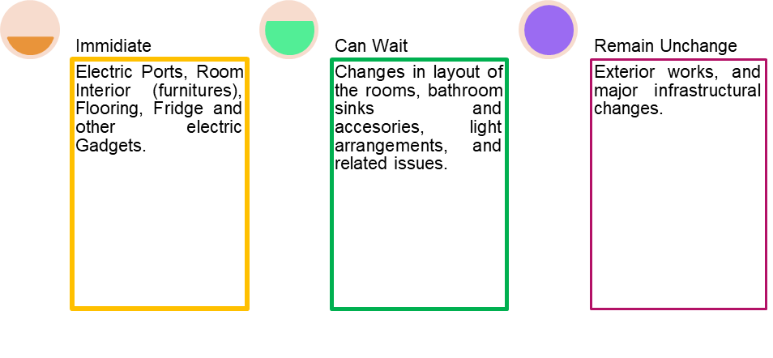
Figure 2:Timelines for Measures to be Taken
Source: (Self-Made)

SOSTAC Analysis of The Plaza New York
This analysis of SOSTAC helps to identify core issues that an organisation is facing and helps to build effective solutions based on the issue. SOSTAC refers to the Situation, Objective, Strategies, Tactics, Action, and Control of a business scenario. The SOSTAC model of The Plaza New York is-

Figure 3:SOSTAC Analysis
Source: (Burnes, 2004)
- Situation: Almost 10000 reviews regarding the hotel across the platforms have been assessed, and among those reviews, there were very few reviews that could have been better and had complaints about both infrastructural and staff-related issues. These reviews dropped the hotel's rating from 4.9 to 4.5 in recent times on average.
- Objective: This report aims to resolve the issues arising in the property within six months from now and to create a perfect action plan.
- Strategy: To solve all tangible and intangible issues such as interior, fittings, and staff problems with a sustainable goal.
- Tactics: Creating a plan of action, budgeting, assessing feedback, and implementing solutions.
- Action: The duty will be distributed between groups based on expertise and work area. Such as H.R. managers will recruit and train current employees, and the property manager will work to improve tangible issues such as interior and lighting.
- Control: The controlling of the process refers to the regular monitoring of work and standards and implementing changes if necessary.

Findings and Results
The analysis carried out in the scope and analysis of the Plaza New York and SOSTAC analysis in the main body section, and the issues discussed showed some significant findings regarding this report (Chen, Law and Yan, 2021). Although most of the analysis was based on customer reviews on multiple platforms about Plaza New York, this hotel still has one of the highest rates and revered customer service standards. In this section of the report, the results and findings of the analyses will be discussed and listed according to their importance.

Interior Issue
Table 3: Interior Issue
Outdated Interior | Need to be replaced with modern interior décor.
Highly Space Consuming | Need to be sleek and linear.
Inconvenient Layout | The layout of interior furniture could be more convenient.
Shabby and Bulky | Small functional and viable furniture addition.
In many rooms, there needs to be more space to walk around due to these bulky interiors, and it causes significant problems in the guests' convenience as the room feels more stuffed and suffocating due to heavy furniture (Bogicevic et al., 2018). These things need to be replaced with modern interiors.

Lighting Issue
Table 4: Lighting Issue
Low Natural light | The windows need to be changed with light passing doors.
Dullness | The colour of the walls and overall room needs to be changed to a shiny and bright colour.
High Consumption of Electricity | Use of natural light to reduce the power consumption.
The Plaza New York Hotel has the most prominent open façade in the city, with great natural lighting sources. However, the property is old, and the windows have sun sheds and tinted glasses that prevent light from entering the room correctly (El-Sayed and Abed, 2021). This is causing high power consumption to keep the light on in the room.

Bathroom Fitting Issue
Table 5:Bathroom Fitting Issue
Water leakage due to broken fittings | Installation of modern and effective fittings.
Water wastage | Digital automated fittings can stop water wastage.
Inconvenient bathroom experience | It needs to be done in 25 rooms in 2 months.
The issue of bathroom fittings is causing significant problems for guests (Buhalis and Moldavska, 2021). According to many guests' showers are inconvenient and need to be improved.

Cleanliness Issue
Table 6:Cleanliness Issue
Unclean Room floor and corners. | Staff needs to be increased.
Unclean Bathroom. | A floor supervisor needs to be appointed.
Guests with O.C.D. experienced severe problems. | Daily two-time cleaning must be done.
This is a significant issue as people prefer to stay clean and hygienic. However, in some reviews, the guests complained about the cleanliness of the property severely (Lockyer, 2003). This issue needs to be addressed immediately.

Outdated Electricity Ports and Technological Support
Table 7:Outdated Electricity Ports and Technological Support
Outdated and Broken electricity ports. | 40 rooms have broken ports.
No stable power outputs for modern devices. | This service needs to be updated within three months.
Inconvenient position of switches and plug-in ports. | Implementation of in-room voice assistant service can improve the situation.
According to customer reviews in many rooms, the electricity ports were outdated or broken (Iranmanesh et al., 2022). Business visitors need help finding necessary technological support for emergency meetings and power support to devices.

Missing Complementary Personal Hygiene and Grooming Kit Issue:
Table 8:Missing Complementary Personal Hygiene and Grooming Kit Issue
Kits are provided for one guest in case of two guest check in. | Guests' number needs to be checked before preparing rooms.
Used kits are in the bathrooms many times. | On-call service needs to be ensured.
Emergency kit support has the issue of latency. | Kit requirements need to be asked before check-in.
The property charges a significant amount of money, and according to a guest, only one toothbrush and toothpaste were given in the bathroom (Yu, Seo and Hyun, 2021). This causes problems in case of two or multiple guest check-ins.

Broken Refrigerator
Table 9:Broken Refrigerator
23 refrigerator is broken or dead. | A new set of fridges needs to be installed within two months.
Inconvenient drinking experience. | 24/7 repair support needs to be there.
Drinking is an integral part of the luxurious stay; if the fridges are not working, the stay experience gets bad (Lashley, 2008). To improve the condition of the refrigerators, they need to be immediately replaced.

Room Service Issue
Table 10:Room Service issue
Late service by 15-30 mins. | Trained room service employees must be placed along with floor-based room service stations with supervisors.
Low serviceman. | The workforce needs to be increased.
The room service is one of the most significant inconveniences of the stay. Many guests had horrendous experiences during room service (Mok and Armstrong, 1998). This is harming the service standards and needs to be addressed immediately.

Concierge Issue
Table 11:Room Service issue
Ineffective at communication. | Trained concierges need to be employed.
Ineffective at the recommendation. | Training and development plans are necessary.
The concierges are essential aspects of front office services, but the concierges at the property are bad at suggesting to the guests or providing guidance (Faulkner and Patiar, 1997).

Bellman Issue:
Table 12:Room Service issue
Sluggish Service. | Needs a more trained bellhop.
Luggage safety Issue. | Effective backdoor baggage service needs to be ensured.
The bellman at the property needs to be more adequate as the luggage is late to the room, so guests have inconveniences regarding changing their dresses and stuff (Lynn and Gregor, 2001).

Staff Shortages:
Table 13:Room Service Issue
60-80 more staffs are necessary for the guest services. | Needs to recruit more staff to serve the guests effectively.
Ineffective performance management. | Effective performance management and employee rewards programs need to be established.
This is the core problem in guest service or intangible issues, and to get rid of the issues, more staff is necessary, along with practical performance management (Davidson and Wang, 2011).

Plan of Action
To solve this issue, a strong plan of action is necessary. The plan of action for solving the issues of The Plaza New York is-
Table 14: Action Plan
Issues | Solutions | Desired Outcome | Time Frame | Date of Completion | Budget  £
- Interior Issue | Identifying a proper modern theme and upgradation of furniture and flooring. | High Guest Rating and Satisfaction. | 3 months | July 31st 2023 | Per room, the interior upgradation budget will be £15000.
- Natural Lighting Issue | Tweaks in window exterior, changing glasses, and colouring walls. | Better natural lighting, less energy consumption, and high sustainability. | Four months | September 30th 2023 | The project's total budget will be £1.5-£2.0 million.
- Bathroom fittings issue. | All bathroom fittings need to be upgraded eventually with modern digital bathroom fittings. | Better bathroom experience, low water wastage, and better sustainability. | Six months | November 30th 2023 | The total project will cost around £2 million.
- Outdated electricity ports issue. | The electricity ports need to be replaced with modern ones, wireless charging stations, a stable power supply, and an in-room voice assistant. | Better in-room utility experience and overall better-staying experience. | Six months. | November 30th 2023 | Per room, the technological upgradation budget will be £4000.
- Cleanliness issue. | Positioning more staff, scheduled cleaning, supervising. | Better cleanliness will provide guests with a better and more cosy stay. | Daily basis | N/A | N/A
- Personal Grooming and Hygiene Kit issue. | Addressing several guests in the room and sorting kits based on that. | Better bathing and personal grooming experience make stay better overall. | Daily Basis. | N/A | N/A
- Refrigerator Issue | It needs to be replaced in 23 rooms and 24/7 repair service assurance. | Better in-room experience of drinking. | One month of replacing and ongoing repairing service. | June 30th 2023 | £30000
- Room Service | Increasing the staff, recruitment, and performance management system improvement. | Better customer service experience and support ensure higher satisfaction. | Ongoing. | N/A | N/A
- Concierge Issue | Training of concierge, daily assessment, and performance monitoring. | Better front office service makes the guests more confident and increases overall satisfaction. | Ongoing | N/A | N/A
- Bellman | Increase in the number of bellmen, better backdoor luggage and baggage transferring service. | Enhances the overall staying experience and satisfaction. | Ongoing | N/A | N/A
- Staff Shortage Issue | 60-80 employees need to be recruited to ensure optimum customer service. | This will ensure better customer service and improve the overall rating. | Six months | 30 November 2023 | £25000 recruitment expenses (excluding the salary increase).

Recommendation
The issues and solutions have been discussed in the Plaza New York Hotel case. Some of the recommendations to implement the solutions based on importance are as follows-
- Implementing the solutions to the problems that are causing guest service experience directly, such as in-room issues like bathroom fittings, outdated electric ports, etc.
- Daily training and improvement programs can ensure better and swift room service, and these needs be maintained.
- The recruitment should be based on the experience and expertise of the employees because this will increase the swiftness of the management.
- Changing lighting is not an immediate requirement but needs to be fixed within a short time.
- Floor-based room service stations are necessary, along with room service supervisors.
- Employees need to be apt in communication and must have a customer-centric attitude.

Conclusion
This consultancy report compiled by Roland Berger for The Plaza New York Hotel shows some significant issues regarding the property. The hotel has the best location and is situated in one of the city's most historic landmarks, along with the long heritage of being one of the best hospitality destinations. After being appointed as a Consultant of the Plaza New York, Ronald Berger has identified some significant issues arising regardless of everything in place. After identifying the issues, the consultancy suggested potential solutions for the problems along with the budget. The hotel has been suffering from issues since its opening after the COVID-19 lockdown. Despite having the best management and all potential conveniences, the rating of the hotel is going down, and the ranking is falling as well.
The hotel is planning to revive its old glory before the holiday season of 2023; The analyses are made in the scope and analysis section of the report to find out the issues that are causing damage to the reputation of the property. Then in the main body, problems and issues were identified along with the SOSTAC analysis, which will help to lay out potential solutions to the problems by analysing each issue. Some significant issues are interior, cleanliness, room service, bellhop service, complementary kit service, in-room tech service issues, bathroom fittings, and others. The problems are assessed in the findings and results, and the solution is provided in the plan of action section, along with the expenses needed to bring the hotel back to the forefront of luxury hospitality.

References
A.B.C. News (2021) Coronavirus Update New York City: Plaza Hotel offers tour ahead of Thursday reopening, ABC7 New York. Available at: https://abc7ny.com/plaza-hotel-reopens-nyc-tourism-covid-update/10662122/.
Accor (2023) The Plaza - A Fairmont Managed Hotel, all.accor.com. Available at: https://all.accor.com/hotel/A568/index.en.shtml (Accessed: 18 May 2023).
Al-Ababneh, M. (2014) ‘Employees’ Service Innovation Behavior and New Service Development in Four- and Five-Star Hotels’, SSRN Electronic Journal. Doi: https://doi.org/10.2139/ssrn.3633078.
B.H.R. (2020) Fairmont Hotels and Resorts reverses the decision to fire all employees due to the impact of Covid-19 on the hotel industry, Business & Human Rights Resource Centre. Available at: https://www.business-humanrights.org/en/latest-news/fairmont-hotels-and-resorts-reverses-decision-to-fire-all-employees-due-to-impact-of-covid-19-on-hotel-industry/ (Accessed: 18 May 2023).
Beerli-Palacio, A., Martín-Santana, J. D. and Román-Montoya, C. (2020) 'Complementary services at hotels following their pricing strategy and the price sensitivity of tourists', International Journal of Hospitality Management, 87, p. 102458. doi https://doi.org/10.1016/j.ijhm.2020.102458.
Best.com (2023) The Plaza Hotel, 10Best. Available at: https://www.10best.com/destinations/new-york/new-york/midtown-east/hotels/the-plaza-hotel-1/ (Accessed: 18 May 2023).
Bogicevic, V. et al. (2018) ‘Gender and age preferences of hotel room design’, International Journal of Contemporary Hospitality Management, 30(2), pp. 874–899. doi https://doi.org/10.1108/ijchm-08-2016-0450.
Bohdanowicz, P. et al. (2001) Energy-efficiency and conservation in hotels – towards sustainable tourism. Available at: http://www.greenthehotels.com/eng/BohdanowiczChurieKallhaugeMartinacHawaii2001.pdf.
Booking (2023) ★★★★★ The Plaza, New York, U.S.A., Booking.com. Available at: https://www.booking.com/hotel/us/the-plaza.en-gb.html (Accessed: 18 May 2023).
Buhalis, D. (2000) ‘Tourism and Information Technologies: Past, Present and Future’, Tourism Recreation Research, 25(1), pp. 41–58. doi https://doi.org/10.1080/02508281.2000.11014899.
Buhalis, D. and Moldavska, I. (2021) ‘In-room Voice-Based AI Digital Assistants Transforming On-Site Hotel Services and Guests’ Experiences’, Information and Communication Technologies in Tourism 2021, pp. 30–44. doi https://doi.org/10.1007/978-3-030-65785-7_3.
Burnes, B. (2004) Managing Change: A Strategic Approach to Organisational Dynamics. Essex: Pearson Education.
Campanile, C. (2023). N.Y.C. tourism is at risk if migrants stay in too many hotels. Available at: https://nypost.com/2023/05/18/nyc-tourism-at-risk-if-migrants-stay-in-too-many-hotels/ (Accessed: 18 May 2023).
Case Centre (2022) Fairmont Hotels & Resorts: Stretching the Targets for Climate Action at Landmark Hotels, The Case Centre. Available at: https://www.thecasecentre.org/educators/products/view?id=93407 (Accessed: 18 May 2023).
Chen, Y.-F., Law, R. and Yan, K. K. (2021) ‘Negative eWOM Management: How Do Hotels Turn Challenges into Opportunities?’, Journal of Quality Assurance in Hospitality & Tourism, pp. 1–24. doi https://doi.org/10.1080/1528008x.2021.1911729.
Davidson, M. C. G. and Wang, Y. (2011) ‘Sustainable Labor Practices? Hotel Human Resource Managers Views on Turnover and Skill Shortages’, Journal of Human Resources in Hospitality & Tourism, 10(3), pp. 235–253. doi https://doi.org/10.1080/15332845.2011.555731.
Denby, E. (2002) Grand hotels: reality and illusion. London: Reaktion.
El-Sayed, S. and Abed, M. (2021) ‘The Use of Sustainability Principles and Lighting Technology in Lighting Hotels’ Lobby Area’, Journal of Association of Arab Universities for Tourism and Hospitality, 0(0). doi https://doi.org/10.21608/jaauth.2021.97836.1243.
Fairmont (2023) The Plaza, A Fairmont Managed Hotel - Luxury Hotel in New York City - Fairmont, Hotels & Resorts, www.fairmont.com. Available at: https://www.fairmont.com/the-plaza-new-york/ (Accessed: 18 May 2023).
Faulkner, B. and Patiar, A. (1997) ‘Workplace induced stress among operational staff in the hotel industry’, International Journal of Hospitality Management, 16(1), pp. 99–117. doi: https://doi.org/10.1016/s0278-4319(96)00053-9.
Fortune (2021) Inside the reopening of New York’s most famous hotel, The Plaza, Fortune. Available at: https://fortune.com/2021/05/22/the-plaza-reopening-nyc-new-york-city-famous-hotels-covid/ (Accessed: 18 May 2023).
Gert Noordzij (2014) Project management of hotel opening processes: exploring better ways to open new hotels. North Charleston: Createspace Independant Publishing Platform.
Gleason, W. (2020) You could be eligible to self-isolate in an N.Y.C. hotel for free, Time Out New York. Available at: https://www.timeout.com/newyork/news/you-could-be-eligible-to-self-isolate-in-an-nyc-hotel-for-free-111320 (Accessed: 18 May 2023).
Ioanna Mavridopoulou and J. O’Mahoney (2020) Elitism in Strategy Consulting: How Institutional Prestige Influences Recruitment, Management Consulting Journal. Available at: https://www.semanticscholar.org/paper/Elitism-in-Strategy-Consulting%3A-How-Institutional-Mavridopoulou-O%E2%80%99Mahoney/9f01115ba48292d887af7c29152d26c8a6c04d9e (Accessed: 18 May 2023).
Iranmanesh, M. et al. (2022) 'Applications of disruptive digital technologies in the hotel industry: A systematic review', International Journal of Hospitality Management, 107, p. 103304. doi https://doi.org/10.1016/j.ijhm.2022.103304.
Isroilova, N. F., Matniyazov, Z. E. and Mansurov, Y. M. (2022) ‘Modern Trends in Interior Design of Hotel Premises’, Eurasian Journal of Engineering and Technology, 5, pp. 55–59. Available at: https://geniusjournals.org/index.php/ejet/article/view/1058.
Karmin, C. and Morris, K. (2018) ‘Guests Turned Away at New York’s Plaza Hotel, Victims of Labor Dispute’, Wall Street Journal, 3 May. Available at: https://www.wsj.com/articles/guests-turned-away-at-new-yorks-plaza-hotel-victims-of-labor-dispute-1525363336 (Accessed: 18 May 2023).
Kerr Forster Associates, P. (1993) ‘Factors Influencing the Design of Hotels’, International Journal of Contemporary Hospitality Management, 5(2). doi https://doi.org/10.1108/eum0000000001688.
Kostuch Media Ltd (2013) Looking Back at the Hospitality Industry in the ‘30s and ‘40s - Hotelier Magazine, Hotelier Magazine. Available at: https://www.hoteliermagazine.com/looking-back-at-the-hospitality-industry-in-the-30s-and-40s/ (Accessed: 18 May 2023).
Krishnan, V. et al. (2020) COVID-19’s effect on the hotel industry | McKinsey, www.mckinsey.com. Available at: https://www.mckinsey.com/industries/travel-logistics-and-infrastructure/our-insights/hospitality-and-covid-19-how-long-until-no-vacancy-for-us-hotels.
Landman, P. (2022) 10 Solutions to Challenges the Hotel Industry Faces in 2022, Xotels. Available at: https://www.xotels.com/en/hotel-management/challenges-problems-hotel-industry (Accessed: 19 May 2023).
Lashley, C. (2008) ‘Studying Hospitality: Insights from Social Sciences1’, Scandinavian Journal of Hospitality and Tourism, 8(1), pp. 69–84. doi https://doi.org/10.1080/15022250701880745.
Lockyer, T. (2003) 'Hotel cleanliness—how do guests view it? Let us get specific. A New Zealand study, International Journal of Hospitality Management, 22(3), pp. 297–305. doi: https://doi.org/10.1016/s0278-4319(03)00024-0.
Luxury Escapes (2023) World-Class The Plaza New York Heritage Stay Overlooking Central Park, New York, U.S.A., Luxury Escapes. Available at: https://luxuryescapes.com/in/offer/the-plaza-new-york-city-usa/0062y000009F7ulAAC (Accessed: 18 May 2023).
Lynn, M. and Gregor, R. (2001) ‘Tipping and service: the case of hotel bellmen’, International Journal of Hospitality Management, 20(3), pp. 299–303. doi: https://doi.org/10.1016/s0278-4319(01)00012-3.
McGeehan, P. (2020) ‘Pandemic Puts N.Y.C. Hotels on the Brink: “A Complete Washout”’, The New York Times, 21 September. Available at: https://www.nytimes.com/2020/09/21/nyregion/nyc-hotels-closing.html.
Mistry, S. (2018) How to Deal with 13 Common Challenges in the Hotel Industry? - eZee Absolute, eZee Absolute. Available at: https://www.ezeeabsolute.com/blog/how-to-deal-with-challenges-in-hotel-industry/ (Accessed: 19 May 2023).
Mok, C. and Armstrong, R. W. (1998) ‘Expectations for hotel service quality: Do they differ from culture to culture?’, Journal of Vacation Marketing, 4(4), pp. 381–391. doi https://doi.org/10.1177/135676679800400406.
N.Y. Times Report (2023) 13 best hotels in New York City in 2023, per travel experts, N.Y. Times. Available at: https://nypost.com/article/best-hotels-in-nyc-per-travel-experts/ (Accessed: 18 May 2023).
Nanu, L. et al. (2020) ‘The effect of hotel lobby design on booking intentions: An intergenerational examination’, International Journal of Hospitality Management, 89, p. 102530. doi https://doi.org/10.1016/j.ijhm.2020.102530.
Noel, M. D. (2020) ‘COVID Economics Competitive Responses in a Devastated Industry: Evidence from Hotels during COVID-19’, SSRN Electronic Journal. Doi: https://doi.org/10.2139/ssrn.3660174.
Padma, P. and Ahn, J. (2020) ‘Guest satisfaction & dissatisfaction in luxury hotels: An application of big data’, International Journal of Hospitality Management, 84, p. 102318. doi https://doi.org/10.1016/j.ijhm.2019.102318.
Park, H. et al. (2019) ‘Does hotel cleanliness correlate with surfaces guests contact?’, International Journal of Contemporary Hospitality Management, 31(7), pp. 2933–2950. doi https://doi.org/10.1108/ijchm-02-2018-0105.
Park, S.-Y. and Allen, J. P. (2012) ‘Responding to Online Reviews’, Cornell Hospitality Quarterly, 54(1), pp. 64–73. doi https://doi.org/10.1177/1938965512463118.
Plaza NY (2023a) Legacy | The Plaza Hotel New York, The Plaza. Available at: https://www.theplazany.com/history/ (Accessed: 18 May 2023).
Plaza NY (2023b) Luxury Hotel Suites in New York City | The Plaza Hotel New York, The Plaza. Available at: http://theplazany.com/rooms-suites/ (Accessed: 18 May 2023).
Reynolds, E. (2023) A $16 Million Condo At New York’s Plaza Hotel Is Designed With ‘Eloise’ Fans In Mind, Forbes. Available at: https://www.forbes.com/sites/emmareynolds/2023/05/17/a-16-million-condo-at-new-yorks-plaza-hotel-is-designed-with-eloise-fans-in-mind/ (Accessed: 18 May 2023).
Suh, E., West, J. J. and Shin, J. (2012) ‘Important competency requirements for managers in the hospitality industry’, Journal of Hospitality, Leisure, Sport & Tourism Education, 11(2), pp. 101–112. doi https://doi.org/10.1016/j.jhlste.2012.02.005.
SWOT Analytica (2023) Fairmont Hotels And Resorts Stretching The Targets For Climate Action At Landmark Hotels SWOT Analysis (10 Steps) - Strengths, Weaknesses, Opportunities & Threats, swotanalytica.com. Available at: https://swotanalytica.com/imd-switzerland/fairmont-hotels-and-resorts-stretching-the-targets-for-climate-action-at-landmark-hotels.php (Accessed: 18 May 2023).
T.P.S. (2020) What to expect at N.Y.C.'s luxury hotels during COVID-19, The Points Guy. Available at: https://thepointsguy.com/news/nyc-hotels-covid-19-what-to-expect/ (Accessed: 18 May 2023).
The Plaza Hotel (2023) The Plaza Hotel Reviews, Deals & Photos 2023 - Expedia, Expedia.com. Available at: https://www.expedia.com/New-York-Hotels-The-Plaza-Hotel.h28044.Hotel-Information (Accessed: 18 May 2023).
TLTC (2023) The Plaza Hotel – History of New York City, blogs.shu.edu. Available at: https://blogs.shu.edu/nyc-history/2017/11/07/the-plaza-hotel/ (Accessed: 18 May 2023).
Travel Weekly (2023) The Plaza, New York- Deluxe New York, NY Hotels- G.D.S. Reservation Codes: Travel Weekly Asia, www.travelweekly-asia.com. Available at: https://www.travelweekly-asia.com/Hotels/New-York-NY/The-Plaza-New-York-p56647746 (Accessed: 18 May 2023).
TripAdvisor (2021) How much is a PCR test at the hotel? Www.tripadvisor.com.au. Available at: https://www.tripadvisor.com.au/FAQ_Answers-g147275-d14163595-t8795438-How_much_is_a_PCR_test_at_the_hotel.html (Accessed: 18 May 2023).
TripAdvisor (2023a) The Plaza is different....... - Review of The Plaza New York - A Fairmont Managed Hotel, New York City, NY - Tripadvisor, www.tripadvisor.com. Available at: https://www.tripadvisor.com/ShowUserReviews-g60763-d675616-r879754397-The_Plaza_New_York_A_Fairmont_Managed_Hotel-New_York_City_New_York.html (Accessed: 18 May 2023).
TripAdvisor (2023b) THE PLAZA NEW YORK - A FAIRMONT MANAGED HOTEL - Updated 2023 Prices & Reviews (New York City), Tripadvisor. Available at: https://www.tripadvisor.com/Hotel_Review-g60763-d675616-Reviews-The_Plaza_New_York_A_Fairmont_Managed_Hotel-New_York_City_New_York.html (Accessed: 18 May 2023).
TripAdvisor (2023c) Unfortunate Experience - Review of The Plaza New York - A Fairmont Managed Hotel, New York City, NY - Tripadvisor, www.tripadvisor.com. Available at: https://www.tripadvisor.com/ShowUserReviews-g60763-d675616-r874173587-The_Plaza_New_York_A_Fairmont_Managed_Hotel-New_York_City_New_York.html (Accessed: 18 May 2023).
TripAdvisor (2023d) Very disappointing, bad experience. - Review of The Plaza New York - A Fairmont Managed Hotel, New York City, NY - Tripadvisor, www.tripadvisor.com. Available at: https://www.tripadvisor.com/ShowUserReviews-g60763-d675616-r880014416-The_Plaza_New_York_A_Fairmont_Managed_Hotel-New_York_City_New_York.html (Accessed: 18 May 2023).
Yu, J., Seo, J. and Hyun, S. S. (2021) ‘Perceived hygiene attributes in the hotel industry: customer retention amid the COVID-19 crisis’, International Journal of Hospitality Management, 93, p. 102768. doi https://doi.org/10.1016/j.ijhm.2020.102768.
Zhang, Z., Ye, Q. and Law, R. (2011) ‘Determinants of hotel room price’, International Journal of Contemporary Hospitality Management, 23(7), pp. 972–981. doi https://doi.org/10.1108/09596111111167551.

Appendix
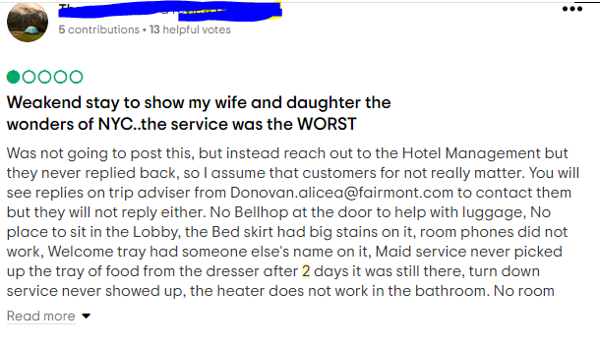
Source: (TripAdvisor, 2023)
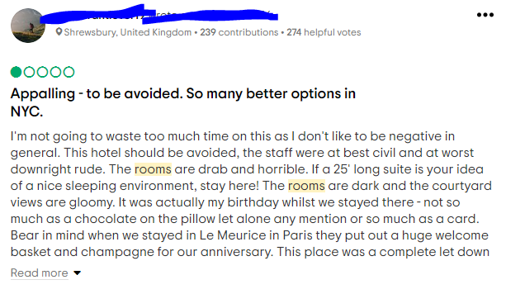
Source: (TripAdvisor, 2023)
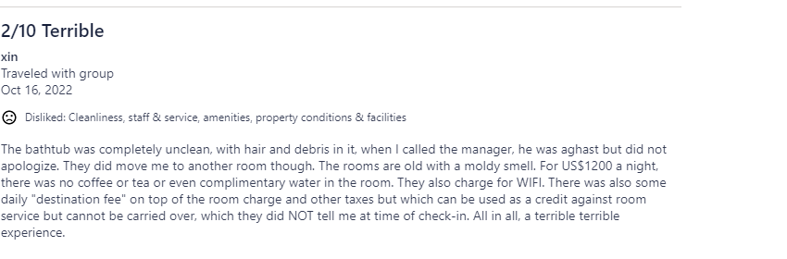
Source: (Expedia, 2023)

