Research Activity

You are a student with a passion for the outdoors and outdoor adventure activities. You feel that outdoor activities can improve people’s health. Being outdoors makes you feel good but do others feel the same? Is there any evidence that that there are health improvements from engaging in outdoor activities? After giving this much thought you are interested in finding out if your instinct is right.
You are ready to engage in inquiry and research.
So were do you start, well you start by writing out the question you want to find an answer to, so that is the starting point.
So you get started, you write the question down in about ten different ways and finally after a gulp of air and a scratch to the head you decide this is how you feel the question is best stated.
Here is the question you have arrived at.

How do you think outdoor activities can be used as a focus for improving people’s general health and wellbeing?

- What type of research paradigm best describes this question?
- Where will you search for information to address this question? (List all)
- How easy / difficult is it to find sources to help answer the question?
- What did you do to make the process less difficult?
- How did you arrange the materials you found? Did you have a system (folders etc)
- Pick five search results.

The next stage is the literature review process.
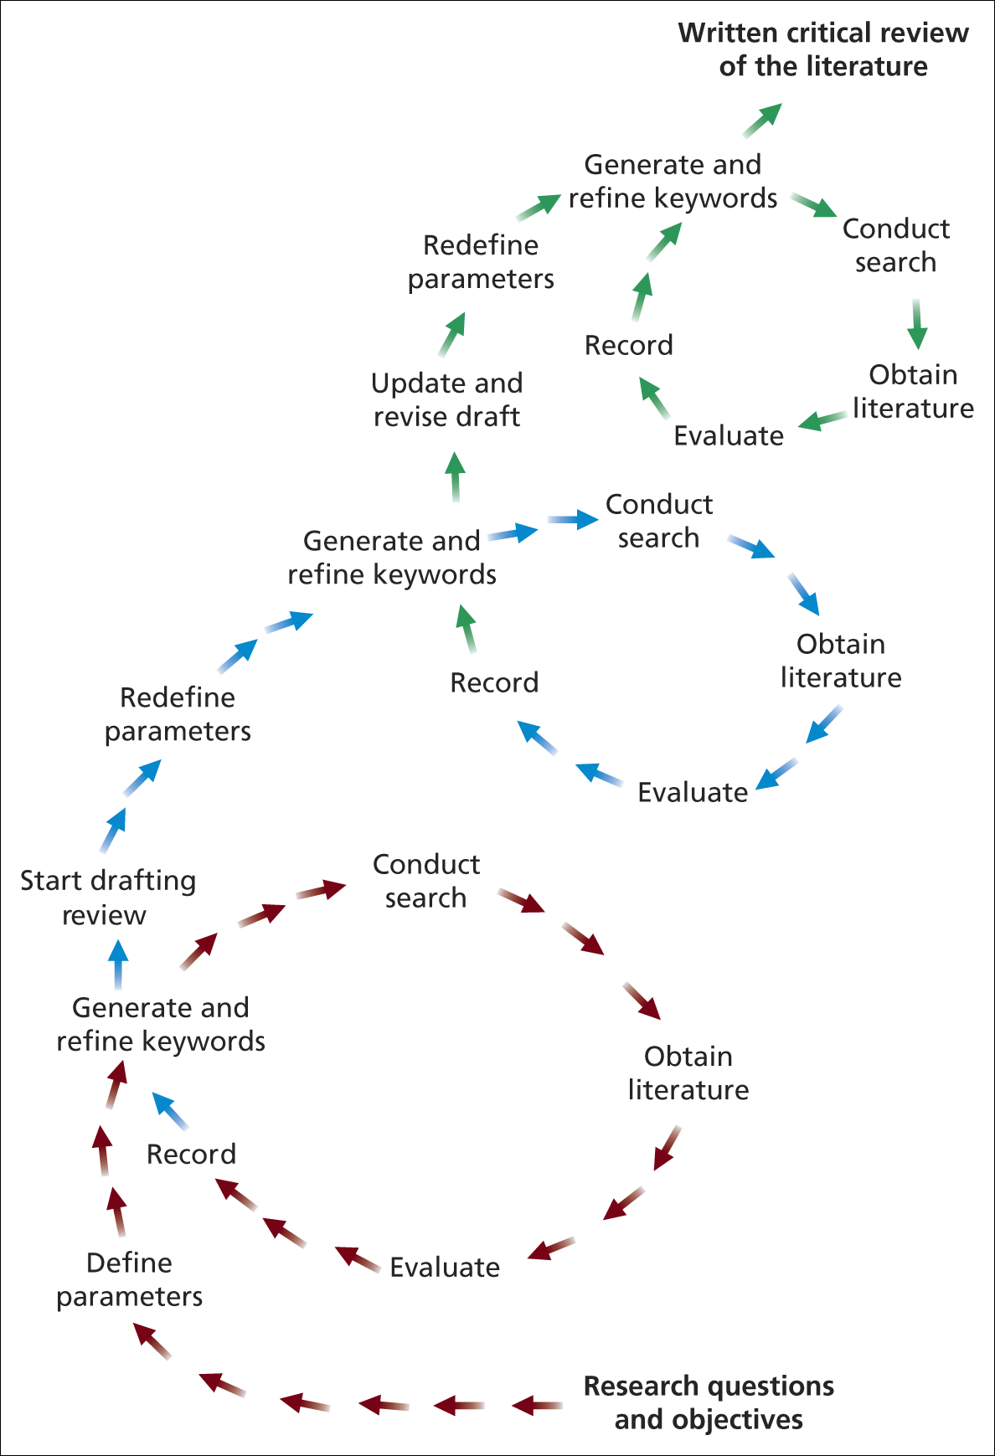
Figure 1 The literature review process Saunders et al., 2009

- The process suggests you need to evaluate those search results, but how do you do that?
- How would you evaluate those five search results? Are there any guidelines / checklists you would follow to decide what you are looking for in those papers?
- Now you have your evaluation checklist ready then read the three research sources and report on your checklist.
- Make a summary of what are the key findings from the papers. Report these.
- Did the sources provide useful findings and what are these findings?
- Did the sources you found indicate a need for further research?

