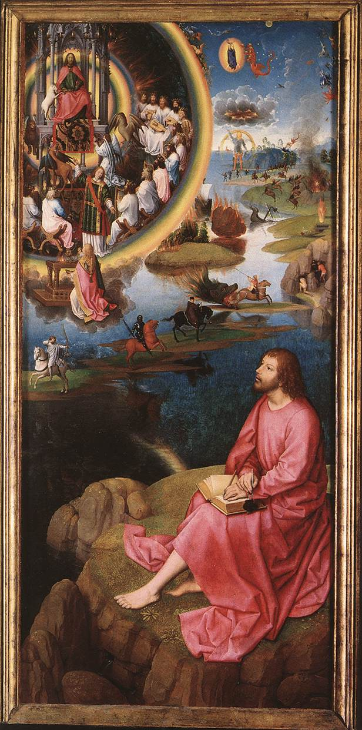St. John’s vision of the Apocalypse
Hans Memling, The St. John Altarpiece (right wing), 1474-1479
Bruges, Memling Museum, St. John’s Hospital

When looking at other images of St john and his vision, you can clearly see that he is separate from the vision and the events happening. This could be a way to show that St. John is there in spirit but not in body, so he is on the outside looking in. It could also convey that St john is not actually going to die in the apocalypse, so he will always be an observer. Its not as obvious in this image, but in other images it looks as though St. John is looking through a window giving emphasis on the idea that he is looking in from the outside like a soul from the outside of the body.
In the book of revelations, it states “there in heaven stood a throne with one seated on the throne…around the throne looks like a rainbow…around the throne are twenty-four thrones…twenty-four elders…on each side of the thrown are four living creatures…the first…like a lion…second…like an ox…third…face like a human…fourth… a flying eagle (revelations 4: 1-7)”. You can clearly see the throne in the image where a person assumed to be Jesus is sat. The throne is haloed by a rainbow as well the elders. You can see the four creatures at the bottom of the throne, they appear to be looking up at Jesus almost like they are waiting for direction or maybe just waiting to be told when the seals break.
In this picture you can clearly see the four horsemen of the apocalypse. The book of revelations described the four horsemen and once again the descriptions match the image. The first was described as a white horse, and the rider had a bow and a crown was given to him (revelation 6: 1-8). In this image the crown appears to be missing but the horse is white and the rider has a bow, this horseman was known as conquest (revelation 6: 1-8). The white horse is the only horse not facing the direction of the land the rider is turned around to see the action, but the horse almost looks like it is running away. A possible reason for this could be because the horsemen was the first one, so he is done with his part of the apocalypse and is no longer needed leaving room for the others to finish the job, or it could be because the horseman is going to his own part of the world.
The second horseman is described in the book of revelations, as having a red horse, and the rider was given a sword, this horseman is known as war (revelation 6: 1-8). In the image the horse is tinted red and the sword is being held in a way that makes the rider look like he is in mid strike. The riders armour is depicted as black, but the book of revelations makes no claim on what colour the armour is. It could be black because a lot of people relate blackness and darkness to the emotion of sadness and the fear. It could also be a representation that the world is about to be thrown into darkness. In the background there appears to be a war taking place showing the second horsemen’s influence on humans.
The third horseman is described, as having a black horse, holding a pair of scales, this horseman is known as pestilence (revelation 6: 1-8). Again, you can see the scales and that the horse is black, the image also shows the horses head being bowed whereas all the others are looking up. This could be to show the horse is looking away from the disgusting sight of the humans who are falling prey to the plague or maybe a way of masking the smell by having his head down the foul odour might not be as bad.
The fourth horseman is death. He appears on a pale green horse, and is followed by hades (revelation 6: 1-8). In the image the horse is not green but is the palest one. There is a dragon like creature following it with the mouth open. The open mouth could represent the hell mouth and the creature itself is supposed to be hades. The horseman appears to be heading in the direction of the people who are heading into the cave which could be a representation of the people entering hell or the people trying to out run death.
In the book of revelations, it claims that each horsemen has a quarter of land which is shown in the picture by each horsemen standing on their own piece of land. The land is also floating on the sea and the battle is happening on a shoreline in the image you can also see a sunken boat and fires happening both on land and at sea. The book of revelations talks about the sea giving up the dead, giving a reason why the image has a large amount of sea being shown (revelations 20: 11-25). Another reason for this could be because the sea touches all land and since all land is in danger it could be a way of representing the world.
In the image it looks like St John is taking notes. However, the book could represent something else. For example, the book could be the same book that the horsemen come out of, or a representation of the book of life, which they used for the final judgement according to the book of revelations (revelation 20:11-25).
Its interesting that the horsemen in the image are not always the first thing people are drawn to. Heaven is the first eye opening thing that a viewer is drawn to. It takes up a large portion of the image despite it being an image of the apocalypse. This could be a way of emphasising heavens part in the apocalypse. The next thing people are automatically drawn to is St John himself as he takes up half the page, a possibility for this is that it emphasises St Johns vision.

Bibliography
The Bible, Book of Revelations 6: 1-8 and 20: 11-15

