

Student Name: Nikki Lotiwan

Student ID: 2518745

Module Name: International Marketing: Principles & Practices

Module Code: LCMB7026

Lecturer’s Name: Tushara Balendran

Word count: 5000

Term 2

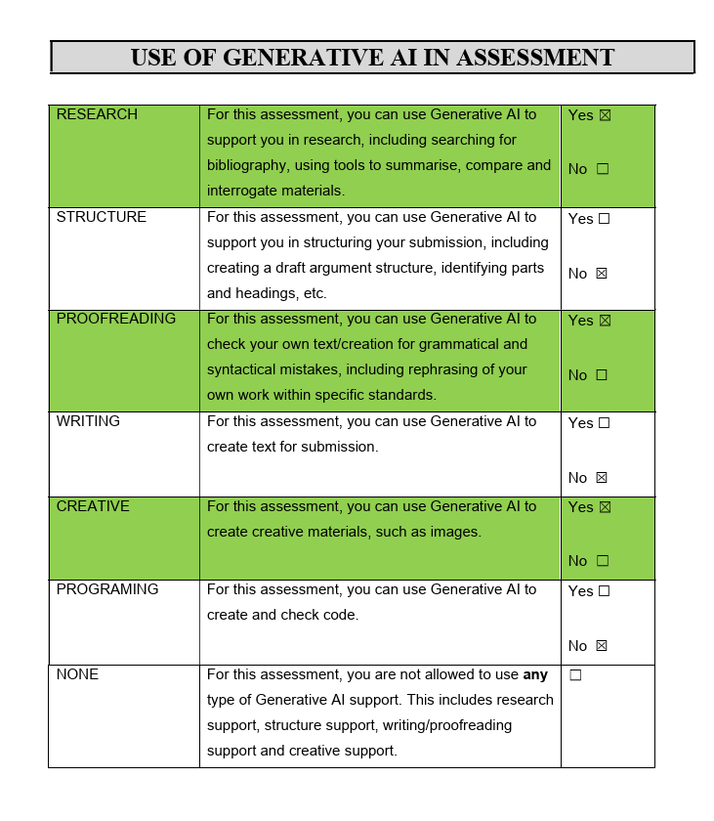

Table of Contents

Section 1: International Market Entry & Marketing Mix
- 1.1 Introduction .................................................................................................... 5
- 2.1 Company Background .................................................................................. 5
- 3.0 Comparative Strategic Analysis .................................................................. 6
  - 3.1 Comparative PESTEL Analysis ................................................................... 6
    - 3.1.1 Political Landscape .......................................................................... 7
    - 3.1.2 Economic Dynamics .......................................................................... 8
    - 3.1.3 Social Factors ................................................................................... 10
    - 3.1.4 Technological Infrastructure ........................................................... 16
    - 3.1.5 Environmental Factors ..................................................................... 17
    - 3.1.6 Legal Environment ........................................................................... 18
  - 3.2 Comparative Hofstede Cultural Analysis ................................................ 12
    - 3.2.1 Power Distance: Hierarchy vs. Status .......................................... 12
    - 3.2.2 Individualism vs. Collectivism ........................................................ 13
    - 3.2.3 Masculinity vs. Femininity .............................................................. 14
    - 3.2.4 Uncertainty Avoidance: Significance of Heritage .......................... 14
    - 3.2.5 Long-Term vs. Short-Term Orientation .......................................... 15
    - 3.2.6 Indulgence vs. Restraint ................................................................. 15
  - 3.3 Evaluation of the Hofstede Model (Advantages & Disadvantages) ....... 15
  - 3.4 Synthesis of Macro-Environmental Similarities & Differences ............... 19
- 5.0 Segmentation, Targeting, and Positioning (STP) ..................................... 20
  - 5.1 Segmentation (Demographic, Geographic, Psychographic, VALS) ...... 21
  - 5.2 Targeting (Differentiated and Concentrated Marketing) ........................ 23
  - 5.3 Positioning (Benefit and User Positioning) ............................................. 24
  - 5.4 Perceptual Map and STP Summary ......................................................... 26
- 6.0 Marketing Mix (7Ps Analysis) ..................................................................... 27
  - 6.1 Product Analysis: Width & Depth ............................................................ 28
  - 6.2 Price Strategy ............................................................................................. 30
  - 6.3 Promotion: Integrated Marketing Communications (IMC) ..................... 32
  - 6.4 Distribution Strategy (Place) ..................................................................... 33
  - 6.5 People: Training and Motivation ............................................................... 34
  - 6.6 Process: Service Delivery and Grievance Handling .............................. 35
  - 6.7 Physical Evidence: E-Servicescape and Aesthetics .............................. 36
  - 6.8 Summary Table of 7Ps Similarities & Differences ................................. 38
- 7.0 Market Entry Strategy: UAE (Host Country) .............................................. 40
  - 7.1 Choice of Entry Method: Wholly Owned Subsidiary (FZE) ................... 40
  - 7.2 Strategic Advantages and Disadvantages of Direct Entry .................... 40
- 8.0 Ethical & Unethical Marketing Practices ................................................... 41
- 9.0 Strategic Recommendations: STP Evolution ............................................. 42
  - 9.1 France: “Eco-Heritage” Strategy ............................................................. 42
  - 9.2 UAE: “Culture-Tech” Strategy .................................................................. 42
Section 2: Gibbs’ Reflective Account of the Research Process .................... 43
- 2.1 Description: The Research Task ..................................................................... 43
- 2.2 Emotions: Prior to & Following the Research ................................................ 44
- 2.3 Assessment: Strengths & Weaknesses .......................................................... 44
- 2.4 Analysis: Insights from Strategic Models ....................................................... 44
- 2.5 Conclusion: Skills Acquired .............................................................................. 45
- 2.6 Action Plan: Future Implementation ............................................................... 45
3.0 Final Summary ................................................................................................ 45
4.0 References List ................................................................................................ 46

- Section 1: International Market Entry & Marketing Mix
1.1 Introduction
This report offers a comparative examination of the International Market Entry Strategy & Marketing Mix for Chanel, focusing on France as the home country and the United Arab Emirates (UAE) as the host country. To assess the operational environments of both countries, the report employs the PESTEL framework to analyze macro-environmental factors, alongside the Hofstede framework to highlight socio-cultural differences and similarities. Furthermore, the study explores Chanel’s Segmentation, Targeting, and Positioning (STP) in conjunction with its 7Ps marketing mix—product, price, place, people, process, and physical evidence—to evaluate how the brand tailors its strategies to fit the distinct cultural and economic contexts of each market. The report reviews the market entry strategy, identifies potential ethical concerns, and offers recommendations for future international marketing efforts.

This report also utilizes Gibbs’ Reflective Cycle to offer a critical reflection on the learning process and the evaluation of Chanel’s international marketing strategies. The reflection addresses key experiences and findings from the analysis of Chanel’s market entry strategy, PESTEL analysis, Hofstede cultural comparison, STP, and the 7Ps marketing mix between France and the UAE. By progressing through the stages of description, feelings, evaluations, analysis, conclusion and action plan, the reflection reveals the understanding acquired from juxtaposing different international business environments and highlights areas for potential improvement in future marketing decisions.

2.1 Company Background
Founded in 1910 by Gabrielle ‘Coco’ Chanel in Paris, Chanel is a privately held French luxury fashion house that has become a global icon of high-end fashion, fragrance, and accessories (Chanel, 2024). Renowned for its heritage in haute couture and its timeless brand positioning, the company operates extensively in its home market of France, which remains the centre of its brand identity (Chanel, 2024). Over recent decades, Chanel has strategically expanded into high-growth regions such as the UAE, where it leverages the country's status as a global luxury hub to reach affluent local consumers, expatriates, and international tourists (Statista, 2024). This background provides the necessary foundation for understanding how Chanel maintains brand exclusivity while navigating the diverse regulatory and cultural environments of the Middle East and Europe. Chanel’s objective is to design and promote outstanding products that embody creativity, craftsmanship, innovation, and the principles of luxury, all while safeguarding its distinctive heritage and identity (Chanel, 2024). Its aims to maintain its status as the premier luxury fashion house globally by safeguarding its enduring legacy while fostering innovation, sustainability, and outstanding customer experience in international markets (Chanel, 2024).
The brand made its entry into the UAE market as a component of its broader international growth strategy, establishing a foothold in the region during the UAE’s emergence as a premier luxury destination. Chanel’s expansion was facilitated by through luxury retail outlets and collaborations, particularly in Dubai and Abu Dhabi, aimed at catering to high-net-worth individuals, tourists and luxury fashion enthusiasts. This growth enabled Chanel to tailor its global strategy to align with the cultural and economic nuances of the UAE, all the while preserving its exclusive brand image.

- Comparative Strategic Analysis: Chanel’s Macro-Environment and Cultural Landscape in France and the UAE

  - Comparative PESTEL Analysis
The PESTEL framework is a strategic analysis tool used to examine the external macro-environmental factors that influence an organisation’s performance and strategic decision-making. According to Johnson, Scholes and Whittington (2017), PESTEL categories the external business environment into six key dimensions: Political, Economic, Social, Technological, Environmental and Legal factors. By analysing threats and develop strategies that respond effectively to changes in the external environment.

Diagram 1

PESTEL ANALYSIS

POLITICAL
⬢
│
ECONOMIC ⬢ ──── ● ──── ⬢ SOCIAL
PESTEL
│
LEGAL ⬢ ─────────── ⬢ TECHNOLOGICAL
│
ENVIRONMENTAL
⬢
Source: Adapted from Johnson, Scholes & Whittington (2017)

- Political Landscape
The political contexts of France and the UAE present a compelling juxtaposition between the volatility of a mature democracy and the stability of a visionary monarchy. France, as a fundamental member and architect of the European Union, recent years have witnessed considerable domestic turmoil. Civil unrest, primarily associated with pension reforms and the rising cost of living, has resulted in operational disruptions (Oxford Economics, 2023). For a brand that depends on the “Parisian Experience,” the frequent protests on the Champs-Elysees and Avenue Montaigne are not merely inconveniences; they constitute a measurable risk to high-net-worth-individual (HNWI) tourism flows. Analysis indicates that during peak unrest periods in 2023, luxury retail foot traffic in Paris saw double-digit declines, necessitating a strategic reassessment of security measures and insurance costs for high-value inventory.
In stark contrast, the UAE functions under a constitutional monarchy that is marked by remarkable political stability and a centralized, proactive governance approach. The “We the UAE 2031” vision acts as a national framework for economic and social advancement, positioning the nation as a global hub for the new economy (UAE Government, 2024). For Chanel, this political climate offers a “safe heaven” status. While France necessitates a strategy of resilience in the face of social unrest and democratic unpredictability, the UAE presents an environment where the government actively promotes the expansion of the luxury sector as part of its national branding. The political orientation in the UAE towards sustainable tourism-related growth fosters a predictable setting for Chanel’s capital-intensive investments in “destination boutiques” and exclusive pop-up experiences in prestigious locations such as the Burj AI Arab or Saadiyat Island.
In general, France exhibits a complex political landscape for Chanel. Positive aspects encompass its robust regulatory framework, esteemed global luxury, status, and its membership in the European Union. Conversely, negative elements include persistent civil unrest, political instability regarding reforms, and interruptions to tourism and luxury retail activities. On the other hand, the UAE provides a significantly more favourable political climate, characterized by its political stability, long-term governmental vision, and strong endorsement of luxury tourism and foreign investment. Nevertheless, Chanel’s operations are still reliant on centralized government policies, indicating that any future changes in regulations or policies could have a direct impact on business operations and market dynamics.

- Economic Dynamics
Figure 1
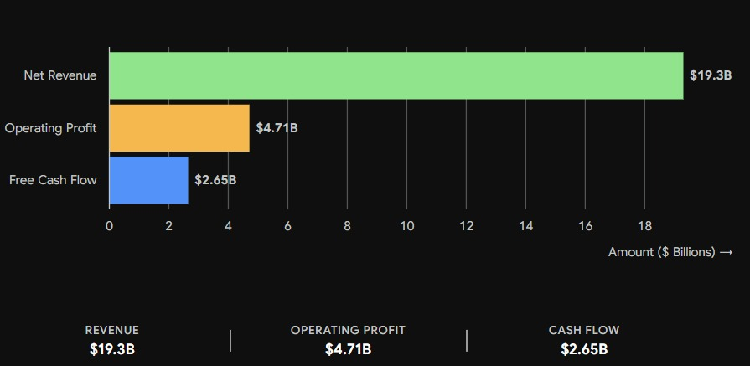
Source: Adapted from Chanel Limited (2025/2026), UAE Ministry of Economy (2025), & International Monetary Fund (2025).
The comparative graph presented above demonstrates that Chanel functions within two separate economic contexts. In Ferance, the modest GDP growth rate of 0.8% & elevated inflation rate of 2.4%, along with a 20% VAT, limit domestic volume growth. As a result, Chanel must depend on tax-free shopping by non-EU tourists to maintain its growth. In contrast, the UAE benefits from a strong GDP growth rate of 5.2%, low inflation at 1.5%, & a minimal 5% VAT, resulting in a market characterized by high liquidity. This favorable environment allows Chanel to manage international logistics costs effectively while safeguarding its profit margins, which directly contribute to its global sales revenue of & an operating profit of $4.71 billion.
Economic indicators in both markets shape the pricing capabilities and consumer perceptions associated with Chanel. France has a developed, high-income economy, yet it is currently contending with the challenges posed by Euro-related inflation and the structural constraints of a high-tax regime. In particular, the standard Value-Added Tax (VAT) in France plays a crucial role in determining the final cost of luxury items (Statista, 2024). While the VAT refund initiative for tourists aids in boosting sales, the local French consumer is becoming more sensitive to inflationary trends, which may result in a decrease in demand for entry-level luxury products (like fragrances and accessories), even as the “Ultra-High Net Worth” segment remains relatively shielded.
The UAE exhibits a distinctly different economic profile. Supported by its position as a global trade centre and a swiftly diversifying economy, the UAE provides a fiscal landscape that is exceptionally conducive to luxury consumption “discretionary income accelerator”. Coupled with a high per-capita GDP, this results in a market characterized by one of the highest marginal propensities to consume luxury goods worldwide. Such conditions foster a synergy between the UAE’s economic framework and its cultural emphasis on conspicuous consumption. For Chanel, this necessitates a dual pricing strategy: in France, the brand must navigate cost-push inflation within the European supply chain, whereas in the UAE, it can leverage a consumer base endowed with substantial purchasing power and rapid transaction rates. The UAE is not merely a high-income market; it represents a scenario where elevated discretionary income coincides with minimal fiscal constraints, enabling Chanel to sustain higher profit margins despite the logistical expenses associated with international distribution.
Overall, while France’s economic environment is favourable, it is tempered by challenges that affect consumer spending, whereas the UAE’s economic conditions are more favourable, albeit with vulnerabilities to external factors.

- Social Factors
The social landscape in France and the UAE distinctly shapes consumer behaviour and luxury buying trends. In France, there is a growing emphasis on quality, sustainability, and ethical consumption among consumers. However, Chanel continues to thrive due to dedicated clientele that values superior craftsmanship and exclusivity. The increase in living expenses and inflation has led some consumers to exercise caution regarding discretionary spending, especially concerning entry-level luxury items. Nonetheless, wealthy consumers and international visitors persist in driving demand for Chanel’s offerings.
Conversely, the UAE boasts a youthful, diverse, and affluent demographic characterized by substantial disposable incomes and a robust inclination towards luxury consumption. Luxury items are commonly perceived as indicators of social status, achievement, and prestige. Furthermore, the act of purchasing luxury items is intricately linked to hospitality and gifting customs, rendering Chanel products particularly appealing for both personal enjoyment and social events. These societal traits present considerable opportunities for Chanel to enhance its market presence and bolster customer loyalty.
In general, France enjoys a well-established luxury consumer demographic; however, the challenges posed by inflation-induced changes in spending behavior cannot be overlooked. On the other hand, the UAE provides a highly advantageous social landscape characterized by wealthy consumers and robust demand for luxury products. Nevertheless, shifting consumer preferences and rising competition necessitate that Chanel remains agile and responsive.

Figure 2
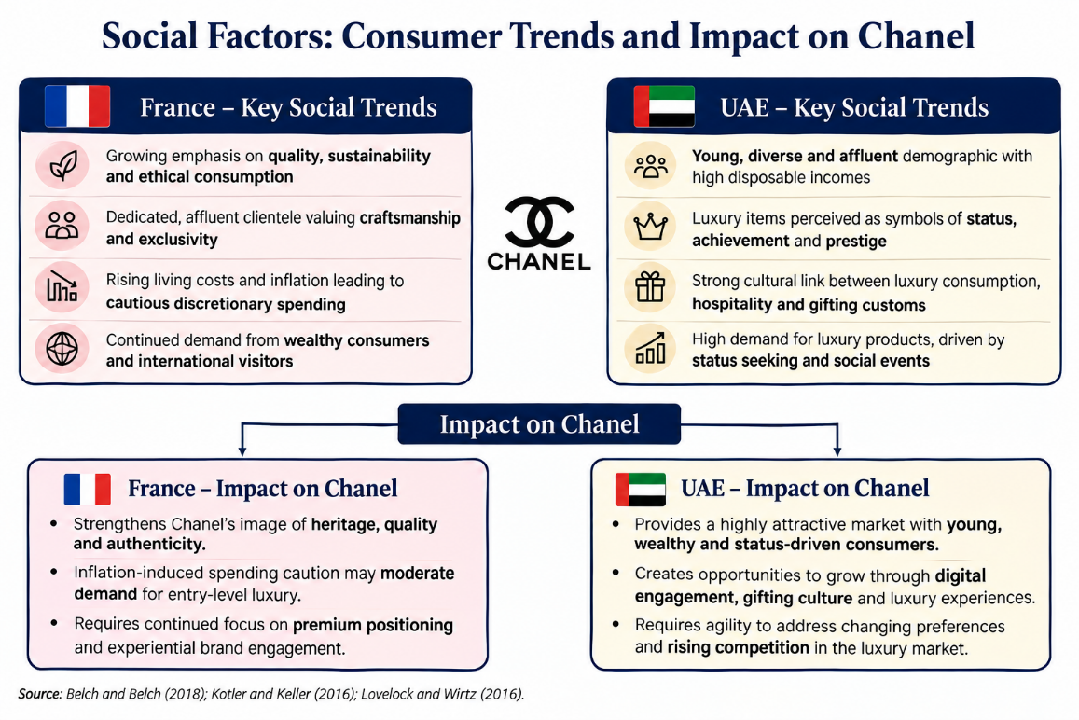
Above figure summaries the major social factors affecting Chanel’s operations in France & the UAE. It highlights the contrast between France’s heritage- and sustainability-driven market and the UAE’s affluent, status-oriented luxury consumption, demonstrating their impact on Chanel’s strategic positioning.
Cultural Factors
France
France exhibits a profound cultural appreciation for heritage, craftsmanship, authenticity, and sustainability, leading consumers to place a high value on luxury brands that boast a rich history and exceptional quality. The French identity of Chanel, along with its timeless brand heritage, resonates deeply with these cultural values, thereby enhancing customer loyalty and fostering long-term brand equity (Kapferer, 2015; Kotler & Keller, 2016).
UAE
In the UAE, a multicultural society, there is a considerable emphasis on prestige, social status, and luxury consumption. Luxury items are often perceived as indicators of success and are commonly acquired for gifting, celebrations, and social events. These cultural inclinations create a conducive environment for Chanel to reinforce its premium positioning and broaden its affluent customer demographics (Kapferer, 2015; Belch & Belch, 2018).
Comparative Hofstede Cultural Analysis
To attain a “systematic understanding” of market entry and sustainability, Chanel must delve deeper than mere macro-environmental data to uncover the psychological factors influencing consumer behaviour. The Hofstede framework serves as an essential tool for interpreting these factors. While PESTEL outlines the characteristics of the environment, Hofstede elucidates the reasons behind the differing reactions of consumers in France and the UAE to identical brand stimuli. For a luxury brand, where the value proposition is predominantly symbolic, cultural alignment distinguishes between being perceived as a “lifestyle choice” and a “social necessity.”
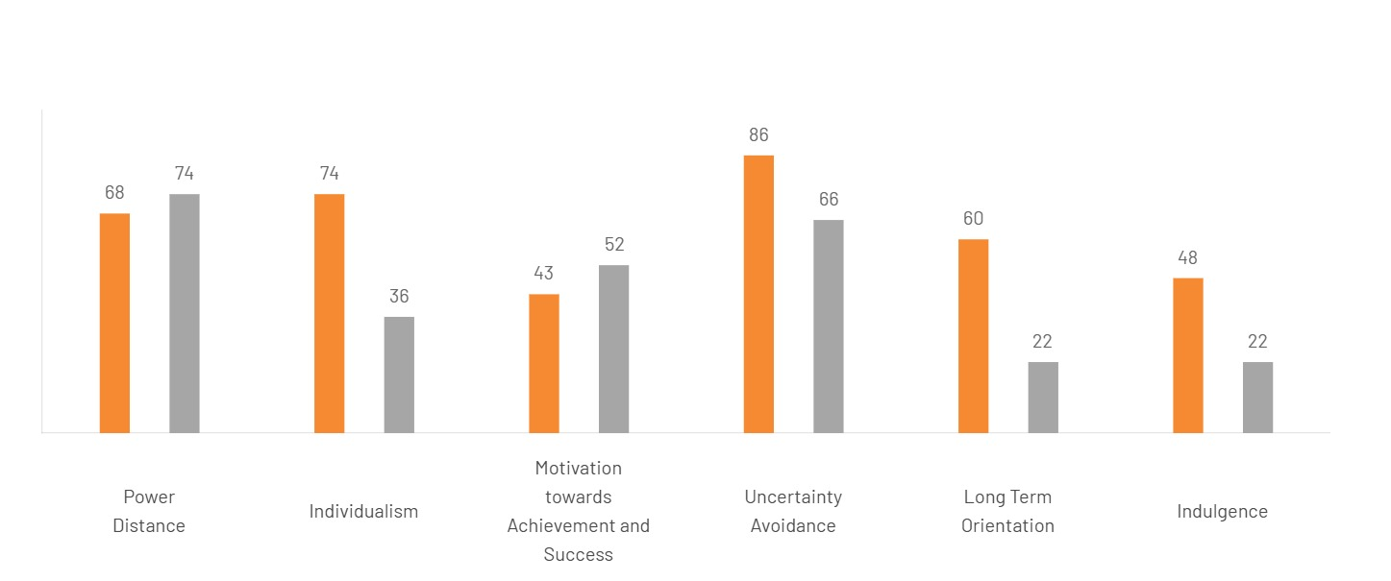
Figure 3. Source: Adapted from Hofstede Insights (2024)
Above

- Power Distance: Hierarchy vs. Status
The power Distance Index (PDI) quantifies the degree to which individuals with less power in a society accept and anticipate an unequal distribution of power. France’s PDI score of 68 is notably high for a Western democracy, suggesting a societal structure that honours hierarchy while simultaneously harbouring a certain level of skepticism toward it. Within the realm of French luxury, brand prestige is acknowledged; however, consumers frequently pursue a form of “stealth luxury’ or “effortless chic” that subtly conveys status without overt displays.
The UAE achieves an impressive score of 90 (Hofstede insights, 2024), signifying a society where social hierarchy is profoundly ingrained and honoured. In this context, brand prestige transcends mere preferences; it serves as a vital indicator of an individual’s social standing. Consumption acts as a means of demonstrating success and affirming one’s position within the hierarchy. For Chanel, this necessitates an increased emphasis on the ‘aspiration’ aspect within the UAE market. Marketing strategies should extend beyond the product itself to highlight the exclusive realm that ownership of the product provides. The brand’s ‘top tier’ status fulfils the Emirati desire for social validation and bolsters the owner’s status in a culture where visible success is not just valued but expected.

- Individualism vs. Collectivism
This dimension represents the most pronounced distinction between the two nations. France exemplifies a highly Individualistic culture, achieving a score of 71 (Hofstede Insights, 2024). For French consumers, Chanel serves as a medium for self-expression—an avenue to showcase a distinctive personal identity. The essential takeaway for Chanel’s strategy in France centers on the ‘individual woman’—her personal journey, her distinctive style, and her empowerment.
Conversely, the UAE embodies a Collectivist culture, scoring 25 (Hofstede Insights, 2024). In this context, the individual is integrated into a broader group, predominantly the family and tribe. The consumption of luxury goods is motivated by social validation and communal celebrations. Gifting plays a pivotal role in this collectivist framework, where a Chanel bag transcends being merely a personal accessory; it symbolizes the honor of the giver and the status of the recipient’s family. Consequently, Chanel’s strategy in the UAE must highlight the brand’s significance in social customs, family milestones, and the prestige associated with the collective. Marketing initiatives should incorporate group dynamics and familial contexts to align with this collectivist perspective.

- Masculinity vs. Femininity
France achieves a score of 43, categorizing it as a “feminine” culture that prioritizes quality of life, aesthetics, and the concept of the “art of living” (art de vivre). Chanel’s communication strategy in France is in perfect harmony with this cultural inclination, emphasizing sensory experiences, the beauty inherent in craftsmanship, and the high quality of materials used. The brand is appreciated for the joy it adds to the wearer’s existence.
In contrast, the UAE holds a mid-range score of 50 (Hofstede Insights, 2024). This score illustrates a compelling equilibrium between the “masculine” pursuit of success and competition and “feminine” principles of traditional hospitality. Within the luxury sector, this duality is expressed through the concept “Luxury Hospitality”. Chanel’s boutiques in the UAE are required to transcend the role of mere retail spaces; they must embody environments of hospitality. This encompasses features such as “Majlis-style” seating arrangements, the provision of traditional refreshments, and a service approach that emphasizes relationships-building as much as it does transactional interactions. The “People” and “Process” components of Chanel’s 7Ps must embody Emirati hospitality, transforming the shopping experience into a competitive exhibition of success, all while being enveloped in a service model that prioritizes feminine hospitality.

- Uncertainty Avoidance: The Significance of Heritage
A notable area of agreement exists in the remain of Uncertainty Avoidance, where both France (86) and the UAE (80) exhibit remarkably high scores (Hofstede Insights, 2024). This suggests that both cultures possess a limited tolerance for ambiguity and a pronounced inclination towards established regulations and reputable brands. This presents a substantial strategic advantage for Chanel. In both markets, Chanel’s reputation as a “timeless’ brand serves as a vital risk-mitigation element. Whether in Paris or Dubai, acquiring a Chanel as a “safe” investment—a safeguard against the unpredictability of fashion trends. Consumers in both locales depend on Chanel’s century—long heritage to offer a sense of stability and assured value. Chanel must persist in utilizing its historical legacy to fulfill this cultural demand for certainty.
- Long- Term Orientation vs. Short-Term Orientation (LTO)
France achieves a notable score of 63 in this dimension, indicative of a pragmatic culture that prioritizes perseverance and the capacity to adapt traditions to contemporary contexts (Hofstede Insights, 2024). For Chanel, this implies that French consumers perceive luxury acquisitions as long-term investments or “timeless’ items that retain their value across generations. Conversely, the UAE registers a lower score of 36, signifying a more normative culture that upholds a strong connection to its historical roots and honors traditional social responsibilities (Hofstede Insights, 2024). This disparity necessitates that Chanel highlights its rich historical legacy and the concept of “timelessness” within the UAE market to resonate with the emphasis on tradition, while in France, the focus can remain on the brand’s capacity for continual evolution while preserving its fundamental identity.

- Indulgence vs. Restraint (IVR)
France achieves a moderate score of 48, positioning it centrally within this dimension. This suggests that while the French appreciate the “joie de vivre’ and the pleasures of life, their aspirations are frequently moderated by social etiquette and a sense of propriety (Hofstede Insights, 2024). In contrast, the UAE registers a considerably lower score of 17, classifying it as a society characterized by high levels of restraint, where impulses and the fulfilment of desires are heavily shaped by social and religious conventions (Hofstede Insights, 2024). This distinction is vital for Chanel’s marketing strategy; in the UAE, promotional efforts should emphasize the brand’s refined elegance and the social acceptability of luxury, rather than focusing solely on hedonistic or indulgent satisfaction, which may be more readily embraced in the French market.
Advantages of the Hofstede Model
- Standardization & Quantifiability: The Hofstede Model provides a systematic and measurable framework for comparing significantly diverse cultures, such as those of France and the UAE. This facilitates a shift for international marketers from relying on anecdotal evidence to insights that are based on empirical research (Hofstede, 2011).
- Actionable Strategic Data: By simplifying complex cultural subtleties into six dimensions, the framework uncovers broad trends that enable brands like Chanel to adjust their marketing strategies—especially in the areas of Promotion and People—to more effectively meet national expectations (De Mooij and Hofstede, 2010).
- Comparative Clarity: The model excels in demonstrating the ‘distance’ between a home country and a host country, thus offering a clear explanation for why certain domestic strategies may falter in international markets due to profound cultural differences (Kirkman, Lowe and Gibson, 2006).

Disadvantages of Hofstede Model
- Cultural Stereotyping: A significant limitation is the phenomenon known as the ‘ecological fallacy,’ which assumes that national populations are homogeneous. This assumption can lead to cultural stereotyping that fails to recognize subcultures or individuals’ variances within a nation, erroneously suggesting that the average characteristic of a country apply universally to all its citizens (McSweeney, 2002).
- Outdated Data in Globalized Markets: A considerable amount of the foundation data is several decades old. In rapidly evolving markets such as the UAE, cultural values can shift more swiftly than the model anticipates, particularly among younger, more Westernized demographics who may not adhere to traditional ‘Restraint’ or ‘Collectivist’ profiles (Signorini, Wiesemes and Murphy, 2009).
- Lack of Contextual Nuance: Although the model prioritizes national culture, it often overlooks the influence of professional or organizational cultures. Critics contend that the model simplifies culture excessively by disregarding the intricate interactions of situation-specific factors that are also vital for the successful operation of a global brand (Venaik and Brewer, 2013).

- Technological Infrastructure
The disparity in technological capabilities between the two markets compels Chanel to adapt its approach, balancing “phygital” sophistication with a mobile-first strategy. In the French market, the digital approach prioritizes “exclusivity-first.” Technology is leveraged to enhance the in-store boutique experience—such as offering private digital styling sessions—while preserving the brand’s essence of exclusivity (Luxury Daily, 2023). French consumers appreciate the ritualistic nature of visiting boutiques, viewing digital tools as complementary to the personal interaction.
Conversely, the UAE market is distinguished by some of the highest rates of internet and smartphone usage globally. Emirati consumers are predominantly “mobile-first” and expect a level of digital integration that significantly surpasses European norms. This encompasses seamless engagement on social media and, importantly, the availability of “digital concierge” services (Euromonitor, 2024). In the UAE, the expectations for luxury clienteling have evolved to include platforms such as WhatsApp and Telegram, where clients anticipate round-the-clock access to their personal shoppers and the opportunity to preview collections through exclusive digital lookbooks. This shift necessitates a more robust digital transformation for Chanel in the UAE, evolving from a mere “web presence” to a comprehensive, hyper-personalized digital ecosystem that reflects the high-touch service of its Parisian salons, yet operates at the pace demanded by a mobile-first culture.
In general, France creates a conducive technological landscape by leveraging digital tools to improve the luxury boutique experience while maintaining a sense of exclusivity. Conversely, the UAE presents an exceptionally advantageous digital ecosystem characterized by high mobile adoption and digital engagement. However, Chanel must consistently invest on technology and innovation to keep pace with the swiftly changing expectations of consumers.

- Environmental
The concept of sustainability has evolved from being merely an ethical consideration to becoming a strategic, influenced by various factors across different markets. In France and the broader European Union, Chanel is obliged to adhere to the stringent regulations set forth by the EU Green Deal. This framework requires substantial transparency in supply chains, comprehensive carbon footprint disclosures, and the promotion of textile circularity (Chanel, 2023). Within Europe, sustainability is not only a matter of regulatory adherence but also a facet of corporate social responsibility (CSR), as consumers increasingly demand accountability from brands regarding their environmental effects.
In the UAE, the discourse is evolving towards the nation of “conscious luxury”, particularly following the development of COP28. Although the regulatory demands are less intense than those in the EU, there is a rising movement among the younger, well-educated Emirati population (Gen Z and Millennials) who perceive sustainability as a crucial element of brand equity (Deloitte, 2024). For this group, a brand’s environmental credentials contribute significantly to its prestige. Consequently, Chanel’s “Mission 1.5°” climate strategy transcends mere compliance in the UAE; it serves as a valuable marketing tool. To sustain its leadership position, Chanel must effectively communicate its sustainability achievements as an integral part of its “timeless” value proposition, illustrating that a heritage brand can also lead the way in the “conscious luxury” sector.
Overall, France fosters a supportive environment with its strong sustainability policies that improve Chanel’s brand image, even though rigorous environmental regulations lead to higher compliance costs. In contrast, the UAE is witnessing a rise in opportunities as the demand for sustainable luxury grows, yet the changing environmental expectations compel Chanel to perpetually advance its sustainability initiatives.

- Legal
The legal environments in France and the UAE pose unique administrative and operational hurdles. France is known for having some of the most stringent labor regulations globally, along with strict compliance requirements for the General Data Protection Regulation (GDPR) (European Commission, 2023). These regulations elevate the expenses associated with retail operations and require sophisticated data management systems for Chanel’s customer relationship management (CRM) initiatives. Additionally, the intellectual property (IP) laws in France are particularly strong, offering Chanel a formidable legal defense against counterfeiting in its domestic market.
The UAE, despite its rapid modernization functions under a legal framework shaped by both Sharia law and contemporary commercial regulations (WIPO, 2023). For Chanel, the UAE’s “Free Zones” present a favourable business climate for establishing logistics and distribution centres. Nevertheless, the intricate legal aspects of Sharia-influenced commercial laws frequently affect the structuring of family-owned boutiques, effectively navigating the local partnership landscape in the Middle East necessitates extensive legal knowledge to maintain brand oversight. Additionally, the strategic significance of intellectual property protection is critical in the UAE, which acts as a global transit hub. Chanel must collaborate closely with UAE authorities to prevent the “grey market” and counterfeit activities from undermining the brand’s exclusivity. Strong intellectual property enforcement is the foremost legal safeguard for Chanel in both markets, preserving the “intangible assets” that contribute to the brand’s multi-billion valuation.
Overall, while France’s legal environment is favourable due to its strong intellectual property safeguards and clear regulations, the presence of strict labour laws and GDPR requirements raise operational costs. In contrast, the UAE’s business-friendly regulations and investment policies are appealing, but Chanel must navigate the intricacies of Sharia law and bolster its efforts against counterfeit and grey-market issues.
The macro-environmental disparity between France’s regulated, heritage-oriented landscape and the UAE’s rapidly growing, digitally sophisticated environment provides a foundation for a more profound examination of the cultural dimensions that shape consumer behaviour.

Similarities of PESTEL
The macro-environments of France and the UAE present a highly advantageous landscape for Chanel’s ongoing operations. Both countries exhibit significant political stability, which fosters a secure atmosphere for investments in high-end retail (Oxford Economics, 2023; UAE Government, 2024). Economically, they are characterized as high-income markets with substantial technological infrastructures that enable Chanel to effectively execute its “phygital” customer experience strategies in both locales (Euromonitor International, 2024; Luxury Daily, 2023).
Culturally, a notable similarity is observed in the elevated scores for Uncertainty Avoidance (France: 86; UAE: 80) (Hofstede Insights, 2024). This suggests that consumers in these markets tend to be risk-averse, favoring established and prestigious brands such as Chanel that provide a “guarantee” of authenticity and quality (De Mooij & Hofstede, 2010). Additionally, both cultures recognize Power Distance and place significant importance on heritage and craftmanship, which aligns with Chanel’s branding as a purveyor of “timeless luxury” (Kapferer, 2015; Müller, 2022). Furthermore, both nations have heightened their commitment to environmental sustainability and robust Intellectual Property (IP) protection measures to address counterfeiting issues (European Commission, 2023; WIPO, 2023).

Differences of PESTEL
From a political and legal standpoint, Chanel must adhere to strict EU regulations (such as GDPR and the Green Deal) in France, while the UAE provides business-friendly “Free Zones” but necessitates navigating Sharia-influenced commercial laws (European Commission, 2023; WIPO, 2023). Economically, the UAE offers a distinct advantage due to the absence of personal income tax, which enhances disposable income in contrast to the inflationary pressures and elevated VAT in the more mature French market (Statista, 2024; UAE Ministry of Economy, 2025).
The most striking differences are cultural, as illustrated by Hofstede’s dimensions. France is characterized as a highly Individualistic (71) and moderately Indulgent (48) society, where luxury serves primarily as a means of personal self-expression and enjoyment (Hofstede Insights, 2024; Solomon et al., 2023). Conversely, the UAE is identified as a Collectivist (25) and highly Restrained (17) society, where luxury consumption is motivated by social status, family prestige, and adherence to traditional and religious values (AI-Mutawa, 2023; Hofstede Insights, 2024). Furthermore, the UAE’s short-Term Orientation (36) emphasizes tradition, while France’s Long-Term Orientation (63) perceives luxury items as practical, generational investments (Hofstede Insights, 2024; Kapferer, 2015). These cultural distinctions necessitate that Chanel’s Promotion strategy in the UAE highlights social “appropriateness” and prestige, whereas in France, it can concentrate on individual empowerment and aesthetics progression (Belch & Belch, 2018; De Mooij & Hofstede, 2010).

5.0 Segmentation, Targeting and Positioning (STP)
5.1 Segmentation
Market segmentation is the process of dividing a broad market into smaller groups of consumers with similar characteristics, needs, behaviours, or preferences, enabling firms to develop more effective marketing strategies (Kotler & Keller, 2022).

Country A – France
Chanel predominantly employs psychographic segmentation, focusing on consumers who value heritage, craftsmanship, exclusivity, and timeless, fashion over overt branding. These individuals, often termed “The Connoisseur,” appreciate the cultural importance of luxury and seek products that embody personal taste and sophistication. For instance, wealthy French professionals and devoted Chanel customers invest in classic handbags and haute couture collections due to their admiration for the brand’s legacy and craftsmanship, rather than for social validation (Euromonitor, 2024).

Country B – UAE
In the UAE, Chanel primarily utilizes behavioural and demographic segmentation strategies. Behaviourally, it targets consumers who pursue exclusivity and prestige through luxury acquisitions, while demographically, it concentrates on ultra-high-net-worth individuals, affluent expatriates, and younger Emirati professionals. For example, “The Status Seeker” opts for limited-edition Chanel collections to signify social standing, whereas “The Cosmopolitan Expat” appreciates globally recognized luxury brands that represents a cosmopolitan lifestyle (Euromonitor, 2024).

5.1.1 Demographic Segmentation
In France, Chanel’s demographic segmentation primarily targets high-net-worth individuals (HNWIs) and the ‘old money’ elite, generally aged between 30 and over 65 (Euromonitor International, 2024). This group comprises affluent professionals who maintain a deep-rooted generational connection to the brand’s legacy. Conversely, the demographic landscape in the UAE is characterized by its multi-generational and diverse nature, including both local Emiratis and a significant number of wealthy expatriates. The target demographic in the UAE tends to be somewhat younger than that in Europe, representing a fashion-conscious, high-earning youth and middle-aged demographic that perceives luxury consumption as a vital aspect of their lifestyle (Deloitte, 2024).

5.1.2 Geographic Segmentation
Chanel’s geographical footprint in France is deliberately focused on historic and esteemed urban luxury centers, particularly in Paris (notably Rue Cambon and Place Vendôme), as well as in upscale resort destinations like Cannes and St. Tropez (Chevalier, 2024). These sites serve both local affluent individuals and wealthy international visitors. In the UAE, the brand’s geographic emphasis is primarily on the global luxury hubs of Dubai and Abu Dhabi. Chanel aims to attract consumers within ultra-exclusive retail settings, such as the Dubai Mall’s Fashion Avenue and the Galleria Mall, which are tailored to create a high-density “luxury tourism” experience that contrasts with the boutique-lined avenues of Paris (Statista, 2024).

5.1.3 Psychographic Segmentation
The psychographic characteristics of Chanel’s clientele in France are fundamentally anchored in a pursuit of subtle elegance and a deep intellectual appreciation for the brand’s rich artistic and artisanal heritage. These consumers prioritize “quiet luxury” and the cultural refinement that accompanies the “Made in France’ designation (Solomon et al., 2023). In contrast, the psychographic segmentation within the UAE is predominantly influenced by notions of status, prestige, and social signalling (AI-Mutawa, 2023; Kapferer, 2015). In this context, luxury goods are frequently acquired as overt markers of achievement and social hierarchy, resulting in a significant demand for well-known symbols and exclusive, limited-edition collections that signify the consumer’s rank within a stratified soci.
5.1.4 VALS (Values, Attitudes, and Lifestyles) Segmentation
Utilizing the VALS framework, the primary target demographic in France predominantly corresponds to the categories of “Innovators” and “Thinkers” (Solomon et al., 2023). These individuals are driven by ideals and self-expression, actively pursuing products that embody their personal aesthetic values and advanced cultural knowledge, rather than simply following trends. In contrast, the prevailing VALS segment for Chanel in the UAE is identifies as “Achievers” (AI-Mutawa, 2023; Kapferer, 2015). This demographic is motivated by a desire for achievement and seeks out premium, high-status products that signify their success to their social circles. Although they hold Chanel’s heritage in high regard, their lifestyle is characterized by a “mobile-first,” cosmopolitan orientation that necessitates high-visibility luxury and effortless digital interaction.

5.2 Targeting
Targeting is the process of identifying the most appealing market segments and formulating marketing strategies tailored to satisfy the requirements of those consumers (Kotler & Keller, 2022).

Country A – France
Chanel focuses on the well-established European luxury markets as well as aspiring professionals who are inclined to purchase entry-level luxury items while appreciating heritage and exclusivity.

Country B – UAE
Chanel aims at wealthy Emirati consumers, ultra-high-net-worth individuals, international tourists, and global travellers in pursuit of premium luxury experiences (Euromonitor, 2024).

5.2.1 Differentiated (Segmented) Marketing
Differentiated marketing refers to the strategy of targeting multiple market segments and creating distinct offers for each (Hollensen, 2020). This approach is fundamental for Chanel when analysing its domestic and international markets. Although the core brand identity remains consistent, Chanel adapts its strategies to align with local consumers preferences. In France, the brand focuses on segments that appreciate “intellectual luxury” and artisanal craftsmanship, while in the UAE, it appeals to a demographic driven by social status and prestige. For instance, the launch of “modest fashion” items or exclusive high-jewellery collections in the UAE exemplifies a differentiated strategy aimed at addressing the unique cultural and economic needs of the Middle Eastern market (Kamarulzaman & Shaari, 2023).

5.2.2 Concentrated (Niche) Marketing
Concentrated marketing, also referred to as niche marketing, is a strategic approach whereby a company aims to capture a significant portion of one or a few smaller market segments or niches (Kotler and Armstrong, 2020). Chanel’s global strategy is fundamentally concentrated, as it exclusively targets the ultra-high-net-worth (UHNW) and ‘aspirational luxury’ segments. In both France and the UAE, Chanel deliberately overlooks the wider consumer market to concentrate on a select, elite demographic that values status, craftsmanship, and exclusivity (Hollensen, 2020). By focusing its resources on these lucrative niches in luxury centers such as Paris and Dubai, Chanel establishes a robust market presence and sustains the elevated price points essential for its luxury business model.

5.3 Positioning
Positioning refers to the method of establishing a unique perception of a brand within the minds of consumer in comparison to its competitors (Kotler & Keller, 2022).
Country A – France
Chanel is portrayed as the Protector of Parisian Heritage, focusing on enduring elegance, skilled craftsmanship, and the legacy of Gabrielle “Coco” Chanel.

Country B – UAE
Chanel is represented as the Pinnacle of Global Achievement emphasizing exclusivity, prestige, glamour, and luxurious lifestyle experiences.

5.3.1 Benefit Positioning
Benefit Positioning involves highlights the specific functional, emotional, or self-expressive advantages that a brand provides to its customers (Solomon et al., 2023).
Chanel Applications: Chanel’s positioning is built upon two primary benefits:
- Status and Prestige: In both markets, possessing a Chanel product provides a significant emotional advantage, indicating elevated social status and personal success. This aspect is particularly pronounced in the UAE, where conspicuous luxury plays a crucial role in influencing consumer behavior (Kapferer, 2015; Solomon et al., 2023).
- Timeless Elegance and Quality: A fundamental functional advantage is the “High Heritage and Craftsmanship” associated with the products (Kapferer, 2015; Solomon et al., 2023). Consumers perceive Chanel items not merely as fashion statements but as lasting investments that endure beyond transient trends, a benefit that aligns closely with the “Long-Term Orientation” prevalent in the French market.

5.3.2 User Positioning
User positioning pertains to a distinct profile of the actual consumer, linking the brand to the lifestyle, values, and traits of those who genuinely purchase the products (Aaker, 1996).
Chanel Application: The Chanel consumer is characterized as affluent, sophisticated Parisian who appreciates “intellectual luxury” and subtle elegance (Aaker, 1996; Batat, 2019).
In France, the typical “user image” embodies the culturally sophisticated Parisian who appreciates “intellectual luxury” and subtle elegance (Aaker, 1996; Batat, 2019).
In the UAE, the actual clientele consists of high-net-worth-individuals (HNWIs), encompassing both residents and affluent expatriates, who are “mobile-first” and trend-conscious. They utilize Chanel to convey a successful, cosmopolitan lifestyle that harmonizes contemporary trends with traditional social standing (Aaker, 1996; Batat, 2019).

5.4 Perceptual Map of Luxury Brands (Price vs. Quality/Heritage)
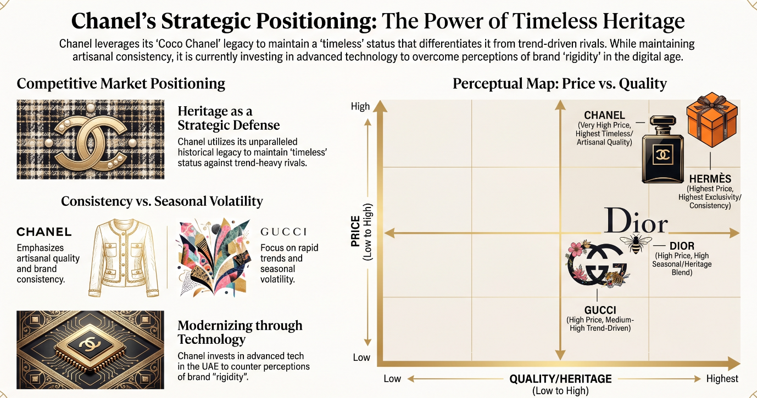
Source: Author’s own illustration developed using information from Chanel (2024), Dior (2024), Gucci (2024), Hermès (2024), and Kapferer (2015).
X-Axis: Quality/Heritage (Low to High)
The horizontal axis illustrates consumers’ evaluation of the craftsmanship, heritage, exclusivity, and enduring value of each luxury brand. Brands located further to the right are regarded as providing enhanced quality, a richer heritage, and increased prestige.
Y-Axis: Price (Low to High)
The vertical axis signifies the perceived pricing strategy of luxury brands. Brands that are positioned higher on this axis are considered more premium and exclusive, indicative of elevated pricing strategies and a strong presence in the luxury market.

Similarities of STP
- Both markets cater to wealthy consumers who prioritize superior quality and exclusivity.
- Chanel upholds a uniform luxury brand identity in both nations.
- In France and the UAE alike, the brand emphasizes high-income clientele and tailored customer experience (Euromonitor, 2024).

Differences of STP
France | UAE
Psychographic segmentation | Behavioural and demographic segmentation
Heritage & craftsmanship influence buying decisions | Status, prestige, and exclusivity influence buying decisions
Aims at the established European elite & aspiring professionals | Aims at the Emirati elite, expatriates, and global travellers
Marketed as the Guardian of Parisian Heritage | Marketed as the Ultimate Symbol of Global Success.

6. Marketing Mix
Define the marketing mix as the “set of tactical marketing tools that the firm blends to produce the response it wants in the target market” (Kotler and Armstrong, 2016).
Diagram of 7ps
7Ps Marketing Mix

Product
▲
│
Price ◄───────────────●──────────────► Promotion
│
▼
Place

People Process Physical Evidence
diagram: The 7Ps Marketing Mix Framework (Adapted from Booms & Bitner, 1981).

6.1 Product Analysis: Width & Depth
6.1.1 Chanel in Home Country
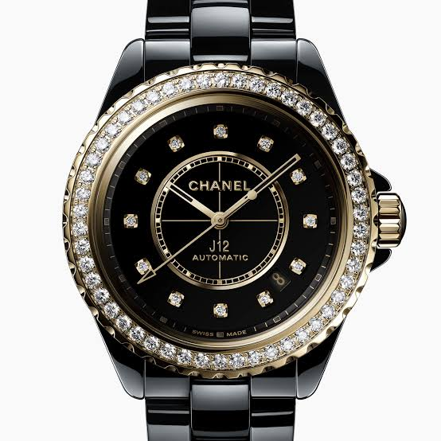
Fig.4 Width: Complete category spectrum (Fine Watches & Jewelry). Source: Chanel/ J12 Diamond Bezel Watch Calibre 12.1, 38MM – Black ceramic | CHANEL
Width: In its domestic market, Chanel upholds a comprehensive range, providing its complete array of luxury categories: Haute Couture, Ready-to-wear, Handbags, Fragrance & Beauty, Fine Jewellery, and watches (Chanel, 2024). This broad spectrum solidifies the brand’s position as a complete lifestyle emblem deeply embedded in French culture (History: Müller, 2022).

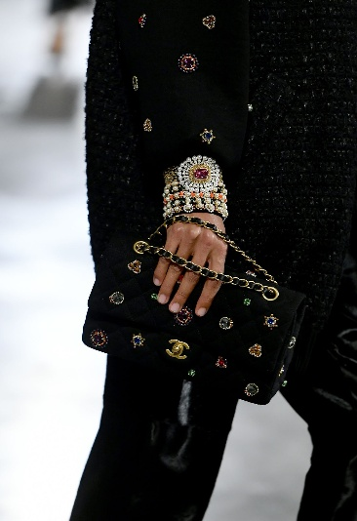
Fig. 5 Depth: Artisanal Métiers d’art embroidery & French savoir-faire. Source: Dominique Charriau/WireImage
Depth: The variations concentrate on the “core” and “tangible” aspects, highlighting artisanal craftsmanship (Métiers d'art) and the “Made in France” designation as a symbol of authenticity (Müller, 2022; AI-Mutawa, 2023).

6.1.2 Chanel in Host Country
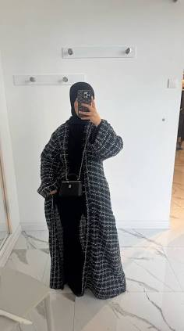
Fig. 6 Width: Regional category adaptation (Modest Fashion Edits). Source: Dressline Arabia / Chanel Abaya with pockets – Dressline Arabia
Width: Carefully selected to feature localized products such as elements of “modest fashion” and an expanded High Jewellery range to cater to regional preferences (Müller, 2022; AI-Mutawa, 2023).

Fig. 7 Depth: Exotic leathers & status-heavy limited editions. Source: Christian Vierig / Getty Images
Depth: Oriented towards high-status and limited-edition offerings, including exotic leathers and enhancements to the “Phygital” service, aimed at delivering greater perceived value for “Achievers” (Müller, 2022; AI-Mutawa, 2023).

6.2 Price
The amount an organisation charges a customer or the sacrifice a customer makes to gain value from consuming the product and enjoying the experience (Viglia & Abrate, 2019).

France
- Inflation & escalating production costs are driving up manufacturing & operational expenses, which in turn affects Chanel’s strategy for premium pricing (Kotler & Keller, 2016).
- High labor expenses & stringent environmental regulations further elevate product prices while ensuring adherence to luxury quality standards (Porter, 1985).
- The brand’s heritage & exclusivity enable Chanel to uphold its premium pricing even amidst economic fluctuations (Kapferer, 2015).

UAE
- High levels of disposable income & a robust demand for luxury items facilitate premium pricing without markedly impacting consumer demand (Kapferer, 2015).
- Import tariffs, logistics expenses, and a value-added tax (5%) affect retail pricing within the UAE market (Kotler & Keller, 2016).
- Luxury goods serve as indicators of status & prestige, diminishing price sensitivity among wealthy consumers, which allows Chanel to uphold its premium pricing strategy (Belch & Belch, 2018).
Price serves as the singular variable that generates revenue, acting as a crucial instrument for defining a firm’s competitiveness and unique position in the marketplace.
Chanel employs a Premium Pricing Strategy, wherein elevated price points are substantiated by superior performance levels and brand reputation, thereby signalling elite status to its target demographic (Viglia & Abrate, 2019; Kapferer, 2015). This strategy must consider the economic conditions of different nations: in its native market of France, the brand contends with high VAT and Euro-zone inflation, while fluctuations in exchange rates affect the purchasing power of international tourists (Kotler & Keller, 2016).
In contrast, the UAE market presents a highly advantageous environment due to the lack of personal income tax, enabling Chanel to sustain its premium positioning, as consumers, driven by status and prestige, face a lower relative economic burden (UAE Ministry of Economy, 2025; Statista, 2024).
Ultimately, this strategy positions Chanel as a significant “quality indicator,” resonating with the high Uncertainty Avoidance and Power Distance scores characteristic of both national cultures (Hofstede Insights, 2024).

6.3 Promotion
6.3.1 Integrated Marketing Communications (IMC)
Belch and Belch (2018) define IMC as a strategic business process used to plan, develop, execute, and evaluate coordinated, measurable, persuasive brand communications programs over time with consumers and other stakeholders.

6.3.2 Media Usage
In France, Chanel employs esteemed traditional media outlets, such as luxury fashion publications like Vogue Paris and cinematic brand films (Luxury Daily, 2023). The promotional strategy emphasizes the artisanal heritage of “Made in France” to resonate with the “Thinkers” segment of the VALS framework (History: Müller, 2022).
In the UAE, Chanel adopts a “mobile-first” approach alongside a high-visibility digital strategy. The brand extensively utilizes social media platforms (including TikTok, Meta, & YouTube), collaborates with influencers, and offers digital concierge services to connect with the tech-savvy “Achievers” segment (AI-Mutawa, 2023; Euromonitor International, 2024).

6.3.3 Promotion Mix Combination
France: The promotional strategy is primarily driven by Public Relations and Branding, emphasizing historical narratives and exclusive events at Rue Cambon to uphold its status as an “Intellectual Luxury” brand (Batat, 2019).
UAE: The promotional mix integrates Digital Marketing with Personal Selling. Chanel employs high-profile Publicity initiatives (such as drone displays or VIP gatherings at The Dubai Mall) alongside personalized digital interactions to cater to the region’s aspirations for status & prestige (Belch & Belch, 2018).

6.3.5 Sales Promotion
Sales Promotion: This is characterized as short-term incentives aimed at expanding purchasing decisions. Although Chanel refrains from mass-market discounts to avoid brand dilution, it implements luxury sales promotions in the UAE, including exclusive gifts-with-purchase and private previews of collections for “Achievers” (AI-Mutawa, 2023).

6.3.6 Digital Promotion
France: Chanel’s Integrated Marketing Communication (IMC) in France merges digital innovation with cinematic narratives that honor its “Made in France” legacy, thereby enhancing the brand’s authenticity and exclusivity (Belch & Belch, 2018). The incorporation of celebrity and influencer endorsements further bolsters consumer confidence through trusted opinion leaders, which aligns with its luxury market niche (Lovelock, 2011; Strydom, 2005).
UAE: Chanel implements a mobile-centric IMC strategy, utilizing platforms such as TikTok and YouTube, along with phygital experiences, to captivate affluent consumers (Belch & Belch, 2018). This strategy, underpinned by celebrity and influencer endorsements, not only boosts brand credibility but also solidifies Chanel’s premium status among Ultra-High-Net-Worth (UHNW) clientele (Lovelock, 2011; Strydom, 2005).

6.4 Distribution Strategy (Place)
Scholarly literature describes distribution (place) as the process of “positioning the goods and services” to persuade the customer by ensuring convenience of search and purchase within a competitive environment (Berman and Evans, 2013; Kotler and Keller, 2016).

6.4.1 Distribution Channel
A distribution channel refers to the network of individuals and organizations, including wholesalers, distributors, and retailers, that links producers to end consumers, ensuring that products are accessible at the appropriate locations and times (Strydom, 2005).
Figure 8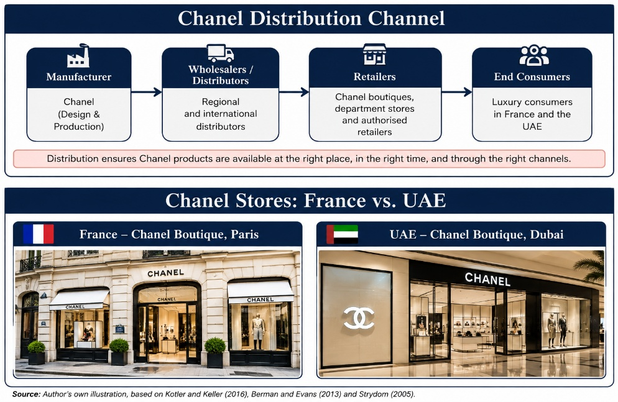
Above image showcase Chanel’s unique distribution strategy & retail presence in France & the UAE. It highlights the way selective distribution contributes to brand prestige, maintains a consistent luxury experience, and enhances Chanel’s positioning in both markets.
6.4.2 Intensive vs. Exclusive Distribution
The choice of distribution strategy is influenced by the intended level of market penetration and the positioning of the brand (Kotler and Keller, 2016).
Exclusive Distribution: This strategy entails selling products through a select number of carefully chosen outlets to uphold brand prestige, exclusivity, and to exert control over the customer experience. It is common practice among luxury brands like Chanel (Kotler & Keller, 2016).

6.5 People: Training & Motivation
6.5.1 Staffing & Operational Footprint
Global Scale: A total of 38,422 worldwide as of December 2024 (Chanel, 2025).
France Footprint: 8,924 Full-Time Equivalent (FTE) staff distributed across 98 subsidiaries, facilitating broad domestic retail & artisanal production network (Chanel, 2025).
UAE Footprint: 433 FTE employees functioning as a streamlined, specialized unit designed to meet the expectations of the regional luxury market (Chanel, 2025).
Strategic Takeaway: The staffing frameworks in both markets ensure that frontline personnel adeptly convey Chanel’s high-heritage positioning across diverse cultural landscapes (De Mooij & Hofstede, 2010; Batat, 2019).
6.5.2 France
- Training Focus: Concentrates on the themes of “High Heritage & Craftsmanship” and the narrative of “Made in France” artisanal production (Müller, 2022). Employees are trained to act as “cultural ambassadors” who are adept in historical narratives and the technical specifics of Métiers d’art, appealing to the “Thinkers” segment of VALS (Ballantyne & Nilsson, 2017).
- Motivation Drivers: Grounded in the honor of representing a national symbol. Considering France’s lower Masculinity score (43 on Hofstede’s index), intrinsic motivation is derived from the aesthetics of work-life balance and the embodiment of timeless Parisian sophistication (Hofstede, 2011).
6.5.3 UAE
- Training Focus: Prioritizes “phygital” engagement and prominent digital concierge services (Chevailer, 2024). Staff are trained to cater to high-resource “Achievers” through personalized, technology-driven interactions that enable immediate status acknowledgement and social signalling (Batat, 2019).
- Motivation Drivers: Fuelled by competitive prestige and expertise in high-visibility sales (as indicated by a higher Hofstede Masculinity score of 50) (Hofstede, 2011; Randeree, 2020). Employees are motivated by the provision of high-status service within a dynamic, cosmopolitan environment (AI-Mutawa, 2023).

6.6 Process
6.6.1 Service Delivery & Workflow
- France: The service delivery model emphasizes traditional, high-touch interactions that are deeply rooted in artisanal expertise and historical significance (Batat, 2019). The operational process focuses on immersive, face-to-face consultations at renowned flagship locations (such as Rue Cambon) to strengthen the narrative of “Made in France” & deliver high sensory value(Müller,2022). .
- UAE: This market adopts a contemporary, mobile-first service approach designed for high-achieving individuals (Chevalier, 2024). It integrates AI-driven appointment scheduling & digital concierge services, creating a specialized phygital workflow that prioritizes speed, convenience, and immediate recognition of status (Harris & Goode, 2010; Batat, 2019).

6.6.2 Grievance Handling & Complaint Management
Global Framework: The governance structure is supported by Chanel’s global Grievance Mechanism & Ethics Helpline, which is accessible in over 20 languages (Chanel, 2025). This system allows for anonymous reporting of misconduct by clients and third parties, thereby enhancing brand trust (Chkanikova & Mont, 2015).

France Execution: This is overseen through established compliance protocols, formal risk assessments, and a centralized Compliance Committee, ensuring alignment with European regulatory standards to maintain the long-term “Relation de Confiance” (Chkanikova & Mont, 2015).
UAE Execution: This is handled through swift, relationship-focused interventions (Randeree, 2020). Boutique managers employ immediate and highly personalized resolution strategies to address negative social signalling and protect the client’s public image and reputation (De Mooij & Hofstede, 2010; AI-Mutawa, 2023).

6.7 Physical Evidence
6.7.1 France

Fig. 9 France E-Servicescape: Heritage-driven editorial interface. Source: Dribble
Design Philosophy: Functions as a digital extension of the historic Rue Cambon flagship (Batat, 2019). The user interface is characterized by monochrome, editorial layouts, archival brand films, and comprehensive documentation of Métiers d’art craftsmanship.
Target Alignment: Specifically designed for the “Thinkers” VALS segment and the local consumer demographics, this approach emphasizes artistic heritage, intellectual luxury, and the genuine “Made in France” narrative, rather than focusing on immediate transactional incentives (De Mooij & Hofstede, 2010; Ballantyne & Nilson, 2017).
6.7.2 UAE
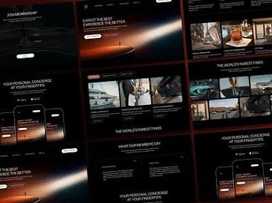
Fig.10 UAE E-Servicescape: Mobile-first concierge & digital scheduling UI. Source: Dribble
Design Philosophy: Engineered as a rapid “mobile-first” digital concierge platform (Chevalier, 2024). The interface seamlessly incorporates direct WhatsApp/digital clienteling links, AI-enhanced private boutique appointment scheduling, and real-time local stock reservations systems throughout the Dubai & Abu Dhabi hubs.
Target Alignment: Designed for affluent “Achievers,” enabling instant status acknowledgement, effortless service provisions, and personal consultation access to fulfil regional luxury standards (Hofstede, 2011; Randeree, 2020).

6.7.3 Tangible Evidence: Packaging & Aesthetics
France: The focus of packaging innovation is on circularity & adherence to environmental regulations, ensuring alignment with EU directives & the values of eco-conscious affluent consumers (Chkanikova & Mont, 2015). Notable initiatives include reducing the plastic content in Hydra Beauty Micro Serum by half, which results in a 50% decrease in greenhouse gas emissions, and achieving a 95% recyclability rate for CHANCE EAU SPLENDIDE packaging (Joy et al., 2012).
UAE: In the UAE, packaging is primarily viewed as a prominent symbol of social prestige and status (Amatulli et al., 2018). It features elaborate, limited-edition designs & unboxing experiences that offer tangible indicators of high status, thereby justifying the considerable price premium associated with luxury consumption in the region (Bitner, 1992; Randeree, 2020).

6.8 Similarities & Differences of 7Ps
Marketing Mix Element | Similarities (France & UAE) | Differences (France vs. UAE)
Product | Both markets offer Haute Couture, Fragrance, and Fine Jewellery with a consistent focus on “High Heritage & Craftsmanship” (Müller, 2022). | France emphasizes the genuine “Made in France” artisanal label along with the complete range of Métiers d’art.  UAE showcases carefully selected regional collections, which encompass modest fashion options & prominently displayed jewellery.
Price | Utilize Premium Pricing Strategies by establishing elevated price points that serve as essential indicators of quality & signals of exclusivity (Kapferer, 2015). | France: Manages typical Euro-zone inflation alongside a significant regional Value-Added Tax (VAT).  UAE: Enjoys the advantages of a low 9% corporate tax rate and a 0% personal income tax, thereby enhancing consumer discretionary spending capacity (UAE Ministry of Economy, 2025; Statista, 2024).
Distribution (Place) | Sustain exclusive distribution via company-operated boutiques located in key urban luxury centres (Chevalier, 2024). | France: Emphasizes its historical & iconic heritage locations (e.g., Rue Cambon, Paris).  UAE: Focuses its retail presence in ultra-modern, high-traffic luxury shopping centers (e.g., The Dubai Mall, Abu Dhabi).
Promotion | Utilize IMC alongside targeted brand ambassador seeding to foster a sense of prestige (Belch & Belch, 2018). | France: Prioritizes the preservation of cinematic heritage through storytelling, supports cultural initiatives, & emphasizes prestigious print media.  UAE: Implements powerful digital marketing campaigns, collaborates with local influencers, and adopts a mobile-centric strategy on TikTok.
People | Employees serve as primary “brand ambassadors” who are educated to influence customer perceptions and ensure the quality-of-service delivery (Wilson et al., 2017) (Chanel, 2025; Hofstede Insights, 2024). | France: 8,924 FTEs focusing on artisanal storytelling aimed at “Thinkers” (Hofstede Femininity: 43) (Chanel, 2025; Hofstede Insights, 2024).  UAE: 433 FTEs dedicated to high touch “phygital” concierge services for “Achievers” (Hofstede Masculinity: 50) (Chanel, 2025; Hofstede Insights, 2024).
Process | Both comply with Chanel’s worldwide Grievance Mechanism & Ethics Helpline to safeguard brand integrity & maintain operational standards. | France: Conventional, personalized boutique processes & structured compliance protocols (Relation de Confiance).  UAE: AI-enhanced “phygital” scheduling systems & swift, manager-driven complaint resolution to protect client standing (Randeree, 2020).
Physical Evidence | Depend on opulent packaging, architectural design, & digital mediums as “concrete indicators” of authenticity (Bitner et al., 2010) (Bitner, 1992). | France: Focuses on the innovation of sustainable materials & the reduction of eco-friendly packaging.  UAE: Showcases elaborate, limited-edition packaging along with luxurious store designs that are tailored for instant social signalling.

7.0 Marekt Entry Strategy: UAE (Host Country)
7.1 Choice of Entry Method: Wholly Owned Subsidiary (FZE)
- Strategic Direct Ownership: Chanel opted for direct entry through a Free Zone Establishment (FZE) to maintain complete control over its brand equity and luxury “servicescape.’
- Regulatory & Tax Efficiency: Utilizing the UAE Free Zone framework allows for 100% foreign ownership & significant tax exemptions, thereby protecting Chanel’s esteemed brand equity (WIPO, 2023; UAE Government, 2024).
- Control of Service Execution: This approach circumvents the typical trade-offs associated with joint ventures or franchising, ensuring direct corporates supervision of essential “People” and “Process” components to uphold global brand exclusivity.

7.2 Advantages of Direct Entry
Strategic Control: Provides comprehensive oversight across various touchpoints, ensuring consistent global premium pricing and brand positioning (Hollensen, 2020).
Profit Retention: Secures the entirety of retail margins from high-resource “Achievers” without the loss of revenue-sharing to local intermediaries.
Direct Market Intelligence: Enables the collection of first-party consumer data in the Emirati market, allowing for the continuous refinement of regional “phygital” workflows.
7.3 Disadvantages of Direct Entry
High Capital Exposure: Necessitates a significant capital investment for the acquisition of primary real estate in luxury locations such as The Dubai Mall.
Operational Complexity: Involves navigating UAE labor regulations & integrating the 9% corporate tax framework within local operational systems.
Resource Intensiveness: Requires substantial ongoing expenditure for specialized human resources (433 FTEs) to maintain Level 7 service standards.

8.0 Ethical & Unethical Marketing Practices
8.1 Ethical Market
- Traceability & Supply Chain Security: Chanel employs the Transparency One platform to map 2,500 suppliers in the Fragrance & Beauty sector across 61 nations, enabling the tracing of 22,000 raw materials. This level of operational transparency acts as a visual representation of product safety, thereby reinforcing artisanal expertise and ethical production standards throughout global supply chains (Gold et al., 2015; Stevenson & Cole, 2018).
- Sustainable Packaging Innovation: In accordance with the directives of the EU Green Deal, Chanel has reengineered the packaging of its Hydra Beauty Micro Sérum, resulting in a 50% reduction in plastic usage and a corresponding 50% decrease in greenhouse gas (GHG) emissions. Furthermore, the packaging for CHANCE EAU SPLENDIDE has achieved a remarkable 95% recyclability rate, ensuring that the brand’s “Physical Evidence” conveys enduring eco-centric value that extends beyond mere immediate consumption (Bitner et al., 2010; Chkanikova & Mont, 2015).
8.2 Unethical Market
- Labor Exploitation & Subcontracting Vulnerabilities: In 2026, regulatory inspections of luxury supply chains revealed illegal subcontracting & labor exploitation, despite the presence of established internal codes of conduct. These legal issues highlight the risks posed by unmonitored Tier-2 & Tier-3 subcontractors, which threaten the brand’s “Physical Evidence” of prestige and equity (Tokatli, 2013; Crane, 2013).
- Modern Slavery & Tier Oversight Deficits: The management of over 20,000 global suppliers introduces systemic risks related to modern slavery (Kara, 2017). In response to the challenges of forced labor & excessive overtime violations, Chanel has instituted mandatory remediation programs for Tier-2 packaging suppliers, emphasizing that compliance across multiple tiers continues to be a significant operational vulnerability within luxury governance (Voss et al., 2019).
9.0 Strategic Recommendations: STP Evolution
9.1 France: “Eco-Heritage” Strategy
Target Market— “Eco-Ethical Affluents”: Shift focus on younger psychographic sub-segments (Millennial & Gen Z “Thinkers” & “Experiencers”) who expect luxury heritage to be explicitly aligned with environmental stewardship & ethical responsibility (Joy et al., 2012; Amatulli et al., 2018).
Positioning— “Pioneer of Sustainable Savoir-Faire”: Establish Chanel as a leader in sustainable luxury, merging traditional French craftsmanship with contemporary circular practices (e.g., achieving a 50% reduction in GHG emissions through eco-designed packaging) (Gazzola et al., 2020).
Strategic Rationale: Transforms brand perception from “intellectual luxury” to “purposeful luxury,” meeting rigorous EU Green Deal standards while appealing to affluent consumers who perceive environmental harm as contrary to genuine prestige (Chkanikova & Mont, 2015).

9.2 UAE: “Culture-Tech” Strategy
Target Market— “Digital Traditionalists”: Narrow the focus from the broad category of “Achievers” to affluent Emirati consumers who are digitally savvy, specifically targeting Gen Z & Millennials. These consumers value high-end “Modest Fashion” while adhering to local cultural & religious principles (Kamarulzaman & Shaari, 2023).
Positioning— “Architect of Phygital Modest Luxury”: Establish Chanel as a leader in culturally customized, technology-enhanced luxury offerings, merging local aesthetics with AI-driven digital concierge services (Batat, 2019; Chevalier, 2024).
Strategic Rationale: This approach leverages the high mobile penetration in the region and the elevated expectations of status. It aims to transform boutiques into community-focused centers that blend local cultural heritage with a premium “virtual servicescape” (Bitner, 1992; Randeree, 2020).

Section 2: Gibbs’ Reflective Account of the Research Process
The research process was assessed through the lens of Gibbs (1988) Reflective Cycle framework, enabling a critical examination of the cognitive, analytical, and practical skills acquired during this Level 7 assessment.
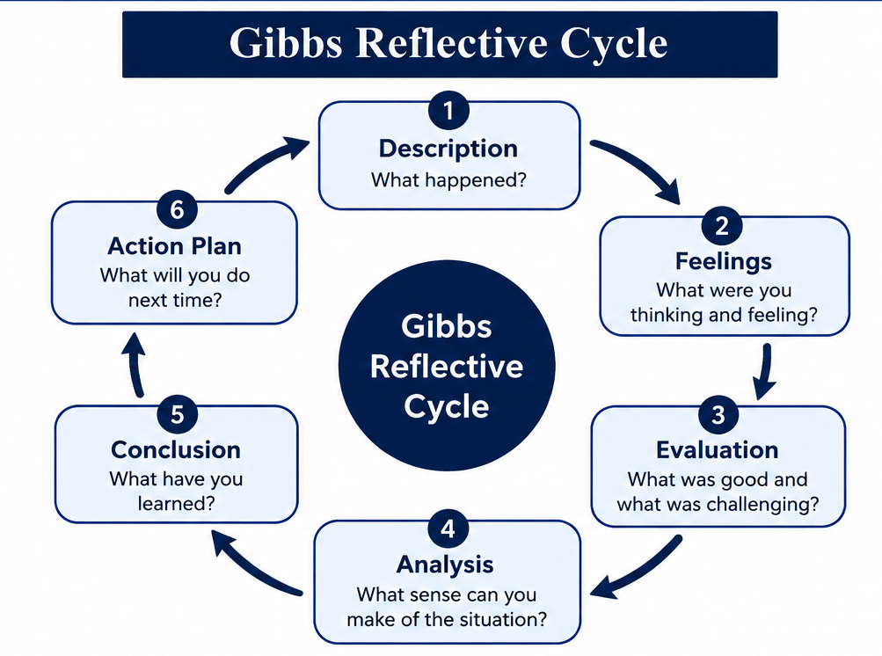
Source: Gibbs, G. (1988) Learning by Doing: A Guide to Reflective Practice.
2.1 Description: The Research Task
Scope & Methodologies: A comparative strategic evaluation of Chanel was conducted, focusing on its domestic market (France) & its international market (UAE).
Framework Application: Macro-environmental frameworks (PESTEL) & cultural typology models (Hofstede, 2011) were synthesized to assess the market environments, in conjunction with the STP model (Kotler & Keller, 2016) & the 7Ps service marketing mix (Booms & Bitner, 1981; Rafiq & Ahmed, 1995).
Governance & Ethics: A critical analysis of market entry strategies (FZE direct ownership) was performed, alongside an examination of supply chain ethics & legal challenges, which include allegations regarding subcontractor labor (Crane, 2013; Tokatli, 2013).

2.2 Emotions: Prior to & Following the Research
Initial Apprehension: Faced concerns regarding the Level 7 expectations for profound critical analysis, prioritizing synthesis over mere description, and acquiring detailed primary corporate date (e.g., FTE distribution, compliance with fiscal tax regulations).
Post-Research Confidence: Developed assurance in assessing & rationalizing international strategic decisions. Transitioned from a product-centric perspective to a service-oriented framework (Vargo & Lusch, 2004, 2008), perceiving Chanel as a “high-heritage” service ecosystem instead of solely a physical product vendor.

2.3 Assessment: Strengths & Weakness
Key Strengths: Effectively integrated peer-reviewed academic theories with corporate financial data (Chanel 2024/2025 financial outcomes). Utilized cultural & operational models such as the French “Relation de Confiance” framework to anchor corporate ethics in scholarly literature (Bitner et al., 2010).
Identified Weakness: Faced limitations due to word-count restrictions while striving to maintain depth across seven marketing variables. Required several rounds of editing to distill intricate comparative theoretical arguments into succinct, impactful segments (Moon, 2004).

2.4 Analysis: Insights from Strategic Models
Hofstede’s Cultural Dimensions: The established cultural dimensions influence luxury consumption patterns (Hofstede, 2011). The elevated Power Distance in the UAE supports status-oriented digital concierge services for “Achievers,” while the significant Uncertainty Avoidance in France necessitates heritage assertions & artisanal assurance (De Mooij & Hofstede, 2010).
STP Evolution: Acknowledged positioning as an evolving process. The proposal of “Eco-Heritage” in France & “Cultur-Tech” in the UAE illustrated that luxury brands must perpetually adapt their brand identity to maintain relevance with contemporary generational equity (Amatulli et al., 2018; Batat, 2019).
Extended 7Ps Framework: Confirmed that in the realm of high-end service delivery, the physical environment & staff behaviours serve as essential “tangible clues” that affirm brand quality (Booms & Bitner, 1981; Wilson et al., 2017).

2.5 Conclusion: Skills Acquired
Critical Synthesis: Progressed from mere descriptive account-taking to sophisticated strategic justification—addressing the rationale behind corporate decisions & their operational costs (Schön,1983).
Ethical Literacy: Cultivated a refined comprehension of the need to balance profit-driven international expansion with corporate social responsibility (CSR) & oversight of multi-tier supply chains (Gold et al., 2015; Voss et al., 2019).

2.6 Action Plan: Future Implementation
Time & Word Count Management: Plan to employ staged drafting & organized debriefs (Gibbs, 1988) in upcoming evaluations to prevent exceeding word limits & to allocate specific space for in-depth qualitative research.
Quantitative Data Analytics: Enhance capabilities in deriving quantitative metrics from financial corporate reports (e.g., OECD Pillar Two tax implications). Continue to leverage data parsing tools to anchor qualitative strategies in empirical financial data (Saunders et al., 2019).

3.0 Final Summary
This comparative analysis examines Chanel’s international marketing strategy in both its home market of France & its host market in the UAE. By employing macro-environmental (PESTEL) & cultural (Hofstede) frameworks, the research illustrates how the market environment significantly influences positioning and marketing execution. In France, Chanel functions within a mature, heritage-oriented market characterized by high uncertainty avoidance (86) & individualistic values (71), necessitating an “Eco-Heritage” approach that highlights artisanal craftsmanship, transparency in the supply chain, and compliance with EU sustainability regulations. In contrast, the UAE’s high-power distance (90) & collectivist tendencies (25) promote status-driven luxury consumption, which calls for a “Culture-Tech” strategy that emphasizes exclusive high-jewellery offerings, regionally modest fashion selections, and AI-enhanced digital concierge services facilitated through direct Free Zone Establishment (FZE) operations.
Despite its leading position in the market, Chanel encounters significant operational challenges in supply chain governance, particularly concerning oversight of multi-tier subcontractors & risks associated with modern slavery. To maintain its global market leadership, Chanel must effectively balance its core brand identity with the need for localized operational flexibility—aligning its European operations with stringent circular economy standards while enhancing its high-touch digital ecosystem throughout the Middle East.

4.0 References List
- Aaker, D.A. (1996) Building Strong Brands. New York: Free Press.
- Al-Mutawa, F.S. (2023) 'Consumer behavior and luxury consumption in the Gulf region: A socio-cultural perspective', Journal of Islamic Marketing, 14(4), pp. 982–1001.
- Amatulli, C., De Angelis, M., Costabile, M. and Guido, G. (2018) 'Sustainable luxury consumption: An introduction', Journal of Cleaner Production, 172, pp. 2480–2486.
- Ballantyne, R. and Nilsson, E. (2017) 'All natural? Customer value creation in luxury servicescapes', Journal of Services Marketing, 31(4/5), pp. 413–422.
- Batat, W. (2019) The Experiential Marketing Matrix: How to Experience the Brand in the Digital Age. London: Routledge.
- Belch, G.E. and Belch, M.A. (2018) Advertising and Promotion: An Integrated Marketing Communications Perspective. 11th edn. New York: McGraw-Hill Education.
- Berman, B. and Evans, J.R. (2013) Retail Management: A Strategic Approach. 12th edn. Upper Saddle River, NJ: Pearson.
- Bitner, M.J. (1992) 'Servicescapes: The impact of physical surroundings on customers and employees', Journal of Marketing, 56(2), pp. 57–71.
- Bitner, M.J., Ostrom, A.L. and Morgan, F.N. (2010) 'Service blueprinting: A practical technique for service innovation', California Management Review, 50(3), pp. 66–94.
- Booms, B.H. and Bitner, M.J. (1981) 'Marketing strategies and organization structures for service firms', in Donnelly, J.H. and George, W.R. (eds.) Marketing of Services. Chicago: American Marketing Association, pp. 47–51.
- Chanel (2023) Chanel Mission 1.5°: Climate Action Plan and Sustainability Report. Paris: Chanel Limited.
- Chanel (2024) Chanel Corporate Heritage and Brand Profile. Paris: Chanel Limited. Available at: https://www.chanel.com (Accessed: 15 July 2026).
- Chanel Limited (2025) Financial Results for the Year Ended 31 December 2024. London: Chanel Limited.
- Chevalier, M. (2024) Luxury Retail Management: How the World's Top Brands Provide Quality Experience to Their Customers. 3rd edn. Singapore: John Wiley & Sons.
- Chkanikova, O. and Mont, O. (2015) 'Corporate supply chain responsibility: Drivers and barriers for sustainable food retailing', Journal of Cleaner Production, 107, pp. 666–682.
- Crane, A. (2013) 'Modern slavery as a management practice: Exploring the conditions for the strategy of contracting illegal labor', Academy of Management Review, 38(1), pp. 49–69.
- De Mooij, M. and Hofstede, G. (2010) 'The Hofstede model: Applications to global branding and advertising strategy and research', International Journal of Advertising, 29(1), pp. 85–110.
- Deloitte (2024) Global Powers of Luxury Goods 2024: Conscious Luxury in Emerging Markets. London: Deloitte Touche Tohmatsu Limited.
- Dior (2024) The House of Dior: Heritage and Financial Overview. Paris: Christian Dior SE.
- Euromonitor International (2024) Luxury Goods in the United Arab Emirates and France: Market Research Report. London: Euromonitor.
- European Commission (2023) The European Green Deal and Supply Chain Due Diligence Regulations. Brussels: European Commission.
- Gazzola, P., Pavione, E., Pezzetti, R. and Grechi, D. (2020) 'Trends in the luxury sector: The impact of sustainability on customer behavior', Sustainability, 12(7), p. 2872.
- Gibbs, G. (1988) Learning by Doing: A Guide to Reflective Practice. Further Education Unit. Oxford: Oxford Polytechnic.
- Gold, S., Hahn, R. and Seuring, S. (2015) 'Sustainable supply chain management in multi-tier supply chains: Managing passes down the chain', Supply Chain Management: An International Journal, 20(5), pp. 543–560.
- Gucci (2024) Kering Group Annual Report: Gucci Brand Positioning. Paris: Kering.
- Harris, L.C. and Goode, M.M. (2010) 'Online servicescapes: Trust and behavioral intentions', Journal of Retailing, 86(3), pp. 230–243.
- Hermès (2024) Hermès International Financial Results and Corporate Strategy. Paris: Hermès.
- Hofstede, G. (2011) 'Dimensionalizing cultures: The Hofstede model in context', Online Readings in Psychology and Culture, 2(1), pp. 1–26.
- Hofstede Insights (2024) Country Comparison Tool: France and the United Arab Emirates. Available at: https://www.hofstede-insights.com/country-comparison/france,the-united-arab-emirates/ (Accessed: 22 July 2026).
- Hollensen, S. (2020) Global Marketing. 8th edn. Harlow: Pearson Education.
- International Monetary Fund (2025) World Economic Outlook Database: Economic Indicators for France and the UAE. Washington, D.C.: IMF.
- Johnson, G., Scholes, K. and Whittington, R. (2017) Exploring Strategy: Text and Cases. 11th edn. Harlow: Pearson Education.
- Joy, A., Sherry, J.F., Venkatesh, A., Wang, J. and Chan, R. (2012) 'Fast fashion, sustainability, and the ethical appeal of luxury brands', Fashion Theory, 16(3), pp. 273–296.
- Kamarulzaman, Y. and Shaari, H. (2023) 'Modest fashion and luxury consumption in the Middle East', Journal of Fashion Marketing and Management, 27(2), pp. 310–328.
- Kapferer, J.N. (2015) The Luxury Strategy: Break the Rules of Marketing to Build Luxury Brands. 2nd edn. London: Kogan Page.
- Kara, S. (2017) Modern Slavery: A Global Perspective. New York: Columbia University Press.
- Kirkman, B.L., Lowe, K.B. and Gibson, C.B. (2006) 'A quarter century of Culture's Consequences: A review of empirical research incorporating Hofstede's cultural values framework', Journal of International Business Studies, 37(3), pp. 285–320.
- Kotler, P. and Armstrong, G. (2016) Principles of Marketing. 16th edn. Boston: Pearson.
- Kotler, P. and Armstrong, G. (2020) Principles of Marketing. 18th edn. Harlow: Pearson Education.
- Kotler, P. and Keller, K.L. (2016) Marketing Management. 15th edn. Boston: Pearson.
- Kotler, P. and Keller, K.L. (2022) Marketing Management. 16th edn. Harlow: Pearson Education.
- Lovelock, C. and Wirtz, J. (2016) Services Marketing: People, Technology, Strategy. 8th edn. Boston: World Scientific Publishing.
- Lovelock, C.H. (2011) Services Marketing: Integrated Communications. Harlow: Pearson.
- Luxury Daily (2023) 'Digital transformations in Parisian luxury retail: Adapting to European regulations', Luxury Daily Insights, 18 October.
- McSweeney, B. (2002) 'Hofstede’s model of national cultural differences and their consequences: A triumph of faith - a failure of analysis', Human Relations, 55(1), pp. 89–118.
- Moon, J.A. (2004) A Handbook of Reflective and Experiential Learning: Theory and Practice. London: RoutledgeFalmer.
- Müller, C. (2022) Heritage and Innovation in European Luxury Houses. Munich: Oldenbourg Verlag.
- Oxford Economics (2023) Economic Impact Assessment: Civil Restraint and Retail Inflows in France. Oxford: Oxford Economics.
- Porter, M.E. (1985) Competitive Advantage: Creating and Sustaining Superior Performance. New York: Free Press.
- Rafiq, M. and Ahmed, P.K. (1995) 'Using the 7Ps as a generic marketing mix: An exploratory study of UK and European marketing academics', Marketing Intelligence & Planning, 13(9), pp. 4–15.
- Randeree, K. (2020) 'Leadership and institutional governance in the UAE luxury sector', International Journal of Organizational Analysis, 28(5), pp. 1045–1061.
- Saunders, M., Lewis, P. and Thornhill, A. (2019) Research Methods for Business Students. 8th edn. Harlow: Pearson Education.
- Schön, D.A. (1983) The Reflective Practitioner: How Professionals Think in Action. New York: Basic Books.
- Signorini, P., Wiesemes, R. and Murphy, R. (2009) 'The misapplication of Hofstede's grid in international education', Teaching in Higher Education, 14(3), pp. 253–254.
- Solomon, M.R., White, K. and Dahl, D.W. (2023) Consumer Behavior: Buying, Having, and Being. 13th edn. Harlow: Pearson Education.
- Statista (2024) Luxury Fashion Market Report: France vs. United Arab Emirates. Hamburg: Statista Research.
- Stevenson, M. and Cole, R. (2018) 'Modern slavery in supply chains: A secondary data analysis of luxury industry disclosures', Supply Chain Management: An International Journal, 23(3), pp. 81–99.
- Strydom, J. (2005) Introduction to Marketing. 3rd edn. Cape Town: Juta and Company Ltd.
- Tokatli, N. (2013) 'Toward a better understanding of the packaging of luxury value chains', Journal of Economic Geography, 13(6), pp. 993–1011.
- UAE Government (2024) We the UAE 2031 Vision: National Agenda for Economic Acceleration. Abu Dhabi: UAE Government Portal.
- UAE Ministry of Economy (2025) Annual Economic Report: Retail Growth and Free Zone FDI Performance. Abu Dhabi: Ministry of Economy.
- Vargo, S.L. and Lusch, R.F. (2004) 'Evolving to a new dominant logic for marketing', Journal of Marketing, 68(1), pp. 1–17.
- Vargo, S.L. and Lusch, R.F. (2008) 'Service-dominant logic: Continuing the evolution', Journal of the Academy of Marketing Science, 36(1), pp. 1–10.
- Venaik, S. and Brewer, P. (2013) 'Critical issues in the Hofstede and GLOBE national culture models', International Marketing Review, 30(5), pp. 469–482.
- Viglia, G. and Abrate, G. (2019) Pricing and Revenue Management in Luxury Services. London: Palgrave Macmillan.
- Voss, M.D., Closs, D.J., Jacobs, M.A. and Lorenc, C. (2019) 'Supply chain integrity and multi-tier supplier audit compliance', Journal of Business Logistics, 40(2), pp. 120–139.
- Wilson, A., Zeithaml, V.A., Bitner, M.J. and Gremler, D.D. (2017) Services Marketing: Integrating Customer Focus Across the Firm. 3rd European edn. Berkshire: McGraw-Hill Education.
- World Intellectual Property Organization (WIPO) (2023) IP Protection and Brand Defense in the Middle East and North Africa. Geneva: WIPO.

