Technical Ring Challenge:

You will produce 3 final rings in this technical challenge:

- In glass
- In recycled smile plastic (cnc)
- 3d printed (using CAD/VR)

You will need to design a glass layered ring based on a simple given template. You will uv bond 2/3 layers of glass, you might want to add print into the layer, this is up to you. You can also keep it really pure. We want monochrome rings, pure blocks of wearable ice, black and white detail can be added, zero colour.

We will exhibit these as a family of glass rings, fusing several disciplines together, the beauty of jewellery and glass and what is possible from one simple form, executed with beautiful finish. In addition this year we have enhanced the challenge to include digital making. You will be using the same illustrator file to cut plastic on CNC machines but we can add textures. 3D print skills extending from Design and Make 4 will allow you to create a more 3d ring in CAD and print it (with a view to possibly casting into metal in the future with an external casting company – for assessment only the 3d print is needed)

You will need to consider end form, facets, polishes edges, frosted, sandblasted etc This will test your ability to finish work to a high professional standard. Strive for perfection.
You might end up with several test rings, and one final ring in glass, one in plastic and one in 3d print.

You will gain skills in :
Illustrator (build on last terms laser cutting knowledge)
Waterjet cutting
CNC recycled plastic
Bonding glass
Polishing glass
Sandblasting
Possible screen print glass
CAD
3D printing (nb we won’t be plating into metal but you can send it off)
Virtual reality drawing intro (to link back to CAD / 3d print)
Digital documentation / photography

This module is designed to work hand in hand with design and make 4, and you might well want to push the idea of digital and handmade jewellery beyond the 3 rings into DM4.

Inspiration in glass:

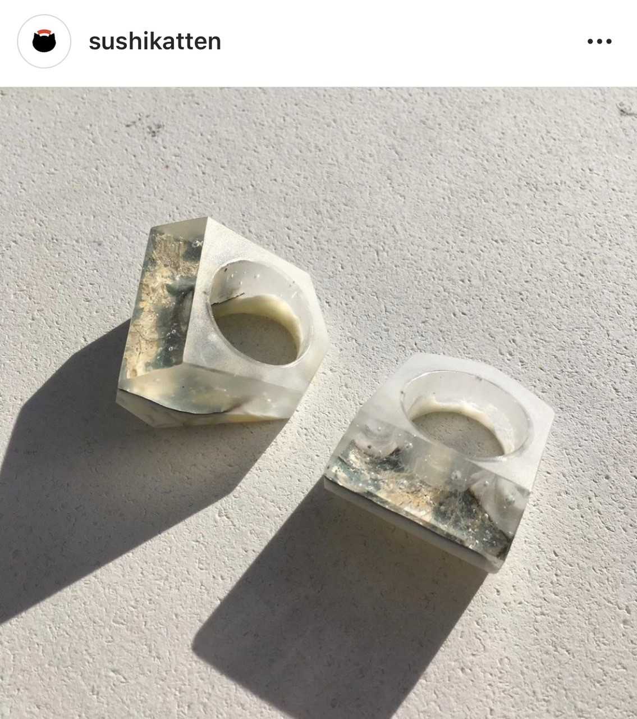
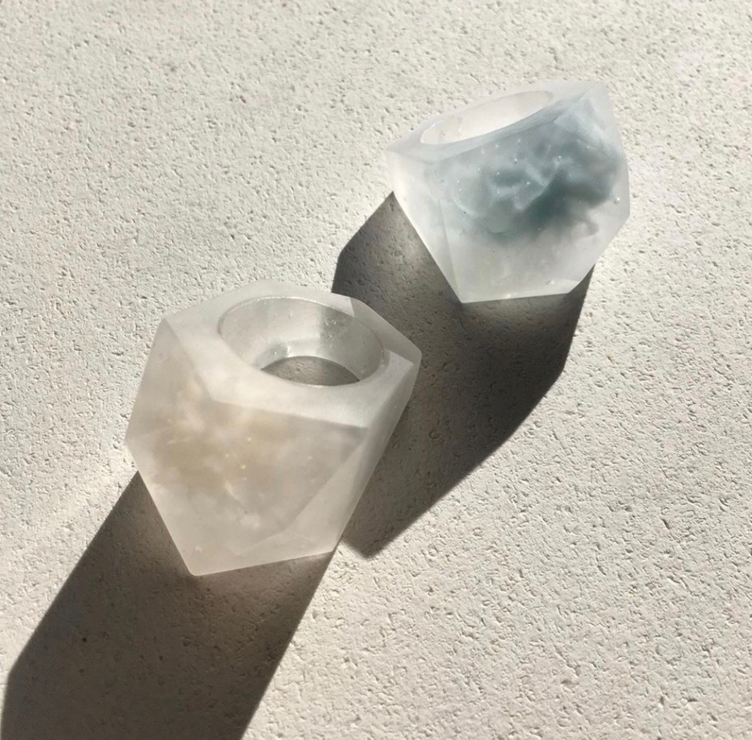

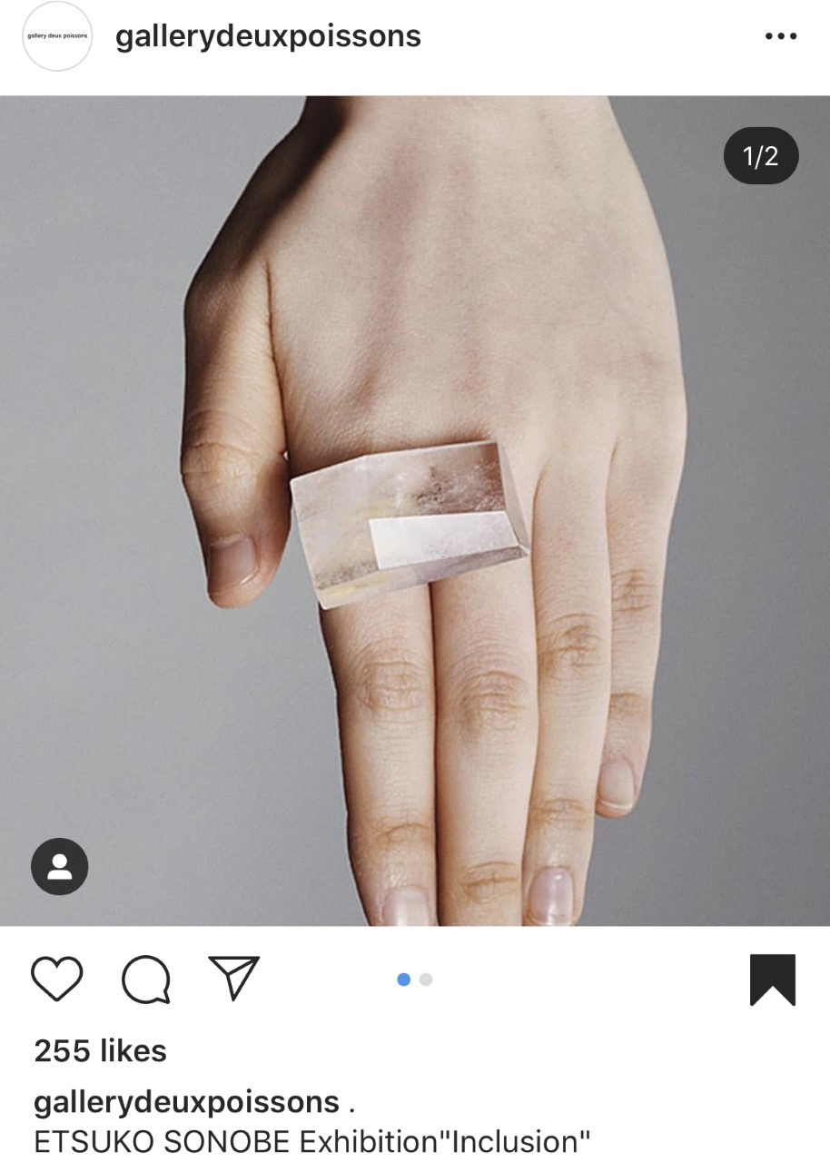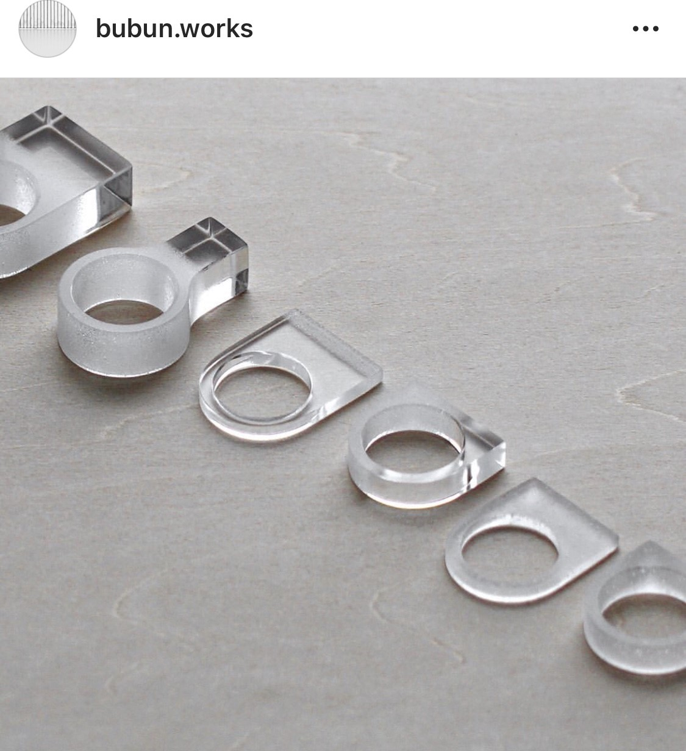
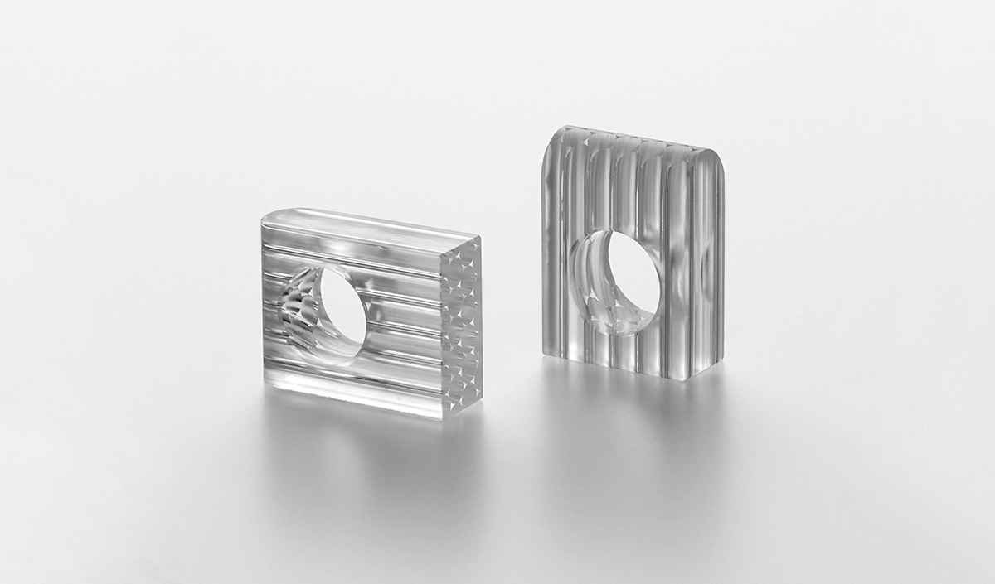
3d printed rings….


