Apollodorus Bibl. 3.4.8

Autonoe and Aristaeus had a son Actaeon, who was bred by Chiron to be a hunter and then afterwards was devoured on Cithaeron by his own dogs. He perished in that way, according to Acusilaus, because Zeus was angry at him for wooing Semele; but according to the more general opinion, it was because he saw Artemis bathing. And they say that the goddess at once transformed him into a deer, and drove mad the fifty dogs in his pack, which devoured him unwittingly. Actaeon being gone, the dogs sought their master howling lamentably, and in the search they came to the cave of Chiron, who fashioned an image of Actaeon, which soothed their grief.

Pausanias 9.2.3
"On the road from Megara [cross Mt Kithairon to Plataia in Boiotia] there is a spring on the right, and a little farther on a rock. It is called the bed of Aktaion, for it is said that he slept thereon when weary with hunting, and that into this spring he looked while Artemis was bathing in it. Stesikhoros of Himera says that the goddess cast a deer-skin round Aktaion to make sure that his hounds would kill him, so as to prevent his taking Semele to wife. My own view is that without divine interference the hounds of Aktaion were smitten with madness, and so they were sure to tear to pieces without distinction everybody they chanced to meet."

Diodorus Siculus, Library of History 4. 81. 3 - 5:
"Aktaion, who, as the myths relate, was torn to pieces by his own dogs. The reason for this bad turn of fortune of his, as some explain it, was that, presuming upon his dedication to Artemis of the first-fruits of his hunting, he purposed to consummate the marriage with Artemis at the temple of the goddess, but according to others, it was because he represented himself as superior to Artemis in skill as a hunter.
But it is not incredible that it was for both these reasons that the goddess became angry; for whether Aktaion made an improper use of the spoils of his hunting to satisfy his own desire upon her who has no part in marriage, or whether he was so bold as to assert that as a hunter he was to be preferred above her before whom even gods withdraw from rivalry in the chase, all would agree that the goddess was justified in having become indignant at him. And, speaking generally, we may well believe that, when he had been changed into the form of one of the animals which he was wont to hunt, he was slain by the gods which were accustomed to prey upon the other wild beasts."
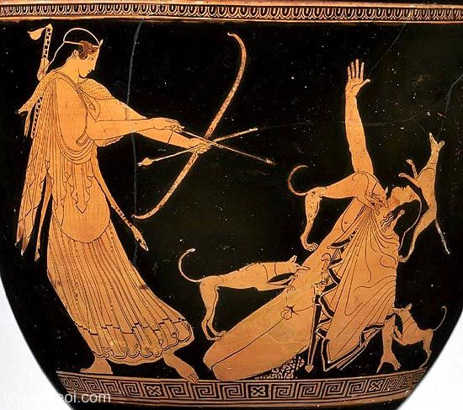
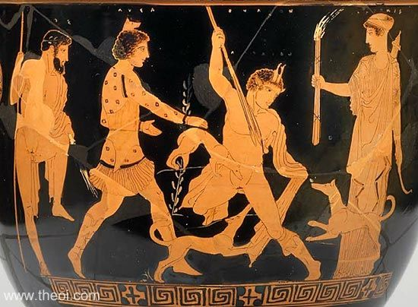
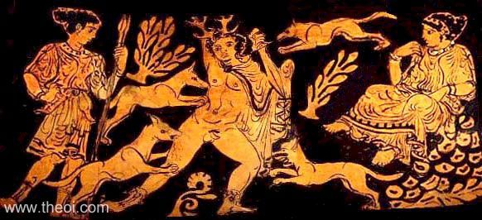

Arachne in a mountain town Hypaepae by skill had grown so famous in the Land of Lydia, that unnumbered curious nymphs eager to witness her dexterity, deserted the lush vineyards of Tmolus; or even left the cool and flowing streams of bright Pactolus, to admire the cloth, or to observe her deftly spinning wool. So graceful was her motion then,--if she was twisting the coarse wool in little balls, or if she teased it with her finger-tips, or if she softened the fine fleece, drawn forth in misty films, or if she twirled the smooth round spindle with her energetic thumb, or if with needle she embroidered cloth;--in all her motions one might well perceive how much Pallas had instructed her: but this she ever would deny, displeased to share her fame; and said, ‘Let her contend in art with me; and if her skill prevails, I then will forfeit all!’
Pallas heard, and came to her, disguised with long grey hair, and with a staff to steady her weak limbs. She seemed a feeble woman, very old, and quavered as she said, ‘Old age is not the cause of every ill; experience comes with lengthened years; and, therefore, you should not despise my words. It is no harm in you to long for praise of mortals, when your nimble hands are spinning the soft wool,--but you should not deny Minerva's [Athena's] art--and you should pray that she may pardon you, for she will grant you pardon if you ask.’
Arachne, scowling with an evil face. Looked at the goddess, as she dropped her thread. She hardly could restrain her threatening hand, and, trembling in her anger, she replied to you, disguised Pallas : ‘Silly fool,--worn out and witless in your palsied age, a great age is your great misfortune!--Let your daughter and your son's wife--if the gods have blessed you--let them profit by your words; within myself, my knowledge is contained sufficient; you need not believe that your advice does any good; for I am quite unchanged in my opinion. Get you gone,--advise your goddess to come here herself, and not avoid the contest!’
Instantly, the goddess said, ‘Pallas comes to you!’ And with those brief words, put aside the shape of the old woman, and revealed herself, Minerva, goddess. All the other Nymphae and matrons of Mygdonia worshiped her; but not Arachne, who defiant stood;--although at first she flushed up--then went pale--then blushed again, reluctant.--So, at first, the sky suffuses, as Aurora (the Dawn) [Eos] moves, and, quickly when the glorious sun comes up, pales into white. She even rushed upon her own destruction, for she would not give from her desire to gain the victory. Nor did the daughter of almighty Jove decline: disdaining to delay with words, she hesitated not.
And both, at once, selected their positions, stretched their webs with finest warp, and separated warp with sley. The woof was next inserted in the web by means of the sharp shuttles, which their nimble fingers pushed along, so drawn within the warp, and so the teeth notched in the moving sley might strike them.--Both, in haste, girded their garments to their breasts and moved their skilful arms, beguiling their fatigue in eager action. Myriad tints appeared besides the Tyrian purple--royal dye, extracted in brass vessels.--As the bow, that spans new glory in the curving sky, its glittering rays reflected in the rain, spreads out a multitude of blended tints, in scintillating beauty to the sight of all who gaze upon it;--so the threads, inwoven, mingled in a thousand tints, harmonious and contrasting; shot with gold: and there, depicted in those shining webs, were shown the histories of ancient days:--
Pallas worked the Athenian Hill of Mars [i.e. the Areopagus], where ancient Cecrops built his citadel, and showed the old contention for the name it should be given.--Twelve celestial gods surrounded Jupiter [Zeus], on lofty thrones; and all their features were so nicely drawn, that each could be distinguished.--Jupiter appeared as monarch of those judging gods. There Neptunus [Poseidon], guardian of the sea, was shown contending with Minerva [Athena]. As he struck the Rock with his long trident, a wild horse sprang forth which he bequeathed to man. He claimed his right to name the city for that gift. And then she wove a portrait of herself, bearing a shield, and in her hand a lance, sharp-pointed, and a helmet on her head--her breast well-guarded by her Aegis: there she struck her spear into the fertile earth, from which a branch of olive seemed to sprout, pale with new clustered fruits.--And those twelve gods, appeared to judge, that olive as a gift surpassed the horse which Neptunus gave to man.
And, so Arachne, rival of her fame, might learn the folly of her mad attempt, from the great deeds of ancient histories, and what award presumption must expect, Minerva wove four corners with life scenes of contest, brightly colored, but of size diminutive. In one of these was shown the snow-clad mountains, Rhodope, and Haemus, which for punishment were changed from human beings to those rigid forms, when they aspired to rival the high gods. And in another corner she described that Pygmy, whom the angry Juno [Hera] changed from queen-ship to a crane; because she thought herself an equal of the living Gods, she was commanded to wage cruel wars upon her former subjects. In the third, she wove the story of Antigone, who dared compare herself to Juno [Hera], queen of Jupiter [Zeus], and showed her as she was transformed into a silly chattering stork, that praised her beauty, with her ugly beak.--Despite the powers of Ilion and her sire Laomedon, her shoulders fledged white wings. And so, the third part finished, there was left one corner, where Pallas deftly worked the story of the father, Cinyras;--as he was weeping on the temple steps, which once had been his daughter's living limbs. And she adorned the border with designs of peaceful olive--her devoted tree--which having shown, she made an end of work.
Arachne, of Maeonia, wove, at first the story of Europa, as the bull deceived her, and so perfect was her art, it seemed a real bull in real waves. Europa seemed to look back towards the land which she had left; and call in her alarm to her companions--and as if she feared the touch of dashing waters, to draw up her timid feet, while she was sitting on the bull's back. And she wove Asteria seized by the assaulting eagle; and beneath the swan's white wings showed Leda lying by the stream: and showed Jove dancing as a Satyr, when he sought the beautiful Antiope, to whom was given twins; and how he seemed Amphitryon when he deceived Alcmena; and how he courted lovely Danae luring her as a gleaming shower of gold; and poor Aegina, hidden in his flame, jove as a shepherd with Mnemosyne; and beautiful Proserpina, involved by him, apparent as a spotted snake. And in her web, Arachne wove the scenes of Neptunus:--who was shown first as a bull, when he was deep in love with virgin Arne then as Enipeus when the giant twins, Aloidae, were begot; and as the ram that gambolled with Bisaltis; as a horse loved by the fruitful Ceres [Demeter], golden haired, all-bounteous mother of the yellow grain; and as the bird that hovered round snake-haired Medusa, mother of the winged horse; and as the dolphin, sporting with the Nymph, Melantho.--All of these were woven true to life, in proper shades. And there she showed Apollo, when disguised in various forms: as when he seemed a rustic; and as when he wore hawk-wings, and then the tawny skin of a great lion; and once more when he deluded Isse, as a shepherd lad. And there was Bacchus, when he was disguised as a large cluster of fictitious grapes; deluding by that wile the beautiful Erigone;--and Saturnus, as a steed, begetter of the dual-natured Chiron. And then Arachne, to complete her work, wove all around the web a patterned edge of interlacing flowers and ivy leaves.
Pallas could not find a fleck or flaw--even Envy can not censure perfect art--enraged because Arachne had such skill she ripped the web, and ruined all the scenes that showed those wicked actions of the gods; and with her boxwood shuttle in her hand, struck the unhappy mortal on her head,--struck sharply thrice, and even once again. Arachne's spirit, deigning not to brook such insult, brooded on it, till she tied a cord around her neck, and hung herself. Pallas moved to pity at the sight, sustained and saved her from that bitter death; but, angry still, pronounced another doom : ‘Although I grant you life, most wicked one, your fate shall be to dangle on a cord, and your posterity forever shall take your example, that your punishment may last forever!.’
Even as she spoke, before withdrawing from her victim's sight, she sprinkled her with juice--extract of herbs of Hecate. At once all hair fell off, her nose and ears remained not, and her head shrunk rapidly in size, as well as all her body, leaving her diminutive.--Her slender fingers gathered to her sides as long thin legs; and all her other parts were fast absorbed in her abdomen--whence she vented a fine thread;--and ever since, Arachne, as a spider, weaves her web.
All Lydia was astonished at her fate the Rumor spread to Phrygia, soon the world was filled with fear and wonder. Niobe had known her long before,--when in Maeonia near to Mount Sipylus; but the sad fate which overtook Arachne, lost on her, she never ceased her boasting and refused to honor the great gods."

