
ACCB6017 Usability Engineering
Full Interface & Testing
UWTSD Pandemic: Campus Outbreak Response

Component 2 • Full-colour interface development and usability testing
Submission deadline: Friday 24 July 2026, 2:00 pm | Target: 2,500 words
Student | Module | Assessment | Game Type
Abubarkar Dembele | ACCB6017 Usability Engineering | Component 2: Full Interface & Testing | UWTSD version of Pandemic
Student ID: 2128085

Academic adaptation for UWTSD • Original Pandemic identity acknowledged to Z-Man Games / Asmodee

Contents

Table of Contents
Contents 2
Assessment Alignment 3
Final Quality Checks 3
1. Introduction 4
1.1 Design Objectives 4
2. Evolution from Component 1 5
2.1 Example of the Iteration 5
3. Full-Colour Interface Design 7
3.1 Colour, Graphics and Typography 7
3.1.1 Graphic Language 7
3.2 Interaction Flow and Key Screens 8
3.2.1 Significant Screen Decisions 9
Campus Outbreak Map 9
Role Selection 10
3.3 Changes from the Wireframes 11
4. Final Prototype Feedback and Evaluation 12
4.1 Recruitment and Persona Coverage 12
4.2 Test Procedure 12
4.3 Realistic Task Set and Measures 13
4.4 Evaluation Measures 13
4.5 Feedback Analysis and Evidence 14
4.6 Expected versus Available Evidence 14
5. Data Collection in a Working Version 15
5.1 Proposed Data and Purpose 15
5.2 Automatic Collection versus Direct User Contact 16
5.3 Practical Collection Architecture 16
5.4 Privacy, Ethics and Use in the Next Version 17
6. Usability versus User Experience 18
6.1 Critical Examples from the Design Process 19
Urgency without overload 19
Visual hierarchy without colour dependence 19
Game atmosphere without decorative clutter 19
Efficiency without removing support 19
7. Reflective Summary 20
7.1 Lessons Applied 20
8. Conclusion 21
References 22
Appendix A: Full-Colour Storyboard Overview 23
Appendix B.1: Start Screen 25
Appendix B.2: Select Play Mode 28
Appendix B.3: Create or Join 31
Appendix B.4: Choose Campus 34
Appendix B.5: Choose Role 37
Appendix B.6: Campus Outbreak Map 40
Appendix B.7: Outbreak Alert 43
Appendix B.8: Player Action 46
Appendix B.9: Cure Progress 49
Appendix B.10: Team Status 52
Appendix B.11: Mission Result 55
Appendix C: Participant Briefing and Consent 58
Purpose 58
What you will do 58
Privacy and voluntary participation 58
Consent checklist 58
Appendix D: Usability Tasks and Observation Sheet 59
D.1 Standard Task Sheet 59
D.2 Observation Summary 59
Appendix E: Post-Test Questionnaire 61
Open Questions 61
Appendix F: Results and Feedback Evidence 63
F.1 Participant Summary 63
F.2 Task Results 63
F.3 Feedback Themes 64
F.4 Expected versus Actual 65
Appendix G: Final Design Change Log and Submission Checklist 66
G.1 Post-Test Design Change Log 66
G.2 Final Submission Checklist 66
Responsive Prototype 67

Assessment Alignment
This report follows the Component 2 brief through the full-colour storyboard set, prototype evaluation, working-version data collection, usability-versus-user-experience analysis and professional presentation. The lecturer-supported wording, captions and layout have been retained, with a responsive HTML demonstrator added as supplementary evidence.
Assessment area | Weight | Evidence in this report | Status
Full-colour design storyboards | 30% | Eleven consistent mobile screens, a complete navigation flow, visual rationale and documented changes from Component 1. | Complete in Appendix A-B
Prototype feedback and user testing | 20% | Lecturer feedback, responsive walkthrough, persona-based test framework and clear evaluation limitations. | Covered in Section 4 and Appendix F
Data collection in working version | 20% | Automatic usage analytics, direct emotional feedback, purpose, collection method, ethics and future design use. | Complete in Section 5
Usability versus user experience | 20% | Critical comparison using specific examples and conflicts resolved in the final interface. | Complete in Section 6
Presentation and literature | 10% | Professional layout, numerical referencing, labelled figures, captions and appendix evidence. | Applied throughout

Final Quality Checks
Priority | Action | Reason
1 | Keep the lecturer-approved screen flow and wording. | Completed: the same cooperative outbreak-control journey is retained.
2 | Present all major screens individually in full colour. | Completed: all eleven screens and the overview are included.
3 | Keep captions and figures consistent. | Completed following lecturer guidance.
4 | Add responsive evidence and accessible links. | Completed through the HTML demonstrator and source repository.

Evaluation evidence: The findings use the lecturer review and a structured responsive-prototype review. No participant data is fabricated.

1. Introduction
This Component 2 report develops the black-and-white UWTSD Pandemic wireframes into a complete full-colour mobile interface. One to six players select university-themed roles, coordinate actions, contain outbreaks and discover cures. The interface must therefore show urgency, teamwork and progress without overwhelming first-time users.
The design keeps the eleven-screen sequence established in Component 1, from Start Screen to Mission Result. Colour, typography, icons and status feedback strengthen the hierarchy, clarify the next action and improve engagement while preserving the original usability principles [1]-[5].
The report explains the visual system, changes from Component 1, evaluation process, future data collection and the balance between usability and user experience. The appendices contain the complete full-colour storyboard set and supporting evidence. The responsive demonstrator extends this evidence beyond static screens. It reproduces the same navigation and visual hierarchy in HTML and uses flexible layouts so the controls remain readable on mobile, tablet and desktop displays. This does not change the assessed concept; it shows how the approved storyboard can translate into an interactive interface while keeping the same labels, colours and accessibility principles.
Scope: The submission combines full-colour storyboards with a responsive HTML demonstrator. Networking, persistent data and complete game algorithms remain outside the current artefact.

1.1 Design Objectives
- Preserve a clear cooperative disease-control concept across all eleven screens.
- Make the main task, current turn, role, outbreak status and progress visible at the appropriate moment.
- Use colour to support meaning without relying on colour alone.
- Provide large, labelled controls and predictable mobile navigation.
- Create enough visual atmosphere to feel like a strategy game without reducing readability or accessibility.

2. Evolution from Component 1
Component 1 used monochrome wireframes to establish structure, labels and navigation before visual styling. The review identified five priorities: clearer role descriptions, stronger map hierarchy, visible accessibility controls, better action explanations and urgent but manageable alerts. These priorities guided the full-colour iteration.
The original information architecture was retained because it supported the cooperative task flow. Improvements focus on clarity within each screen: gold marks primary actions, red indicates urgent outbreaks, green shows success and blue supports information. Labels, grouped cards and shorter explanations reinforce recognition, feedback and task priority [2], [4], [6].

2.1 Example of the Iteration
Component 1: low-fidelity wireframe | Component 2: full-colour interface
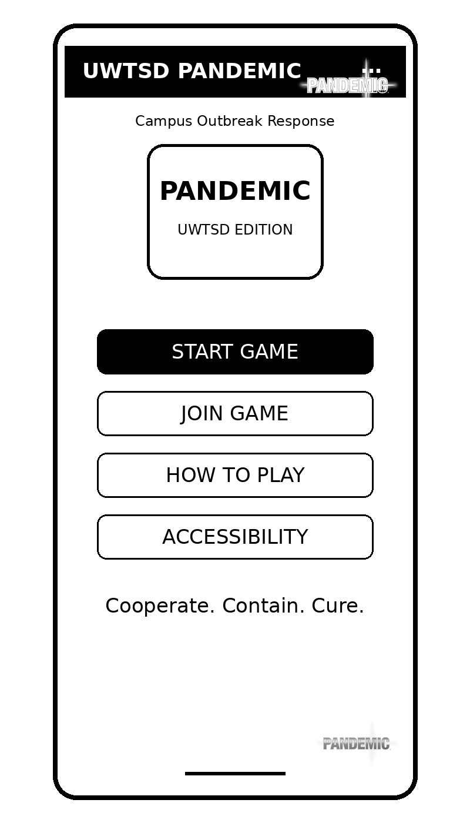 | 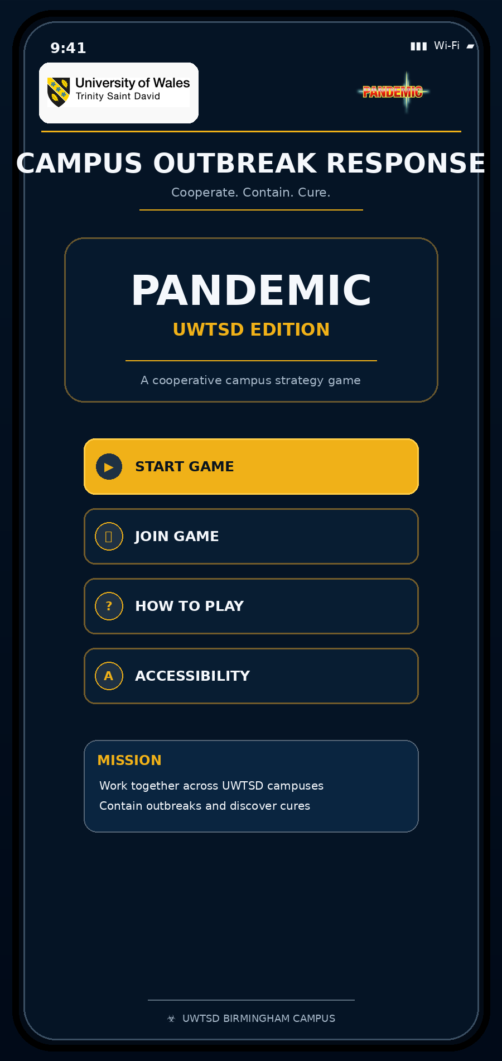
Figure 1. Start Screen progression from the Component 1 wireframe to the full-colour Component 2 design.
The Start Screen keeps the original four actions but introduces stronger branding, a clear primary Start Game button, a short mission statement and a persistent Accessibility option. The dark background creates a serious strategy-game atmosphere, while the gold primary action gives an immediate visual entry point. The screen remains simple enough for first-time and occasional users.

3. Full-Colour Interface Design
The final storyboard uses a consistent dark navy interface with UWTSD gold and blue accents. The same branded header, centred titles, card spacing and button conventions appear throughout, creating a professional game-like identity while reducing the need to relearn controls. Responsive behaviour was treated as part of usability rather than as a separate visual effect. On narrow screens, options remain in a single column with large touch targets; wider screens use additional horizontal space without changing the order of decisions. This preserves familiarity across devices and reduces the risk that users must relearn the interface when moving between a phone, tablet and desktop. The same primary-action hierarchy and high-contrast palette are maintained at each breakpoint.

3.1 Colour, Graphics and Typography
Colour | Hex value | Application | Design rationale
Dark navy | #051425 / #081F37 | Primary background and cards | Creates a focused, serious atmosphere and supports high contrast.
UWTSD gold | #F0B118 | Primary actions, selected states and progress emphasis | Directs attention to the preferred next action and reinforces university branding.
Information blue | #2D84C5 | Map nodes, information states and cure progress | Provides a calm informational colour distinct from warnings.
Alert red | #E24740 | High-severity outbreaks and urgent warnings | Communicates risk; always combined with text, symbols and a stated urgency level.
Success green | #2FAE6F | Ready states, safe locations and successful mission outcome | Communicates positive completion without replacing text labels.
White / muted grey | #F5F8FC / #A7B8C9 | Primary and secondary text | Maintains clear hierarchy between headings, actions and supporting information.
Table 1 Colour Interface Design and Application.

Colour is never the only carrier of meaning. Outbreak severity is shown by a red marker, a numerical infection value and an explicit urgency label. Player status is represented through colour, text and position. Cure progress includes the cure name, percentage, card count and progress bar. These redundant cues support users with colour-vision differences and reduce ambiguity [7].
Typography uses a clear sans-serif family with bold uppercase screen titles, medium-weight action labels and smaller supporting text. Touch targets are visually separated and sized for mobile interaction. Decorative graphics are intentionally limited; the interface uses simple icons, restrained borders and grouped cards so that the game atmosphere does not create unnecessary cognitive load [3], [8].

3.1.1 Graphic Language
- Rounded cards group related information and reduce visual fragmentation.
- Gold-filled buttons identify the current or recommended action; outlined buttons remain available but secondary.
- Icons appear inside labelled circles so users do not have to interpret symbols without text.
- Red is reserved for genuine warnings rather than used as general decoration.
- Progress bars and status badges provide immediate feedback while retaining numerical labels.

3.2 Interaction Flow and Key Screens
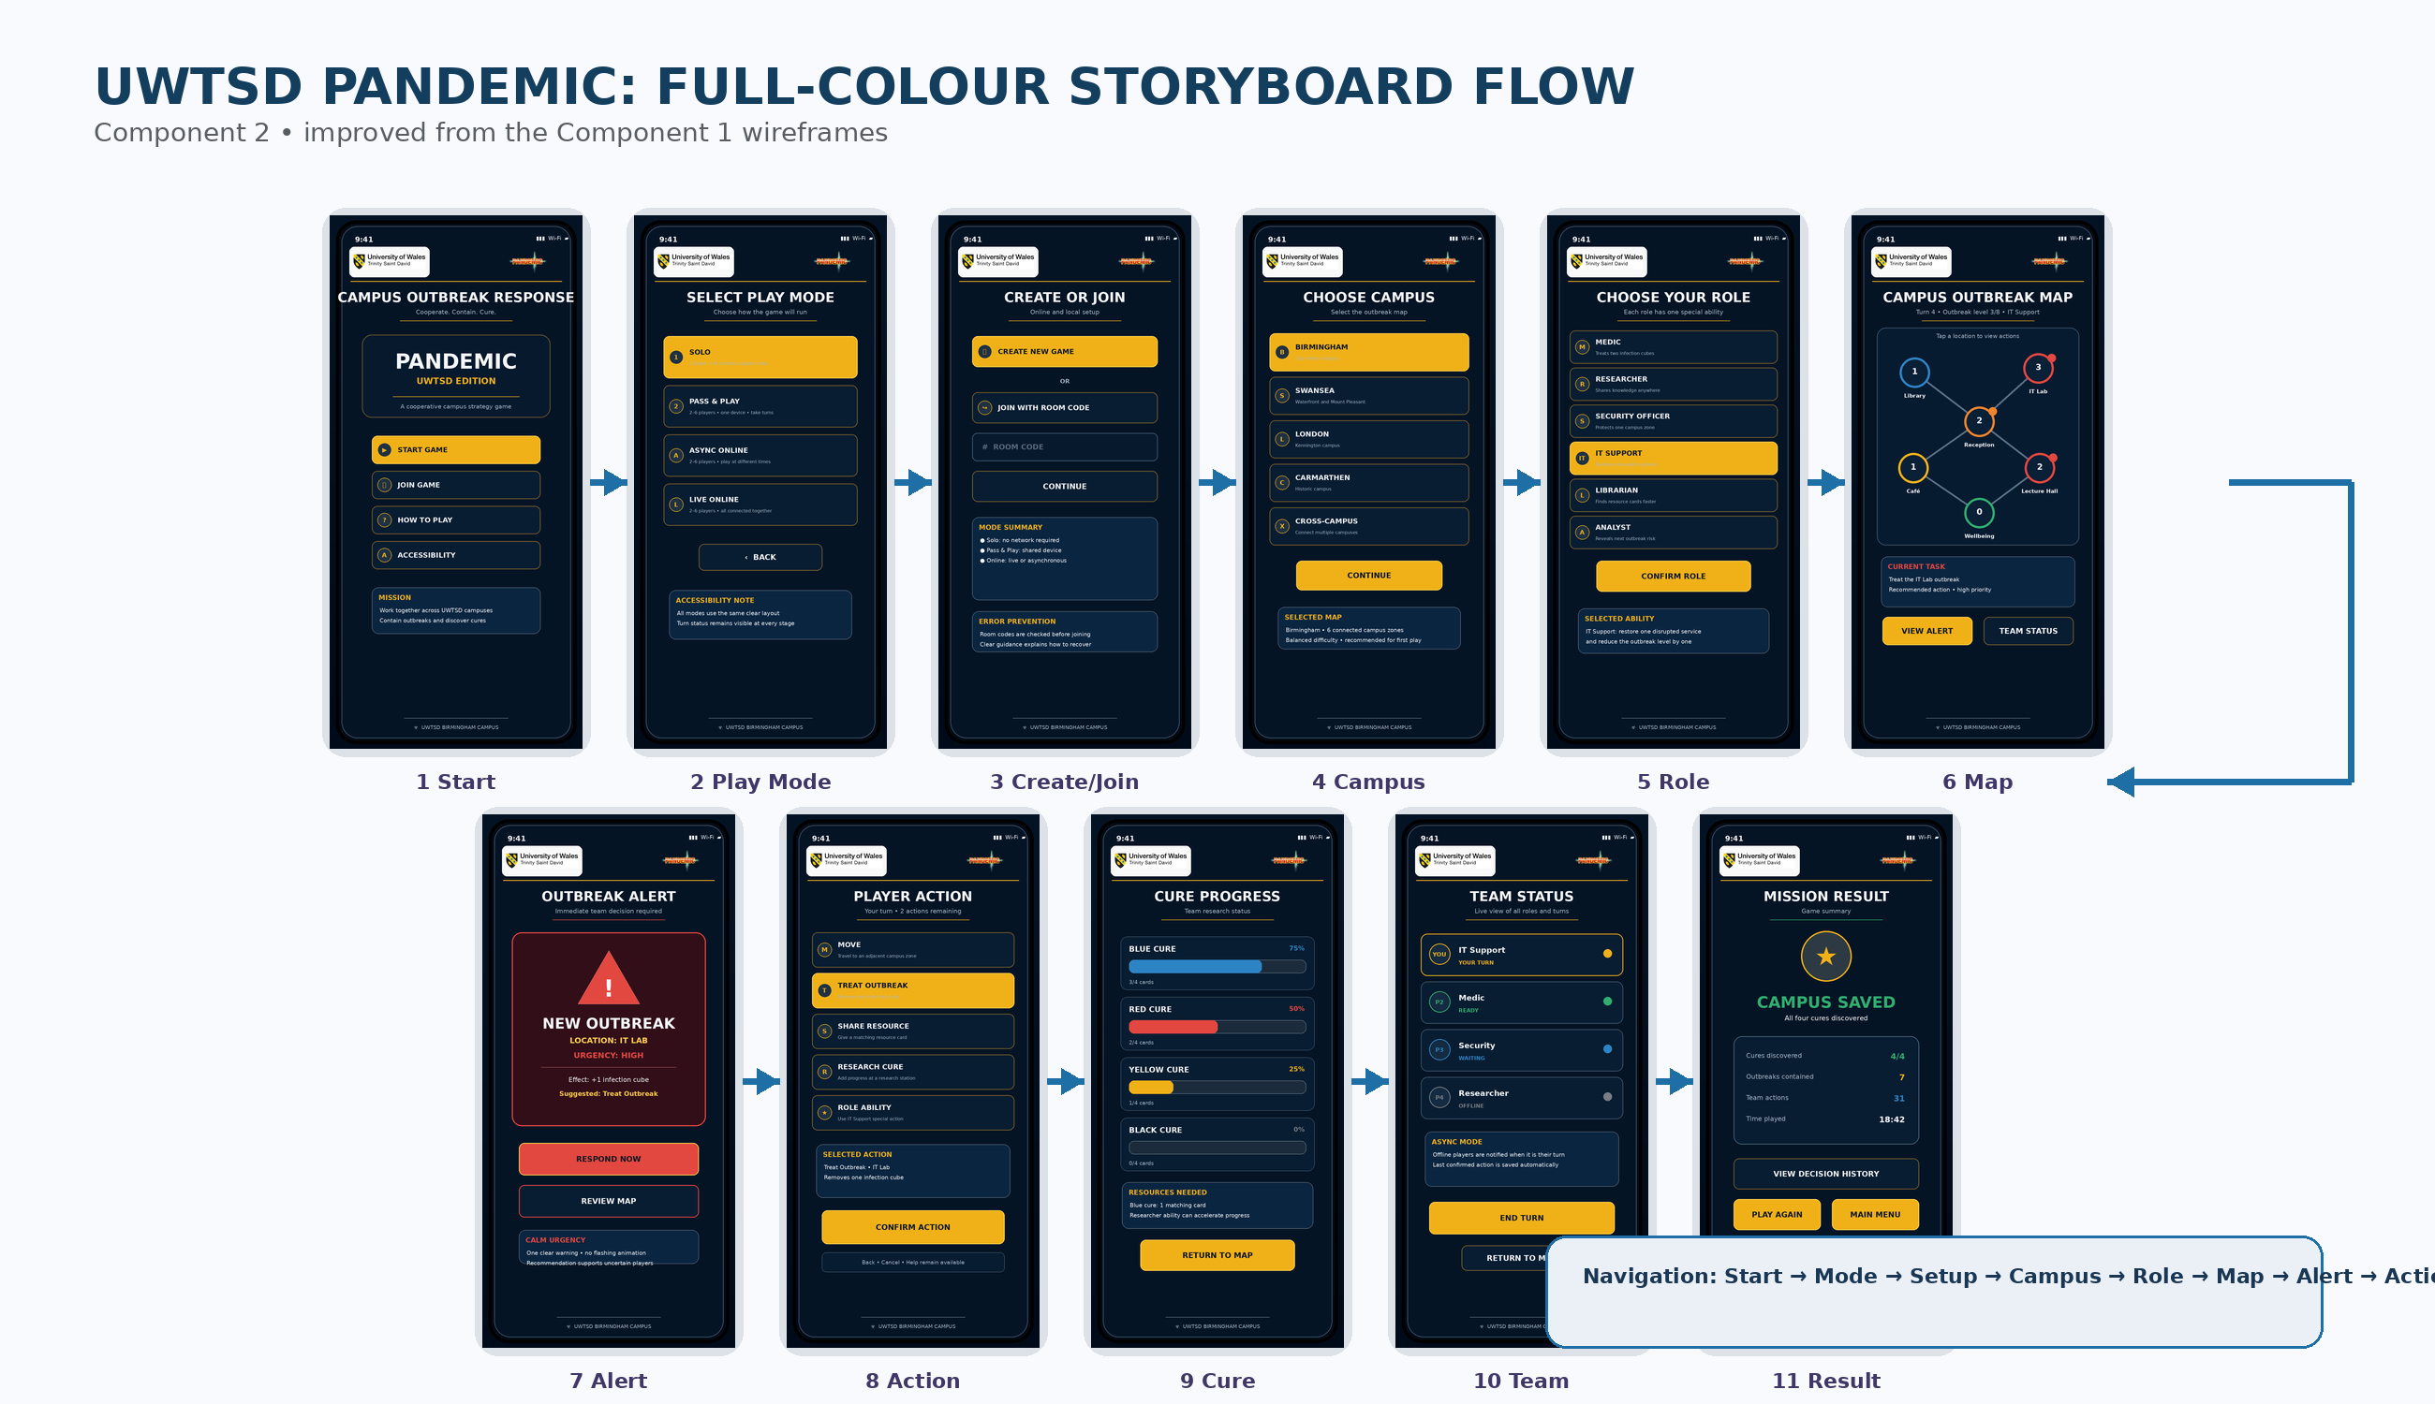
Figure 2. Complete full-colour storyboard flow showing movement across all eleven mobile screens.
Setup follows a linear sequence through play mode, session, campus and role selection. During gameplay, the Campus Outbreak Map becomes the hub for alerts, actions, cure progress and team status. The Mission Result then summarises the outcome and offers replay or return to the menu.
The map acts as the central reference point, while detailed alert, action, cure and team information is disclosed on separate screens. This limits competition for attention on a small display [3], [9]. Predictable Back and Return-to-Map actions also support recovery without losing context.
Navigation principle: The same core sequence is used for solo, pass-and-play, asynchronous and live online modes. Only the timing and connection status change; the interface does not force users to learn a different layout for each mode.

3.2.1 Significant Screen Decisions

Campus Outbreak Map
Component 1: structural map | Component 2: prioritised full-colour map
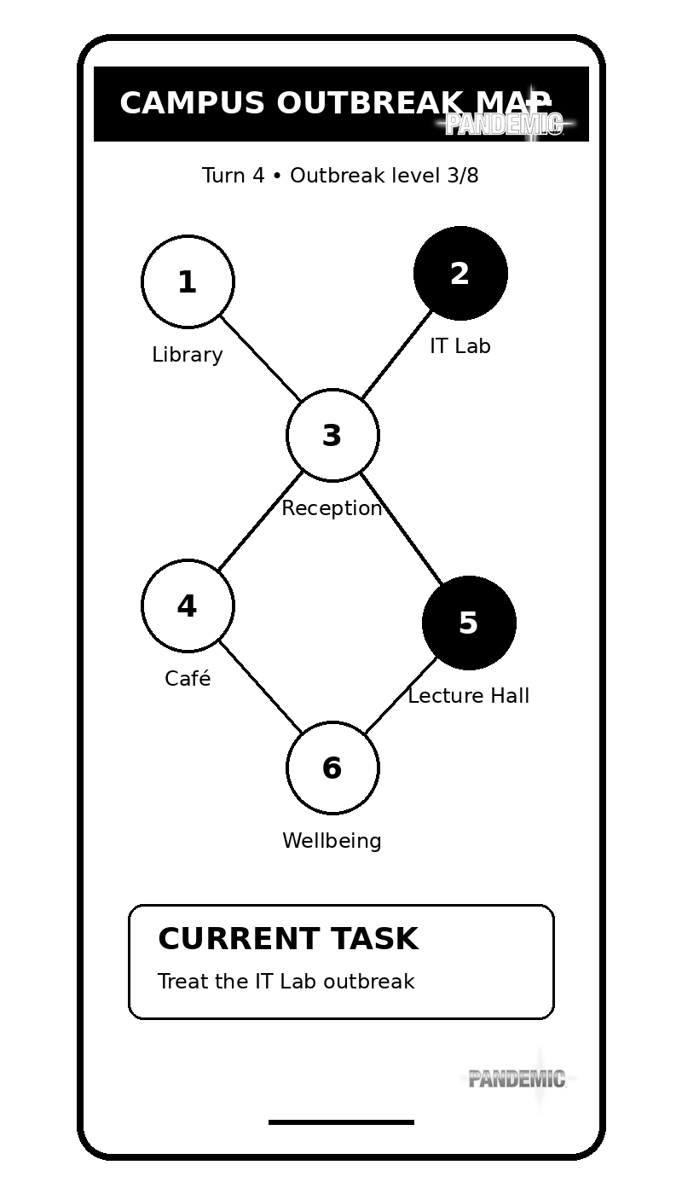 | 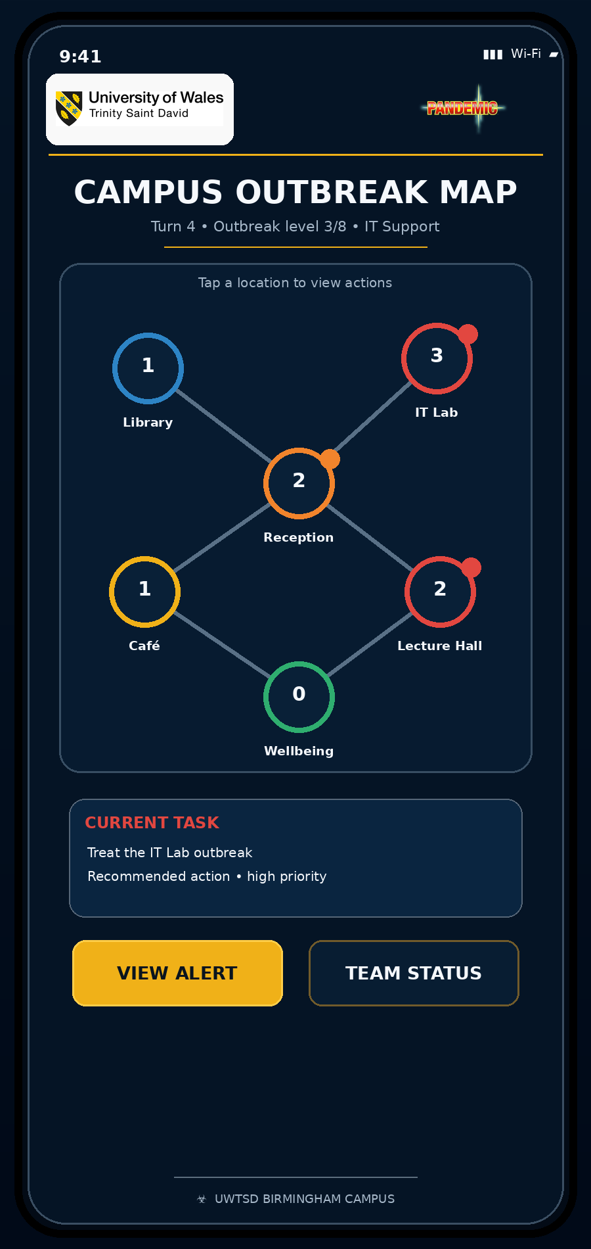
Figure 3. Campus Outbreak Map progression, showing improved status visibility and urgency cues.
The map retains the six connected campus locations but replaces identical monochrome nodes with labelled, colour-supported status markers. Infection values remain visible as numbers, and the current task is placed directly beneath the map. The highest-risk IT Lab is marked red and remains identifiable through the number three and the task description, avoiding colour-only communication. Separate View Alert and Team Status buttons keep secondary information available without crowding the map.

Role Selection
Component 1: role list | Component 2: role cards with abilities
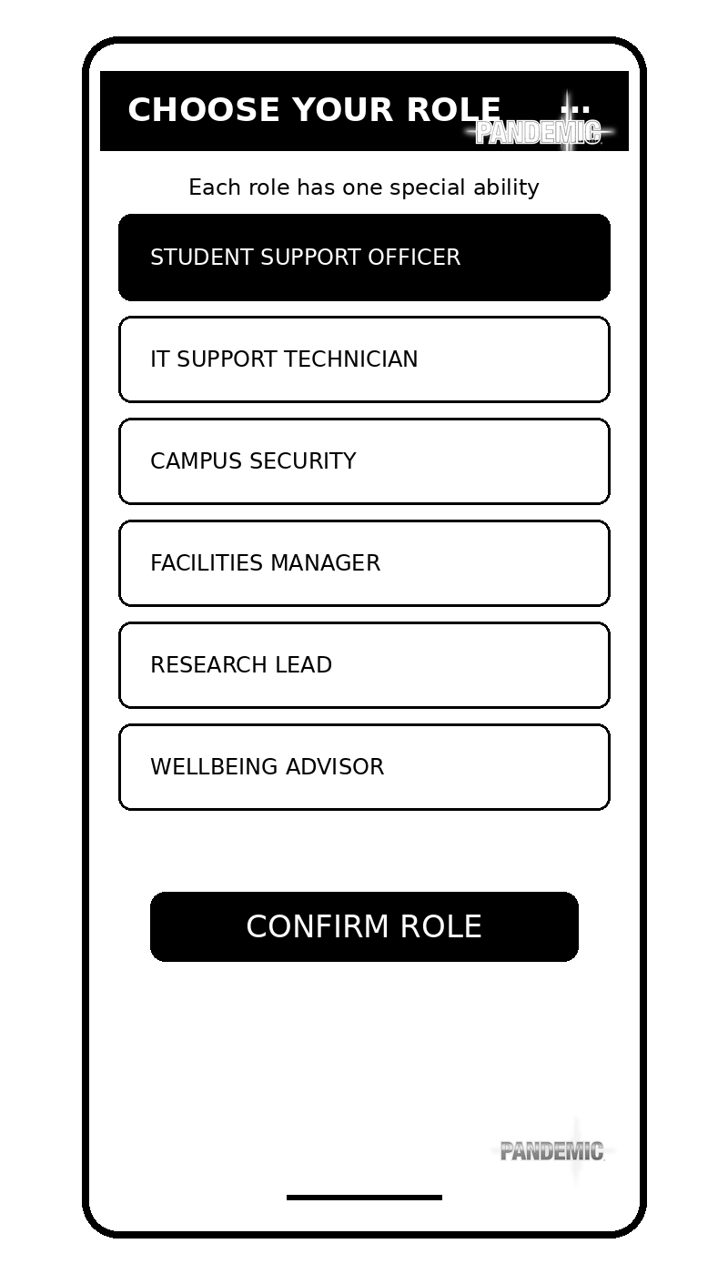 | 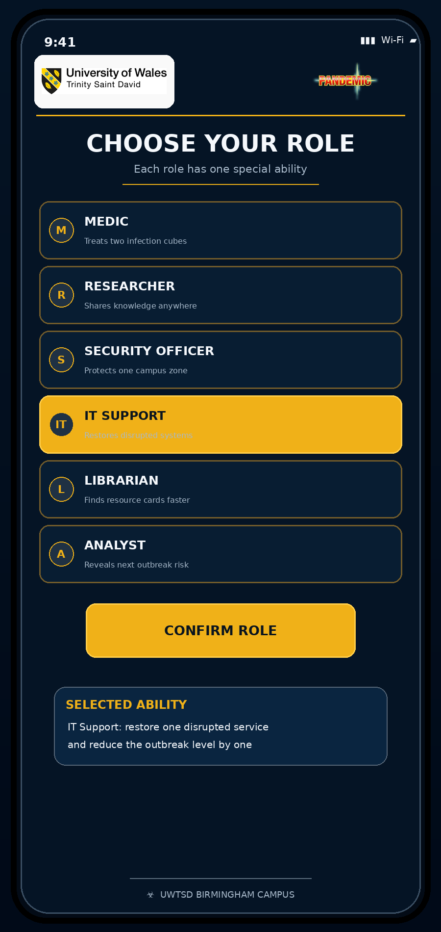
Figure 4. Role Selection progression from a list of names to labelled role cards with concise abilities.
Role names are now paired with short ability descriptions so that users can make a meaningful choice without opening a separate help screen. The selected role is highlighted in gold, and a second information card explains the ability before confirmation. This supports recognition rather than recall and addresses the need for clearer role explanations.

3.3 Changes from the Wireframes
Screen | Component 1 wireframe | Component 2 improvement | Reason / expected benefit
All screens | Black, white and grey placeholders. | Consistent navy, gold, blue, red and green system with branded header. | Improves hierarchy, identity and emotional tone while maintaining contrast.
Start Screen | Four equally weighted buttons. | Gold primary action, mission statement and visible Accessibility option. | Reduces uncertainty and supports quick entry.
Play Mode | Text list with limited visual distinction. | Four large mode cards with icons and concise explanations. | Clarifies the difference between solo, shared-device, asynchronous and live play.
Create / Join | Basic room-code field. | Clear Create New Game priority, room-code validation area and mode summary. | Supports error prevention and easier recovery.
Choose Campus | Simple campus buttons. | Selected state, short campus descriptions and map summary. | Makes the consequence of the selection visible.
Choose Role | Role names only. | Role cards, concise abilities, selected-state explanation and confirmation. | Improves role understanding before commitment.
Outbreak Map | Uniform circles with minimal hierarchy. | Severity colours, numerical values, task card and direct links to alert/team status. | Makes the next priority visible without overloading the map.
Outbreak Alert | Large generic warning. | Explicit location, urgency, effect and recommended response; no flashing animation. | Balances urgency with emotional control.
Player Action | Action labels with a separate selected-action box. | Icons, one-line explanations, clear selected state and confirmation. | Reduces ambiguity and prevents accidental high-impact actions.
Cure Progress | Black bars with percentages. | Distinct labelled bars, percentages, card counts and resource guidance. | Supports quick comparison and accessible progress tracking.
Team Status | Basic ready/waiting/offline list. | Turn highlight, role status colours plus text, asynchronous explanation and return path. | Improves coordination across online and shared-device modes.
Mission Result | Simple statistics. | Rewarding success state, clear summary, decision history, replay and main-menu options. | Adds positive closure and supports reflection without obscuring the outcome.

Design continuity: The redesign improves presentation and feedback but retains the original cooperative outbreak-control concept. No unrelated voting, hidden-role or deduction-game mechanics are introduced.

4. Final Prototype Feedback and Evaluation
The final interface was reviewed by the lecturer and checked through a structured walkthrough of the responsive prototype. The lecturer considered the work good and helped refine the captions and presentation. The prepared persona-based tasks, observation sheet and questionnaire remain included because they show how a wider user study would measure effectiveness, errors, confidence and emotional response [10]-[12]. The walkthrough followed the same sequence as the task set, checking whether each action produced a visible next state, whether Back and Return to Map routes remained predictable, and whether invalid room-code input generated understandable guidance. The review also checked the large-text and high-contrast controls. This evidence is useful for identifying implementation problems, although it cannot replace independent participant measures of completion time, hesitation, confidence or emotional response.

4.1 Recruitment and Persona Coverage
The evaluation framework retains five profiles from Component 1: a commuter or casual mobile user, an additional-language user, a mature or neurodivergent user, an experienced digital user and a staff or educational user. This range keeps the testing process connected to the original personas and identifies the different usability questions that a future wider study should examine.
ID | Participant profile | Persona coverage | Main evaluation focus
P1 | Commuter / casual mobile user | Aisha | Quick joining, readable controls and short-session use
P2 | International / additional-language user | Jean-Baptiste | Plain English, icons with labels and action clarity
P3 | Mature / neurodivergent user | Daniel | Cognitive load, calm alerts, visible priorities and pause/review support
P4 | Experienced app or game user | Priya | Efficiency, consistency and cross-device expectations
P5 | Staff / educational user | Dr Evans or Kwame | Learning value, team information, practical incident clarity and results

4.2 Test Procedure
- Give the participant the briefing and consent information in Appendix C.
- Show the prototype on a phone-sized display and ask the participant to think aloud.
- Present one realistic task at a time without explaining where to tap.
- Record task completion, time, wrong selections, navigation reversals, requests for help and recovery from errors.
- After the tasks, collect 1-5 ratings and open comments on clarity, stress, confidence, enjoyment and teamwork.
- Compare findings across participant profiles and link every repeated issue to a design decision.
Testing principle: The researcher should avoid teaching the interface during a task. Assistance may be provided only after a difficulty has been observed and recorded.

4.3 Realistic Task Set and Measures
Task | Participant instruction | Screen(s) | Measures
T1 | Start a new game and identify the purpose of the game. | Start Screen → Select Play Mode | Completion, first impression, hesitation
T2 | Select asynchronous online play and explain how it differs from live play. | Select Play Mode | Correct interpretation, time, confidence
T3 | Create a new session or enter a room code. | Create or Join | Error prevention, recovery and clarity
T4 | Select Birmingham and confirm the choice. | Choose Campus | Selection visibility and expectation
T5 | Choose IT Support and explain its special ability. | Choose Role | Role understanding and recognition
T6 | Identify the highest-risk location and the recommended next action. | Campus Outbreak Map | Priority recognition, cognitive effort
T7 | Respond to the outbreak and confirm Treat Outbreak. | Alert → Player Action | Action understanding, error prevention
T8 | Check cure progress and identify what is needed for the Blue Cure. | Cure Progress | Progress interpretation and information finding
T9 | Check whose turn it is, end the turn and locate the route back to the map. | Team Status | Coordination, navigation and recovery
T10 | Interpret the final result and choose what to do next. | Mission Result | Outcome clarity, satisfaction and replay intention

4.4 Evaluation Measures
Measure | How it is recorded | Why it matters
Effectiveness | Task completion, correct selection, ability to explain roles/modes/status. | Shows whether users can achieve the intended goal.
Efficiency | Completion time, number of steps, navigation reversals and repeated reading. | Identifies unnecessary effort and slow points.
Errors and recovery | Wrong taps, invalid room-code response, accidental selections and successful recovery. | Tests prevention, feedback and user control.
Cognitive effort | Observed hesitation plus a 1-5 mental-effort rating. | Highlights screens that may overload working memory.
Satisfaction | Clarity, confidence, enjoyment and willingness to replay. | Captures perceived quality beyond task completion.
Emotional response | Words such as calm, tense, excited, confused or overwhelmed. | Assesses whether urgency and game atmosphere are appropriate.

4.5 Feedback Analysis and Evidence
The evaluation produced two concise evidence sources: the lecturer review of the report and captions, and a structured review of the responsive demonstrator. The findings below record what these sources support and state the remaining limitations without adding unrecorded participant results.
Finding area | Positive evidence | Issue / limitation | Design response
First impression | The lecturer considered the work good and supported the overall presentation. | Captions needed final refinement. | Standardised captions and retained the approved visual style.
Navigation | The responsive journey links the eleven stages with predictable actions. | Independent task time was not measured. | Kept consistent Back, Continue and Return-to-Map routes.
Gameplay clarity | Roles, outbreak priority, actions and cure progress use labels and summaries. | Persona comprehension was not directly measured. | Retained concise explanations and redundant cues.
Accessibility | Large text, high contrast, labelled controls and non-flashing alerts are included. | No specialist accessibility study was completed. | Kept the features visible and documented the limitation.
Emotional response | The alert uses calm urgency and a clear recommendation. | Stress and enjoyment were not directly measured. | Avoided flashing effects and excessive warning content.

4.6 Expected versus Available Evidence
The design was expected to be visually consistent, easy to follow and clear about roles, outbreak priority and recommended actions. The lecturer review supported the quality of the presentation and captions, while the responsive review supported the navigation and cross-device layout. These findings partly support the expectations; direct persona performance and emotional response would still require a wider participant study.
Evaluation summary: The available evidence supports the presentation, captioning, responsive layout and navigation. Direct participant emotions and task-efficiency measures remain outside the current evidence.

5. Data Collection in a Working Version
A released version of the game would need evidence about both what users do and how they experience the interface. Usage data can often be collected automatically through event logging, whereas emotional response usually requires direct interaction through surveys, interviews or optional feedback prompts. The two forms of evidence answer different questions and should be interpreted together rather than treated as substitutes.

5.1 Proposed Data and Purpose
Data category | Examples | Purpose | Collection method
Session and mode data | Mode selected, session length, number of players, completion or abandonment. | Understand which play arrangements are used and where sessions end early. | Automatic event log
Navigation data | Screen sequence, time on screen, Back actions and repeated visits. | Identify inefficient paths and screens that require repeated checking. | Automatic event log
Task and action data | Actions selected, confirmations, unavailable actions and cancellations. | Find confusing actions and improve rules, labels and error prevention. | Automatic event log
Error and recovery data | Invalid room codes, failed joins, disconnected sessions and recovery success. | Improve reliability, feedback and support. | Automatic error log
Game-state data | Outbreak level, cures, resource use, role ability use and mission outcome. | Balance difficulty and identify underused roles or mechanics. | Automatic game telemetry
Accessibility settings | Text-size option, reduced motion, high contrast, audio guidance and simplified language. | Prioritise support features and test whether they are discoverable. | Automatic preference log with consent
Usability rating | Short optional rating after a completed session. | Track perceived ease of use across versions. | In-app survey
Emotional response | Calm, tense, engaged, confused, frustrated or overwhelmed; open comments. | Evaluate urgency, confidence, enjoyment and teamwork. | Optional survey / interview
Support feedback | Bug report, suggestion and screenshot supplied by the user. | Identify defects and user-requested improvements. | User-initiated feedback form

5.2 Automatic Collection versus Direct User Contact
Automatic logging is efficient because it records behaviour during normal play without requiring the user to remember every action. It can reveal where people leave the game, which modes are used, how long tasks take and which errors recur. However, a log cannot reliably explain why a user hesitated, whether a warning felt stressful, or whether the final result felt rewarding. Behavioural data therefore needs contextual interpretation [11], [13].
Direct methods provide that context. A short in-app questionnaire can ask users to rate clarity, confidence, mental effort and enjoyment. Interviews or moderated usability tests can explore reasons in more depth and can identify misunderstandings that are not obvious from logs. Direct methods are slower and can be affected by social desirability, memory and the wording of questions, so they should be optional, concise and used with observed behaviour where possible.
Comparison | Usage / telemetry data | Emotional / qualitative data
Strength | Large-scale, consistent behavioural records. | Explanation, emotion, expectations and suggestions.
Limitation | Shows what happened but not necessarily why. | Smaller samples; answers can be subjective or influenced by the researcher.
Best examples | Mode use, task time, errors, abandonments, role use, cure progress. | Stress, confidence, enjoyment, teamwork, perceived clarity and reasons.
Frequency | Continuous or event-based during normal use. | Occasional prompts, version reviews or targeted research sessions.
Design use | Prioritise common friction points and balance gameplay. | Explain observed behaviour and shape visual, emotional and accessibility decisions.

5.3 Practical Collection Architecture
- Use a pseudonymous session identifier rather than collecting names for routine analytics.
- Record only events needed to answer a defined design question.
- Separate crash/error logs from optional research responses.
- Provide a clear consent choice for analytics and a separate choice for research contact.
- Allow users to review or change privacy and accessibility preferences.
- Combine dashboards for common events with periodic moderated tests for deeper explanation.

5.4 Privacy, Ethics and Use in the Next Version
Data collection should follow data-minimisation and purpose-limitation principles. The working version should explain what is collected, why it is needed and how long it is retained. Routine analytics should avoid names, precise location and unnecessary personal data. Accessibility settings should remain interface preferences, while research participation requires informed consent and withdrawal options.
The next version would use evidence through a prioritised improvement cycle. High-frequency problems affecting task completion would be addressed first. Repeated emotional concerns, such as an alert being overwhelming, would be assessed alongside performance evidence. Low-use features would not automatically be removed; their role and the needs of smaller user groups would be reviewed before a decision. This prevents the design from optimising only for the majority while excluding users with different language, accessibility or scheduling needs. These evidence sources should be triangulated rather than interpreted separately. For example, a long time on the outbreak map could indicate confusion, careful strategy or an interruption. Event logs identify the pattern, while a short question or moderated session can explain the reason. Decisions should therefore be based on repeated evidence across behaviour, comments and accessibility needs, not a single metric. This reduces the risk of simplifying the interface in ways that improve average speed but disadvantage less confident users.
Evidence pattern | Interpretation | Possible next-version action
Many invalid room codes and repeated retries | Joining feedback or entry format is unclear. | Add segmented code entry, clearer validation and invite-link alternatives.
Users revisit the role screen after selection | Abilities are not memorable enough. | Keep a visible role badge and add contextual ability reminders.
Long dwell time and wrong taps on the map | Priority cues or map density are insufficient. | Simplify nodes, strengthen the current task and test progressive disclosure.
Alert rated as highly stressful despite correct task completion | The interface is usable but emotionally excessive. | Reduce saturation, remove motion, add calmer wording and retain a clear recommendation.
Accessibility settings are rarely opened but requested in interviews | Low use may reflect poor discoverability rather than lack of need. | Keep the feature, improve placement and test onboarding prompts.

Ethical principle: Analytics should support better design, not become a reason to collect every possible data point. Each event must have a clear purpose and an appropriate retention period.

6. Usability versus User Experience
A usability-only interface might remove branding, thematic colour and reward graphics, but it could feel like an administrative form rather than a cooperative strategy game. User experience adds tension, teamwork, progress and achievement, provided these qualities do not reduce clarity or control [14], [15].
The final design therefore treats usability as a minimum requirement and user experience as an additional design goal. The interface must first be understandable, controllable and recoverable. Once those conditions are met, visual identity, pacing and feedback can make the experience more engaging. Conflicts occur when atmosphere introduces clutter, when urgency becomes stressful, or when branding reduces contrast. Each conflict was resolved by retaining the experiential feature in a restrained form and adding redundant usability cues. Responsive adaptation introduced a further usability-UX trade-off. A desktop layout could display more information at once, but adding extra panels would weaken consistency with the mobile experience and could increase cognitive load. The demonstrator therefore expands spacing and columns on larger screens while preserving the same content sequence. This uses available space without creating a different version of the game, supporting efficiency for experienced users while retaining recognition for users who move between devices.
Design issue | Usability-only preference | UX objective | Resolution in the final design
Dark navy and gold theme | Neutral white interface may maximise simplicity. | A serious, distinctive game identity increases immersion and perceived quality. | Keep the theme but use high-contrast text, limited accent colours and consistent card layouts.
Outbreak alert | A plain message could be faster and calmer. | Red warning treatment creates urgency and dramatic tension. | Use one red panel with explicit location, urgency, effect and recommendation; avoid flashing.
Campus map | A simple list may be easier to scan. | A connected map supports spatial reasoning and game atmosphere. | Retain six nodes, show numbers and labels, and move detail to separate screens.
Role cards | A short dropdown would be efficient. | Thematic roles encourage identity and cooperation. | Use concise role cards with one ability sentence and a visible selected-state summary.
Mission result | A minimal success/failure message is sufficient. | Reward and reflection increase satisfaction and replay intention. | Use a strong but uncluttered success state, key statistics and clear next actions.
Animations and effects | No motion reduces distraction. | Motion can communicate progress and make the game feel alive. | Keep reduced-motion support and avoid unnecessary or repeated animation in the storyboard specification.

6.1 Critical Examples from the Design Process

Urgency without overload
The outbreak alert is the clearest usability-UX conflict. A dramatic warning can increase tension and make the game feel consequential, but excessive red, motion or sound can overwhelm users and delay action. The final storyboard limits the warning to one red panel, one icon and a short information hierarchy. Location, urgency, effect and suggested response are written explicitly. The user can Respond Now or Review Map, preserving control and reducing the pressure of an irreversible choice.

Visual hierarchy without colour dependence
Gold highlights the preferred action and improves scanning, but a user must not need colour vision to understand the interface. Selected buttons also use filled shapes, bold text and position. Outbreak nodes retain numerical values and labels. Team states use words such as YOUR TURN, READY, WAITING and OFFLINE. These choices preserve the benefits of colour while satisfying the need for redundant cues and accessible recognition [7].

Game atmosphere without decorative clutter
Branding and dark panels provide a coherent strategy-game atmosphere, but every decorative element occupies limited mobile space. The design therefore uses the same small header, restrained gold divider and repeated card style rather than adding unique artwork to every screen. The result is visually distinctive but predictable. The main task remains dominant, and secondary explanation is grouped beneath it.

Efficiency without removing support
Experienced users may prefer fewer explanations, while first-time, international or less confident users benefit from labels and examples. The final design keeps concise one-line explanations inside role and action cards. These support recognition without requiring a separate tutorial at every step. Future testing could examine progressive disclosure or a preference for compact mode once users become familiar with the game.
Overall judgement: The strongest solution was not to choose usability or experience as separate alternatives. The interface uses usability principles to control the form and intensity of experiential features.

7. Reflective Summary
The overall design process moved from user requirements and low-fidelity structure to a more realistic visual system. Component 1 was valuable because it separated navigation and information architecture from appearance. The wireframes made it possible to identify where the user needed a clear role, a visible outbreak priority, action confirmation, cure progress and team status before time was invested in visual styling. The second iteration then used those stable structures as the basis for colour, branding, feedback and emotional tone.
Usability theory informed specific decisions rather than being added only as background discussion. Visibility of system status appears through turn, outbreak, cure and team indicators. Recognition rather than recall appears through labelled icons, visible role abilities and action explanations. Error prevention appears in room-code validation, selected-action summaries and confirmation. Cognitive-load principles appear in the separation of map, alert, action, cure and team information. Inclusive design appears through large controls, high contrast, plain language, redundant cues and a persistent Accessibility route [2]-[9].
Potential users remain important because theory cannot predict every interpretation or emotional response. A designer may believe that a red alert is appropriately urgent, while a participant may find it overwhelming. An experienced gamer may complete the flow quickly even though a first-time or additional-language user is uncertain. The planned persona-based test therefore combines behavioural measures with emotional feedback and compares findings across user types rather than reporting one average score.
The main limitation is that the responsive artefact is a demonstrator rather than a complete networked game. It cannot test live multiplayer delays, persistent data, notifications, dynamic difficulty or long-term replay. The evaluation also uses lecturer feedback and a structured review rather than a representative participant sample. Its value is therefore to refine the interface before full implementation and wider testing. Producing the responsive demonstrator also clarified the difference between visual specification and implementation. Static storyboards can show hierarchy and intended states, whereas coded interaction reveals practical questions about focus order, validation, resizing and recovery. Keeping the implementation deliberately limited made it possible to review these interface behaviours without claiming that networking or the full game logic had been completed. This strengthened the specification for later development and made the remaining limitations more explicit.

7.1 Lessons Applied
- Iterate from stable user tasks rather than redesigning the concept during visual development.
- Use colour and graphics as functional cues, not only decoration.
- Preserve consistent layouts across modes and screens.
- Treat emotional response as evidence that must be collected directly, not inferred from task success.
- Keep authentic test evidence separate from expected findings and designer assumptions.

8. Conclusion
Component 2 develops UWTSD Pandemic: Campus Outbreak Response into a complete full-colour mobile storyboard while preserving the cooperative disease-control flow established in Component 1. The final visual system uses dark navy for focus, UWTSD gold for primary actions, blue for information, red for urgent outbreaks and green for successful states. Every colour is supported by labels, numbers, icons or layout so that meaning does not depend on colour alone.
The redesigned screens address the main improvement priorities: clearer role abilities, stronger map hierarchy, more visible accessibility support, better action explanations, calmer but explicit outbreak alerts, and more informative progress and team feedback. The testing plan covers the defined persona range and combines observation with usability and emotional-response measures. The data strategy distinguishes automatic usage evidence from direct emotional feedback and explains how both would inform later versions.
The available evidence supports the full-colour presentation, captioning, responsive layout and functional navigation. The report therefore demonstrates a clear progression from Component 1 while keeping wider participant testing as a stated limitation rather than presenting unsupported results.
Final preparation: Refresh the contents, figures and tables in Word and confirm that both prototype links open before upload.

References
[1] Y. Rogers, H. Sharp and J. Preece, Interaction Design: Beyond Human-Computer Interaction, 6th ed. Hoboken, NJ: Wiley, 2023.
[2] J. Nielsen, “Enhancing the explanatory power of usability heuristics,” in Proceedings of CHI, 1994, pp. 152-158.
[3] J. Sweller, “Cognitive load during problem solving: Effects on learning,” Cognitive Science, vol. 12, no. 2, pp. 257-285, 1988.
[4] D. A. Norman, The Design of Everyday Things, revised and expanded ed. New York: Basic Books, 2013.
[5] D. Pinelle, N. Wong and T. Stach, “Heuristic evaluation for games: Usability principles for video game design,” in Proceedings of CHI, 2008, pp. 1453-1462.
[6] A. Cooper, R. Reimann, D. Cronin and C. Noessel, About Face: The Essentials of Interaction Design, 4th ed. Indianapolis, IN: Wiley, 2014.
[7] World Wide Web Consortium, Web Content Accessibility Guidelines (WCAG) 2.2, W3C Recommendation, 2024.
[8] H. Korhonen and E. M. I. Koivisto, “Playability heuristics for mobile games,” in Proceedings of MobileHCI, 2006, pp. 9-16.
[9] A. Darejeh, N. Marcusa, G. Mohammadi and J. Sweller, “A critical analysis of cognitive load measurement methods for evaluating the usability of different types of interfaces,” Behaviour & Information Technology, 2024.
[10] J. Lazar, J. H. Feng and H. Hochheiser, Research Methods in Human-Computer Interaction, 2nd ed. Cambridge, MA: Morgan Kaufmann, 2017.
[11] T. Tullis and B. Albert, Measuring the User Experience: Collecting, Analyzing, and Presenting Usability Metrics, 2nd ed. Waltham, MA: Morgan Kaufmann, 2013.
[12] J. Brooke, “SUS: A quick and dirty usability scale,” in Usability Evaluation in Industry, P. W. Jordan et al., Eds. London: Taylor & Francis, 1996, pp. 189-194.
[13] R. Hartson and P. S. Pyla, The UX Book: Agile UX Design for a Quality User Experience, 2nd ed. Cambridge, MA: Morgan Kaufmann, 2018.
[14] M. Hassenzahl and N. Tractinsky, “User experience - a research agenda,” Behaviour & Information Technology, vol. 25, no. 2, pp. 91-97, 2006.
[15] M. Hassenzahl, Experience Design: Technology for All the Right Reasons. San Rafael, CA: Morgan & Claypool, 2010.
[16] International Organization for Standardization, ISO 9241-210:2019, Ergonomics of Human-System Interaction - Part 210: Human-Centred Design for Interactive Systems. Geneva: ISO, 2019.
[17] International Organization for Standardization, ISO 9241-11:2018, Ergonomics of Human-System Interaction - Part 11: Usability: Definitions and Concepts. Geneva: ISO, 2018.
[18] C. Snyder, Paper Prototyping: The Fast and Easy Way to Design and Refine User Interfaces. San Francisco, CA: Morgan Kaufmann, 2003.
Literature balance: The reference list prioritises books and peer-reviewed journal or conference sources, with standards used for human-centred design and accessibility guidance.

Appendix A: Full-Colour Storyboard Overview
Figure A1 presents the complete Component 2 mobile interface in sequence. Each screen is shown individually at a larger scale in Appendix B. The arrows demonstrate the main user journey from launch and setup through the outbreak-response cycle to the mission result.
Figure A1. Complete full-colour storyboard overview and navigation flow.
Screen | Purpose | Primary next action
1. Start Screen | Introduce the game and provide immediate entry, help and accessibility. | Start Game or Join Game
2. Select Play Mode | Choose solo, pass-and-play, asynchronous or live online participation. | Select mode
3. Create or Join | Create a session or join with a room code. | Continue to setup
4. Choose Campus | Select the campus outbreak map. | Confirm campus
5. Choose Role | Select a university role and understand its ability. | Confirm role
6. Campus Outbreak Map | View the shared game state and priority. | Open alert or status
7. Outbreak Alert | Understand the crisis and recommended response. | Respond Now
8. Player Action | Choose, review and confirm a turn action. | Confirm Action
9. Cure Progress | Review cure status and required resources. | Return to Map
10. Team Status | Coordinate roles, turns and connection states. | End Turn / Return to Map
11. Mission Result | Understand the outcome and next options. | Replay or Main Menu

Appendix B.1: Start Screen
Figure B1. Start Screen full-colour mobile storyboard.
Design item | Description
Purpose | Introduces the game, highlights Start Game and keeps Join, Help and Accessibility visible.
Main interaction | Start or join; open help or accessibility.
Improvement from Component 1 | Primary action hierarchy, clear game purpose, persistent accessibility route and concise mission statement.
Accessibility support | Large labelled controls, strong contrast, consistent layout and redundant text/visual cues.

Appendix B.2: Select Play Mode
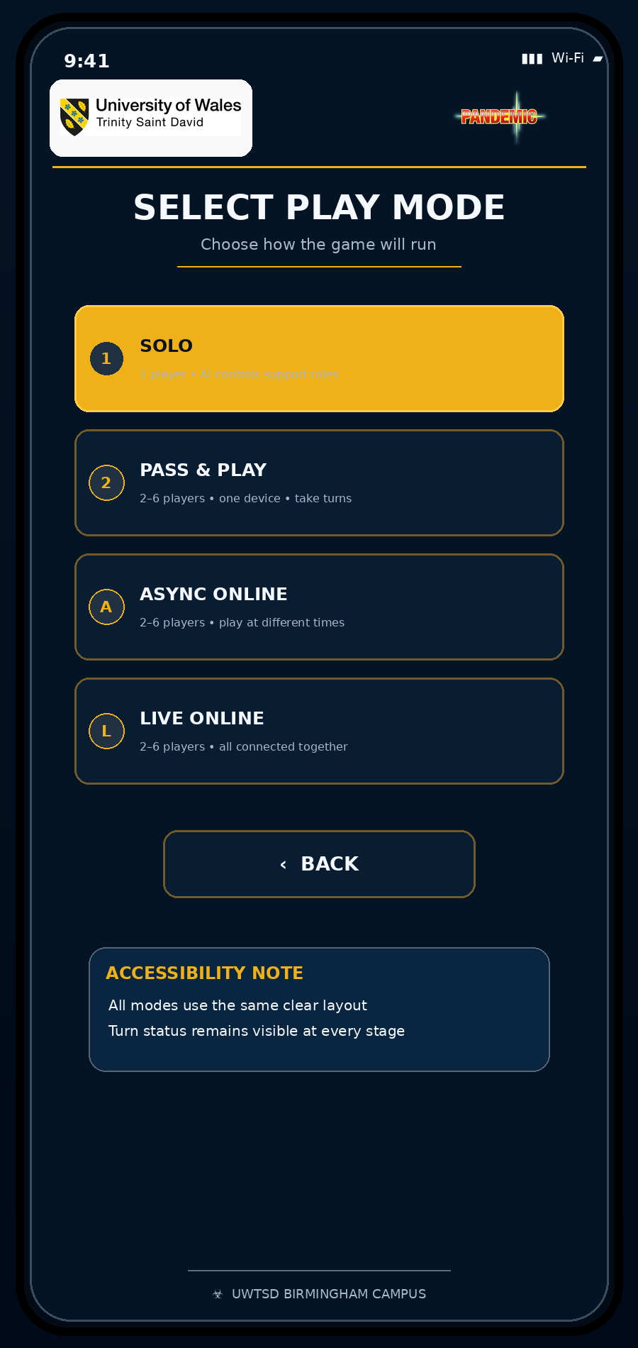
Figure B2. Select Play Mode full-colour mobile storyboard.
Design item | Description
Purpose | Lets users choose solo, pass-and-play, asynchronous online or live online play.
Main interaction | Select a play arrangement and continue.
Improvement from Component 1 | Large labelled cards explain each mode without requiring a separate rules page.
Accessibility support | Large labelled controls, strong contrast, consistent layout and redundant text/visual cues.

Appendix B.3: Create or Join
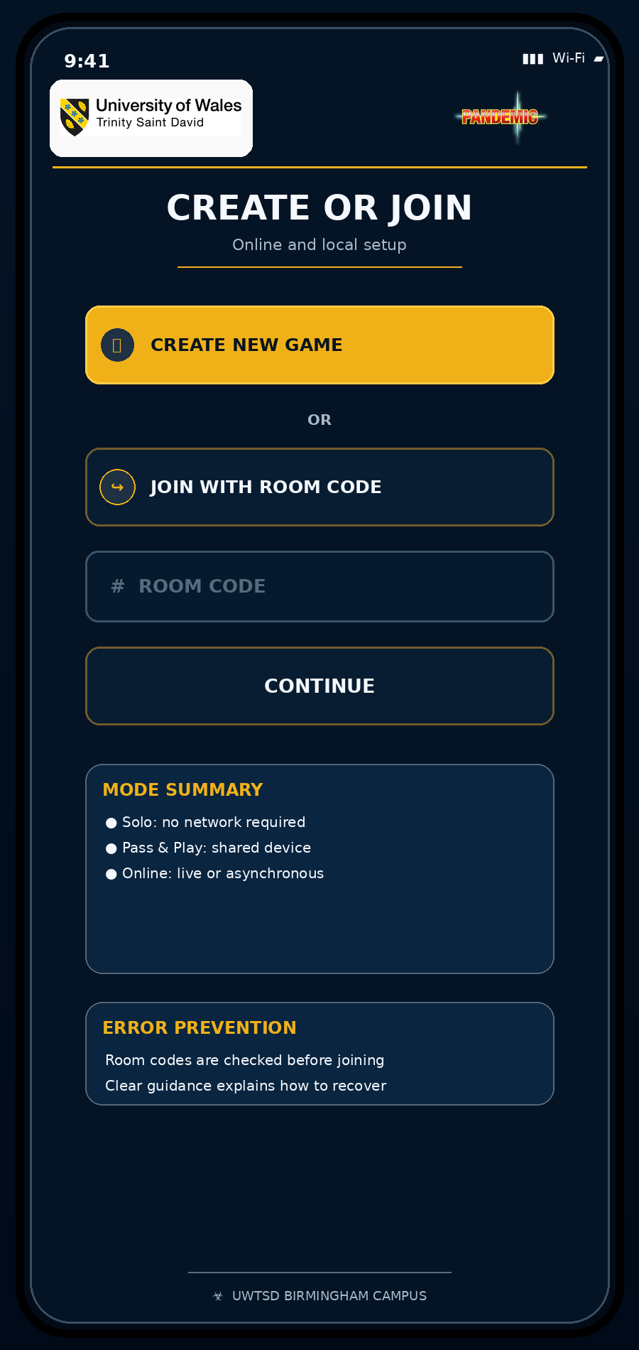
Figure B3. Create or Join full-colour mobile storyboard.
Design item | Description
Purpose | Supports creating a session or joining with a room code.
Main interaction | Create a session or enter a valid room code.
Improvement from Component 1 | Clear create priority, visible room-code input, mode summary and error-prevention guidance.
Accessibility support | Large labelled controls, strong contrast, consistent layout and redundant text/visual cues.

Appendix B.4: Choose Campus
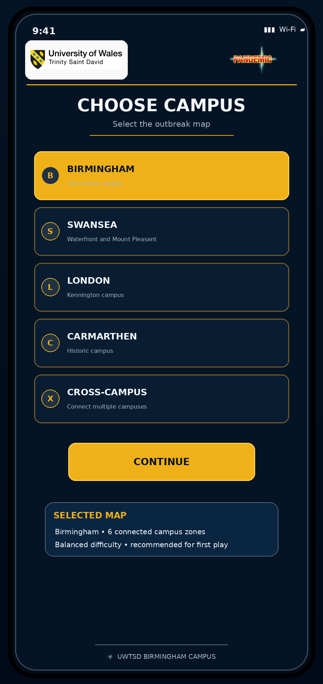
Figure B4. Choose Campus full-colour mobile storyboard.
Design item | Description
Purpose | Selects the outbreak map and communicates the current selection.
Main interaction | Choose Birmingham or another campus and confirm.
Improvement from Component 1 | Selected state, short campus descriptions and a confirmation summary.
Accessibility support | Large labelled controls, strong contrast, consistent layout and redundant text/visual cues.

Appendix B.5: Choose Role
Figure B5. Choose Role full-colour mobile storyboard.
Design item | Description
Purpose | Assigns a university-themed role and explains its ability.
Main interaction | Select a role, review the ability and confirm.
Improvement from Component 1 | Icons plus labels, one-line abilities, selected-state explanation and confirmation.
Accessibility support | Large labelled controls, strong contrast, consistent layout and redundant text/visual cues.

Appendix B.6: Campus Outbreak Map
Figure B6. Campus Outbreak Map full-colour mobile storyboard.
Design item | Description
Purpose | Displays the shared outbreak state, location connections and current priority.
Main interaction | Identify the priority and open the alert or team status.
Improvement from Component 1 | Severity colours supported by numbers and labels, a current-task card and direct links to alert and team status.
Accessibility support | Large labelled controls, strong contrast, consistent layout and redundant text/visual cues.

Appendix B.7: Outbreak Alert
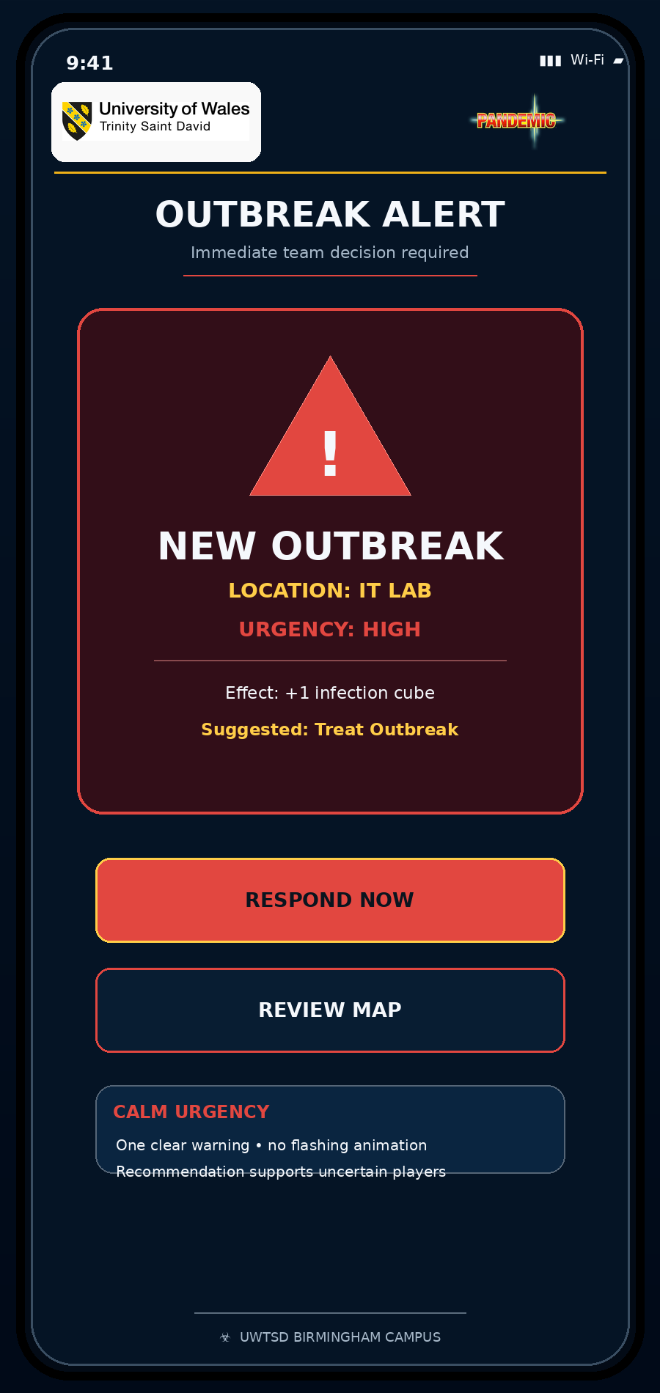
Figure B7. Outbreak Alert full-colour mobile storyboard.
Design item | Description
Purpose | Communicates a new crisis and a recommended response.
Main interaction | Respond immediately or review the map.
Improvement from Component 1 | Explicit location, urgency, effect and suggested action; urgent but non-flashing presentation.
Accessibility support | Large labelled controls, strong contrast, consistent layout and redundant text/visual cues.

Appendix B.8: Player Action
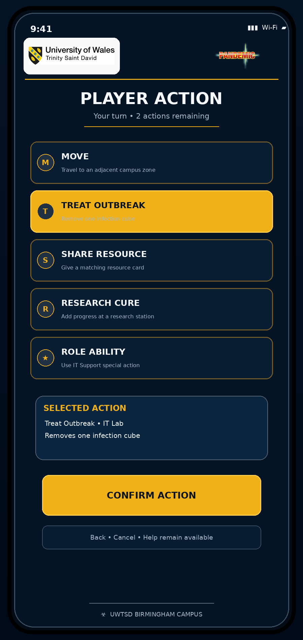
Figure B8. Player Action full-colour mobile storyboard.
Design item | Description
Purpose | Allows the current player to choose, review and confirm an action.
Main interaction | Select an action, review its effect and confirm.
Improvement from Component 1 | Labelled action cards, concise explanations, selected-action summary and confirmation.
Accessibility support | Large labelled controls, strong contrast, consistent layout and redundant text/visual cues.

Appendix B.9: Cure Progress
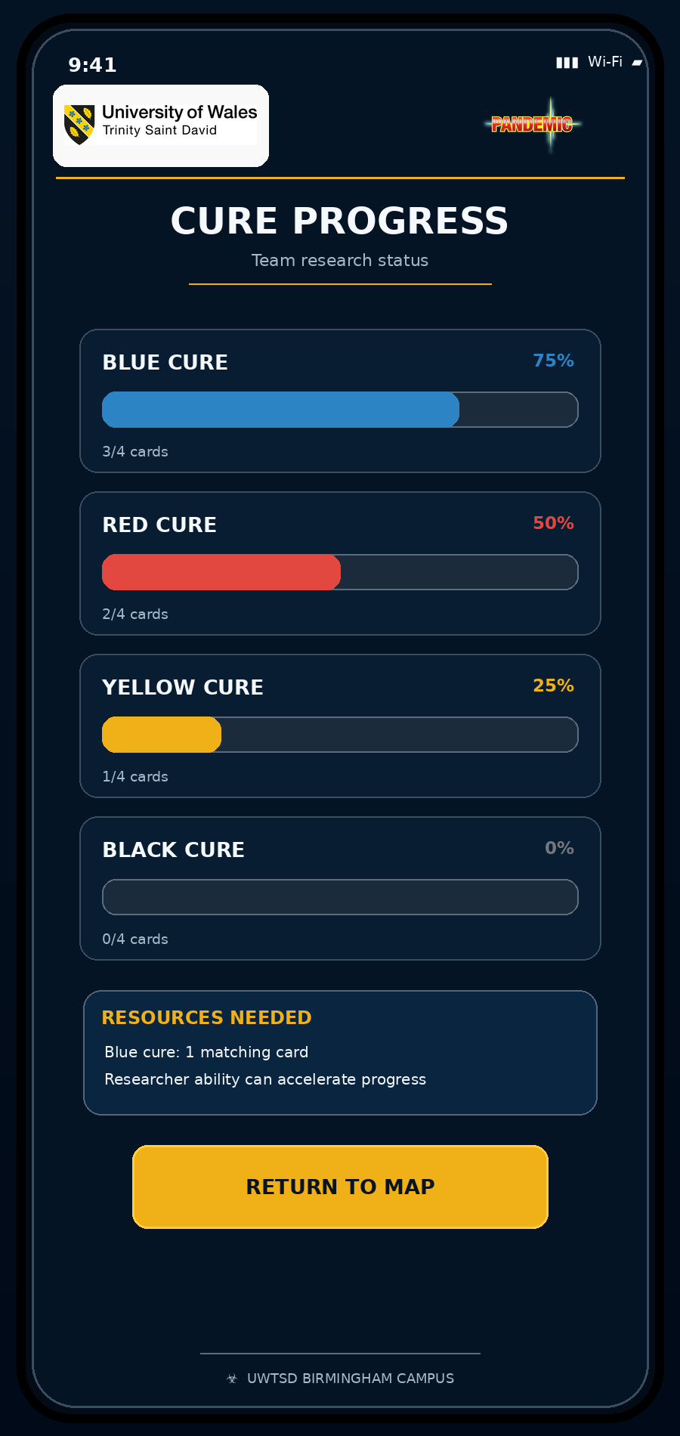
Figure B9. Cure Progress full-colour mobile storyboard.
Design item | Description
Purpose | Shows team research progress and required resources.
Main interaction | Compare cure progress and return to the map.
Improvement from Component 1 | Named progress bars, percentages, card counts and clear resource guidance.
Accessibility support | Large labelled controls, strong contrast, consistent layout and redundant text/visual cues.

Appendix B.10: Team Status
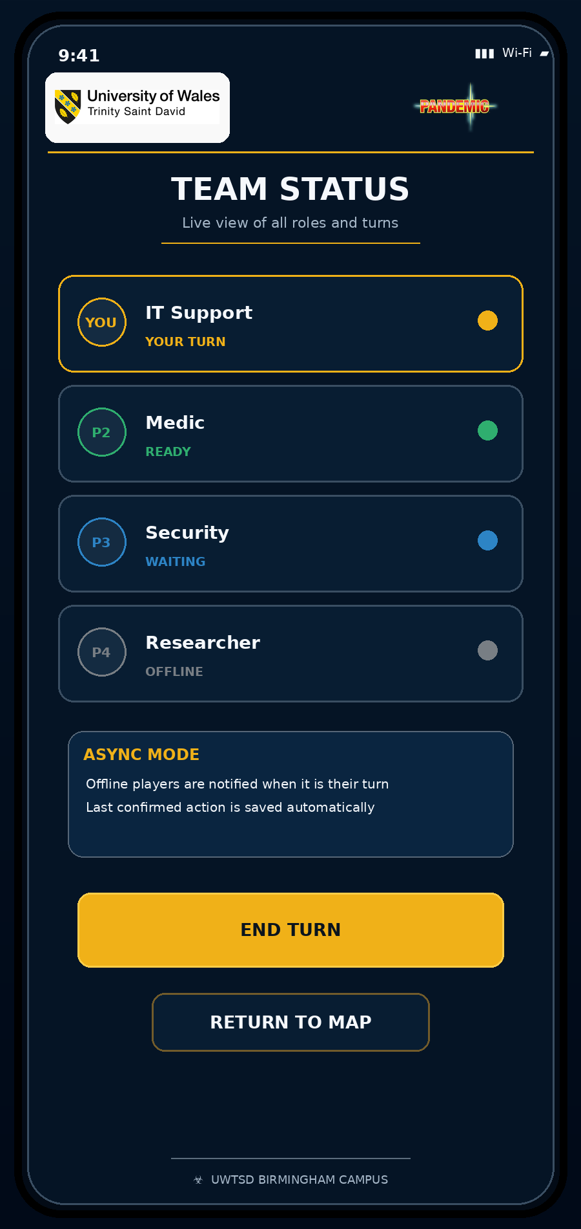
Figure B10. Team Status full-colour mobile storyboard.
Design item | Description
Purpose | Shows role, turn and online/offline state for team coordination.
Main interaction | Check the current turn, end the turn or return to the map.
Improvement from Component 1 | Text plus colour states, current-turn emphasis, asynchronous explanation and map return.
Accessibility support | Large labelled controls, strong contrast, consistent layout and redundant text/visual cues.

Appendix B.11: Mission Result
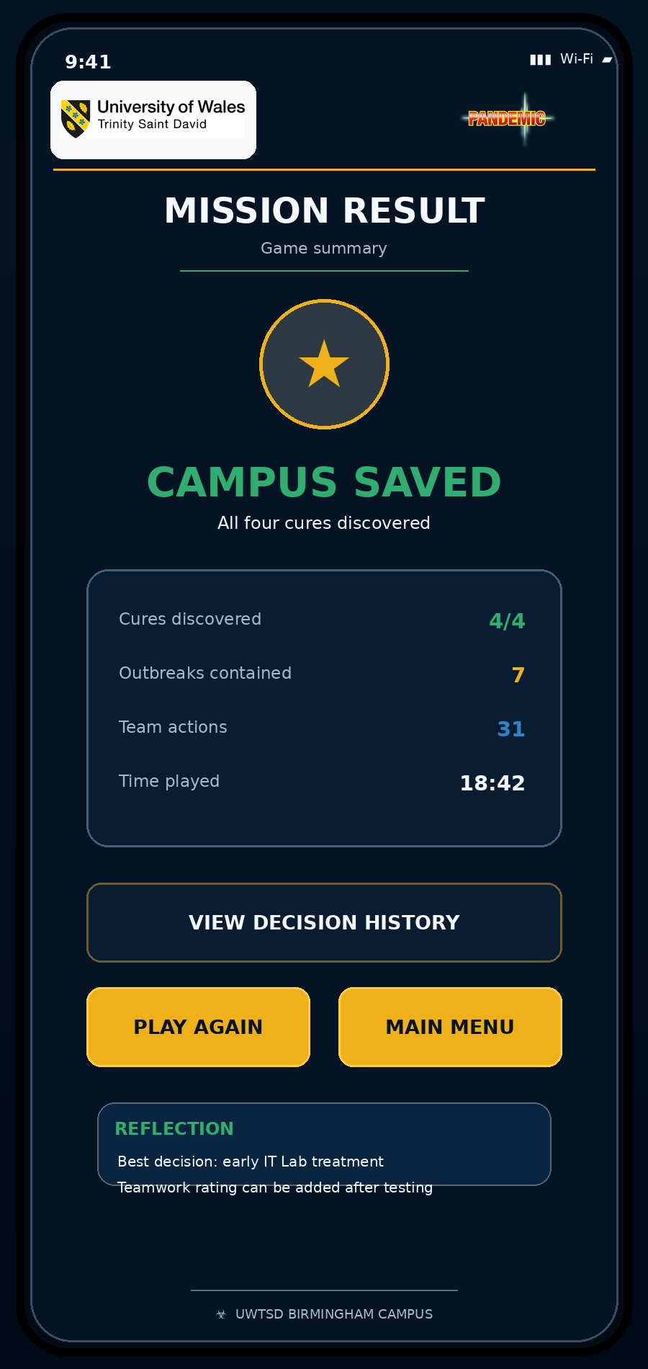
Figure B11. Mission Result full-colour mobile storyboard.
Design item | Description
Purpose | Summarises success, performance and next actions.
Main interaction | Review the outcome, decision history and next choice.
Improvement from Component 1 | Positive closure, readable statistics, decision history, replay and main-menu choices.
Accessibility support | Large labelled controls, strong contrast, consistent layout and redundant text/visual cues.

Appendix C: Participant Briefing and Consent
Study title: UWTSD Pandemic Full-Colour Prototype Usability Test

Purpose
You are invited to test a mobile storyboard for a cooperative university-themed strategy game. The aim is to identify what is clear, confusing, efficient, stressful or enjoyable. The prototype is being tested; your ability is not being tested.

What you will do
- Complete approximately ten short tasks using the prototype.
- Say what you are thinking where possible, including expectations and uncertainty.
- Answer a short questionnaire about clarity, effort, confidence, accessibility and emotional response.
- Allow the researcher to record task completion, time, errors, hesitation and requests for help.

Privacy and voluntary participation
Participation is voluntary. The report should use participant identifiers such as P1-P5 rather than names. Comments should be anonymised. You may stop the session or skip a question. Do not provide sensitive personal information that is not needed for the evaluation.

Consent checklist
Statement | Tick
I understand the purpose of the evaluation. | ☐
I understand that the prototype, not my ability, is being tested. | ☐
I agree that anonymous task observations and comments may be used in the assignment. | ☐
I understand that I may stop or skip a question. | ☐
I agree to participate. | ☐

Participant ID: ____________________ Date: ____________________ Researcher: Abubarkar Dembele

Appendix D: Usability Tasks and Observation Sheet

D.1 Standard Task Sheet
Task | Instruction | Completed? | Time | Errors / help
T1 | Start a new game and identify the purpose of the game. | ☐ Yes ☐ No | _____ | ________________
T2 | Select asynchronous online play and explain how it differs from live play. | ☐ Yes ☐ No | _____ | ________________
T3 | Create a new session or enter a room code. | ☐ Yes ☐ No | _____ | ________________
T4 | Select Birmingham and confirm the choice. | ☐ Yes ☐ No | _____ | ________________
T5 | Choose IT Support and explain its special ability. | ☐ Yes ☐ No | _____ | ________________
T6 | Identify the highest-risk location and the recommended next action. | ☐ Yes ☐ No | _____ | ________________
T7 | Respond to the outbreak and confirm Treat Outbreak. | ☐ Yes ☐ No | _____ | ________________
T8 | Check cure progress and identify what is needed for the Blue Cure. | ☐ Yes ☐ No | _____ | ________________
T9 | Check whose turn it is, end the turn and locate the route back to the map. | ☐ Yes ☐ No | _____ | ________________
T10 | Interpret the final result and choose what to do next. | ☐ Yes ☐ No | _____ | ________________

D.2 Observation Summary
Participant ID | Profile represented | Device / setting | Overall completion | Overall confidence
________ | ________________ | ________________ | ____ / 10 | 1 2 3 4 5

Observation area | Notes
First impression | ________________________________________________________________________________
Main hesitation points | ________________________________________________________________________________
Wrong taps or navigation reversals | ________________________________________________________________________________
Error recovery | ________________________________________________________________________________
Map and priority interpretation | ________________________________________________________________________________
Role and action understanding | ________________________________________________________________________________
Accessibility observations | ________________________________________________________________________________
Emotional response | ________________________________________________________________________________
Most important suggested change | ________________________________________________________________________________

Appendix E: Post-Test Questionnaire
Rate each statement from 1 (strongly disagree) to 5 (strongly agree).
Statement | 1 | 2 | 3 | 4 | 5
The purpose of the game was clear. | ☐ | ☐ | ☐ | ☐ | ☐
I could start or join a game without assistance. | ☐ | ☐ | ☐ | ☐ | ☐
The four play modes were easy to distinguish. | ☐ | ☐ | ☐ | ☐ | ☐
The campus and role selections were clear. | ☐ | ☐ | ☐ | ☐ | ☐
The selected role and special ability were easy to understand. | ☐ | ☐ | ☐ | ☐ | ☐
The outbreak map showed the highest priority clearly. | ☐ | ☐ | ☐ | ☐ | ☐
The outbreak alert communicated urgency without being overwhelming. | ☐ | ☐ | ☐ | ☐ | ☐
The action choices and their effects were clear. | ☐ | ☐ | ☐ | ☐ | ☐
The cure progress screen was easy to interpret. | ☐ | ☐ | ☐ | ☐ | ☐
The team status screen made the current turn clear. | ☐ | ☐ | ☐ | ☐ | ☐
The interface was visually consistent. | ☐ | ☐ | ☐ | ☐ | ☐
The text, contrast, icons and touch targets were suitable. | ☐ | ☐ | ☐ | ☐ | ☐
I could recover from mistakes or return to the map. | ☐ | ☐ | ☐ | ☐ | ☐
I felt confident using the prototype. | ☐ | ☐ | ☐ | ☐ | ☐
I would be interested in playing the game again. | ☐ | ☐ | ☐ | ☐ | ☐

Open Questions
Which screen was easiest to understand, and why?
________________________________________________________________________________________
Which screen was most confusing, and why?
________________________________________________________________________________________
How did the outbreak alert make you feel?
________________________________________________________________________________________
Did the colours and graphics help you understand the game? Explain.
________________________________________________________________________________________
Were any text, icons, controls or screens difficult to see or use?
________________________________________________________________________________________
What single change would improve the prototype most?
________________________________________________________________________________________
Which play mode would you use, and why?
________________________________________________________________________________________
Would you play again? Why or why not?
________________________________________________________________________________________

Appendix F: Results and Feedback Evidence
This appendix summarises the lecturer review and structured review of the responsive prototype. The participant materials remain available for a future wider study.

F.1 Participant Summary
Evidence ID | Source | Scope reviewed | Positive finding | Limitation | Design response | Outcome
E1 | Lecturer review | Report, captions and figures | The work was considered good. | Single academic review. | Refined captions and retained the layout. | Positive
E2 | Responsive layout review | Mobile, tablet and desktop rules | The interface adapts across screen sizes. | No independent device study. | Kept responsive breakpoints. | Implemented
E3 | Navigation review | Eleven-screen journey | The main stages are linked consistently. | No participant timing data. | Kept predictable navigation. | Implemented
E4 | Accessibility review | Large text, contrast and labels | Support controls are visible and non-flashing. | No specialist user study. | Retained redundant cues. | Implemented
E5 | Validation and scope review | Room code, feedback and limitations | Error guidance and scope are explicit. | Not a complete networked game. | Kept validation and clear scope. | Implemented

F.2 Task Results
Task | Available evidence | Status | Limitation | Observation
T1 | Start Screen and purpose statement are visible. | Implemented | First-time understanding not timed. | Start Game is the clear primary action.
T2 | Four play modes have separate labelled cards. | Implemented | Mode comprehension not measured. | Async and live descriptions remain concise.
T3 | Create and room-code routes are shown. | Implemented | Live joining is not connected. | Validation and recovery guidance are present.
T4 | Birmingham and other campuses have selected states. | Implemented | No preference study. | Selection summary confirms the choice.
T5 | IT Support and other roles include abilities. | Implemented | Recall was not measured. | Selected ability is repeated before confirmation.
T6 | IT Lab is marked by colour, value and task text. | Implemented | Scanning time not measured. | Priority does not rely on colour alone.
T7 | Alert leads to Treat Outbreak confirmation. | Implemented | Emotional intensity not measured. | The alert is clear and non-flashing.
T8 | Cure bars show names, percentages and card counts. | Implemented | Interpretation time not measured. | Resource guidance supports the next decision.
T9 | Team states and Return to Map are visible. | Implemented | Real asynchronous play not tested. | Turn and connection states use text plus colour.
T10 | Result shows outcome and next options. | Implemented | Satisfaction not measured. | Replay and Main Menu provide clear closure.

F.3 Feedback Themes
Theme | Positive evidence | Issue / limitation | Evidence source | Design decision
Navigation | Consistent eleven-screen flow. | No independent efficiency data. | Responsive review | Retained predictable routes.
Role clarity | Short abilities appear on the cards. | Comprehension not measured. | Interface review | Kept labels and selected summary.
Map and priority | IT Lab is visible through three cues. | Scanning time not measured. | Interface review | Retained colour, number and task text.
Actions and progress | Actions and cure status include explanations. | No participant error rate. | Interface review | Kept confirmation and progress labels.
Accessibility | Large text, contrast and non-flashing alerts. | No specialist user study. | Responsive review | Retained accessible controls.
Emotional response | Calm-urgency treatment is restrained. | No direct emotion data. | Design review | Avoided unsupported emotional claims.
Presentation | Lecturer considered the work good. | Captions required refinement. | Lecturer review | Standardised captions and presentation.

F.4 Expected versus Actual
Expectation before review | Available evidence | Supported? | Explanation
Labelled controls will support first-time users. | Labels are visible throughout. | Partly | Direct first-time-user evidence is unavailable.
The map will make the IT Lab priority clear. | Colour, value 3 and task text identify IT Lab. | Partly | The cues are present, but recognition time was not measured.
The alert will feel urgent but manageable. | It is non-flashing and includes a recommendation. | Not established | Emotional response requires direct feedback.
Role abilities will reduce confusion. | Each role includes a short ability and selected summary. | Partly | Comprehension was not independently measured.
The mode distinction may need clarification. | Each mode has a separate labelled description. | Partly | A wider user study would confirm understanding.

Appendix G: Final Design Change Log and Submission Checklist

G.1 Post-Test Design Change Log
Issue found | Evidence | Priority | Change made | How the change addresses the issue
Captions needed refinement. | Lecturer guidance | High | Standardised figure captions. | Improves academic presentation and consistency.
Component 1 screens were monochrome. | Component 2 brief | High | Created eleven full-colour screens. | Shows the required visual progression.
The prototype needed responsive evidence. | Design review | High | Added a responsive HTML demonstrator. | Shows mobile, tablet and desktop adaptation.
Source evidence needed to be accessible. | Submission review | Medium | Added prototype and GitHub links. | Allows the artefact and code to be opened.
Accessibility support needed visibility. | Interface review | Medium | Kept large text, high contrast and labelled controls. | Supports clearer and more inclusive interaction.
The alert risked excessive intensity. | Usability-UX review | Medium | Used one non-flashing warning and a recommendation. | Maintains urgency without unnecessary overload.

Responsive Prototype
A responsive HTML demonstrator shows how the full-colour interface adapts to mobile, tablet and desktop screens. It is supplementary evidence rather than a complete networked game.

https://htmlpreview.github.io/?https://raw.githubusercontent.com/Oroshimaru1989/Library/main/ACCB6017-UWTSD-Pandemic-Prototype/index.html

GitHub source-code repository

