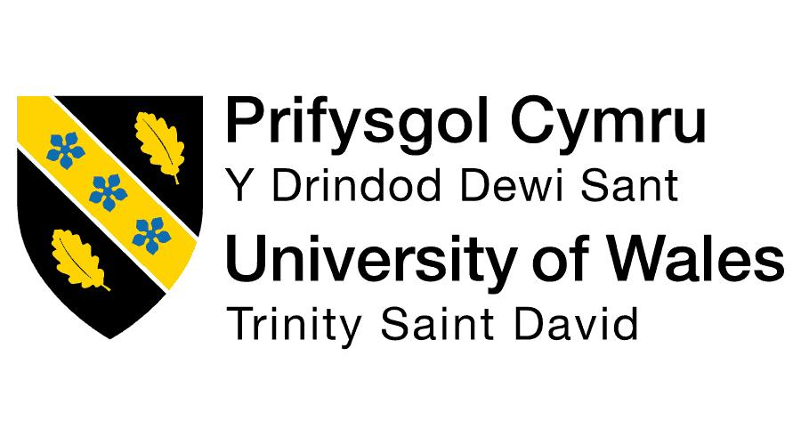
Student Name: Parth Vipulkumar Patel
Student ID: 2532673
Master of Business Administration (MBA)
Module name: Human capital management
Module code: LCMB7023
Assignment component: Individual Report
(Helios)
Lecturer's name: Gladius Kulothungan Eno Maycock
Submission Date: 17 july,2026
Word Count: Approx.2500

DESIGNING A STRATEGIC HUMAN CAPITAL ARCHITECTURE FOR ORGANISATIONAL RENEWAL: A CASE STUDY OF HELIOS URBAN MOBILITY

Table of Contents
TASK A: Socialisation, Identity & Business Activism 3
1. Traditional Onboarding vs Strategic Organisational Socialisation 3
2. Structured Socialisation Framework for Helios 4
3. Building Organisational Citizenship & Business Activism 6
TASK B: Job Design 7
1. Innovative Job Design Strategy 7
2. Motivation & Innovation Outcomes 10
TASK C: Reflective Report 11
1. Responsible AI Decision Support 11
2. Personal Capability Development Plan 11
References 13

TASK A: Socialisation, Identity & Business Activism

1. Traditional Onboarding vs Strategic Organisational Socialisation
The onboarding process in traditional organisations mainly revolves around administrative and operational processes which are used to familiarise the new employees with organisational processes. It typically involves filling out job application forms, presenting employment policies, giving access to technology, orientation and presentation of simple work duties. Although these activities enable the employees to start their work, it is a temporary information sharing and compliance strategy. It rarely takes into account long-term behavioural adaptation, organisation or cultural assimilation commitment and leaves the employees at a loss on what to expect and not connected with the organisation (Ziegler, 2025).
Strategic organisational socialisation is more methodical and wide-ranged in that it is proactive in nature and involves the strategic endeavours of integrating the employees fully into the organisational culture, values, systems and strategic objectives over a certain time span. The process of socialisation is a lifetime process, unlike the onboarding that is a one-time event, which increases employee identity, engagement and performance. Structured learning opportunities, mentoring, ongoing feedback and career development support are provided to new employees to foster higher organisational commitment and quicker adjustment (AbouBakr and ElSerafi, 2023).
The approaches can be distinguished according to a variety of organisational theories. Socialisation Theory developed by Van Maanen and Schein assumes that socialisation strategies that entail institutionalisation like formal orientation, mentoring, sequential learning and collective training reduces uncertainty and accelerates the adaptation of employees. On the other hand, onboarding that is informal is usually unequal and slower to adopt (Parikh, 2022). Psychological Contract Theory goes an extra mile to indicate that employees develop expectations on the organisational support, fairness and career opportunities during the initial stages of employment.
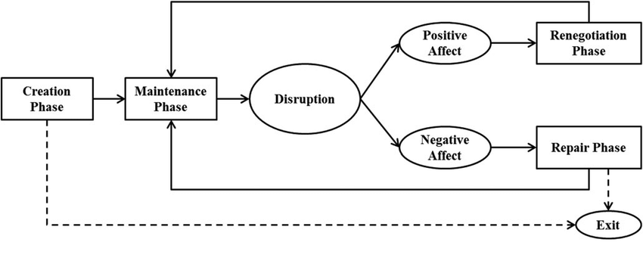
Figure 1: Overview-of-psychological-contract-phases-and-their-interrelations
(Source: researchgate.net,2026)
Identity Construction Theory is the theory that the employees gradually acquire a professional identity in the interactions with the organisational members in the form of meaningful work and internalisation of organisational values. The strategic socialisation therefore develops organisational identification, whereas the traditional onboarding has an inclination to limit identity development.
Such theoretical approaches directly deal with the problems of Helios Urban Mobility. The fact that the organisation took eight months to ramp-up also indicates that there is no clarity of roles and learning support and that there are a declining engagement and attrition of graduates is due to poor psychological contracts and organisational identification. The introduction of a strategic socialisation framework would also hasten the adaptation, employee loyalty and create loyal organisational citizens who can contribute to long term strategic growth of Helios (Alexandro, 2025).

2. Structured Socialisation Framework for Helios
Stage | Key Activities | Justification for Helios
Pre-boarding | Launch a digital pre-boarding programme immediately after offer acceptance. Provide an AI-powered onboarding portal with personalised learning modules, company information, interactive videos and introductions to key stakeholders. Assign each new employee a workplace buddy and discuss organisational values, career opportunities and mutual expectations to establish a positive psychological contract before the first working day (Jiang et al., 2026). | Early engagement reduces uncertainty, strengthens organisational commitment and creates realistic expectations. This accelerates adjustment, shortens Helios' eight-month ramp-up period and lowers the likelihood of early graduate attrition.
First 90 Days | Establish role clarity through clear objectives and performance expectations. Support team integration with collaborative projects, networking sessions and cross-functional meetings. Provide formal mentoring, structured learning pathways, feedback checkpoints at 30, 60 and 90 days, and competency-based performance milestones. | Structured learning and continuous feedback improve confidence, competence and trust while strengthening social integration. These initiatives increase employee engagement, improve productivity and enable faster transition into fully effective organisational contributors.
Year One | Introduce individual career development plans, innovation projects, cross-functional job rotations, continuous professional learning in AI and digital skills, and leadership coaching for high-potential graduates (Bani-Hani, 2021). Encourage participation in strategic business initiatives and long-term capability development. | Long-term development demonstrates organisational investment in employees, strengthens career commitment and enhances retention. Continuous learning and broader organisational exposure improve innovation capability, employee engagement and leadership readiness while supporting Helios' sustainable growth and reducing graduate turnover.

3. Building Organisational Citizenship & Business Activism
Organisational Identification
Helios needs to enhance organisational identification by regularly sharing its mission of coming up with sustainable urban mobility solutions that enhance communities. The employer branding must be robust and work on innovation, cooperation and social responsibility to bring employees on board whose personal values are in line with organisational objectives. The sense of belonging would also be enhanced by team-building exercises, cross-functional teamwork and recognition programme on a regular basis with recognition of innovation, teamwork and customer impact, which would facilitate the development of discretionary behaviours in regard to organisational citizenship (Holm, Kringelum and Anand, 2026).
Ethical Professionalism
The concept of ethical professionalism needs to be instilled by enforcing ethics education, training responsible AI and frequently discussing ethical decision-making situations. A detailed code of conduct should be used to stipulate the anticipated behaviour in terms of integrity, fairness, transparency and data privacy. Leaders should be ethical leaders and continually responsible in their leadership by being good examples and encouraging honesty and communication in making ethical decisions. These practices increase the degree of trust among the employees, minimise organisational risk and accountability in the whole Helios (Kim, 2025). Furthermore, regular ethical audits, transparent reporting system and open communication of ethical issues could be used to encourage employees to report any ethical issue without fear of being punished.
Business Activist Mindset
Helios should create a business activist strategy where the HR professionals adopt the HR Business Partner development suggested by Ulrich where the role of the HR professionals is to become strategic and bring organisational value in addition to the traditional administrative responsibilities (McKean and King, 2024). By using the stakeholder capitalism lens, employees must appreciate their duties to customers, communities, governments and environmental sustainability as well as to financial performance. Participation in sustainability events, employee voice meetings, community participation and organisation-wide innovation competitions would enable the employees to deliver ideas that generate business success and wider social and environmental value, and organisational resilience and competitive advantage in the long term.

TASK B: Job Design

1. Innovative Job Design Strategy
Current Organisational Problems
The fact that employee engagement in Helios Urban Mobility has been decreasing, the length of employee adjustment, and high rate of graduate turnover shows an area of weakness in job design. Constrained autonomy, growth prospects and uncertainties in career promotion degrades staff motivation and innovativeness. Therefore, work redesign should be strategic to make work interesting and retain talented employees and improve performance in organisations.
Job Characteristics Model
The Job Characteristics Model is a very effective model of job redesign created by Hackman and Oldham to enhance the motivation and performance of employees. According to the model, job characteristics that add value to meaningful work experiences and intrinsic motivation are five essence (Matej and Amadeja, 2026).
The degree of skill variety should be improved by letting the employees work in multidisciplinary teams on artificial intelligence, data analytics, engineering and customer solutions. Preparation to different activities expands the competencies and reduces the repetitive work and increases worker satisfaction.
Task identity can be enhanced by allowing employees to deal with complete stages of a project instead of individual tasks. When employees realise how their input affects the end results, they will own up and be responsible towards organisational prosperity.
Task significance should be highlighted by showing how smart mobility technologies at Helios enhance the sustainability of the city, environmental protection and efficiency of public transport. Employees feel more purpose and organisational commitment when they reflect on the wider implications of their activity in the society.
Flexible working arrangements, delegated decision making and self-managed innovation projects should be used to promote autonomy. Greater discretion allows the employees to be more creative and it adds more trust between managers and employees (Ismail et al., 2021).
Finally, feedback must be made ongoing with AI-powered performance dashboards, periodic coaching sessions and peer reviews. Positive and concrete feedback will enable the employees to improve the performance, gain more confidence and enhance their professional development. All these job characteristics comprising redesigns generate more purposeful work experiences and directly tackle Helios engagement and retention issues.
Job Crafting Theory
Job Crafting Theory is a theory that puts forth that employees take charge of altering what they can in their job to enhance job satisfaction, motivation and performance. Employees will be empowered to come up with their job descriptions rather than being provided with a fixed job description based on their strengths, interests as well as career goals and ambitions.
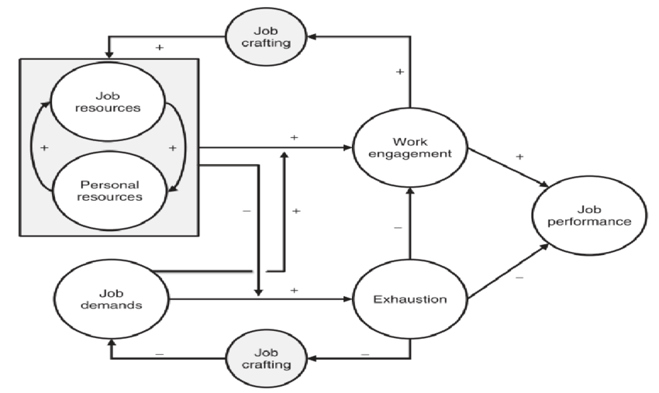
Figure 2: JD-R-theory-with-job-crafting
(Source: researchgate.net,2026)
Workers can modify their job roles by participating in innovation projects, sustainability projects or cross-functional projects, which are not part of their job description as a result of task crafting. At Helios, engineers and analysts would be able to engage in smart city innovation programmes or AI development initiatives at their own discretion that suits their skills.
Relational crafting facilitates development of professional relationship among employees both intra and interdepartmental as well as international. Helios ought to form associative communities, mentoring networks and international project teams between London, Berlin and Singapore employees. More interaction facilitates sharing of knowledge, organisational learning and interpersonal relationships (Bindeeba et al., 2025).
Cognitive crafting assists the employees to redefine their jobs as the service to broader organisational and social objectives. The leaders have to constantly explain how the daily activities of the employees contribute to sustainable urban mobility, accountability to the environment and quality of life of the urban dwellers.
Some of the ways in which Helios can employ job crafting include manager-sponsored development conversations, flexible work planning, innovation workshops and frequent career conversations. The practices help the employees to tailor their work experience and increase the engagement, flexibility and organisational commitment over the long-term.
Skills-Based Architecture / Internal Talent Marketplace
Instead of position-based architecture, which emphasises job titles, Helios should embrace a skills-based architecture, which majorly lays emphasis on employee skills rather than job titles. Roles should be based on critical technical, analytical, leadership and digital competencies required to be successful in organisations of the future.
The assistance of the artificial intelligence, the marketplace of internal talents will be able to identify the skills and learning results of the employees and career interests and, consequently, one will be able to match personalities with the correct projects offered by the company, temporary jobs and permanent positions. The matching skill based on AI assists the employees to locate growth opportunities that they might not have been aware of, and plan organisational workforce (Lee et al., 2023).
The career paths must be well defined and demonstrate advancement in the technical specialist, project leadership and strategic management roles in such a way that employees may be able to realise how they may grow their careers in the long term at Helios. Project market would help in motivating employees to share their special skills to cross-functional innovation projects irrespective of departmental borders.
This loose structure enhances intra-organisational mobility, future potential, minimises external recruitment expenses and enhances employee retention through constant learning and career progression in line with organisational strategy.

2. Motivation & Innovation Outcomes
Intrinsic Motivation
Enhancing autonomy, competence and purpose, via flexible decision-making, continuous learning, mentoring and meaningful work, helps to strengthen intrinsic motivation. These practices are in line with Self-Determination Theory, as they enhance employee engagement, commitment, and innovation as well as decrease graduate turnover. Thus, by designing jobs strategically, retention, workforce capacity and long-term organisational performance of Helios can be improved.
Innovation & Organisational Performance
Also, the suggested job design enhances innovation and the overall organisational performance by fostering a climate that promotes teamwork, lifelong learning and company flexibility.
Internal talent marketplaces and job crafting, in addition to cross-functional teams, are better position to increase the probability of collaboration by uniting employees with different backgrounds and employees in international offices. The knowledge is shared more easily due to increased contact to enable employees to exchange expertise, locate best practices and address more difficult organisational issues (Zapata-Cantu and González, 2021).
Increased autonomy and involvement in the project contribute to creativity and employees are able to test out creative solutions to the AI-enabled mobility systems without feeling overly constrained by bureaucracy. Ongoing learning and leadership that is supportive also promote experimentation and minimise the fear of failure.
This also contributes to the wellbeing of employees because meaningful work, supportive mentoring and career development ensures that workplace stress is minimised and increases their psychological safety. Feeling valued and supported employees are more resilient and committed in the long term (Matej and Amadeja, 2026).
The dynamic architecture based on skills also adds to the organisational agility by enabling Helios to quickly redeploy talent in response to dynamic business demands and technology. Enhanced responsiveness to customer needs and new market opportunities are achieved through faster capability deployment.

TASK C: Reflective Report

1. Responsible AI Decision Support
The rising application of artificial intelligence has changed the way organisations analyse information and aid in decision-making. In my opinion, AI enhances HR practices by handling big data, detecting workforce trends, and providing evidence-based insights to make quicker and more informed managerial decisions. Nevertheless, I understand that AI is to be used in addition to, and not in lieu of, human judgement. Although AI can identify trends and predict outcomes, it does not understand the organisational culture, emotions of employees or ethical issues (Kaggwa et al., 2024). In this regard, critical thinking is crucial to understand AI recommendations and determine their appropriateness in particular organisational scenarios. I also understand that AI systems may be biased according to historic information and this may result in unfair recruitment, performance or promotion decisions. That is why prior to managers making actions based on AI-generated outputs, they have to substantiate them by using professional knowledge, organisational policies and other pieces of evidence.

2. Personal Capability Development Plan
Data Literacy
To improve my data analysis skills, I will improve my data literacy by learning workforce analytics, data visualisation and evidence-based decision-making techniques. I have a SMART goal to complete an approved course in HR analytics within six months and apply the skills in both academic and professional practice in the future (Nwoko et al., 2023).
AI Augmentation in HR
I will get to know how to use AI in practice of recruitment, performance management, and workforce planning. My SMART objective will be to complete specialised education on AI-powered HR solutions within a year and learn and apply new digital tools on a regular basis to be conversant with their possibilities, limitations and ethical implications.
Strategic Influencing Skills
Effective HR professionals should have the ability to impact organisational decisions, by making credible communications and evidence-based recommendations. I will enhance my presentation, negotiation and stakeholder management skills through attending professional workshops, university presentations and group projects. My SMART goal will be to be capable of leading at least three professional presentations in the next twelve months and improve my abilities in driving strategic organisational choices (Ghedabna et al., 2024).
Global Mobility Awareness
Such global workforce management, cultural diversity and international employment practices will be more aware to me as organisations will continue to work across international borders. The SMART objective will be to complete a cross-cultural management course within the next year and keep reading about the practices in the international HR that will be adopted in multinational companies (Zhao et al., 2023).
Personal Learning Goals & Continuous Development
I will embrace lifelong learning as a way of ongoing professional development that involves reflection and interaction with professional HR materials. With the regular self-evaluation of my advancement towards SMART objectives and the use of positive feedback, I aspire to become flexible, technologically proficient and capable of taking up future strategic HR leadership roles.

References
Journals
AbouBakr, D. and ElSerafi, T., 2023. City Growth Challenges as a Dilemma between Urban Mobility and Livability: A Case Study of Heliopolis. Civ. Eng. Archit, 11(4), pp.1795-1813.
Alexandro, R., 2025. Strategic human resource management in the digital economy era: an empirical study of challenges and opportunities among MSMEs and startups in Indonesia. Cogent Business & Management, 12(1), p.2528436.
Bani-Hani, J., 2021. The moderating influence of managers strategic thinking on the effect of talent management on organization core competency. Management Science Letters, 11(1), pp.213-222.
Bindeeba, D.S., Tukamushaba, E.K., Bakashaba, R. and Atuhaire, S., 2025. Green human resources management and green innovation: a meta-analytic review of strategic human resources levers for environmental sustainability. Discover Sustainability, 6(1), p.650.
Ghedabna, L., Ghedabna, R., Imtiaz, Q., Faheem, M.A., Alkhayyat, A. and Hosen, M.S., 2024. Artificial intelligence in human resource management: Revolutionizing recruitment, performance, and employee development. Nanotechnology Perceptions, 20(S10), pp.52-68.
Holm, C.G., Kringelum, L. and Anand, A., 2026. Creating effective strategy implementation: a systematic review of managerial and organizational levers. Review of Managerial Science, 20(2), pp.673-705.
Ismail, A., Majid, A.H.A., Rahman, M.A., Jamaluddin, N.A., Susantiy, A.I. and Setiawati, C.I., 2021. Aligning Malaysian SMEs with the megatrends: The roles of HPWPs and employee creativity in enhancing Malaysian SME performance. Global Business Review, 22(2), pp.364-380.
Jiang, Z., Wu, C.H., Xu, A.J. and Van De Voorde, K., 2026. Thriving at work: A synthesis of human resource management perspectives and a future research agenda. Human Resource Management, 65(1), pp.133-149.
Kaggwa, S., Eleogu, T.F., Okonkwo, F., Farayola, O.A., Uwaoma, P.U. and Akinoso, A., 2024. AI in decision making: transforming business strategies. International Journal of Research and Scientific Innovation, 10(12), pp.423-444.
Kim, Y., 2025. A strategic approach to CEO activism: issue selection and communication of motives. Journal of Marketing Communications, 31(8), pp.959-981.
Lee, C.C., Yeh, W.C., Yu, Z. and Luo, Y.C., 2023. Knowledge sharing and innovation performance: a case study on the impact of organizational culture, structural capital, human resource management practices, and relational capital of real estate agents. Humanities and Social Sciences Communications, 10(1), p.707.
Matej, Č. and Amadeja, L., 2026. Work has changed, has HRM? Designing for the distributed, fragmented, and fluid era. Human Resource Management, 65(2), pp.305-324.
McKean, A.E. and King, B.G., 2024. When ideologies align: Progressive corporate activism and within‐firm ideological alignment. Strategic Management Journal, 45(12), pp.2459-2518.
Nwoko, J.C., Emeto, T.I., Malau-Aduli, A.E. and Malau-Aduli, B.S., 2023. A systematic review of the factors that influence teachers’ occupational wellbeing. International journal of environmental research and public health, 20(12), p.6070.
Parikh, V.C., 2022. Strategic talent management in education sector around organizational life cycle stages. JOURNAL OF THE ASIATIC SOCIETY OF MUMBAI, SSN, pp.0972-0766.
Zapata-Cantu, L. and González, F., 2021. Challenges for innovation and sustainable development in Latin America: The significance of institutions and human capital. Sustainability, 13(7), p.4077.
Zhao, Y., Zhang, T., Dasgupta, R.K. and Xia, R., 2023. Narrowing the age‐based digital divide: Developing digital capability through social activities. Information Systems Journal, 33(2), pp.268-298.
Ziegler, M.T., 2025. Critical intuitions in stakeholder theory and political CSR: The effect of identity constituting values on the dynamics of business ethical debates. Humanistic Management Journal, pp.1-19.
Websites
researchgate.net,2026. JD-R-theory-with-job-crafting. [Online]. Available at: https://www.researchgate.net/figure/JD-R-theory-with-job-crafting_fig5_364058370 [Accessed on: 30.06.2026].
researchgate.net,2026. Overview-of-psychological-contract-phases-and-their-interrelations. [Online]. Available at: https://www.researchgate.net/figure/Overview-of-psychological-contract-phases-and-their-interrelations_fig1_324565677?__cf_chl_f_tk=4fO1Cxk5lqQeDBgxrfiOt7Jnhok1eecyge4TVF1KLLU-1782797339-1.0.1.1-.ZV7.Kw5snXIOekQK.1MRbsO1a8HVwQDxmR_b0vhVX4 [Accessed on: 30.06.2026].

