CRITICAL ANALYSIS OF INDIVIDUALISED CARE AND COLLABORATIVE PRACTICE IN THE UK
Assignment Title: Component 2 – Written Assignment (Report)
Student Name: [ANISA KARIM]

Table of Contents
1.0 Introduction 3
2.0 Critical Appraisal of Person-Centred Care 3
3.0 Theoretical Foundation: Carl Rogers’ Humanistic Model 5
4.0 Ethical Dimensions of Integrated Care 6
5.0 Evaluating Partnership Working (PW) 8
6.0 Practical Application: Inpatient Mental Health Unit 8
7.0 Policy and Legislative Framework 9
8.0 Recommendations for the UK Sector 10
9.0 Conclusion 10
10.0 References 12

1.0 Introduction
In the modern UK health and social care scene, care delivery is paradigmatically different than it was before: the paternalistic model of health care and this clinician-centred model is replaced by the collaborative model and the model centred around individual agency. This report is a critical analysis of Person-Centred Care (PCC) and Partnership Working (PW) in the statutory sectors in the health and social care of the UK.
In order to develop a firm best understanding, Person-Centred Care (PCC) is described by World Health Organization (2015) as a strategy that acts out with the awareness of individual, family, and community as stakeholders in, and beneficiaries of reliable health systems. It is not just an approach but a philosophy that regards the service user as a personality with his or her biography. In line with this, Partnership Working (PW) means a relationship of collaboration between various professional groups sharing a common goal without prejudice on the individual knowledge and professional boundary (Holman et al., 2025).
This analysis dissects the humanistic theories that support these principles, ethical standards that govern the operations of professionals, and laws and legislations that have been set by the government of the UK. The report applies the concept of multidisciplinary collaboration to a case study of a mental health inpatient setting and ends with recommendations of strategic advice on how this system can be improved.

2.0 Critical Appraisal of Person-Centred Care
PCC, fundamentally, is a denial of the so-called paternalistic approach to the medical model, in which the clinician is the decision-maker only. Rather than that, it enhances a culture in which the lived experience by the service user is treated as equal to clinical expertise and shifts the question given in response to a question of: What is the matter with you? to "What matters to you?"
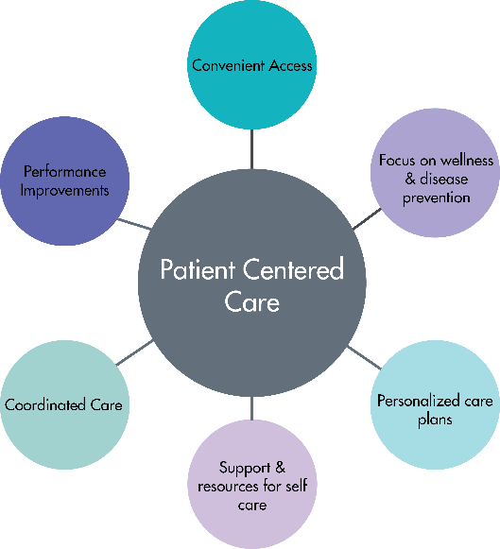
Figure 1: PCC

2.1 Drivers and Advantages of Individualised Care
The major benefit of person-centred approach is that it facilitates the development of so-called self-efficacy. By enabling service users to be engaged in their personal care planning, service users show an increased degree of engagement and better long-term health outcomes (Canais and Nunes, 2024). PCC becomes a recovery tool in mental health, and addressing the strengths of the individual, as opposed to merely his diagnosis.
This strategy assists in the spirit of the No Decision About Me, Without Me, which is the current ethos that is promoted by the NHS. Through considering the person as an expert by experience, the practitioners are able to co-create realistic and sustainable care plans. An example is the inclusion of creative interests of the user of the bipolar service in the persona-centred care plan, which a medical care plan would not consider as a protective factor.

2.2 Obstacles, Critiques, and Implementation Gaps
Most importantly, PCC may not be easy to apply in a place of high risk. The role of law in ensuring the safety of the populace and school personnel can sometimes be inconsistent with the use by a user, therefore, which is an aspect of the so-called locked-ward culture where the subculture of choice is in opposition to the law. In addition, according to Sidani et al. (2018), the problem of tokenistic involvement is still the issue. This happens when the users are called to meetings due to compliance, but their opinions are not incorporated to the final clinical decisions.
There is also a major obstacle of resource scarcity. Being person-centred takes time to establish good relationship and engage as listeners. When the system is geared towards fast bed clearance, such high vacancy rates, and clinical throughput, practitioners may get pushed to think they must adopt a clinical, as opposed to emotional, person-centred approach resulting in a form of care that is bureaucratic.

3.0 Theoretical Foundation: Carl Rogers’ Humanistic Model
In order to get the psychological process of PCC, we should consider the scheme laid down by Carl Rogers. The Person-Centred Approach, formulated by Rogers (1961) assumes that a person to self-actualise or grow needs the environment that will offer them three conditions, which Rogers called the core conditions.
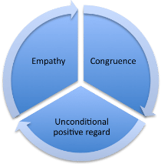
Figure 2: Carl Rogers’ Humanistic Model

3.1 The Three Core Conditions in Practice
- Empathy: The practitioner should seek to take an interest in knowing the world of the service user as though it were his or hers although should never lose the aspect of as if. This is the ability to reflect the feelings of the user to demonstrate that he is really heard.
- Congruence (Genuineness): The practitioner has to be authentic and open. Rogers came up with the argument that as long as the practitioner conceals himself behind a professional mask, the service user will be aware of the inauthenticity and he will not develop the kind of credibility required to recover.
- Unconditional Positive Regard: This is a non-recognition of the reality of the service user. This is to look beyond the symptoms in a mental health meaning to accept them regardless of whether the person is in a crisis or is acting in a difficult way.

3.2 Relevance to Modern Care Pathways
The theory by Rogers is essential since it shifts the emphasis on a patient to a person to be fixed and instead aimed to be supported. This is portrayed in the contemporary practice as in the methods of Active Listening and Motivational Interviewing applied to psychiatric nursing. When a service user can feel unconditionally understood and unjudged (Unconditional Positive Regard), he or she can confess his/her suicidal ideation or drug drugside effects and a more precise and risk-free care arrangement can be developed (McGarry, 2020). The absence of these humanistic conditions makes care sterile and clinical and does not seek the emotional cause of mental distress.

4.0 Ethical Dimensions of Integrated Care
Ethical codes regulate professional practice that contributes to safety, fairness and accountability. Being in the overlap of PCC and PW, it is necessary to balance rival ethical values all the time (Banks, 2020).
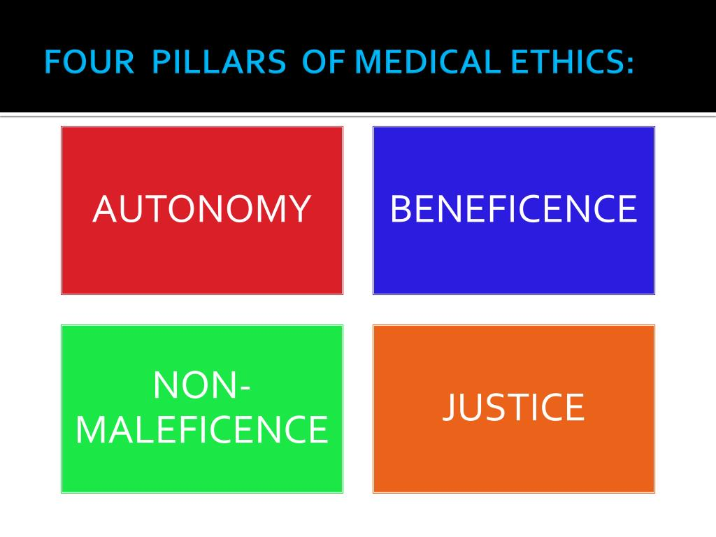
Figure 3: 4 Principles

4.1 Autonomy vs. Paternalism
Although PCC values Autonomy (the right to choose) occasionally Paternalism (acting in the best interest of the patient against his or her will) becomes a legal and ethical requirement. This is the most apparent in the Mental Capacity Act 2005. When an individual is unable to make a certain choice where he is impaired by the mind, it is the obligation of the professionals who must decide according to his or her Best Interest.
This best-interest ethical dilemma is to make certain that such decisions are not only what the physician desires, but based on the past wishes, beliefs, and values of the individual. According to Childress and Beauchamp, (2022), it should be aimed at the maximum amount of freedom, which means that only to the extent to which the personal safety of the individual is the most fundamental, their freedom is limited.

4.2 Fidelity, Teamwork, and Confidentiality
Fidelity (faithfulness to the service user) ethical principle may be tested in a partnership working, as service needs of the team may be conflicting. A user could self-disclose to a support worker a confidential fact, which shows a potential risk of harm. The worker is in the dilemma of protecting the trust of the user (Fidelity) or telling the Multi-Disciplinary Team (MDT) who will also help to keep the information safe (non-maleficence). This shows the importance of the clarity of the Informed Consent at the beginning of any partnership intervention, where the user is entirely convinced about how and why their data is going to be distributed amongst various experts (Parrott, 2018).

5.0 Evaluating Partnership Working (PW)
The complexity of the modern healthcare has been addressed by partnership working as a response to complexity. It considers that no single agency has the entire set of skills needed to assist an individual with a complex set of needs.

5.1 The Benefits of Multi-Agency Collaboration
With integrated care systems, one can view a person in a holistic manner. Indeed, an example of partnership between a psychiatrist, a housing officer and a vocational therapist is to make sure that a service user is not only clinically stable, but that he/she also has a safe place to stay and the purpose. This integrated strategy is demonstrated by decreasing the so-called revolving door syndrome, when patients leave the hospital only to go back several weeks later due to the lack of regulations of their social issues (Bundy, 2020).

5.2 Barriers: Professional Identity and Power Dynamics
One of the major obstacles to PW is the conflict of professional identity. According to Hean et al. (2018), various professions possess diverse languages. Physicians might speak with technical medical jargon and the social workers with a social-justice-based one. It might cause severe misconceptions in the preparation of care.
More so, power imbalances are very likely to exist. The views of the housing officers or even that of service user are often overridden by the beliefs held by clinical psychiatrists. This chain of command compromises the partnership aspect of the teamwork resulting in a plan which might be medically right yet socially unacceptable.

6.0 Practical Application: Inpatient Mental Health Unit
In a psychiatric ward, the implementation of PCC and PW is seen through the Care Programme Approach (CPA). The CPA is a framework for planning and coordinating mental health care.

6.1 The Collaborative Process in the MDT
Within this setting, the partnership includes:
- The Service User: Attending their own ward rounds and setting personal recovery goals.
- Psychiatrists: Managing clinical risk and medication regimens.
- Mental Health Nurses: Providing 24-hour observation and emotional support.
- Independent Mental Health Advocates (IMHA): Ensuring the service user’s legal rights are protected, especially during Mental Health Act tribunals.
- Occupational Therapists: Assessing the user's ability to perform activities of daily living (ADLs) upon discharge.

6.2 Analysis: Transitioning from Hospital to Home
In such the environment, it is necessary to control through partnership working to control the discharge pathway. In case the hospital team fails to cooperate with the Community Mental Health Team (CMHT), the service user will be released into the vacuum. Person-centred partnership can be more recently seen through the example of the use of peers as mentioned support workers, which are people who have been recovered of similar issues within the team (Perkins and Repper, 2019). These employees help close the gap between the terms of professional and patient, which makes the clinical process look more human and less bureaucratic.

7.0 Policy and Legislative Framework
The UK government has implemented several layers of legislation to enforce the adoption of PCC and PW.

7.1 The Mental Capacity Act 2005
This is one of the pillars of the person-centred practice. It begins by assuming that all adults are adults with the ability to make their decisions unless proved otherwise. It stipulates that individuals shall be assisted to make their personal choices within all the possible means (e.g. simplified language or visual tools) before considered incapable which is directly related to the principles of empowerment introduced by Rogers (Department for Constitutional Affairs, 2005).

7.2 The NHS Long Term Plan (2019) and 2022 Reforms
NHS Long Term Plan (2019) envisions the scenario in which Personalised Care will become a normal right. It also focuses on the concept of Social Prescribing, in which GPs have the ability to support patients by sending them to community groups instead of merely socialising social issues as an illness to be addressed by medicines. It was also reinforced by the Health and Social Care Act 2022 whereby the establishment of the Integrated Care Boards (ICBs) was legally required to provide the cohesion of health and social care budgets, compelling the partnership to work at a high level of management (NHS England, 2019).

8.0 Recommendations for the UK Sector
To ensure that PCC and PW continue to evolve, the following three recommendations are proposed:
- Investment in Social Prescribing and Voluntary Partners: The UK needs to institutionalise the place of the voluntary sector in psychiatric discharge. Charities and local assets within a community are most likely to provide more person-centred social support than large bureaucratic NHS trusts.
- Values-Based Recruitment and Training: Providers are supposed to hire employees according to how they many correspond with the conditions of Rogers (empathy and genuineness). Though it is possible to teach technical skills, the skill of creating a person-centred therapeutic alliance is sometimes an inbuilt quality and should thus be considered a priority during hiring.
- Joint Information Systems: A key barrier to collaboration is the lack of sharing of data. It must require the use of one digital care portal where mental health nurses, social workers, and GPs would access the same person-centred care plan in real-time, which does not require the user to tell the same story to different professionals (HCPC, 2023).

9.0 Conclusion
This report has shown that the pillars of a modern, ethical health and social care system are Person-Centred Care and Partnership Working. Although the theory by Carl Rogers offers the psychological basis of an individual related to the dignified and compassionate treatment, the law in the form of Mental Capacity Act guarantees that the right is fixed in the legislation. Nevertheless, given the adversarial dynamics of professional power and lack of resources, the shift in person-oriented integrated system is the most promising approach of service users to attain holistic recovery. To achieve success going forward requires that we go beyond the idea of the professional silos and embrace a culture of genuine collaboration and value generation extending beyond any specific functional area to include a person at the centre of all decisions.

10.0 References
Banks, S., 2020. Ethics and values in social work. Bloomsbury Publishing.
Bundy, C., 2020. The challenge of rethinking Mandela. In Reassessing Mandela (pp. 1-16). Routledge.
Canais, E. and Nunes, L., 2024. People with multiple long-term health problems: personalised care planning. Portuguese Journal of Public Health, 42(1), pp.63-73.
Childress, J.F. and Beauchamp, T.L., 2022. Common morality principles in biomedical ethics: responses to critics. Cambridge Quarterly of Healthcare Ethics, 31(2), pp.164-176.
Department for Constitutional Affairs (2007). Mental Capacity Act 2005 Code of Practice. London: TSO. Available at: https://www.gov.uk/government/publications/mental-capacity-act-code-of-practice
Health and Care Professions Council (HCPC) (2023). Standards of Conduct, Performance and Ethics. London: HCPC. Available at: https://www.hcpc-uk.org/standards/standards-of-conduct-performance-and-ethics/
Hean, S., Green, C., Anderson, E., Morris, D., John, C., Pitt, R. and O’Halloran, C., 2018. The contribution of theory to the design, delivery, and evaluation of interprofessional curricula: BEME Guide No. 49. Medical teacher, 40(6), pp.542-558.
Holman, K.C., Wilson, K.P., Knollman, G. and Russell, A., 2025, August. Competency-based interprofessional education enhances collaboration skills in special education and speech-language pathology students. In Frontiers in Education (Vol. 10, p. 1581257). Frontiers Media SA.
McGarry, A., 2020. The development of additional propositions of the actualising tendency: Person-centred theory and practice. The Person-Centered Journal, 25(1-2), pp.68-82.
NHS England (2019). The NHS Long Term Plan. London: NHS England. Available at: https://www.longtermplan.nhs.uk/
Parrott, J., 2018. The golden rule in Islam: Ethics of reciprocity in Islamic traditions. University of Wales Trinity Saint David (United Kingdom).
Perkins, R. and Repper, J., 2019. Where is peer support going?. Mental Health and Social Inclusion, 23(2), pp.61-63.
Rogers, C. R., 1961. On Becoming a Person: A Therapist's View of Psychotherapy. London: Constable.
Sidani, S., Reeves, S., Hurlock-Chorostecki, C., van Soeren, M., Fox, M. and Collins, L., 2018. Exploring differences in patient-centered practices amongst healthcare professionals in acute care settings. Health communication, 33(6), pp.716-723.
World Health Organisation (WHO) (2015). WHO Global Strategy on People-Centred and Integrated Health Services: Interim Report. Geneva: World Health Organisation. Available at: https://apps.who.int/iris/handle/10665/180984

