

MODULE CODE: ACCC5005
PROJECT MANAGEMENT

Lecturer Name: Modak Koushik

Name: Octavian Cristian Libotean
Student ID: 1815958

Contents

Introduction 2
Project Plan 3
Methodology 6
Risk Management 8
Quality Assurance 9
Conclusion 10
References 11

Introduction
It has been very common in the past there if there is any product that is being developed that in that case it is very important to make sure that the management of all the operations that are involved in that project is done in a proper manner. The project might involve multiple steps such as development, testing, resource gathering, etc. All the stages must be developed properly and therefore project management must be very efficient and accurate. Organization that has been taken into consideration for the given scenario is Japher Motors. The organization is looking for developing a project for the various business services that are being provided by them such as repairs for automatic as well as manual cars and selling spare parts. In the report that is going to be created below, a proper discussion over how project management of all the tasks that are done in this organization can be done has been done.

Project Plan
Project plan is considered to be one of the most important aspect of any project management process because the way in which a project can be planned has a huge impact over the overall quality of the project. For the planning of the given project a proper Gantt chart and work breakdown structure was created we understand the deadline of the project as well as the stakeholders that might be involved in it. All the stages involved in the project plan were kept in mind while the development of these two components.
WBS:
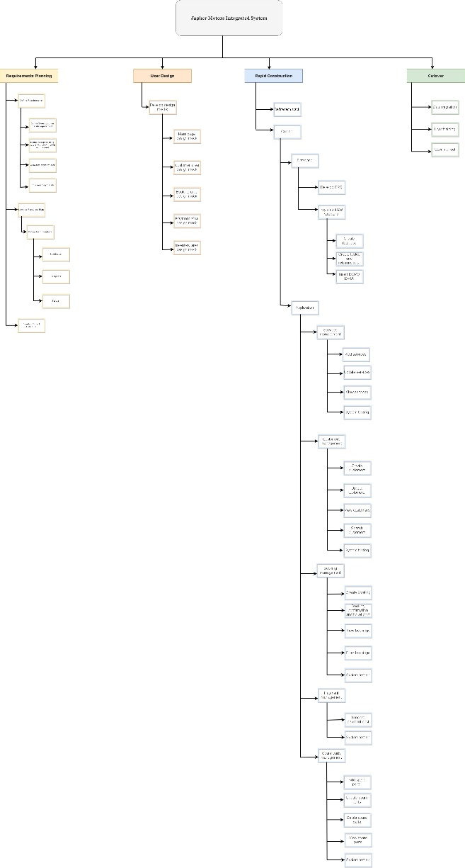
Gantt Chart & Time estimation:
As per the project plan that has been developed it can be said that there are mainly four stages in which the whole project development is divided. The first stage is planning all the requirements and resources that might be needed for the integrated system that is to be created for Japher Motors.
There are multiple steps that are involved in the first stage of project management which is requirement gathering. The First step is to define all the requirements that might be needed for the development of the project, the various services that are being provided by Japher Motors must be kept in mind while defining all the requirements such as spare parts selling and repairing of automated as well as manual cars. The resources that might be required for performing all these tasks must be considered as basic requirements for the project. A resource plan must also be developed which might involve defining the team members as well as the project schedule.
The second stage of the project plant that has been created is the user design which includes the development of mock designs that can be very much useful for understanding the way in which the actual development of the project would be done. There are multiple steps that might be present in it such as development of different activities that would be present in the integrated system. One of the major tasks of this stage is to make sure that all the heuristic principles are being followed during the design of the project. The different activities would be created in this stage such as payment area, booking area, inventory area. The male design of the integrated system would not be completely similar as the design that has been created in this case but the components would be similar.
The third stage of the whole process is rapid construction that involves defining the tech stack which means coding and development of the database further given project. The development of entity relationship diagram is also done in this stage only along with development of demo data so that it can be checked whether all the operations in the database are being done properly or not. The rapid construction of the project also involves customer management in which the information that has been provided by any customer would be stored. The operations that would be done whenever a new customer will be added in the system or whenever any customer would update their details are also defined in this stage only. Booking and payment management is also done in the rapid construction stage of the integrated system for the organization.
The last step or the last stage of the whole task which is to develop the project for the integration system of Japher motors is known as cutover. In this stage there would be 3 main tasks that would be done such as data migration in which the whole database which actually exists in the database of the organization would be transferred to the integrated system so that actual implementation of all the operations associated with the database can be done.
This step is only completed once the testing of the integrated system is done on the basis of the demo data that was created. If the system is known to be working properly with the demo data then in that case it is assumed that it will also work properly with actual data and therefore the data is migrated to this system.
The second step that is involved in cutover process is to train all the users or the employees of the organization who would be newly introduced to this system. There have been multiple instances in the past and budget has been seen that the system that has been introduced in the organization is quite effective but because of improper training provided to the employees, they are not having the ability to use that system to its full efficiency. Therefore, in this case all the employees were involved in the various operations of Japher Motors, would be trained in a proper manner to make sure that these operations are being done in a proper manner.
The last step of cutover process is to provide a user manual so that all the people that would be using this integrated system can also understand even after they have been trained in a proper manner. There might be some of the applications of the system that might not be clear to the employees while they were being trained and therefore to make sure that they have minimum issues in such cases, a proper documentation of the usage of whole system would be created in the form of a user manual so that such issues are not faced by the employees.

Methodology
The main methods that were used for development of the given project but based upon quantitative as well as qualitative analysis. There were data collection tools that were used to make sure that if there are any issues in the development of such project which include creating an integrated system for a large-scale organization, then in that case these issues can be it is all good as soon as possible.
The methodology that was used for the development of the project was agile methodology. The reason for the selection of search methodology was to make sure that reiteration of all the modules can be done. The agile methodology has various advantages such as proper communication can be done between the developer as well as the client so that if there are any change from the end of the developer then in that case it can be made as soon as possible even after the project development is started. All the modules that are involved in the agile methodology can also be tested just after they are created. Once, the development of all the modules is done then in that case an integrated testing can also be done in this methodology.
There are certain aspects of any project management system that must be checked to make sure that the quality of the project is accurate and efficient enough so that it can be used in the organization. One of the main aspects of this project is the input. For the development of the integrated system for Japher Motors, it must be made sure that the input that is being given to the system has no errors so that it can be made sure that the output would be as accurate as possible. The activities of the integrated system must also be made in a proper manner so that it is easier for any user to use it. The output that is being created by the system according to the input must always be accurate so that proper decisions can be made in the organization according to their output. The way in which the results that would be analyzed according to the output would also be playing a massive role in the way in which future plans of the organization might work. Once all the tasks are done and all the aspects are verified then in that case the final component is the impact of the implementation of such project over the organizational growth of the organization which is considered to be the ultimate goal of the project development.
Qualitative data collection tools are also used for understanding the whole project in a proper manner. The face-to-face interviews of the people who have done research in the same topic in the past few years was done to understand what are the major issues that might be faced in the development of such projects. Online literature resources were also gone through to understand the previous works that have been done in the past on the same topic of integrated system development for any organization. Different project plans were created and out of all of them the best plan was chosen according to the budget as well as the efficiency of the plan. Communication was done to experts in this field by the help of email or phone so that some basic knowledge about such project can also be known. These were some of the evaluation methods that were used to understand whether the steps that are taken for the given project are accurate or not.

Risk Management
Following are the various risks that might involve in the development of the project and methods that can be used for resolving these issues.
One of the major risks for the development of the integration system is the security risk in terms of all the data of the customers that would be present in the database of the system. It is very much possible for a newly created database to have multiple vulnerabilities that must be tested before the system is being implemented properly. There have been multiple instances in the past in which it has been seen that whenever a new database is created for any organization then in that case it takes time to implement the security measures that might be used for it and therefore in the meantime external attacks can be done over the database and confidential information of the customers can be manipulated or stolen.
Another one of the major concerns during the development of the integrated system for a automobile preparing organization is improper communication between the inventory as well as the sales department. The development of the system must be done in such a way that whenever there is any item that is less in amount and more in demand then in that case proper notification must be sent to the inventory so that if the item is available in the inventory then in that case it can be sent to the store and if it is not available in the inventor then an order can be placed for getting it to the inventory and then to the store.
To make sure the security of the system is not breached, the possible vulnerability that might be present in the integrated system should be analyzed before the migration of the actual data is done. It must also be made sure that proper security measures must be implemented as soon as the new database has been introduced. The security measures might include AES encryption algorithm or the development of a firewall to make sure that no such attacks are being done over the system.
The way in which the communication must be done between the inventory and the store, should be analyzed and planned before the implementation of the project so that such issues does not arrive. There have been multiple instances in the past investor relevancy in that the notification is sent to the inventory after the item is unavailable at the store which creates a lot of time gap that might cause a heavy loss to the organization if the item is in high demand.

Quality Assurance
The approach that is made to ensure the quality of the project might have some issues that must be mitigated as soon as possible to make sure that whenever the testing or the quality assurance process of the project is being done then in that case it can be done with highest efficiency and as a result, an integrated system with minimum issues or no issues must be obtained. There are many cases in which the team that is involved in the quality assurance process is not having the idea about the way in which the whole project would be working. They are just provided with the test cases and their poor if there is any additional issue in the system then in that case it won't be known to the quality assurance team. This type of approach is known as black box testing. IF the quality assurance team would be having the idea about the way in which the whole system would be working then in that case all the issues that might be present in the system would be detected and according to the impacts of them over the system, resolution would be provided to all of them.

Conclusion
In the report that has been created above, a proper discussion over the development of the integrated system for Japher Motors has been done. A robot project plan was created to understand the way in which the project management would be done which included a Gantt chart and a work breakdown structure. The way in which all the risks that might be involved in the development of the project can be mitigated has also been one of the key points of discussion of the given report. The report also talks about the process of quality insurance for such project and how different methodologies would be contributing to the efficiency as well as the accuracy of the project that is being read.

References
Aljamee, H.K. and Naeem, S.M., 2020. The benefits of applying project management methodology on project delay: A study in construction projects in Iraq. MS&E, 745(1), p.012155.
Boris, P.N. and Svejvig, P., 2020. PRELIMINARY RESEARCH RESULTS: Survey on project management methodologies used in the Half Double Community.
Bushuyev, S., Bushuieva, V., Bushuiev, D. and Bushuyeva, N., 2020, September. Hybridisation of IT Project Management Methodologies. Complementary or Contradictory? In Conference on Computer Science and Information Technologies (pp. 324-342). Springer, Cham.
Cicala, G., 2020. Understanding Project Management Concepts. In The Project Managers Guide to Microsoft Project 2019 (pp. 9-29). Apress, Berkeley, CA.
Davies, A. and Mueller, J., 2020. Project Development Methodologies, Management and Data Modelling. In Developing Medical Apps and mHealth Interventions (pp. 25-73). Springer, Cham.
de Oliveira, R.A., Zych, D.R., de Oliveira, J. and Michaloski, A.O., 2020. Challenges In Adopting Agile Project Management Methodologies In Brazilian Public Sector: A Case Study Of Paraná State Revenue Service. Revista de Gestão e Projetos, 11(2), p.12.
Famuwagun, O.S., Project Management Methodologies and Bodies of Knowledge in Contemporary Global Projects.
López-González, M.A., Serrano-Gómez, L., Miguel-Eguía, V., Muñoz-Hernández, J.I. and Sánchez-Núñez, M., 2021. Comparative Analysis of the SCRUM and PMI Methodologies in Their Application to Construction Project Management. In Project Management and Engineering Research (pp. 17-31). Springer, Cham.
Mandel, H., 2020. Project Management: The different Methodologies on how to manage Projects of private and public Institutions.
Nagy, A. and Sharshakova, D., 2020. The selection of IT project management methodologies.
Ruksa, K.C. and Kautish, S., 2020. Impact of Project Management Methodologies on Project Success Rates: A Study on Foreign Aided Organizations Working In Educational Sector of Nepal. organization, 2(3).
Taana, I.H., 2020. A Conceptual Framework on The Successful Adoption of Project Management Methodologies in Ghana. Technium Soc. Sci. J., 10, p.409.

