
Skills for the Workplace
Module Assignment Submission
Student Name: | Osarugue Fajana
Student Number: | 1808138
Module No: | BMSK 4004
Module Title: | Problem Solving and Decision Making
Lecturer: | Dr Anupam Mazumdar

Table of Content Pages
- Introduction 3
- What is Workplace? 4
- Effective Problem Solving: 5
- SWOT Analysis 10
- PESTEL Analysis 12
- Conclusion 13
- References 14

- Introduction:

The aim of this assignment is to discuss the problem and decision making in workplace. I will delve into this piece of work by discussing a workplace and what qualifies and falls under the umbrella of a workplace. This work will also cover how people handle problems in a workplace and other area such as Effective Problem solving, SWOT Analysis and PESTLE Analysis
I will be using a business I owed in the City of London called Mama Put Kitchen Ltd which closed down in 2014.
MamaPut Kitchen was an African restaurant in the City of London serving African cuisine. MamaPut Kitchen, had a team of 12 staffs which included cook, waiters & waitress, delivery men and flyers distributors.

- What is Workplace ?
Workplace – This is a physical location where a person works for an employer in return for some form of remuneration. The aforementioned physical location could be any one of the following.
- A Factory
- A Hospital
- A Restaurant
- A Home Office
- An office
- A Moving vehicle (Bus Driver)
- An airplane (A Pilot)

In order to effectively articulate usage of my chosen method for solving work-based problems, I think it’s of utmost importance that the predicate of most work-based problems is initially highlighted. It’s a know fact that the vast majority of works based problems ten to manifest when effective communication is either non existent or few and far between, as such though my proposed solutions might differ from a high level perspective, most if not all will be under pinned by effective communication.
Majority of people usually do three things when confronted with a problem.
The look for someone else to shoulder the blame
The become increasingly uncomfortable, do nothing and wish the problem solves itself and goes away
The feel compelled to come up with and immediate solution and believe the solution must be a perfect solution
A couple of important things about problems that ought to be at the forefront of minds of problem solvers because it would help in effectively solving problems are
Problems are inevitable in the workplace, they will always occur
A problem usually presents and opportunity to improve a relationship or the setup.
Problems are usually indicative in the sense that a problem would normally hold information that’s key in solving the problem
Most common errors encountered during problem solving occur as a result of the problem solver trying to find an immediate solution.

- Effective Problem Solving:
Several steps for effective problem solving:
- Identifying the problem - It’s of utmost importance that a clear and concise understanding exists of the underlying problem. The first step towards solving any problem is fully understanding the problem from all perspectives e.g. how does this affect our sales, how does this impact on the morale of our staff. Has it had an adverse effect on our sales. At this point, people react to what they think the problem is. Instead, we should seek to understand more about why we think there is a problem. It is imperative to deal with the real problem and not the symptoms.
With input from yourself and others, a serious of questions on the problem should be addressed. Use the 5 Whys and and How’s to garner information about the problem:
- What can you see that causes the problem
- Where does it occur
- When is it happening
- Why is it happening
- With whom is it happening
- How is it happening

At this stage, it would be a good idea to articulate the problem definition and record it. Doing this will make sure the problem in its’ entirety has been understood and will ensure that you’re addressing the rot problem and not side issues or symptoms. “A problem clearly stated is a problem half solved. Writing the statement will ensure that everyone can quickly understand what the problem is. The problem can be re-phrased as a goal objective. This provides a focus and direction for the problem-solvers that is measurable.
The problem statement should also attempt to have a target date identified and scoped so that it can be realistically tackled.
- Analyse the Problem – In depth analysis of the problem at hand can be facilitated by useful input from anyone who might have noticed the problem and also by all those effected by the problem, information from all the aforementioned people should be collected and considered. The prevailing problem must be observed from perspectives of all concerned. The following questions can be utilized for the information gathering process -
- Is this a problem that has been festering?
- For How long have you had the problem
- How significant is the problem to all concerned?
- From your viewpoint, what caused the problem?
- What impact has the problem had?
- Did you foresee the problem before it manifested?

What processes currently exist for addressing such a problem?
Do these processes have any shortfalls that have been previously experienced in the past?
How much freedom does the team have in gathering information and attempting to solve the problem?
What obstacles keep the team from achieving the goal?
Can the problem be divided into sub problems for definition and analysis?
Understanding where the problem is arising from, its fit in the current development and what the current environments are, is critical when working out if a solution will work or not. The problem definitions validity can be checked here by stepping back and assessing the current situation and what needs to be changed. The cause of the problem should be written down in terms of what is happening, where, when, how, with whom and why.
- Generate Possible Solutions
At this stage, the team and management should generate a number of possible solutions. No evaluation of the solutions should occur but rather the effort should be concentrated on generating as many solutions as possible. Various techniques can be used to solve problems.
- Brainstorming
This is a technique designed to help a group generate several creative solutions to a problem. It is focussed on developing imaginative and innovative solutions. It is a simple means of generating a large number of ideas from a group of people in a short space of time.
Steps:
A group’s members are presented with a problem and all its details.
Members are encouraged to come up with as many solutions as possible, putting aside all personal judgments and evaluations. “Piggy-backing” off another person’s idea is useful.
All ideas are recorded so the whole group can see them.
Ideas are evaluated at another session.
- Reverse Brainstorming
Reverse brainstorming uses a combination of the reversal technique and brainstorming. This technique involves starting with two “reverse” questions:
a) How could I possibly cause the problem rather than How do I solve or prevent this problem?
b) How could I possibly achieve the opposite effect rather than How do I achieve these results?
Brainstorm the reverse problem to generate reverse solution ideas. The ideas should be allowed to flow. No idea should be rejected. The ideas from the reverse problem should now be reversed for the original problem.
- Analyse the Solutions
This stage is where you investigate the various factors about each of the potential solutions. The good, the bad points and other relevant items to each solution is noted. There are several ways to evaluate the chosen solutions, and writing them all down will help the group to choose the best solution to the problem.
a) Making a T-Chart to Weigh the Pros and Cons of Each Idea
The T-chart can be used where team members write down the advantages and disadvantages for each solution. This method will illustrate the strengths and weaknesses of each solution.
b) Develop and Assign Weights to Criteria
All the criteria people are thinking about should be listed and weighted. This way, all group members are clear as to what criteria others are using.
c) Prioritize the Criteria
The next step is for the group to agree on how important these criteria are in relation to each other. For example, is cost the most important criterion, or low resistance by others, etc. The criteria should then be rated in terms of importance. Assign a number to each criterion so that all criteria together total 100.
d) Rate Proposed Solutions Using Criteria
Using the four to six possible solutions, score (on a scale of 1 to 10) each solution against each criteria. Repeat this for each criterion. Multiply this score to the weighting, then add the weighted scores for each solution. This exercise will help compare alternatives objectively.
- Select the best Solution
The various influencing factors for each possible solution is reviewed and solutions are kept or eliminated. The group should be concerned with whether or not the solution chosen solves the problem or just minimizes it. The solution must be workable in relation to the problem. During this step, decisions need to be made. Weighting of the previous step can be used to select the best solutions.?
The T-chart can be reviewed for advantages and disadvantages. The facts and information gathered must be consistent with the proposed solution. Solutions can be voted for and then those can be shortlisted. Shortlisted items can be analysed and further refined and voted on. There is a possibility that no solutions may work. The problem may need to be re-evaluated or generation of solutions may need to be re-visited. This maybe the result of a problem definition that is not well defined.
- Develop an Action Plan
An action plan involves writing down what is going to happen next now that a potential solution is available.. The plan can consist of sequential tasks identifying who is doing what, when and the timeline for completion. The following questions should be used in formulating the action plan:
What is the overall objective and ideal situation? What is needed in order to get there from here? What actions need to be done? Who will be responsible for each action? How long will each step take and when should it be done? What is the best sequence of actions? What training is required to ensure that each person knows how to execute each step in the plan? What standards do we want to set? What resources are needed and how will we get them? How will we measure results? How will we follow up each step and who will do it? What checkpoints and milestones should be established? What are the make/break vital steps and how can we ensure they succeed? What could go wrong and how will we get around it? Who will this plan affect ??? and how will it affect them? How can the plan be adjusted without jeopardizing its results to ensure the best response and impact? How will we communicate the plan to ensure support? What responses to change and other human factors are anticipated and how will they be overcome?
- Implement the Solution
The solution can be implemented as a “project” using the action plan as the baseline. Tasks should be monitored and reported on. The Gantt chart could be used to monitor this progress. Regular meetings should be held with relevant stakeholders to communicate progress on the solution and advise if any slippages or blockers exist on the “project”. Contingency plans can be devised and implemented to recover from slippages.
- Verify the Solution
Once the solution is implemented, it can be tested be reviewing the normal operation of the organisation. Adjustments may be required to improve the effectiveness of the solution. A lessons learnt document/memo should be created highlighting what changes should be made to avoid this type of problem in the future, considering changes in policies and procedures, and training.

- SWOT ANALYSIS
MamaPut Kitchen SWOT Analysis
SWOT Analysis is a useful tool in understanding the strengths and weakness of a business. It also gave me the understanding and embrace the opportunities and threats which we faced at MamaPut Kitchen.
SWOT stands for Strength, Weakness, Opportunities and Threats.
One advantage of the SWOT and one thing that makes it very powerful is the ability to apply a little thought, and a lot of opportunities can come to light. Also by understanding the weaknesses of my business, I was able to handle and tackle the treats that would have caught me unawares.
By using the SWOT framework, I was able to apply a strategy to differentiate my business from other competitors located at both sides MamaPut Kitchen and I was able to compete successfully in at Liverpool Street where the restaurant was located.
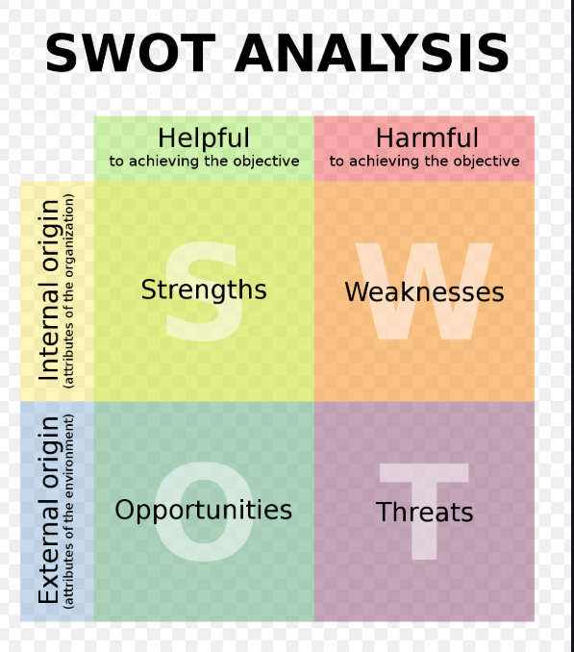
Strengths
- What advantages does Mama Put Kitchen have?
- What do we do better than our competitors?
- What unique or lowest-cost resources can we draw upon that others could not?
- What do people in your market see as your strengths?
- What factors mean that we will increase our sales

Weakness:
- What could you improve?
- What should you avoid?
- What are people in your market likely to see as weaknesses?
- What factors lose you sales?
OPPORTUNITIES
- What good opportunities can you spot?
- What interesting trends are you aware of?
Useful opportunities can come from such things as:
- Changes in technology and markets on both a broad and narrow scale.
- Changes in government policy related to your field.
- Changes in social patterns, population profiles, lifestyle changes, and so on.
- Local events.
THREATS
- What obstacles do you face?
- What are your competitors doing?
- Are quality standards or specifications for your job, products or services changing?
- Is changing technology threatening your position?
- Do you have bad debt or cash-flow problems?
- Could any of your weaknesses seriously threaten your business?
SWOT Analysis can be described as a plain and simple but very important framework for examining a business’s SWOT - strengths, weaknesses, opportunities and threats that we encounter. Our strengths then becomes our bedrock, we improve on our weakness and explores was to transform those weakness to become strengths, we reduce our threats and tap into opening to opportunities in order to grow.
SWOT can be a powerful strategy tool which if implemented can be used to understand the competitors which can give you the insights you need to craft a coherent and successful competitive position.
- PESTEL ANALYSIS
PESTEL analysis is a structure used by marketers to examine and watch the external marketing environment elements that have an impact on an organisation. We can use the outcome of the PESTEL to identify the threats and weaknesses affecting our business.

The abbreviation PESTEL can be explain further as the following:
- P – Political
- E – Economic
- S – Social
- T – Technological
- E – Environmental
- L – Legal

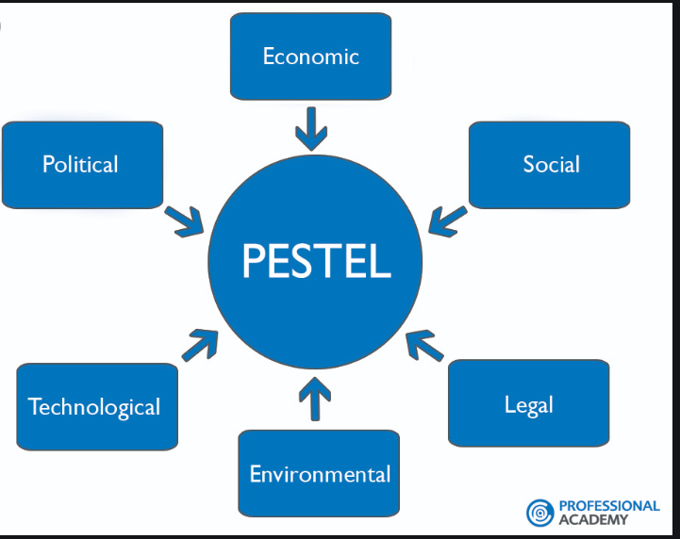

The acronym PESTEL can be explained as following:
Political Factors:
This refers to the extent the government gets involved in the economy. Some examples of Political Factors are – Political Stability, Governmental policy, tax policy, trade restriction etc
Economic Threat:
This explains how the economic threats may have a positive impact on how MamaPut carries out its daily business.
Economic threat can be grouped into Macro-economic & Micro-economic factors. Economic threats deal. Macro deals with the demand in any economy which while micro-economic relate to way peoples incomes are spent.
Social & Technological
We all know how fast the technological landscape changes and how this impacts the way we market our products. Technological factors affect marketing and the management thereof in three distinct ways:
- New ways of producing goods and services
- New ways of distributing goods and services
- New ways of communicating with target markets

Environmental Factors
These factors are quite recent and have become more noticeable due to the unavailability of raw materials, pollution targets

- Conclusion
From the study carried out for this assignment, it is quite apparent that problem solving and decision making if handled and investigated thoroughly have so many outcome. I have also discussed the essential point of problem solving and the positive outcome around the team.

- References
- Andrew Maund, 2017Maund, M.S.a.P.K., 2017
Certificate for Higer Education: Skills for the Workplaxe Studem Yearbook. London:SAGE
- John Dewey, Reflective Thinking Process; 1910
- Sturgess, P.H .a. A. The Happy Manager; (https://the-happy-manaer.com/article/rational-decison-making-model)

