Name: Holly Congdon
Student ID: 2200943
Module: ECAD5008
Word count: 4364
Title: A written assignment critically evaluating how Assessment for Learning can be utilised in a series of learning opportunities to aid progression across chosen areas of learning and experience.
Assessment for Learning (AfL) is a crucial pedagogical tool, with teachers using various AfL strategies for many reasons such as to provide support, aid progression and to identify prior knowledge. The purpose of assessment is to enable teachers to see what progress learners are making and to provide teachers with information to assist planning on how to support learners to make further progress (Department of Education, n.d). Progression is vital within education and ‘’Supporting learners to make progress is a fundamental driver of the Curriculum for Wales’’ (Welsh Government, 2021, p.5). Through research and discussion of opposing views and arguments, this assignment will discuss and evaluate how Assessment for Learning can be used to aid progression and enhance learning. This will include a discussion of three lessons I have planned, throughout which I will discuss the various AfL strategies I intend to implement, their potential impact on progression as well as discussing the decisions I have made within my planning.
The three lessons which I will be discussing are to be delivered to a year 4 class within in an English medium school. The class includes 28 pupils who are eight to nine years old. The pupils in this class have a range of abilities and individual needs. Regarding the progression steps identified in the Curriculum for Wales (Welsh Government, n.d ), there is a whole class focus on progression step 3. However, as there are various abilities within the classroom, the pupils are at various stages of progression, for example some pupils are currently at progression step 3 whereas others are at progression step 2. Therefore, the lessons have been differentiated and adapted to meet the learners’ needs. The current theme within the class is ‘Living things’, with a current particular focus on insects. When planning the lessons, I have taken into consideration the approach of using a blend of learning experiences to aid progression and to meet individual needs. For example, this includes opportunities for independent work, outdoor learning, and active tasks.
The three lessons I have planned will be delivered around the start of this topic. Before these lessons take place, the learners will have had a few informative lessons during which they will have also revisited learning from previous years. The three lessons I have planned focus on three Areas of Learning and Experience (AoLE) proposed by Donaldson (2015). This includes, Languages, Literacy and Communication (LLC), Science and Technology and Expressive Arts. The first lesson I will discuss focusses on LLC, with the particular aim of developing skimming and scanning skills. Languages, Literacy and Communication, which includes four statements of what matters, addresses fundamental aspects of communication and aims to support learners to develop and gain knowledge and skills in literature and various languages (Welsh Government, 2020a). It aims to support learning across the whole curriculum, contributing to realising the four purposes and enabling learners to build confidence, curiosity and enthusiasm. The second lesson focusses on Science and Technology, aiming to develop learners’ scientific knowledge on insects. The Science and Technology AoLE aims to enhance learners understanding and knowledge of the world, to support learning across the whole curriculum and includes six statements of what matters which together contribute to realising the four purposes of the curriculum (Welsh Government, 2020b). It aims to enable learners to become more resilient, encourage learners to take risks and to innovate and evaluate. The third lesson focuses on Expressive Arts. One particular aspect of Expressive Arts which this lesson focusses on is providing the learners with opportunities to be creative, innovative and to use their imagination, particularly focussing on the third what matters statement (Welsh Government, 2020c). The Expressive Arts AoLE, which includes three what matters statements, aims to encourage the development of skills and knowledge and to nurture learners’ wellbeing and self-esteem (Welsh Government,2020c).
It is evident that there is an increasing emphasis being placed on the role of AfL within education. In his review of the Welsh Curriculum, Donaldson (2015) highlights that the Welsh Government has acknowledged weaknesses within its assessment framework and recognised there is a need to provide quality feedback which comes from formative assessment. Donaldson recommends that assessment arrangements should be based on achieving the outcomes of each of the progression steps and should cover all important learning intentions and progression in relation to the four purposes. This implies that teachers need to ensure they are using effective assessment, focussed on enabling pupil progression and providing opportunities to develop knowledge and skills across the whole curriculum. Following Donaldson’s review, the newly implemented Curriculum for Wales (Welsh Government, 2022) features a heavy emphasis on the role of assessment. The Curriculum has also introduced new requirements to ensure that supporting progression is at the heart of the curriculum and emphasises that the purpose of assessment is to support individuals to progress at an appropriate pace and to be challenged accordingly. This highlights the significant shift of the use of AfL within education in Wales. Furthermore, the Welsh Curriculum (Welsh Government, 2023) also identifies 12 pedagogical principles. The seventh principle states that good teaching and learning means employing assessment for learning principles. This highlights the importance of AfL as the curriculum suggests that it contributes to effective pedagogy. Pedagogy should help learners to progress, therefore as one of the principles, AfL should be built upon to support progression.
There are two types of assessment, formative and summative. AfL mainly focusses on informal formative assessment. It focusses on practices which help ‘shape’ student learning, differing from summative assessment which often attempts to measure attainment (Cambridge International Education Teaching and Learning Team, n.d). This suggests that AfL is a forward-looking approach, using ongoing assessments to obtain information to focus on individual needs and to support progression. This is supported by Flórez and Sammons (2013) who suggest that teachers who assess in this way not only confirm and assess what pupils have learnt but should also help learners as well as themselves to understand what the next steps in learning should be and how to possibly get there. Black and William(1998a) emphasised argued that formative assessment is at the heart of effective teaching. The work of Black and Wiliam has been highly influential in research and discussion on AfL. Furthermore, following a visit to various schools, Estyn (2022) found that in schools where the use of assessment is particularly strong, teachers ensure that assessment has a formative role in supporting learners to better understand learning and improving teaching. In these schools, teachers have moved away from a focus on summative assessment and are instead focussing on how their assessment identifies progress and how the information can be used to adjust their teaching. This suggests that formative assessment can aid progression as it can provide information to adjust teaching to better support learners. However, others may argue that summative assessment is more useful, raising the question of whether summative or formative assessment should be focussed on more within education. For example, advantages of summative assessment include it can identify what learning has taken place, it can motivate learners to study and can help identify learning and teaching gaps (Baker, 2024). However, Black and Wiliam (cited Northern Ireland Curriculum, 2007, pg4) suggest that many strategies used in education, particularly those which focus on grades, compare pupils with one another, resulting in feedback which reduces pupil morale. This implies that whilst summative assessment can have advantages it also has disadvantages such as negatively affecting learners’ confidence. This research could be used to argue that providing a blend of summative and formative assessment is beneficial as both can support progression.
There are four elements of AfL, sharing criteria and learning intensions with learners, peer and self-assessment, quality of questions/talk and the use and quality of feedback. These elements are discussed by Black and Wiliam (1998b) and also discussed by Donaldson (2015, p.g76). These elements hold the most value when they are seen as integrated and are supportive of the process of learning (Northern Ireland Curriculum, 2007, p.g 7). One element of AfL is the quality of questions/talk. Questioning takes place every day within the classroom and is an incredibly useful tool to assess learning. Whether it is learner or the teacher asking questions, they should be open-ended when possible and lead to discussion (Welsh Assembly Government, 2010 pg15). Blooms Taxonomy is a hierarchical model which classifies learning objectives into levels of complexity (Main ,2021a). This model orders thinking skills from lower to higher and is a useful tool for teachers. Main (2021a) suggests that one method of applying this in the classroom is through the use of questioning strategies which encourage different levels of thinking such as remembering and applying. Therefore, this suggests that questioning is important as it encourages various levels of thinking and can help create a language rich environment through discussions.
Another element is the use and quality of feedback. The Northern Ireland Curriculum (2007, pg70-71) suggests that feedback can motivate pupils by building self-esteem and enables learners to better understand how to improve work and reach goals. It can also de-emphasis competition, encouraging learners to focus on their own learning than comparing themselves to others. Hattie (2008) suggests that feedback is most powerful when it is from the learner to the teacher, for example feedback on what the learners understand and when they have misconceptions. This implies that feedback can support progression by supporting learners to better understand how to progress and to focus on their own progression. Questioning and feedback go hand in hand, both developing interaction between teachers and the learners. AfL is associated with socio-constructivist theories which argue that learning is built upon previous experiences and interactions with others (Cambridge Assessment International Education, 2019, pg2). These theories can be used to argue the importance of questioning and feedback as they argue that the quality of interactions between the teacher and the learners is vital to learning.
Another element of AfL is peer and self-assessment. Peer and self assessment has many benefits such as creating independent learners, increasing self-esteem and improving understanding (Northern Ireland Curriculum, 2007). Donaldson (2015, p. 80-81) suggests that young people need to be able to reflect on and evaluate their own progress to learn throughout life. Donaldson recommends that peer and self-assessment should be developed to encourage learners to take responsibility for their own learning. Therefore, suggesting that to support progression, teachers need to provide opportunities for peer and self-assessment. However, some research suggests potential disadvantages of peer assessment. For example, Dochy et al (1999, cited Double et al, 2019) suggested that whilst peer assessment can positively affect learning, it can also be hindered by social factors such as friendship. This could be used to suggest that some learners may not want to engage in peer assessment as they might not want to critic the work of their peers, or they may use bias. Peer and self-assessment also goes hand in hand with sharing criteria and learning goals with learners. According to the Welsh Government (2010, p27) In order for learners to take responsibility of their own progress, they need to know the criteria to which they are being assessed. The Welsh Government further suggests that teachers need to use various strategies so that learners gradually internalise the criteria which they are assessed on.
It is also important that teachers consider potential limitations of AfL. For example, Tunnel (2021) suggests that AfL can be a time and resource-expensive procedure as it involves ongoing assessment which collects frequent data and research and time spent refining planning. Tunnel also suggests that another disadvantage is that it can be difficult to determine the intervals at which teachers should evaluate the success of strategies. Disadvantages such as these may be used to suggest why AfL may be underdeveloped in some schools.
The first lesson I have planned (See Appendix A) focusses on the Languages, Literacy and Communication AoLE. I have decided to plan a lesson focussing on LLC as there is a whole-school target focussed on developing literacy skills. This lesson particularly works towards progression step 3 ‘’I can read texts, choosing strategies which best help me understand them’’ (Welsh Government, 2020a). I have decided to plan a reading comprension task with the aim of learners developing reading strategies, with particular focus on developing skimming, scanning and summarizing skills. The task involves learners using reading strategies to answer questions on an information sheet on animals and insects. As there are various abilities within the class, the work will be differentiated and will also include extensions. This lesson does not aim to introduce new reading strategies to learners but instead aims to further develop strategies that the pupils have been developing throughout their time at the school. Therefore, I will only briefly revisit how to use these strategies. The lesson also has links to the AoLE of Science as the task also aims to develop learners’ scientific knowledge and vocabulary.
In this lesson, I plan to use the AfL strategy of live marking. This involves the development of quality of feedback. I will go around the classroom, monitoring, observing and marking work as I walk around. I have practiced this strategy during previous teaching experiences. I found this strategy to be quite effective, therefore I have decided to incorporate this into my lesson. In my previous experiences, live marking has had various benefits. For example, it allowed me to observe learning, identify pupils who needed more support and allowed me to provide specific and individual verbal feedback to learners. This often involved providing positive comments to encourage and motivate pupils. The learners were able to act upon and use this feedback straight away instead of recieving written feedback after completing the work. Using live marking in previous lessons also provided opportunities to give feedback to the whole class as it helped me to identify misconceptions that several pupils had. These findings can be supported by Wells (2018) who suggests that live marking encourages teachers and learners to speak on an individual basis and allows teachers to identify msiconceptions which can be shared with the rest of the class. However, there are potential disadvantages regarding live marking that teachers should be cautious with. For example, Wells (2018) suggests that not only is live marking time-consuming, it is also very difficult to get around a whole class within the confines of a lesson. From my own experience, while I do agree that live marking can be time-consuming, overall, it has been very effective in aiding progression. Not only has it appeared to provide great support to learners, but it has also positively affected my teaching as it allowed me to identify learners who need further support. This has provided me with useful information to use to adjust my teaching to better support progression and to meet individual needs. Therefore, reflecting on the effectivenes of this strategy from previous experiences, I have decided to use it again within this lesson whilst also being cautious of the potential disadvantages.
Another AfL strategy that I plan to use in this lesson is the use of mini plenaries. I will use mini-plenaries throughout this lesson. To do this I will gain attention of the whole-class and assess learning by asking pupils to share what they have learned so far. I will ask each table of pupils, questions such as ‘what did you get for question 2?’. I also plan to ask the learners how they are finding the work and if they need any support. I have practiced using mini plenaries during my placement and have observed various potential advanatages of using this strategy. Using mini-plenaries appeared to work effectively in that it provided me opportunities to assess learning and to identify misconceptions. In addition, it also appeared to also provide support to learners as it provided the learners with opportunities to listen to other pupils explain how they worked out/found their answer. Main (2021b) suggests that plenaries can be opportunities for reflection and discusses that a ‘good’ plenary gets pupils thinking and talking together. Main further suggests that mini plenaries work well if there is limited time after the main task. I plan to use a plenary at the end of this lesson to foster classroom talk, during which I will encourage pupils to discuss what they have learnt and if there is anything they found difficult.
The topic of ‘living things’ heavily links to Science as it involves pupils developing scientific knowledge and their understanding of the world. Therefore, I have decided to focus my second lesson on the Science and Technology AoLE (See appendix B). This lesson links to the description of learning ‘‘The world around us is full of living things which depend on each other for survival’ (Welsh Government, 2020d). The lesson aims for learners to develop scientific knowledge on living creatures through both observation and research. According to Donaldson (2015) Science and Technology is important as it inspires curiosity within young people about the natural world. One part of this lesson involves pupils going on a ‘minibeast hunt’, exploring the woodland area in the school. The learners will be filling in an ‘insect hunt’ recording sheet and will need to gather a variety of information such as what insect they identified, features of the insect and they will also record the number of each insect they found. The learners will then return to class and create a fact file on one insect they found on their ‘hunt’. They will be encouraged to use prior-knowledge from previous lessons and will need to use laptops for research. Learners can either create their fact file on paper or presents their research on a powerpoint. This provides an opportunity for learners to develop their digital skills. The learners will be working in pairs for this lesson. As I have previously discussed, AfL is associated with socio-constructivist theories which suggest that learning is constructed from previous experiences and interactions with others (Cambridge Assessment International Education, 2019, p.g 2). Therefore, using pair work in this lesson can support progression as it promotes social interaction. The task will also be differenitiated in order to meet individual needs and abilities, for example classification keys will be available to pupils who need additional support.
To start the lesson, I will use the strategy of using mini whiteboards to assess pupils understanding and learning from previous lessons. I will use a strategy called ‘secret squirrel’ to do this. This is where the learners write down answers to questions on their whiteboards, hiding their answers from other learners. Pupils are then asked to hold their whiteboards high up in the air so that the answers can be read by the teacher. I plan to ask several questions during this, asking questions such as ‘What is a vertebrate and can you give me examples of one’. According to Hasyn (2023), using mini whiteboards can ensure that independent thinking time and group discussions are utilised effectively by a higher number of pupils. This suggests that mini whiteboards can be seen to encourage all learners to participate, increasing learner engagement. Hasyn also suggests various other benefits about whiteboards. These include that it identifies misconceptions before moving onto independent tasks and it can also provide live formative feedback. The observations I have made whilst practicing the use of mini whiteboards in my previous teaching experiences correspond to these suggestions. For example, all learners appeared to be engaged, with every learner writing providing answers. If there were any pupils who got an incorrect answer, I would give individual support or I would ask a learner who answered correctly to explain how they got their answer. It also provided opportunities to identify misconceptions which was useful as I was then able to discuss these before moving onto the main task. Whilst this strategy is useful, there are elements to be cautious with. Hasyn (2023) suggests that whiteboards can be a distraction and can be quite expensive. Furthermore, teachers should also be cautious in regard to their ‘wait-time’ when they are using questioning. It is essential that teachers provide learners with enough time to answer questions. According to the Welsh Assembly Government (2010, p. 25) the average wait-time of British teachers is 0.9 seconds. However even a small increase of 3 seconds can result in an increase of the number of learners providing an answer and the depth of answers given. Therefore, it is important that whilst using mini-whiteboards learners are given an appropriate amount of time to provide an answer. I will take this into consideration in my lesson and ensure that I am using an effective ‘wait time’.
My third lesson (see Appendix C) focusses on the Expressive Arts AoLE. According to Donaldson ( 2015, p.g 43) engagement with this AoLE ‘requires application, perseverance and close attention to detail, capacities that have benefits across learning more widely.’’ Donaldson further suggests that Expressive Arts provide opportunities which engage thinking, imagination and senses creatively. Therefore, I have decided to focus my lesson on Expressive Arts as it provides opportunities for learners to develop various skills that not only develop creativity but benefits wider learning. The focus of this lesson is to have learners create their own ‘superbug/minibeast’, with the aim of activating pupils’ prior knowledge on insects from previous lessons. The lesson also aims to develop learners skills of reflecting on the creative work of others. This links to progression step 3 which states ‘’I can give and consider constructive feedback about my own creative work and that of others’’ (Welsh Government, 2020e).
My third lesson involves strategies of AfL which links to the element of sharing criteria and learning intentions with learners. According to the Northern Ireland Curriculum (2007) sharing criteria with learners has significant benefits such as helping to cultivate independent learners as it encourages an independent approach to learning. When pupils are aware of the success criteria, they are better able to assess their own work which involves them in their own learning and performance. This lesson involves the learners creating their own success criteria in the form of a checklist. I will start the lesson explaining the task and will also present a ‘WAGOLL’ to the learners. WAGOLLS can be used by teachers as a virtual aid to incorporate creativity into the classroom at any time during lessons (Structural Learning, 2022). Therefore, as my lesson focusses on developing creativity I felt that this was a relevant strategy to use in this lesson. The WAGOLL model will include both a picture of the final creation of a ‘minibeast’ and will also include a brief description of the insect. I will ask the pupils to create their own success criteria for the lesson in the form of a checklist which I will write on the board. This will be done by asking the pupils what they think is good about the WAGOLL example and if there are any recommendations they would make to improve it. I hope that the pupils will contribute various ideas such as ‘I like how the insect has lots of different features like wings’ and ‘I like how colourful it is’. This activates initial thinking, for example by the learning thinking about what materials they might use.
The pupils will first fill in a sheet on which they will draw up a draft for their 3D model of their ‘minibeast’. This will include a small drawing of their insect and a description. After the pupils have done this task, I will ask the learners to give peer feedback to each other using the checklist that was made by the class. This therefore also links to the AfL element of peer assessment. I will ask the learners to check that their peers’ drawings match their descriptions and will ask them to write this feedback on their planning sheet. The learners will then use their draft and the peer feedback that has been given to them to then create their 3D ‘minibeast’. The pupils will be provided with various different materials to create their model. Using peer feedback can be a very useful tool in the classroom. Peer feedback can help learners to develop their social skills and to use higher-level skills such as thinking critically (Cambridge International Education Teaching and Learning Team, n.d. ) It also increases both pupils understanding of what makes a successful piece of work. On the other hand, Boon (2018) suggests that learning can be hindered if unhelpful or insensitive peer feedback is exchanged, and it may strain relationships between pupils. Despite there being potential limitations, I feel that implementing the use of peer assessment into this lesson is useful as it can guide learners on how to make progress and also promotes social interaction in the classroom.
To conclude, I believe Assessment for Learning plays an incredible role in the progression of learners and feel that there should be an increased use of AfL within classrooms. AfL is a very beneficial tool for teachers, particularly enabling them to understand and better support learner’s progress. From this research and reflections from my own teaching practice, I feel that it is important that teachers incorporate the four elements of AfL within their lessons, using a wide range of strategies. From my conclusions, I propose that schools might want to consider increasing the use of verbal feedback. One particular strategy that I would recommend for this is the use of live marking. Live marking can provide feedback to learners who can immediately use it to improve their work and it also helps teachers to identify pupils who need additional support and any misconceptions. However, it is important that teachers also consider that there are limitations and areas to be cautious with within AfL. For example, some strategies can be time consuming and expensive. Furthermore, teachers also need to be cautious that they are providing an appropriate ‘wait time’ when using questioning in the classroom. This research has deepened my knowledge on Assessment for Learning. It has become clear to me how important and useful it is to incorporate AfL within my lessons, especially as it can allow me to obtain information that is needed to adjust my teaching to better support the progression of learners.

Reference list
Baker, J. (2024) What is Summative Assessment? Examples, importance & More. [Blog] Available at: What is Summative Assesment? Examples, Importance & More (splashlearn.com) (Accessed:09/01/24)
Black, P. and William, D. (1998a) Inside the Black Box: Raising standards through classroom assessment. [Online article] Available at (PDF) Inside the Black Box Raising Standards Through Classroom Assessment (researchgate.net) (Accessed:09/01/24)
Black, P. William, D. (1998b) ‘Assessment and Classroom Learning’, Assessment in Education: Principles, Policy & Practice, 5:1, 7-74. Available at: https://www.gla.ac.uk/t4/learningandteaching/files/PGCTHE/BlackandWiliam1998.pdf (Last accessed: 09/01/24)
Boon, S. (2018) Using peer assessment as an effective learning strategy in the classroom. Available at: https://my.chartered.college/impact_article/using-peer-assessment-as-an-effective-learning-strategy-in-the-classroom/ (Last accessed: 08/01/24)
Cambridge Assessment International Education (2019) Assessment for Learning. Available at: https://www.cambridgeinternational.org/images/271179-assessment-for-learning.pdf (Last accessed: 08/01/24)
Cambridge International Education Teaching and Learning Team (no date) Getting started with Assessment for Learning.[Online article] Available at: https://cambridge-community.org.uk/professional-development/gswafl/index.html (Last accessed:08/01/24)
Department of Education (no date) Assessment. Available at: Assessment | Department of Education (education-ni.gov.uk) (Last accessed: 08/01/24)
Donaldson, G. (2015) Successful Futures: Independent Review of Curriculum and Assessment Arrangements in Wales. (Welsh Government publication) Available at: https://www.gov.wales/sites/default/files/publications/2018-03/successful-futures.pdf (Last accessed: 08/01/24)
Double,K.S, McGrane, J.A & Hopfenbeck, T.N. (2020) The Impact of Peer Assessment on Academic Performance: A Meta-analysis of Control Group Studies. Educational psychology review 32,481-509. Available at: The Impact of Peer Assessment on Academic Performance: A Meta-analysis of Control Group Studies | Educational Psychology Review (springer.com) (Last accessed:08/01/24)
Estyn (2022) Effective approaches to assessment that improve teaching and learning. Available at: https://www.estyn.gov.wales/system/files/2022-10/Effective%20approaches%20to%20assessment%20that%20improve%20teaching%20and%20learning.pdf (Last accessed: 08/01/24)
Flórez, M.T. & Sammons, P. (2013) Assessment for learning: effects and impact. Reading: CfBT. Available at: https://files.eric.ed.gov/fulltext/ED546817.pdf (Last accessed: 08/01/24)
Hasyn, R. (2023) Mini Whiteboards: 7 Ways To Use Teachers’ Favourite Classroom Resource. Available at: https://thirdspacelearning.com/blog/mini-whiteboards/
Hattie, J. (2009) Visible Learning: a synthesis of over 800 meta-analyses relating to achievement. Routledge.
Main, P. (2021a) Blooms Taxonomy. Available at: https://www.structural-learning.com/post/blooms-taxonomy-a-teachers-alternative (Last accessed: 08/01/24)
Main, P. (2021b) A Teachers Guide To Lesson Plenaries. Available at: https://www.structural-learning.com/post/a-teachers-guide-to-lesson-plenaries (Last accessed:08/01/24)
Northern Ireland Curriculum, (2007) Assessment for Learning for Key Stages 1 and 2. CCEA, Belfast:PMB. Available at: https://ccea.org.uk/downloads/docs/ccea-asset/Assessment/Assessment%20for%20Learning%20for%20Key%20Stage%201%20%26amp%3B%202%20%28Guidance%20Booklet%29.pdf (Last accessed:08/01/24)
Structural Learning, (2022) WAGOLL: A Teacher’s Guide. Available at: https://www.structural-learning.com/post/wagoll-a-teachers-guide (Last accessed: 08/01/24)
Tunnel,L. (2021) ‘Formative Assessment: Pros and Cons You Need To Know’ Education Advanced, 1 December. [Blog] Available at: https://educationadvanced.com/resources/blog/formative-assessment-pros-and-cons/ (Last accessed: 08/01/24)
Wells, A. (2018) The pros and cons of live marking. Available at: https://www.teachertoolkit.co.uk/2018/03/04/live-marking-2/ (Last accessed: 08/01/24)
Welsh government (no date) Curriculum for Wales. Available at: https://hwb.gov.wales/curriculum-for-wales (Last accessed: 08/01/24)
Welsh Assembly Government (2010) How to develop thinking and assessment for learning in the classroom. Available at: https://hwb.gov.wales/api/storage/663d00fd-9c3b-4003-9a1f-0012bad39fad/how-to-develop-thinking-and-assesment-for-learning-in-the-classroom.pdf (Last accessed:08/01/24)
Welsh Government (2020a) Languages, Literacy and Communication. Available at: https://hwb.gov.wales/curriculum-for-wales/languages-literacy-and-communication/ (Last accessed: 08/01/24)
Welsh Government (2020b) Science and Technology. Available at: https://hwb.gov.wales/curriculum-for-wales/science-and-technology/ (Date last accessed: 08/1/24)
Welsh Government (2020c) Expressive Arts. Available at: https://hwb.gov.wales/curriculum-for-wales/expressive-arts/statements-of-what-matters/ (Last accessed: 08/01/24)
Welsh Government (2020d) Science and Technology: Descriptions of learning. Available at: https://hwb.gov.wales/curriculum-for-wales/science-and-technology/descriptions-of-learning/
Welsh Government (2020e) Expressive Arts: Descriptions of Learning. Available at: https://hwb.gov.wales/curriculum-for-wales/expressive-arts/descriptions-of-learning/ (Last accessed: 08/01/24)
Welsh Government (2021) The Curriculum for Wales – Progression Code. Available at: https://www.gov.wales/sites/default/files/publications/2021-11/curriculum-for-wales-progression-code.pdf (Last accessed: 08/01/24)
Welsh Government (2022) What’s changing in assessment? Available at: https://hwb.gov.wales/curriculum-for-wales/assessment-arrangements/what-s-changing-in-assessment/ (Last accessed: 08/01/24)
Welsh Government (2023) Pedagogy. Available at: https://hwb.gov.wales/curriculum-for-wales/designing-your-curriculum/pedagogy (Last accessed:08/01/24)

Appendix
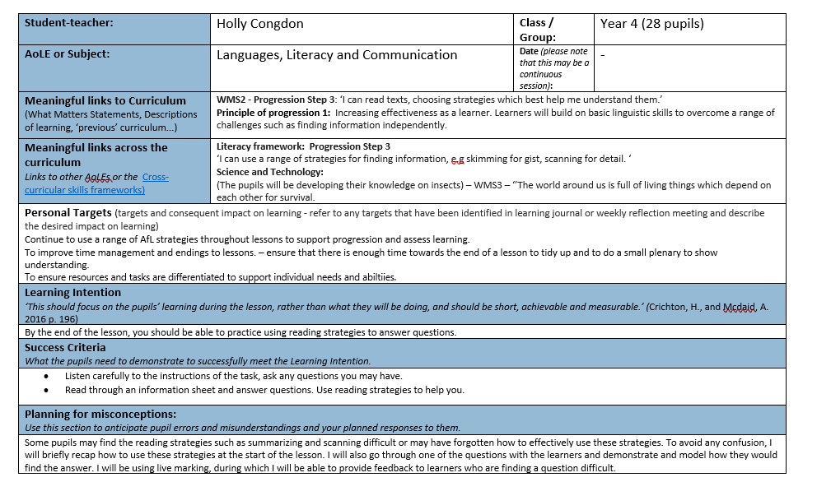
Appendix A – Lesson plan 1
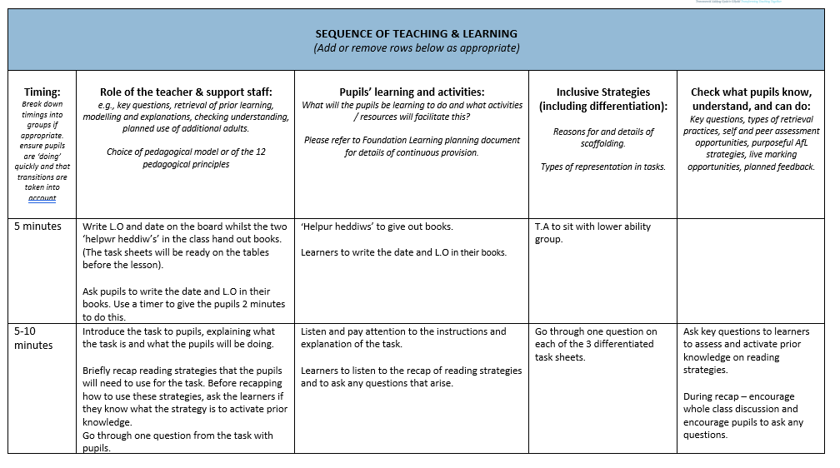
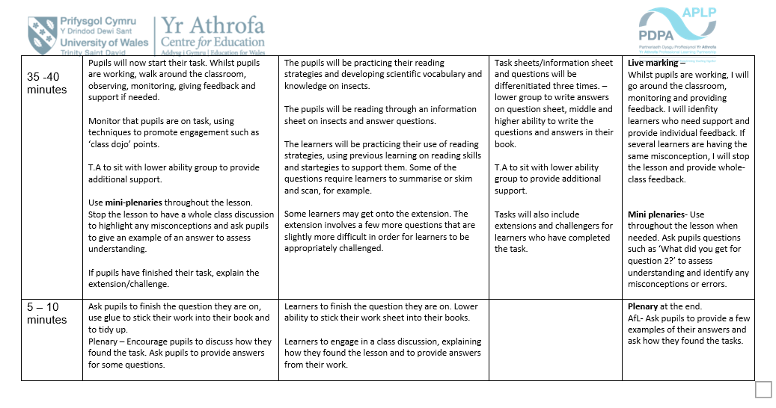
Appendix 2 – Lesson Plan 2
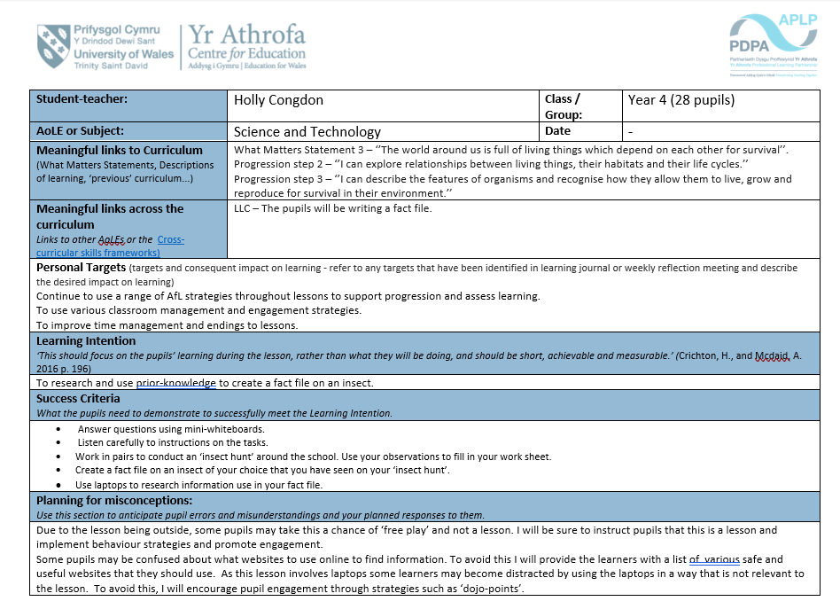

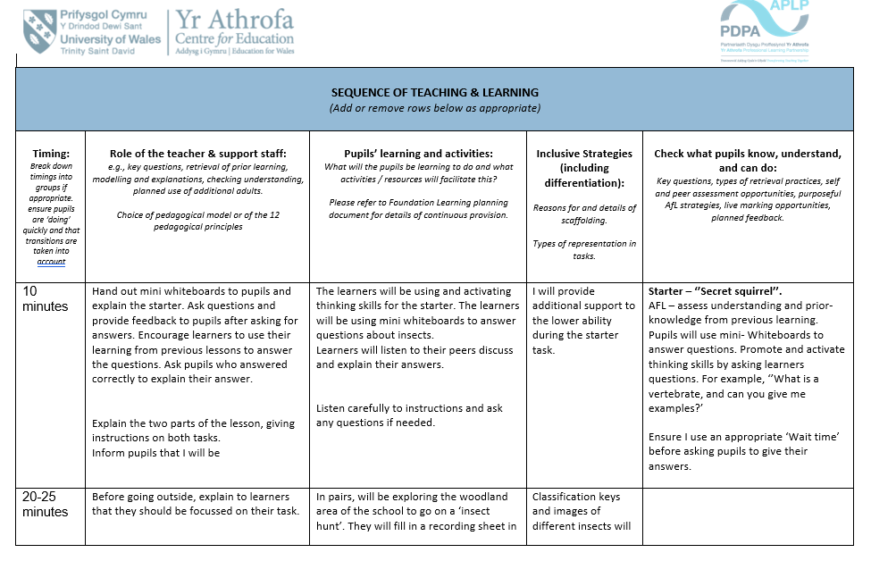

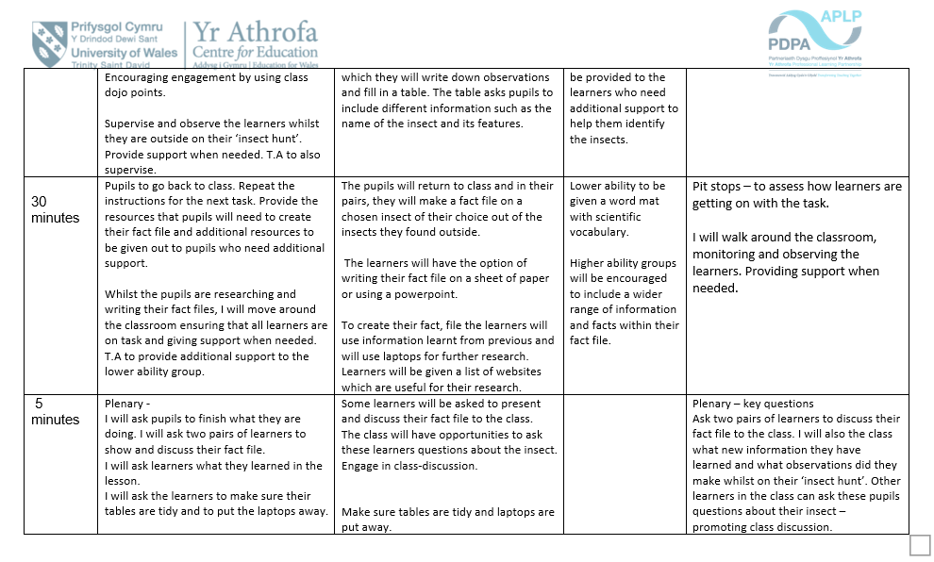

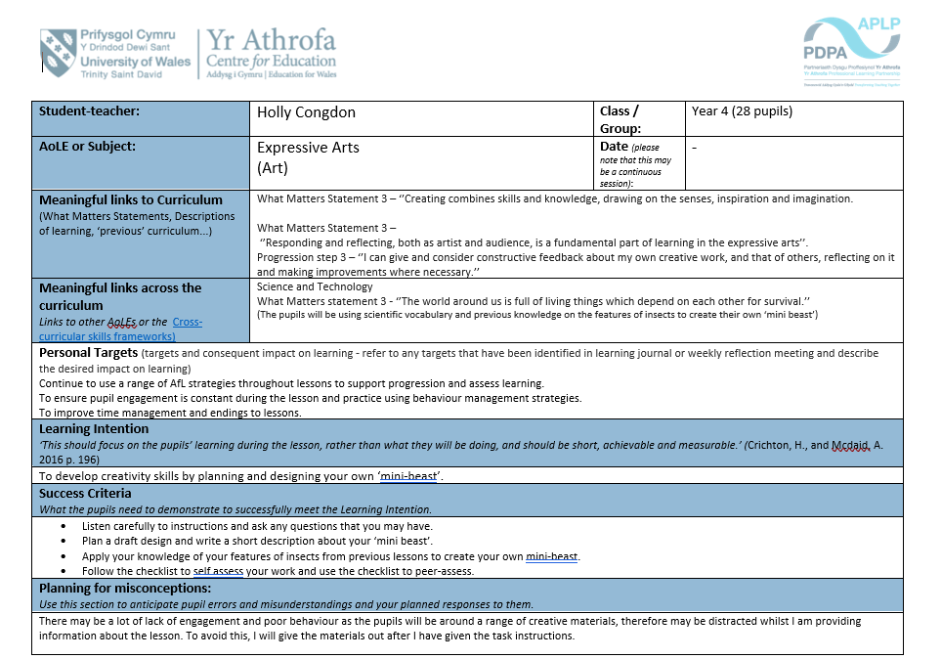
Appendix 3 – Lesson Plan 3



