Manufacturing, Design & Technology

Machines and components are a vital aspect within the engineering industry and having the best possible design can improve procedures and performances within the company and help allow the machines to perform at their optimum level.
Designing components and using different techniques and tools to create the best solution is becoming more important as the engineering industry continues to advance. It can allow company to save money, make greater profits due to machine productivity and reduce the amount of downtime to various tool changes or faults.
As part of the current system in place at Festo, a dispatch station is part of the machine with no automatic tool on there to remove ready built phones from the station. By implementing and designing a robot gripper to automatically remove the phones from the output station it improves the system making it more efficient and effective. The gripper will be designed by using proven tools to analyse each aspect of the design and help allow the gripper to perform at high volume manufacturing.
Design 1
The first design created involves a gripper which acts as a clamp above and below the component it is picking up. To begin with the product was designed for the assembly, this is to maximise efficiency and ease of assembly operations. Velling (2021) suggests that over 70% over the products final costs is determined during the design process of the product. Along with maximising efficiency and ease of assembly the aim of design for assembly (DFA) is to also reduce opportunity for errors, reduce the need for inspections, decrease assembly time and improve health and safety.
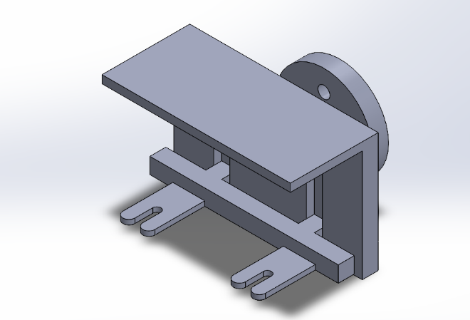
Below is the first gripper designed. Firstly, the components on the gripper are self-aligning due to the grooves cut out either side to help locate the forks with the body. The gripper does require a tool to secure it to the adjustment arm currently part of the festo system. The component is also designed so that is can only be assembled in a single linear motion. By having the assembly system in place, it was easy to design the gripper as it meant that measurements and sizes could easily be taken as well as the function of the tool. By using the design for assembly tool, a calculation can be made to find the efficiency of the design.
The design is based off a simple gripper which has a fixed upper plate and then an adjusting bottom base which would operate using a pneumatic cylinder.
The way in which it is designed is having the cylinder extend and contract allowing the bottom forks to go under the component and grip it with the upper plate.

Design for Assembly
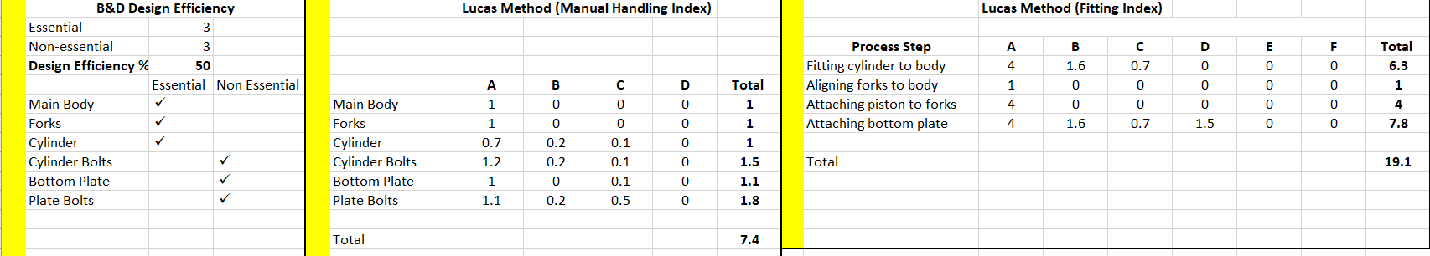
In order to understand how efficient, the design of the gripper is, Lucas’s methodologies are used to determine which parts of the design are essential and what parts are non-essential, non-essential parts can then be evaluated to see whether they can be removed from the design.

Design efficiency is the number of essential parts divided by the total number of parts, expressed as a percentage, as you can see design efficiency of the design is 50%. In order to improve this score a cylinder could be used which has a maximum stroke which does not drive the forks out of the grooves, having this means the bottom plate and bolts could be removed. The Lucas Method also shows how easy the component is to handle and fit, it allows an understanding of what parts are essential and help remove non-essential parts if possible. Understanding the design efficiency is vital to creating a successful product, it needs to withstand long life in work in order to improve the system and save money. Fairhurst (2015) suggests that most issues can be found in the design stage and finding them in the early stages can save the most money.
Failure Mode Effect Analysis (FMEA)
Failure Mode and Effect Analysis helps us review a process step and to identify potential failure modes in a system and their causes and effects that can occur. By using FMEA it enables you to study the consequences of those failures on different process steps, this gave an idea as to what could go wrong with each task within the project.
According to Kent (2016), FMEA’s is an essential tool for improving processes and products. By completing the FMEA it will allow the process of design to be reviewed at each stage and find any issues or potential failures which may occur, by doing this it improves the overall outcome of the process or design. Long & Hillman (2014) support this and add that human error is considered in the in the tool which makes it more relevant and suited to the project.
By completing the FMEA for the first gripper design it allowed to understand what problems can occur with the performance of the gripper and how they can occur and prevent them from happening. FMEA is a great tool to use which can be seen when standards such as ISO/QS 900 and ISO 31000/31010 both highly recommend its use. FMEA has been used in the design part of the gripper in order to improve the quality, reliability, and safety of the product, it also increased customer satisfaction and reduces operational risk.

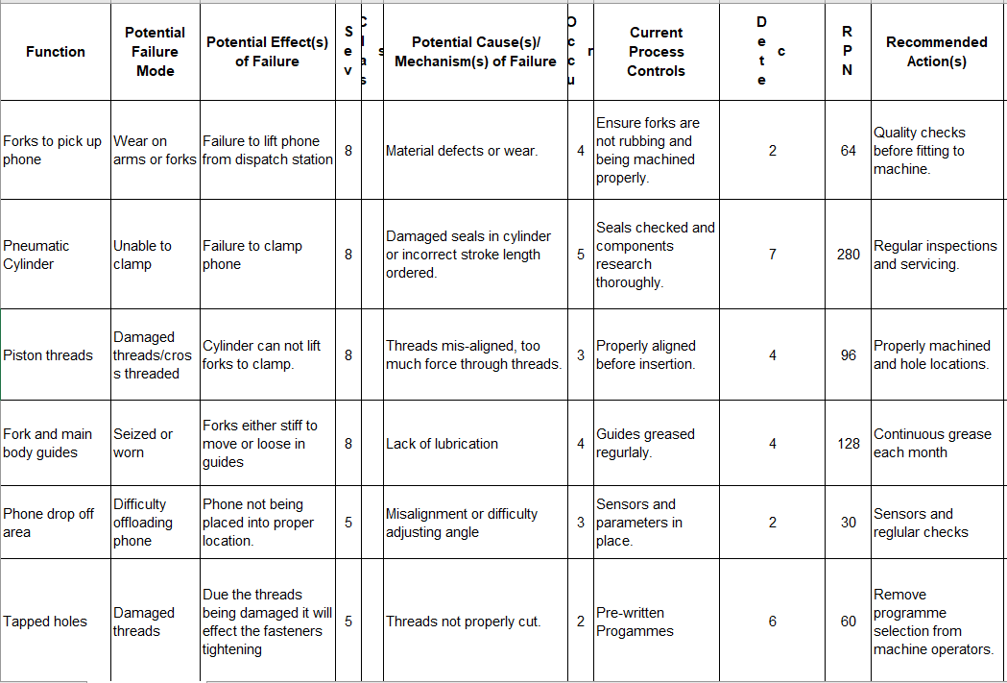
As you can see from the FMEA completed for design 1, clearly shows the highest RPN number shown is 280, this involves a failure of the pneumatic cylinder, the reason this score is so high is due to the severity of the issue and the fact it can occur and the issue may be difficult to find. Obviously, an issue with the cylinder would mean the gripper could not function properly and not pick up the phone.
Quality Function Deployment (QFD)
Quality function deployment is a tool used again in designing and allows companies and designers to understand the customers’ requirements for a product. It allows a design to be made aimed at satisfying the customer, by filling out a chart containing customer requirements and technical requirements it helps visually see the relationship between the two.
Stewart (2017) suggests that using QFDs in the design aspect of a component improves the production efficiency due to the knowledge of the final product characteristics. Addressing problems or faults in the early stages of manufacturing massively increases production efficiency, Stewart (2017) then goes on to say this has a direct outcome to a reduction in overall costs.
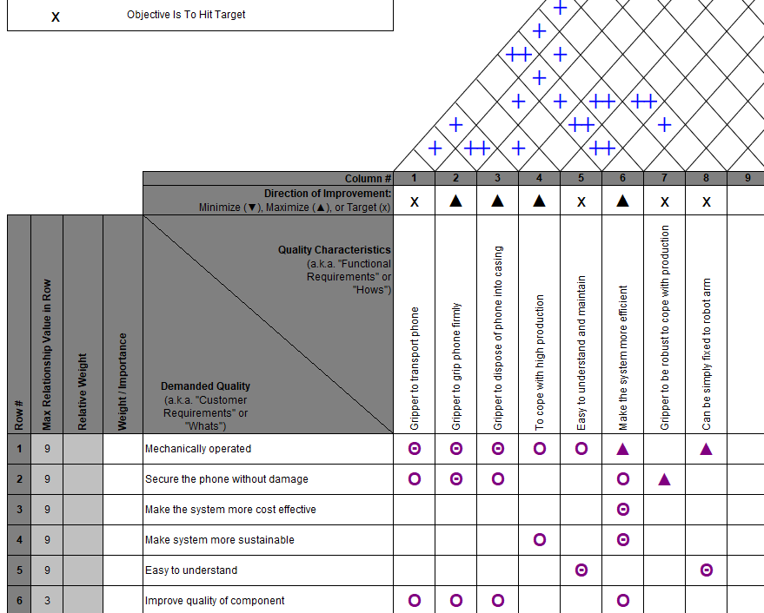

By plotting the technical data and customer demands into the table it clearly shows the relationship and links between various requirements. Using the QFD chart it also allows a visual to be seen on the links between each quality characteristic and how achieving one might affect the other. This gives a greater understanding when designing a component of what can be achieved and what cannot, it can then help allow for data or requirements to be prioritised.
Root Cause Analysis
Poka – Yoke
Simulation
Final Design

