

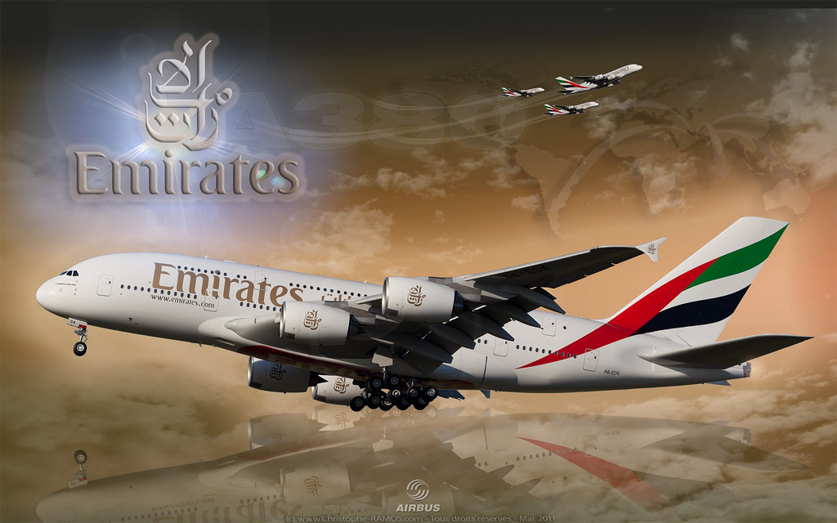
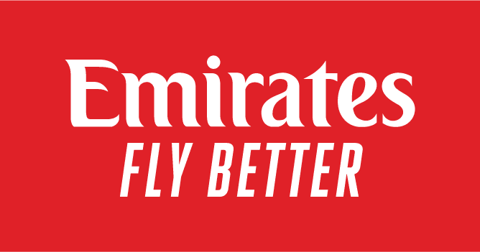

Student name:​ Dewan Ashrafi
Student ID: ​1916230
Programme: MBA- Masters of Business Administration
Module: Marketing Management
Module code: LCMB7006
Lecturer name: Tushara Balendran
Date: 21/08/2023

Table of Contents
Introduction 3
Background 3
Mission and Vision Statement 5
Analysis of Emirates Macro Environment 6
Hofstede's model of Cultural Dimension 17
Dimensions 19
POWER DISTANCE 19
INDIVIDUALISM 19
INDULGENCE 21
Similarities in the Macro Environment of the UAE and the UK for Emirates Airlines: 27
Analysis of Industry Attractiveness for Emirates Airlines in the UK and the UAE 29
Porter's Five Forces 29
Similarities and Differences in Market Forces Analysis of Emirates 36
Advantages and Disadvantages of Porter's Five Forces Model 37
SWOT Analysis of Emirates 37
STP Analysis of Emirates 40
Marketing Mix 45
Market Entry Mode of Emirates Airlines 51
Influences, Advantages and Disadvantages of Direct Export Method 52
Similarities and Differences between both countries Marketing Mix 58
Directional Development Strategy 59
Recommendations 61
Conclusion 63
References 64

Introduction

Emirates Airlines is an international airline based in Dubai, United Arab Emirates. It is one of the world's largest and most well-known airlines, renowned for its luxurious services, extensive route network, and modern fleet of aircraft. (Al Saed, Upadhya and Abu Saleh, 2020). This report aims to comprehensively analyse international marketing strategies employed by Emirates Airlines in the United Kingdom (UK) and the United Arab Emirates (UAE) to achieve the company's marketing objectives.

Background

Emirates Airlines was founded in 1985 with backing from the Dubai Royal family, with a modest initial capital of $10 million from private investors and assistance from Pakistan International Airlines (Emirates, 2023). Emirates conducted its inaugural flights from Dubai to Karachi and Mumbai on October 25, 1985, using a Boeing 737 and an Airbus 300 B4 aircraft leased from PIA (Emirates, 2023). The Government of Dubai owns Emirates Group, the parent private limited corporation of Emirates Airlines. (Emirates Group, 2023) (Emirates, 2023a)
Throughout the late 1980s and early 1990s, Emirates rapidly expanded its fleet, adding modern aircraft like the Boeing 777 and Airbus A330 to accommodate its growing route network, and established Dubai International Airport as its primary hub, leveraging the city's strategic location as a global connecting point between Asia, Europe, Africa, and beyond (Emirates, 2023). Emirates provides industry-leading passenger and freight air transportation services, flying to 150 destinations in 80 different countries and transporting 1.8 million tons of cargo in addition to 43.6 million passengers in the year 2022-23 (Group Emirates, 2023).

Image 1: Evolution of Emirates Fleets
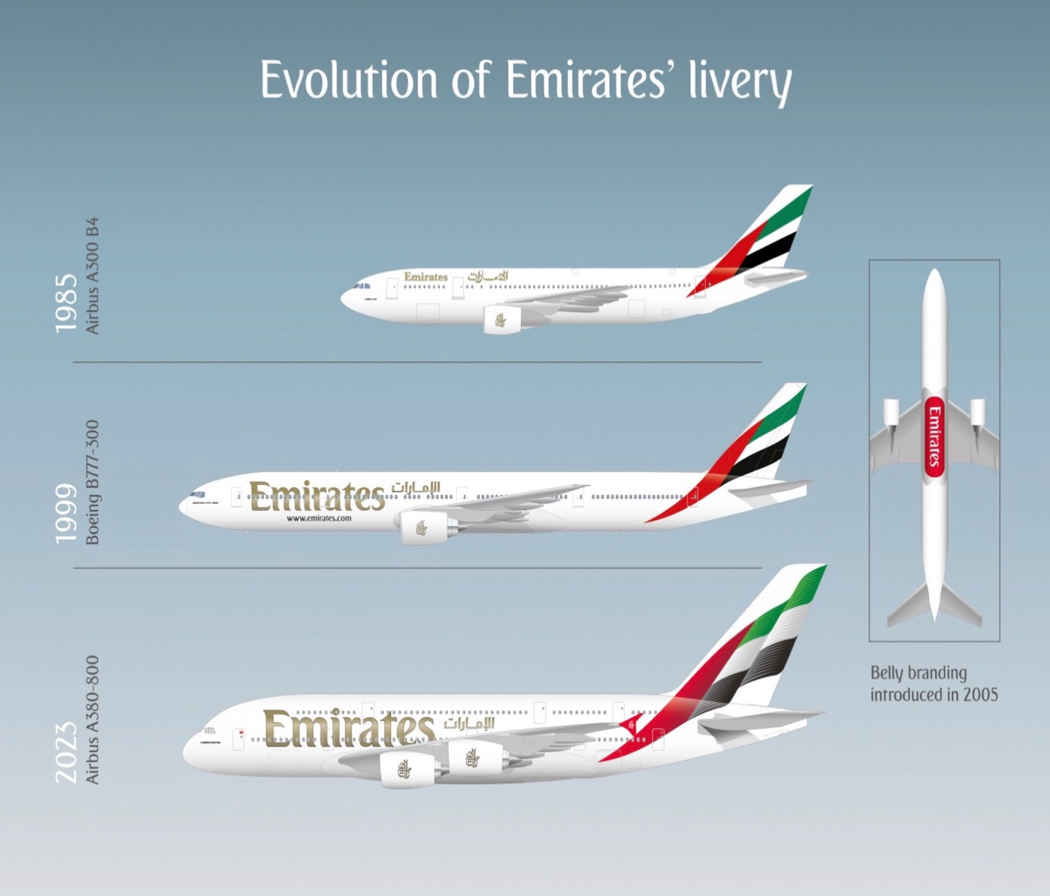
Source: emirates.com
In 2022, Emirates was the fourth-largest international airline by revenue, $32.6 billion) and by brand value, estimated at $5.1 billion (Finance, 2023) (Statista, 2023a). Their parent company, Emirates Group, reported a record profit of $2.9 billion for the fiscal year ending 31 March 2023, compared to a loss of $1.1 billion the previous year; revenue increased by 81% to US$ 29.3 billion as the airline re-established its worldwide network and added more passenger flights (Group, 2023b).
Figure 1: Number of Fleets (2022-2023)
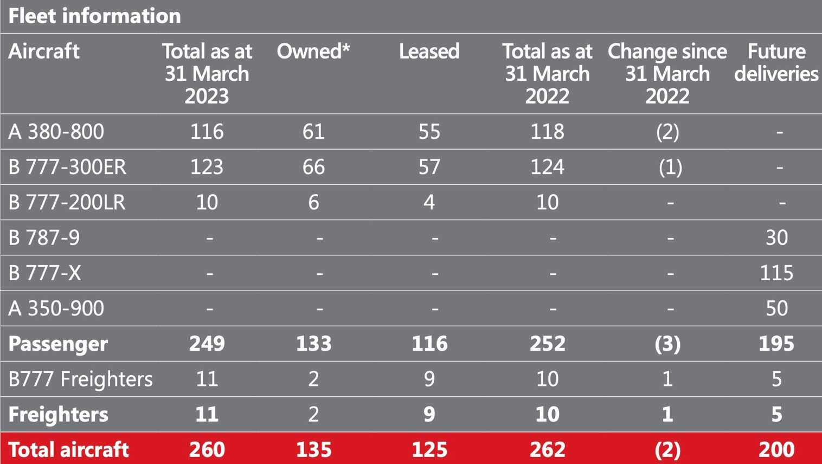
Source: (Group Emirates, 2023)

The Chairman and CEO of Emirates Airlines is Sheikh Ahmed bin Saeed Al Maktoum, while the President is Sir Tim Clark (Airlines, 2023). On numerous occasions, Emirates has won awards for many occasions as "The Best Airline" in global and regional categories (Skytrax, 2023) (Airlines, 2022).

Mission and Vision Statement

Vision: Emirates Airlines aims to uphold its global reputation as a prominent player in the aviation and security services sector and establish a standard of excellence within the industry (Emirates, 2023c).
Mission: They are committed to safeguarding all customers, staff and assets against unlawful interference through continuous reviews, training and education. Emirates is determined to implement internationally established industry standards and practices to ensure a safe and secure environment while facilitating business growth (Emirates, 2023c).

Analysis of Emirates Macro Environment

The micro-environment is the components within a company's close surroundings that impact its operations and choices, encompassing factors such as suppliers, rivals, marketing intermediaries, customers, and public groups (Monash Business School, 2023). On the other hand, the macro-environment refers to the external variables and forces that impact an organisation's operations, strategy, and overall business environment (Itani, O׳Connell and Mason, 2014).

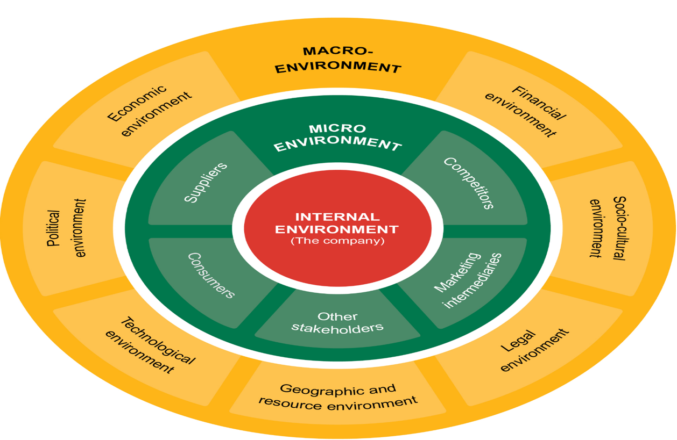
Image Source: (Lippman, Hewitt and Bramdaw, 2021)

  - PESTEL Analysis of Emirates Airlines in the UK and the UAE

Figure 2: PESTEL Analysis
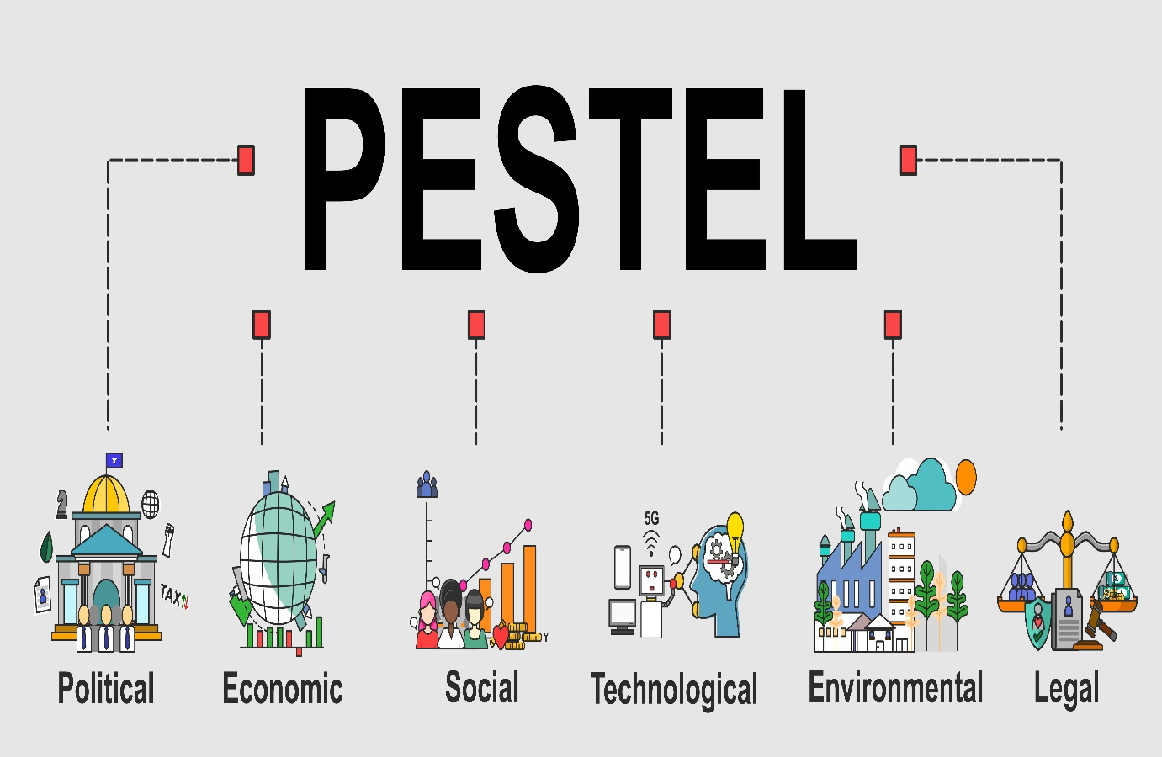
Source: Dewan Ashrafi
In the subsequent section, an evaluation of external environmental factors of the Emirates in the UK and the UAE will be conducted using the PESTEL framework. This approach aims to gain insights into external dynamics that could impact their operations and enable the formulation of strategies to navigate and prosper amid evolving conditions successfully.

Political Factors

The UAE
Stable Government: Since the country's independence in 1971, the UAE authorities' absolute decision-making powers and capacity to govern without constraints have remained consistent (BTI, 2022). The politically stable environment in the UAE supports business operations, including aviation, benefiting Emirates Airlines. However, being a federal monarchy, criticism arises due to potential accountability and transparency issues in such a government. (Ledstrup, 2018) (Anckar, 2020).
Government Support: The Dubai Royal family and the UAE government have consistently backed Emirates Airlines, aiding its success with investments, infrastructure development, and favorable policies (Emirates, 2023b) (Emirates Group, 2023a).
International Relations: The UAE's commitment to multilateralism within the United Nations benefits Emirates Airlines' diplomatic ties and market access (UN, 2023; Britannica, 2023). However, reconciliation efforts with Israel and the association with Russia post-Ukraine conflict face criticism (Parliament, 2023; CNN, 2023; Al-Mughrabi et al., 2023; Traub, Cohen, & Kertcher, 2022). Dubai's popularity among tourists from countries with limited diplomatic relations, such as Russia and Israel, is noteworthy (Affairs, 2021; NATO, 2023; Dubai, 2023).
Freedom of Speech concern: Ranked 145th in the World Press Freedom Index 2022, the UAE's limitations on freedom of expression (RSF, 2023) hinder Emirates Airlines' communication, innovation, diverse perspectives, and reputation-building efforts.
Terrorist Attacks: In 2022, the UAE experienced multiple instances of terrorist attacks carried out by the Yemeni Houthi movement (Aljazeera, 2022). The attack on the UAE could significantly negatively impact Emirates Airlines' business.

The UK
Brexit Implications: Brexit's impact on the aviation sector includes increased operating costs, reduced connectivity, and heightened competition from EU airlines (Pappas, 2019), leading to higher ticket prices, extended routes, and industry job losses (Makortoff, 2022). The UK's departure from the EU also affected trade regulations and travel policies, influencing customer demand in the travel and tourism sector (CAA, 2023) (Zachariah, Sharma and Kumar, 2023). Notably, the number of UK citizens traveling to and from the EU has declined since 2019 (Statista, 2023b), potentially indicating shifts in consumer behavior and creating opportunities for global airlines like Emirates.

Consistent Policies: The UK's established governance structure has ensured remarkable policy consistency since World War II (Marketline, 2023a). This stability in political policies fosters a favorable business climate, enabling Emirates Airlines to operate effectively, strategize, and flourish within the nation.
Strong position in Global Politics: Due to its permanent seat on the UN Security Council, G8 membership, NATO alliance, and historical British Empire influence, the UK holds a crucial position on the global stage. Additionally, the UK wields substantial influence within key international bodies like the International Monetary Fund (IMF) and the World Bank (Marketline, 2023a). Emirates Airlines' operations in the UK benefit from the nation's significant global role, diplomatic connections, economic prospects, and infrastructure advancements driven by its participation in international organizations.

Economic Factors


The UAE
Strong Economic Growth: The UAE's robust economic growth and high disposable income with no personal income tax levels positively influence air travel demand, especially for luxury and premium services (Statista, 2023a) (O'Neill, 2023) (Government, 2023a).

Figure 3: GDP of the UAE
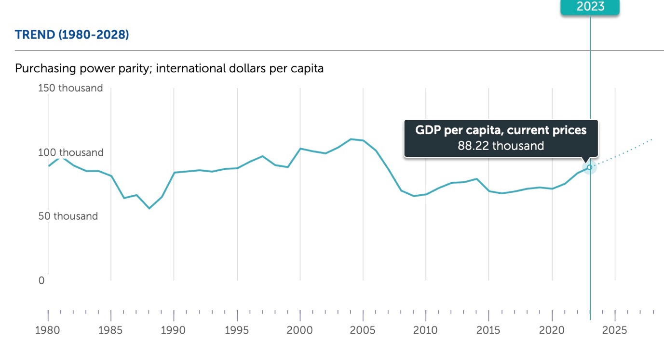
Source: (IMF, 2023a)
Expected growth in the UAE's real GDP from 2023 to 2028 by 0.8 percentage points to 4.34 percent is projected (O'Neill, 2023b), driving increased demand for air travel and benefiting Emirates Airlines.
Oil Prices: Rising oil prices, influenced by supply reductions from major suppliers like Saudi Arabia and Russia, impact airfares and the aviation industry (Kelly and Kelly, 2023). However, higher oil prices contribute to the UAE's current account surpluses as a major oil exporter and may prompt airlines to reduce overcapacity, potentially increasing returns (Mckinsey, 2022). To counter susceptibility to oil price fluctuations, the UAE government emphasizes the UAE Tourism Strategy 2031 to enhance tourism's role in GDP (UAE Government, 2023), benefiting Emirates Airlines.
The UK
Strong Economy: The UK's economic conditions and income influence consumer spending on air travel, particularly in the premium segment, where Emirates Airlines belongs.

Figure 4: UK GDP Per Capita (Purchasing Power Parity)
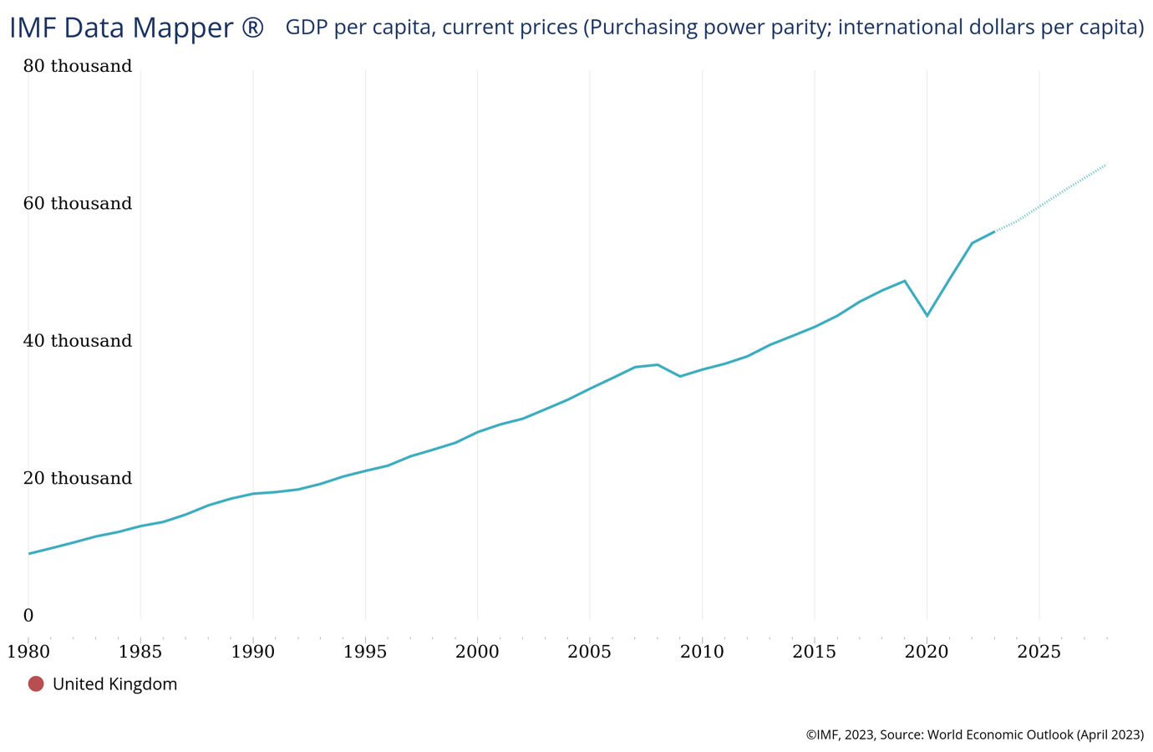
Source: (IMF, 2023)

Figure: 5: Household Disposable Income (The UK)
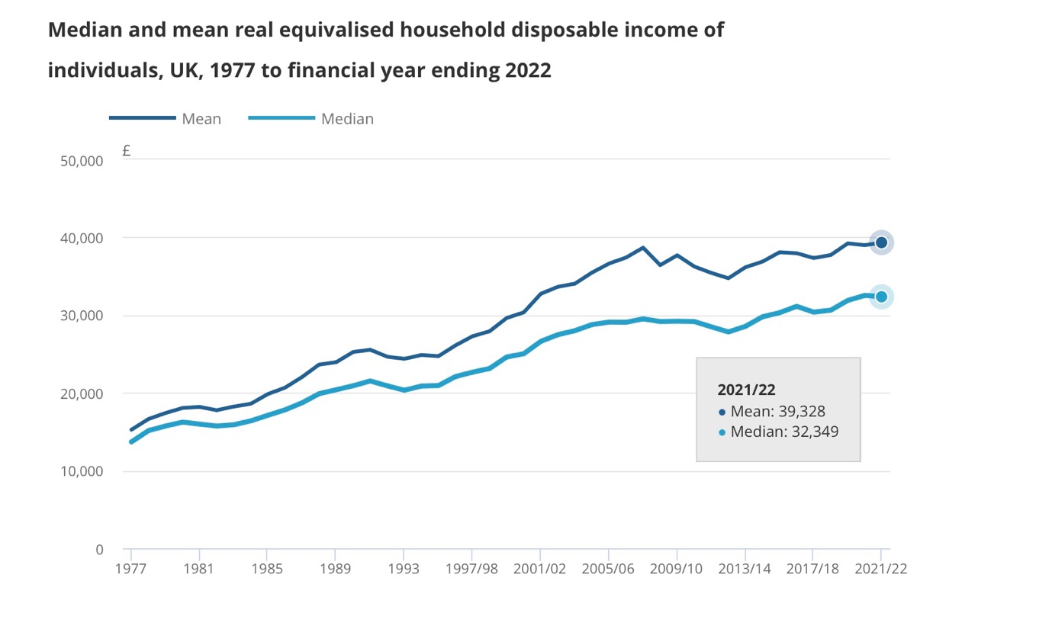
Source: (ONS, 2023)
Inflation, High cost-of-living and Household Debts: On June 2023, consumer price index (CPI) was 7.9%, down from October's 11.1%, the highest rate since 1981, according to the Office of National Statistics. The average household debt in the UK in 2023 is £65,434, an increase of £1,852 compared to 2022 (Herring, 2023).
Figure 6: CPIH of the UK (10 Years)
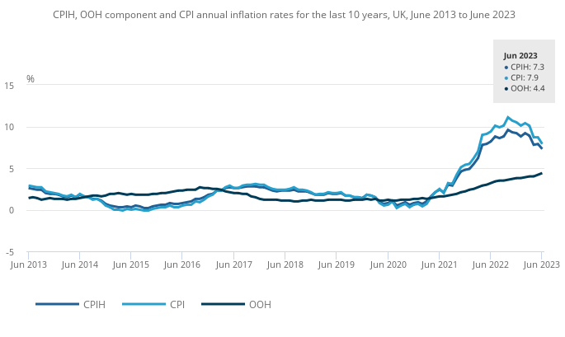
Source: (Herring, 2023)

The high inflation levels impact Emirates Airlines through increased operational costs, reduced ticket sales due to consumer spending shifts, decreased consumer confidence affecting passenger numbers, and potential exchange rate fluctuations affecting international travel costs.
Import and Export Business: Air freight significantly contributes to the economy, with £87.3 billion GVA from air freight exports (Airlines UK, 2020). Air cargo constitutes 40% of UK imports and exports, vital for the economy (Logistics UK, 2023). Emirates Airlines greatly benefits from its air freight service for UK businesses.

Social Factors

The UAE
Diverse Population: The social environment of the United Arab Emirates is diversified, expat workers comprise 90% of the workforce, mostly from South Asian and Southeast Asian nations (Marketline, 2023b). The UAE is the residence of 200 nationalities (Affairs, 2020). The multinational population of the UAE plays a pivotal role in generating demand for air travel and air cargo for personal and business purposes, thereby positively impacting Emirates Airlines' operations and revenue streams.
Tourism: In 2019, before the global pandemic, over 25.28m people visited UAE, and the number was steadily increasing since the 90s (Worldbank, 2023).

Figure: 7: Number of Visitors in the UAE
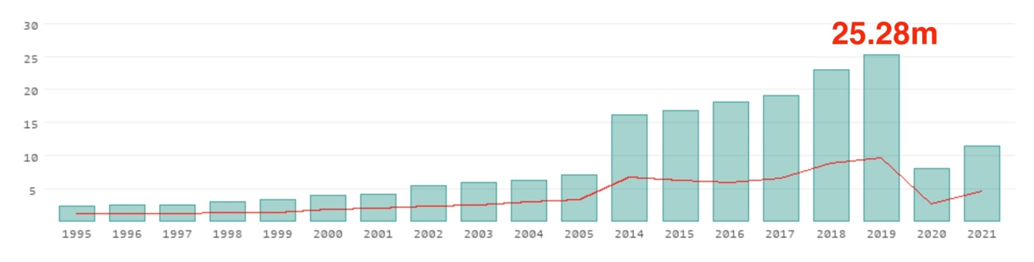Source: (Worlddata, 2023b)
For the second consecutive year, Dubai has been ranked the top global destination based on travellers' preferences. This reaffirms its position as the most popular tourist spot worldwide. (Kickham, 2023).

Figure 8: Top sources of Visitors to Dubai
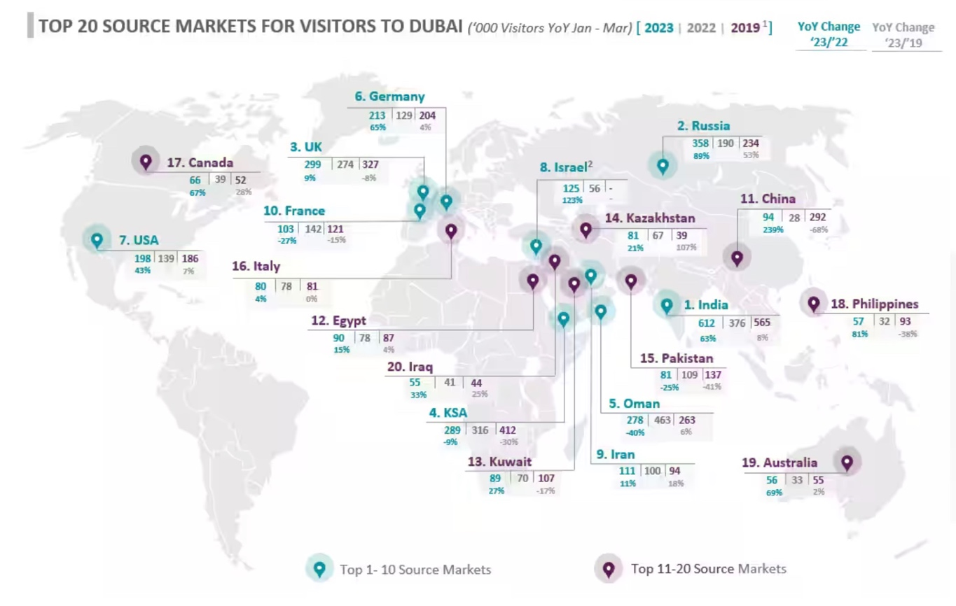
Source: (Dubai, 2023)
In January-March 2023, Dubai received 4.67 million tourists from countries, with 299k from the United Kingdom (Dubai, 2023). The country's appeal as a tourist destination helps passenger traffic, mainly leisure travel segments and Emirates Airlines.
Urban and Young Population: In the UAE, urbanization is on the rise, with a predominantly urban population and a median age of 33.5 years (Worldometer, 2023; Statista, 2023). This aligns with research indicating that individuals under 40 in metropolitan areas have a higher propensity for frequent long-distance travel (Mattioli, Morton, & Schreiner, 2021; Leonhardt, 2019).

Figure 9: % of Urban Population (UAE)
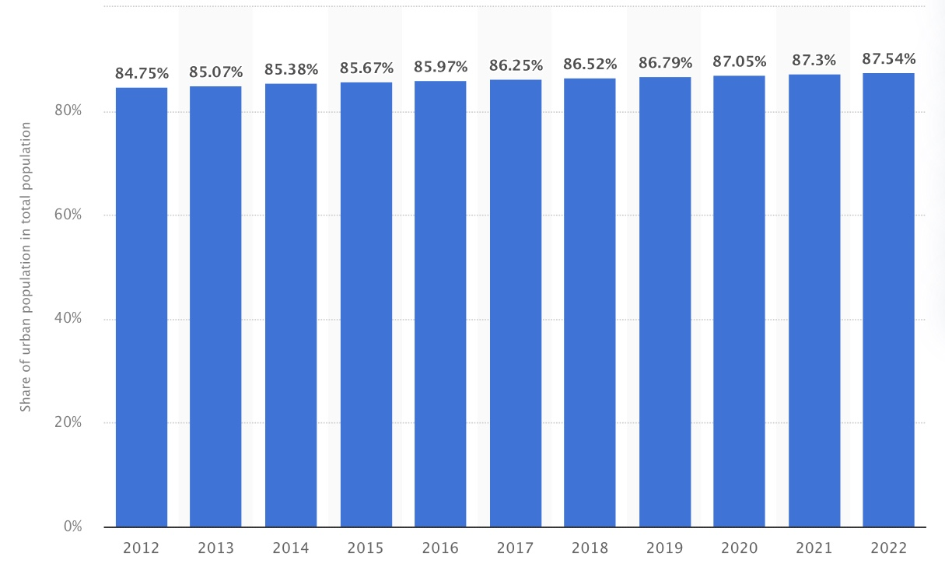
Source: (Statista, 2023)
The UK
Consumer Preferences and Travel Behaviour: The UK's diverse population and cultural influences impact passenger preferences and travel demand. UK air travel rebounded in 2022, with over 224 million passengers, reaching 75% of 2019 (CAA,2023a).

Figure 10: Holiday spending (The UK)
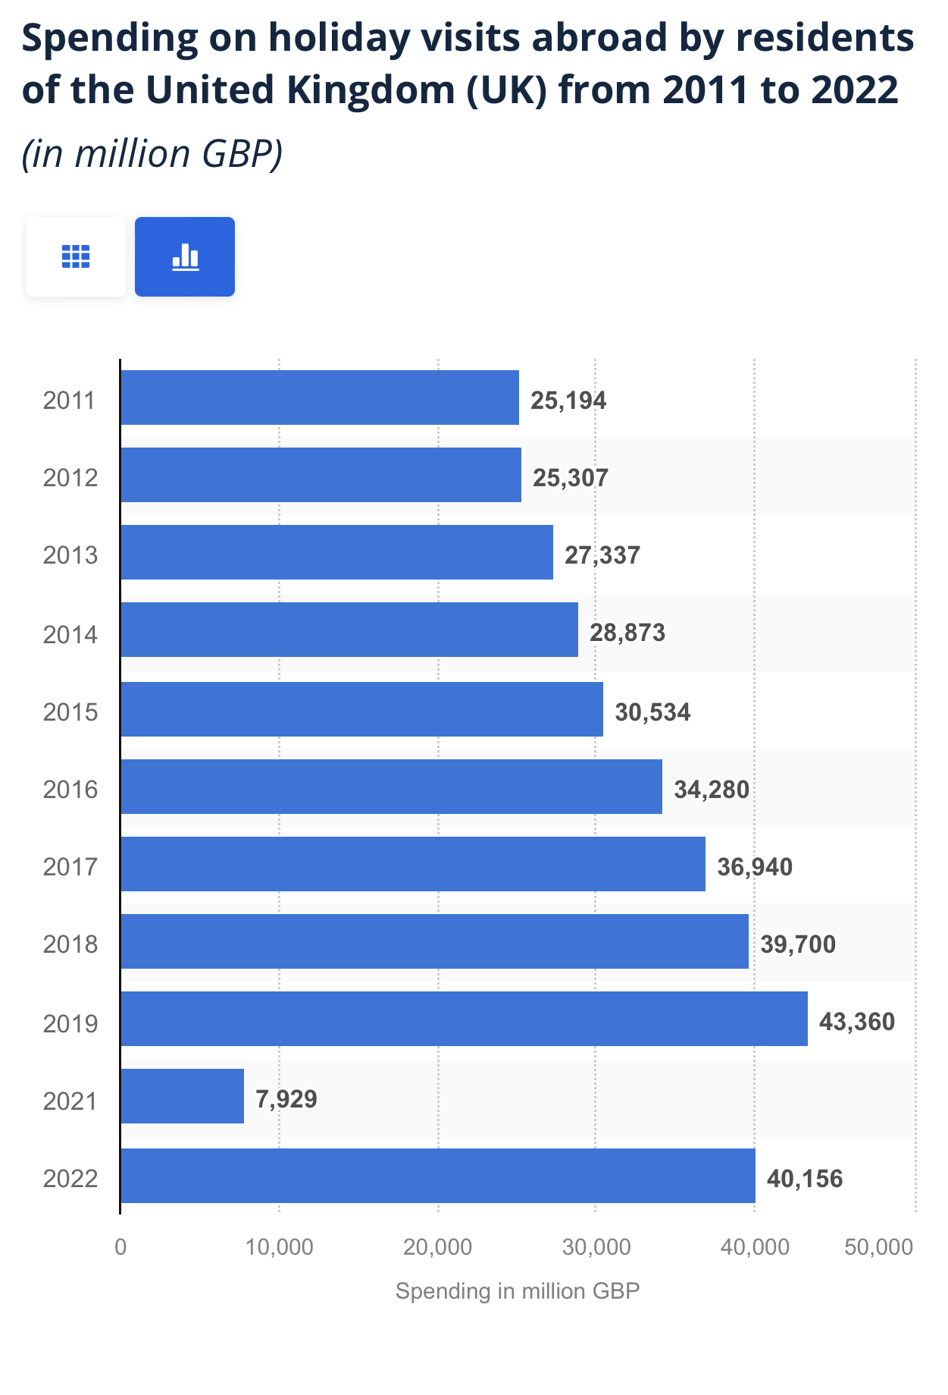
The conditions benefit Emirates Airlines in achieving its business goal.
Ageing Population: Research shows that UK residents aged 25 to 34 are the most frequent international travelers, with 62% going abroad, compared to 27% of those aged 55 to 64 (Statisa, 2023b). The UK's aging population, with 18.6% aged 65 or over, affects air travel frequency. Yet, younger travelers prefer budget airlines, while those over 45 prefer premium carriers (Statista, 2023e), benefiting Emirates.
Social Inequality: In the UK, there are notable inequalities in income, education, employment, and services despite its developed status (Oxfam, 2023) (Oreffice and Quintana-Domeque, 2021).

Figure 11: Income Inequality (Gini coefficient disposable income (%), 2005–21)
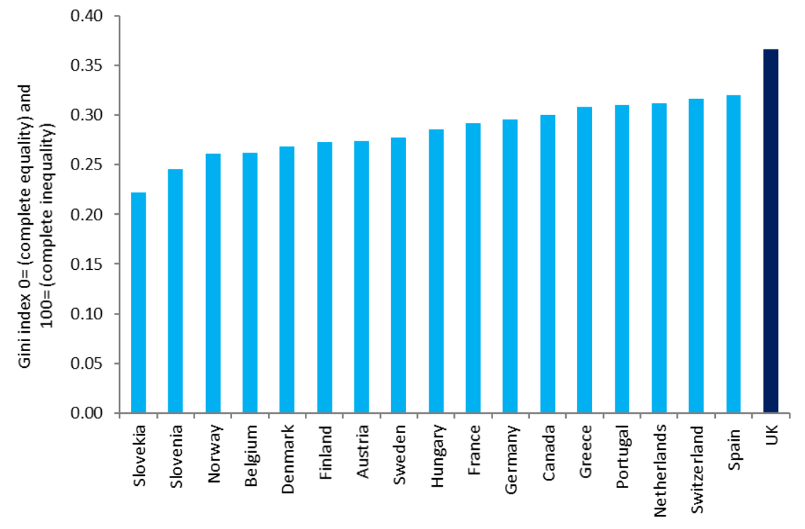
Source: (Marketline, 2023a)

Figure 12: Race Inequality in the UK
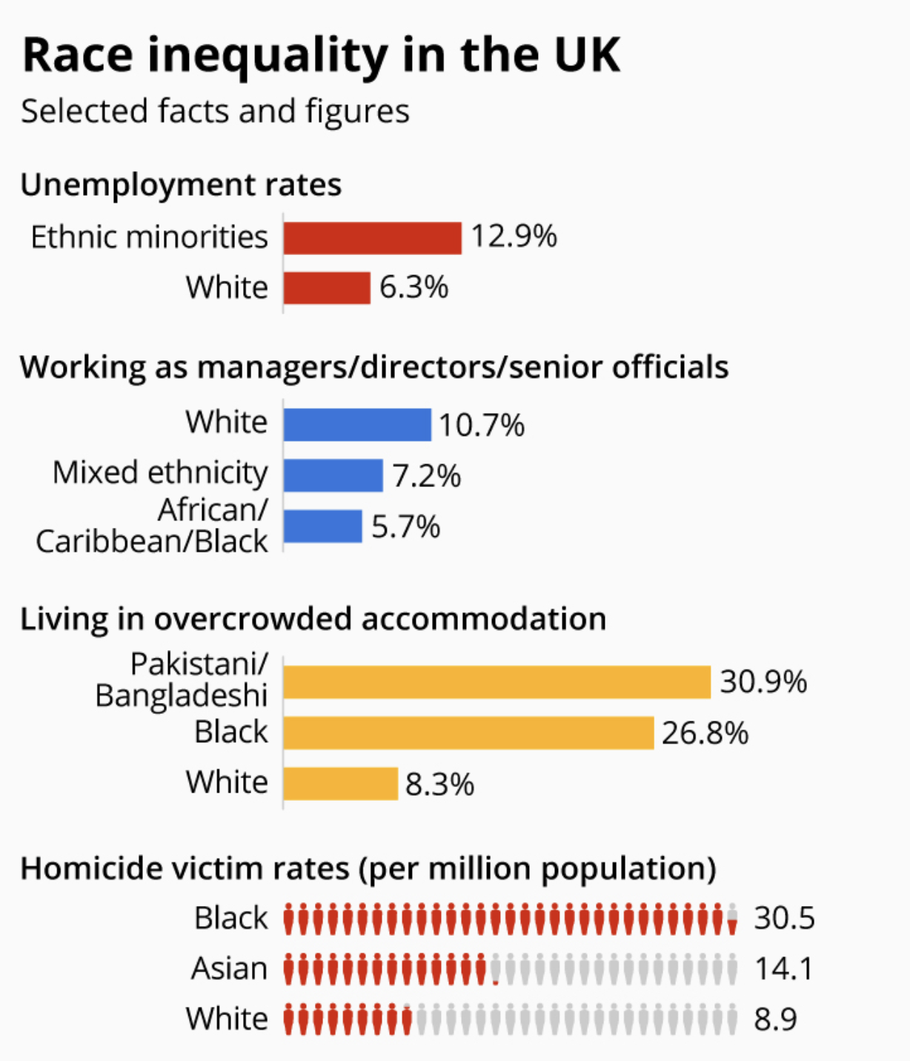
Source: Statista (Armstrong, 2016)
Social inequality impacts Emirates Airlines' UK business operations by affecting customer base, demand variability, pricing sensitivity, branding, business travel patterns, talent acquisition and retention, and consumer behaviour shifts.

Hofstede's model of Cultural Dimension

Hofstede's cultural dimensions model, created by Geert Hofstede, is employed to analyze cultural variations between nations or societies, especially in cross-cultural studies and business settings (British Library, 2023) (Adeoye and Tomei, 2014, p.6). It aids in understanding the influence of culture on communication, behaviour, values, and work practices. (Hofstede and Bond, 1984) (Hofstede, 2001).
In the following section, Hofstede's cultural dimensions model is used to understand the intricate cultural landscapes in the UAE and the UK, aiding Emirates Airlines' objectives in these countries. The model's six dimensions enable comparative analysis between the UAE and the UK. (Insight, 2023):
Figure 13: Comparison between the UAE and the UK (Cultural dimensions)
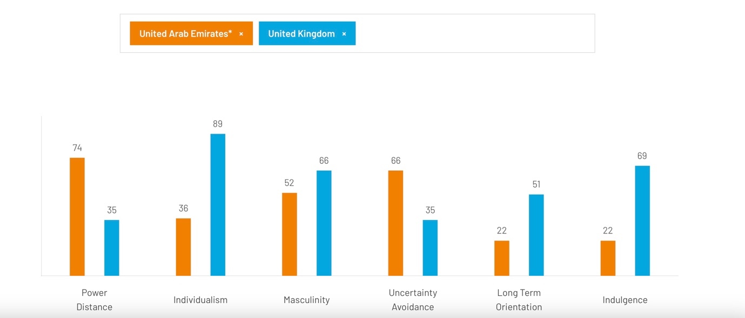
Source: (Insight, 2023)

Dimensions | The UAE | The UK
POWER DISTANCE  Power distance refers to the distribution of authority and the level of acceptance of such inequality, observed in family, work, and organizational settings. (Hofstede, 2011). | The UAE scores high (74) on this dimension, showing a preference for hierarchical structures, centralized authority, and subordinates expecting clear direction from superiors. | Scoring 35 in PDI, the UK focuses on individual equality. Surprisingly, upper classes show lower PD index than working classes, revealing conflict between the class system and belief in progress, driven by fairness and equal treatment.
INDIVIDUALISM  Individualism emphasizes personal autonomy, achievement, and freedom, while collectivism prioritizes group cooperation, communal well-being, and shared goals within communities. | With a score of 36, the UAE embodies collectivism, valuing family and group loyalty. Strong relationships involve shared responsibility, and reputation is important. Work dynamics mimic family bonds, affecting hiring, promotions, and group interests in management practices. | Scoring 89, the UK is highly individualistic, valuing personal privacy and independent thinking. Education promotes individual pursuits and happiness through personal fulfilment. Consumerism and self-centric values are on the rise, sparking discussions about the "ME" culture.
Masculinity  High Masculinity scores reflect competitive societies valuing success and dominance, while low scores signify Feminine societies prioritizing care and quality of life, with success measured by well-being rather than prominence. Motivation varies between striving for the best (Masculine) and pursuing fulfilment (Feminine). | The United Arab Emirates (UAE) scored average on this dimension, with a score of 52. | With a score of 66, the UK emphasizes success and is a Masculine society. This contrasts with British modesty, requiring understanding of implied meanings. Unlike Feminine cultures, the UK prioritizes work and performance goals.
Uncertainty Avoidance  The score on this dimension indicates a culture's comfort level with ambiguity and its strategies to avoid it. | With a score of 66 on this dimension, the United Arab Emirates demonstrates a strong inclination towards uncertainty avoidance. In societies with high Uncertainty Avoidance, strict codes of conduct are upheld, dissenting behaviour and ideas are discouraged, and a need for rules is evident. Such cultures value punctuality, hard work, and security, while being cautious about embracing innovation. | With a score of 35 in Uncertainty Avoidance, the UK exhibits a low preference for structured predictability. The British are comfortable with adapting plans as new information arises, often described as "muddling through." While the society lacks strict rules, adhering to a few significant ones like queuing reflects their value of fairness. This leads to a flexible and fluid approach to planning, favouring innovation due to their high individualism and curiosity. This is reflected in the society's creativity, consumerism for innovative products, and thriving industries such as advertising, marketing, and finance.
Long-Term Orientation  This dimension considers how societies manage their history alongside current and future needs. | The normative aspect of Emirati society is evident in its low score of 22 on this dimension. In such societies, there's a strong emphasis on seeking the ultimate Truth and adhering to norms. They hold traditions in high regard, save less for the future, and anticipate achieving swift outcomes. | The British culture's inclination in this dimension remains undefined due to its moderate score of 51.
INDULGENCE  This dimension categorizes cultures as Indulgent or Restrained based on the extent of control. | Scoring 22 on this dimension, the United Arab Emirates can be categorised as a Restrained society. Unlike Indulgent cultures, they prioritise self-control over leisure and gratification, influenced by social norms that discourage indulgence. | Scoring 69, the British culture is categorized as Indulgent, reflecting a willingness to indulge impulses and desires for enjoyment, along with a positive attitude, optimism, and valuing leisure time and spending freely.

Advantages of Hofstede Model:

- Data-Driven, Flexible and Easy to Understand: Hofstede's model is easy to understand and flexible; it can compare cultures at various levels, from national to organisational.
- Cross-Cultural Understanding: The Hofstede model provides a systematic way to compare and understand cultural differences across countries.
- Business and International Relations: The model helps global companies navigate cultural nuances and adapt strategies for successful cross-border interactions.
- Employee Management: The model facilitates effective management of multicultural teams by understanding cultural dimensions, promoting inclusivity optimising dynamics.
- Marketing and Customer Relations: Companies can tailor their marketing and communication strategies based on cultural preferences and values identified by the model (Valaei et al., 2017).

Limitations and disadvantages of Hofstede's model:

Gender Bias: The model's assignment of masculinity and femininity to cultures overlooks evolving gender roles, reinforcing stereotypes and disregarding progressive changes, seen as Eurocentric and sexist by Witte (2011).
Cultural Stereotyping: The model can reinforce stereotypes by attributing traits to nations, overlooking societal groups and individual variation, leading to biased assumptions (Burr & Dick, 2017).
Changing Cultural Landscapes: Cultures change with globalization, migration, and other factors, which the model may not entirely capture.
Data Collection Procedure and Validity: Hofstede's initial research from the 1960s and 1970s, based on IBM employees, might not accurately represent current cultural realities. Doubts also arise about the reliability of cross-country data collection methods (Hofstede and Bond, 1984) (Hofstede, 2011).
Ignoring Subcultures: The model often ignores subcultures within a nation, which can be equally important in understanding behaviours and values.
Despite drawbacks, the Hofstede model remains useful to initiate understanding cultural differences when integrated into a comprehensive approach that considers context and embraces cultural diversity.

Technological Factors


The UAE
Strong Infrastructure: Benefitting from advanced technology infrastructure, including high-speed networks and modern transport facilities (UAE, 2023), Emirates Airlines leverages the UAE's tech prowess, which ranks 28th in network readiness and 31st in innovation (Marketline, 2023b), enhancing its own innovative edge.
Support for Innovation and Research: Pursuing global technology leadership, the UAE invests heavily in digital transformation, exemplified by projects like the UAE AI Strategy 2031, which aligns with Emirates Airlines' tech-driven approach (Cabinet, 2023) (Emirates Airlines, 2023b) (Kamel, 2023).
The UK
Strong in various technological metrics. Ranked 4th in the Global Innovation Index, the UK offers advanced network infrastructure and innovation capabilities, fostering a favorable tech environment for Emirates Airlines (Marketline, 2023a).
Digital Strategy: The UK's digital strategy, encompassing areas like connectivity, skills, and innovation (Government, 2022), offers Emirates Airlines a chance to enhance connectivity, tap into talent, and benefit from investment opportunities, fostering growth and customer experience.
Negative Perception and Digital Literacy Rate: While the UK is technologically advanced, a significant portion of its population lacks digital literacy and holds negative views towards technology.

Figure 14: Population with zero basic digital skills in the UK
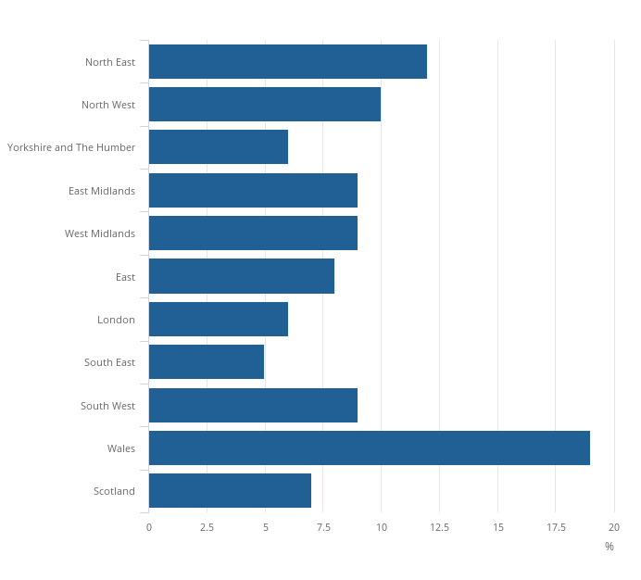
Source: (Office for National Statistics, 2019)

Figure 15: Most common Reasons for not using Technology like the Internet (In Percentage)
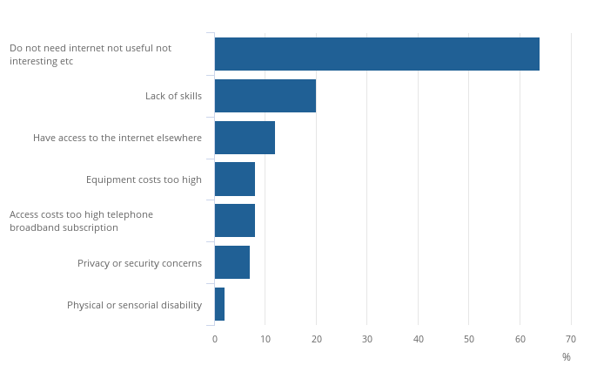
Source: (Office for National Statistics, 2019)

This hinders Emirates Airlines by impeding customer engagement, online sales, marketing, and the adoption of innovative services.

Environmental Factors


The UAE

Sustainability Initiatives: The UAE's Ministry of Climate Change and Environment Agency introduced the General Environmental Policy in 2021 to promote clean energy, water conservation, and waste reduction (MOCCAE, 2021). Emirates Airlines aligns with this sustainability goal, implementing measures like sustainable aviation fuel, efficient aircraft operations, and direct routing (Global, 2023).
Hot and Humid Climate in the UAE: Dubai's hot and humid climate poses challenges for Emirates Airlines, leading to increased fuel usage, emissions, and potential damage to aircraft components, causing higher costs (Ren and Leslie, 2019). This environmental factor is unfavourable for the airline.
The UK
Climate Change: Changing climate in the UK, driven by excessive carbon emissions and pollution, has resulted in more frequent extreme weather conditions (ONS, 2022), affecting aviation negatively. This impacts flight operations, fuel efficiency, emissions, and infrastructure adaptation (Ryley, Baumeister, & Coulter, 2020).
Environmental Regulations: The UK's strong environmental commitment is evident through its various goals and infrastructure developments. The 'Jet Zero Strategy' aims to decarbonize aviation by 2050 in collaboration with the industry, focusing on technology advancement while preserving air travel benefits (Transport, 2022). Emirates Airlines can benefit from aligning with this strategy and implementing sustainable measures.

Legal Factors

Taxation: The UAE ranks 30th in the World Bank's Paying Taxes Report (2020), benefiting from no federal income tax and a low 9% corporation tax, making it favorable for businesses like Emirates Airlines (Marketline, 2023b) (Barrington, 2023).
Judicial Effectiveness: UAE's judicial effectiveness has been questioned recently, with a score of 34.5 according to The Heritage Foundation (2023), significantly below the global average.

Figure 16: Judicial Effectiveness of the UAE

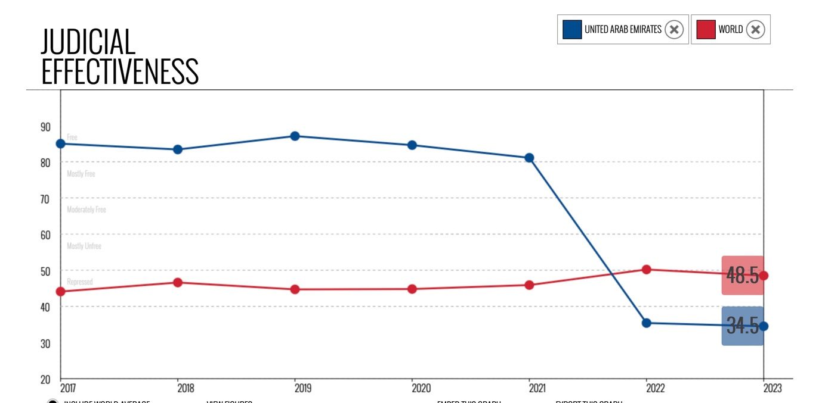
Source: (The Heritage Foundation, 2023)

An ineffective judicial system in the UAE could hinder Emirates Airline's business by delaying contract enforcement, disrupting operational efficiency, eroding investor confidence, and potentially increasing legal costs.

The UK
Transparent and Efficient Legal System: The United Kingdom's legal system is well-organised, clear, and efficient. This creates a business-friendly atmosphere because legislation is drafted in a realistic manner with every stakeholder in consideration (Marketline, 2023a).

Figure 17: Judicial Effectiveness of the UK
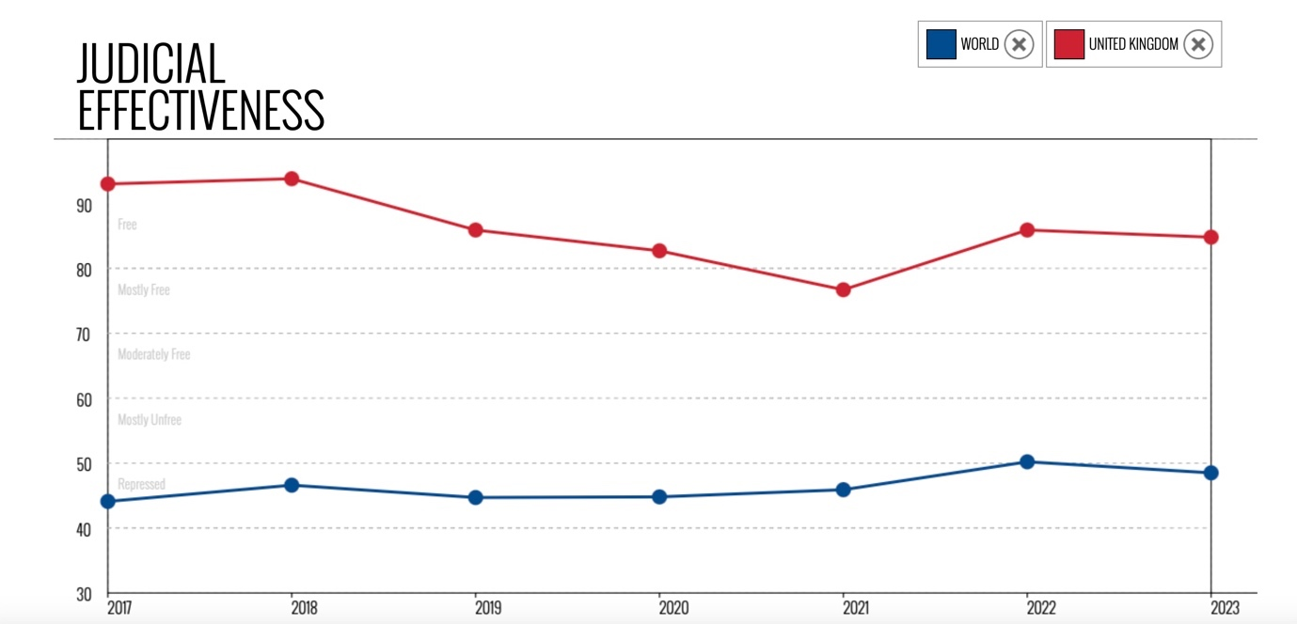
Source: (The Heritage Foundation, 2023)
Transparent and efficient legal systems in the UK offer Emirates and all businesses advantages such as legal certainty, streamlined contract enforcement, increased investor confidence, reduced corruption, quicker dispute resolution, and enhanced intellectual property protection.
High Corporation tax: In April 2023, the British government increased the corporation tax rate from 19% to 25% for enterprises with profits exceeding £250,000, which is unfavourable for Emirates Airlines (Government of UK, 2022).

Similarities in the Macro Environment of the UAE and the UK for Emirates Airlines:
- Stable Government: Both countries benefit from stable political environments, providing conducive conditions for business operations.
- International Relations: Positive diplomatic relations and active participation in international organisations in both countries enhance the airline's market access and global connectivity.
- Strong economy: Robust economies of the countries contribute to increased air travel demand and potential growth for Emirates Airlines.
- Technological Infrastructure: The UAE and the UK offer advanced technological infrastructure, benefiting Emirates Airlines.
- Tourism: The UAE and the UK are popular tourist destinations, contributing to passenger traffic, especially in leisure travel segments.
- Environmental Initiatives: Both countries emphasis sustainability, with the UAE focusing on clean energy and the UK aiming decarbonises aviation, aligning with Emirates Airlines' commitment to environmentally conscious practices.

The Differences in the Macro Environment of the UAE and the UK for Emirates Airlines are the following:
Political System: The UAE is a federal monarchy, whereas the UK has a parliamentary democracy. This affects governance and decision-making processes.
Freedom of Speech: The UAE has restrictions on freedom of speech, which could impact Emirates Airlines' communication strategies, while the UK's higher press freedom supports open communication.
Brexit Impact: Brexit has impacted the UK's aviation industry, leading to increased operating costs and reduced connectivity, which could affect Emirates Airlines' operations in the country.
Ageing Population: The UK has an ageing population, impacting air travel demand among older demographics, which may affect Emirates Airlines differently than in the UAE' which has a younger population.
Social Inequality: The UK experiences higher social inequality, affecting Emirates Airlines' customer base, pricing sensitivity, and brand perception.
Climate Conditions: The UAE's hot and humid climate can impact flight operations, while the UK faces challenges related to climate change and extreme weather events.
Legal Systems: The UAE's judicial system has faced questions about effectiveness, whereas the UK's transparent and efficient legal system benefits business operations.
Taxation: The UAE has low corporate and no income taxes, while the UK has implemented higher corporation tax rates.

Analysis of Industry Attractiveness for Emirates Airlines in the UK and the UAE

The industry attractiveness analysis gives Emirates Airlines the necessary insights to make well-informed decisions, mitigate risk and capitalises on opportunities, and tailor its strategies for success in the UAE and UK markets.

Porter's Five Forces

Studying a company's competitors reveals its weaknesses, opportunities, and threats in the industry (Adom et al., 2016). Michael E. Porter's Five Forces model, established at Harvard Business School, is a strategic framework for assessing an industry's competitiveness and attractiveness (HBS, 2023). The model evaluates five factors impacting competition intensity and industry profitability (Porter, 1979).

Figure 18: Porters Five Forces Model
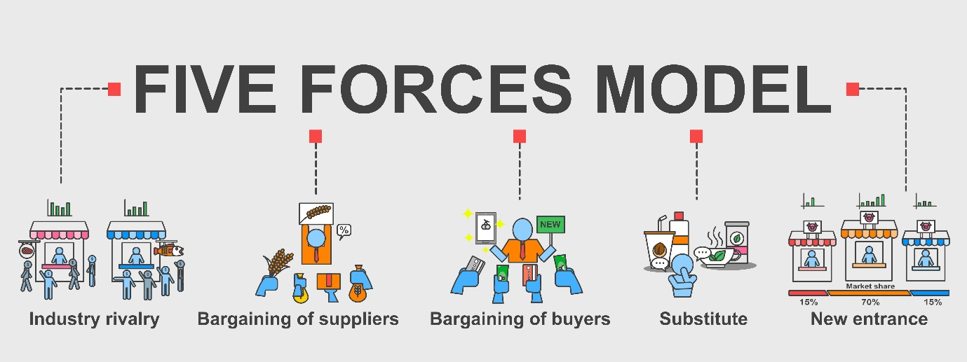
Source: Dewan Ashrafi

Threat of New Entrants
Emirates is a well-established global airline offering premium service. It is very challenging for new businesses to enter the premium aviation market as it requires huge capital, favourable government policies, ideal geographical location and access to distribution channels.

The UAE:
Emirates Group, a government-owned airline (Emirates Group, 2023), enjoys advantages like financial backing, stability, strategic route planning, and national interest service. Government airlines also manage crises, control pricing, and boost tourism. They signify national pride, contribute to the economy, and aid infrastructure (Bailey, 2020). With scale economies and strong branding, Emirates Airlines deters new entrants, supported by demand-side benefits, switching costs, capital needs, and government regulation (Porter, 2008). This leads to a low threat of new entrants in the UAE.
The UK:
Similar to the UAE, the UK faces low threats from new entrants in its airline industry. High capital demands, regulatory barriers, and entrenched competitors create hurdles for newcomers. Emirates Airlines' global reputation and premium service image act as entry barriers, a reputation bolstered by safety and loyal clientele (Fernandez, 2023). The airline's history overlaps with the closure of 24 airlines, several British-owned (Slotnick, 2020), underscoring industry competition. UK aviation presents entry challenges through limited slots, high charges, and strict regulations overseen by the Civil Aviation Authority (CAA, 2023), constraining new entrants' resources and compliance abilities.

Bargaining Power of Suppliers

Emirates Airlines relies on a wide range of suppliers for essential services and products, including aircraft manufacturers (Boeing, Airbus), engine suppliers (GE, Rolls-Royce), in-flight entertainment (Panasonic), cabin interiors, catering, fuel, ground handling, maintenance, amenity kits (Bvlgari), entertainment equipment (Panasonic), IT partners, uniforms, and logistics support (Centre, 2023) (Panasonic, 2017) (UK, 2020) (Amex, 2023) (Kellner, 2015) (Emirates, 2015). These suppliers are crucial for the airline's operational efficiency and passenger experience.
The UAE:
Bargaining power of suppliers is medium in the UAE. Emirates Airlines relies on a diverse supplier network for essential products and services. These include aircraft manufacturers (Boeing, Airbus), engine suppliers (GE, Rolls-Royce), in-flight entertainment (Panasonic), cabin interiors, catering, fuel, ground handling, maintenance, amenity kits (Bvlgari), entertainment equipment (Panasonic), IT partners, uniforms, and logistics support (Centre, 2023) (Panasonic, 2017) (UK, 2020) (Amex, 2023) (Kellner, 2015) (Emirates, 2015). This network is pivotal for the airline's operational efficiency and passenger experience.Therefore, bargain power of suppliers is medium.
The UK: While the Emirates does maintain associations with local suppliers, its principal collaborators and suppliers are international and renowned global brands. Consequently, the consistency of relationships and the depth of negotiations remain relatively uniform across diverse geographical locations for the Emirates. Considering aspects such as currency exchange rates, governmental regulations, and taxation in the UK, there might be slight variations in the bargaining power of suppliers. Nonetheless, overall, a relatively stable and moderate level of supplier bargaining power is anticipated.

Bargaining Power of Buyers
Factors contributing to this power include the number of airlines, low switching costs, price importance, and service quality.

The UAE
The bargaining power in the UAE is medium. Numerous airlines compete for customers, serving major UAE cities worldwide (Skyscanner, 2023a). Premium airlines prioritize Dubai, Abu Dhabi, and Sharjah (Skyscanner, 2023a). UAE-based scheduled and chartered airlines add to choices (Worlddata, 2023a), keeping switching costs low. Yet, the pandemic raised air travel costs, limiting economical options (Bloomberg, 2023). Loyalty programs, convenience, and frequent flyer miles curb buyer power. Satisfaction and allegiance influence switching, while Emirates' reputation and premium services offset buyer influence.
The UK
All the factors that influence the UAE market are similarly present here. However, the UK has more airports; the Civil Aviation Authority recognises 60 as of January 2022 (CAA, 2022).

Figure 19: Buyer's Bargain Power
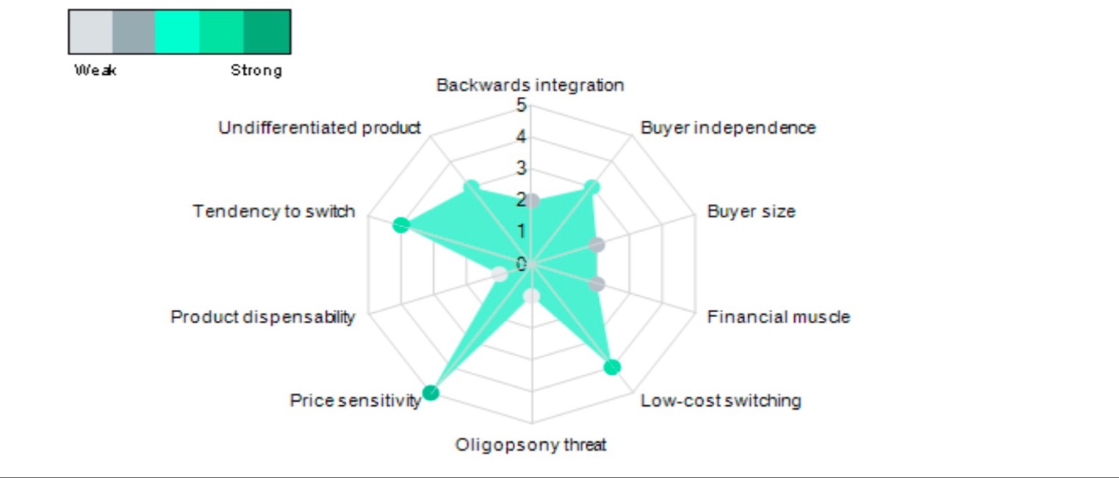Source: (Marketline, 2021)

These airports handle a substantial daily flight volume. In the UK, airports manage 6040 daily flights domestically and internationally (Statistics, 2023b). Heathrow, the UK's largest airport, connects 214 destinations in 84 countries through 89 airlines (Airport, 2023). It's a premier port by value and offers an extensive global network with over 218 Air Cargo destinations (Airport, 2023). Hence, buyers enjoy ample choices with low switching costs. Consequently, even after acknowledging the factors such as airfares, customer loyalty, and service quality, the buyer's bargaining power remains medium in the UK.

The Threat of Substitutes
Premium products or services come with premium prices. According to Ashraf, Li and Mehmood (2017), products at a premium price point differ not only in terms of price but also in terms of comfort and quality. In addition to possessing superior quality, luxury or premium products or services must encompass a symbol of prestige or establish a profound emotional connection with the buyer. (Ko, Costello and Taylor, 2019).
The UAE
Emirates airline's main substitute could be UAE's low-cost airlines. However, Emirates' premium service offers distinct value, quality, and convenience not easily matched by budget alternatives. Substitute threats include high-speed rail, road transport, virtual meetings, cruising, and emerging modes. Yet, these lack coverage, physical replication, air travel luxury, global reach, economic viability, and personal interactions' uniqueness. Therefore, the threat of substitutes for Emirates in the UAE is low.
The UK
Similar to the UAE, the UK has diverse public transportation and virtual options. Yet, none can replace airlines' global connectivity, time-saving, and unique flying experience.

Figure 20: Threats of Substitutes in the UK
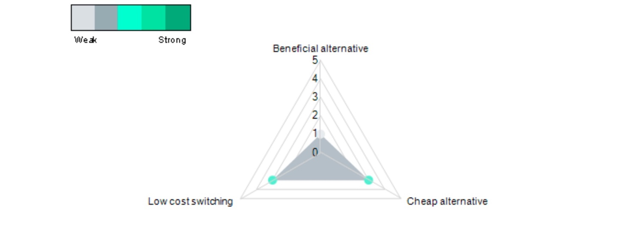
Source: (Marketline, 2021)

British concerns about aviation-related pollution are rising, leading some to choose alternative transportation modes (Hurst, 2021) (Timperley, 2020). Yet, developing equally premium alternatives takes time. Thus, Emirates' substitute threat remains low in the UK.
Industry Rivalry:
Industry rivalry analysis, per Boudreaux (2019), examines competition within an industry, revealing rivals' strategies and strengths for informed business planning. The aviation industry hit $803 billion in 2022, with Emirates owning 4% ($32.6b) (IATA, 2023) (Statista, 2023a).
The UAE
The competitive rivalry of Emirates Airlines in the UAE is high. The country is home to several other major airlines, including Etihad Airways, Flydubai and Air Arabia. Flydubai and Air Arabia are low-cost airlines (ITA, 2022). So, their target market, service level and overall business models are different. However, Etihad is in the same category because of geographical proximity, and they compete for the same market with a similar standard of luxury service. Etihad Airways is also a government-owned airline that is also based in the UAE. Etihad has been increasing recently and has become a significant competitor to Emirates. They have (Etihad, 2023). Their regional competitors are Gulf Air, Qatar Airways, Saudi Arabian Airlines, Royal Jordanian, Kuwait Airways and Oman Air (Airmundo, 2023). These airlines compete with Emirates on many routes, both regionally and internationally. All major airlines fly to the UAE. Global big names premium airlines such as British Airways, Qantas, Lufthansa, Virgin Atlantic, Air France, Turkish Airlines and Singapore Airlines are Emirate's UAE (GlobalData, 2023) (Skyscanner, 2023b).

The UK
The rivalry between the Emirates and its competitors is high in the UK.

Figure 21: Drivers of Degree of Rivalry
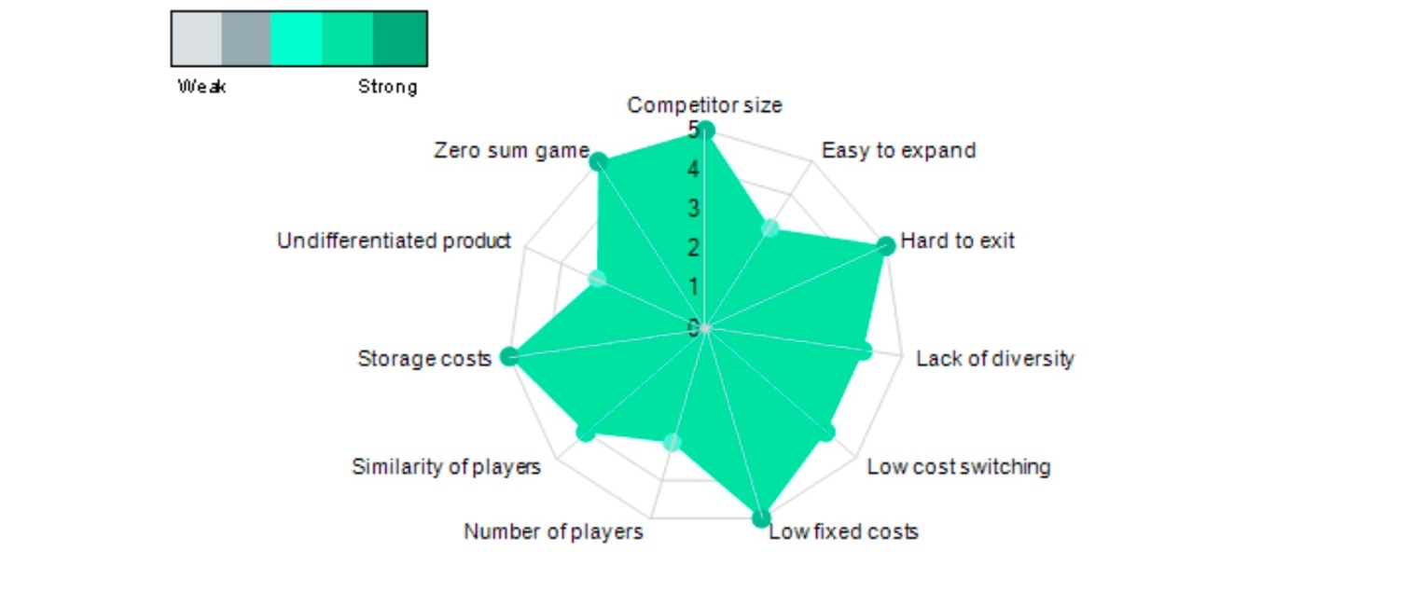
Source: (Marketline, 2021)
Emirates' direct competitors in the UK include British Airways, Virgin Atlantic, Qantas, Qatar, KLM, and Lufthansa. British Airways and Virgin Atlantic are UK-based airlines, so they have a competitive edge over emirates airlines.

Figure: Emirates and its rivals in the UK (Brand Awareness Ranking) 2022
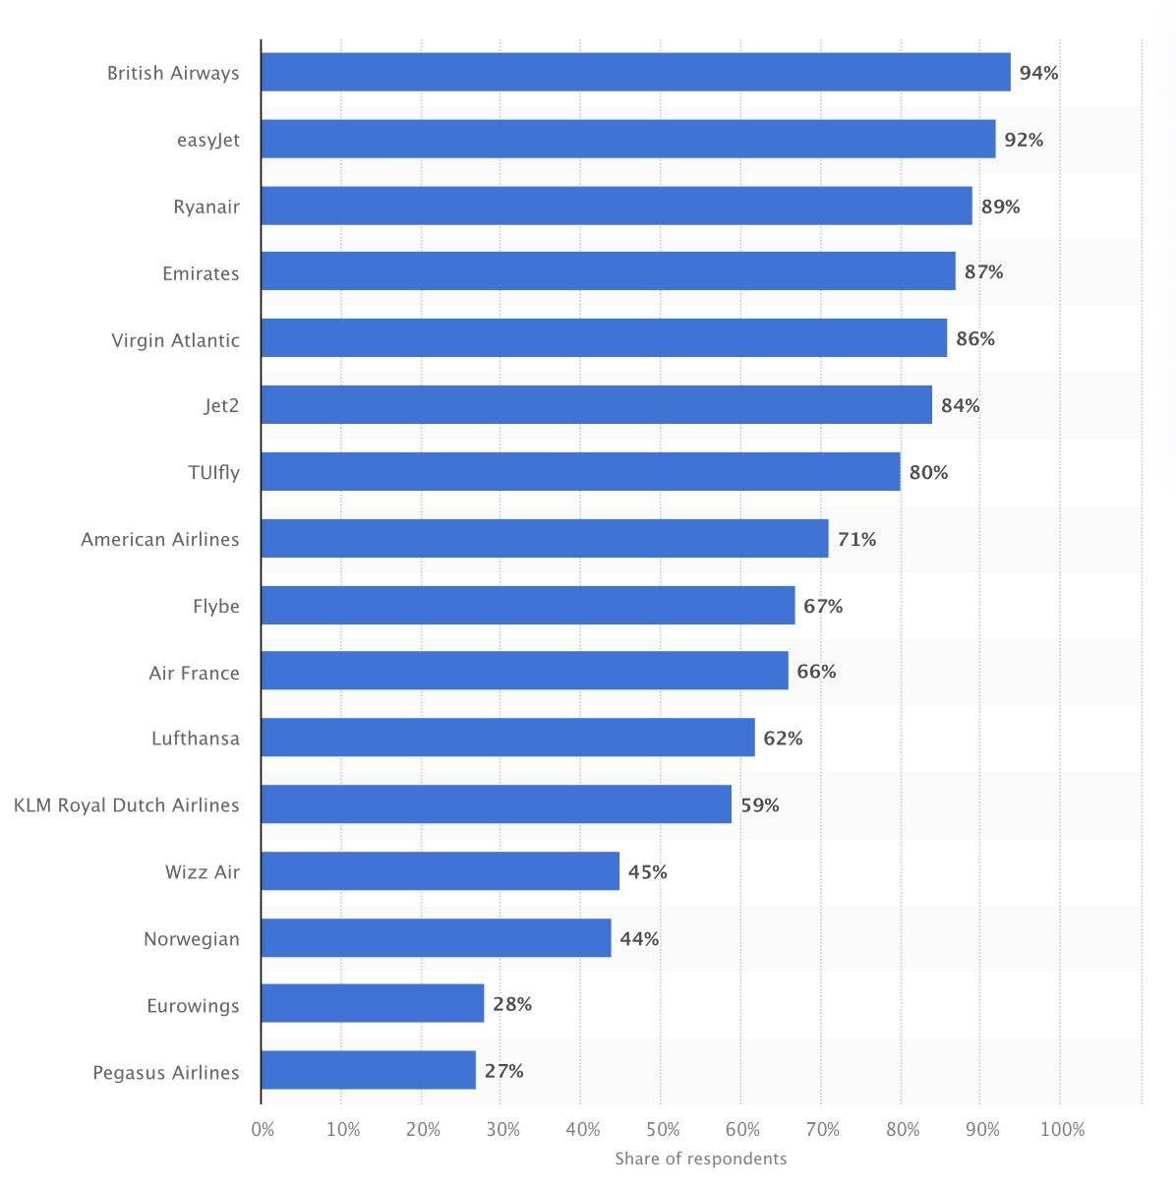
Source: (Kunst, 2023)
Major airlines compete extensively in the UK, battling on price, service, and amenities. Emirates confronts competition from indirect rivals like EasyJet, Ryanair, and JetBlue, providing cost-effective options. While they pose a route-specific threat, their customer focus differs from Emirates.

Figure 22: Most Popular Airlines in the UK in Q1 2023
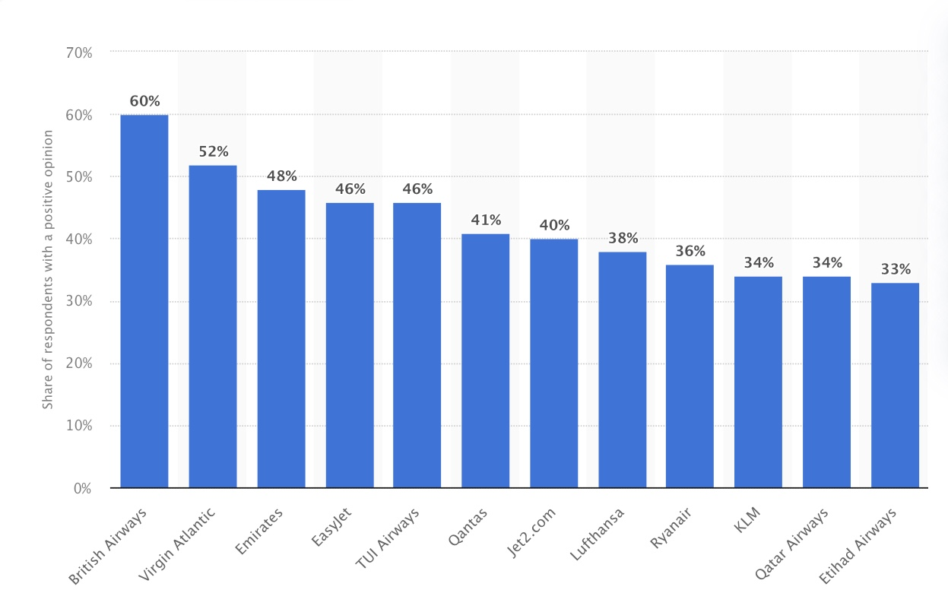
Source: (Statista Research Department, 2023)
The UK is a significant market for air travel, and several well-established airlines compete for market share. This means that Emirates is constantly under pressure to keep its prices competitive and offer a high service level.

Similarities and Differences in Market Forces Analysis of Emirates
Similarities: All the factor levels are quite similar in both countries. Emirates Airlines faces low threats of new entrants in both the UAE and the UK due to its established market presence and high entry barriers. Their extensive supplier networks, catering to essential services and products, play crucial roles in operational efficiency in both regions. Customer bargaining power is moderated by factors like loyalty programs and convenience in both markets, while the low threat of substitutes arises from the uniqueness of premium airline services in both regions. High industry rivalry is a shared challenge in both the UAE and the UK, with established competitors vying for market share.
Differences: In the UAE, government backing boosts Emirates, while UK regulations and rivals impede entrants. Supplier clout varies due to scale and currency rates. COVID-19 lifts UAE travel costs, shifting buyer power, while the UK's multiple options counterbalance. Substitutes are curbed in the UAE by coverage and experience, while eco-concerns influence UK choices. Emirates contends with Etihad, Qatar Airways, and more in UAE, while British Airways, Virgin Atlantic, and Qantas rival in the UK.

Advantages and Disadvantages of Porter's Five Forces Model

Porter's five model provides a structured approach to analyse competitiveness considering internal and external factors for strategic insights that help in decision-making, strategy formulation, and benchmarking.
However, it oversimplifies complex industries and lacks consideration of rapid changes as it is a static analysis, neglecting industry dynamics and innovations (Shi, Agbaku and Zhang, 2021). This model also assumes independence among forces, which may not hold in reality, and It doesn't prescribe specific strategies for addressing challenges.

SWOT Analysis of Emirates

The SWOT analysis evaluates a company's strengths, weaknesses, opportunities, and threats as a strategic planning tool. It entails identifying and assessing internal and external elements that may influence a project's or business's outcome and predicting whether it will succeed or fail (Teoli and An, 2022).

Figure 23: SWOT Analysis of Emirates Airlines
Strengths   |  | Weaknesses  
The UAE    Dubai's strategic positioning as a hub is situated at the centre of the globe (Emirates Group, 2023).  Strong government support and ownership provide financial stability (Emirates Group, 2023).  Strong Brand image and customers loyaltyRecognisedgnisednational pride (Group Emirates, 2023).  Extensive network and diverse routes (Emirates, 2023). | The UK    Growing brand awareness and popularity in the UK (Statista Research Department, 2023) (Kunst, 2023).  Skilled and diverse workforce (Emirates Group, 2023).  Exclusive and modern operational fleet (Group Emirates, 2023). | The UAE  High operating costs and reliance on premium services(Group Emirates, 2023).  Vulnerability to geopolitical tensions affecting the Middle East region.  Potential over-reliance on tourism and transit passengers.  Competition from other premium airlines. |  | The UK  Intense competition from the UK's national and regional airlines (Statista Research Department, 2023)  Reliance on Dubai: All Emirates flights from the UK are connected to Dubai.  Exposure to political and economic uncertainties, Brexit impacts, and regulatory changes.
Threats   |  | Opportunities  
The UAE  Economic volatility and fluctuating oil prices (Isidore and Hickey, 2022)  Political uncertainty and terrorism (Aljazeera, 2022). |  | The UK  Competition from other premium airlines and low-cost carriers.  Economic downturns affect travel demand (Herring, 2023).  Potential regulatory challenges post-Brexit (Pappas, 2019).  Russia- Ukraine War (Nicholls, 2023) | The UAE  The growing popularity of UAE as a business and tourism hub (Uppal and Saba, 2023)  Expansion of routes to untapped markets.  Strategic partnerships with other airlines (EA, 2023).  Technological Advancement: AI, Augmented reality, robotics, development of new aircraft, and in-flight entertainment systems can give Emirates a competitive advantage. |  | The UK  Growing demand for international travel and tourism (UK, 2023).  Increasing adoption of sustainable practices in the aviation industry(Hurst, 2021) (Timperley, 2020).  Expansion of routes to new destinations.  Leveraging technology for enhanced customer experience.

Similarities and Differences in SWOT for Emirates in the UK and the UAE

In terms of strengths, Emirates Airlines benefits from a strong brand image and customer loyalty in the UAE and the UK, contributing to its widespread recognition and reputation in the aviation industry. Additionally, the airline boasts an extensive network with diverse routes that allow it to connect passengers to various destinations efficiently.

However, there are also weaknesses that are common between the UAE and the UK. In both regions, the Emirates faces the potential challenge of over-reliance on certain factors. Moreover, both markets share the concern of high operating costs, which could impact Emirates' profitability and operational efficiency.
Turning to threats, economic volatility poses a common risk for the Emirates in both the UAE and the UK. Fluctuating oil prices impact the UAE's economy, affecting Emirates' operations, while potential economic downturns can impact travel demand in the UK market. Additionally, both regions face unique threats, with political uncertainties and terrorism affecting the UAE and regulatory challenges post-Brexit and geopolitical events like the Russia-Ukraine War being potential concerns for the UK market.
On the other hand, there are promising opportunities for Emirates in both regions. The growing popularity of the UAE as a business and tourism hub presents an opportunity for the airline to tap into a thriving market.

STP Analysis of Emirates

STP analysis is a marketing strategy for Segmentation, Targeting, and Positioning. In each business, customers vary due to distinct requirements, resources, geographical locations, purchasing patterns, and perspectives (Kotler and Keller, 2019). Emirates Airlines use STP analysis to understand more about its consumers and better match marketing activities with their needs and expectations.
Segmentation
Market segmentation divides large populations based on similar needs (Pride et al., 2014, p.640). Enterprises use it to identify demand segments, target categories, and tailor marketing strategies for an edge (Madhavaram and Hunt, 2007).
Emirates Airlines employs market segmentation to serve varied customer groups effectively. They align tailored offerings to preferences, needs, and characteristics. Demographic and psychographic factors guide their segmentation approach.
Geographic
Emirates operates globally and serves a wide range of international destinations. It tailors its services to cater to the preferences and cultural nuances of passengers from different regions worldwide. Emirates Airlines employs geographic segmentation by focusing on different emirates and cities within the country. This includes targeting Dubai, Abu Dhabi, Sharjah residents, and other key regions. The airline strategically tailors its services, routes, and marketing efforts to cater to the preferences and demands of each emirate's population. Nonetheless, with their headquarters situated in Dubai, United Arab Emirates, their prominence is most pronounced in the Western Asian region.

Image: Map of the UAE
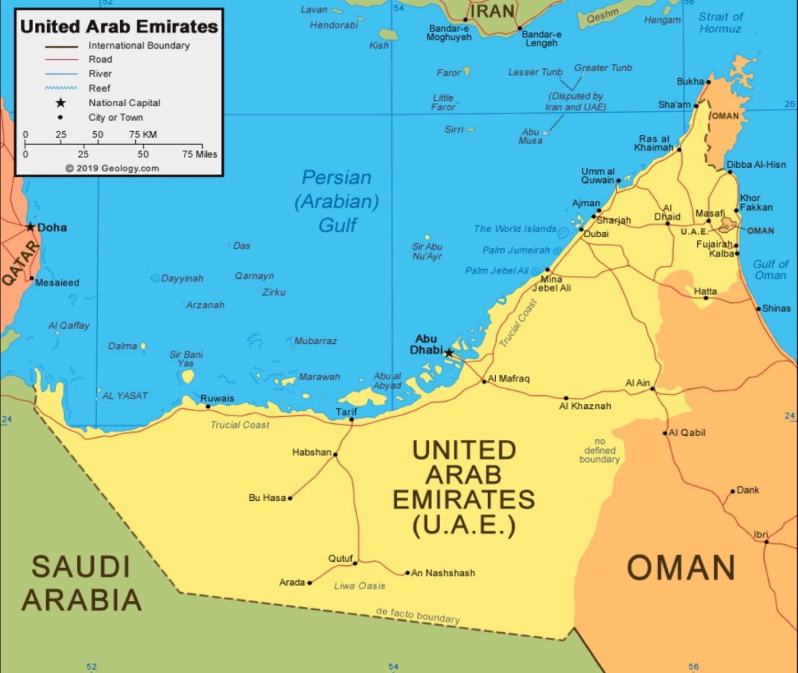
Source: (Geology, 2023)
Dubai stands as a global epicentre for both commerce and tourism, further underscoring its stronghold in the UAE. With an area of 83,600 km², the UAE's compact size ensures that distances to major cities are relatively short (UN, 2014), facilitating accessible connections.

Similarly, Emirates Airlines applies geographic segmentation in the UK by considering different cities and regions. London, a major international travel hub and the biggest city in the UK, would receive special attention with various flight options and premium services.

Image: Map of The United Kingdom
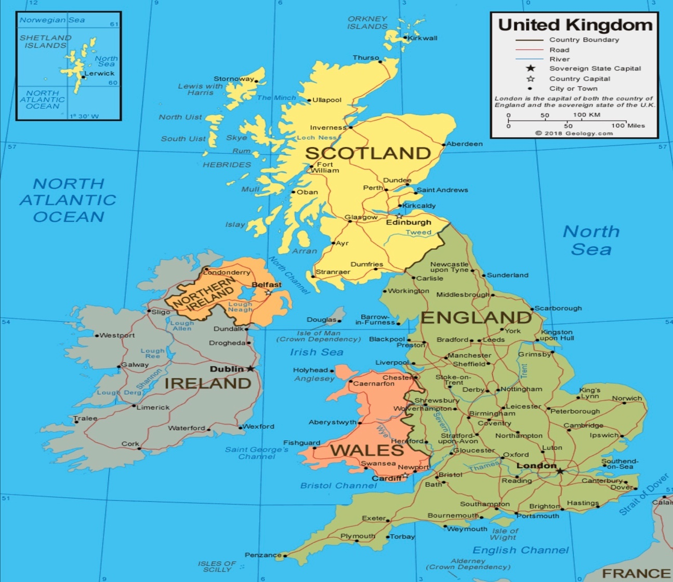
Source: (Geology, 2023)
Emirates serves three airports in London: Heathrow, Gatwick and Stansted. Also, Emirates targets other prominent cities like Manchester, Birmingham, Newcastle, and Glasgow (Group Emirates, 2023).
Demographic
In the United Arab Emirates, demographic segmentation is crucial for Emirates Airlines, considering the multicultural nature of the population. The UAE is a urban country with a diverse population of various nationalities, income levels, and lifestyles). (Marketline, 2023b) (Affairs, 2020).. The majority of the population are expats, and the median age is 33.5(Worldmeter, 2023 As a premium airline Emirates primarily targets tourists, affluent locals and expatriates working in high-income sectors such as finance, oil, and technology. However, It offers different fare classes and services that cater to the specific preferences of these segments. For instance, its first-class cabins cater to luxury-seeking individuals, while its economy class caters to budget-conscious travellers. Family-oriented services and unique offerings are designed to cater to families with children (EA, 2023a).
Emirates Airlines uses demographic segmentation in the UK to customise services for different customer segments, considering factors like age, gender, income, and occupation. The UK This acknowledges the diverse UK population and the average size of UK families. They focus on business travellers, particularly finance and tech professionals desiring comfort and efficiency. Additionally, they cater to leisure travellers, offering flexible fares and family-friendly services. The airline also attracts luxury travellers valuing premium services.

Psychographic
Emirates Airlines employs psychographic segmentation in the UAE and the UK to target distinct customer segments based on their lifestyles, values, and interests. In both countries the airline focus on high-achieving professionals who value luxury and status, aiming to offer exclusive services and premium experiences. They also target adventurous travellers who seek unique experiences and are willing to explore new destinations. Emirates tailors their services to appeal to tech-savvy individuals who value convenience and seamless travel experiences. Additionally, they could target environmentally conscious travellers by emphasizing their commitment to sustainable practices (Group, 2023c).

Behavioural Segmentation: Emirates considers the behaviour of its customers, such as frequent travellers who might benefit from loyalty programs and frequent flyer miles. The airline offers loyalty programs like Emirates Skywards to reward and retain its loyal customer base (EA, 2023b).

Targeting and Positioning

Emirates targets luxury-seeking professionals and adventure enthusiasts in the UAE. It positions itself as a luxury airline connecting the world through Dubai, emphasizing convenience, prestige, and unique travel experiences. In the UK, Emirates targets tech-savvy travellers and environmentally conscious individuals. It positions itself as a modern airline offering advanced technology, comfort, and sustainability. Emirates strategically tailors its offerings in both markets and positions itself to appeal to specific customer preferences and values.

Similarities and Differences in Both Markets

Emirates Airlines uses geographic segmentation to tailor its services in both the UAE and the UK. In the UAE, it targets different emirates and cities, while in the UK, it focuses on London and other major cities. Demographically, Emirates caters to diverse segments in both regions, including affluent locals, business professionals, and expatriates in the UAE, and tech-savvy travellers and luxury-seeking individuals in the UK.

Emirates targets high-achieving professionals, adventure enthusiasts, and tech-savvy individuals in both markets. It also emphasizes sustainability to attract environmentally conscious travellers. Behaviourally, the airline offers loyalty programs like Emirates Skywards to retain frequent travellers in both regions.

Emirates positions itself as a luxury airline for professionals and adventurers in the UAE, highlighting its unique travel experiences. It appeals to tech-savvy travellers and environmentally conscious individuals in the UK, emphasizing advanced technology and sustainability. Emirates tailors its offerings and positioning to cater to specific customer preferences and values in both markets.

Marketing Mix

The phrase "marketing mix" refers to a business foundation model that has historically been oriented on product, price, place, and promotion (Mccarthy, 1960) (The "4 Ps"). The marketing mix is defined as "the set of marketing techniques used by the firm to accomplish its marketing goals in the target market (Kotler and Keller, 2019)." An extended marketing mix is used in services marketing, often consisting of 7Ps, which is made up of the basic 4 Ps expanded by process, people, and physical evidence (Berry, Conant and Parasuraman, 1991).

Product: Emirates Airlines offers a variety of products and services to cater to diverse customer preferences. These include scheduled passenger flights, cargo services, Emirates Skywards loyalty program, in-flight entertainment, lounges, catering and dining, chauffeur drive, special services, chartered flights, holiday packages and online booking and check-in.

Image: Emirate’s First-class cabin with shower facility
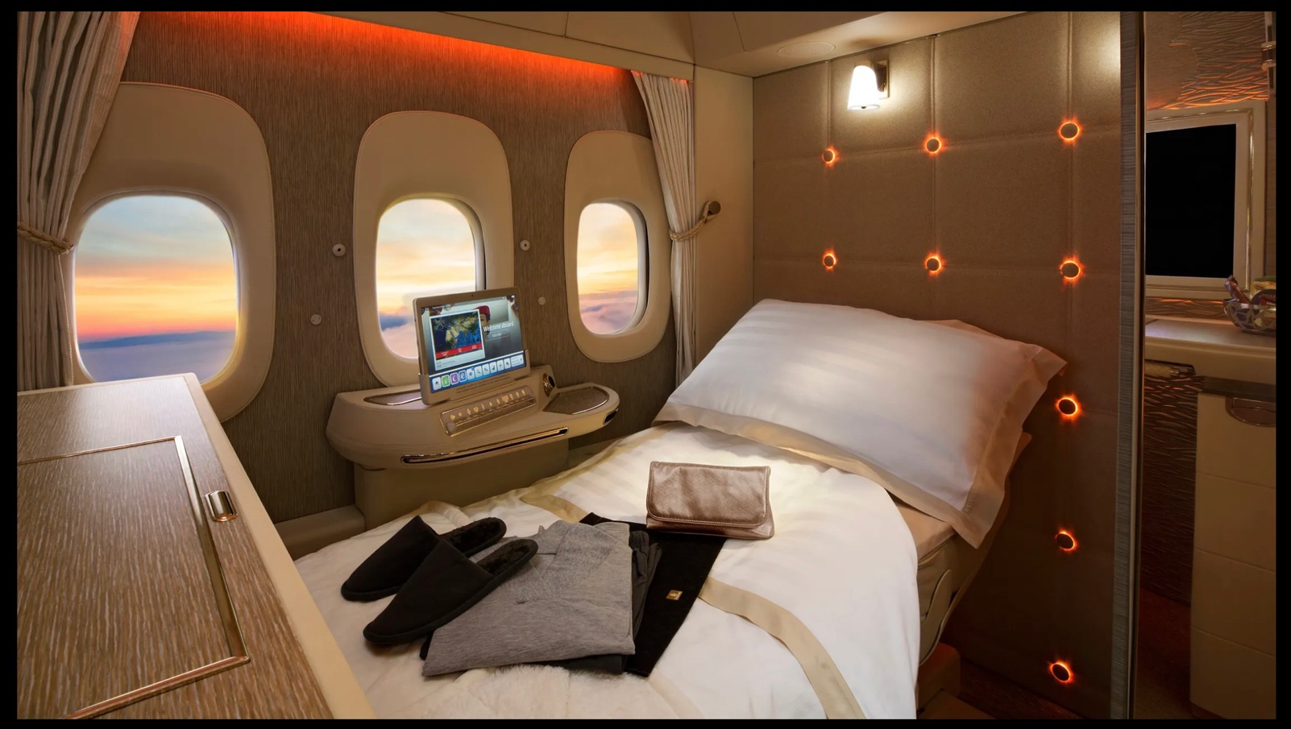
Source: emirates.com
These services cater to business and leisure travellers, offering First Class, Business Class, premium economy and Economy Class classes with unique amenities and services (Emirates Group, 2023a).

Image: Emirates A380 (Largest passenger carrier)
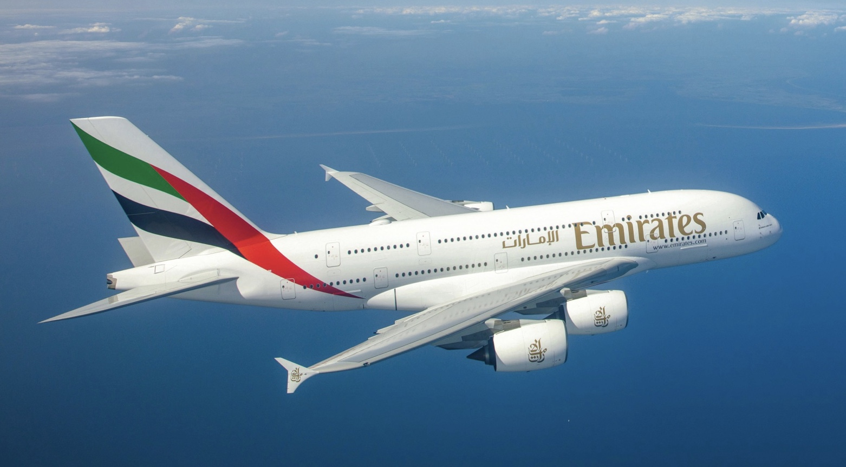Source: emirates.com

However, emirates products often range vary from country and location. For example, all airports they serve do not have lounge facilities (Airlines, 2023).
Image: Economy Seating in Emirates
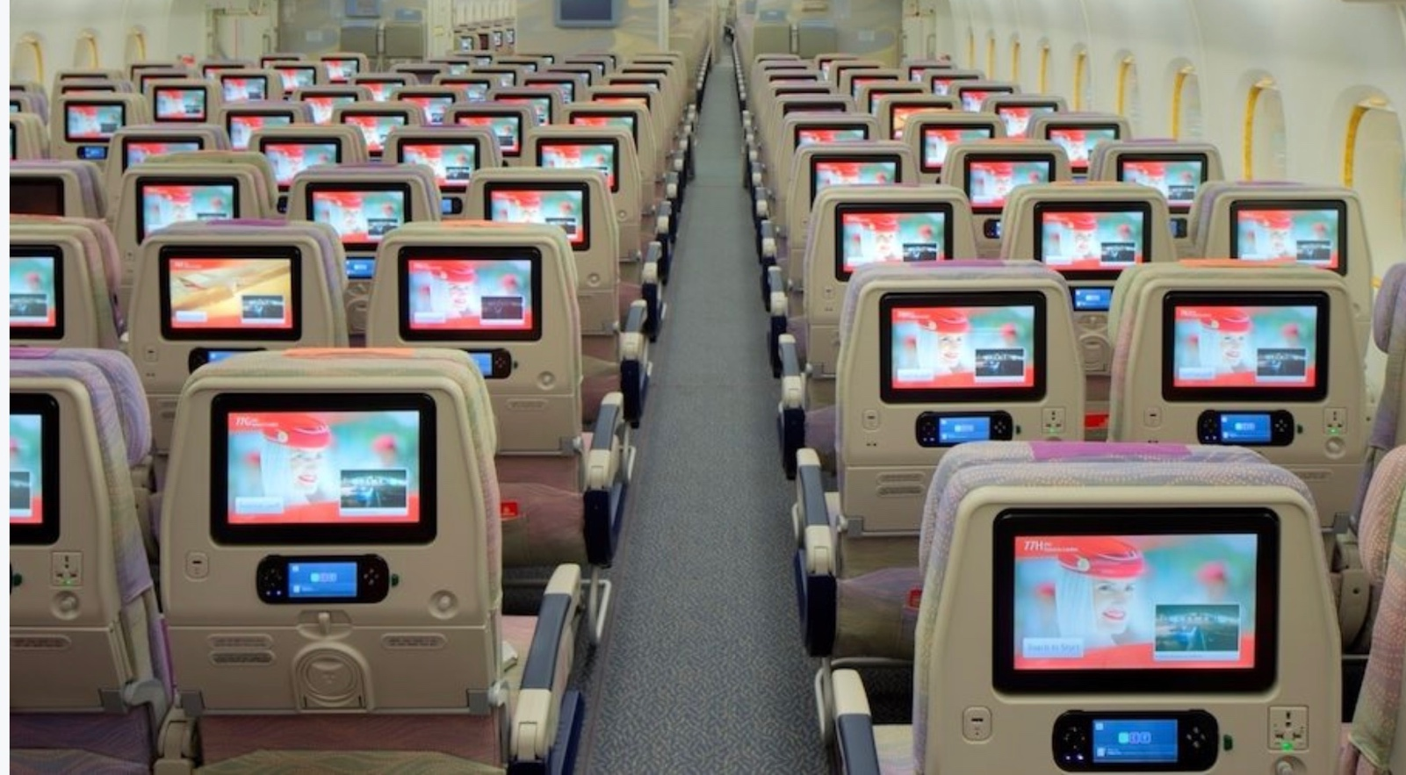
Source: (Cannon, 2017)

Similarly, not all routes have first-class seating and chauffeur service (Au, 2023). Their Flagship A-380 planes fly to cities with higher demands (Nukina, 2023). All these service are available for the UK and the UAE customers.
Price: In marketing, price pertains to the monetary value that customers are prepared to exchange for a product or service. Setting the right price is a fundamental aspect of business tactics, contributing to financial functions and serving as a prerequisite for strategic placement and the achievement of business goals (Mattos, Oyadomari, & Zatta, 2021).
Emirates employs dynamic pricing strategies, considering demand, seasonality, and booking time. They offer competitive fare options for various classes and special deals and promotions to attract and retain customers. However, A premium airline's pricing strategy often involves setting higher prices for its products and services than its competitors. This approach is adopted to position the airline as offering superior quality, luxury, and exclusivity.

Place:
Emirates operates a vast network of routes, connecting major global cities through its hub in Dubai. The airline strategically selects airports, focusing on significant international hubs to ensure a worldwide reach and convenient passenger connections. They fly to 150 destinations in 80 different countries. and all of these destinations have their offices or ticket counters. (Group Emirates, 2023).

Image: Emirates counter at Gatwick Airport, London, UK
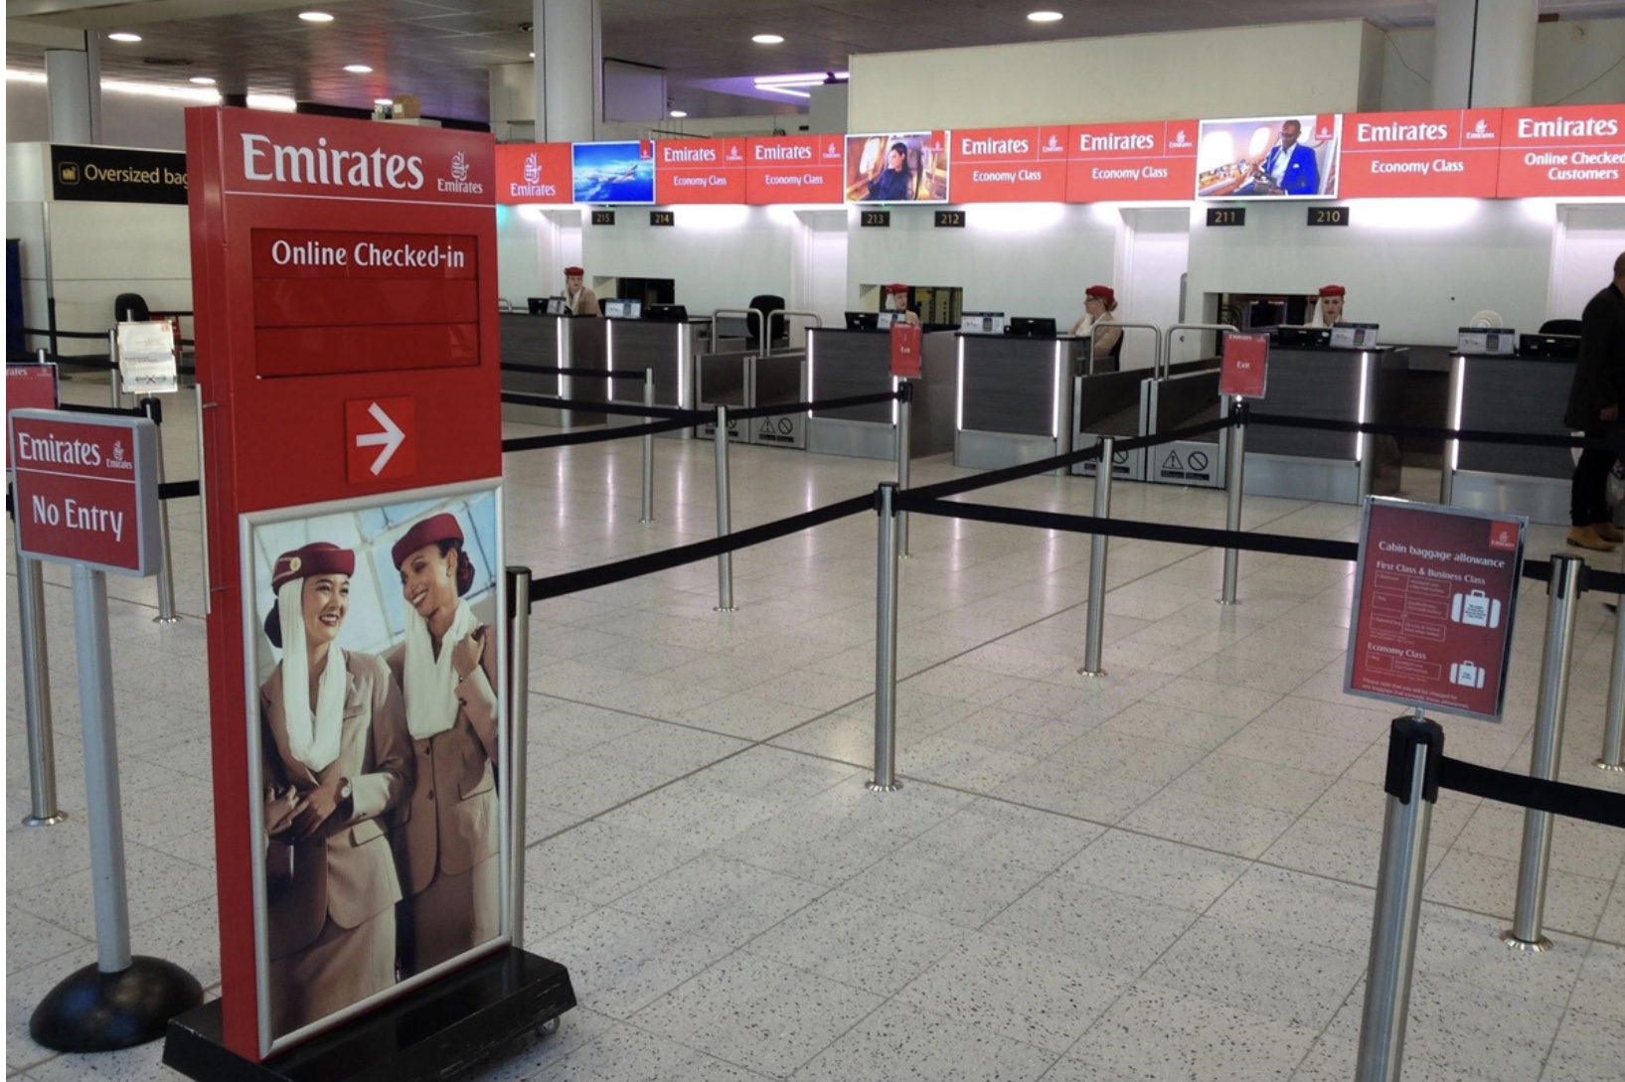
Source: (Skytrax, 2018)
The company has a strong presence in the UK and the UAE, two of its most important markets. They have local offices in London, Manchester, Glasgow, Edinburgh, Newcastle and London. Emirates Airlines have offices in all major cities in the UAE (Airlines, 2023).
Image: An Emirates Office
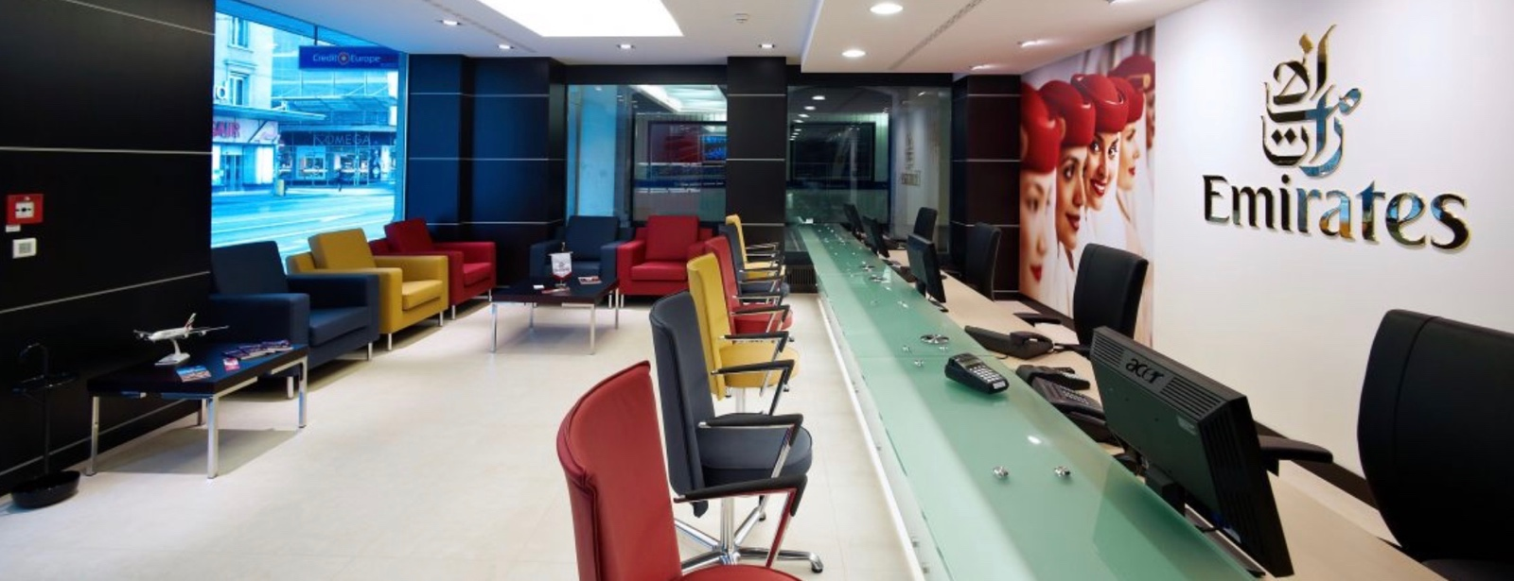
Source: (airways office, 2021)
Besides these offices and counters emirates have a very active online store, which is ranked 1 in the travel & tourism category in the UAE and had 16.1m visit in July 2023 (Similarweb, 2023). Their website many country sites. The UAE site is available in two languages: English and Arabic.
Image: Emirate’s UAE website in Arabic
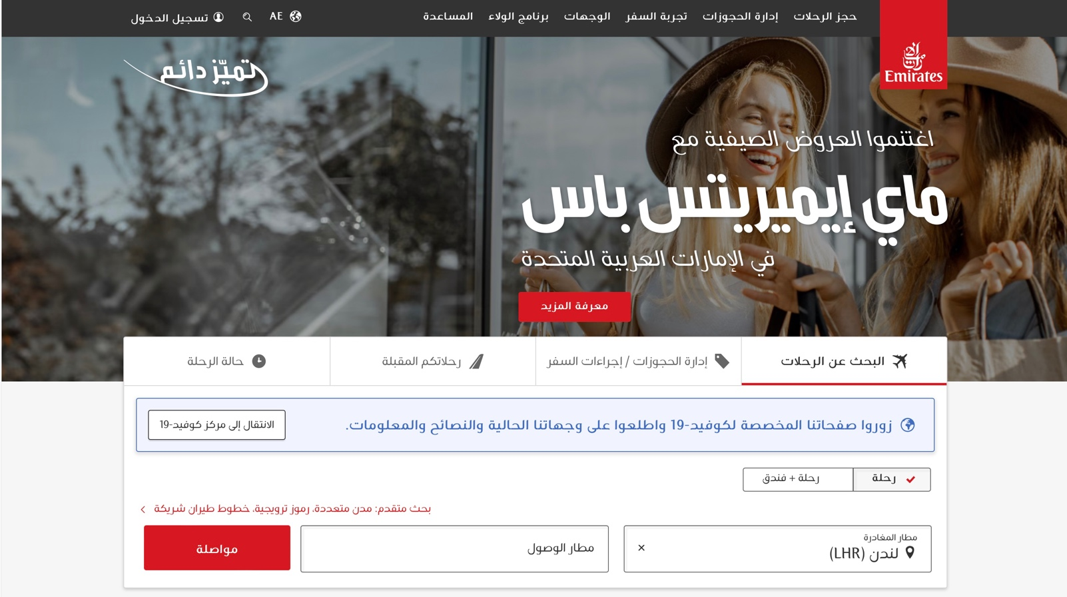
Source: (Airlines, 2023)
Image: Emirate’s UK website
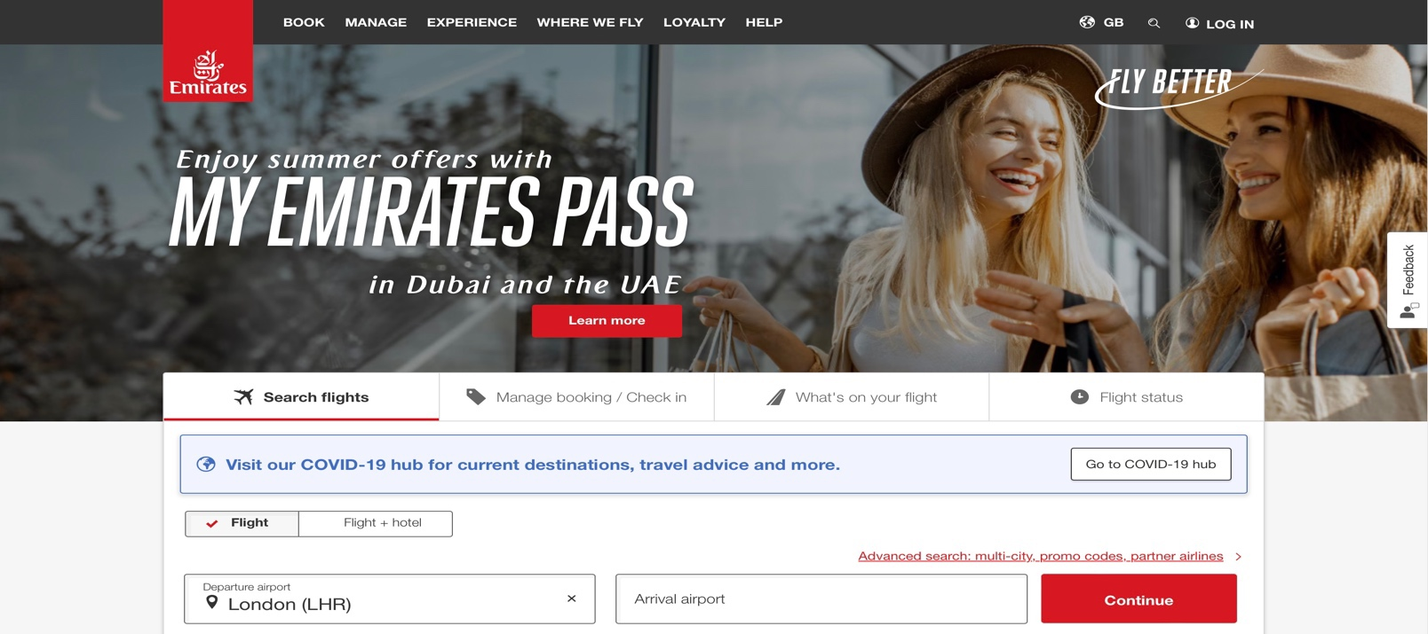
Source: Source: (Airlines, 2023)

On top of that many travel (Booking) agents in both countries have been selling Emirates products on behalf of the airline (O’Neill, 2021).

Market Entry Mode of Emirates Airlines
In the context of global trade, foreign market entry methods refer to a company's strategies to extend its services into a market outside its home country.
These entry methods can be broadly categorized into two main types: equity-based and non-equity-based. Non-equity methods encompass export and contractual agreements, while equity methods encompass joint ventures and wholly owned subsidiaries (Peng, 2020). The entry method Emirates use is Direct Exporting method.
Growth is a fundamental driver of success for companies, allowing them to prosper, innovate, and adapt to changing market conditions. It enables businesses to remain competitive, attract investment, and fulfil social responsibilities. The aviation industry has arguably been pivotal in advancing globalisation over the past few decades, and this sector has been growing rapidly. The industry's worldwide market size is projected to reach about $841.5b by the end of 2023, an increase of 7% (Mazareanu, 2023). Even though the aviation sector was among the most severely impacted industries globally during the coronavirus epidemic, over the next 20 years, the demand for passenger transportation will increase by 3.6% yearly (Airbus, 2023), and the worldwide volume of air freight transit is expected to grow 14.28% between 2023 and 2028 (Degenhard, 2023). International airlines continuously pursue innovative marketing entry methods to secure their share of this remarkable growth by exploring new markets and Emirates airlines is no exception.
Direct exports treat and fulfil international orders as if they were domestic ones (Praveen Parboteeah and Cullen, 2010). Emirates Airlines uses a direct export market entry method because it gives the company the most control over its operations in the target market. This is important for Emirates Airlines because it is a service-providing business, and the quality of its service is essential to its success. Direct exporting also allows Emirates Airlines to build a strong brand presence in the target market and allow them to compete against other major airlines in the global market With a strong brand presence, Emirates Airlines can attract more customers and differentiate itself from its competitors.
Finally, direct investment allows Emirates Airlines to take advantage of the growth potential of the target market. The global air travel market is expected to grow significantly in the coming years (ICAO, 2023). By investing directly in the target market, Emirates Airlines can position itself to capture a share of this growth.

Influences, Advantages and Disadvantages of Direct Export Method
Direct export method is influenced by factors such as market demand for the product, the target market's cultural and regulatory environment, distribution capabilities, cost-effectiveness of transportation, and the company's level of control desired over marketing and sales processes. Additionally, the company's resources, international experience, and risk tolerance also play a role in the decision to use direct export as a market entry strategy (Zhang, Liu and Wang, 2020).
The advantages of the direct export mode include potential higher profits due to direct control over pricing, greater market knowledge and customer insights, stronger brand visibility, and the ability to establish direct relationships with customers in the target market. Additionally, it offers flexibility in adapting to market changes and enables the company to maintain a consistent product image and quality (Lin and Ho, 2019).
However, direct exporting is associated with disadvantages. It often involved high expenses (Yoshino and U Srinivasa Rangan, 1995). Emirates must get involved with significant costs like additional marketing, logistics, installation and HR costs which may impacted pricing and competitiveness. Limited knowledge of foreign markets, currency fluctuations and language and cultural barriers can be challenging to overcome (Chung and Enderwick, 2001).
Emirates Airlines chooses direct export as it allows greater control over brand and operations, leveraging its global recognition, premium services, and competitive advantage. This strategy aligns with their market knowledge, profit potential, and long-term growth goals, despite challenges like high costs and regulatory complexities.
Promotion:
Emirates Airlines engages in various promotional activities in both the UAE and the UK to attract customers and enhance its brand visibility:
In the UAE:
Advertising Campaigns: Emirates runs advertising campaigns across various platforms, including television, radio, print media, and online platforms, to showcase its premium services and destinations.
Sponsorships and Partnerships: Emirates sponsors high-profile events, sports teams, and cultural activities in the UAE, such as the Dubai Air show and Dubai Shopping Festival, to increase its brand presence.
Image: Dubai Air show
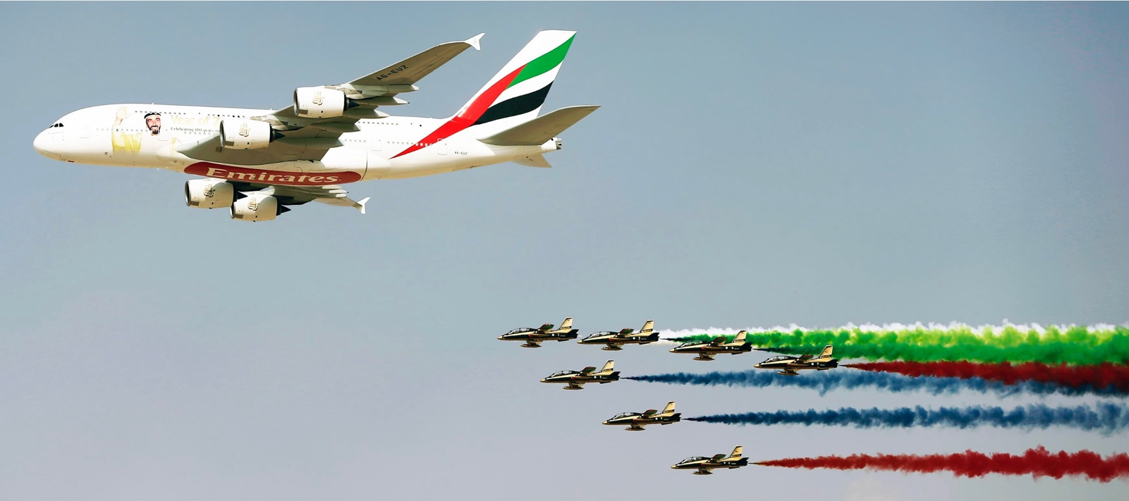
Source: dawn.com
Social Media and Influencer Marketing: The airline uses social media platforms like Instagram, Twitter, and Facebook to share travel experiences and special offers and engage with customers. It also collaborates with social media influencers and bloggers to reach a wider audience.

Image: Emirates Facebook Page
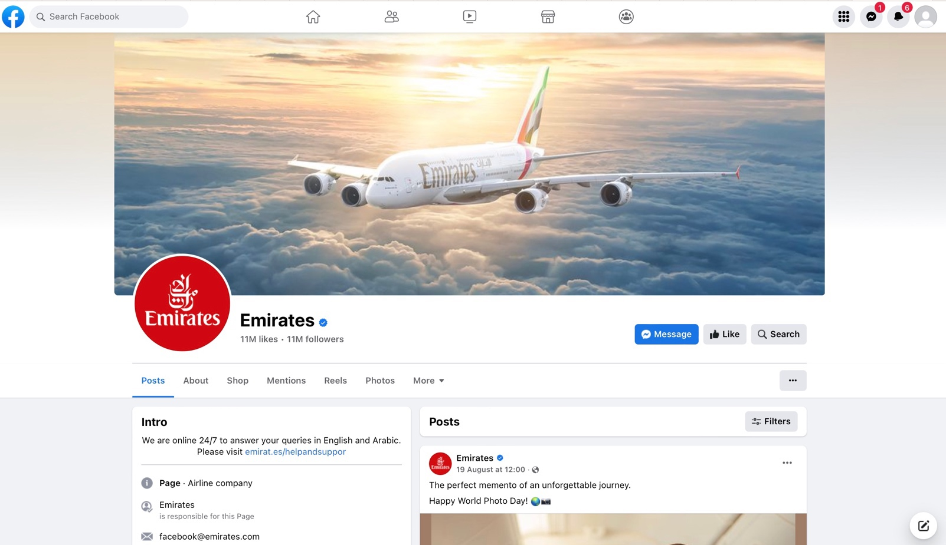
Source: Facebook (Emirates)
Email Marketing: Emirates sends personalized emails to its frequent flyer members and subscribers, informing them about exclusive deals, offers, and new routes.
Customer Loyalty Programs: Emirates' Skywards loyalty program rewards frequent travellers with miles, upgrades, and special privileges, encouraging repeat business and customer retention.

In the UK:
Digital Advertising: Emirates employs digital advertising campaigns across popular UK websites and social media platforms to target potential travellers and highlight its premium services.
Sponsorships: The airline may sponsor events, sports teams, and cultural activities in the UK to enhance brand visibility and create a positive association.

Image: Emirates (Official Sponsor of Emirates FC)

Source: emirates.com
Public Relations and Media Coverage: Emirates aims for positive media coverage in the UK through press releases, media events, and partnerships with travel and lifestyle publications.
Travel Fairs and Exhibitions: Emirates participates in travel fairs and exhibitions in the UK, such as the World Travel Market, to directly interact with potential customers, travel agents, and industry professionals.
Celebrity Brand ambassadors: Emirates has a long history of appointing global celebrities as their brand ambassadors.
Image: Penelope Cruz as Emirates Brand Ambessoder
Source: emirates.com
Customer Engagement: The airline engages with customers through its website, where they can explore routes, book flights, and access special offers. It also provides customer support via online chat, email, and phone.
People: Emirates invests in its workforce to ensure exceptional customer service. Cabin crew members are well-trained and multilingual, offering an onboard personalized and professional experience. Staff across different touchpoints, including check-in and customer service, contribute to the brand's reputation.

Image: Emirates Cabin Crew
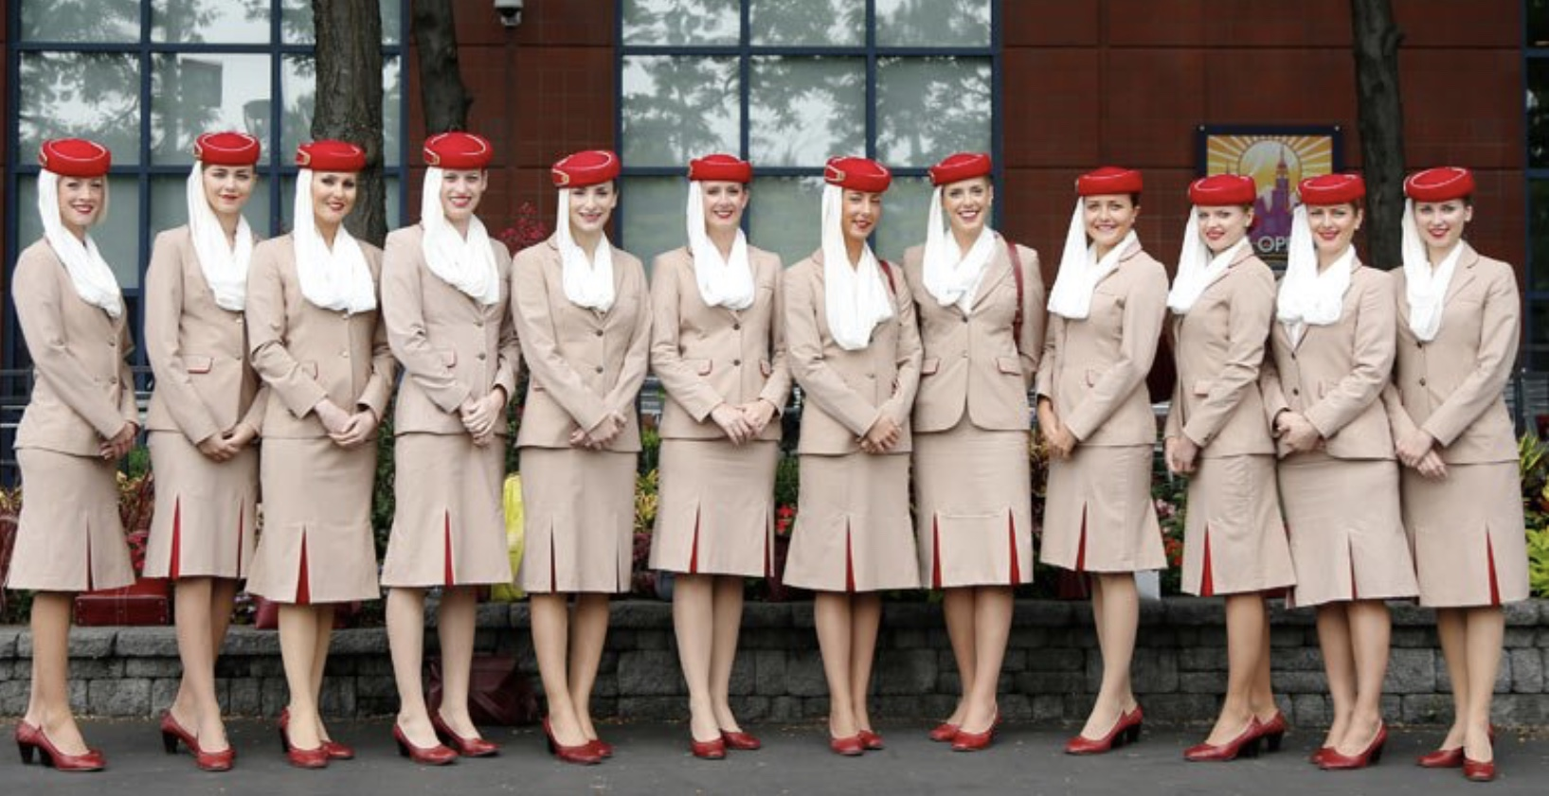
Source: www.cabincrewwings.com
Emirates Airlines' well-trained cabin crew, ground staff, and customer service representatives ensure a personalized and efficient passenger experience, contributing to the airline's positive reputation and customer satisfaction.
Process: Emirates focuses on efficient and hassle-free processes to enhance the customer journey. From online booking and check-in to onboard experiences and baggage handling, the airline aims to provide a seamless and comfortable travel process. Emirates Airlines has a well-defined process for delivering its products and services. This process is designed to ensure that customers have a positive experience. For example, Emirates Airlines has a dedicated team of customer service representatives who are available 24/7 to answer questions and resolve issues.

Physical Evidence: Emirates emphasizes the quality of its aircraft, lounges, and ground facilities. The aircraft fleet is modern and equipped with advanced amenities.

Image: Emirates Business Lounge at Dubai Airport

Source: (SKYTRAX, 2023)
The Emirates lounges provide a luxurious pre-flight experience, offering comfort, privacy, and premium services.

Similarities and Differences between both countries Marketing Mix

Emirates Airlines maintains a consistent marketing mix across the UAE and UK, yet with nuanced adaptations. The product lineup remains similar, offering various classes, entertainment, catering, and online booking. Dynamic pricing strategies and competitive fares are employed in both regions. Emirates' presence is strong in both markets, with local offices, counters, and an online store. Promotional activities encompass advertising, sponsorships, social media, and loyalty programs in both the UAE and the UK. The workforce, including trained cabin crew and customer service representatives, contributes to the brand's reputation in both regions. While the core remains constant, slight differences exist; service offerings may vary by location, and pricing strategies may position the airline as a luxury brand. Local presence, routes, and promotional strategies could differ slightly. Nonetheless, the physical evidence of lounges, facilities, and aircraft quality remains consistently upheld.

Directional Development Strategy

Directional development strategy is about expanding a company's operations in a specific direction aligned with its strengths and market trends, aiming for growth and competitiveness. (Wilmsmeier, Monios and Lambert, 2011).

Ansoff matrix
The Ansoff Matrix serves as a strategic planning tool employed by businesses to define their strategies for product and market growth. This framework aids in evaluating possible strategic directions by examining two primary aspects: products and markets. This directional development strategy can include market penetration, market development, product development, and diversification strategies to achieve sustainable growth and enhance the company's competitive position. (Dawes, 2018).

Figure 23: Ansoff Matrix
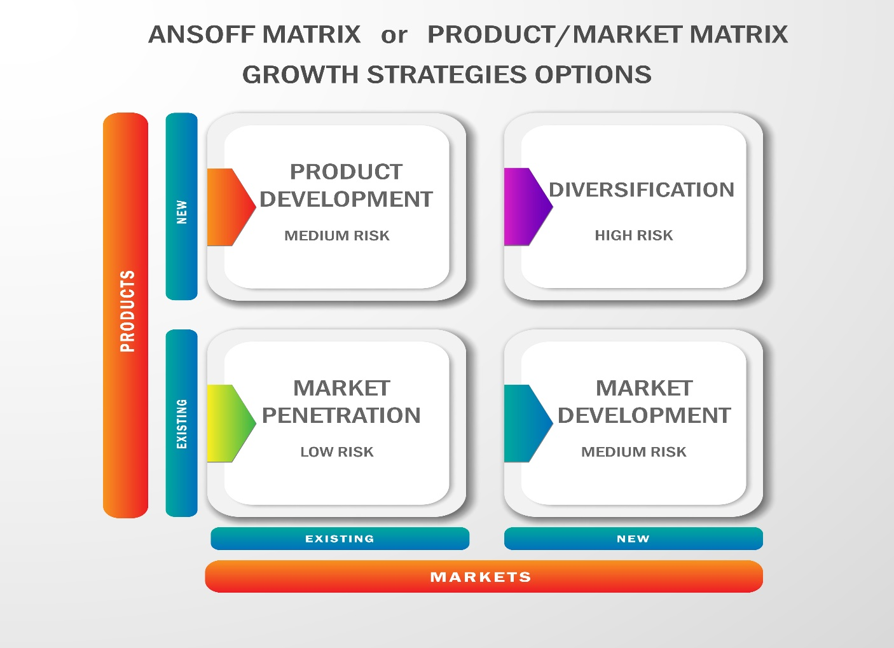
Source: Dewan Ashrafi

Market Penetration
The most common method to penetrate a market Emirates uses is actively advertising its services through various marketing platforms. However, when it was launched in UAE, the emirates did not need to be aggressive in marketing. Because it was the first airline in the country. It took quickly grabbed attention. The competition was not intense back than and it was backed by the Dubai Royal family (Hayward, 2023). Dubai initiated infrastructure investments during the late 1970s (Group, 2018). Consequently, the parallel progress in development and the surge in demand for premium airlines in the area led to rapid popularity of these airlines.
However, to attract more travellers, it used aggressive marketing in the UK. It also provides various discounts on vacations and other cultural activities. The firm has a significant market share and is always working to enhance it. To help consumers during extended airport stays, the firm has formed a strategic collaboration with hotels and other resorts. Emirates' business and first-class services are also promoted by emphasizing amenities in order to increase revenue (Airlines, 2023).
Emirates Airlines has pursued product development strategies in both the UAE and the UK markets to enhance its offerings and cater to evolving customer needs.

Product Development
Emirates has continuously invested in enhancing its fleet, onboard services, and customer experiences. The airline introduced the iconic Airbus A380 to its fleet, offering luxurious amenities and spaciousness to travellers. The development of Dubai International Airport as a global hub has allowed Emirates to offer seamless connections and convenient travel options for passengers. The airline's collaboration with luxury brands like Bulgari for onboard amenities adds to its premium image. Additionally, Emirates has launched various cabin classes, including First Class Suites and Economy Class enhancements, tailored to both high-end travellers and budget-conscious passengers (Emirates, 2023b) (Airlines, 2023) (Emirates, 2015) (Emirates, 2018).

Emirates has also focused on product development to cater to the preferences of UK customers. The airline offers extensive flight options connecting major UK cities like London, Manchester, and Birmingham with its global network through Dubai. Emirates' A380 aircraft have been a centrepiece of its product development strategy, providing innovative features like onboard lounges and enhanced entertainment systems. Emirates is the first and only airlines who has facility on board shower a lounge in plane. The airline's partnerships with UK airports, such as Heathrow and Gatwick, reflect its commitment to providing a seamless travel experience for British travellers. The introduction of upgraded cabin configurations, comfortable seating, and modern amenities further enhances the attractiveness of Emirates' product offerings in the UK market (Emirates, 2023b) (Airlines, 2023) (Emirates, 2018).

In both regions, Emirates' product development initiatives aim to maintain its reputation for luxury and quality, offering passengers a differentiated and memorable travel experience.

Recommendations

Emirates airlines is one of the leading brands in the the world aviation industry with strong track record and successful business model. However, In order to expand its operations and enhance its market presence, Emirates should consistently explore novel and creative methods to enhance and assess its strategic choices. This approach will enable the airline to make informed decisions regarding its marketing strategies in the UAE and the UK.

TOWS Matrix

The TOWS Matrix, also known as the TOWS Strategic Alternatives Matrix, is a strategic planning tool that helps businesses analyse their internal strengths and weaknesses in conjunction with external opportunities and threats. By combining these factors, the matrix generates strategic recommendations and alternative courses of action to formulate effective strategies. It aims to align a company's strengths with opportunities, mitigate weaknesses against threats, and ultimately develop a comprehensive strategic plan (Weihrich, 1982).
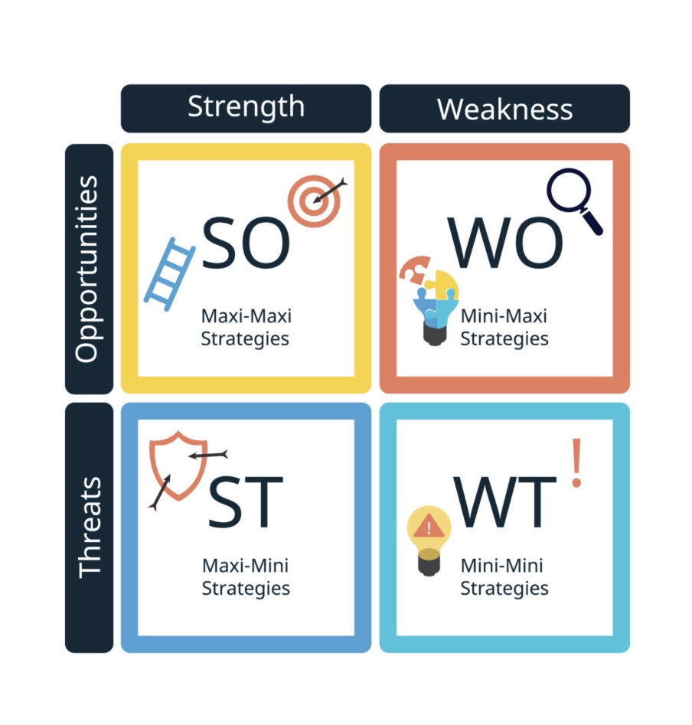
Source: Dewan Ashrafi

Here are some recommendations for Emirates airlines using TOWS matrix:
Strengths-Opportunities (SO) Strategies:
UAE: Emirate can leverage the strong government support and strategic location in Dubai to establish partnerships with local tourism authorities and promote the UAE as a global travel hub, attracting more international tourists.
UK: The airline can capitalize on the strong brand image and popularity in the UK to introduce innovative loyalty programs (e.g., Partnering with local luxury brands) that target specific customer segments, encouraging repeat business and fostering customer loyalty.
Strengths-Threats (ST) Strategies:
UAE: The extensive global network can be unitised and diverse routes to offset potential threats from geopolitical tensions by focusing on expanding routes to stable and less affected regions, ensuring consistent revenue streams.
UK: Emirates should mitigate the rivalry posed by other premium airlines by utilizing Emirates' established customer loyalty and reputation to provide individualised travel experiences and exceptional customer support.
Weaknesses-Opportunities (WO) Strategies
UAE: Address the potential over-reliance on tourism by diversifying into related sectors such as travel technology and hospitality, allowing Emirates to offer end-to-end travel solutions and enhance customer experience.
UK: Develop partnerships with local travel agencies and companies to offer integrated travel packages that cater to various customer preferences and provide a seamless travel experience.
Weaknesses-Threats (WT) Strategies:
UAE: Counter the potential high operating costs by investing in sustainable aviation technologies, thereby reducing environmental impact and catering to the growing demand for eco-friendly travel.
UK: Address the risk of economic downturns by introducing budget-friendly fare options and packages that target cost-conscious travellers, ensuring a steady flow of passengers even during challenging economic periods.

Conclusion

In conclusion, the valuable insights into Emirates Airlines' operations, strategies, and market dynamics in the UAE and the UK have been comprehensively examined. Through the analysis of various aspects, such as the macro environment, PESTEL analysis, cultural dimensions, industry attractiveness via Porter's Five Forces, SWOT analysis, marketing mix strategies, and market entry methods, a holistic understanding of Emirates' position in both markets has been achieved. Similarities are revealed in terms of the commitment to quality service, global presence, and tailored marketing strategies, while differences are observed due to specific market demands, regulations, and cultural nuances. The report underscores Emirates' strategic success, grounded in the ability to adapt offerings while maintaining a strong brand image and customer-centric approach. Strategic insights into potential growth avenues through the ANSOFF Matrix are provided. Ultimately, the significance of leveraging strengths, mitigating weaknesses, capitalizing on opportunities, and addressing challenges is emphasized, positioning Emirates Airlines for sustained growth and excellence in both the UAE and the UK markets.

References

Adeoye, B.F. and Tomei, L. (2014). Effects of information capitalism and globalization on teaching and learning. Hershey: Information Science Reference, p.6.
Adom, A., Kofi Nyarko, I., Narki, G. and Som, K. (2016). Competitor Analysis in Strategic Management: Is it a Worthwhile Managerial Practice in Contemporary Times? An International Peer-reviewed Journal, [online] 24(1), pp.1–12. Available at: https://core.ac.uk/download/pdf/234696346.pdf [Accessed 1 May 2023].
Affairs, M. of F. (2021). List of Countries and Status of Diplomatic Relations with Israel. [online] GOV.IL. Available at: https://www.gov.il/en/Departments/General/israeli_relations [Accessed 16 Aug. 2023].
Affairs, U.M. of F. (2020). The Ministry of Foreign Affairs and International Cooperation’s Report Marking the 49th UAE National Day. [online] www.mofa.gov.ae. Available at: https://www.mofa.gov.ae/en/mediahub/news/2020/12/2/02-12-2020-uae-report [Accessed 9 Aug. 2023].
Airbus (2023). Global Market Forecast | Airbus. [online] www.airbus.com. Available at: https://www.airbus.com/en/products-services/commercial-aircraft/market/global-market-forecast [Accessed 8 Aug. 2023].
Airlines UK (2020). Why Aviation Matters Blog Series – the Importance of Air Cargo by Zoe McLernon, Policy Manager at Logistics UK. [online] Airlines UK. Available at: https://airlinesuk.org/why-aviation-matters-blog-series-the-importance-of-air-cargo-by-zoe-mclernon-policy-manager-at-logistics-uk/#:~:text=As%20well%20as%20its%20direct [Accessed 17 Aug. 2023].
Airlines, E. (2022). Emirates Scoops 5 Global Accolades at Both the ULTRA and APEX Awards 2022-23. [online] Emirates scoops 5 global accolades at both the ULTRA and APEX awards 2022-23. Available at: https://www.emirates.com/media-centre/emirates-scoops-5-global-accolades-at-both-the-ultra-and-apex-awards-2022-23/#:~:text=Dubai%2C%20UAE%3A%202%20November%202022 [Accessed 8 Aug. 2023].
Airlines, E. (2023a). Leadership team | Our people | About Us | Emirates United Kingdom. [online] United Kingdom. Available at: https://www.emirates.com/uk/english/about-us/our-people/leadership-team/#:~:text=Chairman%20and%20Chief%20Executive%2C%20Emirates [Accessed 8 Aug. 2023].
Airlines, E. (2023). Local Emirates Offices | Help | Emirates United Kingdom. [online] United Kingdom. Available at: https://www.emirates.com/uk/english/help/offices [Accessed 21 Aug. 2023].
Airlines, Em. (2023). Paid lounge access | Our lounges | The Emirates Experience | Emirates United Kingdom. [online] United Kingdom. Available at: https://www.emirates.com/uk/english/experience/our-lounges/paid-lounge-access/# [Accessed 21 Aug. 2023].
Airmundo (2023). List of airlines in the Middle East. [online] AirMundo. Available at: https://airmundo.com/en/blog/list-of-airlines-in-the-middle-east/ [Accessed 8 Aug. 2023].
Airport, H. (2023). Facts and figures | Heathrow. [online] Heathrow Airport. Available at: https://www.heathrow.com/company/about-heathrow/facts-and-figures#:~:text=And%20you%20have%2089%20airlines [Accessed 15 Aug. 2023].
airways office (2021). Emirates Airlines Office Address | Phone Number | Ticket Booking. [online] Airways Office. Available at: https://airwaysoffice.com/emirates-airlines-office-address-phone-number-ticket-booking/ [Accessed 21 Aug. 2023].
Al Saed, R., Upadhya, A. and Abu Saleh, M. (2020). Role of Airline Promotion Activities in Destination branding: Case of Dubai vis-à-vis Emirates Airline. European Research on Management and Business Economics, 26(3), pp.121–126. doi:https://doi.org/10.1016/j.iedeen.2020.07.001.
Al-Mughrabi, N., Williams, D., Yaakoubi, A.E. and Al-Mughrabi, N. (2023). Analysis: New Arab allies face dilemma as Israel shifts hard-right. Reuters. [online] 6 Jan. Available at: https://www.reuters.com/world/middle-east/new-arab-allies-face-quandary-israel-shifts-hard-right-2023-01-05/.
Aljazeera (2022). Why Did the Houthis Attack the UAE? Everything You Need to Know. [online] www.aljazeera.com. Available at: https://www.aljazeera.com/news/2022/1/31/explainer-a-simple-guide-to-the-uae-houthi-escalation [Accessed 15 Aug. 2023].
Amex (2023). Emirates Emirates Skywards - Transfer Points Membership Rewards®. [online] www.americanexpress.com. Available at: https://www.americanexpress.com/en-gb/rewards/membership-rewards/partner/Emirates/Emirates-Skywards/EK-01N [Accessed 15 Aug. 2023].
Anckar, C. (2020). Constitutional Monarchies and semi-constitutional monarchies: a Global Historical study, 1800–2017. Contemporary Politics, 27(1), pp.1–18. doi:https://doi.org/10.1080/13569775.2020.1824360.
Arlidge, J. (2023). Book premium economy with this airline – it’s the closest you can get to business class. [online] The Telegraph. Available at: https://www.telegraph.co.uk/travel/advice/premium-economy-class-worth-paying-extra-flights/ [Accessed 21 Aug. 2023].
Armstrong, M. (2016). Infographic: Race Inequality in the UK. [online] Statista Infographics. Available at: https://www.statista.com/chart/5550/race-inequality-in-the-uk/ [Accessed 17 Aug. 2023].
Ashraf, S.F., Li, C. and Mehmood, B. (2017). A Study of Premium Price Brands with Special Reference to Willingness of Customer to Pay. International Journal of Academic Research in Business and Social Sciences, 7(7). doi:https://doi.org/10.6007/ijarbss/v7-i7/3126.
Au, S. (2023). The Definitive Guide to Emirates’ Direct Routes From the U.S. [Plane Types & Seat Options]. [online] UpgradedPoints.com. Available at: https://upgradedpoints.com/travel/airlines/emirates-us-routes-plane-types/#:~:text=Emirates%20offers%20first%20class%20on [Accessed 21 Aug. 2023].
Authority, C.A. (2023). UK Regulations | Civil Aviation Authority. [online] www.caa.co.uk. Available at: https://www.caa.co.uk/uk-regulations/ [Accessed 19 Aug. 2023].
Bailey, J. (2020). What Are the Pros and Cons of State-Owned Airlines? [online] Simple Flying. Available at: https://simpleflying.com/pros-cons-state-owned-airlines/ [Accessed 19 Aug. 2023].
Barrington, L. (2023). UAE begins corporate tax roll-out, with free zones exempted. Reuters. [online] 1 Jun. Available at: https://www.reuters.com/world/middle-east/uae-begins-corporate-tax-roll-out-amid-diversification-push-2023-06-01/ [Accessed 18 Aug. 2023].
Berry, L.L., Conant, J.S. and Parasuraman, A. (1991). A Framework for Conducting a Services Marketing Audit. Journal of the Academy of Marketing Science, 19(3), pp.255–268. doi:https://doi.org/10.1177/009207039101900309.
Bloomberg (2023). Why Airline Tickets Are Still So Expensive and Likely to Remain That Way. [online] Bloomberg.com. Available at: https://www.bloomberg.com/news/articles/2023-04-26/why-flying-is-so-expensive-and-likely-to-remain-that-way [Accessed 14 Aug. 2023].
Boudreaux, C.J. (2019). The Importance of Industry to Strategic Entrepreneurship: Evidence from the Kauffman Firm Survey. Journal of Industry, Competition and Trade, 1(1). doi:https://doi.org/10.1007/s10842-019-00310-7.
Britannica (2023). United Arab Emirates - Foreign Relations | Britannica. In: Encyclopædia Britannica. [online] Available at: https://www.britannica.com/place/United-Arab-Emirates/Foreign-relations [Accessed 9 Aug. 2023].
British Library (2023). Geert Hofstede: Cultural Diversity Thinker. [online] The British Library. doi:https://www.bl.uk/people/geert-hofstede.
BTI (2022). BTI 2022 United Arab Emirates Country Report. [online] BTI 2022. Available at: https://bti-project.org/en/reports/country-report/ARE [Accessed 9 Aug. 2023].
Burr, V. and Dick, P. (2017). Social Constructionism. The Palgrave Handbook of Critical Social Psychology, pp.59–80. doi:https://doi.org/10.1057/978-1-137-51018-1_4.
CAA (2022). UK Airport Data January 2022 | Civil Aviation Authority. [online] www.caa.co.uk. Available at: https://www.caa.co.uk/data-and-analysis/uk-aviation-market/airports/uk-airport-data/uk-airport-data-2022/january-2022/ [Accessed 19 Aug. 2023].
CAA (2023a). 2022 in review: UK Air Travel Reaches 75% of pre-pandemic Levels as Spain Tops Most Popular Destination List | Civil Aviation Authority. [online] www.caa.co.uk. Available at: https://www.caa.co.uk/newsroom/news/2022-in-review-uk-air-travel-reaches-75-of-pre-pandemic-levels-as-spain-tops-most-popular-destination-list/#:~:text=UK%20air%20travel%20increased%20significantly [Accessed 16 Aug. 2023].
CAA (2023b). Information on Aviation Law in the UK | Civil Aviation Authority. [online] www.caa.co.uk. Available at: https://www.caa.co.uk/uk-regulations/aviation-safety/basic-regulation-the-implementing-rules-and-uk-caa-amc-gm-cs/information-on-aviation-law-in-the-uk/#:~:text=Since%20the%20UK%20fully%20left [Accessed 15 Aug. 2023].
Cabinet, T.U. (2023). News. [online] uaecabinet.ae. Available at: https://uaecabinet.ae/en/details/news/uae-cabinet-adopts-national-artificial-intelligence-strategy-2031 [Accessed 17 Aug. 2023].
Cannon, M. (2017). Flight review: Emirates A380 economy. [online] Business Traveller. Available at: https://www.businesstraveller.com/tried-and-tested/flight-review-emirates-a380-economy-2/ [Accessed 21 Aug. 2023].
Centre, E.M. (2023). Emirates Signs Historic $9.2 Billion* Order with Rolls-Royce for A380 Engines. [online] emirates.com. Available at: https://www.emirates.com/media-centre/emirates-signs-historic-92-billion-order-with-rolls-royce-for-a380-engines/#:~:text=Sir%20Tim%20Clark%2C%20President%20Emirates [Accessed 15 Aug. 2023].
Chung, H.F.L. and Enderwick, P. (2001). An Investigation of Market Entry Strategy Selection: Exporting Vs Foreign Direct Investment Modes—A Home-host Country Scenario. Asia Pacific Journal of Management, 18(4), pp.443–460. doi:https://doi.org/10.1023/a:1012871225166.
Clark, D. (2023). UK Median Age 2020, by Region. [online] Statista. Available at: https://www.statista.com/statistics/367796/uk-median-age-by-region/ [Accessed 17 Aug. 2023].
CNN (2023). UAE Says Russia Ties Are a ‘calculated risk’ in an Increasingly Polarized World. [online] CNN. Available at: https://edition.cnn.com/2023/06/16/middleeast/uae-russia-st-petersburg-mime-intl/index.html [Accessed 9 Aug. 2023].
Dawes, J. (2018). The Ansoff Matrix: A Legendary Tool, But with Two Logical Problems. [online] papers.ssrn.com. Available at: https://papers.ssrn.com/sol3/papers.cfm?abstract_id=3130530 [Accessed 5 May 2023].
Degenhard, J. (2023). Air Freight Transport in the World 2028. [online] Statista. Available at: https://www.statista.com/forecasts/1153062/air-freight-transport-forecast-in-the-world#:~:text=The%20global%20volume%20of%20air [Accessed 8 Aug. 2023].
Department for Transport (2022). Transport and environment statistics 2022. [online] GOV.UK. Available at: https://www.gov.uk/government/statistics/transport-and-environment-statistics-2022/transport-and-environment-statistics-2022 [Accessed 18 Aug. 2023].
Department, S.R. (2023a). Holiday Travel Spending by UK Residents 2011-2019. [online] Statista. Available at: https://www.statista.com/statistics/578962/holiday-spending-by-united-kingdom-uk-residents/ [Accessed 17 Aug. 2023].
Dubai, G. of (2023). Tourism Performance Report January - March 2023. [online] www.dubaitourism.gov.ae. Available at: https://www.dubaitourism.gov.ae/en/research-and-insights/tourism-performance-report-march-2023 [Accessed 16 Aug. 2023].
EA (2023a). Family travel | Emirates United Kingdom. [online] United Kingdom. Available at: https://www.emirates.com/uk/english/family/ [Accessed 21 Aug. 2023].
EA (2023b). Our Partners | Emirates Skywards | Emirates United Kingdom. [online] United Kingdom. Available at: https://www.emirates.com/uk/english/skywards/partners/ [Accessed 20 Aug. 2023].
Emirates (2015). Emirates Refreshes Its Bvlgari Amenity Kits in First and Business Class. [online] emirates.com. Available at: https://www.emirates.com/media-centre/emirates-refreshes-its-bvlgari-amenity-kits-in-first-and-business-class/ [Accessed 19 Aug. 2023].
Emirates (2018). Emirates’ Game Changer First Class Suite to debut on Vienna route. [online] Emirates’ Game Changer First Class Suite to debut on Vienna route. Available at: https://www.emirates.com/media-centre/emirates-game-changer-first-class-suite-to-debut-on-vienna-route/#:~:text=The%20airline%20pioneered%20the%20private [Accessed 21 Aug. 2023].
Emirates (2023a). History | about Emirates | Emirates. [online] mobile.emirates.com. Available at: https://mobile.emirates.com/MobileAboutEmirates/global/english/emirates_story.xhtml#:~:text=Though%20wholly%20owned%20by%20the [Accessed 8 Aug. 2023].
Emirates (2023b). History Timeline | about Us | Emirates United Kingdom. [online] https://www.emirates.com. Available at: https://www.emirates.com/uk/english/about-us/timeline/ [Accessed 1 Aug. 2023].
Emirates (2023c). Our Vision, Mission and Values | Emirates Group Security. [online] www.emiratesgroupsecurity.com. Available at: https://www.emiratesgroupsecurity.com/about-us/vision-and-mission [Accessed 8 Aug. 2023].
Emirates Airlines (2023b). Game On! Emirates Group and AWS Team up to Craft an Immersive Digital World. [online] emirates.com. Available at: https://www.emirates.com/media-centre/game-on-emirates-group-and-aws-team-up-to-craft-an-immersive-digital-world/ [Accessed 17 Aug. 2023].
Emirates Group (2023a). Emirates Group Brands. [online] www.theemiratesgroup.com. Available at: https://www.theemiratesgroup.com [Accessed 8 Aug. 2023].
Emirates Group, T. (2023b). Annual Report 2022-2023. Dubai, UAE: The Emirates Group, pp.1–219.
Etihad (2023). Home. [online] Etihadaviationgroup.com. Available at: https://www.etihadaviationgroup.com/en-ae/ [Accessed 15 Aug. 2023].
Fernandez, C. (2023). These are the top 10 safest airlines in the world for 2023—see which U.S. carrier made the list. [online] CNBC. Available at: https://www.cnbc.com/2023/01/10/top-10-safest-airlines-in-the-world-2023.html [Accessed 19 Aug. 2023].
Finance, B. (2023). Airlines 50 2021 | Brand Value Ranking League Table | Brandirectory. [online] brandirectory.com, London: Brand Finance, pp.1–35. Available at: https://brandirectory.com/rankings/airlines/table [Accessed 8 Aug. 2023].
Geology (2023). UAE: United Arab Emirates Map and Satellite Image. [online] geology.com. Available at: https://geology.com/world/united-arab-emirates-satellite-image.shtml [Accessed 15 Aug. 2023].
Global, E. (2023). Reducing emissions | Our planet | About Us | Emirates. [online] Global. Available at: https://www.emirates.com/english/about-us/our-planet/reducing-emissions/#:~:text=Renewable%20energy&text=Our%20current%20installations%20generate%20over [Accessed 17 Aug. 2023].
GlobalData (2023). The Emirates Group Peers & Key Competitors - GlobalData. [online] www.globaldata.com. Available at: https://www.globaldata.com/company-profile/the-emirates-group/competitors/ [Accessed 15 Aug. 2023].
Government of UK (2022). Rates and allowances: Corporation Tax. [online] GOV.UK. Available at: https://www.gov.uk/government/publications/rates-and-allowances-corporation-tax/rates-and-allowances-corporation-tax [Accessed 18 Aug. 2023].
Government, T.U. (2022). UK Digital Strategy. [online] GOV.UK. Available at: https://www.gov.uk/government/publications/uks-digital-strategy/uk-digital-strategy#:~:text=Increased%20funding%20through%20UKRI%20allocations [Accessed 17 Aug. 2023].
Government, U. (2023a). Taxation - the Official Portal of the UAE Government. [online] u.ae. Available at: https://u.ae/en/information-and-services/finance-and-investment/taxation#:~:text=The%20UAE%20does%20not%20levy [Accessed 15 Aug. 2023].
Group Emirates (2023). Annual Report 2022 2023. Dubai: Emirates, pp.1–219.
Group, E. (2023c). Emirates Group Announces 2022-23 Results. [online] Emirates Group announces 2022-23 results. Available at: https://www.emirates.com/media-centre/emirates-group-announces-2022-23-results/#:~:text=The%20Group%27s%20revenue%20was%20AED [Accessed 8 Aug. 2023].
Group, O.B. (2018). Rising infrastructure investment in Dubai points to future growth - The Middle East 2018 - Oxford Business Group. [online] Oxford Business Group. Available at: https://oxfordbusinessgroup.com/reports/uae-dubai/2018-report/economy/firing-on-all-cylinders-rising-infrastructure-investment-points-to-considerable-future-growth#:~:text=Alongside%20the%20opening%20of%20Jebel [Accessed 21 Aug. 2023].
Hayward, J. (2023). How Etihad Airways Got Its Name. [online] Simple Flying. Available at: https://simpleflying.com/etihad-airways-name-origin-story/#:~:text=Prior%20to%20the%20establishment%20of [Accessed 12 Aug. 2023].
HBS (2023). The Five Forces. [online] Harvard Business School. Available at: https://www.isc.hbs.edu/strategy/business-strategy/Pages/the-five-forces.aspx [Accessed 1 May 2023].
Herring, E. (2023). What Is the Average Personal Debt in the UK? [online] Finder UK. Available at: https://www.finder.com/uk/debt-statistics#:~:text=The%20average%20debt%20per%20person%20is%20105%25%20of%20the%20average [Accessed 16 Aug. 2023].
Hofstede, G. (2001). Culture’s consequences: Comparing values, Behaviors, Institutions, and Organizations across Nations. 2nd ed. Thousand Oaks, California: Sage.
Hofstede, G. (2011). Dimensionalizing Cultures: the Hofstede Model in Context. [online] ScholarWorks@GVSU. Available at: https://scholarworks.gvsu.edu/orpc/vol2/iss1/8/ [Accessed 18 Aug. 2023].
Hofstede, G. and Bond, M.H. (1984). Hofstede’s Culture Dimensions: an Independent Validation Using Rokeach’s Value Survey. Journal of Cross-Cultural Psychology, 15(4), pp.417–433. doi:https://doi.org/10.1177/0022002184015004003.
Hollensen, S. (2020). Global Marketing. 8th ed. S.L.: Pearson Education Limited.
Hurst, D. (2021). Aviation, Decarbonisation and Climate Change. London: The UK Parliament, pp.1–56.
IATA (2023). Airline Profitability Outlook Strengthens. [online] www.iata.org. Available at: https://www.iata.org/en/pressroom/2023-releases/2023-06-05-01/#:~:text=Revenue%3A%20Industry%20revenues%20are%20expected [Accessed 17 Aug. 2023].
ICAO (2023). Future of Aviation. [online] International Civil Aviation Organization. Available at: https://www.icao.int/Meetings/FutureOfAviation/Pages/default.aspx [Accessed 21 Aug. 2023].
IMF (2023a). https://www.imf.org/external/datamapper/PPPPC@WEO/ARE?zoom=ARE&highlight=ARE. [online] www.imf.org. Available at: https://www.imf.org/external/datamapper/PPPPC@WEO/ARE?zoom=ARE&highlight=ARE [Accessed 15 Aug. 2023].
IMF (2023b). https://www.imf.org/external/datamapper/PPPPC@WEO/GBR?zoom=GBR&highlight=GBR. [online] www.imf.org. Available at: https://www.imf.org/external/datamapper/PPPPC@WEO/GBR?zoom=GBR&highlight=GBR [Accessed 15 Aug. 2023].
Insight, H. (2023). Country comparison tool. [online] www.hofstede-insights.com. Available at: https://www.hofstede-insights.com/country-comparison-tool?countries=united+arab+emirates [Accessed 15 Aug. 2023].
Isidore, C. and Hickey, C. (2022). Gas prices had a wild ride this year, making 2023 tough to predict | CNN Business. [online] CNN. Available at: https://edition.cnn.com/2022/12/29/energy/oil-gas-prices-2022/index.html [Accessed 12 Aug. 2023].
ITA (2022). United Arab Emirates - Aerospace and Aviation. [online] www.trade.gov. Available at: https://www.trade.gov/country-commercial-guides/united-arab-emirates-aerospace-and-aviation#:~:text=The%20UAE%20has%20four%20major [Accessed 15 Aug. 2023].
Itani, N., O׳ConnellJ.F. and Mason, K. (2014). A macro-environment Approach to Civil Aviation Strategic Planning. Transport Policy, 33, pp.125–135. doi:https://doi.org/10.1016/j.tranpol.2014.02.024.
Kamel, D. (2023). Emirates airline to introduce multilingual check-in robots to cut travel time. [online] The National. Available at: https://www.thenationalnews.com/business/aviation/2023/03/09/emirates-to-introduce-multilingual-check-in-robots-to-cut-travel-time/#:~:text= [Accessed 17 Aug. 2023].
Kellner, T. (2015). GE Signs $16 Billion Deal to Service Emirates’ Next-Gen Jet Engines | GE News. [online] www.ge.com. Available at: https://www.ge.com/news/reports/emirates-signs-16-billion-deal-to-service-ge-jet-engines#:~:text=GE%27s%20latest%20engine%20 [Accessed 19 Aug. 2023].
Kelly, S. and Kelly, S. (2023). Oil Prices up, Hit Nearly 3-month High as US Inflation Eases. Reuters. [online] 13 Jul. Available at: https://www.reuters.com/business/energy/oil-prices-rise-early-trade-us-inflation-cools-2023-07-13/#:~:text=Oil%20prices%20have%20rallied%20by [Accessed 15 Aug. 2023].
Kickham, D. (2023). Dubai Crowned Number One Global Destination. [online] Forbes. Available at: https://www.forbes.com/sites/debbikickham/2023/01/24/dubai-crowned-number-one-global-destination/ [Accessed 16 Aug. 2023].
Ko, E., Costello, J.P. and Taylor, C.R. (2019). What is a luxury brand? A new definition and review of the literature. Journal of Business Research, 99(1), pp.405–413. doi:https://doi.org/10.1016/j.jbusres.2017.08.023.
Kotler, P. and Keller, K.L. (2019). Marketing management. 15th ed. Harlow: Pearson Education.
Kotler, P.T. and Armstrong, G. (2020). Principles of Marketing, Global Edtion. 18th ed. S.L.: Pearson Education Limited.
Kunst, A. (2023). Airline brand awareness KPI ranking UK 2022. [online] Statista. Available at: https://www.statista.com/statistics/1339630/most-well-known-airline-brands-in-the-uk/ [Accessed 18 Aug. 2023].
Lappeman , J., Hewitt, K. and Bramdaw , S. (2021). Marketing to South African Consumers. 1st ed. [online] openbooks.uct.ac.za. Caoe Town: University of Cape Town. Available at: https://openbooks.uct.ac.za/uct/catalog/view/29/52/1574 [Accessed 3 Aug 2023].
Ledstrup, M. (2018). Nationalism and Nationhood in the United Arab Emirates. London: Palgrave Pivot Cham. doi:https://doi.org/10.1007/978-3-319-91653-8.
Leonhardt, M. (2019). Millennials Are Making Travel a Priority More than Previous generations—that’s Not a Bad Thing. [online] CNBC. Available at: https://www.cnbc.com/2019/08/30/millennials-making-travel-a-priority-more-than-previous-generations.html [Accessed 18 Aug. 2023].
Lin, F.-J. and Ho, C.-W. (2019). The knowledge of entry mode decision for small and medium enterprises. Journal of Innovation & Knowledge, 4(1), pp.32–37. doi:https://doi.org/10.1016/j.jik.2018.02.001.
Logistics UK (2023). Air Cargo. [online] logistics.org.uk. Available at: https://logistics.org.uk/contact-us [Accessed 17 Aug. 2023].
Madhavaram, S. and Hunt, S.D. (2007). The service-dominant logic and a hierarchy of operant resources: developing masterful operant resources and implications for marketing strategy. Journal of the Academy of Marketing Science, 36(1), pp.67–82. doi:https://doi.org/10.1007/s11747-007-0063-z.
Makortoff, K. (2022). Ryanair Boss Blames Brexit for Airport Chaos and Says Era of €10 Airfares over. [online] the Guardian. Available at: https://www.theguardian.com/business/2022/aug/11/ryanair-boss-blames-brexit-for-airport-chaos-and-says-era-of-10-euro-airfares-over-michael-oleary [Accessed 15 Aug. 2023].
Marketline (2021). Airlines in the United Kingdom September 2021. Manchester: Marketline, pp.1–44.
Marketline (2023a). Country Analysis Report: United Kingdom. manchester: Marketline, pp.1–71.
Marketline (2023b). United Arab Emirates Country Profile. Manchester: Marketline, pp.1–76.
Mattioli, G., Morton, C. and Scheiner, J. (2021). Air Travel and Urbanity: the Role of Migration, Social Networks, Airport Accessibility, and ‘Rebound’. Urban Planning, 6(2), pp.232–245. doi:https://doi.org/10.17645/up.v6i2.3983.
Mattos, A.L., Oyadomari, J.C.T. and Zatta, F.N. (2021). Pricing Research: State of the Art and Future Opportunities. SAGE Open, 11(3). doi:https://doi.org/10.1177/21582440211032168.
Mazareanu, E. (2023). Global Airline Industry Market Size. [online] Statista. Available at: https://www.statista.com/statistics/1110342/market-size-airline-industry-worldwide/ [Accessed 8 Aug. 2023].
Mccarthy, E.J. (1960). Basic Marketing: A Managerial Approach. Homewood, Ill: R.D. Irwin.
Mckinsey (2022). How Airlines Could Adapt to Rising Fuel Prices | McKinsey. [online] www.mckinsey.com. Available at: https://www.mckinsey.com/industries/travel-logistics-and-infrastructure/our-insights/why-rising-fuel-prices-might-not-be-as-bad-for-the-airline-sector-as-it-seems# [Accessed 15 Aug. 2023].
MOCCAE (2021). The United Arab Emirates General Environmental Policy 2021. UAE: MOCCAE, pp.1–19.
Monash Business School (2023). Micro-environment. [online] Monash Business School. Available at: https://www.monash.edu/business/marketing/marketing-dictionary/m/micro-environment#:~:text=the%20factors%20or%20elements%20in [Accessed 8 Aug. 2023].
Nations, U. (2023). Member States. [online] United Nations. Available at: https://www.un.org/en/about-us/member-states#gotoU [Accessed 9 Aug. 2023].
NATO (2023). Relations with Russia. [online] NATO. Available at: https://www.nato.int/cps/en/natolive/topics_50090.htm [Accessed 16 Aug. 2023].
Nicholls, D. (2023). Russia ‘poses danger to UK’ if beaten in Ukraine. The Telegraph. [online] 26 May. Available at: https://www.telegraph.co.uk/news/2023/05/26/russia-poses-danger-to-uk-sir-mike-wigston-raf/ [Accessed 20 Aug. 2023].
Nukina, K. (2023). Emirates A380s in 2023: Routes, Fleet & Retirement Plans. [online] KN Aviation. Available at: https://knaviation.net/emirates-a380/ [Accessed 21 Aug. 2023].
O’Neill, A. (2023a). United Arab Emirates: Gross domestic product (GDP) from 1988 to 2028. [online] Statista. Available at: https://www.statista.com/statistics/297605/uae-gross-domestic-product/#:~:text=The%20GDP%20is%20estimated%20to [Accessed 15 Aug. 2023].
O’Neill, A. (2023b). United Arab Emirates: Gross Domestic Product (GDP) Growth from 2018 to 2028. [online] Statista. Available at: https://www.statista.com/statistics/297772/uae-gross-domestic-product-change-percent/ [Accessed 16 Aug. 2023].
O’Neill, S. (2021). Emirates Wants to Shake Up Ticket Sales Through Closer Ties to Travel Agencies. [online] Skift. Available at: https://skift.com/2021/04/07/emirates-wants-to-shake-up-ticket-sales-through-closer-ties-to-travel-agencies/ [Accessed 21 Aug. 2023].
Office for National Statistics (2019). Exploring the UK’s Digital Divide - Office for National Statistics. [online] Ons.gov.uk. Available at: https://www.ons.gov.uk/peoplepopulationandcommunity/householdcharacteristics/homeinternetandsocialmediausage/articles/exploringtheuksdigitaldivide/2019-03-04 [Accessed 17 Aug. 2023].
ONS (2022). Climate change insights, families and households, UK - Office for National Statistics. [online] www.ons.gov.uk. Available at: https://www.ons.gov.uk/economy/environmentalaccounts/articles/climatechangeinsightsuk/august2022 [Accessed 18 Aug. 2023].
ONS (2023a). Average household income, UK - Office for National Statistics. [online] www.ons.gov.uk. Available at: https://www.ons.gov.uk/peoplepopulationandcommunity/personalandhouseholdfinances/incomeandwealth/bulletins/householddisposableincomeandinequality/financialyearending2022 [Accessed 15 Aug. 2023].
ONS (2023b). Consumer Price inflation, UK - Office for National Statistics. [online] www.ons.gov.uk. Available at: https://www.ons.gov.uk/economy/inflationandpriceindices/bulletins/consumerpriceinflation/june2023 [Accessed 15 Aug. 2023].
ONS (2023c). UK Trade in goods, Year in Review - Office for National Statistics. [online] www.ons.gov.uk. Available at: https://www.ons.gov.uk/economy/nationalaccounts/balanceofpayments/articles/uktradeingoodsyearinreview/2022 [Accessed 17 Aug. 2023].
Oreffice, S. and Quintana-Domeque, C. (2021). Gender inequality in COVID-19 times: evidence from UK prolific participants. Journal of Demographic Economics, 87(2), pp.1–27. doi:https://doi.org/10.1017/dem.2021.2.
Oxfam (2023). Oxfam GB | Making things fair. [online] Oxfam GB. Available at: https://www.oxfam.org.uk/get-involved/campaign-with-oxfam/bridging-inequality-gap-making-things-fair/ [Accessed 15 Aug. 2023].
Panasonic (2017). Panasonic Avionics Delivers a Series of Inflight Entertainment in. [online] www.panasonic.aero. Available at: https://www.panasonic.aero/press-release/panasonic-avionics-delivers-a-series-of-inflight-entertainment-industry-firsts-to-emirates/ [Accessed 19 Aug. 2023].
Pappas, N. (2019). UK outbound travel and Brexit complexity. Tourism Management, 72, pp.12–22. doi:https://doi.org/10.1016/j.tourman.2018.11.004.
Parliament, U. (2023). United Arab Emirates (UAE): Introductory Country Profile. [online] https://commonslibrary.parliament.uk, pp.1–15. Available at: https://researchbriefings.files.parliament.uk/documents/CBP-9586/CBP-9586.pdf [Accessed 9 Aug. 2023].
Peng, M.W. (2020). Global Business. 4th ed. Mason: South-Western.
Porter, M.E. (1979). How Competitive Forces Shape Strategy. [online] Harvard Business Review. Available at: https://hbr.org/1979/03/how-competitive-forces-shape-strategy [Accessed 1 May 2023].
Porter, M.E. (2008). The Five Competitive Forces That Shape Strategy. [online] Harvard Business Review. Available at: https://hbr.org/2008/01/the-five-competitive-forces-that-shape-strategy [Accessed 19 Aug. 2023].
Praveen Parboteeah and Cullen, J.B. (2010). Strategic International Management. 5th ed. Australia: South-Western Cengage Learning.
Pride, W.M., Ferrell, O.C., Lukas, B., Schembri, S. and Niininen, O. (2014). Marketing Principles. 2nd ed. South Melbourne, (Australia) Etc.: Cengage Learning, p.640.
Ren, D. and Leslie, L.M. (2019). Impacts of Climate Warming on Aviation Fuel Consumption. Journal of Applied Meteorology and Climatology, 58(7), pp.1593–1602. doi:https://doi.org/10.1175/jamc-d-19-0005.1.
RSF (2023). Index | RSF. [online] rsf.org. Available at: https://rsf.org/en/index/score-pol?year=2023 [Accessed 15 Aug. 2023].
Ryley, T., Baumeister, S. and Coulter, L. (2020). Climate Change Influences on aviation: a Literature Review. Transport Policy, 92(5), pp.55–64. doi:https://doi.org/10.1016/j.tranpol.2020.04.010.
Shi, C., Agbaku, C.A. and Zhang, F. (2021). How Do Upper Echelons Perceive Porter’s Five Forces? Evidence From Strategic Entrepreneurship in China. Frontiers in Psychology, 12(12). doi:https://doi.org/10.3389/fpsyg.2021.649574.
Silva, A.L. da and Castañeda-Ayarza, J.A. (2021). Macro-environment analysis of the corn ethanol fuel development in Brazil. Renewable and Sustainable Energy Reviews, 135, p.110387. doi:https://doi.org/10.1016/j.rser.2020.110387.
Similarweb (2023). emirates.com Traffic Statistics. [online] SimilarWeb. Available at: https://www.similarweb.com/website/emirates.com/#overview [Accessed 21 Aug. 2023].
Skyscanner (2023a). Cheap Flights to United Arab Emirates from £117 Return | Skyscanner. [online] www.skyscanner.net. Available at: https://www.skyscanner.net/flights-to/ae/cheap-flights-to-united-arab-emirates.html#:~:text=Emirates%2C%20Qantas%2C%20Garuda%20Indonesia%2C [Accessed 19 Aug. 2023].
Skyscanner (2023b). Compare Cheap Flights & Book Airline Tickets to Everywhere | Skyscanner. [online] www.skyscanner.net. Available at: https://www.skyscanner.net/transport/flights-from/dxb/230825/230906/?adults=1&adultsv2=1&cabinclass=economy&children=0&childrenv2=&inboundaltsenabled=false&infants=0&outboundaltsenabled=false&preferdirects=false&ref=home&rtn=1 [Accessed 20 Aug. 2023].
SKYTRAX (2023). Emirates Business Class Lounge at Dubai International Airport. [online] Skytrax. Available at: https://skytraxratings.com/airline-lounges/emirates-business-class-lounge-at-concourse-b-t3-dubai-international-airport [Accessed 21 Aug. 2023].
Skytrax (2018). Emirates flight review Gatwick to Dubai. [online] SKYTRAX. Available at: https://www.airlinequality.com/news/emirates-flight-review-gatwick-to-dubai/ [Accessed 21 Aug. 2023].
Skytrax (2023). Airline of the Year Winners | SKYTRAX. [online] SKYTRAX. Available at: https://www.worldairlineawards.com/airline-of-the-year-winners/ [Accessed 8 Aug. 2023].
Slotnick, D. (2020). 26 Famous Airlines That Have Gone out of Business. [online] Business Insider. Available at: https://www.businessinsider.com/airlines-that-go-out-of-business-2019-3?r=US&IR=T#tower-air-defunct-2000-7 [Accessed 19 Aug. 2023].
Statista (2023a). Disposable Income - United Arab Emirates United Arab Emirates. [online] Statista. Available at: https://www.statista.com/statistics/297772/uae-gross-domestic-product-change-percent/ [Accessed 15 Aug. 2023].
Statista (2023b). Largest Commercial Airlines Worldwide 2022. [online] Statista. Available at: https://www.statista.com/statistics/246347/the-largest-airline-worldwide-by-revenue/#:~:text=Largest%20commercial%20airlines%20worldwide%20%2D%20ranked%20by%20revenue%202022&text=In%202022%2C%20Delta%20Air%20Lines [Accessed 8 Aug. 2023].
Statista (2023c). Number of UK Visits to the European Union 2011-2022. [online] Statista. Available at: https://www.statista.com/statistics/569263/visits-to-the-eu-by-united-kingdom-uk-residents/ [Accessed 15 Aug. 2023].
Statista (2023d). Number of Visits from the European Union to the United Kingdom (UK) from 2011 to 2022. [online] Statista. Available at: https://www.statista.com/statistics/616823/number-of-visits-from-european-union-to-the-united-kingdom-uk/ [Accessed 15 Aug. 2023].
Statista (2023a). United Arab Emirates - Urbanization 2012-2022. [online] Statista. Available at: https://www.statista.com/statistics/455950/urbanization-in-united-arab-emirates/#:~:text=In%202022%2C%20the%20share%20of [Accessed 16 Aug. 2023].
Statista , R.D. (2023b). Share of Individuals Who Took Overseas Holidays from the United Kingdom (UK) in the past 12 Months as of October 2022, by Age Group. [online] Statista. Available at: https://www.statista.com/statistics/1087669/share-of-individuals-taking-overseas-holidays-uk-by-age-group/#:~:text=Over%20the%20period%20considered%2C%20surveyed [Accessed 17 Aug. 2023].
Statista Research Department (2023b). Most Popular Airlines in the UK 2019 | Statista. [online] Statista. Available at: https://www.statista.com/statistics/951250/most-popular-airlines-uk/ [Accessed 8 Aug. 2023].
Statista, D. of R. (2023e). UK: Age Distribution of Air Passengers by Airport 2018. [online] Statista. Available at: https://www.statista.com/statistics/304641/age-distribution-of-air-passengers-by-airport-uk/ [Accessed 17 Aug. 2023].
Statistics, O. for N. (2023a). Profile of the Older Population Living in England and Wales in 2021 and Changes since 2011 - Office for National Statistics. [online] www.ons.gov.uk. Available at: https://www.ons.gov.uk/peoplepopulationandcommunity/birthsdeathsandmarriages/ageing/articles/profileoftheolderpopulationlivinginenglandandwalesin2021andchangessince2011/2023-04-03#:~:text=2.- [Accessed 17 Aug. 2023].
Statistics, O. of N. (2023b). Daily UK flights - Office for National Statistics. [online] www.ons.gov.uk. Available at: https://www.ons.gov.uk/economy/economicoutputandproductivity/output/datasets/dailyukflights [Accessed 19 Aug. 2023].
Teoli, D. and An, J. (2022). SWOT Analysis. [online] Nih.gov. Available at: https://www.ncbi.nlm.nih.gov/books/NBK537302/ [Accessed 2 May 2023].
The Heritage Foundation (2023). Index of Judicial Effectiveness. [online] Heritage.org. Available at: https://www.heritage.org/index/visualize [Accessed 18 Aug. 2023].
Timperley, J. (2020). Should we give up flying for the sake of the climate? [online] BBC. Available at: https://www.bbc.com/future/article/20200218-climate-change-how-to-cut-your-carbon-emissions-when-flying [Accessed 20 Aug. 2023].
Transport, D. of (2022). Jet Zero Strategy Delivering net zero aviation by 2050. Department of Transport, pp.1–81.
Traub, D., Cohen, R.A. and Kertcher, C. (2022). The road to normalization: The importance of the United Arab Emirates’ neoliberal foreign policy in the normalization with Israel: 2004–2020. Digest of Middle East Studies, 32(1), pp.60–78. doi:https://doi.org/10.1111/dome.12286.
UAE Government (2023b). UAE Tourism Strategy 2031 - the Official Portal of the UAE Government. [online] u.ae. Available at: https://u.ae/en/about-the-uae/strategies-initiatives-and-awards/strategies-plans-and-visions/tourism/uae-tourism-strategy-2031 [Accessed 16 Aug. 2023].
UAE, G. of T. (2023). Smart sustainable cities - The Official Portal of the UAE Government. [online] u.ae. Available at: https://u.ae/en/about-the-uae/digital-uae/digital-cities/smart-sustainable-cities [Accessed 17 Aug. 2023].
UK, E. (2020). Our Fleet | the Emirates Experience | Emirates United Kingdom. [online] United Kingdom. Available at: https://www.emirates.com/uk/english/experience/our-fleet/ [Accessed 19 Aug. 2023].
UK, O. (2023). UK visits abroad: All visits Thousands - SA - Office for National Statistics. [online] Ons.gov.uk. Available at: https://www.ons.gov.uk/peoplepopulationandcommunity/leisureandtourism/timeseries/gmax/ott [Accessed 16 Aug. 2023].
UN (2014). UNdata | country profile | The UAE. [online] data.un.org. Available at: https://data.un.org/CountryProfile.aspx/_Docs/CountryProfile.aspx?crName=United%20Arab%20Emirates [Accessed 20 Aug. 2023].
UNCTAD (2023). World Economic Situation and Prospects 2023. [online] UNCTAD. Available at: https://unctad.org/publication/world-economic-situation-and-prospects-2023 [Accessed 14 Aug. 2023].
Uppal, R. and Saba, Y. (2023). Dubai chases long-term growth as property booms, seeks to blunt debt risk. Reuters. [online] 19 Jun. Available at: https://www.reuters.com/world/middle-east/dubai-chases-long-term-growth-property-booms-seeks-blunt-debt-risk-2023-06-19/ [Accessed 12 Aug. 2023].
Valaei, N., Rezaei, S., Ismail, W.K.W. and Oh, Y.M. (2017). The Effect of Culture on Attitude Towards Online Advertising and Online brands: Applying Hofstede’s Cultural Factors to Internet Marketing. International Journal of Internet Marketing and Advertising, 10(4), p.270. doi:https://doi.org/10.1504/ijima.2016.081346.
Weihrich, H. (1982). The TOWS Matrix - a Tool for Situational Analysis. Long Range Planning, 15(2), pp.54–66. doi:https://doi.org/10.1016/0024-6301(82)90120-0.
Wilmsmeier, G., Monios, J. and Lambert, B. (2011). The directional development of intermodal freight corridors in relation to inland terminals. Journal of Transport Geography, 19(6), pp.1379–1386. doi:https://doi.org/10.1016/j.jtrangeo.2011.07.010.
Witte, A.E. (2011). Making the Case for a Post-national Cultural Analysis of Organizations. Journal of Management Inquiry, 21(2), pp.141–159. doi:https://doi.org/10.1177/1056492611415279.
Worldbank (2023). International tourism, Number of Arrivals - United Arab Emirates | Data. [online] data.worldbank.org. Available at: https://data.worldbank.org/indicator/ST.INT.ARVL?end=2020&locations=AE&start=2015&view=chart [Accessed 15 Aug. 2023].
Worlddata (2023a). Largest airports and airlines in the United Arab Emirates. [online] Worlddata.info. Available at: https://www.worlddata.info/asia/arab-emirates/airports.php [Accessed 16 Aug. 2023].
Worlddata (2023b). Tourism in the United Arab Emirates. [online] Worlddata.info. Available at: https://www.worlddata.info/asia/arab-emirates/tourism.php [Accessed 15 Aug. 2023].
Worldmeter (2023). United Arab Emirates Population. [online] www.worldometers.info. Available at: https://www.worldometers.info/world-population/united-arab-emirates-population/#:~:text=the%20U.A.E. [Accessed 18 Aug. 2023].
Yoshino, M.Y. and U Srinivasa Rangan (1995). Strategic alliances : an entrepreneurial approach to globalization. 1st ed. Boston, Mass.: Harvard Business School Press.
Zachariah, R.A., Sharma, S. and Kumar, V. (2023). Systematic Review of Passenger Demand Forecasting in Aviation Industry. Multimedia Tools and Applications. doi:https://doi.org/10.1007/s11042-023-15552-1.
Zhang, Y., Liu, C. and Wang, T. (2020). Direct or indirect? the Impact of Political Connections on Export Mode of Chinese Private Enterprises. China Economic Review, 61, p.101434. doi:https://doi.org/10.1016/j.chieco.2020.101434.

