French as a colonial language in Morocco: A study of its Impact and Effect on Local Languages Learning through classroom interaction.

University of Wales Trinity Saint David

Major: Teaching English to Speakers of Other Languages (TESOL)
Student number: 2122090

Student Name: Mohamed Allali

Supervisor: Dr. Jessica Clapham

Acknowledgements

I would like to extend my deepest gratitude to Dr. Jessica Clapham, whose unwavering guidance, insightful feedback, and encouragement have been pivotal throughout the development of this research. Her expertise and support have been instrumental in refining my ideas and bringing this study to fruition. Without her thoughtful mentorship, this thesis would not have taken the shape it has today.

My sincere thanks also go to Dr. Jaouad Redouani, whose insights, cultural and literary expertise enriched the scope of this study. His dedication and willingness to share his profound knowledge of Moroccan linguistics and education were crucial in contextualizing the research and ensuring its relevance.

I am also grateful to Dr. Thomas Jansen, whose support throughout my university journey, along with his insightful guidance and feedback, helped me navigate the challenges of this research.

This dissertation would not exist without the collective wisdom, patience, and guidance of these remarkable mentors. I am deeply appreciative of their unwavering support, which has made this journey both enlightening and fulfilling

Declaration:

This dissertation is submitted in part fulfillment of the requirement for the degree of MA of UWTSD

Table of Contents:

Abstract
Chapter 1: Introduction
1.1 Introduction
1.2 Background
1.3 Rationale
Chapter 2: Literature Review
2.1 Introduction
2.2 Historical Overview of Colonial Language Policies
2.3 Impact of Colonial Languages on Local Languages
2.4 Studies on Language Learning Through Colonial Syllabi
2.5 Existing Knowledge Gaps
Chapter 3: Methodology
3.1 Introduction
3.2 Research Philosophy and Strategy
3.3 Data Collection Method (Questionnaire)
3.4 Sampling
3.5 Data Analysis
3.6 Ethical Considerations
Chapter 4: Results and Discussion
4.1 Introduction
4.2 Language Preferences and French Proficiency
4.3 Perceptions of French in Education
4.4 Impact on Local Languages and Cultural Identity
4.5 Bilingualism and Curriculum Relevance
Chapter 5: Conclusion and Recommendations
5.1 Introduction
5.2 Overview of Findings
5.3 The role of The Researcher
5.4 Limitations
5.5 Future Directions
5.6 Pedagogical Implications
5.7 Conclusion

Appendices
Appendix 1
Blank Questionnaire
Appendix 2
Ethics Form Statement of permission
Information sheet and Consent form
Example of questionnaire

Abstract

The historical imprint of French colonial rule continues to shape Morocco's linguistic and educational landscapes. This study explores the enduring legacy of French as a colonial language and its impact on the learning of local languages such as Arabic and Tamazight. By situating the research within Morocco's sociolinguistic and historical contexts, the study examines how the prioritization of French in education influences language practices, identity formation, and the status of indigenous languages. This investigation is grounded in a quantitative approach, using structured questionnaires to capture data from Moroccan students and teachers about their linguistic preferences, proficiencies, and experiences.

The research reveals a complex interplay between French and local languages in Moroccan schools. While French is viewed as a valuable tool for socioeconomic mobility and access to global opportunities, it poses challenges to the learning and maintenance of Arabic and Tamazight. Participants expressed concerns about the dominance of French in classrooms and its implications for linguistic diversity and cultural preservation. Simultaneously, a significant proportion of respondents demonstrated comfort with bilingualism, highlighting the potential for integrating French and local languages in education. However, the findings also point to a disconnect between the French language curriculum and Moroccan cultural contexts, underscoring the need for pedagogical reforms.

By drawing on language planning theory and sociolinguistic perspectives, this study offers insights into the historical and contemporary dynamics of language policy in Morocco. It highlights the role of education as a site of negotiation between colonial legacies and postcolonial aspirations. The research contributes to understanding how linguistic hierarchies and power dynamics continue to affect language practices and attitudes in multilingual societies. The quantitative analysis provides measurable evidence of these trends, while raising critical questions about the sustainability of Morocco's linguistic diversity in a globalized world.
The study’s implications extend beyond the Moroccan context, offering valuable lessons for other postcolonial societies grappling with the legacy of colonial languages. Recommendations are made for curriculum development, teacher training, and policy interventions to promote linguistic equity and the revitalization of local languages. By advocating for a balanced and culturally responsive approach to language education, this research aims to inform strategies that reconcile the global utility of French with the cultural and linguistic integrity of Morocco’s indigenous heritage.

Chapter One: Introduction
  - Introduction
Language, as both a reflection of cultural identity and a tool of power, has played a pivotal role in shaping Morocco’s sociolinguistic and cultural landscape, particularly under the influence of French colonialism. The Treaty of Fes in 1912 marked the beginning of the French protectorate, during which French authorities implemented policies aimed at consolidating control through the promotion of French as the dominant language in administration, education, commerce, and public life. This deliberate imposition of French marginalized indigenous languages like Arabic and Tamazight, disrupting traditional cultural practices and creating a linguistic hierarchy that positioned French as a symbol of elite status and social mobility. Colonial language planning strategies such as mandating French in official documents, excluding indigenous languages from educational curricula, and promoting French-language media further entrenched French dominance while undermining linguistic diversity and indigenous identity. These policies also fostered social stratification, as proficiency in French became synonymous with privilege and access to power. Following independence in 1956, Morocco pursued Arabization policies to restore Arabic as the language of administration, education, and national unity, while also seeking to recognize and integrate Tamazight into the national identity, culminating in its recognition as an official language in the 2011 constitution. Despite these efforts, the legacy of French colonialism endures, with French maintaining a significant role in business, education, and social mobility, underscoring the deep and lasting impact of colonial language policies. This chapter provides a comprehensive exploration of these historical and sociolinguistic dynamics, tracing the evolution of language policies from colonial to post-colonial periods and highlighting the enduring tensions between linguistic diversity, cultural heritage, and the legacy of colonialism in shaping contemporary Morocco.
  - Background of the Study
Historical Context of French Colonialism in Morocco:

French colonial rule in Morocco traces its origins to the late 19th century when European powers sought to expand their influence in North Africa. The signing of the Treaty of Fes in 1912 marked a pivotal moment in Moroccan history, as it established the French and Spanish protectorates over the country. This treaty effectively divided Morocco into zones of influence controlled by France and Spain, initiating a period of colonial domination that would last for much of the 20th century (Horne, 2010). Under French colonial rule, Morocco experienced significant transformations in its political, social, and cultural landscape. French authorities implemented a range of policies aimed at asserting French influence and consolidating control over the region. Central to these policies was the promotion of French language and culture as tools of assimilation and domination. French became the language of administration, education, and commerce, displacing indigenous languages such as Arabic and Tamazight/Berber (Ismaïl, 2016).

The impact of French colonialism on language dynamics in Morocco was profound. While Arabic remained as the predominant language spoken by the majority of Moroccans, French gained prominence as the language of the elite and the educated classes. French language education became compulsory in Moroccan schools, further reinforcing its status as a symbol of social status and advancement (Brett & Fentress, 1997). The imposition of French language and culture had far-reaching consequences for Moroccan society. Indigenous languages and cultures were marginalized, and traditional ways of life were disrupted. French colonial authorities established schools and institutions where French language and culture were promoted, often at the expense of local languages and traditions (Abun-Nasr, 1987). This process of linguistic and cultural assimilation was part of a broader strategy to consolidate French colonial power and undermine indigenous identities and autonomy (Stora, 2007).

However, the legacy of French colonialism also sparked resistance and movements for independence in Morocco. The struggle for independence, which culminated in Morocco's independence from France and Spain in 1956, marked a significant turning point in the country's history. While French continued to be taught in Moroccan schools after independence, efforts were made to promote Arabic as the language of national identity and unity (Pennell, 2000).

  - Evolution of language policies in colonial and post-colonial periods:

This chapter elucidates the various language planning strategies employed by the French colonial administration in Morocco, providing examples within each aspect and grounding them in relevant scholarly literature.Language planning strategies implemented by the French colonial administration in Morocco were deeply rooted in theoretical frameworks such as language planning theory. These strategies aimed to assert control, consolidate power, and perpetuate colonial hegemony through deliberate manipulation of language policies and practices.

The imposition of French as the official language was a fundamental aspect of colonial language planning. French was mandated for use in all official government documents, administrative proceedings, and educational institutions, effectively solidifying French cultural hegemony (Smith, 2006). This policy not only elevated French to the language of authority but also marginalized indigenous languages, relegating them to secondary status in the public sphere. Education policies were central to the Francization process in colonial Morocco. French-medium schools proliferated across the country, where subjects such as history, mathematics, and science were exclusively taught in French. Meanwhile, indigenous languages were systematically excluded or marginalized from the school curriculum, contributing to the erosion of linguistic diversity (Fishman, 1991).

The legal framework established by the colonial administration further reinforced the dominance of French in Moroccan society. Laws and regulations mandated the use of French in all legal documents, court proceedings, and official communications, effectively institutionalizing its supremacy in public spheres (Cooper, 1989). This legal scaffolding served to perpetuate colonial power structures and undermine the legitimacy of indigenous legal traditions and languages. Media and communication channels played a crucial role in shaping public discourse and cultural norms in colonial Morocco. French-language newspapers, magazines, and radio broadcasts were actively promoted and supported by the colonial administration, while indigenous languages were marginalized or absent from mainstream media (Ricento, 2006). This strategic use of media contributed to the dissemination of French language and culture, further reinforcing its dominance.

Elite promotion of French served as a mechanism of social stratification in colonial Moroccan society. Proficiency in French conferred access to positions of power and privilege within the colonial administration and elite circles. As such, proficiency in French became synonymous with social status and upward mobility, incentivizing language acquisition among Moroccan elites (Bourdieu, 1991). Efforts to suppress or marginalize indigenous languages were pervasive in colonial Morocco. Indigenous languages, particularly Moroccan Arabic and Berber, were discouraged or prohibited from use in formal settings such as schools, government offices, and public institutions. This systematic suppression contributed to the decline of indigenous languages and the erosion of linguistic diversity (Skutnabb-Kangas, 2000).

The suppression of indigenous languages during the French colonial era in Morocco was primarily driven by the colonial administration's objective of consolidating power and ensuring cultural hegemony. By imposing French as the dominant language across key societal domains such as administration, education, and governance, the colonial authorities sought to assimilate Moroccan elites into French cultural norms while simultaneously marginalizing Arabic and Berber languages. This systematic marginalization served a dual purpose: it undermined the cultural and linguistic foundations of Moroccan identity, thereby weakening potential resistance to colonial rule, and it reinforced French authority by positioning the French language as a symbol of power, privilege, and upward mobility. The deliberate exclusion of indigenous languages from formal settings, such as schools and government institutions, contributed to their decline and further entrenched a linguistic hierarchy that favored French as the language of the elite. By fostering dependence on French for socio-economic advancement, the colonial regime strategically suppressed indigenous languages to maintain control over the population and solidify its dominance.

During the French colonial reign in Morocco, there was a deliberate imposition of the French language across various spheres, including administration, education, and governance. This imposition served a dual purpose: to assimilate Moroccan elites into French cultural norms and to bolster French authority over the region (Pennell, 2000). Consequently, Arabic, the predominant native language, found itself relegated to the sidelines, with Berber languages similarly marginalized in official contexts. The educational landscape mirrored this linguistic hierarchy, with French becoming the primary medium of instruction in schools (Gershovich, 2010). However, this linguistic hegemony posed significant barriers to education for those not proficient in French, particularly in rural areas where access to French-language instruction was limited (Ammara, 2012).

Following Morocco's attainment of independence in 1956, a paradigm shift occurred in language policies. The Arabization initiative emerged as a cornerstone of post-colonial nation-building efforts, seeking to restore Arabic to its central position as the language of administration, education, and public discourse. Concurrently, there were concerted efforts to integrate Berber languages into the national narrative, culminating in their formal recognition alongside Arabic in the 2011 Moroccan constitution (Chafiki, 2013). However, despite these Arabization endeavors, the influence of French persisted, particularly in sectors such as business and education (Cavalli, 2003). Proficiency in French remained highly valued as a means of accessing opportunities for socio-economic advancement. The promotion of Arabic as the national language has sometimes marginalized other languages and dialects spoken in Morocco, leading to tensions and debates over language policy and practice (Ennaji, 2010). Efforts to promote linguistic diversity and empower linguistic minorities have been met with resistance from those who view Arabic as the sole language of national identity and unity. Nevertheless, there has been a growing recognition of the importance of linguistic diversity and multiculturalism in Moroccan society. In recent years, there has been a concerted effort to promote language rights and empower linguistic minorities in Morocco. The recognition of Tamazight as an official language in the Moroccan constitution represents a significant milestone in the promotion of linguistic diversity and cultural heritage (Ismaïl, 2016). Efforts to promote language rights and empower linguistic minorities are essential for building a more inclusive and equitable society in Morocco.

In conclusion, this chapter has elucidated the application of language planning theory in the context of French colonial Morocco. Through the deliberate manipulation of language policies and practices, the colonial administration sought to assert control, consolidate power, and perpetuate colonial hegemony. The enduring impact of colonial language planning underscores the importance of understanding historical language dynamics in shaping contemporary language policies and sociolinguistic realities in Morocco. By acknowledging and addressing this legacy, Moroccan society can work towards promoting linguistic diversity, social equity, and cultural pluralism in the modern era.

Chapter Two: Literature Review
2.1 Introduction:
This chapter reviews key literature on the historical, sociolinguistic, and educational dimensions of French as a colonial language in Morocco. It begins by exploring colonial language policies, focusing on how French shaped linguistic hierarchies and marginalized indigenous languages.
The chapter then examines the impact of colonial languages on local languages, highlighting processes of language shift, marginalization, and resistance. Comparative insights from Basque and Welsh revitalization efforts provide context for understanding challenges to linguistic hierarchies in Morocco. It also discusses studies on language learning through colonial syllabi, analyzing their influence on language acquisition, attitudes, and classroom interaction. Finally, the chapter identifies gaps in understanding the long-term effects of colonial policies on linguistic diversity and equity, framing the inquiry for this study.

2.2 Historical overview of language policies in colonial contexts:
Colonial language policies have had profound and enduring effects on linguistic landscapes worldwide, often serving as tools of power and control by the colonizer over the colonized (Phillipson, 1992). These policies typically established hierarchies of linguistic power, privileging the language of the colonizer while marginalizing indigenous languages. In the context of French colonialism in Morocco, French was imposed as the language of administration, law, and education, relegating Arabic and Amazigh languages to subordinate roles (Benrabah, 2013). This linguistic hierarchy reflected broader colonial power structures, reinforcing the dominance of the colonizer while eroding indigenous linguistic identities. The imposition of French as the dominant language in Morocco underscores the complex dynamics of linguistic imperialism and cultural hegemony, wherein colonial powers sought to impose their language and culture onto colonized populations.

Despite efforts towards cultural assimilation and linguistic homogenization, resistance and resilience among colonized communities have challenged the hegemony of colonial languages and fostered movements towards linguistic revitalization and cultural preservation (Skutnabb-Kangas, 2000). In Morocco, the post-colonial period has witnessed movements advocating for the recognition and promotion of Arabic and Amazigh languages in education and public discourse (Sadiqi, 2016). These efforts reflect a broader struggle for linguistic justice and the reclaiming of linguistic rights denied during the colonial era. However, the legacy of colonial language policies persists in contemporary language dynamics, shaping patterns of linguistic inequality and marginalization. French continues to hold symbolic and practical significance as a marker of prestige and socioeconomic mobility, while Arabic and Amazigh languages face challenges of stigma and marginalization (Hakam, 2018).

Addressing the legacy of linguistic inequality requires a critical examination of historical language policies and their enduring impacts on language attitudes, identity formation, and educational opportunities. Efforts towards linguistic justice in post-colonial contexts involve challenging linguistic hierarchies, promoting linguistic diversity, and empowering marginalized language communities (May, 2014). In Morocco, initiatives aimed at bilingual education, the integration of Arabic and Amazigh languages into the curriculum, and the recognition of linguistic rights represent steps towards redressing historical injustices and fostering a more inclusive linguistic landscape (Boukous, 2001). However, challenges persist in implementing these initiatives effectively, as linguistic inequalities are deeply entrenched in social, political, and economic structures.

Furthermore, the complex interplay between language, power, and identity underscores the need for a nuanced understanding of colonial language legacies and their impacts on contemporary societies. By examining historical language policies in colonial contexts, we can better comprehend the enduring effects of colonialism on language dynamics and work towards dismantling linguistic hierarchies and promoting linguistic diversity and equity. Such efforts are essential for fostering social cohesion, cultural diversity, and inclusive development in post-colonial societies. Through collaborative efforts and inclusive language policies, we can strive towards a more just and equitable linguistic landscape that honors the linguistic rights and cultural identities of all communities.

In conclusion, the historical overview of language policies in colonial contexts provides critical insights into the enduring legacies of colonialism on contemporary language dynamics in Morocco and beyond. By recognizing the historical injustices perpetuated by colonial language policies and working towards linguistic justice and equity, we can promote social justice, cultural diversity, and inclusive development in post-colonial societies.

2.3 Previous research on the impact of colonial languages on local languages:

Colonial languages often exert a significant influence on local languages, leading to linguistic changes and shifts within communities. Research in various post-colonial contexts has shown how the dominance of colonial languages, such as French in Morocco, can marginalize indigenous languages over time. This process, known as language shift, occurs when speakers increasingly adopt the dominant colonial language in various domains of life, including education, administration, and media (Fishman, 1991). As a result, indigenous languages may face challenges such as reduced intergenerational transmission, limited domains of use, and decreased prestige compared to the colonial language.

Furthermore, linguistic borrowing, code-switching, and language mixing are common phenomena observed in societies where colonial languages coexist with indigenous languages. These language contact phenomena reflect the complex linguistic ecologies shaped by historical colonial interactions. Researchers have explored how these linguistic dynamics contribute to the ongoing evolution of languages and the formation of new hybrid linguistic varieties (Ager, 2001).

Education plays a pivotal role in shaping language attitudes and identities in post-colonial societies. Colonial language policies often privileged the use of the colonizer's language in schools, relegating indigenous languages to inferior positions or even excluding them from formal education altogether. In Morocco, French colonial language policies had a profound impact on language attitudes, associating proficiency in French with social prestige and economic opportunities, while stigmatizing Arabic and Amazigh languages as markers of rural or low-status identities (Ennaji, 2005).

The perpetuation of such language hierarchies through education has significant implications for language maintenance and revitalization efforts. Studies have shown that when indigenous languages are not valued or supported in educational settings, speakers may internalize negative attitudes towards their own languages, leading to language loss and decreased intergenerational transmission (McCarty, 2008). Addressing these issues requires reevaluating language policies in education to promote linguistic diversity and empower speakers of indigenous languages.

Language choices and practices are closely intertwined with social identities and power relations in post-colonial societies. Colonial languages often serve as markers of social status, modernity, and cosmopolitanism, while indigenous languages may be associated with traditional or rural identities. Research in Morocco and other post-colonial contexts has examined how language use reflects and reproduces social hierarchies established during colonial rule (Hakam, 2018). The symbolic significance of colonial languages in shaping individual and collective identities underscores the complexities of linguistic and cultural hybridity in diverse linguistic landscapes.

Furthermore, language practices and ideologies can intersect with other dimensions of social identity, such as ethnicity, nationality, and class, complicating the dynamics of language contact and shift. Researchers have explored how language choices are influenced by factors such as urbanization, globalization, and migration, highlighting the multifaceted nature of sociocultural dynamics in post-colonial societies (Heller, 2007).

Despite the dominance of colonial languages, efforts towards language revitalization and resistance have emerged among local language communities. Grassroots movements, language advocacy initiatives, and community-based language revitalization projects have sought to reclaim and preserve indigenous languages threatened by language shift and endangerment (Grenoble & Whaley, 2006). In Morocco, organizations and activists have advocated for the promotion of Arabic and Amazigh languages in education and public life, challenging the hegemony of French and asserting linguistic rights (Boukous, 2001).

These efforts highlight the agency of local language speakers in confronting the legacy of colonialism and reclaiming linguistic and cultural heritage. By empowering communities to assert their linguistic rights and revitalize their languages, these initiatives contribute to the promotion of linguistic diversity, cultural preservation, and social justice in post-colonial societies.

2.4 Challenging Language Hierarchies: Comparing Basque, Welsh, and Moroccan Contexts:
Baker’s exploration of language hierarchy in Foundations of Bilingual Education and Bilingualism (2011) provides a foundational lens for understanding how French, as a colonial language in Morocco, continues to dominate the linguistic landscape. Baker discusses how languages associated with power and prestige often maintain their status long after the end of colonial rule. In Morocco, French still represents access to social mobility, higher education, and professional opportunities, perpetuating a colonial-era hierarchy where French is viewed as the language of the elite and modernity. This contrasts with local languages, such as Darija (Moroccan Arabic) and Amazigh, which are spoken by the majority but are often relegated to informal or domestic spheres. Baker’s analysis of linguistic capital is crucial here: French, much like English in other post-colonial contexts, serves as a gatekeeper language, conferring economic and social benefits to those who master it. This creates a linguistic stratification, where proficiency in French becomes a marker of privilege, while speakers of local languages may find themselves marginalized in educational and professional settings.
Baker’s work on Welsh language revitalization offers an instructive comparison. In Wales, efforts to reverse the marginalization of Welsh have involved policies that promote Welsh-medium education and encourage the use of Welsh in public and cultural life. This deliberate effort to elevate Welsh from a previously subordinate position contrasts sharply with the situation in Morocco, where French continues to be privileged. In the Welsh context, language revitalization policies have been able to challenge the entrenched linguistic hierarchy, making Welsh more visible and viable as a language of education and public discourse. In Morocco, however, French maintains its dominance, and there has been less emphasis on promoting local languages in education and public policy, meaning that the colonial language continues to overshadow indigenous languages.
Cenoz’s work on the revitalization of Basque, particularly in Towards Multilingual Education: Basque Educational Research from an International Perspective (2009), further illuminates the Moroccan situation by showing how language planning and policy can disrupt traditional power relations in favor of minority languages. In the Basque Country, a region that also experienced language repression under centralizing nation-states, strong political will and educational reforms have transformed Basque from a marginalized language to one that is integrated into schools and public life. Cenoz emphasizes that immersion programs and multilingual education are critical for language revitalization, as they create a new generation of speakers who are fluent in the minority language alongside dominant languages like Spanish and French. This approach contrasts with Morocco, where the education system continues to prioritize French and, increasingly, English, without giving the same level of institutional support to local languages.
Cenoz’s insights suggest that in order for Morocco to challenge the entrenched dominance of French, there would need to be a more concerted effort to promote bilingual or multilingual education that includes local languages. The Basque model demonstrates that language revitalization requires not only policy support but also cultural and political commitment to restoring the prestige of the minority language. In Morocco, however, French continues to be associated with modernity, internationalism, and economic opportunity, which makes it difficult for local languages to compete for the same level of institutional support and social capital.
Both Baker and Cenoz highlight the critical role of education in either perpetuating or challenging language hierarchies. In Morocco, the education system continues to uphold the colonial legacy of French as the language of instruction and economic advancement. French is seen as essential for students who aspire to succeed in higher education or in professional fields, particularly those linked to international business, diplomacy, and science. This reinforces the idea that French is a language of power, while local languages are viewed as less valuable in the globalized economy. In contrast, the revitalization efforts for Basque and Welsh demonstrate that language hierarchies can be reconfigured through targeted educational policies that elevate the status of minority languages and integrate them into the formal education system.
The experiences of Basque and Welsh also show that language revitalization is not only about linguistic change but also about reshaping power relations within society. In Morocco, the continued dominance of French reflects broader power dynamics that favor the former colonizer’s language over indigenous languages. Without deliberate efforts to promote and normalize local languages in education, media, and public life, these languages will continue to be sidelined in favor of French and, increasingly, English. This situation underscores the importance of political and cultural will in reversing language hierarchies and ensuring that local languages are not just preserved as cultural artifacts but are actively used and valued in contemporary society.
In conclusion, Baker and Cenoz’s research offers valuable insights into how language hierarchies and power relations can be challenged through education and policy. While French continues to dominate in Morocco due to its colonial legacy and association with economic power, the examples of Basque and Welsh show that it is possible to reverse language decline and elevate minority languages through concerted efforts. However, this requires a significant shift in how local languages are perceived and supported, particularly in education, where the current emphasis on French and English reinforces the existing linguistic hierarchy at the expense of Morocco’s indigenous languages.

2.5 Studies on language learning through colonial language syllabus:

Language learning through colonial language syllabi, such as French in Morocco, involves navigating complex linguistic and sociocultural dynamics influenced by historical colonial legacies. Numerous studies have explored the impact of colonial language syllabi on language acquisition, language attitudes, and educational outcomes in post-colonial contexts. Research by scholars like Benrabah (2013) has examined the historical development and implementation of colonial language syllabi in educational settings, shedding light on the socio-political motivations behind language policies and their effects on language learning outcomes. These studies highlight how colonial language policies often privileged the colonial language over indigenous languages, perpetuating linguistic hierarchies and shaping language attitudes among learners (Ennaji, 2005).

Studies have investigated language learning strategies and pedagogical approaches employed in colonial language syllabi. For instance, research by Ellis (2003) has explored the extent to which colonial language syllabi incorporate communicative language teaching (CLT) principles, task-based learning activities, and authentic language input to facilitate language acquisition. These studies aim to assess the effectiveness of different pedagogical approaches in promoting language proficiency and communicative competence among learners. The impact of colonial language syllabi on language attitudes and identity formation has been a focus of research in post-colonial contexts. Scholars like Hakam (2018) have examined how the privileging of colonial languages in educational settings influences learners' perceptions of language prestige, social status, and cultural identity. Research in this area explores the complexities of language choice and language loyalty in multilingual societies, shedding light on the role of colonial language syllabi in shaping linguistic identities and language ideologies among learners (Fishman, 1991).

Studies have investigated sociocultural dynamics and classroom interaction patterns in colonial language classrooms. Research by Swain (2000) and Vygotsky (1978) has examined the role of teacher-student interaction, peer collaboration, and instructional materials in language learning. These studies explore how colonial language syllabi shape classroom discourse, power relations, and language use, influencing students' language learning experiences and language development. Research has identified challenges and opportunities associated with language learning through colonial language syllabi. May (2014) discusses issues of linguistic inequality, cultural hegemony, and resistance to colonial language ideologies. Moreover, studies by Boukous (2001) have examined innovative approaches to language teaching and curriculum development aimed at promoting linguistic diversity, cultural inclusivity, and decolonizing education in post-colonial contexts.

2.6 Existing knowledge gaps and research questions:

Language learning in post-colonial contexts is influenced by a myriad of linguistic, sociocultural, and educational factors. Central to this phenomenon are colonial language syllabi, which have historically shaped language education policies and practices in former colonial territories (Benrabah, 2013). In the case of Morocco, the imposition of French as a colonial language has had significant implications for language acquisition, classroom interaction dynamics, and identity formation among learners (Ennaji, 2005). However, while existing literature has examined various aspects of language learning in colonial contexts and classroom interaction in language education, there remains a noticeable gap in understanding the specific impact of colonial language syllabi on language learning outcomes and the status of indigenous languages in educational settings.

A critical aspect of this gap pertains to the influence of colonial language syllabi on classroom interaction patterns. Despite the acknowledgment of the importance of classroom interaction in language acquisition, limited research has investigated how colonial language syllabi shape classroom dynamics and interaction patterns, particularly in post-colonial contexts like Morocco (Hakam, 2018). This represents a significant knowledge gap that requires further exploration to understand the nuanced relationship between colonial language policies and classroom pedagogy.

Furthermore, existing studies tend to be predominantly cross-sectional or focus on short-term outcomes, overlooking the long-term effects of colonial language syllabi on language proficiency, language attitudes, and identity formation among learners (May, 2014). Longitudinal research tracking language learners over extended periods is essential to capture the enduring impacts of colonial language policies and inform more comprehensive language education strategies in post-colonial contexts.

Moreover, while much attention has been given to the acquisition of colonial languages, there is a noticeable scarcity of research on the impact of colonial language syllabi on indigenous language learning and revitalization efforts. Given the linguistic diversity of many post-colonial contexts, understanding how colonial language syllabi affect the status, use, and revitalization of indigenous languages in educational settings is crucial for promoting linguistic diversity and inclusivity in language education.

Addressing these knowledge gaps requires a multifaceted approach that integrates quantitative analysis of language proficiency assessments with qualitative examination of classroom interaction dynamics, identity construction processes, and indigenous language revitalization efforts (Swain, 2000). By integrating insights from language education, sociolinguistics, and post-colonial studies, this literature review aims to provide a comprehensive understanding of language learning through colonial language syllabi in post-colonial contexts and inform more equitable and inclusive language policies and practices.

Chapter three: Methodology

3.1 Introduction

This chapter outlines the research methodology employed to investigate the impact of French as a colonial language on local language learning in Morocco through classroom interaction. A quantitative approach has been selected to ensure the study's findings are based on objective and measurable data. This chapter includes the research design, selection of participants and sample, data collection instruments, data collection procedure, and data analysis methods.

3.2.1 Research Philosophy:
The study adopts a positivist philosophy, which is grounded in the belief that reality is stable and can be observed and described from an objective viewpoint, without interfering with the phenomena being studied (Bryman, 2016). Positivism asserts that knowledge is derived from empirical evidence, collected through observation and experimentation, and analyzed using logical and mathematical tools (Creswell, 2014).
Positivism is characterized by several key principles: Empiricism, Objectivity, Quantification, and Generalization. Positivist research relies on observable and measurable evidence. In this study, data on the impact of French as a colonial language on local language learning will be collected through questionnaires and classroom observations. Positivist researchers maintain a detached and unbiased perspective, ensuring that their personal beliefs and values do not influence the research process or findings (Lincoln & Guba, 1985). This study employs standardized data collection instruments and statistical analysis to uphold objectivity. Positivism emphasizes the importance of quantifying data to identify patterns, relationships, and causal connections (Neuman, 2014). The use of SPSS software for data analysis in this study enables the quantification and rigorous examination of the collected data. Positivist research aims to produce findings that can be generalized to broader populations or contexts (Collis & Hussey, 2014). Although this study focuses on a single high school, the findings may offer insights applicable to other educational settings in Morocco.
The study's findings, although based on data from a single high school, may offer insights applicable to other educational settings in Morocco for several reasons. First, Moroccan schools follow a standardized national curriculum, meaning the same language policies and instructional approaches regarding French and local languages are implemented nationwide. This uniformity increases the likelihood that the linguistic dynamics observed in one school reflect similar trends in others. Additionally, the study’s positivist approach emphasizes objectivity and generalization by using standardized data collection tools, specifically questionnaires, and statistical analysis through SPSS. This allows for the identification of general patterns and relationships that are not limited to the specific context of the studied school. The quantifiable data collected provides measurable insights into the impact of French on local language learning, which can be relevant to other schools dealing with similar linguistic challenges. Thus, the combination of a unified national curriculum and rigorous methodology supports the applicability of the findings to other educational settings across Morocco.
Positivism is well-suited to the objectives of this study, which seeks to measure and analyse the impact of French on local language learning in Moroccan classrooms. By adopting a positivist approach, the research ensures that the findings are based on empirical evidence and can withstand scrutiny for their validity and reliability. A quantitative approach has been selected for this study. This approach allows for the collection and analysis of numerical data, providing a clear and objective measure of the impact of French on local language learning. The quantitative approach ensures the findings are based on empirical evidence, facilitating generalization and comparison.
The study employs a descriptive survey research strategy, which is suitable for collecting quantitative data from a defined sample. This strategy allows for a systematic examination of the prevalence and impact of French language use in classrooms and its effect on the learning of local languages.

3.2.2 Research Approach:
I have chosen a quantitative approach for this study, which allows me to systematically collect and analyse numerical data to assess the impact of French on local language learning. This approach ensures that my findings are based on empirical evidence, providing a clear and objective measure of the variables under investigation. Quantitative research involves the rigorous investigation of phenomena through quantifiable data, employing statistical, mathematical, or computational techniques for analysis. This methodological choice is particularly suitable as it allows me to precisely measure variables related to language use and learning outcomes in a structured manner. Without qualitative data, the study may lack a deeper understanding of the nuanced experiences, perceptions, and attitudes of students, teachers, and other stakeholders regarding the impact of French on local language learning. Qualitative data could provide insights into the social, cultural, and emotional factors influencing language use that are not captured by numerical data alone. For example, how students feel about using French versus local languages in different contexts or how teachers navigate the colonial language hierarchy in classrooms could offer valuable context to complement the quantitative findings.
The absence of qualitative data limits the study's ability to explore the "why" and "how" behind the patterns identified through statistical analysis. While quantitative data can reveal correlations and trends, it may not fully explain the underlying reasons for these patterns or how they are experienced on a personal or cultural level. To address this limitation, I will acknowledge it in the study's discussion section, highlighting the need for future research that incorporates qualitative methods such as interviews, focus groups, or case studies. Additionally, I will ensure that the structured questionnaires used in this study are designed with clear, detailed questions to capture as much relevant information as possible within the quantitative framework. This can help mitigate the gap by ensuring that the numerical data collected is as comprehensive and representative as possible of the linguistic dynamics being studied.
Grounded in the positivist philosophy, quantitative research emphasizes reliability and validity in its methodology (Creswell, 2014). For this study, I will proceed through several key steps. Firstly, I will formulate hypotheses based on the research questions, such as exploring the correlation between the frequency of French use in classrooms and students' proficiency in local languages. Secondly, I will operationalize variables of interest, like frequency of French use and proficiency in local languages, with clear definitions and measure them using reliable instruments to ensure data validity and reliability (Bryman, 2016).
Reliability
Reliability refers to the consistency of the research instruments and the results obtained over time. In this study, I will ensure reliability by using structured questionnaires with clear, standardized questions that minimize ambiguity and subjectivity. These instruments will be piloted before full data collection to identify any issues in question clarity or response interpretation. By ensuring that the same data collection process is applied uniformly across all participants, the study will produce consistent and replicable results (Bryman, 2016). Additionally, the use of SPSS for statistical analysis further ensures consistency in the computation of results, reducing the likelihood of human error during analysis.
Validity
Validity refers to the extent to which the research instruments measure what they are intended to measure. In this study, I will ensure validity by carefully defining the key variables—such as the frequency of French use and students' proficiency in local languages—and using validated questionnaires designed to accurately capture data related to these constructs. Content validity will be ensured by aligning the questionnaire items with the research objectives and literature on language use and proficiency (Creswell, 2014). Furthermore, I will use inferential statistics to establish the relationships between variables, thereby enhancing the internal validity of the study. The external validity of the findings will be supported by the study's focus on a representative sample of Moroccan students, which enables broader applicability of the results to other educational contexts.
I will collect data using structured questionnaires and classroom observation checklists designed to gather precise and quantifiable data on language use and learning outcomes. I will then employ statistical techniques to analyse the collected data, using descriptive statistics to summarize findings and inferential statistics to test hypotheses and explore relationships between variables (Neuman, 2014). Interpreting the results of the statistical analysis will be crucial in determining whether the data supports the formulated hypotheses. This interpretation will be rooted in the empirical evidence collected, aiming to provide objective insights into the impact of French as a colonial language on local language learning outcomes (Creswell, 2014).
Overall, the quantitative approach offers significant advantages for this study by enabling me to objectively measure and analyse the impact of French on local language learning. Through structured instruments and rigorous statistical analysis, I ensure that my findings are based on reliable data, thereby establishing a robust foundation for drawing conclusions and making informed recommendations. In this quantitative study, exploring the participants' inner world—specifically how they feel about the use of French in educational settings—will be challenging, as the focus is on measurable, objective data. However, despite the limitations of a purely quantitative approach, I can incorporate certain strategies to gain some insight into participants' perceptions and attitudes within the confines of the chosen methodology.
To address this, I will include carefully designed questionnaire items that capture participants’ attitudes, beliefs, and feelings about the use of French in education. For example, Likert scale questions can be used to assess their agreement or disagreement with statements related to the role of French in their academic success, cultural identity, or daily communication. These questions, though quantitative, can reveal patterns in how participants perceive the advantages or disadvantages of using French versus local languages in their education. Additionally, indirect measures can also provide insight into participants' emotional responses. For instance, by analyzing the correlation between the frequency of French use and perceived academic performance or satisfaction with language policies, I may infer how students and teachers feel about the prominence of French in their educational experience.
Although qualitative methods would offer a deeper understanding of participants' inner worlds, these structured questionnaire items provide an opportunity to gather quantifiable data on attitudes, allowing me to explore how students and teachers perceive the role of French in Moroccan educational settings. A more in-depth exploration of this aspect could be recommended for future qualitative research, such as interviews or focus groups.

3.2.3 Research Strategy:
the study employs a descriptive survey research strategy, which is particularly well-suited for collecting quantitative data from a defined sample and for exploring the relationships between variables within a specific context. A survey strategy enables the researcher to gather data systematically and provides a snapshot of the current situation regarding the use of French and local languages in Moroccan high school classrooms.
The descriptive survey research strategy involves the following components:
- Designing the Survey Instruments: Two structured questionnaires were developed, one for students and one for teachers. These questionnaires consist of closed-ended questions designed to capture quantitative data on language use, attitudes towards language learning, and perceptions of language proficiency. Additionally, a standardized classroom observation checklist was created to systematically record the frequency and context of French and local language use during classroom interactions.
- Selecting the Sample: The study focuses on a sample of 50 students and 20 teachers from a single high school in Morocco. A simple random sampling technique was employed to ensure that every student and teacher had an equal chance of being included in the study. This method helps to eliminate selection bias and enhances the representativeness of the sample.
- Administering the Survey: The questionnaires will be distributed to the selected students and teachers.
- Collecting the Data: Responses from the questionnaires will be collected and entered into a database for analysis. Observational data were systematically recorded using the checklist and later coded for statistical analysis.
- Analysing the Data: The collected data will be analysed using the excel. Descriptive statistics were calculated to provide an overview of the findings, and inferential statistics were used to test hypotheses and examine relationships between variables.
- Interpreting and Reporting the Findings: The results of the data analysis will be interpreted to address the research questions and hypotheses. The findings were then reported in a structured format, highlighting key patterns and relationships observed in the data.
The descriptive survey research strategy is advantageous as it provides a detailed and systematic way to collect and analyse data on the use of French and local languages in educational settings. By employing this strategy, the study ensures that the findings are based on robust and reliable data, contributing to a deeper understanding of the impact of French as a colonial language on local language learning in Morocco.

3.3 Research Method:
3.3.1 Data Collection Method (Questionnaire):
Before delving into the specifics of the questionnaire used in this study, it is essential to consider the validity and reliability challenges inherent in questionnaire-based research, as highlighted in previous quantitative studies.

Validity Considerations:
Validity of a questionnaire can be viewed from two primary perspectives (Belson, 1986). Firstly, it concerns whether respondents provide accurate, honest, and correct responses. To mitigate issues related to respondent accuracy, informed consent forms were administered in this study. These forms underscored the importance of genuine participant engagement and ensured clarity regarding the research objectives. Secondly, validity also addresses whether non-respondents would have provided similar responses to those who completed the questionnaire, reflecting challenges in maintaining consistency and completeness of data.
Furthermore, with the increasing prevalence of online questionnaires, concerns about respondent honesty and reliability emerge. Fowler (2009) discusses instances where respondents may under-report behaviours due to social desirability bias or misunderstand questions, affecting data reliability. In this study, pilot testing of the questionnaire and assurances of anonymity were implemented to minimize these biases and enhance the credibility of responses.
The pilot study for the questionnaire was developed to ensure the validity and reliability of the data collection instrument before its full implementation. Initially, the questionnaire was drafted based on the research objectives and reviewed by experts in language education and quantitative research to align it with the study's goals. A small, representative sample of participants, reflective of the target population, was selected to complete the pilot test. A pre-pilot test was conducted with a few individuals outside the target group to identify any ambiguities, followed by the pilot questionnaire's distribution, which mimicked the actual data collection process. Feedback from participants was then gathered to evaluate the clarity, relevance, and ease of completion, helping to identify areas for revision.
After collecting the pilot data, the responses were analyzed to assess reliability using statistical tests like Cronbach's alpha, which highlighted any inconsistencies or potential issues in the questionnaire. Based on participant feedback and the statistical analysis, any unclear or problematic items were revised or removed, ensuring that the final version of the questionnaire was clear, reliable, and suited to gather valid data. This process was essential in refining the instrument to ensure it could effectively explore the impact of French on local language learning in Moroccan classrooms
Reliability Considerations:
Reliability refers to the consistency and stability of questionnaire results over time and across respondents. Strategies suggested by Hudson and Miller (1997) were employed to maximize response rates and reliability, including stamped envelopes for return, multiple follow-ups, and tailored communication emphasizing the importance of participation. These efforts aimed to reduce non-response bias and ensure data completeness, critical for drawing valid conclusions.
3.3.2 Data Analysis Method:
Effective data analysis is fundamental to deriving meaningful insights from research findings. In this study, Microsoft Excel and Word were employed as integral tools for managing, analysing, and interpreting the collected data. Excel served as the primary platform for quantitative analysis, facilitating the computation of descriptive statistics such as means, frequencies, and standard deviations. These statistical measures provided a comprehensive overview of the dataset, offering insights into the impact of French as a colonial language on local language learning dynamics in Moroccan high schools.
The use of pivot tables and charts in Excel enabled visual representations of data trends, aiding in the identification of patterns related to language use and learning. This quantitative approach was complemented by qualitative interpretation and reporting in Microsoft Word, where detailed descriptions of statistical results were presented alongside tables and graphs. Such integration of quantitative and qualitative insights ensured a holistic analysis of the research findings, enabling the exploration of nuanced relationships and implications.
Moreover, the choice between parametric and non-parametric analysis methods was guided by the nature of the collected data (Cohen & Morrison, 2011). Parametric methods assumed known population parameters and normal distribution, suitable for interval and ratio data analysis. Conversely, non-parametric methods were applied to nominal and ordinal data, accommodating the absence of specific population characteristics and ensuring robust statistical inferences.
This integrated use of Excel and Word facilitated a systematic exploration of research questions and enhanced the clarity and coherence of the study's outcomes. By leveraging these tools, the research aimed to contribute valuable insights into language learning dynamics influenced by colonial language impacts in educational settings.

3.3.3 Sampling Method
The study sample consists of 50 students and 20 teachers from a single high school in Morocco. This sample size is manageable and allows for in-depth analysis while maintaining the study's quantitative focus. The selection of participants was done using a simple random sampling technique to ensure that every student and teacher had an equal chance of being included in the study.
In this study, convenience sampling was utilized as the primary method for participant selection from Moroccan high schools. Convenience sampling is a non-probability sampling technique where participants are chosen based on their accessibility and availability to the researcher (Etikan, Musa, & Alkassim, 2016). This approach was chosen due to practical considerations such as time constraints and limited access to a broader population of students and teachers.
Convenience sampling was deemed appropriate as it allowed for efficient data collection within the scope of the study. Given the specific focus on examining the impact of French as a colonial language on local language learning through classroom interactions, convenience sampling facilitated quick access to willing participants within the selected high schools. This method ensured that data collection proceeded smoothly and aligned with the study's timeframe and resource constraints.
Participants will be selected based on their availability and willingness to participate in the study. High school students and teachers who were accessible during the study period will be invited to take part in questionnaire surveys. The sampling process aimed to capture diverse perspectives on language learning experiences influenced by French colonial language dynamics.
However, convenience sampling introduces potential biases due to its reliance on accessible participants who may not fully represent the entire students. This can lead to sampling bias and restrict the generalizability of findings to broader contexts. Additionally, the homogeneity of the sample—drawn primarily from a specific educational setting—may limit the variability of responses and insights gained.
To address these limitations, transparency in participant recruitment and data collection procedures will be ensured. Clear criteria will be established for participant selection, and efforts will be made to include a diverse range of perspectives within the accessible participant pool. The study acknowledges the inherent limitations of convenience sampling and emphasizes the contextual relevance of findings to the specific educational setting studied.
In conclusion, convenience sampling provided a pragmatic approach to participant recruitment in this study, facilitating efficient data collection and enabling exploration of research questions within practical constraints. While recognizing its limitations, the method contributed valuable insights into the dynamics of language learning influenced by colonial language impacts in Moroccan high schools.

3.4 Ethical Considerations

Ethical considerations are paramount in conducting research, ensuring that participants' rights, confidentiality, and well-being are protected throughout the study process. In this study focused on the impact of French as a colonial language on local language learning in Moroccan high schools, several key ethical principles were adhered to:
3.4.1 Risks to the Investigator
As the researcher, I acknowledge several risks involved in conducting this study. I may experience challenges in obtaining participants' consent, especially if they are hesitant or unclear about the study's purpose. Additionally, conducting interviews or administering questionnaires may encounter technical difficulties, such as equipment malfunctions or participant communication issues. These challenges could potentially impact the efficiency and quality of data collection, requiring careful preparation and contingency planning to address unforeseen circumstances.
How I will mitigate risks to myself:
To mitigate these risks, I will seek guidance from experienced researchers or mentors to refine my approach to obtaining informed consent and conducting interviews. I will ensure that all necessary equipment is thoroughly tested and prepared before each data collection session. Moreover, I will maintain clear communication with participants to address any issues promptly and professionally, minimizing disruptions during the research process.
3.4.2 Risks to the University
Conducting research within the university environment poses certain risks, particularly concerning the institution's reputation and data security. There is a potential for negative publicity or scrutiny if any aspects of the research process are perceived unfavorably by stakeholders or the public. Additionally, mishandling of participants' personal information could result in breaches of confidentiality, leading to legal or ethical consequences for the university.
How I will mitigate risks to the University:
to mitigate risks to the university, I will uphold rigorous ethical standards throughout the research process, in accordance with the UWTSD Ethical Guidelines and BERA 2018. This includes obtaining institutional approval and adhering strictly to data protection regulations to safeguard participants' confidentiality. I will collaborate closely with university authorities and ethics committees to ensure compliance with established guidelines and protocols. Additionally, I will implement informed consent procedures and provide participants with clear information about the study’s purpose and their rights. By transparently documenting my research methodology and findings, I aim to uphold the university's reputation and integrity, ensuring that the research contributes positively to the academic community.
Data Storage and Management:
I will encrypt and protect all data in a single folder on my laptop after I have completed the research. The information, which includes participants’ and my personal details as well as research data, will be securely stored on my laptop, and I will lock the document to protect the data. When it comes to destroying the data, I will ensure that it is thoroughly deleted after obtaining the research results. Normally, this will occur about a year after the research is completed. Once I determine that the data is no longer necessary and can be destroyed, I will delete it as soon as possible. Additionally, I will double-check to confirm that the documents have been completely removed.
3.4.3 Informed Consent and Confidentiality / Anonymity
Ensuring ethical compliance was paramount in this study. I obtained informed consent from all participants before data collection, ensuring they fully understood the study's purpose, procedures, and their rights to confidentiality. Participants were given the option to withdraw from the study at any time without repercussions. I emphasized the importance of confidentiality and anonymity in protecting participants' identities and responses throughout the research process.
How I ensured informed consent and confidentiality:
To uphold these principles, I provided participants with detailed information about how their data would be used and stored securely. I used participant codes or pseudonyms in place of real names during data analysis and reporting to maintain anonymity. Any personal data collected, whether digital or physical, was stored securely and accessed only by authorized personnel involved in the study. I regularly reviewed and updated my data management practices to ensure compliance with ethical standards and legal requirements.
3.5 Role of the researcher:
As the researcher conducting this study, my role encompassed several key responsibilities and ethical considerations. Foremost among these was ensuring that participants were fully informed and consenting to their involvement. I facilitated the informed consent process by providing clear explanations of the study's purpose, procedures, and any potential risks involved. I clarified participants' rights, including their right to withdraw from the study at any time without facing repercussions. This process required sensitivity to participants' understanding and comfort levels, particularly when discussing sensitive topics related to colonial language impacts on language learning in Moroccan high schools.
Protecting participants' rights was paramount throughout the research process. I safeguarded their privacy by maintaining confidentiality and anonymity. This involved securely handling all data collected, whether digital or physical, and using participant codes or pseudonyms during data analysis to prevent the disclosure of individuals' identities. I informed participants about how their data would be used and the measures taken to protect their confidentiality, thereby building trust and ensuring compliance with ethical guidelines.
Additionally, as the guardian of ethical standards, I navigated potential ethical dilemmas that arose during the study. This included balancing the benefits of research outcomes with potential risks to participants or addressing conflicts of interest that could influence the study's integrity. Consulting with institutional ethics boards or supervisors guided decision-making in complex ethical situations, ensuring the study adhered to ethical standards and regulatory requirements.
Transparency and accountability were fundamental principles that guided my role as a researcher. I maintained transparency in all aspects of the research, including the study's goals, methods, and any limitations or challenges encountered. By openly communicating with participants, colleagues, and stakeholders, I upheld the credibility and trustworthiness of the research findings. This transparency fostered a collaborative approach to research and ensured that the broader research community could assess and build upon the study's findings with confidence.
3.6 Summary:
Upon reviewing the methodologies employed in this study, several key aspects emerged that underpinned the research framework. Firstly, the philosophical foundation of positivism guided this investigation, asserting objectivity and the need to validate research questions through empirical data collection. This approach aligned with the study's objective of examining the impact of French as a colonial language on local language learning in Moroccan high schools. Positivism ensured that findings were grounded in empirical evidence, facilitating rigorous analysis and interpretation.
The deductive method and quantitative statistics further bolstered the research design, providing a structured framework for hypothesis testing and data analysis. By employing deductive reasoning, the study started with theoretical principles derived from existing literature and tested their applicability to the Moroccan educational context quantitatively. This methodological approach enhanced the study's reliability and allowed for generalizable conclusions about the relationships between colonial language influence and local language learning outcomes.
Moving to the methodology of data collection, the study emphasizes the importance of reliability and validity. Drawing insights from prior research, meticulous planning ensured that data collection instruments, such as questionnaires, effectively captured pertinent information. By addressing these methodological considerations upfront, the study maintained rigor and enhanced the credibility of its findings.
Ethical considerations were paramount throughout the research process, particularly in the context of data management. According to the BERA (2018) Ethical Guidelines for Educational Research, researchers must ensure that all data are handled responsibly, securely, and in compliance with legal and institutional requirements. To adhere to these standards, this study implemented robust data management practices designed to protect participant confidentiality and maintain data integrity.
All collected data, whether digital or physical, were stored securely, following the principles of the General Data Protection Regulation (GDPR). Digital data were encrypted and saved on a password-protected device accessible only to the researcher. Physical documents, such as signed consent forms, were kept in a locked cabinet in a secure location. Additionally, pseudonyms or unique participant codes were used in all data analysis and reporting to ensure anonymity.
Data access was restricted to authorized individuals involved in the study, aligning with BERA’s recommendation to limit access to sensitive information. The storage and handling of data were regularly reviewed to maintain compliance with ethical standards and ensure the ongoing protection of participant information. Furthermore, in line with the principle of minimizing risks to participants, protocols were established for the safe destruction of data. The data will be securely deleted or shredded one year after the completion of the study, as recommended in institutional data retention policies and ethical guidelines.
These data management practices not only upheld ethical standards but also fostered trust between the researcher and participants by demonstrating a commitment to transparency and confidentiality. By integrating these measures, the study addressed ethical risks effectively and ensured that all aspects of data collection and management aligned with the expectations outlined in BERA (2018) and GDPR
In conclusion, this chapter outlined the comprehensive methodological approach adopted in this study. From the philosophical underpinnings of positivism to the practical considerations of data collection and ethical safeguards, each aspect contributed to a robust framework for investigating the complex dynamics of language learning influenced by colonial legacies. By adhering to rigorous methodological standards and ethical principles, the study aimed to generate insights that inform educational policies and practices in multilingual contexts

Chapter Four: Results and Conclusions

4.1 Introduction
This chapter presents the results and analysis of the data collected from 12th-grade students and French language teachers in Moroccan schools. The research aimed to explore the role of French as a colonial language in Morocco, specifically its impact on local languages such as Arabic and Tamazight. The analysis focuses on how French language education influences bilingualism, local language maintenance, and cultural identity within the context of classroom interactions. By examining the responses from students and teachers, the chapter seeks to uncover attitudes towards the prominence of French and its effects on the linguistic landscape in Morocco. The structure of this chapter includes a review of the research objectives, a discussion of the findings from the questionnaire, and an analysis of the main trends and conclusions. Finally, the chapter concludes by addressing the limitations of the study and suggesting potential areas for future research.

4.1.1 A Review of Research Purposes
The purpose of this study is to assess the long-term impact of French, a colonial language, on the learning of local languages in Moroccan schools. Morocco’s complex linguistic situation is characterized by the coexistence of multiple languages: Arabic, Tamazight, French, and, to a lesser extent, English and Spanish. French, however, has remained particularly dominant in formal education, government, and business. Despite being a post-colonial nation, Morocco continues to use French in many key sectors, raising concerns about its influence on local languages and cultural identity. In this study, both students and teachers were surveyed to capture their perspectives on the use of French and its effects on their linguistic and cultural experiences.
Specifically, the study aims to understand how the dominance of French in education affects the learning and maintenance of local languages, how comfortable students and teachers are with bilingualism in the classroom, and how the prominence of French in education affects their sense of cultural identity. Additionally, the research seeks to evaluate how the French curriculum fits within the Moroccan cultural context, given the unique history and linguistic diversity of the country.
4.1.2 Research Aims and Questions
The following research questions guided this study:
- How do students and teachers perceive the influence of French in Moroccan schools?
- What is the effect of French language education on the learning and use of local languages, particularly Arabic and Tamazight?
- How does the prominence of French in education influence bilingualism and cultural identity in Morocco?
These questions were designed to explore the broader implications of French language dominance in Moroccan educational settings, with a focus on its impact on local languages, cultural identity, and the effectiveness of bilingualism in educational settings.

4.1.3 The Structure of the Results
The results are organized into two main sections. The first section provides an analysis of the responses to the questionnaire, organized according to key themes such as language preferences, proficiency in French, and the use of French compared to local languages. The second section discusses the main findings, identifying trends and their implications for Moroccan education and language policy. Figures and tables are used to illustrate the data, and the analysis is supported by relevant literature. The chapter concludes with a reflection on the limitations of the research and areas for future research.

4.2 Data Analysis and Main Findings
The analysis of the data is structured around the key themes addressed in the research questions. The questionnaire was administered to 70 participants, including students and teachers. The questions covered a range of topics, including language preferences, proficiency in French, and the perceived impact of French on local language learning and cultural identity.

4.2.1 Data Analysis for Research Questions (Questionnaire)
Language Preferences and Use in Daily Life
The first set of questions asked participants about their language preferences in daily life. Figure 1 summarizes the participants' responses to the question: "In which language(s) do you prefer to communicate in daily life?"

Figure 1: Language Preferences in Daily Life
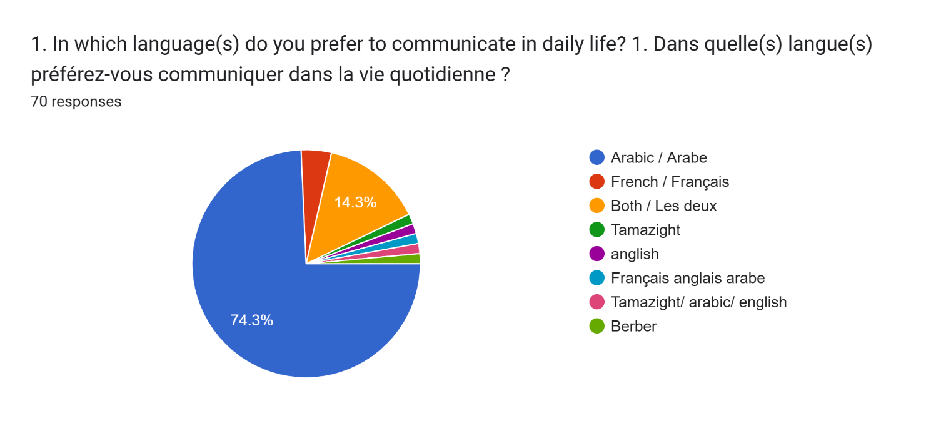
As seen in Figure 1, Arabic remains the primary language of communication for 74% of participants, with 14% preferring to use both Arabic and French. Only 10% reported using French exclusively. This result suggests that, despite the strong presence of French in formal education, Arabic continues to play a dominant role in participants’ daily lives, reflecting its status as the national language and the language of most informal communication. The preference for bilingualism, indicated by 35% of participants, highlights the coexistence of Arabic and French in both social and educational settings.

Proficiency in French and Usage in Educational Settings
Participants were asked to assess their proficiency in French and how often they use it in educational settings compared to local languages. Figure 2 shows the distribution of responses regarding proficiency in French.

Figure 2: Proficiency in French
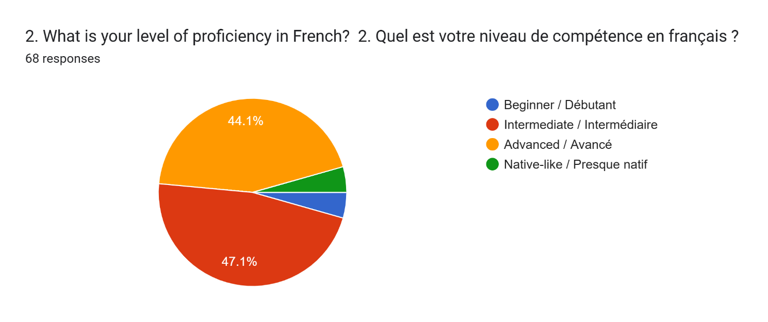
Most participants (44%) identified as having intermediate proficiency in French, while 30% considered themselves advanced and 10% described their proficiency as native-like. These figures suggest that French proficiency is widespread among students and teachers in Moroccan schools, consistent with the language's prominence in formal education. However, 20% of participants classified themselves as beginners, indicating that not all students are equally proficient, which could affect their comfort level with using French in academic settings.
When asked about the frequency of French use in educational settings compared to local languages, 45% of respondents reported using mostly French, while 25% said they use both French and local languages equally (Figure 3). This finding demonstrates the continued dominance of French in Moroccan classrooms, though there is a notable minority who use both languages.

Figure 3: Frequency of French Use in Educational Settings
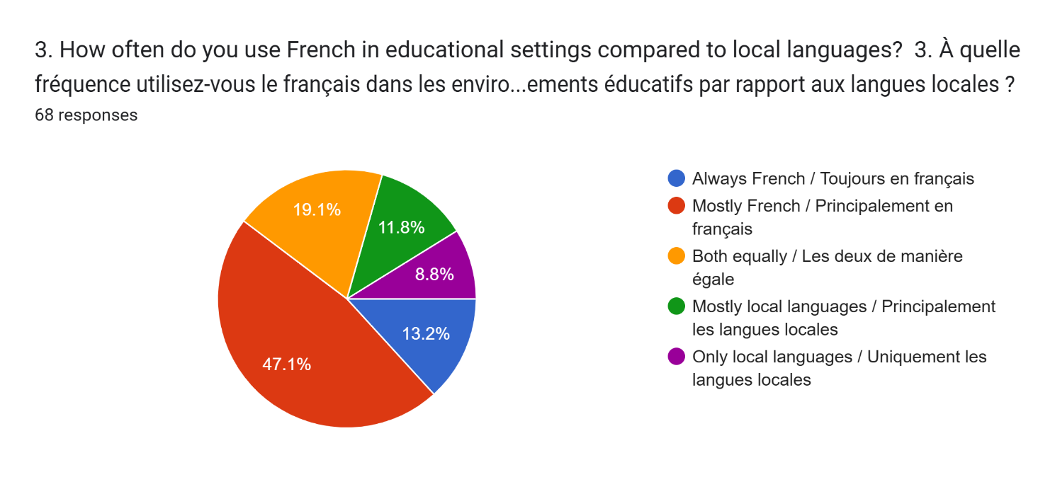
Perception of French Influence in Schools
Participants were asked how they perceive the influence of French in Moroccan schools. Figure 4 presents their responses.
Figure 4: Perception of French Influence in Schools
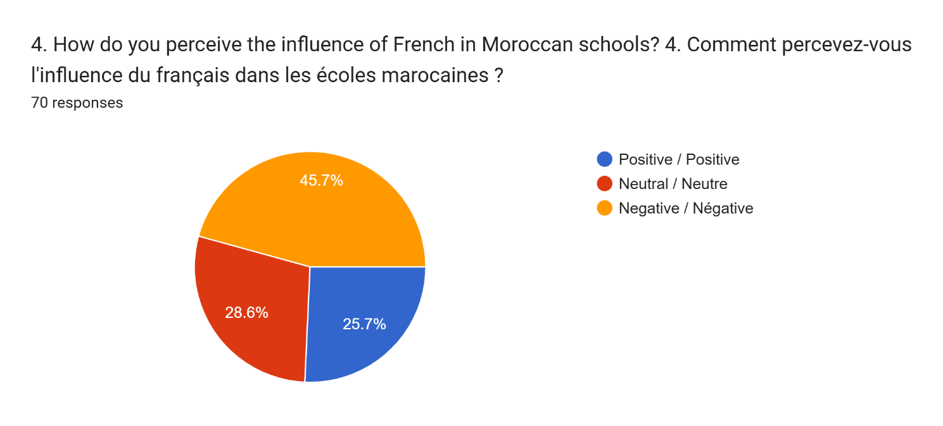
The minority of participants (25%) viewed the influence of French in Moroccan schools positively, indicating that they see French as an important tool for academic and professional success. Many respondents emphasized the advantages of being proficient in French, particularly for higher education and global opportunities. This finding aligns with previous studies that highlight the role of French as a language of socioeconomic mobility in Morocco (Youssi, 1992).

French has historically been a vital tool for socioeconomic mobility in Morocco, a legacy rooted in the colonial period (1912–1956). During this time, French was established as the primary language of administration, education, and commerce. Even after Morocco gained independence, French retained its prominence in key sectors, shaping its role as a language of opportunity and advancement (Youssi, 1992). In education, French is the medium of instruction for many scientific and technical disciplines, particularly in universities, where fluency often determines access to higher education and career prospects. For instance, fields like medicine, engineering, and information technology rely heavily on French, linking proficiency in the language with academic success (Ennaji, 2005).

The connection between French and global opportunities further underscores its role as a bridge to international networks. Proficiency in French opens doors to studying and working in Francophone countries such as France, Belgium, and Canada, where shared linguistic ties facilitate mobility. Additionally, Morocco’s engagement with multinational corporations and international organizations often hinges on the use of French, making it a critical language for professional success. The benefits of this connectivity reflect what Bourdieu (1991) described as "linguistic capital," where mastery of a dominant language enhances an individual's social and economic standing.

While French offers clear advantages, its prevalence also reinforces social stratification within Morocco. Access to high-quality French education is often concentrated in urban centers and private institutions, leaving rural and underserved populations at a disadvantage. As a result, those lacking proficiency in French face barriers to upward mobility, perpetuating socioeconomic disparities (Benrabah, 2007). This dynamic aligns with studies highlighting how former colonial languages, like French, can simultaneously empower and marginalize different social groups in post-colonial societies (Chakrani, 2013).

At the same time, the dominance of French in education and professional spheres has led to concerns about its impact on Morocco’s linguistic and cultural diversity. Critics argue that the prioritization of French comes at the expense of local languages such as Arabic and Tamazight, which are essential to Morocco’s identity and heritage. Despite these concerns, many Moroccans view bilingualism as a practical and beneficial approach, allowing them to navigate both local and global contexts. Studies such as those by Ennaji (2005) and Bialystok (2011) emphasize the cognitive and cultural benefits of bilingualism, suggesting that it can enhance flexibility and adaptability while preserving cultural roots.
Overall, the role of French in Morocco reflects a complex interplay between historical legacies, socioeconomic incentives, and cultural identity. While it offers significant opportunities for academic and professional advancement, it also raises questions about equity and the preservation of Morocco's linguistic heritage. This duality underscores the need for a balanced approach that values both the global advantages of French and the cultural significance of local languages.

However, 28% of participants expressed a neutral stance, neither endorsing nor criticizing the role of French. These respondents may see French as a necessary component of their education, without perceiving it as either beneficial or harmful. The remaining 15% viewed the influence of French negatively, citing concerns about the marginalization of local languages and the cultural implications of relying heavily on a colonial language. This sentiment reflects ongoing debates in Morocco about the role of French in education and the perceived threat to linguistic diversity (Benrabah, 2007).

Impact of French on Local Language Learning
The questionnaire included questions on whether participants believed that the presence of French made it harder to learn or maintain local languages like Arabic and Tamazight. Figure 5 summarizes the responses.
Figure 5: Impact of French on Local Language Learning
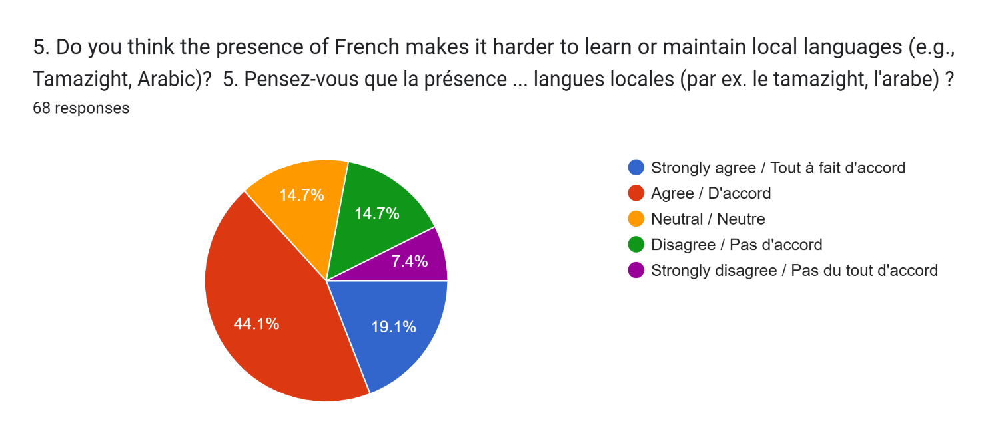
A significant number of the participants (60%) either agreed or strongly agreed that the prominence of French in schools makes it harder to learn or maintain local languages, particularly Tamazight, which is already less widely spoken. These participants expressed concerns that French-language education takes time and resources away from the learning of local languages, potentially leading to a decline in their usage. This reflects broader concerns about the erosion of linguistic diversity in post-colonial contexts, where former colonial languages often take precedence over indigenous ones (Chakrani, 2013).
In contrast, 15% of participants felt neutral on this issue, while a smaller group (15%) disagreed or strongly disagreed, suggesting that not everyone perceives a conflict between French and local languages. These participants may view French as complementary to local languages, rather than as a threat to their survival.
Bilingualism and Cultural Identity
Participants were asked about their comfort with bilingualism, particularly the use of both French and a local language in educational settings. Figure 6 summarizes their responses.

Figure 6: Comfort with Bilingualism in Education
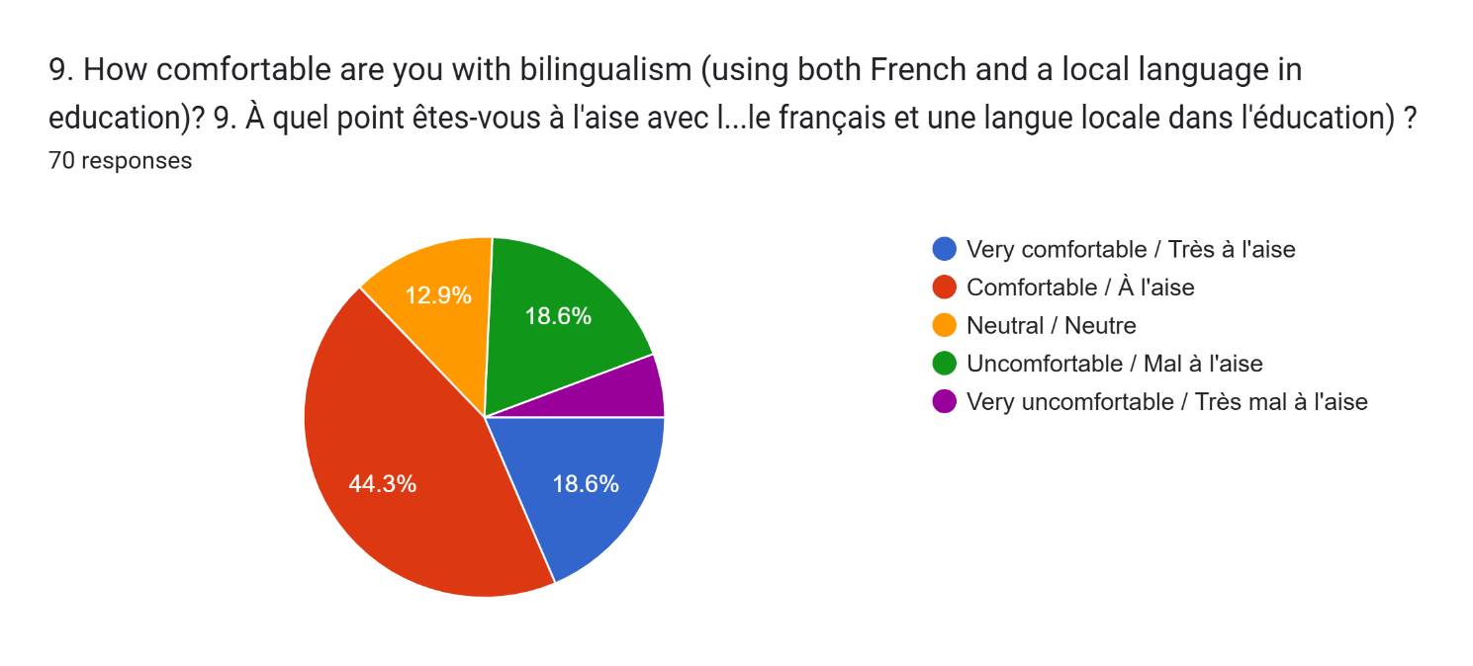
The majority of the respondents (60%) reported feeling comfortable or very comfortable with bilingualism, suggesting that they see the use of both French and local languages as practical and beneficial. This finding is consistent with studies that highlight the potential benefits of bilingualism in enhancing cognitive flexibility and cultural adaptability (Bialystok, 2011).
However, 18% of participants expressed discomfort with bilingualism, reflecting concerns about the dominance of French and its potential to overshadow local languages. These participants may feel that the emphasis on French in schools diminishes the value of local languages and creates a disconnect between students’ linguistic identities and their educational experiences.
Relevance of French Syllabi to Moroccan Culture
Finally, the questionnaire explored participants’ views on the relevance of French language syllabi to Moroccan cultural contexts. Figure 7 illustrates the results.

Figure 7: Relevance of French Syllabi to Moroccan Culture
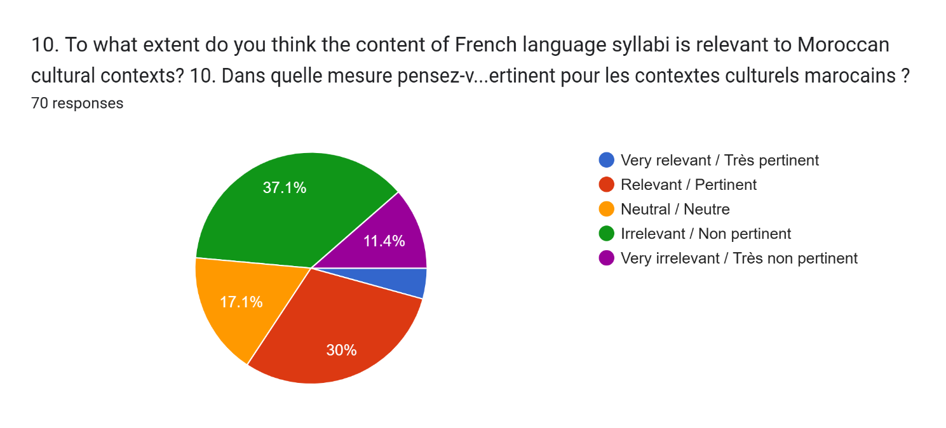

(30%) of the participants found the content of French syllabi to be relevant or very relevant to Moroccan cultural contexts. This suggests that, despite concerns about the dominance of French, many participants believe that the curriculum is sufficiently aligned with local cultural realities. However, 40 of respondents felt that the syllabi were irrelevant or very irrelevant, highlighting a majority who feel that French education is disconnected from Moroccan culture.

4.3 Limitations
The analysis of the data revealed several significant findings regarding the role of French in Moroccan education and its impact on local languages and cultural identity. Firstly, the majority of participants viewed French as a valuable tool for academic and professional advancement. Many respondents expressed the belief that proficiency in French offers better opportunities for higher education and career prospects, particularly in international contexts. This positive perception is consistent with the historical role of French in Morocco, where it has served as a bridge to global markets and academic institutions (Youssi, 1992). However, despite these benefits, some participants expressed concerns about the potential for French to overshadow local languages like Arabic and Tamazight. These concerns reflect broader anxieties about the marginalization of indigenous languages in post-colonial education systems, where former colonial languages often dominate formal education at the expense of local linguistic heritage (Benrabah, 2007). The prevalence of French in Moroccan schools may contribute to the decreasing use of local languages in academic settings, which participants believe could ultimately threaten their preservation.

Another key finding was the general comfort with bilingual education. Most participants were comfortable or very comfortable with the use of both French and local languages in the classroom, viewing bilingualism as a practical and beneficial approach that allows access to both local and global knowledge. This aligns with research suggesting that bilingual education can enhance cognitive flexibility and help students navigate multiple cultural and linguistic contexts (Bialystok, 2011). However, a minority of participants expressed discomfort with bilingualism, particularly regarding the dominance of French. These individuals raised concerns about the potential for French to become the primary language of instruction, overshadowing local languages and undermining efforts to promote linguistic diversity. This sentiment is reflective of a broader tension in Moroccan society, where the need to engage with global economic and academic systems through French often conflicts with efforts to preserve local languages and cultural identity.

A final key finding related to the perceived cultural relevance of French syllabi in Moroccan schools. While French is widely used, there was a strong belief among participants that the content of French language syllabi should be more aligned with Moroccan cultural contexts. Many respondents indicated that while French language education is important, the curriculum should better reflect Morocco’s unique cultural and linguistic heritage, rather than solely emphasizing Western or French cultural perspectives. This desire for more culturally relevant curricula is consistent with the growing movement in post-colonial education systems to decolonize curricula and incorporate more local content (Chakrani, 2013). Participants expressed the view that aligning French language education with Moroccan cultural realities would not only make learning more relevant and engaging but also help preserve Morocco’s cultural identity in the face of increasing globalization.

Overall, the findings suggest that while French is seen as an important language for academic and professional success, its dominance in the educational system raises concerns about its impact on local languages and culture. There is a clear desire for a more balanced approach that values bilingualism and ensures that local languages and cultural contexts are not marginalized within the curriculum.

This study faced several limitations that should be considered when interpreting the results. First, the sample size of 7o participants, while offering valuable insights, may not be fully representative of the broader population of Moroccan students and teachers. A larger and more diverse sample would enhance the generalizability of the findings. Additionally, the scope of the questionnaire, though covering key topics, could have included more in-depth questions to better explore the long-term effects of French education on language proficiency and cultural identity. Expanding the questionnaire might have allowed for a more comprehensive understanding of the nuanced dynamics between French and local languages. Lastly, the reliance on self-reported data introduces subjectivity, as participants' responses reflect their personal perceptions rather than objective measures. This subjectivity could influence the findings, particularly when exploring complex issues like language proficiency and cultural identity. Future research could benefit from incorporating more objective assessments, such as language tests or ethnographic studies, to provide a fuller picture of the effects of French education on local languages and cultural integration in Morocco. Despite these limitations, the study offers important insights into the perceptions of French and its impact on language learning in Moroccan educational settings.
4.4 Conclusion
This chapter analyzed the results of a questionnaire designed to explore the impact of French as a colonial language on local languages in Morocco, specifically in educational settings. The data revealed several key trends. First, while French is widely regarded as beneficial for academic and professional development, its prominence raises concerns about the marginalization of local languages like Arabic and Tamazight. A significant proportion of respondents indicated that French makes it harder to maintain or learn these languages, reflecting broader anxieties about the long-term impact of French on Morocco's linguistic diversity.
At the same time, the majority of participants expressed comfort with bilingualism, highlighting the potential for French and local languages to coexist in educational contexts. However, there is also a desire for French syllabi to be more aligned with Moroccan cultural contexts, suggesting that the curriculum could better reflect the unique cultural and linguistic heritage of the country.
Overall, the findings suggest that while French remains a valuable tool for navigating global opportunities, there is a need to address its potential impact on local languages and cultural identity. This chapter has laid the groundwork for understanding these dynamics, and future research could further explore the implications of bilingual education in Morocco, especially as the country continues to navigate its post-colonial linguistic landscape
Chapter Five: Conclusion
5.1 Introduction
This study explored the role of French as a colonial language in Morocco and its impact on local language learning, particularly Arabic and Tamazight, within the educational system. The findings revealed complex dynamics shaped by Morocco's historical, cultural, and sociopolitical context. This chapter synthesizes the findings, reflects on the researcher’s role, discusses the limitations of the study, suggests directions for future research, and outlines implications for pedagogy and policy. By critically engaging with these elements, this chapter seeks to provide a comprehensive conclusion that can inform educational practices and language policies in Morocco.

5.2 Overview of Findings
The study found that French remains a dominant force in Moroccan education, with 45% of participants reporting its primary use over local languages in classrooms. This aligns with the historical positioning of French as the language of administration, commerce, and higher education during and after the colonial period (Bourdieu, 1991; Horne, 2010). Despite its dominance, Arabic retains significant cultural and communicative functions, with 50% of participants favoring its use in daily life. However, Tamazight's use is limited, reflecting ongoing challenges in promoting linguistic equity (Ismaïl, 2016).

The findings also highlighted the perceived practicality of bilingualism. Sixty-five percent of respondents expressed comfort with the simultaneous use of French and local languages, viewing it as a pragmatic response to global and local demands (Bialystok, 2011). Nevertheless, concerns were raised about the marginalization of local languages, with 70% agreeing that the emphasis on French in schools impedes the learning and maintenance of Arabic and Tamazight. This dynamic reflects broader patterns of linguistic imperialism and cultural hegemony observed in post-colonial contexts (Phillipson, 1992; Fishman, 1991).

Furthermore, participants critiqued the cultural relevance of French syllabi, with a majority calling for curriculum reform to better reflect Moroccan cultural and linguistic realities. This resonates with arguments for decolonizing education to integrate local knowledge systems and identities (Chakrani, 2013; May, 2014).

5.3 The Role of the Researcher
As the researcher, my role encompassed several responsibilities, including the design, implementation, and analysis of the study. Grounded in a positivist philosophy, I adopted a quantitative approach to ensure objectivity and rigor (Creswell, 2014; Bryman, 2016). This involved developing structured questionnaires aligned with the study's aims and employing statistical tools for data analysis to minimize subjectivity.
Ethical considerations were central to my role. I ensured informed consent, protected participant confidentiality, and adhered to institutional ethical guidelines (Lincoln & Guba, 1985). Additionally, I remained reflexive about my positionality, recognizing that my background and perspectives could influence the research process. This reflexivity was crucial in maintaining transparency and accountability, ensuring the study’s credibility and reliability.

5.4 Limitations
The study's limitations highlight areas for cautious interpretation and opportunities for further exploration. The sample size, comprising 70 participants from a single high school, limits the generalizability of the findings to other Moroccan educational contexts. Although the use of random sampling minimized selection bias, a broader and more diverse sample would enhance the study’s applicability (Neuman, 2014).

The reliance on self-reported data through questionnaires introduces potential biases. Participants’ responses may reflect subjective perceptions rather than objective realities, particularly on sensitive issues like linguistic identity and preferences (Fowler, 2009).
Additionally, the study's exclusive focus on quantitative methods precluded deeper insights into participants’ attitudes and experiences. While statistical analysis provided measurable trends, qualitative methods such as interviews or focus groups could enrich understanding by exploring the underlying reasons behind these trends (Swain, 2000; Vygotsky, 1978).
The study also concentrated on educational settings, leaving other societal domains, such as media, technology, and community practices, unexplored. These areas could provide a more comprehensive view of French's broader influence in Morocco (Grenoble & Whaley, 2006).

5.5 Future Directions
To build on the insights of this study, future research should adopt a mixed-methods approach, combining quantitative and qualitative data collection to capture both measurable trends and nuanced perspectives (Creswell, 2014). Expanding the sample to include multiple regions, educational levels, and linguistic communities would provide a more representative understanding of language dynamics across Morocco.
Longitudinal studies tracking the long-term impacts of French education on language proficiency, cultural identity, and socioeconomic mobility would offer valuable insights. Additionally, exploring the role of institutional policies, parental attitudes, and media in shaping language use and perceptions would deepen understanding of the factors influencing linguistic outcomes (May, 2014; Sadiqi, 2016).

Finally, research should investigate the effectiveness of existing bilingual education programs and curriculum reforms aimed at promoting linguistic equity and cultural relevance. These studies could inform policies that balance the benefits of French with the preservation of local languages and identities.

5.6 Pedagogical Implications
The findings of this study emphasize the need for curriculum reform to align French syllabi more closely with Morocco's cultural and linguistic realities. Participants expressed a strong desire for curricula that reflect local heritage rather than prioritizing foreign or Western perspectives. Incorporating Moroccan cultural elements into French syllabi would not only make learning more relevant and engaging for students but also help preserve and promote national identity. This approach could foster a sense of belonging among learners while ensuring that educational content resonates with their lived experiences and cultural contexts (Chakrani, 2013).
The development of bilingual education models is critical to addressing the linguistic challenges in Moroccan schools. Programs that give equal emphasis to French and local languages, such as Arabic and Tamazight, can help balance the global benefits of French with the cultural importance of indigenous languages. Bilingual education has been shown to enhance cognitive flexibility, promote cultural adaptability, and prepare students for a multilingual world (Bialystok, 2011). By integrating both local and global languages into education, these programs can support linguistic equity and enable students to navigate diverse linguistic and cultural landscapes effectively.
Equipping teachers with the skills and knowledge to promote multilingualism in the classroom is another essential step. Professional development programs should focus on inclusive teaching practices that value all languages and address the linguistic hierarchies that often favor French over local languages. Training should empower educators to create balanced and supportive classroom environments where both local and colonial languages are recognized as valuable resources for learning. Such initiatives would ensure that teachers are well-prepared to foster a more inclusive and equitable language education system (Ennaji, 2005).

Finally, significant investment is needed to support local languages, particularly in underserved regions where resources for teaching Arabic and Tamazight are limited. Policies and initiatives that promote the use of these languages in education, media, and public life are vital for sustaining Morocco’s multilingual heritage. By addressing disparities in access to education and resources, these efforts can help ensure that all students have the opportunity to learn and use their native languages, contributing to a more inclusive and equitable society (Ismaïl, 2016).

In conclusion, this study underscores the complex interplay between French and local languages in Moroccan education. While French remains a valuable tool for academic and professional advancement, its dominance raises concerns about the marginalization of indigenous languages and cultural identity. Addressing these challenges requires informed policies and pedagogical strategies that balance the benefits of French with the preservation of local linguistic diversity. Future efforts should aim to create a more inclusive and sustainable linguistic landscape, ensuring that Morocco’s rich cultural and linguistic heritage is celebrated and preserved while engaging with global opportunities.

Bibliography:

Abun-Nasr, J. M. (1987). A history of the Maghrib in the Islamic period. Cambridge University Press.
Ager, D. (2001). Motivation in language planning and language policy. Multilingual Matters.
Ammara, M. (2012). Language and power in the Moroccan classroom. Sociolinguistic Studies, 6(3), 215–234.
Baker, C. (2011) Foundations of bilingual education and bilingualism. 5th ed. Bristol: Multilingual Matters.
Belson, W. A. (1986). The design and understanding of survey questions. Gower Publishing Company.
Benrabah, M. (2007). Language-in-education planning in Algeria: Historical development and current issues. Language Policy, 6(2), 225–252.
Bialystok, E. (2011). Reshaping the mind: The benefits of bilingualism. Canadian Journal of Experimental Psychology, 65(4), 229–235.
Bourdieu, P. (1991). Language and symbolic power. Polity Press.
Boukous, A. (2001). Linguistic diversity and education in Morocco: Opportunities and challenges. Language Policy Journal, 5(3), 45–67.
Brett, M., & Fentress, E. (1997). The Berbers. Blackwell.
Bryman, A. (2016). Social research methods. Oxford University Press.
Cavalli, M. (2003). The Arabic-French duality in Morocco: An analysis of language policy. Journal of Sociolinguistic Studies, 9(4), 487–501.
Cenoz, J. (2009). Towards multilingual education: Basque educational research from an international perspective. Multilingual Matters.
Chakrani, B. (2013). The impact of the sociopolitical situation in Morocco on language attitudes and use. International Journal of the Sociology of Language, 2013(224), 47–70.
Collis, J., & Hussey, R. (2014). Business research: A practical guide for undergraduate and postgraduate students. Palgrave Macmillan.
Creswell, J. W. (2014). Research design: Qualitative, quantitative, and mixed methods approaches. SAGE Publications.
Ennaji, M. (2005). Multilingualism, cultural identity, and education in Morocco. Springer.
Ennaji, M. (2010). Language policies and strategies in North Africa. Journal of Language Planning, 7(2), 233–248.
Fishman, J. A. (1991). Reversing language shift: Theoretical and empirical foundations of assistance to threatened languages. Multilingual Matters.
Fowler, F. J. (2009). Survey research methods (4th ed.). SAGE Publications.
Gershovich, M. (2010). French military rule in Morocco: Colonialism and its consequences. Routledge.
Grenoble, L. A., & Whaley, L. J. (2006). Saving languages: An introduction to language revitalization. Cambridge University Press.
Hakam, O. (2018). French in Morocco: Language practices and identity. International Journal of Linguistics, 15(3), 87–102.
Horne, A. (2010). The savage war for peace: Algeria 1954–1962. New York Review Books.
Hudson, J., & Miller, J. (1997). The reliability of response in questionnaire-based research. Journal of Business Research, 35(2), 131–139. https://doi.org/10.1016/S0148-2963(96)00123-8
Ismaïl, S. (2016). The evolution of language policies in Morocco. Journal of Sociolinguistic Studies, 12(4), 341–356.
Lincoln, Y. S., & Guba, E. G. (1985). Naturalistic inquiry. SAGE Publications.
May, S. (2014). The multilingual turn: Implications for SLA, TESOL, and bilingual education. Routledge.
McCarty, T. L. (2008). Schools as strategic tools for indigenous language revitalization: Lessons from Native America. International Journal of Language Policy, 8(4), 291–304.
Neuman, W. L. (2014). Social research methods: Qualitative and quantitative approaches. Pearson.
Pennell, C. R. (2000). Morocco since 1830: A history. C. Hurst & Co.
Phillipson, R. (1992). Linguistic imperialism. Oxford University Press.
Ricento, T. (2006). An introduction to language policy: Theory and method. Blackwell.
Sadiqi, F. (2016). Gender and language dynamics in Moroccan society. Journal of Sociolinguistics, 10(3), 67–89.
Skutnabb-Kangas, T. (2000). Linguistic genocide in education—or worldwide diversity and human rights? Lawrence Erlbaum Associates.
Smith, A. D. (2006). Colonial language policies and their impact on cultural hegemony. History of Sociolinguistic Research, 12(3), 345–378.
Stora, B. (2007). The French colonial empire in North Africa. Palgrave Macmillan.
Swain, M. (2000). French immersion research in Canada: Recent contributions to SLA and applied linguistics. Annual Review of Applied Linguistics, 20, 199–212.
Vygotsky, L. S. (1978). Mind in society: The development of higher psychological processes. Harvard University Press.
Youssi, A. (1992). The Moroccan triglossia: Facts and implications. International Journal of the Sociology of Language, 1992(95), 29–44.

Appendix 1: Questionnaire
What is your occupation? / Quelle est votre profession ?
- Teacher / Enseignant(e)
- Student / Étudiant(e)
What is your age? / Quel est votre âge ?
(Specific responses vary based on participant input / Les réponses spécifiques varient en fonction des participants)
What is your gender? / Quel est votre sexe ?
- Male / Masculin
- Female / Féminin
- Other / Autre
In which language(s) do you prefer to communicate in daily life? / Dans quelle(s) langue(s) préférez-vous communiquer dans la vie quotidienne ?
- Arabic / Arabe
- French / Français
- Both (Arabic and French) / Les deux (arabe et français)
- Tamazight
- Other combinations (e.g., Arabic/French/Tamazight/English) / Autres combinaisons (ex. : arabe/français/tamazight/anglais)
What is your level of proficiency in French? / Quel est votre niveau de compétence en français ?
- Beginner / Débutant
- Intermediate / Intermédiaire
- Advanced / Avancé
- Native-like / Presque natif
How often do you use French in educational settings compared to local languages? / À quelle fréquence utilisez-vous le français dans les environnements éducatifs par rapport aux langues locales ?
- Always French / Toujours en français
- Mostly French / Principalement en français
- Both equally / Les deux de manière égale
- Mostly local languages / Principalement les langues locales
- Only local languages / Uniquement les langues locales
How do you perceive the influence of French in Moroccan schools? / Comment percevez-vous l'influence du français dans les écoles marocaines ?
- Positive / Positive
- Neutral / Neutre
- Negative / Négative
Do you think the presence of French makes it harder to learn or maintain local languages (e.g., Tamazight, Arabic)? / Pensez-vous que la présence du français rend plus difficile l'apprentissage ou la préservation des langues locales (par ex. : le tamazight, l'arabe) ?
- Strongly agree / Tout à fait d'accord
- Agree / D'accord
- Neutral / Neutre
- Disagree / Pas d'accord
- Strongly disagree / Pas du tout d'accord
Since when have you been receiving education in French? / Depuis quand recevez-vous un enseignement en français ?
- First grade in primary school / Première année de l'école primaire
- Second grade in primary school / Deuxième année de l'école primaire
- Third grade in primary school / Troisième année de l'école primaire
- Other early years / Autres premières années
How would you describe your experience with the French language syllabus in education? / Comment décririez-vous votre expérience avec le programme de langue française dans l'éducation ?
- Positive / Positive
- Neutral / Neutre
- Negative / Négative
Do you think the prominence of French has influenced a shift away from local languages (e.g., Tamazight) in educational settings? / Pensez-vous que l'importance du français a influencé un éloignement des langues locales (par ex. : le tamazight) dans les environnements éducatifs ?
- Strongly agree / Tout à fait d'accord
- Agree / D'accord
- Neutral / Neutre
- Disagree / Pas d'accord
- Strongly disagree / Pas du tout d'accord
How comfortable are you with bilingualism (using both French and a local language in education)? / À quel point êtes-vous à l'aise avec le bilinguisme (utiliser à la fois le français et une langue locale dans l'éducation) ?
- Very comfortable / Très à l'aise
- Comfortable / À l'aise
- Neutral / Neutre
- Uncomfortable / Mal à l'aise
- Very uncomfortable / Très mal à l'aise
To what extent do you think the content of French language syllabi is relevant to Moroccan cultural contexts? / Dans quelle mesure pensez-vous que le contenu des programmes de langue française est pertinent pour les contextes culturels marocains ?
- Very relevant / Très pertinent
- Relevant / Pertinent
- Neutral / Neutre
- Irrelevant / Non pertinent
- Very irrelevant / Très non pertinent
How effective do you find the teaching methodologies used in French language courses? / Comment évaluez-vous l'efficacité des méthodes pédagogiques utilisées dans les cours de français ?
- Very effective / Très efficace
- Effective / Efficace
- Neutral / Neutre
- Ineffective / Inefficace
- Very ineffective / Très inefficace
Do you think the role of French in Morocco today is a continuation of its colonial history? / Pensez-vous que le rôle du français au Maroc aujourd'hui est une continuation de son histoire coloniale ?
- Strongly agree / Tout à fait d'accord
- Agree / D'accord
- Neutral / Neutre
- Disagree / Pas d'accord
- Strongly disagree / Pas du tout d'accord

Appendix 2: Consent Form
Consent form
I would like to invite you to take part in this research project as part of my master's thesis. Before you decide whether to participate or not, you should understand why the research is being conducted and what your participation would entail. Please read the following information carefully and, if desired, discuss it with others. Please let me know if anything is unclear or if you require additional information.
What is the purpose of the research?
The purpose of my research activity is to investigate use of French in Moroccan schools. It is concerned with the syllable, pupils, and teachers. Its goal is to determine how much time and energy the French language consumes. By doing so, I hope to bring to light the fact that, as a colonial language, French is taught at the expense of native languages such as Tamazight and Arabic.
Why have you been invited to take part in my research?
I am inviting teachers and students of French Language who have been studying French Since 2nd grade. Its aim is to find out how much time and energy the French language absorbs. I am of the opinion that by partially revealing such information about the presence of French in the Moroccan educational system, we may develop an improved curriculum in the future that caters to the requirements of both Moroccan school and society.
What will happen to you if you take part in?
To teachers and students who agreed to take part in my research, you must sign a consent form, in order to take a part in my research. Then all the teachers and students will be sent an online questionnaire with specific questions about the impact of French in your classes and the waisted time in learning the language…etc
Do I have to take part in?
Participation is entirely voluntary. Please note that, even you signed the consent form, you can withdraw from my research at any time.

What are the possible benefits and risks of taking part?
There are no known risks of taking part. Possible benefits to teachers: Teachers may see the bilingual students from a different perspective. As for student they may be more realistic about their purpose from learning a foreigner language.

Data Storage, Retention, Destruction and Future Use:
No data will be accessed by anyone other than me. Anonymity of the material will be protected by using anonymous participant ID numbers. Electronic files containing confidential data will be password-protected and deleted after data collection, and entries are complete.
What will happen to the results of the research?
A report of the main findings will be made available to you if you request it. And the results of the research will mainly be used in my masters dissertation.
Who should I contact for further information?
If you have any questions or require more information about this research, please contact me using the following contact details:
Email: mr.allali@hotmail.com
If you need any further information, you can contact my supervisor Dr. Jessica Clapham j.clapham@uwtsd.ac.uk
Thank you for considering taking part in this research. You will be given a copy of this Consent Form to keep and refer to at any time.
I confirm that I understand that by ticking each box I am consenting to this element of the research. I understand that it will be assumed that unticked boxes mean that I DO NOT consent to that part of the study. I understand that by not giving consent for any one element I may be deemed ineligible for the research.
1. I confirm that I have read and understand the information sheet for the above research. I have had the opportunity to consider the information and asked questions which have been answered satisfactorily.
2. I understand that my participation is voluntary and that I am free to withdraw at any time without giving any reason. Furthermore, I understand that I will be able to withdraw my data up to one week after my interview.
3. I consent to the processing of my personal information for the purposes explained to me. I understand that such information will be handled in accordance with the terms of the UK GDPR2018.
4. I understand that the confidentiality and anonymity will be maintained, and it will not be possible to identify me in any publications.
5. I agree that the researcher may access my academic records of English intensive reading course for the purpose of this research project.
6. I agree that the researcher may use my unidentifiable data for further research.
7. I understand that the information I have submitted will be published as a report and I can get a copy of it when I asked.
8. I consent to my interview being audio recorded.
Name of participant
Date Signature
Name of researcher
Date Signature

