Reflection on Study Skills
Study Skills for Electronics
(ACDA4021)
Electrical and Electronic Engineering

Ayoob Mohammed Azhar (2400571)

CONTENTS

Introduction

Section 1: Presentation skills
1.1 Brief self-overview as per the presentation.
1.2 Screengrabs from presentation
1.3 Key points learned when creating and delivering a successful presentation
1.4 Areas to improve in future presentations

Section 2: Personal research on required skill sets
2.1 Skills for Higher Education
2.2 Transferable Skills Employers Look For

Section 3: Self-evaluation and action planning
3.1 Self-evaluation results
3.2 Short-term and long-term goals
3.3 SMART action plans

Section 4: Application
4.1 Looking after your data
4.2 Time management and self-organisation
4.2.1 Steps to improve productivity/time management
4.2.2 Self-organisation method (e-portfolio)

Section 5: Conclusion & Evaluation

Section 6: Referencing

Section 7: Appendices

Introduction
This report will focus on the author’s demonstration of the various study skills he developed and implemented throughout this module.

Section 1: Presentation skills
  - Brief self-overview as per the presentation exercise.
My name is Ayoob. Although I do have a full name which is quite long for people to know. I am 19 years old. I was born in Sri Lanka, where I lived for over 3 years. I grew up in Muscat, the capital and the largest city in Oman, where I lived for over 13 years until the end of 2021. Before coming to university, I completed a BTEC Level 3 course in Advanced Manufacturing Engineering (Motorsport) at Gower College.
I am an introvert, shy, and untalkative by nature. However, I do like to get to know people, although it would take some time to get comfortable with talking to them. I like to hang around with friends I’m close with. I recharge myself by doing so or I would feel empty. I prefer studying in the morning because I feel more productive, rather than studying at night.
Moving on to my strengths. I am adaptable to different learning environments. I am able to work in a team effectively and sometimes contribute the skills I have that others may not have. I can usually manage my time effectively so that I am able to complete my tasks/work at a specified time according to priorities. I am dedicated to working towards my goals.
Next, my weaknesses. I have difficulty and nervousness trying to socialise and connect with people. I have difficulty and nervousness during public speaking. I am sometimes not consistent. I am not the best at organising my schedules
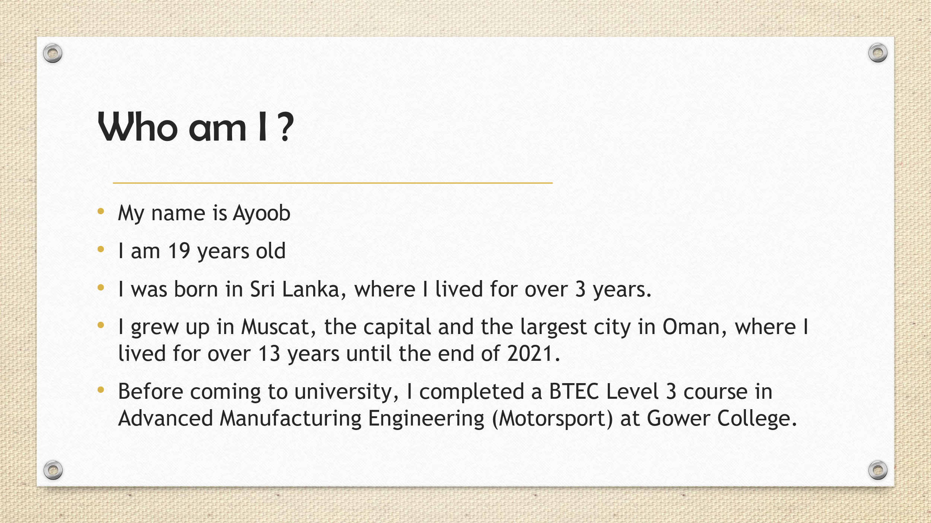
  - Screengrabs from presentation

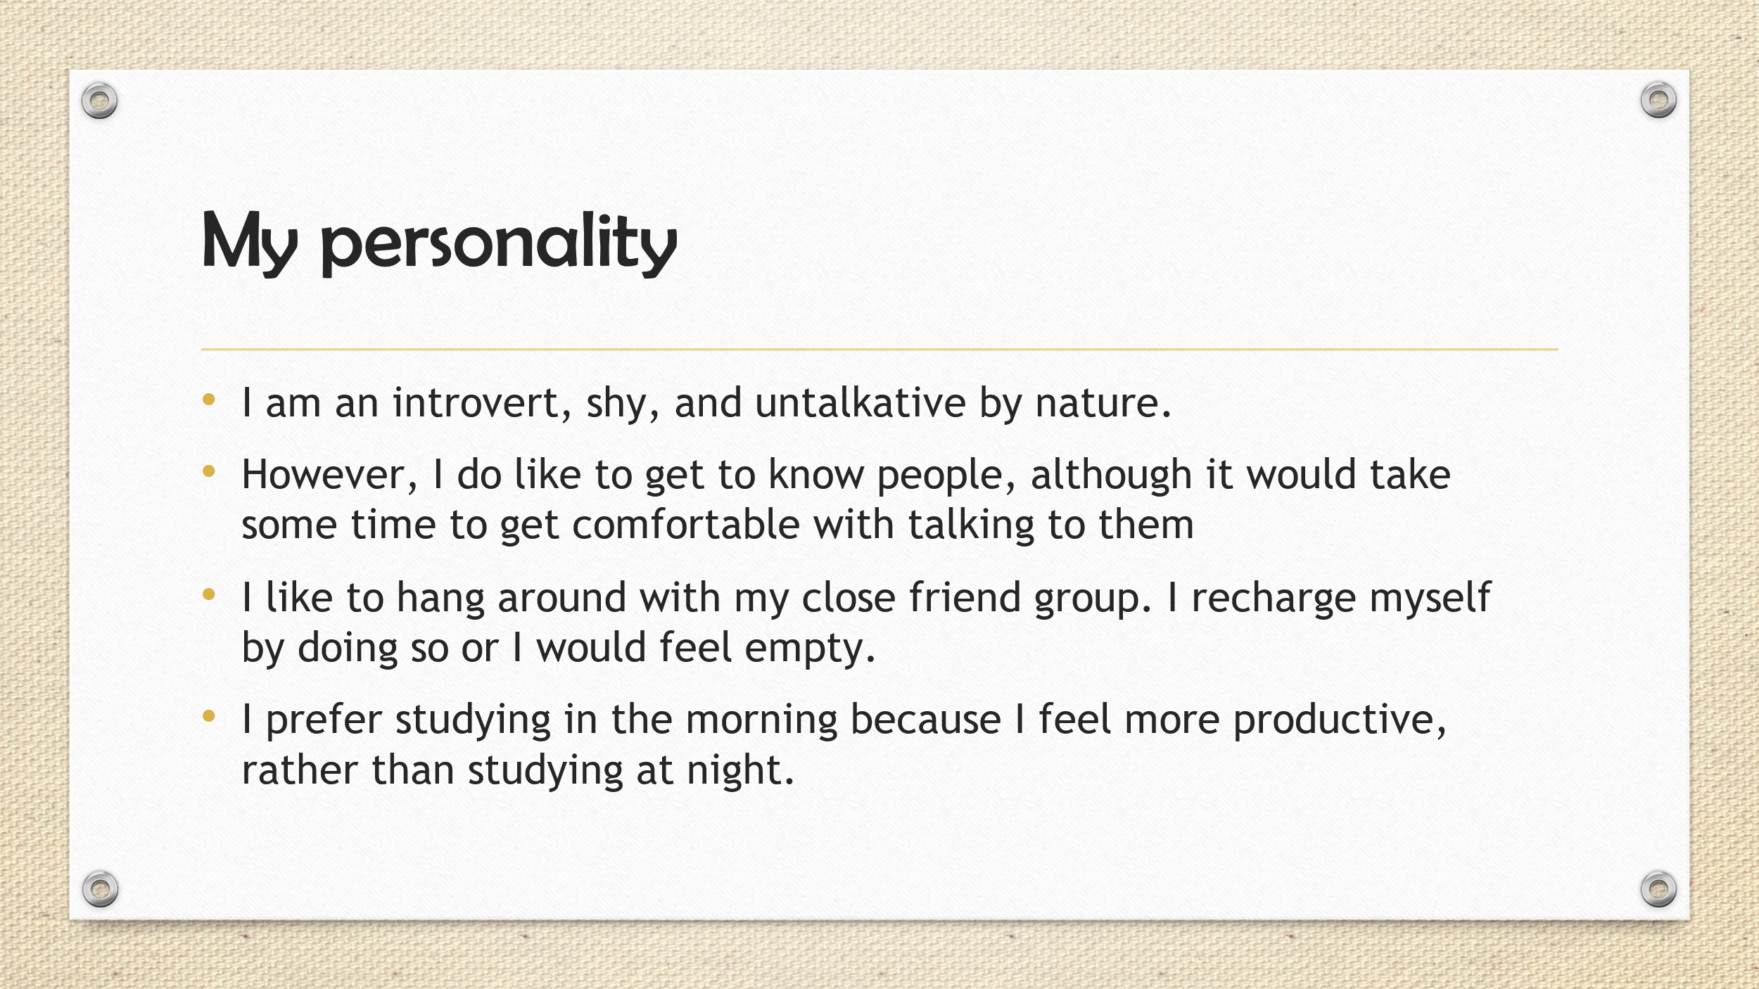

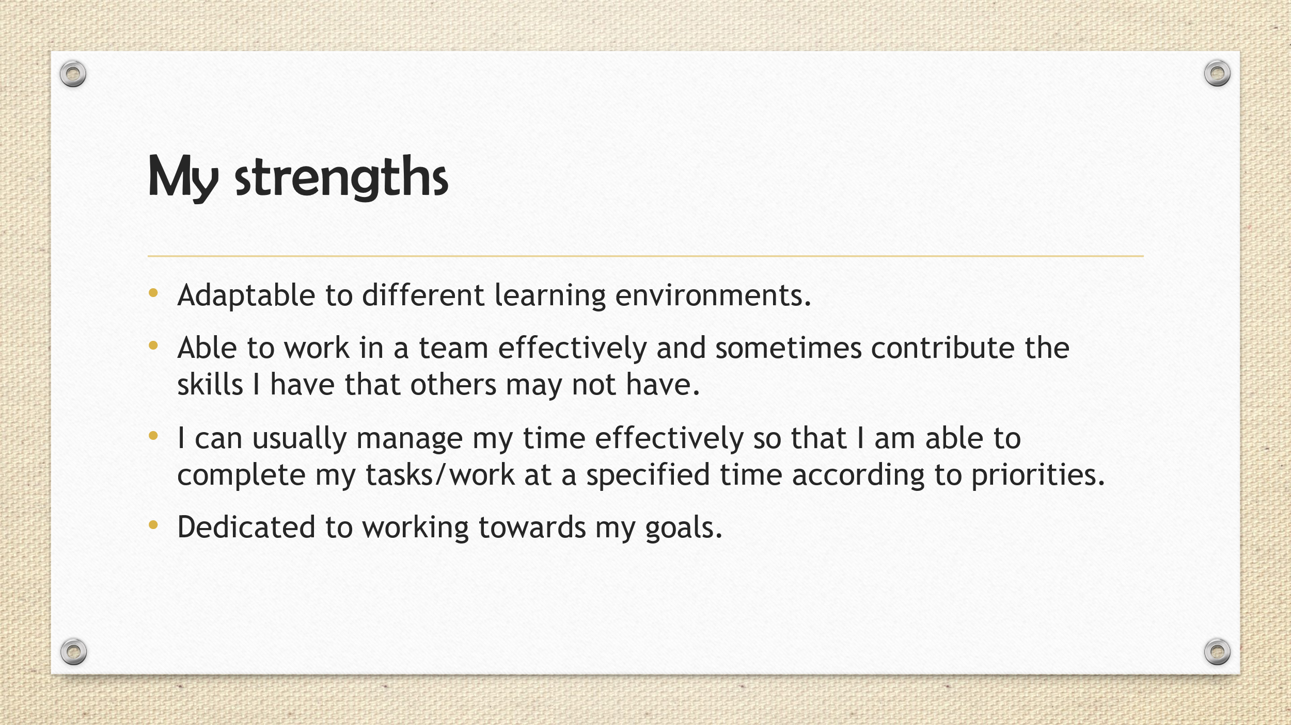

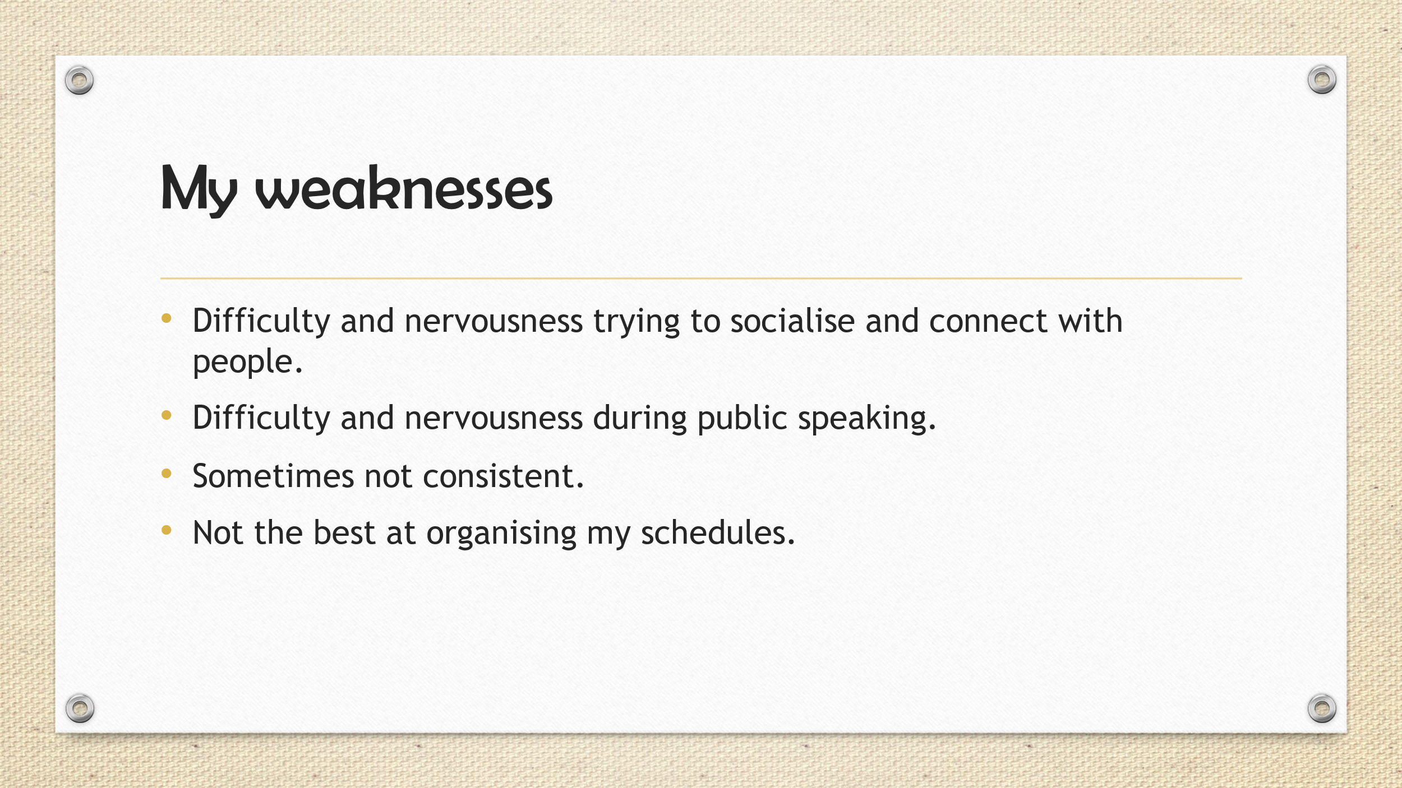
  - Key points learned when creating and delivering a successful presentation
- Firstly, the author has ensured that the main body should be structured in bullet points when trying to create a good presentation to ensure professionalism and so that the content is easier to retain.
- Next, the author also learned to keep the font sizes of the title, heading and main body considerably big enough so that it becomes more readable for the audience.
- Additionally, the author added transitions to the presentation to keep it more engaging to the audience.
- Further, the author ensured to keep his presentation delivery as close as possible to the time limit of 5 minutes demonstrating effective time management.
- Moreover, the author delivered the presentation content at a moderate pace to ensure that information was conveyed clearly.
- Furthermore, the author kept eye contact with the audience whenever possible to enhance audience engagement.
1.4 Areas to improve in future presentations
In future presentations, the author should include images wherever relevant to make the presentation interesting and better engage his audience.
Secondly, the author should move around a bit more and use hand gestures to improve engagement the atmosphere more livelier when delivering his presentation.
The author should also practice delivering his presentation a few times to become more confident prior to the presentation day.

Section 2: Personal research on required skill sets
2.1 Skills for Higher Education
There are various skills needed for students (including the author) to thrive in a higher education environment, i.e., in university.
Critical thinking
One of the main skills students need to develop is critical thinking as they must have the ability to; think logically, identify and understand strong arguments, and then deduce from the information provided to them. An example of critical thinking is being able to identify biases and assess information objectively which is essential during research. [1]
Communication
Another skill students will develop during university is communication, which allows them to properly express their ideas in writing or speech to their colleagues, or lecturers. For example, they will be able to improve these skills by delivering presentations. [1]
Time management
Students should be able to develop this skill as it helps them effectively utilise the time they have to handle and prioritize various tasks and finish those on time such as writing up assignments, finishing a laboratory task, or revising notes for exams. [1]
Reading
It is important to develop this skill as it helps students save time and allows them to select the correct information to read, through skimming and scanning techniques. Using the skimming technique allows them to go through the information to get a basic idea of what the content is and if it is worth reading thoroughly. They can also use the scanning technique to find a specific piece of information they're looking for whilst ignoring irrelevant information. [1]
Academic writing
Lastly, a very important skill for students is academic writing as they will have to use this skill throughout their higher education for things such as writing up their assignments, lab reports etc. They will have to ensure their writing is of an academic standard that requires correct spelling and grammar, avoiding plagiarism, and using references whenever necessary with the required referencing style such as IEEE. [1]
2.2 Transferable Skills Employers Look For
Employers look for diverse transferable skills such as the following.
Communication
Communication is a transferrable skill that is used in any profession which is crucial for understanding tasks, teamwork, and providing desired results. [2]
Problem-solving
In any job profession, this skill is needed and transferrable as it demonstrates the employees’ ability to recognise problems, come up with potential solutions, and put successful strategies into action. [2]
Leadership and Team Management
These transferrable skills are essential when it comes to project management or supervision job roles. Leadership skills entail leading a team of people towards shared objectives whereas team management skills require ensuring that all the members of the team work cooperatively and efficiently. [2]
Time Management
Time management is a very essential and transferrable skill as it directly affects efficiency and productivity since it demonstrates the employees’ ability to manage their time efficiently, set priorities for tasks, and adhere to deadlines. [2]
Adaptability
Another important transferrable skill that employers look for is the ability to thrive and adapt in changing work environments and acquire new skills. [2]
Data Analysis
This transferrable skill is important in job roles that require strategic planning, research, or performance monitoring. This skill requires analysing data which is used for thoughtful decision making. [2]
Project Management
This transferrable skill is vital in job roles that require time and resource management as it demonstrates the employees’ ability to be able to plan, carry out, supervise and ensure that projects are finished on schedule and within budget. [2]
Attention to Detail
Lastly, attention to detail is a skill that requires identifying and rectifying errors or variations to ensure high-quality work. This is used in professions such as engineering where precision and accuracy are crucial. [2]

Section 3: Self-evaluation and action planning
3.1 Self-evaluation results
The author first conducted a Big Five personality test, and the results are shown in Figure 1. The Big Five personality test is a well-known personality test that describes five broad aspects of human personality traits, they are Openness, Conscientiousness, Extraversion, Agreeableness, and Neuroticism [3]. Although some of the traits are known using other terms that can be seen in Figure 1.
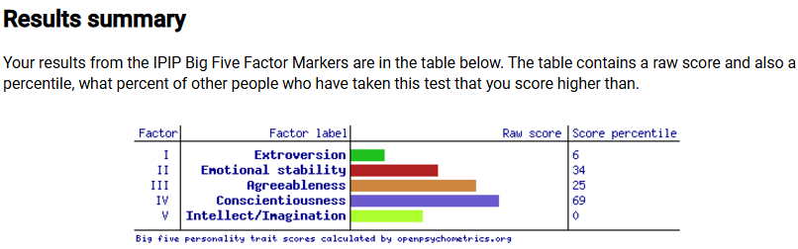
As shown in Figure 1…
Figure 1: Big Five personality test results [5]
The author’s ‘Extroversion’ (Factor 1) trait was at the 6th percentile, implying that the author is mostly introverted. (according to the description taken from Figure 1 in Appendix A) This trait denotes that he likes to spend time alone or with small groups such as close friends, however, he feels uneasy in large social gatherings. It also shows how cautious he is when speaking with others and how less assertive he is when it comes to conversations. This is similar to how the author perceived himself before doing this personality test.
The author’s ‘Emotional stability’ (Factor 2) trait was at the 34th percentile, implying that the author is vulnerable to negative emotions. (according to the description from Figure 2 in Appendix A) This personality trait is almost not how the author perceived himself before doing this personality test as the author is rarely vulnerable to negative emotions and does not show any maladaptive behaviours.
The author’s ‘Agreeableness’ (Factor 3) trait was at the 25th percentile, implying that the author tends to be more sceptical and competitive. (according to the description from Figure 3 in Appendix A) This personality trait is almost not how the author perceived himself before doing this personality test as the author would be unlikely to express opinions forcefully even if it may be opposed by others. Rather than being less motivated to maintain social harmony, he would be neutral. However, indeed, the author is sometimes sceptical and competitive.
The author's ‘Conscientiousness’ (Factor 4) trait was at the 69th percentile implying that the author is characterised as being hardworking, reliable, and efficient (according to the description taken from Figure 4 in Appendix A). The author’s traits are also described to be responsible, well-organised and motivated to achieve his goals. He may also show a strong sense of perseverance and self-discipline. Some strengths that come with this trait include improved academic and job performance, and health-promoting behaviours, such as exercising regularly and maintaining a healthy diet. This is similar to how the author perceived himself before doing this personality test. However, he does lack efficiency characteristics and may not have health-promoting behaviours, such as exercising regularly.
The author’s ‘Intellect/Imagination’ (Factor 5) trait was at 0 implying that the author’s openness to experience is typically more traditional and conservative, preferring to do things the way they've always been done. (according to the description from Figure 5 in Appendix A) He may prefer predictable and familiar experiences and would be less likely to explore new experiences. This personality trait is not entirely how the author perceived himself before doing this personality test as he does prefer unique experiences and is more likely to explore new experiences.
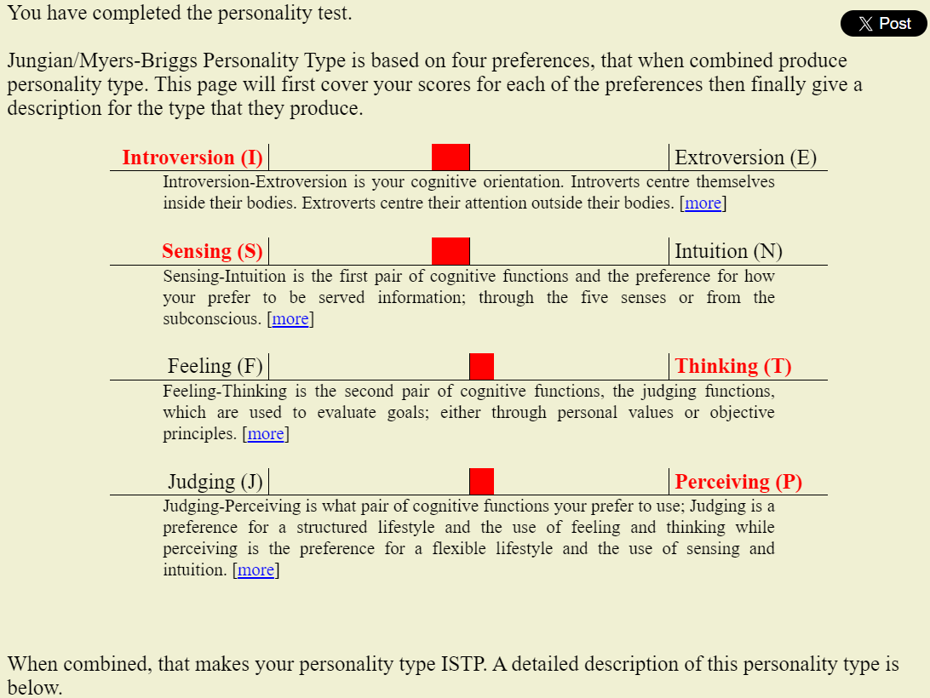
Another personality test the author did was the Open Extended Jungian Type Scales, commonly known as the Myers-Briggs Type Indicator (MBTI) test and the results are shown in Figure 2. Carl Jung is the psychiatrist who proposed the theory of psychological types in the 1920s, later in the 1940s was when his theory was implemented by Isabel Myers and her mother, Katharine Briggs to create a practical self-report tool which led to the sixteen basic personality types that are universally accepted, each of which are known using a four-letter personality type code. [4]
Figure 2: Open Extended Jungian Type Scales results [6]
Figure 2 shows the author’s personality type as ISTP, which depicts mainly Introversion, Sensing, Thinking, and Perceiving traits.
According to the personality description quoted in Appendix A, the author’s characteristics include practicality, independence, being quiet and observant, interested in experiences that involve hands-on activities, enjoying engaging with the physical world, and having a love for adventures and new experiences.
There are various strengths that come with the ISTP personality type:
- Creative and resourceful problem-solving abilities.
- Observational skills.
- Direct and honest communication style.
- Strategic thinking capabilities.
Work related strengths include:
- Adaptable and flexible to changing environments.
- Excellent in roles that require autonomy, independent thinking, and hands-on problem solving such as mechanic or engineering tasks.
- Finding innovative solutions to problems.
- Working best when there is freedom to explore different approaches and are not restricted by strict rules or hierarchies.
- Ability to stay calm under pressure.
On the other hand, there are weaknesses with this personality type in the work environment and in an emotional aspect.
Weaknesses in the work environment include:
- Becoming detached in highly regulated or routine-driven environments.
- Difficult to commit to routine tasks.
Weaknesses in an emotional aspect:
- May seem detached or insensitive to others’ emotions.
- Less sensitive to emotional nuances.
- Struggle with understanding and expressing own emotions, and others’ emotions.
It can be learned from these personality tests that it should not be the main factor in decision making as they can be inaccurate, it also cannot predict someone’s behaviour in every situation. Thus, the author would merely use this for self-reflection and as a rough guideline, so where there are weaknesses and if the author thinks it needs to be worked on it, it can be improved.
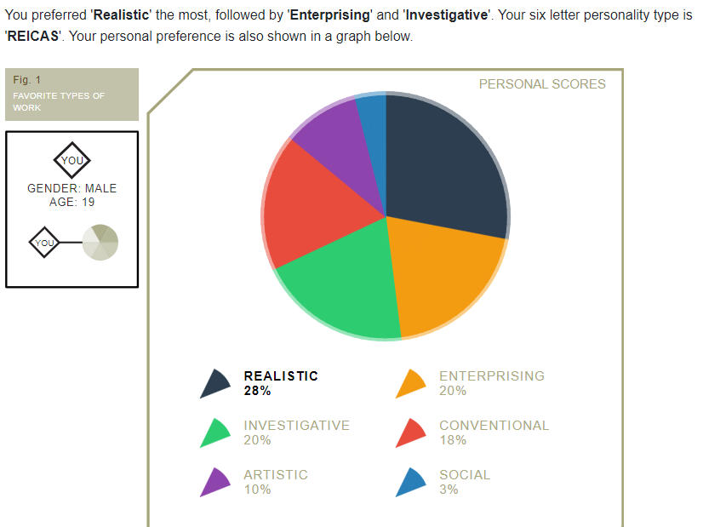
The author also did a career aptitude test that follows the Holland code system. The results are shown in Figure 3.

Figure 3: Career aptitude test results [7]
The top three careers the author got suggested was Automotive engineer, Natural resources consultant, and Solar energy engineer [5]
3.2 Short-term and long-term goals
Short-term goals:
- Complete all assignments a day before the deadline.
- Allocate study times daily (for additional learning and research ) for modules next semester.
- Improve public speaking skills.
Long-term goals:
- Learn a language.
- Bulk to gain 15kg of healthy weight and muscle.
- Start an online business.
- Graduate with a First-Class Honours degree.
- Get a graduate scheme at a good company.
3.3 SMART action plans
SMART is an action plan for achieving goals and the acronym stands for Specific, Measurable, Achievable, Relevant, and Timebound. Below are 4 academic and personal goals the author wants to achieve using the SMART action plan.
Improve public speaking skills
Specific:
Deliver short (5-minute) presentations confidently in front of a group.
Measurable:
The author will know this is achieved by honestly reviewing the quality of each presentation he delivered and asking for feedback from classmates.
Achievable:
This will be achieved by creating a set of presentations and practising them. Then, by booking a silent room in the library every week or when available and rehearsing the presentation in front of a few classmates and recording each presentation delivery.
Relevant:
Improves public speaking skills which is relevant for delivering presentations during university and it’s a skill that’s transferrable for future career.
Timebound:
Achieve this before the start of the next academic year.
Complete all assignments a day before the deadline
Specific:
Complete all assignments a day before the official due date to ensure less stress and enough time for proofreading.
Measurable:
The author will know this is achieved by taking note of the completion dates of the assignment in comparison with the official due date.
Achievable:
This will be achieved by getting started with assignments as soon as it handed out. Each assignment will be broken down into smaller manageable tasks with their own deadlines. Personal deadlines will also be set a day before the official due date for each assignment. The assignment due dates will be marked on the author’s e-calendar.
Relevant:
This is relevant as it improves the author’s time management and reduces any last moment stress.
Timebound:
Achieve this currently till the end of the academic year.
Bulk to Gain 15kg of Healthy Weight and Muscle
Specific:
Gain body weight by 15kg through muscle gain and a considerable amount of fat gain.
Measurable:
The author will know this is achieved by tracking weight weekly and seeing his physique every 3 months for a noticeable difference.
Achievable:
This will be achieved by using a calorie calculator to calculate daily calorie intake including the amount of protein and other nutrients needed. Going to the gym 4 - 5 days a week implementing a hypertrophy training program and using progressive overloading technique every week.
Relevant:
This is relevant as the author is underweight and looking to improve physique, strength and overall health.
Timebound: achieve this by 2027
Graduate with a First-Class Honours degree
Specific:
Graduate with a First-Class Honours degree in Electrical and Electronic Engineering at UWTSD.
Measurable:
By ensuring to get a 70% average grade of the best 100 credits in the second and third year of university to guarantee a First-Class Honours classification.
Achievable:
This will be achieved by attending all the lectures and doing assignments properly and on time. This will also be done by taking effective notes whenever necessary and revising them, allocating study times for each module and doing past papers before exam season.
Relevant:
This is relevant as it shows the author’s academic achievement and improves career prospects.
Timebound:
This will be achieved at the end of the degree.

Section 4: Application
4.1 Looking after your data

4.2 Time management and self-organisation
4.2.1 Steps to improve productivity/time management

4.2.2 Self-organisation method (e-portfolio)

Section 5: Conclusion & Evaluation

Section 6: Referencing

[1] | “What Are The 6 Essential Skills For University Students?,” UNIADMISSIONS, 11th December 2024. [Online]. Available: https://www.uniadmissions.co.uk/application-guides/6-essential-skills-for-university-students/. [Accessed 24th December 2024].
[2] | “What are some examples of transferable skills,” Totaljobs, 30th August 2024. [Online]. Available: https://www.totaljobs.com/advice/what-are-some-examples-of-transferable-skills. [Accessed 24th December 2024].
[3] | “Big Five Personality Traits: The 5-Factor Model of Personality,” SimplyPsychology, 20th December 2023. [Online]. Available: https://www.simplypsychology.org/big-five-personality.html. [Accessed 27th December 2024].
[4] | “Understanding the 8 Jungian Cognitive Functions,” CognitiveProcesses, [Online]. Available: https://www.cognitiveprocesses.com/. [Accessed 27th December 2024].
[5] | 123test, [Online]. Available: https://www.123test.com/report/FXVNCEMHPPWHQJS6A3/. [Accessed 27th December 2024].
[6] | Open Source Psychometrics Project, [Online]. Available: https://openpsychometrics.org/tests/IPIP-BFFM/results.php?r=1.6363636363636365,2.6,3.3,3.727272727272727,2.3333333333333335#_V. [Accessed 26th November 2024].
[7] | Open Source Psychometrics Project, [Online]. Available: https://openpsychometrics.org/tests/OEJTS/results.php?r=2.625,2.625,3.25,3.25. [Accessed 26th November 2024].

Section 7: Appendices
Appendix A
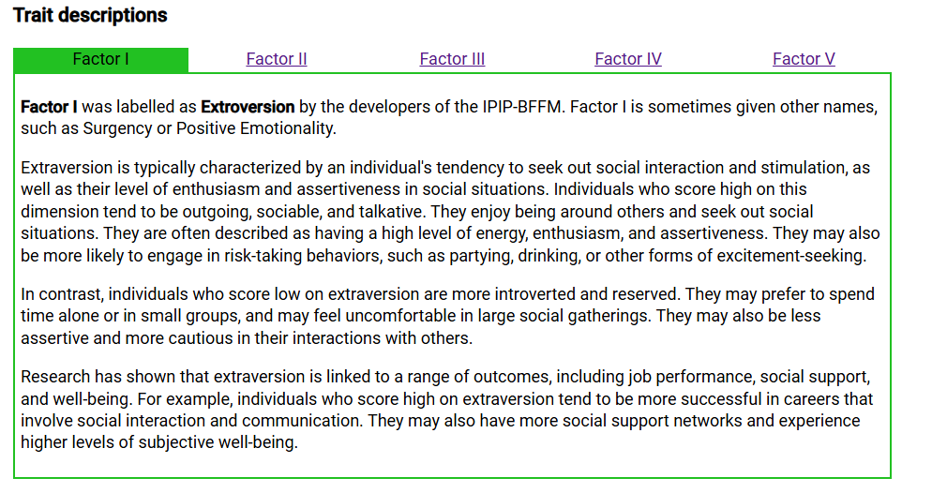

Figure 1

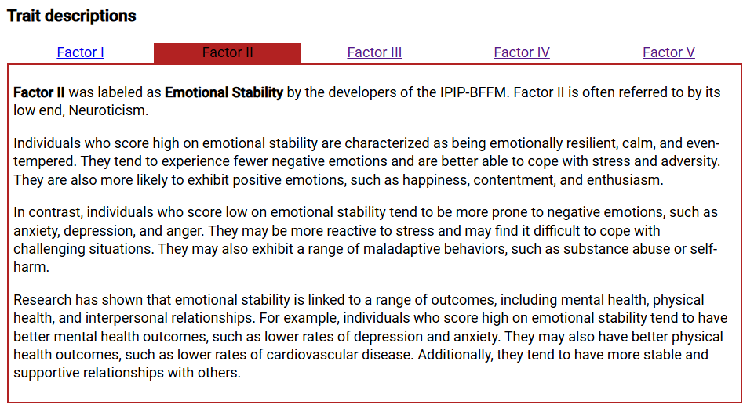

Figure 2

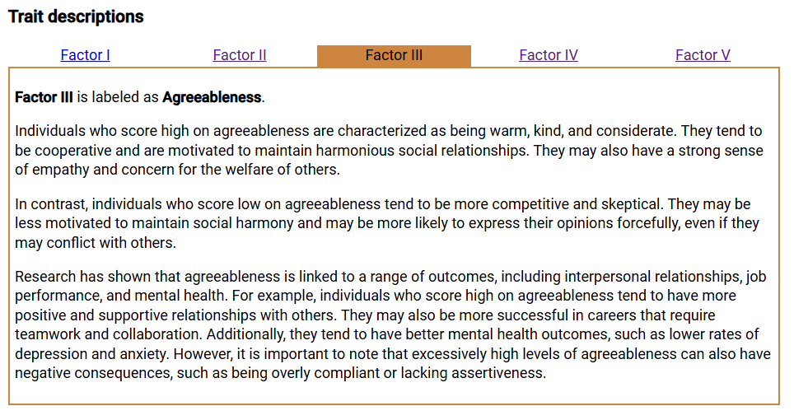
Figure 3

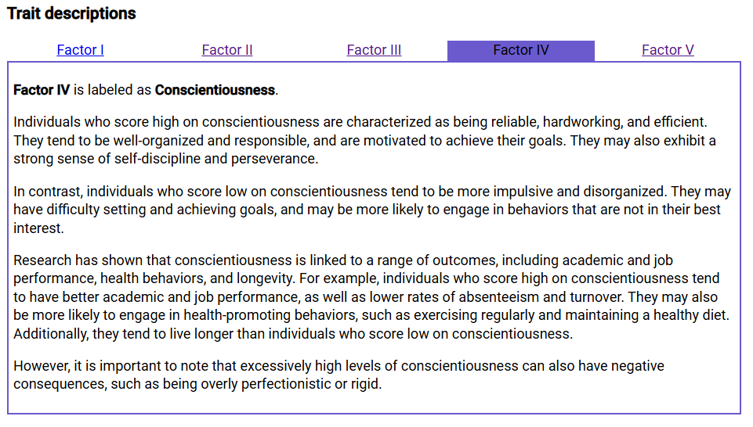
Figure 4

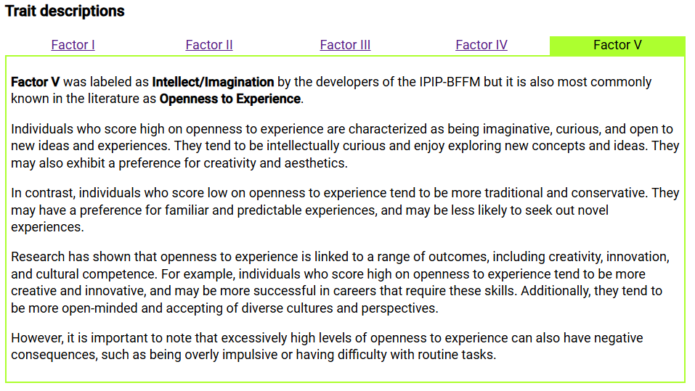
Figure 5

Description of the ISTP personality type according to the Open Source Psychometrics Project website:
“ People with an ISTP personality are known for their practicality, independence, and strong ability to solve problems with creativity and resourcefulness. ISTPs are typically quiet and observant, preferring to analyze their surroundings and understand how things work. They are often drawn to activities that involve hands-on experience and enjoy engaging with the physical world, which can make them excellent craftsmen, mechanics, or engineers.
One of the defining characteristics of ISTPs is their love for adventure and spontaneity. They thrive on excitement and are always on the lookout for new experiences. This makes them adaptable and flexible, able to easily navigate changing environments and situations. ISTPs are also known for their direct communication style; they prefer to get straight to the point and value honesty over pleasantries. This straightforward approach is often appreciated in situations that require quick, decisive action.
Despite their adventurous nature, ISTPs are not typically impulsive. They are strategic thinkers who like to assess situations before taking action. They rely heavily on their keen sense of observation and their ability to remain calm under pressure. This logical approach to life helps them navigate complex situations with ease and efficiency. However, their preference for logic can sometimes make them seem detached or insensitive to others' emotions.
In relationships, ISTPs value their independence and often seek partners who respect their need for space and freedom. They are not naturally attuned to emotional nuances and may struggle with understanding and expressing their own emotions, as well as those of others. However, when they are committed, ISTPs are loyal and supportive partners who enjoy sharing experiences and activities with their loved ones.

In the workplace, ISTPs excel in roles that require hands-on problem-solving, autonomy, and the ability to think on their feet. They are practical and resourceful, often finding innovative solutions to challenging problems. However, they may become disengaged in environments that are overly structured or routine. ISTPs work best when they have the freedom to explore different approaches and are not constrained by strict rules or hierarchies. Their ability to stay calm in crisis situations and their practical approach to problem-solving make them valuable team members in dynamic and fast-paced work environments.”

Appendix B

