

The impact of leadership styles on organizational performance

BA Business Management

Dissertation
LCBB6000

Student name: Liudmila Diacov
Student ID: (2023710)
Supervisor: Dr. Anupam Mazumdar

Declaration

I hereby certify that the research presented in this dissertation, titled “The Impact of Leadership Styles on Organizational Performance”, is my original and own work. I have not previously submitted this research, for any degree or examination at any other institution of higher education. I have made every effort and have taken great care to ensure the accuracy and reliability of the research, and have followed all ethical guidelines and standards in the conduct of the research. I take full responsibility for the research, its findings, and any errors or omissions that may be contained within.

Full Name: Liudmila Diacov

Date: December 2023

Signed:

Abstract

This dissertation examines the impact of leadership styles on organizational performance. This research aims to examine and understand the impact and the relationship between transformational and transactional leadership styles on organizational performance. The relationship between leadership and performance is an important topic across all industries, and understanding this relationship can help organizations improve their performance and competitiveness. The research was conducted through a literature review on leadership styles and organizational performance identifying the gaps and areas for further investigation. Two hypotheses were developed based on the literature review and the specific research objectives: H₀ (Null Hypothesis): There is no relationship between transformational leadership and transactional leadership style and organizational performance. H₁ (Alternative Hypothesis): There is a significant relationship between transformational and transactional leadership styles and organizational performance. The research design includes quantitative methods. The primary data were collected data using a survey with 103 respondents. The data were analysed using appropriate statistical techniques to test the research hypotheses such as regression and correlation analysis, and t-test in SPSS software. The results of the data were interpreted and analysed. The research findings were shared through figures and tables and the discussion and conclusion also were provided to contribute to knowledge in the field. The findings of the study indicate that a combined approach of transformational and transactional leadership styles is linked to improved organisational performance. The research adds to the body of knowledge in the field of leadership studies by offering new insights into this critical research topic. Finally, the provided study's recommendations can be used by organizations in any industry seeking to improve their leadership practices and enhance performance.

Acknowledgments

I would like to share my heartfelt appreciation to the following individuals: Above all else, I would like to share my appreciation to my supervisor Dr. Anupam Mazumdar, for their support and guidance, encouragement, and constructive feedback throughout this research. Their wealth of knowledge and expertise provided valuable insigns that shaped the direction and focus of this research. Their feedback and dedication helped me to refine my research questions and hypotheses, and their guidance throughout the research process was indispensable. I thank you to the participants of the research, who graciously agreed to participate in the survey by answering the questions and providing me with their valuable insights and perspectives. Their participation was integral to the success of this research, and I am incredibly grateful for their time and cooperation in the data collection process. In addition, I acknowledge the support and encouragement of my work colleagues for their valuable feedback and support throughout this process of study. Their constructive feedback helped me to refine my ideas and improve my research methodology. Finally, I would like to extend my gratitude to my family, whose love has provided unwavering support when needed and championing my efforts every step of the research. Without their help and support, this research would not have been possible. I extend my heartfelt appreciation to all.

Table of Contents

Declaration 2
Abstract 3
Acknowledgments 4
List of Figures 8
List of Tables 10
Chapter 1 12
1.1: Introduction 12
1.2: Background of the study 12
1.3: Problem Statement 13
1.4: Aim of the Research 13
1.5: Objectives of the Research 13
1.6: Research Hypothesis 14
1.7: Significance of the Study 14
1.8: Relevance/Rationale of Study 15
1.9: Methodology 15
1.10: Scope of the Research/Demarcation 15
1.11: Structure of the Dissertation 16
1.12: Summary of Chapter 1 17
Chapter 2: Literature Review 18
2.1: Introduction 18
2.2: Concepts of Leadership 18
2.3: Definition of Leadership Style 20
2.4: Leadership Styles and Their Characteristics 20
2.5: Leadership Theories 24
2.6: Gaps identified to situate own research 28
2.7: Summary of Chapter 2 28
Chapter 3: Research Methods and Methodologies 29
3.1: Introduction 29
3.2: Research Philosophy 30
3.3: Research Paradigm 30
3.4: Research Approach 30
3.5: Research Method 31
3.6: Research Strategy 32
3.7: Research Sample and Population 32
3.8: Data Collection and Data Analysis Tools/Techniques 33
3.9: Ethical Considerations of the Research 33
3.10: Summary of Chapter 3 34
Chapter 4: Data Analysis and Discussions 35
4.1: Introduction 35
4.2: Reliability Statistic 35
4.3: Descriptive Statistics 36
4.4: Frequency Distribution Analysis 38
4.5: Factor Analysis 53
4.6: Inferential Statistics 54
4.7: Correlation among variables 55
4.8: Regression analysis 56
4.9: T-test 59
4.10: Summary of Chapter 4 60
Chapter 5: Conclusions, Limitations & Recommendations 61
5.1: Introduction 61
5.2: Accomplishing Research Aim, Objectives, and Research Hypothesis 61
5.3: Conclusions on the Research Problem 62
5.4: Summary of the research findings and outcomes 62
5.5: Limitations of the Research 62
5.6: Recommendations 63
5.7: Summary of Chapter 5 63
Reference List 64
Appendix 67
1: Survey Questions 67
2: Ethics Form 72

List of Figures

Figure 1. Characteristics of Autocratic Leadership Style…………………………………….21
Figure 2. Characteristics of Democratic leadership style…………………………………….22
Figure 3. Characteristics of Laissez-Faire leadership style…………………………………..23
Figure 4. Elements of Transformational Leadership…………………………………………23
Figure 5. Transactional Leadership Characteristics………………………………………….24
Figure 6. Trait Theory of Leadership………………………………………………………...25
Figure 7. Fiedler’s Contingency Model of Leadership………………………………………26
Figure 8. Great Man Theory………………………………………………………………….27
Figure 9. Research Onion…………………………………………………………………….29
Figure 10. Research Approach……………………………………………………………….31
Figure 11. Sampling Techniques……………………………………………………………..32
Figure 12. Age Pie Chart distribution………………………………………………………...39
Figure 13. Gender Pie Chart………………………………………………………………….40
Figure 14. Educational Level Pie Chart……………………………………………………...41
Figure 15. Industry Pie Chart………………………………………………………………...42
Figure 16. Job position Pie Chart…………………………………………………………….43
Figure 17. Leadership Styles Pie Chart………………………………………………………43
Figure 18. Current Leadership Style Pie Chart………………………………………………44
Figure 19. Motivation Pie Chart……………………………………………………………..45
Figure 20. Encouragement Pie Chart………………………………………………………...46
Figure 21. Leadership style impact on employee productivity Pie Chart……………………47
Figure 22. Leadership style impact on company’s financial performance Pie Chart………...47
Figure 23. Pie Chart of Distribution of the extent of promotion of communication and collaboration………………………………………………………………………………….48
Figure 24. Pie Chart of Distribution of alignment with the organization’s values and mission……………………………………………………………………………………….49
Figure 25. Pie Chart of Distribution of the extent of support for a positive and healthy work environment…………………………………………………………………………………..50
Figure 26. Pie Chart Distribution of the extent of promotion of the culture of innovation and creativity……………………………………………………………………………………...50
Figure 27. Pie chart of distribution of effectiveness of managing conflicts and resolving issues…………………………………………………………………………………………51
Figure 28. Pie Chart of Distribution of Received Feedback…………………………………..52
Figure 29. Pie Chart of Distribution of the alignment of rewards with employee…………...53

List of Tables

Table 1: Case Processing Summary of Reliability Statistic………………………………….35
Table 2. Reliability Statistics…………………………………………………………………36
Table 3. Descriptive Statistics………………………………………………………………..37
Table 4. Frequency Distribution Analysis……………………………………………………38
Table 5. Age Frequency distribution…………………………………………………………39
Table 6. Gender Frequency Distribution……………………………………………………..39
Table 7. Educational level Frequency Distribution…………………………………………..40
Table 8. Industry Frequency Distribution…………………………………………………….41
Table 9. Job position Frequency Distribution………………………………………………..41
Table 10. Leadership style Frequency Distribution…………………………………………..43
Table 11. Current leadership style Frequency Distribution…………………………………..44
Table 12. Motivation Frequency Distribution………………………………………………..44
Table 13. Encouragement Frequency Distribution…………………………………………...45
Table 14. The Frequency distribution of the impact of leadership style on organizational performance…………………………………………………………………………………..46
Table 15. Frequency distribution of Leadership style of the impact on company financial performance…………………………………………………………………………………..47
Table 16. Frequency Distribution of the extent of promotion of communication and collaboration………………………………………………………………………………….48
Table 17. Frequency Distribution of alignment with the organization’s values and mission...49
Table 18. Frequency Distribution of the extent of support for a positive and healthy work environment…………………………………………………………………………………..49
Table 19. Frequency Distribution of the extent of promotion of the culture of innovation and creativity……………………………………………………………………………………...50
Table 20. Frequency distribution of effectiveness of managing conflicts and resolving issues…………………………………………………………………………………………51
Table 21. Frequency Distribution of received feedback……………………………………..52
Table 22. Frequency Distribution of the alignment of rewards with employees…………….53
Table 23. KMO and Bartlett’s Tests………………………………………………………….54
Table 24. Correlation analysis among variables……………………………………………...55
Table 25. Multiple Regression Model Summary……………………………………………..56
Table 26. ANOVA Analysis of Variances…………………………………………………….57
Table 27. Coefficients Table of Regression Analysis………………………………………...58
Table 28. Group Statistics of T-Test………………………………………………………….59
Table 29. Independent Sample Test…………………………………………………………..59

Chapter 1

1.1: Introduction

Leadership refers to how a leader directs and manages their team. It can significantly impact the overall performance of an organization. Effective leadership can inspire and motivate employees, leading to increased productivity, innovation, and overall success. Conversely, ineffective leadership can lead to disengaged employees, low morale, and ultimately poor organizational performance. Leaders can adopt different styles of leadership, such as autocratic, democratic, laissez-faire, transformational, and transactional. Thus, leaders need to understand their leadership style and its impact on their team to drive positive outcomes for the organization.

1.2: Background of the study

The impact of leadership style on organizational performance has been a topic of interest and research for many years (Iszatt-White & Saunders, 2017). Researchers have sought to understand how the behaviour and approach of leaders affect the overall success and performance of an organization. Over time researchers have conducted numerous studies to determine the relationship between leadership style and organizational performance. How leaders interact with their team and the broader organization can have a significant impact on its overall performance. Transformational and democratic leadership styles have positive effects on employee satisfaction, motivation, and overall organizational performance. On the other hand, autocratic and laissez-faire styles of leadership can have impacts on these factors, hindering organizational success. Overall, the research provides valuable insights for managers and leaders. It underscores the importance of adopting an effective leadership style that aligns with the organization's goals and culture, emphasizing the role of leaders in inspiring and motivating their teams to achievement of high levels of performance and success.

1.3: Problem Statement

- Despite the extensive research conducted on styles of leadership and their potential impact on the performance of the organization, there is still a need to further explore and understand the specific mechanisms through which different leadership styles influence various aspects of organizational performance.
- The need for more comprehensive and nuanced research that goes beyond simply identifying correlations between leadership styles and organizational performance. It highlights the importance of exploring the underlying processes and mechanisms through which leadership styles affect employee motivation, engagement, creativity, and ultimately, organizational performance.

1.4: Aim of the Research

This research aims to gain an all-encompassing understanding of the complex relationship between leadership styles and organizational performance. In particular, the research seeks to analyse the impact of different styles of leadership, such as transformational, and transactional, on a range of organizational outcomes, such as employee engagement, job satisfaction, patient satisfaction, and organizational profitability. The research also aims to identify the underlying mechanisms and processes through which leadership styles influence organizational performance and to provide recommendations for organizations being proactive to improve their leadership practices and enhance performance. By pursuing this aim, the research aims to contribute to the existing body of knowledge on leadership and performance and to provide insights that can inform leadership development programs, organizational policies, and practices

1.5: Objectives of the Research

The research objectives were formulated to guide the study:
1) Contextualizing leadership style: The research aims to investigate the broader context within which leadership styles are situated and their implications for organizational performance. This includes examining factors such as industry, organizational culture, and external influences that may shape the effectiveness of different leadership styles.
2) Analysing leadership styles: The research aims to examine the different leadership styles that exist in organizations, their characteristics, and the impact they have on various aspects of performance.
3) Understanding the link between styles of leadership and performance: The study aims to investigate the complex relationships between leadership style and organizational performance, including the mechanisms through which leadership style impacts performance.
4) Identifying issues and challenges: The research aims to identify the challenges and issues associated with the research topic.
5) Developing a theoretical framework: The research aims to develop a comprehensive framework of theory that integrates the various findings and insights from the research to provide a deeper understanding of the research topic.

1.6: Research Hypothesis

The following two Hypotheses were formed:
H₀ (Null Hypothesis): There is no relationship between transformational leadership and transactional leadership style and organizational performance.
H₁ (Alternative Hypothesis): There is a significant relationship between transformational and transactional leadership styles and organizational performance.

1.7: Significance of the Study

Leadership styles have a significant impact on organizational performance. Different styles of leadership can either promote or hinder the success of an organization. The reasons why it is important to study this topic will be explored next. First, it can help organizations understand which style of leadership is more effective in achieving their goals. This information can then be used to develop leadership training and development programs that are tailored to the specific needs of the organization (Ebener & Jalsenjak, 2021). Second, by understanding this topic of research, organizations can identify and address the issues that may be holding them back from achieving their full potential. For example, if a particular style of leadership is found to be ineffective in promoting innovation, the organization can take steps to develop a more innovative culture.

1.8: Relevance/Rationale of Study

The rationale for this research is to understand how different styles of leadership can affect the performance of organizations. This information should be used by organizations in the improvement of their leadership practices and to ensure that they are using the most effective leadership styles to achieve their goals. By understanding the impact of leadership styles, organizations can make better decisions about how to lead their teams and how to create a positive working environment that will lead to high-performance levels. The rationale of this study is based on the understanding that leadership is a critical factor in shaping the success and effectiveness of organizations on various aspects of organizational performance, such as financial outcomes, employee engagement, productivity, innovation, and culture (Gibbons, 2006).

1.9: Methodology

In light of the purpose of this study of checking the impact of transformational and transactional leadership styles in organizations, therefore the population is selected from administrative sectors from different industries. This study employed a quantitative method to develop a deeper and more holistic comprehension of the research problem. The sources of data include primary data collected directly from research participants, and secondary data, obtained from existing sources of literature. The population and sample of the study was 103 participants selected from different administrative services and industries. A survey as a measuring instrument was used for the collection of data. The data collection process involved SPSS to analyse data and interpret findings. By utilising this approach, it was possible to understand the research problem and facilitated the triangulation of data, leading to more robust and credible findings.

1.10: Scope of the Research/Demarcation

The scope and demarcation of the research is limited to the United Kingdom (UK) as the geographic area. This means that the research will focus on the styles of leadership and practices of managers in organizations located within the UK and that the findings will be limited to this geographic area. The choice of the UK as the geographic area for the study is justified by factors such as the availability of data, the relevance of the research problem to the UK context, and the researcher's familiarity with the leadership styles in the UK.

1.11: Structure of the Dissertation

Chapter 1: The introduction section provides a broad overview of the impact of leadership style on organizational performance, setting the context for the rest of the study, including the background of the study, and the problems that exist. It also includes the research hypothesis which is related to the objectives of the research, also determined in this Chapter, finalizing it with the explanation of why the research is relevant and what significance it provides to the field.
Chapter 2 Literature review: The chapter provides an overview of the research that exists in the literature on Leadership, including Leadership Concepts and Definitions, Leadership Styles and their Characteristics, and Leadership Theories and Models.
Chapter 3 Research Methods and Methodologies: This chapter describes used methods in the research, including research philosophy, paradigm, approach, research methodology and strategy, sampling methods, data collection tools, and data interpretation techniques. It also, explains how the research will be conducted following ethical considerations. Finally, the conclusion will be provided to summarise the key research findings and their implications.
Chapter 4: Data Analysis and Discussion: This Chapter introduces the main themes of data analysis and discussion of the findings. This chapter will analyse the collected data and present the findings clearly and concisely, using tables, and figures to interpret the data. Data validity and reliability of the data will also be discussed. This chapter will discuss the implications of the findings in light of the research objectives and the broader literature on leadership and performance. Finally, this section will provide a summary of the key findings and conclusions of the chapter, highlighting the contribution of the research to the topic.
Chapter 5 Conclusions, Limitations & Recommendations: This section will introduce the chapter by summarizing the research problem, aims, objectives, and research hypothesis, and provide a brief overview of the findings in Chapter 4. This chapter will present the conclusions on each aim, objective, and proposition based on the findings in Chapter 4. The chapter also will present a comprehensive conclusion on the research problem, synthesizing the findings from Chapter 4 and the implications for the field of leadership studies and organizational performance. Will summarize the key research findings and outcomes, highlighting the contributions of the research to the field. Will discuss any limitations or weaknesses of the research, such as sample size or data limitations. Based on the findings of the study this Chapter will provide recommendations for future research. Finally, this chapter will provide a summary of the chapter's key points.

1.12: Summary of Chapter 1

The background of the study and the problem statement were presented in this Chapter, highlighting the importance of understanding the research topic. The aims, objectives, research questions, hypotheses, and propositions were also outlined, providing a clear direction for the research. Was discussed in the chapter the rationale for the study, emphasizing the value of the research in contributing to the existing literature on leadership and performance, and in providing practical recommendations for organizations. The methodology section outlined the sources of data, the sample and population of the study, the measuring instruments used, and the data collection and analysis processes, followed by the entire structure section of the study. Finally, the scope and demarcation of the research were defined, limiting the research to the United Kingdom as a geographic area. In summary, the research problem, the rationale for the study, and the outline of the methodological approach used to conduct the research were introduced in this Chapter.

Chapter 2: Literature Review

2.1: Introduction

Effective leadership is the key to unlocking the full potential of an organization and encompasses a broad range of behaviors and characteristics that work in harmony to create a successful and sustainable organization. By fostering a positive, inclusive, and empowering culture, leaders can create a high-performing team that drives success and achieves organizational goals. This review of literature explores the impact of leadership styles on organizational performance, highlights the key definitions and concepts related to leadership, and the characteristics of leadership styles that drive results, and highlights the traits, factors, and behaviors of leadership theories.

2.2: Concepts of Leadership

The leadership concept remains largely elusive and enigmatic (Holz, 2018). Its contextual-effective leadership depends on the situation, the culture, and the personalities involved. What works for one group might not work for another. The concept of leadership is multidimensional and involves a combination of skills, traits, and behaviours. The leadership concept refers to the capability of an individual or a group to influence others toward achieving a goal. Leadership comprises the exercise of authority, influence, and decision-making to inspire, motivate, and direct individuals or teams toward accomplishing organizational objectives.
Here are some key concepts related to leadership:
Influence: Leadership involves influencing others through persuasion, communication, and inspiring trust and confidence. Influential leaders can effectively persuade and motivate others to follow their vision and achieve goals. Communication skills include the key aspects of influence and represent the ability to clearly articulate ideas and inspire others to take action (Adair, 2018).
Vision: This is the foundation of effective leadership. Vision provides direction: A clear vision helps a leader set goals and make decisions that move the team or organization toward that vision. Vision inspires and motivates: A compelling vision can create passion and enthusiasm in the team, driving them to work harder towards the common goal. Vision builds trust: When a leader articulates a clear and compelling vision, it builds trust and credibility with the team (Northouse, 2015).
Relationship-building: Leadership involves building and nurturing relationships with the team by establishing trust, and respect, and creating a supportive environment. Strong relationships between a leader and their team members create a foundation of trust, which is essential for effective communication and collaboration. When team members feel valued and supported, they are more likely to take risks, be innovative, and work effectively together. Also, strong relationships enable leaders to give and receive honest and constructive feedback, which is crucial for growth and development (Gosling, et al., 2012).
Decision-making: Leaders are responsible for making strategic choices and critical decisions that have far-reaching consequences on the organization. This concept involves balancing conflicting interests. A leader needs to weigh the needs of the team, of organization, and others, analyse data and consider different perspectives when making logical and informed decisions (Adair, 2018).
Emotional intelligence: Involves self-awareness, empathy, and self-regulation. Leaders can understand and manage their own emotions, strengths, and weaknesses, as well as those of the team to build relationships create a positive team environment, and remain calm and rational in challenging situations (Northouse, 2019).
Authenticity: Includes the truth to oneself, transparency, and vulnerability. Leaders need to be authentic, genuine, and transparent in their communication, actions, and interactions with others to build trust and credibility (Gosling, et al., 2012).
Accountability: An accountable leader takes responsibility for their team's actions and decisions, sets clear and achievable goals and expectations for the team, and encourages their team to take ownership of their work and responsibilities (Gosling, et al., 2012).
Integrity: Means being honest and transparent in all interactions and decisions, and means adhering to high moral and ethical standards, even when it may be difficult or inconvenient (Adair, 2018).

2.3: Definition of Leadership Style

The field of leadership encompasses different definitions of leadership styles, but one popular definition is that leadership can be conceptualized as a dynamic process wherein an individual exerts influence, motivates, and guides other individuals to deliver a common goal (Henry, 2021). Leadership involves setting a vision, communicating it effectively, inspiring and motivating others, building relationships, making sound decisions, taking responsibility, acting with integrity, and giving others the authority and resources they need to take action. In short, leadership is about empowering others to do their best work and achieve great things together, is the ability to adjust and respond to changing circumstances, and to adapt one’s leadership style to different situations. Leadership style refers to the approach a leader takes in interacting with their team and managing the organization (Roache, 2023). From the definitions above, the definition from Roache (2023) has been considered for this study because:
- It's broad enough to capture a range of different styles of leadership and their potential influence on performance.
- It emphasizes the role of the leader in shaping organizational culture and outcomes, which is critical in understanding the impact of leadership style.
- It acknowledges that the impact of leadership style is context-specific, meaning that the same style may have different effects in different organizational settings.
- Finally, it highlights the interactive nature of leadership, in that leaders and followers mutually shape each other's behaviour and attitudes.

2.4: Leadership Styles and Their Characteristics

Different leadership styles have different characteristics. Some common characteristics of different leadership styles include:
Authoritarian leadership (autocratic): Autocratic leaders make all decisions themselves, without consulting their subordinates or considering their input. This style can lead to a lack of motivation, lower job satisfaction, and reduced productivity among employees. Characteristics include: i) High control: Leaders make all decisions and control all aspects of the work; ii) Low autonomy: Employees have little to no freedom to make decisions or take initiative; iii) High pressure: The leader uses fear and intimidation to maintain control and ensure compliance; iv) Low trust: There is a lack of trust between the leader and employees; v) Low creativity: With little freedom to experiment or take risks, creativity, and innovation is stifled. (Kelly & Williams, 2018).
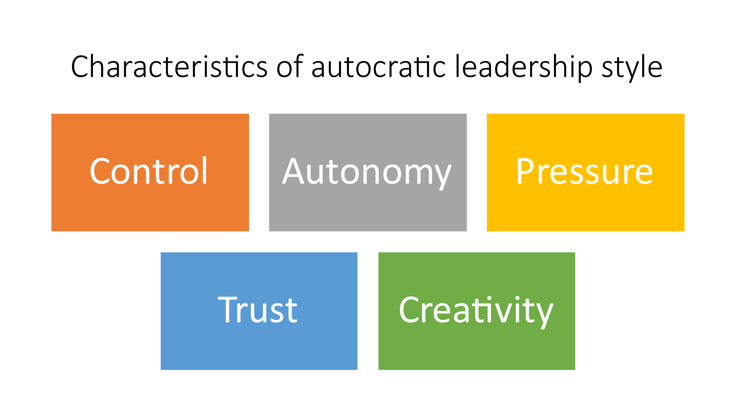
Figure 1. Characteristics of Autocratic Leadership Style
Source: Created by Author
The democratic leadership (participative) style: is all about collaboration and empowerment. Here are some characteristics: i) Collaborative approach and shared decision-making: Where the leader involves followers in decision-making and values their input. Democratic leaders encourage their subordinates to participate in the process of decision-making; ii) Open communication: There is a free flow of information and ideas among team members; Empowerment: Employees are given autonomy and authority to make decisions and take action; iii) Mutual trust: trust is built between the leader and employees through transparency and open communication; iv) Supportive environment: The leader provides support and resources to help employees succeed. This style leads to increased job satisfaction and productivity among employees. Moreover, the inclusion of different perspectives and expertise in decision-making often results in more effective solutions and better performance outcomes (Northouse, 2019).
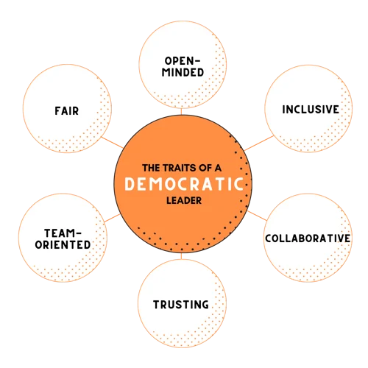
Figure 2. Characteristics of Democratic leadership style
Source: (Niagara Institute, 2023).
Laissez-faire leadership (delegative): In this leadership style, the leaders empower followers to exercise autonomy, make independent decisions, and take initiative without constant supervision. Leaders provide minimal guidance, low supervision, and trust and allow employees to work independently, which can hinder organizational performance. Without clear direction and support from leadership, employees may lack motivation and a sense of purpose, resulting in decreased productivity and performance. Laissez-faire leadership can also lead to confusion and conflict, as employees may struggle to prioritize tasks or receive conflicting information from different leaders (Huczynski & Buchanan, 2007).
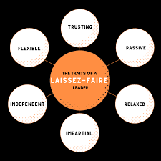
Figure 3. Characteristics of Laissez-Faire leadership style
Source: (Niagara Institute, 2023).
Transformational leadership (visionary) style focuses on motivating and inspiring followers to reach their fullest potential and work collaboratively towards a common vision and purpose. Leaders who use this style often challenge their followers, set targets, and use their charisma and passion to motivate them. They also focus on developing the skills and abilities of their followers fostering them to reach continuous improvement. Some characteristics of transformational leaders include: i) Inspiring vision: The leader articulates a compelling vision that inspires and motivates others; ii) Empowerment: The leader empowers team members to develop and grow professionally; iii) Authenticity: The leader acts with integrity and authenticity, earning the trust and respect of their team; iv) Emotional intelligence: The leader has a high level of emotional intelligence, allowing them to effectively communicate and motivate others; v) Change management: The leader is skilled at managing change and leading the organization through times of transition (Mullins, 2002).

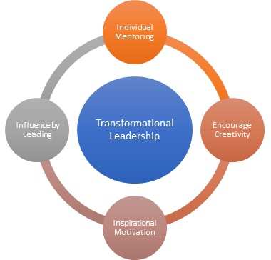
Figure 4. Elements of Transformational Leadership
Source: (MBASkool, 2023).
Transactional leadership (managerial) focuses on task accomplishment, providing concrete expectations, and leveraging the strategic use of rewards and punishments to motivate followers to achieve specific goals. Leaders who use this style often set clear objectives and expectations for their followers, making them responsible for meeting those objectives. Here are some characteristics: i) Task-focused: The leader is focused on completing tasks efficiently and effectively; ii) Structured: The leader operates in a structured, organized, and controlled environment, with clear roles and responsibilities; iii) Contingent rewards: Transactional leaders use rewards, bonuses, or promotions to motivate their followers and also use punishments such as disciplinary action or dismissal to discourage poor performance; iv) Goal-oriented: The leader sets clear and measurable goals, and holds employees accountable for achieving them; v) Top-down: The leader makes decisions and communicates them to employees, with little input or feedback from employees (Pfeffermann, 2019).
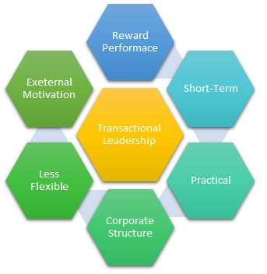
Figure 5. Transactional Leadership Characteristics
Source: (MBASkool, 2023).
For this study, the researcher has adopted Transactional and Transformational leadership styles because these styles are often considered to be the most impactful on organizational performance. Transactional leadership focuses on setting clear goals, providing feedback, and using rewards and punishments to motivate performance. This style is effective in providing a structure for employees to follow and achieve specific results., transformational leadership inspires and motivates employees to exceed expectations, think creatively, and engage in personal growth. This style is effective in fostering a positive and innovative work environment that promotes high performance. Both styles complement each other, as transactional leadership provides structure and direction, while transformational leadership inspires and motivates employees to achieve more.

2.5: Leadership Theories

There are many leadership theories. Below, some of the theories will be discussed.
- The Trait Theory is based on the idea that certain personality traits such as charisma, intelligence, and decisiveness determine someone to be a successful leader. Some common traits that are associated with effective leadership include i) Intelligence: where leaders need to be able to think critically, be problem-solvers, and make informed decisions; ii) Self-Confidence: Where leaders need to have the confidence to make decisions and take action. The belief in a leader’s abilities and the willingness to take risks; iii) Decision-making: Leaders need to be able to make decisions quickly and efficiently; iv) Persistence: Leaders need to be able to persevere even in the face of challenges or obstacles; v) Honesty and Integrity: Leaders need to be honest, transparent and ethical in their actions, and to inspire trust in others; vi) Emotional intelligence: The ability of a leader to understand and manage own emotions, as well as the emotions of others; vii) Charisma: The ability to inspire and influence others through communication and personal appeal.
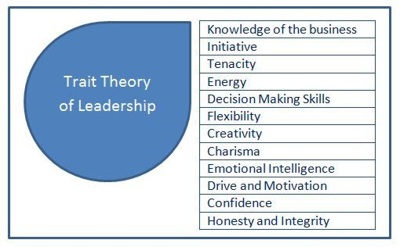
Figure 6. Trait Theory of Leadership
Source: (eba, 2021)
- The Behavioural Theory is based on the idea that leaders can be effective based on their actions, not just their personality traits. The Theory suggests that leadership can be developed through training and practice. Some common behaviours that are associated with effective leadership include: i) Task behaviour: The ability to direct and organize the work of others to achieve goals; ii) Setting a good example for individuals to follow; iii) Being consistent in behaviour and approach, showing respect for followers, using effective communication skills; iv) Motivation: Encouraging and supporting followers, encouraging and rewarding good performance, and, being approachable and accessible to followers; v) Communication: The ability to communicate effectively and clearly, both verbally and nonverbally; vi) Problem-solving: The ability to identify and solve problems creatively and collaboratively.
- The Contingency Theory: According to the Contingency Theory, three key factors determine the effectiveness of a leader in a given situation: Leader-Member Relations: This factor considers the level of trust, respect, and rapport between the leader and their followers. If the relationship is positive, the leader’s influence is likely to be greater. Task Structure: This factor examines the degree to which tasks are clearly defined and structured. In situations with high task structure, there are explicit guidelines, procedures, and goals that make it easier for leaders to guide their followers. Position Power: This factor refers to the amount of formal authority a leader possesses to reward or punish their followers. Leaders with high position power can effectively influence and control their followers’ behaviour. Follower readiness: Refers to the level of experience and expertise of the team members. Organizational environment: Refers to the overall culture and climate of the organization.
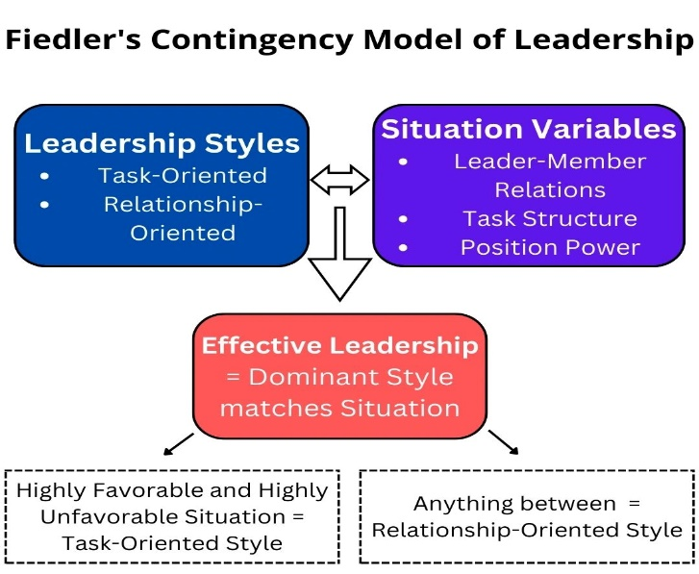
Figure 7. Fiedler’s Contingency Model of Leadership
Source: (Works, 2022)
- The Great Man Theory suggests that great leaders are endowed with unique qualities, rather than made or developed through education (Guah, 2021). Also, suggests that certain people are naturally gifted with the qualities necessary to be effective and successful leaders. Individuals who possess certain inherent qualities and traits are destined for leadership positions because of their innate characteristics, such as intelligence, charisma, courage, and determination. The Great Man Theory implies that leadership is primarily determined by one’s natural qualities and abilities. Here are some of its key elements: i) Heroic leadership: The idea that great leaders possess heroic qualities, such as courage, charisma, and determination; ii) Individual focus: The focus on the individual qualities of the leader, rather than on the collective efforts of the team; iii) Historical context: The idea that great leaders emerge at specific moments in history, in response to particular challenges or crises.

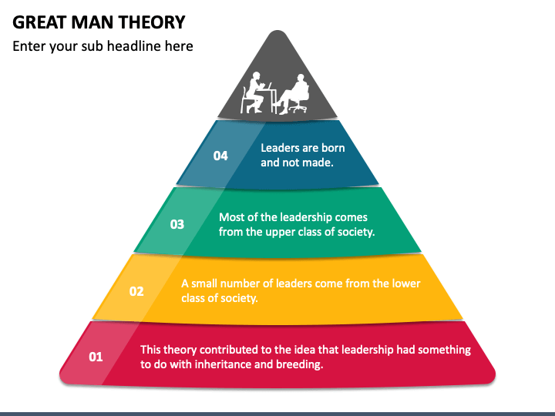
Figure 8. Great Man Theory
Source: (sketchbubble, 2023).
- Situational Theory: The theory proposes that the most optimal leadership style is contingent upon the specific circumstances and conditions of the situation. The situational theory is all about flexibility and adaptability. Here are some of its key elements: i) Leadership style: Leaders should choose the appropriate leadership style (e.g., directive, participative, delegative) based on the situation; ii) Task requirements: Leaders should match their leadership style to the needs of the task at hand; iii) Followers’ readiness: Leaders should consider the readiness and ability of followers to take on different levels of responsibility; iv) Environmental factors: Leaders should take into account the external environment, such as political, economic, and social factors.
For this study, the Behavioural leadership theory is well-suited because for studying the research topic because it focuses on the specific behaviours of leaders that can influence employee motivation, satisfaction, and productivity. The theory emphasizes the importance of specific leadership behaviours, such as decision-making, goal-setting, and communication, which can directly impact performance. The theory emphasizes the idea that different styles of leadership may be more effective in different circumstances. The theory acknowledges that leadership is not a static concept, but rather a dynamic process that can be influenced by a range of factors, such as the leader's personality, the organization's culture, and the larger societal context.

2.6: Gaps identified to situate own research

The following gaps have been identified in the literature regarding this topic. While there is a wealth of literature on leadership styles, most studies have focused on individual traits or behaviours of leaders, rather than the broader organizational context within which leadership styles are situated. Previous studies have focused on specific industries or contexts, with limited research on leadership styles in the United Kingdom. There has been limited research on the interplay between different styles of leadership and their impact on performance, particularly in terms of how leadership styles interact with organizational culture, structure, and other factors. There has been limited research on the practical implications of different leadership styles for organizational performance, such as how leaders can develop and apply different leadership styles to improve organizational outcomes.

2.7: Summary of Chapter 2

Overall, the literature on leadership styles suggests that effective leadership is multifaceted and depends on many factors. However, some common themes emerge, including the ability to inspire and motivate followers, clear communication, and adaptability to different situations. While no single leadership style is best, effective leaders often have a mix of traits and skills that allow them to lead effectively in different contexts. In short, leadership is complex, but key characteristics like inspiration, communication, and adaptability are essential for success. In this chapter, the literature on leadership styles and organizational performance was reviewed, providing a comprehensive understanding of the theoretical and empirical foundations of the study. Overall, the chapter introduced the base theory, definitions, and characteristics of leadership styles, highlighting their importance in organizational performance. Theoretical frameworks, models, and theories related to leadership styles and organizational performance were discussed, along with the research issues that have emerged in this field of study. The gaps in the existing literature were identified, providing a rationale for the current research and highlighting the unique contribution it will make to the field. In summary, this Chapter provided a thorough study of the literature on leadership styles and organizational performance, providing a solid foundation and setting the stage for the research.

Chapter 3: Research Methods and Methodologies

3.1: Introduction

When it comes to conducting research is important to distinguish between “methods” and “methodology”. Research methods are the specific techniques and procedures used to collect, analyse, and interpret data. Common methods include surveys, interviews, experiments, and observations. Research methodology refers to the overall approach and the philosophical assumption that conducts it, including research design, the theoretical framework, and data analysis. It helps researchers justify their approach and ensure that the findings are reliable and valid. There are different methodological approaches, including quantitative (using numerical data and statistical analysis), qualitative (using words, images, and other non-numerical data), and mixed methods as shown below image.
This chapter will discuss the research methodology used in the study. In addition, will present the sampling methods, measuring instruments, and methodology for gathering the data for this research. Finally, will propose the statistical analyses to test the research hypothesis.
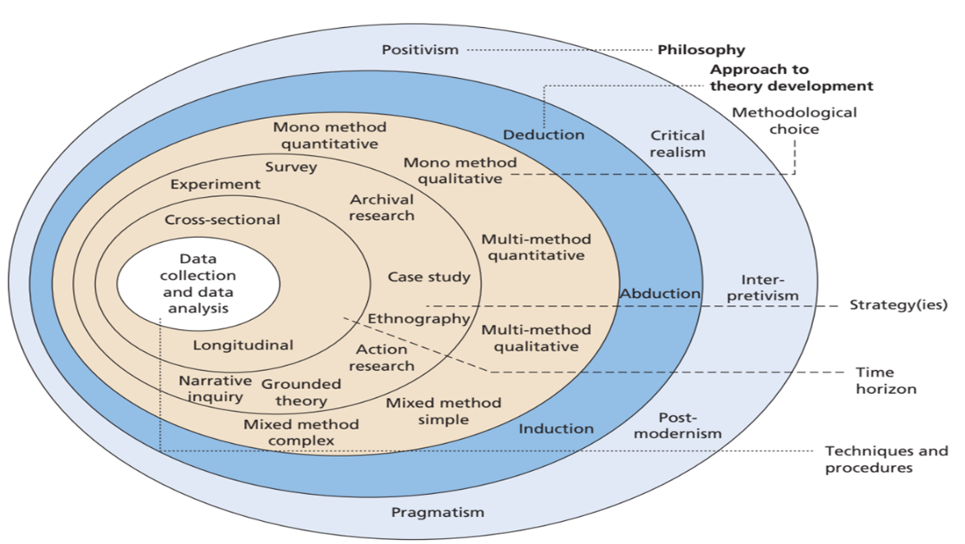
Figure 9. Research Onion
Source: (Saunders, et al., 2009)

3.2: Research Philosophy

Ontology refers to the study of the nature of being or existence, and in research, it deals with the categories, concepts, and relationships that are used to describe and understand the world. Ontological assumptions are the underlying beliefs or perspectives that researchers bring to their study and shape how they approach and interpret data. The ontological research philosophy for this study was chosen to understand different ways that we conceptualize leadership. Ontology provides different assumptions and underly beliefs about the nature of leadership and guides the research process. Besides, knowing a leader’s own beliefs and what they truly believe can be studied through ontology (Gilbert & Pratt-Adams, 2022).

3.3: Research Paradigm

A research paradigm is a broad framework that guides how researchers approach their work, including their ontological and epistemological assumptions. Ontology deals with the nature of reality, while epistemology deals with the nature of knowledge. As research paradigm of this study will apply positivism because this allows the researcher to focus on objective and measurable facts about the impact of leadership styles and organizational performance, using quantitative methods and evidence to produce reliable and valid findings and support research conclusions. Positivism is an approach that comprises the use of evidence to make predictions about future outcomes, and methods to understand and explain social phenomena. It seeks to separate the researcher’s personal biases and values from the research process to produce objective knowledge. (Saliya, 2023).

3.4: Research Approach

For this study, a deductive research approach is the most appropriate. In a deductive approach, researchers start with developing hypotheses based on existing theory, make predictions about what should happen from the theory, and then test those predictions through observations and data, to see if they support the theory. Researchers begin with existing theories, and models of leadership, such as transformational leadership or transactional leadership, and test their impact on performance indicators through data analysis. If the predictions are supported, the hypothesis is considered valid. If not, the hypotheses need to be revised or rejected. This approach involves collecting data that is aligned with predefined variables and theories (Crowther & Lauesen, 2017).
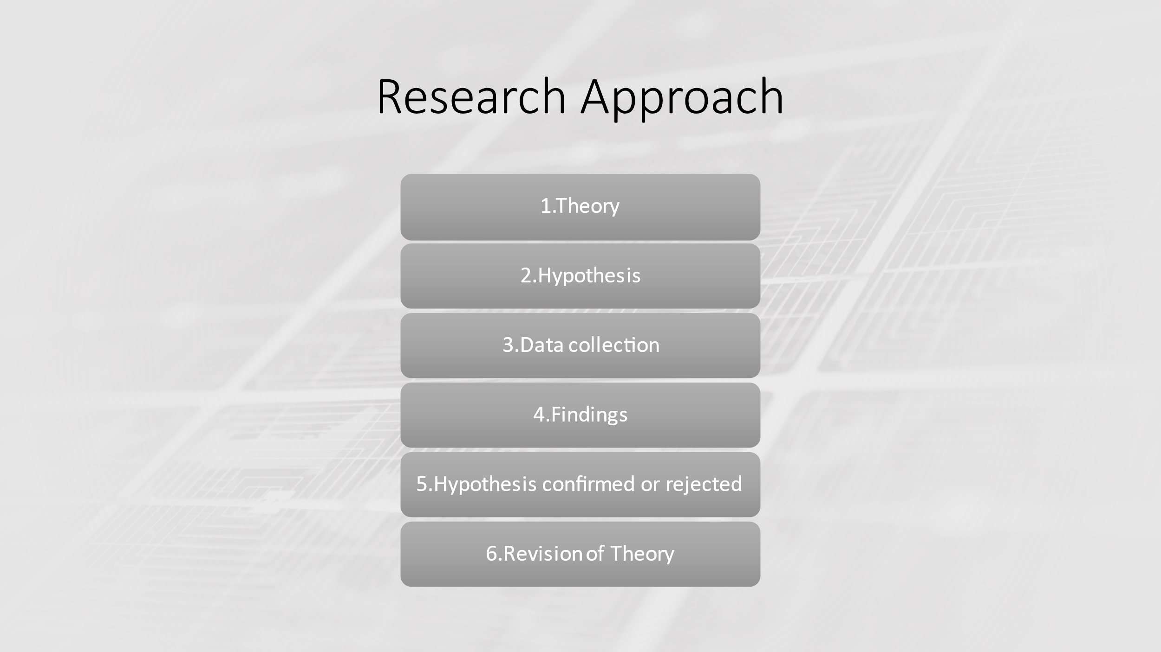
Figure 10. Research Approach
Source: Created by Author

3.5: Research Method

Quantitative research is all about using numerical data and statistical analysis to study or test hypotheses. It aims to provide evidence that can be generalized to a large population and relies on the use of statistical tests to analyse data and draw conclusions. The quantitative research methodology is the most appropriate for this study. There are several reasons why quantitative research is great for this study:
- It allows researchers to study the impact of specific leadership behaviours on performance metrics (like profitability, productivity, or employee satisfaction) systematically and objectively.
- It can provide statistically significant evidence of the relationship between leadership style and performance, which can be used to make informed decisions about leadership development and organizational strategy.
- It can help identify patterns and trends over time, allowing researchers to assess the long-term impact of different leadership styles.
- It can be replicated and compared across different organizations, industries, and cultures, providing a broader understanding of the impact of leadership style.

3.6: Research Strategy

The most common strategy used in this type of research is online surveys. This allows the researcher to reach and ask questions to a large and diverse number of participants to gather data. Researchers can design surveys and distribute them online through an online tool to collect data in real-time and measure a variety of different variables that might impact organizational performance such as employee engagement, job satisfaction, and performance metrics.

3.7: Research Sample and Population

When it comes to sampling in the context of leadership research, the probability sampling method is suited for this study. This involves selecting a representative sample of the population using random methods, such as stratified sampling: dividing a population into subgroups. Leadership style can vary among different demographic groups, such as age, gender, or job level, so stratifying the sample by these characteristics can help ensure that all perspectives are represented. Leadership style can also vary between industries or sectors, so stratifying the sample by industry can help capture the nuances of leadership style in different contexts. Stratified sampling allows researchers to analyse the impact of leadership style within each subgroup, as well as across the entire population.
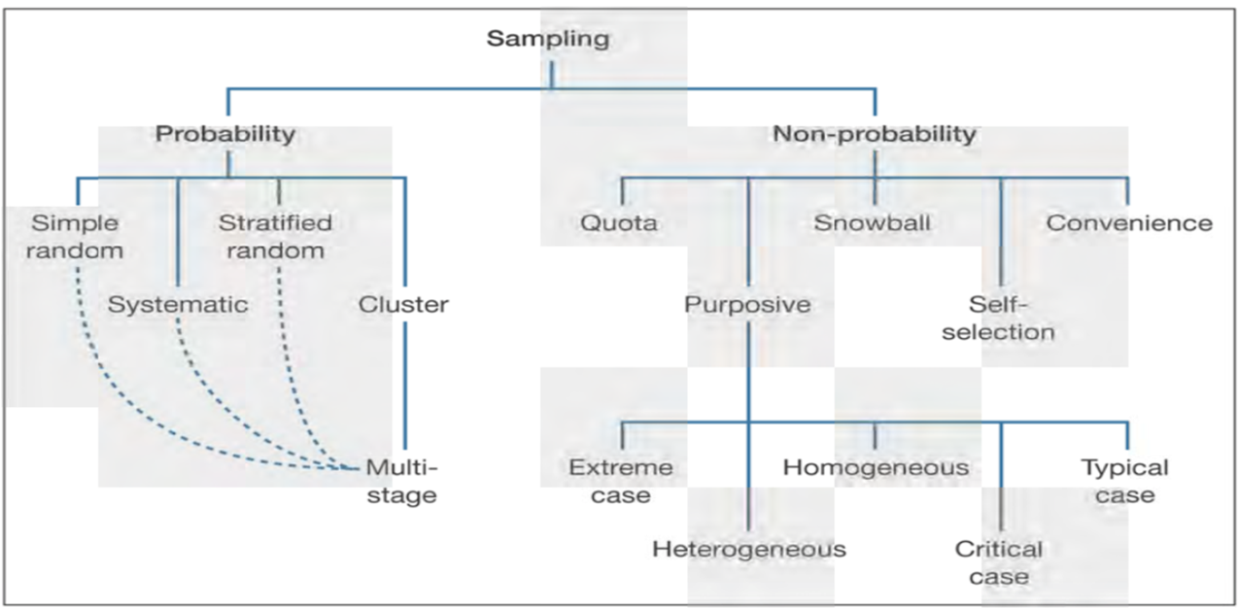
Figure 11. Sampling Techniques
Source: (Saunders, et al., 2009)

3.8: Data Collection and Data Analysis Tools/Techniques

The survey questionnaire is the primary tool used in this research. Questions from online surveys are widely tool used to collect data on leadership styles and organizational performance. These questionnaires constituted of Likert scale of 5 responses which the participants were required to choose from. Questions will capture information on leadership behaviours, employees' perceptions of leadership styles, and performance indicators. When interpreting the data, it is important to consider the quantitative nature of the data. A technique for interpreting data will be correlation and regression analysis, T-Test statistical analysis to test the hypothesis because this will help to examine and understand the strength and direction of the relationship between the two leadership styles (transactional and transformational) and different variables of performance outcomes. The collected data will be entered and analysed in SPSS.

3.9: Ethical Considerations of the Research

The research is conducted responsibly and ethically, and participants are treated fairly and respectfully. This research includes several ethical considerations:
- Informed consent of those taking part - The consent from all participants is obtained before participating in the research, and aware of their withdrawal anytime.
- Confidentiality - The data collected is stored in a way that protects the privacy and confidentiality of the participants’ information.
- Avoidance of harm - The researcher aims to minimize any undue harm to the participants, either physical or psychological.
- The research is conducted ethically and transparently, and the findings are reported in a way that is objective and unbiased.
- Respect for participants: Researchers should respect the autonomy, dignity, and rights of study participants.
- Beneficence: Researchers should aim to maximize benefits for participants.

3.10: Summary of Chapter 3

This chapter is an opportunity to include every task together and make the reader understand the main points of the research. In this chapter, the methodologies and research methods utilized in the study were outlined and justified. The philosophical position of the research was discussed, explaining the underlying assumptions and worldviews that guided the research approach and methodology. The paradigm position of the study was explained, highlighting the theoretical and epistemological underpinnings of the research. The research approach and methodology were outlined, including the research strategy and design, sample and population, data collection and analysis tools and techniques, and ethics considerations. Each of these aspects of the research was explained and justified, providing a clear rationale for the research approach and design. In summary, this chapter described the research methods and methodologies used in the study, providing a clear and transparent account of the research process and its underlying assumptions and values

Chapter 4: Data Analysis and Discussions

4.1: Introduction

The data presented in this research was obtained through a survey of 103 respondents. The survey measured the impact of leadership style on organisational performance and consisted of 18 questions designed to elicit information on research variables. The data were analysed using statistical analyses, and the results provided valuable insights into research findings. This chapter provides information on the research hypothesis, sample, and methods used for data collection and data analysis. It also highlights the significance of the findings and how they can contribute to our understanding of the research topic.

4.2: Reliability Statistic

Reliability statistics are an essential component of good research practice, and an important aspect of data analysis, and help to check the consistency and accuracy of items in the questionnaire and ensure that the data collected and research results are trustworthy and reliable. Reliability statistics can be used to help researchers and decision-makers make informed decisions based on data that is accurate and trustworthy. They can also help identify any potential issues or biases in the data collection process, allowing researchers to make adjustments or improvements to ensure the reliability of future data. Cronbach’s Alpha measures reliability in research and consistency of items in a questionnaire.
Findings: Cronbach coefficient alpha was computed for this research as follows:
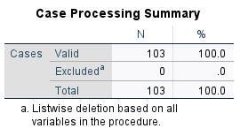
Table 1. Case Processing Summary of Reliability Statistic
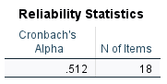
Table 2. Reliability Statistics
The survey’s reliability was determined to be 0.512 based on the sample of 103 respondents who participated in the current research.
Discussion: Cronbach’s alpha is calculated by looking at the correlation between all items on a scale or questionnaire. The higher the Cronbach’s alpha value, the more consistent and reliable the items are. The Cronbach’s Alpha value ranges from 0 to 1, and the higher the better. So, the Cronbach’s alpha value of 0.512 of this research survey is acceptable for research purposes, and the survey is highly reliable, it also, suggests that the survey has poor internal consistency, and will give credible results.

4.3: Descriptive Statistics

Descriptive Statistics are a set of statistical techniques used to summarize and describe the characteristics of data and check the normality of the data for a research report. They are an important starting point in further data analysis. They provide a simple and effective way to understand the key characteristics of a dataset and a foundation for further investigation of hypothesis testing. Descriptive statistics provide a numerical description of the data. Some common descriptive statistics include the central tendency (mean, median, mode), dispersion (standard deviation and variance), and frequency distribution of data. They can be useful for understanding the characteristics of a dataset at a glance.
Findings: Table 3 has been created below to indicate the findings of values.
The Table indicates: N=103 respondents; Minimum = 1respondent / question; Maximum = 17respondents / question ; Mean statistic value 1.40 - 9.08; Standard deviation statistic 0.492 - 5.218;
Skewness: Statistic = -0.535 - 1,365; Standard error = 0.238
Kurtosis: Statistic = -1.858 – 2.371; Standard error = 0.472
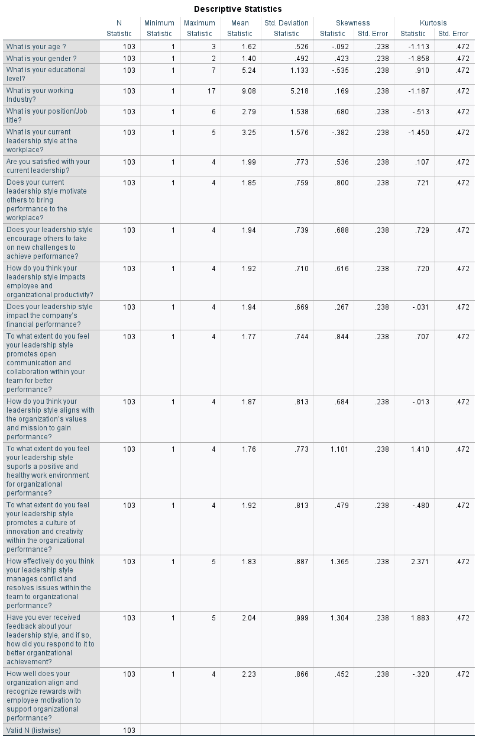
Table 3. Descriptive Statistics
Discussion: The mean, minimum, and maximum values are determined to show the center of the distribution of data and, if there are problems in the data. A high mean value of 9.08 indicates that the data is skewed towards higher values. The standard deviation gives you a sense of how spread out the data is. A large standard deviation of 5.218 indicates a lot of variability in responses, while a small standard deviation of 0.492 indicates more consistency in data collected from respondents. The skewness and kurtosis are checked for normality. The skewness determines if the data is positively or negatively skewed in terms of the responses. These values should range from -2 to +2. The skewness distribution in this case has been within the range of -0.535 to +1.365, which is quite skewed, and the kurtosis range of -1.858 to +2.371. So, we can still conduct important tests.

4.4: Frequency Distribution Analysis

Frequency distribution analysis is a simple and effective technique used to summarize, visualize, and understand the distribution of data. It’s a method of organizing data into groups or categories, based on the frequency or number of occurrences of each value. The frequency distribution tables were created below to indicate the distribution of respondents in each category of question. Also, Pie Charts were created to visualize and understand the distribution of data.
Findings:

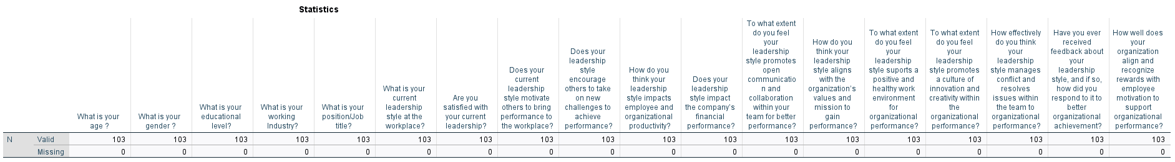
Table 4. Frequency Distribution Analysis
The above Table 4 shows that there are 103 respondents, and each survey question. There are no missing responses from each respondent on each question.

Frequency Tables
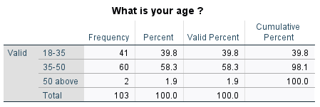
Table 5. Age Frequency distribution
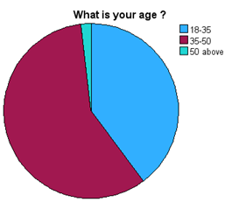
Figure 12. Age Pie Chart distribution
Discussion: Table 5 presents the Age frequency distribution of 103 survey respondents. For this question, the frequency answer value is 58,3 % (n=60), predominantly 35-50 age group, followed by those in the age group 18-35 years who constituted a further 39,8% of the sample (n=41), and those 50 above years made up the remaining 1,9 % of the respondents (n=2).

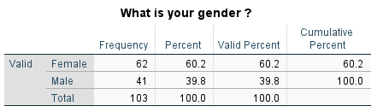
Table 6. Gender Frequency Distribution
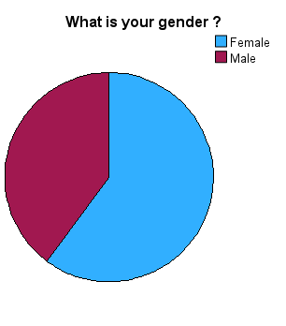
Figure 13. Gender Pie Chart
Discussion: Table 6 presents the findings of the gender frequency distribution of 103 research participants. Males represented 39,8 % (41) of the sample population, while females constituted 60,2 % (62). For this question, the frequency answer value constitutes predominantly female gender as shown in the above pie chart, Figure 13.
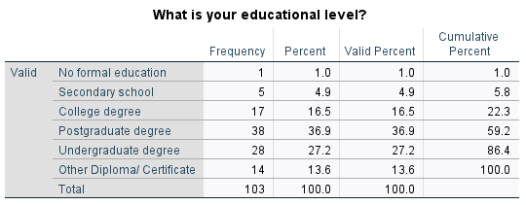
Table 7. Educational level Frequency Distribution

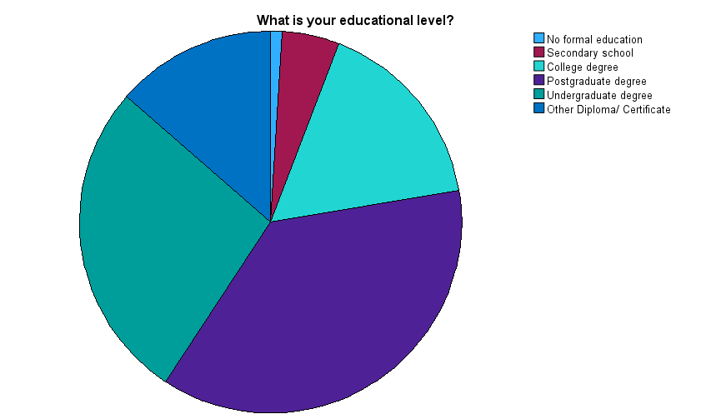
Figure 14. Educational Level Pie Chart
Discussion: For educational level, the frequency answer value is 36,9 %, predominantly n=38 of respondents completed a Postgraduate degree level of education, followed by 27,2 % (n=28) Undergraduate degree, 16,5 % (n=17) College degree, 13,6 % (n14) other Diploma/Certificate, 4,9 % (n=5) Secondary school, and 1% (n=1) no formal education.
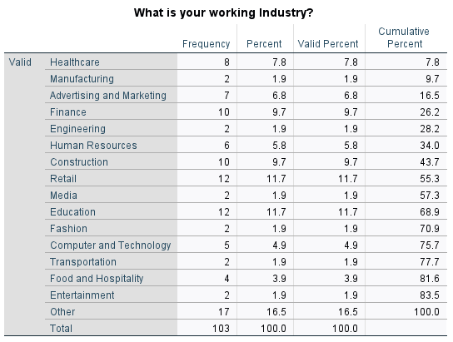
Table 8. Industry Frequency Distribution
Discussion: Table 8 represents the respondent’s working industry. The frequency answer value is 16,5 % (n=17), predominantly Other working industries do not show in the answering option after Retail and Education 11,7 % (n=12), Finance and Construction 9,7 % (n=10), Healthcare 7,8 %, (n=8), Advertising and Marketing 6,8 % (n=7), Human Resources 5,8 % (n=6), Computer and Technology 4,9 % (n=5), Food and Hospitality 3,9% (n=4), and the last ones 1,9 % (n=2) - Manufacturing, Engineering, Media, Fashion, Transportation and Entertainment.
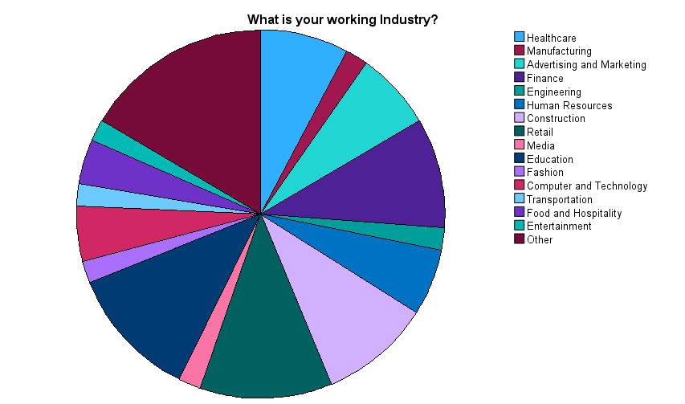
Figure 15. Industry Pie Chart
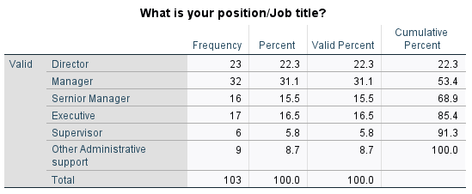
Table 9. Job position Frequency Distribution
Discussion: For this question, the frequency answer value is 31,1 % (n=32), predominantly the Manager job position, as shown in the Pie Chart (Figure 16), followed by Director – 22,3% (n=23), Executive -16,5% (n=17), Senior Manager- 15,5% (n=16), Other administrative support 8,7% (n=9), and Supervisor – 5,8%(n=6).
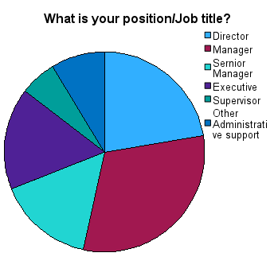
Figure 16. Job position Pie Chart
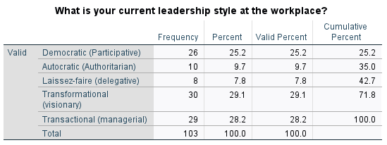
Table 10. Leadership style Frequency Distribution

Discussion: For this question, the frequency answer value is 29,1 % (30 respondents), predominantly Transformational (visionary) leadership style after Transactional (managerial) leadership style – 28,2% (n=29), Democratic – 25,2% (n=26), Autocratic – 9,7% (n=10), and 7,8 % (n=8) - Laissez-faire leadership style implemented by respondents at the workplace.
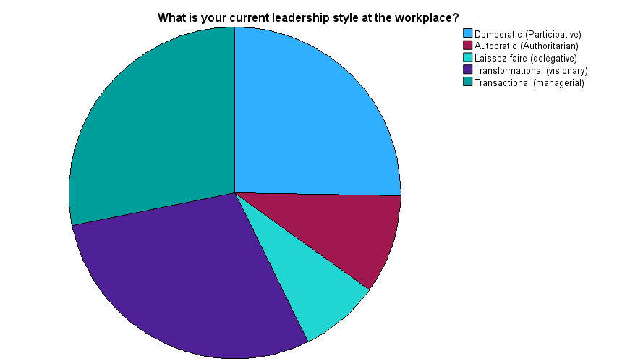
Figure 17. Leadership Styles Pie Chart
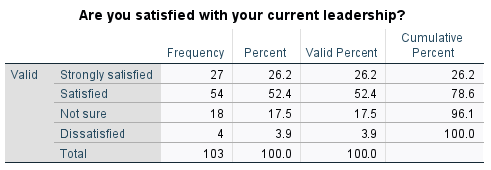
Table 11. Current leadership style Frequency Distribution

Discussion: In Table 11 the frequency answer value is 52,4 %, showing that 54 respondents are satisfied with the current leadership style; 26,2 % of respondents (n=27) are strongly satisfied with the current leadership style, 17,5 % (n=18) are not sure and 3,9 % of respondents (n=4) are dissatisfied with current leadership style.

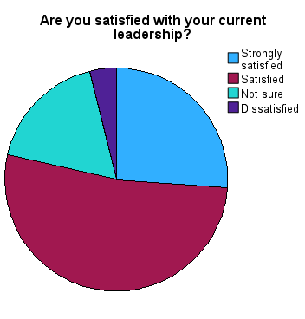
Figure 18. Current Leadership Style Pie Chart
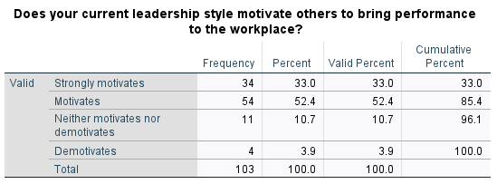
Table 12. Motivation Frequency Distribution
Discussion: In Table 12 the frequency answer value is 52,4 %, showing that 54 of the respondents motivate others to improve performance at the workplace; 33 % of respondents (n=34) strongly motivate others; 10,7 % (n= 11) neither motivate nor demotivate, and 3,9 % of respondents (n=4) demotivate others to bring performance at the workplace.
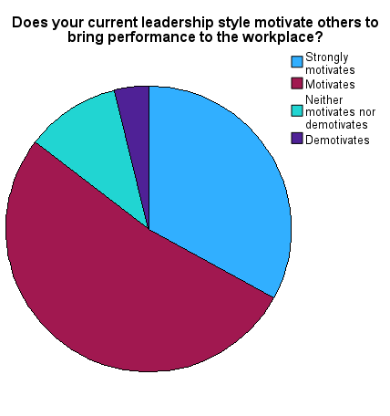
Figure 19. Motivation Pie Chart
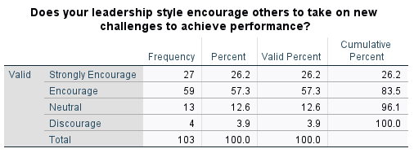
Table 13. Encouragement Frequency Distribution

Discussion: For this question the frequency answer value is 57,3 % (n=59), showing that the respondent’s leadership style encourages others to take on new challenges to achieve performance; 26,2 % (n=27) respondents strongly encourage others to take challenges;
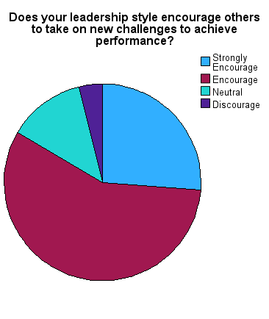
Figure 20. Encouragement Pie Chart

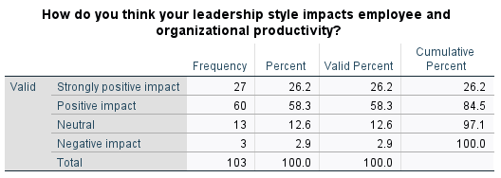
Table 14. The Frequency distribution of the impact of leadership style on employee and organizational performance
Discussion: For this question the frequency answer value is 58,3% (n=60), showing that the respondent’s leadership style positively impacts employee and organisational productivity, followed by 26,2 % (n=27) strongly positive impact, 12,6 % (n=13) neutral, 2,9 % (n=3) of the respondent’s leadership style negatively impacts the employee productivity.
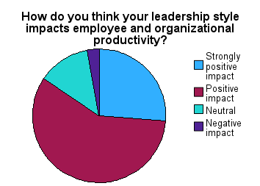
Figure 21. Leadership style impact on employee productivity Pie Chart

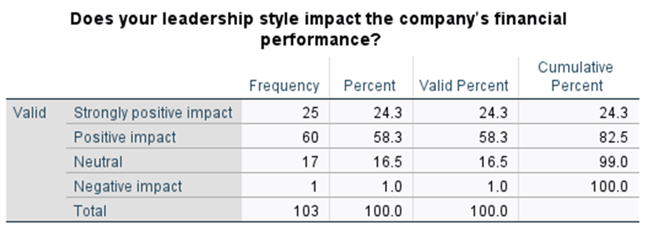
Table 15. Frequency distribution of Leadership style of the impact on company financial performance

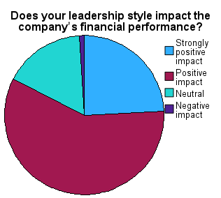
Figure 22. Leadership style impact on company’s financial performance Pie Chart

Discussion: For this question the frequency answer value is 58,3 % (n=60), showing that the respondent’s leadership style positively impacts the company’s financial performance, followed by 24,3 % (n=25) of respondents’ leadership style strongly positively impact, 16,5 % (n=17) - neutral impact, 1% (n=1) negatively impacts the financial performance of the company.
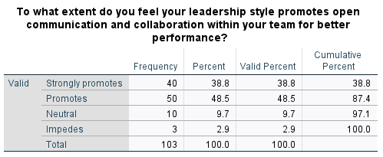
Table 16. Frequency Distribution of the extent of promotion of communication and collaboration

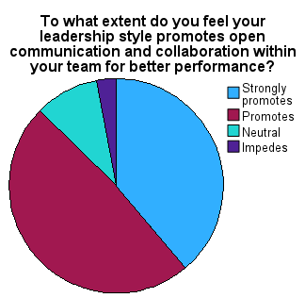
Figure 23. Pie Chart of Distribution of the extent of promotion of communication and collaboration

Discussion: For this question the frequency answer value is 48,5 % (n=50), showing that the respondent’s leadership style promotes open communication and collaboration within the team for better performance, 38,8 % (n=40) strongly promote it, 9,7 % (n=10) are neutral, and 2,9 % of respondents (n=3) impede open communication and collaboration within the team.
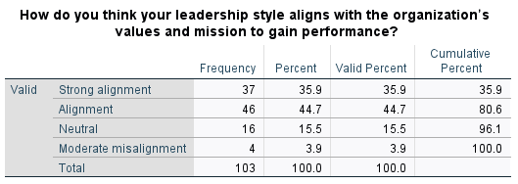
Table 17. Frequency Distribution of alignment with the organization’s values and mission

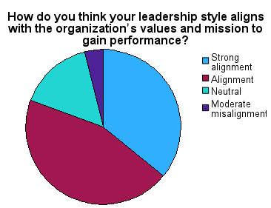
Figure 24. Pie Chart of Distribution of alignment with the organization’s values and mission

Discussion: For this question the frequency answer value is 44,7 % (n=46), showing that the respondent’s leadership style aligns with the organization’s value and mission to gain performance, 35,9 % (n=37) strongly aligns, 15,5 % (n=16) neutral alignment, and 3,9 % (n=4) moderately aligns with the value and mission of the organization.
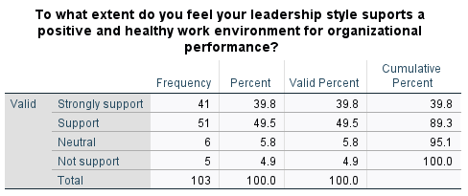
Table 18. Frequency Distribution of the extent of support for a positive and healthy work environment
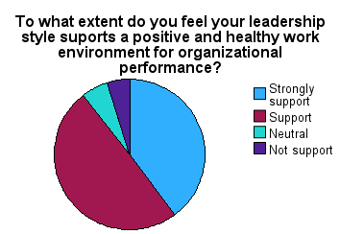
Figure 25. Pie Chart of Distribution of the extent of support for a positive and healthy work environment
Discussion: For this question the frequency answer value is 49,5 % (n=51), showing that the respondent’s leadership style supports a positive and healthy work environment for organisational performance, 39,8 % (n=41) strongly support, 5,8 % (n=6) are neutral, and 4,9 % (n=5) of respondents do not support a healthy work environment.
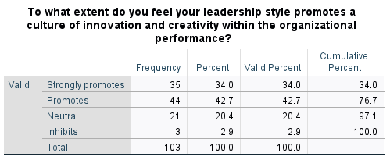
Table 19. Frequency Distribution of the extent of promotion of the culture of innovation and creativity
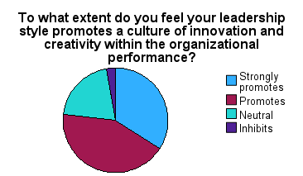
Figure 26. Pie Chart Distribution of the extent of promotion of the culture of innovation and creativity

Discussion: For this question, the frequency answer value is 42,7 %, 44 respondents promote a culture of innovation and creativity within the organizational performance, 34,0 %(n=35) strongly promote it, 20,4 % (n=21) are neutral, and 2,9% (n=3) inhibit the creativity and innovation within the organizational performance.
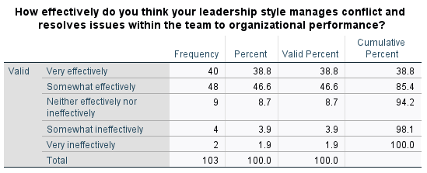
Table 20. Frequency distribution of effectiveness of managing conflicts and resolving issues
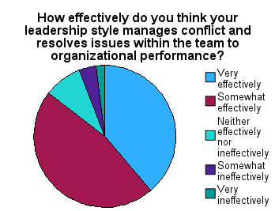
Figure 27. Pie chart of distribution of effectiveness of managing conflicts and resolving issues

Discussion: For this question, the frequency answer value is 46,6 %, 48 respondents somewhat effectively manage conflicts and resolve issues within the team for organizational performance, 38,8 % (n=40) very effectively manage conflicts, 8,7 % (n=9) neither effectively nor ineffective, 3,9 % (n=4) somewhat ineffective, 1,9 % (n=2) of respondents very ineffective manages conflicts and issues within the team.
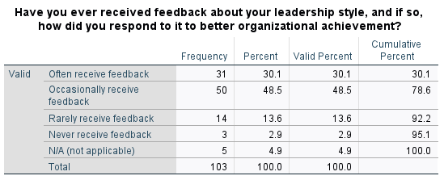
Table 21. Frequency Distribution of received feedback

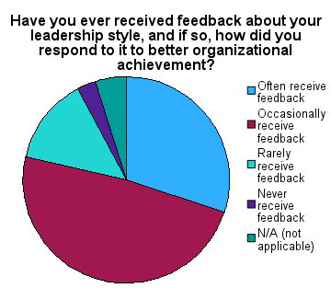
Figure 28. Pie Chart of Distribution of received feedback

Discussion: For this question the frequency answer value is 48,5 %, showing that the respondents (n=50) occasionally receive feedback, 30,1 % (n=31) often receive feedback, 13,6 % (n=14) rarely receive feedback, 4,9 % (n=5) is not applicable, and 2,9 % of respondents (n=3) never received feedback about their leadership style.

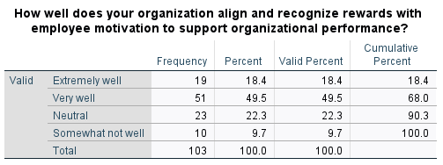
Table 22. Frequency Distribution of the alignment of rewards with employees

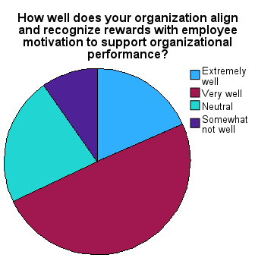
Figure 29. Pie Chart of Distribution of the alignment of rewards with employees

Discussion: For this question the frequency answer value is 49,5 %, showing that 51 respondents very well align and recognize rewards with employee motivation to support organizational performance, 22,3 % (n=23) are neutral, 18,4 % (n=19) extremely well recognize rewards, and 9,7 % (n=10) somewhat not well recognizing the rewards with the employee.

4.5: Factor Analysis

Factor analysis is a technique used to identify underlying factors or components in a dataset. The technique is used to reduce a large number of variables into a smaller set of factors that can be easily to analyse and interpreted. Factor analysis allows researchers to identify these underlying factors and assess their relative importance. It does this by looking for patterns and grouping variables that are highly correlated.
Findings:
The Kaiser-Meyer-Olkin (KMO) is a statistical test used to measure and assess the suitability of a dataset for a factor analysis. It measures the sampling adequacy of the data, which is an important factor in determining the accuracy of the results of a factor analysis.
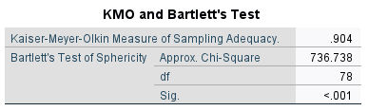
Table 23. KMO and Bartlett’s Tests

Discussion: The KMO test is used to determine whether there is enough variability in the dataset to justify the use of factor analysis. If the KMO value is high, generally above 0.5, it suggests that there is sufficient variability in the data for factor analysis to be useful. In this research, the KMO value is 0.904, which is above 0.5. The KMO test is often used in conjunction with other measures, such as Bartlett’s test of sphericity, to assess the suitability of a dataset for factor analysis. According to the above information from the Table 23 results the sample size is adequate, valid, and reliable.

4.6: Inferential Statistics

Inferential statistics is a type of statistical analysis that allows researchers to draw conclusions and generalizations about the population. The main purpose of inferential statistics is to allow researchers to provide support for hypotheses about the population. Inferential statistics rely on probability theory and statistical tests, such as t-tests, ANOVA, correlation, and regression analysis, to assess the strength of the relationships and associations in the data. These statistical tests allow researchers to determine whether the differences or relationships observed in the sample are significant enough to be considered real and representative of the population as a whole.

4.7: Correlation among variables

Findings: Correlation analysis is a type of inferential statistical technique that measures the strength and direction of the linear relationship between two variables. If two variables are related to each other, then changes in one variable will be associated with changes in the other variable. To quantify the strength of the relationship between two variables the correlation coefficient should range from -1 to 1. A perfect negative correlation is indicated by the value -1, meaning that as one variable increases, the other variable decreases. A perfect positive correlation is indicated by value 1, meaning that as one variable increases, the other variable also increases. A no correlation between variables should indicate a value of 0. Pearson’s Correlation Coefficient was computed in Table 24 below to determine the relationship between the dimensions of organisational performance and transformational and transactional leadership styles.
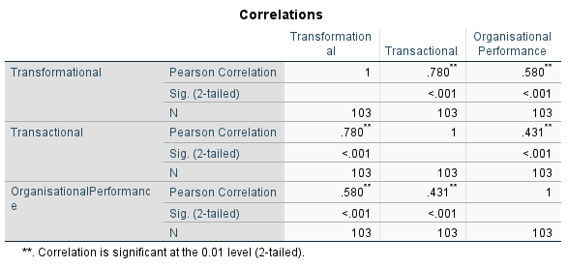
Table 24. Correlations analysis among variables
Discussion: Correlation measures the strength of the relationship between variables. The correlation coefficient varies from -1 to +1, no correlation is indicated by 0. A correlation coefficient of 0.5 or higher is generally considered a strong positive correlation, while a correlation coefficient of -0.5 or lower is generally considered a strong negative correlation. The research analysis found a significant positive correlation between transformational leadership style and organisational performance, with a correlation coefficient of 0.580. This suggests that leaders who adopt a transformational leadership style, characterized by empowering and involving employees in decision-making, may contribute to better organizational performance. On the other hand, we found a significant positive correlation between transactional leadership style and organisational performance, with a Pearson correlation coefficient of 0.431. For testing the hypothesis, the Pearson correlation value should be < 0,05 to reject the null hypothesis and accept the research alternative hypothesis. In our analysis, the correlation is significant at the 0,01 level (2-tailed), <0,05. This means that we reject the null hypothesis H₀ - There is no relationship between transformational leadership and transactional leadership style and organizational performance, and accept H₁ (Alternative Hypothesis) - There is a significant relationship between transformational and transactional leadership styles and organizational performance.

4.8: Regression analysis

Regression analysis is a powerful tool for understanding the relationship between variables, and for making predictions based on that relationship. Regression analysis is used to model the relationship between a dependent variable (the variable being predicted) and one or more independent variables (the variable that is thought to influence the dependent variable).
Findings:
Multiple regression
Multiple regression is a type of regression analysis that allows for the modelling of the relationship between a dependent variable and multiple independent variables.
In our research, the multiple regression model could be used to determine the impact of transformational and transactional leadership styles on organizational performance and to identify any interactions or synergies between the leadership styles.

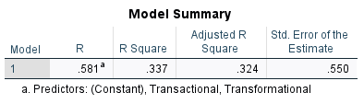
Table 25. Multiple Regression Model Summary

Discussion: Table 25 above of Model Summary in a multiple regression analysis provides a summary of the key results and statistics that describe the fit of the model. R Square is a measure of the percentage of variance in the dependent variable that is explained by independent variables. For a better fit, R Square should be high. The results shown in Table 25 above suggest a moderate percentage of the variation in organisational performance explained by transformational and transactional leadership style entered in the equation R Square = 33,7 %. Adjusted R Square = 32,4 %, this is a more conservative measure of the fit of the model, which takes into account the number of independent variables in the model. The accuracy of the model’s predictions is indicated by the standard error of the estimate, 0.550. A lower standard error indicates a more accurate model.
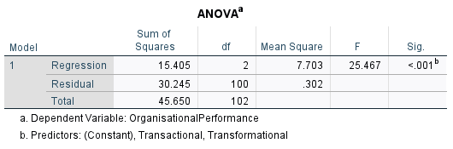
Table 26. ANOVA Analysis of Variances
Discussion: The ANOVA analysis (Table 26) is another important component of a multiple regression analysis. It provides a summary of the results of the overall model. The Sum of Squares indicates the total variation in the dependent variable that is explained by the model. Degrees of freedom (df) indicate the number of independent variables in the model. The F-statistic of 25.467 indicates the overall significance of the model. In our research, F indicates that the model is a good fit for the data. The probability value for the F-statistic is the P-value and should be less than 0.05. In our analysis, the P-value <0.01, indicates that the overall model is statistically significant. The ANOVA analysis Table 26 provided above of a quick overview of the overall fit of the model helped the researcher to determine that the model is a good fit for the data and was used to suggest that transformational leadership and transactional leadership play a greater role in predicting organisational performance.

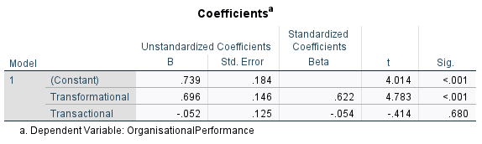
Table 27. Coefficients Table of Regression Analysis

Discussion: The Coefficient in Table 27 is a key component of a regression analysis. Table 27 above provides the estimates of the effects of each independent variable on the dependent variable. It represents the change in the dependent variable for a unit change in the independent variable. The standard error measures the precision of the estimate. A lower standard error of 0.125 from Table 27 indicates a more precise estimate, while a high standard error of 0.184 indicates a less precise estimate. T-statistic (t) is a test statistic used to determine the statistical significance of the coefficients. A high t-statistic of 4.783 from Table 27 indicates that the coefficient is statistically significant. The P-value of <0.001 from Table 27 is the probability value for the t-statistic and is less than 0.05, this indicates that the coefficient is statistically significant. By examining the coefficient in Table 27 above can conclude that the transformational leadership style has a more positive and significant effect on organizational performance.

4.9: T-test

T-test is a statistical test used to determine whether the mean of a sample is significantly different from a known or hypothesized value.
Independent sample t-test
An independent sample t-test compares the means score of two different independent samples.
Findings:
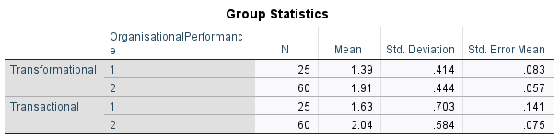
Table 28. Group Statistics of T-Test

Discussion: A researcher wants to know if there are significant relationships between transactional and transformational leadership styles and organizational performance. In this scenario, we could easily see that data is collected in one continuous variable – organisational performance, however, it is collected from two different groups – transactional and transformational leadership style, that are then compared using an independent sample t-test. It looks like the transformational leadership style has an average score of 1.91 and the transactional leadership style has an average score of 2.04. This suggests that respondents tend to view transformational leadership as slightly less significant than transactional leadership on organizational performance.
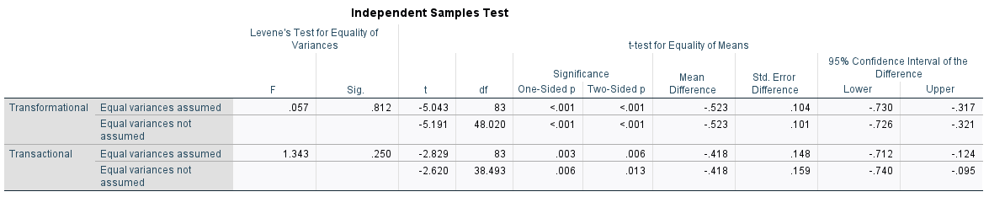
Table 29. Independent Sample Test
Discussion: Table 29 captures two tests Levene’s Test for Equality of Variances and the t-test for Equality of Means. Levene's test examines if the variability in the two groups is equal. The null hypothesis of Levene's test is that the variances in the two groups are equal. Levene's test statistic follows a standard statistical distribution called an F distribution, when is true that the variances in the two groups are equal. In this case, the F statistic distribution has values of 0.057 and 1.343 for variables, these are not equal. For this statistic distribution, SPSS calculates p values 0.812 and 0.250. If the p-value is less than 0.05 the null hypothesis is considered true. In this case, the p-value is above 0.05, which results that the null hypothesis that there is no relationship between transformational and transactional leadership style and organisational performance is not true. In conclusion, we can reject the null hypothesis if there is sufficient evidence that the mean of the Transformational group (1.91) is either higher or lower than the mean of the Transactional group (2.04). SPSS looks up the t-statistic (-2.829 to -5.191) in above Table 29 and gives the p-value associated with the calculated t-statistic and degrees of freedom (38.493 to 48.020). SPSS reports in this case p=0.001 one-sided and two-sided significance. Therefore we can reject the null hypothesis because the two groups do not have the same means, and the value is less than 0.005 in our study.

4.10: Summary of Chapter 4

This chapter has provided an overview of the findings which emerged from the data analysis. The generated hypotheses were tested and have been reported on. The chapter included a discussion of the findings obtained and elucidated the relationship between leadership style and organisational performance. The current research indicates that a significant correlation exists between transformational and transactional leadership styles and the overall dimensions of organisational performance, this conclusion is derived from the research results. Transformational and transactional leadership style positively impacts all organisational performance dimensions in this research. Hence, the null hypothesis - there is no relationship between transformational leadership and transactional leadership style and organizational performance is rejected.

Chapter 5: Conclusions, Limitations & Recommendations

5.1: Introduction

In this chapter, I will summarize the key findings and outcomes of the research discussed in previous chapters, discuss the limitations of the study, and make recommendations for future research and practice. While the findings of the research provide valuable insights into the impact of leadership styles on organizational performance, it is important to acknowledge the limitations of the study and to consider how the research could be improved upon in the future. In addition, the recommendations provided in this chapter can serve as a guide for future researchers and practitioners seeking to build upon the findings of this study and to further our understanding of the relationship between leadership styles and organizational performance.

5.2: Accomplishing Research Aim, Objectives, and Research Hypothesis

To accomplish the research aim and objectives of examining and understanding the impact of leadership styles on organizational performance researcher has involved the following steps: the researcher reviewed the literature, defined and operationalized the key concepts, such as leadership styles and organizational performance; developed a research design and methodology, such as a survey to collect data on leadership styles and organizational performance; analysed the data using appropriate statistical techniques, such as correlation analysis, regression analysis, and t-test to test the two research hypothesis and to identify relationships between leadership style and organisational performance; interpreted the results and provided the discussion of findings. By following these steps and conducting rigorous and systematic research, the researcher accomplished the research aim and objectives of understanding the impact of leadership styles on organizational performance and making a valuable contribution to the field of leadership studies.

5.3: Conclusions on the research problem

Based on the research problems defined in Chapter 1, can be concluded that the need for more in-depth research to fully understand the mechanisms and processes through which leadership styles influence organisational performance was accomplished. This conclusion highlights that the need for researchers to take a more holistic approach to leadership research, and to go beyond simply identifying correlations to understand the underlying causes and effects of different leadership styles also was accomplished. It also suggests that future research should aim to develop more comprehensive models of leadership and performance that take into account the complex factors that shape organizational performance.

5.4: Summary of the research findings and outcomes

This research relates the significance of the impact of two leadership styles (transformational and transactional) on organizational performance. Both transactional and transformational leadership styles have many facets in common that influence good organisational performance. Through this research, it has been acknowledged by the methodological approach, a survey research design, a deductive research approach, a quantitative research strategy, statistical results from correlation analysis, regression analysis, and t-test that both leadership styles have an impact on organizational performance. The main idea that both leadership styles affect organisational leadership stands true. Both research hypotheses were tested, rejecting the null hypothesis of research and accepting the alternative hypothesis. Keeping in view the importance of leadership in any organization, this study provides an ample chance for managers in any organization to enhance their relationships with employees and to improve their performance for the betterment of organizational performance.

5.5: Limitations of the Research

Research on the impact of leadership styles on organizational performance might have the following limitations: Limited generalizability: The results of the study may only apply to the specific respondents from the industries studied, and may not be generalizable to other respondents or working industries. Selection bias: The sample of leaders or other respondents from administrative support studied may not be representative of the population, which could introduce bias into the results. Measurement error: The measures and statistical analysis used to assess the impact of leadership styles on organizational performance may not be valid or reliable, which could lead to inaccurate results. Lack of control for confounding variables: The study may not adequately control for other variables that may influence organizational performance. Cross-sectional design: The cross-sectional design of research may only provide a snapshot of the relationship between leadership styles and organizational performance at a single point in time, and may not capture the long-term effects of leadership styles on organizational performance.

5.6: Recommendations

Some recommendations to address the limitations of the dissertation are presented below. The researcher can conduct a longitudinal study to examine the long-term effects of leadership styles on organizational performance. Can expand the sample to include a more diverse range of working industries and respondents from administrative support. Researchers can use more valid and reliable measures of leadership styles and organizational performance. Can control for confounding variables by using other statistical techniques. Can conduct follow-up studies to replicate the findings and validate the results. By addressing these limitations and incorporating these recommendations, future research on the impact of leadership styles on organizational performance can provide more robust and generalizable findings that can inform leadership development and training programs, as well as organizational policies and practices.

5.7: Summary of Chapter 5

This chapter provides a comprehensive conclusion of the research problem, objectives, and hypotheses explored in the dissertation. The main objective of the study was to examine whether leadership styles impacted organizational performance. The chapter summarizes the findings and outcomes of the research and provides conclusions on each research issue, objective, and proposition based on the results of the study. Additionally, the chapter discusses any limitations or weaknesses of the research, such as limited generalizability, selection of bias, measurement error, lack of control for confounding variables, and cross-sectional design. Finally, this chapter provides recommendations for future research based on the findings of this study, to conduct a study to examine the long-term effects of different leadership styles which may impact the performance of organizations, using valid and reliable measures of leadership styles, and statistical techniques for data analysis and interpretation.

Reference List

Adair, J. E., 2018. Lessons in leadership: the 20 key concepts. s.l.:Bloomsbury Business.
Crowther, D. & Lauesen, L. M., 2017. Handbook of Research Methods In Corporate Social Responsibility. Cheltenham: Edward Elgar.
eba, 2021. Trait Theory of Leadership and Its Key Characteristics. [Online]
Available at: https://www.educational-business-articles.com/trait-theory-of-leadership/
[Accessed 07 August 2023 August 2023].
Ebener, D. R. & Jalsenjak, B., 2021. Leadership for a Greater Good. A text book for Leaders. New York: Paulist Press.
Gibbons, J. M., 2006. Employee Engagement A Review of Current Research and Its Implications, New York: The Conference Board.
Gilbert, J. & Pratt-Adams, S., 2022. Soft Systems Methodology in Education. Applying a Critical Realist Approach to Research on Teacher Education. Cambridge: Springer.
Gosling, J., Sutherland, I. & Jones, S., 2012. Key Concepts in Leadership. 1 ed. London: London: SAGE Publications, Limited.
Guah, M. W., 2021. Handbook of Research on Innate Leadership Characteristics and Examinations of Succesful First-Time Leaders. South California: IGI Global.
Hair Jr, J. F. et al., 2023. Essentials of Business Research Methods. 5 ed. New York: Routledge.
Henry, A. E., 2021. Understanding Strategic Management. 4 ed. Oxford: Oxford University Press.
Holz, P., 2018. Towards a New Social Order? Real Democracy, Sustainability, and Peace. s.l.:Vernon Press.
Huczynski, A. & Buchanan, D., 2007. Organisational Behaviour. 6 ed. s.l.:Prectice Hall.
Iszatt-White, M. & Saunders, C., 2017. Leadership. 2 ed. United States of America: Oxford University Press.
Kelly, M. & Williams, C., 2018. BUSN Introduction to Business. s.l.:CENGAGE Learning Custom Publishing.
Klein, A. S., Cooke, R. A. & Wallis, J., 2013. The impact of leadership styles on organizational culture and firm effectiveness. An empirical study. Journal of Management & Organization, 19(3), pp. 241-254.
MBASkool, 2023. Transactional Leadership - Definition, Importance & Example. [Online]
Available at: https://www.mbaskool.com/business-concepts/human-resources-hr-terms/17820-transactional-leadership.html
[Accessed 10 November 2023].
MBASkool, 2023. Transformational Leadership - Definition, Importance & Example. [Online]
Available at: https://www.mbaskool.com/business-concepts/human-resources-hr-terms/8837-transformational-leadership.html
[Accessed 10 November 2023].
Mullins, L., 2002. Management and organisational behaviour. 6 ed. s.l.:Prectice Hall.
Niagara Institute, I., 2023. The Leadership Styles Handbook. [Online]
Available at: https://www.niagarainstitute.com/leadership-styles-handbook
[Accessed 10 November 2023].
Northouse, P. G., 2015. Introduction to leadership: concepts and practice. 3 ed. s.l.:SAGE Publications.
Northouse, P. G., 2019. Introduction to Leadership Concepts and Practice. 5 ed. s.l.:SAGE Publications.
Pfeffermann, N., 2019. New Leadership in Strategy and Communication. Paris: Springer.
Roache, D. A.-M., 2023. Transformational Leadership Styles, Management Strategies, and Communication for Global Leaders. 1 ed. s.l.:IGI Global Business Science Reference.
Saliya, C. A., 2023. Social Research Methodology and Publishing Results: A Guide to Non-Native English Speakers. Sri Lanka: IGI Global.
Saunders, M., Lewis, P. & Thornhill, A., 2009. Research methods for business students. 5 ed. Harlow: Pearson Education.
sketchbubble, 2023. The Great Man Theory. [Online]
Available at: https://www.sketchbubble.com/en/presentation-great-man-theory.html
[Accessed 7 August August 2023].
Works, M., 2022. Fiedler's Contingency Theory of Leadership. [Online]
Available at: https://managementworksmedia.com/blog/f/fiedlers-contingency-theory-of-leadership
[Accessed 7 August August 2023].

Appendix

1: Survey Questions

Demographic questions:
Q1. What is your age?
18-35 | 35-50 | 50 above

Q2. What is your gender?
Female | Male | Prefer not to say

Q3. What is your educational level?
No formal education | Primary school | Secondary school | College degree | Postgraduate degree | Undergraduate degree | Other Diploma/Certificate

Q4. What is your working Industry?
Healthcare | Manufacturing | Advertising and Marketing | Finance | Engineering | Human Resources | Construction | Retail | Government | Media | Education | Fashion | Computer and Technology | Transportation | Food and Hospitality | Entertainment | Other

Healthcare, Manufacturing, Advertising and Marketing, Finance, Engineering, Human Resources, Construction, Retail, Government, Media, Education, Fashion, Computer and Technology, Transportation, Food and Hospitality, Entertainment, Other

Q5. What is your Position/Job Title?
Director | Manager | Senior Manager | Executive | Supervisor | Other Administrative support

Questions related to the Context:
Q6: What is your current leadership style at the workplace?
Democratic (Participative) | Autocratic (Authoritarian) | Laissez-faire (delegative) | Transformational (visionary) | Transactional (managerial)

Q7: Are you satisfied with your current leadership?
Strongly Satisfied | Satisfied | Not Sure | Dissatisfied | Strongly Dissatisfied

Q8: Does your current leadership style motivate others to bring performance to the workplace?
Strongly motivates | Motivates | Neither motivates nor demotivates | Demotivates | Strongly demotivates

Q9: Does your leadership style encourage others to take on new challenges to achieve performance?
Strongly encourages | Encourages | Neutral | Discourages | Strongly Discourages

Q10: How do you think your leadership style impacts employee and organizational productivity?
Strongly positive impact | Positive impact | Neutral | Negative impact | Strongly negative impact

Q11: Does your leadership style impact the company’s financial performance?
Strongly positive impact | Positive impact | Neutral | Negative impact | Strongly negative impact

Q12: To what extent do you feel your leadership style promotes open communication and collaboration within your team for better performance?
Strongly promotes | Promotes | Neutral | Impedes | Strongly impedes

Q13: How do you think your leadership style aligns with the organization’s values and mission to gain performance?
Strong alignment | Alignment | Neutral | Moderate misalignment | No alignment

Q14: To what extent do you feel your leadership style supports a positive and healthy work environment for organizational performance?
Strongly support | Support | Neutral | Not support

Q15: To what extent do you feel your leadership style promotes a culture of innovation and creativity within the organizational performance?
Strongly promotes | Promotes | Neutral | Inhibits | Strongly inhibits

Q16: How effectively do you think your leadership style manages conflict and resolves issues within the team to organizational performance?
Very effectively | Somewhat effectively | Neither effectively nor ineffectively | Somewhat ineffectively | Very ineffectively

Q17: Have you ever received feedback about your leadership style, and if so, how did you respond to it to better organizational achievement?
Often receive feedback | Occasionally receive feedback | Rarely receive feedback | Never receive feedback | N/A (not applicable)

Q18: How well does your organization align and recognize rewards with employee motivation to support organizational performance?
Extremely well | Very well | Neutral | Somewhat not well | Extremely not well

2: Ethics Form

APPLICATION FOR ETHICAL APPROVAL

file:///C:/Users/liudm/OneDrive/Desktop/Dissertation/Signed%20-%20PG2%20Application%20for%20Ethical%20Approval.pdf

