Marketing Fundamentals

Module Number: LCBB4004
Lecturer: Tushara Balendran

GROUP ACTIVITY
Members:
Madalin Ioan Petrovici (1813112)
Irina Bejenari (1812797)
Roxana Violeta Zanfir (1813454)
Georgiana Andreea Ene (1813123)

Unilever (Dove) Blog

Background

Unilever is a transnational consumer goods company that is been also known as a British Dutch company. The company is been headquartered in the London, UK as well as in Rotterdam, Netherland (Unilever UK & Ireland. 2019). It was founded in the year 2 September 1929 around 89 years ago by the William Lever, 1st Viscount Leverhulme, James Darcy Lever, Samuel van den Bergh, Georg Schicht and Singrose.
The company produces consumer goods that include food as well as the beverages that help them to generate around 40 percent of their revenue. It also produces cleaning agents, personal care and the beauty products. Unilever is the seventh most valuable company in the Europe. It is also the oldest multinational company, which is available in around 190 countries all over the world (Unilever Global. 2019).

History

The company use to own over four hundred brands such as Axe, Omo, Dove, Knorr, Heart brand ice creams, Lux, Lipton, Magnum, Rexona, Sunsilk, surf and many others. The company is dual listed that consist of the Unilever Plc. that is been based in the Londonand the Unilever N.V that is been based in the Rotterdam.
Both the companies use to operate as a one-business organisation that have same board of the directors.
Unilever has four main divisions that includes food, beverages and ice cream, Home care and the personal and beauty care range.
The company had established its various Research and Development facilities at different countries such as in UK, Netherlands, china, United States and in India. In the second half of 20th century, the company improved and developed a range of its products and their diversification in order to benchmark itself from the other rival companies (Unilever registered offices. 2019).
In the year 1872, the Antoon Juegens established the first factory of margarine in the Oss, Netherlands. It was the first factory of margarine all over the world. After that in the year 1888, Samuel van den Bergh also opened a margarine factory at the same place Oss, Netherlands. Later, both the companies merged to form the Margarine Unite. In the year 1929, September the Margarine Unite and one of eth British soap maker Lever Brother merged to form Unilever.

After that in the year 1930, the company grew their business organisation by opening new ventures and launched themselves in the Latin America as well as in Africa. The company later focused upon acquiring new businesses in the country of UK and US because Unilever was unable to make any investment of its capital in Europe due to the Nazi occupation over the Europe during the Second World War. Unilever has the total turnover of around 50.797 billion Euros.
The company acquired T.J Lipton that use to hold majority of stake in the Frosted Food and was one of the largest canners of vegetables in the United Kingdom In the year 1944 the company occupied Pepsodent. In 1954, Unilever Launched Sunsilk in the United Kingdom. Dove was launched in the year 1957 in United States. The organisation also focused upon taking full owner ship of the frosted foods in the year 1957 that was then named as the bird eye. They also acquired the Good Humor Ice cream that was UK based in the year 1961.
In the earlier 1960s the laundry soaps as well as the edible fats use to contribute towards the half of the profit of the Unilever. The market became stagnant for the yellow fats, detergents and soaps that was diversified by the company Procter & Gamble (P&G).Procter & Gamble (P&G) use to increase the competition in the consumer market by benchmarking their products.
In the year, 1971 Unilever occupied a British based Lipton Limited from the allied suppliers and in the year, 1978 Unilever occupied national Starch that made the company the largest foreign acquisition business organisation. In the year 1970 through the various acquisition strategies, Unilever gained around 30 percent of the ice cream market in the Western Europe.
In the year 1982 the management of the Unilever repositioned itself from a conglomerate business organisation to a concentrated Fast-Moving consumer Goods (FMCG) company. The Fast-Moving Consumer Goods (FMCG) is been also known as the Consumer Packed Goods (CPG) that helps a business organisation to sell its products quickly at a relatively lower cost. This Fast-Moving Consumer Goods (FMCG) includes the household goods that are durable such as the packaged beverages, foods, toiletries, drugs as well as the other consumables.
Unilever is one of eth largest buyers of media all around the world that use to invest around 6 billion dollars for the advertising, promotion as well as its endorsements (Investor Relations. 2019). Its largest international competitors are the Procter & Gamble (P&G) and Nestle. Unilever also focuses upon its products in the local market and the local competitors and gives various efforts to benchmark itself from the other competitors (Unilever UK & Ireland. 2019).

Unilever holds two companies and their subsidiary companies use to operate as a practical as well as the single entity within the economy (Encyclopaedia Britannica. 2019). The subsidiaries of the company had separate stock exchange and different shareholders (Proactive investors UK. 2019).
However, the company has sequential legal agreements between Unilever and its subsidiaries. The company has also stated such laws that the shareholders enjoy the same amount of respect and money in both the companies and they should be treated as equal (Ft.com. 2019).

Mission

Unilever’s mission is to add value and vitality to the consumer’s life (Unilever mission. 2004). The company always looks forward to meet the hygiene, nutrition, personal care and other consumer care so that people live a better life (Our vision. 2019). The company also has the vision to help the customers in order to feel good, look good and can get more from their life (Our vision. 2019).

DOVE Products (Georgiana Andreea Ene )
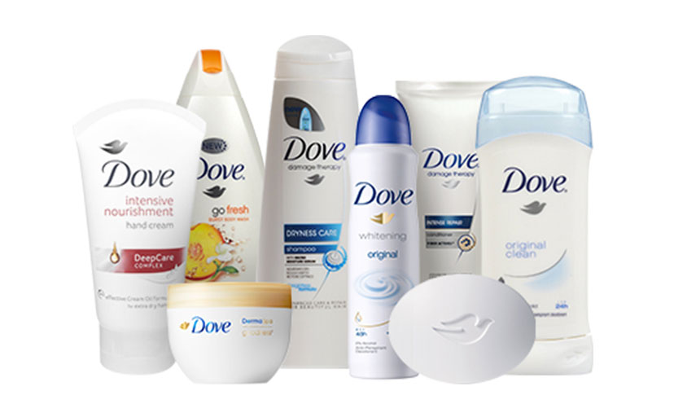
Dove is a subsidiary and its parent product are Unilever.
Dove belongs to the FMCG sector
the main USP (Unique Selling Price) of Dove is that it is a single product however it provides double impact to the skin. DOVE use to provide both cleansing as well as moisturizing of the skin. It uses to provide a huge range of that it helps the brand to make easy targets to its customers. Dove had continuously targeted customers basically women with any size, shape and colour. It always teaches and preaches women that they are not less than anyone
manufacturing of dove products includes high quality ingredients, which consists of synthetic surfactants, vegetables oils, zero level of pH, salts of the animal fats and moisturizing cream that is been included around 1/4 percent in every product.
The brand always commits to be the product that enhances the beauty of the women irrespective of their body size, colour, skin type and other attributes (Dove UK. 2019). Some of the products of dove are:

- Facial products for face care- dove deep pure face wash
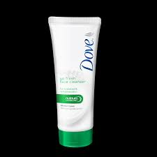

- Hair care products- Dove oxygen moisture conditioner
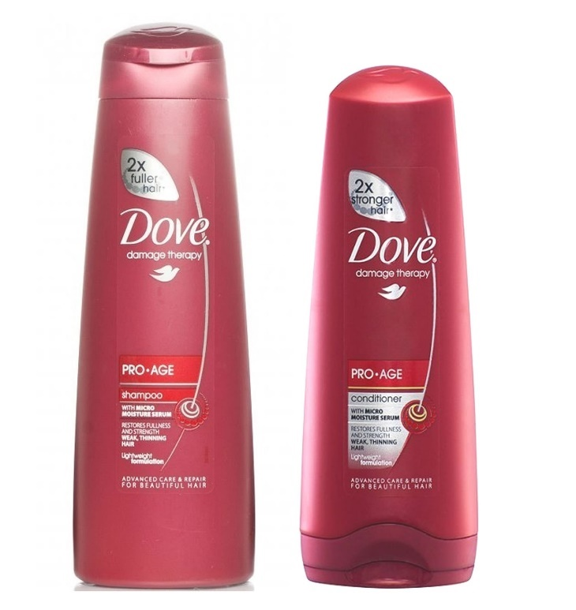

- Moisturizers and lotions - Dove go fresh bathing lotion, Dove purely pampering Shea butter and warm vanilla body lotion.
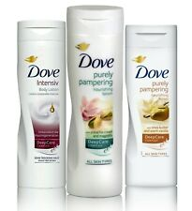
- Beauty bars- dove go fresh bathing bar, original cream beauty bathing bar
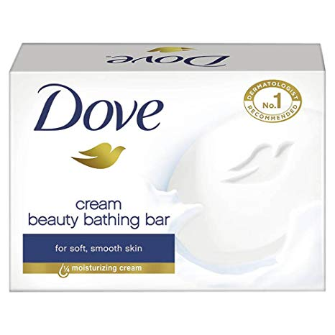
- Body wash - dove go fresh body wash Deodorants and antiperspirants- dove original antiperspirant stick
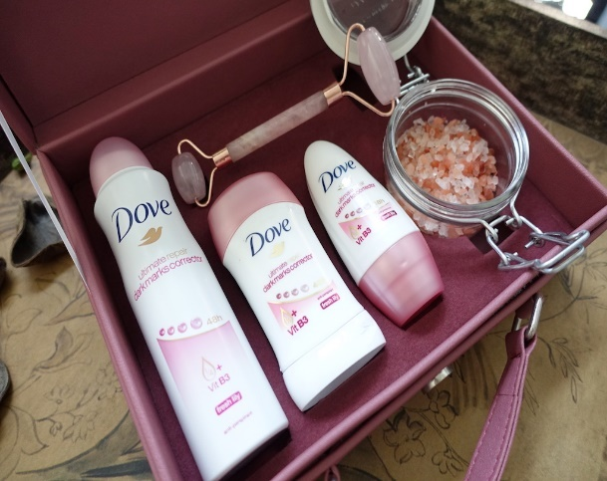

Dove is a well-known for its hair care , bathing as well as washing bars, skin care and deodorants products that is been recommended by the renowned dermatologist. Dove use to provide high quality products for its customers. Dove products always look forward to position their products in a better way than its competitors do. Dove had introduced their advance personal care and body care range all around the world that helps the brand to position itself at a better place into the market.
Dove had also looked forward to launch Derma Spa range in Europe and UK that helped the brand to gain a strong customer base. Spa experience makes the customer more satisfied as it provides more than care for the customers. Recently dove had also look forward to explore itself into the baby care range that includes the baby moisturizer, baby soap, baby shampoo and other many more that will help the brand to benchmark its products in the consumer market and will also help them to gain a competitive advantage over its rivals.
Dove use to provide a wide range high quality product and it keep introducing itself with the new products. Dove always look forward to make its products better than before so that it can add value to the customer’s life and can provide satisfaction to the customers beyond their expectations. However, the core product of Dove is the Beauty bar that had helped Unilever to extend its product line towards the high degree of success that had been achieved by the Dove. The products of Dove come in different sizes so that it can satisfy the various segments of the customers.
Dove had always looked forward to grow and develop its products so that it can gain huge amount of profit and market share in the international market as well as in Europe (Dove UK. 2019).
DOVE Prices ( Violeta Roxana Zanfir )

Dove is considered as a premium product in the market while the company has a well-developed and well-integrated pricing strategy with reasonable and affordable pricing. In order to compare with the other products,
Dove are priced a bit higher as it produces quality products while being able to implement, they are unique pricing policy successfully.
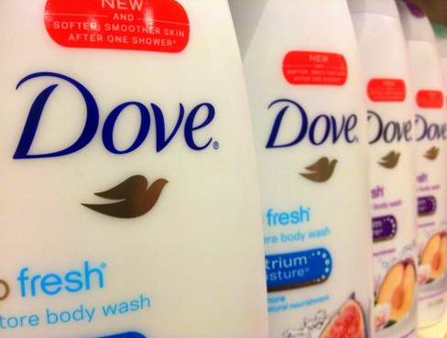

It implements a higher policy on personal care products, which help to enhance the pricing strategy for women customers. They adopt value-added pricing policy where customers relate their high price engagement with qualitative products.
Other competitors govern the price strategy in market while they were initially priced premium due to high demand of the products. In its initial stages the Dove only aimed upon the upper-class customers but after knowing of its low demand among the customers the brand reduced its pricing rate so that it can attract a better number of customers.

Dove use to offer value added pricing strategy to its customers for it overall range of products. However, the company use to offer its products at a high charge than its rivals so that the customer can know about the high quality of Dove and its attributes that will ultimately leads to the high demand of the Dove products.
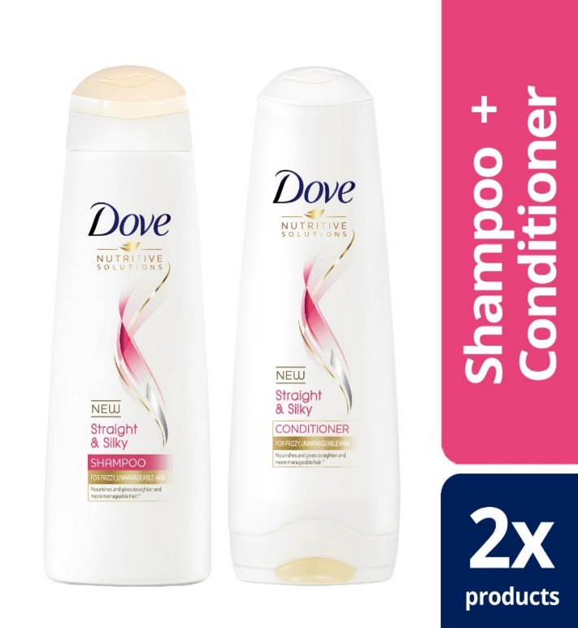
Dove uses competitive strategy for pricing. The pricing strategy of Dove is been governed by analysing the various competitors in the market so that the product can benchmark itself from its rivals and can gain a competitive advantage over its rivals.
The company always uses a well-integrated strategy of pricing so that the pricing policy is always distinctive from its competitors as well as affordable for the customers.
The product had raised the awareness among the women that Dove caters high quality products that ultimately influences the customers to pay extra for their personal care so that they can enhance their beauty and personality.
Dove always look forward to adopt the value-added strategy of pricing in order to provide quality products at relatively high prices from eth customers. However, the company choose such pricing strategy so that the products are been accessible to both upper class as well as middle class customers (my Supermarket, 2019).

DOVE Place ( Irina Bejenari)

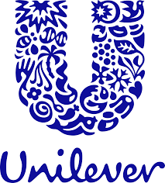

Dove is considered as an international brand by promoting its global presence. The network of Dove is well spread in the various countries like Turkey, the United State, South Africa, Pakistan, Netherland, Mexico, India, Germany, China, Canada, Australia, Argentina, United Kingdom and others.
It includes the manufacturing production efficiency to the retailers with physical stores, retail stores, discount stores, supermarkets, convenience stores, malls and hypermarkets.
It is their responsibility to develop the products, which may be available for customers at respective stores by their efficient distributing channels. It is the responsibility of the retailers, which may be available for the customers with 2500 stockists.
The dog products are sold in more than 80 countries with the distribution channel of Unilever, their parent company. Products are sent to warehouse from factory with the agent cells to stockists and retailers. Moreover, the products are bought from e-commerce sites beside the physical stores.
Their online and company websites are another place from where people can get idea and details regarding the Dove products (Dove. 2019).
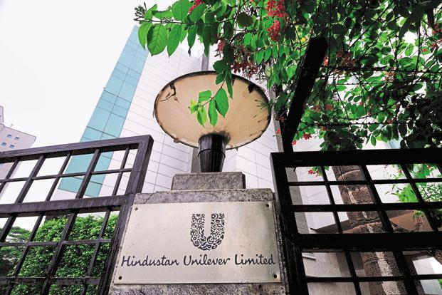

DOVE Promotion (Ioan Madalin Petrovici)

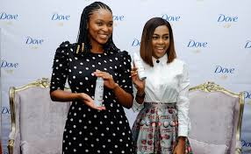

The promotion and advertising strategy of dove is unique while it is forecasted to deal with using company’s inspirational strategy to focus on women self-esteem. ‘Campaign for real beauty’ is focused to establish the self-esteem of women as high inspirational thoughts. It has strong brand awareness in the targeted market and it is important for branding and advertising.

Advertisement has its forces on reaction and emphasis after usage of the products. The ads and advertisements use real beauty for the confidence of good customer base and social development for customers. The social media including Twitter, Facebook and Instagram have created the advertising with their presence by creating a good customer base and unusual promotion and policy.
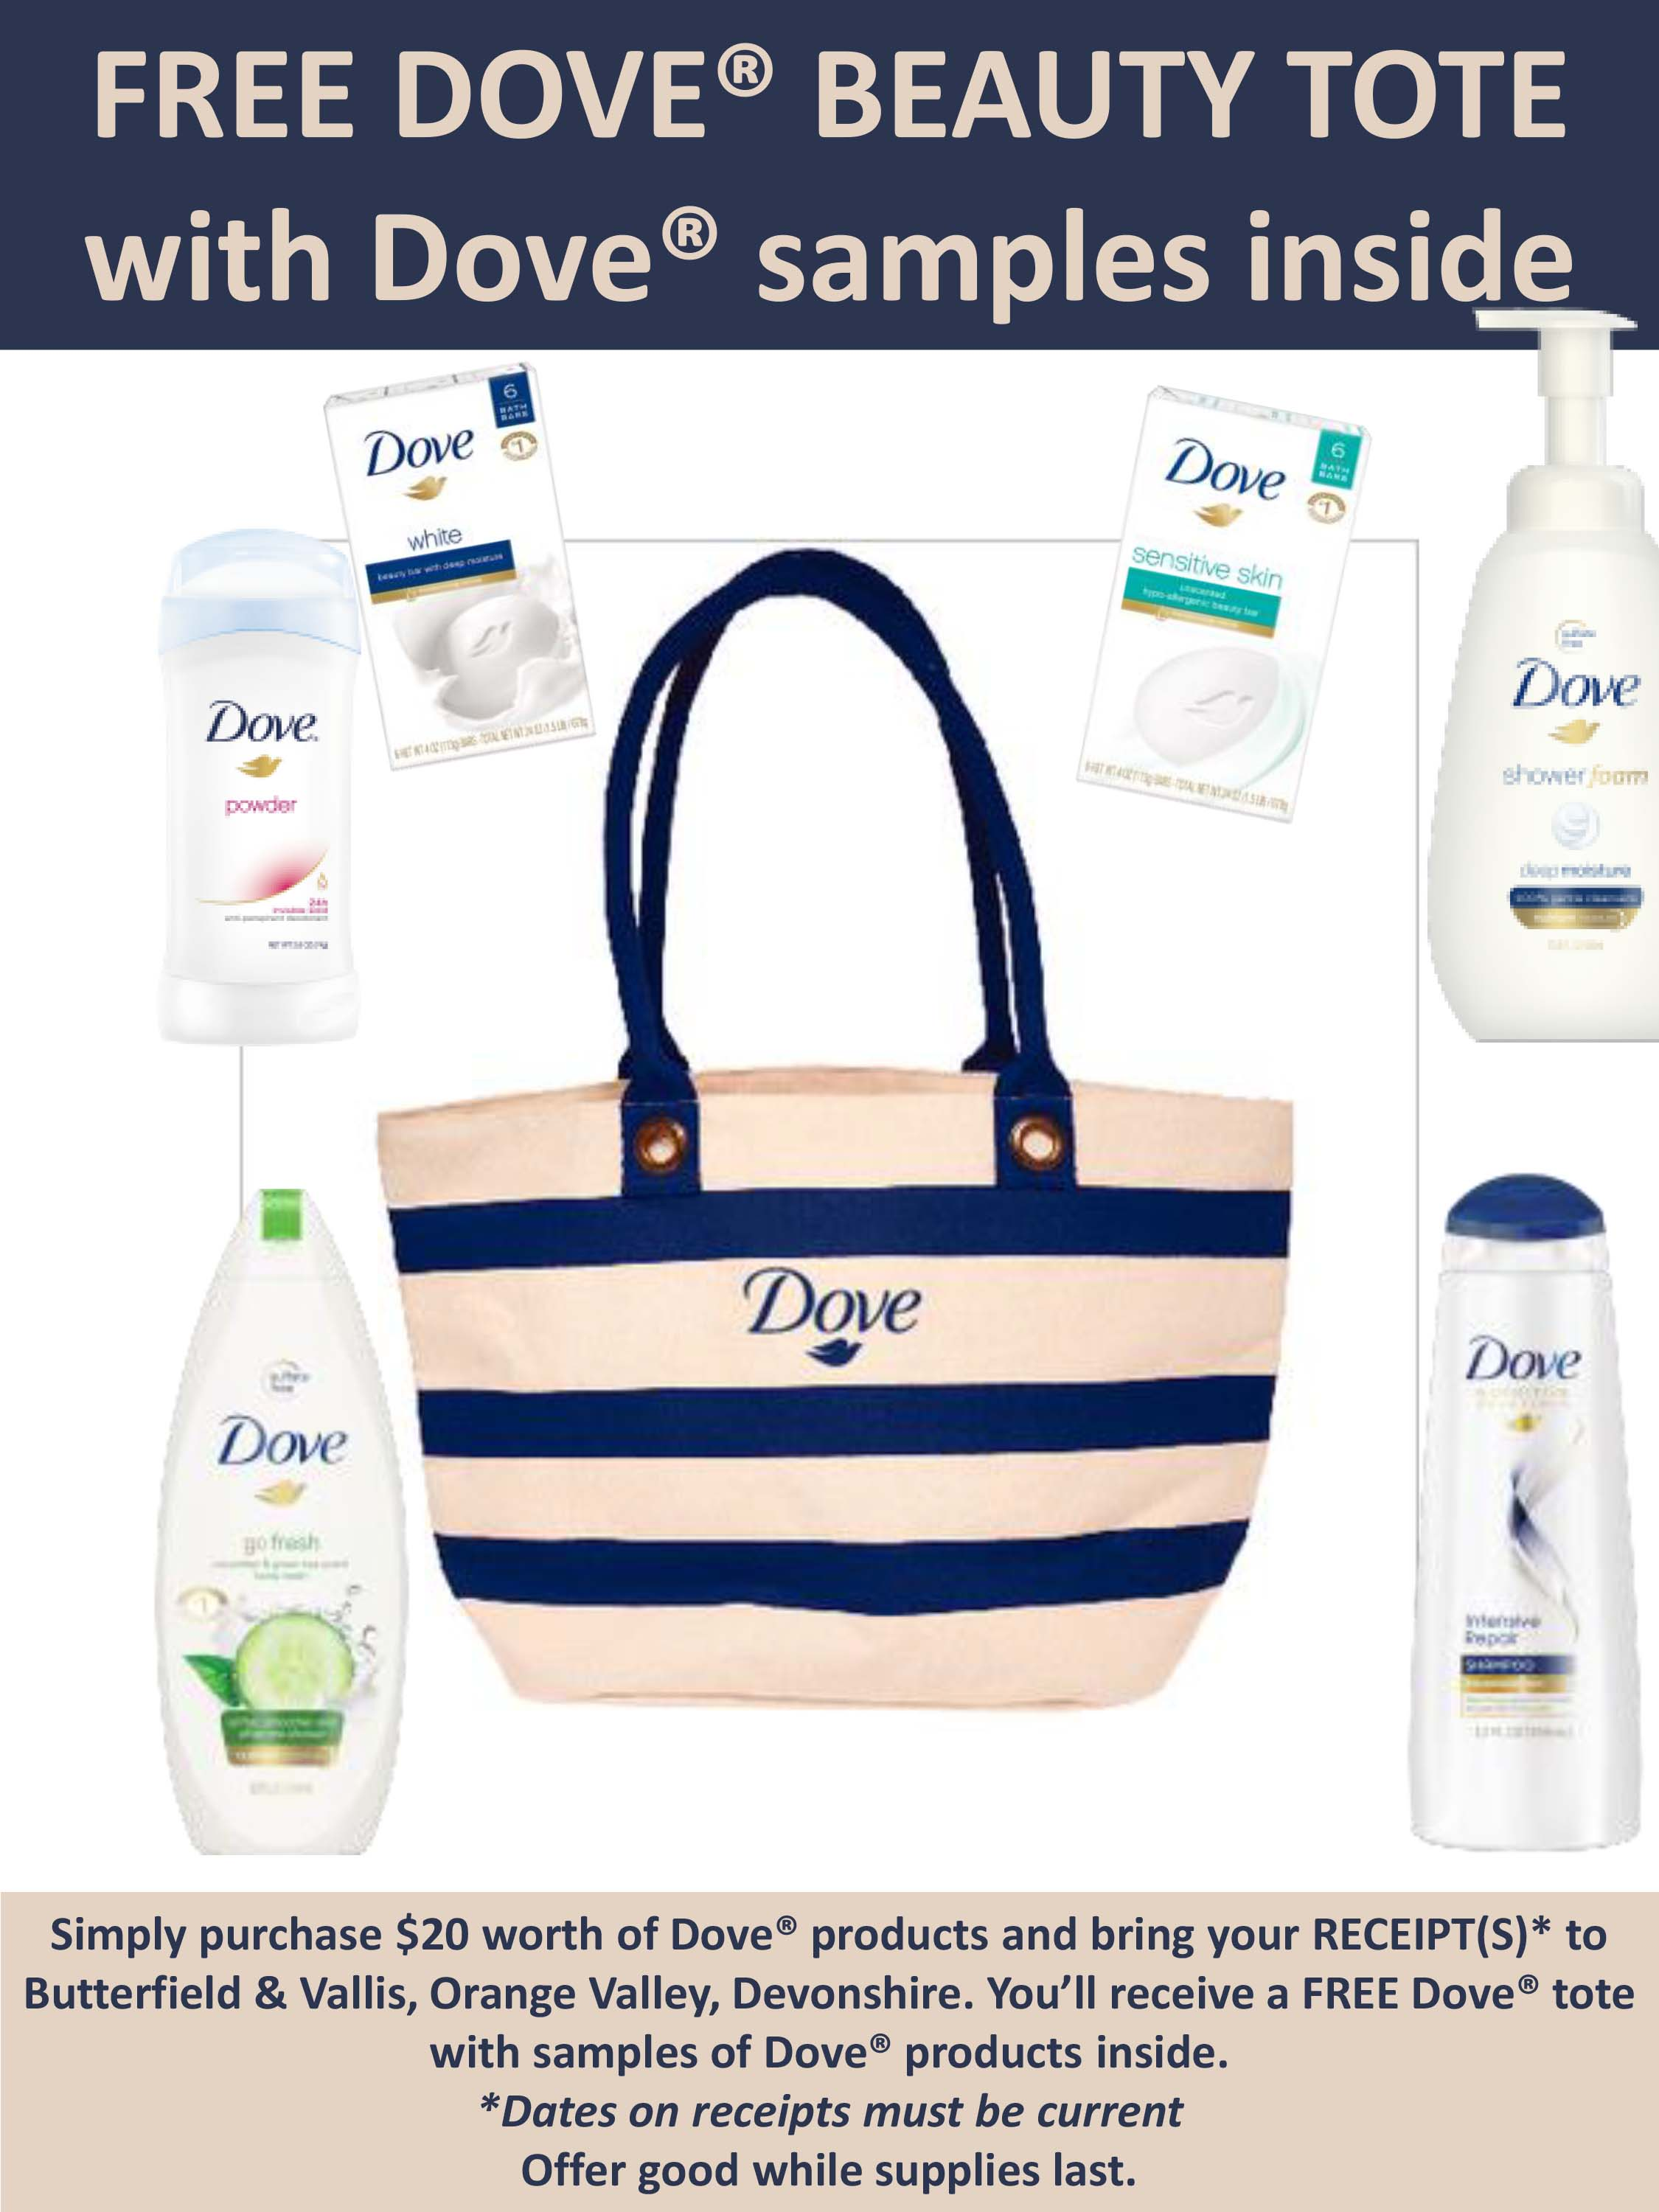

Advertisements are placed in a different role on different channels of radio, television and social media with the print media help. Marketing policies have different roles to aspire everyone about company's product. Dove uses a unique advertisement by non-models regarding beauty concept. They promote the campaign by introducing beauty is equal for the people including all body sizes, colours and age.

They used curvy women from all body shapes and colours that creates positive message regarding basic beauty concept to boost women's self-esteem. They were successful to change the concept of beauty regarding attracting customers and revolutionary campaigns regarding beauty.

Dove always uses motivational advertisements on various platforms. The company also uses many other motivates in order to motivate the women to bring positivity among themselves. The company use to endorse itself all around the world and always select the ordinary women for endorsing their products so that the women can relate with themselves. The beauty products of Dove use such strategies that the make the products inspirational for the women all around the world. Dove also took various imitative and by launching a campaign in order to combat the negative impacts of the media that exploits the women’s security as well as their self-esteem.

Dove always seeks to advertise themselves in the Cosmopolitan magazines so that women are always connected with eth product launching and its advertisements. Dove had also looked forward to establish aims to educate the girls by taking imitative and establishing a self-esteem fund. This fund helps millions of girls as well as the women to over their education related problems and the bullying by others.

Dove also established some of the evidence-based programmes that had reached around 19 million peoples in around 115 countries all over the world. Dove always uses various advertisements, promotional as well as the endorsement methods in order to create a trust worthy image of the brand among the customers.

These strategies had helped the company to break the beauty related stereotypes. The Dove had occupied a distinct image that has helped the company to increase its connection with the customers’. It had also leaded to grow its sales and gain a higher amount of popularity by targeting the real-world population (Dove UK. 2019).

Reference List

Dove UK. (2019). Contact Us. [online] Available from: https://www.dove.com/uk/secure/contactus.html (Accessed 17 Jul. 2019).
Dove UK. (2019). Dove collections. [online] Available from: https://www.dove.com/uk/collections.html [Accessed 17 Jul. 2019].
Dove UK. (2019). Welcome to Dove. UK, D. [online] Available from: https://www.dove.com/uk/home.html (Accessed 17 Jul. 2019).
Dove. (2019). Care, P. [online] Unilever UK & Ireland. Available at: https://www.unilever.co.uk/brands/personal-care/dove.html (Accessed 17 Jul. 2019).
Encyclopaedia Britannica. (2019). Unilever NV | international holding company. [online] Available from: https://www.britannica.com/topic/Unilever-NV (Accessed 17 Jul. 2019).
Ft.com. (2019). Unilever’s Dutch relocation details anger UK investors | Financial Times. [online] Available from: https://www.ft.com/content/c6188df8-b587-11e8-b3ef-799c8613f4a1 (Accessed 17 Jul. 2019).
Investor Relations. (2019). Unilever global company website. [online] Available from: https://www.unilever.com/investor-relations/ (Accessed 17 Jul. 2019).
My Supermarket. (2019). Dove Price Comparison in Tesco | Dove offers in My Supermarket. [online] Available from: http://www.mysupermarket.co.uk/brands/Dove_in_Tesco.html (Accessed 17 Jul. 2019).
Our vision. (2019). are, W. [online] Unilever UK & Ireland. Available from: https://www.unilever.co.uk/about/who-we-are/our-vision/ (Accessed 17 Jul. 2019).
Our vision. (2019). are, W. [online] Unilever global company website. Available from: https://www.unilever.com/about/who-we-are/our-vision/ (Accessed 17 Jul. 2019).
Proactive investors UK. (2019). Unilever plc Share Price - ULVR, RNS News, Articles, Quotes, & Charts (LON:ULVR). [online] Available from: https://www.proactiveinvestors.co.uk/LON:ULVR/Unilever-plc/ (Accessed 17 Jul. 2019).
Unilever Global. (2019). Unilever global company website | Unilever global company website. [online] Available from: https://www.unilever.com/ [Accessed 17 Jul. 2019].
Unilever mission. (2004). Unilever puts vitality at core of new [online] global company website. releases, P. Available from: https://www.unilever.com/news/press-releases/2004/04-02-12-Unilever-puts-vitality-at-core-of-new-mission.html [Accessed 17 Jul. 2019].
Unilever registered offices. (2019). us, C. [online] Unilever global company website. Available from: https://www.unilever.com/contact/unilever-registered-offices/ [Accessed 17 Jul. 2019].
Unilever UK & Ireland. (2019). Home. [online] Available from: https://www.unilever.co.uk/ [Accessed 17 Jul. 2019].
Unilever UK & Ireland. (2019). Who we are. [online] Available from: https://www.unilever.co.uk/about/who-we-are/ [Accessed 17 Jul. 2019].

