Name of Student: Rinkuben Akshaygiri Aparanathi

Student ID: 2221508

Name of Lecturer: Dr. Tushara Balendran

Module Name: Marketing Management

Module Code: LCMB7001

Assessment Title: Assessment – 2

Submission Date: 05/05/2023

Table of Contents
1. Introduction 2
2. Environmental Analysis of Superdry 2
2.1 External Analysis 2
2.1.1 Pestle Analysis 2
2.1.2 Conclusion of PESTEL 4
2.1.3 Porters five Forces Analysis of Superdry 4
2.2 Internal Analysis 6
2.2.1 SWOT Analysis of Superdry 6
3. The STP of Superdry 7
4. The Marketing Mix of Superdry 8
5. Competitors' Analysis of Superdry 9
6. Recommendations 10
7. Conclusion 11
8. Infographic 12
9. References 13

Introduction
Managing marketing functions in business management is critical as it allows the customers to be aware of the new product/service to assist them with buying decisions. The following report would essentially be analysing the macro and micro environmental aspects of SuperDry for identifying the critical opportunities and threats in the fashion industry market. Varied tools like PESTLE analysis, SWOT analysis, STP analysis, marketing mix strategies and more would be used for effectively evaluating the marketing concerns. Finally, the recommendations to the company would be made based on potential threats and weaknesses associated with the company.

Environmental Analysis of Superdry

EXTERNAL ANALYSIS

PESTLE Analysis
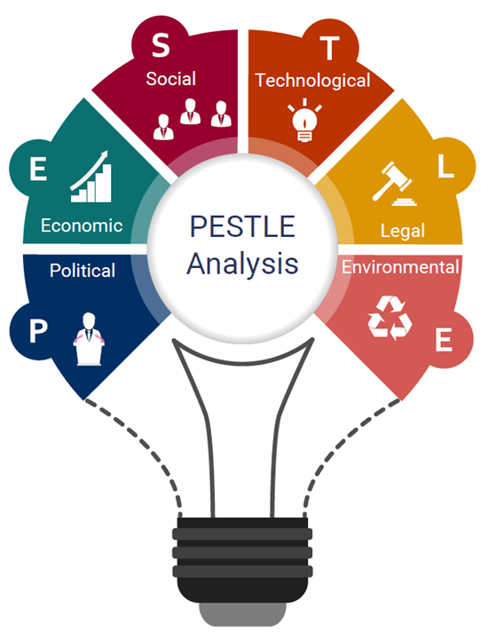
Figure 1: PESTLE analysis
Source: (IBISWorld, 2020)

Factors | Impact
Political | As a political factor, Brexit would impact the operations of Superdry in the UK. Clearly, the Post-Brexit has been impacted by various challenges i.e. higher trade costs, reduced sales etc. Moreover, 5% VAT charges would influence Superdry with its operations cost management. Thus, Political factors might be a threat to Superdry (Hammer and Plugor, 2016).
Economical | The minimum wage rate in the UK is £9.18 per hour which is higher than most of the markets where Superdry operates. Also, PPP (Purchasing Power Parity) in the UK is 44978.71 USD which shows the higher purchasing power of the UK customers (The Global Economy, 2022). Thus, economic factors would be opportunistic for Superdry.
Social | The UK customers are highly educated and they understand the sense of fashion. UK people like fashion which has the traditional touch and is super comfy and fast fashion is trending in society. Thus, societal factors would be opportunistic for Superdry as it has a blend of American and Japanese styles that would surely fulfil societal needs (Niinimäki et al., 2020).
Technological | The Garment business is revolutionizing as technology is being adopted by manufacturing businesses. Big data, digital marketing, data analytics, AI (Artificial Intelligence), RFID technologies etc. are trending in the textile industry. Superdry has adopted industry 4.0 technologies thus it would favourable factor (Jia et al., 2020).
Environmental | Sustainability creation is the major factor that impacts the fashion industry. For instance; transportation CO2 emissions, and reducing carbon footprints would be major challenges to Superdry. The Environment Protection Act, of 1990 would influence the operations of Superdry due to various material usage i.e. leather use. This might be a challenging but opportunistic factor for Superdry.
Legal | In the UK, critically the Consumer Protection Act and Equality Act would influence the operations of Superdry. UK government is especially very strict with its laws i.e. Health and Work Safety Act, 1974 would be unfavourable and challenging for Superdry (Knudsen, 2018).
Table 1: PESTLE analysis
Source: (Jia et al., 2020; Niinimäki et al., 2020)

Conclusion of PESTEL
The PESTLE analysis indicates opportunities and threats to Superdry with their functions in the UK. Critically, political and legal factors are the major barriers to effective functions of Superdry i.e. the VAT and work and consumer regulatory policies could influence the business performance. Moreover, economic, social, environmental and technological factors would be opportunistic for the company as they would assist Superdry to evolve while improving its sales and making a better position in the market.

Porters five Forces Analysis of Superdry
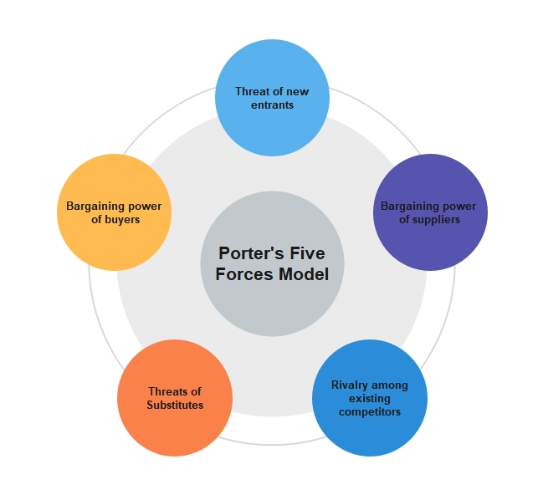
Figure 2: Porter’s Five Forces Analysis
Source: (Thorisdottir and Johannsdottir, 2019)
Threats of new entrants (Low): Particularly in the fashion and clothing industry, the threat of new entrants is low due to higher capital requirements and the cost of inventory, marketing, real estate etc. Superdry would be advantageous as the company won’t have any major threats from new rivals in the luxury fashion industry (Thorisdottir and Johannsdottir, 2019).
Bargaining power of suppliers (Moderate): The bargaining power is moderate due to a large number of vendors available in the clothing industry. However, Superdry being a luxury fashion retailer, the company have certain and limited quality vendors which make bargaining power moderate in the industry. Superdry needs to strategically manage its suppliers (Thorisdottir and Johannsdottir, 2019).
Bargaining power of buyers (High): The bargaining power of buyers in the clothing industry is high due to the many brands available in both offline and online marketplaces. The customer can find greater deals and compare prices, designs, cloth etc. Thus, it is challenging for to Superdry of gaining a loyal and honest customer base (Ruiz-Fernández et al., 2021).
Threats of substitute products (Moderate): A range of substitute products are available i.e. fast fashion and vintage clothing. However, Superdry is targeting the market uniquely by blending products from traditional American wear with Japanese-style graphics. This could be opportunistic for Superdry to better position itself.
Rivalry among competitors (High): The fashion industry is led by varied players and brands. Superdry would get impacted due to higher rivalry in the industry as there are many brands like ASOS, M&S, and H&M etc. offering equivalent products (Ruiz-Fernández et al., 2021).

INTERNAL ANALYSIS

SWOT Analysis of Superdry
Strengths | Weaknesses
- Superdry is catering to varied customer segments in the retail segment with multiple selling platforms.  - The spirit of Japan and the mainly merged cultural style differentiates Superdry.  - The strong brand recognition of Superdry in Asian and Western markets.  - Superdry has a competitive edge with its product depth, international growth potential and innovation. | - Superdry has a lack of focus on women's clothing which reduces its customer base.  - The compensation structure of Superdry is irrelevant as revenue per employee is higher than the retail industry average.  - The lack of clear differentiation of products acts as a major weakness of Superdry.
Opportunities | Threats
- Superdry has the opportunity to focus on new segments like sportswear and fashionable gym clothing.  - Through technological innovation and focusing on intensive content marketing, Superdry could enhance its positioning in the market. | - Competitor threats are inevitable in the fashion industry that would disrupt the business performance of Superdry.  - Changing the political climate in the UK due to Brexit would be a barrier for Superdry with its relevant strategies.
Table 2: SWOT analysis
Source: (Pandey et al., 2020; Prarup, 2020; Superdry, 2023)

The STP of Superdry
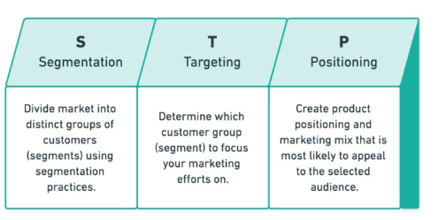
Figure 3: STP analysis
Source: (DeSarbo, 2017)
Segmentation: Superdry has segmented its customers into distinct groups of audience. Mainly, the segmentation of Superdry customers is made based on geographic and demographic segmentation. Geographically, Superdry focuses on people living in suburban areas with age 25 and more where fashion is considered by the young. Demographic segmentation is made on focusing on upper-middle-class people with higher incomes that can afford luxurious Superdry clothing products (DeSarbo, 2017; Superdry, 2023).
Targeting: Superdry makes its targeting strategy based on profitability, size and reachability. Since Superdry is a male-focused company thus it has major target market is males around the globe. Critically, young males with 25-34 are targeted with fast fashion products. Significantly, Superdry has 50.87% Male and 49.13% of female customers with upper-middle-class customers as a preferable focus (Similar Web, 2023b).
Positioning: Superdry has a distinctive brand positioning strategy as the company follows a unique approach. Superdry positions itself as a stylish brand that changes customer personality and make them feel more confident. Superdry makes itself unique through its cultural blend uniqueness in the DNA of every product (DeSarbo, 2017; Superdry, 2023).

The Marketing Mix of Superdry
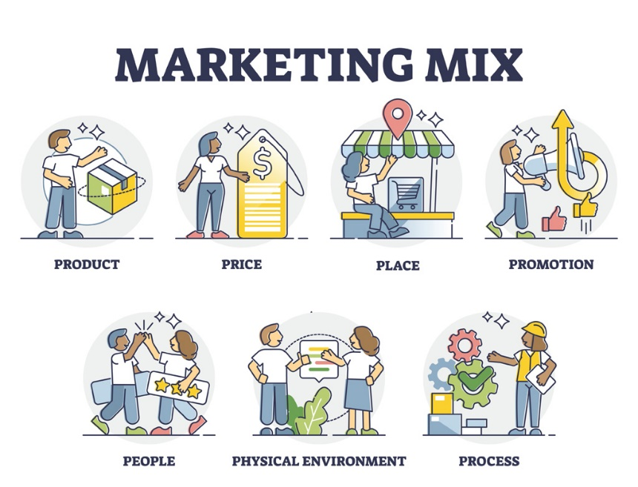
Figure 4: Marketing Mix of Superdry
Source: (Darmawan and Grenier, 2021)
Product: In order to better serve the target market, an entirely novel sustainable product line for apparel and other items could be developed. Aside from that, Superdry's goods should be based on market service and interest to better bridge the market gap.
Price: A competitive pricing approach may be used to enter the market for new sustainable products. Specifically, the pricing strategy would assist Superdry in effectively attracting potential market participants and focusing on niche markets (Darmawan and Grenier, 2021; Superdry, 2023).
Place: The target market would be offered sustainable apparel goods via Omni channel aid. People will be able to obtain things through mediums such as internet website sales and physical store selling.
Promotion: Traditional media techniques, traditional advertising, and online advertising strategies would be used to better capture the target market for successful promotional methods. Platforms like Twitter, Instagram, and Facebook would be used.
People: Superdry staff would be taught and developed through training sessions. Employees would primarily be taught customer management tactics to strengthen client interactions (Darmawan and Grenier, 2021; Superdry, 2023).
Process: To render Superdry operations sustainable reliable vendors in the UK marketplace would be contracted, and regional vendors would be contacted. To better service the company operations, the JIT (Just In Time) approach would be used.
Physical evidence: For this, Superdry would use paper bags, and recycled materials to be more sustainable with their packaging. Also, with every purchase Superdry would provide digital receipts, a Superdry customer club card etc. (Darmawan and Grenier, 2021; Superdry, 2023).

Competitors' Analysis of Superdry
The fashion industry in the UK is led by many players and clothing brands that could be a major threat to Superdry. The main competitors of Superdry are Supreme Clothing, ASOS Plc, and Next Plc. and more. The fashion industry is highly competitive as major competitors are consistently using new technologies and advanced tools for making their brand count in the market. With the intensive competition, Superdry positions itself with 728 country rank in the UK (Similar Web, 2023a). However, Superdry has no evident market share in the UK and the globe which makes it less competitive in the market. Superdry only deals with jackets, T-Shirts, hoodies etc. whereas its competitors like ASOS.com deals with the latest fashion trends with routinely new collection of clothing and other products.
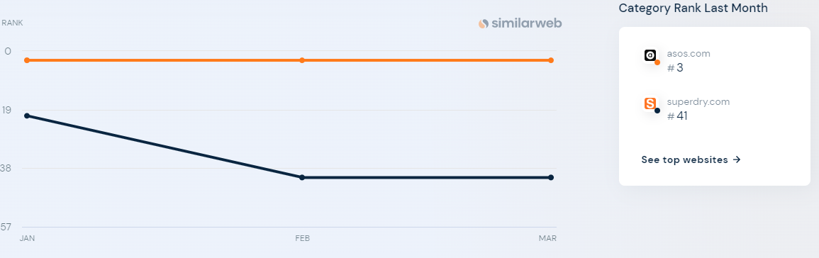
Figure 5: UK ranking comparison of Superdry with ASOS
Source: (Similar Web, 2023a)
The aforementioned figure indicates that Superdry has a market position of 41st rank in the UK whereas ASOS stands at 3rd rank. Moreover, the traffic share by a country index is higher for ASOS with 92.7% share and Superdry stagnant at 7.27% (Similar Web, 2023b). Thus, the margin is higher and surely Superdry suffers from the competitive impact in the market. Superdry has irrelevant strategies that make the brand to be less competitive such as a major focus on the male market, lesser competitive products, the absence of fast fashion which is trending, effective marketing strategies and more imposing problems Superdry effectively competes in the UK and world markets. Broadly, the rise of digitalization and brand awareness are the major concerns of Superdry.

Recommendations
Through the analysis, it is recommended to Superdry for using some market strategies to enhance its positioning in the competitive market. Superdry must use Ansoff matrix strategic tool to make relevant strategies which involve:
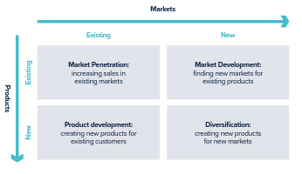
Figure 6: Ansoff Matrix
Source: (Clarissia, 2020)
It is suggested that Superdry should adopt "Product Development" strategies as the company loses its market and has very less loyal customers. Simply, through product development, the company would focus on creating new products for existing customers (Clarissia, 2020). For this, Superdry should focus on the fast-fashion market and come up with new trendy clothes to attract Gen-Z and Millennial customers. Also, it is recommended to Superdry that the company should start emphasizing women's clothing and apparel to enhance its market opportunities. Moreover, adapting extensive digital marketing abilities would Superdry to make its position better in the market. Social media, content, and SEO marketing could be the major marketing tool that Superdry could consider.

Conclusion
From the analysis and discussion, it is found that managing marketing in the contemporary business environment is a complex process that impacts business performance. Critically, this report has discussed the core concerns of Superdry, a clothing retailer based on macro and micro environmental analyses. The issues like losing the target market, no attractive products, men-centric clients etc. were found that are impacting the business performance and finally, recommendations were made to Superdry as using Ansoff strategies for improvising its marketing position.

Infographic
Figure 7: Poster; Source: By Author

References
Clarissia, S. M. S. (2020) ‘A study on Ansoff Matrix Technique: As a growth strategy and an adaptive learning technique adopted in the leading brand of products’, BIMS Journal of Management, 18(3), pp. 56-63.
Darmawan, D., and Grenier, E. (2021) ‘Competitive Advantage and Service Marketing Mix.’ Journal of Social Science Studies (JOS3), 1(2), pp. 75-80.
DeSarbo, W. S., Blanchard, S. J., and Atalay, A. S. (2017) ‘A new spatial classification methodology for simultaneous segmentation, targeting, and positioning (STP analysis) for marketing research. In’ Review of marketing research, pp. 75-103.
Hammer, N., and Plugor, R. (2016) ‘Near‐sourcing UK apparel: value chain restructuring, productivity and the informal economy’ Industrial Relations Journal, 47(5), pp. 402-416.
IBISWorld, (2020) How to Conduct a PESTLE Analysis Available at: https://www.ibisworld.com/blog/3-step-pestle-analysis/99/1127/ (Accessed: 1 May 2023)
Jia, F., Yin, S., Chen, L., and Chen, X. (2020) ‘The circular economy in the textile and apparel industry: A systematic literature review’ Journal of Cleaner Production, 259(2), pp. 120-128.
Knudsen, J. S. (2018) ‘Government regulation of international corporate social responsibility in the US and the UK: How domestic institutions shape mandatory and supportive initiatives’, British Journal of Industrial Relations, 56(1), pp. 164-188.
Niinimäki, K., Peters, G., Dahlbo, H., Perry, P., Rissanen, T. and Gwilt, A. (2020) ‘The environmental price of fast fashion’ Nature Reviews Earth & Environment, 1(4), pp. 189-200.
Pandey, S., Pandit, P., Pandey, R., and Pandey, S. (2020) ‘Marketing Strategies for Upcycling and Recycling of Textile and Fashion’ Recycling from Waste in Fashion and Textiles: A Sustainable and Circular Economic Approach, pp. 253-275.
Prarup, G. (2020) To work on various methods to increase the sales on Superdry India website. NIFT.
Ruiz-Fernández, L., Rienda, L., Marco-Lajara, B., and Seva-Larrosa, P. (2021) ‘Quantitative analysis of the fashion industry comparing Spanish and British small and medium-sized companies’ Firms in the Fashion Industry: Sustainability, Luxury and Communication in an International Context, pp. 67-86.
Similar Web, (2023a) Competitive analysis of Superdry Available at: https://www.similarweb.com/website/superdry.com/#geography (Accessed: 26 April 2023)
Similar Web, (2023b) Superdry target market (Online) Available at: https://www.similarweb.com/website/superdry.com/#:~:text=superdry.com's%20audience%20is%2050.87,34%20year%20olds%20(Desktop (Accessed: 28 April 2023)
Superdry, (2023) About us Available at: https://www.superdry.com/about-us (Accessed: 29 April 2023)
The Global Economy, (2022) UK GDP per capita, PPP Available at: https://www.theglobaleconomy.com/United-Kingdom/gdp_per_capita_ppp/#:~:text=GDP%20per%20capita%2C%20Purchasing%20Power%20Parity&text=The%20latest%20value%20from%202021,to%20compare%20trends%20over%20time (Accessed: 30 April 2023)
Thorisdottir, T. S. and Johannsdottir, L. (2019) ‘Sustainability within fashion business models: A systematic literature review’ Sustainability, 11(8), pp. 2233-2238.

