Qualification: CIPD Diploma in Applied Human Resources

Module Name: Contributing to the Management of Change

Word Count: 2907

Student Name: Stephanie Rayner
Student Number: 1907192
CIPD Membership Number: 55478507

By signing below, I confirm that the work/evidence presented is my own, unaided work. I understand the regulations pertaining to candidate malpractice and the action that may be taken as a result.

Signed:

Date: 25th January 2021

Contents Page

Title | Page Number
 | 3-5
  Be able to plan for the implementation of change processes within an organisation
Evidence | 6-29
 | 30-31
  Be able to implement a change plan
Evidence | 32-44
 | 45-46
  Be able to assess the impact of change processes within an organisation
Evidence | 47-53
Evidence Matrix | 54-56
Bibliography | 57-58

Contributing to the Management of Change

Be able to plan for the implementation of change processes within an organisation

Establish the need, objectives and potential benefits in relation to a specific change requirement.

According to (CIPD, 2020), change is constant and as such, organisations need to carefully consider ways in which change is managed, ensuring those leading on change are provided with the relevant advice and support. Whilst there may be many factors driving change, it is important to maintain commitment from the workforce throughout the process and following implementation.

Within my role as HR & OD Business Partner, I am required to act as the HR lead during Organisational Reviews and Restructures. An example of which being a requirement to review the staffing structure and model of delivery in relation to Education other than at Schools (EOTAS). The main driver for change was identified as a result of a proposed new build, due to open on 1st January 2021 with the aim to ‘ensure the future provision best meets the needs of vulnerable young people’. A report was considered by Cabinet in September 2019, (EV1) detailing context around the need for change, identifying budget implications in relation to staffing and the benefits of the proposals. Following approval, discussions commenced regarding the process, (EV2), and I drafted a consultation timeline outlining the required considerations throughout the process (EV3) all of which are in line with the principles set out by Swansea Council regarding consultation, (EV4).

Analyse who will be affected by the changes and their potential information and support needs.

During the initial discussions, we undertook an analysis of the current workforce and the future requirements identifying ‘pools’ of staff and individuals who were potentially affected by the change, (EV5). The appropriate methods of communication were considered to ensure staff were provided with the relevant support during the process. It is best practice within Swansea Council to engage Trade Unions from the outset and as such, a briefing meeting was arranged with Trade Unions prior to meeting with individuals which was then followed by a full staff meeting, (EV6). This being in line with (Personnel Today, 2011-2020) outlining the importance of any change process having a structured approach with clear communication channels.

With regard to the information and support provided to staff, during the individual/team meetings, I outlined options and support available for consideration, followed up via email attaching information leaflets in relation to the Occupational Health and Stress Management Service. In addition, clear channels of communication was confirmed providing staff with the opportunity to comment/feedback on the proposals and the offer of a further 121’s with HR and/or Management, (EV7). This approach encouraging open dialogue with staff providing clear and consistent messages regarding the proposals which is key for employees understanding and engagement of any change initiative, (People Management, 2017).

Identify the resources required for the change and how these will be made available

An effective change management process requires dedicated resources and funding including a Project Team consisting of experienced, flexible, ambitious and collaborative individuals. A Project Lead should be appointment with the strategic understanding of the project and access to the appropriate funding requirements. Organisations are encouraged to dedicate the appropriate resources to the project to achieve the desired outcomes, (Prosci, 2020).

During the EOTAS restructure, the Project Team was defined from the outset with Director or Education identified as the Programme Sponsor. The Manager of the Service was appointed as the Project Manager with the necessary knowledge and experience in relation to both the new build and staffing to lead the change process. Due to the staffing implications, it was not appropriate to appoint any employee’s onto the Project Team and as such, dedicated resource was provided from HR including myself as the Lead and a HR Advisor who were available to provide advice and support throughout the process. A cost comparison exercise was undertaken identifying the budget implications, (EV8), which was also detailed within the Cabinet report, (EV1).

Devise a plan, including objectives, actions and timescales for implementing the required change.

According to (SHRM, 2021), during a change process, HR carry out a number of functions linked with the communication, implementation and tracking of the change initiative. HR are also the point of contact for employees, providing the opportunity for questions and concerns and outlining the implications on staffing.

As evidenced within (EV7), staff were advised of contact details for both myself and a HR Advisor who were available to provide support during the change process. I was also present during the initial consultation meetings outlining staffing implications.

During the restructure, I supported the Project Lead in devising a project plan, (EV9) detailing the Project Team, Stakeholders, methods of communication, action points and timescales for implementing the required change. I was not involved with communication regarding parents and young people however, (EV10) clearly outlines the communication undertaken during the process. Due to the varied terms and conditions of staff within EOTAS, an important factor for consideration were the required timescales as set out within Teachers terms and conditions, (EV11). Failure to meet the timescales could have resulted in a delay in implementing the changes and potential budget implications.

Communicate the change plan, and gain agreement for its implementation, from decision maker

There was a requirement to gain approval from the EOTAS Steering Group to commence the change process regarding the proposed restructure, (EV12). Following which informal discussions took place between myself and the project lead to discuss the process in relation to implementation and it was agreed to proceed with consultation as set out within the project plan, (EV13). Consultation meetings were arranged with Trade Unions and Staff to discuss the proposals and potential implications to staff, (EV14).

Due to Covid-19, CMT made a decision to postpone employee relations cases and as such, letters were issued to staff advising them that the consultation process was put on hold, (EV15). Final approval was obtained from CMT in September 2020, (EV16), resulting in a further meeting being arranged with Trade Unions to recommence the process, (EV17). This was subsequently followed up in writing to staff advising them of the recommencement of the process, (EV18).

Due to the circumstances as a result of Covid, I produced an updated proposed timeline which was included within the presentation issued to staff following the decision to recommence consultation, (EV19).

In addition to the evidence during the process, confirmation has been received from my Principal Officer detailing the complexity of the process the requirements of my role as the HR Lead, (EV20).

LO1 - Evidence

EV1
Review of EOTAS Services in Swansea - Report for Consultation – September 2019
1. Introduction
• Education Other than at School (EOTAS) operates as a central local authority service to make educational provision for children with social, emotional behavioural, medical or other issues who, without its provision, cannot access suitable education. It allows children who have been excluded from, or have otherwise disengaged from, their registered school to participate in education until they are prepared for re-entry to an existing school place, achieve a new school place or to maintain their education until compulsory school leaving age.
• The current rationale for review is to achieve the planned proposals approved by Cabinet in December 2016. In doing this, consideration has also been given to:
-changing local, regional and national priorities
-curriculum reform
-growing demand for EOTAS provision – nationally and locally
-additional learning needs (ALN) reform
-greater alignment of service delivery
Purpose
Report on new staff structure required as part of the overhaul of the model of service delivery provided by the Behaviour Support Unit and Pupil Referral Unit in relation to pupils who are Educated Other Than at School (EOTAS)
Content
Briefing note on proposed review of staff and delivery of EOTAS services to Swansea schools and within the local authority.
Report Author
Amanda Taylor, Headteacher of Swansea PRU and Head of Behaviour Support Unit

Current structure July 2019
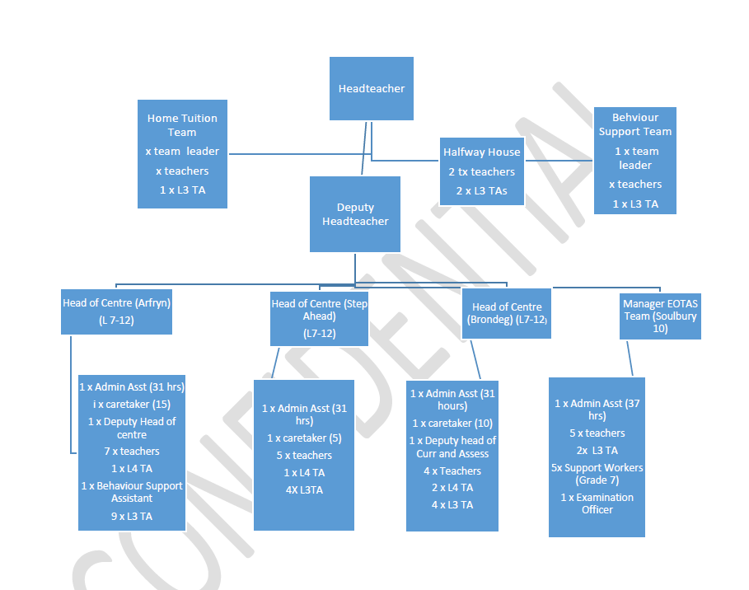
On the basis of an agreed staff:pupil ratio of 2:7, i.e. 1 teacher and 1 L3 TA to 7 pupils, the current structure supports the provision for:
• 21 pupil places at Primary Arfryn
• 28 planned pupil places at KS3 Arfryn
• 28 planned pupil places at Step Ahead
Whilst there are currently 60 planned places at KS4 Brondeg, there is a need for a higher staff:pupil ratio. However, there are less staff as the centre works in partnership with external providers to be able to offer a broader range of curriculum and vocational subjects.
Total Places – 137
The proposed new build is designed in keeping with Cabinet approved proposals to offer:
• 21 pupil places at Primary SEBD (Social, Emotional and Behavioural Difficulties)
• 28 planned pupil places at KS3 SEBD
• 35 planned pupil places at SEMH (Social, Emotional and Mental Health)
• 50 planned places at KS4 SEBD
• 14 planned places at Halfway House
Total places – 148 (158 if no reduction in planned places for KS4 Brondeg 2019/20
Cabinet approved proposals in December 2016 were to reduce five places per year to 50 planned places. Whilst there has been a reduction year on year in planned places offered at Brondeg, from an initial 75 to the current 60 in line with the proposals, it is potentially difficult to realise further reductions without placing significant pressures on schools. This is as a result of the national and local context of increasing numbers of KS4 pupils requiring EOTAS/PRU provision. There are also additional pressures being placed on the PRU as a result of the commitment of SSD to the repatriation of pupils from Swansea, who are currently looked after and placed out of county. Further pressure is being recognised locally and nationally as a result of an increasing number of pupils, from out of county, being placed in privately run residential homes in Swansea and requiring specialist educational provision.

Context for Change
Following a review of EOTAS provision in Swansea in 2016, options were considered by Cabinet in order to extensively overhaul the entire education other than at school (EOTAS) service in Swansea to ensure future provision best meets the needs of vulnerable young people. As an outcome of this process, a final model was agreed. The model for provision was based on the following key recommendations:
*italics denote actions already achieved
• The need for a more cohesive approach to working with children and young people who needed, or were at risk of needing EOTAS services and that all professionals involved needed to communicate more effectively with each other.
• More emphasis on pupils being reintegrated back into mainstream schools – re-integration figures have increased over the last 2 years
• Development of a leadership structure – Appointment of Head of PRU and Deputy Head of PRU in 2017and re-organsiation of middle leaders to create strong leadership – judged as good by recent Estyn Inspection
• Devolved funding to secondary – Full £700K devolved annually to secondary schools based on agreed formula and Memorandum of Agreement. Monitoring reports collated annually.
• Reduction in places at Arfryn and Brondeg – This has reduced from 131 – 109 currently. A reduction of 7 places has been made from the Primary Provision and 15 places from KS4 Brondeg.
• Focus on early identification and appropriate intervention – the draft strategy has a greater emphasis on early identification and prevention and the proposed staffing model supports the realisation of the strategy.
• Support should be established, with improved infrastructure with built-in accountability
• Continue to provide a centrally co-ordinated service that will be more flexible to the needs of a small number of our most vulnerable children and young people - the draft Behaviour strategy is focused on delilvering on this and the proposed staffing model supports the realisation of this. See diagram below
• An effective package of support to address learner and the family needs (which will involve a co-ordinated response from all professionals within the Directorate) – Work to align the activity of the Support Work Team based within the PRU has commenced and partnership with Social Services colleagues has been agreed to support a uniform approach to family assessment and interventions using the Signs of Well-Being and the Well-being framework.
• Two new teams (Expert Team around the Child (ETAC) and the Rapid Intervention Team (RIT)) should be established as part of a graduated response to provide targeted early intervention in supporting learners and families at risk of becoming in need of EOTAS services. Uncertainty as to what these teams would look like, but the remit of the Halfway House, Prevention and Early Intervention Team (PEIT) and Support Work Team should realise the key aims.

Vision and Values
• There is a clear and articulated commitment to the success and well-being of every learner in Swansea, so that every child and young person gains the skills and qualifications that they need to succeed in life. This is supported by a recognition for and a commitment to ensuring a joined up, integrated approach to create a continuum of support for all learners, regardless of background or personal circumstance.
• To develop and embed the core purposes as identified by Professor Donaldson in his report on the Curriculum and Assessment Arrangements in Wales
• Our expectation is that all children and young people will experience a safe, nurturing, positive and engaging learning environment. For some of our young people, we recognise that the key to achieving those ambitions requires a collaborative focus across all of our public services.
• Our values of equality, inclusion and the rights of the child underpin all of our work with children and young people. Effective partnerships will be developed both within the Council and across the wider community, to seek and expect the highest standards and aspirations for all children and young people so that every person in Swansea can achieve his or her potential.

4 Key Principles
Swansea City Council is committed to the following principles:
• To educate the whole child, develop their personal and social skills and ensure that their own well-being and that of others are maximised
• To provide safe and stimulating learning environments for all children and young people that enable them to reach their full potential and become successful learners, effective contributors, responsible citizens and confident individuals
• To ensure children and young people have regular opportunities to develop an understanding of their rights and responsibilities
• To develop a desire in all children and young people to participate positively and contribute at all times.
• To develop an awareness of consequence in children and young people
• To ensure early, timely and preventative interventions, based on a proportionate assessment of need.
• To ensure that the voice of children, young people and their families is integral to all work
• To develop approaches that are person centred and which take a strength based resiliency approach whilst recognising risks such as adverse experiences

The Broad Behaviour Strategy to deliver the Cabinet agreed proposals:
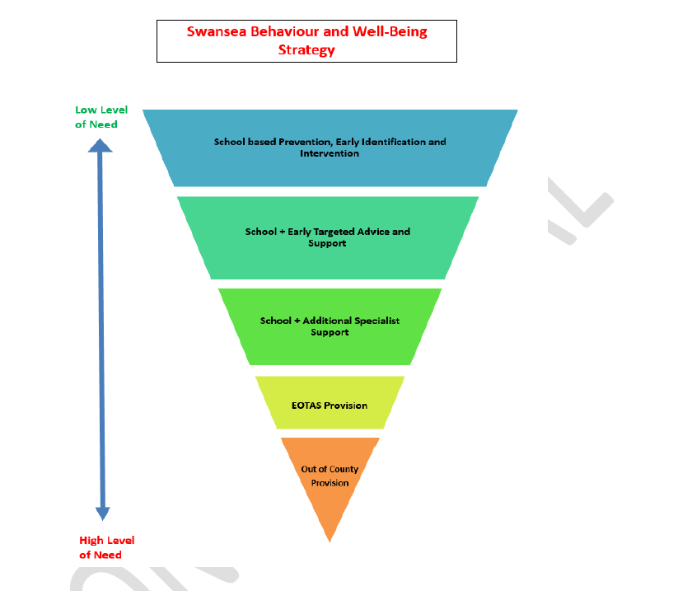

School Based Prevention, Early Identification and Intervention
• Universal provision
• Self-evaluation toolkit
• Internal capacity building via training programme to include:
-on-line training
-School/Cluster training
-Centre based training
-Emotional Literacy Support Assistant (ELSA) – delivered by an educational psychologist (EP) from within Prevention and Early Intervention Team (PEIT)
7
School + Early Targeted Advice and Support
• Specialist advice and support accessible via phone/on-line/drop in surgeries to support schools identification/ intervention/sign-posting via PEIT Team
• Targeted bespoke capacity building delivered via PEIT Team
• Targeted training for schools/key staff
• ELSA in schools
School + Additional Specialist Support
• Behaviour Support Team (BST)
• Half-Way House
• Managed Move
• Secondary based specialist provision (funding devolved)
• ALN Team including the Educational Psychology Service (EPS)
• Delegation of funds to secondary schools to support learners with SEBD aged 14-16
• Child and Adolescent mental health Services (CAMHS)
EOTAS Provision
• PRU – Halfway House for part-time, short term intervention
• PRU - Clear pathway towards full re-integration
• PRU - limited opportunities for re-integration
• Home Tuition
• Bespoke multi-agency package

Process followed to reach the proposed option:
The EOTAS Steering Group was formed out of the Intervention Board, with a remit to oversee the impelmentation of the proposals agreed by Cabinet in December 2016. As such, the Staffing and Leadership Group of the EOTAS Steering Group was tasked with working on staffing structure proposals to realise the ambitions set out in the initial proposal paper agreed by Cabinet.
October 2018: Single option (Option 1) was presented to EOTAS Steering Group
Feedback :
• The option was deemed to be a replica of current provision and needed to be more innovative.
• Concerns that the model assumed too much direct line management by Headteacher - not enough distributed Leadership
• Group requested revision to provide more innovative structure model
• A second model was requested to be added by the Head of Service in response to feedback from a staff member

January 2019: 3 options presented to EOTAS Steering Group
Feedback :
• Reiterated concerns that Option 1 was deemed to be a replica of current provision and needed to be more innovative.
• Concerns were expressed re option 2 as the ambiguity of a model suggested by a staff member with no clarity as to how it would operate or costs.
• Option 3 was felt to be a positive move forward and better distributed leadership and appropriate lines of management with better balanced areas of responsibility.
May 2019: a request was received to include an option (option 4) devolving funding to SSD for Support Worker Function as part of the restructuring of Child and Family Services.
4 options were presented to EOTAS Steering Group
Feedback :
• Option 1 (original) dismissed due to concerns re an overly heavy direct line management and limitations within the model to deliver to support the strategic direction of EOTAS provision
• Option 2 - Concerns were expressed that a member of staff had been able to submit option 2 when no other staff or team were given the opportunity – unanimous decision by Steering Group to remove the option. Additional concerns re the ambiguity and unknown costs or mode of operation of the option
• Option 3 agreed as the most appropriate model to take forward.
• Option 4 – the initial request to devolve funding to SSD to support the prevention strategy was not agreed as compatible to the developing SSD model by SSD members- Option 4 was therefore removed.
Request from Steering Group member to add additional model including matrix management of Support worker Team and align team with draft SSD re-modelled structure – developed as Option 5
July 2019: Meeting of EOTAS Steering Group.
Option 3 and 5 presented to the Group.
Feedback:
• Concerns were expressed and debated re the lack of clarity as to who will provide matrix management and potential conflict in the operational delivery of the model
• Agreement was reached to move forward on the single remaining model – Option 3 – See below
9
Advantages:
• Offers a more integrated and specialised Prevention and Early Intervention Team to support schools in building internal capacity
• Reduces direct operational line management of too many teams by the Head of the PRU and Behaviour Support Unit (BSU)
• Provides a continuous provision around Home Tuition in terms of line management and the ability to work more effectively and respond faster to the needs of pupils with anxiety and mental health issues
• Provides a stronger, more equitable and more manageable level of responsibility across assistant head posts
• Provides more manageable support for operational management of secondary SEBD phase
• KS4 curriculum integrated with vocational curriculum to provide a more seamless provision and to enable joint working on aspects such as pedagogy and key skills in addition to delivery of the Welsh Baccalaureate across the whole curriculum
• Provides an integrated and joined-up structure to support the well-being of all pupils across the PRU aligned to support available to schools
• Uses a Signs of Safety / Signs of Wellbeing framework and common language across the continuum of need.
• Provides a clearer and more joined-up structure to support the well-being of all pupils across the PRU
• Services to deliver the well-being assessment and provide a step up and step down support from SSD are all within the PRU/BSU
• Provides a more robust and joined up business support to the operational management of the PRU/BSU
• Provides staffing for specialist teaching areas such as Design and Technology (DT), Science, Food Technology, outdoor learning etc. to broaden the curriculum offer and range of experiences available to pupils within the centre
Disadvantages:
• Loss of youth work trained line manager to provide supervision to the support work team
10
7 Proposed Option:
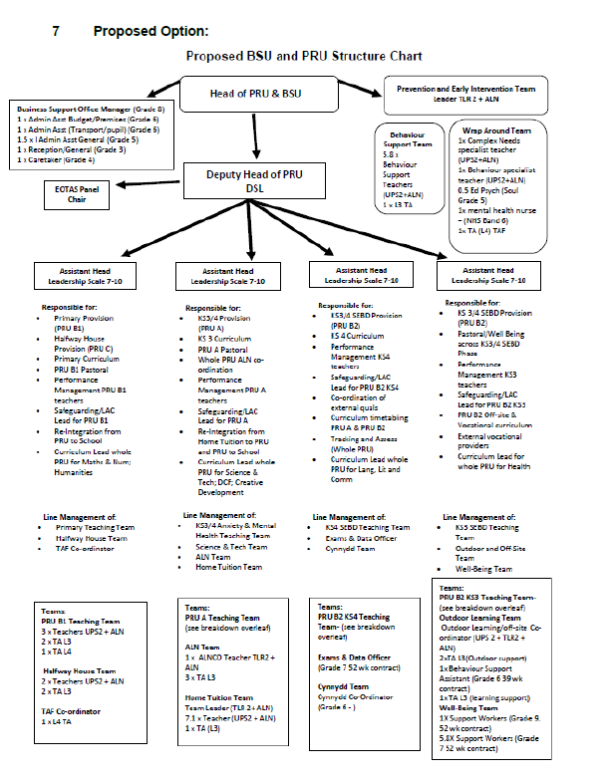
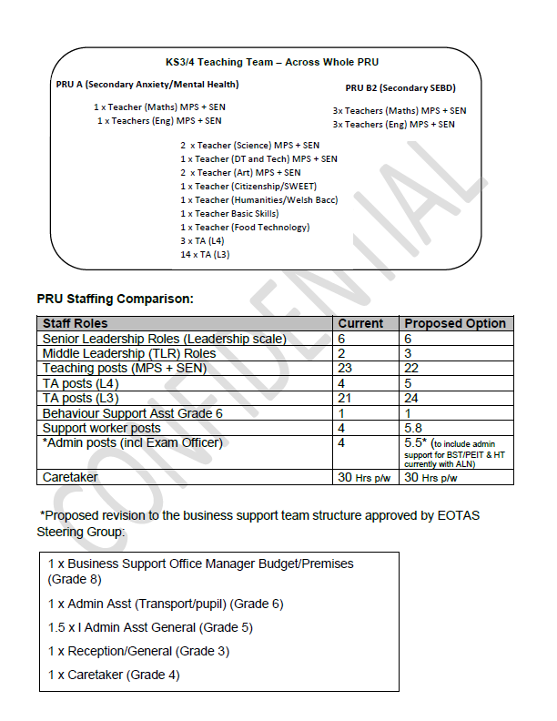
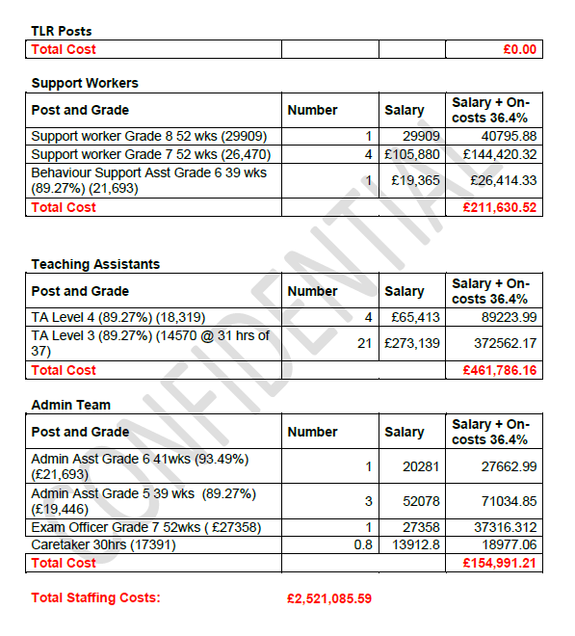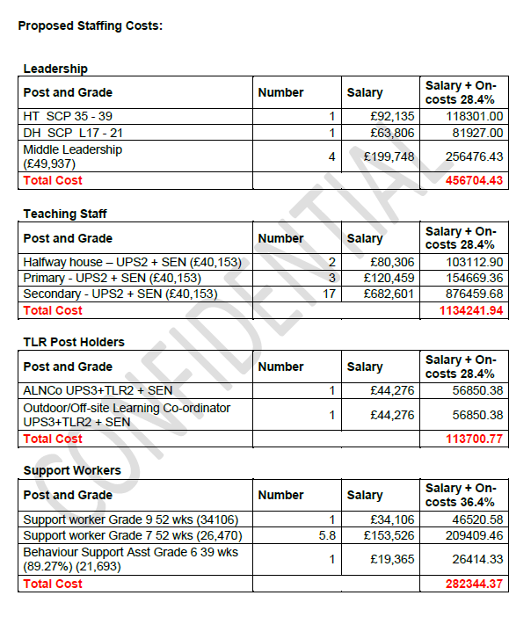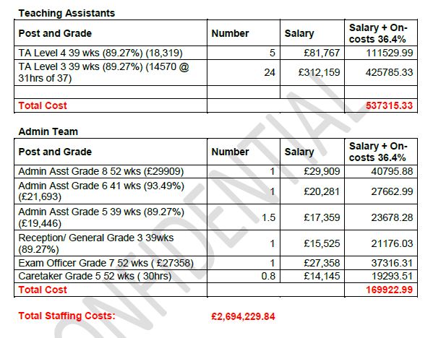
Staffing Cost Summary
Whilst the new model costs £173,144, this includes the full staffing for the Halfway House and a more robust leadership, business and support team. It also offers a more specialised staffing profile in order to deliver a broader and richer curriculum offer. The staffing costs can be met from the current budget envelope, fully utilising the additional funding for the Halfway House Team and Leadership Team approved by Cabinet in 2016.

EV2
Fab – thanks Stephanie!

I have attached a report that is going to Cabinet on Monday – and is confidential as yet. However, this should provide some key information. I have also attached the staffing costings – they need updating to this years and have only been done by myself so may need a more expert eye to run over them…..Can you let me know some dates re when you can meet and if there is anything that I need to do in the meantime? I need advice as to what reports I will need to produce and for whom etc….
Thanks,

Amanda

Amanda Taylor

Pennaeth Uned Cyfeirio Disgyblion Abertawe (UCD) ac Uned Cefnogi Ymddygiad
Adran Addysg
Amanda.taylor@abertawe.gov.uk

Headteacher Swansea PRU and Behaviour Support Unit
Amanda.taylor@swansea.gov.uk

From: Rayner, Stephanie <Stephanie.Rayner@swansea.gov.uk>
Sent: 17 September 2019 16:32
To: Taylor, Amanda (Education) <Amanda.Taylor@swansea.gov.uk>
Subject: RE: Help with process for staff re-structure

Hi Amanda

I hope you are well

Yes no problem, Nicola Reid and I will meet with you to commence discussions regarding the proposals

Please can you advise if there is any documentation regarding the proposals that we can consider prior to the meeting?

Thank you, Steph

Stephanie Rayner
Partner Busnes AD a DS
HR and OD Business Partner

From: Taylor, Amanda (Education) <Amanda.Taylor@swansea.gov.uk>
Sent: 14 September 2019 19:42
To: Rayner, Stephanie <Stephanie.Rayner@swansea.gov.uk>
Subject: Help with process for staff re-structure

Hi Stephanie,
We have now had a proposed structure approved by the EOTAS steering group so I need to start the wider process next. Are we able to meet up to discuss next steps and put together a timeline? In order to be able to appoint any new posts to start in sep 2020, we need to realistically be working to getting an agreed approved model by Christmas. 🙈
Thanks,
Amanda
Get Outlook for iOS

EV3
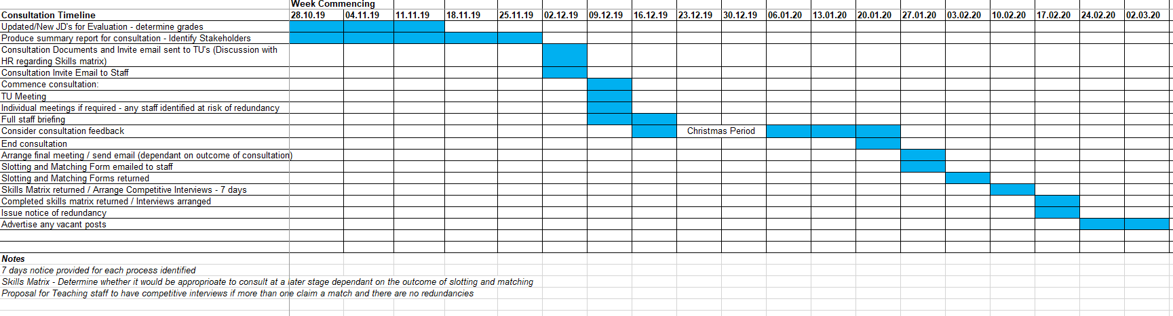

EV4
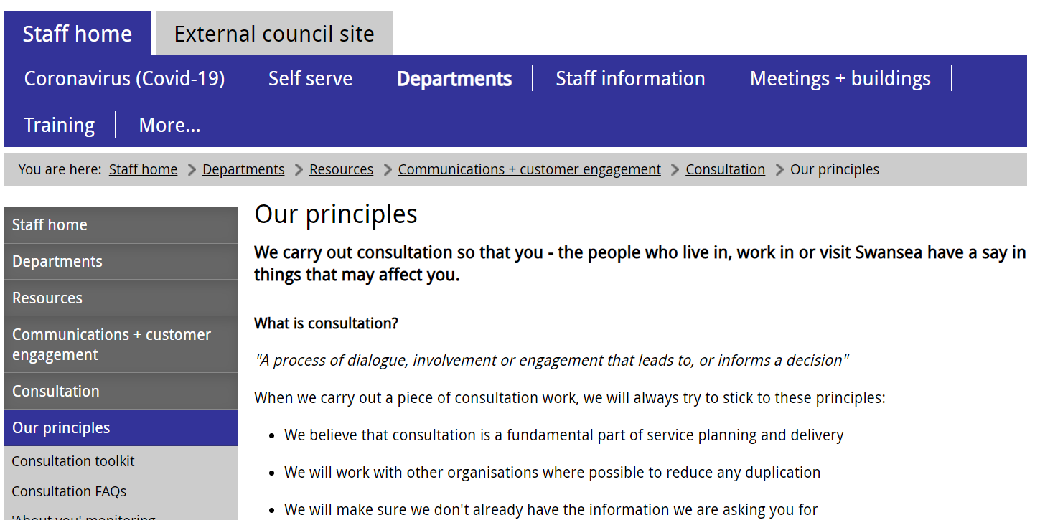
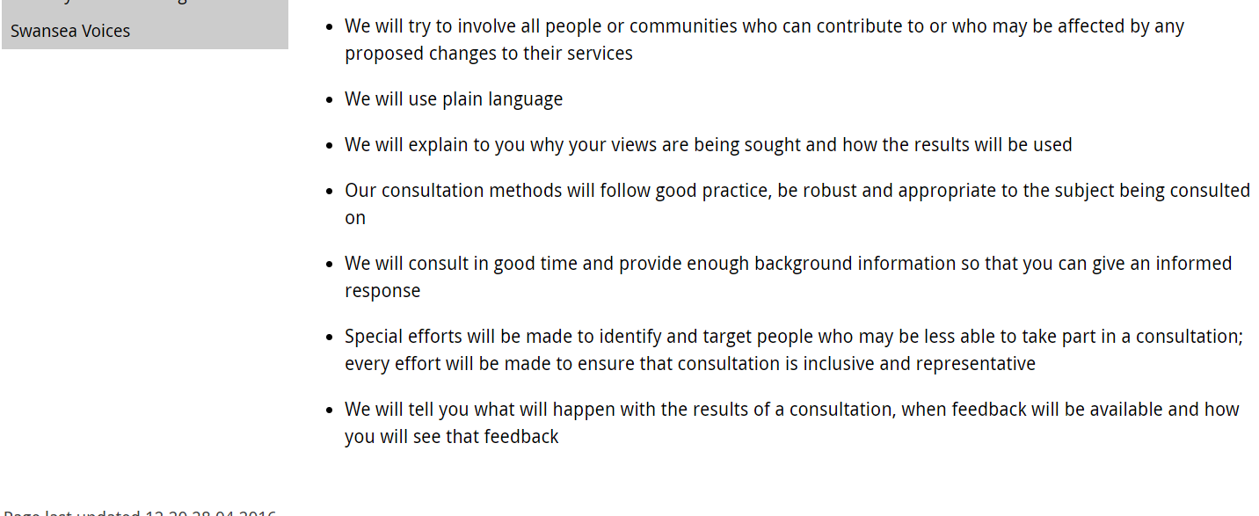

EV5
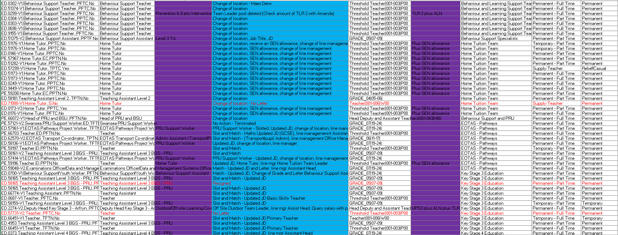

EV6

From: Stephanie Rayner
Sent: 05 February 2020 16:13
To: Amanda Taylor (Education) <Amanda.Taylor@swansea.gov.uk>
Cc: Mathew Fisher <Mathew.Fisher@swansea.gov.uk>
Subject: Consultation

Hi Amanda

Further to our meeting today, please find attached updated consultation invite templates and a timeline in relation the meetings.

I will be able to confirm tomorrow morning whether I am available on Thursday 13th February 2020

Please see below action points discussed:

- Prevention and Early Intervention Team Leader JD – AT
- Confirm evaluation outcomes – HR
- Provide details of TLR Payments – HR
- Issue emails to staff and Trade Unions as per attached, include consultation report within email to Trade Unions – AT
- Prepare skills matrix in relation to Maths – AT
- Prepare presentation in readiness for the full staff meeting – AT
- Communicate with staff who are currently absent i.e. sickness, maternity etc. – AT
- Attendance Sheet – SE
- Communicate with individual suspended – HR
- Print consultation paper to hand to staff in readiness for the full staff meeting – AT

Any queries please let me know

Thank you, Steph

Stephanie Rayner
Partner Busnes AD a DS
HR and OD Business Partner

EV7
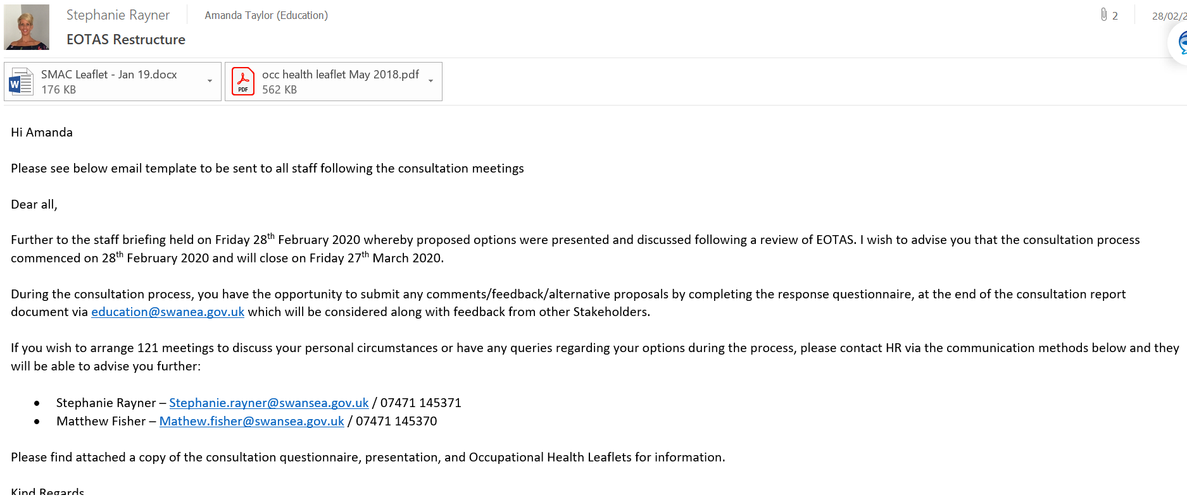

EV8
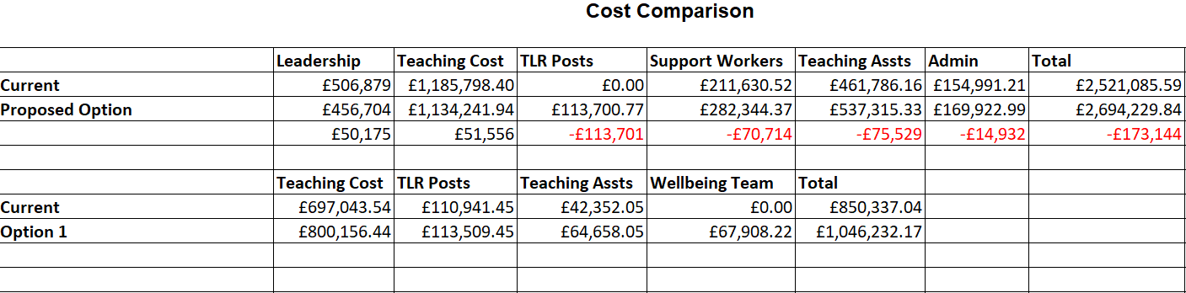

EV9
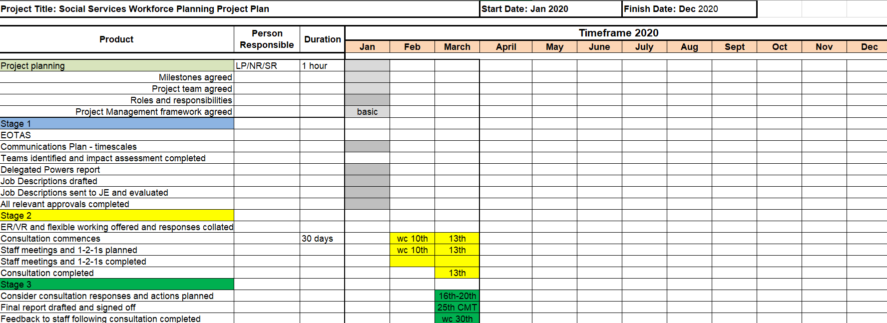

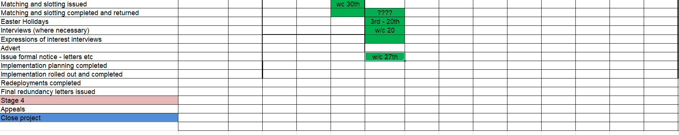
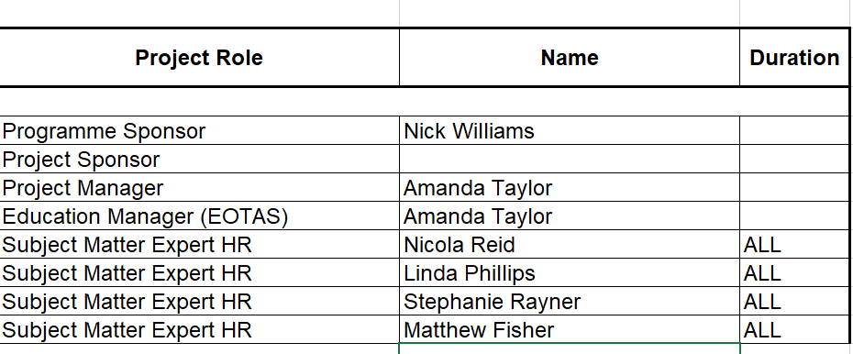
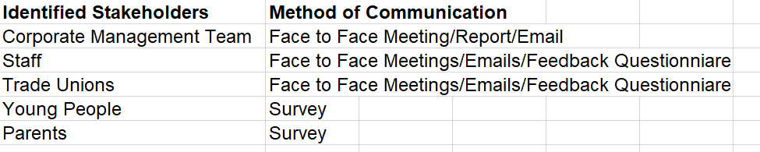

EV10

From: Amanda Taylor (Education) <Amanda.Taylor@swansea.gov.uk>
Sent: 16 January 2021 09:28
To: Stephanie Rayner <Stephanie.Rayner@swansea.gov.uk>
Subject: Re: Communication Methods

Hi Steph,
Initially we held face to face meetings for parents and for pupils. This was to update them on plans and seek their views. We have tried to build in pupil requests into the design if the building - where toilets are located, meals cooked on site, carpeted areas in classrooms, designated play and field areas etc. Pupils were also involved in designing play areas, the name of the new provision, the motto and the logo. There was a large programme of ‘on site’ work planned for 2020. However, due to Covid, most of this work had to be cancelled. However pupils did create huge art pieces to be used as the hoardings for the site. Since March 2020, we have maintained some face to face work with pupils to inform them of progress, shown them videos, photos and virtual tours of the building and involved them in colour choices, furniture choices etc. We have continued to communicate with parents and pupils through council updates as part of the Council website, as well as through letters, building report updates and emails from myself.

Hope that that helps!! Let me know if I have missed anything.

Regards/Cofion,

Amanda

Amanda Taylor
Headteacher Swansea PRU and BSU

From: Stephanie Rayner <Stephanie.Rayner@swansea.gov.uk>
Sent: Saturday, January 16, 2021 8:49:33 AM
To: Amanda Taylor (Education) <Amanda.Taylor@swansea.gov.uk>
Subject: Communication Methods

Hi Amanda

Please can you advise the communication methods used for Parents and Young people in relation to the EOTAS restructure as I didn’t have involvement regarding this?

Thank you, Steph

EV11 – Extract from Teachers Terms and Conditions ‘Burgandy Book, 2000’
Teachers resigning their appointments
2.1 All teachers resigning their appointments will be paid salary;
- at the end of the Summer term to August 31; or, in the case of a teacher resigning to take up an appointment with another employer to the day preceding the day on which the school under the new employer opens for the Autumn term if this be earlier than September 1;
- at the end of the Autumn term to December 31;

- at the end of the Spring term to April 30; or, in the case of a teacher resigning to take up an appointment with another employer, to the day preceding the day on which the school under the new employer opens for the Summer term if this be earlier than May 1. A teacher resigning his/her appointment with effect from the end of the Spring term to take up an appointment with another employer should not be required by the former employer to attend the first days of the Summer term if that commences earlier than May 1.

2.2 Teachers resigning their appointments under the terms of paragraphs 2.1. will be required to give notice in accordance with the periods specified in paragraph 4. 5

3. Deduction of Salary
3.1 The various circumstances in which calculations shall be made for the non-payment of salary are set out in Sections 4, 5 and 6 of this scheme.
3.2 In addition to the provisions of Sections 4, 5 and 6, where authorised unpaid leave of absence or unauthorised absence (e.g. strike action) occurs deductions of salary shall be calculated at a daily or part-daily rate based on the day’s salary being 1/365th of a year for each day of the period of absence.

4. Period of notice and termination of contract
4.1 All teachers shall be under a minimum of two months’ notice, and in the Summer term three months’, terminating at the end of a school term as defined in paragraph 1 above.
4.2 Notwithstanding paragraph 4.1 above, all head teachers shall be under a minimum of three months’ notice and in the Summer term four months, terminating at the end of a school term as defined in paragraph 1 above.
4.3 Notwithstanding paragraph 4.1 above, where a teacher has been continuously employed for more than eight years he/she shall be entitled to receive additional notice, as specified in the Employment Rights Act 1996.
4.4 The provisions of paragraphs 4.1 to 4.3 apply to the termination of a teacher’s contract for any reason other than gross misconduct, including dismissal for ill-health and redundancy.

EV12

From: Taylor, Amanda (Education) <Amanda.Taylor@swansea.gov.uk>
Sent: 14 September 2019 19:42
To: Rayner, Stephanie <Stephanie.Rayner@swansea.gov.uk>
Subject: Help with process for staff re-structure

Hi Stephanie,
We have now had a proposed structure approved by the EOTAS steering group so I need to start the wider process next. Are we able to meet up to discuss next steps and put together a timeline? In order to be able to appoint any new posts to start in sep 2020, we need to realistically be working to getting an agreed approved model by Christmas. 🙈

Thanks,
Amanda
Get Outlook for iOS

EV13

From: Mathew Fisher <Mathew.Fisher@swansea.gov.uk>
Sent: 03 February 2020 12:18
To: Amanda Taylor (Education) <Amanda.Taylor@swansea.gov.uk>; Stephanie Rayner <Stephanie.Rayner@swansea.gov.uk>
Subject: RE: URGENT EOTAS Consultation

Hi Amanda

As discussed, please see attached template consultation emails to send the Trade Unions and the staff. You can amend if needed.

Please hold on sending these until I have spoken with Steph tomorrow and to confirm that she is available on Wednesday 12th September from 2.30.

Regards
Mathew
Mathew Fisher
Ymgynhorydd AD a DS
HR & OD Adviser

From: Amanda Taylor (Education) <Amanda.Taylor@swansea.gov.uk>
Sent: 31 January 2020 20:40
To: Stephanie Rayner <Stephanie.Rayner@swansea.gov.uk>; Mathew Fisher <Mathew.Fisher@swansea.gov.uk>
Subject: URGENT EOTAS Consultation

Hi Stephanie/Mathew

Apologies both - It has been an exceptionally busy and long week and it is only now that I have been able to respond sorry. Because I am operational all day at present whilst at Arfryn, I am not getting a chance to look at emails until late every night. I am so sorry.

Please see responses in line with queries below and report attached. I am hoping that this covers what you have requested.

The main concern that I have is that whilst you have said that I need to send meeting requests and consultation documentation to Tus, and said previously that you would send template letters – I have not received the templates and I do not know what consultation documentation is required to be sent along with the invitations. Mathew – could you please contact me urgently to advise me re this so that I can send off today??? Mob is 06817140969.

Regards,

Amanda
Amanda Taylor
Pennaeth Uned Cyfeirio Disgyblion Abertawe (UCD) ac Uned Cefnogi Ymddygiad
Adran Addysg
Amanda.taylor@abertawe.gov.uk

Headteacher Swansea PRU and Behaviour Support Unit
Amanda.taylor@swansea.gov.uk

From: Stephanie Rayner <Stephanie.Rayner@swansea.gov.uk>
Sent: 30 January 2020 17:07
To: Amanda Taylor (Education) <Amanda.Taylor@swansea.gov.uk>
Cc: Mathew Fisher <Mathew.Fisher@swansea.gov.uk>
Subject: EOTAS Consultation

Hi Amanda

Further to our discussion this morning, please find attached project plan and consultation timeline outlining details regarding the EOTAS consultation process

I have included potential dates up to the point where staff will have an opportunity to slot and match to posts or complete a skills matrix however, I am unable to advise the next steps until we have a full understanding of what pools of staff are affected and whether there are going to be any potential redundancies.

I have arranged a review meeting on Wednesday 5th February 2020 at 1pm, at the Guildhall to discuss further

In preparation for the meeting, please can you consider the following:

- Identify affected staff i.e. posts are being deleted – no posts are being deleted
- Identify new posts on the structure – new posts highlighted on structure in report attached
- Details of current establishment list to identify pools of staff and where they will fit in the new structure – see report attached

To enable formal consultation to start week commencing 10th February 2020, a meeting request needs to be sent to the Trade Unions 7 days prior to the meeting along with the consultation documentation. Following this, a full staff meeting will be arranged for you to present the proposed structure. Staff will then be provided with an opportunity of 121 meetings to discuss their individual circumstances.
Trade Unions details are included within the consultation timeline document.

In addition, please can you consider what communication channel will be used to collate the consultation feedback and whether you are going to include a questionnaire for stakeholders to complete? I have attached an example questionnaire for discussion. In relation to previous consultations within Education, the Education mailbox has been used as a central point for all stakeholders to respond to the consultation so perhaps this is something that can be considered and discussed with Helen Morgan-Rees.

Also, please can you identify any other stakeholders who will be consulted with? In relation to Schools, the information is normally communicated via the newsletter issued by Rhodri Jones.

I am on leave until Tuesday but Matthew will be available Monday should you have any queries

Thank you, Steph

Stephanie Rayner
Partner Busnes AD a DS
HR and OD Business Partner

EV14

Consultation Meetings – EOTAS
28th February 2020
TU Meeting – 12.00pm

Present Amanda Taylor – Project Lead
Stephanie Rayner – HR & OD BP
Rob Phillips – Chair of PRU Management Panel
Hayley Steel – NEU
Susan Adams – GMB
Bev Phillips – NAHT
Andrea Jones - NASUWT

Introductions

Purpose
Prepare staffing structure in readiness for the new build
Currently three centres merging onto one site
Paper approved by Cabinet in December 2016 – clear and agreed strategy, policy and building in construction.
Haven’t filled vacancies, high number of agency staff throughout the service, haven’t put any posts unnecessarily at risk.

Staffing implications
Existing model and existing model, staffing comparison
Re-defining of the structure in line with the new build, current teaching model over three sites, going forward teaching model over one site.
Define hours of core subjects
Change of the needs of the service and the curriculum disciplines required

Meeting with teams of staff who are potentially affected as part of the proposals

Maths – 1 x redundancy
Caretakers – Increase in hours and grade
Leadership – Opportunities
Behaviour Support Team Leader – Potential match to Prevention and Early Intervention and Team Leader
Deputy Head of Afryn – Potential opportunities

Is the model fit for purpose?

Model needed for staff and the building, considered the curriculum opportunities to engage and best opportunities for the pupils, realise strategy, provide early identification of intervention.

Cost
Slightly increased cost – realising significant savings for the last 2 financial years, Cabinet funded model going forward.

Increase of staffing apart from Teachers

More flexibility in the new build to utilise staff

HS – Refer to UPS2
AT – Broad point of funding for calculation, accountant did the actual cost comparison based on actual costs and an average.

BP - Does it meet the needs of the current cohort of pupils?
AT - Meets the ratio of staff/pupils, year on year the cohort changes.

New build will meet the current demands and provide further opportunities for pupils.

BP – Secondary get specialist provision, funding devolved, was it explored for Primary Schools?

AT – New model, spoked to Primary Heads, identify trends with the BSU and PRU, what are the core needs.
Mental Health Needs, Upper Primary and years 7/8
Build capacity and support schools – use the Elsa approach, 0.5 EP provide training to all schools, transition process. Support, supervision for the cases within each school. Mechanism to meet the needs of a greater range of pupils.

BP – Designated EP, making better working environment for staff

RP – This is the internal structure within EOTAS, current restructure within ALN which may consider EP for EOTAS.

AT – In addition, 1 mental health nurse to support pupils and staff.

AT provided detail regarding new posts

Admin Team
All new posts – opportunities for existing post holders

Prevention and Early Intervention Team Leader
Wrap Around Team
Assistant Heads
ALNCO
Taf Co-ordinator
Outdoor and Off-Site Team
Wellbeing Team – Additional Support Workers, Manager
Teacher (Food Technology)
Teacher (DT and Technology)

HS – Breaktime, Lunchtime Supervisors?
AT – We don’t currently have that provision, currently undertaken by different members of staff. Biggest needs to help pupils get along with others, communicating appropriately, eating appropriately, managing a play session appropriately with others.
Currently have teaching and support staff supervising breaks. Need to ensure staff have their break entitlement, more flexibility on one site.

HS – Is everyone having lunch at the same time?

AT – No, they will have lunch at different times/sittings in line with needs of the pupils.

ALNCO middle leadership

Date in relation to the new build – Japanese Knotweed affecting certain trees, debate with public and members, slightly delayed in relation to internal features.
Mid October 2020 – Completion, phased move
Potential move January 2021

Meeting concluded – 1.00pm

Team Meetings

SR explained process at the start of all meetings, opportunity to advise individuals of how they are potentially affected as part of the proposals.

Jeff Miles - Caretaker
30 hours – Grade 5
Temporary, would I have an opportunity for the new post?
Yes, you are a long standing temporary employee and therefore be able to claim a match for the new post on your current contracted hours.
If there are any hours remaining, AT could provide an opportunity to ring fence to existing staff prior to advertising.

Maths Team
Merging three centres into one build
Design Technology, Science, Food Technology specific areas – what do we need to deliver the subjects.
0.6 potential redundancy of maths
Options and opportunities for staff – haven’t been recruiting to vacant posts and as a result will have vacancies across the who provision.
SR explained options i.e. Skills Matrix, ER/VR, Redeployment
AT explained options within the proposed structure

Leadership Team
Removal of the Head of Centre posts – opportunities for new posts on the structure
Timescales regarding moving to the New Build
Questions options as to whether other individuals will be able to match to a post if they are not ‘at risk’ – SR confirmed no, individuals ‘at risk’ would be provided with opportunities prior to advertising/ring fencing any posts.

Tilly McMorran
Andrea Jones – NASUWT
Current post of Behaviour Support Team Leader is proposed to be deleted from the structure however, there are opportunities for you to consider.
TLR posts within the proposed structure.
Questioned the management for the new post – confirmed additional 4 members of staff.

Martin Thomas – Deputy Head of Afryn
There isn’t a Deputy Head post on the proposed structure, however there are opportunities for you to consider.

EV15
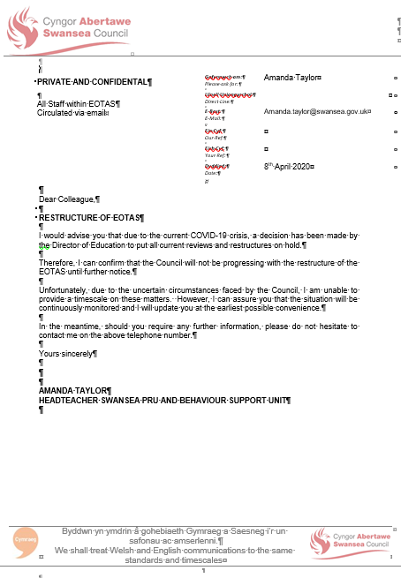

EV16

From: Stephanie Rayner <Stephanie.Rayner@swansea.gov.uk>
Sent: 17 September 2020 16:22
To: Ben Smith <Ben.Smith@swansea.gov.uk>; Helen Morgan-Rees <Helen.Morgan-Rees@swansea.gov.uk>
Cc: Amanda Taylor (Education) <Amanda.Taylor@swansea.gov.uk>
Subject: RE: Eotas

Hi Ben

Thank you very much for your quick response

Steph

From: Ben Smith <Ben.Smith@swansea.gov.uk>
Sent: 17 September 2020 16:21
To: Stephanie Rayner <Stephanie.Rayner@swansea.gov.uk>; Helen Morgan-Rees <Helen.Morgan-Rees@swansea.gov.uk>
Cc: Amanda Taylor (Education) <Amanda.Taylor@swansea.gov.uk>
Subject: RE: Eotas

Confirmation it was approved formally at cmt on the understanding the education director would ensure education budget as a whole rebalanced in future years

That still holds (and Helen you got that message from me yesterday again as did all Directors)

The restructure in Eotas essential and is considered approved by CMT

Regards
Ben
Ben Smith
Prif Swyddog Cyllid (Swyddog Adran 151)
Chief Finance Officer (S151 Officer)

From: Stephanie Rayner <Stephanie.Rayner@swansea.gov.uk>
Sent: 17 September 2020 15:57
To: Helen Morgan-Rees <Helen.Morgan-Rees@swansea.gov.uk>; Ben Smith <Ben.Smith@swansea.gov.uk>
Cc: Amanda Taylor (Education) <Amanda.Taylor@swansea.gov.uk>
Subject: FW: Eotas
Importance: High

Hi Both

Further to the email correspondence below, the Workforce Team have requested approval in relation to the EOTAS restructure.

Therefore, please can you formally confirm approval of the EOTAS Restructure as approved by CMT

I am emailing you both hoping for one response by the end of the day as we have tight timescales in relation to advertising posts

Thank you in advance

Steph

Stephanie Rayner
Partner Busnes AD a DS
HR and OD Business Partner

EV17
Follow up discussions – EOTAS

Date 4th June 2020

Present Amanda Taylor
Nicola Reid - HR
Stephanie Rayner - HR
Susan Adams - GMB
Jan Murray – Unison
Hayley Steel – NEU
Bev Phillips – NAHT

SR explained reason for the meeting

SR to circulate consultation documentation to the group

Reasons to proceed with consultation
AT explained current situation regarding COVID-19 will be ongoing for some time, question as to at what stage can we recommence process.
Staff under the pressure of reorganisation for some time, asking questions as to what is happening. Provide staff with reassurance regarding the proposal and moving forward.
New build remains ongoing, fit for purpose building potentially without the appropriate staffing. Potential opening January 2021, process of consultation, agree final proposal, slotting and matching prior to recruiting. Notice required for successful candidates.
Nervous insufficient staff to manage the new build.
Haven’t recruited to vacant posts for some time, greater number of vacancies, forced to close Afryn as there were not enough staff to run the building safely. On return, out of 7 teaching staff there is likely to be 4 staff available, 70% agency staff working in Afryn.
One member of staff seconded, due to end secondment end of the Summer, need to approach the school to extend secondment, however don’t currently have a date to approach the school.

NR explained if there was agreement to proceed with process, no detriment to staff who are unsuccessful at the end of the process, no formal notice will be issued until we have further guidance from CMT.

Potentially 1 individual at risk within Maths Department, they have confirmed they are interested in another post on the restructure so in effect there won’t be a redundancy.
A number of surplus posts so individuals have opportunity to slot and match.

Consider a way forward for staff and the new build.

Consultation process to recommence
Appoint teachers with the deadline of 31st October 2020
Restructure finalised as soon as possible in readiness for the new build – aim for 1st January 2021
Opportunities for individuals on the proposed structure

Discussions regarding appropriate timescales regarding consultation taking into consideration personal circumstances
All agreed

HS issues regarding Head of Centre 11-12, Assistant roles 7-10, there may be a detriment to staff, individuals may question whether they want to take on the additional roles for lesser money.

AT explained the main source of queries being received have been from the leadership team, rightly identified that the responsibilities are huge, the weighting and uncertainties are causing more stress then if we didn’t proceed with consultation.

SA at what stage was the consultation?

SR confirmed full staff meeting, 121’s, group meetings had taken place, opportunity for staff to feedback on the proposals.

NR stated individuals would be offered the opportunity for further meetings with HR and Management.

AT explained no responses had been considered to date.

BP realistic timeline taking into consideration the current pressures.

NR staff perspective to proceed with consultation and finalise as soon as possible, staff currently are not aware of details regarding the final structure.
Ensure individuals have enough time to familiarise themselves with the documents and provide feedback.
Commence w/c 15th June 2020 until 29th June 2020 (4 weeks until the end of term)
Write to staff advising them of the recommencement of the process, outlining timelines, paperwork issued with the letters.
Continue to review the situation depending on current pressures.

HR and AT separate meeting to discuss proposed timeline of events – determine whether the process can be concluded by the end of the Summer Term.

AT confirmed most staff have been enthusiastic and seem to want a conclusion to the restructure.

Send letter and timeline to Trade Unions prior to issuing to staff

If unable to meet timelines by the end of term, consider starting in September 2020.

12th June 2020 – 26th June 2020
29th June consider responses and produce final report
W/C 6th July CMT approval
13th July slotting and matching

SR arrange meeting with NR/AT

12th June 2020 | Re-commence consultation
26th June 2020 | End consultation
27th – 29th June 2020 | Consider responses – finalise report
w/c 29th June 2020 (AT confirm date for CMT) | Final approval
w/c 29th June 2020 (1st July 2020) | Issue slotting and matching documents (Include personal statement)
w/c 6th July 2020 (8th July 2020) | Return slotting and matching
9th & 10th July 2020 | Assess slotting and matching
w/c 13th July 2020 | Confirm slotting and matching/arrange interviews if necessary

In the absence of JD’s, detail evidence how they match to the new posts 60% or more.

EV18
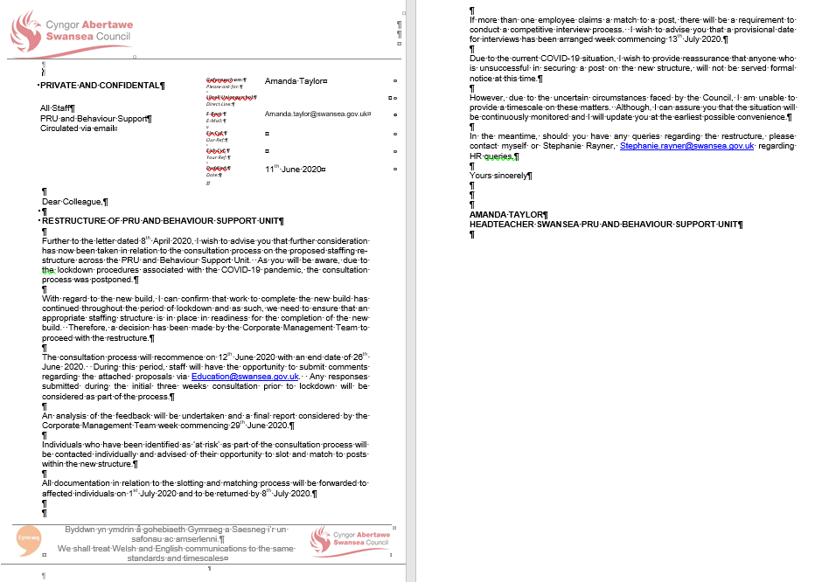

EV19
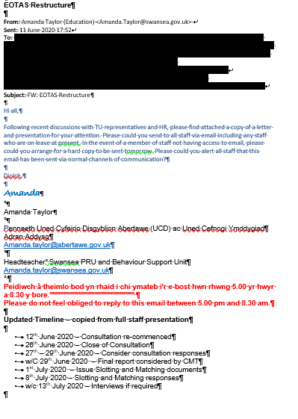

EV20
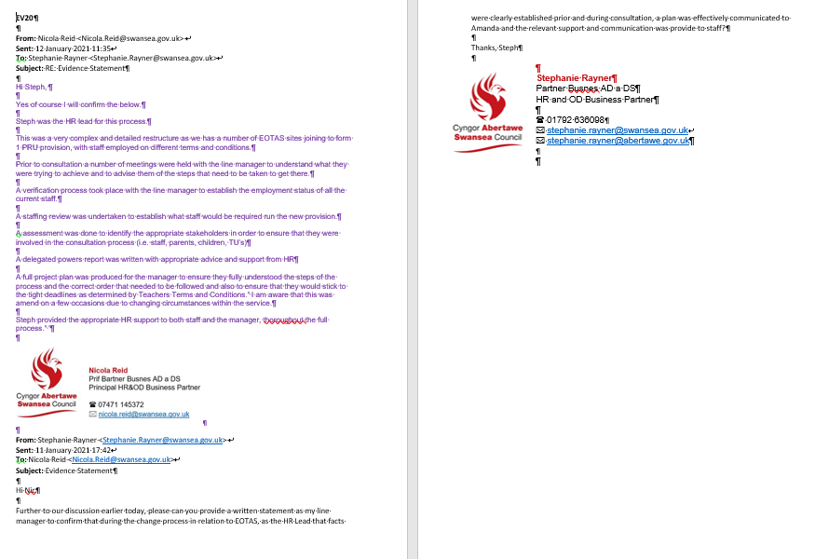

Follow the agreed plan to implement change processes

Prior to the commencing the change process, I had an opportunity to work with the Project Officer to enhance my knowledge and skills in relation to project management. This including understanding the benefits of producing a project plan from the outset in agreement with the Project Lead. This is evidenced within an evaluation I undertook regarding my personal development in relation to Change Management, (EV21).

The initial project plan was designed using a Gantt chart to clearly identify the milestones, timescales, stakeholders and methods of communication required in order to meet the desired outcome, (EV9).

As stated previously, due to Covid-19, there was a requirement to review the project plan and consider amended timescales, (EV19) in line with the directive from the Corporate Management team. This was effectively communicated to both staff and Trade Unions throughout the process, (EV15, EV17, EV18).

Provide information and support to stakeholders in line with their identified requirements.

It is important to remember that any change process can impact stakeholders in different ways and as such Organisations need to closely manage expectations and advise them if any concerns arise. Continued engagement will ensure two way communication enabling an open and transparent process, (MindTools, 2020).

This is evidenced throughout the EOTAS change process whereby all relevant Stakeholders were engaged from the outset, an initial meeting was arranged with Trade Unions followed by individual/team meetings and a full staff briefing, (EV14). Further details of the proposals and options of support were subsequently sent to affected individuals via email, (EV7). Positive engagement continued with Trade Unions to try and accommodate their availability in attending consultation meetings, (EV22).

Following the decision to recommence the process, a further meeting was arranged with the Trade Unions, (EV17) and the updated information circulated to staff providing them with the opportunity to comment on the proposals, (EV23). Following the outcome of the consultation process, a further letter was issued to staff and Trade Unions advising them of the outcome, (EV24). Whilst the initial communication was conducted face to face, due to Covid restrictions, the majority of communication was relayed via email which was identified as an appropriate method of communication from the outset.

As outlined within the Kubler-Ross Model of change, employees go through different feelings during periods of change including emotionally, mentally and physically. (Acas, 2020) recognise the range of emotions employees experience before accepting the final stage and moving forward. It is therefore important for Managers to liaise with HR to relay the support available for employees during times of uncertainty. This including signposting to Occupational Health, clearing outlining options, identifying any training or coaching opportunities. It can be evidenced within (EV7) that staff were advised of their options and the support available during the change process.

Apply techniques for maintaining positive working relationships throughout the change process

Positive working relationships between the Organisation, Managers and HR can contribute to change management in a number of ways including effective communications, people participation and encouraging an organisation culture that embraces change.

Swansea Council set out consultation principles, (EV4) which evidences a culture whereby staff are encouraged to engage in such processes. During the EOTAS consultation process, the initial report provided clear rational for the change (EV1) with open and transparent communication provided to Stakeholders throughout. This is evidenced within a number of evidence documents provided.

A further report was produced and considered by CMT giving due consideration of the consultation feedback received, (EV25). Again this evidencing that Swansea Council value opinions from staff and consider things from their perspective.

There were a number of opportunities as a result of the change process to which individuals have been successful in gaining promotion.

A witness testimony provided by Amanda Taylor, Head of EOTAS/Project Lead confirm my effective relationship skills and support for both herself personally and all Stakeholders throughout the process, (EV26). This is also confirmed within the witness statement from my Line Manager, Nicola Reid, (EV20).

Monitor the effectiveness of the implementation, agreeing and making justified adaptations where required.

(HRZone, 2019) recognised the ‘4Es principles of human change’ being, educated, engaged, empower, and enable. All of which play a vital role in engaging the workforce during change management.

During the EOTAS restructure, the rationale for change was relayed to staff during the consultation meeting, (EV14), providing a two way communication process whereby staff could have the opportunity to engage with HR and Management on an individual basis and also provide formal feedback via the consultation questionnaire (EV23). The consultation response report (EV25) evidences the consideration of feedback whereby employees feel their opinions are valued, thus empowering individuals. The implementation of the restructure and the move to the new build will provide staff with the necessary skills, resources and working environment where they feel confident and solution focused enabling them to succeed.

As specified above, due to Covid there has been a requirement to continuously monitor the implementation of the process and review the milestones as set out within the project plan. There has been a requirement to make the necessary adaptions in line with the global pandemic, this is also confirmed by the Project Lead, (EV26). Unfortunately I have been unable to undertake a formal analysis of the implementation as the move to the new build has been delayed and staff are currently required to provide a provision to support vulnerable young people within EOTAS and as such it wouldn’t be a true reflection on normal working practices.

LO2 – Evidence

EV21

Evaluate your knowledge, skills and ability in relation to this area, using the definitions from the Profession Map and discuss any development needs with your manager. Record your discussion.

Having considered and discussed the core knowledge area of change as set out within the CIPD Professional Map, (CIPD, 2020) with my line manager, we determined that my role requires me to work between both Associate and Chartered level.

As HR & OD Business Partner, I am recognised as the HR Lead on various organisational reviews, advising the Director of Education, Senior Managers and Headteachers from the outset identifying and liaising with a range of Stakeholders. To enable me to undertake my role effectively, it is important for me to analyse workforce data and advice accordingly e.g. identify skills gaps, succession planning for the future needs of the Department and Organisation. Thus providing managers with the relevant data to assist with any change management processes.

Prior to the pandemic, I had the opportunity to work alongside the OD Project Officer who provided me with the skills and understanding of producing a project plan and as such, prior to commencing any formal consultation process, I encourage and support Senior Managers in the use of a this tool, clearly identifying Individuals within the Project Group, milestones, timescales and the proposed affected areas or individuals as a result of the change.

During any change process, it is important for me to identify the targeted audience and adapt my approach accordingly. Employee’s need to understand how the change is going to affect them and what options and support are available. I have the skills and ability to relay messages with empathy and understanding to the situation and also encourage Stakeholder engagement.

I also advise on the appropriate methods of communication during such process which is vital for employee’s to feel their opinions are valued and Senior Managers provide feedback following any consultation process detailing the justification as to why alternative options may or may not be considered.

From a HR perspective, my view is that the way in which messages are relayed is vital and any consultation needs to be meaningful with employees having an opportunity for their opinions to be heard.

Going forward, it was agreed for me to liaise with the OD Project Officer in relation to Organisational Development, providing me with a broader skill set in relation to Authority’s approach and culture. This will enable me to meet my aspiration of working towards a Chartered Member.

EV22
Hi Amanda

I would advise that the meetings arranged for tomorrow are postponed as per the request from the Teaching Unions.

If we could re-arrange for Friday 28th February 2020 that would be more convenient for HR as I have Headteacher training all day on 25th February 2020.

I am in a meeting with Nick Williams now and he has provided me with an update regarding the new build

Please give me a call when you are free to discuss further

Thank you, Steph

From: Amanda Taylor (Education) <Amanda.Taylor@swansea.gov.uk>
Sent: 12 February 2020 17:00
To: Stephanie Rayner <Stephanie.Rayner@swansea.gov.uk>; Mathew Fisher <Mathew.Fisher@swansea.gov.uk>
Cc: Nick Williams <Nick.Williams@swansea.gov.uk>; Helen Morgan-Rees <Helen.Morgan-Rees@swansea.gov.uk>
Subject: Re: EOTAS consultation

Hi Stephanie,

Is this likely to be a problem if the union has suggested 25/2?

Regards/Cofion,

Amanda

Amanda Taylor
Headteacher Swansea PRU and BSU

From: Stephanie Rayner <Stephanie.Rayner@swansea.gov.uk>
Sent: Wednesday, February 12, 2020 3:21:12 PM
To: Amanda Taylor (Education) <Amanda.Taylor@swansea.gov.uk>; Mathew Fisher <Mathew.Fisher@swansea.gov.uk>
Cc: Nick Williams <Nick.Williams@swansea.gov.uk>; Helen Morgan-Rees <Helen.Morgan-Rees@swansea.gov.uk>
Subject: RE: EOTAS consultation

Hi Amanda

I would advise that the meetings arranged for tomorrow are postponed as per the request from the Teaching Unions.

If we could re-arrange for Friday 28th February 2020 that would be more convenient for HR as I have Headteacher training all day on 25th February 2020.

I am in a meeting with Nick Williams now and he has provided me with an update regarding the new build

Please give me a call when you are free to discuss further

Thank you, Steph

Stephanie Rayner
Partner Busnes AD a DS
HR and OD Business Partner

From: Amanda Taylor (Education) <Amanda.Taylor@swansea.gov.uk>
Sent: 12 February 2020 13:25
To: Stephanie Rayner <Stephanie.Rayner@swansea.gov.uk>; Mathew Fisher <Mathew.Fisher@swansea.gov.uk>
Cc: Nick Williams <Nick.Williams@swansea.gov.uk>; Helen Morgan-Rees <Helen.Morgan-Rees@swansea.gov.uk>
Subject: RE: EOTAS consultation

HI Stephanie,

They are not affected in terms of posts being at risk, but they are affected in terms of changes to line management.

Do I now write out to all staff and advise that the meetings scheduled tomorrow are all cancelled?

Do I need to write to the other TUs who are planning on attending to advise them that the meeting is cancelled.

Are you able to confirm a date for the meeting to take place? Hayley has suggested Tuesday 25th February. Can HR make this date? Would you like me to write out to all TUs and staff to inform them of this as a new date?

Are you able to advise asap so that I can get everything sent out today to comply with notice period and to give everyone notice of the cancellations.

Regards,

Amanda

From: Stephanie Rayner <Stephanie.Rayner@swansea.gov.uk>
Sent: 12 February 2020 10:29
To: Amanda Taylor (Education) <Amanda.Taylor@swansea.gov.uk>
Cc: Nick Williams <Nick.Williams@swansea.gov.uk>; Helen Morgan-Rees <Helen.Morgan-Rees@swansea.gov.uk>
Subject: RE: EOTAS consultation

Hi Amanda

I discussed this with Hayley and advised that I didn’t feel this was a conflict (mainly on the basis that home tutors are unaffected as part of the proposals) however I asked how she felt providing representative on the basis of the below and advised her to speak to the Union.

Thank you, Steph

Stephanie Rayner
Partner Busnes AD a DS
HR and OD Business Partner

From: Amanda Taylor (Education) <Amanda.Taylor@swansea.gov.uk>
Sent: 12 February 2020 09:24
To: Stephanie Rayner <Stephanie.Rayner@swansea.gov.uk>
Cc: Nick Williams <Nick.Williams@swansea.gov.uk>; Helen Morgan-Rees <Helen.Morgan-Rees@swansea.gov.uk>
Subject: RE: EOTAS consultation

Thanks Stephanie,

Will do.

Before I send – is it appropriate that Hayley Steel is the union rep as her father is one of the home tuition teachers?Isnt this a conflict of interest?

Regards,

Amanda

Amanda Taylor

From: Stephanie Rayner <Stephanie.Rayner@swansea.gov.uk>
Sent: 12 February 2020 09:12
To: Amanda Taylor (Education) <Amanda.Taylor@swansea.gov.uk>
Cc: Nick Williams <Nick.Williams@swansea.gov.uk>; Helen Morgan-Rees <Helen.Morgan-Rees@swansea.gov.uk>
Subject: RE: EOTAS consultation

Hi Amanda

To ensure meaningful consultation, we are required to fully engage Trade Unions and staff throughout the consultation process and therefore it would not be appropriate to commence consultation with Central Unions prior to meeting with Teaching Unions.

I would advise that you respond to Hayley to request whether any other representatives are available to attend the meetings tomorrow, if they are unable to attend all meetings, they could attend the initial TU meeting and we can pass their contact details onto staff.

Thank you, Steph

Stephanie Rayner
Partner Busnes AD a DS
HR and OD Business Partner

From: Amanda Taylor (Education) <Amanda.Taylor@swansea.gov.uk>
Sent: 10 February 2020 19:53
To: Stephanie Rayner <Stephanie.Rayner@swansea.gov.uk>
Cc: Nick Williams <Nick.Williams@swansea.gov.uk>; Helen Morgan-Rees <Helen.Morgan-Rees@swansea.gov.uk>
Subject: Fwd: EOTAS consultation

Hi Steph,

Is there anything stopping us from
Meeting with other staff and their unions as planned on Thursday?

Regards/Cofion,

Amanda

From: HAYLEY STEEL <HAYLEY.STEEL@neu.org.uk>
Sent: Monday, February 10, 2020 5:33:23 PM
To: Amanda Taylor (Education) <Amanda.Taylor@swansea.gov.uk>
Cc: Mathew Fisher <Mathew.Fisher@swansea.gov.uk>; Stephanie Rayner <Stephanie.Rayner@swansea.gov.uk>; Nick Williams <Nick.Williams@swansea.gov.uk>; Andrea Jones <a.jones015@btinternet.net>; Gareth Morgan <gareth@ucac.cymru>
Subject: Re: EOTAS consultation

Dear Amanda,

Thank you for getting in touch regarding our concerns at education unions not being able to attend the EOTAS consultation.

Whilst we understand your concerns about delaying the meeting until after half term, I believe that our members would rather the correct process be followed.

Therefore, having spoken to NASUWT and UCAC, we request that the meetings are postponed to after half term. Historically, facility time for the education unions has been on Tuesdays a Fridays. Could the meetings be done on Tuesday, 25th February?

Regards,

Hayley

From: Amanda Taylor (Education) <Amanda.Taylor@swansea.gov.uk>
Sent: Monday, 10 February 2020, 12:16
To: HAYLEY STEEL
Cc: Mathew Fisher; Stephanie Rayner; Nick Williams
Subject: RE: EOTAS consultation
Dear Hayley,
I have spoken with Stephanie Rayner who has explained the difficulties for the teaching unions in having anyone to represent them at the meeting planned for this Thursday. I have huge concerns that if we don’t commence the consultation process this week after giving staff notice, we will be placing them under a huge amount of stress over half term. As you can see from the report, there are lots of opportunities within the structure, and I am keen to ensure that staff have this information asap.

I am happy to change whatever is in my diary for the whole week to accommodate you – and Stephanie has said that she can make herself available on either Weds morning, Thursday morning or, if you are happy for us to speak to teaching staff beforehand, we could meet with you on Friday morning?

I have left you a voice mail with my number – 07817140969. If you could get back to me to confirm that could make one of those times, we can hopefully avoid causing concern for staff by cancelling the meeting times that we have already sent out for this Thursday.

Kind regards,

Amanda

Amanda Taylor

From: Stephanie Rayner <Stephanie.Rayner@swansea.gov.uk>
Sent: 10 February 2020 09:37
To: Amanda Taylor (Education) <Amanda.Taylor@swansea.gov.uk>
Subject: RE: EOTAS consultation

Hi Amanda

I hope you had a good weekend

Apologies but Matthew and I are off on Friday so therefore the consultation meetings will need to be arranged the week after half term.

All meetings will need to be changed as there is a requirement to meet with the Unions prior to any meetings with staff

Thank you, Steph

Stephanie Rayner
Partner Busnes AD a DS
HR and OD Business Partner

From: Amanda Taylor (Education) <Amanda.Taylor@swansea.gov.uk>
Sent: 07 February 2020 22:24
To: Stephanie Rayner <Stephanie.Rayner@swansea.gov.uk>
Subject: Re: EOTAS consultation

I can do Friday 14th - but would we need to change dates for everyone? Or would we still meet with staff on Thurs as planned?

Regards/Cofion,
Amanda
Amanda Taylor
Headteacher Swansea PRU and BSU

From: Stephanie Rayner <Stephanie.Rayner@swansea.gov.uk>
Sent: Friday, February 7, 2020 6:10:26 PM
To: Amanda Taylor (Education) <Amanda.Taylor@swansea.gov.uk>
Subject: FW: EOTAS consultation

Hi Amanda

Please can you consider the request below to re-arrange the consultation meeting on the basis that all Teaching Unions are unavailable to attend?

Thank you, Steph

Stephanie Rayner
Partner Busnes AD a DS
HR and OD Business Partner

From: HAYLEY STEEL <HAYLEY.STEEL@neu.org.uk>
Sent: 07 February 2020 10:55
To: Stephanie Rayner <Stephanie.Rayner@swansea.gov.uk>
Subject: EOTAS consultation

Dear Stephanie,

Unfortunately, NEU, NASUWT, UCAC and NAHT are unable to attend the meeting next Thursday.

NEU and NASUWT both have facility time on Tuesdays and Fridays and it has generally been accepted that Education meetings be on these days.

Whilst we understand staff involved will want this sorted as soon as possible, we would appreciate the meeting being rearranged to ensure effective and meaningful consultation is conducted.

Regards,

Hayley

EV23
From: Stephanie Rayner
Sent: 23 June 2020 16:23
To: HAYLEY STEEL <HAYLEY.STEEL@neu.org.uk>; Susan Adams <Susan.Adams@swansea.gov.uk>; Bev Phillips <bev.phillips@swansea-edunet.gov.uk>; janmurray58@hotmail.co.uk; a.jones015@btinternet.com
Cc: Amanda Taylor (Education) <Amanda.Taylor@swansea.gov.uk>
Subject: FW: Consultation on proposed re-structure of Swansea PRU and BSU

Hi All

Please see below and attached information that has been recirculated to staff within the BSU and PRU

Thank you, Steph

Stephanie Rayner
Partner Busnes AD a DS
HR and OD Business Partner

From: Amanda Taylor (Education) <Amanda.Taylor@swansea.gov.uk>
Sent: 22 June 2020 12:18
To: S Evans (City & County of Swansea Pupil Referral Unit) <evanss607@hwbmail.net>; A Marner (City & County of Swansea Pupil Referral Unit) <marnera1@hwbmail.net>; S Whitford (City & County of Swansea Pupil Referral Unit) <whitfords2@hwbmail.net>; R Chapman (City & County of Swansea Pupil Referral Unit) <chapmanr2@hwbmail.net>; Tilly McMorran <Tilly.McMorran@swansea.gov.uk>; Judith Marks <Judith.Marks@swansea.gov.uk>
Cc: Stephanie Rayner <Stephanie.Rayner@swansea.gov.uk>
Subject: Consultation on proposed re-structure of Swansea PRU and BSU

HI all,

Please could you forward the following email and attachment to all staff today? Please ensure that all staff who are on leave are also included and that any staff who do not have an email address, receive a paper version.

Many thanks

Dear all,

Firstly, I hope that you are all well.

Please see the attached for your information. This attachment is the original documentation sent out with the accurate structure at the very start of the consultation process. The presentation version that was circulated more recently had some issues due to text boxes hiding some posts and the inclusion of pay grades that were used for average calculations only.

If you have already responded to the proposal, there is no need to do so again as we have all responses sent prior to lock down saved.

Many thanks,

Amanda

Amanda Taylor

EV24

Hi All

I wish to advise you that the final structure and letter has been issued to all staff as per the email I forwarded onto yourselves

Any staff who were deemed at risk as a result of the restructure have been afforded the opportunity to slot and match into the new posts on the structure, the deadline for a response is today and any potential interviews will be arranged next week.

I can confirm that the Maths Teachers are no longer at risk as an individual expressed an interest in an alternative role which has now been approved.

If you require any further information please let me know

Thank you, Steph

Stephanie Rayner
Partner Busnes AD a DS
HR and OD Business Partner

From: HAYLEY STEEL <HAYLEY.STEEL@neu.org.uk>
Sent: 07 July 2020 15:51
To: Stephanie Rayner <Stephanie.Rayner@swansea.gov.uk>; Bev Phillips <bev.phillips@swansea-edunet.gov.uk>; janmurray58@hotmail.co.uk; a.jones015@btinternet.com; Susan Adams <Susan.Adams@swansea.gov.uk>
Cc: Amanda Taylor (Education) <Amanda.Taylor@swansea.gov.uk>
Subject: Re: new structure

Dear Steph,

I have a query in relation to the letter issued to staff, please can you advise?
Can you shed some light on the statement 'Individuals who have not automatically slotted into a post on the new structure have been contacted directly.' found in the letter sent out to staff?
Regards,
Hayley
Ysgrifennydd / Secretary
Yr Undeb Addysg Genedlaethol - Abertawe - / National Education Union- Swansea
Ebost / Email: hayley.steel@neu.org.uk
Ffôn symudol / Mobile: 07927 793035

From: Stephanie Rayner <Stephanie.Rayner@swansea.gov.uk>
Sent: 03 July 2020 13:00
To: HAYLEY STEEL <HAYLEY.STEEL@neu.org.uk>; Bev Phillips <bev.phillips@swansea-edunet.gov.uk>; janmurray58@hotmail.co.uk <janmurray58@hotmail.co.uk>; a.jones015@btinternet.com <a.jones015@btinternet.com>; Susan Adams <Susan.Adams@swansea.gov.uk>
Cc: Amanda Taylor (Education) <Amanda.Taylor@swansea.gov.uk>
Subject: FW: new structure

Hi All

Please see below and attached information that has been recirculated to staff within the BSU and PRU

Thank you, Steph

Stephanie Rayner
Partner Busnes AD a DS
HR and OD Business Partner

From: Amanda Taylor (Education)
Sent: 03 July 2020 09:54
To: S Evans (City & County of Swansea Pupil Referral Unit) <evanss607@hwbmail.net>; S Whitford (City & County of Swansea Pupil Referral Unit <WhitfordS2@hwbmail.net>; R Chapman (City & County of Swansea Pupil Referral Unit <ChapmanR2@hwbmail.net>; Tilly McMorran <Tilly.McMorran@swansea.gov.uk>; Judith Marks <Judith.Marks@swansea.gov.uk>
Subject: new structure

Dear all,

Please could you forward the email below and attachment to all staff in your team/centre including those on leave – this morning. Please ensure that staff who do not have access to email received a paper copy today. Agency staff are NOT included.

Please could you confirm when you have sent to all.

Many thanks.

Amanda

Amanda Taylor

EV25

Re-structure of EOTAS provision in Swansea to include staffing re-structure of Swansea PRU, Behaviour Support Team and Home Tuition Team
Consultation Response Report with Recommendations
28 June 2020 V1.0
Purpose | To provide a consultation response report on the re-structure of the EOTAS provision in Swansea to include the staffing re-structure of Swansea PRU, Behaviour Support Team and Home Tuition Team in line with the recommendations of the Cabinet Report on the overhaul of Swansea EOTAS provision 2016, the Swansea Behaviour Strategy and Promoting Positive Behaviour Policy.
Content | Advantages and disadvantages of proposals post consultation and recommendations to Corporate Management Team (CMT).
Report Author | Amanda Taylor (Headteacher of Swansea Pupil Referral Unit and Behaviour Support Unit – which encompasses both the Home Tuition Team and Behaviour Support Team)

- Background

  - In CMT on 2 October 2019, agreement to consult on a re-structure of the EOTAS provision within the Education Directorate was secured. The current rationale for review was in order to achieve the planned proposals approved by Cabinet in December 2016. In doing this, consideration had also been given to:
- changing local, regional and national priorities
- curriculum reform
- growing demand for EOTAS provision – nationally and locally
- additional learning needs (ALN) reform
- greater alignment of service delivery

The proposed staffing re-structure as part of the planned overhaul of EOTAS provision in Swansea has been developed to support the agreed Behaviour Strategy and agreed Policy to Promote Positive Behaviour in Swansea.

  - A key aim of the proposal is to ensure an appropriate staffing structure is in place to support pupils who are referred to EOTAS provision in Swansea when the existing Pupil Referral Units, Behaviour Support Team and Home Tuition Team move to the new purpose designed building currently under construction at Cockett, Swansea.

  - The difference in costs from the current structure was provided when presented to CMT in October 2019, and has been updated in line with annual pay awards etc. Please see Appendix B for a breakdown of these costs. The cost of the existing structure which includes the staff across the PRU, Home Tuition, Behaviour Support and interim Halfway House model is approx. £3.7M compared to the estimated new costs of the proposed model of £4.3M. The difference in costing of the new model of approx. £670K can be attributed to the following proposed changes:

- Development of the new Prevention Team in line with cabinet paper 2016 – to include 0.5 Ed psych; 1 x behaviour specialist teacher; 1 x ASD specialist teacher; 1x mental health specialist and 1 x TA, plus full development of Halfway House team. £420K additional funding budgeted for this from 2016 cabinet approved budget increase.
- Revision of leadership team to include 1 x Asst HT in the place of the Soulbury 10 support work manager post – increased cost of approx. £20K incl on-costs
- Increased in cost of awarding home tuition team ALN point – approx. £20K per annum before on-costs
- Provision of 2 x TLR new posts including an ALNCO non-teaching post and Offsite learning co-ordinator post in the structure – approx. £123K including on-costs.
- Inclusion of specialist DT and Food Technology teaching staff – approx. £110K including on-costs

*Re-organising existing posts has offset some of the above costs to ensure that the total cost remains within the overall budget envelope of the PRU

  - In October 2019, CMT agreed to and gave permission to begin consultation on the following proposals:

- Creation of the Prevention and Early Intervention Team
- Re-development of the Senior Leadership Team across the PRU
- Creation of new TLR posts across the PRU
- Re-organisation of the Administrative Team to work across the EOTAS provision
- Change of line management of the Home Tuition Team
- Enhancement of the Support Worker Team

  - Consultation with nearly 100 staff commenced on 28 February 2020. As a result of the impact of the Covid-19 pandemic and resulting lockdown measures, the consultation was then paused after 3 weeks and recommenced on 12 June 2020 offering an additional week to the agreed 4 week consultation period. The consultation ended on 26 June 2020. 36 written responses were received and 5 face to face meetings were held with 12 consultees, including trades unions and headteacher consultation representatives. The proposal was initially developed by the EOTAS Steering Group and was shared during the consultation period with the PRU Management Committee. 12 staff were directly affected by the proposal with 1.6 posts placed at risk as a result of the proposal.

  - The proposal to CMT on a future staffing structure was underpinned by the following principles:

- To educate the whole child, develop their personal and social skills and ensure that their own well-being and that of others are maximised
- To provide safe and stimulating learning environments for all children and young people that enable them to reach their full potential and become successful learners, effective contributors, responsible citizens and confident individuals
- To ensure children and young people have regular opportunities to develop an understanding of their rights and responsibilities
- To develop a desire in all children and young people to participate positively and contribute at all times.
- To develop an awareness of consequence in children and young people
- To ensure early, timely and preventative interventions, based on a proportionate assessment of need.
- To ensure that the voice of children, young people and their families is integral to all work
- To develop approaches that are person centred and which take a strength based resiliency approach whilst recognising risks such as adverse experiences

2 What was proposed and what did consultees tell us?
2.1 Consultation Responses – 36 responses in total:
 | I agree with the proposal | I disagree with the proposal | I neither agree nor disagree with this proposal
Creation of the Prevention and Early Intervention Team | 35 | 0 | 1
Re-development of the Senior Leadership Team across the PRU | 22 | 11 | 3
Creation of new TLR posts across the PRU | 24 | 2 | 10
Re-organisation of the Administrative Team to work across the EOTAS provision | 21 | 7 | 8
Change of line management of the Home Tuition Team | 11 | 10 | 15
Enhancement of the Support Worker Team | 28 | 0 | 8

Consultation Responses as a percentage:
 | I agree with the proposal | I disagree with the proposal | I neither agree nor disagree with this proposal
Creation of the Prevention and Early Intervention Team | 97% | 0% | 3%
Re-development of the Senior Leadership Team across the PRU | 61% | 30% | 9%
Creation of new TLR posts across the PRU | 67% | 6% | 27%
Re-organisation of the Administrative Team to work across the EOTAS provision | 58% | 19% | 22%
Change of line management of the Home Tuition Team | 31% | 27% | 42%
Enhancement of the Support Worker Team | 78% | 0% | 22%

Maintain records of the change process in line with organisational requirements.

Swansea Council have a Corporate records retention schedule which clearly prescribes the period for which different types of records should be retained by each service unit, (Swansea Council, 2021). Potential implications of change processes requires Swansea Council to maintain such records for a maximum period of 7 years.

Records also need to be maintained line with General Data Protection Regulations (GDPR) which were introduced in 2018, principles of which set out the main responsibilities for organisations regarding data protection, (Gov.uk, 2018).

Be able to assess the impact of change processes within an organisation

Manage the effectiveness of the change process in meeting the required objectives

A number of techniques can be used to monitor and manage the effectiveness of the change process utilising both quantitative (statistics, KPI’s, compliance data) and qualitative data (opinions and feedback).

Unfortunately due to the delay of implementation of the EOTAS restructure, I have been unable to obtain records to analyse the impact of the change process however, clear qualitative data was obtained throughout the consultation process whereby Stakeholders had the opportunity to provide comments and feedback in relation to the change process, (EV25). In addition, whilst there was a requirement to continuously review the timescales due to the pandemic, the structure has been implemented and as such met the desired outcomes for the organisation, (EV26).

An example where Swansea Council has used quantitative data to analyse the impact of a change initiative includes the implementation of a New Ways of Working pilot which was introduced across a number of departments including the Service Centre and HR&OD allowing employees to have a flexible approach to work managing their own time with the emphasis being on work output. The data below evidences that the pilot reduced sickness absence within both service areas.

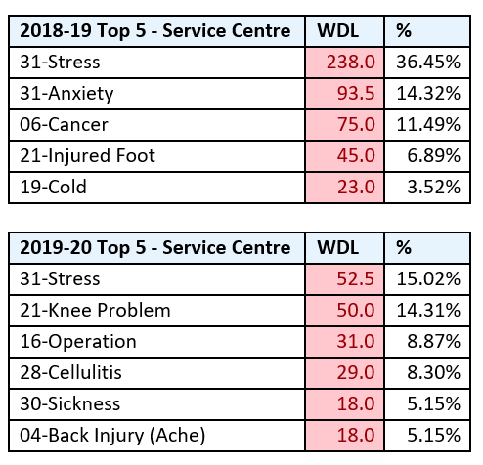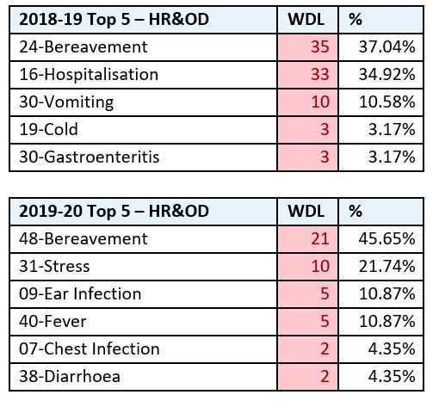

As a result of the successful outcomes in relation to the change initiative, CMT were considering the roll out of the pilot within other areas of the Authority however, due to the Pandemic, there has been a requirement for staff to work from home whilst facing personal challenges and as such, the new ways of working pilot has effectively be introduced across the authority to meet the requirements of the organisations whilst allowing staff to work flexibly.

Identify further work required to embed changes and/or further developments required.
Swansea Council recognises the effect Covid-19 has had and continues to have on employees both within their personal and working lives and as such, the Corporate Management Team (CMT) issued a survey to office-based staff requesting feedback regarding well-being and working from home arrangements during such unprecedented times. It also provided an opportunity for CMT to gain the view of individuals regarding their wellbeing and future working arrangements, (EV27).

Whilst there were mixed views in relation to the positive and negative impact of working from home, it was evident that the majority of employees would prefer to have a flexible approach to work in the future and maintain working from home arrangements.

According to (HR Review, 2020), to maintain high levels of employee engagement, organisation are encouraged to stay in touch with their employees and work with them to build the future for the organisation.

I have undertaken a SWOT analysis, (EV28) to assess the current position in relation to ways of working, identifying areas that are working well and what is not working so well. Consideration has been taken as to where the organisation is now, where it needs to get to and how it is going to get there, (Mind Tools 2020).

Communicate the key outcomes and the impact of change to stakeholders.

According to (MindTools, 2020), it is important to remember that any change process can impact stakeholders in different ways and as such Organisations need to closely manage expectations and advise them if any concerns arise. Continued engagement will ensure two way communication enabling an open and transparent process.

Swansea Council are committed to consulting with, and engaging relevant stakeholders in their decision making processes, (Swansea Council 2021).

The change initiative currently being considered by CMT including a review of the accommodation strategy including agile working, flexible working arrangements etc. needs to incorporate an effective communication strategy, (EV29) to ensure any corporate correspondence reaches the whole workforce. This has been effective during the pandemic and as such HR would encourage for such approach to continue.

The key outcomes and impact on the change has been communicated to staff via the intranet which have been successful as the changes to the ways in which staff are required to work in the main effect office based staff, (EV30).

Evaluate the effectiveness of own performance in contributing to the management of change.

In line with the CIPD Profession Map (CIPD, 2020), I believe I am working to the required level to enable me to make a valued contribution to management of change. I understand my role as the HR Lead, providing professional HR advice and support throughout a change process.

I have previously undertaken an evaluation of my knowledge, skills and ability in relation to change management, (EV31) which outlines the requirement of my role but also my development needs which will enable me to meet my aspiration of working towards a Chartered Member.

Witness statements from both my Line Manager, (EV20) and the Project Lead (EV26) provide confirmation of the advice and support provided from a HR perspective which I believe is a true reflection of me as an individual and within my role as a HR professional.

When providing advice and support throughout a change process, whilst I appreciate the messages being relayed may be difficult, it is important for staff to clearly understand what the change means for them providing support and detailing the options available. During the EOTAS restructure, due to the pandemic we were faced with a number of challenges however, I feel these were overcome and messages were communicated with staff at the appropriate time.

LO3 Evidence

EV27
Employee engagement survey – working from home during the covid-19 pandemic and beyond.

Which Directorate do you work in?
- Education
- Place
- Resources
- Social Services

Which Council office building are you normally based at?
- Civic Centre
- Clydach Depot
- Guildhall
- Heol Y Gors (Cave Street)
- Other
- Pipehouse

How would you rate your well-being since the COVID-19 pandemic?
- Very Good
- Good
- Neutral
- Poor
- Very Poor

Do you know where to access information and advice for support with your health and wellbeing?
- Yes
- No
- Maybe

Do you like working from home?
- Yes
- No
- Neutral

How often did you work from home before the pandemic?
- 1 day a week
- 1 or 2 days a month
- 2 days a week
- 5 days a week
- More than 2 days a week
- Never

How often do you work from home now?
- 1 day a week
- 1 or 2 days a month
- 2 days a week
- 5 days a week
- More than 2 days a week
- Never

After COVID, how often would you like to work from home (if your role allows you to work from home)?
- 1 day a week
- 1 or 2 days a month
- 2 days a week
- 5 days a week
- More than 2 days a week
- Never

How much of your role can you carry out at home?
- All of it
- Half
- Most
- None
- Not a lot
- Quarter

How productive do you feel working from home compared to working in the office?
- Less productive
- More productive
- The same

After COVID-19 I feel that working from home will enable me to be more effective in my role (i.e. able to meet deadlines etc.)
- Agree
- Disagree
- Neutral – neither agree nor disagree
- Strongly agree
- Strongly disagree

Do you have all the necessary equipment to work from home?
- No
- Yes

Do you have all the necessary software and applications to work from home?
- No
- Yes

Do you have access to the internet to work from home?
- No
- Yes

Do you need additional ICT training or support to work remotely?
Maybe
- No
- Yes

Are you happy with the type of communication you currently receive from your line manager?
- Yes
- No
- Maybe

Are you happy with the frequency of communication you receive from your line manager?
- Yes
- No
- Maybe

Do you like attending virtual meetings?
- Neutral (neither like nor dislike it)
- No
- Yes

After COVID-19, how often do you think you will want to attend the workplace to have fact to face meetings with your manager?
- Daily
- Monthly
- Never – I’m happy using Teams
- Once a week
- Twice a week

After COVID-19, how often do you think you will need to attend face to face meetings with your team members and colleagues?
- Daily
- Monthly
- Never – I’m happy using Teams
- Once a week
- Twice a week

Please provide any further comments regarding your working arrangements and wellbeing during this time:

EV28
Activity 2
Complete a SWOT analysis of an impending change in your organisation. Clearly list the strengths, weaknesses, opportunities and threats represented by the change.

SWOT Analysis
Due to Covid-19, the Organisation has identified the need to review the accommodation strategy, which will expand on agile working, flexible working arrangements, reduction of carbon footprint, home working etc. all of which will impact the HR Function.

Below is a SWOT analysis clearly detailing the Strengths, Weaknesses, Opportunities and Threats of such long term changes.

Strengths  Increased flexibility  Increased productivity  Better work life balance  Increased staff morale  Financial savings due to reduction of costs  Stability  Workforce feel trusted in undertaking their roles and responsibilities  Clear strategy for the future  Meets individuals needs | Weaknesses  Only part of the workforce will benefit from the change  Difficult to manage a virtual team  Performance management process is not fully integrated  Lack of trust by managers  Micro management
Opportunities  Income generation fir Civic Buildings  New ways of working  Development of new robust policies and procedures  Become an employer of choice  More flexible working arrangements | Threats  Workforce taking advantage  Decrease in productivity  Lack of social interaction which could have a detrimental effect to health and wellbeing  Reduction in development opportunities  Employee’s unable to differentiate between work life and home life  Increased sickness absence

Following a discussion with Nicola Reid, Principal HR & OD Business Partner considering the HR implications, it was evident that whilst the Organisation has already experienced significant changes to the ways in which the Workforce are required to undertake their roles. If the changes are going to longer term, a number of factors need to be considered.

Whilst the Authority has previously had an old fashion approach, the current crisis has meant a sudden change to working arrangements, changes to the way services are provided which has proven successful.

There is a requirement in conjunction with the Trade Unions to review relevant policies and procedures e.g. flexible working policy, agile working policy and performance management ensuring they are fit for purpose and meet the future needs of both the organisation and the workforce.

Consideration of an effective communication strategy to ensure any corporate correspondence reaches the whole workforce. This has been effective during the pandemic and as such HR would encourage for such approach to continue.

Performance Management is an important tool for both Managers and Employee’s should the news way of working continue to be successful in the longer term. Manager’s need to be provided with softer skills training which will enable them to have difficult conversations but also recognise employees who may be feeling isolated and as such require additional support.

It is important for HR to incorporate the implementation of the Performance Management programme with any proposed changes as this will have an impact on employee engagement and in turn effect productivity. HR need to encourage trusting culture which is embedded into the Organisation being led by the Corporate Management Team.

Another consideration for HR is to ensure the relevant support is provided for employees during and following the implementation of the changes. Working with Occupational Health and Stress Management allowing a collaborative approach in providing the necessary support not only during the Pandemic for but also for the future workforce.

EV29
Develop a communications strategy for the change. Discuss this with your line manager and submit a summary of your discussion plus the strategy (500-750 words)

Swansea Council Communication Strategy
Company Profile | Swansea Council is run by the local authority for the purpose of providing services to the public. It employs approximately 11,300 employees including around 5,000 based in schools with others delivering a wide range of services across Swansea.
Issue | Due to the Covid-19 pandemic, there was a requirement for Swansea Council to quickly adapt new ways of working enabling the workforce to continue to provide services to the Community whilst also being faced with personal challenges.  As a result, considerations are being given to implementing changes in the longer term allowing flexibility for staff whilst also meeting the overall business objectives.
Research | A staff survey on agile and home working was carried out in September 2019 which was essential to assist in planning for the future.  More than 1,600 staff responded with two thirds of staff stating they like working from home, with 84% of staff wanting to continue to work from home at least two days a week or more and 21% want to work from home full-time.  The benefits for both the organisation and employees is that 78% of staff have the ability to undertake their full role at home and 85% felt they were either at least as or more productive.  At the outset of the pandemic, Digital Services were vital in issuing IT equipment to enable staff to work from home however, the results of the survey conveyed that only half of the respondents felt they had all the necessary equipment.  The results of the survey will be used to guide the strategy for agile working for office-based staff and the development of policies which facilitate it.  However, it is important to recognised the need for a flexible approach considering the variety of needs and preferences within the workforce.
Communication Objectives | Provide clarity for staff in relation to new ways of working in the longer term  Create clear policies and procedures in line with the proposed changes  Provide reassurance and support to staff during times of uncertainty
Audiences | Engage with Directors and Heads of Service to guide strategy  Line Managers  Employees (Office based staff)  Trade Unions  Health & Safety Department (Occupational Health and Stress Management)  Digital Services
Key Messages | The hard work and efforts of Staff is acknowledged by Senior Leaders within the Authority who appreciate the circumstances at which staff have been and are still required to work during unprecedented times.  Following the survey carried out in September 2019, further consideration has been made regarding the longer term arrangements in relation to new ways of working.  We appreciate that we don’t have all the answers however, we want to provide reassurance of the support available for you during this time and in the future. All of which are available via the Staff Intranet.  The review of the Accommodation Strategy will enable us to provide clear clarification going forward implement policies and procedures which are fit for purpose.
Tactics/channels | Undertake a further engagement survey via Microsoft Forms to determine any differentiations in responses during the Winter months and changes to personal circumstances.  Continue written communication via emails and Staff Intranet  Initial communication to be issued via the Chief Executive  Line Managers to relay key messages via Team meetings and 121’s to ensure two way communication  Relay any updates via the weekly Newsletter  Discuss via formal Trade Union forum  Offer support via Occupational Health  General email address for staff to provide comments/feedback  Feedback provided to staff via email, Staff Intranet
Risks | Delays of implementation could result in uncertainty and low staff morale  Increased sickness absence  Culture change for managers, lack of trust could result in increased employee relations cases  Lack of trust for Senior Management
Measurement | Continued engagement with staff via Line Managers  Set up workshops to encourage views/feedback  Analysis of Sickness Absence Data  Analysis of Stress Management Referrals  Annual engagement survey
Review | Continuously review objectives during the change management process  Identify whether communication is reaching the required audience  Undertake a review of what went well, lessons learnt  Were the timescales adhered to?  Consider whether email addresses have been issued to operational staff to encourage corporate communication awareness  Encourage Managers to undertake performance management which will increase employee engagement and in turn increase performance and productivity.
During a discussion with Nicola Reid, Principal HR& OD Business Partner, we agreed that during the Pandemic clear and regular communication has been cascaded to staff offering support and advice during unprecedented times. However, we recognised that whilst the future working arrangements are unknown, it is important for the Authority to consider implementation of the new ways of working in the longer term.

EV30

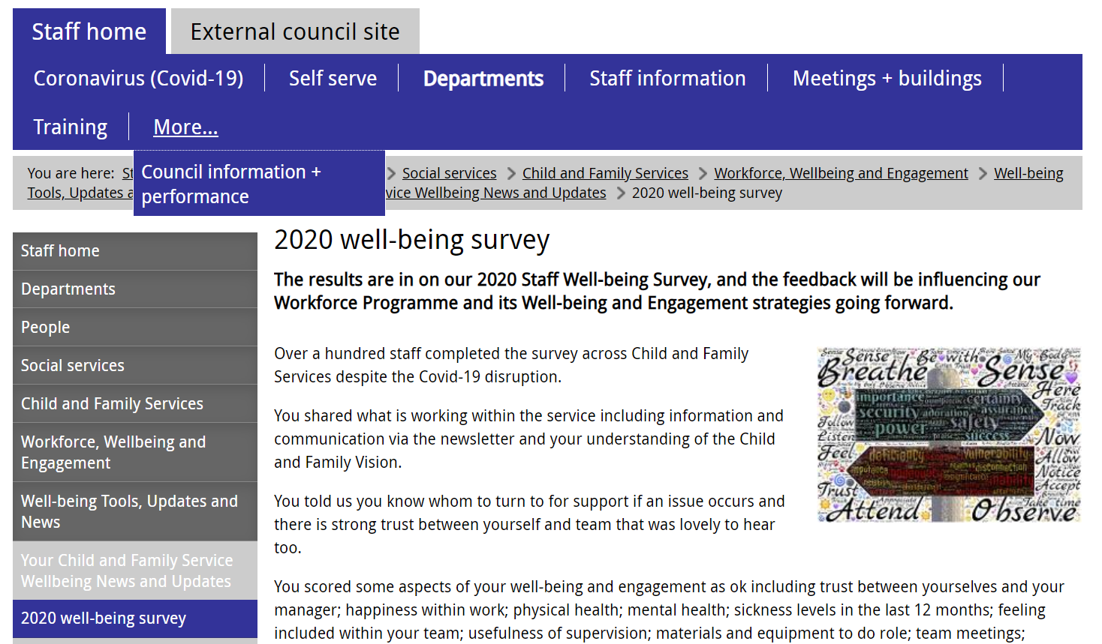
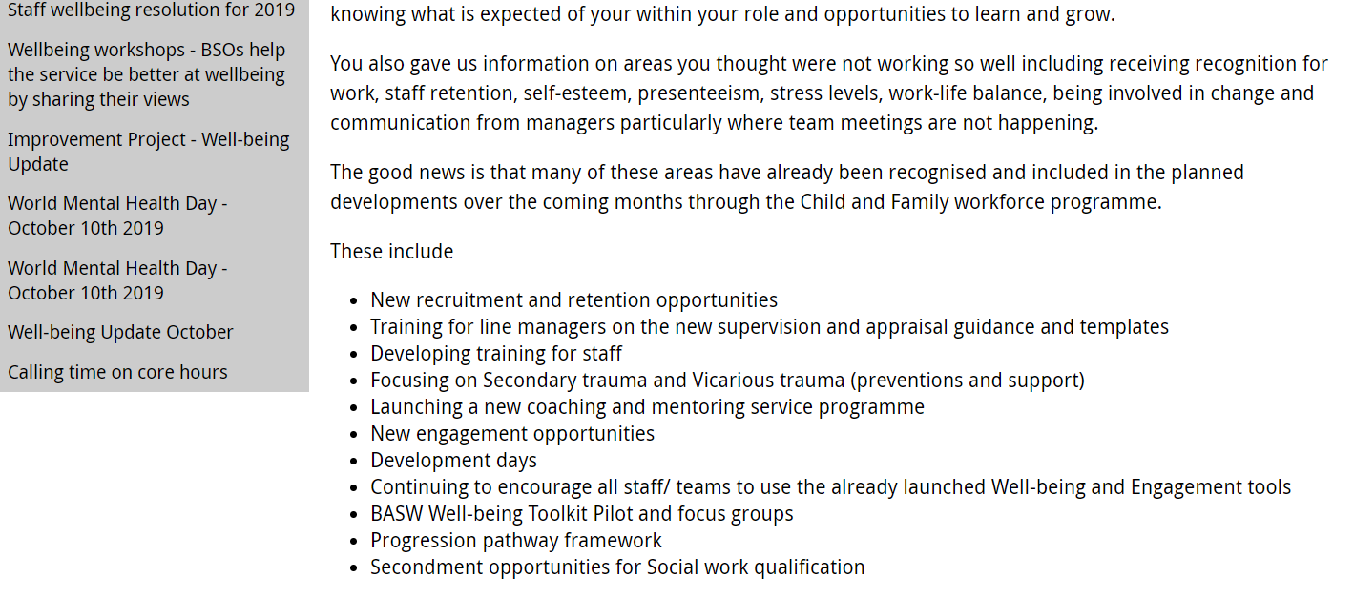
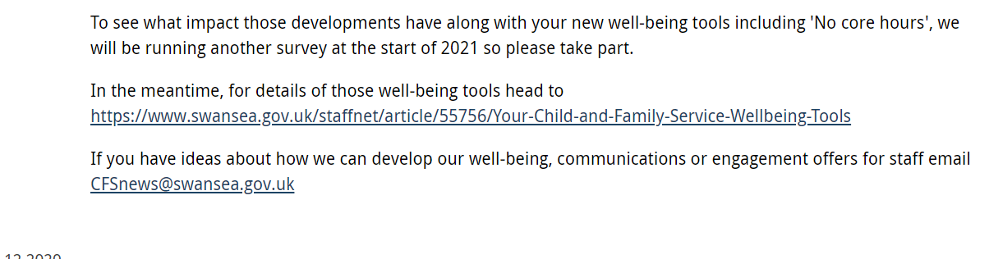

Candidate name: Stephanie Rayner |  |  |  |  | CIPD Membership/registration No.:  55478507
Qualification title: CIPD Level 5 Diploma in Applied Human Resources |  |  |  |  | Unique Learner No. (ULN):  1907192
Unit code | Unit title |  | Assessment criteria no. | Evidence description | Evidence reference number |  | Assessor  initials | I/V initials if sampled
5AMOC | Contributing to Management of Change |  | 1.1, 1.2, 1.3, 1.4, 1.5 | Initial report to Cabinet outlining proposals | EV1
5AMOC | Contributing to Management of Change |  | 1.1, 1.2, 1.3, 1.4, 1.5 | Initial discussions regarding process | EV2
5AMOC | Contributing to Management of Change |  | 1.1, 1.2, 1.3, 1.4, 1.5 | Draft consultation timeline | EV3
5AMOC | Contributing to Management of Change |  | 1.1, 1.2, 1.3, 1.4, 1.5 | Swansea Council – Consultation principles | EV4
5AMOC | Contributing to Management of Change |  | 1.1, 1.2, 1.3, 1.4, 1.5 | Verification List | EV5
5AMOC | Contributing to Management of Change |  | 1.1, 1.2, 1.3, 1.4, 1.5 | Invite to Consultation Meetings | EV6
5AMOC | Contributing to Management of Change |  | 1.1, 1.2, 1.3, 1.4, 1.5 | Email issued to staff following consultation meetings | EV7
5AMOC | Contributing to Management of Change |  | 1.1, 1.2, 1.3, 1.4, 1.5 | Cost Comparison | EV8
5AMOC | Contributing to Management of Change |  | 1.1, 1.2, 1.3, 1.4, 1.5 | Project Plan | EV9
5AMOC | Contributing to Management of Change |  | 1.1, 1.2, 1.3, 1.4, 1.5 | Communication methods with parents and young people | EV10
5AMOC | Contributing to Management of Change |  | 1.1, 1.2, 1.3, 1.4, 1.5 | Extract from Teachers Terms and Conditions | EV11
5AMOC | Contributing to Management of Change |  | 1.1, 1.2, 1.3, 1.4, 1.5 | EOTAS Steering Group Approval | EV12
5AMOC | Contributing to Management of Change |  | 1.1, 1.2, 1.3, 1.4, 1.5 | Agreement of project plan | EV13
5AMOC | Contributing to Management of Change |  | 1.1, 1.2, 1.3, 1.4, 1.5 | Initial Consultation Meeting Notes | EV14
5AMOC | Contributing to Management of Change |  | 1.1, 1.2, 1.3, 1.4, 1.5 | Letter issued to staff – consultation postponed due to Covid | EV15
5AMOC | Contributing to Management of Change |  | 1.1, 1.2, 1.3, 1.4, 1.5 | Final approval by CMT | EV16
5AMOC | Contributing to Management of Change |  | 1.1, 1.2, 1.3, 1.4, 1.5 | TU Meeting notes – recommencing consultation | EV17
5AMOC | Contributing to Management of Change |  | 1.1, 1.2, 1.3, 1.4, 1.5 | Letter issued to staff confirming recommencement of consultation | EV18
5AMOC | Contributing to Management of Change |  | 1.1, 1.2, 1.3, 1.4, 1.5 | Updated proposed timeline and email to staff | EV19
5AMOC | Contributing to Management of Change |  | 1.1, 1.2, 1.3, 1.4, 1.5 | Line Manager Witness testimony | EV20
5AMOC | Contributing to Management of Change |  | 1.1, 1.2, 1.3, 1.4, 1.5
5AMOC | Contributing to Management of Change |  | 1.1, 1.2, 1.3, 1.4, 1.5
5AMOC | Contributing to Management of Change |  | 1.1, 1.2, 1.3, 1.4, 1.5
5AMOC | Contributing to Management of Change
5AMOC | Contributing to Management of Change
Candidate declaration:
- I confirm that the work/evidence presented for assessment is my own unaided work.
- I have read the assessment regulations and understand that if I am found to have ‘copied’ from published work without acknowledgement, or from other candidate’s work, this may be regarded as plagiarism which is an offence against the assessment regulations and leads to failure in the relevant unit and formal disciplinary action.
- I agree to this work being subjected to scrutiny by textual analysis software if required.
- I understand that my work may be used for future academic/quality assurance purposes in accordance with the provisions of the Data Protection Act 1998.
- I understand that the work/evidence submitted for assessment may not be returned to me and that I have retained a copy for my records.
- I understand that until such time as the assessment grade has been ratified through internal and external quality assurance processes it is not final.
Signature: |  |  |  |  |  | Date:

Notes on candidate evidence matrices

Candidates should be encouraged to develop a matrix indicating how their evidence relates to each unit/module and learning outcomes/assessment criteria. This helps advisors and assessors to support candidates to draw links between units and encourage cross-referencing and the possible multi-use of evidence.

Evidence matrices can be developed using the unit/module and learning outcomes/assessment criteria, giving candidates an opportunity to link their evidence to each outcome.

Another approach is to have a more generic form where candidates list evidence and tick relevant boxes to show coverage.

Whatever approach is employed candidates should be encouraged to complete these forms themselves and not expect assessors to do this for them.

Bibliography

Acas (2020). ‘Managing Change’. Available at: Managing change | Acas (Accessed 22nd January 2021)

CIPD (2020) ‘Change Management’. Available at: https://www.cipd.co.uk/knowledge/strategy/change/management-factsheet (Accessed 9th January 2021)

CIPD (2020) ‘Understanding how to effectively enable change’. Available at: Change | CIPD Profession Map (Accessed 24th January 2021)

Gov.UK (2018). ‘Guide to the general data protection regulation’. Available at: guide-to-the-general-data-protection-regulation-gdpr-1-0.pdf (publishing.service.gov.uk) (Accessed 24th January 2021)

HR Review (2020) ‘Employee Engagement during Covid-19’. Available at: https://www.hrreview.co.uk/analysis/axel-schiphof-employee-engagement-during-covid-19/125643 (Accessed 24th January 2021)

HRZone (2019). ‘Change management: how to shift the behaviours and mindsets of your people’. Available at: https://www.hrzone.com/lead/change/change-management-how-to-shift-the-behaviours-and-mindsets-of-your-people (Accessed 22nd January 2021)

Mind Tools (2020) SWOT Analysis. Available at: https://www.mindtools.com/pages/article/newTMC_05.htm (Accessed 24th January 2021)

MindTools (2020). ‘Building Good Work Relationships’. Available at: Building Good Work Relationships - From MindTools.com (Accessed 24th January 2021)

MindTools (2020). ‘Lewin’s Change Management Model’. Available at: Lewin's Change Management Model - from MindTools.com (Accessed 11th January 2021)

MindTools (2020). ‘What is Stakeholder Management?’. Available at: https://www.mindtools.com/pages/article/newPPM_08.htm (Accessed 22nd January 2021)

People Management (2017) ‘I’ll tell you something: Anthea Marris’. Available at: https://www.peoplemanagement.co.uk/voices/comment/tell-you-something-anthea-marris (Accessed 11th January 2021)

Personnel Today (2011-2020) ‘Change Management’. Available at: https://www.personneltoday.com/hr-strategy/change-management/#:~:text=Change%20management%20is%20the%20process,or%20the%20introduction%20new%20processes.&text=Change%20can%20be%20a%20difficult,involves%20redundancies%20or%20TUPE%20transfers (Accessed 11th January 2021)

Prosci (2020) ‘Best Practices in Change Management’. Available at: https://www.prosci.com/resources/articles/change-management-best-practices (Accessed 12th January 2021)

SHRM (2021) ‘Managing Organisational Change’. Available at: Managing Organizational Change (shrm.org) (Accessed 16th January 2021)

Swansea Council (2021). ‘Consultation’. Available at: Swansea Staffnet - Consultation (Accessed 24th January 2021)

Swansea Council (2021). ‘Corporate records retention schedule’. Available at: Swansea Staffnet - Corporate records retention schedule (Accessed 24th January 2021)

