Case Study: The Sea View Resort

A 2000 Word Report

BMIH 5007 Financial Management for the Hospitality Industry
STUDENT: FESTUS TUMI 2121888
LECTURER: Tristan Hawkins
Date due: 16th November 2023

Contents
Executive Summary 2
Introduction: 2
Purpose of this report 3
Financial Performance 2020 - 2022 3
Income Statement 3
Balance Sheet Analysis 4
Cash Flow Analysis 5
Financial Ratios 5
Market and Competitor Analysis 6
Marketing and Branding Evaluation 8
Marketing and Promotion: 8
Operational Efficiency: 10
Customer Experience Enhancement: 10
Recommendations 10
REFERENCES 11
APPENDICES 13
Definitions: 13

Executive Summary

The Seaview Resort, nestled along a scenic coastline, once flourished as a premier vacation destination, offering luxury and relaxation. However, recent years have seen a troubling downturn in revenue, occupancy rates, and customer satisfaction. Notably, despite the resort's decline, the emergence of newer properties in the area suggests that external factors may not be solely responsible for Seaview's struggles.
This report aims to assess the financial viability of Seaview Resort and propose a strategic turnaround plan. Financial analysis spanning the last three years reveals a concerning trend, with total revenue plummeting from £520,000 in 2020 to £430,000 in 2022. Operating expenses surged by over 15%, exacerbating the decline in profitability. Notably, the net profit margin, a critical indicator, plummeted from 15% in 2020 to -11% in 2022, signaling an unsustainable financial trajectory.
To revitalise Seaview, the proposed strategies include rigorous financial restructuring, cost management, and revenue diversification. A market and competitor analysis will uncover shifting trends, while an evaluation of current marketing and branding strategies will guide targeted improvements. The aim is not only to regain lost ground but to reposition Seaview Resort as a thriving, customer-centric destination in the competitive hospitality market. Through a strategic blend of financial recalibration and operational enhancements, we are confident that the Seaview Resort will be able overcome its current challenges.

Introduction:
The Seaview Resort, a 25 bed property with restaurant, bar and event facilities, located on a picturesque coastline, was once a thriving destination for vacationers seeking relaxation and luxury. However, in recent years, the resort has experienced a decline in revenue, occupancy rates, and customer satisfaction.
While the Seaview Resort has seen a marked overall decline, there has been several newer properties that have been developed in the area. This indicates that the reduction in the number of visitors to the Seaview has little to do with the destination as a whole, but there may be other, more specific factors affecting the resort.

Purpose of this report

This report will evaluate the financial viability of the hotel and then based on the findings to propose a turnaround strategy, and will consider the following:
- Financial performance analysis by gathering and evaluating the financial statements of the last three years that have been made available including its
  - income statement
  - Balance sheet
  - Cash Flow
  - Financial ratios to assess Seaview Resort’s liquidity, solvency, profitability and efficiency.
  - Identify revenue, expenses and profit margins to locate areas of concern.
- Market and Competitor Analysis:
  - Conduct a thorough analysis of the local and regional hospitality market, including market trends, customer preferences, and competitors' offerings.
  - Identify any shifts in customer demographics or preferences that may have contributed to the decline in revenue and occupancy rates.
- Marketing and Branding Evaluation:
  - Review the resort's current marketing strategies, including online presence, social media engagement, and advertising efforts.
  - Assess the effectiveness of branding initiatives and promotional activities in attracting new guests and retaining existing ones.

Financial Performance 2020 - 2022

Income Statement
Table 1 – Income Statement Analysis (2020-2022)
Item | 2020 | 2021 | 2022
Total Revenue | 520,000 | 480,000 | 430,000
Operating Expenses | 390,000 | 400,000 | 450,000
Gross Profit | 130,000 | 80,000 | (20,000)
Net Loss (Loss) | 78,000 | 40,000 | (47,000)
Net Profit Margin | 15% | 8% | -11%

The company's total revenue has been declining over the three years, decreasing from £520,000 in 2020 to £480,000 in 2021 and then further dropped to £430,000 in 2022. This indicates reduced sales or market challenges. A significant factor could be the impact of the Covid-19 pandemic as it hit the hospitality and tourism sector particularly hard. Noel (2022) notes that even though hotels were open during the pandemic the complementary services associated with them such as restaurants, conferencing and beaches were closed limited the desire to travel and use hotels in the first place.
Operating expenses however increased over the same period by over 15%, possibly contributing to the reducing profitability of the business.
Novy-Marx (2013) suggests that profitability is measured by gross profits-to-assets, which in turn shows how efficient the business is managing its production and distribution costs.
However, table 1 shows a significant reduction in profits from 2020 -2021 and then turned negative in 2022. This, combined with the higher operating costs over the same period informs that the cost of goods sold might be too high relative to revenue, thus leading to losses.
Seaview Resort reported net losses in all three years, with the net loss increasing from £78,000 in 2020 to -£47,000 in 2022. This indicates that the company is not generating enough profit to cover its operating expenses, resulting in losses
The net profit margin is a key metric that measures the company's profitability as a percentage of total revenue. In 2020, the net profit margin was 15%, but it declined to 8% in 2021 and turned negative at -11% in 2022. The negative net profit margin in 2022 is a significant concern, as it means the company is losing money for each pound of revenue generated.

Balance Sheet Analysis

Table 2 – Balance Sheet Analysis (End 2022)
Item | Amount £
Total Assets | 1,030,000
- Current Assets | 250,000
- Property and Equipment | 630,000 (100,000 – Inventory)
- Other Assets | 150,000
Total Liabilities | 580,000
- Current Liabilities | 180,000
- Long term debt | 400,000
Equity | 450,000

The company's current assets of £250,000 cover its current liabilities of £180,000, which is a positive sign. However, the company has a substantial amount of long-term debt, which could affect its financial stability and interest payments in the long term. The company's financial health and ability to meet its long-term obligations would depend on its cash flows and profitability. The balance of the total assets minus the total liabilities matches with the equity value on the balance sheet and this represents Mr Henderson’s ownership interest in the company.

Cash Flow Analysis

Table 3 – Cash Flow Analysis (2022)
Item | Amount £
Net Cash Flow from Operations | -80,000
Capital Expenditures | 30,000
Net Cash Flow (Change in Cash Balance) | -110,000

In 2022, the company had a net cash outflow from operations of -£80,000, meaning that the company spent £80,000 more on its day-to-day operating activities meaning core operations isn’t generating enough cash.
A further investment of £30,000 in capital expenditure has exacerbated the net cash flow position to £-110,000,leading to a negative cash flow.

Financial Ratios
For definitions please refer to Appendix 1: Definitions
Table 4 – Financial ratios (2022)
Current Ratio | Current Assets/Current Liabilities | 1.39
Quick Ratio | (Current Assets - Inventory)/Current Liabilities | 0.83
Debt-to-Equity Ratio | Total Debt/ Total Equity | 1.29
Return on Assets | Net Profit/ Total Assets | -0.05
Return on Equity | Net Profit/Total Equity | -0.11

The current ratio of 1.39 indicates that that the company has a reasonable level of liquidity to meet its short-term obligations.
A quick ratio of 0.83 suggests a lower level of liquidity compared to the current ratio and the hotel will rely on inventory to cover its short-term obligations.
A debt-to-equity ratio of 1.29 indicates that the company has a relatively high level of debt compared to its equity suggesting a significant reliance on debt for financing.
An ROA of -0.05 means that the company had a negative return on its assets, indicating that it incurred a loss in relation to its total assets.
An ROE of -0.11 indicates that the company incurred a negative return on equity, meaning it had a loss in relation to its equity.
Overall, the company's liquidity position, as indicated by the current and quick ratios, is reasonable, but the high debt-to-equity ratio and negative returns on assets and equity are concerning. The company did not generate a profit in 2022, and the high debt level is a concern. Consistent declines in revenue, gross and net profit together with higher operating expenses suggests that the business may need to implement cost cutting measures, renegotiate existing loans or seek additional funding to ensure financial stability.
Considering that the core business has been in negative, the hotel will need to review its operating expenditure in an attempt to reduce it.
- Cost Management
Conduct a detailed analysis of operating expenses to identify areas where costs can be reduced without compromising the quality of services.
- Financial Planning and Budgeting:
Develop a realistic budget and financial plan to ensure effective resource allocation and monitor financial performance regularly.
- Negotiate with suppliers for better rates and explore opportunities for bulk purchasing to achieve cost savings.

- Energy Efficiency Measures:
Han (2021) echoes other scholars by acknowledging that a company’s environmental corporate social responsibility practices significantly influence customers decision-making process and consumption behaviours. He adds that when travellers perceive that a firm has strong environmental corporate social responsibility activities, they are more likely to patronise their product.

Market and Competitor Analysis

The Seaview Resort’s beach front location continues to be a popular destination as there have been several, newer hotels in the area. This suggests demand for the destination has remained strong and provides The Seaview Resort with the opportunity to leverage its location is a key strength to help rebuild its reputation among the other properties in the area.
Table 5
Average Room Rate £ | Year | Value
 | 2020 | 250
 | 2021 | 230
 | 2022 | 210
Occupancy Rate % | 2020 | 70
 | 2021 | 65
 | 2022 | 60

The declining average room and occupancy rates over the period may well be as a result of changes in the demand for the Seaview Hotel (either as a result of the pandemic) or the competition from the newer hotels in the area.
Table 6
YEAR | ARR x Occupancy | RevPAR
2020 | £250*70 | £175
2021 | £230*65 | £149.50
2022 | £210*60 | £126

The key metrics of the average room rate (ARR), occupancy rate, and RevPAR are all declining however this may be a response to the greater competition posed by the increasing number of hotels in the area (Bhandari 2021) However studies by Kim, Roehl, and Lee (2019) and others suggest this strategy of deliberately lowering rates may not on its own help to revive the market share among its competitors.
Customer satisfaction reviews have also declined over the same period, and crucially this points to potential operational issues within the hotel itself. Chakraborty & Biswal (2020) suggests that consumers opinions built upon online reviews in the hospitality sector has a significant impact on their decision to purchase. Recent customer reviews have been disappointing, and may have contributed to the falling occupancy rates.
Since the pandemic scholars like Liu-Lastres, Han and Wei-Jue (2023) have noted considerably resignation rates among hospitality and tourism staff and a corresponding reduction in applications and staff affecting hotels and other hospitality sections of the economy. A loss of staff, especially in the Seaview’s luxury market segment, would have a detrimental effect on its service delivery.
Newer properties in the area have moved to more sustainability. Ensuring that potential customers understand the Seaview’s commitment to sustainability would be beneficial as referenced by Han (2021a) above. For example, Whitbread owners of Premier Inn makes their sustainability a major selling point in their marketing material.

Marketing and Branding Evaluation

In view of the recent competition the hotel should consider the market conditions and competitor actions and adjusting its pricing strategy to remain competitive in the market. Dynamic pricing or yield management works on the premise that different consumers are prepared to pay different amounts for the same service depending the elasticity of demand (Badinelli 2000)

Marketing and Promotion:
- Develop a robust marketing strategy to increase brand visibility and attract more guests. This may involve online marketing, social media campaigns, and collaborations with travel agencies. Understanding the hotels and its competitive sets demographics can help target advertising and promotions to key demographic groups. Social media platforms that most resonates with the various demographic groups will help with promoting the Seaview Resort. Table 7 below suggests that to attract the crucial 35+market (with their perceived higher disposable income, then the hotel can target its promotions and adverts on the most likely social media platform.
Table 7 (Gambo & Ozad, 2020)
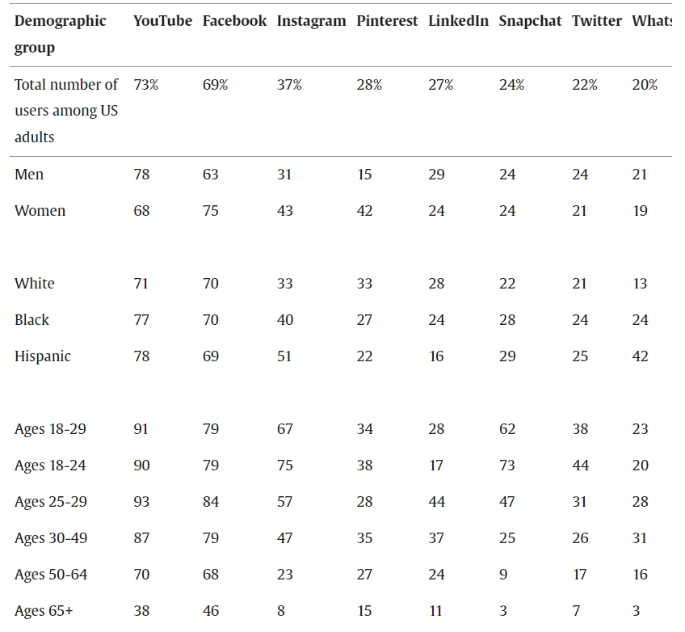
- Utilising websites like Similarweb.com allows for the hotel to check this information. For example, understanding that more and more hotels are promoting sustainability and wellness to women. The Global Wellness Institute as quoted by Ruiz (2023) states that wellness tourists have deep pockets, spending 177 percent more than an average guest when traveling domestically; and 35 percent when traveling internationally.
- Ruiz continues “according to American Express in their recent global trends travel report, 73 percent of survey respondents report that they are planning a vacation around improving their physical and emotional health; while 43 percent report having selected a hotel based on its spa and wellness amenities.” Developing and promoting spa and wellness would be a way to return to profitability.
- Implement loyalty programs to encourage repeat business and referrals. Similar to the programs like Marriott’s Bonvoy, STASH Hotel Awards is a program designed for the smaller independent hotel and offers many of the perks that the larger groups provide.

Operational Efficiency:

- Streamline operational processes to improve efficiency. This may involve re-evaluating workflows, staffing levels, and resource allocation.
- Invest in technology to automate manual tasks and enhance overall operational efficiency.
- Regularly assess the quality of services and amenities offered by the hotel. Ensuring cleanliness, maintenance, and adherence to quality standards can contribute to positive guest experiences

Customer Experience Enhancement:
- Focus on providing an exceptional guest experience to encourage positive reviews and word-of-mouth recommendations.
- Train staff to deliver outstanding customer service and address customer feedback promptly.
- Invest in training and development programs for staff to enhance their skills and improve overall service quality.
- Ensure that employees are motivated and engaged, as their satisfaction can have a direct impact on guest satisfaction.

Recommendations

Implement Dynamic Pricing and Wellness Initiatives:
Seaview Resort should adopt dynamic pricing strategies to stay competitive in the market. Utilise yield management to adjust room rates based on demand fluctuations, ensuring optimal revenue. Additionally, tap into the growing wellness tourism trend by promoting spa and wellness amenities. Leverage the Global Wellness Institute's data, targeting the 35+ demographic with tailored promotions on platforms most frequented by this group. Dynamic pricing combined with wellness offerings can attract high-spending guests, contributing to increased revenue and market differentiation.
Enhance Operational Efficiency and Customer Experience:
Streamline operational processes through technology adoption, reducing manual tasks and optimizing resource allocation. Invest in staff training programs to enhance customer service, addressing negative reviews and improving guest satisfaction. Consider loyalty programs to incentivize repeat business. Ensure cleanliness, maintenance, and adherence to quality standards to enhance overall customer experience. A focus on operational efficiency and customer-centric services can positively impact Seaview's reputation, attracting more guests and fostering loyalty.

REFERENCES

- Badinelli, R (2000) “An optimal, dynamic policy for hotel yield management” European Journal of Operational Research Volume 121, Issue 3, 2000 Pages 476-503 Available at: https://www.sciencedirect.com/science/article/pii/S0377221799000466 Accessed: 15th November 2023
- Bhandari, A (2021) “Price Wars Have No Winners” Business World, New Delhi April 6, 2021. Available at: https://www.proquest.com/docview/2508796702/fulltext/2067887ABABA4C23PQ/1?accountid=130472 Accessed: 15th November 2023
- Chakraborty & Biswal (2020) “Impact of Online Reviews on Consumer’s Hotel Booking Intentions: Does Brand Image Mediate?”, Journal of Promotion Management, 26:7, 943-963, DOI: 10.1080/10496491.2020.1746465.
- Corporate Finance Institute Available at: https://corporatefinanceinstitute.com/resources/accounting/quick-ratio-definition/ Accessed: 2nd Nov 2023
- Financial Accounting. Pearson Education 2013 Ratio Analysis Chapter 13 pg. 351.
- Gambo. S & Özad, O 2020 “The demographics of computer-mediated communication: A review of social media demographic trends among social networking site giants.” Computers in Human Behaviour Reports, Volume 2, 2020. Available at: https://www.sciencedirect.com/science/article/pii/S2451958820300166 Accessed: 15th November 2023.
- Heesup Han (2021) “Consumer behavior and environmental sustainability in tourism and hospitality: a review of theories, concepts, and latest research”, Journal of Sustainable Tourism, 29:7, 1021-1042, DOI: 10.1080/09669582.2021.1903019 Available at: https://www.tandfonline.com/doi/full/10.1080/09669582.2021.1903019 Accessed: 15th November 2023
- Kim, Roehl, and Lee (2019) “Effect of hotels’ price discounts on performance recovery after a crisis.” International Journal of Hospitality Management, Vol 83, 2019 pgs. 74-82 Available at: https://www.sciencedirect.com/science/article/pii/S0278431918311824) Accessed: 15th November 2023.
- Liu-Lastres, Wen & Huang (2023) “A reflection on the great resignation in the hospitality and tourism industry” International Journal of Contemporary Hospitality Management Vol 35 (1):15 Jan 2023 Available at: https://www.emerald.com/insight/content/doi/10.1108/IJCHM-05-2022-0551/full/html Accessed: 15th November 2023
- Noel, M. D. (2022) “Competitive survival in a devastated industry: Evidence from hotels during COVID‐19” Journal of Economics & Management Strategy. Available at: https://web-s-ebscohost-com.ezproxy.uwtsd.ac.uk/ehost/pdfviewer/pdfviewer?vid=0&sid=f558ec08-4998-4266-ac11-f32213fe45e5%40redis Accessed 15th November 2023:
- Novy-Marx, R (2013) “The other side of value: The gross profitability premium” Journal of Financial Economics, Vol 108, Issue 1 2013, pg. 1-28 Available at: https://www.sciencedirect.com/science/article/pii/S0304405X13000044 Accessed: 15th November 2023.
- Ruiz, R. (2023) “6 Questions on the Future of Wellness Travel and Why the Time for Transparency is Now” Women Leading Travel and Hospitality. Blog July 17, 2023 Available at: https://womenleadingtravelandhospitality.com/6-questions-on-the-future-of-wellness-travel-and-why-the-time-for-transparency-is-now/ Accessed: 15th November 2023
- SiteMinder (2023) “What is RevPAR?” Available at: https://www.siteminder.com/r/calculate-revpar/ Accessed: 12th November 2023
- STASH Rewards (2023) Website Available at: https://www.hoteliers.stashrewards.com/ Accessed: 15th November 2023
- Weetman, P. (2019) “Financial and Management Accounting: An Introduction.” 8th Edition. Pearson Publishing

APPENDICES

Definitions:

Current Ratio: The current ratio indicates the extent to which short term assets are available to meet short term liabilities. Weetman, P (2019
Below 1:1 raises issues of cash flow. Ideal above 1:1 to 2:1
Quick Ratio: “Also known as the acid test measures the ability of a business to pay its short term liabilities by having assets that are readily convertible to cash.” Corporate Finance Institute (2023).
Debt-to-equity ratio: used to evaluate a company's financial leverage and is calculated by dividing a company's total liabilities by its shareholder equity.
Return on Assets: a profitability ratio that provides how much profit a company can generate from its assets. In other words, return on assets (ROA) measures how efficient a company's management is in earning a profit from their economic resources or assets on their balance sheet.
Return on Equity: a measure of financial performance calculated by dividing net income by shareholders' equity.
Average Room Rate:
RevPAR: ‘Revenue Per Available Room’, is a hotel industry metric that provides insight into the number of rooms that are being sold at a hotel and how much revenue is being generated from those bookings.

