NSEDA Assignment G
Assignment Brief
Your narrative should:
- Determine the source activity on the day of the incident and why such high activities are needed for this purpose.
- Estimate, by hand calculation, the unshielded dose rate at 2 m from the source. A point source calculation can be used but comment on the suitability of this model and how more accurate estimates could be made.
- Explain why a maze entrance system in used in this application.
- Estimate the dose rate at 2 m accounting for shielding by 1 m water, using the provided half-value layer.
- Hence estimate the effective dose to the maintenance technician using the RPA reconstruction.
- Compare this with the measured effective dose, explaining any discrepancies.
- Discuss any health implications from the radiation exposure in this incident.
- Assess compliance with the Ionising Radiations Regulations 2017.
- Evaluate the event against ONR Safety Assessment Principle EKP.5 Defence in Depth and two other SAPs of your choice
- Propose proportionate improvements, justified on ALARP grounds, that would reduce the likelihood or consequences of a similar event.

NSEDA Assignment G Incident Dossier
Equipment: Pool-Type Industrial Sterilisation Irradiator
Location: Commercial Medical Products Sterilisation Facility at [Redacted] Berkshire

1. The Radioactive Source Assembly
Source Type: Sealed cobalt-60 source pencils arranged in a panoramic source rack.
Isotope: Cobalt-60.
Original Activity: 12.0 PBq certified on 15 February 2018.
The source rack comprises multiple doubly encapsulated cobalt-60 pellets welded into stainless steel pencils and arranged to provide a high-intensity gamma field when raised into the irradiation position.
[For the purposes of this assignment, internal attenuation within the source assembly may be neglected].
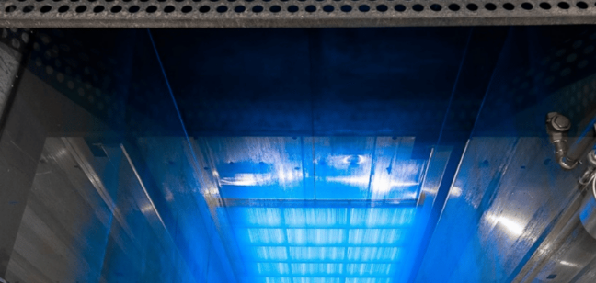

2. Engineering and Irradiator Design
The irradiator consists of a 5 m deep water pool in which the source rack is stored when not in use. During operation, the rack is raised from the pool into the irradiation chamber by a motor-driven hoist mechanism.
The pool water provides the principal biological shielding when the source is in the parked position.
Products [medical instruments in tote boxes] are conveyed through the irradiation chamber using an automated conveyor system. Access to the chamber is prevented by interlocks unless the source rack is confirmed to be fully lowered into its shielded position in the pool.
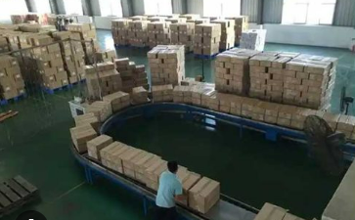

3. Maintenance and Operational Background
In the period leading up to the incident, intermittent discrepancies were reported in the source hoist position indication system. On several occasions, the indicated parked position did not fully align with expected hoist travel times, although no formal fault was declared.
The conveyor system had also experienced recurring misalignment faults, resulting in occasional jams requiring manual intervention following shutdown.
Maintenance entries into the irradiation chamber had previously been carried out following routine confirmation that the source rack was fully lowered into the pool.

4. The Incident — 9 December 2024
At the end of a production cycle, the source rack was commanded to return to its fully shielded position in the pool. Owing to a mechanical fault in the hoist mechanism, the rack stopped with its upper edge approximately 1.0 m below the water surface, rather than at the normal fully parked depth of~ 5 m.
The control system indicated that the source was safely parked.
Prior to authorising entry, the shift supervisor manually checked the radiation level at the maze entrance using a portable gamma survey meter. A reading of approximately 0.5 µSv h⁻¹ was obtained. This was considered by the shift supervisor to be consistent with normal background conditions for a safe state with the parked source.
On this basis, a maintenance technician was authorised to enter the irradiation chamber to clear a conveyor jam.
The two ‘danger of death’ gamma signs which are activated by the gamma dose rate meter remained illuminated but were at first ignored by the maintenance technician. He later stated he thought they must be erroneous based on the dose rate monitoring carried out at the door which seemed to agree with the indication of a ‘parked’ source.
The maintenance technician started work on the jam then withdrew after noticing that the sources were not deep in the pool and the illuminated ‘danger of death’ sign.
The technician reported feeling faint and nauseous. The shift supervisor contacted the RPA immediately.
5. Personal Dosimetry
The technician was wearing:
- an electronic personal dosimeter (EPD) on the chest
- a whole-body TLD at waist level
Post-incident dosimetry indicated:
- EPD dose: 310 mSv
- EPD peak dose rate: 24 Sv h⁻¹
- TLD dose: 380 mSv
After emergency reading of the TLD, incident was reported for formal investigation to the HSE by the Approved Dosimetry Service.

6. Post Incident Review
Post-incident reconstruction by the RPA indicated that:
- the technician remained inside the irradiation chamber for approximately 45–75 s
- the torso was approximately 2.0 m from the effective source position
- approximately 1.0 m of intervening water lay between the source and the technician for most of the exposure
[For the purposes of hand calculation, the radiation field may be treated as the unshielded dose rate at 2.0 m, attenuated by 1.0 m of water shielding].
The half-value layer of water for ⁶⁰Co gamma radiation may be taken as 0.23 m.
Post-incident review concluded that the radiation dose rate measured at the maze entrance was consistent with a partially shielded source.

Irradiator System-
Heavy duty interlocked door
Conveyor
Illuminated Warning Sign
Plan View- not to scale
Gamma
detector
Irradiation
Zone
6 m
Pool for collimated radioactive source
Walls are 1.5 m thick barytes concrete
Lead/steel
Baffle

