

Programme: BA Business Management

Module code: | LCBB4001
Unit tittle: | Accounting Fundamentals
Lecturer: | Riaz Bhatti
Student name: | Desislava Zhelyazkova
Student ID: | 1917424

Report – Part 1

Date: 29/08/2020

Table of Contents
Task 1 – Practical question 1 3
Task 2 – practical question 2 7
Task 3 – Theoretical question 3 9

Introduction

This work is purposed to show knowledge and understanding about accounting fundamentals. There are three tasks in this report, two of which are practical exercise. The tasks covering question 1 and 2 are practical tasks that aims to help learners gain practical skills. The third task is theoretical, so that the learner could show knowledge and understanding of the topic. This report will provide a vary of examples of financial transactions needed to be done in a certain organisation before making the final annual trial balance, income statement and a Statement of financial Position. The theoretical part of this work will be related with the concepts concerning financial information, such as financial statement, financial income, statement of financial position, users of financial data, etc.

Task 1 – Practical question 1

Trial Balance at 31 Dec 2019 - Wales PLC
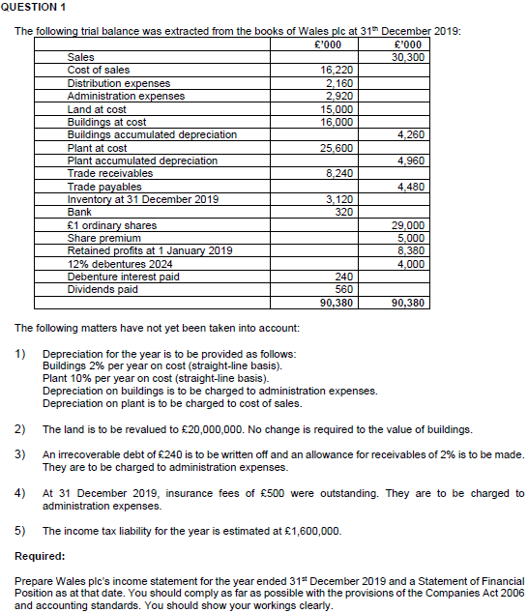

Based on the Trial Balance of Wales PLC at 31 December 2019. It is required to be made an Income statement and a Statement of Financial Position. Additional transactions are to be done and the trial balance adjusted accordingly.

Adjustment of Trial Balance | Before adjusting |  | After adjusting
Accounts | D | C | D | C
-------- | £000 | £000 | £000 | £000
Sales |  | 30,300 |  | 30,300
Cost of sales (D-2560) | 16,220 |  | 18,780
Distribution expenses | 2,160 |  | 2,160
Admi. Exp-s (D-320; 240;160; 500) | 2,920 |  | 4,140
Allowance for Bad Debts |  |  |  | 160
Land at cost (D-5000) | 15,000 |  | 20,000
Revaluation Surplus (C-5000) |  |  |  | 5,000
Buildings at cost | 16,000 |  | 16,000
Build. A. Depreciation (C-320) |  | 4,260 |  | 4,580
Plant at cost | 25,600 |  | 25,600
Plant A. Depreciation (C-2,560) |  | 4,960 |  | 7,520
Trade receivables (C-240) | 8,240 |  | 8000
Trade payables |  | 4,480 |  | 4,480
Inventory at 31 December 2019 (C-500) | 3,120 |  | 2,620
Bank | 320 |  | 320
£1 ordinary shares |  | 29,000 |  | 29,000
Share premium |  | 5,000 |  | 5,000
Retained profits at 1 January 2019 |  | 8,380 |  | 8,380
12% debentures 2024 |  | 4,000 |  | 4,000
Debentures interest paid | 240 |  | 240
Dividends paid | 560 |  | 560
Total | 90,380 | 90,380 | 98,260 | 98,260

Detailed Bookkeeping
Administrative Expenses
Dr | £000 | Cr | £000
Balance | 2,920
Depreciation Building | 320
Irrecoverable debt written off | 240
Allowance for receivables | 160
Insurance fees paid | 500
Total | 4,140

The way the additional transactions have been workout are added as follow:
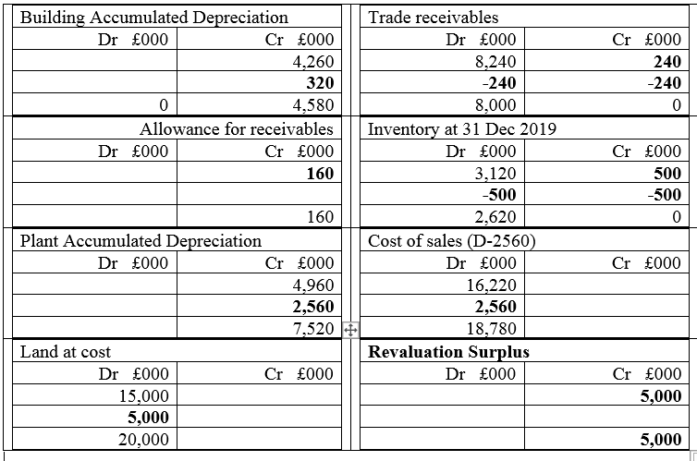
First solution – Income Statement
Income Statement
N | Accounts | £000
1 | Revenue | 30,300
2 | Cost of sales | (18,780)
3 | Gross Profit | 11,520
4 | Distribution Cost | (2,160)
5 | Administrative expenses | (4140)
6 | Operating profit | 5,220
7 | Finance cost (4000x12%) | (480)
8 | Profit before taxation | 4,740
9 | Taxation | (1,600)
10 | Profit for the period | 3,140

Second solution – Statement of financial Position.
Statement of Financial Position
 | Assets | £000 | £000
 | Current assets
 | Trade receivables | 8,000
 | Inventories (31 Dec 2019) | 2,620
 | Bank | 320 | 10,540
 | Non-Current assets
 | Land at cost (15,000 + 5,000) | 20,000
 | Plant at cost (25,600-7,520) | 18,080
 | Buildings at cost (16,000-4580) | 11,420 | 49,500
 | Total assets |  | 60,040
 | Less liability
 | Trade and other Payables (W1) | 6,080
 | Non cur. Liability
 | Long term liabilities | 4,000 | 10,080
 | Net assets |  | 49,960
 | Equity
 | Ordinary shared capital |  | 29,000
 | Retained profit (W2) |  | 10,960
 | Share premium |  | 5,000
 | Revaluation reserve |  | 5,000
 | Total |  | 49,960

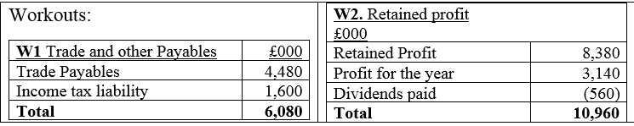

Task 2 – practical question 2

Extracts from the latest financial statements of Jerry plc supplies will be used in order to be done some specific calculations, that could help decision making about planned expansion of the business abroad.
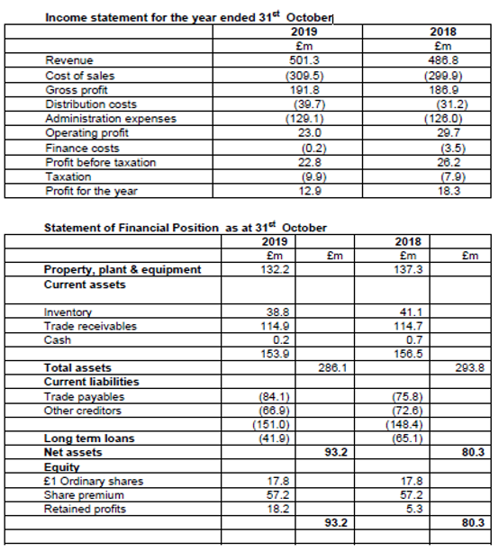

- Calculate the following Ratios

- Return on capital employed. The formula for calculating it is ROCE = (Profit before interest/ Assets employed) x 100%
The formula for the Assets employed = total assets – current liabilities.
- Return on equity. The formula for calculating it is = (Earnings / Ordinary share capital and receivers) x 100%
- EPS. The formula for calculating it is Earnings per share = (Earnings / Number of ordinary Shares)
- Gross profit margin. The formula for calculating it is = (Gross profit/Sales) x 100%
- Asset turnover. The formula for calculating it is = Turnover / Assets employed
Assets employed = total assets – current liabilities
- Stock holding period. The formula for calculating it is = (inventory / Cost of sales) x 365
- Debtors collection period. The formula for calculating it is = (Trade receivables/sales) x 365
- Current ratio. The formula for calculating it is = Current assets / Current liabilities
- Gearing. The formula for calculating it is = (Long term debt / Capital employed) x100%.
- Interest cover. The formula for calculating it is = Profit before interest / Interest charges

N | Ratio | Year | Calculations | Results
1 | ROCE | 2018 | (£29.7/£293.8 – £148.4) x 100 = £2970/145.4 | 20.43%
1 | ROCE | 2019 | (£23.0/£286.1 – £151.0) x 100 = £2300/135.1 | 17.02%
2 | ROE | 2018 | (£18.3/£80.3) x 100 | 22.88%
2 | ROE | 2019 | (£12.9/£93.2) x 100 | 13.84%
3 | EPS | 2018 | (£18.3/£17.8) x 100% | 102.81%
3 | EPS | 2019 | (£12.9/£17.8) x 100% | 72.47%
4 | GPM | 2018 | (£186.9 / £486.8) x 100% | 38.39%
4 | GPM | 2019 | (£191.8 / £501.3) x 100% | 38.26%
5 | AT | 2018 | £486.8 / (£293.8 – £148.4) | £ 3.35
5 | AT | 2019 | £501.3 / (£286.1 – £151.0) | £ 3.71
6 | SHP | 2018 | (£41.4/£299.9) x 365 | 50.39 days
6 | SHP | 2019 | (£38.8/£309.5) x 365 | 45.75 days
7 | DCP | 2018 | (114.7/486.8) x365 | 86.00 days
7 | DCP | 2019 | (114.9/501.3) x365 | 83.66 days
8 | CR | 2018 | £137.3 / £145.4 | £0.94
8 | CR | 2019 | £132.2 / £151.0 | £0.88
9 | G | 2018 | (65.1/145.4) x 100% | 44.77%
9 | G | 2019 | (41.9/135.1) x 100% | 31.01%
10 | IC | 2018 | £29.7 / £3.5 | £8.49
10 | IC | 2019 | £23.0 / £0.2 | £115

- Discussing the result of question 2a
The ROCE ratio indicates the company’s value level. The results show decreasing of the parameters, so this indicator is to be observed on regular basis.
The ROE in indicator dealing with the efficiency of the company. Again, a decreasing according to the last year was detected and additional attention is necessary.
Earning per share concerns the profitability and is mainly important for the shareholders. 30% decreasing of this indicator is quite a reason to worry. Additional attention is required before taking decisions.
The gross profit margin is not registering any significant percentage, due to which this ratio gives some hopes that the business might really need expansion.
The assets turnover indicates the efficiency of generating revenue. Considering that it is actually increasing, that might another sing that expansion of the business could work well.
The stoke holding period shows the period of how long the company can hold inventory. It is normally defined as good if it is about 3 months.
Debtors collecting period indicates the effectiveness of managing the account receivable practices. This ratio defines that the period company is able to wait for its money is about 3 months.
Current ratio is defining how able to pay its obligation is the business, which usually concerns a period of 1 year.
Gearing ratio defines the company’s health or sustainability, and it is indicating the financial risk of the business. In this case it is a bit high.
The interest covering ratio is concerning the interest of the debts, and the good here is that it is highly increased. It is probably a good sign because to expand the business, the company could need to borrow money from the banks.

Task 3 – Theoretical question 3

- User groups explained
Investors
Investors are a significant group of users that is highly interested in the financial statements of the businesses that are interest of their investing wishes. They need correct and relevant information so that the decision they take based on them to be as close as possible to the right one. They are risking their money and expect to get some profit of them, that is why they could regularly monitor the financial situation of the businesses they have invested in, or are going to invest in. The companies are interested to show good data, so that they can attract investors or creditors, suppliers etc (Gibassier & Unerman, 2010).
Suppliers
The suppliers are very important part of each business because the quality of their supplies define the quality of the company’s final outcome. The suppliers though need business partners that are able to pay their purchases and borrowed products, services or raw material on time. Companies are also interested to attract good and responsible suppliers, so they could also monitor their financial statements.
Government
The governments and their agencies are as important users as investors, suppliers and Managers of the businesses. The government is interested to know how much taxes will be paid for a certain period of trading, based on which the government could make plans for spending them smartly. The governments are also interested to check if the financial statements are correct and the right fees are paid. The companies are interested to provide realistic data to the government because problems with the government could create greater problems for the business. All of them are interested in the accuracy of the provided financial information. The role of the ruling a nation government, plays a dominant role in the successful execution of corporate governance (Emeagwali, 2017) .

- Advantages and disadvantages of a highly regulated financial reporting regime.

The European Union's efforts in the field of consumer protection are aimed at developing the European regulatory framework in a way that meets the challenges of global markets and at building a common and consistent approach to supervisory practices at European level.
A highly regulated financial reporting regime is important especially now when great amounts of money are exchanged daily between the businesses across the world. Creating international regulations is even more important now, because the international business activities are very intensive and technologically well developed.
Advantages of a a highly regulated financial reporting regime comes from the security that it brings to the businesses. The businesses are sharing information very fast and businesses have short time to compare prices and quantities based on chosen quality. Without e proper regulations the international markets will turn into a mess. The standards defined by these regulations save time, money and increase trust in brands. Supported by the law the regulations define how these standards are followed. The understanding if the financial transaction is also important and businesses do relay on these regulations to keep them safe of frauds and crimes.
Improving efficiency – Following the regulations and being clear on regulations is essential for a company that respect itself. The business should make it sure that the staff is familiar with the legal framework in which the company operates, and respect the need of or regulatory compliance.
When trying to implement certain strategy that the business needs, the company should work within the regulations and focus on its customers’ needs.
Disadvantages can come when the international regulations are too different from the internal regulations of the country. Many countries could not join a specific European regulating organisation such as IFRS because their internal accounting system and regulations are too different. To make the changes could take decades, which for the today’s intensive business life is impossible step. Such is the case with US and IFRS (Mohana, 2011).

- Limitations of financial statements.

There are many limitations of the financial statements some of which are:
Limited to different periods of time – usually for past time. The time statements have been done for are not exactly what the users need, or the period of time is too short or too long to satisfy the needs of the users. Managers also could take wrong decisions of relay on data from a winter period and make decisions for a summer period (KUPPAPALLY, 2009).
Inflationary effects – The inflation can create limitations. This is because the assets and liabilities cannot be adjusted according to each inflation. This could provoke making wrong decisions, making incorrect analysis of the situation, especially in cases when the information applies to long-term assets (Mohana, 2011).

Fraud is also in the list of limitations because many businesses could try to give wrong information, if they struggle to find the right investor or creditor. Such frauds could have been done in order to gain something that won’t happen if the realistic data has been realised.
The limitations are the factors about which the business should be well aware of.

Conclusion

This work managed to show the importance of financial statement for both creator and user. The concept of accounting, financial transactions and financial statement, their importance advantages and advantages were also discussed. In general, this work has been completed successfully and transactions in the practical example were clear and well explained. This report has achieved its goals. Specific skills were gained from the practical exercise. Knowledge and understanding were supporting the completing of the whole job.

References
Emeagwali, L., 2017. Corporate Governance and Strategic Decision Making. First ed. Rijeka: InTech.
Gibassier, D. & Unerman, J., 2010. Sustainability Accounting and Accountability. First ed. London: Routledge.
KUPPAPALLY, J. J., 2009. ACCOUNTING FOR MANAGERS. First ed. New Delhi: Private Limited.
Mohana, R. P., 2011. Financial Statement Analysis and Reporting. First ed. New Delhi: PHI Learning Private Limited.

