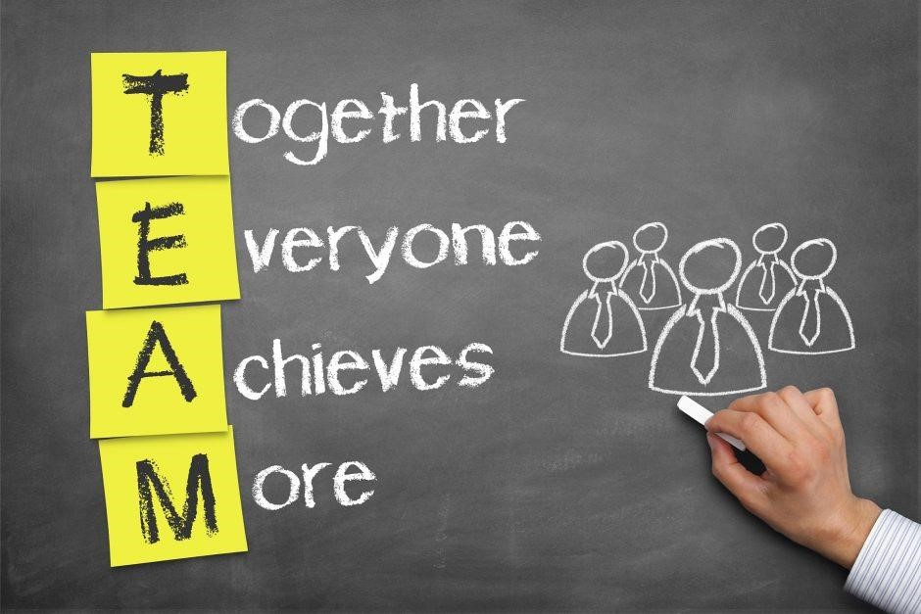
Effective Team Working
And Communication BMSW4002

Shaila Sultana Sonia Kazi (2013422) Maimuna Sani (2010130)
Mireia Male Una Detna (2008766) Martina Rossi (2007919)
Yogesh Saulick (2011272)
Agenda
- Benefit of Team Working
- Stages of Team Development (Tuckman)
- Team Roles (Belbin)
- Managing Conflicts (Thomas- Kilman)
- Successful team Development

Main Objective
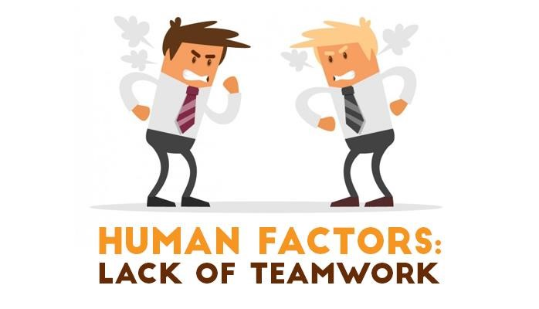
Sunflower Food Super Market
Grocery-Wine-Frozen-Fresh- Newspapers 2M Store with 30 Employees
Observation:
- - 25% sales per yr. and poor customer service.
- Lack of productivity and conflicts.
- Absenteeism and poor communication.

A Leader involvement;
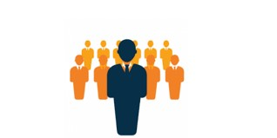
- Understand Team Purpose
- Find out what you contribute
- If support needed
- Identify who is doing what
(Qin, Johnson, & Johnson, 1994)
➢Teams are groups of identifiable people who actually work together to achieve a common set of objectives. (Griffith, Brian A., 2014)
- Creates a relationship among team.
- Commitments are shared.
- Productivity is increased.
- Combining abilities and ideas.

Disadvantages working in team (Griffith, Brian A., 2014)
- Unequal participation.
- Time Delays.
- Poor Communication.
- Changes can be obstacle for existing employees.


TEAM ROLES AND LEADERSHIP ROLES AT WORK

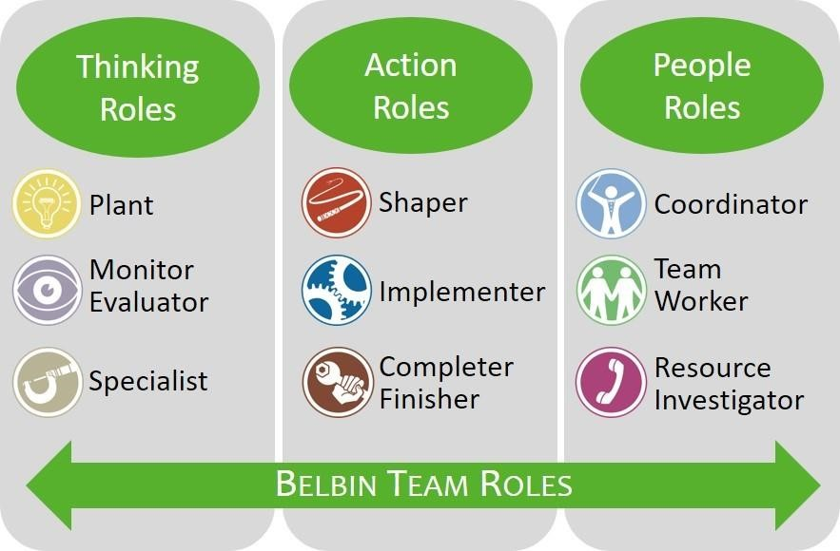
According to Belbin’s theory (1981-1993))
- 9 Roles was discovered
- Strengths and Weakness
- People personalities and quality


Action-Oriented Roles
- Shaper (SH)
People Oriented Roles
- Coordinator (CO)
Thought Oriented Roles
- Plant (PL
(Bednár and Ljudvigová, 2020)

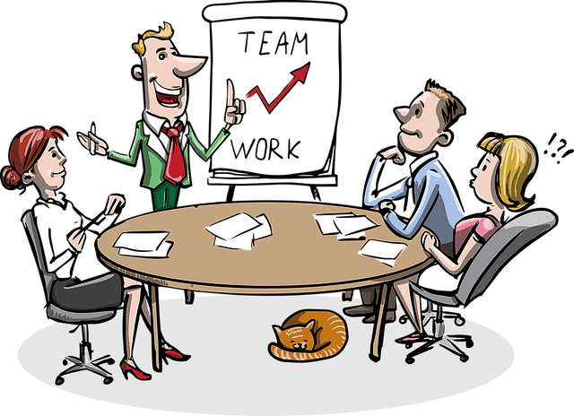
Belbin’s Knowledge:
- Good judgement
- Behaviour
- Approach
- Recruitment
- Delegation
Belbin (1981)

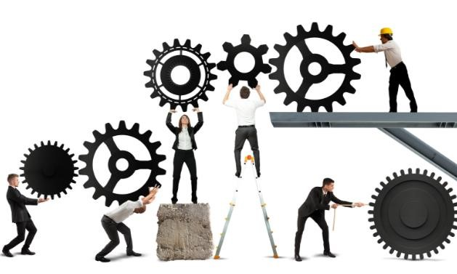
Sunflower Food Supermarket
Leader Role
Five values fundamental of effective team performance.
- Team member contribution.
- Work with team.
- Lead by example
- Organise Team Belbin (1981)

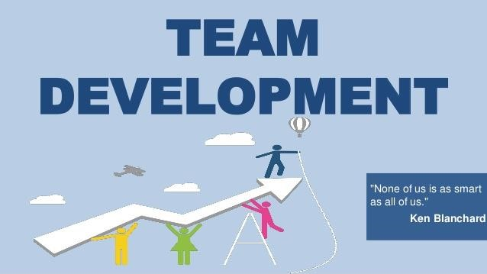

STAGES OF TEAM DEVELOPMENT
The phases of Forming-Storming-Norming-Performing are inevitable to grow a effective over time, face challenges, find solution, and to achieve goal (Tuckman, 1965).

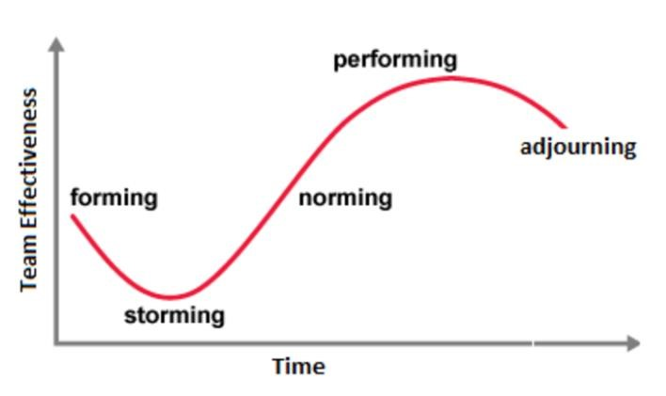
The effectiveness of Team over time

FORMING STAGE
Stage of orientation
(Harper,2019)
- Excitment is high
- Anxiety and uncertain STORMING STAGE NORMING STAGE
Stage of conflict. Stage of consensuse.
- Disaggrement and frustration • Resolve the discrepancy
- Decrease team performance • Increase group cohesion

PERFORMING STAGE ADJOURNING STAGE
PEAK STAGE OF TEAM EFFICTIVENESS. ^{STAGE OF COMING TO AN END.}
(Tuckman and Jensen, 1977).

- Competence is elevated ▪ Accknowledgement
- Problem solving ▪ Impending dissolution
- Accomplishment ▪ Drop productivity

Applying Tuckman in supermarket

Stages of Team  Development | Approach of team Leader and members
Forming Stage | Be open minded, interaction, establish clear goal and objective.
Storming Stage | Be positive and supportive, assertive leadership, specific direction, personality test
Norming Stage | Provide feedback, step back of leader, follow up, incorporate team
Performing Stage | Independent team, evenly and fairly delegation, prevent regression, individual development
Adjourning Stage | Celebration, recognise, individual reflection, guidance about future plans

Improving on Tuckman Model

- Storming is a consistent occurrence rather than a stage (Norton,2017)
- Stages may regress from performing to storming.
- Lack of explanation of how groups change over time (Rickards and Moger, 2000)
- Group has considered as closed systems (Amber,2010)
- No specific solution to solve conflict (Kobiruzzaman, 2021 )
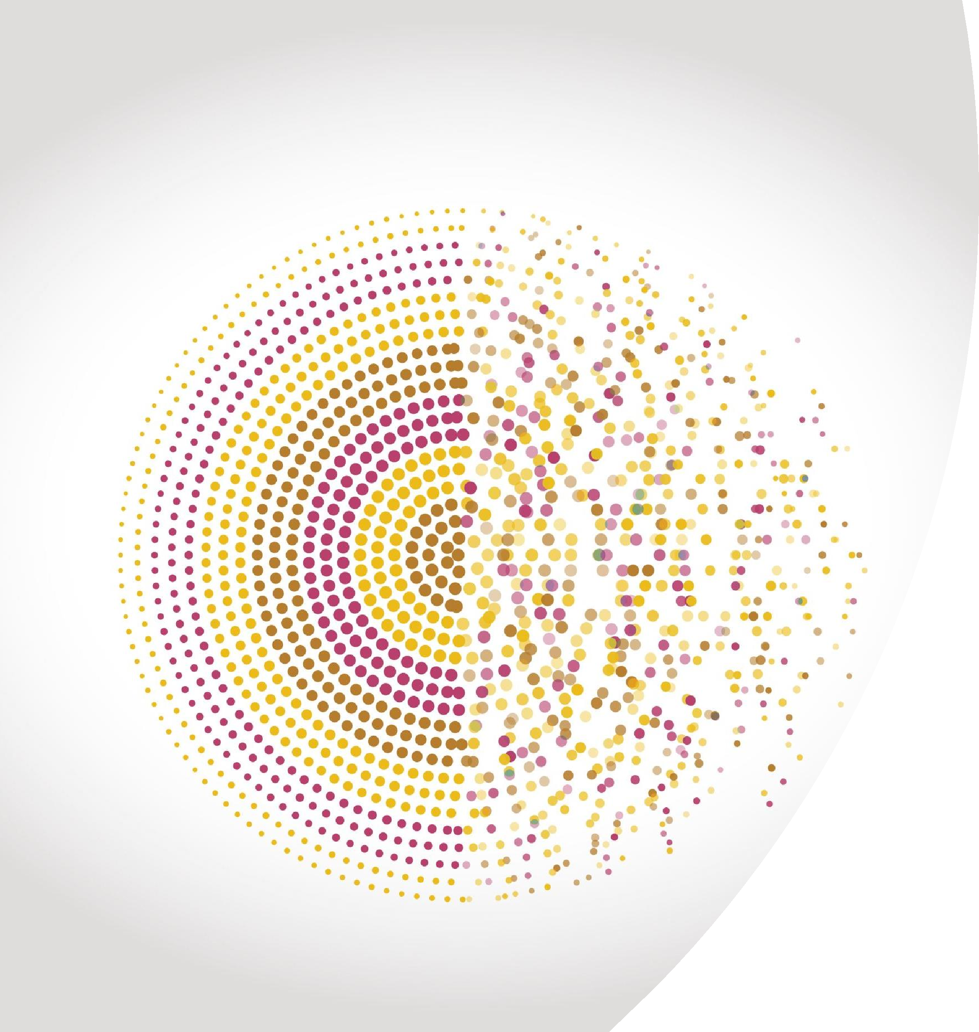
MANAGING
CONFLICT
RESOLVING CONFLICT
AT WORK.

What is a conflict?
•
Webster’s
dictionary
defines
conflict
as
a
sharp
disagreement
or
opposition
of
interests
or
ideas
.
(
University
of
Oklahoma,
2021
)

Is conflict a bad thing?
•
Conflict
does
not
have
a
good
reputation
.
•
P
ositive conflict help to increase productivity.
(
Brady,
2018)

Thomas
–
Kilmann Model
This model identifies two dimensions
:
•
Assertiveness
•
Cooperativeness
(
Day,
2021)
Thomas-Kilmann Model sets five way to deal with conflict:

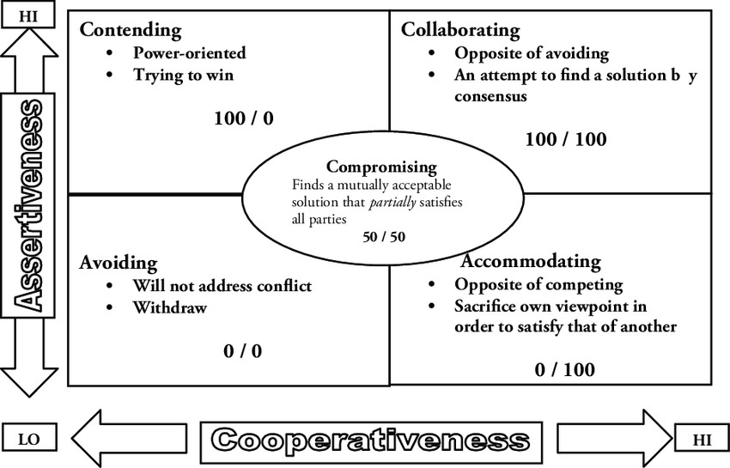
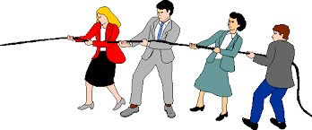

SUCCESSFUL TEAM DEVELOPMENT

Culture of Employee Engagement
- Realistic goals and responsibilities
- Employee attachment and Friendly Atmosphere
(Landsberg, 2015)

“People may forget
What you said or did
But will never forget how you make me feel”
Carl Buechner

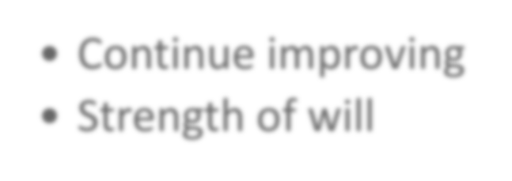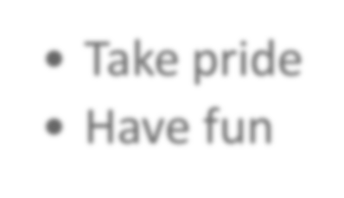 (Landsberg, 2015)
•
Share idea
•
Offer support
Contribution
•
Continue improving
•
Strength of will
Consistency
•
Take pride
•
Have fun
Celebration
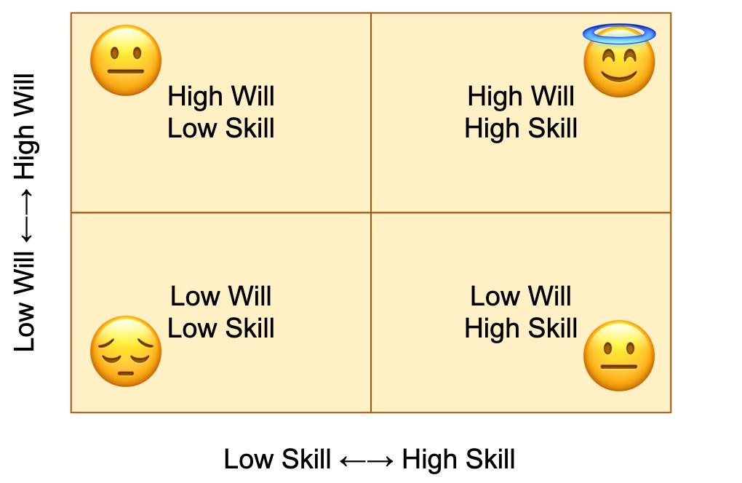
Motivation
- Reviews
- Identify Motivators
- Support
- Training and PDP
(Landsberg, 2015)
Rewards and Recognition
- Thank you and Well done
- Employee of the Month
- Team Build Events
- Certificates of achievement
(Landsberg, 2015)

To Conclude;
- Implementing effective teamwork
- Capabilities and qualities
Sunflower super market will meet their targets
The end.

- Griffith, Brian A., and Ethan B. Dunham. Working in Teams : Moving From High Potential to High Performance, SAGE Publications, 2014. ProQuest Ebook Central, https://ebookcentral.proquest.com/lib/trinity/detail.action?docID=5165231
- Johnson, D.W. & Johnson, R.T. (1994) Learning together and alone (4th ed.),
Needham Heights, MA: Allyn and Bacon
- Landsberg. M. (2015), The Tao of Coaching: boost your effectiveness at work by inspiring and developing those around you, pp.5 -17 Available at https://www-vlebookscom.ezproxy.uwtsd.ac.uk/Vleweb/Product/Index/704786?page=0
[Accessed:18 Apr 2021]
- Atwater, L. and Waldman, D. (1998)
- R Meredith Belbin. (2010). Team Roles at Work: Vol. 2nd ed. Routledge.
- Bednár, R. and Ljudvigová, I., 2020. Belbin team roles in a start-up team. In SHS Web of Conferences (Vol. 83, p. 01002). EDP Sciences.
- Aritzeta, A., Senior, B. and Swailes, S. (2005b). ‘Team role preference and cognitive styles: a convergent validity study’. Small Group Research, 36, 404–36.
- Amber, Y. (2010) Human Resource Development International. Routledge Taylor&Francis Group, 13(1), pp. 111-120.
- Harper, H. (2019) workstyle.io. [Online]. Available at: https://www.workstyle.io/stages-of-teamdevelopment
(Accessed: 2 March 21).
- Kobiruzzaman, M. (2021) newsmoor.com. [Online]. https://newsmoor.com/tuckmans-model-fivestages-of-group-and-team-development-theory/ (Accessed: 3 March 21).
- Norton, D. (2017) Onbelay.co. [Online]. Available at: https://onbelay.co/articles/2017/5/5/tuckmanwas-wrong (Accessed: 4 March 21).
- Rickards, T., and Moger.S. (2000) Creative leadership processes in project team development: An alternative to Tuckman’s stage model. British Journal of Management, 11(4), pp. 273– 83.
- Tuckman, B. W. (1965) Developmental sequence in small groups. Psychological Bulletin, 63(6), pp. 384-399.
➢Tuckman, B. W., & Jensen, M. C. (1977) Stages of small group development revisited. Group and Organizational Studies, 2, pp. 419–42
- Human Resources (2021), ‘Resolving conflicts at works: Employee information’, The University of Oklahoma [Online], Available at: https://hr.ou.edu/Employees/Career-Development/ResolvingConflicts-at-Work#3934542-addressing-conflic, (Accessed: 8 April 2021).
- Brady D. (2018), ‘Is Team Conflict a good thing or a bad thing? In Conflict Management, Culture Change, Team.’, TotalTeamBuilding.com [Online], Available at: https://www.totalteambuilding.com.au/team-conflict-good-or-bad/, (Accessed: 8 April 2021).
- Day I. (2018), ‘Conflict and challenge (The Tomas Kilmann Model)’, Challenging Coaching going beyond traditional coaching to face the facts, News and Muse [Online], Available at:
https://challengingcoaching.co.uk/conflict-and-
challenge/#:~:text=The%20Thomas%20Kilmann%20model%20model,satisfy%20the%20other%20p erson's%20concerns, (Accessed: 8 April 2021).
➢Huneynov T.(2010), ‘Mountains Karabath: New Paradigms for Peace and Development in the 21st
Century.’, International Negotiation, (15)1, pp. 7-31, ResearchGate [Online], Image from Google,
Available at: https://www.researchgate.net/figure/The-so-called-Thomas-Kilmann-Conflict-Mode-
Instrument_fig1_233641635, (Accessed: 8 April 2021)

