Coursework Title
Module Name:
Module Code:
Student Name:
Student ID:
Lecturer Name:

Table of Contents
Introduction 3
Key functions of general operating systems 4
Task 1 4
Process Management: 4
Memory Management: 5
File Management: 6
Security and User Management: 7
Task 2 8
Example 1: 8
Example 2: 9
Example 3 10
Example 4: 11
Example 5: 12
Example 6: 13
Example 7: 14
Example 8: 14
Example 9: 15
Example 10: 15
Task3 16
Use of Linux OS CLI commands 16
Example 1: 16
Example 2: 16
Example 3: 17
Example 4: 17
Example 5: 18
Example 6: 18
Example 7: 19
Example 8: 19
Example 9: 20
Example 10: 20
Reference list 21

Introduction
This report looks at the main ideas and functions of operating systems, especially how they manage computer hardware and software. It covers process management, memory management, file handling, and system security. The report also shows how to use command line interfaces (CLI) in Windows and Linux. It includes examples of different commands, along with screenshots, to explain how they work for file management, networking, user control, and task scheduling. Overall, the report highlights how operating systems help users with everyday computing tasks.

Key functions of general operating systems
The Windows operating system, developed by Microsoft and first released in 1985, is widely used in personal and professional computing. It provides a user-friendly interface and manages hardware, software, memory, and processes efficiently, making it essential for running applications and ensuring system stability [1], [2].

Task 1

Process Management:
The heart of an Operating System is Process Management. It is responsible for managing the programs that are running. It also determines which programs should be running, for how long, and how to share the resources. For example, in Windows, you can use the Task Manager to check running programs and shut those that have crashed.

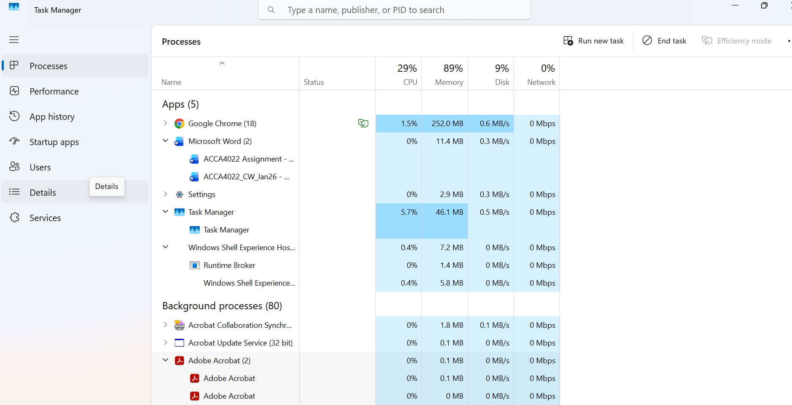

Figure 1: The Windows Task Manager displays currently active processes.

Memory Management:
Memory Management is another important task that the Operating System has to do. It has to allocate the RAM in the computer and ensure that each program has enough space to work without stepping on others’ toes. It should be efficient in its task to prevent crashes and make the system fast.In Linux, you can also use system monitors to do the same. For instance, in Windows, memory usage is accessible through the Task Manager under the Performance tab.

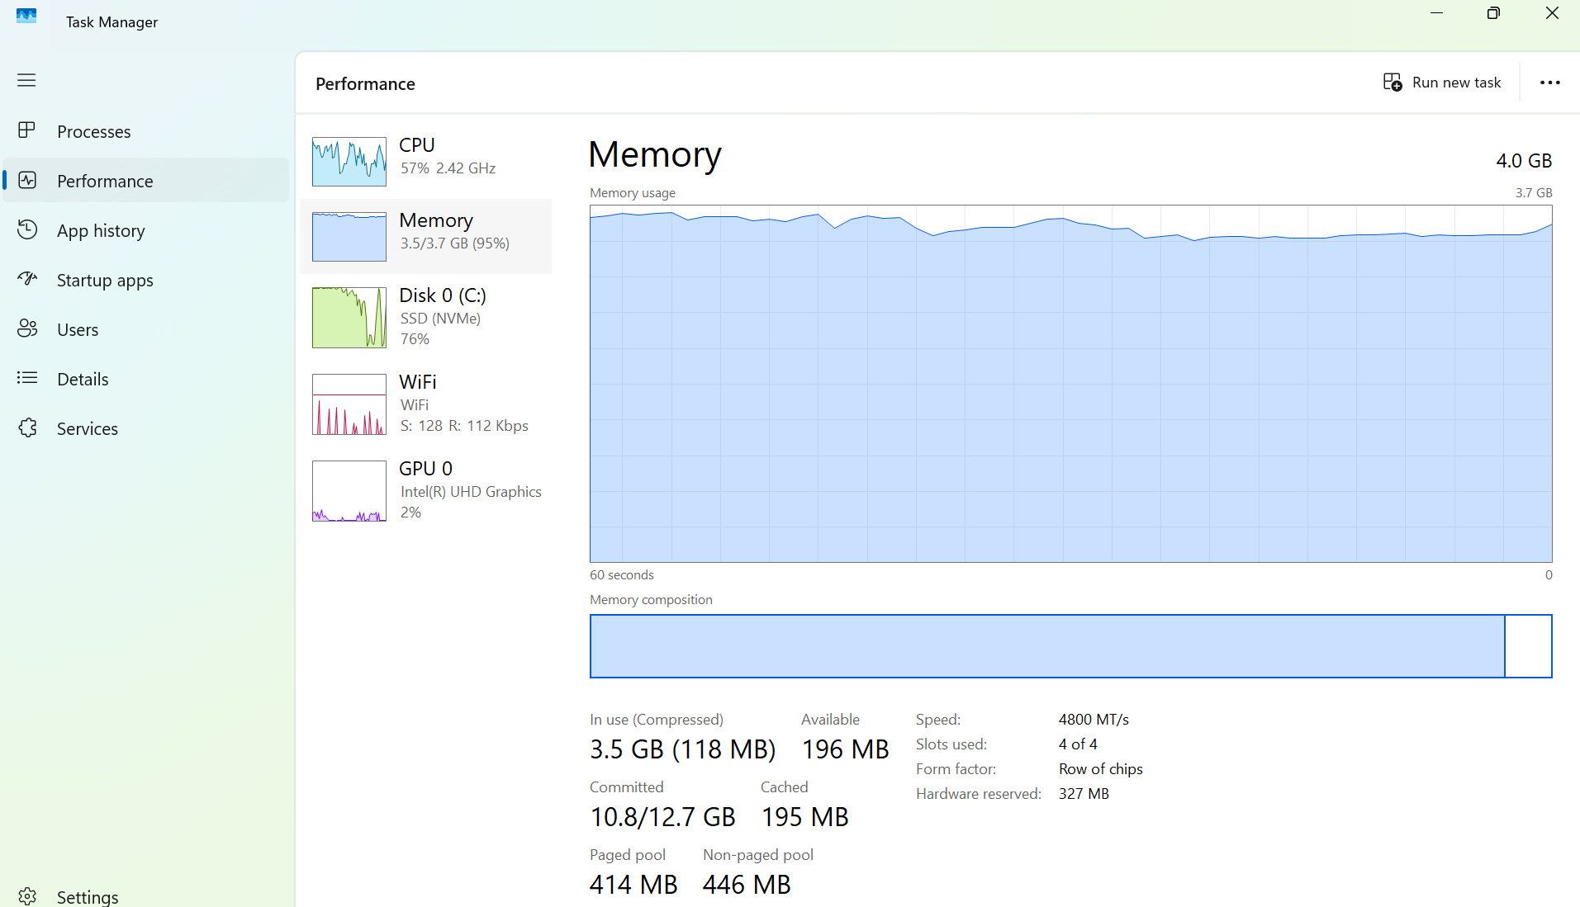 Figure 2: The Windows Task Manager displaying system memory usage.

File Management:
File management is a key function of an operating system. It organises data into files and folders so users can store, find, and manage information. For example, Windows uses File Explorer, while Linux uses directory structures accessed through the terminal or file manager.

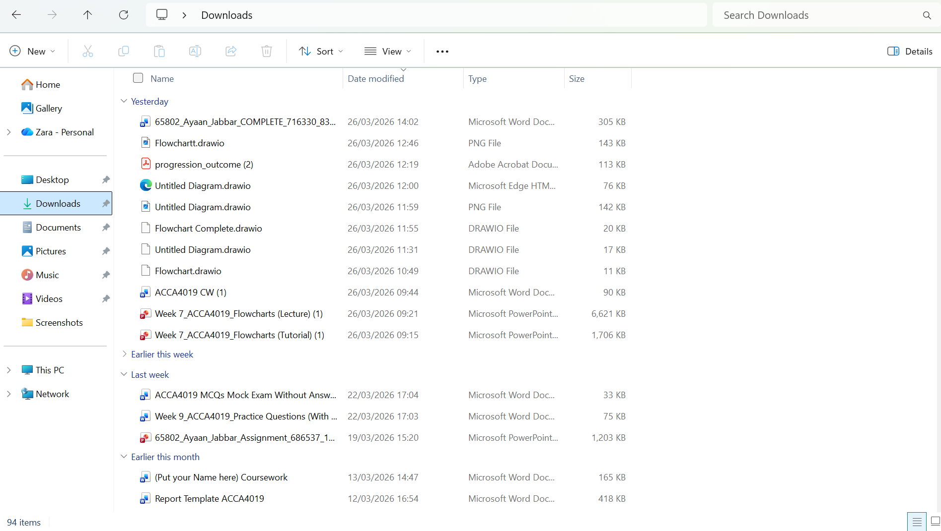
Figure 3: File Explorer displaying files and folders in Windows.

Security and User Management:
Security and User Management are also important parts of operating systems. They keep data safe by using user accounts and permissions to control who can access what, making sure sensitive information stays private. Features like passwords, encryption, and firewalls are common in systems like Windows and Linux. In Windows, manage user accounts and security settings using system settings and Windows Security tools.

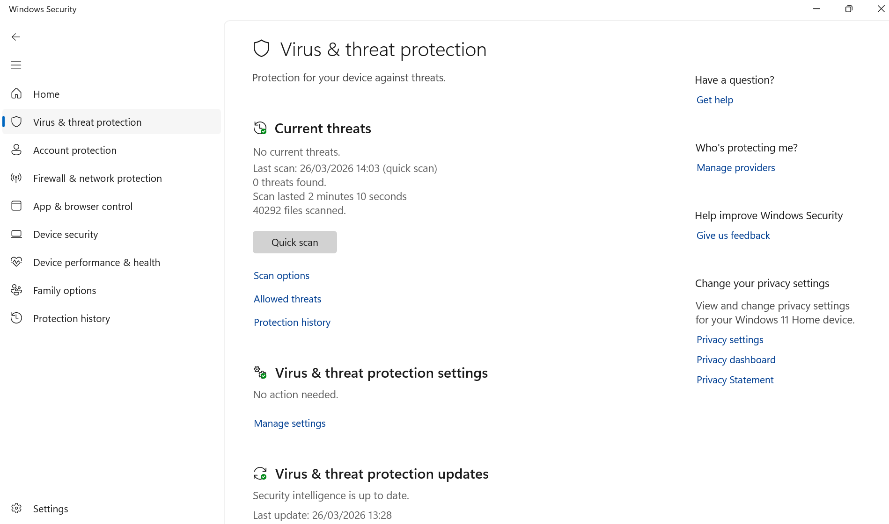Figure 4: Windows Security settings illustrating system protection features.
In short, operating systems play a key role in managing both hardware and software. They organize processes, memory, files, devices, and security to help computers run smoothly and give users and applications a stable place to work.

Task 2
The Windows Command Line Interface (CLI) allows users to interact with the operating system using text-based commands. It is used for tasks such as file management, system monitoring, and automation [1], [3].

Example 1:

The tasklist command displays all running processes on the system. It shows process names, IDs, and memory usage, helping users monitor and manage active applications.
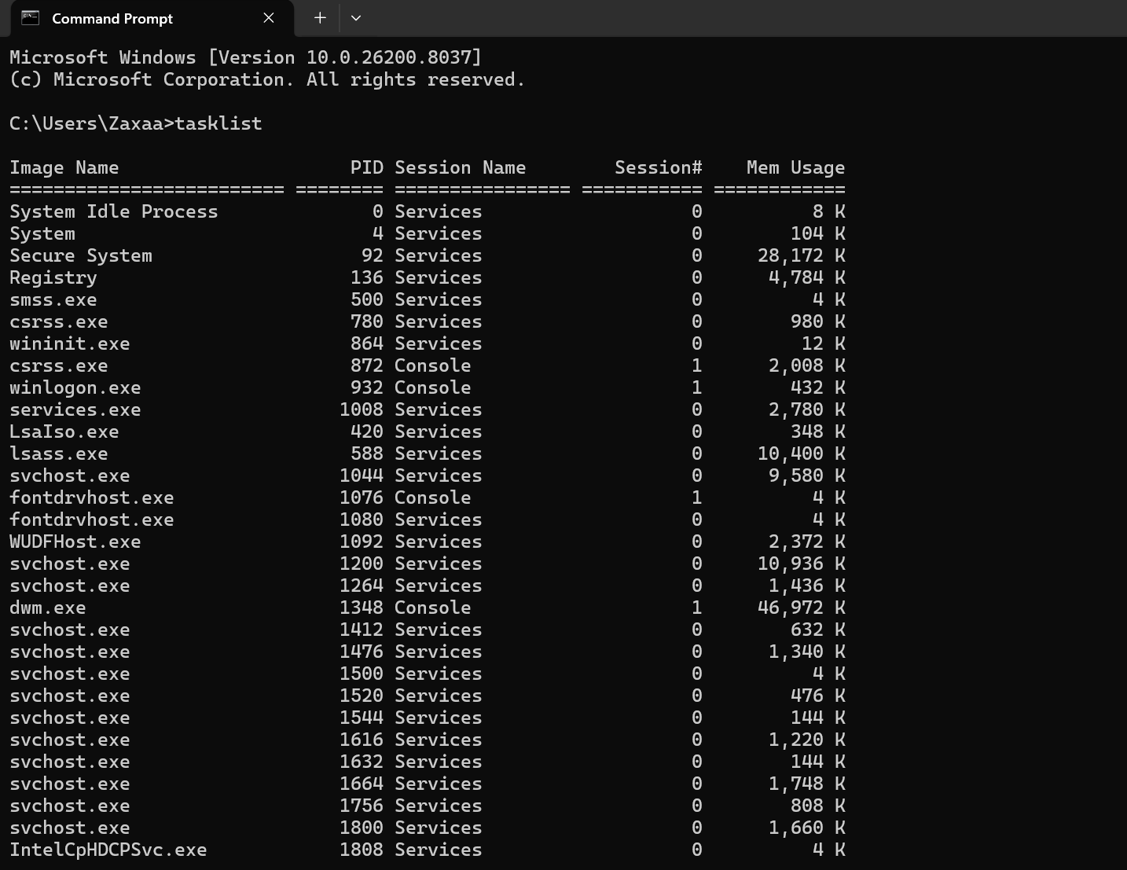
Figure 5: tasklist command output displaying active processes.

Example 2:

You can use the taskkill command to stop a running process. By entering the process name, you can close programs that are unresponsive or not needed, which helps your computer run better.

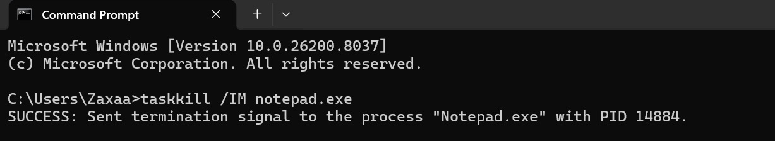
Figure 6: Terminating a process with the taskkill command.

Example 3
The dir command shows all files and folders in the current directory. It also displays details like file size and date, making it easier for users to see and organize their data.

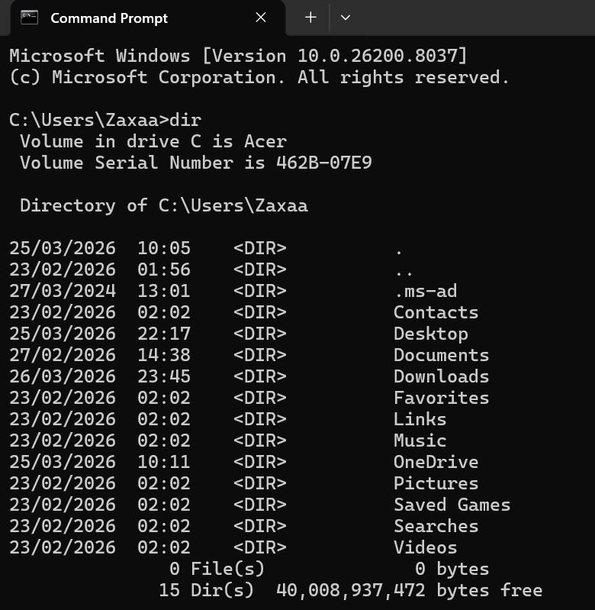
Figure 7: Directory listing using dir command.

Example 4:
The mkdir command lets you make a new folder in your current location. This helps you keep your files organized and makes it easier to manage your data.
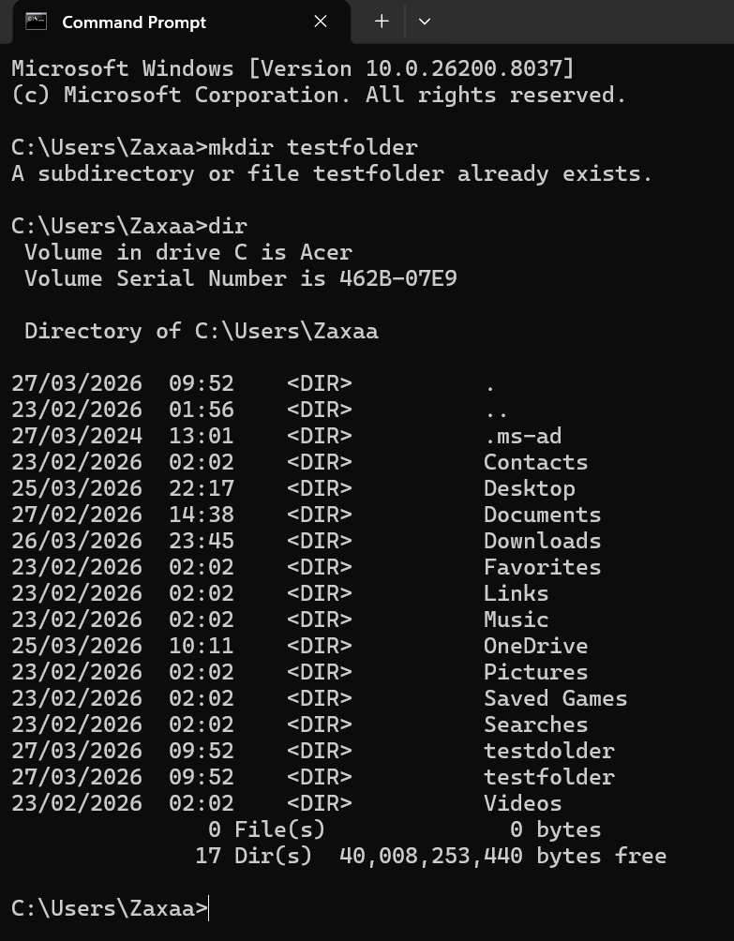
Figure 8: Creating a new folder with mkdir command.

Example 5:
The cd command lets you change your current working directory. With it, you can move between folders and reach different places in the file system easily.

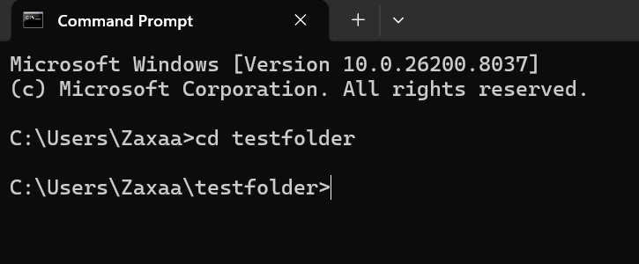
Figure 9: Using cd command to change directories.

Example 6:
The ipconfig command shows details about your network setup, such as your IP address and default gateway. You can use it to check your network settings and fix connection problems on your computer.

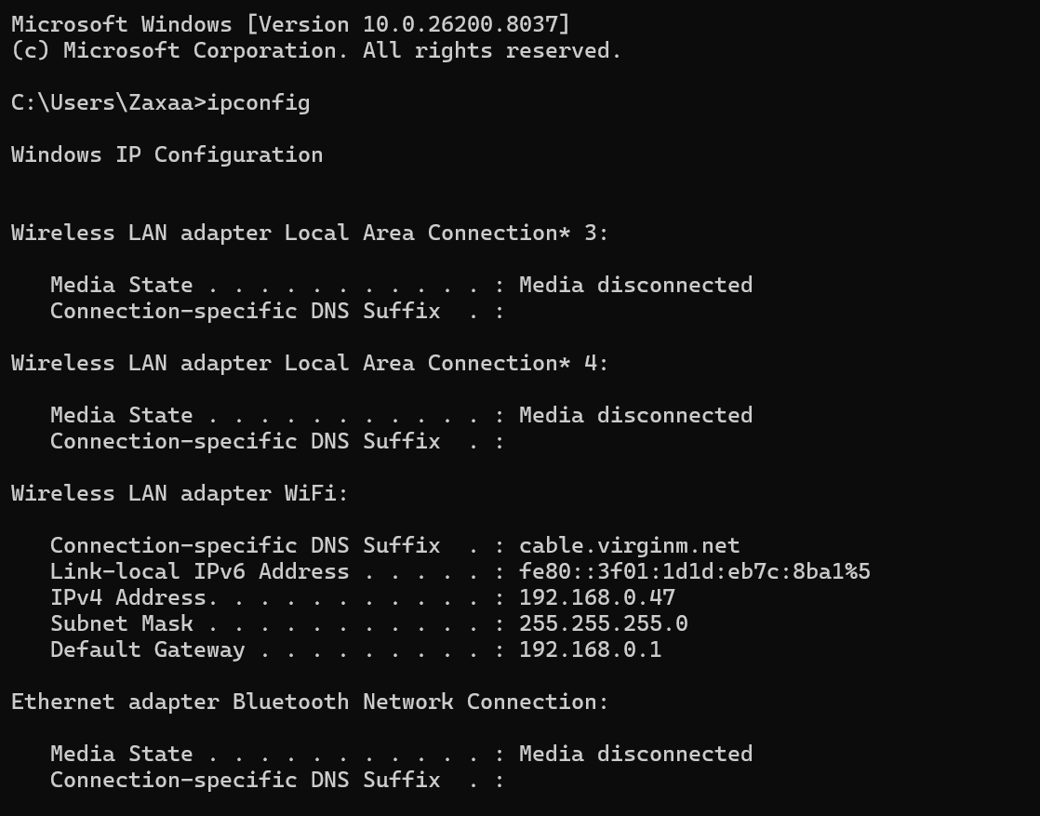
Figure 10: Network settings shown with ipconfig command.

Example 7:
The ping command checks if your computer can connect to another device or website. It sends small data packets and measures how long it takes to get a response, helping you see if the network is working well.
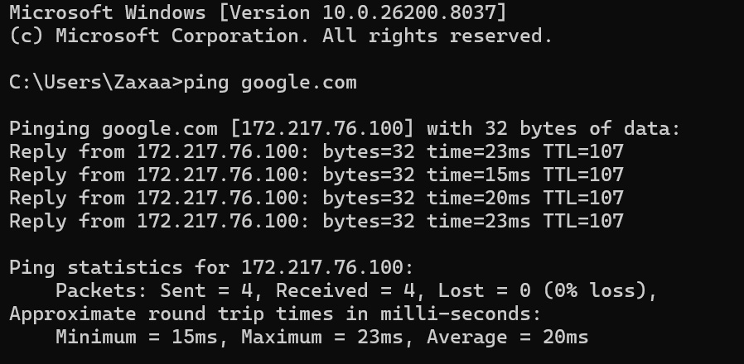
Figure 11: Using the ping command to test a network connection.

Example 8:
The net user command lets you see all user accounts on the system and helps you manage them. Administrators can use it to view, add, or change user account details and permissions.

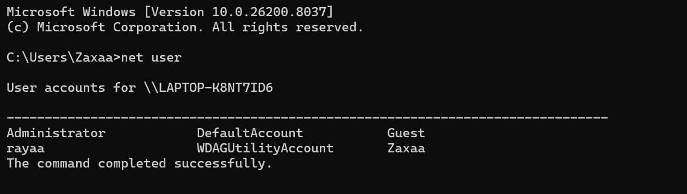
Figure 12: Displaying user accounts using net user command.

Example 9:
The schtasks command lets you view and manage scheduled tasks on your system. With it, you can automate tasks and set programs to run at certain times or intervals.

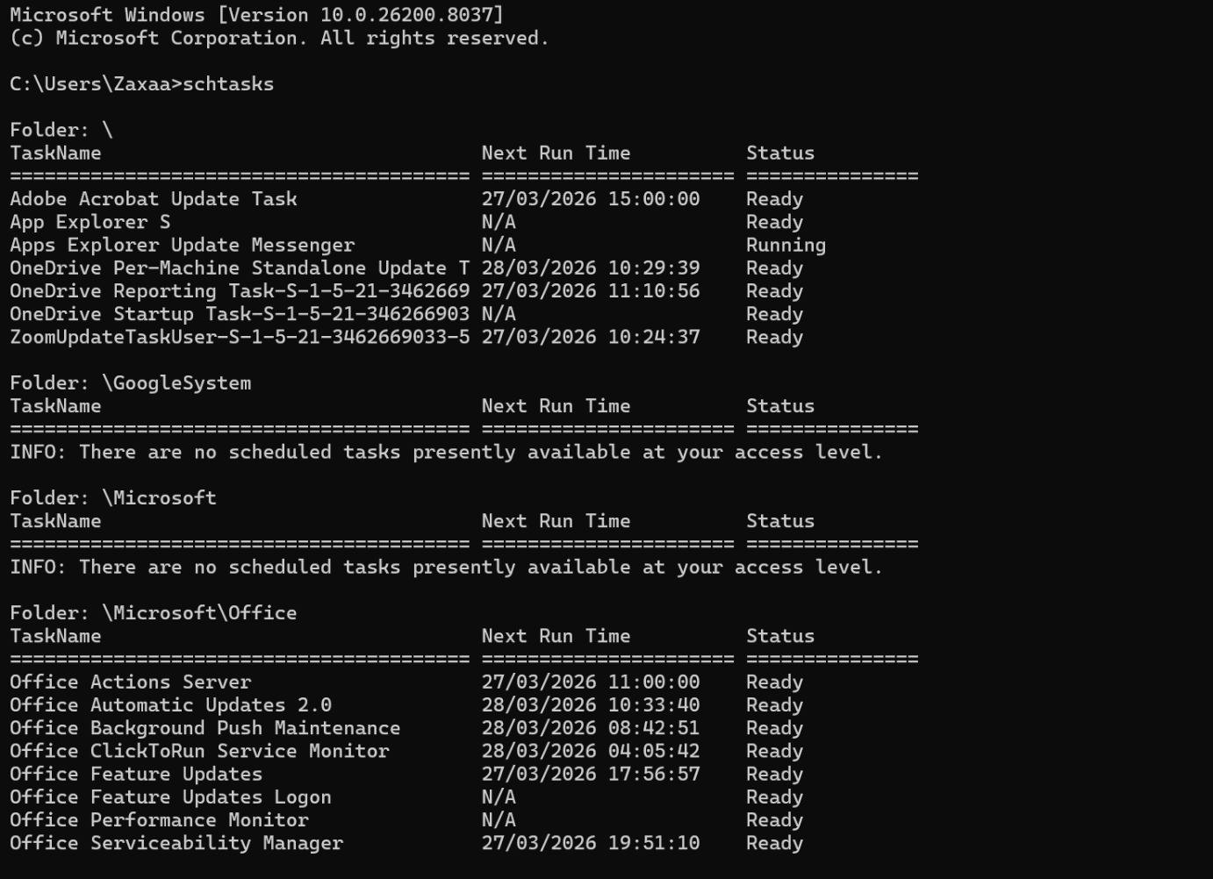
Figure 13: Viewing scheduled tasks with the schtasks command.

Example 10:
The echo command shows text on the screen. People often use it in scripts to display messages or give feedback while commands run.
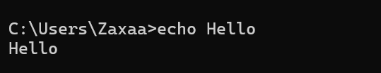
Figure 14: Displaying text with the echo command.

Task3

Use of Linux OS CLI commands

The Linux Command Line Interface (CLI) allows users to interact with the system using text-based commands. It is used for file management, process monitoring, networking, and automation, providing efficient control over system operations [1], [4].

Example 1:
The ls command shows the files and folders in your current location. It lets you see and organize your data in the Linux file system.

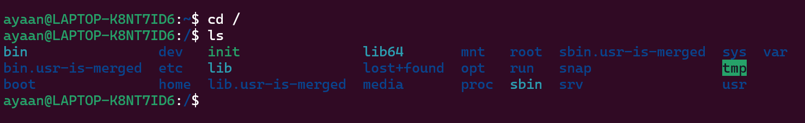
Figure 15: This is the output of the ls command, which displays the contents of a directory.

Example 2:
The pwd command shows you which folder you are currently in. This helps you know where you are in the file system and makes it easier to move around.


Figure 16: Example output from the pwd command showing your current folder.

Example 3:
The mkdir command lets you make a new folder. You can use it to organise your files and keep your data tidy in Linux.

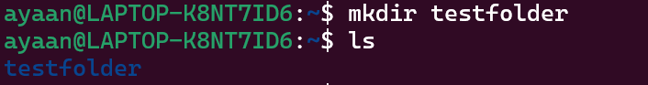

Figure 17: Making a new folder with the mkdir command.

Example 4:
The cd command lets you move to a different folder. This helps you go to different places in the system.
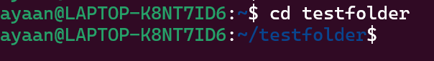
Figure 18: Moving to another folder with the cd command.

Example 5:
The rm command deletes files from your system. Use it to get rid of files you no longer need.
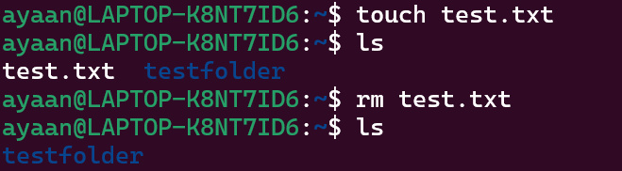
Figure 19: Deleting a file with the rm command.

Example 6:
The top command shows you what programs are running right now and how much CPU and memory they are using. It helps you keep an eye on your computer’s performance.
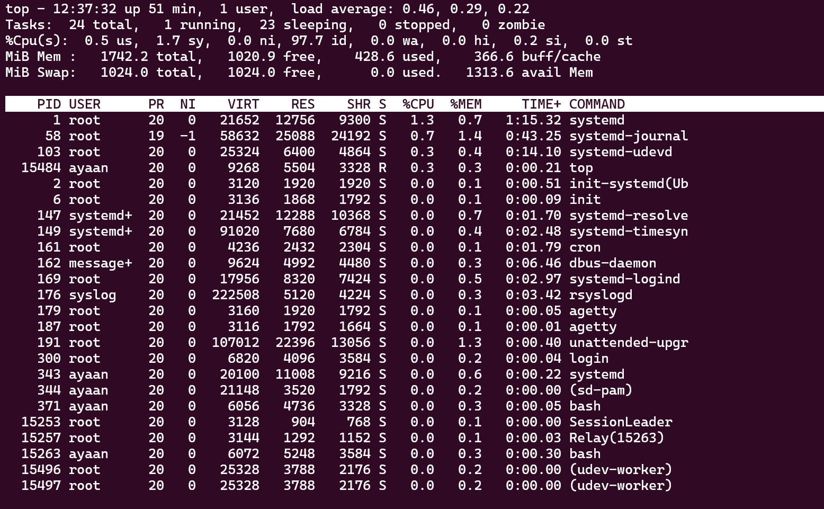
Figure 20: Viewing running programs with the top command.

Example 7:
The ps command shows which programs are running right now. It gives you details about what is active on your system.

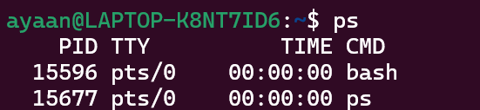
Figure 21: Showing active programs with the ps command.

Example 8:
The ip a command shows your network settings, like your IP address and network connections. It helps you check how your computer is set up for networking.

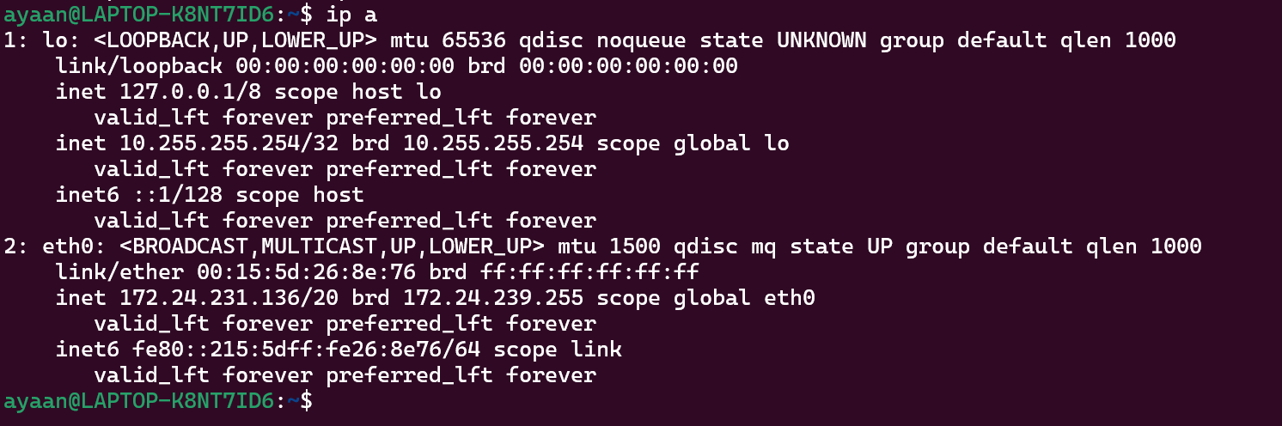
Figure 22: Checking network settings with the ip a command.

Example 9:
The ping command checks if your computer can reach another device or website. It helps you see if your network connection is working.

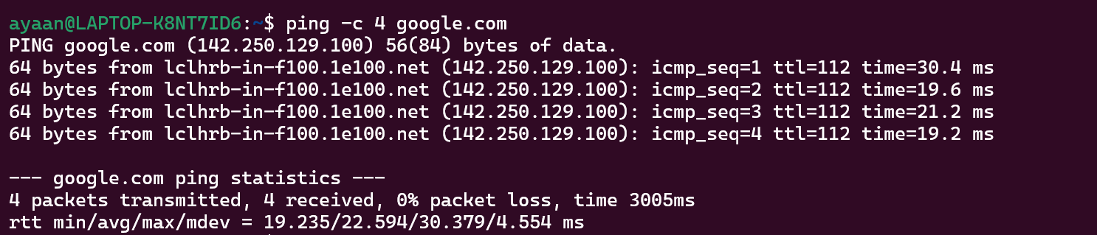
Figure 23: Checking your network connection with the ping command.

Example 10:
The whoami command tells you which user is currently logged in. This helps you check your identity and what you can do on the system.

Figure 24: Showing the current user with the whoami command.

Reference list

[1] OpenAI ChatGPT, private communication, Mar. 2026
[2] Microsoft, “Windows History,” Available: https://learn.microsoft.com/, Accessed: Mar. 2026.
[3] Microsoft, “Windows Command-Line Documentation,” Available: https://learn.microsoft.com/, Accessed: Mar. 2026
[4] The Linux Foundation, “Linux Documentation,” Available: https://www.linuxfoundation.org/, Accessed: Mar. 2026.

