  Component One: Student Journal (learning log) 750 words +/- 10%  Contribution to Overall Module Assessment: 25% | Student No: | 2239360
 | Module Title: | Housekeeping
 | Module Code:
 | Lecturer:

Reflective Learning Log: Enhancing Teamwork and Communication in Housekeeping at Bournemouth Highcliff Marriott Hotel

Introduction
I experienced significant lessons about the operations of the hospitality industry through my internship at the Bournemouth Highcliff Marriott Hotel’s housekeeping department which focused on certain hospitality elements. This reflective blog, narrated on the basis of according to the Gibbs' Reflective Cycle, explains a difficult situation where our group was assigned the task of preparing a big block of rooms for immediate conference, showing me the role, emotional path, evaluations, theoretical linkages and the learning outcomes in the end (Alcalde-González, Gálvez Mozo and Valenzuela Bustos, 2021).

Description
The scenario evolved during a very bustling weekend that is apparently much busier because there are very many conferences in progress. In a housekeeping staff as a member ours, the crucial duty is doing a perfect job in every room that was made for the conference attenders to make them look at the high-quality hotel cleanliness and comfort. The major significance of the conference made the bedsheets in all the rooms set before the arrival of the guests who had expected a lot from us(Iannuzzi and Sacchetto, 2020). This circumstance put us in a very tense and competitive environment where there was a lot of pressure. If teamwork and communication are going to be seamless and really efficient, this type of environment is really needed. For me, the task proved to be a stark irony since I learned that it is very tough to keep up the level of services in a highly competitive world, especially when it comes to satisfying our clients during the high-profile events.

Feelings
To start with, the sheer scale of our job - to ensure the readiness of a massive number of rooms within the short period of time left for the next conference, - left me entirely confused and bewildered. Underneath the general anxiety was a subconscious fear of whether the team could adhere to the looming deadline without compromising the details, or without sacrificing precision and quality that we demanded as roles. While some barriers were seen in the beginning, bonds of camaraderie and co-operation became evident as we together in the process. This newly found solidarity was the elixir to my initial troubles bringing in harmony and promoting a healthy working environment. Though this made a huge and positive change, there were instances of irritation too. These frequent mistakes in communication as a team were caused by the sporadic breakdowns in communication and coordination within our team. The errors caused much more repetitions and ineffective work conduct, bringing into our attention those areas that required updating. However, in the midst of this feeling of togetherness, these moments reminded me how the operational tasks can fail under pressure, revealing that the teamwork and task execution require a perfect balance even in the extreme environment (Lestariningsih et al., 2021).

Evaluation
Some positive points of this episode were the work ethic demonstrated by the team collectively which we gave to one another as a support. On the other hand, scenario was the highlight that good communication channels between our team and better planning should be. The example clearly brought me to a more profound understanding of importance of good team work and communication in the fast-moving field of hotel housekeeping service (Nimri et al., 2020).

Analysis
Overcoming those challenges, shows that different theoretical principles come together in real life providing a commitment to teamwork and communication in achieving group objectives. Also and in the same way, organizational communication affects operational efficiency in hotel management. By going over these theories after they became clearly evident, it was seen that team cohesion and effective communication were drawbacks that clearly affected our performance and stress (Sadhale, 2021).

Conclusion
Through this example, I have realized that the success of housekeeping in the hospitality industry is not a single person alone, but it is a team effort and communication is key to the effectiveness. Reflecting on my part in the way communication was conducted among team members, I see the benefit of taking a more active role in the facilitation of communication. This involves assigning tasks to team members clearly, and ensuring that progress is monitored consistently.

Action Plan
As a going forward step, I am intending to proactively push forward a short daily meeting with my team to clearly state daily objectives, assign tasks more effectively and address any current and future issues. Furthermore, I plan to bring my communication skills to a higher level by attending professional development workshops which center on conflict resolution and team management, in order to assist my team in terms of effectiveness and morale.

Component Two: Health and Safety Guide

COMPONENT 3
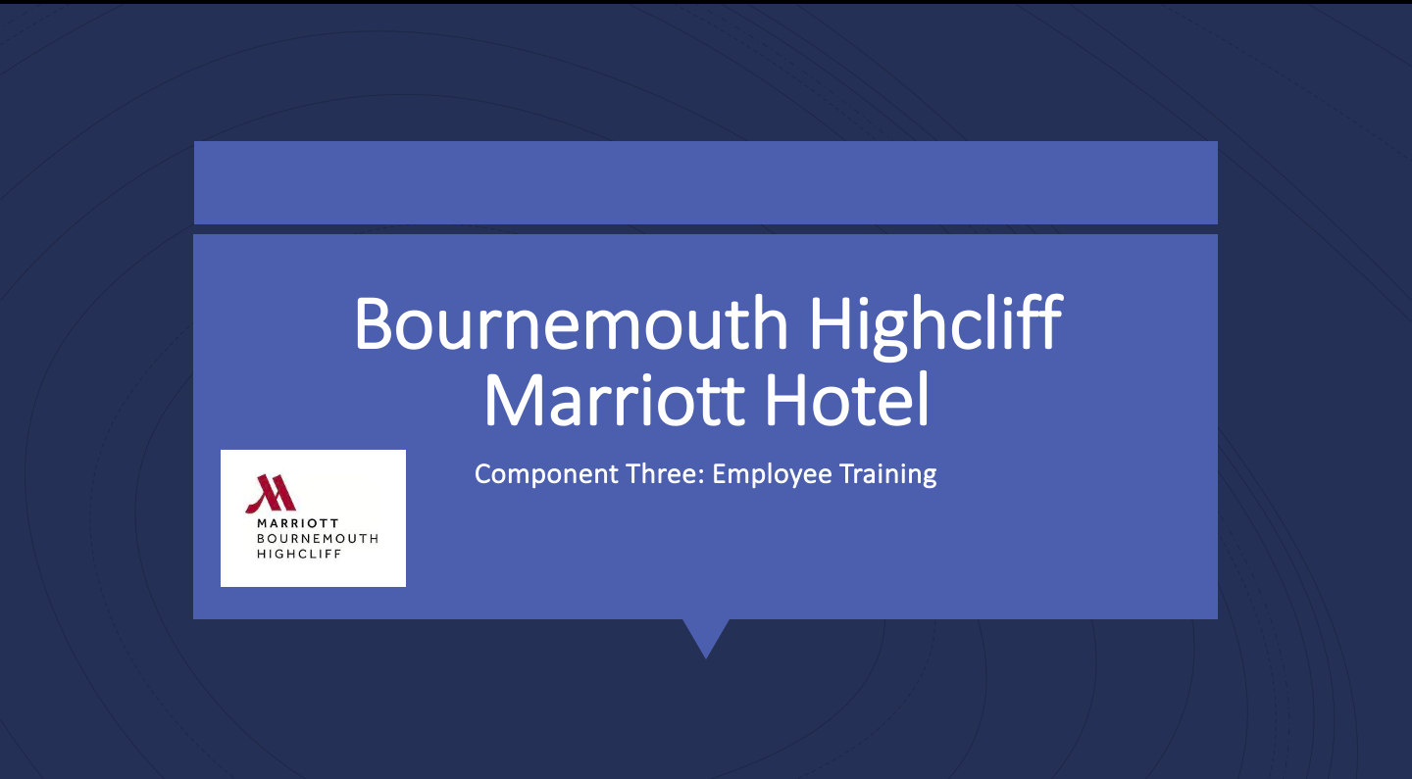
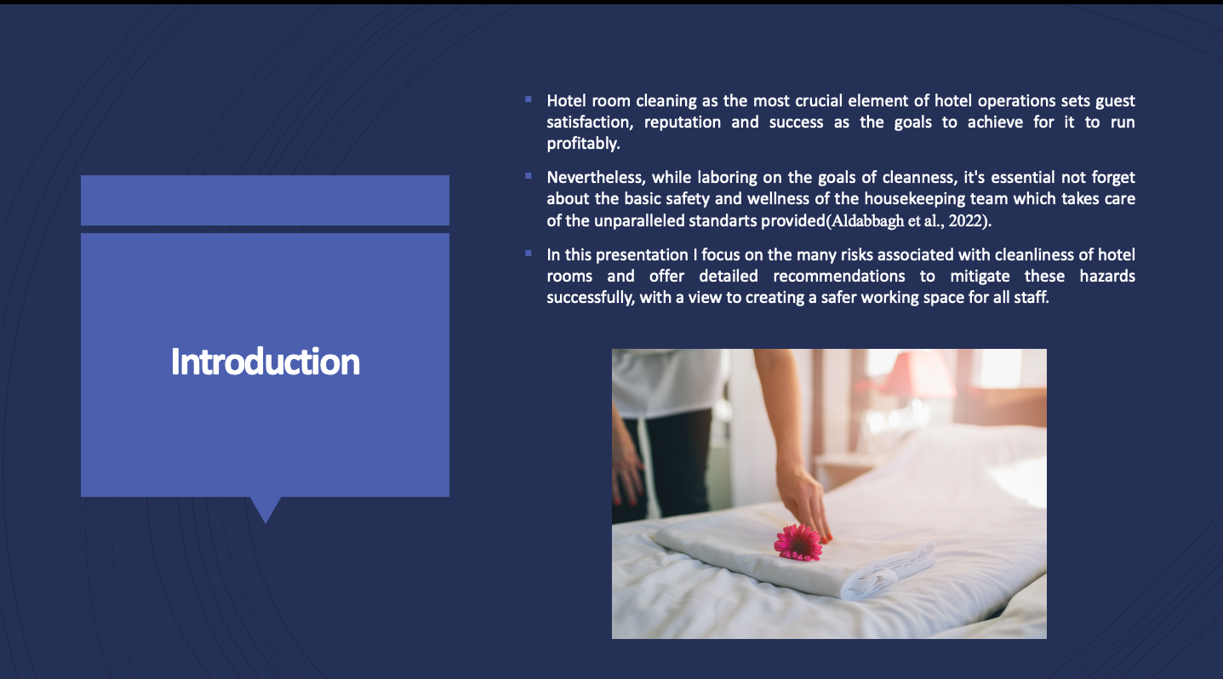
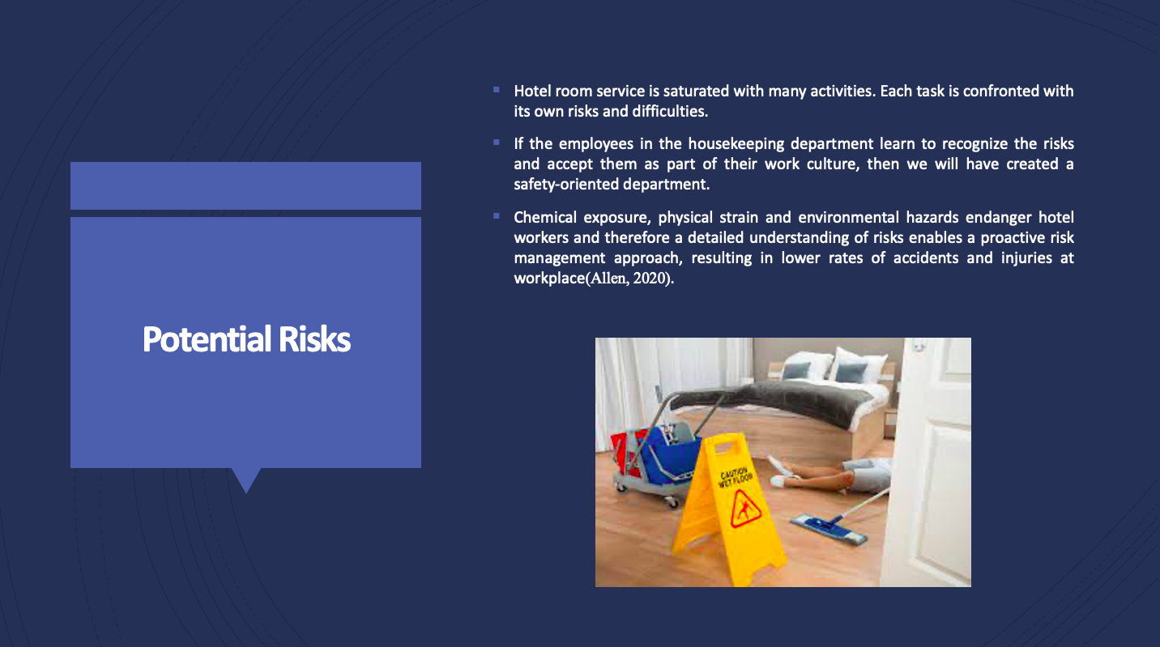
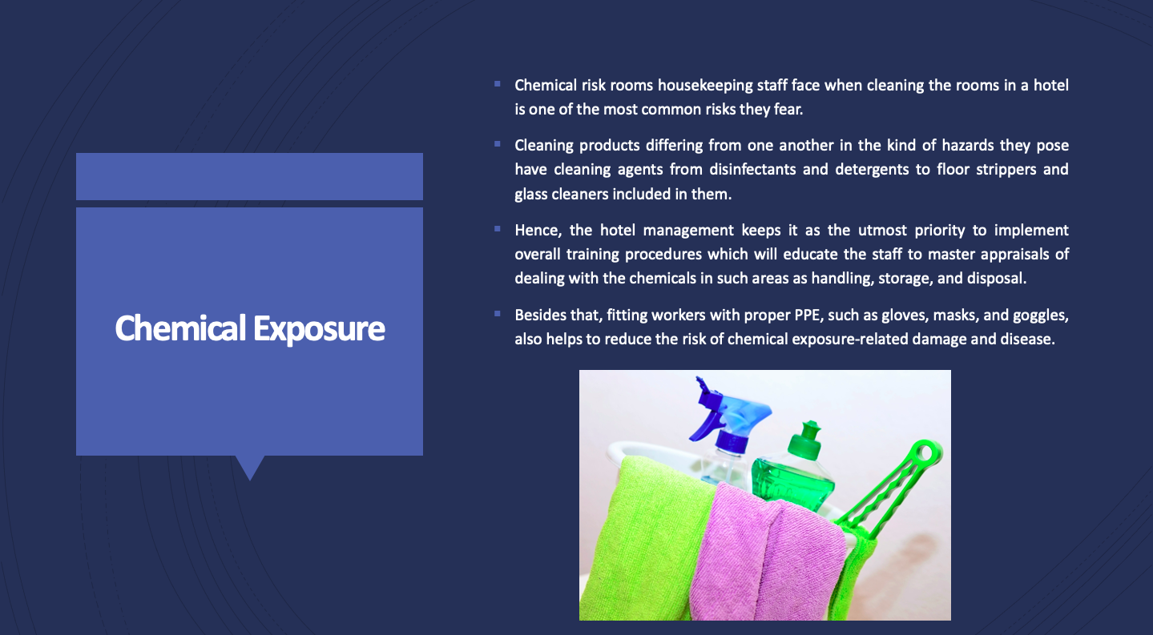
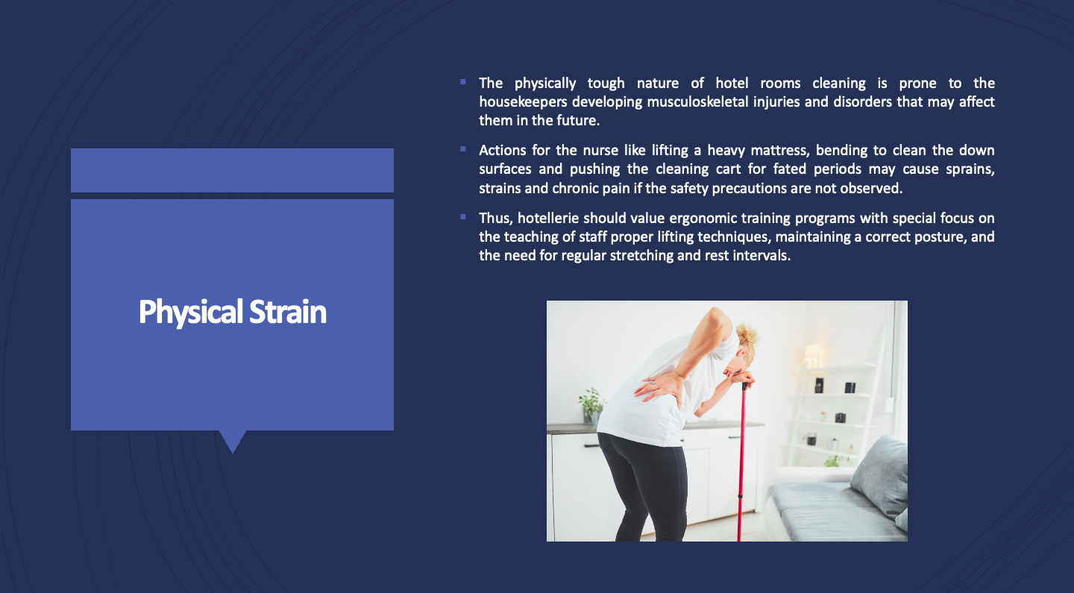
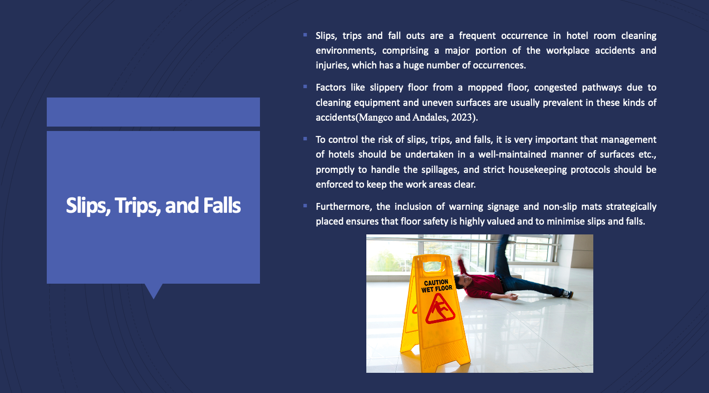
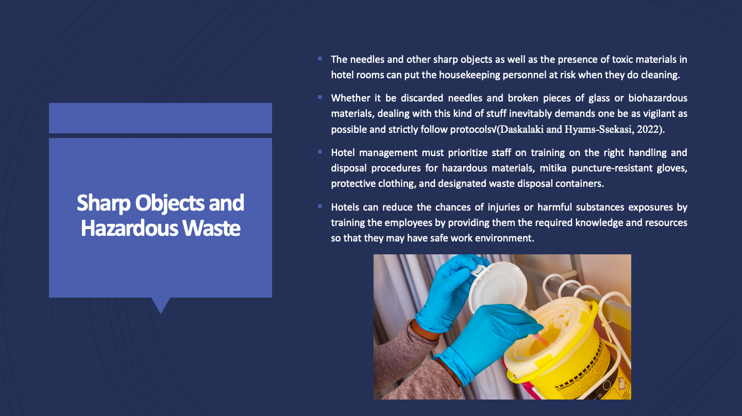
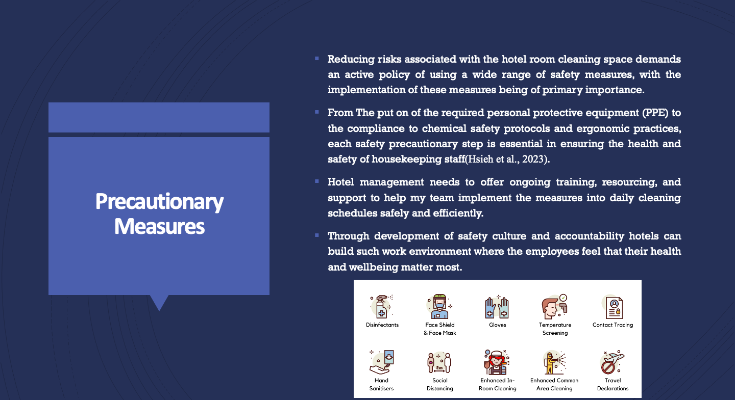
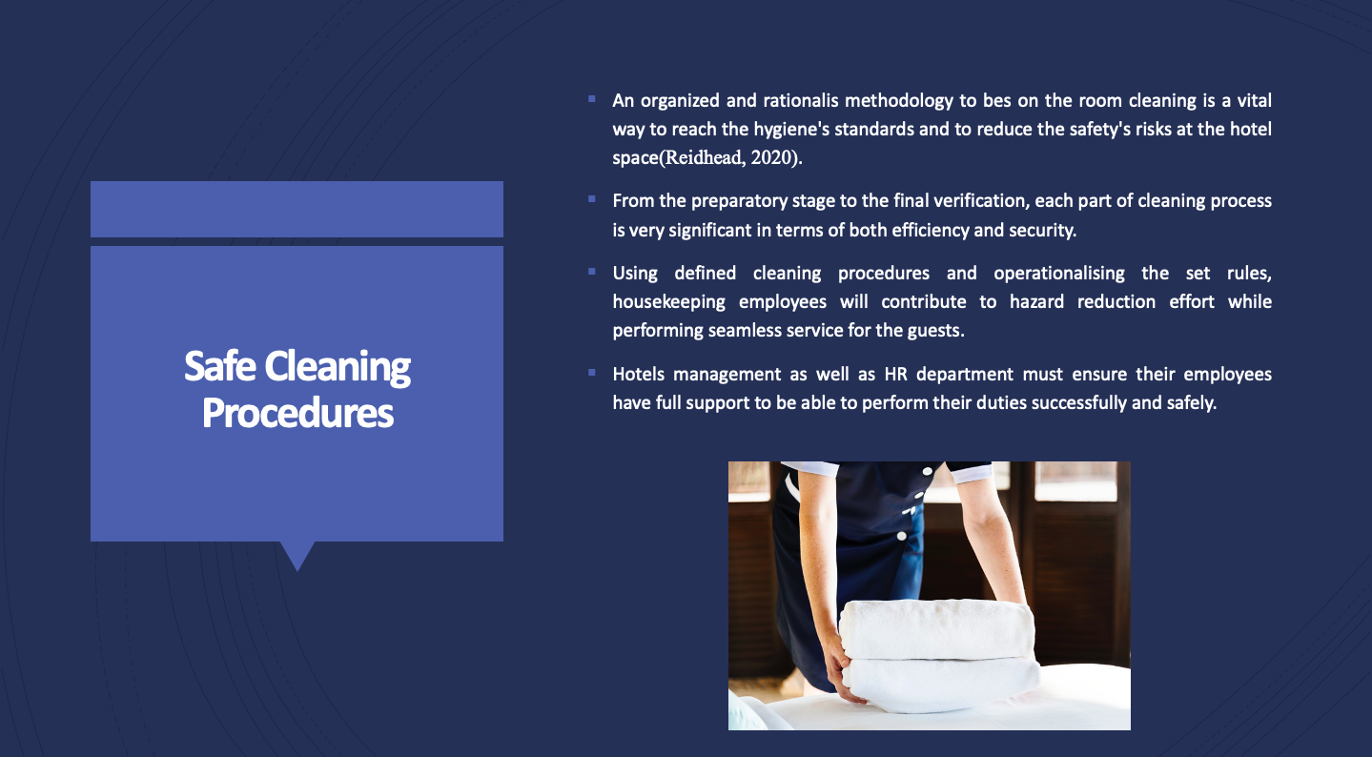
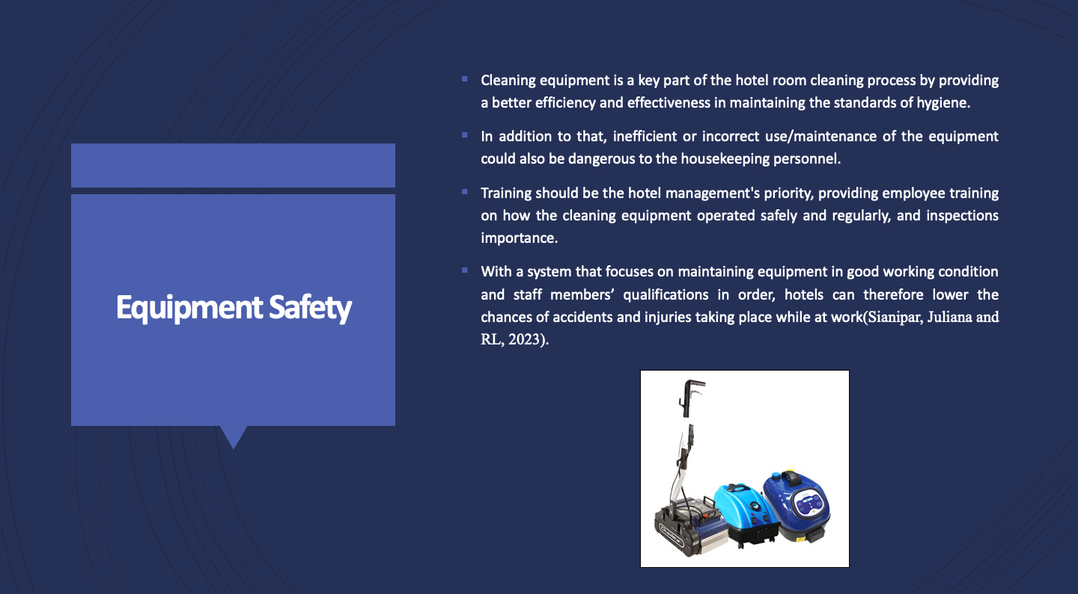
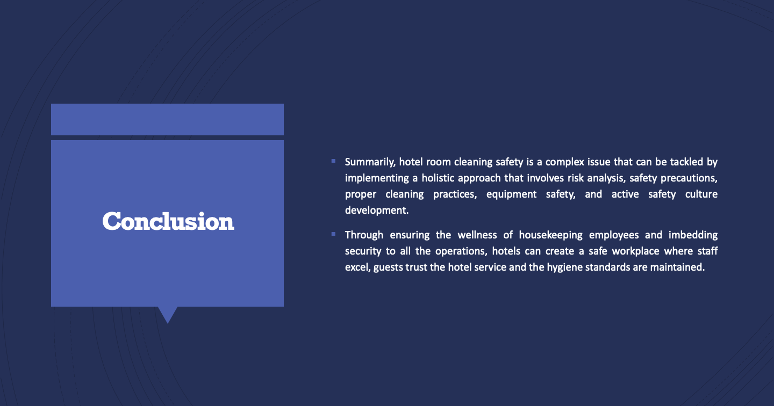
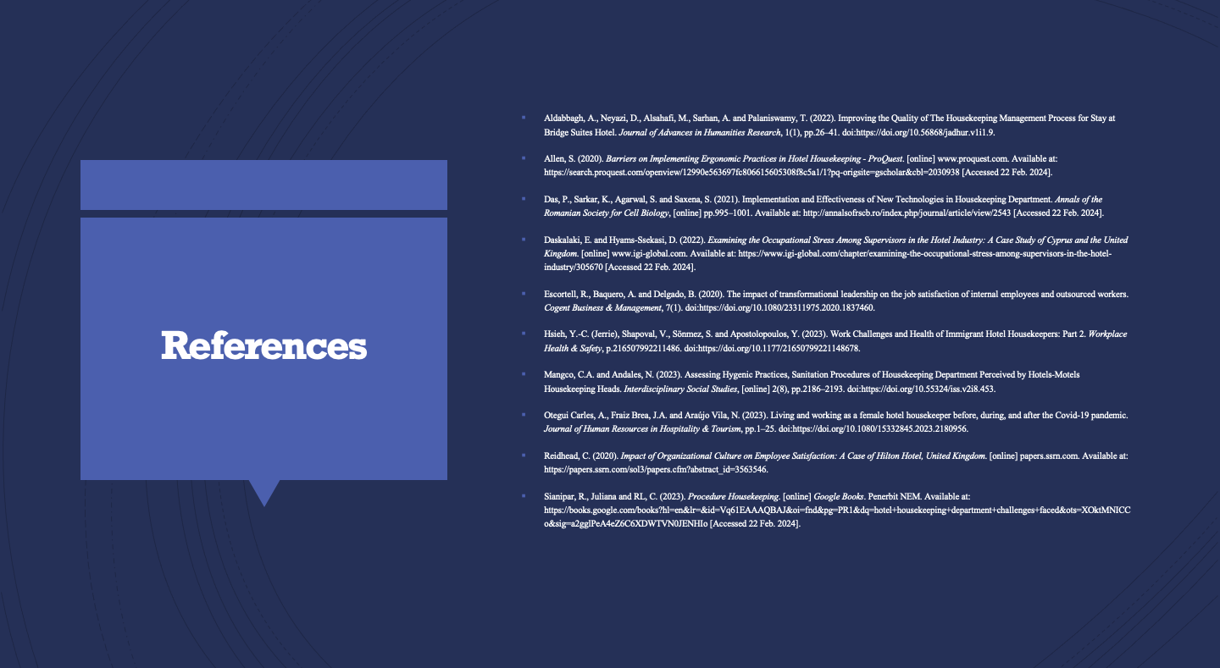

Reference List
Alcalde-González, V., Gálvez Mozo, A. and Valenzuela Bustos, A. (2021). No clean rooms, no hotel business: Subversion tactics in Las Kellys’ struggle for dignity in hotel housekeeping. Annals of Tourism Research, 91, p.103315.
Iannuzzi, F.E. and Sacchetto, D. (2020). Outsourcing and workers’ resistance practices in Venice’s hotel industry: The role of migrants employed by cooperatives. Economic and Industrial Democracy, p.0143831X2096022.
Kusuma, B.S., Hasibuan, A., Nasution, S.P., Utami, A.P. and Dalimunthe, A.R. (2022). AN INCREASING KNOWLEDGE ABOUT THE IMPORTANCE OF OCCUPATIONAL SAFETY AND HEALTH (K3) IN HOUSEKEEPING LABOR HOTELS. INFOKUM, [online] 10(5), pp.424–431. Available at: http://seaninstitute.org/infor/index.php/infokum/article/view/1013.
Lestariningsih, T., Winarno, B., Hidayatullah, N.A., Syafitri, E.M. and Rahim, R. (2021). ICONEBS 2020: Proceedings of the First International Conference on Economics, Business and Social Humanities, ICONEBS 2020, November 4-5, 2020, Madiun, Indonesia. [online] Google Books. European Alliance for Innovation. Available at: https://books.google.com/books?hl=en&lr=&id=ueYuEAAAQBAJ&oi=fnd&pg=PA281&dq=housekeeping+in+hotels&ots=_J4fqobRPH&sig=0qfKzn5h7R9zJHU3Em_SuBPpTv8 [Accessed 22 Feb. 2024].
Nimri, R., Kensbock, S., Bailey, J., Jennings, G. and Patiar, A. (2020). Realizing dignity in housekeeping work: Evidence of five star hotels. Journal of Human Resources in Hospitality & Tourism, pp.1–20.
Sadhale, M. (2021). The Changing Role of Housekeeping Department in Hotels Post COVID-19 Pandemic. [online] 210.212.169.38. Available at: http://210.212.169.38/xmlui/handle/123456789/9834.
Tiwari, A., Singh, M. and Dahiya, A. (2022). A study on the effect of Technological Innovation on Outsourcing in the Hotel Housekeeping Department. [online] IEEE Xplore.
W. Fakhry, B., Saad, S. and Ibrahim, Y. (2022). Factors Affecting the Turnover of Entry-Level Employees in Housekeeping Department in Five Star Hotels. International Journal of Tourism, Archaeology and Hospitality, 2(1), pp.3–16.

