A Review of Entrepreneurship Theory Research

Qinqin Lou(2109268)

15th May, 2022

Module: LCDB7009
Module Lead: Dr Emma Roberts

Part one
A critical literature review for Doctoral research
Literature review, in general, refers to the process of in-depth reading and summarizing of relevant literature by the researcher (Fraenkel, 2007). Specifically, when a researcher embarks on a new research endeavour, it is usually always necessary to collect, read, collate and analyse the results of relevant research work that has already been done by previous researchers, and on this basis, summarise and evaluate the relevant research results of previous researchers and identify new research questions and research paths accordingly(Zhang Xianbin et al,2015).

1 The significance of a literature review
The more important value of a literature review is that it embodies the essence of scientific research activity. Knowledge in any academic field is gradually accumulated through the efforts of successive generations, and gradually forms a body of knowledge (Wee, & Banister,2016). In essence, human knowledge and the exploration of knowledge is an organic whole, and there is an inextricable interconnection between the exploration of knowledge and its results engaged in by different generations and different people. The relevant research work of previous generations has laid the foundation of knowledge and methods for the research of later generations, and the learning, absorption and understanding of the existing research results by later generations constitute the prerequisites for new research work(Denney & Tewksbury,2013). Thus, although on the surface a particular research work often appears to be carried out as individual labour, in reality this individual work is carried out against the background of the entire body of knowledge and is based on the fruits of the labour of the entire academic community. "Scientific research is the collective effort of many, many researchers who share their findings with each other in the pursuit of knowledge with the power of community (NEUMANWL,2010)."

2 The role and purpose of the literature review
2.1 The role of the literature review
2.1.1 Seeking entry and breakthrough points for the selection of thesis topics
Through a review, researchers can get a deeper understanding of the various aspects of research and its methods. They can also improve their skills in identifying the strengths and weaknesses of their own work. Moreover, by developing a deeper understanding of their own research, they can make informed decisions when it comes to their dissertation topic, we call it "stand on the shoulders of giants ".
2.1.2 Seeking new research methods and strong argumentation for thesis research

A literature review is also a great way to keep up with the latest developments in academic thinking and scientific research. It can help researchers gain a deeper understanding of the various theories and methods used in their studies. Through a review, researchers can also find new ways to improve their research and develop effective strategies for in-depth analysis. It can also help them make informed decisions when it comes to their dissertation topic.
2.1.3 Avoiding duplication of effort and increasing the significance and value of research
The role of the literature review is to fully go through the existing research materials, to avoid repeating the issues that have been already solved, to redo the analysis that has been done before, and to repeat the mistakes that have been made by others. Therefore, researchers must do a comprehensive literature review study before deciding on the topic of the dissertation to improve the significance and value of the research.
2.1.4 The literature review is an important part of the thesis
The literature review, as an important part of a dissertation, intends to introduce the present state of the research, outline the ideas of the chosen topic, the research's aim and relevance, and present the topic's innovative characteristics. In this way, it can reflect the chosen topic's scientific, innovative, and practical aspects, as well as allow evaluation experts to fully comprehend the value of the dissertation research, judge the depth and breadth of knowledge mastered by postgraduate students, and ensure a good grade in the thesis assessment (Wang, 2010).
2.2 Purpose of the literature review
The main goals of a literature review are to inform the reader on the progress and challenges of relevant research in existing study areas, as well as to provide food for thought for future researchers: to demonstrate the position of multiple theories, enabling for various conceptual frameworks; to determine whether future research may identify more meaningful and important results; to determine whether future research can identify more meaningful and significant results; to provide a foundation for new theory and empirical ideas; to identify the presuppositions between concepts; to understand and learn from how others have defined and measured key concepts; to improve and critique existing research; to introduce alternative research; to discover new research methods and approaches; and to validate other relevant research. The researcher will theoretically be able to recognize presuppositions between concepts, understand and learn from how others have defined and measured key concepts, improve and critique existing research, introduce alternative research, discover new research methods and approaches, and validate other relevant research (Kraus& Das-Rodrguez,2020).
3 Literature review and critical study
A literature review isn’t simply a review of previous analysis within the field; it is also be a 'critical' assessment of existing analysis. The literature review should denote the pros and cons of previous studies. It can also point out where the research to be undertaken will innovate, develop and improve on existing research（Smith, & Ferris,2017）.
In reading the literature the researcher should not only record and summarise important conclusions and revealing elements, but should also critically and constructively evaluate them (Grant, & Booth,2009). The literature review should conclude with a summary of all the shortcomings and omissions of the previous studies - and those that the current study will address. In other words you should not only criticise the previous research but also be able to propose a research proposal that addresses the shortcomings and omissions that have been criticised（Lu Yang,2011）.

4 Systematic literature review and meta-analysis
A systematic literature review is a comprehensive analysis technique during which individuals use the internet, databases and search methods to comprehensively and objectively uncover and evaluate the progress of research amid a topic/field and draw conclusions.
It has been developed in the context of the knowledge explosion and is becoming the preferred method of review research in various fields, as it helps researchers not only to access the true nature of knowledge, but also to achieve knowledge innovation. The core essence of the systematic literature review approach is to point to specific questions, to use standardised protocols for selecting and assessing literature, and to build on the qualitative evaluation of existing research findings. A systematic literature review can be subdivided into qualitative, which is a qualitative evaluation and outline of the findings and conclusions of the previous literature, and quantitative, which is a method of mixing the results with the help of applied math methods, also called as meta-analysis or meta-analysis. In some areas of research that are tougher to mix and analyse through statistical methods, a qualitative review approach is a lot of applicable, as is that the case with e-commerce entrepreneurship research（Pati, & Lorusso,2018）.
From a knowledge generation perspective, the essence of the systematic literature review approach is a comprehensive research method with a knowledge innovation function. It is a set of research methods that, with a particular research aim and based on a precise research question, selects a number of individual documents from the relevant literature according to strict inclusion and exclusion criteria, is administrated by a certain methodology, and utilizes standardised techniques to extract and integrate data from the chosen writing fabric to reach at update questions and theories (Irving et al,2017).
Examining the differences and connections between the systematic literature review approach and meta-analysis will help researchers to more accurately grasp the systematic literature review approach. As can be seen, there is an international trend towards the view that a systematic literature review approach is not the same as a meta-analysis; however, a systematic literature review approach can include a meta-analysis (Panic, Leoncini, E et al,2013).

5 The difference between a systematic literature review and a traditional literature review
The differences between a systematic literature review VS a traditional literature review is obvious. One is the difference in knowledge assumptions. The assumption of knowledge in a traditional literature review is an objective view of knowledge, i.e. that knowledge resides in the literature and that the narrative approach is sufficient to allow knowledge to be preserved. The systematic literature review approach, on the other hand, assumes a dynamic view of knowledge, i.e. that knowledge is continuously generated through the interaction of human questions to the literature and dialogue with the literature (Huang Fuquan et al,2017).
Secondly, there are technical contrasts. In a conventional literature review, the 'search, reading and refining problem' (Jesson,2011) is generally based on drafting a framework, dividing the searched literature into theoretical and connnected categories, selecting a number of center writing for near persuinging, summarising the crucial parts of the core texts, comparing the similarities and differences in the thesis of the core texts and comparing them with each other. Theoretically, we may able to choose some center writings and read them closely, outline the imperative parts of the core texts, compare the similarities and differences between the core texts and write about them. Then, more literature is read, more summaries are written, more comparisons are made, gaps in knowledge and gaps in research methods are identified, and research questions are formulated. In contrast, systematic literature reviews are driven by clear questions, standardised screening and assessment of the literature, and transparent analysis of processes and techniques (van Dinter et al,2021).
Thirdly, while traditional literature reviews are largely not tasked with knowledge innovation and answering specific research questions, systematic literature reviews utilize the knowledge accessible within the literature to answer particular questions and create new knowledge.

Part two
How to organize my literature

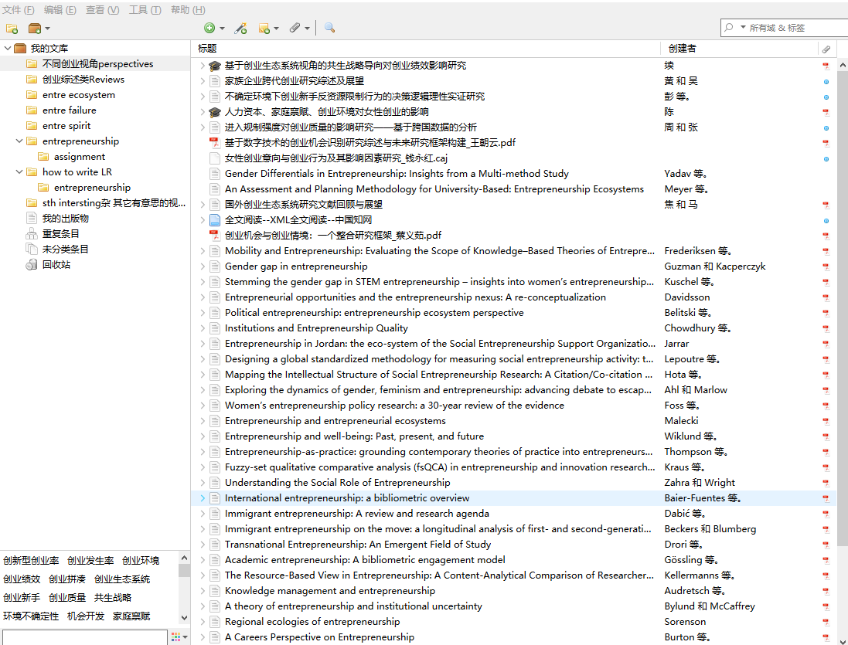

Fig.1 Different perspectives on entrepreneurial research

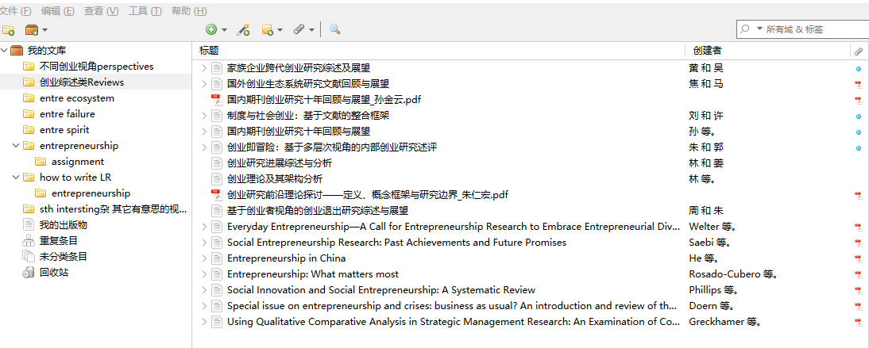

Fig.2 Review articles

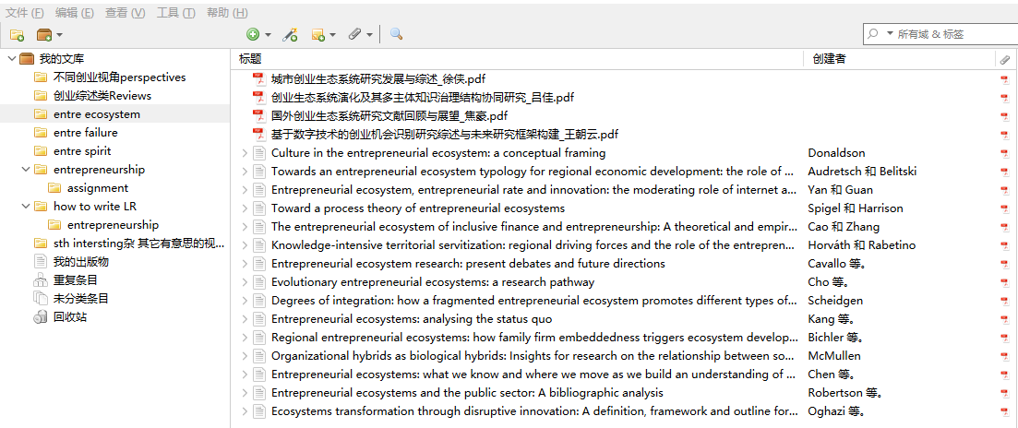
Fig.3 Entrepreneurial ecosystem articles

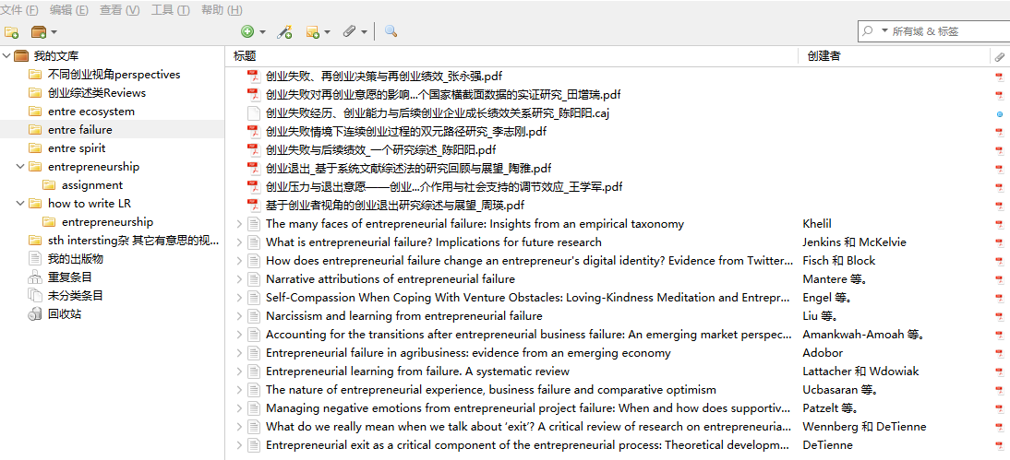
Fig.4 Entrepreneurial failure and exit articles


Fig.5 Entrepreneurial spirit articles




Fig.6 Articles for the assignment

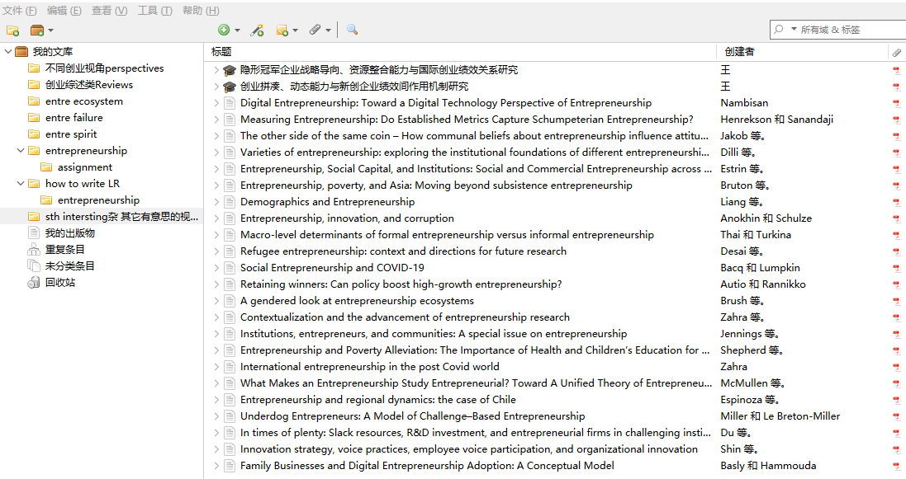
Fig.7 Sth. Interesting when doing the LR

Literature Management
I basically follow the process of: search, collect, organise, read, annotate and re-use for my literature research.
1 Searching: Firstly, I need to be familiar with the search techniques and data structure of the databases commonly used in your field. In practice, this means having a good idea of the metadata and organisation of the database literature (for example, abstract databases generally provide information on titles, authors, journals, abstracts, etc.). The actual literature management software is strong in managing formatted abstracts. I usually look at the keywords and abstracts and skim through the full text before deciding whether to add zotero.
I mainly use uwtsd's database and Chinese journal databases. I also keep track of journals specialising in the field of entrepreneurship and keep up to date with the latest research.
2 Collection: Most of the time I actively search and sometimes RSS feed content, which is a proactive, formatted way of exploring areas of interest to me. In addition to databases, I also get information from websites, and although the web search comes up with more fragmented content, the content is more current. In particular, the topics of some institutions and conferences are sometimes more inspiring for doing research on frontiers and research gaps.
3 Organising: I mainly use zotero as my literature management tool. I am diligent in organising the collected literature and never build up a backlog: those with value are retained, those without value are simply discarded, and a tag cloud of subject attributes, article attributes, etc. is created for the retained literature.
At the beginning I had the misconception of being greedy and hoarding a lot of articles. However, as I am not skilled enough in bibliography, I am not clear enough in labelling and categorisation, so a lot of articles will still lead to confusion. So now I am going to subtract for the time being and start with core journals, core authors (thought leaders) and core institutions in my field, and collect quality literature in a targeted and selective manner. I have found that this involves bibliometrics or scientometrics. I am also trying to learn this and it is still very helpful in terms of efficiency in collecting literature, reserving knowledge of the field and identifying cutting edge advances.

Part three
Several directions for entrepreneurship research

- Entrepreneurship
  - Glossary of terms and meanings for entrepreneurship
Many scholars have argued that entrepreneurship can take place within existing organisations (AmitGlosten and Mueller 1993; Casson 1982). It has also been suggested that the 'narrow' concept of entrepreneurship refers to the 'creation of a new business from scratch' and the 'broad' concept of entrepreneurship 'also includes the creation of a revitalised business from a troubled one (Zhang Dongsheng and Liu Jianjun 2000).

Table 1 Definitions of Entrepreneurship
*Zhu Renhong(2004); The explanations in the table are taken from Low and MacMillan's interpretation of the original author's definition in 1988.

1.2 Several major schools of entrepreneurship theory
1.2.1 The "venture" school of thought
The term entrepreneur was introduced into economics as early as 1755 by the French economist Cantillon. He argued that the entrepreneur takes the risk of buying a commodity at a fixed price and selling it at an uncertain price. The entrepreneur's reward is the difference between the offering cost and the buying cost. If the entrepreneur precisely sees and captures the market opportunity, he or she earns a benefit, and if not, he or she takes a risk (Huang Qunhui 2000).
1.2.2 The 'leadership' school of thought
The "leadership" school of thought examines entrepreneurial activity and entrepreneurial behaviour in terms of the leadership functions of the entrepreneur in the business organisation. Marshall, the British economist, gave entrepreneurs (entrepreneurs) multiple administration capacities in a commerce such as administrative coordination, intermediary, innovator and risk-taking. He argued that a true entrepreneur must be able to do two things: on the one hand, he must know his business well and be able to expect trends; on the other hand, he must be able to lead others and manage situations, select his assistants well and trust them (Ronstadt, 1984).
1.2.3 The "innovation" school
Schumpeter's theory of entrepreneurship has the most distinctive features. Schumpeter gave the entrepreneur the picture of the 'innovator' and argued that the ability of the entrepreneur is to achieve a new combination of factors of production (Schumpeter, 1934). Entrepreneurship is the way of accomplishing innovation and innovation is the substance and means of entrepreneurship. The function of the entrepreneur "is not primarily to invent something or to create conditions for the use of the enterprise but to have the means to induce people to do these things" (Schumpeter, 1942). He further argued that the root of the development of economic systems lies in entrepreneurial activity.
1.2.4 The 'cognitive' school of thought
"The 'cognitive' school of thought emphasises entrepreneurship in terms of the psychological characteristics of the entrepreneur, particularly the cognitive characteristics, and the subjective factors such as cognition and imagination of the entrepreneur, who, according to Casson, "is a person who is skilled in making wise decisions about the coordinated use of scarce resources(Casson M., 1982)." Kirzner (1973) argues that entrepreneurs have a "sensitivity" that the average person does not have to be able to identify opportunities in the market. Only those who possess this sensitivity can be called entrepreneurs.
1.2.5 The 'social' school of thought
"The 'social' school of thought does not see entrepreneurship as a product of individuality or personal background, but rather emphasises the study of entrepreneurial phenomena and problems from an external social perspective. Saxenian（1999）argues that Silicon Valley has an industrial system based on regional networks that facilitate collective learning and flexible adaptable adjustment of a extend of relevant technologies by specialist producers. Woodward put forwards that social networks play an dynamic role in helping entrepreneurs to establish and develop their businesses, for example, an individual's social organize characteristics can increment the probability of actually beginning a business (Woodward, 1988).
1.2.6 The 'management' school of thought
The "management" school rejects the subjectivist approach to entrepreneurship and the idea that entrepreneurship is a gift, an inspiration or a flash of wisdom. According to contemporary management guru Drucker, "Anyone who dares to face a decision can become an entrepreneur through learning and entrepreneurship. (Drucker，1985) Entrepreneurship is a behaviour rather than a personal character trait." Stevenson Roberts and Grousbeck(1994) see entrepreneurship as a management approach that "captures and exploits opportunities without being constrained by current resource constraints" and can be described in six ways: strategic orientation to seize opportunities, access to resources, control over resource management, structured rewards and Policy.
1.2.7 The "strategy" school of thought
Bhide (1994) argues that each firm has its own institutional and strategic development experience and accordingly proposes a three-step framework for research based on the strategy of the firm: firstly, to clarify the entrepreneur's current goals; secondly, to evaluate the goals' implementation strategies; and thirdly, to assess its own ability to execute the procedure. Hitt, Ireland, Camp and Sexton (2001) believe that creating business wealth is a important issue common to both entrepreneurship and strategic management. Zahra and Dess argue that there should not be a strict differentiation between business investigation and strategic management but maybe there are numerous opportunities to coordinate key strategic management investigate and entrepreneurship research (Zahra & Dess, 2001).
1.2.8 The 'opportunity' school of thought
The as of late risen 'opportunity' school of thought highlights the study of entrepreneurship from the viewpoint of a combination of 'the presence of beneficial opportunities' and 'the presence of enterprising individuals'. Venkataraman argue that the impact of 'opportunity' and 'individuals' on entrepreneurship should not be confused and state that "there is variation in the quality of entrepreneurial opportunities identified by different people "The measurement of entrepreneurial opportunities cannot be ignored"(Shane & Venkataraman, 2000).

1.3 Theoretical perspectives on entrepreneurship research from 4 different disciplines
1.3.1 Economics
Looking back at the history of entrepreneurship research, the concepts of entrepreneurship and entrepreneurship were first introduced and used by economists; R. Cantillon argued that business people purchase work and implies of production at an acceptable cost in a market transaction and then offer the corresponding product at an dubious price. Following Caniltlon's theory, scholars such as A. Schumpeter, F. Knight, L. von Mises and Kirzner have each developed their own view of entrepreneurship (Hebert & Link, 1989). Schumpeter's theory of innovation states that innovation comes from entrepreneurship and that innovation should be the measure for judging entrepreneurship. According to Knight, entrepreneurs should be those who take risks and make choices under dubious situations. Kotsner builds on Mises' theory by suggesting that entrepreneurs have the "acumen" to capture profitable opportunities in the market. He argues that entrepreneurs are able to use their unique knowledge to identify such opportunities and reap the rewards of exploiting them.
1.3.2 Psychology
Shaver and Scott emphasised the importance of social cognitive and attribution theories of entrepreneurship, focusing on motivational processes and perceived control in their study of choice, and examined the possibility that an individual's enduring ability to influence entrepreneurial behaviour , noting that motivational variables can have an impact on individuals' behavioural choices(Shaver & Scott 1991).
1.3.3 Sociology
Reynolds summarises the progress of sociological research on entrepreneurship in three ways. First, as a result of today's boom in entrepreneurship, sociologists have begun to revisit the old assumption that mass-production organizations have an overwhelming economic advantage in society. Secondly, more attention has been paid to the many social factors that influence entrepreneurship, such as modernisation, the role of government in economic development, issues of the informal economy, and the group characteristics and ecological situation of organisations. Thirdly, in terms of how to model entrepreneurial behaviour, sociologists have experimented with the impact of demographic characteristics on entrepreneurship and have studied social networks in relation to entrepreneurial behaviour (Reynolds 1991).
1.3.4 Management
Management studies entrepreneurship primarily from the perspective of organisational behaviour, and management scientists are more interested in the relationship between entrepreneurs and organisations, and in the entrepreneurial behaviour of organisations. Management science views entrepreneurship as a management process that can occur within any type of organisation.Sandberg builds on Gartner's research on the concept of entrepreneurship, incorporating different schools of strategic management thought and addressing issues related to new business creation, innovation, opportunity seeking, risk taking, top management teams and the collective decision-making process for strategy (Sandberg 1992. Gartner 1990).
1.4 Boundaries of entrepreneurship research
There are many variables in entrepreneurship research involving entrepreneurs (individuals and teams), which we summarise as entrepreneurial characteristics, including personal characteristics and social characteristics. Personal characteristics refer to the entrepreneur's personality, intentions, motivation, motivation, ambition and vision and intuition; social characteristics refer to the entrepreneur's social skills, gender and ethnicity, entrepreneurial team, entrepreneurial experience, social and family background, etc. The first refers to the common social, political, economic, cultural and institutional environment as well as innovative and infrastructural conditions; the other primarily refers to the environment related to entrepreneurial activities, such as the financing environment, professional and mechanism environment, government support, cultural and social norms, business(Liu Zeshuang et al, 2009). The latter mainly refers to the environment related to entrepreneurial activities, such as financing environment, professional and technical environment, government support, cultural and social norms, business environment and professional infrastructure and other business environment (Jiang Yanfu, Gao Jian, Cheng Yuan, Qiu Qiong, 2003). Many studies have examined how entrepreneurs use venture capital, human capital, or different marketing strategies in the context of entrepreneurial operations. Shane and Venkataraman argue that the entrepreneurial process should include not only the process of exploiting opportunities such as mobilising resources, creating organisations and opening markets, but also the process of opportunity identification, because even though entrepreneurial gains may exist, they can only be won if the entrepreneur identifies the opportunity and judges its value. Venkataraman (2000) argue that two factors affect the ability of particular people to identify particular opportunities, namely the availability of the necessary priority information to identify the opportunity and the cognitive properties to evaluate the opportunity. Shane and Venkataraman agree that it is the kind of person, rather than a stable personal characteristic that distinguishes them from others, who responds to opportunities that arise in a dynamic environment, and that an analysis of these two factors. An analysis of these two factors helps us to further explore why it is these individuals and not others who identify particular entrepreneurial opportunities. Almost all entrepreneurship studies use entrepreneurial performance as the dependent variable, but the specific performance indicators vary considerably, from financial to strategic indicators. In this paper, I agree with Hoang and Antoncic that the performance of entrepreneurial ventures (i.e. entrepreneurial outcomes) consists of three types, i.e. starting a new business, new business performance and exit activities (e.g. IPOs, mergers, acquisitions, strategic alliances and business dissolutions) (Hoang Ha, 2003).

Table 2 Conceptual framework and research variables
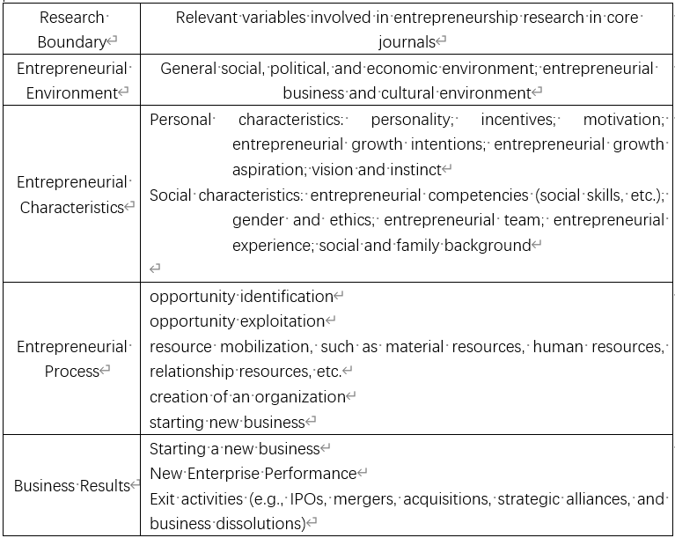
*Zhu Renhong(2004)

2 Entrepreneurial cognition and entrepreneurial opportunities
2.1 Research related to entrepreneurial cognition
2.1.1 The meaning of entrepreneurial cognition
The most widely accepted definition of entrepreneurial cognition comes from the cognitive school of thought—Mitchell (2000), who defines entrepreneurial cognition as "the structure of knowledge on which individuals base their assessments, judgments, and decisions related to opportunity development, business creation, and growth". Mitchell defines entrepreneurial cognition as the summation of fragmented entrepreneurial knowledge that leads to a mental model for entrepreneurial activities related to opportunities, decisions, etc. This definition defines entrepreneurial cognition in terms of knowledge structures (or 'mental models') and identifies the importance of entrepreneurial cognition for all types of entrepreneurial activity, clearly explaining the nature and role of entrepreneurial cognition. For example, Wright et al. (2000) define entrepreneurial cognition as inspiration and beliefs that influence entrepreneurial behaviour, but although this concept explains the relationship between entrepreneurial cognition and behaviour, the meaning of inspiration and beliefs is vague and therefore not widely used. Thus, it has not been widely used.
2.1.2 Patterns of entrepreneurial cognition
Entrepreneurial cognition is dependent on the entrepreneur and produces different patterns depending on the entrepreneur's information processing preferences, which in turn This has an impact on behaviours such as learning, knowledge acquisition, and decision making (Kickul et al. 2009).
Olson (1985) classified cognitive patterns into two categories, intuitive and analytical, based on the amount of mental resources used by the individual to process new information, with intuitive cognition meaning that individuals rely less on mental resources and more on their own intuition when processing new information, and the cognitive process is random rather than based on objective systematic analysis. This model is considered to be the individual's "heat treatment" of information. Analytical cognition, in which the individual processes information in a rational way, following norms and using more mental resources, is considered to be a "cold processing" of information.
Sarasvathy (2001) suggests two cognitive reasoning models that influence entrepreneurial decisions: causal reasoning and effectual reasoning, based on the cognitive mechanisms of entrepreneurial decision making in entrepreneurial practice. Causal reasoning takes maximising expected rewards as the ultimate goal and emphasises the use of accurate market forecasting and analysis to select the appropriate means to achieve the ultimate goal; effectual reasoning refers to the cognitive way in which entrepreneurs invest in resources that are within their risk tolerance range in an uncertain environment, seek scarce resources by establishing mutually beneficial relationships with external networks, and make the most of unexpected events to create possible outcomes (Zhang, Yuli, 2011).
2.2 Research related to entrepreneurial opportunities
2.2.1 The concept of entrepreneurial opportunity
Some scholars define entrepreneurial opportunities from the perspective of the source of entrepreneurial opportunities, such as Drucker (1985) who states that 'change' provides the opportunity for people to create new and different businesses, and when change occurs, entrepreneurs take advantage of the opportunity to create new value. Kirzner (1979) argues that entrepreneurial opportunities are a series of market imperfections, where market participants have different judgements about market clearing prices and the future emergence of new markets due to information asymmetries, thus creating a series of market opportunities. Schumpeter (1934) emphasised the possibility for entrepreneurs to combine resources to create value, and he argued that entrepreneurial opportunities have to be creatively combined with resources to meet market needs to the point of creating a possibility for value. Products and services that create or add value to their use.
2.2.2 Identification of entrepreneurial opportunities
Ardichvili, Cardozo and Ray's (2003) model of entrepreneurial opportunity identification and development consists of six main components: entrepreneurial personal attributes, prior knowledge, social network, alertness, opportunity type, and the core process of opportunity identification. The basic logic of the model is that personal attributes and a priori knowledge act together in the entrepreneur's social network, and that the entrepreneur increases his or her alertness to entrepreneurial opportunities through his or her social network, and then identifies and exploits them. The model proposes a "perception - development - creation" - "opportunity evaluation" - "opportunity development"-"new venture formation". Lin Song and Jiang Yanfu (2005) proposed a model of entrepreneurial opportunity identification that includes five components: natural attributes of the opportunity, personal characteristics of the entrepreneur, core development process, entrepreneurial strategy, and business growth. This model remedies the shortcomings of Ardichvili et al.'s study by incorporating opportunity characteristics and environmental factors into the entrepreneurial opportunity identification model, emphasising the interaction between "entrepreneur-opportunity-environment". Chen Haitao et al (2007) proposed a model of opportunity identification that includes the environment, the entrepreneur and the social network as influencing factors, and summarised the interaction between these three factors in the opportunity identification process.

3 Entrepreneurial intentions and entrepreneurial behaviour
3.1 The connotation of entrepreneurial behaviour
Entrepreneurial behaviour itself is a circuitous abstraction that encompasses entrepreneurial behaviour in a ample faculty and entrepreneurial behaviour in a attenuated sense. Entrepreneurial behaviour in the broad sense refers mainly to accumulate entrepreneurship, also known as intra-firm entrepreneurship, which Bird (1989) defines as an organisational behaviour. Entrepreneurial behaviour in a narrow sense refers to the alone administrator starting a new business, an individual act of establishing a new organisation (Gartner & Starr 1993). The broad entrepreneurial behaviour proposed by Yuli Zhang (2003) encompasses perceived opportunities, integration of resources, new business survival and finally new business growth, while the narrow entrepreneurial behaviour encompasses perceived opportunities, integration of resources and new business survival.
3.2 Characteristics of entrepreneurial behavior
Entrepreneurial behaviour is a very demanding activity that involves a series of processes in product development. The process of entrepreneurial behaviour involves the acquisition of resources, the acquisition of information, the learning of entrepreneurial knowledge, etc. The process is complex and tedious and not everyone who has the will to start a business will complete it. Only those entrepreneurs with risk-taking qualities, a high need for achievement and a willingness to take risks will be able to persevere and ultimately succeed. At a micro level, the entrepreneurial behaviour of the individual entrepreneur (or group of individuals) revolves around the entrepreneurial thinking of the individual entrepreneur, and nascent entrepreneurial behaviour is the behaviour of the individual entrepreneur, not the behaviour of an existing business (Lumpkin & Dess, 1996).
3.3 Entrepreneurial behaviour is a multi-level phenomenon
Brush et al. (2008), Katz and Gartner (1988) and Reynolds and Miller (1992) all point out that the outcomes of entrepreneurial behaviour are indistinguishable and that the best example of this is the 'achievement of sales revenue', which can be seen both as entrepreneurial behaviour and as an outcome of entrepreneurial behaviour (firm performance). The best example of this is the 'attainment of sales revenue', which can be seen as both an entrepreneurial act and an outcome of entrepreneurial behaviour (business performance). Entrepreneurial behaviour is the process by which an entrepreneur creates a business, such as writing a business plan, finding investment and organising a start-up team. Very beginning, entrepreneurial behaviour is marked by an outflow of resources and is a value-consuming activity, and therefore the consumption worth results in larger value, admitting the outcome of entrepreneurial behaviour is that the creation of value once the business has been with success established, and especially refers to the flow of resources into the business. It can be seen that entrepreneurial behaviour and the outcome of entrepreneurial behaviour are sequential in time; only after the entrepreneurial behaviour is completed and the business model is built does the flow of resources into the firm occur and value creation becomes the outcome of entrepreneurial behaviour.

4 Entrepreneurial ecosystem
Spigel (2017) suggests that entrepreneurial ecosystems consist of local cultural perspectives, social networks, investment capital, universities and active economic policies. These elements provide a favourable entrepreneurial environment for the innovative agents within the system. Cohen (2006) argues that a sustainable entrepreneurial ecosystem includes formal networks, informal networks, government, universities, talent, capital services, etc. Stam (2015) suggests that the elements of an entrepreneurial ecosystem can be divided into systemic elements (entrepreneurial networks, leadership, finance, people, knowledge and supportive services) and framework elements (institutional and physical factors).
The classification of entrepreneurial ecosystem types varies considerably among scholars due to different research perspectives. Nambisan and Sawhney (2009) classify entrepreneurial ecosystems as either network-centralised or network-decentralised, based on the degree of network concentration among the actors within the ecosystem. The former is dominated by the core firm, which centralises leadership and coordination within the system, while in the latter, the participants are not prioritised, and leadership and coordination responsibilities are decentralised to each player.
The interdependence and synergistic development of the entrepreneurial ecosystem is based on shared values (Zhang baosheng, 2020), with different types of actors using their complementary resources as a basis to jointly promote the ecosystem and achieve their goals. As creative ecosystems evolve, relationships between firms of the same type gradually shift from initial interdependence to competitive predation under symbiotic networks (Zahra, 2011).

5 Entrepreneurial failure and Exit
5.1 Entrepreneurial failure
The entrepreneurial process encompasses all stages from the creation of a firm to the harvesting of its value (Reynolds and White, 1997). Most previous research on the entrepreneurial process has focused on the early stages of entrepreneurship, which is thought to begin with the birth of the entrepreneur and end with the creation of the new business (Korunka et al., 2003). However, the ability to reap the value of the firm at some point in the future depends on whether much of the effort involved in creating a new business is rewarded (Holmberg, 1991). The exit from entrepreneurship is an important point at which this value is harvested. Therefore, entrepreneurship is not only the creation of a new business, but also more than the creation of a new business, but should be a complete process that includes the exit of the business (DeTienne, 2010).
Failure to start a business can have a range of negative effects. From a cognitive developmental perspective, entrepreneurial failure leads to a significant reduction in self-efficacy; from a resource accumulation perspective, entrepreneurial failure is often accompanied by a reduction in human and social capital; and from an emotional perception perspective, entrepreneurs who have failed in business may have negative feelings towards entrepreneurship due to the loss of their career. Based on a process perspective, Shepherd (2003) proposes the concept of recovery from failure, suggesting that after failure entrepreneurs can recover in an alternating "loss-oriented-recovery-oriented" manner to achieve greater learning efficiency. Cope (2011) suggests that emotional management and failure learning are key to entrepreneurial failure recovery, with failure learning as one of the key activities, including self-learning, internal learning and external learning (Li Zhigang et al, 2022).
5.2 Entrepreneurial exit
Entrepreneurial exit is a crucial stage in the entrepreneurial process that is defined as the entrepreneur's decision to leave self-employment and terminate an entrepreneurial career (Dawson and Henley, 2013; Callanan and Zimmerman, 2016;). At the individual level, entrepreneurial exit is that the call to finish self-employment or perhaps to abandon associate entrepreneurial career, and is one among the choices that a private will face early or late within the entrepreneurial process. At the firm level, entrepreneurial exit refers to the end of a start-up's operations and its exit from the market, such as the withdrawal of a firm from a specific market, closure, collapse or bankruptcy. In terms of process, entrepreneurial exit involves generating intentions, making decisions and implementing exit behaviours. The reasons why entrepreneurs exit are complex, with the level of performance of the start-up being an important factor, but non-economic factors are also an important reference point for entrepreneurs. When considering whether to exit, there are two types of reasons: one is that the business is not performing well and the entrepreneur has to accept the failure of the start-up and thus exit the business involuntarily; the other is that the entrepreneur chooses to exit voluntarily for personal reasons or other factors, such as the start-up being acquired, the entrepreneur retiring or pursuing further studies (Zhou & Zhu, 2021).

6 Possible research gaps
1.Based on the various styles of entrepreneurial opportunities, the psychological feature and decision-making processes of entrepreneurs and in the larger entrepreneurial context throughout the discovery/creative chance development process.
2.Different dimensions of the entrepreneurial context have some space to be explored, such as the interaction working system between institutional context uncertainty and discovery opportunity development, the interaction working system between objective market context uncertainty and subjective market context uncertainty and so on.
3. It is possible to investigate the mechanisms of transmission and transformation between entrepreneurial opportunities and entrepreneurial contextual dynamics. (Cai Yiru, 2022).
In terms of research methodology, entrepreneurship study can help to foster cross-disciplinary collaboration and theoretical interplay between sociology, psychology, and traditional management. As a result, study design and methodology should be varied, with experimental studies and field studies being actively used in addition to surveys and secondary data. Currently, the entrepreneurship literature in mainstream international journals has shown a clear trend of combining qualitative and quantitative methods (Chanscr, 2015).
Meanwhile, to test and improve the accuracy and prediction potential of ideas, future study should use a variety of research approaches. For example, several analyses of the research questions using methodologies such as various case studies and mixed methods can be used to test the theory's explanatory ability. At the same time, predictive approaches can be used to identify trends in the interplay between entrepreneurial prospects and entrepreneurial conditions, as well as possible outcomes based on proposed theories, and so on.

References
Cai Yiru, Cai Li, Chen Ziying, Yang Yaqian(2022). Entrepreneurial opportunity and entrepreneurial context: An integrated framework.44(4):18-33.
Callanan，G． A． ，and M． Zimmerman(2016)． To be or Not to be an Entrepreneur: Applying a Normative Model to Career Decisions. Journal of Career Development. 43( 5) : 447 － 461．
Cohen B. (2006). Sustainable valley entrepreneurial ecosystems. Business Strategy and the Environment. 15(1):1-14.
Cope. J (2011). Entrepreneurial learning from failure: an interpretative phenomenological analysis. Journal of business venturing, 26(6):604-623.
Colombelli A,Paolucci E,Ughetto E.(2019). Hierarchical and relational governance and the life cycle of entrepreneurial eco⁃ systems. Small Business Economics, 52(2):505-521.
CHAN C S R，PARK H D（2015）. How images and color in business plans influence venture investment screening deci sions. Journal of Business Venturing，30（5）：732 - 748.
Denney, & Tewksbury, R. (2013). How to Write a Literature Review. Journal of Criminal Justice Education, 24(2), 218–234.
Dawson，C． ，and A． Henley（2013）.Over-Optimism and Entry and Exit from Self-Employment．International Small Business Journal.31，( 8) : 938 － 954．
DeTienne，D.R (2010). Entrepreneurial Exit as a Critical Component of the Entrepreneurial Process: Theoretical Development. Journal of Business Venturing, 25，( 2) : 203 － 215．
Dou Junsheng, Bao Jia(2016). Continuous Creativity: Literature Review, Synthesis and New Interpretations .Foreign Economics and Management, 38(4): 90-103, 113.
Grant, & Booth, A. (2009). A typology of reviews: an analysis of 14 review types and associated methodologies. Health Information and Libraries Journal, 26(2), 91–108.
Irving, Davis, S., & Collier, A. (2017). Aging With Purpose: Systematic Search and Review of Literature Pertaining to Older Adults and Purpose. International Journal of Aging & Human Development, 85(4), 403–437.
Huang Fuquan , You Jingru , Tu Lina , Zeng Wenjie (2017), The systematic literature review approach: cases, procedures and values, e-Education research, (11):11-25.
Hoang Ha., Antoncic, Bostjan.Network -based Research in Entrepreneurship: A Critical Review. Journal of Management , 2003 , (18):165 - 187.

JESSON J K，LYDIA MATHESON，LACEY F M. Doing your literature review：traditional and systematic techniques [M]. Los Angeles：Sage，2011：5-125．
Korunka，C． ，H． Frank，and M． Lueger，et al (2003)． The Entrepreneurial Personality in the Context of Resources，Environment，and the Startup Process: A Configurational Approach．Entrepreneurship Theory and Practice, 28，( 1) : 23 － 42．
Korunka，C.,H． Frank，and M． Lueger，et al (2003). The Entrepreneurial Personality in the Context of Ｒesources，Environment，and the Startup Process: A Configurational Approach. Entrepreneurship Theory and Practice， 28，( 1) : 23-42．
Kraus, Breier, M., & Dasí-Rodríguez, S. (2020). The art of crafting a systematic literature review in entrepreneurship research. International Entrepreneurship and Management Journal, 16(3), 1023–1042.
Low M. B., MacMillan I. C. Entrepreneurship: Past Research and Future Challenge. Journal of Management , 1988 ,(14):139 -161.
Li Zhigang, Ren Jiaqiu, Zhang dianzhen, Deng Xiaohu(2022). Research on dual paths of serial entrepreneurship in the context of entrepreneurial failure. Chinese Journal of Management.19(03):385-396.
Lu Yang. (2011).Literature reviews in social science research: principles, structures and issues. Social Science Management and Review,(02),70-76.
Liu Zeshuang, Duan Xiaoliang(2009). Study on the identification of entrepreuriao environment key factor based on ISM. 2009 ISECS international colloquium on computing, communication, control, and management.
Nambisan S,Sawhney M.(2009). Making the most of the global brain for innovation. International Commerce Review, 8(2-4):128-135.
NEUMAN W L. Social research methods：qualitative and quantitative approaches[M]. 6th ed. Beijing: People's Post and Telecommunications Publishing House, 2010.
Pati, & Lorusso, L. N. (2018). How to Write a Systematic Review of the Literature. HERD, 11(1), 15–30.
Panic, Leoncini, E., de Belvis, G., Ricciardi, W., & Boccia, S. (2013). Evaluation of the Endorsement of the Preferred Reporting Items for Systematic Reviews and Meta-Analysis (PRISMA) Statement on the Quality of Published Systematic Review and Meta-Analyses. PloS One, 8(12), e83138–e83138.
Reynolds，P.D. ，and S.B. White(1997)． The Entrepreneurial Process: Economic Growth，Men，Women，and Minorities. Westport, CT: Quorum Books．
Smith, & Ferris, S. P. (2017). Using restaurant reviews to teach how to write literature reviews. Communication Teacher, 31(3), 167–171.
Stam E. (2015). Entrepreneurial ecosystems and regional policy: a sympathetic critique. European Planning Studies, ,23(9):1759-1769.
Spigel B. The relational organization of entrepreneurial ecosystems .Entrepreneurship Theory and Practice,2017,41(1):49-72.
Schumpeter J .A .The Theory of Economic Development [ M] .Cambridge .MA :Harvard University Press, 1934 .
Shane S.＆Venkataraman S．2000 “The Promise of Entrepreneurship as a Field of Research” Academy of Management Review.25：217-226．
Shepherd. DA.(2003). Learning from business failure: proposition of grief recovery for the self-employed. Academy of management review,28(2):318-328.
van Dinter, Tekinerdogan, B., & Catal, C. (2021). Automation of systematic literature reviews: A systematic literature review. Information and Software Technology, 136, 106589–.
Wang qi(2010). The meaning, steps and common problems of writing a literature review. Degree and postgraduate education,(11):49-52.
Wee, & Banister, D. (2016). How to Write a Literature Review Paper? Transport Reviews, 36(2), 278–288.
Woodward,W.(1988).A Social Network Theory of Entrepreneurship：an Empriical study PhD Thesis, University of North Carolina at Chapel Hill．
Yangyang Chen, Weiwei Dong, Mingwei Jin(2020), Make use of difference of failure and exit to improve the operation efficiency. IGI Global.
Zahra S A,Nambisan S.(2011). Entrepreneurship in global innovation ecosystems. AMS review ,(1):4-17.
Zhou ying, Zhu ling(2021), Research review and prospect of entrepreneurial exit from the perspective of entrepreneurs. Journal of Fudan University (natural science).60(6):817-824.
Zhang Binxian, Li Shuguang.(2015). Literature review and writing doctoral dissertations in education. Degree and postgraduate education, (1):59-63.
Zhang, Baosheng, Zhang, Qingpu(2020). Symbiotic relationship, evolutionary model and simulation of tacit knowledge flow network members' cooperation. Modern Intelligence,40(11):34-43,53.
Zhu Renhong(2004). Exploring Frontier Theories in Entrepreneurship Research - Definition, Conceptual Framework and Research Boundaries. Management Science, ,17(4):71-77.

