University of Wales Trinity Saint David

Computer Aided Engineering



Application of Computer Aided Engineering Processes
ACDB5007

Alexander McDonald Nichols

2114693

April 2023

Lecturer: Andrew Noble

Contents
1.0 Introduction 3
1.1 Aims & Objectives 3
2.0 Background Information 4
3.0 Methodology 7
4.0 Validation 12
5.0 Results & Analysis. 14
20mm Thickness Test. 14
100mm Thickness Test. 16
200mm Thickness Test. 18
6.0 Conclusion 19
7.0 Reference List 20
References 20

Introduction
This report will explore the use of Computer Aided Engineering (CAE) tools for designing a projectile and simulating a ballistic impact on targets of varying thickness. The report will look at the limitations and benefits of using CAE software in relation to the case study that has been completed as part of this assignment. This case study will be based on a tungsten long rod penetrator impacting on different thicknesses of steel plate. This has been inspired from a real-world example of an Armour Penetrating Fin Stabilised Discarding Sabot (APFSDS) Round. Specifically, this report will look at the accuracy that CAE software is able to model an impact of this type compared to real-world testing. The CAE software that will be discussed in the report is Solid Works for the design of the components and assembly with Ansys being used for the kinematic simulation and analysis.

Aims & Objectives
This report aims to demonstrate the effectiveness of Solid Works to be able to model complex geometric features and assemblies. Another focus of this report is to explore the effectiveness of Ansys and the realism of the results that are produced from simulations. The limitations of these CAE tools will also be explored as it is expected that a CAE simulation will never fully reflect the real-world testing, especially when looking at a ballistic impact. Because of this the report will also look to compare the simulation to information that can be found from real world examples to determine its accuracy.

This report will also seek to inform the reader on the steps that were taken to produce the outcome of the case study and how it was created. This will include how the components and assemblies were made on Solid Works as well as how the simulation was set up on Ansys. The report will also look to interpret the results that were gathered from the case study and what this means within the context of the simulation. Another key aim of this report is to make the simulation as accurate as possible which will be done by exploring material values, velocities, and designs of projectile. Another aim for this report is to provide and accurate demonstration of the outcome of a ballistic impact between an APFSDS round and Steel target. This will allow for the effectiveness of the round to be shown and the effects on the target to be analysed.

2.0 Background Information
The CAE tools chosen for this case study as previously mentioned are Solid Works and Ansys. Solid Works is an example of a Computer Aided Design (CAD) tool which allows for almost any shape to be created by using parametric modelling [1]. Solid Works features a wide array of tools to assist with CAD drawings and even features Finite Element Analysis (FEA) tools, however these features are quite limited and are more useful for quick simple analysis [2]. Because of this to achieve more accurate kinematic analysis another CAE tool has be used. The analysis software that was chosen for the purposes of this case study is Ansys, this is because it is a professional analysis software and is widely regarded as a better software then Solid Works for simulation purposes [2]. However, like SolidWorks Ansys also has its drawbacks featuring very limited modelling and drawing features therefore both will be used to produce to most accurate results for the case study.

By using both CAE tools this case study will be able to take full advantage of the features that the software has to offer. Solid Works will be able to accurately draw and extrude the components used into 3D models. Another advantage of Solid Works is the ability to complete an assembly with multiple components, this will allow for the positioning of the components to be set before creating the simulation. Another important feature is the ability to export components and assemblies as STEP files. STEP stands for “Standard for the Exchange of Product Data” [3]. These files are compatible with most CAE tools and maintains a high level of accuracy when compared to other file types [3]. By using STEP files, the Solid Works assemblies can be easily transferred to Ansys while preserving the quality of the geometry allowing for a more accurate simulation.

As previously stated in this report the focus of the case study is a ballistic impact between a kinetic penetrator and a steel target. Before the simulation is discussed it is important to look at the context behind the case study. The task was given to simulate the testing of a real-world system, as this course is following the subject of Ordinance, Munitions, and Explosives a ballistic impact was chosen as the focus of the study. To provide the case study with a rich set of data the decision was made to use a long rod penetrator stye of projectile for the simulation. After researching the topic, it was found that the most common type of long rod penetrator was the APFSDS round. These rounds, as the name suggest, are made to penetrate armour. The rounds also feature fin stabilisation, this allows for the rounds to penetrate more armour and at greater distances when compared to traditional spin stabilised rounds [4]. This is because fins allow for longer penetrator lengths, better accuracy, and better stability [4]. These rounds also feature a discarding sabot which is essentially a section of material that engages the rifling a barrel and provides a seal to prevent gas escaping, allowing propellent to push the penetrator out of the barrel of a gun before segmenting and detaching from the projectile body [4]. Because the sabot detaches from the projectile for the purposes of this study it was not modelled however the threading it attaches to is modelled on the projectile.

After researching the topic of projectiles an example was found. This was the 100mm APFSDS BM2 round (see figure 1). This is an example of a 1960s area APFSDS round these types of rounds are typically made from tungsten due to its high density and therefore higher kinetic energy [5]. This type of round was designed to be fired from the T-12 100mm anti-tank gun [6]. The image shown in figure 1 was used as the inspiration to model the projectile used in the case study. This was chosen as due to its age as there is more data available then newer variations. Its design is also more simplistic when compared to other similar types of APFSDS round while still being detailed enough to produce accurate results for the purposes of this case study. Despite being over 60 years old this is still a relevant example in current times with the gun still being used by several countries [7].
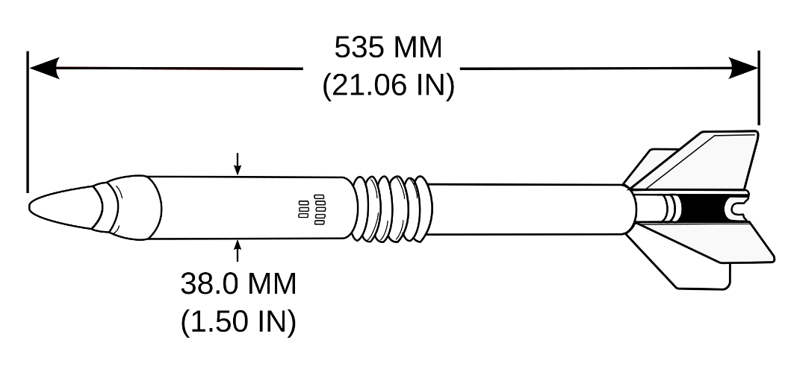
Figure 1
During the research of this round information was found regarding the performance and construction of the round. This information can be compared with the results of case study simulation to determine if CAE tools can accurately simulate this type of impact. This is possible as the data for the velocity, weight, dimensions, and armour penetration values is known. This allows for the conditions of the real-world example to be accurately represented using CAE tools. For the target of the ballistic impact plates of steel have been chosen. These plates each have different thicknesses, this will provide a wide range of data showing the effects on lightly and heavily armoured targets. These simplistic plates are the equivalent to basic tank armour know as Rolled Homogeneous Armour (RHA) [8]. This will allow for the case study to simulate an impact between a typical target that this round would be used against. The different thickness of target will allow for an analysis of how effective the round is for different thicknesses of armour and if the simulation matches real-world testing results.

3.0 Methodology
To perform the case study the first step was to create a drawing of the projectile that will be used. This was done on Solid Works after several iterations of the design, the final drawing was made by using the measurements of the example APFSDS round found during the research for the project seen in figure 1. Because the diagram shown in figure 1 has limited measurements in some parts of the sketch certain areas had to be estimated. The drawing was done as accurately to scale as possible given the limited information using visual references on the diagram. To be efficient only half of the projectile was sketched, this allowed time to be saved as the projectile is symmetrical. After the details such as the fins, threading, and tip of the projectile had been sketched the drawing was then extruded 360 degrees from the mid-point. This resulted in a symmetrical 3D model of a cylindrical nature, the final step was to extrude cut the fins removing any access material. This left the finished model to be used for the case study which can be seen below in figure 2.

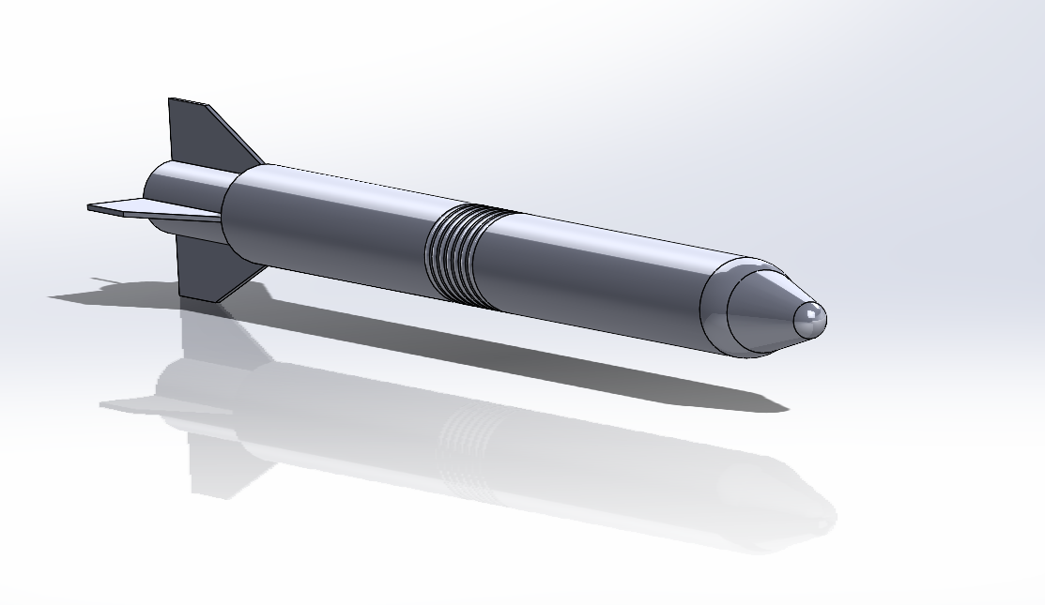
Figure 2
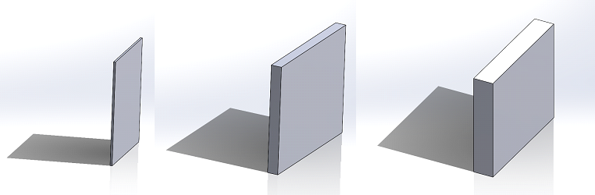
The next step was to create drawings of the targets to be used in the simulation. As it was decided to perform several simulations using different thicknesses of targets 3 different targets were sketched. These targets were made sketching rectangles of the same hight and width before extruding them to different thicknesses on Solid Works. The thickness of these targets is 20mm, 100mm and 200mm. These targets can be seen in figure 3 in order of thickness from smallest to largest. After completing the sketches for the projectile and the targets they could be then added together in an assembly.
Figure 3
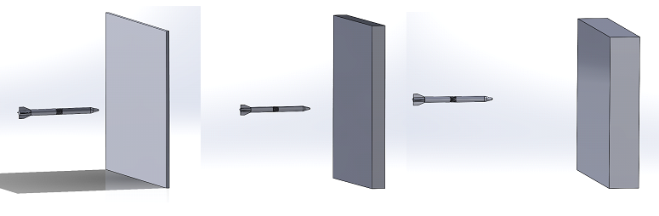
To then create the final 3D assembly that would be used in the case study the components were then brought together in a Solid Works assembly. This allows for multiple components to be saved in 1 file and to have their position relative to each other saved which is important for the simulation. To do this the target was first added to the assembly, this is because it will act as the centre and does not need to be moved. This allows for an easer set up as the projectile can then be added into the assembly and placed a short distance away from the targets surfaced and be centred. This was then saved as a STEP file to ensure data integrity and ease of transfer. These steps were repeated with each of the 3 targets using the same projectile each time. This resulted in the 3 completed assemblies which can be seen in figure 4. After this had been completed the simulation could then be set up using Ansys.

Figure 4
To set up the simulation Ansys workbench was used, the type of study that was used to model the impact was explicit dynamic. This allows for a non-linear dynamic simulation; this is especially useful for high-speed impacts such as the one in this case study as time can be factored into the simulation [9]. After selecting the explicit dynamic option on Ansys the box shown in figure 5 appears. The first step taken to setting up the simulation was to import the geometry of the first setup into Ansys, this was the projectile with the 20mm target. After this Engineering data was then selected from the Ansys granta material database. This database offers a wide range of materials with different properties with some common materials such as steel having many different variations. To ensure that all material properties necessary for a simulation where present materials were only selected from the “Explicit Materials” section. As previously stated, the materials that were chosen for this simulation were tungsten for the projectile and steel for the target. These materials were added to the engineering data of the study to be applied to the geometry within the simulation.
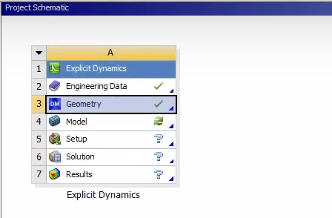
Figure 5

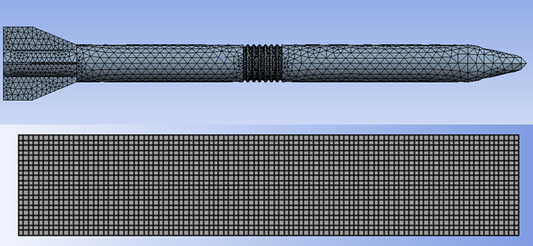
After importing the geometry and engineering data the model of the simulation was then set up, this was essentially meshing the components used in the simulation. For the projectile because of the complex geometrical features and curved surfaces a triangular mesh was used to more accurately represent the features. The varying features of the projectile also meant that different sized cells were used with some features requiring nodes to be closer together in order to mesh the geometry. The largest distance between these nodes was 10mm with the smallest being 1mm allowing for all the projectile to be accurately meshed without using too fine of a mesh for the entire body which would increase calculation time. For the target as the geometry is simplistic and not curved a quadrilateral mesh can be used, this allows for fewer cells and a more uniform mesh, this will mean that the processing time for the simulation faster. As with the projectile all the target meshes are a maximum of 10mm, this will allow for accuracy in the simulation while also not making the simulation more complicated therefore requiring a higher processing time. The completed mesh for the projectile and the target can be seen in figure 6.
Figure 6

The next stage of the study was to complete the setup section of the simulation after the meshing had been completed. The setup consisted of serval parts such as applying simulation time length, material properties, velocitiy, and fixed positions. For the length of the simulation because of the very high velocity of of the projectile and its proximity to the target only a very short length of time was required. Because of this it was decided after several trials to use a simulation time of 0.008 seconds, this allowed for a shorter processing time while also allowing the projectile to have time to fully pass through the target. The next stage was to assign the material properties to the geometary as while the properties were in the simulation it had not yet been specified on the components. After this a velocity of 1,575m/s was then assigned to the projectile with the direction being specified in the -Z axis so that it would make contact with the target in the right direction. This velocity was chosen as it is the stated muzzel velocity of the round the the projectile has been based off [6]. After this the sides of the target were then set as fixed supports so that the target did not move during the impact. Other conditions such as the environement temperature and number of steps the simulation were not altered. Before the simulation could be ran the type of results desired also had to be specified wich in this case was total deformation. This was repeated for the three different simulations wich can be seen in figure 7.
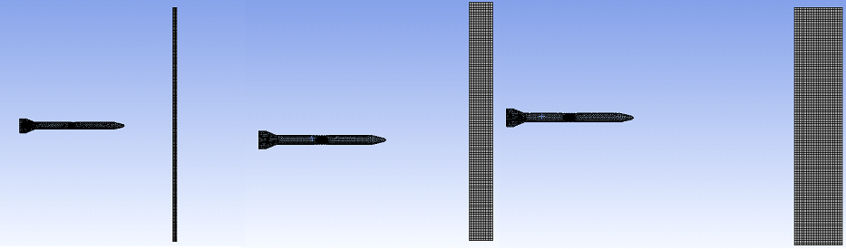
Figure 7

4.0 Validation
To ensure that the case study would yield results that were relevant and accurate, a validation to prove its effectiveness had to be carried out. This is done by creating a study on an object that has known results from previous testing and mathematical equations. This object has set geometry and values and a force is then applied to it. The deformation and stresses that occur on this object can then be observed. The results of this simulation can then be compared to the calculations and alternative simulations when the object was subjected to these forces. The difference between the simulation and the calculations can then be compared to determine the accuracy of the software.

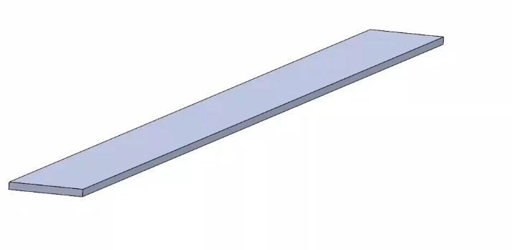
For the purposes of validating the simulation in this case study it was decided to perform a structural analysis validation study. This validation consisted of a cantilever beam, measuring elastic bending under a uniform load, this beam was 100cm long, 50cm wide and 5cm tall. Using the information from the validation example the cantilever beam was sketched and dimensioned on solid works and then exported as a step file to Ansys. Because of the simplistic nature of the beam this was not necessary but as a step file was used for the main case study it was chosen to demonstrate the reliability of the file type. The completed component created in solid works can be seen in figure 8.
Figure 8
After the geometry of the beam had been created, it was then transferred to Ansys which would be used to complete the simulation. In Ansys a static structural study was created, and the geometry was imported, the next stage was then to add the material properties to the engineering data. This included things such as young’s modulus, Poisson’s ratio, and sheer modulus. All these values were found to on the validation sheet ensuring the same conditions were followed. This is because the pre set material properties on Ansys are not the same as those used in the validation study, so they need to be changed to accurately conduct the study. To do this a new custom material was created and the values stated in the data sheet were entered, after saving this new material this was also added to the study. After this the environmental temperate of the study was set to ambient which is approximately 22 degrees Celsius. The beam was then meshed using the default settings for a mechanical study with the element size set to 2.5mm to allow for detailed results. A fixed support was then applied to the end of the beam and a uniform pressure of 27500Pa was applied to the top of the beam. To measure the results of the study the solution chosen was total deformation which will allow for the deformation that occurs under the load to be displayed.

After the simulation had been completed it was then run and an output was generated which can be seen in figure 9. From the results we can see that there was a maximum deformation of 157.15mm. As can be seen in figure 9 the deformation is highest at the point furthest away from the fixed support. Using the equations provided in the validation example the mathematical calculation gives a figure of 157.143mm as the total deformation. The other simulation software used to compare against Ansys in the validation had a total deformation of 157.13mm. From these results this case study was 99.995% accurate when compared to a mathematical calculation and 99.991% accurate when compared to another computer simulation package for showing total deformation. This shows that Ansys is an accurate CAE simulation software to be used in the case study for this report. While the conditions of the case study will be different to this validation this proves that the package is capable of accurately calculating the total deformation of an object which will be the focus of the case study.

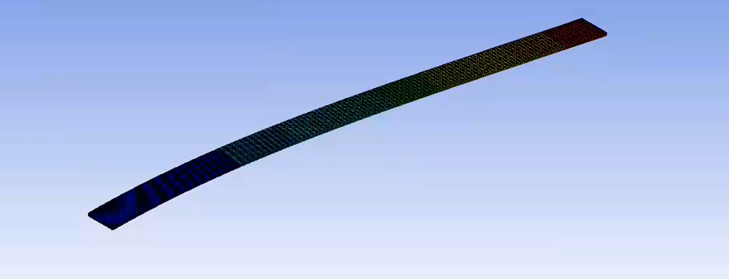
Figure 9

5.0 Results & Analysis.
After the successful setup of each of the simulations all 3 had been completed. The simulations all used the same projectile, The APFSDS inspired long rod penetrator, with targets of varying thicknesses of steel. This will allow for the effects of the projectile on different thicknesses of armour to be explored. These results can be compared to information gathered about the projectile this case study is based off to determine the accuracy of CAE tools to model a ballistic impact.

20mm Thickness Test.
The first of the 3 simulations were the 20mm Steel plate being stuck by the Tungsten APFSDS round at 1,575m/s. The results of this impact can be seen in Figure 10, 11, and 12. In figure 10 the projectile has just impacted the target and from the red dots visible has caused some of the material to be destroyed. This a result of the erosion control feature in Ansys when elements are subject to excess strain they are destroyed and displayed by red dots. This means that as the projectile hit the target some material has been separated from the rest. Figure 10 also shows that a large amount of material has been deformed along the path of the projectile. This is plastic deformation as it can be seen in figure 11 and 12 that the material does not return to the original position after the projectile has passed through. This is likely because of the ductile properties of steel that allows for materials to be deformed without breaking off. Figure 11 shows that the projectile is largely intact after the impact, however the fins of the dart have become very deformed. This is likely due to the fins being thinner and sticking out from the main body of the projectile, however this is not important as the fins only serve for in flight stabilisation and are not designed to penetrate the armour.
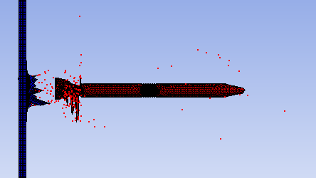
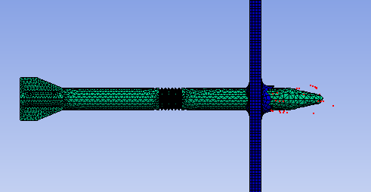

Figure 10
Figure 11
Similarly, to when the projectile first hit the target figures 11 and 12 also show that there is significant element destruction as the penetrator fully passes through the projectile. This could possibly be from the fins of the projectile breaking off or parts of the target when the fins impacted. This is likely because unlike the tip of the projectile with a small surface area the fins have a large surface area causing the strain on a wide section of the target breaking areas of both the target and projectile off. As can be seen in figure 12 the front of the projectile looks undamaged, this is likely because the small surface area of the tip pushed the material out of the way rather than fracturing like with the fins. The damage caused by the fins would likely be beneficial in an APFSDS application as this would cause more damage behind the target rather than passing through cleanly. Figure 11 shows the destroyed elements spreading out in a conical direction, this would increase the area of damage the with shrapnel being created. In its intended role this is how APFSDS round destroy tanks with the spalling created by both the projectile and armour dispersing and causing damage far larger than the entry hole size to a target [10]. This can also be seen in Figures 11 and 12 with the entry point of the projectile being relatively small but the exit point is larger with jagged edges.

From the results of the first simulation I can be said that the projectile sucsessfully penatrated the entirity of the steel target. In doing so the main body of the dart susitaned little damage with the fins sustaning significant deformation and distruction. The impact also caused significant spalling from both the target and the projectile resulting in many smaller pices of material fracting from the main body while spreading out. As these fragments dispersed alongside the projectile it can be assumed that they are traveling with significant velocity.
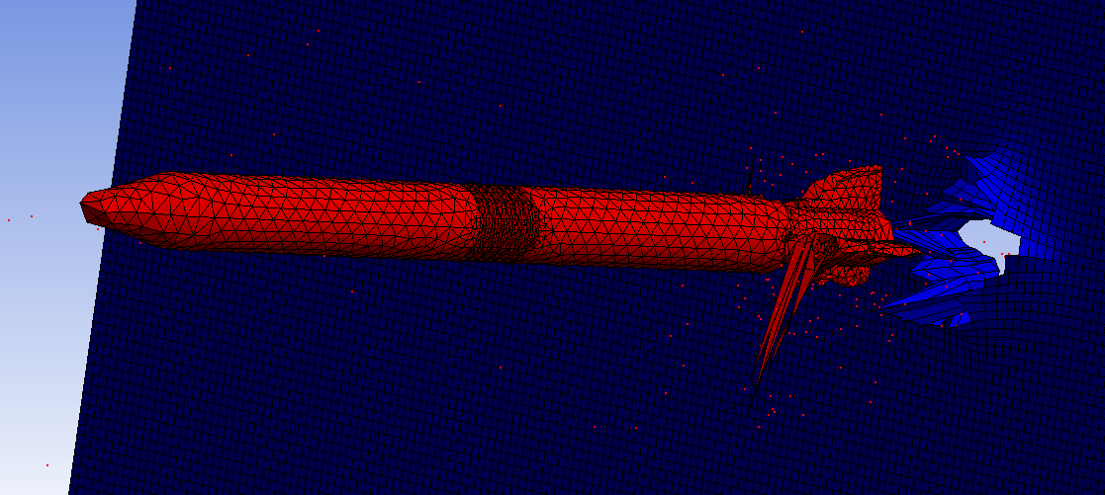

Figure 12

100mm Thickness Test.
For the second simulation a target thickness of 100mm of steel was used, all conditions of the simulation were the same as those in the first simulation with the projectile and the velocity not being altered. The results of this simulation can be seen in figures 13, 14, and 15. In figure 13 a difference from the first simulation can be seen, this is the tip of the projectile as figure 13 clearly shows that it has been majorly deformed. The tip has become almost entirely flattened with thin parts of the material sticking out from the centre of the body of the projectile. This is likely due to the projectile meeting significantly more material then in the first simulation. As the target is thicker in the second simulation the projectile is contacting material for a longer period. This suggests that the damage has been done not via initial contact with the target but as damage due to increased time of contact wit the target. Figure 13 also shows that the spalling created from this impact travels in a vertical direction abruptly. It also shows more spalling being created in the initial contact then in the first simulation. Figure 14 shows that after the initial penetration the fractured material from the impact begins to spread out in a wider direction than in the first simulation but with a less being created.
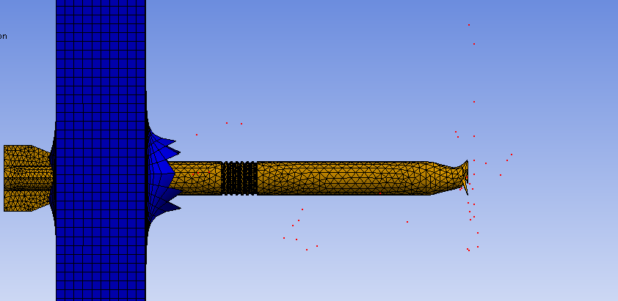
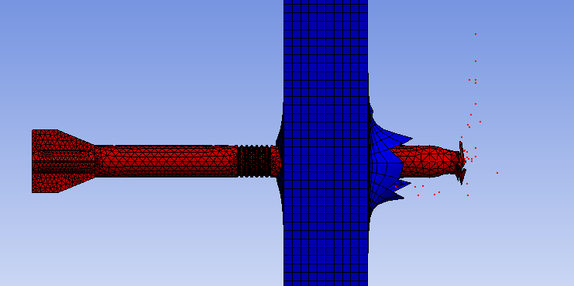
Figure 13
Figure 14

Figure 15 shows a front view of the projectile, in this the spread of the destroyed material can be seen, the diameter of the spread is far larger than that of the projectile. This means that even if the projectile did not hit something behind the target the spalling created the by the impact might. Figure 15 also shows a distinctive cross pattern that has been created by the fins, this shows that the fins have created substantial deformation to the target creating a hole larger than the body of the projectile. This suggests that the tip of the projectile has pushed the material out of the way while the fins have caused a more damage due to their larger profile. The increased amount of deleted elements suggests that with a thicker target more material is broken off therefor increasing the behind armour affect, this would mean that if used in its intended role a tank with thicker armour would receive more damage once penetrated when compared to one of thinner thickness.

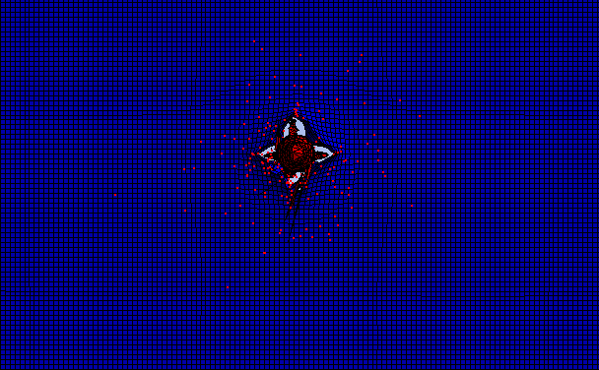

Figure 15

From the second simulation I can be seen that the projectile sustained more damage then
when compared to the first simulation. It can also be seen that more damage was done to the target with more element deletion occurring due to the material fracturing. However less deformation occurred on the exit hole of the target when compared to the first target. The spalling created from the impact also appears to have spread out more than in the first simulation providing a larger area of after armour effect.

200mm Thickness Test.
The final simulation done was yet again done under the same conditions as the first two but with a steel target with a thickness 200mm. The results of this simulation can be seen in figures 16 and 17. From these results major deformation to the tip of the projectile can be seen. Unlike the previous simulations the projectile did not fully penetrate the target. This was because after the tip of the projectile had made it through the target Ansys would stop the simulation because of an error. After several attempts to fix the error non worked, and the projectile never moved past the initial point. This could be because the mesh was not fine enough to solve the major deformation and the next step was too complicated to calculate. However, from the results in figure 17 a small about of element deletion can be seen showing that some fracturing of the target has occurred, the target has also been penetrated with a hole passing through both sides seen in figure 16. From this It can be said that the target was penetrated and there would be some damage cause behind the target, however because of the low amount of spalling this is likely to be less then the effect created in the first and second simulations.

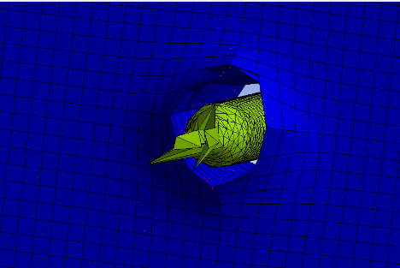
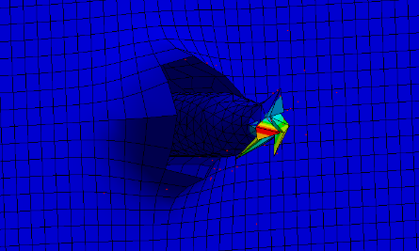
Figure 16
Figure 17

From the results of the CAE simulation, it has been found that that an APFSDS round will penetrate 20mm and 100mm of steel with ease passing through completely. However due to limitations with Ansys the results of the projectile hitting a 200mm target are inconclusive. From researching the APFSDS round used as the model for this simulation it is stated as being capable of penetrating up to 180mm of steel at 2,000m [11]. From looking at the results of achieved from the simulations this had been met as while the third simulation failed the target was still fully penetrated. Figure 18 shows and example of steel armour after being stuck by a similar APFSDS round as the one used in this case study. Comparing the results in the simulations to figure 18 some similarities can be seen. These similarities include a small diameter hole slightly larger than the projectile, metal fragmentation and metal around the exit hole deforming without separating from the target. Both figure 18 and the results from the simulations also show a larger exit hole then entry. Because of this it can be said that the CAE has produced a relatively accurate simulation of what would happen during a real-world impact.
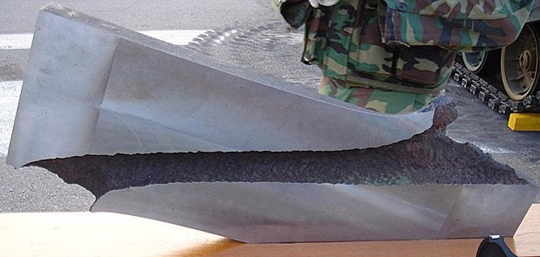

Figure 18 [11]

6.0 Conclusion
From this case study the use of CAE software to model and simulate a ballistic impact based off a real-world example has been explored. This has consisted of using Solid Works as a design tool using iterative design to optimise models for accuracy. Ansys was then used to analyse the interactions between the modelled projectile and targets to compare to the real-world examples. The CAE tools used have been validated as being accurate by calculating the deformation on a material and comparing to the result achieved by Ansys as well as against other CAE tools. The methodology of the case study has been explored with reasoning explaining the decisions made. From the results of the simulations all targets were successfully defeated by the projectile.

This case study has produced 3 different sets of results relating to a kinematic study of a ballistic impact. These results showed the effects that a APFSDS round has on varying thickness of steel plate with the results being analysed. These results have shown to be accurate to real world testing with the round penetrating a thickness of armour that it was expected to. The results also show close similarities to real world examples of ballistic impacts. Because of this the CAE tools used have shown that they are able to accurately simulate a ballistic impact using explicit dynamics. With solid works being able to accurately replicate the projectile used and Ansys simulating the interaction with the target. Some of the limitations of the CAE tools that were used include Ansys not being able to complete the final simulation and the long processing times that were required for the simulations. Another limitation faced by this case study was limited information surrounding the projectile with geometry and velocity not being exact. However, from the results of this study, it has been shown that CAE tools used are a viable option to model a ballistic impact with accurate results being achieved.

7.0 Reference List

References

[1] | ALL3DP, ALL3DP, [Online]. Available: https://all3dp.com/2/what-is-solidworks-simply-explained/. [Accessed 05 04 2023].
[2] | Grok Lab, [Online]. Available: https://groklab.org/tips-designers/frequent-question-does-ansys-use-fea.html#:~:text=Solidworks%20is%20mainly%203D%20CAD%20software%2C%20and%20the,than%20SolidWorks.%20For%20modelling%20purpose%20SolidWorks%20is%20right.. [Accessed 05 04 2023].
[3] | J. O'Connell, ALL3DP, 4 December 2022. [Online]. Available: https://all3dp.com/2/step-file-format-simply-explained/.
[4] | S. M. Buc, “FIN-STABLIZED DESCARDING SABOT”. United States of America Patent 5,473,989, 12 Dec 1995.
[5] | “Norfolk Tank Museum,” [Online]. Available: http://norfolktankmuseum.co.uk/types-of-ammunition/. [Accessed 05 04 2023].
[6] | R. Sherman, “Military Analysis Network,” 11 December 1999 . [Online]. Available: https://man.fas.org/dod-101/sys/land/row/t-12.htm.
[7] | D. Axe, “Forbes,” 1 may 2022. [Online]. Available: https://www.forbes.com/sites/davidaxe/2022/05/01/ukraines-citizen-soldiers-are-shooting-60-year-old-guns-at-russian-tanks/?sh=6cb139f03431.
[8] | GlobalSecurity.Org, “Rolled Homogeneous Armor (RHA),” [Online]. Available: https://www.globalsecurity.org/military/intro/armor-rha.htm. [Accessed 05 04 2023].
[9] | “What is Explicit Dynamics?,” Ansys, 27 July 2022. [Online]. Available: https://www.ansys.com/blog/what-is-explicit-dynamics.
[10] | S. Way, 28 12 2012. [Online]. Available: http://www.army-guide.com/eng/article/article_2579.html.
[11] | J. Hawkes, “Primer: AFV Protection,” 01 may 2021. [Online]. Available: https://www.tanknology.co.uk/post/primer-protection.

