University of Wales Trinity Saint David
School of Engineering

Six Sigma Principles for Process Improvement

Charlie Richards
2307328
14/04/2024

Contents
2 Introduction 1
2.1 Aims 1
2.2 Objectives 1
3 Main Body 2
3.1 Problem Statement Definition (DEFINE) 2
3.2 Performance Metrics and Data Collection (MEASURE) 5
3.3 Data Analysis for Root Cause Identification (ANALYSE) 7
3.4 Proposed Improvement Strategies (IMPROVE) 9
3.5 Establishing Control Mechanisms (CONTROL) 11
4 Conclusion & Final Recommendations 13
5 References 14

Introduction

Specialising in bulk production of Metal Film Resistor (MFR’s), Precision Electronic Solutions Cymru (PESC) supply many different manufacturing companies, OEM (Original Equipment Manufacturer) to be more specific. Their manufacturing process is complex involving several steps such as metallising, welding and spiralling. Recently customers have been complaining while costs have also been increasing due to the spike in defect rates, this is considerably concerning when looking at their production capacity of 15 million resistors annually.

Aims
The DMAIC (Define, Measure, Analyse, Improve, Control) six sigma process will be used to structure this report to address the issues PESC face.

Objectives
The more distinct objectives of the report are as follows:
- Define: This will include the definition of the issues causing manufacturing problems allowing a problem statement to be formed.
- Measure: Key performance metrics will be developed during this objective which creates an assessment of the current state process at PESC. Data collection methods will also be defined so that process performance can be quantified.
- Analyse: Methods to analyse data will be considered at the stage to enable the root cause of the defects currently seen in the PESC manufacturing process. The suitable statistical tools will be selected.
- Improve: Three improvement initiatives will be suggested that would aid reducing defects. Each initiative will be explained on how they will address the previous root causes suggested.
- Control: It was made clear at this part of the report about how important having established control protocols will be for continuous improvement. Specific measures will be recommended for monitoring the process at PESC, so issues don’t creep back in the future.
These objectives will structure a report on effective solution on improving the manufacturing process at PESC while using the principles of six sigma.

Main Body

Problem Statement Definition (DEFINE)

Clearly defining the problem statement is of the utmost importance in any improvement initiative, especially in relation to the Six Sigma methodology. The statement of the problem creates the basis for the entire project, directs further steps and ensures consistency with the goals of the organization. For Precision Electronic Solutions Cymru (PESC), developing an effective problem solver for the manufacturing process is essential to overcome the large number of defects and related challenges.
A clear problem statement helps identify specific issues to be addressed and avoids misunderstandings. For instance, instead of a general problem like "increased manufacturing defects," a more effective approach is to pinpoint the root cause, such as "High error rate in MFR manufacturing leading to customer complaints and higher costs."
Next, support is often received when a clear problem statement is defined. Stakeholders will engage more when they understand the depth of the problem at hand, resulting in a higher chance of receiving adequate resource. The study “Including the stakeholders: The business case” by Wheeler and Sillanpa, 1998 explained how by expressing the problem statement in terms of how the issue will affect customer relationship and the finances of the company is a good way of giving an appreciation of the need for improvements to stakeholders.
A project charter is one of the tools that could be utilized to formulate an effective problem statement. These are often used during the define stage of six sigma projects. Often the charter allows the scope of the project to be recognized while outlining the objectives, stakeholders, and project deadlines. The development of the Charter allows the team to make sure the project aligns with the companies’ goals which ensures upper management buy-in. Reference figure 1 below for an example of what a blank charter template will look like.
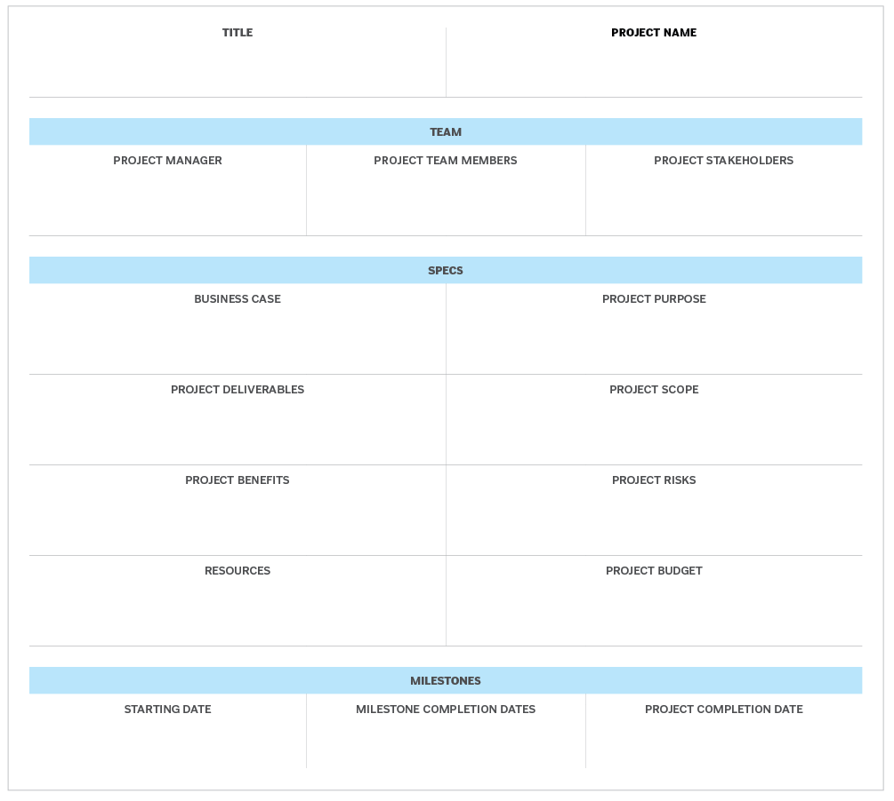
Figure 1 - An example of a concise Project Charter (Gillis, 2022)

Furthermore, during this stage of a six-sigma project applied to PESC, Root Cause Analysis tools such as cause-and-effect diagrams could be simple means to recognize the underlying issues resulting in high defect rates. A research paper on a Oil company in Iran claimed that their findings recognized that the application of a cause-and-effect diagram reduced scraps resulting in a 0.92% decrease of oil waste (Masoud Hekmatpanah, 2011). See figure 2 for an example of how this type of tool would be used to identify the root cause of an engine failure in a car.
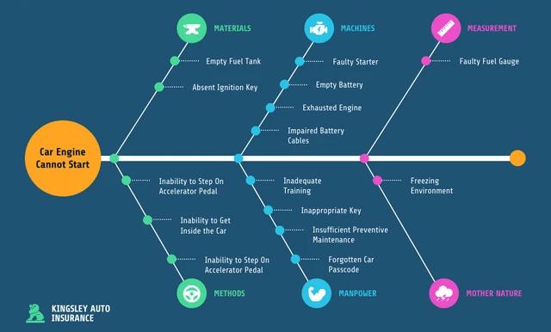
Figure 2 - Example of a Car Engine failure Cause and Effect diagram (Ramuthi, 2023)

To summarise on the importance of having a clearly defined problem statement, is so that improvement initiatives have a base to build on. A good way to validate that your problem statement is effective is to check it against the SMART strategy, it should be specific, measurable, achievable, relevant, and time-based. From this, companies like PESC can initiate the appropriate interventions to address manufacturing issues, whilst driving continuous improvement throughout the organization.

Performance Metrics and Data Collection (MEASURE)
Identifying and measuring key performance indicators (KPI’s) to effectively understand the process performance results allows a comprehensive analysis to be taken for the current state PESC manufacturing process. The wider organization goals should be considered when determining project metrics (Lohman, Fortuin and Wouters, 2004). During the measure stage of a six-sigma project, numerous tools can be employed for better data collection and analysis methods.
The first performance metric to be tracked in terms of PESC should be defect rate. This metric will directly impact the quality of their products and relationship with their customers. The plan should be to track the number of units produced at each manufacturing stage turning out defective so that areas of the process that are vulnerable to errors can be recognized and focused on during improvement initiatives. A good example of where a company focused on a KPI of defects was at a sock production company in Indonesia, they saw their monthly defects rate decrease from 11.08% to 5.54% (Kurnia, Jaqin and Purba, 2021). Statistical Process Control (SPC) charts would be a useful tool to apply at PESC as it will monitor variation in the process over a period allowing the metric to be quantified. An SPC chart also will highlight deviation from the required quality standards for the resistors.
The next metric that PESC should focus on is cycle times for their processes, this is important as it measures the period required to carry out each step in the manufacturing process. Often, inefficiencies and bottlenecks are found due to the high cycle times indicating that there is an issue within a process. High cycle times often correlate to the production downtime and higher costs. A good use of a Six Sigma tool is the case of PESC is the application of process mapping, more specifically value stream mapping (V.S.M). This tool can support by visualizing the sequence of steps involved with producing the resistors, resulting in identified opportunities for streamlining or optimizing certain areas. Look at figure 3 to see an example of how a basic V.S.M was carried out for a Triaging process.
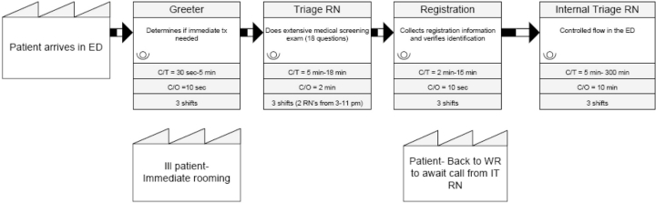
Figure 3 - A V.S.M of a process (Murrel et al, 2011)

Alongside the first two metrics suggested, a good option would be first-pass yield (FPY) which can be critical as it “indicates the percentage of units coming out of a process that are deemed acceptable or defect-free” (Fogg, 2021). Process stability issues occur when a company’s FPY is low resulting in unreliable production results. This would be ideal to employ at PESC with the resistor problem, as this could have started the investigation into root causes sooner. Within context at PESC, a failure mode effect analysis (FMEA) would help anticipate potential failure modes and their consequences. Risk mitigation strategies could be placed ahead of time.
There are numerous data collection methods PESC can utilize to gather data for the performance metrics suggested. In the case of PESC’s suggested KPI’s, collecting data manually through check sheets/forms or electronic systems could be used to record defect counts, cycle times, and yield rates directly from the shop floor. Reference figure 4 on how a check sheet could be utilised to show defect types per vehicle breakdown maintenance. To avoid overwhelming resources, representative data can be collected through various sampling techniques.
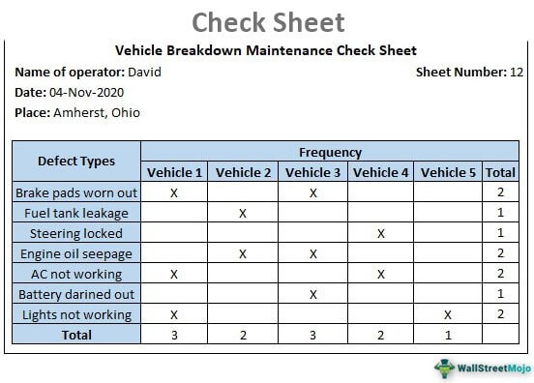
Figure 4 - An example of a Defect Check Sheet (Srivastav, 2020)
To summarise, picking the right metrics and using specific data tools for PESC's manufacturing process is key in the Six Sigma DMAIC method. By measuring how well the process works and looking at data with the right tools, PESC can find areas to get better and add changes to increase how well the operations run and the quality of the product.

Data Analysis for Root Cause Identification (ANALYSE)
During the next sub-section of this report, the importance of the role that data analysis plays when identifying the root cause of defects within the manufacturing process will be discussed. This is especially popular in the Six Sigma methodology. Once data is collected, several statistical and analytical tools will be suggested that could be employed at PESC.
A common tool used in the context of the issues PESC are facing throughout their manufacturing process would be pareto analysis which could get applied to identify the most frequent defect types. Quality guru J.M Juran explained the pareto principle as “separating the vital few from the trivial many, which allows the prioritization of the most significant factors causing defects (McMahon, 2021). Defects can be visually categorized by type such as incomplete metallization or coating defects. This helps the wider team focus on the harder hitting issue first resulting in improvements that are more impactful. See figure 5 on how defect type can be represented on a pareto chart.
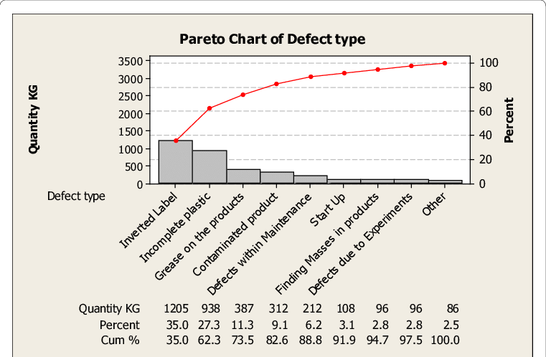
Figure 5 - An example of a Pareto Analyis on Defect types (Abohashima, 2015)

A second important tool for data analysis that could be employed in PESC’s case for data analysis is a histogram. This is another tool that can visually represent data distribution at PESC allowing identification of trends/patterns. Looking at the manufacturing process at PESC, histograms could be used to analyse specific process variables such as cycle times or change over times. For example, histograms can highlight any erratic behaviour within the production process by illustrating the distribution of cycle times for the different manufacturing stages. A semi-conductor manufacturer used a histogram to look at the cycle time of one of their processes in figure 6. Potential production inefficiencies or bottlenecks can be identified by comparing different histograms which can focus improvement efforts on activities that will optimize cycle times and the overall process performance.
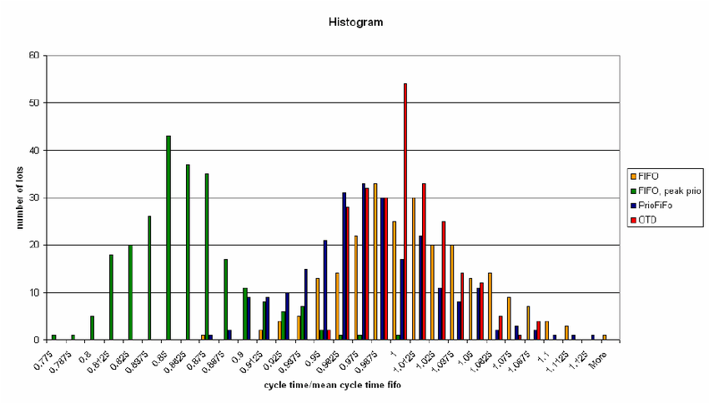
To conclude, the use of statistical and analytical tools like Pareto analysis and Histograms can provide PESC with important insights to what the root cause of the production line issues are.

Proposed Improvement Strategies (IMPROVE)
Three improvement strategies will be proposed, that PESC could use based on analysis conducted that identified some root causes of defects occurring within the manufacturing process. The following explanation of each follow:
- Work instructions and operator training to be standardised:
Inconsistency of operator performance may be recognized as one of the root causes from the analyse phase of the six-sigma project. This can be due to poor working practices and insufficient training. PESC could address this issue by implementing Standard Operating Procedures (SOPs) for each step of their process which clearly guides the operator through best practices. Likewise, PESC can develop comprehensive training classes to guarantee that shop floor operator possesses the necessary skills to carry out their tasks. The organization should see a decreased variability in operator performance if standardised work instructions and training was developed resulting in less defects.
- Error proofing devices to be implemented:
Similarly, to operator performance, another common root cause in PESCS case is human error during manual process such as resistance spot welding. To reduce the likelihood of this, the organization can implement error proofing devices/poka-yoke mechanisms to prevent real time errors. For instance, sensors are a popular within this type of manufacturing, they could be installed to make sure the placement of components during assembly are in the correct position. Implementation of automated systems will prevent errors during assembly before they happen.

- Production layouts to be optimized:
Analysis during manufacturing six sigma projects that are looking at issues with production lines often reveal inefficiencies in the current layout. Looking at PESC’s plant layout they operate with a zigzag flow which could potentially contribute to delays in material handling and bottlenecks within production. To address this, they could redesign their plant layout to the popular U-shaped production line. Allen-Bradley is an example of a company that used this type of production line as it allows smoother material flow and reducing unnecessary transportation resulting in being able to produce their motor drives to customer orders within 24-hours (Miltenburg, 2001). Cycle times can be minimized, changeover times decreased and PESC’s overall process efficiency enhanced through the optimization of production line layouts. In addition, visual management techniques could be added to the improved layouts such as floor markings or kanban systems which will only minimize waste further and improve flow of material (Bateman, Philp and Warrender, 2016). A good example of optimising flow of material using floor marking in a production line is shown in figure 7.

Figure 7 - Production line floor markings (Creativesupply.com, 2024)

To conclude, PESC will effectively address the root cause of their defects if they are to implement appropriate improvement initiatives.

Establishing Control Mechanisms (CONTROL)

It is important to create control mechanisms in order to sustain improvements made during the DMAIC project. Having these in place will provide some sort of safety net to the process ensuring the long-term performance continues to excel without reverting to old practices. The following control measures suggested will show why having solid control mechanism in place is essential to the continuous improvement of manufacturing processes:
- Statistical Process Control (SPC): This will involve the use of statistical tool/techniques to track process performance. Charts such as X-bar or R charts will track process parameters and be able to detect any deviation over time.
- Continuous monitoring/review: Frequent reviews allow for early detection of issues allowing for intervention to stop them from escalating into a bigger process issue. A system should be implemented for monitoring of the process performance allowing for detailed reviews into the key process performance metrics.
- Visual management and Gemba walks:
Performance dashboards and status boards such as Andon systems (traffic light system) would be good visual management techniques to implement at PESC to show what areas of the process require attention. See a reference of a Andon system in figure 8. These can communicate KPI’s and highlight issues requiring attention. Frequent Gemba walks would provide important insight into day-to-day shop floor activities as manager/supervisors will be able to observe the manufacturing process firsthand.

Figure 8 - Andon Systems in production (Display, 2019)
PESC can sustain the improvement made through the DMAIC project framework by implementing control measures which will ensure long term process stability and success.

Conclusion & Final Recommendations
To review, applying the DMAIC structure to a process improvement project at PESC will provide a structured approach to address the problems they through the manufacture of Metal Film Resistors (MFRs). Important insights have been made into the defect root cause at PESC through the Define, Measure, Analyse, Improve, and Control stages. These stages have led into the implementation of improvement strategies.
It has been shown by the implemented solutions that the organization can potentially achieve immense improvements in the efficiency of their operations, relationships with customers and quality of resistors. In contrast, the improvements must be sustained which will require continuous commitment to control measures and process performance monitoring.
For that reason, one final recommendation that PESC needs to ensure the prioritization of establishing strong control measures while investing in development and training programs ensuring their readiness for future long-term success. As well as, creating an organizational culture of continuous improvement which is important for leading future projects aimed at enhancing process efficiency further while keeping a competitive edge through the resistor market.

References

Abohashima, Hanaa & Aly, Mohamed & A, Mohib & HA, Attia. (2015). Minimization of Defects Percentage in Injection Molding Process using Design of Experiment and Taguchi Approach. Industrial Engineering & Management. 04. 10.4172/2169-0316.1000179. [Accessed 17 May 2024].
Bateman, N., Philp, L. and Warrender, H. (2016). Visual management and shop floor teams – development, implementation and use. International Journal of Production Research, 54(24), pp.7345–7358. doi:https://doi.org/10.1080/00207543.2016.1184349. [Accessed 5 May 2024].
Creativesafetysupply.com. (2024). Floor Marking Resources. [online] Available at: https://www.creativesafetysupply.com/resources/floor-marking/ [Accessed 17 May 2024].
Display, S. (2019). Andon displays - What are they and how are they used today? [online] Spectra Displays. Available at: https://spectra-displays.co.uk/andon-displays-what-are-they-and-how-are-they-used-today/. [Accessed 17 May 2024].
Fogg, E. (2021 First Pass Yield: What is it, Formula, and How to Improve. [online] www.machinemetrics.com. Available at: https://www.machinemetrics.com/blog/first-pass-yield. [Accessed 1 May 2024].
Gillis, A. (2022). What is a Project Charter? Definition and Examples. [online] SearchCIO. Available at: https://www.techtarget.com/searchcio/definition/project-charter. [Accessed 17 May 2024].
Kurnia, H., Jaqin, C. and Purba, H. (2021). Quality Improvement with the DMAIC Approach Using the Implementation of Benchmarking and KPI Methods. [online] Available at: https://ieomsociety.org/proceedings/2021indonesia/400.pdf [Accessed 28 April 2024].
Lohman, C., Fortuin, L. and Wouters, M. (2004). Designing a performance measurement system: A case study. European Journal of Operational Research, [online] 156(2), pp.267–286. doi:https://doi.org/10.1016/s0377-2217(02)00918-9. [Accessed 28 April 2024].
Masoud Hekmatpanah (2011). The application of cause and effect diagram in the oil industry in Iran: The case of four liter oil canning process of Sepahan Oil Company. African Journal of Business Management, 5(26). doi:https://doi.org/10.5897/ajbm11.1517. [Accessed 28 April 2024].

McMahon, T. (2021). Lean Quote: The Vital Few and Trivial Many, Doing More by Doing Less. [online] Available at: http://www.aleanjourney.com/2013/06/lean-quote-vital-few-and-trivial-many.html. [Accessed 3 May 2024].
Miltenburg, J. (2001). U-shaped production lines: A review of theory and practice. International Journal of Production Economics, 70(3), pp.201–214. doi:https://doi.org/10.1016/s0925-5273(00)00064-5. [Accessed 5 May 2024].
Murrell, Karen & Offerman, Steve & Kauffman, Mark. (2011). Applying Lean: Implementation of a Rapid Triage and Treatment System. The western journal of emergency medicine. 12. 184-91. [Accessed 17 May 2024].
Ramuthi, Danesh. (2023) “15+ Fishbone Diagram Examples for Brainstorming Problem Causes.” Venngage, 13 Oct. 2023, venngage.com/blog/fishbone-diagram-examples/. [Accessed 17 May 2024].
Rose, Oliver (n.d). Transient Behavior During Single Product Start Peaks in a Semiconductor Fabrication Facility.https://www.researchgate.net/publication/228875484_Transient_Behavior_During_Single_Product_Start_Peaks_in_a_Semiconductor_Fabrication_Facility/citation/download [Accessed 17 May 2024].
Srivastav, A.K. (2020). Check Sheet. [online] WallStreetMojo. Available at: https://www.wallstreetmojo.com/check-sheet/. [Accessed 17 May 2024].
Wheeler, D. and Sillanpa¨a¨, M. (1998). Including the stakeholders: The business case. Long Range Planning, [online] 31(2), pp.201–210. doi:https://doi.org/10.1016/s0024-6301(98)00004-1. [Accessed 26 April 2024].

