Design and Evaluation of Wireless Sensor Networks
Yohannes Zerzghi, Computer Networks; Module: Wireless Networks and Simulation, Lecturer: Simon Downes
Abstract----- today’s era, the Internet of things (IoT) is gaining popularity due to its ease of use and many other benefits such as smart farming, smart city and smart home. Hence, network simulation is vital in creating networks and analysing the different parameters before implementing the actual network. Computer Simulation can be mathematical or hypothetical.

Keywords: Internet of Things (IOT); MATLAB; NetSim; Binary Phase Shift Keying (BPSK); Quadrature Phase Shift Keying (QPSK); Quadrature Amplitude Modulation (QAM); Bit Error Rate (BER); Amplitude Modulation (AM)

Introduction
Nowadays, the world is becoming a village due to the emergence of new technologies and the internet of things (IoT). Today, IoT is becoming vital in creating smart technology such as smart city, smart farming, smart home and more. IoT devices utilise different communication modulation techniques than the wired network devices. Hence, this paper will detail the development and implementation of smart farming network using sensors and also the different modulation techniques that were used. This paper is divided into three sections. The first section looks into research of different modulation techniques and their functions. The second part explains the network design of the smart farming using different simulation software’s such as NetSim and MATLAB. The NetSim is used to create and simulate a wireless sensor network with 30 nodes and the MATLAB is used to design QPSK modulation technique. The last section details the implementation of the network using NetSim and MATLAB.

Literature review

Purpose of modulation in communication devices
In today’s era, the use of communication systems is vital to organizations, business companies as well as to individuals. Communications system contains three parts; these are the baseband, medium and the carrier. The main aim of communication systems is to transmit a message from one place to another. For this, communication systems utilise modulation [1].
Modulation [2], is a modest technique where a carrier wave of content phase, frequency and amplitude are reformed by a non-linear incoming signal. As a result, the output signal changes its properties parallel with the modulation signal. The primary role of modulation is to strengthen the input signal in order to ensure the signal can travel to a long distance. Moreover, it can be used to decrease the effects of noise to improve the quality of reception on the receiver side. Furthermore, modulation is important to increase the area coverage of communication, avoid mixing signals, as well as to reduce the height and size of the antenna needed. It can also be used to support a wide range of frequencies for transmission [3].

Classification of modulation techniques
In general, there are two main types of modulation techniques in communication systems: analogue and digital modulation [4].

Analog modulation techniques
Analog modulation [4], is a modulation technique, where the carrier signal properties such as (amplitude, frequency and phase) is differing persistently in accordance to the input signal. In analogue modulation, there are three types of modulation: amplitude, frequency and phase modulation [4].
Amplitude modulation (AM) [5], is a method in which the amplitude of the carrier signal is altered in accordance with the input signal, where there is persistence in frequency and phase. It is commonly used in broadcasting radio signals. Frequency modulation [5], commonly abbreviated as FM, is a process where the frequency is altered proportionally in relation to the input signal. It is mainly used in radio broadcasting due to its strong resistance to noise. However, it is more complex and expensive to use.
The third type of analogue modulation is called Phase modulation [4] abbreviated as PM, is a similar process to both amplitude and frequency modulation techniques, in which the phase is modified accordingly in reference to the amplitude of the message signal. It is mainly used in data communication systems such as computers, tablets and laptops due to its strong resistance to noise. However, PM is more complex to implement at the receiver end [6].

Digital modulation techniques
Digital modulation is a process, in which a source of a binary signal is altered in accordance with the carrier signal at a discrete amplitude level to produce analogue signal. It is a similar process to analogue modulation except the source signal has a two distinct amplitude points; these are 0 and 1, where 0 represent the low value and 1 represents the high value of the amplitude [7]. Digital modulation can be achieved using three basic modulation schemes: amplitude shift key (ASK), frequency shift key (FSK) and phase shift key (PSK). These three modulation techniques are different in relation to the variations of the carrier signals. In ASK, only the amplitude is altered in relation to the carrier signal during modulation, whereas in FSK and PSK two parameters are altered in relation to carrier signals.
Moreover, it is possible to create different forms of digital modulation, other than the three basic types. This can be accomplished by combining one or more digital modulation methods in relation to the carrier signal, for example, the binary signal can be added with PSK to produce BPSK and so on.
Phase Shift Keying abbreviated as (PSK) [8], is a digital modulation that modulates the signal by altering the phase of the carrier signal. This modulation technique is mainly used in wireless telecommunications, radio communications, and satellites due to its capability of covering extensive areas and doubling the bandwidth [9]. This modulation technique can be able to produce various modulation techniques such as BPSK, QPSK, DPSK, QAM, OQPSK and others [7].

However, this assignment will focus on the three main derivatives of PSK: Binary Phase Shift Keying (BPSK), Quadrature Phase Shift Keying (QPSK) and Quadrature Amplitude Modulation (QAM).

Binary Phase Shift Keying (BPSK)
Binary Phase Shift Keying abbreviated as (BPSK) [10], is a simple but important modulation technique. It is also known as 2PSK, as it generates two phases representing binary 0 and 1. This modulation technique creates 180 degree of difference between the two phases by alternating the signal between +1 and -1. In BPSK, modulation is achieved, by taking only one sinewave as the main task and changing the phase of the sine wave in line to the bits state (0 or 1), where 0 represent 180 degree and 1 represents 0 degree [11]. The visual representation can be generated using the general equation as shown below [12] [13].
S₁ (t) = A_{c} cos (2πf_{c} t), for binary 1
S₀ (t) = A_{c} cos (2πf_{c} t + π), for binary 0
Where, A_{c} represents the amplitude of the sine wave, f_{c} is the frequency of the carrier signal, t is the time taken in seconds of the instantaneous, π is in radians which is equal to 180 degrees. Both S1 (t) and S₀ (t) represent the carrier signal accordingly to the message bit 1 and 0 respectively. The visual representation of the modulated signal using the BPSK technique can be seen below.

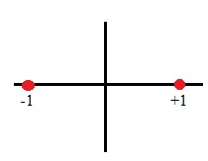
Figure 1: BPSK constellation diagram

As it can be seen on figure-1, the constellation points are separated by 180 degrees. For this reason, BPSK is strong to noise interference. Hence, it can be used for long distance wireless communications. However, this modulation technique is slow comparing to others as it modulates one bit at a time [14].

Quadrature Phase Shift Keying (QPSK)
Quadrature Phase Shift Keying abbreviated as QPSK [10], is another modulation technique of PSK. This modulation technique sends 2 bits per symbol by generating four phases which are separated by 90 degrees from each other. To accomplish this, 2 bits are joined into a symbol to form 4 different combinations. The combinations can be 11, 01, 10 and 00, where each combination refers to 45, 135, 225 and 315 degrees of the carrier phases respectively. And the symbol contains two components: in-phase(I) and quadrature(Q) representing the first and second bit respectively. In other words, the (I) and (Q) carriers are multiplied by the (I) and (Q) of the input data, and the result of both (I) and (Q) are added together to produce QPSK modulated signal [15]. In a nutshell, QPSK modulation is the product of a sine and cosine waves of the phase carrier signal where both amplitude and frequency remain unchanged. The visual representation of QPSK modulation can be represented using the mathematical equation as seen below [13].

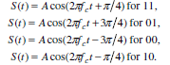
Figure 2: mathematical equation of QPSK signal
Where, f_{c} represents the frequency of the carrier signal, t is the time in seconds and A is the amplitude of the frequency. And S_{n} (t) represents the carrier signal where n value is 1 to 4, for example, when n=1, the phase shift is at 45º and the symbol is 11.

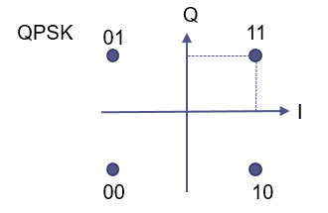
Figure 3: QPSK constellation diagram

From the above diagram, the constellation points are separated by 90º, where each point contains 2 bits. Hence, the QPSK modulation technique can be used in wireless communication to double the data. However, this modulation technique is more complex and less resistant to noise comparing to BPSK [16] [14].

Quadrature Amplitude Modulation (QAM)
Quadrature Amplitude Modulation denoted as (QAM) [8], is a combination of both ASK and PSK modulations, where its amplitude varies with the phase of the carrier signal while the frequency remains unchanged. In QAM, modulation is achieved by changing the amplitude of two carrier signals so that the two carriers are shifted in phase by 90 degrees. It is also called M-ary [17] modulation. Because it gives four or more possible carrier signals by varying the amplitude and the phase of the carrier. To achieve this, two or more bits are joined to form a symbol, where the symbol is a combination of phase and amplitude at each time interval of the carrier [18].
In QAM, the number of possible signals can be found using M =2^{k} or k=log₂ (M) where k is the number of bits per symbol and M is the number of bits transmitted per symbol [19]. The simplest form of QAM is 4-QAM modulation which can be used to transmit 2 bits at a time similar to QPSK. And this can be verified using the formula from the above k=log₂ (4) where the value of M is 4. Other common forms of QAM are 16-QAM, 64-QAM and 256-QAM. Therefore, with QAM the data rate increases by a factor of k, hence it can be used for effective usage of bandwidth [19] [20]. The picture below shows the constellation points of a 16-QAM.
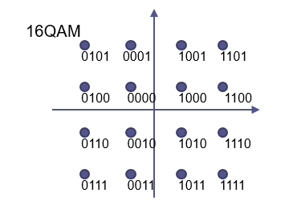
Figure 4: QAM constellation diagram
In general, QAM can be used to provide high data rate using multilevel modulation, for example, 16-QAM to 64-QAM, 64-QAM to 256-QAM and so on. However, it is more vulnerable to noise as the distance between the constellation point’s decreases [19]. In addition, it is more complex compared to QPSK and BPSK. It is commonly used with satellites, wireless systems, digital TV, cellular networks and more [21].

Based on the research, all three modulations have their own advantages and disadvantages. Hence, it is good practice to research on these techniques to get a better understanding by using simulation software’s. For this purpose, the author utilises the NetSim as a simulation software. This network simulation software supports only OQPSK, a version of QPSK as a modulation technique for wireless sensor networks. Hence, the author decides on QPSK as a modulation technique for this project. Moreover, QPSK can be used to double the data rate transmission while maintaining the bit error low for the project. The table below shows the classification of the three modulation methods according to their advantages and disadvantages.

Name | Bit/symbol | Advantages | disadvantages
BPSK | 1 | -least to errors  -Simple to implement | -Slow data rate
QPSK | 2 | -Double data rate | -Vulnerable to errors
QAM | 4 or more | -Fastest data rate | -More vulnerable to errors  -more complex
Figure 5: Modulation techniques

Benefits and drawbacks of using simulation over other methods
Simulation [22] is a process of representing a real-world task or system using mathematical or computerised processes over time. In other words, it is a modelling of real-world operations. It is used to conduct experiment to understand the behaviour of the system under different conditions. The aim of simulation is to support the objectives of the actual scenario by analysing different elements of the system.
The most common type of modelling is mathematical model. It is used in various fields. This type of modelling includes various classifications such as continuous, discrete, deterministic, non-linear and others [22]. Nowadays, Simulation is used in various fields such as science, technology, education and others. For example simulation could be used in computer networking. In this case, simulation can be used to represent a real network for the purpose to simulate and analyse the connectivity between network devices and end devices or check bit error, delay, throughput and others.

Simulation is used for many reasons. One of the main reasons is, to use in testing new products and services before implemented in real-world. In addition, it is more affordable in terms of cost and time. Moreover, it can be used to conduct experiments [23]. However, there are drawbacks of using simulation. One of the main drawbacks of simulation is its computational complexity. Furthermore, simulation could be hard and time consuming as well as it is difficult to achieve accurate information.

Design

NetSim Design
In the second part of this assignment, the author first builds the network design. The smart farming area contains 25 cows, 5 sheep, one dog and strawberry and blueberry crops which is located in west Glamorgan. The diagram below shows, the logical topology of the network, which is build using the draw.io from the internet.

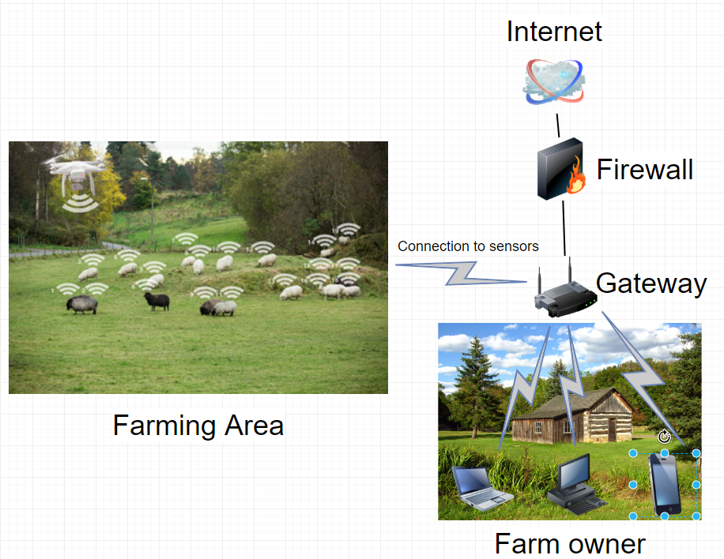
Figure 6: Smart farming network design
Hence, the author utilises the NetSim simulation software to build the network for the smart farming area using the Internet of Things (IoT) tool. The network contains one SINKNODE (6LowPan) as a gateway of the network, 25 sensor nodes for each cows, 5 sensor nodes for each sheep, 1 sensor for the dog and extra four sensors for the two crops namely temperature, humidity, moisture and weather sensors. The network area is chosen to be 500m by 500m in order to cover all the farming area. Moreover, one sink node is placed at a suitable position as a gateway to the internet so that all the sensors can send and receive traffic through it. The device used as a sink node is 6LowPan. The reason is, this device is designed for low-power wireless personal area network (LoWPAN) with internet protocol (IPv6). Hence, the sensors can get IPv6 automatically from the LoWPAN. This device uses the IEEE802.15.4 protocol to communicate with the nodes (sensors). In addition, the device is applicable to low-power, low-rate and low cost.
Moreover, the design contains one router that links the LoWPAN with the database server, where all the data from each sensor nodes is stored. Furthermore, an access point (AP) is also used that is linked to the router. This device is used to connect devices such as laptop, smartphone and tablets by radio (wirelessly). Hence, the owner of the farming area can access the data from anywhere. Thus, one laptop is used in the network design.

MATLAB Design
The author also intends to utilise MATLAB. This software is used to simulate different communication systems using mathematical procedure. Hence, using MATLAB a QPSK modulation is built on Simulink. The picture below shows the MATLAB design on Simulink.

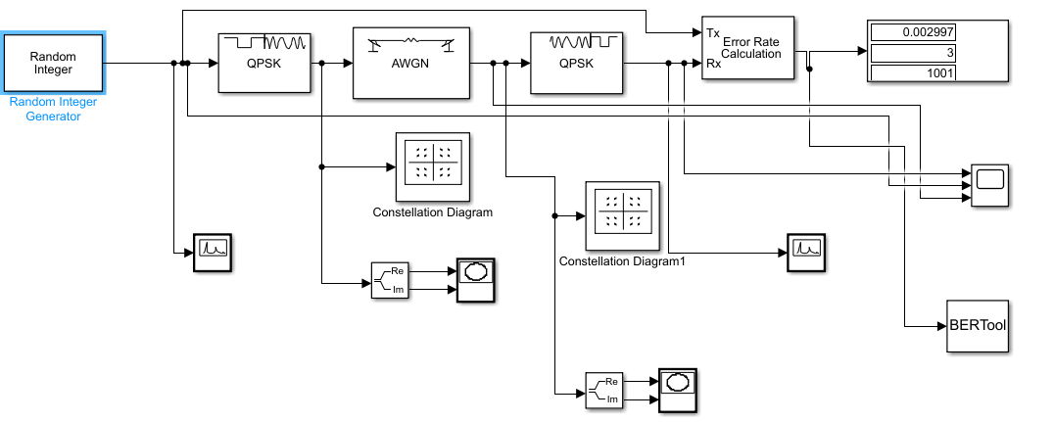
Figure 7: QPSK building blocks on Simulink
The table below shows the list of blocks used in constructing a QPSK modulation on Simulink.
Blocks
Random integer generator
Error rate calculation
Display
Scope
Bit error tool
XY graph
Complex to real-Imag
Power spectral density
Constellation diagram
Table 1: building blocks from Simulink

Implementation
This section is the implementation of the smart farming designed in NetSim. It also contains the MATLAB implementation of QPSK in Simulink.

NetSim Simulation
The picture below is the actual implementation of the smart farming without the application connections.

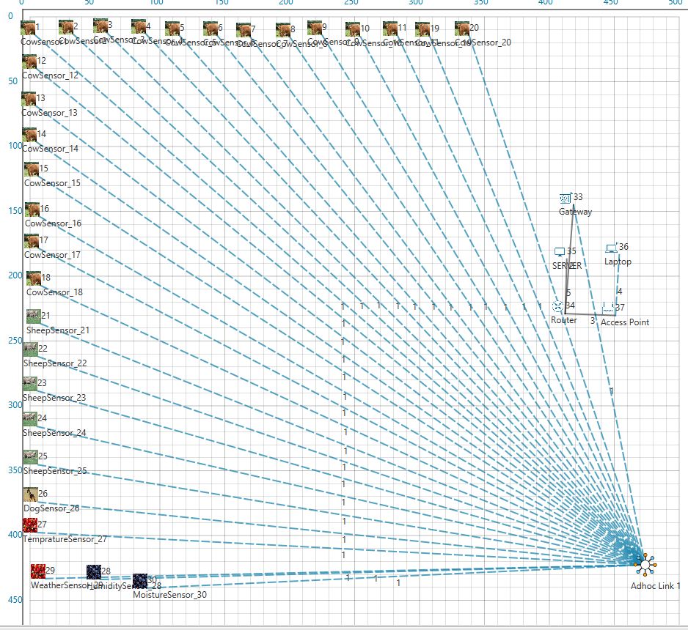
Figure 8: Smart farming network design on NetSim
The screenshot below is the smart farm design with the application connections and the radio range is on.
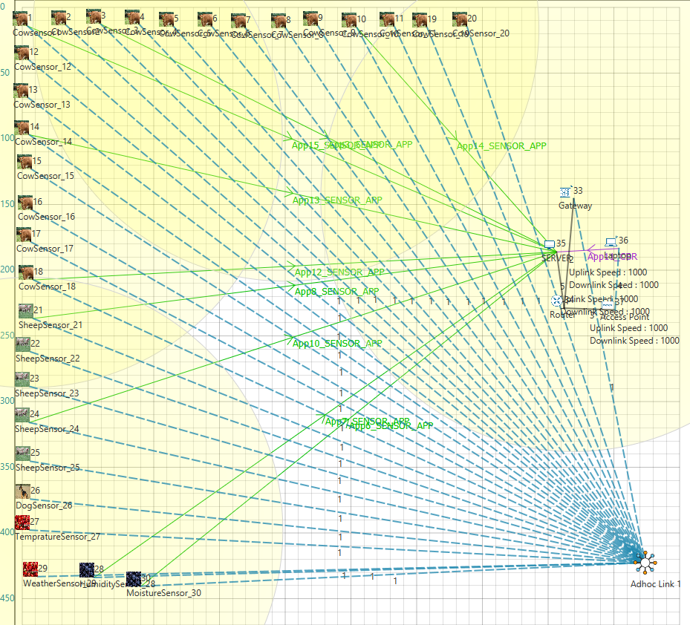
Figure 9: Smart Farming design with application connection
The author uses different simulation parameters. The simulation is setup within an area of 500m * 500m, where the nodes are placed manually using drag and drop from the NetSim. Moreover, the distance between the nodes is 20m. although, there are 30 sensors in the network, for the sake of simulation the author utilises 9 application sensor nodes and one laptop. The simulation parameters are show in the table below.

Protocols used | AODV
Application Metrics | Throughput and delay
Network metrics | Packet transmitted, packets collided and packet error data
Nodes (sensors) | 30
Area | 500m * 500m
Traffic type | CBR and Sensor_APP
Simulation time | 100 sec
Mobility | Random walk,
Mobility speed | 10 m/s for sheep and 5 m/s for the cows
Beacon order | Enabled/disabled
Channel characteristics | Pathloss_AND_Fading_AND_Shadowing, no path loss
Encryption | TEA
Transport | UDP
Link speed | 1000Mps
Table 2: simulation parameters

Simulation with channel characteristics.
The screenshot below concludes the simulation of the network with encryption enabled. The simulation was done using the channel characteristics Pathloss_AND_Fading_AND_Shadowing enabled.

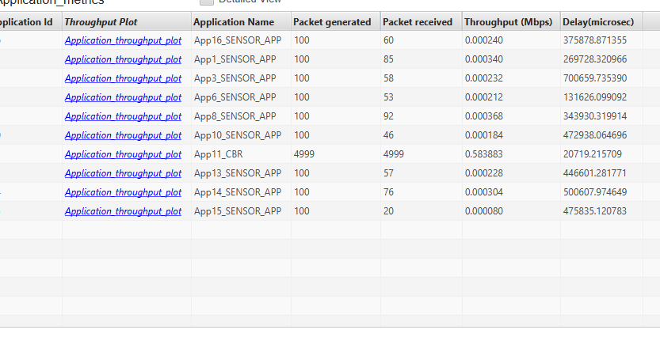
Figure 10 Simulation result
From the above picture, the total received packet is 5546 out of the total 5899 packets transmitted and the average delay is 373852.5004microsconds. The pictures below show delay vs the source nodes and throughput vs sensor nodes. From the graph, source node 3 has the highest delay. One of the reasons is the distance from the sink node and also due to interference of noise. Source node 36 has the lowest delay from the simulation. Because, the source node is connected via wireless to the server database at a link speed of 1000Mbs. And nodes 14, 10 and 20 are at constant delay.

Figure 11: Delay vs Sensor nodes with pathloss, fading and shadowing enabled

In the picture below, the throughput of node 36 is the highest compared to the other nodes. Because, the node is wirelessly connected using the protocol IEEE802.11 at a link speed of 1000Mbps. However, the other nodes are using IEEE802.15.4, which is preferable for low power devices. Moreover, the channel characteristics of the link with path loss, fading and shadowing enabled. Hence, the throughput is lower comparing to the laptop.

Figure 12: Throughput vs sensor nodes with pathloss, fading and shadowing enabled
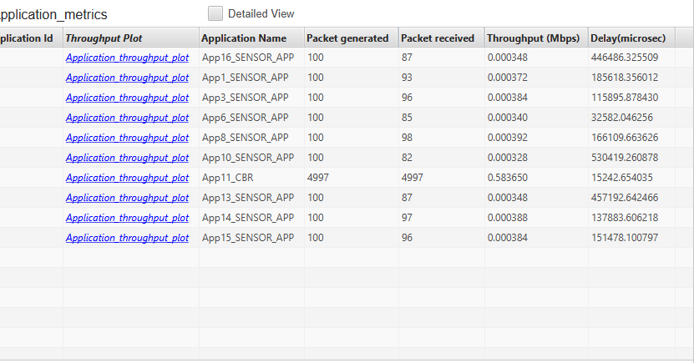
Figure 13: simulation result with nopathloss
The picture below shows, the delay when the nopathloss is enabled on the channel characteristics. From the graph, the average delay is 223890.8554microsec.

Figure 14: delay with nopathloss

Figure 15: throughput with nopathloss
From the above graph, the average throughput is 0.0586934Mbps. The simulation result concludes that, the average delay is less with no pathloss than pathloss with fading and shadowing. This is because, with no pathloss there is no interference on the channel, whereas with pathloss, fading and shadowed enabled the delay is higher due to the geographical location of the area such as rain, mountains and so on. Moreover, the throughput is higher with no pathloss than with pathloss, fading and shadowing enabled.

Simulation with beacon order
The author also intended to simulate the network with the beacon order. Beacon order is used to determine the number of packets transmitted in the IEEE 802.15.4 protocol by dividing into 16 slots. For this simulation, the beacon order is disabled and the pathloss with fading and shadowing is enabled. The screenshot below shows the result of the simulation.

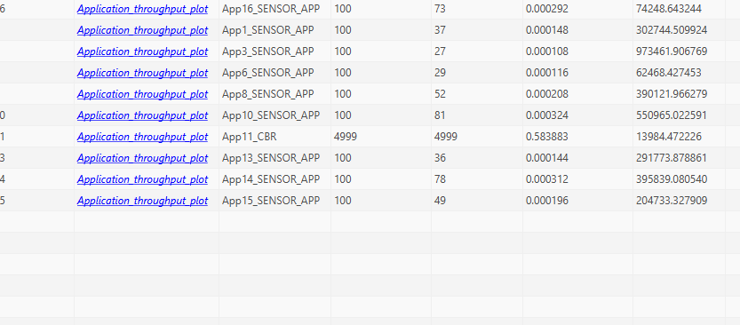
Figure 16: simulation result with no beacon order.

The picture below concludes the simulation with an average delay of 326034.1236 microseconds.

Figure 17: delay with beacon order disabled

Comparing to the simulation with channel characteristics, the averaged delay is less when the beacon order is disabled. One of the reasons is when beacon order is disabled there is no overhead traffic on the network. The overhead traffics can be information about the network, power information of the nodes and so on.

The picture below the shows the average throughput when the beacon order is disabled.

Figure 18: throughput with beacon order disabled.
In the picture below, the author changed the parameter of the beacon order by enabling the beacon order with SuperframeOrder and BeaconOrder at 10.

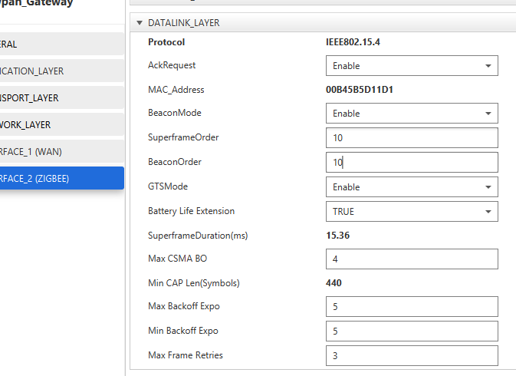
Figure 19: beacon mode enabled

From the simulation result, node three is with the highest delay value, because the node is located at a far distance from the sink node. The average delay of the simulation was found to be 341440.6859 microseconds.

Figure 20: Delay with beacon order enabled.

However, the average throughput remains at an average of 0.0586479. As it can be seen from the picture below, the throughput of the majority sensors is almost at constant rate except of node 36.

Figure 21: throughput with beacon order enabled.

Simulation with Bit Error Rate
The author also utilises the medium property to simulate the network. The medium property is used to count the rate of errors (BER) in the data. The screenshot below shows the values of uplink and downlink BER. For testing the values are changed to 0.00001 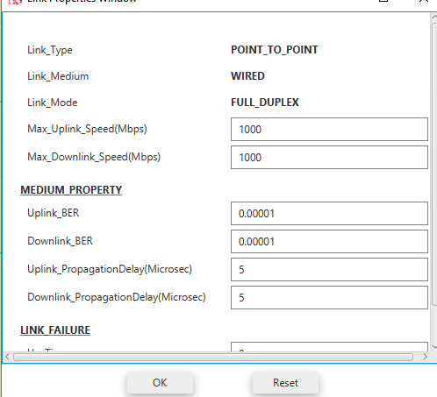
Figure 22: Uplink and downlink BER
The picture below show the result of the packet collided after the simulation. The network contains five links. Link one is between the sink node and the nodes, link two is between the sink node and the router, link three is between the router and the access point (AP), link four is between the access point and the laptop and link five represent the link between the router and the database server.

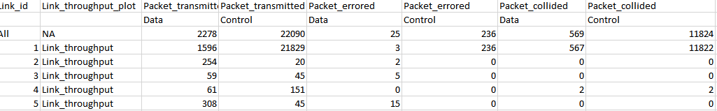
Figure 23: simulation result with BER of the uplink and downlink.

From the above picture, link 1 contains the highest number of packets collided. This shows that link 1 medium is busy as it is the only gateway to the internet through the sink node. Moreover, the link is suffering from interference due to the geographical location of the network. However, the number of packet errors is less.

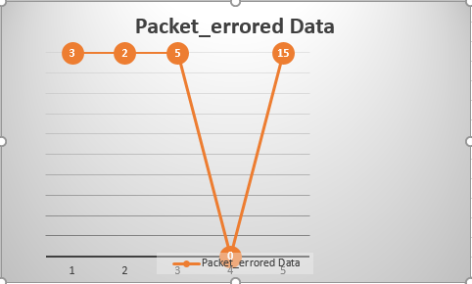
Figure 24: packet error data
As it can be seen from the above graph, the link 5 contains 15 data error. This link is between the router and the database server. One of the reasons is that the link is a busy line and also due to the noise interference of the cable.
The screenshot below contains packet transmitted, packet error and packet collided data. The simulation results show that link contains the highest number of packet collided as this link is between the sink node and the sensors. Hence, the expectation of packet collision is high as the packet transmitted is high that is 1596. However, packet error data is less compared to the transmitted data.
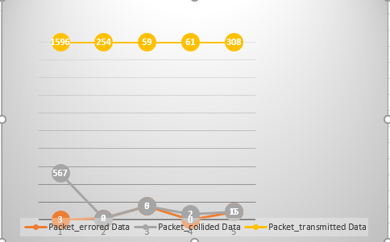
Figure 25: packet transmitted and collided

The picture below shows the network metrics with BER 0.00000001. the result of the simulation concludes, link 3 suffered with the highest packet data error due to the noise interference and also the position and signal strength of the AP. This link is between the router and the access point (AP). However, the total packet error data of all the links is 90, relatively low with total transmitted data.

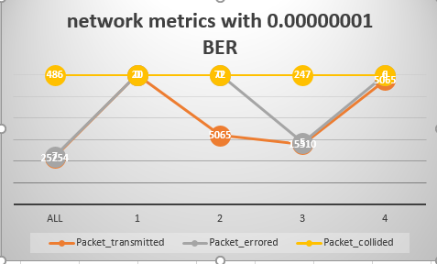
Figure 26: BER with 0.00000001 value.

Results and findings
The result of the simulation shows that; the network can be used better with beacon mode enabled than disabled. Moreover, the smart farming network metrics functions better with BER at a value of 0.00000001. The throughput and delay is better when the nopathloss mode enabled i.e. with no interference. However, the network is designed for smart farming area located around west Glamorgan. Hence, the transmission of data will be affected by rain and mountains and others. Therefore, the author utilises the channel with pathloss, fading and shadowing which are applicable to the network design of the smart farming.

MATLAB simulation
The Matlab simulation is run at 100sec throughout the simulation with MaxErrs=100 and MaxBits=1e8. The picture below shows the result of modulation with SNR value 10.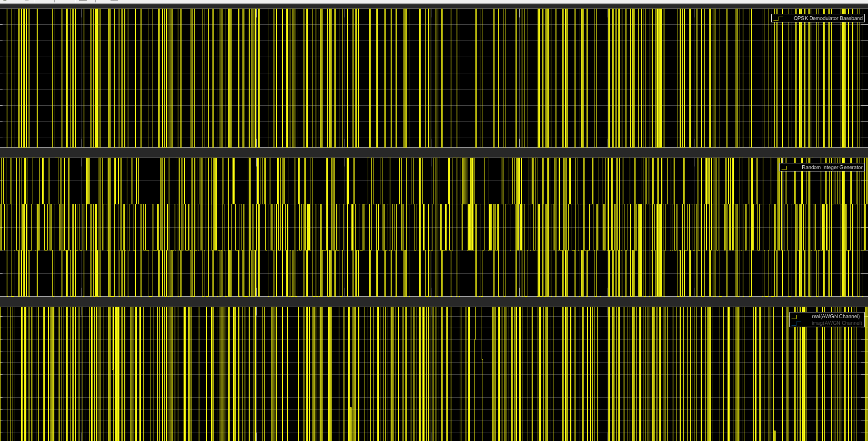
Figure 27: modulation at a SNR value 10
The result of the simulation shows that the signal before and after the channel is similar. Hence, the number of errors is almost 0%.
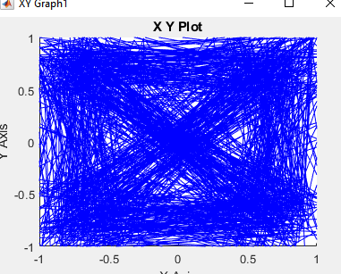
Figure 28: XY graph at 10
The picture below shows when the SNR value changed to 20.

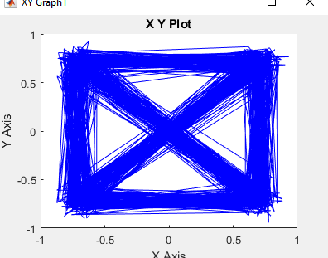
Figure 29: XY graph at 20 SNR
The above graph shows that the signal is transmitted without error. Hence, the signal transmitted at 20 SNR is proven to be better than at 10 SNR.
Moreover, the author also changed the value of SNR to negative values in order to get better understating of the signal. The picture below shows the result of simulation when the value of SNR is -10. As it can be seen from the XY Plot, the signal transmitted contains more error.
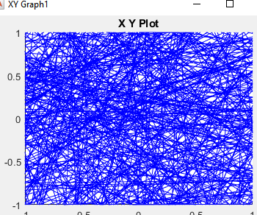
Figure 30: signal output at -10 SNR

Figure 31: signal output at -20 SNR
In addition, the following plot diagrams explain the general bit error rate of the simulation using the BER tool. The BER tool is build based on the assumption of the E_{b}/N_{o} range from -10:0.5:10 value to get better understanding of error rate. The plot diagram below shows the result of the bit error rate. The result shows that the error rate starts to decrease at -2dB.

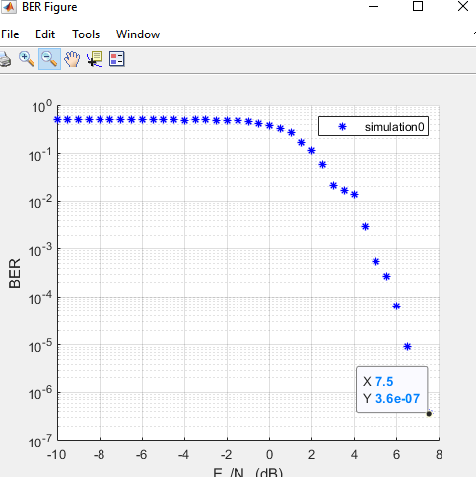
Figure 32: BER plot
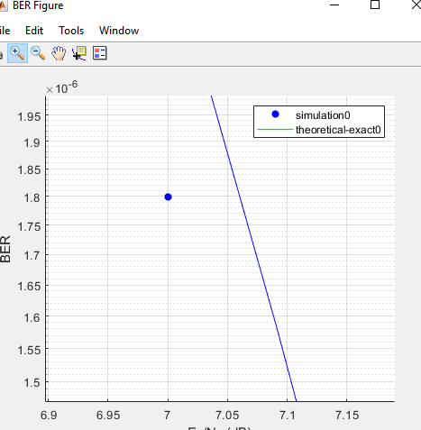
Figure 33: BER Plot
From the above plot, the turning point or value is at a value of 7dB.

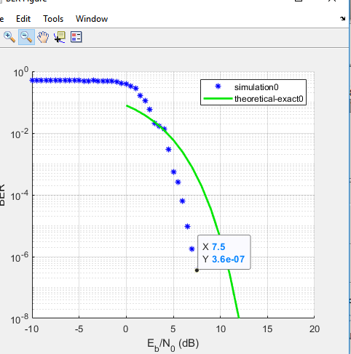
Figure 34: BER vs Theoretical
From the above picture the BER value is more close to the theoretical.

Conclusion
To conclude, network simulation is important as it helps the objectives of the actual network by analysing different parameters of the system. Moreover, simulation can be used for academic and experimental purposes. In the case of network, communication systems utilise different modulation techniques. Hence, network simulation can be used in relation to communication systems to understand and analyse by changing different parameters. From the above, the comparison between the different network parameters from the smart farming network shows that there were different results. The results of nopathloss model for throughput and delay verified to be better comparing to model pathloss, fading and shadowing. Moreover, the results from beacon order disabled proven to be better than beacon order enabled. This result cannot be verified due to the NetSim limitations. Moreover, the results from the simulation can vary as the author utilises excel sheet to analyse the data. In general, the results could have been accurate if a full version of NetSim was used.

References

[1] | C. Langton, “All About Modulation- Part 1,” Complext To Real, 2002. [Online]. Available: http://berk.tc/habsis/mod1.pdf. [Accessed 10 April 2019].
[2] | “Basic Radio Awareness,” taitradioacademy, [Online]. Available: https://www.taitradioacademy.com/topic/how-does-modulation-work-1-1/. [Accessed 10 April 2019].
[3] | Sasmita, “Explain the need for modulation in a communication system,” electronicspost, 21 January 2016. [Online]. Available: https://electronicspost.com/explain-the-need-for-modulation-in-a-communication-system/. [Accessed 10 April 2019].
[4] | “What is Modulation in Telecommunications?,” carritech, 9 January 2018. [Online]. Available: http://www.carritech.com/news/what-is-modulation-in-telecommunications/. [Accessed 10 April 2019].
[5] | Ashish, “What’s The Difference Between AM and FM Radio Waves?,” scienceabc, 12 April 2016. [Online]. Available: https://www.scienceabc.com/innovation/what-difference-frequency-amplitude-modulation-radio-waves.html. [Accessed 10 April 2019].
[6] | “amplitude modulation vs frequency modulation vs phase modulation,” RF Wireless, [Online]. Available: http://www.rfwireless-world.com/Terminology/amplitude-modulation-vs-frequency-modulation-vs-phase-modulation.html. [Accessed 10 April 2019].
[7] | H. K. Channi, “A Comparative Study of Various Digital,” International Journal in IT and Engineering, vol. 4, no. 3, pp. 39-49, 2016.
[8] | S. O. Popescu, G. Budura and A. Gontean, “Review of PSK and QAM — Digital modulation techniques on FPGA,” in IEEE, Timisoara, 2010.
[9] | M. Barnela, “Digital Modulation Schemes Employed in,” International Journal of Wired and Wireless Communications, vol. 2, no. 2, pp. 15-21, 2014.
[10] | S. Sharma and H. Singh, “Comparison of Different Digital Modulation Techniques in LTE System using OFDM AWGN Channel: A Review,” International Journal of Computer Applications, vol. 143, no. 3, pp. 1-4, 2016.
[11] | P. Manhas and D. Soni, “BER ANALYSIS OF BPSK, QPSK & QAM BASED OFDM SYSTEM USING SIMULINK,” International Journal of Electrical and Electronics Engineers, vol. 7, no. 2, pp. 54-60, 2015.
[12] | sonoma, “Binary Phase Shift Keying (BPSK),” 18 November 2014. [Online]. Available: http://web.sonoma.edu/users/f/farahman/sonoma/courses/ces540/lectures/psk_modulation_dig.pdf. [Accessed 13 April 2019].
[13] | S. Jain and S. Yadav, “A Survey Paper on Digital Modulation Techniques,” International Journal of Computer Sciences and Engineering, vol. 3, no. 12, pp. 107-111, 2015.
[14] | D. Sharma, A. Mishra and R. Saxena, “ANALOG & DIGITAL MODULATION,” International Journal of Computing Science and Communication Technologies, vol. 3, no. 1, pp. 551-561, 2010.
[15] | A. Moubark, M. Ali, H. Sansui and S. Ali, “FPGA implementation of low power digital QPSK modulator using,” Journal of Applied Sciences, vol. 13, no. 3, pp. 385-392, 2016.
[16] | A. Sharma, S. Majumdar, A. Naugarhiya, B. Acharya and S. M. a. S. Verma, “VERILOG based simulation of ASK, FSK, PSK, QPSK digital modulation techniques,” in IEEE, Palladam, 2017.
[17] | S. Sadinov, “Simulation study of M-ARY QAM modulation techniques using Matlab/Simulink,” in ResearchGate, 2017.
[18] | S. Haykin, Digital Communication systems, Hoboken: John Wiley & Sons, Inc, 2014.
[19] | I. Pro.Wells, “Advanced Modulation,” UWTSD, 22 September 2018. [Online]. Available: https://moodle.uwtsd.ac.uk/mod/folder/view.php?id=111190. [Accessed 15 April 2019].
[20] | R. Hranac, “SPECTRAL EFFICIENCY,” scte, October 2012. [Online]. Available: https://www.scte.org/TechnicalColumns/12-10-01%20spectral%20effieciency.pdf. [Accessed 15 April 2019].
[21] | L. Frenzel, “Cell Phones,” in Electronics Explained (Second Edition), Elsevier, 2018, pp. 195-216.
[22] | C. Dr.Campbell, “Wireless Networks and Simulation: ACCB5004,” UWTSD, 25 Septemeber 2018. [Online]. Available: https://moodle.uwtsd.ac.uk/mod/folder/view.php?id=165533. [Accessed 17 April 2019].
[23] | A. Maria, “Introduction to modeling and simulation,” in winter simulation conference, Binghamton, 1997.
[24] | “Why use simulation modeling?,” anylogic, [Online]. Available: https://www.anylogic.com/use-of-simulation/. [Accessed 17 April 2019].

marking criteria and Student FEEDBACK

This section details the assessment criteria. The extent to which these are demonstrated by you determines your mark. The marks available for each criterion are shown. Lecturers will use the space provided to comment on the achievement of the task(s), including those areas in which you have performed well and areas that would benefit from development/improvement.

Common Assessment Criteria Applied (Assignment 1) | Marks available | Marks  awarded
1. Research-informed Literature
Extent of research and/or own reading, selection of credible sources, application of appropriate referencing conventions.
The report shows excellent research and applied techniques. The varied sources also adds to the background knowledge, giving validity to the report. For the future remember to research both tasks to ensure that you maximise the research for analysis. (Grade mark: 93.33%) | 15 | 14
2. Knowledge and Understanding of Subject
Extent of knowledge and understanding of concepts and underlying principles associated with the discipline.
The knowledge demonstrated is very good making justifications and conclusions within the report easier to achieve. Modulation and WSN knowledge is more than sufficient for the subject. (Grade mark: 93.33%) | 15 | 14
3. Analysis
Analysis, evaluation and synthesis; logic, argument and judgement; analytical reflection; organisation of ideas and evidence
The report contains a very good analysis of modulation and techniques required to perform experimentation of QPSK. The overall mark could be improved had the final conclusion been more in depth regarding NetSim. That said the conclusion is good, the report is analysed very well. (Grade mark: 86.67%) | 30 | 26
4. Practical Application and Deployment
Deployment of methods, materials, tools and techniques; application of concepts; formulation of innovative and creative solutions to solve problems.
The practical solution for MatLab is basic and the testing shows knowledge of the necessary elements required for the assignment. NetSim implementation shows the required elements to deploy a WSN, the evidenced testing on part one and two is presented well for the reader. (Grade mark: 74.29%) | 35 | 26
5. Skills for Professional Practice
Attributes in professional practice: individual and collaborative working; deployment of appropriate media; presentation and organisation.
The use of the IEEE structure is good and only has minor errors (see comments). The overall appearance looks okay and the relevant IEEE referencing and bibliography is used throughout the report. (Grade mark: 80.00%) | 5 | 4

Assignment Mark (Assessment marks are subject to ratification at the Exam Board. These comments and marks are to give feedback on module work and are for guidance only until they are confirmed. ) | Late Submission Penalties (tick if appropriate) |  | 84%
 | Up to four weeks late |  | 84%
 | First Attempt? |  | 84%

