Module Name: Employability and Career Development
Module Code: LCLM4005

Table of Contents
Introduction 3
Task 1: Comparison of Job Adverts (250 words) 4
Task 2: Self-Assessment and Evidence of Readiness (450 words) 5
SWOT Analysis 5
Evidence of Readiness for Employability and Personal Advancement 6
Task 3: Employment Goals and Personal Development Plan (450 words) 6
Short-Term and Long-Term Goals 7
Personal Development Plan (PDP) 7
Conclusion 9
References 10
Appendix 11

Contents: Table

Table 1: Common Skills and Knowledge Across the Four Job Adverts 4
Table 2: Personal Development Plan 7

REPORT ON EMPLOYABILITY READINESS AND PERSONAL DEVELOPMENT

Introduction
In this report, I discuss my employability preparation to the post of Registered Manager in the health and social care industry. It starts with the analysis of four job adverts that aim to define the core skills, knowledge requirements, and competencies that are required by employers (Sunday and Sefotho, Maximus Monaheng, 2025). The report is completed using a structured self-assessment, which incorporates a SWOT analysis, to assess my strengths, areas of development, and evidence of readiness at the moment. Lastly, it is a description of my short and long-term employment objectives and my Personal Development Plan in detail which is aimed at helping me achieve my professional growth and advancement into the responsibility of a manager within a regulated care setting.

Task 1: Comparison of Job Adverts
An overview of the four adverts of Registered Manager job opportunities reveals a number of job common skills, competencies, and knowledge statements that are necessary in the care industry. Despite the differences in the roles in the adult domiciliary care, residential dementia care, and children homes, the leadership, regulatory knowledge, safeguarding, and communication skills are strongly emphasized in all the adverts.
When the adverts are cross-compared, it is evident that they have similar competencies which are required. A summary of the essential overlapping skills and knowledge is presented in Table 1.
Table 1: Common Skills and Knowledge Across the Four Job Adverts
Skill/Knowledge Area | Advert 1 | Advert 2 | Advert 3 | Advert 4
Leadership & Team Management | ✓ | ✓ | ✓ | ✓
Safeguarding Knowledge | ✓ | ✓ | ✓ | ✓
Regulatory/Compliance Understanding | ✓ | ✓ | ✓ | ✓
Communication Skills | ✓ | ✓ | ✓ | ✓
Problem-Solving | ✓ | ✓ | ✓ | ✓
Experience in Care Sector | ✓ | ✓ | ✓ | ✓
Every advert needs good management skills such as overseeing teams, checking of standards of services and effective leadership. This is seen across the broader literature that suggests that the leadership is a decisive factor of quality in social care environments (Chartered Institute of Personnel and Development, 2023). Protective and compliance measures, including knowledge of CQC requirements and Children's Homes Regulations, are found throughout the job ads and indicate how legal and ethical concerns play a role in managing the care (Skills for Care, 2022).
Moreover, communication skills, problem-solving, and the capacity to organize or monitor care delivery are also focus points of all the positions. These results match the literature that indicated that communication, emotional intelligence, and decision-making are some of the most appreciated employability skills in the health and social care sector (Organization for Economic Co-operation and Development, 2021).
To conclude, the analysis has revealed that the role of a Registered Manager needs a combination of operational leadership, regulatory competency, and interpersonal skills. These conclusions are used in the self-reflection and developmental planning of the following work.

Task 2: Self-Assessment and Evidence of Readiness
I performed a self-assessment through SWOT analysis to assess my preparedness to work in the care management sector. This is a good approach to emphasise internal strengths and weaknesses, but it also reveals external opportunities and threats that can be used to determine the progression of the career (Seth, 2022).

SWOT Analysis
Strengths:
I have a high communication ability, which has been developed by doing academic presentations, group projects, and voluntary work with the community support programmes. My planning skills allow me to cope with tasks effectively, whereas my active listening skills and empathy are more in line with the person-centred focus on care roles. My reliability, teamwork, and willingness to take initiative are aspects that are frequently mentioned by peers and mentors and are necessary qualities of a supervisor (Chartered Institute of Personnel and Development, 2024).
Weaknesses:
I do not have the direct management experience in a regulated care environment, which is there as an essential in all four job advertisements. Also, I am not very acquainted with CQC control and protection standards, and those related to children residential homes. Another weakness that I have is time-management under pressure especially when I have to juggle opposing academic deadlines.
Opportunities:
The career opportunities are promising because there is high demand of Registered Managers in the country, as evidenced by the Care Quality Commission (2023). The career workshops, employability workshops, and placements available to me through my continuous studies can be useful in filling the gaps in competencies. The growing professionalism of social care also offers the opportunity of the systematic qualification, i.e., the Level 5 Diploma in Leadership and Management in Adult Care.
Threats:
Growth to a managerial position may not be as fast as it can be because of competition with seasoned applicants. Continuous upskilling might be necessary due to regulatory changes or changing CQC standards. Also, the emotional strains related to the preservation of responsibilities are dangerous in case they are not dealt with properly.

Evidence of Readiness for Employability and Personal Advancement
My academic development shows my dedication towards professional development. To illustrate, reflective practice and leadership theory modules have enhanced my theoretical concepts on the management in the care setting. I also enrolled in safeguarding awareness short course and this has enhanced my background knowledge in safeguarding vulnerable people.
Practical experiences in supporting people with complex needs has been offered by extracurricular activities like volunteering with a charity that supports the needs of people. The experience has improved my empathy, resilience, and interpersonal skills skills, which have been identified as highly desirable in health and social care (Wendy Inglis Humphrey et al., 2022).
Moreover, the team-based university projects have seen me acquire skills of teamwork, conflict-solving, and elementary coordination. All these experiences demonstrate that I am on the right path to acquire competencies that would enable me to become employable and advance long-term, although I still need additional practice to prepare to fulfill the expectations of a Registered Manager position to the fullest.

Task 3: Employment Goals and Personal Development Plan
This section is concerned with both short-term and long-term and a personal development plan (PDP).

Short-Term and Long-Term Goals
My employment objectives, as outlined below are based on the weaknesses I have discovered during my SWOT analysis, which are oriented towards my long term desire of becoming a Registered Manager. The short-term objectives are the acquisition of practical skills in a controlled care environment, enhancement of the understanding of protecting laws, and the achievement of the corresponding qualifications, such as the Level 3 Certificate in Health and Social Care. These objectives are critical since they deal with the main experiential and control lapses raised in the job advertisements.
My future aspirations are to graduate Level 5 Diploma in Leadership and Management in Health and Social Care- which is a necessity or desirable in all adverts of the position of a Registered Manager. I would also like to acquire a supervisory position within three years where I would acquire managerial competence. Finally, within five years, I will have managed to obtain a Registered Manager role. The above objectives fit into my career goal of becoming a team leader, ensuring quality care, and assisting vulnerable patients to achieve better outcomes.

Personal Development Plan (PDP)
The PDP gives very particular steps, timeframes and resources that will be required to move towards these objectives (see Table 2). Structured PDP is advised to use in employability literature because it fosters accountability, reflexivity, and quantifiable development (Chartered Institute of Personnel and Development, 2025).
Table 2: Personal Development Plan
Development Need | Action Steps | Timeline | Resources Required | Measurement of Progress
Gain practical care experience | Apply for part-time care assistant roles; volunteer in support services | 3–6 months | Job boards, university careers service | Securing a placement/role and receiving employer feedback
Improve safeguarding knowledge | Complete certified safeguarding courses (levels 1–3) | 2–4 months | Online training (Wendy Inglis Humphrey et al., 2022) | Certificates and improved confidence in applying safeguarding principles
Develop regulatory understanding | Attend workshops on CQC standards; study relevant legislation | 6 months | Skills for Care resources | Ability to explain regulatory frameworks during interviews
Enhance time-management skills | Use digital planners; attend time-management workshops | Ongoing | University learning services | Reduction in missed deadlines; improved productivity logs
Achieve qualifications | Enrol in Level 3 (short term) and Level 5 (long term) diplomas | 1–5 years | Accredited training providers | Completion certificates; eligibility for managerial roles
The PDP delivers a structured pathway that addresses each identified weakness. Following it consistently I will build the competencies needed for successful career progression. Continuous reflection as well as feedback will allow me to adjust the plan in response to personal along with industry developments, ensuring ongoing employability and alignment to sector expectations.

Conclusion
Overall, the job advert analysis indicates that the following skills are crucial in the Registered Manager positions, whether it is the leadership, regulatory, or communication skills. The self-assessment shows that whereas I have a good interpersonal skills and an area of developing knowledge in the sector, there is need to develop more in regulatory insight, protection, and management expertise. These gaps and my employability are outlined in the employment goals and Personal Development Plan as a clear roadmap of how to fill them. Through such a plan and through lifelong learning, I will be in a better position to advance to supervisory and managerial positions in the care profession, which will facilitate professional growth in the long term.

References
Care Quality Commission (2023). The state of health care and adult social care in England 2022/23 (House of Commons Paper) HC 1871. London, United Kingdom: Dandy Booksellers under the Open Government Licence.
Chartered Institute of Personnel and Development (2023). Learning at work 2023. [online] CIPD. Available at: https://www.cipd.org/globalassets/media/knowledge/knowledge-hub/reports/2023-pdfs/2023-learning-at-work-survey-report-8378.pdf [Accessed 1 Dec. 2025].
Chartered Institute of Personnel and Development (2024). CIPD Good Work Index 2024. [online] Available at: https://www.cipd.org/globalassets/media/knowledge/knowledge-hub/reports/2024-pdfs/8625-good-work-index-2024-survey-report-1-web.pdf [Accessed 1 Dec. 2025].
Chartered Institute of Personnel and Development (2025). CIPD Good Work Index 2025. [online] Available at: https://www.cipd.org/globalassets/media/knowledge/knowledge-hub/reports/2025-pdfs/8868-good-work-index-2025-report-web1.pdf [Accessed 1 Dec. 2025].
Organization for Economic Co-operation and Development (2021). OECD Skills Outlook 2021 LEARNING FOR LIFE. [online] Available at: https://www.oecd.org/content/dam/oecd/en/publications/reports/2021/06/oecd-skills-outlook-2021_6f4da936/0ae365b4-en.pdf [Accessed 1 Dec. 2025].
Seth, C. (2022). SWOT analysis. S.L.: 50Minutes.com.
Sunday, O.M. and Sefotho, Maximus Monaheng (2025). Career Coaching and Employability Skills Acquisition. IGI Global.
Wendy Inglis Humphrey, Smithies, A., Prestt, J., Fletcher, M. and Cresswell, K. (2022). The NHS Digital Academy Digital Health Leadership Programme. IOS Press eBooks. doi:https://doi.org/10.3233/shti220901.

Appendix
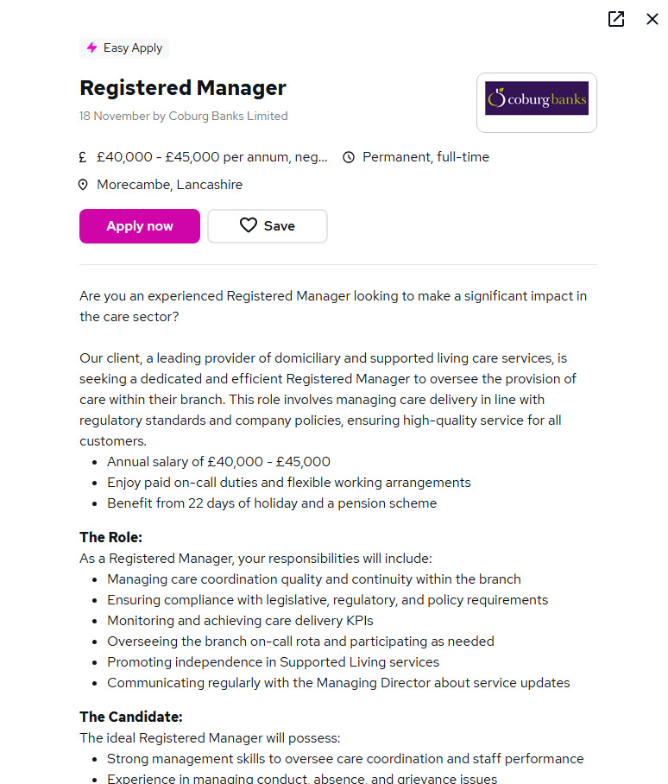
Link:https://www.reed.co.uk/jobs/registered-manager/56091164?source=searchResults&filter=%2Fjobs%2Fpermanent-manager-jobs

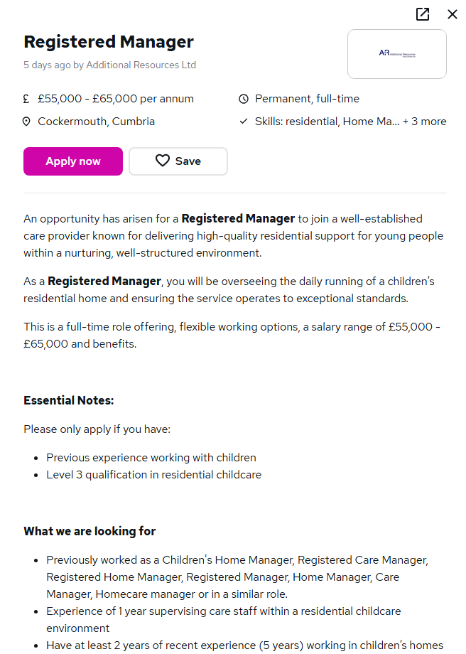
Link:https://www.reed.co.uk/jobs/registered-manager/56123446?source=searchResults&filter=%2Fjobs%2Fpermanent-manager-jobs

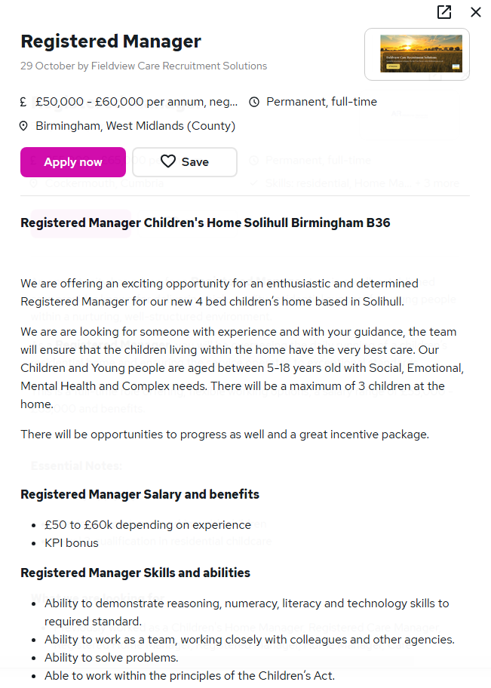
Link:https://www.reed.co.uk/jobs/registered-manager/55555552?source=searchResults&filter=%2Fjobs%2Fpermanent-manager-jobs
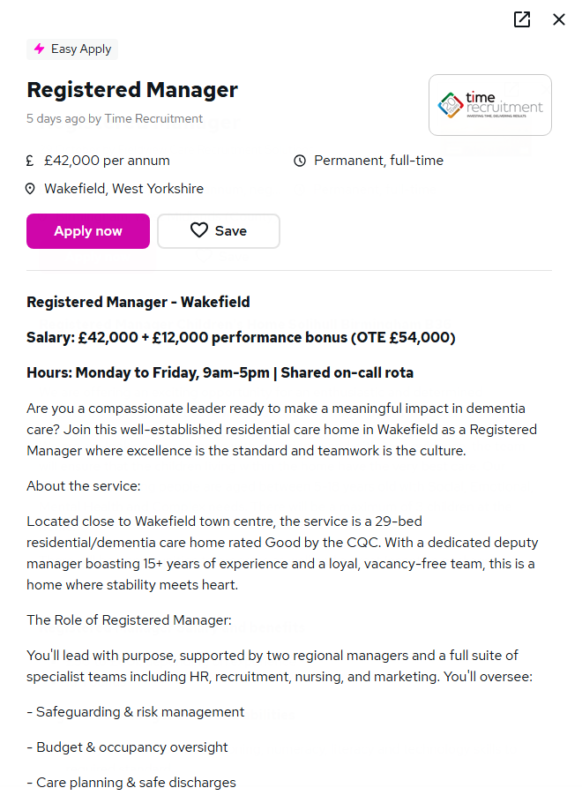
Link:https://www.reed.co.uk/jobs/registered-manager/56127524?source=searchResults&filter=%2Fjobs%2Fpermanent-manager-jobs

