In trying to understand contemporary international relations, is it most useful to think of the world as unipolar, bipolar, or multipolar?
In this essay, we are going to discuss the polarity of contemporary international relations. High tensions in countries in the modern day are one thing that we shall study and research. What I think is that it is a crucial aspect of building a country’s long-term strategy. My main focus will be to try to answer whether the world at present is; unipolar, bipolar or multipolar. In order to do so, I will evaluate certain countries and regions in terms of their economy, military, and politics. Also, I would like to note that I have to narrow down the topic so that I can answer such question since the topic itself can take various directions. Moreover, it is essential to give the readers an idea that comparing countries is not as easy as comparing just two integers. What I mean by that is, merely looking through a country's economic statistics or military weapon numbers will not be the whole focus of this essay. However, the numbers and analyses of such things are helpful.
First of all, I want to give the readers an aspect of what contemporary international relations mean. As I stated in this essay’s introduction, I am narrowing down this contemporary term from the end of the Cold War (Bohlen, 1991) to Nowadays. It is a basic understanding for students who are studying politics and international relations that there were two superpowers during the Cold War which were the United States of America (USA) and the Union of Soviet Socialist Republic (USSR) (The Editors of Encyclopaedia Britannica, 2023), or we can say two poles. Nevertheless, the end of the Cold War had come as a consequence of the USSR’s collapse (Bohlen, 1991), resulting in the existence of one major power, the USA, in the world. Therefore, I am going to analyse the United States of America to answer if the USA is still a ‘superpower’ hitherto.
Historically, the rise of the US superpower started in 1898 after the Treaty of Paris (Anon., n.d.). When colonisation superpowers happened to lose their influence in the world, the US had already started patching their absences. The USA’s great contribution in the twentieth century, the endurance of the First and Second World Wars, and the Cold War show this country’s stability in international power. However, it seems, the USSR was the biggest threat to the US both ideologically and in weaponry. After four years USA first possessed the atomic bomb, USSR exploded its first atomic bomb resulting in the discovery of the hydrogen bomb by the USA in 1952 followed by the USSR with its version in 1953 (Anon., 2023). Those two superpowers were racing in every field. As terrifying and dangerous as it is, the race for nuclear bombs was so intense between the USA and the USSR that the United Nations stated:
“The world’s nuclear arsenals ballooned throughout the Cold War, from slightly more than 3,000 weapons in 1955 to over 37,000 weapons by 1965 (United States 31,000 and the Soviet Union 6,000), to 47,000 by 1975 (United States 27,000 and the Soviet Union 20,000), and over 60,000 in the late 1980s (United States 23,000 and the Soviet Union 39,000)” (Nations, 2023).
On the other hand, how good was their economy? Averagely the USSR’s economy was growing faster than the USA's economy from the mid-1960s to the mid-1970s, raising Soviet Gross National Product (GNP) from 49 to 57 percent of US GNP. However, after 1975, the US economy grew faster and Soviet GNP fell to 52 percent of the US level in 1984 (Anon., 1985). Moreover, the USA was spending almost 8 per cent of GNP on military just after the Second World War (Higgs, 1994). Also, USA and USSR’s influence in the world in terms of economy was recorded as follows:
“The share of the global economy controlled by Washington, Moscow, and their two alliance blocs was a whopping 88 per cent of global GDP in 1950; today, these countries only make up 57 per cent of global GDP. That power has diffused elsewhere, moving away from superpowers toward a variety of capable, dynamic middle powers that will help to shape the international environment in the coming decades.” (Emma Ashford, 2023).
It shows us that the US influence in the world has dropped dramatically. However, even nowadays, after 32 years of the USSR’s collapse, the USA is still standing as the biggest economy in the world. Therefore, the USA keeps its position at the international level as a world superpower. So is the world unipolar these days? Some scholars argue that answering the polarity of the world can be based on ‘common sense’ (Mansfield, 1993). Thus the simplest and obvious answer to this question is ‘No’. The reason I imply the world is not unipolar is the existence of China, which will be our next sub-topic to discuss.
The People’s Republic of China, as we know it modern China, declared its creation on October first, 1949 (Anon., n.d.). Ever since then until Mao Zedong’s (founder of the PRC) death China’s economy was centrally controlled. After his death, his successor Deng Xiaoping and his colleagues started opening up China’s economy both internally and externally (Dorn, 2023). This event led China to gradually gain power on the international stage in the long term. Because of China's large amount of people, in other words, the massive working force rocketed its economy with an average Gross Domestic Product (GDP) growth of 9.5% up until 2018 (Anon., 2019).
(Cheung, 2018)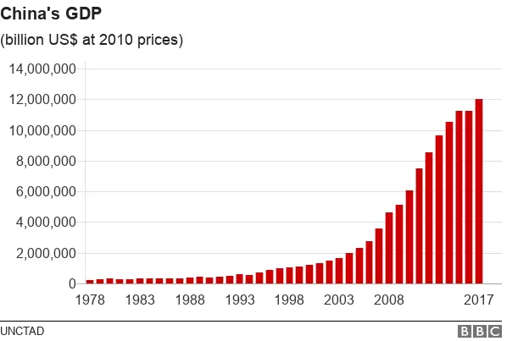
Now China is the second biggest economy in the World. (see next picture).
(Rao, 2023)
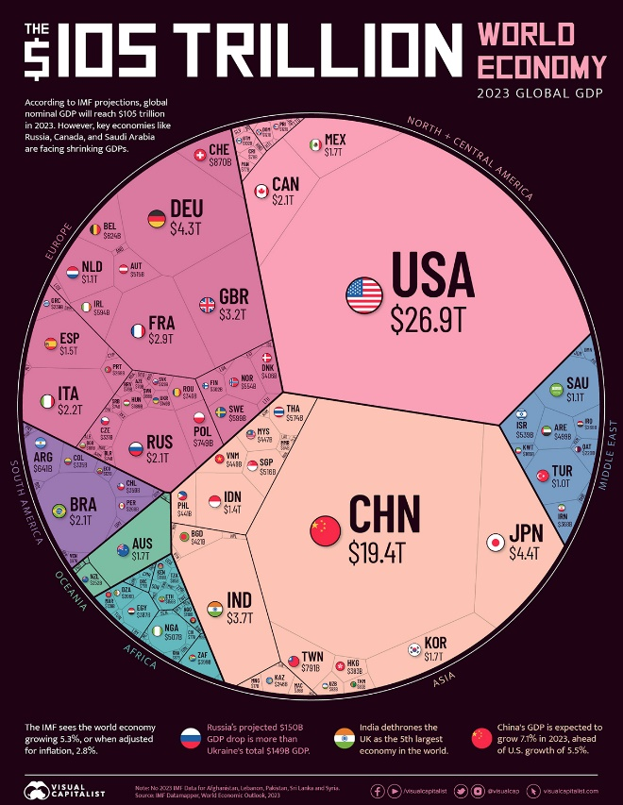
What about China’s military strength? It is said that China’s military strength was not advantageous enough during the 1990s. Hence, they started replacing old weapons and equipment as late as the mid-1990s (Heginbotham, 2015). Since then China has consistently grew not only in terms of economics but also in terms of military. “The Economist” journal noted that China has 2 million personnel in the People’s Liberation Army with an annual budget of $225 billion, the world’s biggest army and navy and a vast missile force (Anon., 2023). In those senses, China is compatible with the USA when we talk about the polarity of the world. However, we shall not forget that, as Xi Jinping (President of China) calls ‘the peace disaster’, PLA is struggling to hire skilled people, from engineers to fighter pilots that is to say it has almost no experience of combat (Anon., 2023). Furthermore, China and the US are clearly shaping the world in senses of economic cooperation, diplomacy and conflict resolution. We can see that from Joe Biden and Xi Jinping’s meeting in San Francisco this week. Lastly, as D. Mansfield stated in his journal article ‘Concentration, Polarity, and the Distribution of Power’;
“In a multipolar system, there are several (more than two) "Great Powers" whose military power is roughly equal, and whose rivalry and cooperation dominate politics in the system”. (Mansfield, 1993),
China and the USA both are spherical influential, world polars. But the next question will be ‘Are they the only two superpowers of the world, in effect, is the world bipolar?’
Well, if we mean ‘superpower’ as a country, the answer to that question will be ‘Yes, the world is bipolar’. However, we will not limit ‘superpower’ by strict borderlines in this essay. Hence, the European Union (EU) will be the next base of analysis.
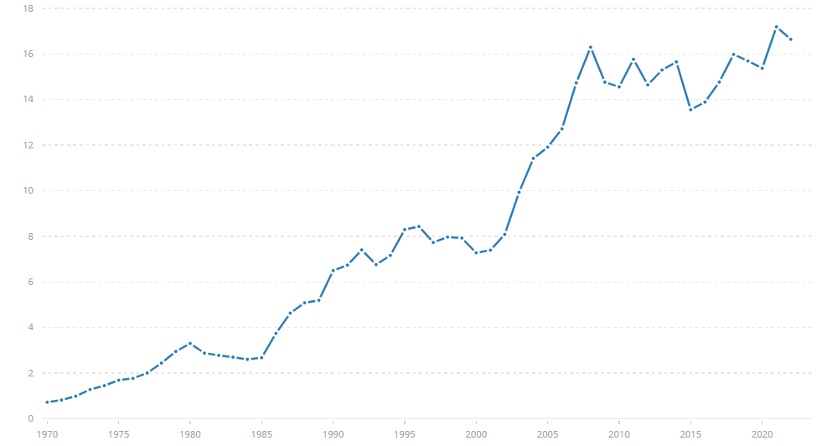
(World Bank national accounts data, 2023) (the EU’s GDP from 1970 to 2022)
Europe as a continent has an enormous history of human development and is examined as the birthplace of Western civilisation. Nowadays, this cultural wealth is used to solidify the European Community (Diane Boudreau, Melissa McDaniel, Erin Sprout, Andrew Turgeon, 2023). The EU possesses a strong position when it comes to global trade. The EU is the top trading partner for 80 countries, whereas, the US is the top trading partner for a little over 20 countries (European Commission, 2023). The openness of the EU’s trade regime makes it one of the biggest players on the global trading scene (Trade, 2023). Unlike the USA or China, European countries are able to work together as a single body. This can be seen from the graph above. By 2022, the EU’s total GDP was 16.64 trillion dollars, whereas the USA and China’s total GDP were 25.46, and 17.88 trillion dollars respectively, making the EU the third largest economy in the world (O'Neill, 2023). In terms of the EU’s military strength, the ‘Common Security and Defence Policy’ is the European Defence Union. It has 1.4 million active personnel (Agency, 2018). Annually, the EU spends 243.8 billion dollars as of 2018 (Agency, 2018). In total, the EU holds 300 warheads and hosts 90 to 130 US warheads. Italy possesses 70 to 90 B61 nuclear bombs, while Germany, Belgium and the Netherlands have 10 to 20 each (Kristensen, 2008). Thus, the EU possesses the third largest arsenal of nuclear weapons in the world after the US and Russia which makes them compatible in the military. Therefore, military and economic research suggests that the EU is not just a spherically influenced area, but a polarity area itself.
In my conclusion, I have attempted to give the readers specific and many aspects of how many polars there are in the world. I have narrowed down the essay question to be able to answer it. My efforts were made to demonstrate countries’ and an area’s economic and military strength. As we know now, the USA, China, and the EU are spending enormous amounts of money on their military. Perhaps, it is because they have a functional economy that is able to fund their military. Either way, their influence and strength in the world is almost undoubted. China’s rapid growth, the EU’s stability in international power, and the US superiority might lead to high tension for other countries in the future. I have stated in the introduction that bearing those thoughts and senses in mind will be helpful in shaping a country’s economic and political strategy in any situation. Moreover, bipolar systems are distinguished from multipolar system based on whether a third power is able to challenge the top two (Mansfield, 1993). According to that theory, we can say the world is multipolar in contemporary international relations. We have analysed and seen that they are all big enough, in terms of economy and military, to question each other’s existence in the polarity. Also, I have provided a chart that shows the prediction of the global economy in 2050. I hope that it will help to have an angle of that multipolarity future. Now I have another question to ask based on the end of this essay. Is it even possible to have no polar at all in the world?
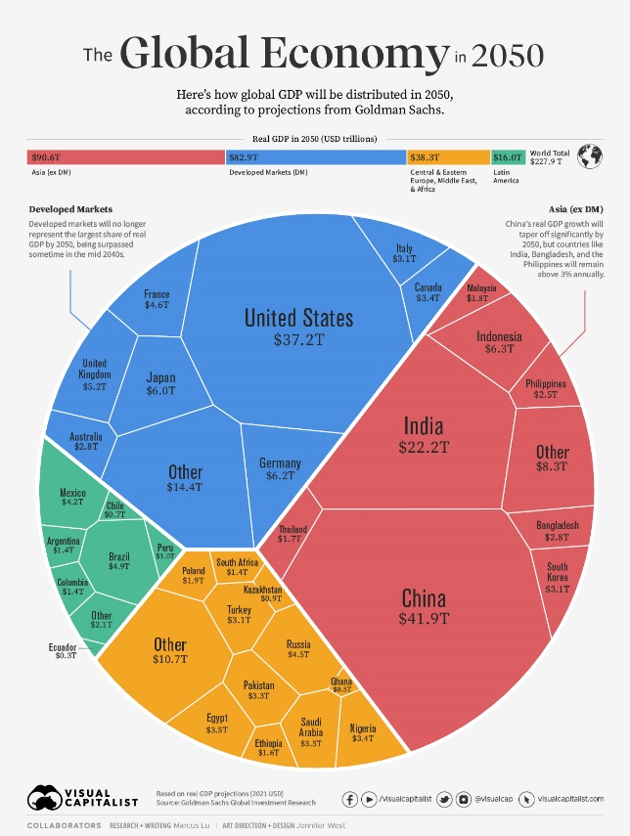
(Lu, 2023)

Bibliography
Agency, E. D., 2018. Defence Data 2017-2018. [Online]
Available at: https://eda.europa.eu/docs/default-source/brochures/eda-defence-data-2017-2018
[Accessed 19 11 2023].
Agency, E. D., 2018. Official 2005–2017 defence statistics from the European Defence Agency. [Online]
Available at: https://eda.europa.eu/publications-and-data/defence-data
[Accessed 19 11 2023].
Anon., 1985. A Comparison of the US and Soviet Economies: Evaluating the Performance of the Soviet System, Washington: Central Intelligence Agency.
Anon., 2019. Congressional Research Service reports. [Online]
Available at: https://www.everycrsreport.com/reports/RL33534.html
[Accessed 18 11 2023].
Anon., 2023. American Museum of Natural History. [Online]
Available at: https://www.amnh.org/exhibitions/einstein/peace-and-war/nuclear-arms-race
[Accessed 19 11 2023].
Anon., 2023. How scary is China? The Economist, p. 12.
Anon., n.d. Office of the Historian, Foreign Service Institute, United States Department of State. [Online]
Available at: https://history.state.gov/milestones/1945-1952/chinese-rev
[Accessed 18 11 2023].
Anon., n.d. Office of the Historian, Foreign Service Institute. United States Department of State. [Online]
Available at: https://history.state.gov/departmenthistory/short-history/superpower
[Accessed 19 11 2023].
Bekkevold, J. I., 2023. No, the World Is Not Multipolar. [Online]
Available at: https://foreignpolicy.com/2023/09/22/multipolar-world-bipolar-power-geopolitics-business-strategy-china-united-states-india/
Bohlen, C., 1991. The New York Times. [Online]
Available at: https://www.nytimes.com/1991/02/26/world/warsaw-pact-agrees-to-dissolve-its-military-alliance-by-march-31.html
[Accessed 18 11 2023].
Cheung, H., 2018. China's staggering 40 years of change in pictures. [Online]
Available at: https://www.bbc.co.uk/news/world-asia-china-46602785
[Accessed 18 11 2023].
Diane Boudreau, Melissa McDaniel, Erin Sprout, Andrew Turgeon, 2023. Europe: Human Geography. [Online]
Available at: https://education.nationalgeographic.org/resource/europe-human-geography/
[Accessed 19 11 2023].
Dorn, J. A., 2023. CATO institute. [Online]
Available at: https://www.cato.org/publications/chinas-post-1978-economic-development-entry-global-trading-system
[Accessed 18 11 2023].
Emma Ashford, E. C., 2023. Yes, the World Is Multipolar. [Online]
Available at: https://foreignpolicy.com/2023/10/05/usa-china-multipolar-bipolar-unipolar/
European Commission, 2023. EU position in world trade. [Online]
Available at: https://policy.trade.ec.europa.eu/eu-trade-relationships-country-and-region/eu-position-world-trade_en
[Accessed 19 11 2023].
Heginbotham, E., 2015. CHAPTER ONE Introduction. In: The U.S.-China Military Scorecard: Forces, Geography, and the Evolving Balance of Power, 1996–2017. Santa Monica: RAND Corporation, p. 1.
Higgs, R., 1994. The Cold War Economy: Opportunity Costs, Ideology, and the Politics of Crisis. Independent Institute, 01 07.
Kristensen, H., 2008. USAF Report: “Most” Nuclear Weapon Sites In Europe Do Not Meet US Security Requirements. [Online]
Available at: https://web.archive.org/web/20221115202507/https://fas.org/blogs/security/2008/06/usaf-report-most-nuclear-weapon-sites-in-europe-do-not-meet-us-security-requirements/
[Accessed 19 11 2023].
Lu, M., 2023. Visualizing the Future Global Economy by GDP in 2050. [Online].
Mansfield, E. D., 1993. Some Limitations of Polarity. Concentration, Polarity, and the Distribution of Power, 37(1), pp. 108-109.
Mansfield, E. D., 1993. Two Underlying Assumptions of Polarity. Concentration, Polarity, and the Distribution of Power, 37(1), p. 110.
Nations, U., 2023. United Nations. [Online]
Available at: https://www.un.org/en/observances/end-nuclear-tests-day/history
[Accessed 19 11 2023].
O'Neill, A., 2023. The 20 countries with the largest gross domestic product (GDP) in 2022. [Online]
Available at: https://www.statista.com/statistics/268173/countries-with-the-largest-gross-domestic-product-gdp/
[Accessed 19 November 2023].
Rao, P., 2023. Visualizing the $105 Trillion World Economy in One Chart. [Online]
Available at: https://www.visualcapitalist.com/visualizing-the-105-trillion-world-economy-in-one-chart/
The Editors of Encyclopaedia Britannica, 2023. Britannica. [Online]
Available at: https://www.britannica.com/event/Cold-War
[Accessed 18 11 2023].
Trade, D.-G. f., 2023. EU position in world trade. [Online]
Available at: https://policy.trade.ec.europa.eu/eu-trade-relationships-country-and-region/eu-position-world-trade_en
[Accessed 19 11 2023].
World Bank national accounts data, a. O. N. A. d. f., 2023. GDP (current US$) - European Union. [Online]
Available at: https://data.worldbank.org/indicator/NY.GDP.MKTP.CD?locations=EU
[Accessed 19 11 2023].

