A marketing plan for written
Ritz Carlton

Student Name: Mohammed Abdul Bathen
Student ID number: 2212002

Marketing Essentials BMIH4005
Lecturer; Christopher Wilkin

Contents
Introduction 3
Situation analysis (5Cs) 4
Microanalysis (SWOT) 4
Customers 4
Collaborators 5
Porter's Five Force Analysis 5
Strategies 6
Ritz Carlton's marketing mix 7
Action 8
Control 8
Conclusion 9
References 9
Presentation Slides with Notes……………………………………………………………10-16

Introduction
The most crucial component of a company's profitability nowadays is marketing. The majority of company types execute various marketing techniques to showcase respective brands to such an intended consumer base. However, individuals must be completely knowledgeable regarding marketing to accomplish the duty of marketing flawlessly (Armstrong et al., 2022). The marketing strategy for such primarily British Ritz Carlton Hotel can be aided by this demonstration. In addition, it has locations in the United Arab Emirates, Germany, Qatar, Ireland, Jersey, Guernsey, etc. This presentation will highlight the entire marketing essentials to make a successful marketing plan within the required timeframe.

Situation analysis (5Cs)

Microanalysis (SWOT)
Strengths | Weaknesses
Reasonable prices  Marketing messages promote awareness and marketing capabilities.  numerous lodging alternatives spread throughout the major metropolitan area  planning for corporate customers' trips  revealing information regarding a particular business's most valuable customers (Sandhusen, 2018)  Board room rental | There is a bunch of competitiveness because there are so many competitors.  Only a few countries have hotels owned by companies.
Opportunities | Threats
travellers looking for occasional offers in various spots  the elimination of opponents | Competition  Recession  Poor reputation with certain customers (Pride & Ferrell, 2020)  reduction in tourism as a consequence of violence and calamities

Customers
The high-quality services offered by Ritz Carlton have been available at cheaper costs. With its weekly advertising, Ritz Carlton specifically targeted low-income people. Business travelers are the second group that Ritz Carlton may profit from (Daz et al., 2020). It will provide short-term accommodations that the majority of corporate travelers.

Collaborators
In the face of challenges, we want to push B2B. Initial reports are positive, resulting in seeking to increase within Ritz Carlton Plus accommodations. To drive demand through the intermediaries or to target new B2B clients.

Porter's Five Force Analysis
New entrants
High barriers for entry are necessary to sustain or offer high-quality meals to hotel customers due to such industry's fast expansion as well as the state's encouragement or facilitation.
Substitutes
High entrance of substitutes Keeps consumers comfortable or satisfied and provides legal room for a replacement (Kotler et al., 2022)
Bargaining power of buyers
Consumers' negotiating power is quite strong because the low-cost hotel industry is losing ground to the hospitality industry.
Bargaining power of Suppliers
The provider does not have a lot of negotiating power. To keep a prominent hold of leverage with suppliers, substantial relationships or assistance is necessary (Scholz & Josephy, 2020).
Rivalry
Because of the intense rivalry, cost margins are low. Because of the tough rivalry, maintaining quality and reliability seems to be a serious issue.
PESTLE analysis
Political factors | Environmental factors
A travel embargo could endanger the hospitality and tourism industries.  Hoteliers could benefit from the tax change.  Apprehension throughout the national campaign (Matear, 2018) | CSR activities  Eco-friendly business
Economic factors | Social factors
Big investment anticipated increasing  The business can benefit from the stability of such a euro | Major Rental issues
Legal factors | Technological factors
Honesty regulations  Laws governing innkeepers | Owing to the online, information is shared quickly.  The need to compete globally is driven by travel sites for resorts.

Strategies
On the contrary side, a compelling hotel value proposition explains to visitors what sets the business apart and why they are an excellent combination for customers. Ritz Carlton's value proposition seems to be unambiguous, makes utilisation pertinent visuals, as well as exudes a playful attitude. But the way the business sets itself apart is just what gives it strength. They demonstrate that they've disregarded quality standards or attempted to persuade customers they must provide a true feeling that enthralls one within the region and gives people the impression that is native instead of a visitor (Davis, 2019).
Besides, the market segment analysis has also helped in selecting the targeted market for the hotel business. It should be based on the geographical, demographical, psychological, and behavioral activity of the market.
A complete and user-friendly positive significance, Bowman's Strategy Clock offers alternatives for position inside a marketplace depending on prices as well as perceived worth (Wedel & Kamakura, 2022).

Ritz Carlton's marketing mix
Product
In a wider scenario, Ritz Carlton hoteliers cater to a plethora of distinct market segments, a few of which appear to have distinct demands (Shapiro, 2021). Whereas a hotel guest can prefer the inn's professional facilities, including its busy area, online meeting facilities, and powerful in-room web connection, a pleasant tourist enjoying a holiday can favour the inn's amusement or wellness accommodations.
Price
Examples of the several fee schedules used by Ritz Carlton include Bending, Semi-Flex, and Advanced, Standard, as well as non-Flex fees. The hotel frequently uses the bargain pricing strategy to provide its customers with exceptional deals (Westhuyzen & Merwe, 2017). Similarly, to that, it also employs a rate differential strategy, usually offering the lowest rate for bookings on Friday, Saturday, and Sunday afternoons. However, it should be mentioned that some visitors have expressed dissatisfaction, claiming that the facility cannot always live up to its promise of providing relatively affordable lodgings, making it difficult to get a room despite the best rate while there are often few apartments available.
Place
Ritz Carlton has about 800 accommodations within the UK, along with locations in countries together with Ireland, the United Arab Emirates, Qatar, and Germany. Through the resort's online webpage, visitors can make straightforward bookings. People can now use third-party services like Bookings, Lastminute.com, and many others to complete this. While appointments can be made well over the telephone, Ritz Carlton recommends making them beforehand.
Promotion
Specials appear to be a crucial part of Ritz Carlton's marketing plan. The business spends a lot of money advertising on platforms including TV, papers, website, or networking sites. In 2022, it intends to invest £20 million in social media, focusing on expanding across many (Burgers, 2021). Upwards of 325,000 people support the Ritz Carlton site's social media pages. But only a little more than 22,000 people follow its Instagram profile. This highlight how important is for these establishments to increase brand presence on a variety of social media platforms.

Action
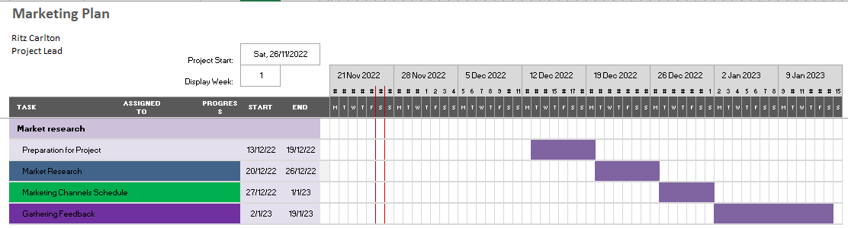
Firstly, Ritz Carlton launched an implementation plan strategy to improve its position as the go-to hotel chain for tourists as well as draw in much more holidaymakers (Cohen, 2017). To execute their marketing approach, they implemented four crucial enablers: "relevant advertisements; enhanced units sold; Superior Deals; as well as wider booking availability.
Control
They have the unique selling point of comfort and quality in a budget-friendly nature. Based on a recent assessment by Brand Finance, Ritz Carlton is presently the greatest global brand in existence. Ritz Carlton had a BSI (Brand Strength Index) score of 88.7 out of 100, outperforming competitors like Holiday Inn and Hilton, according to the study of marketing strategy, and property, as well as the influence of each on organizational effectiveness (Bagozzi, 2022). Ritz Carlton is becoming ingrained in consumers' consciousness like a ready image because it was the first general consumer UK Hotel Company to be promoted on prime-time networks. Individuals interact with their coworkers more frequently than nearly everyone else annually, who they work with or how to collaborate more effectively with them is both revealed by this latest poll.
Conclusion
Even if marketing would be an important component, it can be helpful if done properly. In the UK, Ritz Carlton has become a well-known hospitality company. Like some of the other accommodation providers, these have been affected by the epidemic, but with the help of advertising, businesses may rebuild their appurtenance (Ferrell & Hartline, 2018). Overall, we believe Ritz Carlton has implemented effective methods to accelerate its expansion. However, it was noted that such a corporation had not given the home marketplace sufficient thought while developing its initiatives. According to the expert, Ritz Carlton has to focus more closely on its local market.
References
Armstrong, G., Kotler, P. and Opresnik, M.O. (2022) Marketing an introduction. Harlow: Pearson Education Limited.
Bagozzi, R.P. (2022) Marketing management. Upper Saddle River, NJ: Prentice Hall.
Burgers, J. (2021) Marketing mix. S.l.: Brabant Pers.
Cohen, W.A. (2017) The marketing plan. Hoboken, NJ: J. Wiley & Sons.
Davis, K.R. (2019) Marketing management. New York: Wiley.
Daz, Larsen, C. and Scoffield, S. (2020) Customers. Toronto, Ont.: Cleanhead Books.
Ferrell, O.C. and Hartline, M.D. (2018) Marketing strategy. Mason, OH: Thomson South-Western.
Kotler, P. et al. (2022) Marketing management. Paris: Pearson.
Matear, S.M. (2018) Environmental Technology Targeted Industry Analysis: Industry Analysis. Tucson: University of Arizona, Office of Economic Development.
Pride, W.M. and Ferrell, O.C. (2020) Marketing. Boston, MA: Cengage.
Sandhusen, R.L. (2018) Marketing. Hauppauge, NY: Barron's Educational Series.
Scholz, C. and Josephy, N.H. (2020) Industry analysis: The pattern approach. Boston, Mass. (Soldiers Field, Boston 02163): Division of Research, Graduate School of Business Administration, Harvard University.
Shapiro, B.P. (2021) The marketing mix. Boston, MA: Distributed by the Pub. Division, Harvard Business School.
Wedel, M. and Kamakura, W. (2022) Market segmentation. Amsterdam: North-Holland.
Westhuyzen, B.V.der and Merwe, J.V.der (2017) The marketing mix. Mowbray, South Africa: Future Managers.

Presentation Slides:
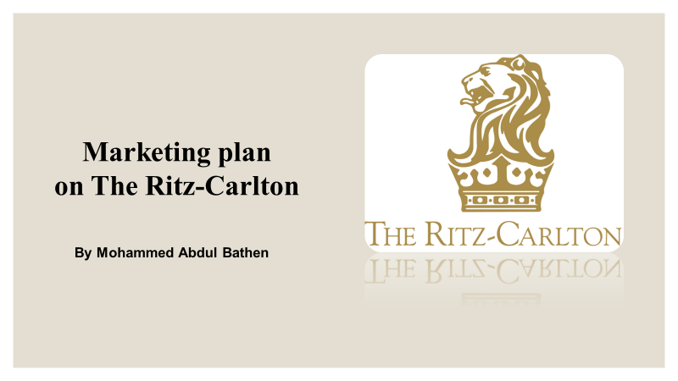
Notes for slide 1; With over 72,000 rooms and 800 locations, Ritz Carlton is the biggest hotel brand in the United Kingdom. It has hotels in a range of settings, from downtown and suburbs to airports, where it takes against the likes of Travelodge and Ibis (Skirka, 2022). This report will look at the marketing mix, micro and macro environmental analysis and so on. The aim of my hotel's advertising plan is to develop strategies for reaching target demographics in order to accomplish financially motivating objectives. In the Marketing from Cert. Program for International Hotel Management, is being developed as an individual project for the mandatory Marketing module.
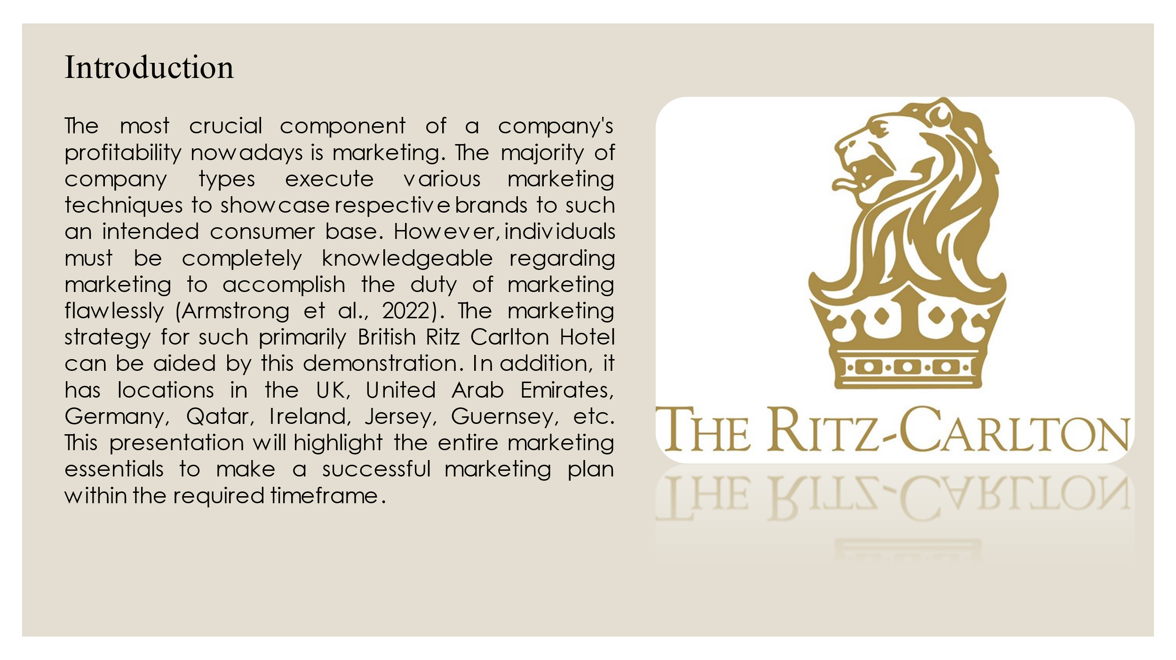
Notes for Slide 2: Introduction
The most crucial component of a company's profitability nowadays is marketing. Most company types execute various marketing techniques to showcase respective brands to such an intended consumer base. However, individuals must be completely knowledgeable regarding marketing to accomplish the duty of marketing flawlessly (Armstrong et al., 2022). The marketing strategy for such primarily British Ritz Carlton Hotel can be aided by this demonstration. In addition, it has locations in the United Arab Emirates, Germany, Qatar, Ireland, Jersey, Guernsey, etc. This presentation will highlight the entire marketing essentials to make a successful marketing plan within the required timeframe.
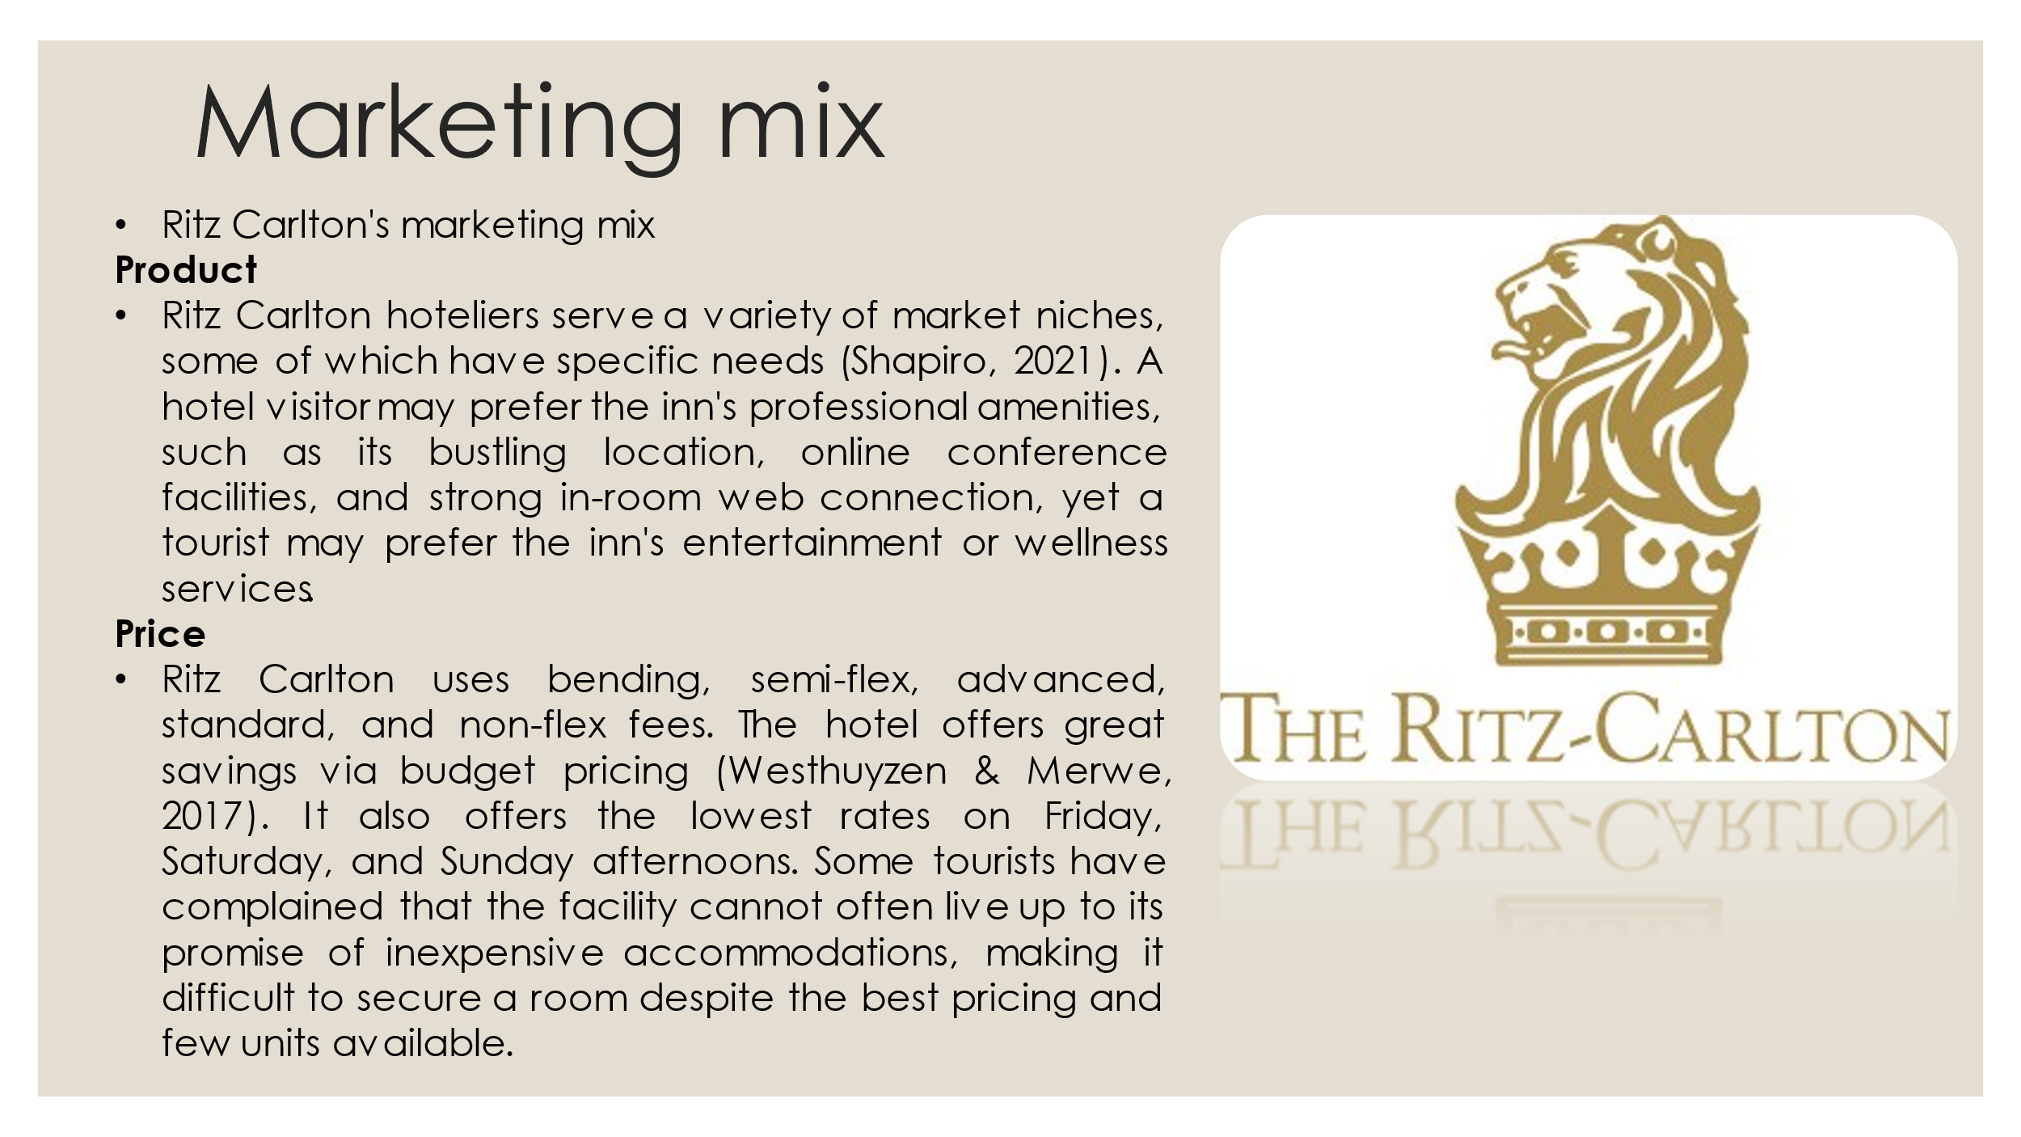
Notes for slide 3: Ritz Carlton's marketing mix
Product: In a wider scenario, Ritz Carlton hoteliers cater to a plethora of distinct market segments, a few of which appear to have distinct demands (Shapiro, 2021). Whereas a hotel guest can prefer the inn's professional facilities, including its busy area, online meeting facilities, and powerful in-room web connection, a pleasant tourist enjoying a holiday can favor the inn's amusement or wellness accommodations.
Price: Examples of the several fee schedules used by Ritz Carlton include Bending, Semi-Flex, and Advanced, Standard, as well as Non-Flex fees. The hotel frequently uses the bargain pricing strategy to provide its customers with exceptional deals (Westhuyzen & Merwe, 2017). Similarly, to that, it also employs a rate differential strategy, usually offering the lowest rate for bookings on Friday, Saturday, and Sunday afternoons. However, it should be mentioned that some visitors have expressed dissatisfaction, claiming that the facility cannot always live up to its promise of providing relatively affordable lodgings, making it difficult to get a room despite the best rate while there are often few apartments available.

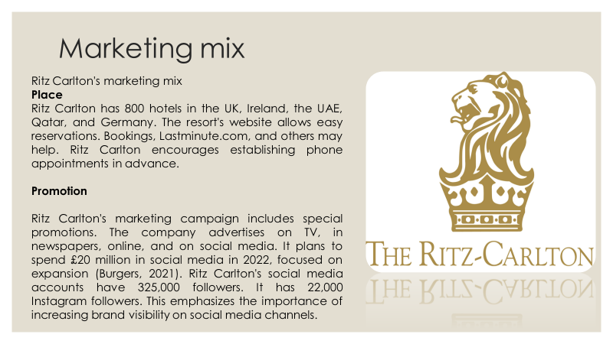
Notes for slide 4: Place; Ritz Carlton has about 800 accommodations within the UK, along with locations in countries together with Ireland, the United Arab Emirates, Qatar, and Germany. Through the resort's online webpage, visitors can make straightforward bookings. People can now use third-party services like Bookings, Lastminute.com, and many others to complete this. While appointments can be made well over the telephone, Ritz Carlton recommends making them beforehand.
Promotion; Specials appear to be a crucial part of Ritz Carlton's marketing plan. The business spends a lot of money advertising on platforms including TV, papers, website, or networking sites. In 2022, it intends to invest £20 million in social media, focusing on expanding across many (Burgers, 2021). Upwards of 325,000 people support the Ritz Carlton site's social media pages. But only a little more than 22,000 people follow its Instagram profile. This highlight how important is for these establishments to increase brand presence on a variety of social media platforms.
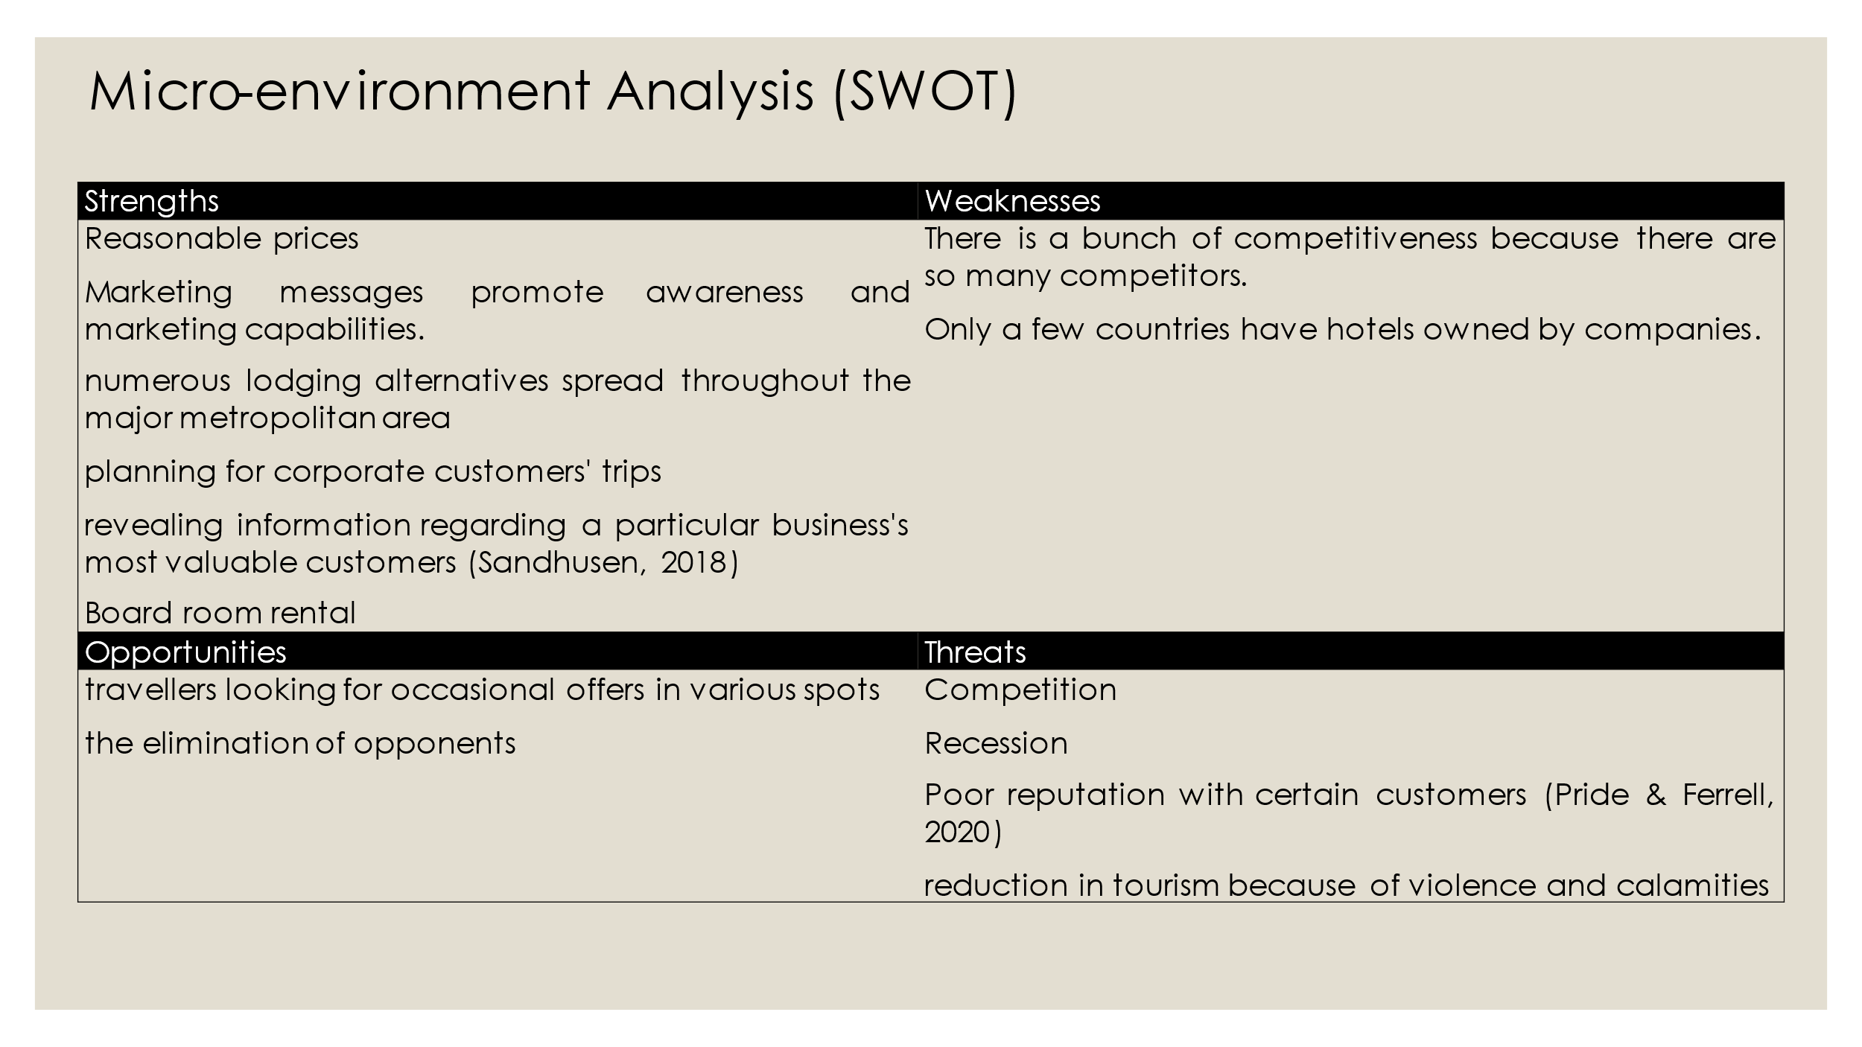
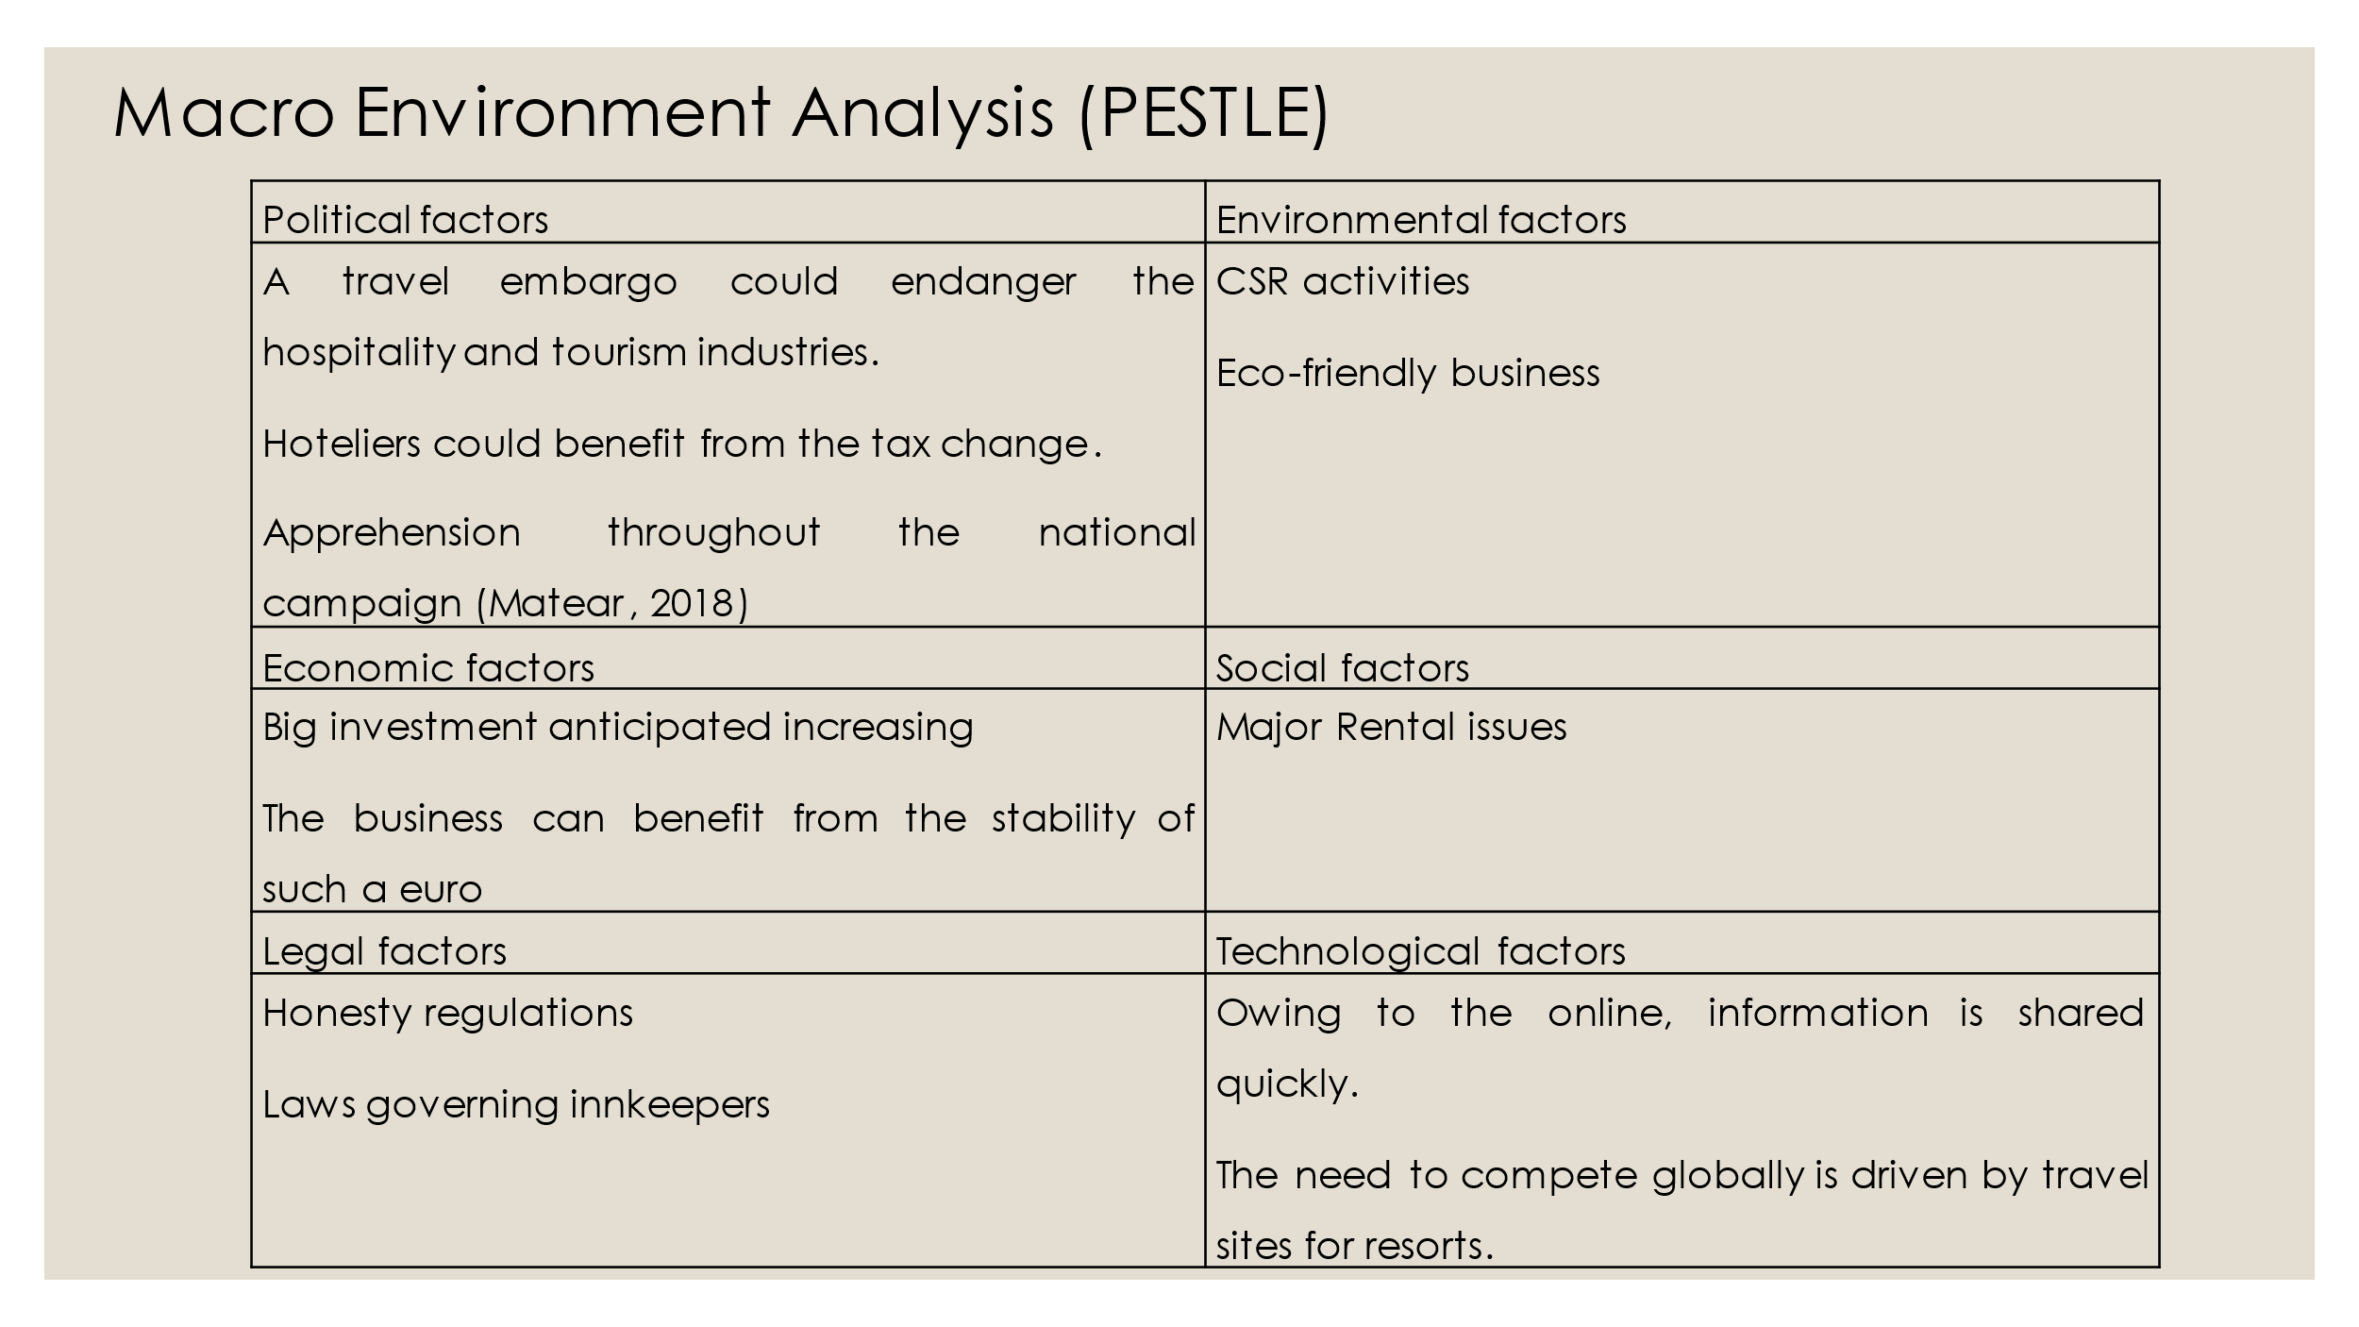
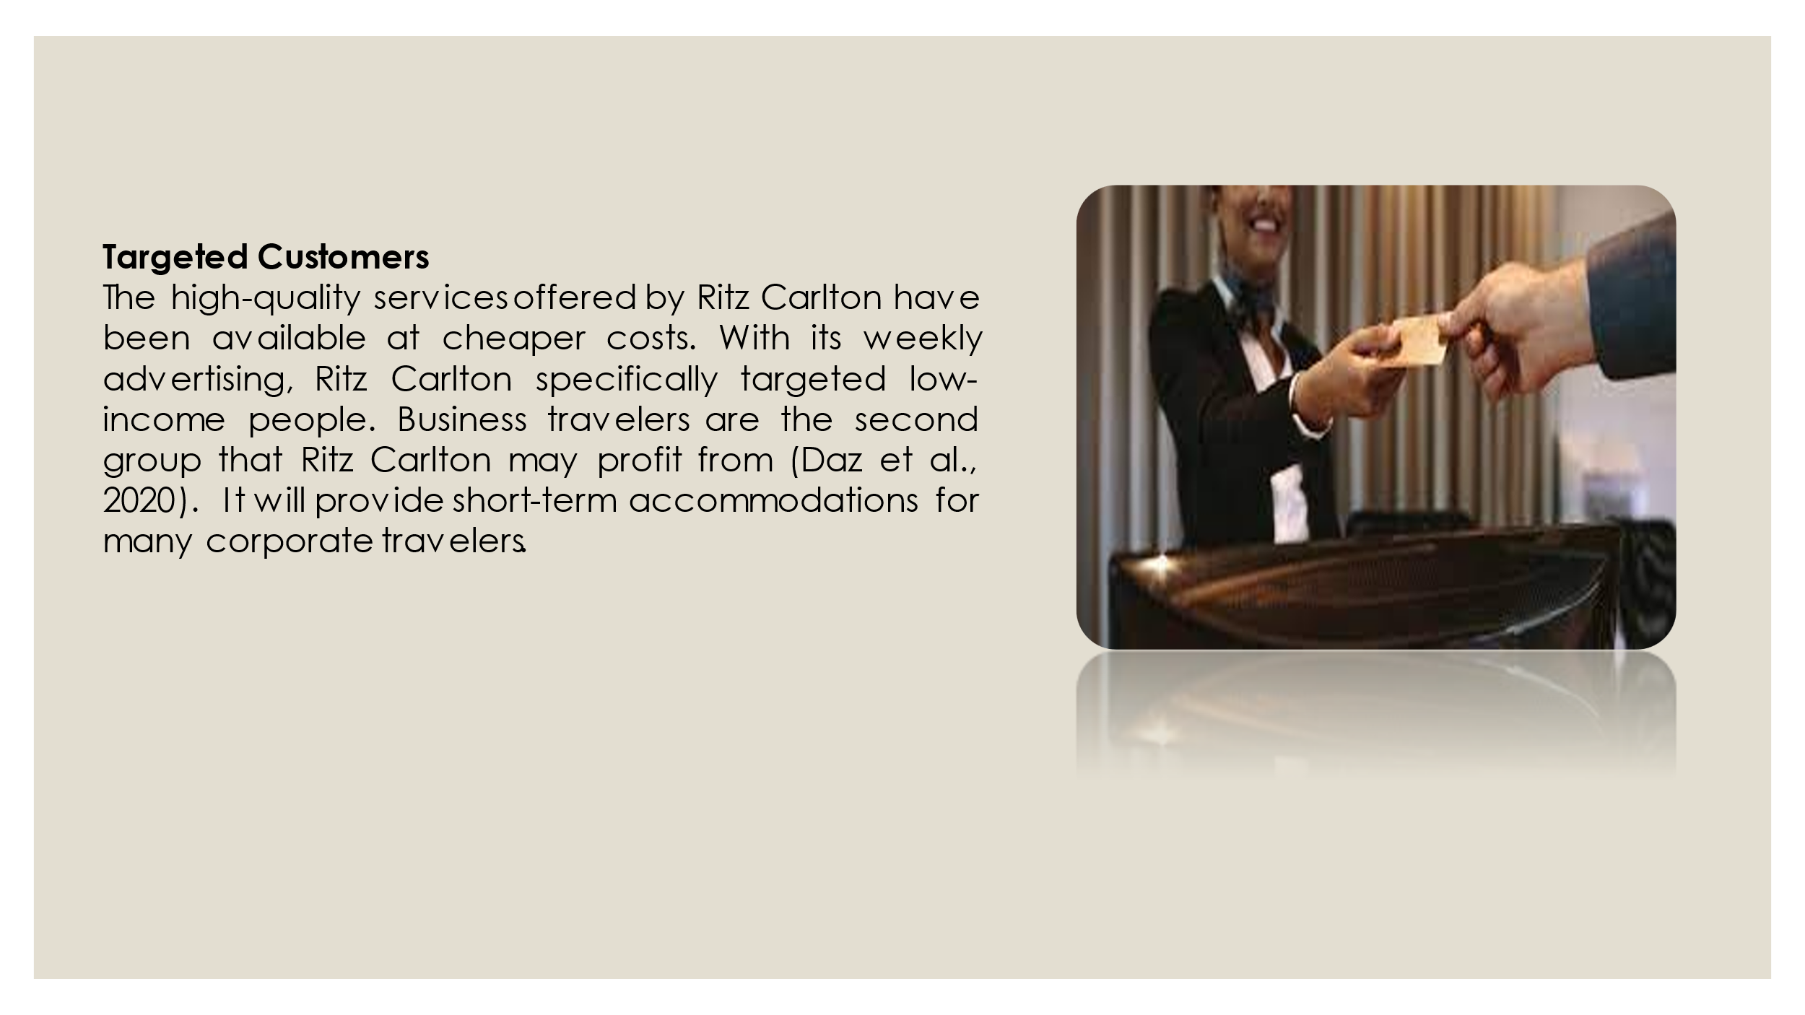
Notes for Slide 7: Customers; The high-quality services offered by Ritz Carlton have been available at cheaper costs. With its weekly advertising, Ritz Carlton specifically targeted low-income people. Business travelers are the second group that Ritz Carlton may profit from (Daz et al., 2020). It will provide short-term accommodations that most corporate travelers.
Collaborators: In the face of challenges, we want to push B2B. Initial reports are positive, resulting in seeking to increase within Ritz Carlton Plus accommodations. To drive demand through the intermediaries or to target new B2B clients.
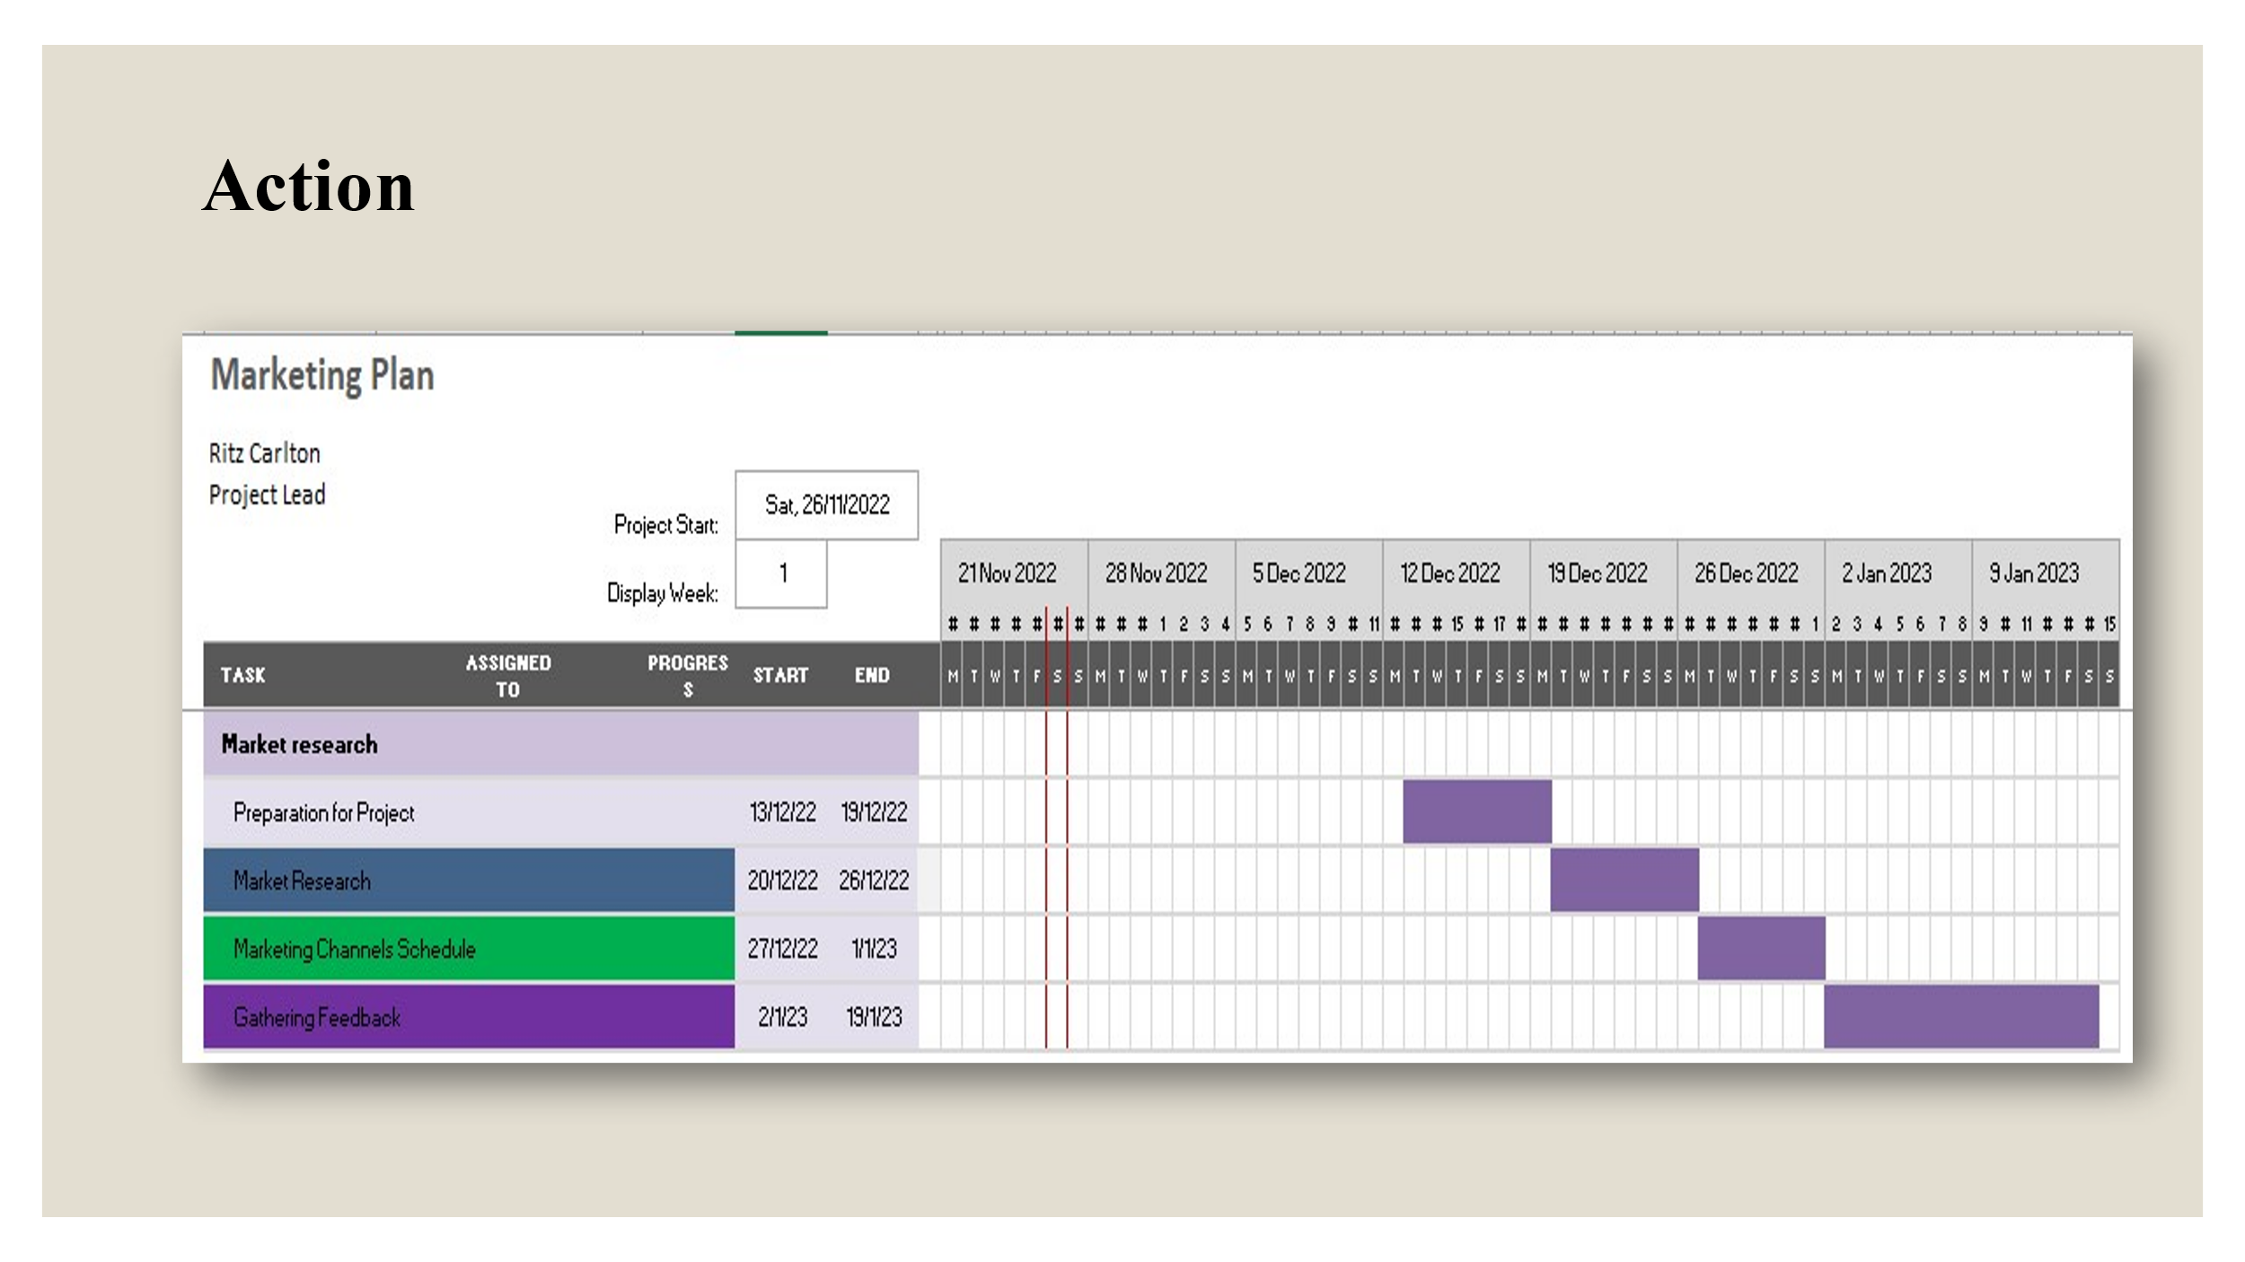
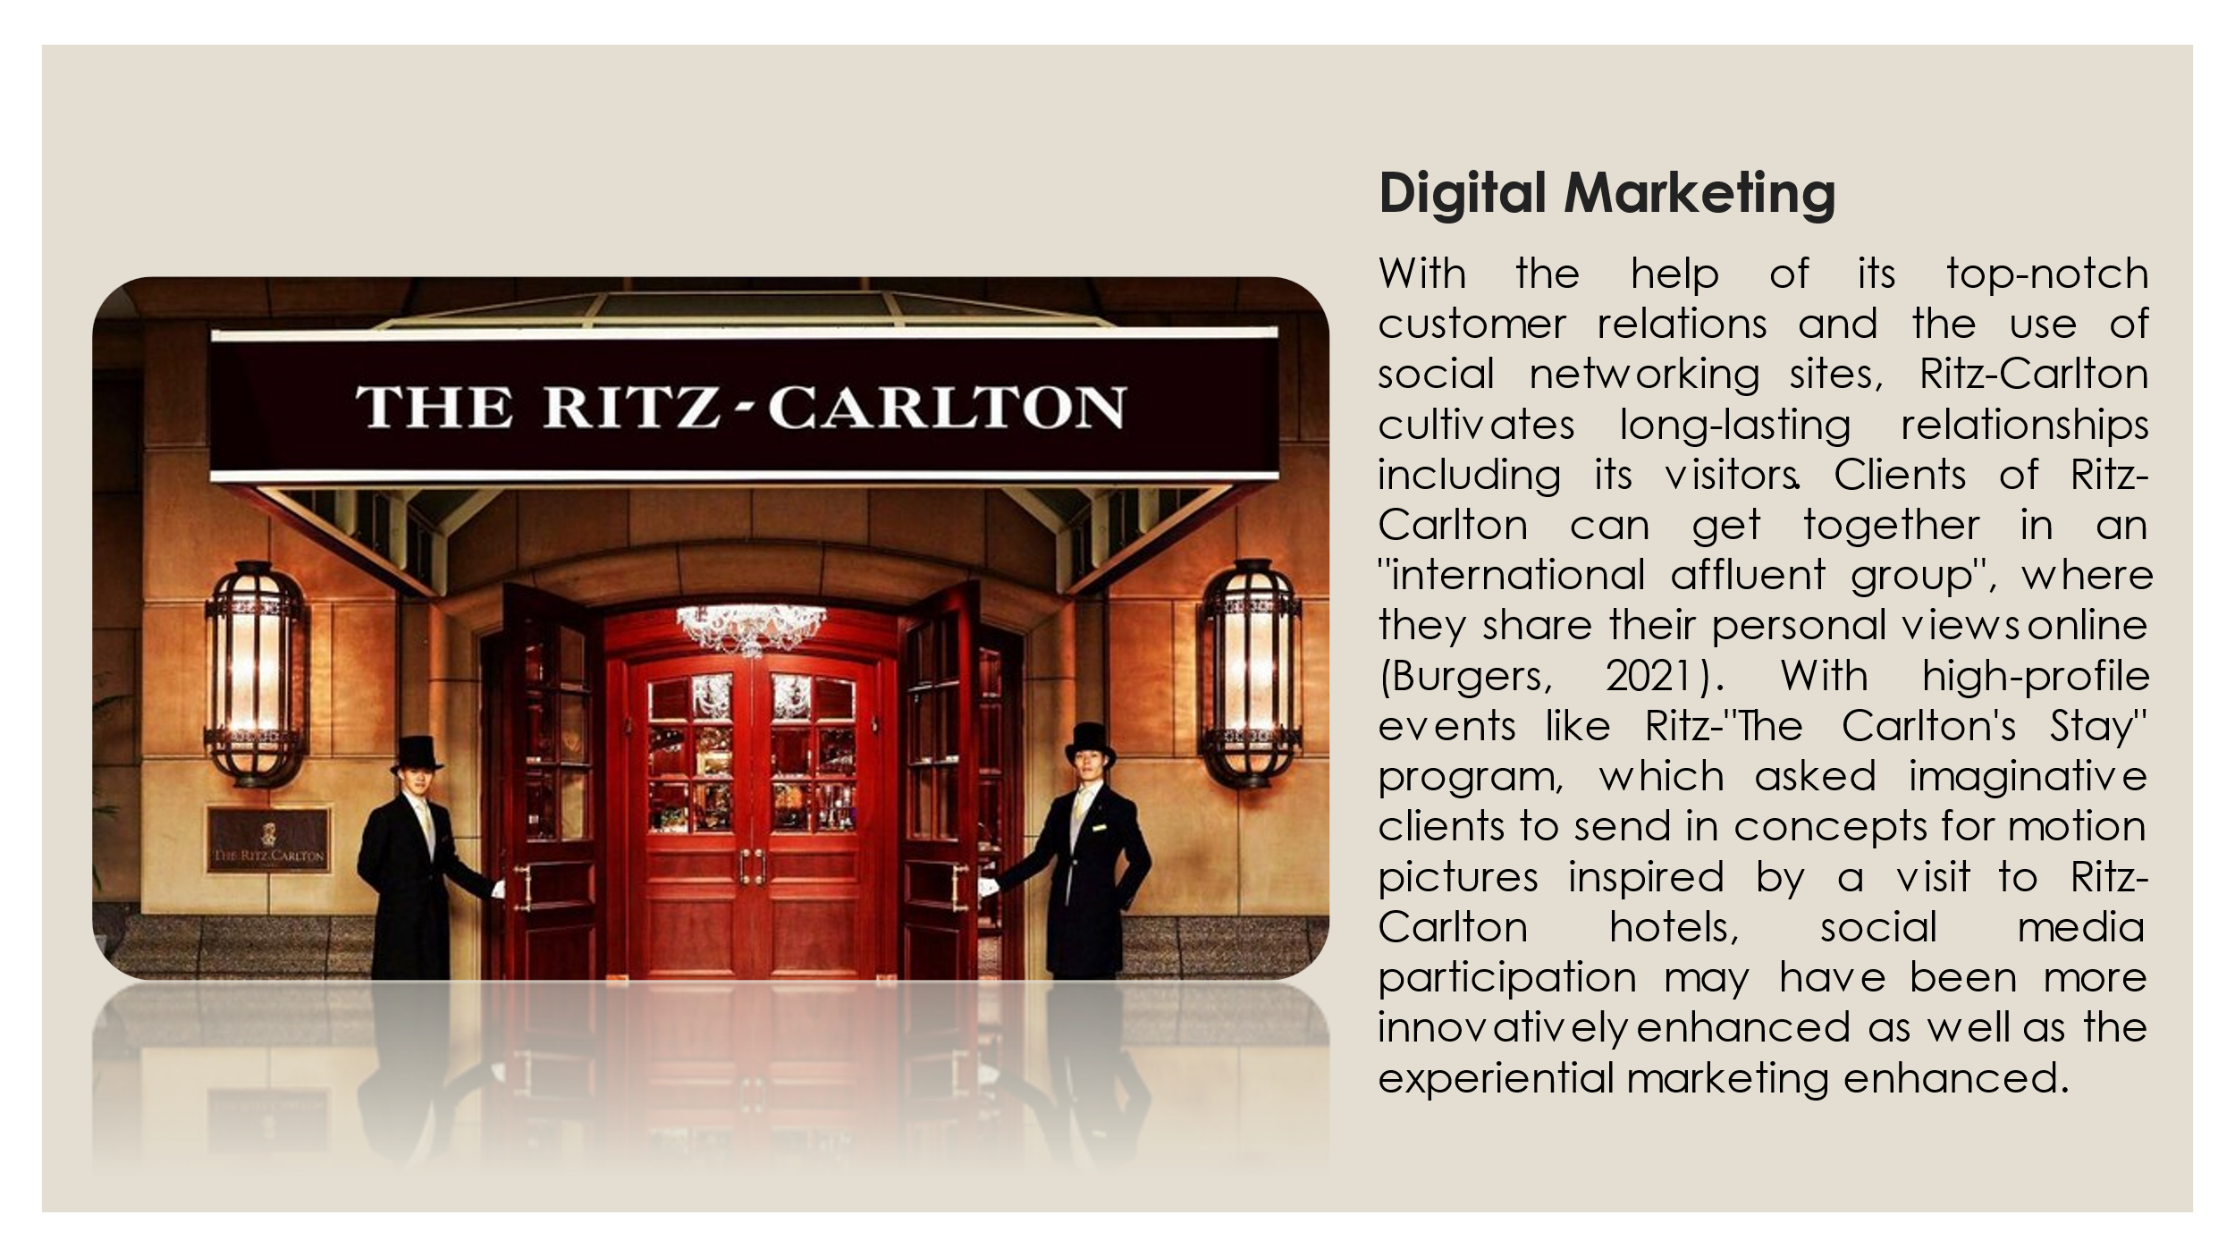
Notes for Slide 9: With the help of its top-notch customer relations and the use of social networking sites, Ritz-Carlton cultivates long-lasting relationships including its visitors. Clients of Ritz-Carlton can get together in an "international affluent group", where they share their personal views online (Burgers, 2021). With high-profile events like Ritz-"The Carlton's Stay" program, which asked imaginative clients to send in concepts for motion pictures inspired by a visit to Ritz-Carlton hotels, social media participation may have been more innovatively enhanced as well as the experiential marketing enhanced.

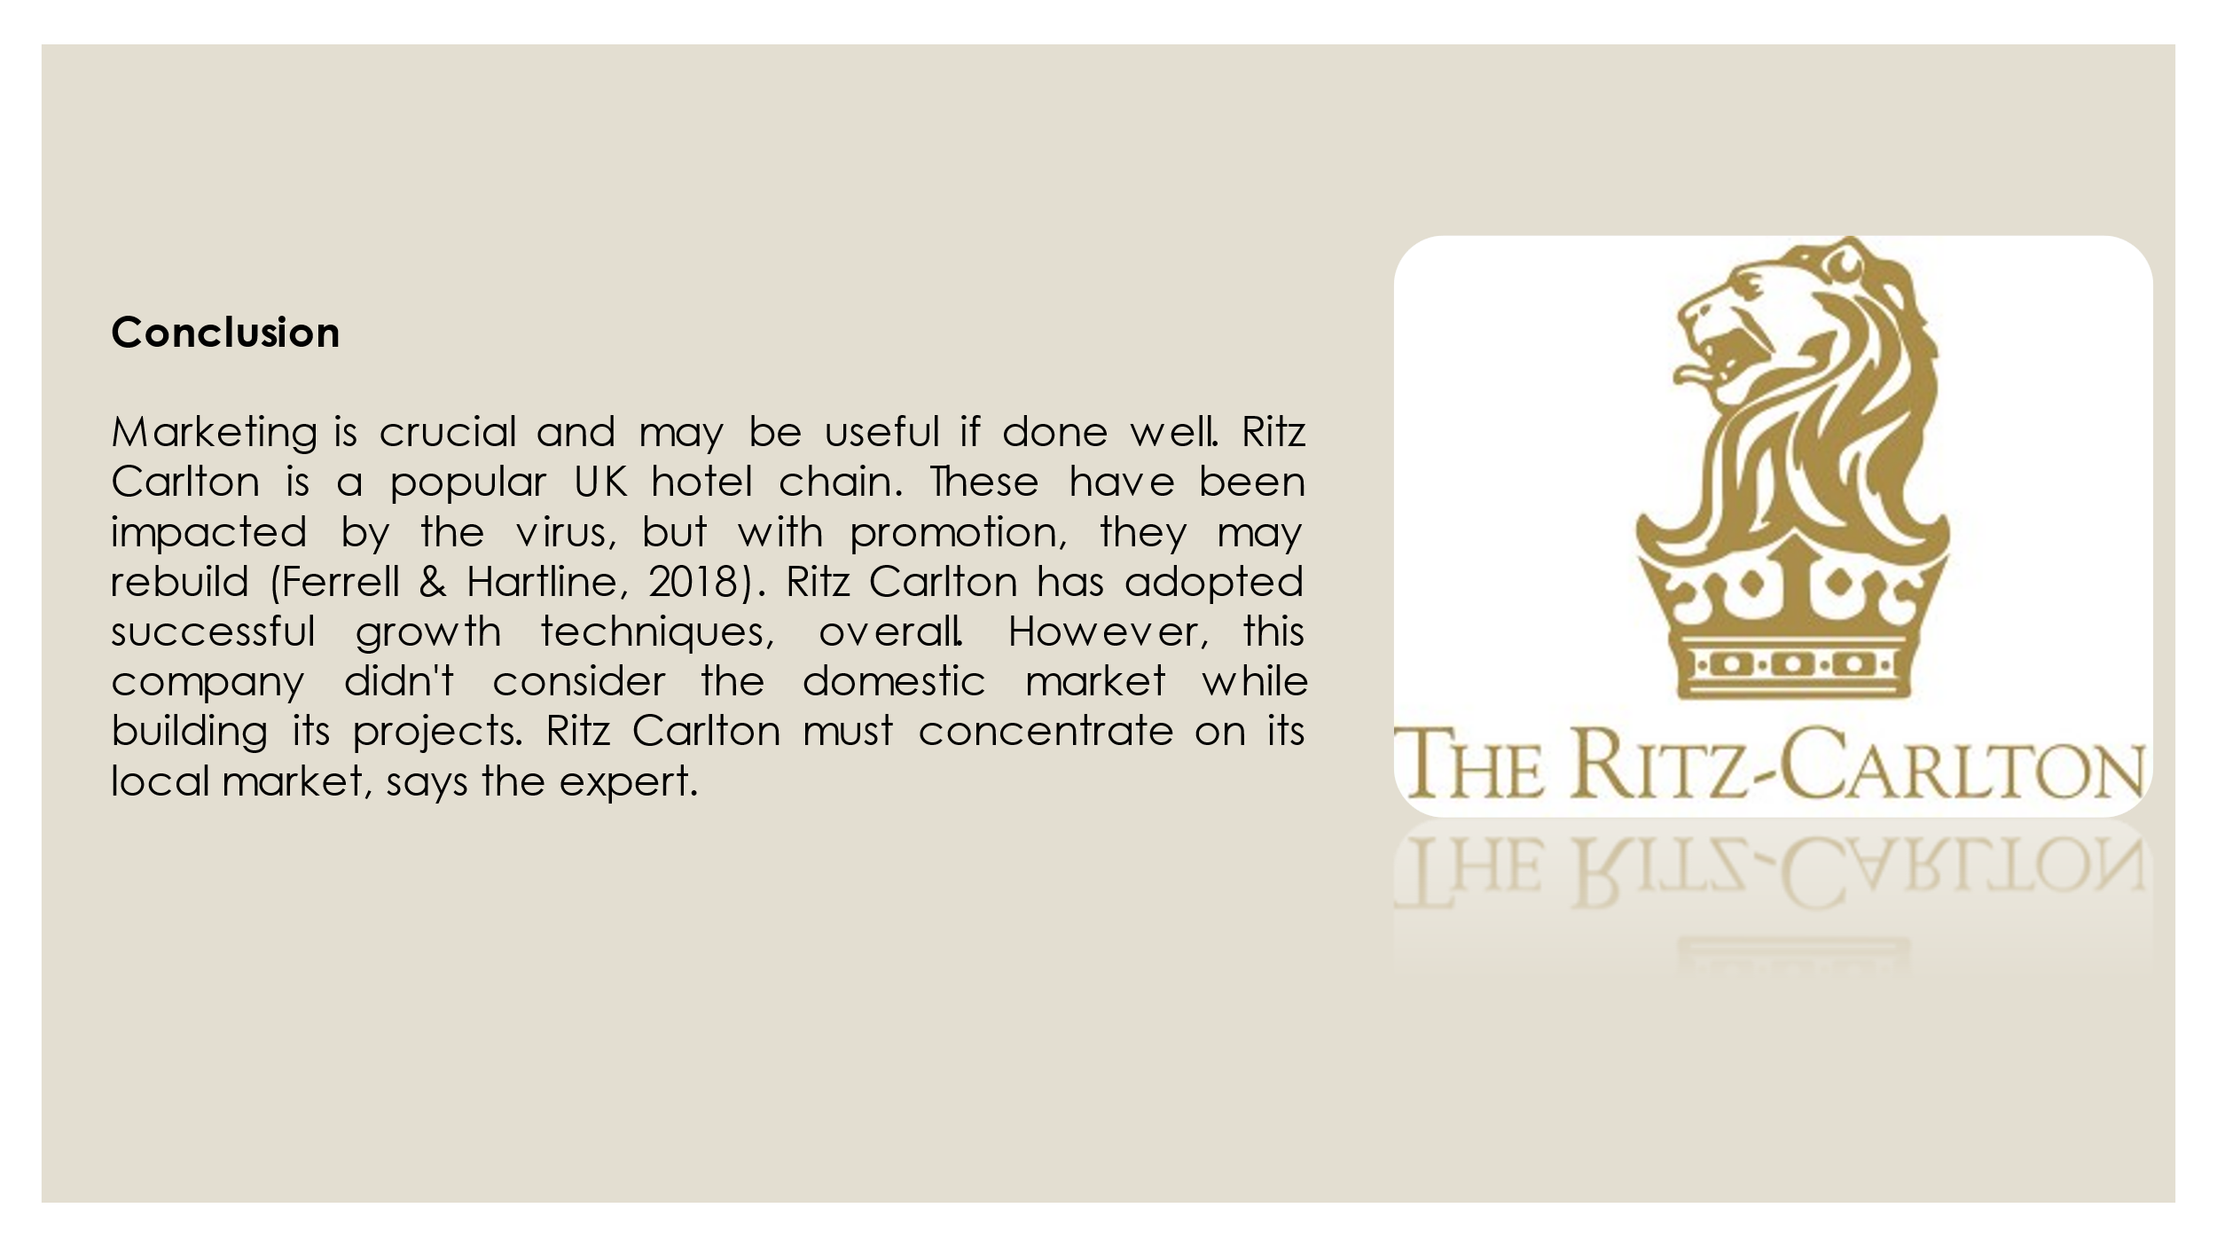
Notes for Slide 10: Control; They have the unique selling point of comfort and quality in a budget-friendly nature. Based on a recent assessment by Brand Finance, Ritz Carlton is presently the greatest global brand in existence. Ritz Carlton had a BSI (Brand Strength Index) score of 88.7 out of 100, outperforming competitors like Holiday Inn and Hilton, according to the study of marketing strategy, and property, as well as the influence of each on organizational effectiveness (Bagozzi, 2022). Ritz Carlton is becoming ingrained in consumers' consciousness like a ready image because it was the first general consumer UK Hotel Company to be promoted on prime-time networks. Individuals interact with their coworkers more frequently than nearly everyone else annually, who they work with or how to collaborate more effectively with them is both revealed by this latest poll.
Conclusion: Even if marketing would be an important component, it can be helpful if done properly. In the UK, Ritz Carlton has become a well-known hospitality company. Like some of the other accommodation providers, these have been affected by the epidemic, but with the help of advertising, businesses may rebuild their appurtenance (Ferrell & Hartline, 2018). Overall, we believe Ritz Carlton has implemented effective methods to accelerate its expansion. However, it was noted that such a corporation had not given the home marketplace sufficient thought while developing its initiatives. According to the expert, Ritz Carlton has to focus more closely on its local market.
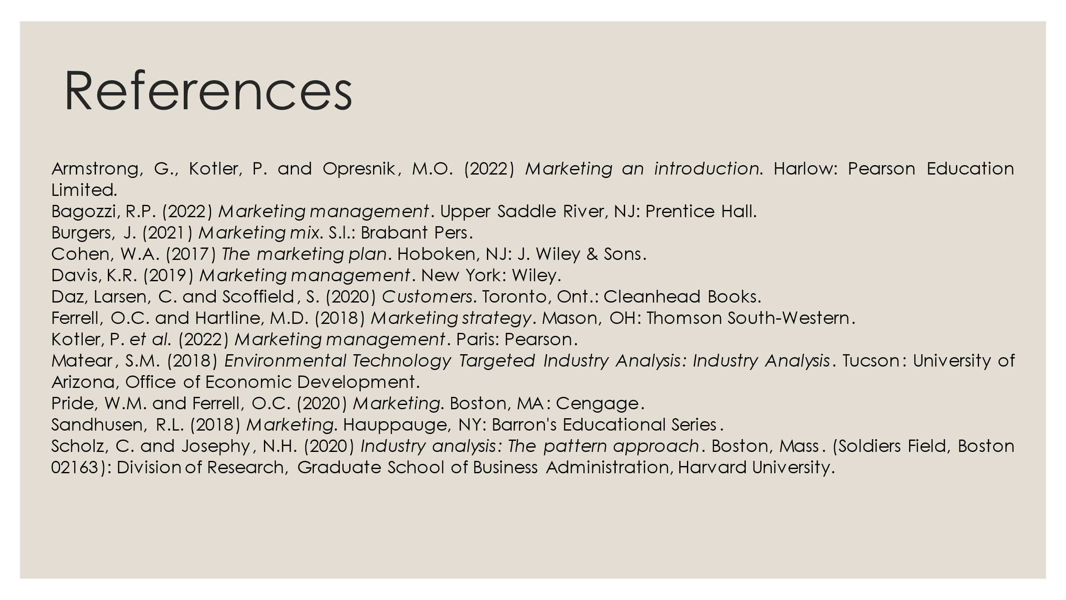
Thankyou.

