  Component One:  What are the key skills required when working in the housekeeping team? 750 words (+/- 10%)  Contribution to Overall Module Assessment: 25% | Student No: | 2128517
 | Module Title: | Operating Hotel Facilities
 | Module Code: | BMIH4006
 | Lecturer: | Kathryn Roberts
- Introduction
The housekeeping teams within the hospitality industry are crucial for not only the maintenance of the hotel but also for increasing the guests' experience, which ultimately surges guest loyalty. In this student journal, I will be assessing numerous skills which I believe are required and important in the housekeeping team.
- Hotel housekeeping teams
From my viewpoint, I believe that it is among the utmost priority of the hotel management to execute their everyday tasks as per the preferences and comfort of the guests, which actively indicates that housekeeping staff is essential for every hotel organization to acquire. The housekeeping staff, on general terms, look after the cleanliness and overall maintenance of the guest rooms. Their duties include vacuuming, sweeping floors, doors and windows, rearranging or changing bed sheets, providing room services and reporting any case of transgression to the hotel's top management. I also got to access that it is the housekeepers' sole duty to frequently regulate room services while always keeping tabs on the guests' needs and requirements (Olimovich et al., 2020). For this instance, I will cite the example of Ritz Carlton because, given the hotel's luxurious image, their housekeeping teams provide doorman, porter and overall handyperson services, through which they achieve high-class guest experience (The Ritz Carlton, 2023).
- Key skills required to work in the housekeeping teams
- Communication skills
Excellent communication abilities, in my perspective, are highly essential for any employee to assess, including housekeeping employees. If the housekeeping teams maintain a communicational flow, then there are fewer chances for any misconceptions to occur, thus leading the staff to build a robust image with high guest satisfaction. Further, I am very well aware that concise and clear speech has a lot of benefits because it not only delivers a message to another employee easily but it also helps the guests understand the dynamics of the hotel quite properly. This way, the engagement level between peers and guests will remain stable (Les Roches, 2022).
- Interpersonal skills
Given how the housekeeping employees are directly in contact with the guests, the need for interpersonal skill is a must, especially if the housekeeper execute them in an integrative manner. I believe that interpersonal skills allow the housekeepers to build a trustworthy rapport with the guests because most hotel customers are likely to think that their personal belongings are at risk of theft from the housekeeping services. Hence, efficient interpersonal skills increase the housekeepers' dependability, teamwork and responsibility. Further, from my knowledge, housekeeping staff also maintain their patience, resilience and overall good impressionable image in front of the guests from their interpersonal skills.
- Problem-solving skills
The skill to identify a problem and then propose an effective action plan is considered to be an essential part of the hotel's housekeeping jobs. Whenever a problem arises within the catered services, the guests expect the housekeeping staff to immediately come up with a handy solution or else report the hazard to the top managerial body. Either way, they demand a solution at hand, which the housekeepers have to efficiently deliver. Problem-solving skills of hotel housekeepers include identification of the problem, plotting an immediate action plan, executing it profoundly and securing guest satisfaction (Indeed, 2023).
- Teamwork skills
Teamwork abilities bring together housekeeping duties because it enables every individual worker to bring their talent to the table. With equal contribution from every housekeeper's part, the housekeeping services have the potential to be extremely productive and effective, thus ensuring a high guest experience. The ability to cooperate and work collaboratively strengthens the notion of housekeeping, which results in less time consumption. Since it secures punctuality, the guests get an excellent impression of the hotel's staff, which permits them to book their repetitive stays. Additionally, teamwork also lessens the burden on the housekeepers by allocating tasks (Law Insider, 2023).
- Ownership skills
Ownership in this context relates to taking responsibility for actions. Hence, I got to evaluate that ownership is indeed an essential skill required for housekeepers because viability and transparency are the two driving factors in taking responsibility for any action. Oftentimes, services shift in a wrong, unfavourable direction which may lead the customer to have a bad impression of the hotel. The shortcoming may encompass faulty technical assets in the rooms, risk of hazards and such. The housekeepers who admit their shortcomings have a positive impact on the customers' preferences, thus allowing the employee to correct their mistakes.
- Conclusion
In conclusion of this journal, I evaluated that housekeeping is an essential part of the hotel for ensuring a high guest experience. The skills required for the housekeeping teams entail communication, interpersonal, problem-solving, teamwork and ownership of the duties skills. From such, I enlightened myself about the worth of housekeeping skills.
Word Count | 750

Component Two:
Contribution to Overall Module Assessment: 25%
In this scenario – You have just been promoted to the team leader for a floor within the hotel. A guest complained that on their arrival, their room had not been properly cleaned. Create an action plan and answer the following questions.

Problem | Why did it happen? | What are you going to do? | How will you prevent this from happening in the future? | What measures would you introduce to improve team effectiveness?
Lack of use of technology | The hotel was not up to date with the latest technology, thus leading to little or no use. | In an effort to resolve this issue, I will adopt technological assets such as AI and IT in an effort to keep tabs on the customer profile and preferences prior to their actual visit. This will allow me to include all of the customer's preferred amenities beforehand, thus saving them the time to order the service. This will additionally increase customer satisfaction. | I will inform my hotel's top managerial body about technology adoption before enlightening my team members about the necessary actions they have to implement in order to efficiently use technology. | I will employ a performance evaluation system, which will easily measure the effectiveness of my hotel’s adoption of technology.
Hotel service is slow. | The guests experienced slow hotel services due to demotivated and unproductive staff. | I will aim to motivate the workforce by formulating a productive work framework for them and assigning them exciting tasks in an effort to diminish their boredom. I will also promote teamwork and likewise offer them exciting rewards after the accomplishment of each task. This will allow them to deliver services quickly with efficiency, given how their goal is set upon a promised reward. | I will request the top management to boost their regarding system and similarly invest my time and money in their engagement programs and activities. | I will measure employees' motivation and productivity by monitoring their actions as well as asking for their feedback.
The room was not cleaned. | The major factor that can lead to this issue is the lack of communication and coordination among the cleaning and front desk staff. Due to a lack of coordination and communication, the guests were given a room which was not clean. | To solve this issue, I will apologize to guests for the inconvenience and will ask them to spend some time in our luxury suite so that the staff can clean their room immediately and will provide them with drinks as a gesture of apology. | I will make sure that staff is being trained to get proper training and increase their level of coordination. | Through training and a reward system
The guest is angry and upset. | Due to getting an uncleaned room and less-than-expected service quality, the guests are upset. | I will make sure to provide swift services to the clients and solve their issues. Blow fragrance candles and an apology note for guests to improve their mood. | I will make sure to increase the efficiency of the team and the quality of services. | Training will be provided to the staff for handling the upset guests and how the quality of service can be improved.
Staff is incompetent in meeting the guest requirements. | The staff have no idea if the rooms are properly cleaned, and there is a lack of monitoring on the cleaning staff. | I will increase the use of technology to keep track of operations in the hotel and increase the use of technology. | Through proper monitoring systems and employees performance management | Performance and reward management system will be used to manage the employee's competencies

Component Three:
Contribution to Overall Module Assessment: 50%
Your task is to create and prepare a presentation following the detailed scenario provided below.

As the floor housekeeping manager and given the recent guest complaints, you need to put together a basic training presentation for your colleagues within the housekeeping team to get the best out of them, ensure that brand standard is being achieved and that Health and Safety procedures are also being followed.

Introduction
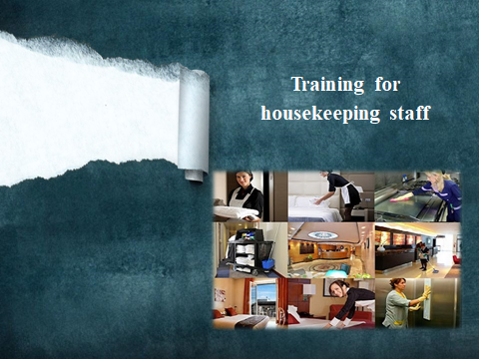
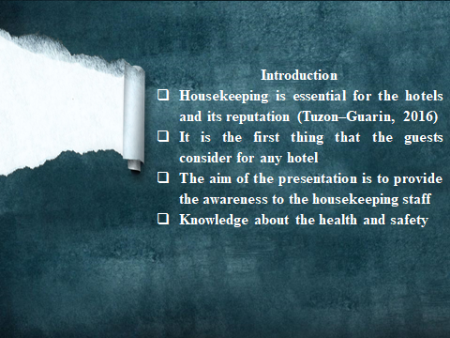

Training Notes: Housekeeping staff is an essential part of the hotel because this department is solely responsible for managing cleanliness and hygiene in the hotel
The cleanliness and representation of the hotel is the first thing which guests observe in the hotel. The aim of the presentation is to provide useful information and skills to the housekeeping staff for managing performance.
Guest reviews
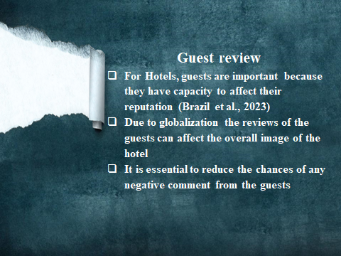

Training Notes: Guests are considered core for the hotels because their reviews and comments about the hotels have a significant impact on the hotel's reputation. In this digital era, the remarks of guests are of more value because these affect the hotel's image in the industry. Not properly cleaned room shows the inefficiency of the housekeeping staff.

Role of housekeeping staff
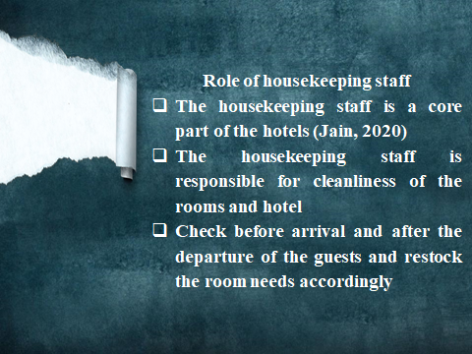

Training Notes: It is evident to communicate the role of housekeeping staff to the organization because it is essential to understand the role and its importance in the hotels. The housekeeping team is responsible for inspecting and checking the cleanliness of the room after the guest's departure and restocking the room supplies. The housekeeping staff have to take care of the hotel's cleanliness according to hotel standards.
Training program
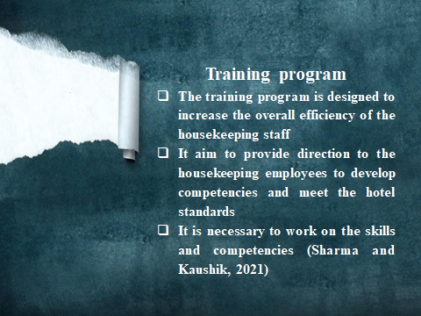

Training Notes: The training program is designed to increase the efficiency of the housekeeping staff in the hotel and also communicate the effective strategies that can help to reduce the number of complaints in the hotel. The training program provides direction to housekeeping employees for developing their competencies and work based on standards.
Training program
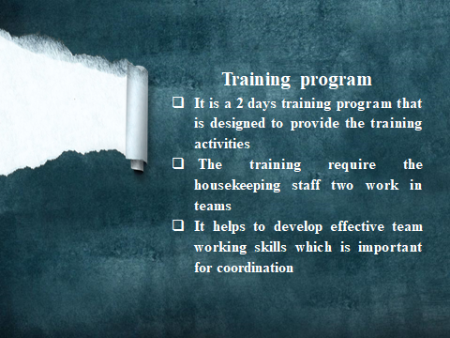

Training Notes: It is a 2 days induction training program that is designed to provide classroom-based training and activities. The housekeeping staff will be divided into teams to provide training for working with proper coordination. Along with that, the aim is to develop a positive attitude in the housekeeping staff to solve the issues.

Health safety and brand standards

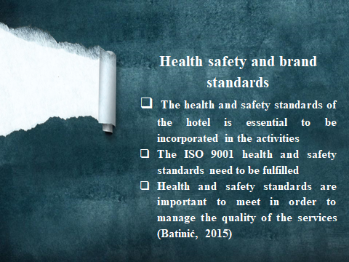

Training Notes: The housekeeping staff should have knowledge about the hotel standards that are essential to meet while performing their job.
Housekeeping staff need to focus on the 7S standard for housekeeping, which includes sort, sweep, safety, systematize, self-discipline, standardize, and sustain. Along with that, the ISO 9001 standards have to be followed for managing housekeeping responsibilities.
Health safety and brand standards
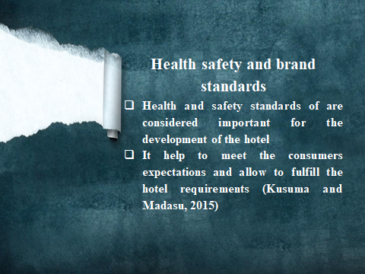

Training Notes: These health and safety standards are considered important for the hotel's development, and, along with that, it is also related to the hotel's reputation. It is essential to provide a clean and safe environment to the guests and also make sure that the food which is provided to them is effective and important.
Employees engagement
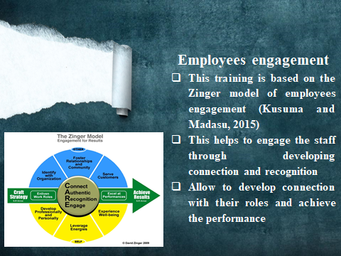

Training Notes: Employee engagement is considered essential in order to provide the success of the training program and increase the efficiency of the employee. The training program is designed based on the zinger model of employee engagement; it is efficient at connecting the employees by recognizing the employees.
Hotel standards and effective practices
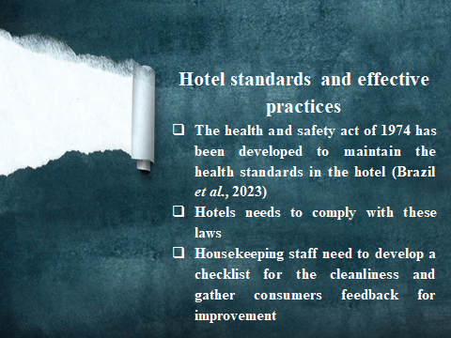

Training Notes: Hotels should comply with the 1974 act of health and safety work. It is essential to follow all the hotel standards while cleaning the rooms and dealing with the guests. On the other hand, it's also essential to perform the housekeeping audit regularly, develop a cleaning checklist and fix the proper time duration for cleaning rooms. Ask for consumers' feedback and incorporate it into the practice.
Conclusion
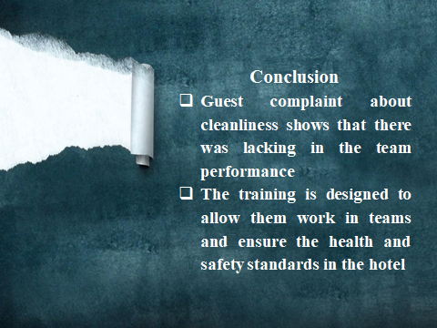

Training Notes: After guests complain, it is essential to provide training to the housekeeping staff to manage their performance and fulfilling their duties well. It is essential for the employees to meet the health and safety standards and increase the quality of services for the guests.

References
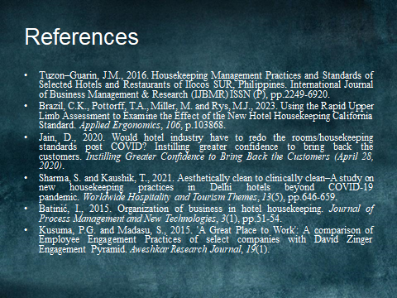
Indeed. 2023. 9 Key Skills for a Hospitality Career (Examples and Tips). [online]. Available at: https://www.indeed.com/career-advice/resumes-cover-letters/hospitality-skills#:~:text=Problem%2Dsolving%20is%20one%20of,afterward%20to%20ensure%20their%20satisfaction.. [Accessed on 3rd March 2023]
Law Insider. 2023. Teamwork and Leadership in housekeeping. [online]. Available at: https://www.lawinsider.com/clause/teamwork-and-leadership-in-housekeeping. [Accessed on 3rd March 2023]
Les Roches. 2022. Communication skills in hospitality industry. [online]. Available at: https://lesroches.edu/blog/communication-skills-in-hospitality-. [Accessed on 3rd March 2023]
Olimovich, D.I., Bakhtiyorovich, T.M. and Salimovna, N.G., 2020. Improving of personnel training in hotel bussines. Academy, (2 (53)), pp.18-19.
The Ritz Carlton. 2023. Resident Services. [online]. Available at: https://www.theresidenceschevychase.com/services/. [Accessed on 3rd March 2023]

