University of Wales Trinity Saint David

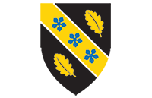

Program: Certificate of Higher Education Skills for the Workplace (Health and Social Care)
Title: Assessment 2 -Report on a Health Issue
Module Code: LCHS 4008 – Component 2
Module: Introduction to Public Health
Name of Student: Rizwana
Student ID: 2504702
Lecturer Name: Gillian Weaver

1. Introduction 3
2. Approaches Used to Measure and Monitor Dementia 3
3. Control of Dementia 5
4. Consequences of Dementia on People in Community 6
5. Health and Social Care Support Services 7
6. Conclusion 8
7. References 9

Introduction
Dementia is a chronic nervous disorder that impairs memory, thinking, behaviour and performance of daily activities. It is not a disease but rather a general name that is applied to refer to a cluster of symptoms caused by disorders that destroy brain cells. Dementia takes the shape of Alzheimer disease which is the most prevalent and covers about 60-70 percent of the cases. Others are vascular dementia, Lewy body dementia and frontotemporal dementia. Such conditions slowly disrupt the cognitive functioning and influence the independence and quality of life of a person.
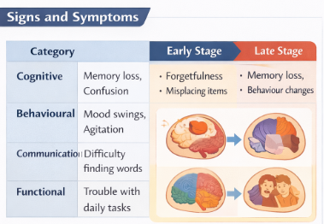
Fig. 1: Signs & Symptoms of Dementia

Dementia has general signs and symptoms such as loss of memory, confusion, lack of concentration, communication, mood and inability to perform daily activities like cooking or do financial transactions. As the disease advances, the care and supervision of the patient might be needed to a higher degree. Dementia is a serious societal health concern across the globe. Worldwide statistics show that over 57 million individuals in the world live with dementia, with almost 10 million cases of dementia being reported annually. The prevalence of dementia in the United Kingdom is estimated at approximately 982, 000 persons and it is projected that by 2040, its prevalence will increase by 1.4 million because of an aging population.

Approaches Used to Measure and Monitor Dementia
Precise measurements and surveillance of dementia play a crucial role in the diagnosis of the disease early, planning of treatment and the progression of the disease. There are numerous medical, psychological and statistical techniques that healthcare professionals employ to diagnose dementia and track its disease progression. Cognitive testing is one of the most extensively been used techniques. Cognitive tests measure how an individual can recall facts, solve problems, focus and express himself or herself. MiniMental State Examination (MMSE) and the Montreal Cognitive Assessment (MoCA) are the widely used devices in medical facilities. These are tests, which include answering questions, remembering words, simple mathematical tasks and other tasks, which include drawing shapes or clocks. The outcomes assist physicians in establishing that an individual is undergoing mental degradation.
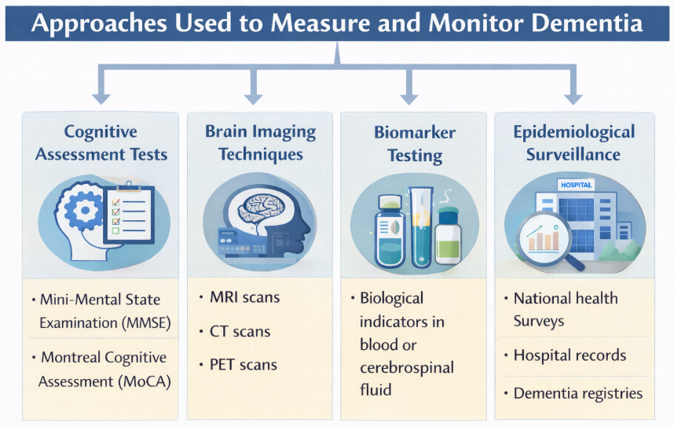
Fig. 2: Approaches used to measure & monitor Dementia
The other critical method is brain imaging. The techniques of medical imaging enable physicians to monitor brain changes that can be the signs of dementia. The scans that are obtained through Magnetic Resonance Imaging (MRI) can indicate the shrink of regions of the brain involved in memory and thinking. The computed tomography (CT) scan can be used to detect strokes, bleeding, or other structural issues that can be a cause of dementia. In some cases, Abnormal proteins related to Alzheimer disease are identified using the Positron Emission Tomography (PET) scans. Along with the imaging procedure, biomarker testing is expanded in the diagnosis of dementia. Biomarkers are biological indicators that occur in the blood or cerebrospinal fluid and they may indicate the presence of disease. An example is that abnormal concentrations of beta-amyloid and tau proteins are closely associated with the Alzheimer’s disease. These are the tests that can assist the doctors to confirm a diagnosis and the type of dementia that the patient has.
Symptom and behavioural observation over a long term is also relevant to monitoring dementia. Medical practitioners usually monitor the change in the memory, mood, communicative abilities, and normal functioning over time. The family members and caregivers can also give valuable information regarding changes in the behaviour or abilities of the individual. The dementia is also measured through the national health statistics and epidemiological studies by public health organisations. They are systems that gather data of cases of dementia in hospitals, clinics and communities to comprehend the prevalence and impact of the disease on various groups.

Control of Dementia
Even though dementia is incurable but there are various ways that can be utilized to control the disease, contain the symptoms and enhance the lives of patients with the disease. These interventions are medical individual, lifestyle and social health interventions. Dementia symptoms are generally treated using drugs. The drugs like cholinesterase inhibitors (donepezil and rivastigamine) are used to boost the amount of some chemicals in the brain that aid memory and thinking. Memantine is another drug that is used in controlling brain activity and can enhance learning and memory. Although these drugs will not cure dementia, they can slow down the development of the symptoms in certain people. The lifestyle modifications are also relevant in lowering the risk of dementia and managing the symptoms. The studies indicate that healthy lifestyle can reduce the risk of dementia development. Exercise enhances blood flow to the brain, as well as keeping the brain in shape. The healthy foods and fats combined with fruits, vegetables, whole grains form a balanced diet that promotes the health of the brain.
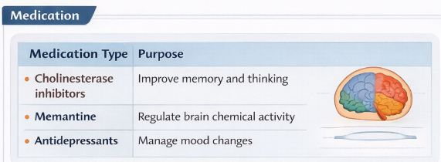
Fig. 3: How Dementia is controlled
Another consideration in the management of dementia is mental stimulation. Reading, solving puzzles, playing games or learning new skills are some of the activities that keep the brain going and can possibly slow cognitive deterioration. Mental wellbeing is also contributed by social interaction and the possibility of being isolated is eliminated. Another effective measure in management of dementia is early diagnosis. Early diagnosis of the condition will enable medical practitioners to initiate treatment earlier and offer information on how to cope with the symptoms. Early intervention also gives people and families the opportunity to plan their future care needs. The governments and health organisations are also encouraging people to engage in public awareness through educating them on the symptoms, risk factors and prevention of dementia. Such campaigns make people consult the doctor in case they experience any change in memory or thinking.
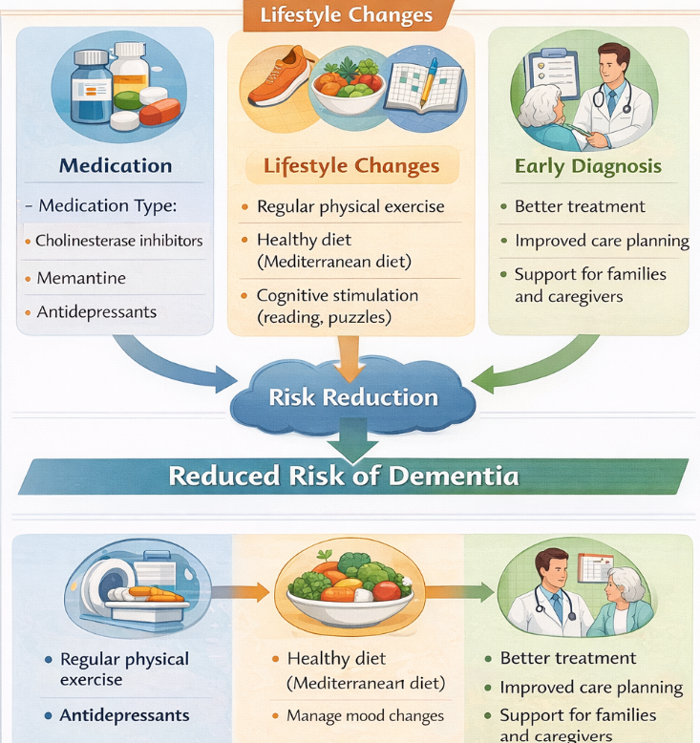
Fig. 4: Lifestyle changes

Consequences of Dementia on People in Community
Dementia has extensive implications on individuals, families, communities and systems of healthcare. The condition impacts on numerous areas of everyday life and poses a lot of social, emotional and financial difficulties. In the case of people with dementia, the situation causes their memory and ability to think to decline steadily. Tasks that were once easy like preparing food, remembering your appointments or doing your finances are even harder. With the progression of the disease, people might have problems with communication and might lose a sense of time, place or even the members of their family. Caregivers and families also have a major struggle. Many family members consider the role of informal caregivers, who offer personal care, medication management and home-based activities daily. Dementia may be both emotionally taxing and physically tiring to care about a dementia patient. The protracted responsibilities of care giving may create stress, anxiety and depression to caregivers.
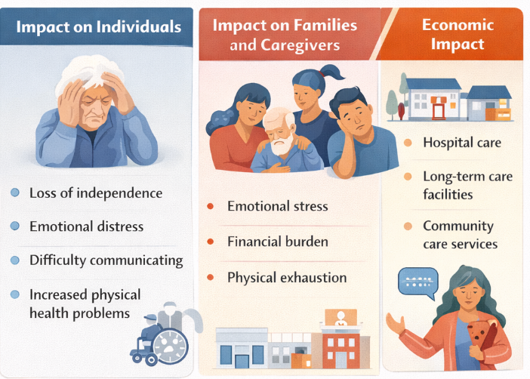
Fig. 5: Consequences of Dementia
There are also significant economic impacts of dementia. The financial burden on the healthcare systems and governments is the cost of medical treatment, long-term care and support services. Moreover, most of the caregivers decrease the number of work hours or quit working to offer care which also affects the household income. Social isolation is another significant result. The dementia patients can give up on social life due to the embarrassments of having memory lapses or misunderstanding the ability to communicate with others. This isolation might have an adverse effect on their emotional state and can promote cognitive impairment. Societies also have issues with managing individuals with dementia. The infrastructure, transportation and the health facilities need to accommodate the demands of the people with mental disabilities.

Health and Social Care Support Services
Users with dementia need a variety of health and social care services to ensure that they are supported and that they have a quality life. Such services entail the medical care, psychological support and help with daily living activities. Healthcare providers will be very crucial in the diagnosis and treatment of dementia. The collaboration between general practitioners, neurologists, psychiatrists and specialist dementia nurses is aimed at evaluation of the symptoms and creating a treatment strategy. The memory clinics are also highly valuable as they offer specialised cognitive testing and continuous observation to people who have memory issues. Community care services enable individuals with dementia to stay as long as possible in their respective houses. Home care workers help persons with cooking, cleaning, bathing, and taking medication. Such services assist people to be independent and at the same time to be safe.
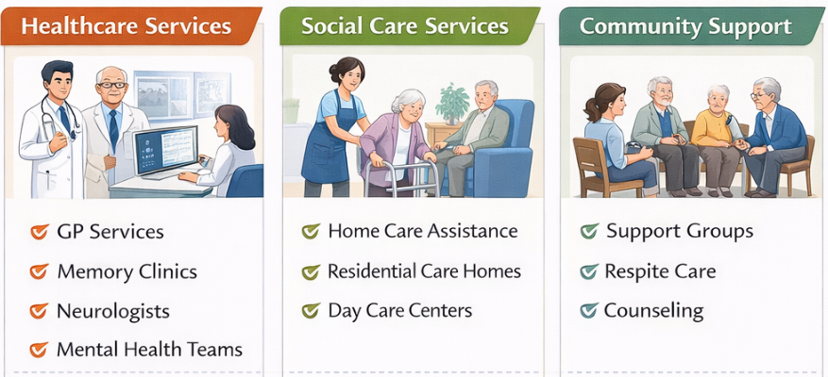
Fig. 6: Health & Social care support services
Social interaction and therapeutic activities are offered at day care centres and community programmes. Group exercises, art therapy, music therapy and memory training activities are some of the activities that are regularly provided in these centres and that may enhance cognitive functionality and emotional wellbeing. Caregivers also require support services. The respite care services are the services where the care givers can rest and the services are performed by the trained professionals to temporarily take care of the dementia person. Caregivers are also assisted through counselling and educational programmes to be aware of the condition and learn to cope with it. Moreover, there are numerous charities and voluntary organisations that help people with dementia. These organisations provide support groups, help lines and educational materials to assist families deal with the issues that are related to the disease.

Conclusion
Dementia is a severe and an increasing health condition which impacts millions of individuals across the globe. It is marked by gradual destruction of the brain which causes loss of memory, confusion and inability to do their daily chores. Dementia is a significant burden to the health care systems and society because it affects almost one million individuals in the United Kingdom and over 57 million worldwide. Despite the fact that currently, it has no cure, early diagnosis, proper monitoring and proper treatment of dementia can be used to control the symptoms and enhance the quality of life. Habitual changes may also be effective in preventing development of dementia where lifestyle changes like routine exercise, healthy diet and mental challenge are applied in preventing the disease. Dementia is also associated with major implications on the individuals, families and the society, emphasizing on the relevance of robust health and social care assistance frameworks. Ability to increase awareness, support services, as well as research on prevention and treatment can enable the communities to better assist individuals with dementia and assist them to live with dignity, independence, and wellbeing.

References

- World Health Organization (WHO) (2023) Dementia.
- NHS (2024) Dementia – Overview.
- Alzheimer’s Society (2023) What is dementia?
- Alzheimer’s Research UK (2023) Dementia statistics hub.
- Prince, M., Wimo, A., Guerchet, M., Ali, G., Wu, Y. and Prina, M. (2015) World Alzheimer Report 2015: The global impact of dementia. London: Alzheimer’s Disease International.
- Livingston, G. et al. (2020) ‘Dementia prevention, intervention, and care’, The Lancet, 396(10248), pp. 413–446.
- Alzheimer’s Disease International (2022) World Alzheimer Report 2022.
- National Institute for Health and Care Excellence (NICE) (2018) Dementia: assessment, management and support for people living with dementia and their carers.
- Public Health England (2019) Dementia profile: England.
- Burns, A. and Iliffe, S. (2009) ‘Dementia’, BMJ, 338, pp. 405–409.
- Alzheimer’s Society (2022) Dementia UK update report. London: Alzheimer’s Society.
- Department of Health and Social Care (2023) Prime Minister’s Challenge on Dementia 2025. London: UK Government.
- Brodaty, H. and Donkin, M. (2009) ‘Family caregivers of people with dementia’, Dialogues in Clinical Neuroscience

