
Leadership and Management, Theory and Practice
LCBB6003
ASSESMENT 1

Student Name: Valentina Stefanovska
Student ID: 2123930
Lecturer: Dr. Laila Maazouz
Term: June 2024
Submission Date: 23.08.2024
Contents
Introduction 3
Task 1 3
Task 2 7
1. Managing and Leading: Personal and Employability Skills 7
2. Development of Skills and Impact on Performance 10
Conclusion……………………………………………………………………………………11
References 12

Introduction
Although they are distinct from one another, effective management and leadership are complementary. In contrast to management, which focusses on ensuring that plans are implemented and goals are achieved, leadership is focused with inspiring others to strive towards a shared goal. It is essential to comprehend these roles and how they interact in order to promote organisational success and maintain a productive workplace.

Task 1
Guidance and direction-setting are essential components of leadership. Supervising and guiding a group of individuals to accomplish a common objective is the essence of management. No leader can also be an effective manager, but all managers need to know how to lead. The leader's attention is drawn to the organisation as a whole. Conversely, in order to guide their team to success, managers need to possess a minimal set of leadership abilities (Pellegrini et al. 2020). They need to connect with their staff on a personal level, inspire them to do better and hold them accountable.
The Visionary Vs. The Outcome
Visionaries who prefer to focus on the long term rather than immediate results are sometimes labelled as leaders. Through their connections, they motivate their followers to do great things. They make their team more cohesive and effective. Clear and tangible outcomes are the product of a well-coordinated team. As an example of a leader with vision, consider Steve Jobs (Kim, 2020). He guided Apple's development of revolutionary products like the Mac and iPhone by emphasising innovation and the broader perspective. Managers, on the other hand, often concentrate on results, both in terms of measuring and attaining them. Also, they lose some of their independence because they get too engrossed in the procedures. His successor, Tim Cook, is a legendary manager who led Apple to record-breaking profits by streamlining operations and producing quantifiable results (Mickle, 2020).
People Vs. Process
Developing meaningful connections with customers and other stakeholders is a top priority for leaders. People look up to leaders because of their personal connections with them. Leaders are able to deliver on their promises because they are renowned for having an effective staff. As a result, they are able to keep their relationships with stakeholders and customers strong. The "Starbucks College Achievement Plan," which covers full tuition for workers, is an example of how former Starbucks CEO Howard Schultz connected with employees (Starbucks, 2024). Schultz did this by personally visiting shops and listening to their comments. Stronger bonds and allegiance were the results of this strategy.
Contrarily, managers are more likely to centre their attention on the means by which the objective may be accomplished (Pellegrini et al. 2020). They aim to maximise the structures that facilitate a certain result. I must admit, there is some good to this. This form of management wisdom is useful in more conventional industries, such as the legal profession or investment banking. Simplifying financial operations and increasing profitability are goals of Goldman Sachs' "Marquee" platform, an advanced tool for optimising trading procedures and controlling risks (Marque, 2024). Goldman Sachs is able to meet its exact financial goals and keep its competitive advantage in investment banking because of its emphasis on process efficiency.

Figure 1: Transformational vs Transactional Leadership
(Source: Starbucks, 2024)
Transactional Vs Transformational Leadership
Although it may be seen as harsh, we have observed managers exhibiting transactional leadership styles. Managers who practise transactional leadership provide incentives to their staff when they achieve set goals and "punish" them when they fall short (Abbas and Ali, 2023). When they are under time pressure or require results immediately, a transactional mindset helps them concentrate on the here and now. During Amazon's early development stages, transactional leadership was shown by Jeff Bezos, who enforced stringent performance standards and focused on rewarding performance measures like hitting quarterly sales objectives (Adigwe, 2024). Results in the near term and operational efficiency were driven by this strategy.
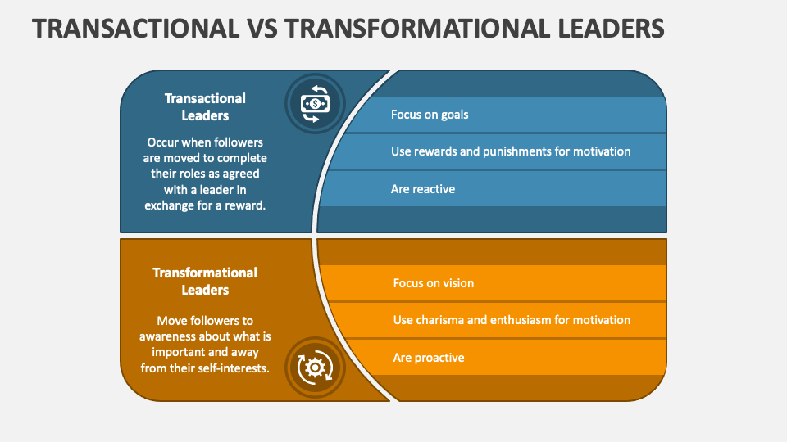
Figure 2: Transformational vs Transactional Leadership
(Source: Abbas and Ali, 2023)
In a similar vein, transformational leadership is often seen as being used by leaders. Without micromanaging, a transformational leader encourages and motivates their followers to increase output (Asbari et al. 2020). Workers are now competent enough to make judgements on their own due to their training. This way of thinking often emerges when employees see a strong business culture and a high degree of autonomy at the top level. The leadership style of Satya Nadella of Microsoft, on the other hand, is characterised by change. By praising people for taking the initiative and seeking out novel solutions—for example, in the creation of Azure Cloud services—Nadella promoted an environment of empowerment and creativity. This style of leadership promotes a culture that values individual decision-making and continual improvement, with an emphasis on long-term growth and employee development.
Development Vs. Achievement
Leaders strive for ongoing self-improvement. They see each obstacle as a chance to grow intellectually and make an effort to expand their knowledge daily. They are always on the lookout for new ways to learn and develop, and they seize each chance they have. Managers, on the other hand, are always trying to improve their abilities and expertise. For success, they stick to tried-and-true methods (Carvajal et al. 2023). A manager responds to changes, but a leader initiates them. Managers are accountable for making the leader's vision a reality.
Risk taker Vs. Risk Averse
Fearlessly blazing a trail across uncharted territory is the mark of a true leader. It is possible to choose leadership. It carries weight as a duty. So, in order to inspire their followers, leaders must sometimes take measured risks. When it comes to the organisation's future, they make the decisions. The opposite is true for managers who actively seek out danger. They are in charge of making sure everything runs well at the company and that the task is done without any problems. Risk management methods should be known to them. After going over these distinctions, a manager and a leader have quite different approaches to work. Plus, no business can function without both. Even more importantly, the nature of the organisation has a role. A managerial style of leadership is better suited to a sector that is rigid and traditional (Pellegrini et al. 2020). In contrast, transformative leadership is crucial for emerging or rapidly developing industries.

Task 2

1. Managing and Leading: Personal and Employability Skills
a) Managing: Getting People to Do What Needs to Be Done
For fast and quality work completion, effective management calls for a mix of particular personal and employable abilities.
Organisational Skills: Being well-organised is the first step in effective management (Klus and Müller, 2021). Managers need strong time management, organisational, and prioritisation skills to keep projects on track and finish on time. As an example, project management software such as Microsoft Project or Asana may be useful for keeping tabs on tasks and their respective due dates (Milojević et al. 2023). Task tracking and project delivery were much improved after introducing similar technologies in my past responsibilities.
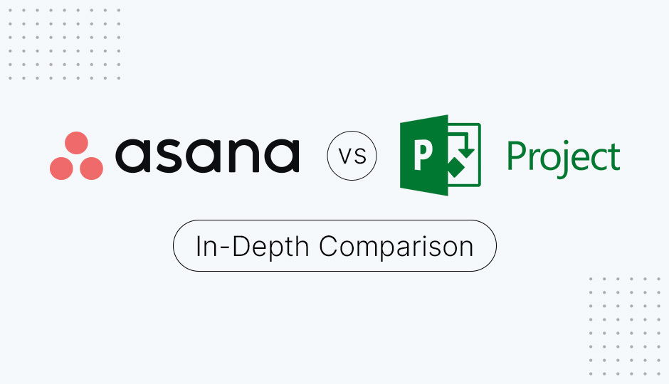
Figure 3: Microsoft Project and Asana
(Source: Milojević et al. 2023)
Communication Skills: The ability to manage requires the ability to communicate clearly and concisely. Managers should guide their teams by providing them with guidance, criticism, and encouragement. By keeping everyone informed and on the same page, good communication helps reduce the likelihood of miscommunication. For instance, in a project with a tight deadline, the team was able to stay focused and on track due to regular and detailed updates (Puscas et al. 2021).
Problem-Solving Skills: Managers need to be able to think on their feet and come up with answers fast when faced with unforeseen obstacles. Problem analysis, choice evaluation, and effective solution implementation are all part of this (Gunawan et al. 2020). On one occasion, I had to deal with an interruption in the supply chain; nonetheless, I was able to keep the project on schedule by swiftly evaluating alternatives and coordinating with suppliers.
Delegation Skills: Effective Management Requires Effective Delegation Skills. The key is to figure out what each team member is good at and then give them work that plays to their strengths. Productivity and quality were both enhanced in an earlier position by assigning duties according to employees' areas of competence.
Performance Monitoring: Managers are obligated to keep tabs on their team's performance and assess it periodically. Conducting performance evaluations, giving constructive criticism, and outlining specific goals are all part of this. My staff was able to pinpoint problem areas and progress professionally once I instituted a frequent feedback loop.
b) Leading: Getting People to Want to Do What Needs to Be Done
On the other side, leadership entails persuading and inspiring others to contribute to organisational objectives voluntarily. This calls for an alternative set of soft talents that employers value:
Inspirational Vision: A leader's job is to paint a picture of the future that inspires their team members and fits in with their values and objectives. To do this, one must first establish a course of action and then motivate others to follow it. At Apple, for instance, Steve Jobs was seen as a visionary leader whose dedication to innovation and enthusiasm for the company's mission drove his people to achieve their best (Kim, 2020).
Emotional Intelligence: A high level of emotional intelligence allows great leaders to be in tune with and in control of their own emotions as well as the emotions of others around them. Possessing this talent is beneficial for creating harmonious relationships, settling disagreements, and encouraging teamwork. Trust and morale were both boosted when I demonstrated that I understood and empathised with the team's problems.
Empowerment: Leaders encourage their team members to take responsibility for their job and provide them the freedom to make choices. Innovative technologies like Gmail and AdSense were born out of Google's "20% time" philosophy, which permits workers to dedicate a part of their workweek to personal projects (Clark, 2022).
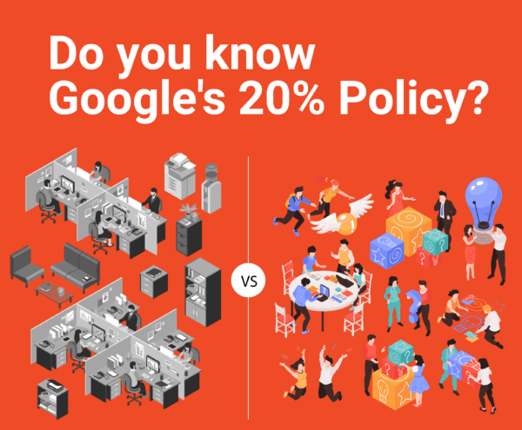
Figure 4: Google’s 20% Policy
(Source: Clark, 2022)
Encouraging Development: Leaders prioritise the development of their team members both personally and professionally. Offering chances for training, mentorship, and professional progression is part of this (Kim and Beehr, 2021). I boosted work satisfaction and retention at a prior position by instituting a mentoring program that allowed employees to gain new skills and progress in their careers.
Building a Positive Culture: Leaders inspire their teams by establishing an environment that is welcoming and accepting of all workers. Achievements, triumphs, and the promotion of a feeling of belonging may all be recognised and celebrated in this way. People are devoted and driven to work for Patagonia because of the company's dedication to environmental sustainability and their own well-being.

2. Development of Skills and Impact on Performance
Individual and organisational performance are both greatly improved by the development of management and leadership abilities.
Enhanced Efficiency and Productivity: Improved operational efficiency is a direct result of competent management. For example, the timely and high-quality completion of tasks is guaranteed by effective organisation, communication, and delegation. Productivity and efficiency saw a marked improvement in my prior employment as a consequence of enhancing organisational processes and using project management technologies.
Improved Employee Engagement and Motivation: Leadership qualities that inspire growth, empower employees and understand the importance of emotional intelligence all work together to make employees more invested in their work (Riyanto et al. 2021). Contributions to organisational objectives are more likely to come from workers who feel appreciated and supported. My team, for instance, saw increased drive and contentment in our work lives once we instituted a system of frequent feedback and acknowledgement.
Increased Innovation and Creativity: Employees are more likely to be bold and creative when they work in an environment that is supportive of their ideas and autonomy, which is created by transformational leadership (Lee et al. 2020). Novel approaches and enhancements may result from this. Significant inventions have been produced by Google's policy of enabling workers to focus on personal projects, illustrating how a culture of support can promote creativity.
Better Conflict Resolution and Problem-Solving: Conflicts and difficulties may be effectively handled with the help of competent management and leadership (Jordan and Troth, 2021). Emotionally intelligent leaders can keep the peace in the office and handle interpersonal disputes with ease, while managers who are good problem solvers can get things done quickly. As a result, activities run more smoothly with fewer interruptions (Assery et al. 2020).
Higher Employee Retention and Satisfaction: Workers are more inclined to remain with a company if they have agency over their work and believe that their advancement is encouraged. There will be less need to hire new employees and pay for their training because of this. Investing in staff development initiatives, for instance, led to reduced turnover rates and a more stable workforce in my previous firm.

Conclusion
Leadership requires empathy and a broad perspective, while management demands organisational prowess and problem-solving prowess. Investing in these skills, which increase motivation, creativity, and efficiency, may improve performance, employee satisfaction, and organisational success. Both roles are critical for the achievement of long-term objectives.

References
- Abbas, M. and Ali, R., 2023. Transformational versus transactional leadership styles and project success: A meta-analytic review. European Management Journal, 41(1), pp.125-142.
- Adigwe, C.S., 2024. Transformational Leadership: A Comparative Exploration of the Leadership Prowess of Jeff Bezos and Steve Jobs. Asian Journal of Economics, Business and Accounting, 24(3), pp.68-89.
- Asbari, M., Santoso, P.B. and Prasetya, A.B., 2020. Elitical and antidemocratic transformational leadership critics: is it still relevant?(A literature study). International Journal of Social, Policy and Law, 1(1), pp.12-16.
- Assery, S., Tjahjono, H.K., Palupi, M. and Dzakiyullah, N.R., 2020. The role of conflict resolution on supply chain performance. International Journal of Scientific and Technology Research, 9(3), pp.4007-4011.
- Carvajal, A.L.P., Sanchez, R.D. and Amihan, S.R., 2023. Probing the Seven Qualities of True Leadership: A Qualitative Investigation of Selected Experienced and Successful Leaders in Various Industries. International Journal of Open-access, Interdisciplinary and New Educational Discoveries of ETCOR Educational Research Center (iJOINED ETCOR), 2(3), pp.898-912.
- Clark, D. (2022) Google’s ‘20% rule’ shows exactly how much time you should spend learning new skills-and why it works, CNBC. Available at: https://www.cnbc.com/2021/12/16/google-20-percent-rule-shows-exactly-how-much-time-you-should-spend-learning-new-skills.html (Accessed: 27 July 2024).
- Gunawan, G., Harjono, A., Nisyah, M.A., Kusdiastuti, M. and Herayanti, L., 2020. Improving Students' Problem-Solving Skills Using Inquiry Learning Model Combined with Advance Organizer. International Journal of Instruction, 13(4), pp.427-442.
- Jordan, P.J. and Troth, A.C., 2021. Managing emotions during team problem solving: Emotional intelligence and conflict resolution. In Emotion and performance (pp. 195-218). CRC Press.
- Kim, H., 2020. Comparison of strategic leadership: Steve Jobs and Tim cook. Business and Management Studies, 6(3), pp.17-25.
- Kim, M. and Beehr, T.A., 2021. The power of empowering leadership: Allowing and encouraging followers to take charge of their own jobs. The International Journal of Human Resource Management, 32(9), pp.1865-1898.
- Klus, M.F. and Müller, J., 2021. The digital leader: what one needs to master today’s organisational challenges. Journal of Business Economics, 91(8), pp.1189-1223.
- Lee, A., Legood, A., Hughes, D., Tian, A.W., Newman, A. and Knight, C., 2020. Leadership, creativity and innovation: A meta-analytic review. European Journal of Work and Organizational Psychology, 29(1), pp.1-35.
- Marquee (2024) Goldman Sachs Marquee, Marquee.gs.com. Available at: https://marquee.gs.com/ (Accessed: 27 July 2024).
- Mickle, T., 2020. How Tim cook made apple his own. The Wall Street Journal, 7.
- Milojević, D., Macuzic, I., Djordjevic, A., Savković, M. and Djapan, M., 2023. COMPARATIVE ANALYSIS OF SOFTWARE TOOLS FOR AGILE PROJECT MANAGEMENT.
- Pellegrini, M.M., Ciampi, F., Marzi, G. and Orlando, B., 2020. The relationship between knowledge management and leadership: mapping the field and providing future research avenues. Journal of Knowledge Management, 24(6), pp.1445-1492.
- Puscas, L., Kogan, J.R. and Holmboe, E.S., 2021. Assessing interpersonal and communication skills. Journal of graduate medical education, 13(2s), pp.91-95.
- Riyanto, S., Endri, E. and Herlisha, N., 2021. Effect of work motivation and job satisfaction on employee performance: Mediating role of employee engagement. Problems and Perspectives in Management, 19(3), p.162.
- Starbucks (2024) ASU Starbucks: Starbucks College Achievement Plan, Starbucks.asu.edu. Available at: https://starbucks.asu.edu/ (Accessed: 27 July 2024).

