Introduction to Web and Database Concepts (ACCA4023_LON)

Module Name: Introduction to Web and Database Concepts
Assignment:2
Assignment title: HTML & CSS Web Development
Module Code: ACCA 4023
Student Name: MOHAMMAD MUKITUR RAHMAN ADNAN
Student ID: 2517206
Group:2
Lecturer’s Name: Dr. Anum Paracha

University of Wales Trinity Saint David
London Campus

Contents
1.Introduction: 1
2. Requirements: 1
3. Implementation: 1
3.1Home page (index.html): 3
3.2 Catania page (Catania.html): 4
3.3 Taormina page (taormina.html): 5
3.4 Etna page (etna.html): 6
3.5 Conatct page (contact.html): 7
4.Validation: 7
4.1 HTML Validation: 8
4.2 CSS Validation: 11
5.Evaluation: 12
5.1. Usability : 12
5.2.Accessibility: 13
5.3.Search Engine Optimisation (SEO) : 13
5.4.Evaluation of (Travel destination) Website: 14
6.Website Comparison (Travel Destination Websites) : 14
7.Conclusion 15
8.References: 16
8. Appendices: 17
A.Index.html: 17
B.catania.html: 18
C. taormian.html: 20
D.etna.html: 22
E.Contact.html: 24
F.Style.css: 25

1.Introduction:
This report presents the architecture and construction of a responsive tourist website showcasing destination in Eastern Sicily, particularly Catania, Taormina, and Mount Etna. When developing the site, I used HTML and CSS in accordance with current web development standards. My goal was to provide a website that allows user easy access to good information related to their trip, with consistent visual appeal across all pages, including the same design elements within all pages to maintain this appeal. User experience principles influenced all key design decisions, including navigation, layout and a mobile-first approach to ensuring that content could be accessed from smaller devices. During the development of the website, we created a large number of pages that were linked to each other, maintained uniformity in terms of styling and made sure that all of the text on the website was easy to understand, thus providing users with a positive browsing experience. This report provides details regarding the requirements , the implementation process used to create the final version of the website, validation procedures that were performed to ensure that the website functioned properly and evaluation methods that were used to be able to determine whether or not the successful implementation of effective web development principles were used to create an effective and user-friendly site [1].

2. Requirements:
This website aims to create an aesthetically pleasing and educational resource for tourists visiting the major areas of Eastern Sicily (Catania, Taormina, and Mount Etna) as well as promote tourism by providing the user with accurate information on attractions and activities offered by each location. Tourist and those who are interested in travel and Italian heritage are target market for this website. This website will need to be responsive to all devices , so the user experience is consistent. The website will consists of multiple pages that will be digitally connected through hyperlinks for easy navigation, all of which will have clear content structures throughout the site. This website is designed in accordance with current standards for usability, accessibility and user experience to increase user to user interaction and improve readability within a web browser [1].

3. Implementation:
The implementation of the website was accomplished using HTML5 and CSS3 by using a structured and modular type of approach to ensure consistent maintenance of the site over time. There were 5 pages of content developed for the site. These pages include Home, Catania, Taormina, Etna and Contact. The use of Semantic HTML elements improves not only the accessibility of the site but the overall organization of the web content as well. The CSS framework was used to develop a consistent layout throughout the site. Additionally, Flexbox was used where needed. Finally, images and text content were organized on the web pages to improve readability and user experience. The development of the website was accomplished by following modern industry website standards which will ensure cross-browser compatibility and performance efficiency for the end user [2]; The following screenshots show the implemented website :

3.1Home page (index.html):
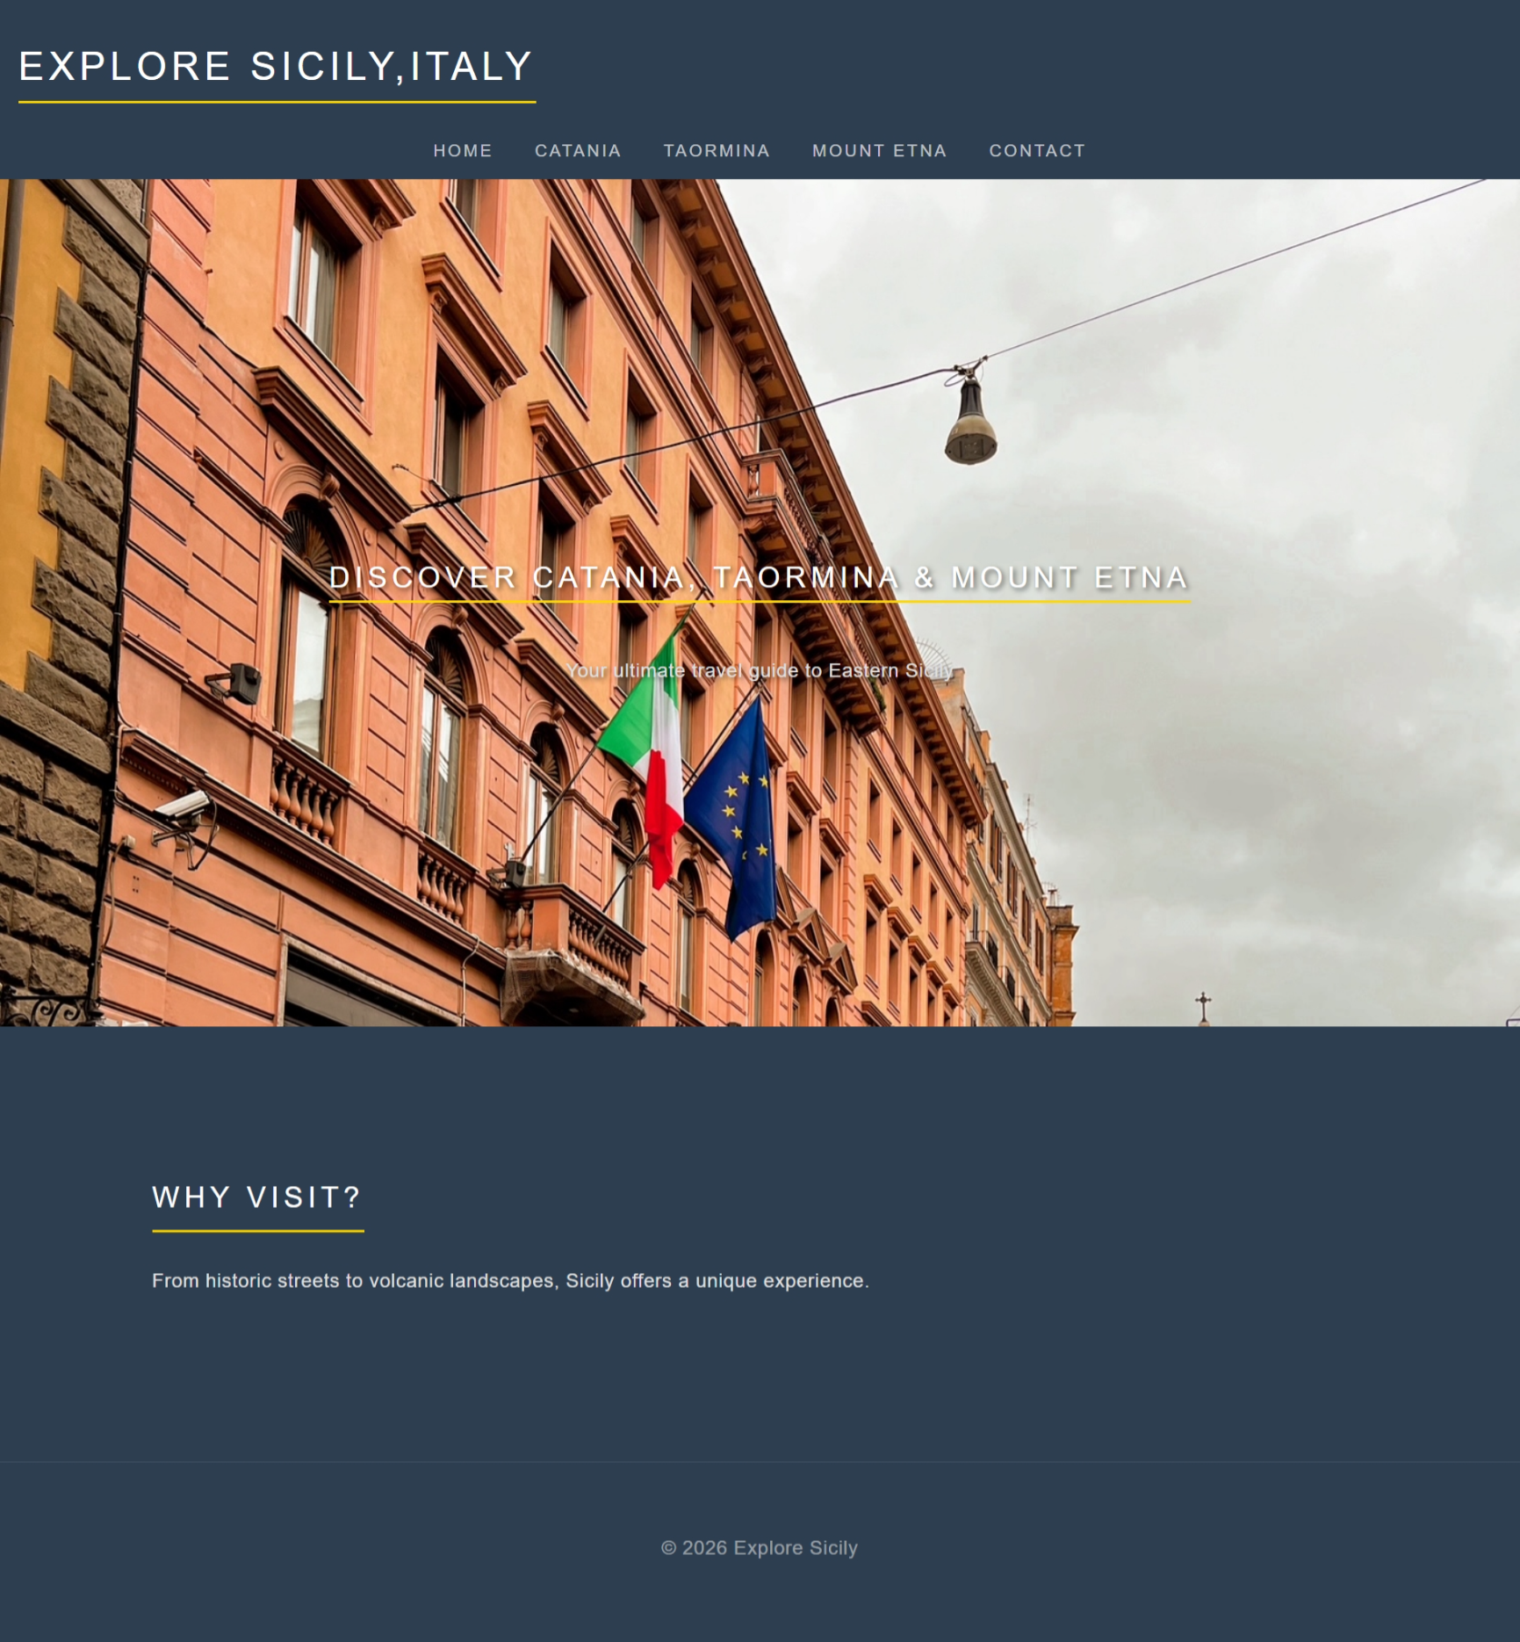
Figure 1: Travel Destination Southern Sicily home page (index.html).

3.2 Catania page (Catania.html):
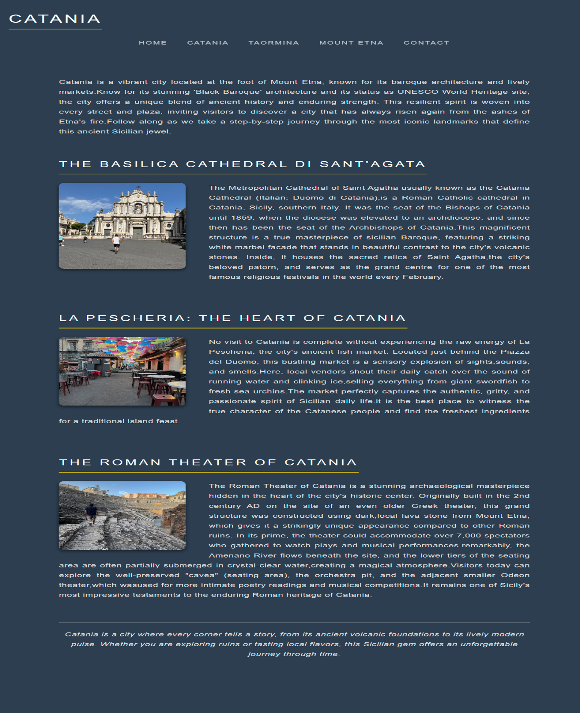
Figure 2: Travel Destination Southern Sicily Catania page (catania.html).

3.3 Taormina page (taormina.html):
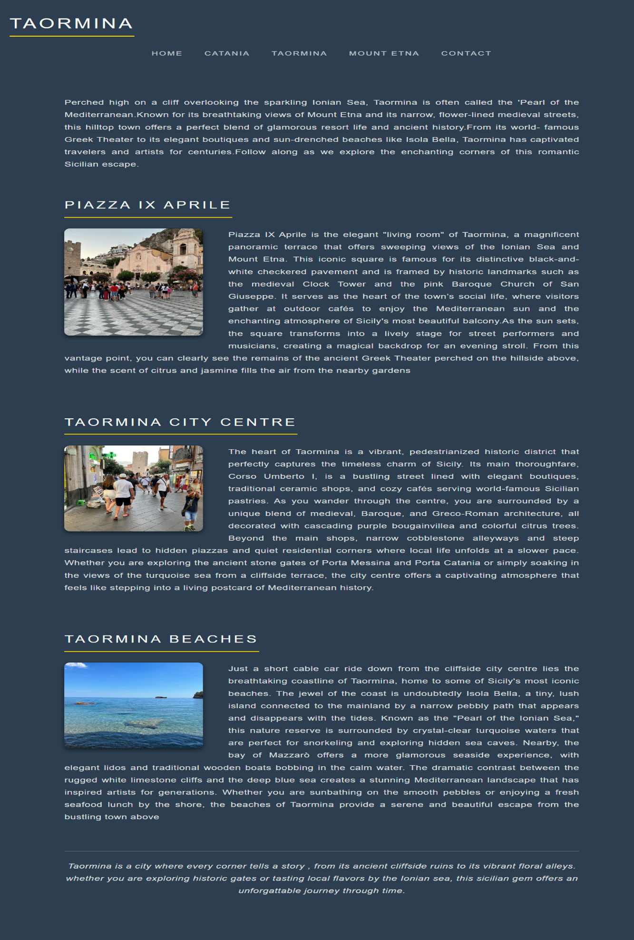
Figure 3: Travel Destination Southern Sicily Taormina page (taormina.html).

3.4 Etna page (etna.html):
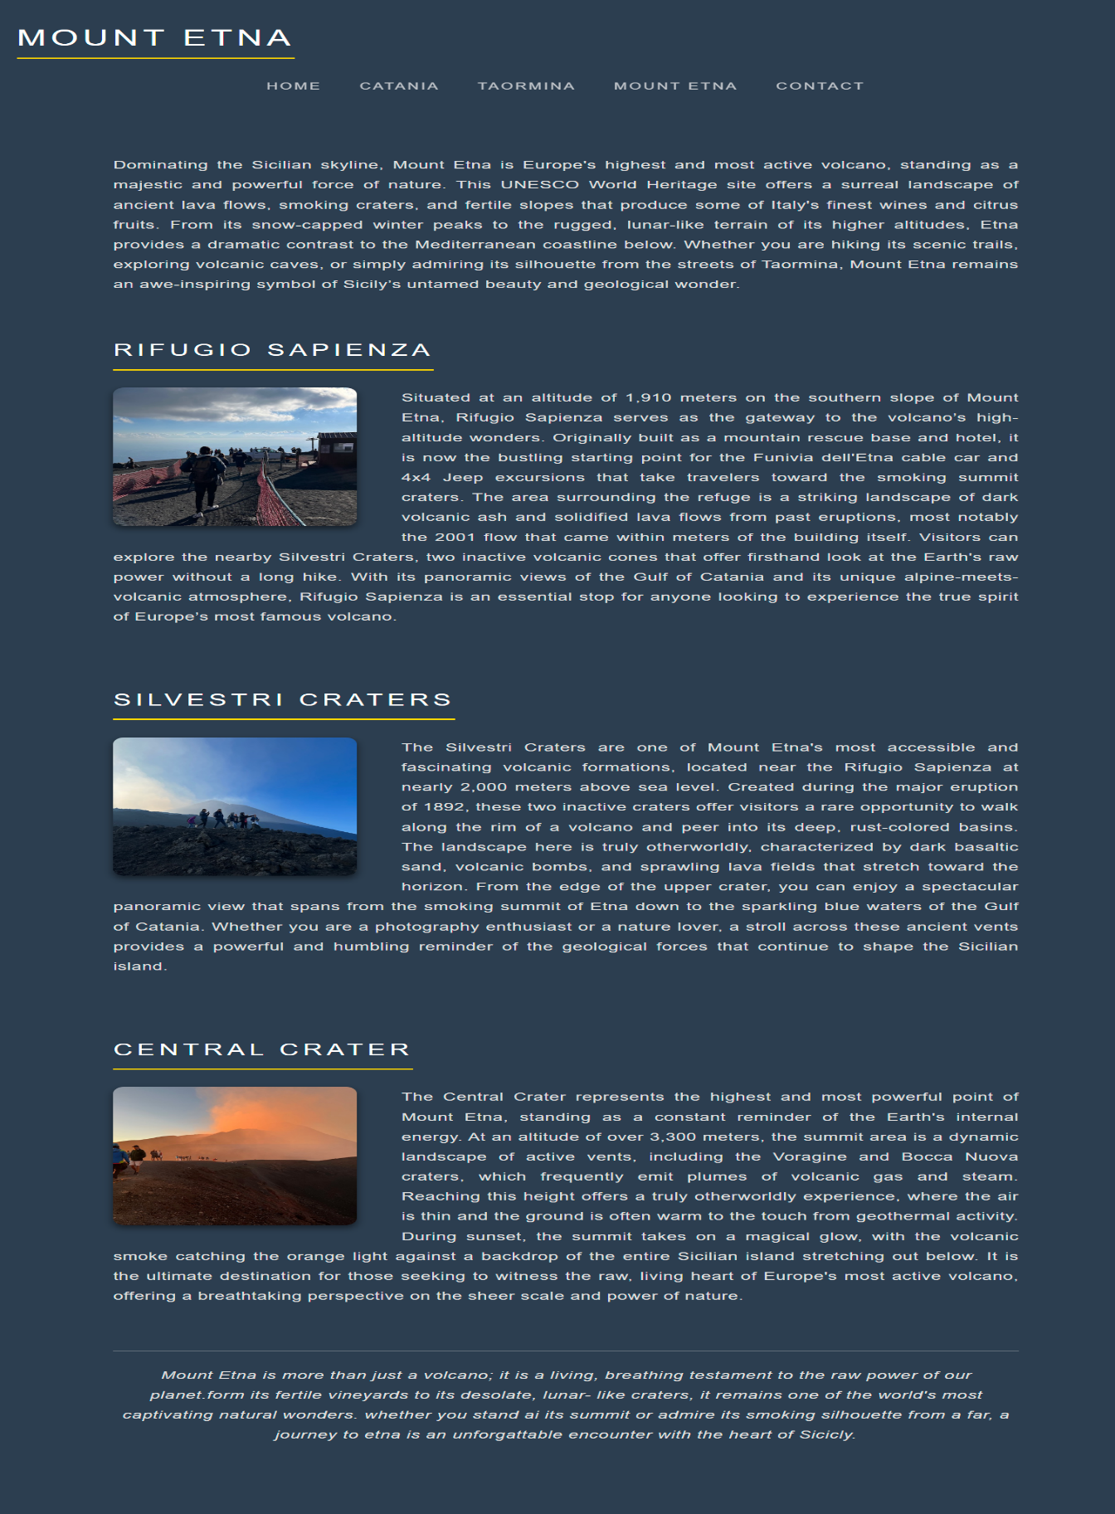Figure 4: Travel Destination Southern Sicily home page etna page(etna.html)

3.5 Contact page (contact.html):
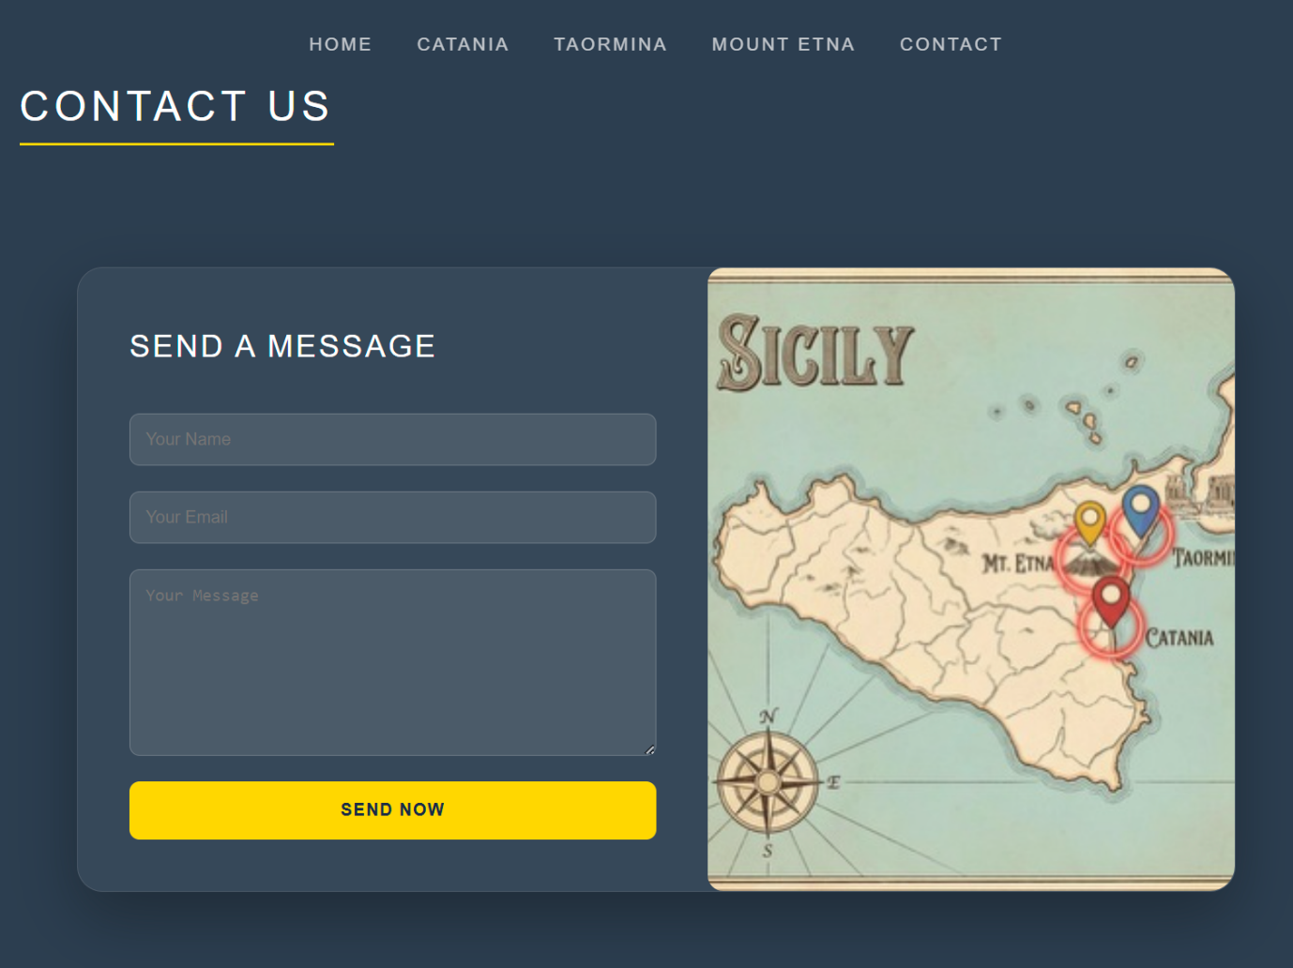
Figure 5 :Travel Destination Southern Sicily Contact page (contact.html).

4.Validation:
Website validity is determined using Validation Tools from the World Wide Web Consortium (W3C): HTML code was valid per W3C Markup Validator and CSS stylesheets were valid per W3C CSS Validation Service during testing. A number of minor issues were found in the code such as no alternative text for images , small syntax errors and improper tag structure . These issues were fixed by updating the code, and making sure to follow proper formatting and semantic structure when creating tags. Several warnings for new CSS properties did exits; however, they didn’t impact how the site functioned or displayed. After all issues were corrected, the website successfully passed validation with no critical errors. Validating code is beneficial because it increase browser compatibility, decreases chance of bugs, and secures that your web site follows the industry accepted standards of web development [3].

4.1 HTML Validation:
The subsequent screenshots provide visual evidence of the successful validation tests for The HTML source code of each webpage:
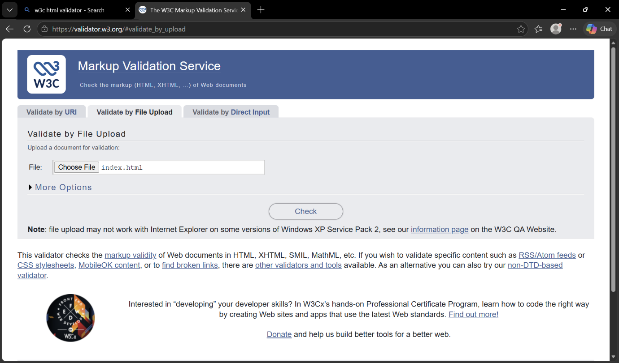
Figure 6: Uploading the source file(index.html) to the W3C markup Validation service.
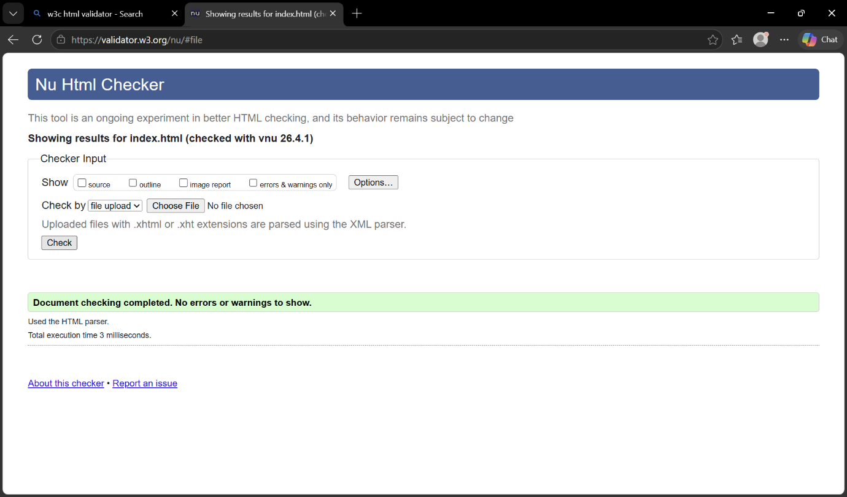
Figure 7: Successful index.html validation result showing no errors or warning.

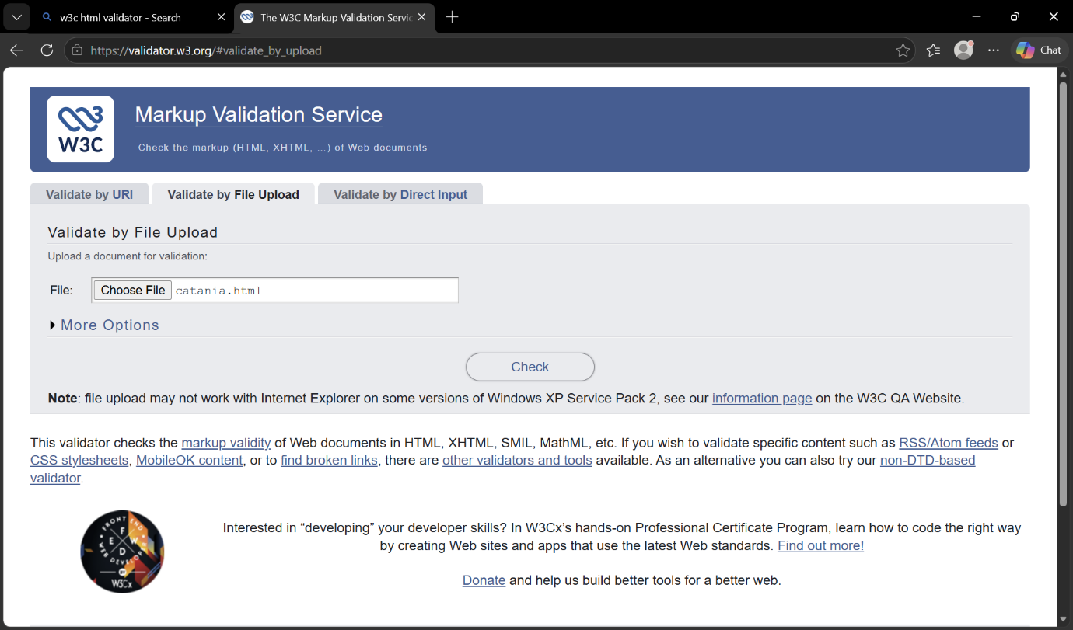
Figure 8: Uploading the source file(catania.html) to the W3C markup Validation service.

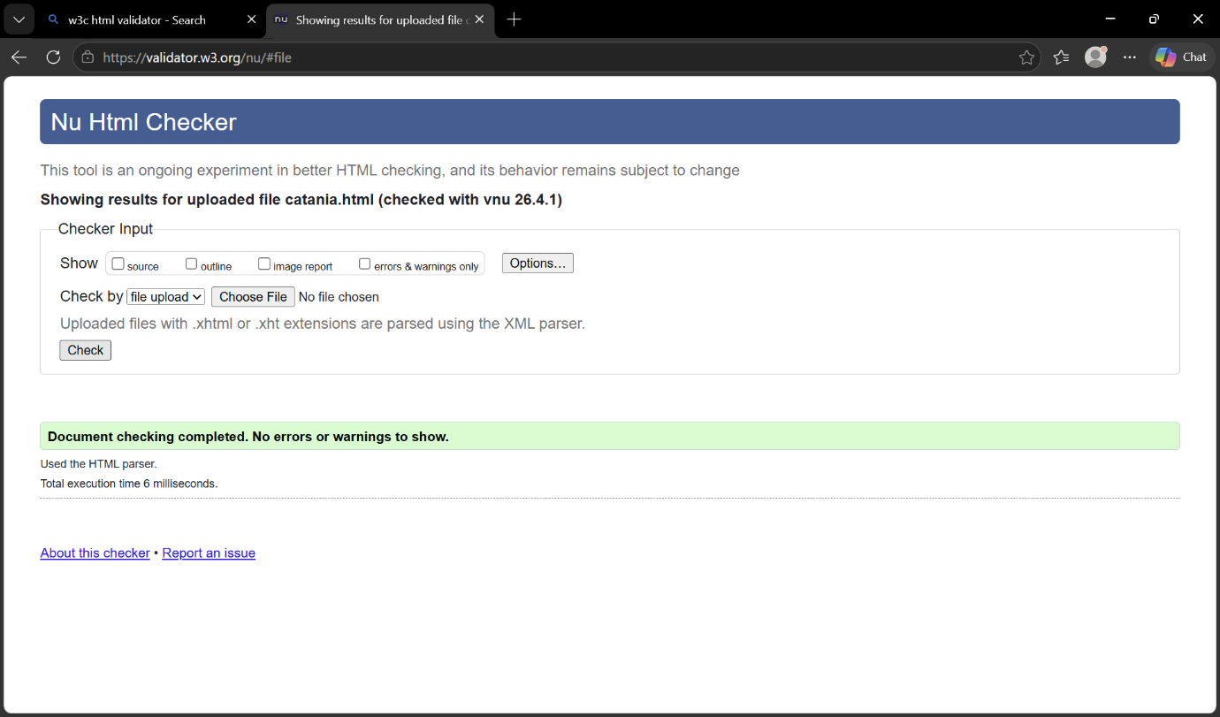
Figure 9: Successful catania.html validation result showing no errors or warning.

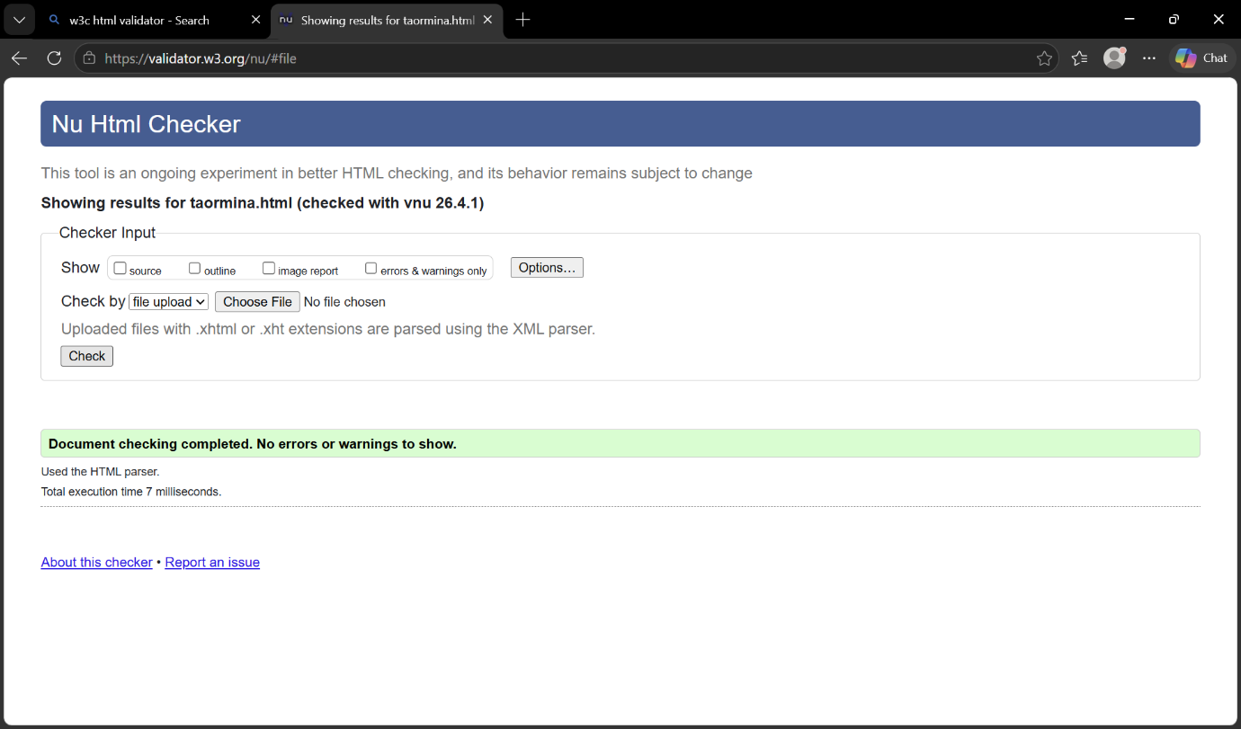
Figure 10: W3C Markup Validation of the Taormina page (taormina.html).

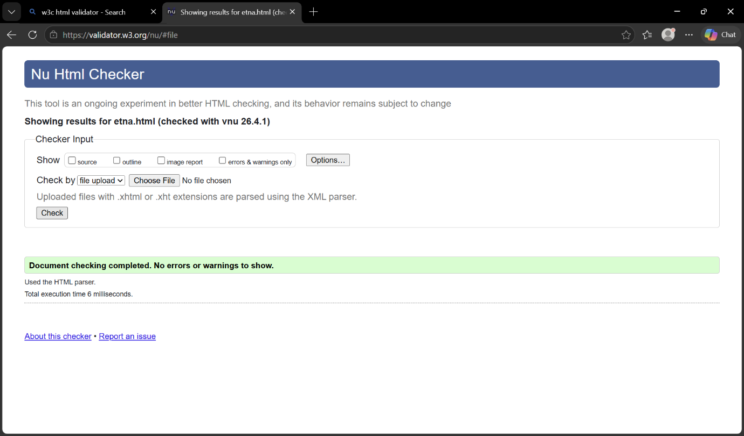
Figure 11: W3C Markup Validation of the Etna page (etna.html).

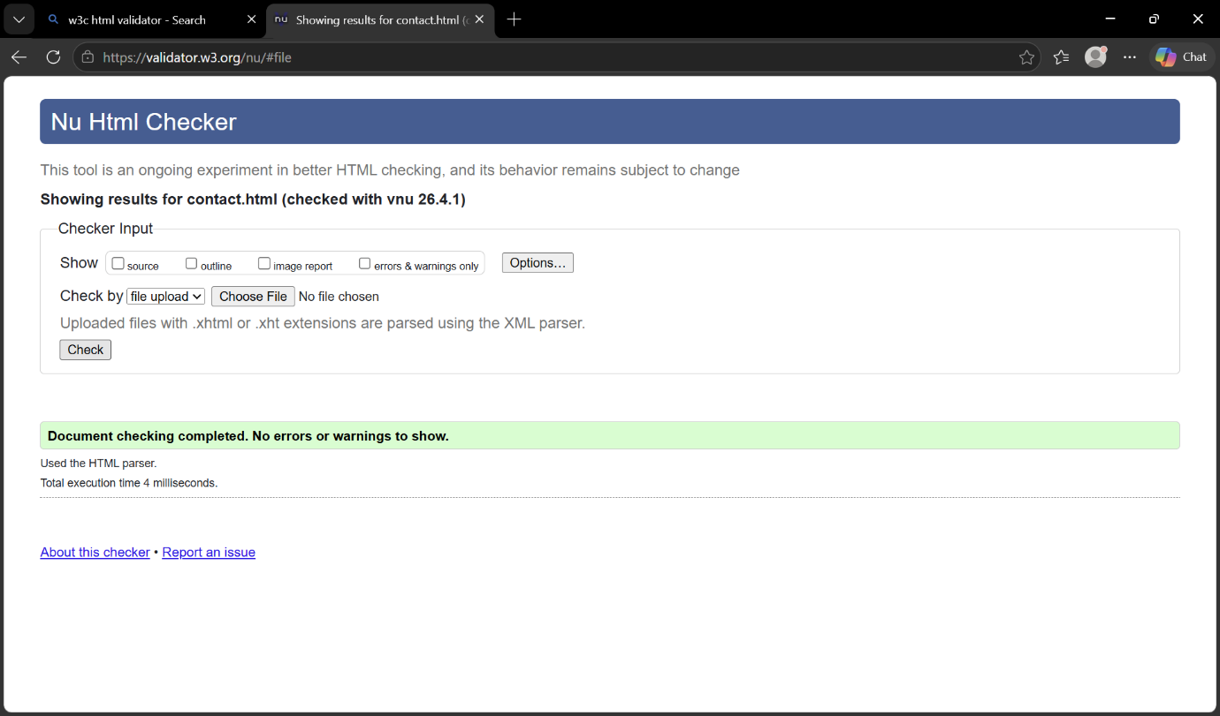
Figure 12: W3C Markup Validation of the Contact page (contact.html).

4.2 CSS Validation:
The stylesheet (style.css) was tested to ensure all design properties were correctly implemented and free form syntax errors.
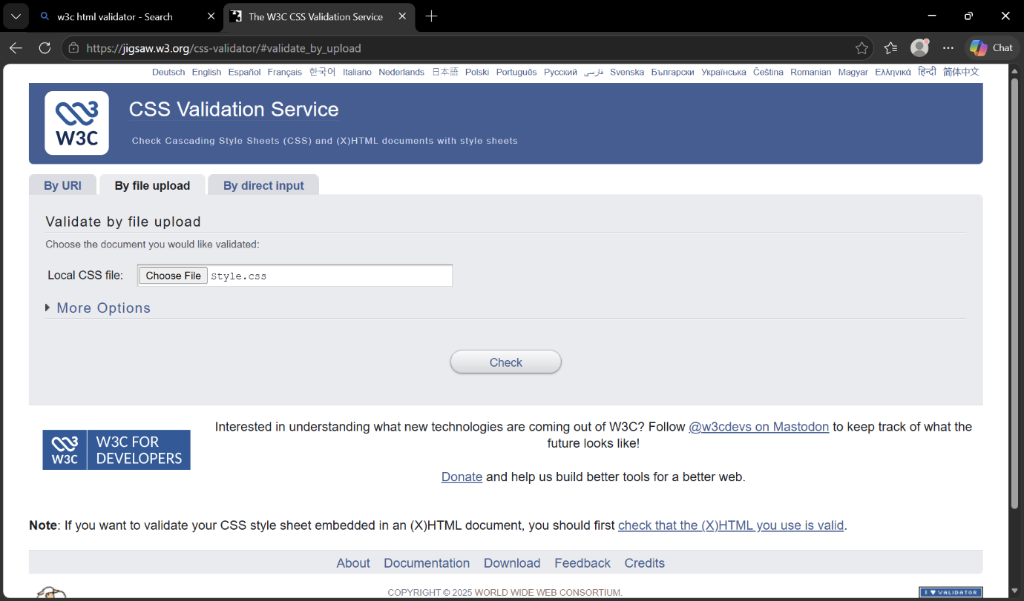
Figure 13: W3C CSS validation service used to check the stylesheet (style.css).

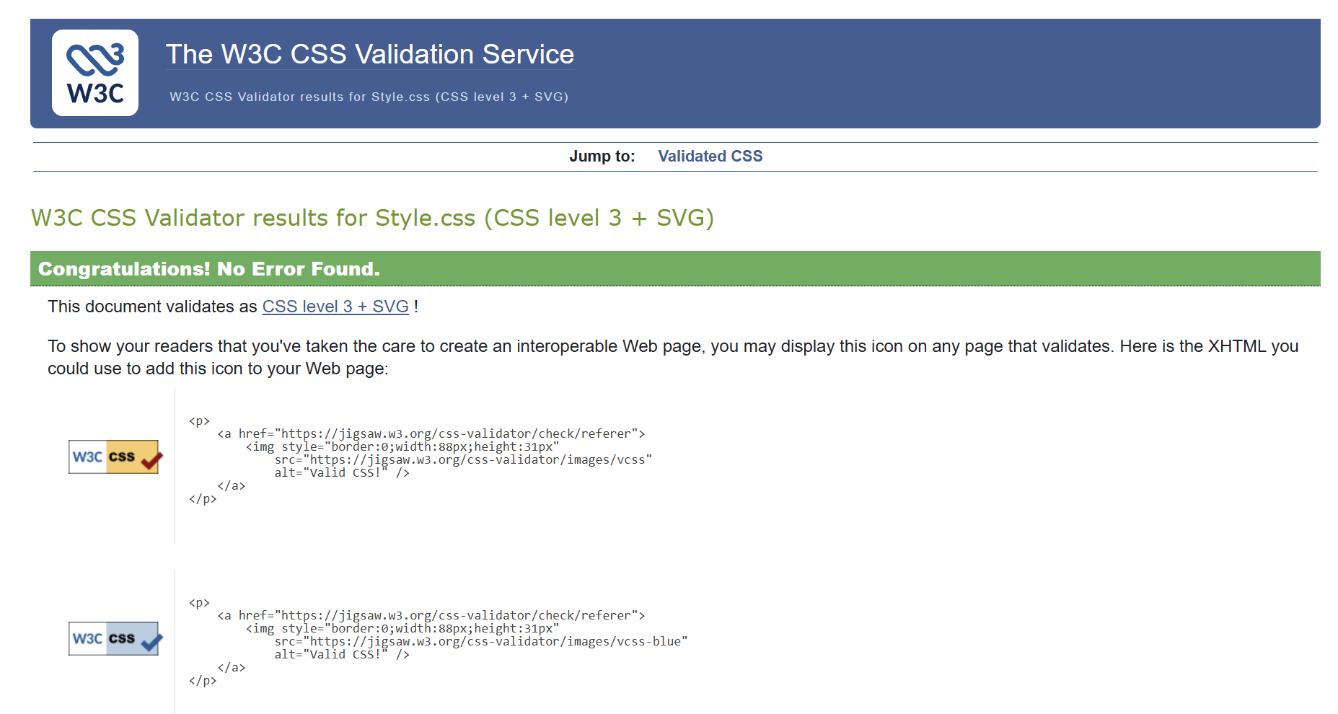
Figure 14: Successful CSS validation result confirming the stylesheet meets W3C standards.

5.Evaluation:

5.1. Usability :
In this project, we addressed usability through providing users with a clear navigation system, a logical structure for each page, and consistent design across all pages. The navigation bar allows users quick access to different area of the site. The content has been formatted using heading and organised in a way that allows for easy reading by users. To encourage user engagement and improve comprehension, we used images text. We also used responsive design techniques to ensure proper function of the site across all screen sizes, including mobile devices. Usability research indicates that websites that are easy to navigate with simple layouts create significantly higher levels of user satisfaction and overall experience than those that do not. According to Steve Krug, users prefer sites that are simples to navigate with little effort as possible [4]. Overall, this website provides adequate usability, although some potential improvements could be made by adding interactivity and improving visual feedback.
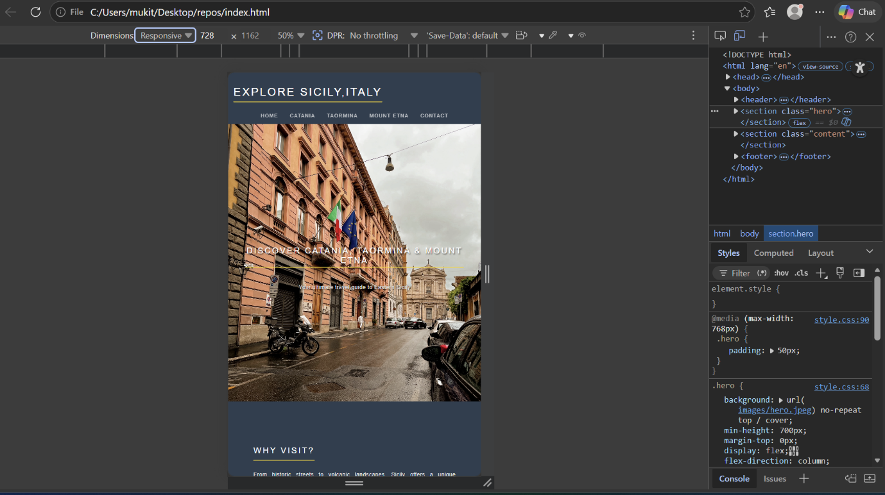
Figure 15: Responsive mobile view of the homepage demonstrating layout adaption for smaller screen sizes.

5.2.Accessibility:
A website’s accessibility refers to those who can use the site regardless of their ability to see, hear or move. As part of this project, an evaluation was performed to assess how well it followed the principles established by the World Wide Web Consortium’s Web Content Accessibility Guidelines Version 2.1 (WCAG 2.1), which were developed using four principles: perceived, operable, understandable and robust. To enhance usability on the website, the website features will easily read fonts, headings to guide users through content and consistent navigation throughout the entire experience. Lastly, order to develop solid website structure all elements within the website will be created using semantic HTML. Contrast checkers and separated browsers extensions were used to identify potential/ accessibility related problems. The website generally complies with basic criteria for accessibility however, additional upgrades could include support for keyboard navigation and more specific ARIA labels. Overall, improving accessibility will create a more inclusive environment for all users and allow for equal access to content[5].
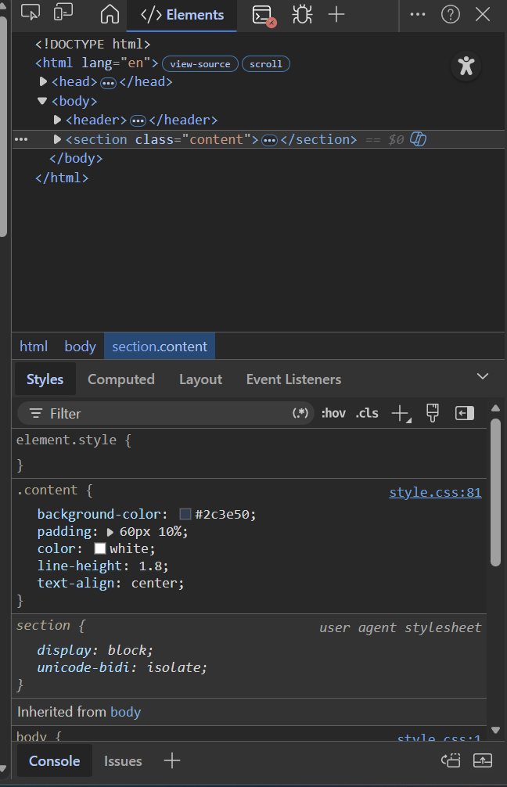
Figure 16: Developer tools view demonstrating semantic HMTL tags and CSS properties for text legibility.
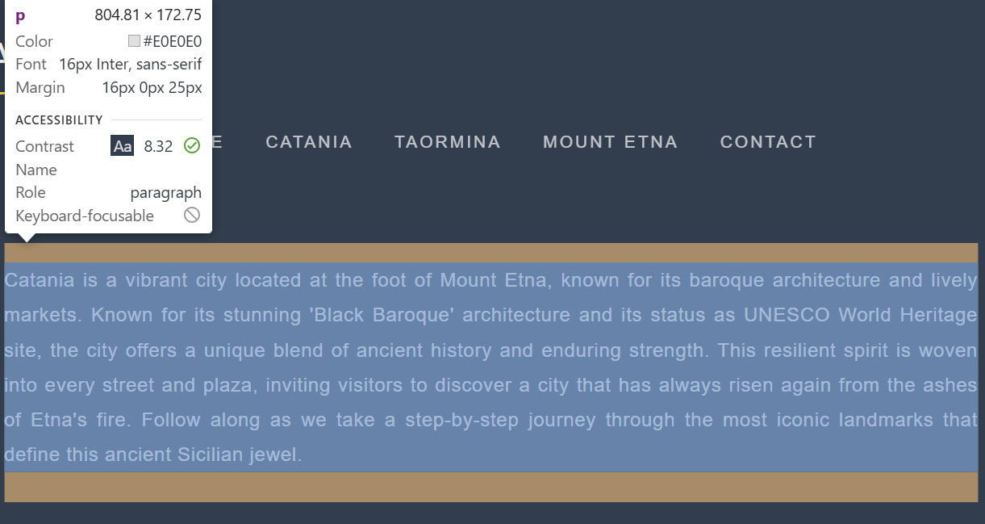
Figure 17: Accessibility audit confirming a contrast ratio of 8;32 for the body text elements.

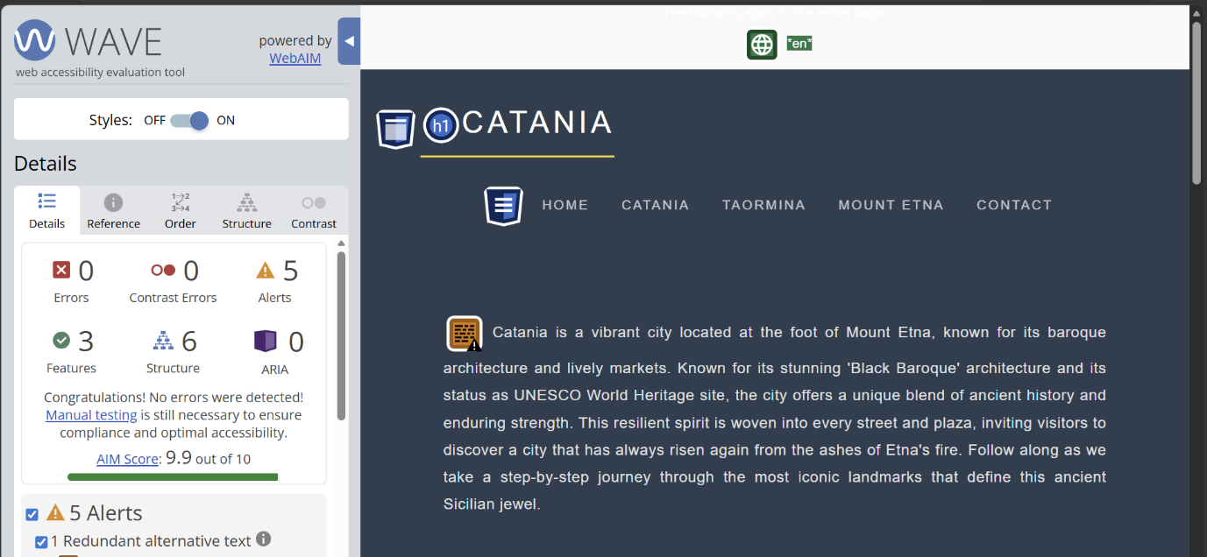
Figure 18: Results of the automated accessibility audit using the wave tool, showing a 9.9/10 score with zero errors.

5.3.Search Engine Optimisation (SEO) :
SEO refers to the various techniques used to help a website perform better in search engines. Within the context of this project, many of these on-page SEO techniques were implemented in order to help the website be more easily found by users. All pages have an appropriate title and headings in a structured format (h1,h2) which helps search engines identify how information on each page is arranged. In addition, meta tags were added to provide a short description of what the page contains to improve indexing and click through rate. Each image has been optimised using appropriate file names and all attributes; this also increase accessibility for users. Interlink between the different pages( Catania, Taormina, Etna, contact) help users navigate the website more easily and allow search engine crawlers to follow the links when they crawl the website. Furthermore, many pages contain clean and semantic HTML code , which allows for easier indexing by search engine. According to research by B. Killoran, well-structured meta content and content structure are very important factors in improving search engine ranking [6]. Overall, the website employs an effective basic approach to optimising all aspects of SEO.
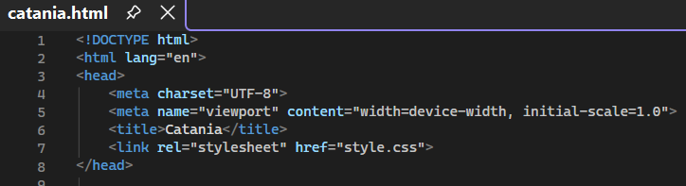
Figure 19: Meta tags and page title for search engine optimization.

Figure 20: SEO-friendly heading structure image alt text.

5.4. Overall Evaluation of (Sicily) Website:
A new website has been designed with a common interface and consistently formatted pages, and with logical navigation between each part. Users can find pages easily; for example, they can easily access the following categories: Home, Catania, Taormina, and Mount Etna. This convenience provides for effective experiences while using the site. The layout of each page is designed so that the use of headings, images and spacing all work together to improve the ease at which a user reads the page and helps to keep a user interested in staying on the page for an extended amount of time. This website has been designed using responsive web design so that it can be accessed easily from different kind of devices. Overall, the usability of this website is very high, but there opportunity for improvement with regards to increasing user engagement adding more features such as animations or dynamic content. The website has implemented alt text and adequate colour contrast in order to ensure accessibility. However more features could be added to support users who rely upon a keyboard for navigation when navigating through the pages of this website. Some basic search engine optimisation has been implemented to help improve search engine visibility. D. Norman, states that "user centred design is crucial to creating effective and engaging digital experiences" [7].

6.Website Comparison (Travel Destination Websites) :
Two travel-oriented websites were compared — Tripadvisor and Lonely Planet — with regard to their usability (ease of use), accessibility (how easily users can access each site), SEO (how well a site ranks) and mobile responsiveness (how well you can view a site on a mobile device). Tripadvisor’s site structure allows for an interactive approach, including allowing users to leave reviews, as well as mobile optimization of content that allows users to easily find a destination. Lonely Planet has a much cleaner layout with more editorial content, however, there is less interaction with the content than on Tripadvisor because users cannot submit reviews.
The two sites are comparable in terms of accessibility with good contrast between colours and readable content. However, the Tripadvisor website has more dynamic features that could affect how some users perceive their respective level of accessibility. When considering Search Engine Optimisation (SEO), both sites use effective Meta tags, headings and keyword rich content that will help increase their ability to rank well in searches.
Both sites provide a good mobile experience due to the ease of use when viewed on a smartphone. As a result, Tripadvisor has a more user-friendly and interactive webpage while Lonely Planet is superior when evaluating the quality, quantity and ease-of-use of the information presented on each page [8].
Both sites have great designs and functionality, but their focus is different from one another. Tripadvisor has a more user-driven, very interactive site, while Lonely Planet has a lot of structured and good-to-know information. Usability and accessibility, as well as SEO, are good for both sites; however, Tripadvisor is better at engaging their users, while Lonely Planet is better at providing users with more specific information on how to travel.

7.Conclusion :
To summarize, this project produced a fully functional responsive website based on contemporary web standards. It accomplished its primary goal by offering thoroughly informative, and engaging content regarding several significant sites in Easten Sicily. During each project phase, the consideration of Usability, Accessibility, and SEO was performed to ensure an enjoyable experience for users when interacting with site. The effectiveness of the website was achieved through structured navigation systems, site-wide responsiveness, and the use of semantic HTML. When validating the website, the processes determined that it complied with standard coding conventions and increased compatibility across varying browsers and devices. Additionally, the evaluation of the project showed both positive aspects and negative aspects of how the project performed. A review of other existing travel websites further supported knowledge of industry conformity and best practices. This initiative was beneficial to all participants by providing helpful guidance regarding developing an environment where all users will benefit. Future improvements will be made by improving the styles used in the application, increasing the number of interactions that users can have with the application and by improving the performance and engagement of application users through additional enhancements.

8.References:
[1] J. N. Robbins, Learning Web Design, 5th ed. Sebastopol, CA, USA: O’Reilly Media, 2018.
[2] J. Duckett, HTML and CSS: Design and Build Websites. Indianapolis, IN, USA: Wiley, 2011.
[3] T. A. Powell, HTML & CSS: The Complete Reference, 5th ed. New York, NY, USA: McGraw-Hill, 2017.
[4] S. Krug, Don’t Make Me Think: A Common Sense Approach to Web Usability, 3rd ed. Berkeley, CA, USA: New Riders, 2014.
[5] W3C, “Web Content Accessibility Guidelines (WCAG) 2.1,” 2018. [Online]. Available: https://www.w3.org/TR/WCAG21/. Accessed: Apr. 2026.
[6] J. L. Ledford, SEO: Search Engine Optimization Bible, 2nd ed. Indianapolis, IN, USA: Wiley, 2009.
[7] D. A. Norman, The Design of Everyday Things, Revised and Expanded ed. New York, NY, USA: Basic Books, 2013
[8] H. M. DeLone and E. R. McLean, “Information systems success: The quest for the dependent variable,” Information Systems Research, vol. 3, no. 1, pp. 60–95, 1992.

9. Appendices:

A.Index.html:
<!DOCTYPE html>
<html lang="en">
<head>
<meta charset="UTF-8">
<meta name="viewport" content="width=device-width, initial-scale=1.0">
<title>Explore Sicily, Italy</title>
<link rel="stylesheet" href="style.css">
<meta name="description" content="Travel guide to Catania, Taormina and Mount Etna">
</head>

<body>

<header>
<h1>Explore Sicily, Italy</h1>
<nav>
<a href="index.html">Home</a>
<a href="catania.html">Catania</a>
<a href="taormina.html">Taormina</a>
<a href="etna.html">Mount Etna</a>
<a href="contact.html">Contact</a>
</nav>
</header>

<section class="hero">
<h2>Discover Catania, Taormina & Mount Etna</h2>
<p>Your ultimate travel guide to Eastern Sicily</p>
</section>

<section class="content">
<h2>Why Visit?</h2>
<p>From historic streets to volcanic landscapes, Sicily offers a unique experience.</p>
</section>

<footer>
<p>© 2026 Explore Sicily</p>
</footer>

</body>
</html>

B.catania.html:
<!DOCTYPE html>
<html lang="en">
<head>
<meta charset="UTF-8">
<meta name="viewport" content="width=device-width, initial-scale=1.0">
<title>Catania</title>
<link rel="stylesheet" href="style.css">
</head>

<body>

<header>
<h1>Catania</h1>
<nav>
<a href="index.html">Home</a>
<a href="catania.html">Catania</a>
<a href="taormina.html">Taormina</a>
<a href="etna.html">Mount Etna</a>
<a href="contact.html">Contact</a>
</nav>
</header>

<section class="content">

<p>
Catania is a vibrant city located at the foot of Mount Etna, known for its baroque architecture and lively markets. Known for its stunning
'Black Baroque' architecture and its status as UNESCO World Heritage site, the city offers a unique blend of ancient history and enduring strength.
This resilient spirit is woven into every street and plaza, inviting visitors to discover a city that has always risen again from the ashes of
Etna's fire. Follow along as we take a step-by-step journey through the most iconic landmarks that define this ancient Sicilian jewel.
</p>
<h2>The Basilica Cathedral di Sant'Agata</h2>
<img src="images/IMG_0029.jpeg" alt="catania cathedral" style="float:left; width:220px; margin-right:40px; margin-bottom:10px;border-radius:10px;
box-shadow: 0 4px 8px rgba(0,0,0,0.5);">
<p>
The Metropolitan Cathedral of Saint Agatha usually known as the Catania Cathedral (Italian: Duomo di Catania),is a Roman Catholic cathedral
in Catania, Sicily, southern Italy. It was the seat of the Bishops of Catania until 1859, when the diocese was elevated to an archdiocese,
and since then has been the seat of the Archbishops of Catania. This magnificent structure is a true masterpiece of Sicilian Baroque, featuring
a striking white marble facade that stands in beautiful contrast to the city's volcanic stones. Inside, it houses the sacred relics of Saint
Agatha, the city's beloved patron, and serves as the grand centre for one of the most famous religious festivals in the world every February.
</p>
<div style="clear:both; margin-bottom: 40px;"></div>
<h2>La Pescheria: The Heart of Catania</h2>
<img src="images/IMG_0035.jpeg" alt="Pescheria Market" style="float:left; width:220px; height:200px; object-fit:cover; margin-right:40px;
margin-bottom:10px; border-radius:10px; box-shadow: 0 4px 8px rgba(0,0,0,0.5);">
<p>
No visit to Catania is complete without experiencing the raw energy of La Pesqueira, the city's ancient fish market. Located just behind the
Piazza del Duomo, this bustling market is a sensory explosion of sights, sounds, and smells. Here, local vendors shout their daily catch over the
sound of running water and clinking ice, selling everything from giant swordfish to fresh sea urchins. The market perfectly captures the authentic,
gritty, and passionate spirit of Sicilian daily life.it is the best place to witness the true character of the Catanese people and find the
freshest ingredients for a traditional island feast.
</p>
<div style="clear:both; margin-bottom: 40px;"></div>
<h2>The Roman Theater of Catania</h2>
<img src="images/roman.jpeg" alt="Roman Theater" style="float:left; width:220px; height:200px ; object-fit:cover; margin-right:40px;
margin-bottom:10px; border-radius:10px; box-shadow: 0 4px 8px rgba(0,0,0,0.5);">
<p>
The Roman Theatre of Catania is a stunning archaeological masterpiece hidden in the heart of the city's historic centre. Originally built in the
2nd century AD on the site of an even older Greek theatre, this grand structure was constructed using dark, local lava stone from Mount Etna, which
gives it a strikingly unique appearance compared to other Roman ruins.
In its prime, the theatre could accommodate over 7,000 spectators who gathered to watch plays and musical performances. remarkably, the Amenano
River flows beneath the site, and the lower tiers of the seating area are often partially submerged in crystal-clear water, creating a magical
atmosphere. Visitors today can explore the well-preserved "cavea" (seating area), the orchestra pit, and the adjacent smaller Odeon theatre, which
was used for more intimate poetry readings and musical competitions. It remains one of Sicily's most impressive testaments to the enduring Roman heritage of Catania.
</p>
<div style="clear:both; margin-bottom: 40px;"></div>
<p style="text-align: center; font-style: italic; border-top: 1px solid rgba(255,255,255,0.3); padding-top: 20px; margin-bottom: 40px;">
Catania is a city where every corner tells a story, from its ancient volcanic foundations to its lively modern pulse.
Whether you are exploring ruins or tasting local flavours, this Sicilian gem offers an unforgettable journey through time.
</p>
</section>
</body>
</html>

C. taormian.html:
<!DOCTYPE html>
<html lang="en">
<head>
<meta charset="UTF-8">
<meta name="viewport" content="width=device-width, initial-scale=1.0">
<title>Taormina</title>
<link rel="stylesheet" href="style.css">
</head>

<body>

<header>
<h1>Taormina</h1>
<nav>
<a href="index.html">Home</a>
<a href="catania.html">Catania</a>
<a href="taormina.html">Taormina</a>
<a href="etna.html">Mount Etna</a>
<a href="contact.html">Contact</a>
</nav>
</header>

<section class="content">

<p>
Perched high on a cliff overlooking the sparkling Ionian Sea, Taormina is often called the 'Pearl of the Mediterranean. Known for its breathtaking views of
Mount Etna and its narrow, flower-lined medieval streets, this hilltop town offers a perfect blend of glamorous resort life and ancient history. From its world-
famous Greek Theatre to its elegant boutiques and sun-drenched beaches like Isola Bella, Taormina has captivated travellers and artists for centuries. Follow along as we explore the enchanting corners of this romantic Sicilian escape.
</p>
<h2>Piazza IX Aprile</h2>
<img src="images/piazza.jpeg" alt="taormina" style="float:left; width:220px; margin-right:40px; margin-bottom:10px;border-radius:10px;
box-shadow: 0 4px 8px rgba(0,0,0,0.5);">
<p>
Piazza IX Aprile is the elegant "living room" of Taormina, a magnificent panoramic terrace that offers sweeping views of the Ionian Sea and Mount Etna.
This iconic square is famous for its distinctive black-and-white checkered pavement and is framed by historic landmarks such as the medieval Clock Tower
and the pink Baroque Church of San Giuseppe. It serves as the heart of the town’s social life, where visitors gather at outdoor cafés to enjoy the
Mediterranean sun and the enchanting atmosphere of Sicily's most beautiful balcony. As the sun sets, the square transforms into a lively stage for street
performers and musicians, creating a magical backdrop for an evening stroll. From this vantage point, you can clearly see the remains of the ancient Greek
Theatre perched on the hillside above, while the scent of citrus and jasmine fills the air from the nearby gardens
</p>
<div style="clear:both; margin-bottom: 40px;"></div>
<h2>Taormina City Centre</h2>
<img src="images/city.jpeg" alt="city centre" style="float:left; width:220px; height:200px; object-fit:cover; margin-right:40px;
margin-bottom:10px; border-radius:10px; box-shadow: 0 4px 8px rgba(0,0,0,0.5);">
<p>
The heart of Taormina is a vibrant, pedestrianized historic district that perfectly captures the timeless charm of Sicily. Its main thoroughfare, Corso
Umberto I, is a bustling street lined with elegant boutiques, traditional ceramic shops, and cozy cafés serving world-famous Sicilian pastries. As you
wander through the centre, you are surrounded by a unique blend of medieval, Baroque, and Greco-Roman architecture, all decorated with cascading purple
bougainvillea and colourful citrus trees. Beyond the main shops, narrow cobblestone alleyways and steep staircases lead to hidden piazzas and quiet
residential corners where local life unfolds at a slower pace. Whether you are exploring the ancient stone gates of Porta Messina and Porta Catania or
simply soaking in the views of the turquoise sea from a cliffside terrace, the city centre offers a captivating atmosphere that feels like stepping into
a living postcard of Mediterranean history.
</p>
<div style="clear:both; margin-bottom: 40px;"></div>
<h2>Taormina Beaches</h2>
<img src="images/sea.jpeg" alt="taormina beaches" style="float:left; width:220px; height:200px ; object-fit:cover; margin-right:40px;
margin-bottom:10px; border-radius:10px; box-shadow: 0 4px 8px rgba(0,0,0,0.5);">
<p>
Just a short cable car ride down from the cliffside city centre lies the breathtaking coastline of Taormina, home to some of Sicily's most iconic beaches.
The jewel of the coast is undoubtedly Isola Bella, a tiny, lush island connected to the mainland by a narrow pebbly path that appears and disappears with
the tides. Known as the "Pearl of the Ionian Sea," this nature reserve is surrounded by crystal-clear turquoise waters that are perfect for snorkelling and
exploring hidden sea caves. Nearby, the bay of Mazzaro offers a more glamorous seaside experience, with elegant lidos and traditional wooden boats
bobbing in the calm water. The dramatic contrast between the rugged white limestone cliffs and the deep blue sea creates a stunning Mediterranean
landscape that has inspired artists for generations. Whether you are sunbathing on the smooth pebbles or enjoying a fresh seafood lunch by the shore, the
beaches of Taormina provide a serene and beautiful escape from the bustling town above
</p>
<div style="clear:both; margin-bottom: 40px;"></div>
<p style="text-align: center; font-style: italic; border-top: 1px solid rgba(255,255,255,0.3); padding-top: 20px; margin-bottom: 40px;">
Taormina is a city where every corner tells a story , from its ancient cliffside ruins to its vibrant floral alleys. whether you are exploring historic gates
or tasting local flavours by the Ionian sea, this Sicilian gem offers an unforgettable journey through time.
</p>
</section>
</body>
</html>

D.etna.html:

<!DOCTYPE html>
<html lang="en">
<head>
<meta charset="UTF-8">
<meta name="viewport" content="width=device-width, initial-scale=1.0">
<title>Mount Etna</title>
<link rel="stylesheet" href="style.css">
</head>

<body>

<header>
<h1>Mount Etna</h1>
<nav>
<a href="index.html">Home</a>
<a href="catania.html">Catania</a>
<a href="taormina.html">Taormina</a>
<a href="etna.html">Mount Etna</a>
<a href="contact.html">Contact</a>
</nav>
</header>

<section class="content">

<p>
Dominating the Sicilian skyline, Mount Etna is Europe's highest and most active volcano, standing as a majestic and powerful force of nature. This
UNESCO World Heritage site offers a surreal landscape of ancient lava flows, smoking craters, and fertile slopes that produce some of Italy's finest wines
and citrus fruits. From its snow-capped winter peaks to the rugged, lunar-like terrain of its higher altitudes, Etna provides a dramatic contrast to the
Mediterranean coastline below. Whether you are hiking its scenic trails, exploring volcanic caves, or simply admiring its silhouette from the streets of
Taormina, Mount Etna remains an awe-inspiring symbol of Sicily’s untamed beauty and geological wonder.
</p>
<h2>Rifugio Sapienza</h2>
<img src="images/rif.jpeg" alt="rif sap" style="float:left; width:220px; height:200px; object-fit:cover; margin-right:40px; margin-bottom:10px; border-radius:10px;
box-shadow: 0 4px 8px rgba(0,0,0,0.5);">
<p>
Situated at an altitude of 1,910 meters on the southern slope of Mount Etna, Refugio Sapienza serves as the gateway to the volcano’s high-altitude wonders.
Originally built as a mountain rescue base and hotel, it is now the bustling starting point for the Funivia dell'Etna cable car and 4x4 Jeep excursions
that take travellers toward the smoking summit craters. The area surrounding the refuge is a striking landscape of dark volcanic ash and solidified lava flows
from past eruptions, most notably the 2001 flow that came within meters of the building itself. Visitors can explore the nearby Silvestri Craters, two inactive
volcanic cones that offer firsthand look at the Earth's raw power without a long hike. With its panoramic views of the Gulf of Catania and its unique
alpine-meets-volcanic atmosphere, Refugio Sapienza is an essential stop for anyone looking to experience the true spirit of Europe’s most famous volcano.
</p>
<div style="clear:both; margin-bottom: 40px;"></div>
<h2>Silvestri Craters</h2>
<img src="images/etna1.jpeg" alt="silverstri" style="float:left; width:220px; height:200px; object-fit:cover; margin-right:40px;
margin-bottom:10px; border-radius:10px; box-shadow: 0 4px 8px rgba(0,0,0,0.5);">
<p>
The Silvestri Craters are one of Mount Etna's most accessible and fascinating volcanic formations, located near the Rifugio Sapienza at nearly 2,000 meters
above sea level. Created during the major eruption of 1892, these two inactive craters offer visitors a rare opportunity to walk along the rim of a volcano
and peer into its deep, rust-coloured basins. The landscape here is truly otherworldly, characterized by dark basaltic sand, volcanic bombs, and sprawling
lava fields that stretch toward the horizon. From the edge of the upper crater, you can enjoy a spectacular panoramic view that spans from the smoking
summit of Etna down to the sparkling blue waters of the Gulf of Catania. Whether you are a photography enthusiast or a nature lover, a stroll across
these ancient vents provides a powerful and humbling reminder of the geological forces that continue to shape the Sicilian island.
</p>
<div style="clear:both; margin-bottom: 40px;"></div>
<h2>Central Crater</h2>
<img src="images/etna2.jpeg" alt="central" style="float:left; width:220px; height:200px ; object-fit:cover; margin-right:40px;
margin-bottom:10px; border-radius:10px; box-shadow: 0 4px 8px rgba(0,0,0,0.5);">
<p>
The Central Crater represents the highest and most powerful point of Mount Etna, standing as a constant reminder of the Earth's internal energy. At an altitude
of over 3,300 meters, the summit area is a dynamic landscape of active vents, including the Voragine and Bocca Nuova craters, which frequently emit plumes of
volcanic gas and steam. Reaching this height offers a truly otherworldly experience, where the air is thin and the ground is often warm to the touch from
geothermal activity. During sunset, the summit takes on a magical glow, with the volcanic smoke catching the orange light against a backdrop of the entire
Sicilian island stretching out below. It is the ultimate destination for those seeking to witness the raw, living heart of Europe's most active volcano,
offering a breathtaking perspective on the sheer scale and power of nature.
</p>
<div style="clear:both; margin-bottom: 40px;"></div>
<p style="text-align: center; font-style: italic; border-top: 1px solid rgba(255,255,255,0.3); padding-top: 20px; margin-bottom: 40px;">
Mount Etna is more than just a volcano; it is a living, breathing testament to the raw power of our planet. form its fertile vineyards to its desolate, lunar-
like craters, it remains one of the world's most captivating natural wonders. whether you stand ai its summit or admire its smoking silhouette from a far,
a journey to etna is an unforgettable encounter with the heart of Sicily.
</p>
</section>
</body>
</html>

E.Contact.html:
<!DOCTYPE html>
<html lang="en">
<head>
<meta charset="UTF-8">
<meta name="viewport" content="width=device-width, initial-scale=1.0">
<title>Contact</title>
<link rel="stylesheet" href="style.css">
</head>

<body>

<header>
<nav>
<a href="index.html">Home</a>
<a href="catania.html">Catania</a>
<a href="taormina.html">Taormina</a>
<a href="etna.html">Mount Etna</a>
<a href="contact.html">Contact</a>
</nav>
<h1>Contact Us</h1>
</header>
<section class="content" style="display: flex; justify-content: center; padding: 60px 20px;">

<div style="display: flex; background: rgba(255, 255, 255, 0.05); border-radius: 20px; overflow: hidden; box-shadow: 0 20px 50px rgba(0,0,0,0.3);
max-width: 900px; width: 100%; border: 1px solid rgba(255, 255, 255, 0.1);">
<div style="flex: 1; padding: 40px;">
<h2 style="margin-top: 0; border: none; font-size: 24px; letter-spacing: 2px;">SEND A MESSAGE</h2>
<form style="display: flex; flex-direction: column; gap: 20px;">
<input type="text" placeholder="Your Name" style="padding: 12px; background: rgba(255,255,255,0.1); border: 1px solid rgba(255,255,255,0.2);
border-radius: 8px; color: white;">
<input type="email" placeholder="Your Email" style="padding: 12px; background: rgba(255,255,255,0.1); border: 1px solid rgba(255,255,255,0.2);
border-radius: 8px; color: white;">
<textarea placeholder="Your Message" style="padding: 12px; background: rgba(255,255,255,0.1); border: 1px solid rgba(255,255,255,0.2);
border-radius: 8px; color: white; height: 120px;"></textarea>
<button type="submit" style="background: #ffd700; color: #1a2a44; font-weight: bold; border: none; padding: 15px;
border-radius: 8px; cursor: pointer; text-transform: uppercase; letter-spacing: 1px;">SEND NOW</button>
</form>
</div>
<div style="flex: 1; display: flex; align-items: center; justify-content: center;">
<img src="images/map.jpg" alt="Sicily Map" style="width: 100%; height: 100%; object-fit: cover;">
</div>
</div>
</section>
</body>
</html>

F.Style.css:
body {
background-color: #2c3e50;
margin: 0;
padding: 0;
color: white;
}

header {
background: #2c3e50;
color: white;
padding: 15px;
}
h1 {
font-family: 'Inter', sans-serif;
font-weight: 300;
letter-spacing: 4px;
text-transform: uppercase;
color: #ffffff;
border-bottom: 2px solid #ffd700;
display: inline-block;
padding-bottom: 10px;
margin-bottom: 20px;
}
p {
font-family: 'Inter', sans-serif;
line-height: 1.8;
font-size: 16px;
color: #e0e0e0;
margin-bottom: 25px;
letter-spacing: 0.5px;
text-align: justify;
}
img {width: 350px;
height: 250px;
object-fit: cover;
border-radius: 12px;
}
nav {
margin-top: 10px;
text-align: center;
}

nav a {
color: white;
margin: 0 15px;
text-decoration: none;
font-size: 14px;
font-weight: 500;
text-transform: uppercase;
letter-spacing: 2px;
font-family: 'Inter', sans-serif;
transition: all 0.3s ease;
opacity: 0.7;
}
h2, h3 {
font-family: 'Inter', sans-serif;
font-weight: 300;
letter-spacing: 4px;
text-transform: uppercase;
color: #ffffff;
border-bottom: 2px solid #ffd700;
display: block;
width: fit-content;
padding-bottom: 5px;
margin-top: 60px;
margin-bottom: 25px;
}
.hero {
background: url('images/hero.jpeg') no-repeat top/cover;
min-height: 700px;
margin-top: 0px;
display: flex;
flex-direction: column;
justify-content: center;
align-items: center;
color: white;
text-align: center;
text-shadow: 2px 2px 4px rgba(0,0,0,0.6);
}

.content {
background-color: #2c3e50;
padding: 60px 10%;
color: white;
line-height: 1.8;
text-align: center
}

@media (max-width: 768px) {
.hero {
padding: 50px;
}

nav {
display: block;
}
}
footer {
background-color: #2c3e50;
color: white;
text-align: center;
padding: 40px 20px;
margin-top: 50px;
font-family: 'Inter', sans-serif;
font-size: 14px;
letter-spacing: 1px;
border-top: 1px solid rgba(255, 255, 255, 0.1);
}

footer p {
opacity: 0.6;
text-align: center;
width: 100%

}

