

Student Name: Ionut Claudiu Ungureanu
Student ID: 2323114
Module: Principles Concept of Finance
Lecturer: Christine Joy
Assignment title: Budgeting Principles and Approaches
Word count: 4000
Submission deadline: 23rd March 2026 at 23:59
Executive Summary
Silver Stitch Ltd is a chain of high-quality casual dress retail outlets and it is facing immediate financial stress due to having a current overdraft of £30,000, the bank has required the overdraft to be cleared by the end of December. To this end, the firm has conducted a thorough review of the firm financial plans within a six months period, with a focus on the budgeting and the financial control mechanisms. This report is aimed at preparing important budgets, examining the financial status of the company and analysing the effectiveness of the traditional budgeting methods in a dynamic retail competitive setting.
The cash budget analysis shows that the business addresses its liquidity limitations, although initially, its financial situation is poor, but gradually the business state gets better, and the overdraft is completely removed within the given time frame. Monthly changes in cash flows between months on the other hand show timing problems between inflows and outflows and specifically because of credit terms and planned capital expenditures. Regarding the profitability aspect, the firm shows high profitability performance due to its steady gross profit margin of 40% thus generating a profitable net profit within the six months period.
However, some of the issues that the business is struggling with include increasing inventory stock, a strain on working capital, and high outflows in the form of refurbishment and operation expenses. These problems highlight the need to have better financial planning and increased control on resources. It is advised that the management should focus on better management of their inventory, economies of their operation, and move towards more adaptable budgeting methodologies to enhance the liquidity and the efficiency of their operations.

TABLE OF CONTENTS
1. Introduction 4
2. Methodology and Assumptions 4
3. Financial Analysis 5
3.1 Stock Budget Analysis 5
3.2 Cash Budget Analysis 6
3.3 Profitability Analysis 8
4. Problems and Management Actions 9
4.1 Problems Identified 9
4.2 Recommended Actions 9
5. Budgeting and Behavioural Issues 10
5.1 Conditions for Successful Budgeting 10
5.2 Behavioural Considerations 11
6. Critical Evaluation of Traditional Budgeting 11
6.1 Weaknesses of Traditional Budgeting 11
6.2 Strategic Limitations 12
6.3 Modern Alternatives 13
6.4 Critical Conclusion 13
7. Conclusion 13
Reference List 15

1. Introduction
Silver Stitch Ltd is a retail organisation with twelve stores which deals with high-quality casual wear. As a company in a rather competitive retail industry, the company has to constantly juggle profitability, and effective working cash. Retail companies are, in fact, faced with special issues caused by micromotions of demand, inventory needs and the necessity to invest in the presentation of their stores and the customer experience constantly. Budgeting plays a significant part in such an environment in terms of financial stability and aid in strategic decision-making.
This report aims mainly to determine the financial performance and status of Silver Stitch Ltd in reference to six months, between July and December. This is the preparation of major financial budgets that consist of a stock budget, cash budget and a budgeted profit and loss account. These budgets offer an organised platform on future performance projection, likely financial risks, as well as to support managerial decisions.
Besides the preparation of such budgets, the report will analyse the financial position of the company, as part of its task, in terms of liquidity, profitability and the efficiency of operations. This analysis helps to highlight some of the main problems that could affect the business in the short run with reference to the need to abolish the current overdraft. In addition to that, the report assesses the usefulness of traditional budgeting systems in facilitating organisational performance, especially in a fast-paced business environment.
The timeframe that can be considered is the month of July to December wherein this is a decisive time period that the firm can revise its financial position. This report focuses on cash management and strategic planning since it is noted that profitability cannot exist without the appropriate liquidity. The report through this analysis aims to give insights and recommendations in order to help the management stabilise, as well as achieve long-term success.

2. Methodology and Assumptions
The budgeting and analysis in this report is pegged on a series of financial principles and the information provided in the case of Silver Stitch Ltd. One of the major assumptions made in the calculations is benchmarking gross profit of 40 percent, which presupposes that cost of sales is 60 percent of the total sales revenue. Such a relationship is always used over the six months to get the cost of goods sold and assist in preparing the profit and loss account (Abdi and Mutswenje, 2023).
The terms of credit are very crucial in deciding when cash will flow. On the assumption that the suppliers of stock allow one month on credit, purchases made within the current month would be paid within the next month. On the same note, selling costs are projected to be paid after a period of one month. Administration expenses on the other hand are regarded to be paid during the same month which they occurred (Ramadhan and Rosmawati, 2022). These time lags play a vital role in creating a proper cash budget and in the liquidity position of the company.
Depreciation that is a part of the administration expenses is considered as a non-cash transaction and therefore, not included in the cash budget but the profit and loss account only. The percentage of credit card transactions is 35% of total sale and 2.5% charge is charged on this percentage. This is added as an expense on the profit and loss account and subtracted like cash inflows in the cash budget.
Other assumptions made are the presence of no bad debts, which means that all sales have been collected successfully, and that everything has proceeded smoothly in terms of operations during the period, and there is no great occasion of disruptions. Non-coding rounding has been altered by making minor adjustments, where there is a need to make things easy (Nasri et al., 2022). These assumptions provide the consistency and make the analysis of the financial performance and the position of the company clear and structured.

3. Financial Analysis

3.1 Stock Budget Analysis
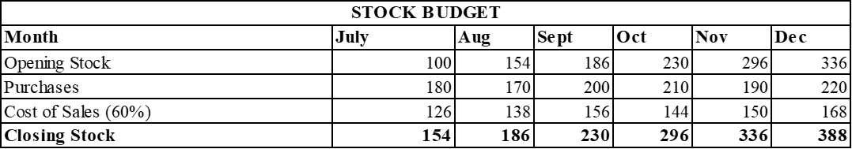
Figure 1: Stock Budget
(Source: Self-Created)
The stock budget of Silver stitch LTD shows that the inventory levels of Silver stitch LTD are expected to rise significantly with a consistent increase during the six months period. The growth of the opening stock is between 100,000 in July to 336,000 in December whereas that of closing stock is between 154,000 in July to 388,000 in December. This trend of increase indicates that sales of inventory are continually higher than the amount of sales demanded and accumulate inventory on a monthly basis (Okeke et al., 2024).
This tendency indicates that the company is buying more items than it is selling which gives rise to the concerns over the excessive purchases. Although having adequate inventory is necessary in a retail business to fulfil what the customers desire and theoretically help prevent any stock outages, having too much inventory may cause operational inefficiencies. The fact that the closing stock is constantly increasing shows that the business is not necessarily harmonising its buying decisions with the actual sales demand.
One of the implications of this growing inventory is its effect on cash flow. Inventory is yet another ingredient of the working capital and the high inventory levels bind up cash that could otherwise be utilised to meet the operational requirements or even the investment opportunities (Isibor et al., 2022). In this instance, stockkeeping pressure will strain the liquidity particularly when other cash outflows, including refurbishment and loan repayments are added to it.
Moreover, the stock budget suggests potential inefficiency of inventory planning and control. The underutilization of increasing stocks in making purchases is an indicator that the company might not be applying proper demand forecasting and inventory control. This may cause the risks of obsolescence, high costs in storing and low long term profits. On the whole, the stock budget shows that there should be more control over the level of inventory to enhance operational effectiveness as well as cash management.

3.2 Cash Budget Analysis
The cash budget will give a closer look at the liquidity position of Silver Stitch ltd within the six-month period and will also point out the vital trends in cash inflows and outflows. July opens with an overdraft of 30000 pounds and this tells us that there exists an initial cash deficit and strain on the company (Adhikara et al., 2022). But the business shortly stabilises and an appreciable end in cash of £0.16k is achieved at the end of July and the overdraft actually does not come to pass as soon as projected.
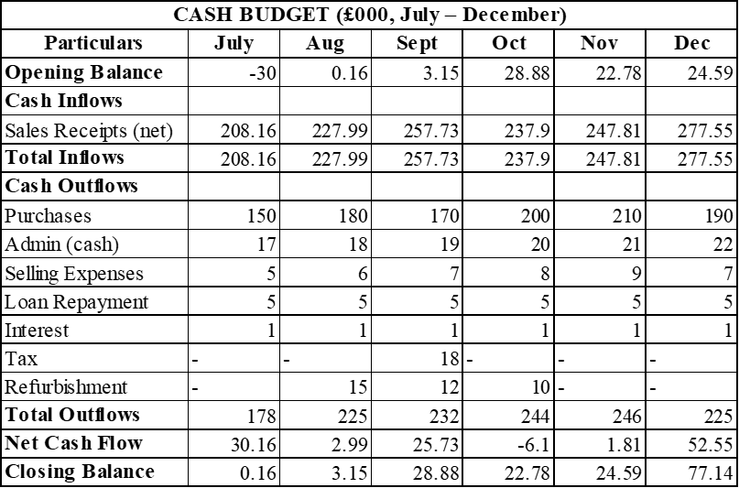
Figure 2: Cash Budget
(Source: Self-Created)
During the period, the cash inflows are also reported to be robust and to a certain extent steady because of the regular receipts of sales. The inflows are also constant as monthly they fluctuate between 208.16k in July and 277.55k in December. This high inflow will be helpful in enhancing the cash position of the firm in the long run.
Cash outflows on the other hand differ in the months depending on the time difference and extra expenses. Some of the common outflows are purchases, management expenses, sales expenses, loan payment and interest payments. Moreover, it has major one-off outflows like taxation during September, renovation expenditures during the months of August, September and October. Such extra payments cause a variation in the net cash flow (Mawad et al., 2022).
One of the outstanding features of the cash budget is the negative net cash flow at the month of October at -6.1k. This is mainly attributed to the high cost of purchase and refurbishment costs that continue to be spent on. Although this is a short-term strain, the company has a positive closing balance because of the good cash position made in the preceding months. This is a sign of strength in the liquidity management of the company.
In general, the business has shown a better cash position as it closes the year on a healthy balance at the end of December of 77.14k. The analysis reveals that the firm can generate a sufficient amount of cash as well as the fact that it is sensitive to the timing of inflows and outflows (Namazi and Rezaei, 2024). Good cash flow planning is necessary in order to prevent a shortage of cash in months where expenditure is high.

3.3 Profitability Analysis
The projected profit and loss account shows that Silver stitch Ltd is financially profitable within six months of period. The total amount of sales revenue is £1,470,000, and the gross profit is 40 per cent of which the overall gross profit is only 588,000. This implies good pricing and cost management at the gross profit level which is an affirmative development to the business.
The analysis of operating expenses however reveals that a substantial part of this gross profit is consumed in costs (Chukwuma-Eke et al., 2022). The administration costs including depreciation is 159, 000 as compared to selling costs of 45,000. Also costs of credit cards amounting to £13,000 also decrease profitability. The overall operating costs are not less than 217 000 pounds with only the operating profit of 371 000 pounds.
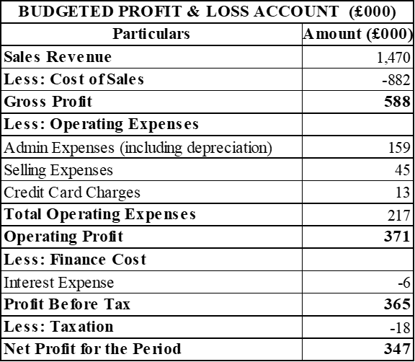
Figure 3: Budget Profit & Loss Statement
(Source: Self-Created)
There are finance costs, which are interest costs amounting to 6000, then the profit before tax will be 365.000. After taxing the profit of £18000, the net profit realisation is 347,000 where the period denotes the period ending on the 26th of December 2008. This proves that the business is not incurring its expenses but is also making a large profit.
No matter how profitable it is (this is very much so), it is worth mentioning that profitability does not always mean liquidity. The previous cash budget analysis reveals that the company experiences a fluctuation in cash flow because of the differences in timing and huge expenses in some months (Nkwinika and Akinola, 2023). This underlines the most important lesson of the fact that the business is not only profitable but also is close to the management of the cash flow.

4. Problems and Management Actions

4.1 Problems Identified
The financial analysis exposes a number of the fundamental problems that SilverStitchLtd will encounter within a six-month span. Cash flow pressure especially in the start up days of the period is one of the main concerns as we have the overdraft of the company operating on an overdraft of £30,000. The overdraft would be cleared out in a short time but the business still faces the risk of being exposed to the changing cash flow because of timing differences between the inflows and the outflows (Prasetia, 2023).
The other serious problem is the constant rise in the inventory levels. The stock budget reveals that the balance of closing stock is increasing consistently every month which shows that the company is carrying more stock than it requires. This is wasted working capital since some of the money is held back in stock instead of being used in other requirements of the operations.
The business is also faced with high fixed costs. Administration fees and loan payment are continuous financial obligations which cannot be covered by the sales performance. These fixed expenses make financial flexibility less and the risk of any loss in revenue more significant.
Moreover, capital spending on store refurbishment over-imposes an extra generated charge on cash funds (Taiwo, 2022). Although such investments might be required to drive long term growth, such investments lead to short term liquidity problems especially when combined with other outflows like taxation and operating costs.

4.2 Recommended Actions
In order to deal with these difficulties, a number of management measures might be taken. Financially, the company may re-evaluate decisions on capital expenditure and postpone some projects on refurbishment or implement the same in phases to cut down the cash outlays in the short run. The cash flow could also be enhanced by negotiating with suppliers on long credit terms which would hold up payment and alleviate the short term burden.
One of the priorities should be the improvement of inventory turnover (Güngör Göksu, 2023). This can be done through aligning the purchasing decisions with the sales in terms of forecasting and minimizing the stock level at the end of the budget year. A good inventory management would unlock the money tied up in inventory and enhance the general liquidity.
Operationally, there is an urgent need to have a more efficient demand forecasting and more restrictive measures of cost control. With the right forecasting of the customers, the company would be able to optimize inventories and decrease wastage. The management of both administrative and selling costs have the potential to increase the profitability and lessen the unwarranted fiscal interference as well (Mursalin and Utama, 2025).
The business may also work on strategic areas of enhancing pricing policies as well as ensuring the sales are more efficient. It can be through specific promotions, better customer relationships and more product offerings. The company will be in a position to enhance profitability and cash flow as the revenue will increase, and expenses will not rise significantly.

5. Budgeting and Behavioural Issues

5.1 Conditions for Successful Budgeting
To have a successful budgeting system in an organisation like the Silver Stitch Ltd, there are a number of requirements to be met. Among the most significant ones, there is strong management support at the higher-level (Al Frijat et al., 2024). The top management should ensure that the budgeting process is taken seriously, through the top managers being actively involved in the budget making and allowing the budget to be matched with the strategic goals of the organisation. Without this support, the budgets can be seen as being very insignificant or even administrative in nature, and thus they fail to be effective.
Budgeting must also have clear goals. The budgets are to be formulated with specific and achievable objectives like bettering the cash flow, curbing the cost, or raising the profitability. Clear goals allow employees to understand what is required of them and the way their quality of performance is going to be measured (Wang et al., 2022). Such transparency also leads to increased focus and accountability within the organisation.
In the achievements of the budgeting systems, the role played by employee participation is immense. When budgets are prepared taking into consideration their participation the employees are able to offer their ideas and opinions especially those operating at the ground level. This does not only enhance accuracy of budget but also raises the level of commitment and acceptance by the individuals as they have a feeling of ownership to the targets which are set.
Another very important requirement is realistic goals. The over-ambitious budgets will become a discouragement to the employees, but on the flip side, overly easy targets will cause complacency. Setting attainable but not too difficult targets motivates employees to give their best performance and at the same time their own morale and motivation is heightened (Gunawan et al., 2023).
There also needs to be effective communication where the budgets are being communicated and implemented in the right way. The management should clearly communicate expectations, assumptions, and changes of plans to all the employees concerned. This assists in preventing misunderstanding and ensures that all are being drawn to the common organisational goals.

5.2 Behavioural Considerations
As much as budgeting is an important management tool, it may bring about behavioural problems in an organisation. A typical problem is a budgetary slack that is characterised by employees underestimating their ability or inflating the costs during budgetary determination. The behaviour is stemmed by the fact that the employees might desire to have targets that are easy to hit hence raise their chances of receiving positive appraisals (Ali and Shabn, 2024). Nonetheless, this slack may manifest itself in interaction of resources and poor organisational performance.
Another factor of behaviour of importance is motivation. When the budgets are seen to be unrealistic or unachievable, the employees are likely to feel discouraged and demotivated. As an example, when sales objectives are established too ambitious without reference to market circumstances, the employees will think that their work will not bear fruit, which will also lead to reduced productivity and regulated interest (Safitri and Syahrin, 2024).
Another reason for resistance toward change may occur when there are new budgeting systems or methods. It is possible that employees who have been used to working in a traditional way will not be willing to embrace new practices, especially without understanding the full benefits. This can decrease the pace of implementation of better budgeting techniques and constrain their performance.
The second major concern is that it is important to note that managers tend to prioritise short term set targets at the expense of long term organisational objectives. When performance is conditioned mainly according to budgetary goals, managers can decide to focus on all activities to enhance short-term performances, like reducing necessary investments, or postponing necessary expenditure (Cuadrado-Ballesteros and Bisogno, 2022). This practise is damaging to the long-term growth and sustainability of the organisation.

6. Critical Evaluation of Traditional Budgeting

6.1 Weaknesses of Traditional Budgeting
The traditional budgeting systems have been of use in most organisations over the number of years, but of late, most organisations have been heavily criticised on their drawbacks especially in volatile businesses. Among the major weaknesses, there is that the process is usually time-consuming and resource-consuming (Doublefin, 2023). Annual budgeting consumes a lot of effort among the management and the staff which may not always translate into commensurate gains.
The other constraint is that the traditional budgeting is mostly grounded on past data. Such a dependence on last performance is based on the fact that the next time the market will be similar, and this is not always true in dynamic markets. As a result, budgets can soon come to be old fashioned and irrelevant (qubit.capital, 2026).
Absence of flexibility is a huge issue. When budgets have been developed, they are often inflexible during the whole duration, regardless of whether the external conditions may have changed. This inflexibility may make organisations not react well to new opportunities or threats and hence decreases their competitiveness.
There is also a probability of promotion of inflexible behaviour among managers in traditional budgeting. Since performance can be evaluated based on set targets, managers can become shortsighted in tracking budgetary numbers as opposed to adjusting to evolving situations. This may restrain innovation and discourage young decision making.

6.2 Strategic Limitations
Along with the weaknesses of traditional budgeting, there are also a number of strategic limitations of this method. It also tends to put more emphasis on the cost management over the value creation which limits the organisation's capabilities to chase growth opportunities (bluecopa, 2024). With a focus on working within the set budget, the management can fail to embrace innovative ideas that need further investment.
Conventional budget products are not very helpful in innovation because they deter innovations and experimentation. The managers are likely to decline to work towards new initiatives unless they are factored in the budget even when the new initiatives have the potential to generate long term value.
Moreover, conventional budgetary processes may restrict the responsiveness of organisations. Their strategies must not be adapted slowly because businesses have to respond to developing conditions in a fast changing environment (Biondi and Russo, 2022). But strict budget systems lead to the inability to shift resources or change plans, limiting the effectiveness of the organisation to react.

6.3 Modern Alternatives
As a reaction to the weaknesses of traditional budgeting, a number of new methods have been created. A rolling budget is one method that is used to update budgets continuously all year round. Rather than making set budgets every year, organisations stretch the budget term towards the end of time, enabling them to produce more realistic budgets that are more relevant (Nkwinika and Akinola, 2023).
The other alternative which also needs expenses to be justifiable is the zero-based budgeting which involves justifying expenses by starting anew, as opposed to basing on past budgets. This will make cost evaluation more critical and will assist in removing unwarranted spending.
Beyond budgeting is a more radical methodology in that it recommends eliminating budgets altogether. It emphasises on decentralised decision-making, constant performance appraisal, and increased flexibility (Güngör Göksu, 2023). This will be done in an effort to make an organisation more adaptive and responsive, as befits the contemporary business environments.

6.4 Critical Conclusion
In summary, despite the fact that traditional budgeting is still a helpful control and planning tool, it is no longer sufficient to handle the demands of the contemporary business environments. It is too inflexible, is based on past information, and emphasises immediate objectives to be met, which are appealing to strategic decision-making and adaptability of organisations (Gunawan et al., 2023).
Nevertheless, old-fashioned budgeting cannot be completely abandoned. Rather it is required to be modified and complemented with more adaptable and progressive methods. Combining the aspects of the latest budgeting methods, organisations like Silver Stitch Ltd will develop their potential to react effectively to the change, be able to perform better, and live successfully in the long run.

7. Conclusion
The financial position analysis of Silver Stitch Ltd over the six as a half-period shows a business that is basically profitable but the issue is how to control the cash flow and working capital. Although the company manages to remove its overdraft and to create a good closing cash balance, the changes in the monthly cash flows and the growth in the inventory levels are a pointer to issues.
The potential risks include, among others, ineffective management of inventory, high fixed costs, and the effects of and a large amount of capital bottles on liquidity. These problems prove that profitability is not the only requirement of financial stability and proper cash management is the key to sustainable operations.
The analysis of budgeting practices also signifies the critical relevance of the strategies that are more flexible and strategic. Best practices in budgeting traditional practices, though still valuable, might not be able to cater to the requirements of a dynamic retailing environment.

Reference List
Abdi, M. B., and Mutswenje, V. S. (2023). Budgetary process and financial performance of manufacturing firms listed in the Nairobi Securities Exchange, Kenya. International Academic Journal of Economics and Finance, 3(9), 288-308.
Adhikara, A., MF, M., and Nur Diana, M. B. (2022). Organizational performance in environmental uncertainty on the Indonesian healthcare industry: A path analysis. Academic Journal of Interdisciplinary Studies, 11(2), 365-377.
Al Frijat, Y. S., Albawwat, I. E., and Elamer, A. A. (2024). Exploring the mediating role of corporate social responsibility in the connection between board competence and corporate financial performance amidst global uncertainties. Corporate Social Responsibility and Environmental Management, 31(2), 1079-1095.
Ali, N., and Shabn, O. S. (2024). Customer lifetime value (CLV) insights for strategic marketing success and its impact on organizational financial performance. Cogent Business & Management, 11(1), 2361321.
Biondi, L., and Russo, S. (2022). Integrating strategic planning and performance management in universities: a multiple case-study analysis. journal of management and governance, 26(2), 417-448.
bluecopa, (2024), The Ultimate Guide You Shouldn’t Miss On Budget Variance Analysis, [Online] Available from: https://www.bluecopa.com/blog/the-ultimate-guide-you-shouldnt-miss-on-budget-variance-analysis [Accessed 13 march, 2026]
Chukwuma-Eke, E. C., Ogunsola, O. Y., and Isibor, N. J. (2022). A conceptual framework for financial optimization and budget management in large-scale energy projects. International Journal of Multidisciplinary Research and Growth Evaluation, 2(1), 823-834.
Cuadrado-Ballesteros, B., and Bisogno, M. (2022). Budget transparency and financial sustainability. Journal of Public Budgeting, Accounting & Financial Management, 34(6), 210-234.
Cuadrado-Ballesteros, B., and Bisogno, M. (2022). Budget transparency and financial sustainability. Journal of Public Budgeting, Accounting & Financial Management, 34(6), 210-234.
Doublefin, (2023), The Role of Budget Analysis in Strategic Financial Planning, [Online] Available from: https://www.doublefin.com/blog-posts/the-role-of-budget-analysis-in-strategic-financial-planning [Accessed 10 March, 2026]
Gunawan, A., Jufrizen, J., and Pulungan, D. R. (2023). Improving MSME performance through financial literacy, financial technology, and financial inclusion. International Journal of Applied Economics, Finance and Accounting, 15(1), 39-52.
Güngör Göksu, G. (2023). A retrospective overview of the Journal of Public Budgeting, Accounting and Financial Management using bibliometric analysis. Journal of Public Budgeting, Accounting and Financial Management, 35(2), 264-295.
Isibor, N. J., Ibeh, A. I., Ewim, C. P. M., Sam-Bulya, N. J., and Martha, E. (2022). A financial control and performance management framework for SMEs: Strengthening budgeting, risk mitigation, and profitability. International Journal of Multidisciplinary Research and Growth Evaluation, 3(1), 761-768.
Mawad, J. L., Athari, S. A., Khalife, D., and Mawad, N. (2022). Examining the impact of financial literacy, financial self-control, and demographic determinants on individual financial performance and behavior: An insight from the Lebanese Crisis Period. Sustainability, 14(22), 15129.
Mursalin, A., and Utama, N. U. (2025). Financial strategies to increase business sustainability. INTERNATIONAL JOURNAL OF FINANCIAL ECONOMICS, 1(12), 801-812.
Namazi, M., and Rezaei, G. (2024, April). Modelling the role of strategic planning, strategic management accounting information system, and psychological factors on the budgetary slack. In Accounting Forum (Vol. 48, No. 2, pp. 279-306). Routledge.
Nasri, H., Nurman, N., Azwirman, A., Zainal, Z., and Riauan, I. (2022). Implementation of collaboration planning and budget performance information for special allocation fund in budget planning in the regional development planning agency of Rokan Hilir regency. International Journal of Health Sciences (IJHS) Ecuador, 6(S4), 639-651.
Nkwinika, E., and Akinola, S. (2023). The importance of financial management in small and medium-sized enterprises (SMEs): an analysis of challenges and best practices. Technology audit and production reserves, 5(4 (73)), 12-20.
Okeke, N. I., Bakare, O. A., and Achumie, G. O. (2024). Forecasting financial stability in SMEs: A comprehensive analysis of strategic budgeting and revenue management. Open Access Research Journal of Multidisciplinary Studies, 8(1), 139-149.
Prasetia, I. (2023). Strategic planning in improving organizational performance: analysis of practice in schools. International Journal of Social Science And Human Research, 6(7), 4359-4365.
qubit.capital, (2026), Budget vs Actual: Tracking Financial Performance, [Online] Available from: https://qubit.capital/blog/budget-vs-actual [Accessed 11 march, 2026]
Ramadhan, M. I., and Rosmawati, W. (2022). The Effect of Budget Planning and Budget Evaluation on Organizational Performance. Journal of Research in Construction, Communication, and Commercial, 1(1), 36-44.
Safitri, T. A., and Syahrin, M. (2024). Financial risk management strategies for startups in the digital era. International Journal of Economic Literature, 2(1), 2669-2682.
Safitri, T. A., and Syahrin, M. (2024). Financial risk management strategies for startups in the digital era. International Journal of Economic Literature, 2(1), 2669-2682.
Taiwo, S. O. (2022). PFAI™: A Predictive Financial Planning and Analysis Intelligence Framework for Transforming Enterprise Decision-Making. International Journal of Scientific Research in Science Engineering and Technology, 10.
Wang, J., Omar, A. H., Alotaibi, F. M., Daradkeh, Y. I., and Althubiti, S. A. (2022). Business intelligence ability to enhance organizational performance and performance evaluation capabilities by improving data mining systems for competitive advantage. Information Processing & Management, 59(6), 103075.

